Supporting Information

Polymeric Ionomer-Mediated Electrodeposition of Mn(OH)₂ Nanonets on Carbon Nanofibers toward Enhanced Electrochemical Performance
Yeji Yim¹, Myung Hwa Kim^{1,2,}* and Dasol Jin^{3,}*

Address: ¹Department of Chemistry and Nanoscience, Ewha Womans University, Seoul 03760, Republic of Korea
²Institute of Multiscale Matter and System (IMMS), Ewha Womans University, Seoul 03760, Republic of Korea
³Department of Chemistry, Jeonbuk National University, Jeonju 54896, Republic of Korea

Email: Dasol Jin (dasoljin@jbnu.ac.kr) and Myung Hwa Kim (myungkim@ewha.ac.kr)
* Corresponding author

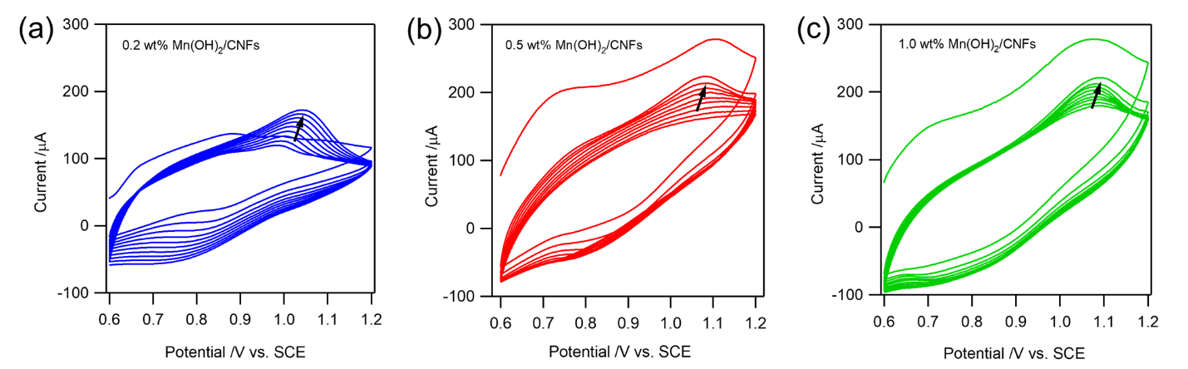
Figure S1: Cyclic voltammograms recorded between 0.6 and 1.2 V for 10 cycles at a scan rate of 20 mV s^{‒1} in an aqueous electrolyte containing 1.0 mM Mn(CH₃COO)₂, obtained under different Nafion concentrations: (a) 0.2 wt%, (b) 0.5 wt%, and (c) 1.0 wt%.

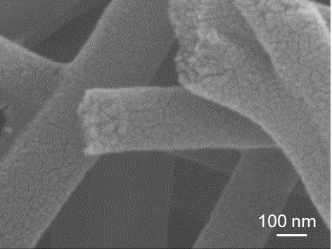
Figure S2: SEM image of pristine carbon nanofibers after Mn²⁺ electrodeposition in the absence of Nafion.
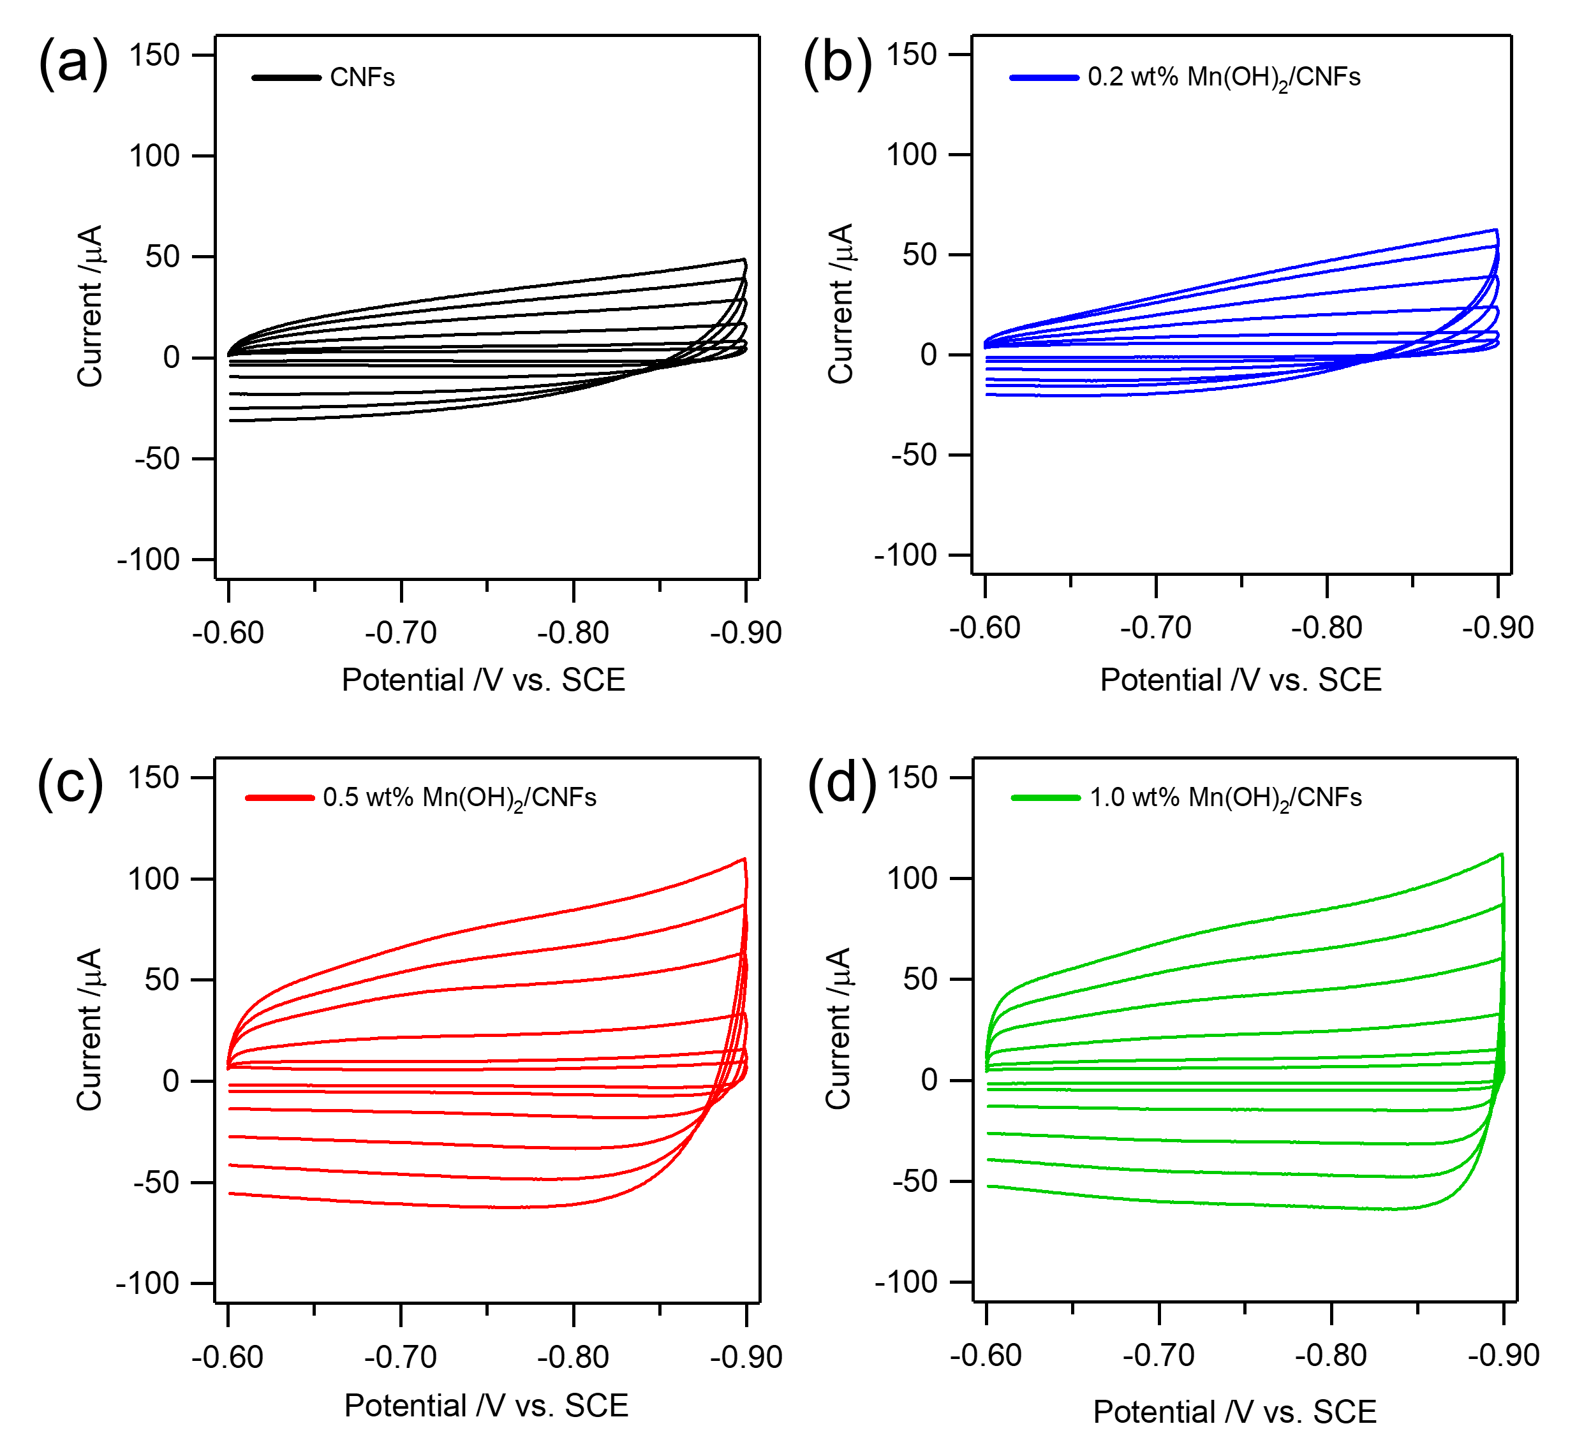
Figure S3: Cyclic voltammograms of the as-prepared electrodes recorded in 1.0 M KNO₃ (aq) at scan rates of 10, 20, 50, 100, 150, and 200 mV s^{‒1} within a potential window of 0.3 V.

