Supplementary Information
Functionalized Magnetic Covalent Organic Framework Composites for Enrichment of Synthetic Cannabinoids in Wastewater Coupled with UPLC-MS/MS Analysis
Can Li^{+[b]}, Zihua Zhang^{+[b]}, Pingyong Liao^{[b]}, Fei Fan^{[b]}, Junchang Wang^{[b]}, Yue Xu^{[b]}, Xuejun Zhao^{[a][b]*}and Wenbin Liu^{[a][b]}*
^{[a]} Shanghai Key Laboratory of Crime Scene Evidence, Shanghai Research Institute of Criminal Science and Technology, Shanghai 200072, China
^{[b]} Shanghai Yuansi Standard Science and Technology Co., Ltd., Shanghai 200072, China
^{[+]} These authors contributed equally to this work.

Supplementary Files |  | Page
General |  | 3
Supplementary Fig. 1 | TEM image of Fe₃O₄ nanospheres. | 4
Supplementary Fig. 2 | TEM images of Fe₃O₄@COFs-1 to -3 | 4
Supplementary Fig. 3 | TGA curves of Fe₃O₄ and Fe₃O₄@COFs-1 to -3 | 5
Supplementary Fig. 4 | Raman spectra of Fe₃O₄ and Fe₃O₄@COFs-1 to -3 | 6
Supplementary Fig. 5 | Water contact angles of Fe₃O₄@COFs-1 to -3 | 7
Supplementary Fig. 6 | Effect of adsorption time and elution solvent on extraction recovery | 8
Supplementary Fig. 7 | Effect of elution time on elution efficiency | 9
Supplementary Fig. 8 | Linear equation of 18 analytes | 10
Supplementary Fig. 9 | Precision, matrix effect, and recovery of 18 analytes | 13

General
Material
Reagents and solvents were purchased as reagent-grade and used without further purification unless otherwise stated. Anhydrous FeCl₃, anhydrous sodium citrate, ethylene glycol, anhydrous sodium acetate, and ethylene glycol were purchased from leyanpharm, 5'-(4-aminophenyl)-[1,1':3',1''-terphenyl]-4,4''-diamine, 2,5-dichloroterephthalaldehyde, [1,1'-biphenyl]-2,2'-dicarboxaldehyde and 2,5-dimethylterephthalaldehyde were purchased from bidepharm. All nine SCs and nine common drugs were synthesized according to known methods.
Characterization
The transmission electron microscope (TEM) analyses were carried out on a Tecnal G2 F20 S-Twin (FEI Company, USA). A Nicolet iS50 FT-IR coupled with a smart attenuated total reflection accessory (Thermo Scientific, USA) was used to collect the FT-IR spectra. Thermal stability and composition were evaluated by TGA (Perkin Elmer TGA 4000). The crystal structure and morphology were analyzed by X-Ray Diffraction (XRD, Rigaku SmartLab 9 kw, Japan). The Uv-Visible absorption spectra were measured on UV-visible spectrophotometric (PerkinElmer LAMBDA 365, USA). Raman scattering spectra were measured by Raman Spectrometer (HORIBA LabRAM HR Evolution, USA), with a 633 nm laser at a 1.5 μm beam diameter, with an integration time of 50 seconds. Brunauer-Emmett-Teller (BET) method were analyzed from nitrogen adsorption-desorption isotherms performed on Quadrasorb EVO (Quantachrome, USA).

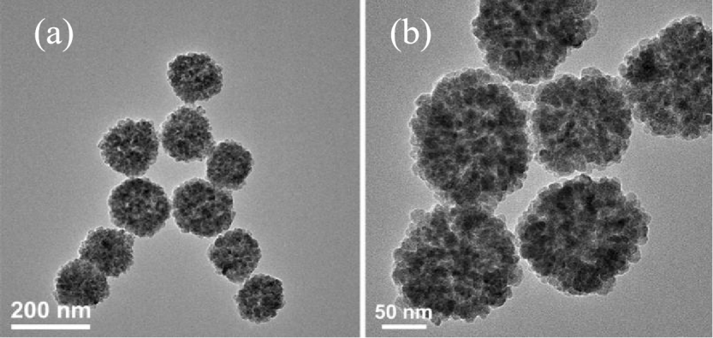
Supplementary Fig. 1 TEM image of Fe₃O₄ nanospheres.

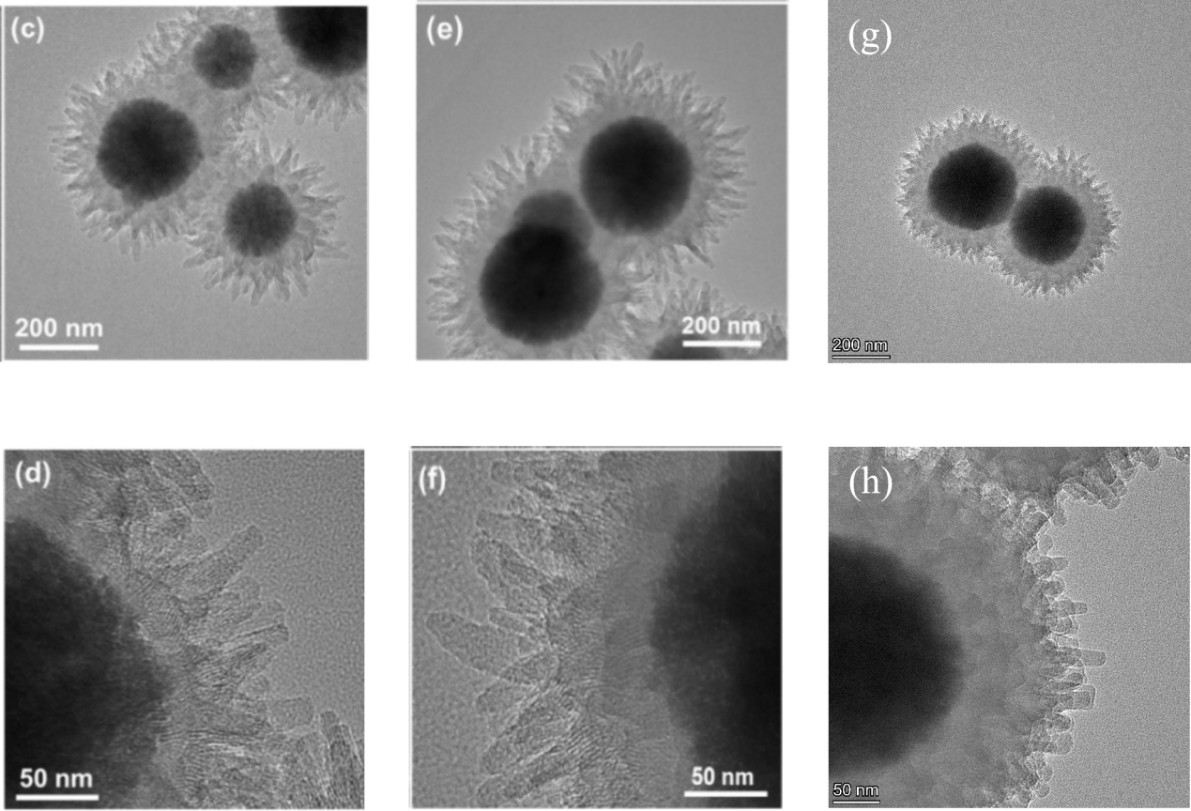
Supplementary Fig. 2 TEM images of Fe₃O₄@COFs-1 (c, d), Fe₃O₄@COFs-2 (e, f) and Fe₃O₄@COFs-3 (g, h) respectively.

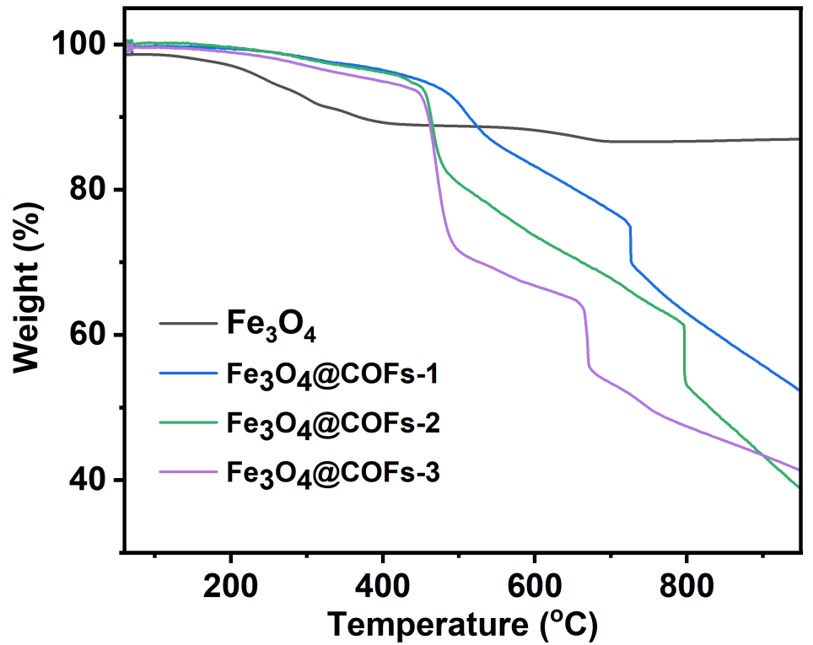
Supplementary Fig. 3. TGA curves of Fe₃O₄ and Fe₃O₄@COFs-1 to -3 respectively.

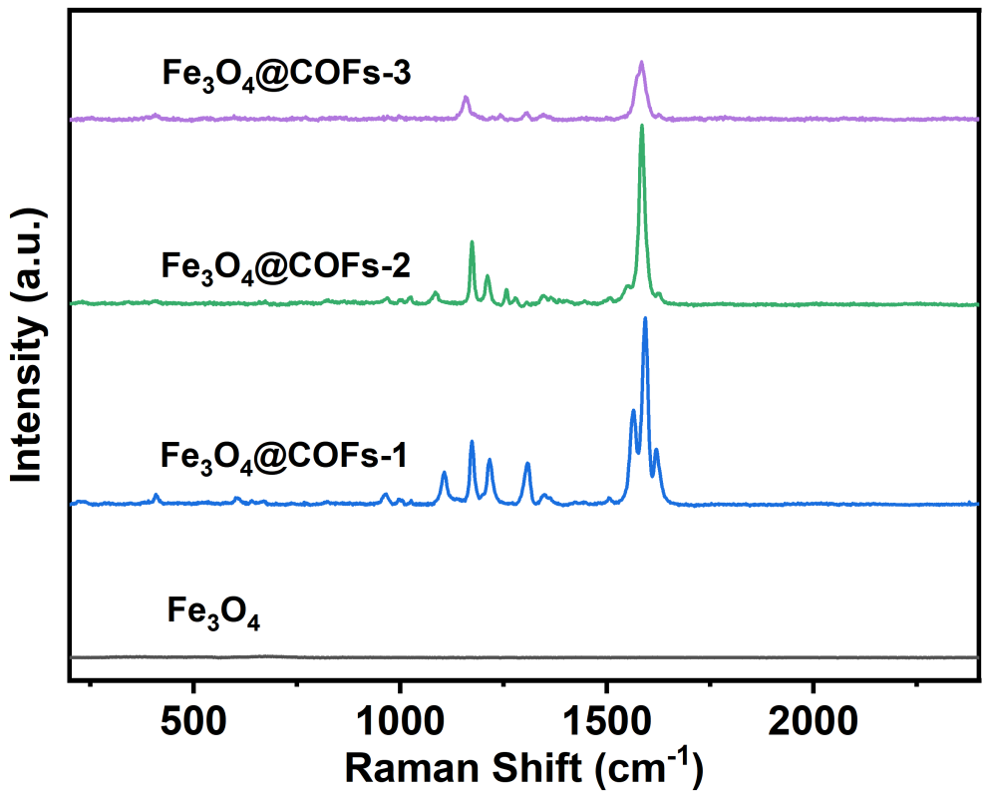
Supplementary Fig. 4. Raman spectra of Fe₃O₄ and Fe₃O₄@COFs-1 to -3 respectively.

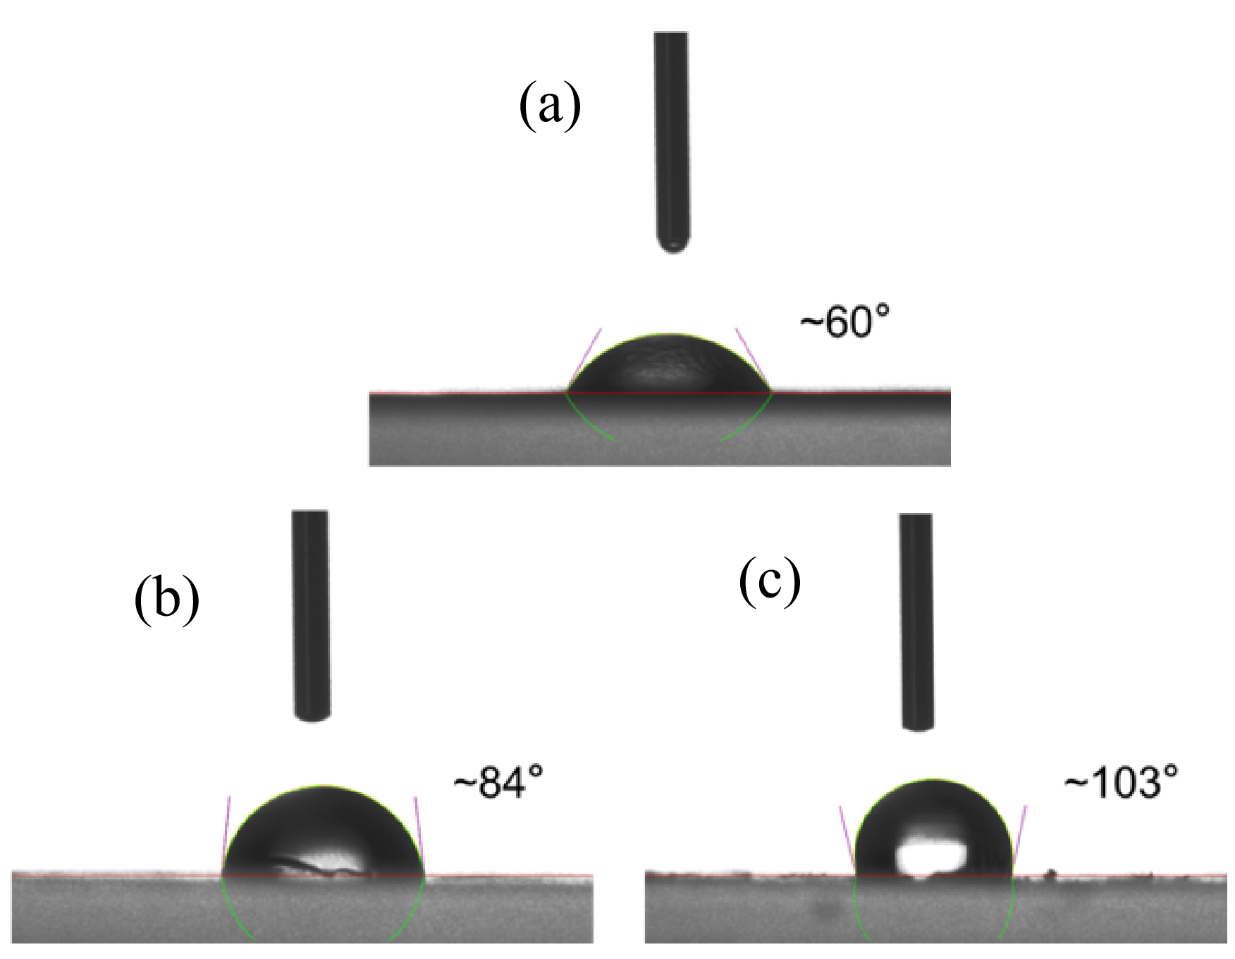
Supplementary Fig. 5. Water contact angles of (a) Fe₃O₄@COFs-1, (b) Fe₃O₄@COFs-2 and (c) Fe₃O₄@COFs-3 respectively.

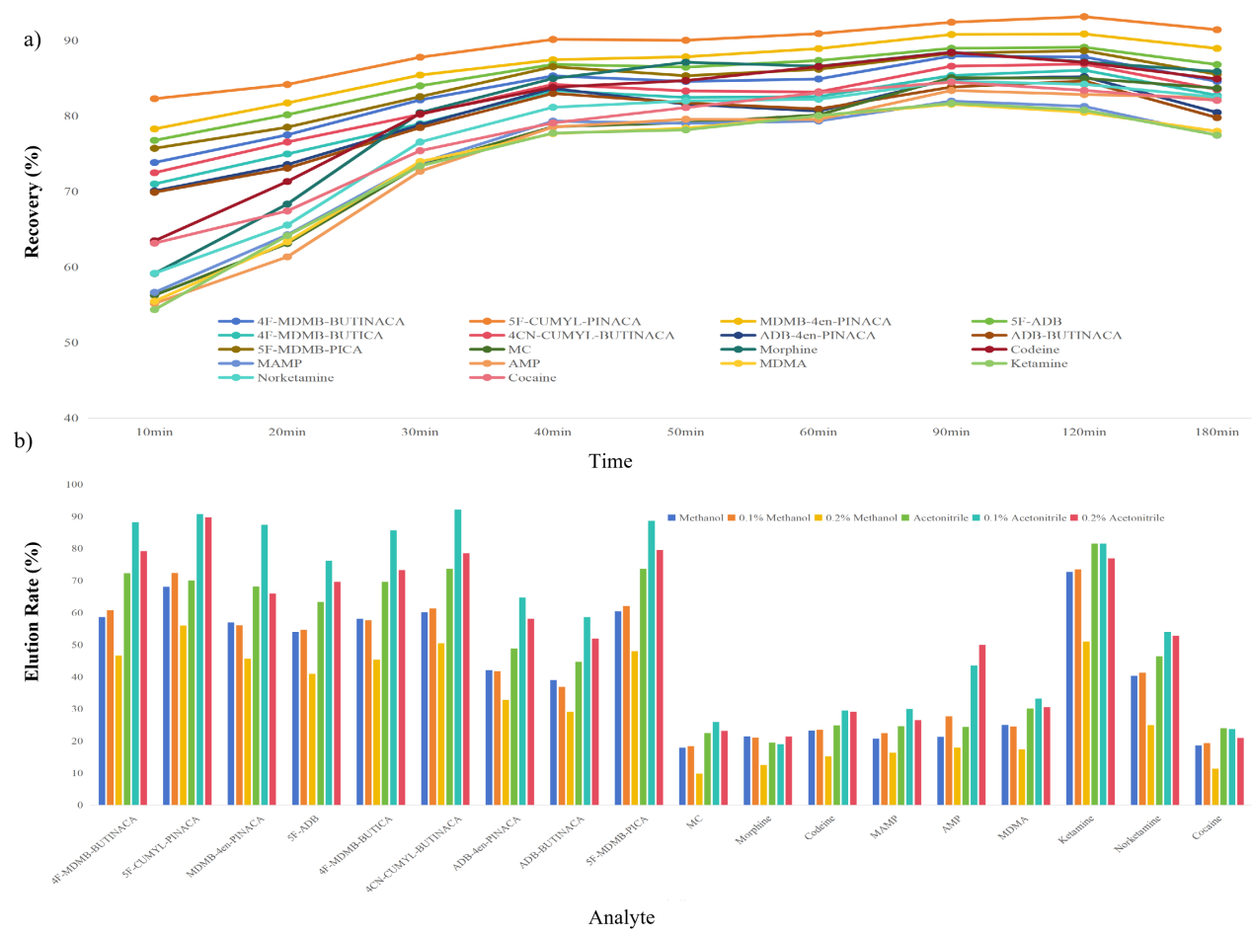
Supplementary Fig. 6. a) Effect of adsorption time on extraction recovery; b). Effect of elution solvent on elution efficiency.

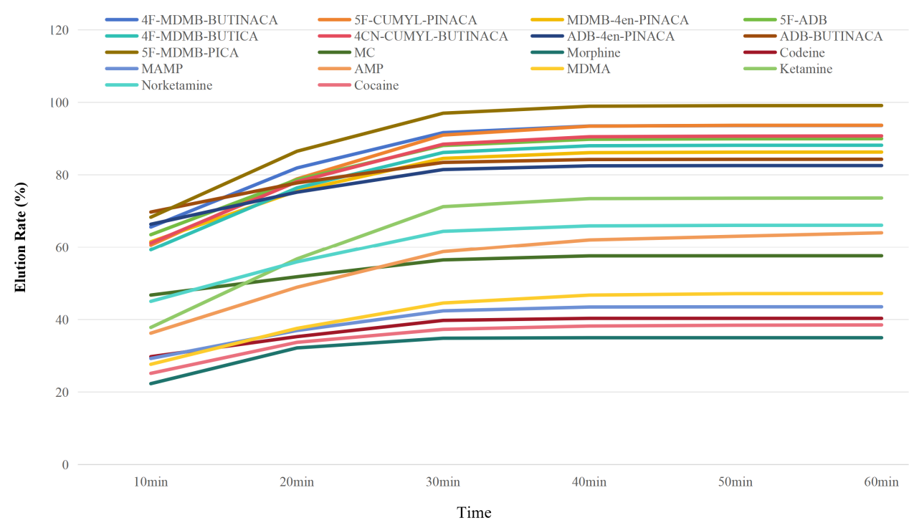
Supplementary Fig.7. Effect of elution time on elution efficiency.

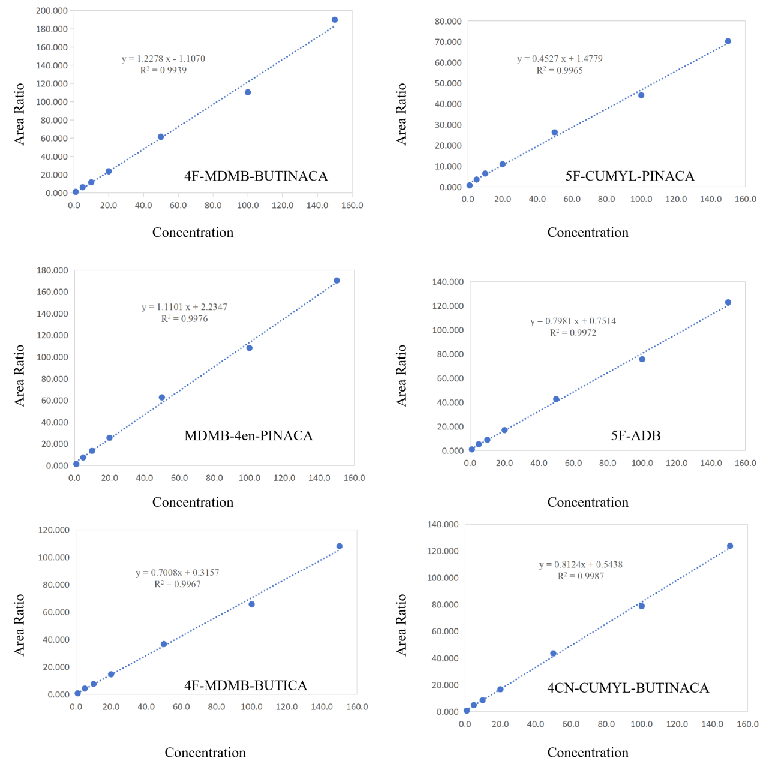
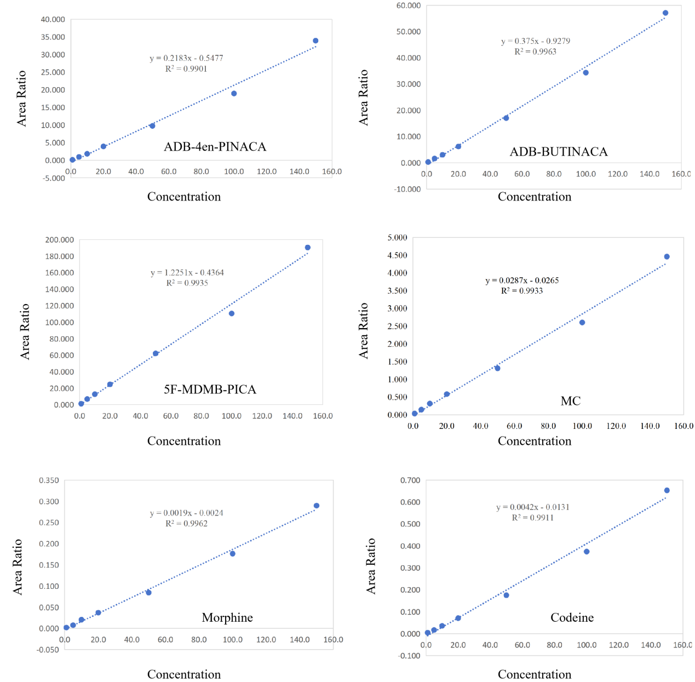
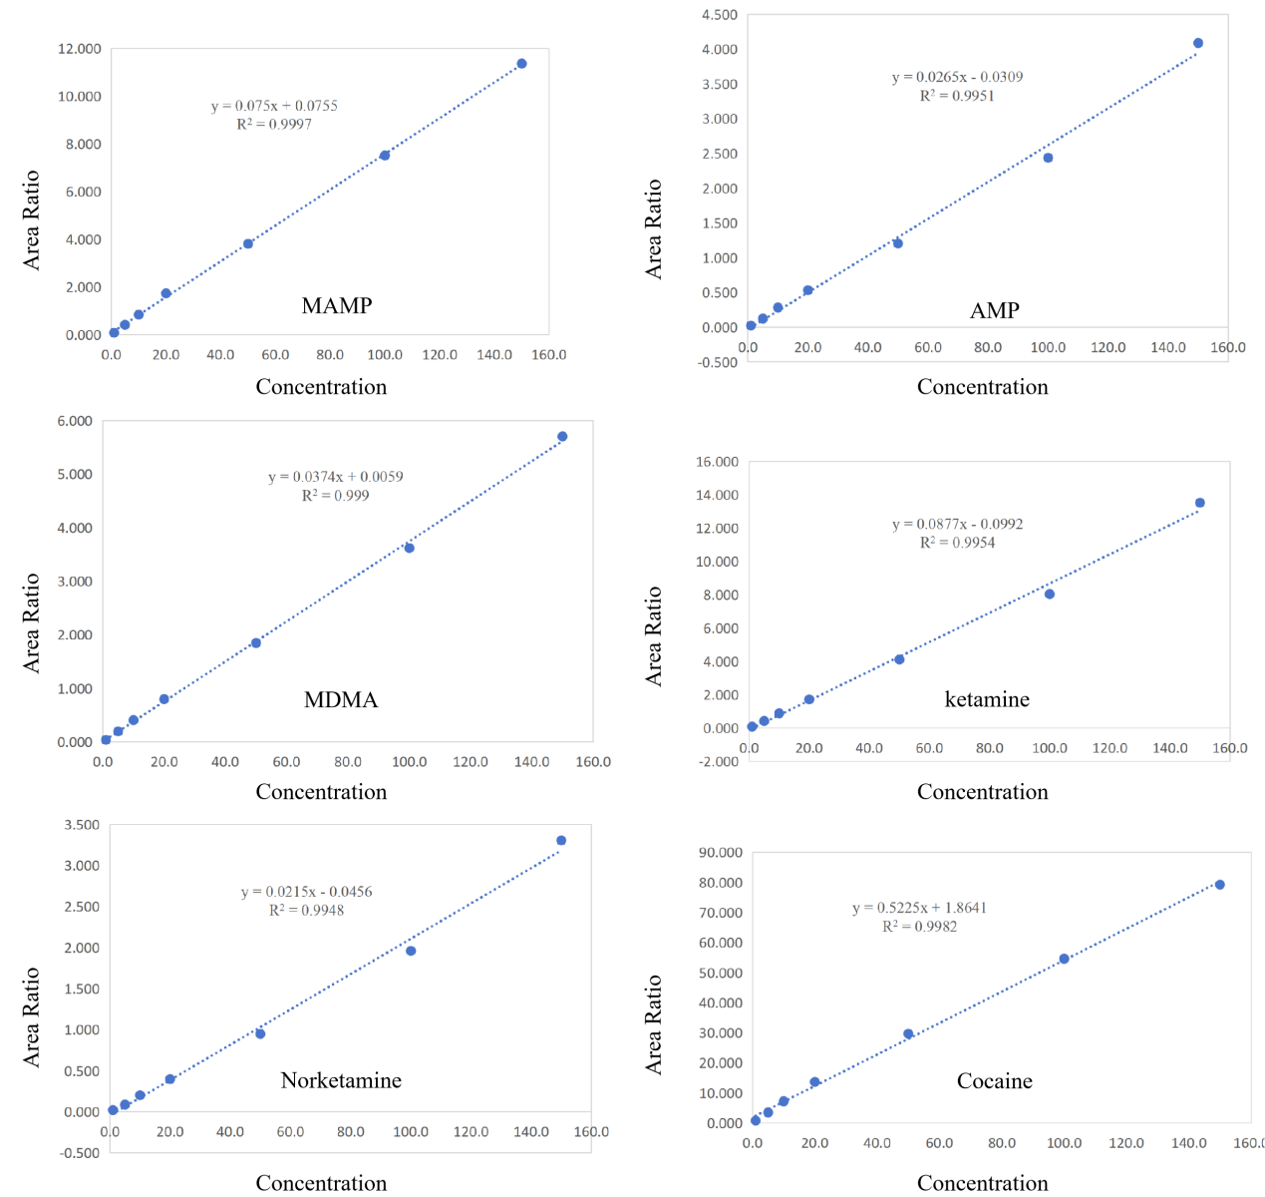
Supplementary Fig. 8. Linear equation of 18 analytes.

Analyte | Concentration （μg/L） |  | Intra-day （n=18） |  | Inter-day （n=18） |  | Matrix effect | Recovery
Analyte |  |  | RSD  （%） | RE  （%） | RSD（%） | RE  （%） | RSD  （%） | RSD（%）
4F-MDMB-BUTINACA | LOQ | 5.00 | 5.3 | 1.1 | 5.3 | 3.3 | 4.0 | 6.3
4F-MDMB-BUTINACA | MOQ | 50.00 | 1.6 | 7.6 | 3.8 | 4.2 | 13.7 | 6.1
4F-MDMB-BUTINACA | HOQ | 100.00 | 3.2 | 9.5 | 7.3 | 8.1 | 11.0 | 6.4
5F-CUMYL-PINACA | LOQ | 5.00 | 4.1 | 8.2 | 5.6 | 6.0 | 10.0 | 5.0
5F-CUMYL-PINACA | MOQ | 50.00 | 2.7 | 12.4 | 5.5 | 9.9 | 9.6 | 7.2
5F-CUMYL-PINACA | HOQ | 100.00 | 5.5 | 8.4 | 6.5 | 7.3 | 13.3 | 5.7
MDMB-4en-PINACA | LOQ | 5.00 | 5.9 | 9.4 | 4.3 | 9.3 | 14.5 | 5.9
MDMB-4en-PINACA | MOQ | 50.00 | 4.9 | 4.9 | 5.3 | 9.0 | 12.4 | 4.9
MDMB-4en-PINACA | HOQ | 100.00 | 6.2 | 5.3 | 4.9 | 7.5 | 11.8 | 6.2
5F-ADB | LOQ | 5.00 | 4.0 | 10.4 | 5.6 | 5.8 | 11.4 | 4.0
5F-ADB | MOQ | 50.00 | 4.7 | 1.8 | 5.5 | 6.2 | 9.7 | 4.7
5F-ADB | HOQ | 100.00 | 6.4 | -1.0 | 6.7 | 5.6 | 12.8 | 6.4
4F-MDMB-BUTICA | LOQ | 5.00 | 3.9 | 4.7 | 6.3 | 2.6 | 14.5 | 3.9
4F-MDMB-BUTICA | MOQ | 50.00 | 5.9 | 3.9 | 6.6 | 4.2 | 8.1 | 5.9
4F-MDMB-BUTICA | HOQ | 100.00 | 2.7 | 9.5 | 2.9 | 9.3 | 14.1 | 2.7
4CN-CUMYL-BUTINACA | LOQ | 5.00 | 5.6 | 3.3 | 15.5 | 11.6 | 11.1 | 5.6
4CN-CUMYL-BUTINACA | MOQ | 50.00 | 7.8 | -2.4 | 6.5 | 3.9 | 12.7 | 7.8
4CN-CUMYL-BUTINACA | HOQ | 100.00 | 6.8 | -2.8 | 7.3 | 5.1 | 13.5 | 6.8
ADB-4en-PINACA | LOQ | 5.00 | 11.5 | 1.7 | 7.9 | -0.9 | 9.8 | 11.5
ADB-4en-PINACA | MOQ | 50.00 | 7.1 | 4.2 | 7.0 | 2.8 | 14.1 | 7.1
ADB-4en-PINACA | HOQ | 100.00 | 5.2 | 6.0 | 4.0 | 8.2 | 14.4 | 5.2
ADB-BUTINACA | LOQ | 5.00 | 7.5 | 3.2 | 5.4 | 2.0 | 12.7 | 4.2
ADB-BUTINACA | MOQ | 50.00 | 7.5 | 1.7 | 8.2 | 3.4 | 8.4 | 7.5
ADB-BUTINACA | HOQ | 100.00 | 6.0 | 2.0 | 5.4 | 5.2 | 14.8 | 6.0
5F-MDMB-PICA | LOQ | 5.00 | 4.9 | 3.5 | 15.6 | 13.7 | 5 | 4.9
5F-MDMB-PICA | MOQ | 50.00 | 3.3 | 4.4 | 4.6 | 6.4 | 10.6 | 3.3
5F-MDMB-PICA | HOQ | 100.00 | 4.1 | 4.8 | 4.3 | 8.6 | 14 | 4.1
MC | LOQ | 5.00 | 2.6 | -8.7 | 4.4 | -5.4 | 5.9 | 2.6
MC | MOQ | 50.00 | 2.5 | -12.3 | 5.8 | -7.8 | 7.3 | 2.3
MC | HOQ | 100.00 | 4.2 | -10.6 | 7.6 | -3.8 | 8.9 | 4.2
Morphine | LOQ | 5.00 | 5.2 | -3.7 | 5.3 | -2.1 | 10.7 | 5.2
Morphine | MOQ | 50.00 | 6.1 | 0.4 | 6.0 | 1.3 | 7.7 | 6.1
Morphine | HOQ | 100.00 | 2.9 | -4.3 | 4.0 | -4.2 | 1.9 | 2.9
Codeine | LOQ | 5.00 | 4.2 | -4.8 | 5.8 | -7.4 | 13.9 | 4.2
Codeine | MOQ | 50.00 | 3.2 | 0.1 | 6.4 | -4.8 | 4 | 3.2
Codeine | HOQ | 100.00 | 2.0 | -5.3 | 4.8 | -4.4 | 3.9 | 2.0
MAMP | LOQ | 5.00 | 4.0 | 5.1 | 3.4 | 4.6 | 3.7 | 4.0
MAMP | MOQ | 50.00 | 2.8 | -1.7 | 3.6 | 0.2 | 2.5 | 2.8
MAMP | HOQ | 100.00 | 2.9 | -3.4 | 4.8 | 0.0 | 4.9 | 2.9
AMP | LOQ | 5.00 | 4.3 | -7.4 | 5.9 | -8.0 | 6.6 | 4.3
AMP | MOQ | 50.00 | 1.5 | -10.8 | 5.0 | -8.6 | 11.5 | 1.5
AMP | HOQ | 100.00 | 3.5 | -9.1 | 7.2 | -4.0 | 5.1 | 3.5
MDMA | LOQ | 5.00 | 4.2 | 10.4 | 5.3 | 5.0 | 4.2 | 4.2
MDMA | MOQ | 50.00 | 2.8 | 5.9 | 5.0 | 3.7 | 5.5 | 2.8
MDMA | HOQ | 100.00 | 2.1 | 1.6 | 4.7 | 0.0 | 4.7 | 2.1
Ketamine | LOQ | 5.00 | 5.1 | 3.8 | 5.5 | 5.7 | 6.2 | 3.8
Ketamine | MOQ | 50.00 | -10.8 | 1.5 | 1.1 | 6.5 | 5.8 | 2.5
Ketamine | HOQ | 100.00 | -9.1 | 3.5 | 0.7 | 4.7 | 6.9 | 2.0
Norketamine | LOQ | 5.00 | 4.5 | -8.3 | 4.6 | -6.9 | 6.8 | 4.5
Norketamine | MOQ | 50.00 | 2.0 | -9.8 | 6.2 | -6.6 | 2.5 | 2.0
Norketamine | HOQ | 100.00 | 4.6 | -6.5 | 7.6 | -1.1 | 5.7 | 4.6
Cocaine | LOQ | 5.00 | 7.0 | -5.2 | 6.8 | -0.6 | 7.6 | 7.0
Cocaine | MOQ | 50.00 | 4.7 | 4.1 | 5.2 | 6.3 | 10.4 | 4.7
Cocaine | HOQ | 100.00 | 2.2 | 1.5 | 6.4 | 2.8 | 14.5 | 2.2
Supplementary Fig. 9. Precision, matrix effect, and recovery of 18 analytes.

.
.

