Supporting Information

PhI(OAc)₂ Oxidative Dearomatization of o-Methoxy-phenols. A Facile Preparation of ortho-endo bicyclo[2.2.2]octenones
Christos Anagnostopoulos, Christos Kalogiros, Maria Nikolaidou, Leandros V. Polychronis, Eirini Tileli, and Lazaros P. Hadjiarapoglou*
Department of Chemistry, University of Ioannina, GR-45110 Ioannina, Greece.
Corresponding Author:
Lazaros P. Hadjiarapoglou: lxatziar@gmail.com
Spectral Data

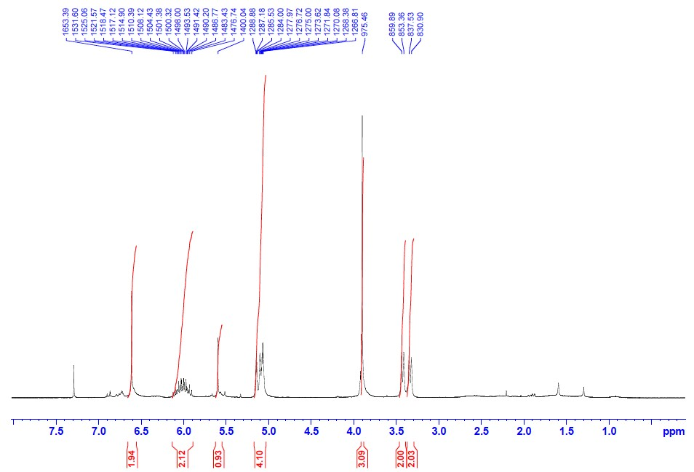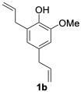
Figure S1. ¹H NMR of phenol 1b (250 MHz, CDCl₃, 300 K)
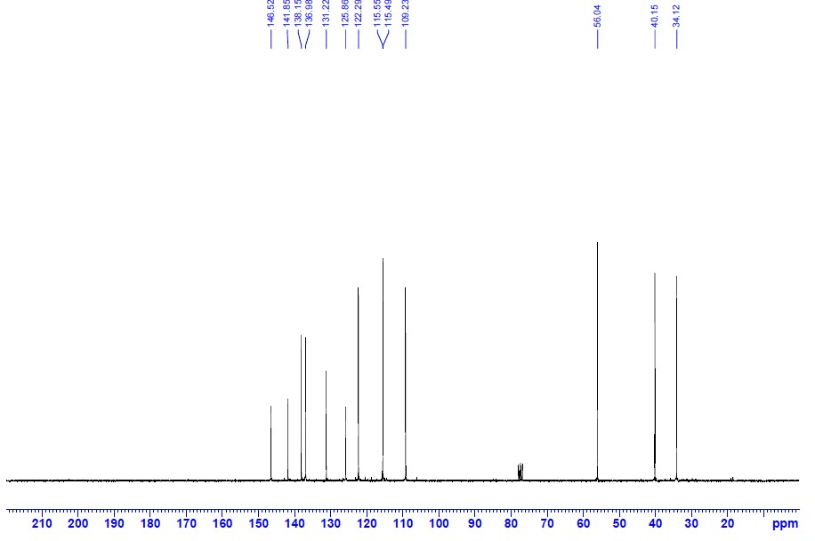
Figure S2. ¹³C NMR of phenol 1b (62.5 MHz, CDCl₃, 300 K)

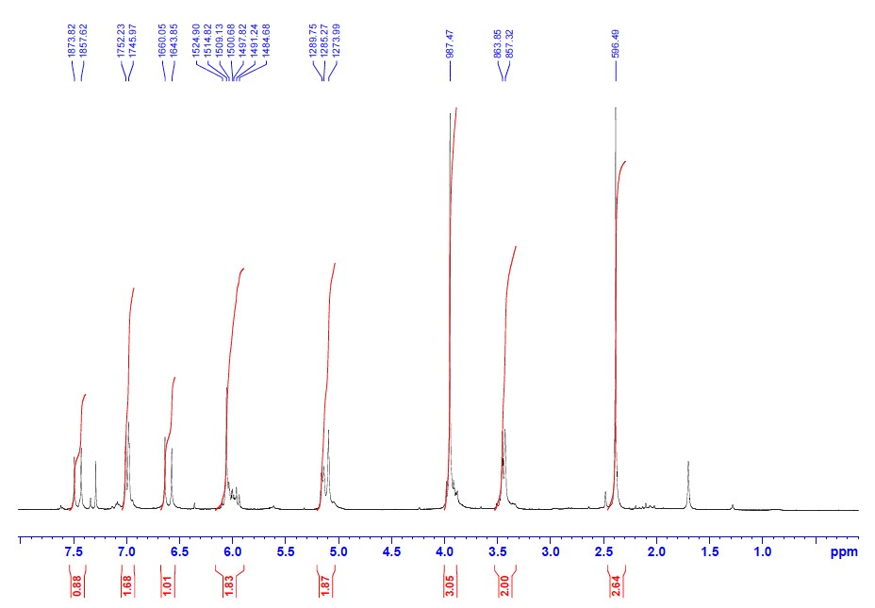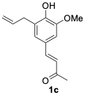
Figure S3. ¹H NMR of phenol 1c (250 MHz, CDCl₃, 300 K)
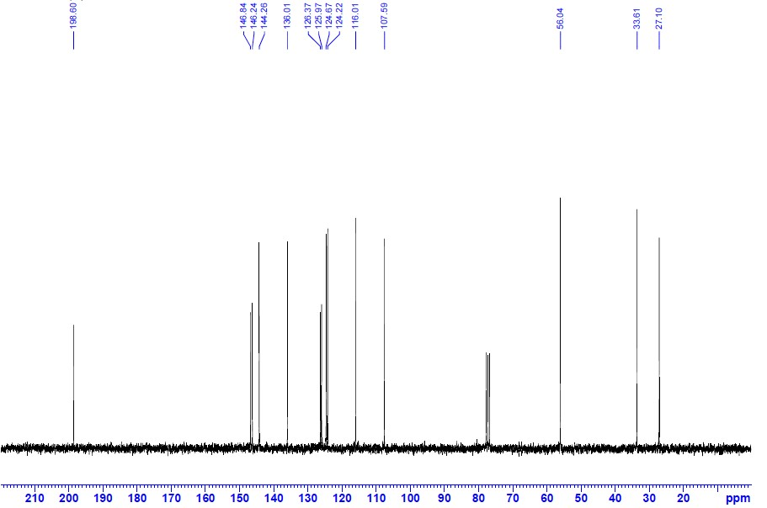
Figure S4. ¹³C NMR of phenol 1c (62.5 MHz, CDCl₃, 300 K)

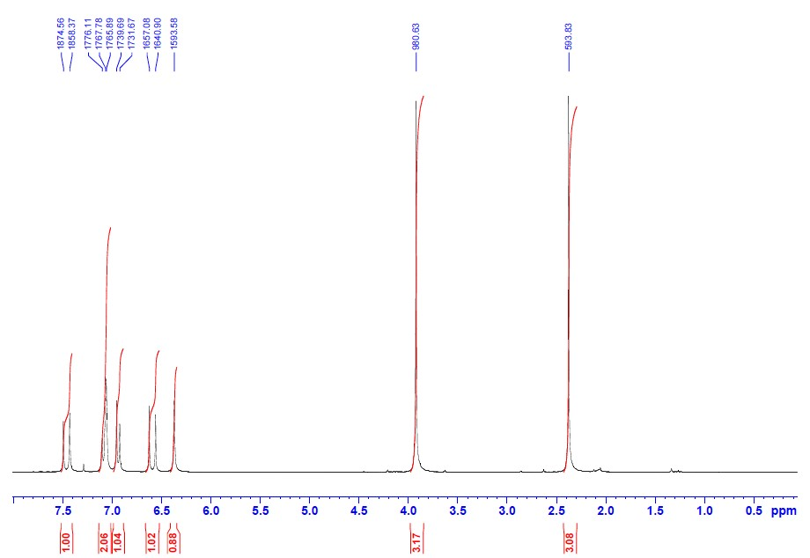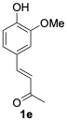
Figure S5. ¹H NMR of phenol 1e (250 MHz, CDCl₃, 300 K)
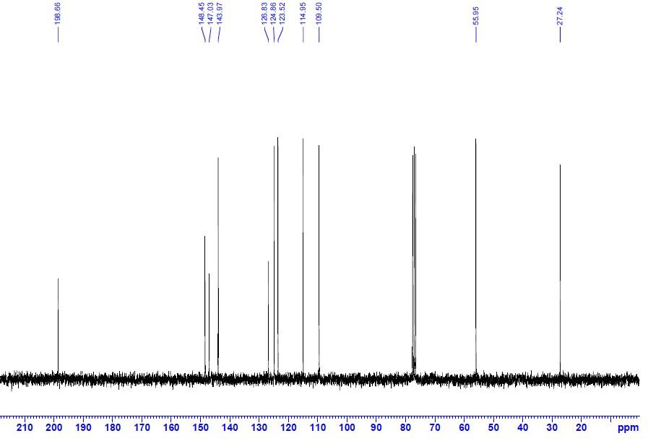
Figure S6. ¹³C NMR of phenol 1e (62.5 MHz, CDCl₃, 300 K)

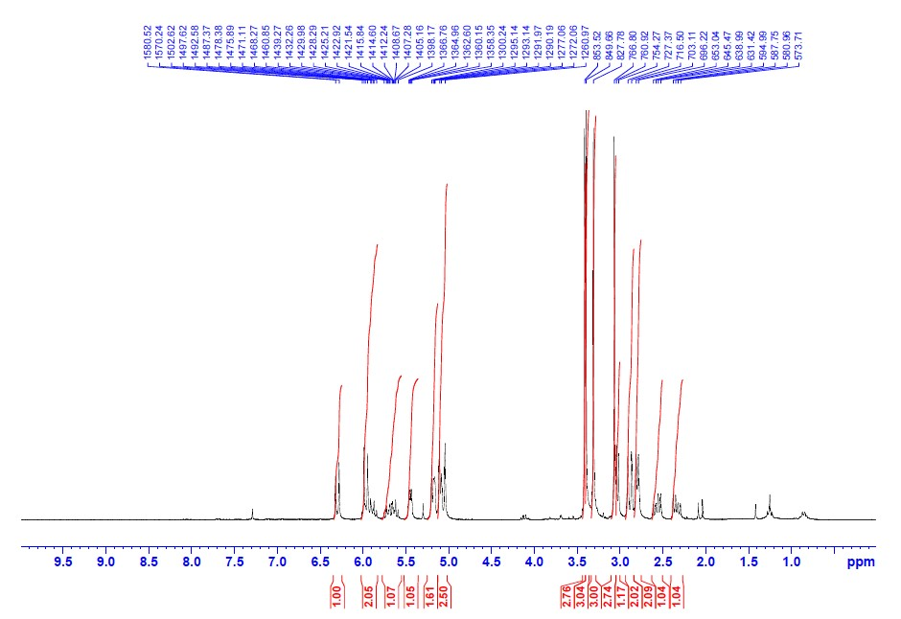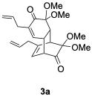
Figure S7. ¹H NMR of dimer 3a (250 MHz, CDCl₃, 300 K)
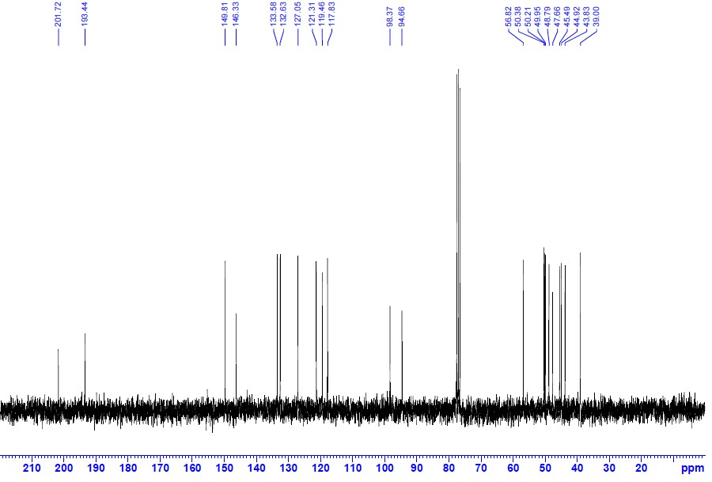
Figure S8. ¹³C NMR of dimer 3a (62.5 MHz, CDCl₃, 300 K)

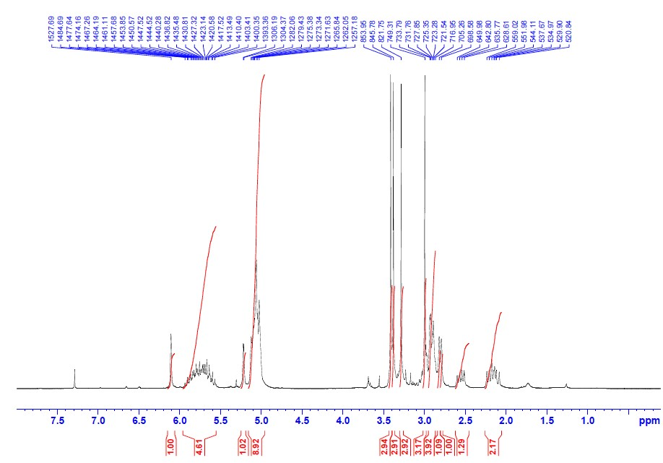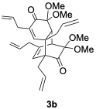
Figure S9. ¹H NMR of dimer 3b (250 MHz, CDCl₃, 300 K)
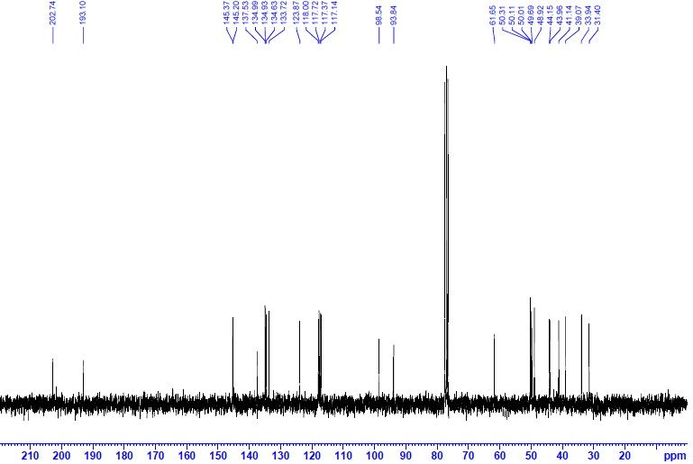
Figure S10. ¹³C NMR of dimer 3b (62.5 MHz, CDCl₃, 300 K)

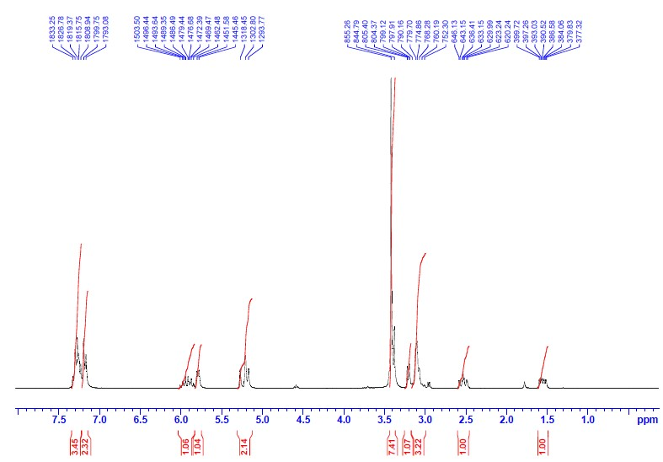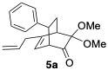
Figure S11. ¹H NMR of cycloadduct 5a (250 MHz, CDCl₃, 300 K)
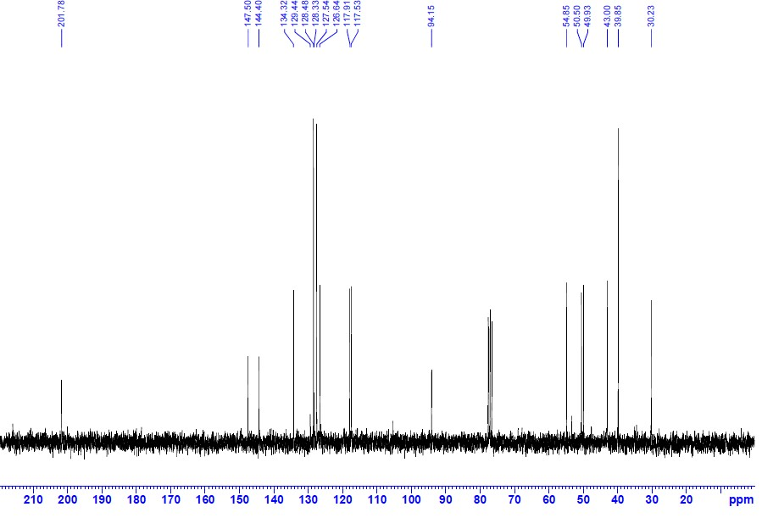
Figure S12. ¹³C NMR of cycloadduct 5a (62.5 MHz, CDCl₃, 300 K)

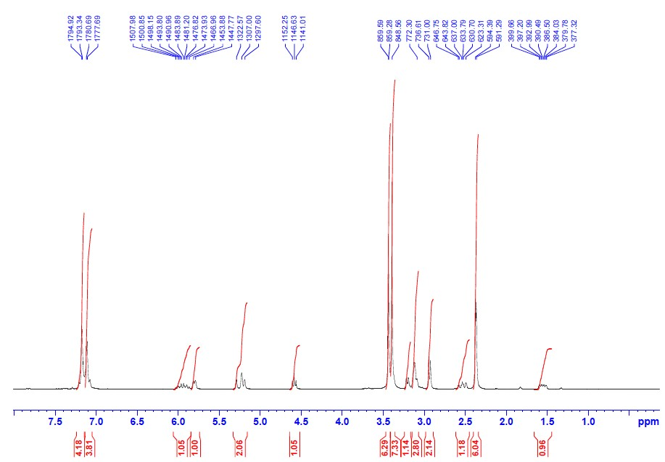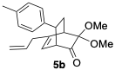
Figure S13. ¹H NMR of cycloadduct 5b (250 MHz, CDCl₃, 300 K)
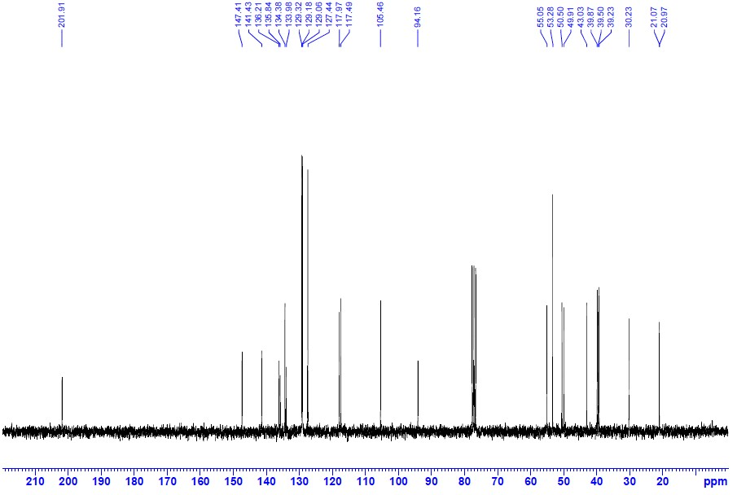
Figure S14. ¹³C NMR of cycloadduct 5b (62.5 MHz, CDCl₃, 300 K)

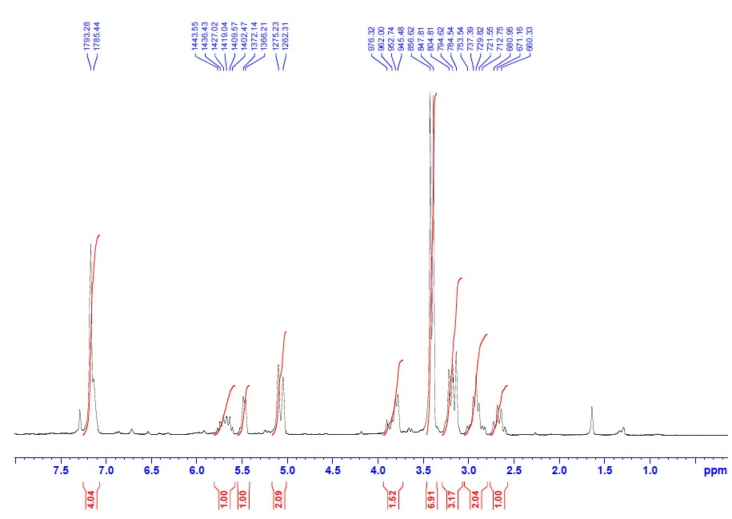
Figure S15. ¹H NMR of cycloadduct 5c (250 MHz, CDCl₃, 300 K)
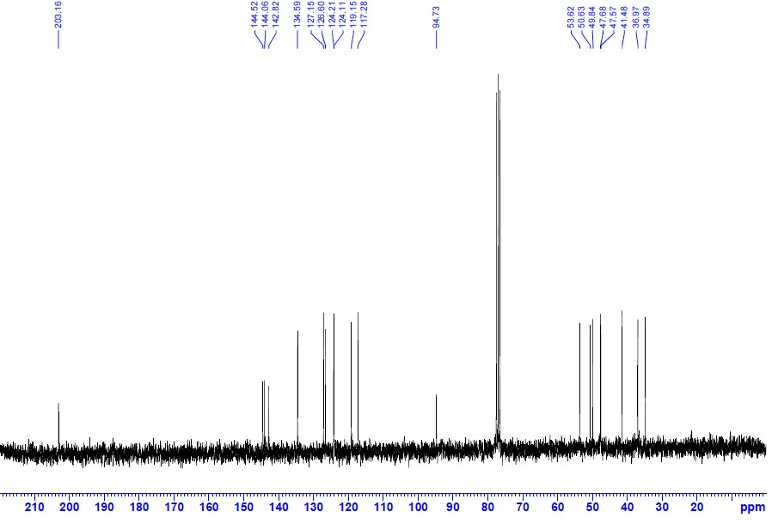
Figure S16. ¹³C NMR of cycloadduct 5c (62.5 MHz, CDCl₃, 300 K)

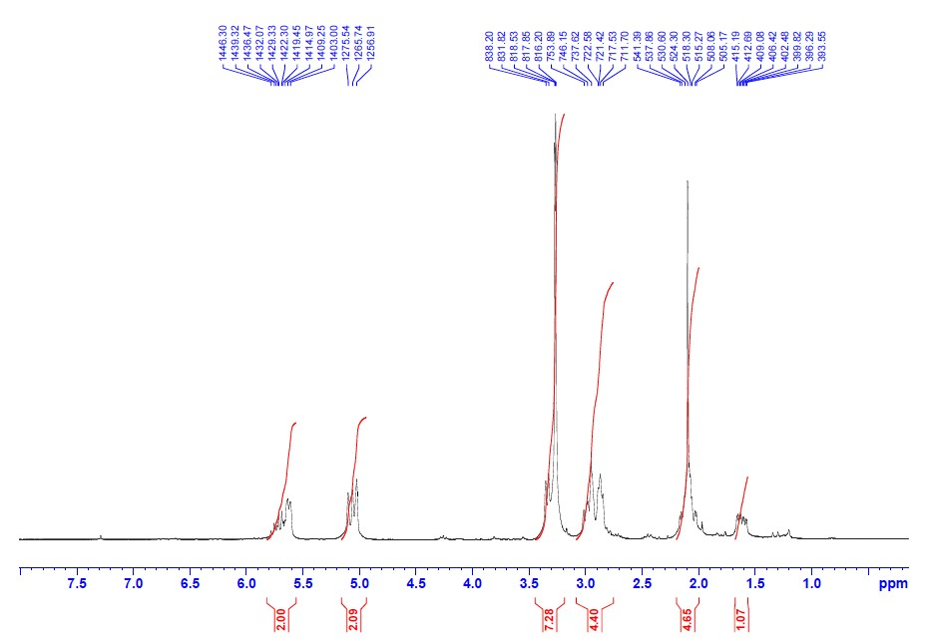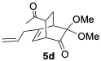
Figure S17. ¹H NMR of cycloadduct 5d (250 MHz, CDCl₃, 300 K)
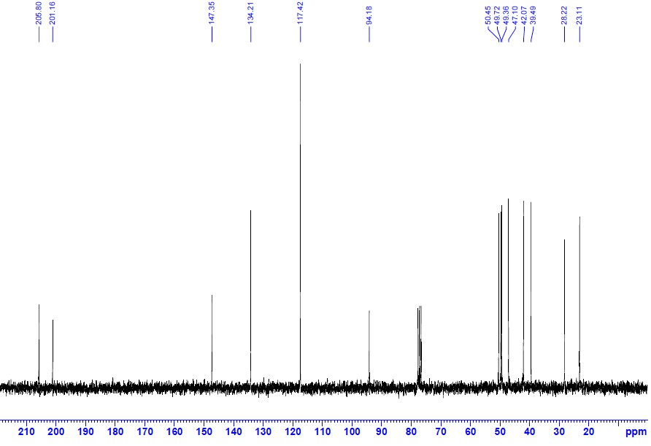
Figure S18. ¹³C NMR of cycloadduct 5d (62.5 MHz, CDCl₃, 300 K)

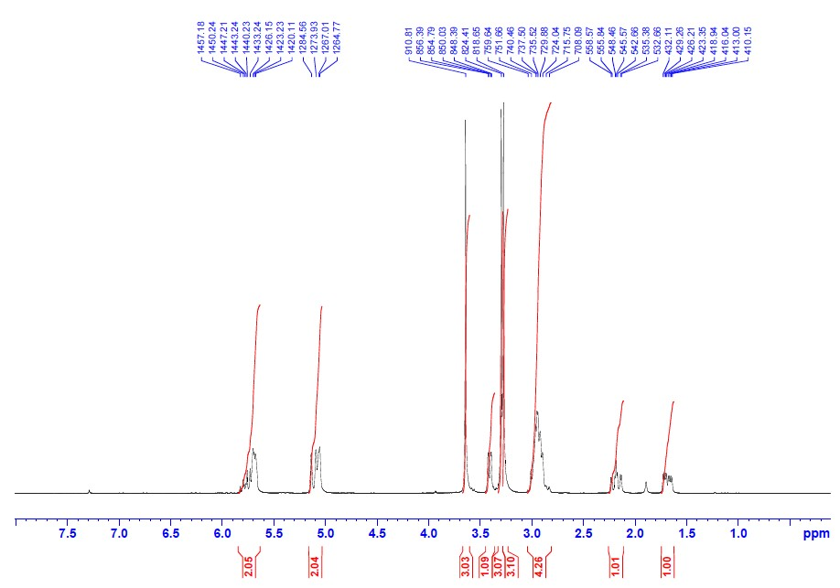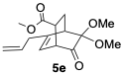
Figure S19. ¹H NMR of cycloadduct 5e (250 MHz, CDCl₃, 300 K)
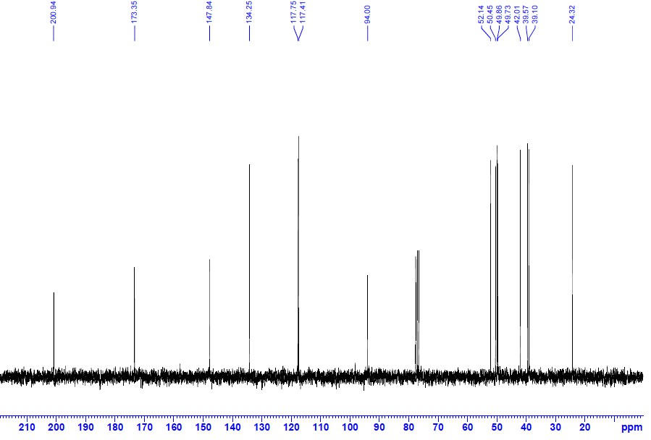
Figure S20. ¹³C NMR of cycloadduct 5e (62.5 MHz, CDCl₃, 300 K)

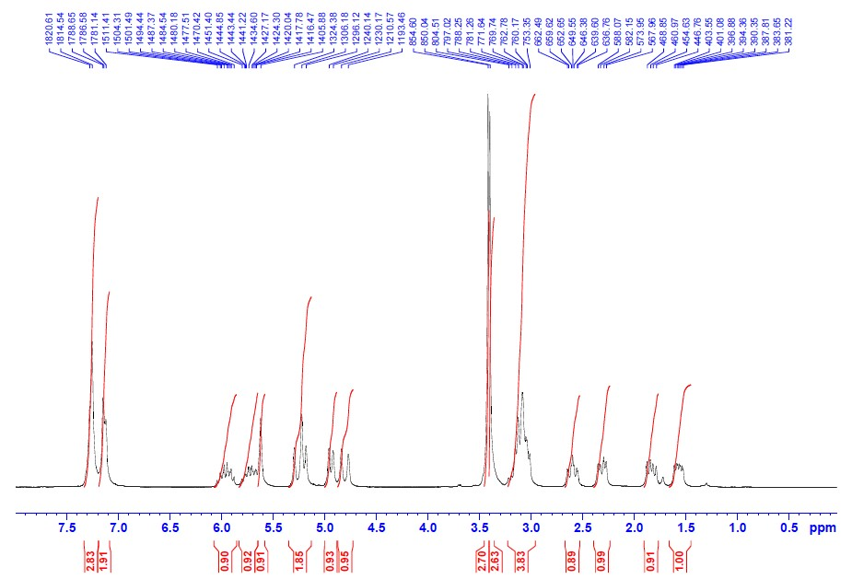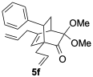
Figure S21. ¹H NMR of cycloadduct 5f (250 MHz, CDCl₃, 300 K)
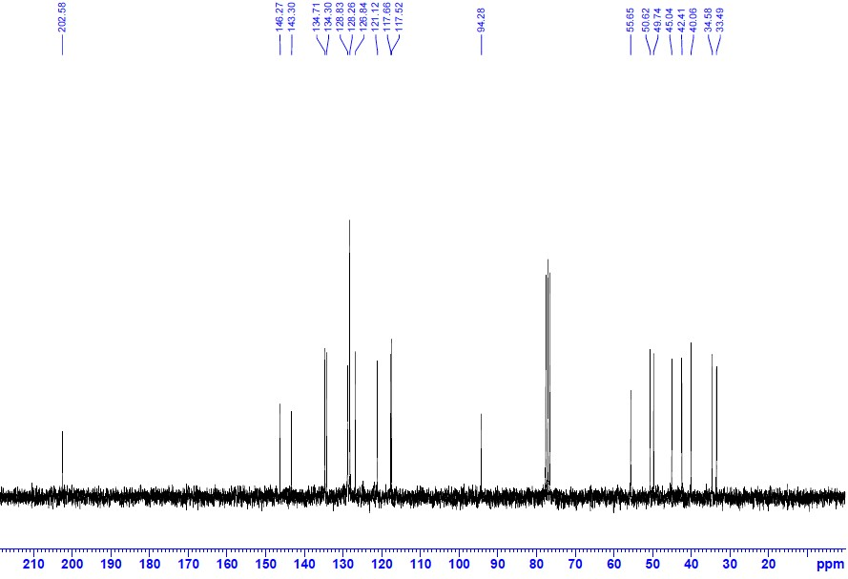
Figure S22. ¹³C NMR of cycloadduct 5f (62.5 MHz, CDCl₃, 300 K)

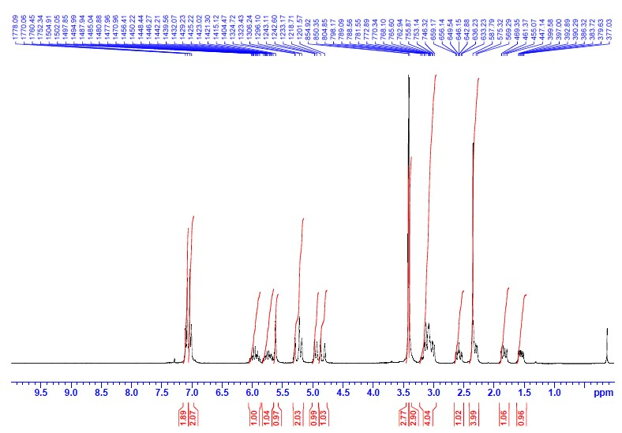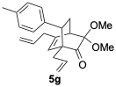
Figure S23. ¹H NMR of cycloadduct 5g (250 MHz, CDCl₃, 300 K)
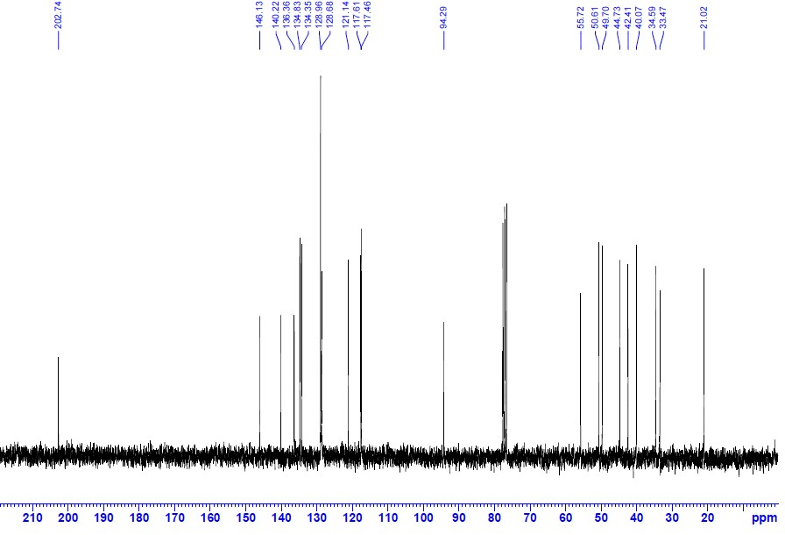
Figure S24. ¹³C NMR of cycloadduct 5g (62.5 MHz, CDCl₃, 300 K)

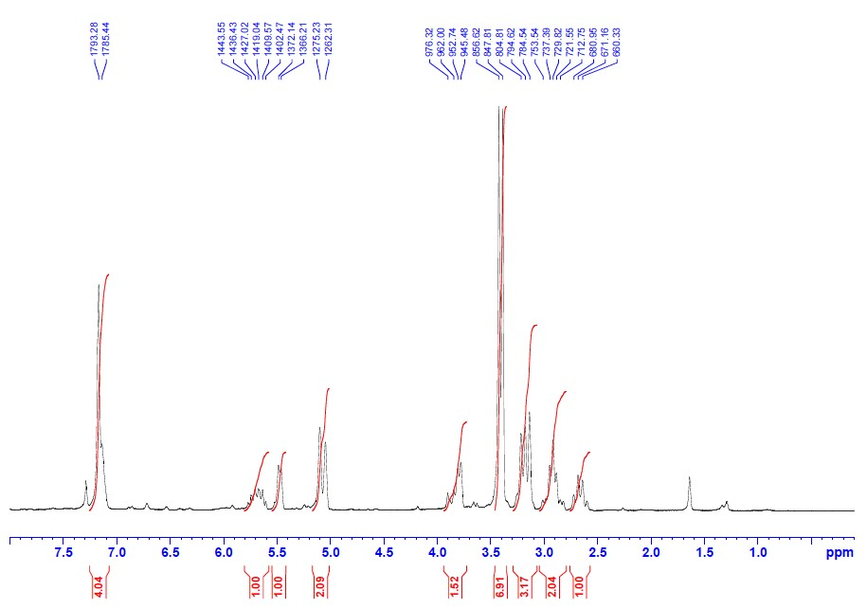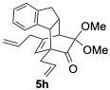
Figure S25. ¹H NMR of cycloadduct 5h (250 MHz, CDCl₃, 300 K)
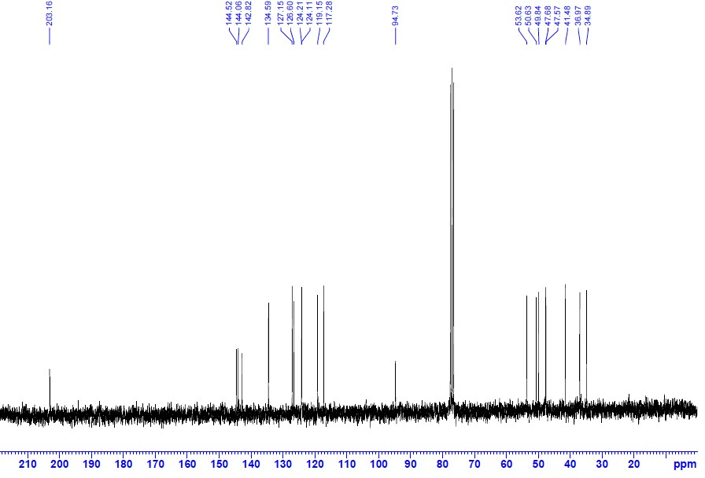
Figure S26. ¹³C NMR of cycloadduct 5h (62.5 MHz, CDCl₃, 300 K)

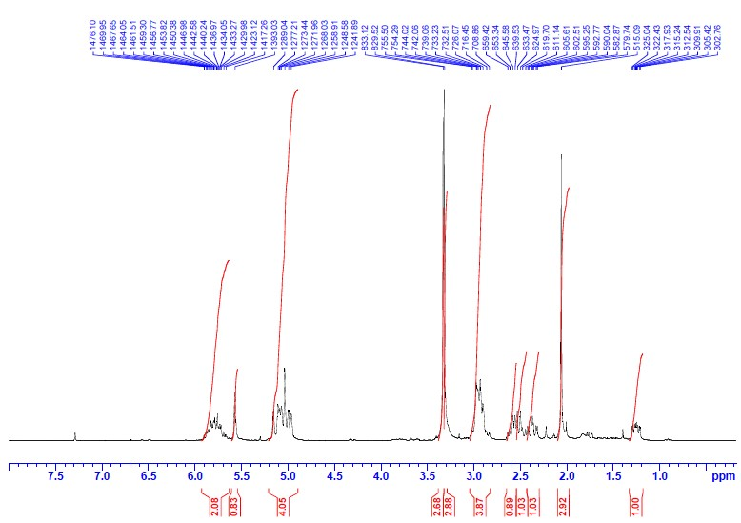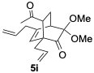
Figure S27. ¹H NMR of cycloadduct 5i (250 MHz, CDCl₃, 300 K)
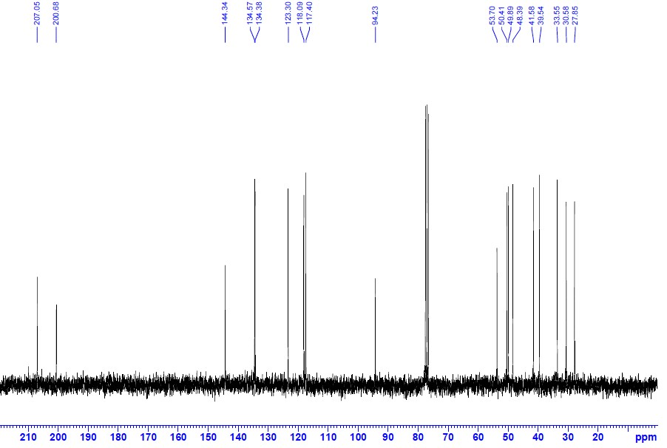
Figure S28. ¹³C NMR of cycloadduct 5i (62.5 MHz, CDCl₃, 300 K)

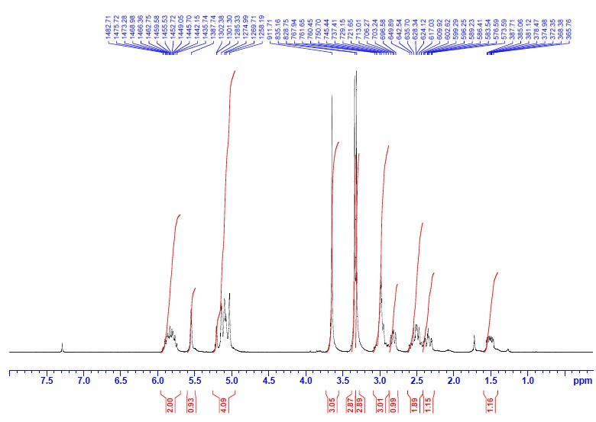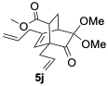
Figure S29. ¹H NMR of cycloadduct 5j (250 MHz, CDCl₃, 300 K)
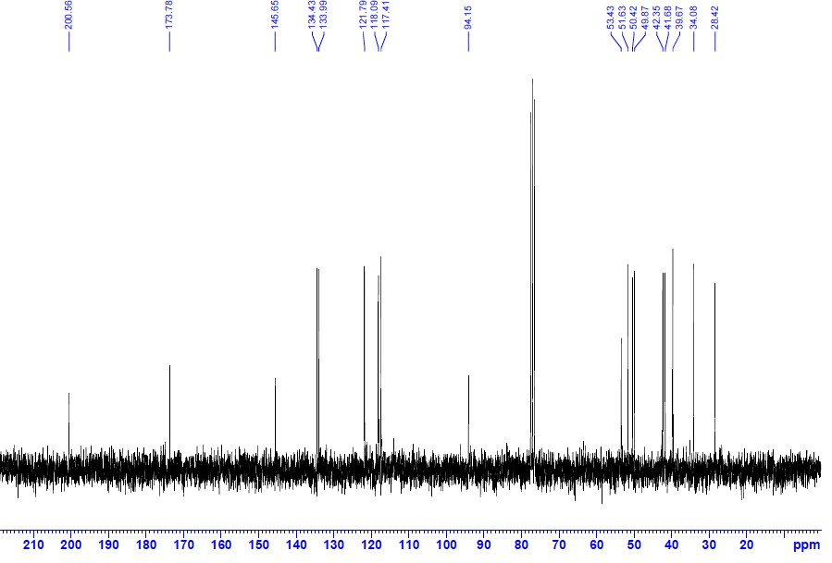
Figure S30. ¹³C NMR of cycloadduct 5j (62.5 MHz, CDCl₃, 300 K)

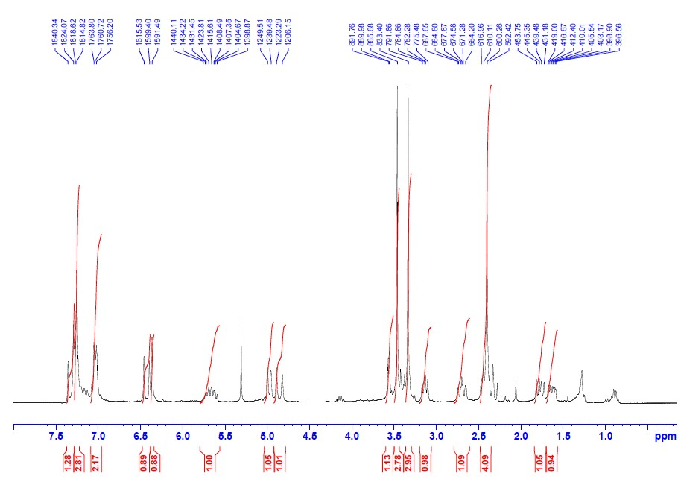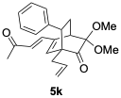
Figure S31. ¹H NMR of cycloadduct 5k (250 MHz, CDCl₃, 300 K)
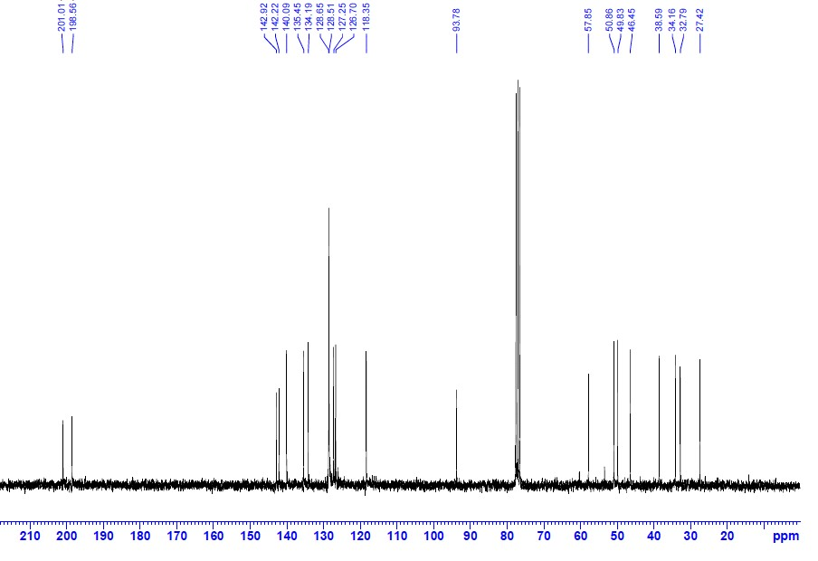
Figure S32. ¹³C NMR of cycloadduct 5k (62.5 MHz, CDCl₃, 300 K)

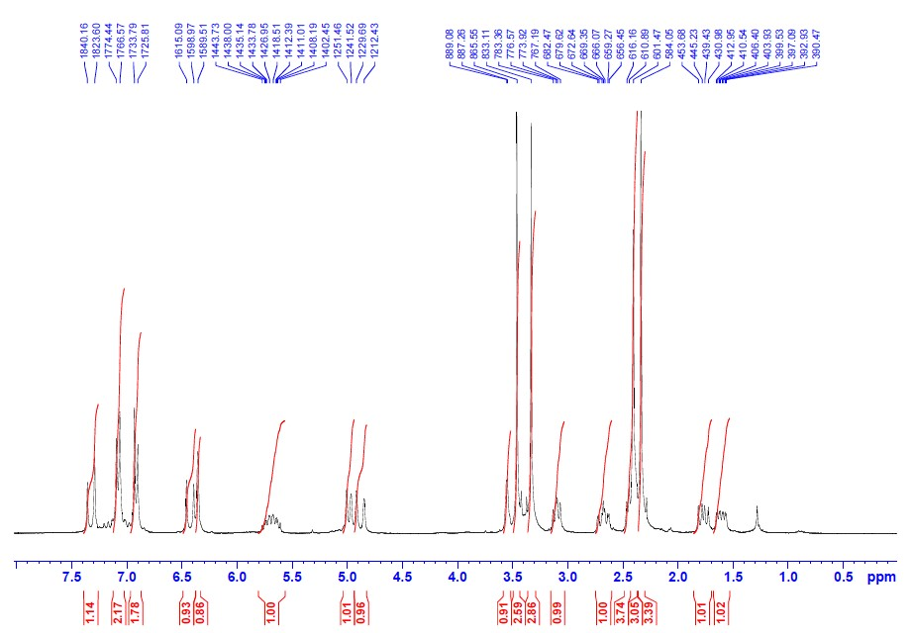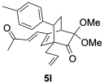
Figure S33. ¹H NMR of cycloadduct 5l (250 MHz, CDCl₃, 300 K)
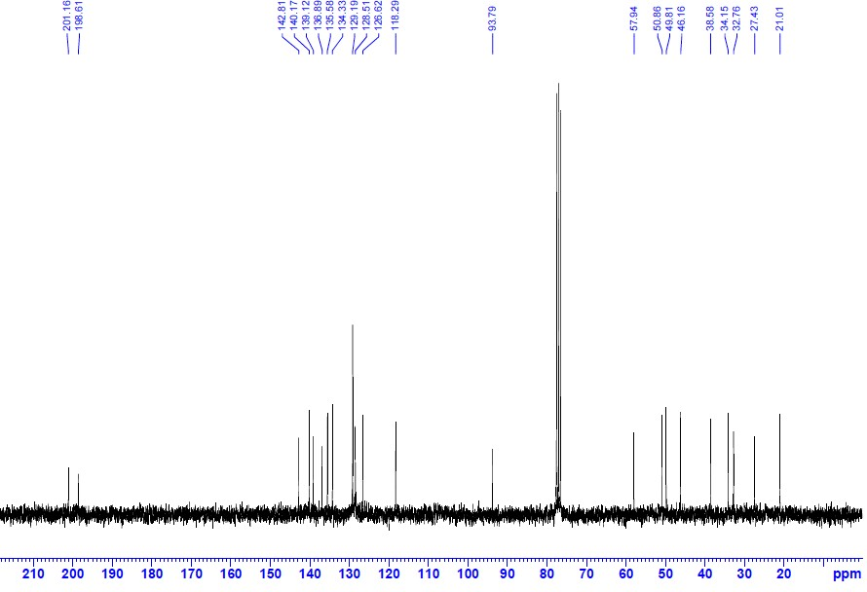
Figure S34. ¹³C NMR of cycloadduct 5l (62.5 MHz, CDCl₃, 300 K)

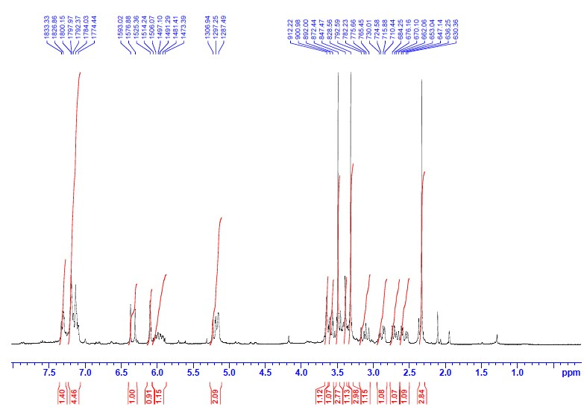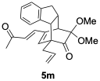
Figure S35. ¹H NMR of cycloadduct 5m (250 MHz, CDCl₃, 300 K)
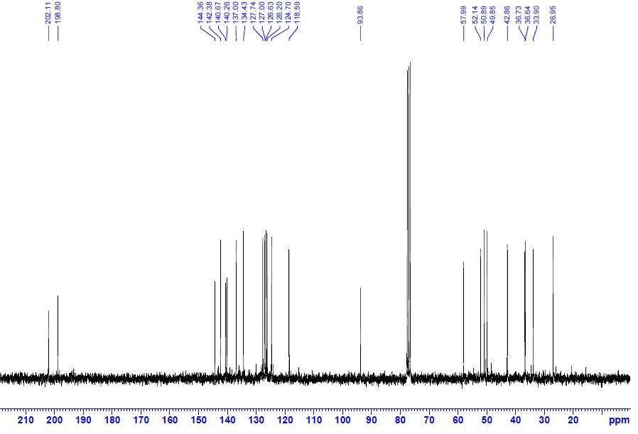
Figure S36. ¹³C NMR of cycloadduct 5m (62.5 MHz, CDCl₃, 300 K)

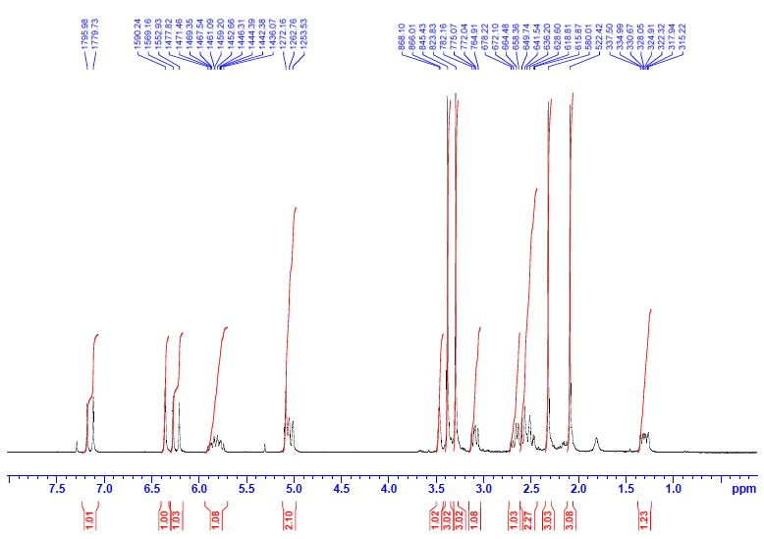
Figure S37. ¹H NMR of cycloadduct 5n (250 MHz, CDCl₃, 300 K)
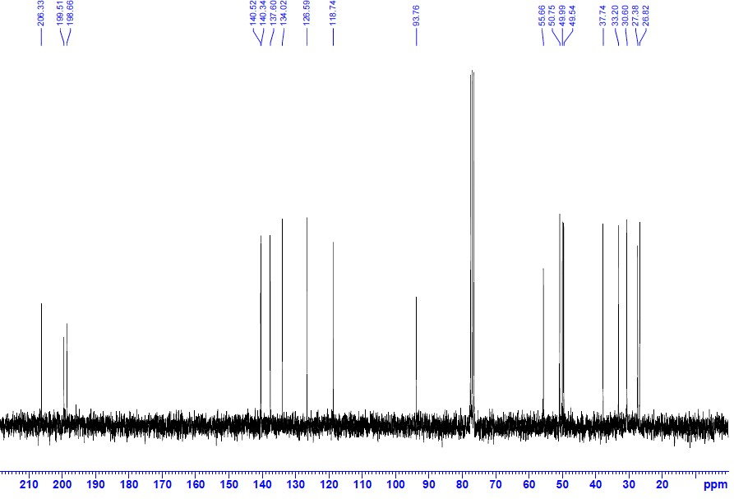
Figure S38. ¹³C NMR of cycloadduct 5n (62.5 MHz, CDCl₃, 300 K)

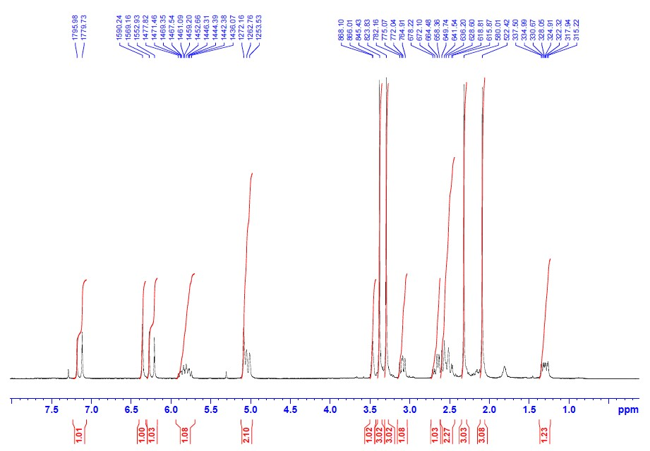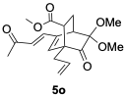
Figure S39. ¹H NMR of cycloadduct 5o (250 MHz, CDCl₃, 300 K)
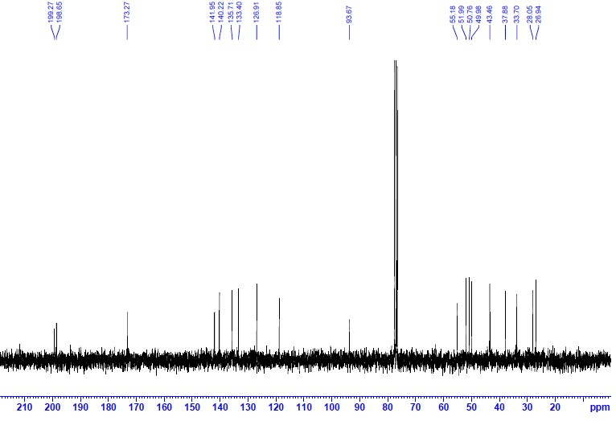
Figure S40. ¹³C NMR of cycloadduct 5o (62.5 MHz, CDCl₃, 300 K)

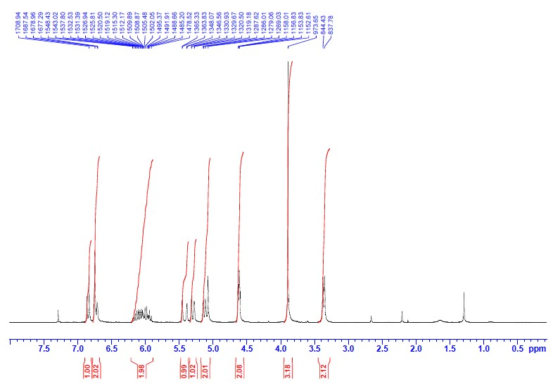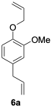
Figure S41. ¹H NMR of ether 6a (250 MHz, CDCl₃, 300 K)
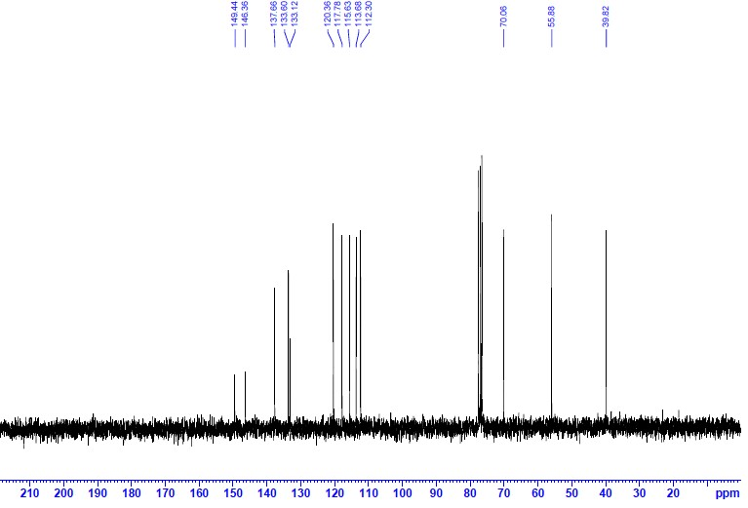
Figure S42. ¹³C NMR of ether 6a (62.5 MHz, CDCl₃, 300 K)

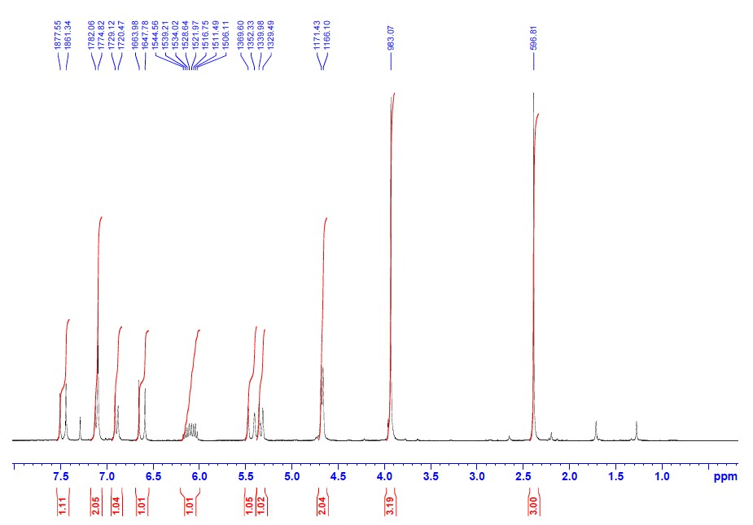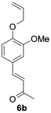
Figure S43. ¹H NMR of ether 6b (250 MHz, CDCl₃, 300 K)
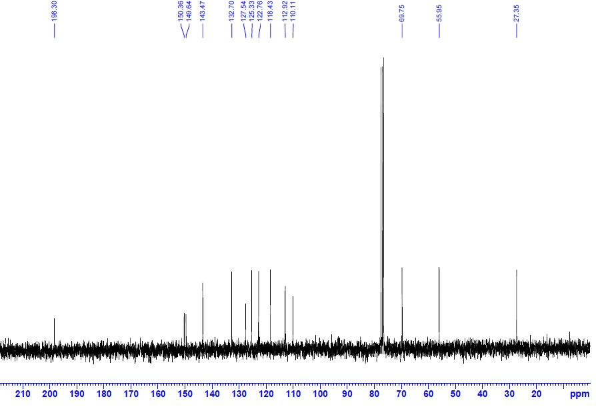
Figure S44. ¹³C NMR of ether 6b (62.5 MHz, CDCl₃, 300 K)

