# Supporting Information

## S1. Schematic Illustration of the batch ablation chamber

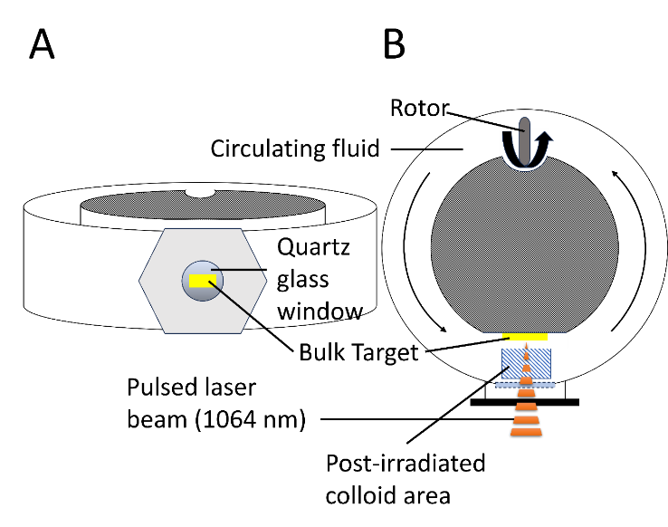

**Figure S1:** Schematic representation of the ablation chamber used in this study, shown from the front (A) and from the top (B). The circulating fluid represents the respective solvents acetone, ethanol, and acetonitrile.

## S2. Global compositional values determined via STEM-EDS and respective deviations

**Table S1:** EDS measurements of crystalline CrMnFeCoNi nanoparticles (via picosecond-pulsed LAL) at five different positions with average values and standard deviations (St.Dev.).

|  |  |  |  |  |  |
| --- | --- | --- | --- | --- | --- |
| **Position** | **Cr-K [at%]** | **Mn-K [at%]** | **Fe-K [at%]** | **Co-K [at%]** | **Ni-K [at%]** |
| **1** | 22.8 | 17.7 | 21.2 | 18.1 | 20.3 |
| **2** | 22.3 | 16.9 | 21.8 | 18.7 | 20.3 |
| **3** | 22.6 | 17.0 | 20.8 | 20.0 | 19.6 |
| **4** | 23.5 | 14.0 | 21.1 | 20.4 | 21.0 |
| **5** | 19.7 | 18.3 | 21.0 | 22.5 | 18.6 |
| **Average** | 22.2 | 16.8 | 21.2 | 19.9 | 20 |
| **St.Dev.** | 1.31 | 1.49 | 0.36 | 1.52 | 0.83 |

**Table S2:** EDS measurements of amorphous CrMnFeCoNi nanoparticles (via nanosecond-pulsed LAL) at five different positions with average values and standard deviations (St.Dev.).

|  |  |  |  |  |  |
| --- | --- | --- | --- | --- | --- |
| **Position** | **Cr-K [at%]** | **Mn-K [at%]** | **Fe-K [at%]** | **Co-K [at%]** | **Ni-K [at%]** |
| **1** | 23.5 | 20.3 | 18.9 | 18.2 | 19.1 |
| **2** | 20.8 | 20.9 | 20.1 | 20.4 | 17.7 |
| **3** | 21.5 | 21.5 | 18.5 | 18.9 | 19.6 |
| **4** | 18.2 | 22.4 | 17.8 | 20.1 | 21.5 |
| **5** | 20.7 | 20.6 | 21.8 | 18.1 | 18.8 |
| **Average** | 20.9 | 21.1 | 19.4 | 19.1 | 19.3 |
| **St.Dev.** | 1.70 | 0.74 | 1.40 | 0.95 | 1.25 |

## S3. Characterization of the CrMnFeCoNi bulk target

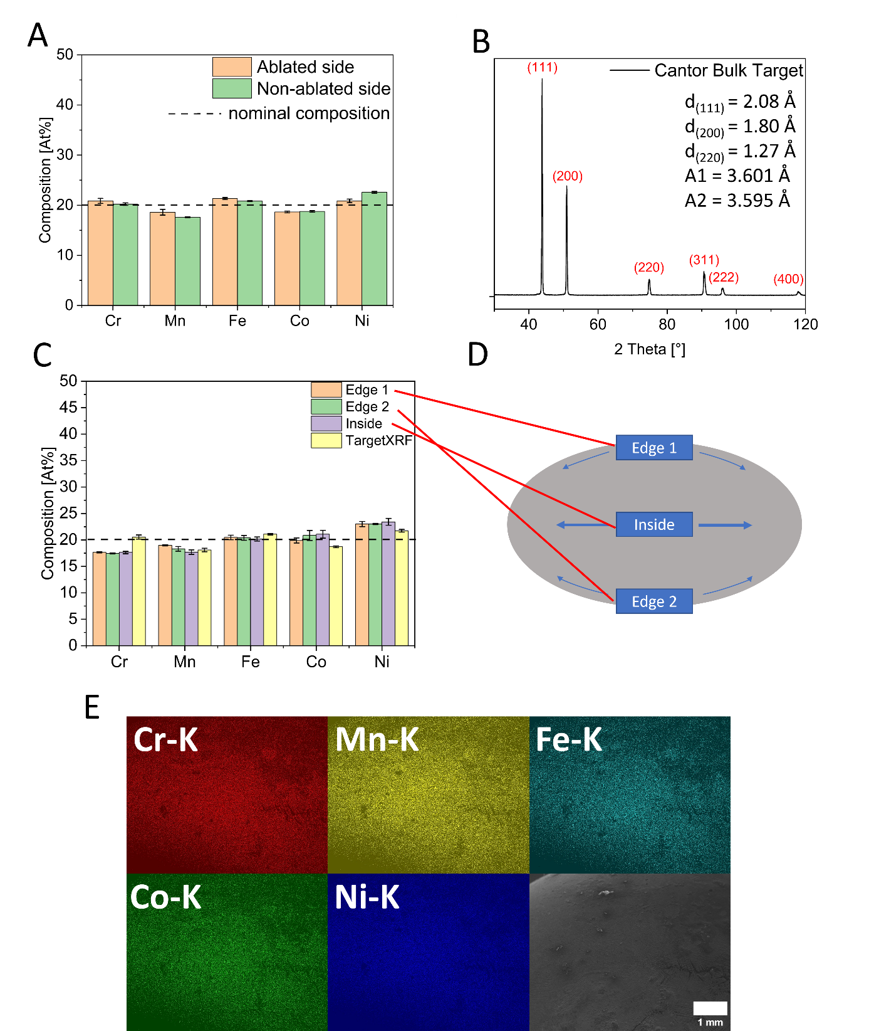

**Figure S2:** (A) XRF-analysis of both of the bulk targets’ surface compared to the nominal composition. (B) XRD pattern of the bulk target with reflections at 2θ = 43.8°, 51.0°, 74.8°, 90.6°, 95.4°, and 117.8, and respective d-values as well as the lattice parameters of 3.601 Å and 3.595 Å, depicting a fcc structure. (C) EDS data of the bulk target’s cross-section (shown in (D)). Both edges and inside values are determined by five EDS measurements each and are compared to the global XRF values, shown in (A). (E) EDS map of a selected area showing the homogeneous distribution of the elements Cr, Mn, Fe, Co, and Ni. Dark spots are attributed to surface contaminations and can be removed by sandpaper. Error bars in (A) and (C) represent standard deviation of three measurements at XRF analysis and five measurements at EDS analysis.

## S4. CrMnFeCoNi colloids made in acetonitrile (ps-LAL) and ethanol (ns-LAL)

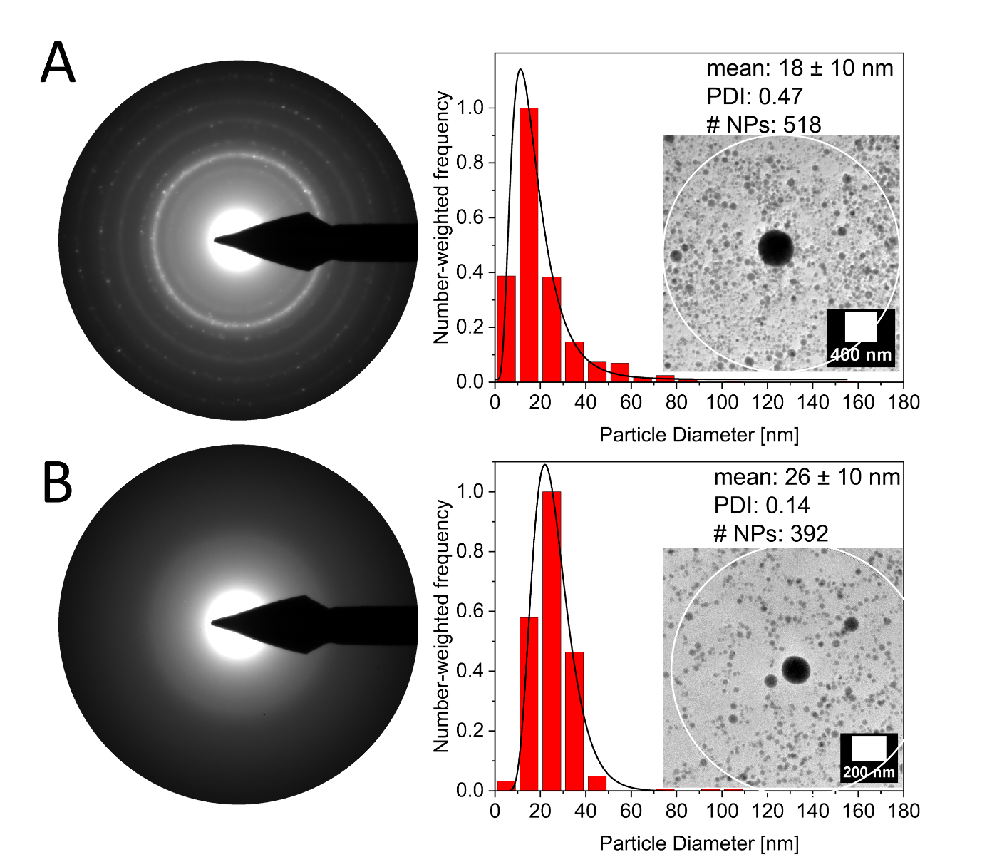

**Figure S3:** SAED analysis of crystalline colloids made by ps-LAL in acetonitrile (A) and amorphous colloids by ns-LAL in ethanol (B) to extend the studies by Waag et al. [1] and Johny et al. [2]. The corresponding areas used for SAED analysis and particle size distribution are marked with a white circle inside the overview TEM-images.

## S5. HAADF image and EDS analysis of a HEA NPs with an oxide shell

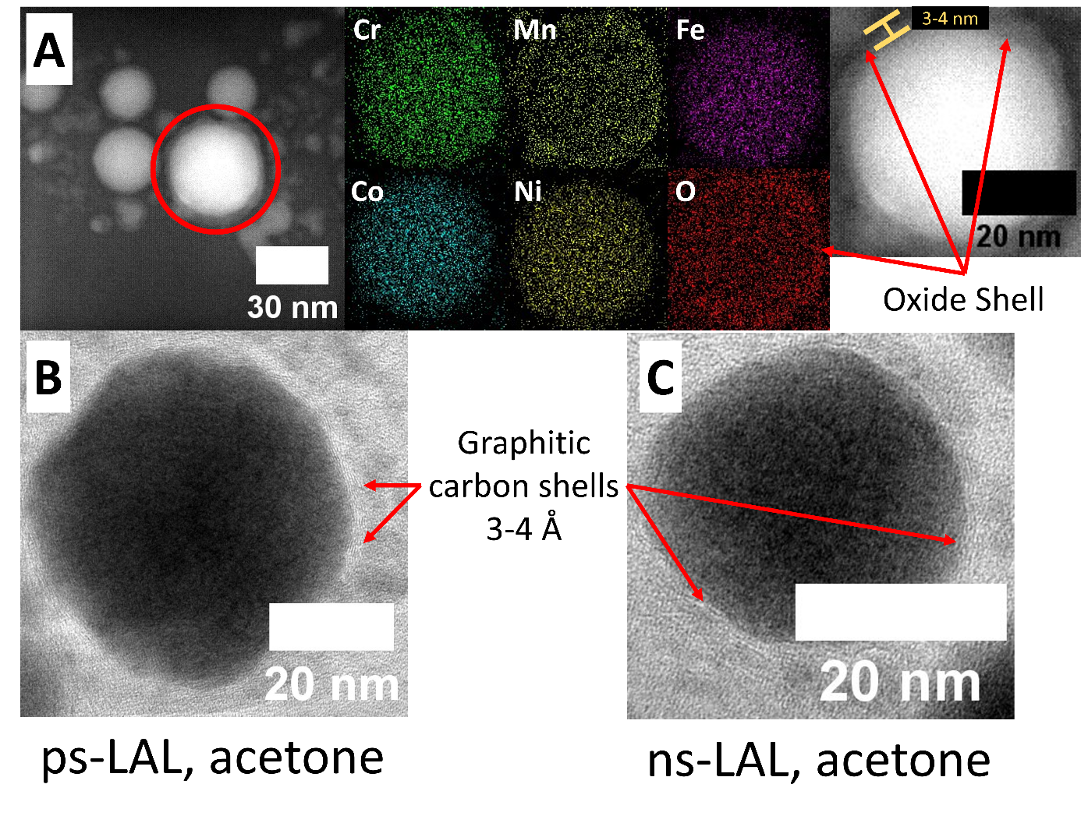

**Figure S4:** HAADF image and EDS analysis of a HEA NP with an oxide shell that correlates with the Mn-signal of the EDS analysis, being one possible explanation for the appearance of MnO signals in XRD spectra. (A) HRTEM images of chosen HEA NPs with graphitic shells, synthesized by ps-LAL in acetone (B) and ns-LAL in acetone (C).

## S6. Crystalline vs amorphous structure in CrMnFeCoNi colloids made by ps-LAL/ns-LAL in ethanol

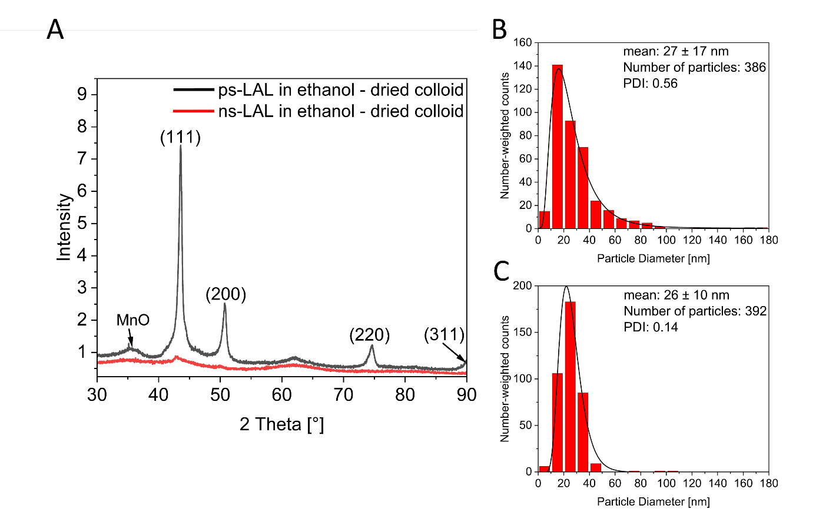

**Figure S5:** XRD pattern, comparing CrMnFeCoNi colloids made by both ps- and ns-LAL in ethanol, strengthening the observation of solvent-independent structural difference in ignoble HEA NPs. The crystalline particles by ps-LAL depict two fractions lattice parameters (3.599 Å and 3.615 Å) with crystallite sizes of 25 nm and 9 nm, respectively (A). Representative particle size distributions of HEA NPs by ps-LAL in ethanol (B) and by ns-LAL (C), showing the same trend in polydispersity as in acetone.

## S7. SEM-EDS analysis of post-irradiated bulk target surface after ps- and ns-LAL

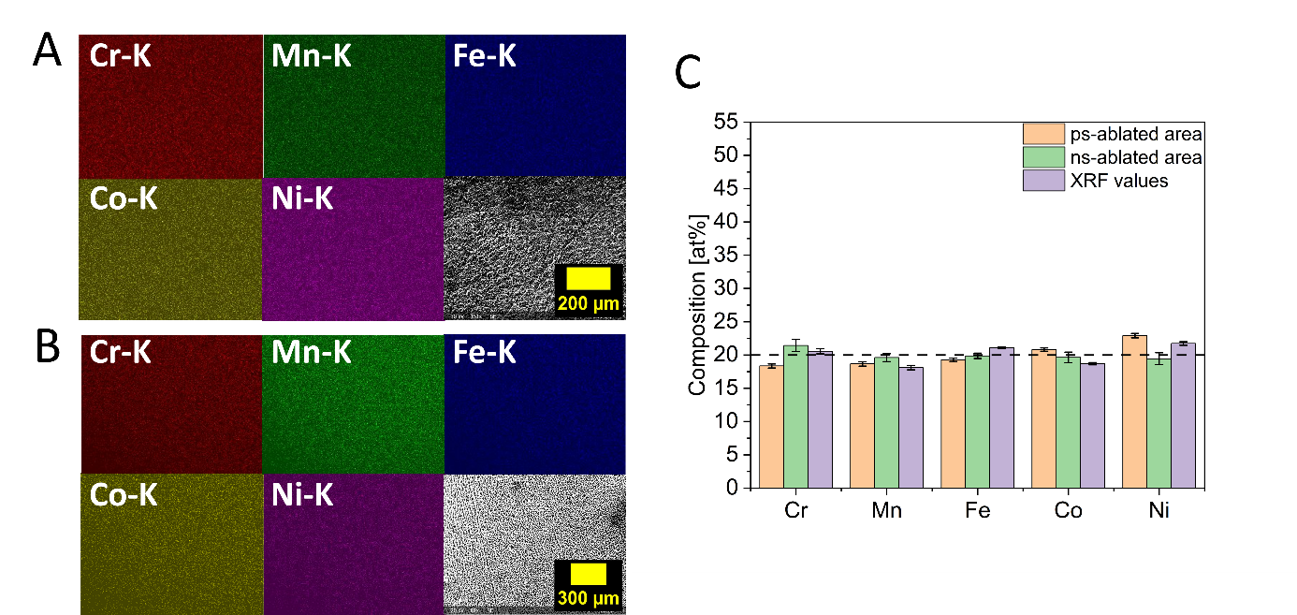

**Figure S6:** EDS analysis of post-ablated target surfaces after ps-LAL (A) and ns-LAL (B) in acetone. (C) Average composition of five measurements each, comparing values of both ps- and ns-ablated surface with global XRF values, averaged from Figure S2 A.

## S8. Parameters and crystallographic results conducted by experiments at the same laser fluence

**Table S3:** Laser parameters used for conducting LAL at the same laser fluences of 1.6 J/cm².

|  |  |  |
| --- | --- | --- |
|  | **ps-LAL** | **ns-LAL** |
| **Wavelength** | 1064 nm | 1064 nm |
| **Pulse Duration** | 10 picoseconds | 10 nanoseconds |
| **Frequency** | 100 kHz | 10 kHz |
| **Mean Power** | 4.2 W (0.04 mJ) | 1.2 W (0.12 mJ) |
| **Area of focused laser beam** | 2.6 . 10-3 mm² | 7.2 . 10-3 mm² |
| **Laser Fluence** | 1.6 J/cm² | 1.6 J/cm² |

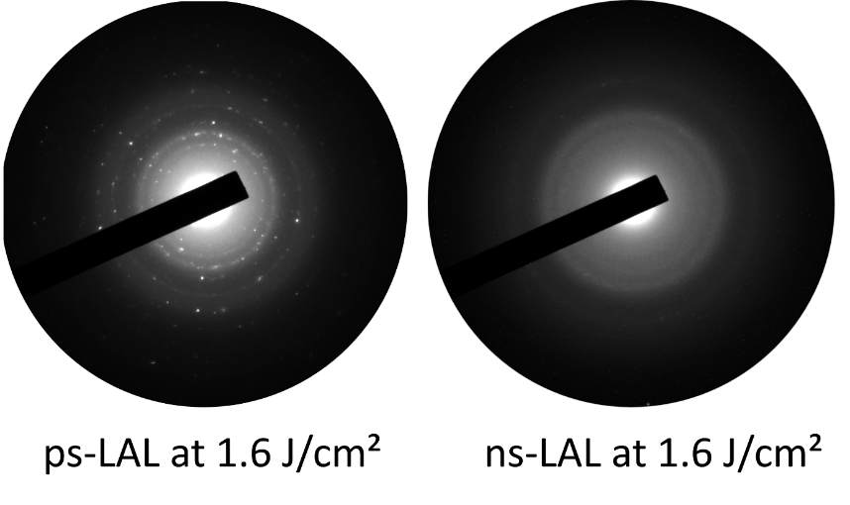

**Figure S7:** SAED analysis of ensemble HEA NPs made by ps-LAL in acetone at 1.6 J/cm² (left) and by ns-LAL (right), also in acetone at 1.6 J/cm².

## S9. SAED analyses after post-irradiation experiments of already produced colloids

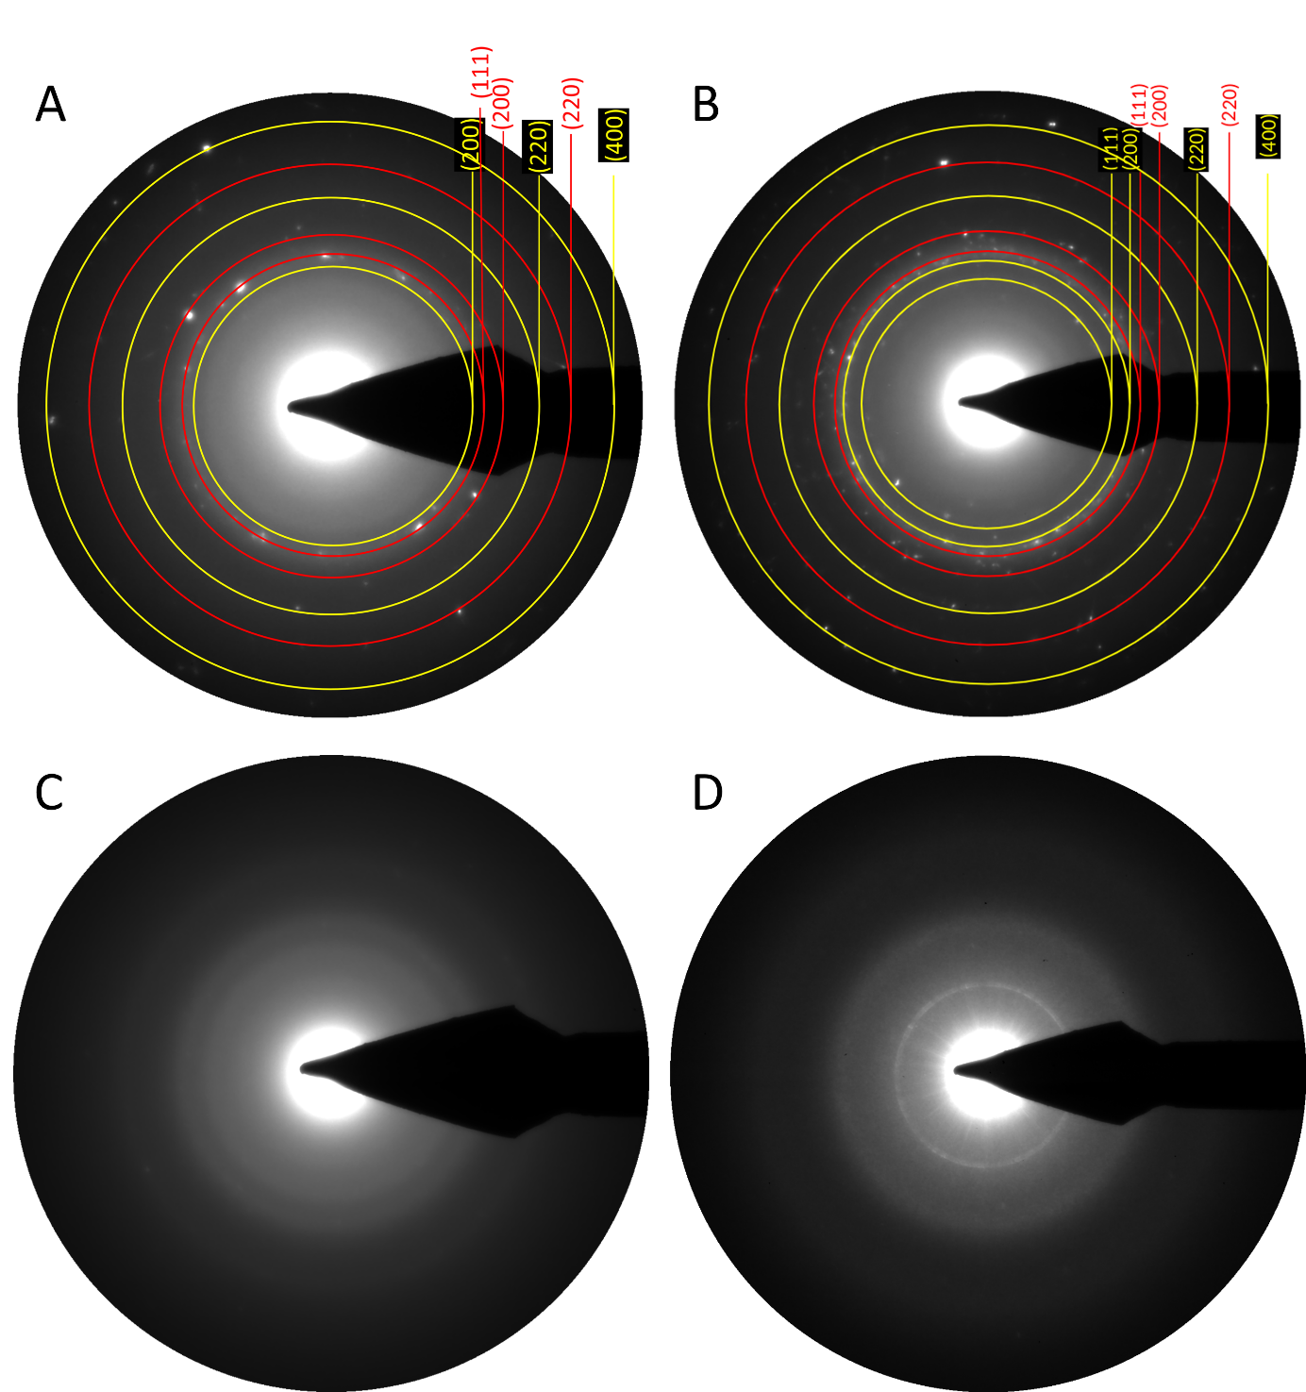

**Figure S8:** SAED analysisof post-irradiated colloids in acetone. (A) Colloid by ps-LAL irradiated with ns pulses. (B) Colloids by ps-LAL irradiated by ps pulses. (C) Colloids by ns-LAL irradiated by ns pulses. (D) Colloids by ns-LAL irradiated by ps-pulses. Red circles represent the respective reflections from the metallic fcc structure while yellow circles represent manganese-dominated oxide species. The results show that post-irradiation exhibit no effect on the nanoparticles’ structure.

## S10. Compositions of single HEA NPs

Section S10 provides data about the composition of representative HEA NPs obtained by LAL in acetone. In both tables particles were chosen that are comparable in size to the determined mean values of 21 ± 10 nm for ps-LAL and 21 ± 7 nm for ns-LAL (Particles No. 1-4), particles that exceed the mean particle diameter by roughly the double value (Particles No. 5 and 6), and particles that exceed the mean particle diameter by at least three times (Particle No. 7). In both cases a lack of manganese is obvious, even though in ns-LAL the depletion is not as strong as in ps-LAL.

**Table S4:** Composition of individual HEA NPs made by ps-LAL in acetone.

|  |  |  |  |  |  |  |
| --- | --- | --- | --- | --- | --- | --- |
| **Particle**  **No.** | **Diameter**  **[nm]** | **Cr [at%]** | **Mn [at%]** | **Fe [at%]** | **Co [at%]** | **Ni [at%]** |
| **1** | 23 | 21 | 8 | 23 | 23 | 25 |
| **2** | 22 | 19 | 15 | 20 | 20 | 26 |
| **3** | 18 | 29 | 8 | 22 | 23 | 18 |
| **4** | 31 | 19 | 11 | 22 | 24 | 24 |
| **5** | 57 | 20 | 16 | 22 | 22 | 20 |
| **6** | 49 | 21 | 14 | 20 | 21 | 24 |
| **7** | 80 | 20 | 16 | 20 | 21 | 24 |
| **Average** |  | **21** | **13** | **21** | **22** | **23** |

**Table S5:** Composition of individual HEA NPs made by ns-LAL in acetone.

|  |  |  |  |  |  |  |
| --- | --- | --- | --- | --- | --- | --- |
| **Particle** | **Diameter**  **[nm]** | **Cr [at%]** | **Mn [at%]** | **Fe [at%]** | **Co [at%]** | **Ni [at%]** |
| **1** | 25 | 24 | 15 | 22 | 21 | 18 |
| **2** | 28 | 26 | 14 | 23 | 21 | 16 |
| **3** | 17 | 23 | 20 | 19 | 21 | 17 |
| **4** | 21 | 19 | 27 | 17 | 19 | 18 |
| **5** | 42 | 23 | 20 | 22 | 18 | 17 |
| **6** | 49 | 23 | 26 | 22 | 21 | 18 |
| **7** | 126 | 22 | 10 | 24 | 23 | 21 |
| **Average** |  | **22** | **19** | **21** | **21** | **17** |

# References

1. Waag, F.; Li, Y.; Ziefuß, A. R.; Bertin, E.; Kamp, M.; Duppel, V.; Marzun, G.; Kienle, L.; Barcikowski, S.; Gökce, B. *RSC Adv.,* **2019**, *9*, 18547–18558.

2. Johny, J.; Li, Y.; Kamp, M.; Prymak, O.; Liang, S.-X.; Krekeler, T.; Ritter, M.; Kienle, L.; Rehbock, C.; Barcikowski, S. *Nano Res.,* **2022**, *15*, 4807–4819.