**Supporting Information**

*for*

**Assembly strategy for thieno[3,2-*b*]thiophenes *via* a disulfide intermediate derived from 3-nitrothiophene-2,5-dicarboxylate**

Roman A. Irgashev

**Full experimental details, characterization data and copies of NMR spectra for all new compounds**

Table of content

1. General information S4

2. Experimental procedures S4

*Procedure for the synthesis of sulfide* ***2*** *using thioacetamide and K2CO3* S4

*Procedure for the synthesis of disulfide* ***3*** *using potassium thioacetate (KSAc)* S5

*Procedure for the synthesis of disulfide* ***3*** *using Na2S2* S5

*Procedure for one-pot reduction–alkylation of disulfide* ***3*** *using Na2S2O4 (synthesis of compound* ***4a****)* S6

*General procedure for one-pot reduction–alkylation of disulfide* ***3*** *using NaBH4 (Synthesis of compounds* ***4****-****6****)* S7

*General procedure for the cyclization of compounds* ***4a****,* ***4b*** *and* ***5a*** *using LiH* S12

*Procedure for the synthesis of thieno[3,2-b]thiophene-2-carboxylic acid* ***9bA*** S13

*General procedure for the cyclization of compounds* ***6a-c*** *using Mg(OMe)2* S14

3. References S16

4. Copies of 1H, 19F, 13C NMR spectra S17

Tetramethyl 3,3'-thiobis(thiophene-2,5-dicarboxylate) (**2**) S17

Tetramethyl 3,3'-disulfanediylbis(thiophene-2,5-dicarboxylate) (**3**) S19

A mixture of compounds **2** and **3** from the reaction of ester **1** with potassium thioacetate S21

A mixture of compounds **2** and **3** from the reaction of ester **1** with potassium xanthate S22

A mixture of compounds **2** and **3** from the reaction of ester **1** with sodium diethyldithiocarbamate S23

A mixture of compounds **2** and **3** from the reaction of ester **1** with thioacetamide and K2CO3 S24

A mixture of compounds **2** and **3** from the reaction of ester **1** with Na2S2 S25

Dimethyl 3-[(4-cyanobenzyl)thio]thiophene-2,5-dicarboxylate (**4a**) S26

Dimethyl 3-{[4-(methoxycarbonyl)benzyl]thio}thiophene-2,5-dicarboxylate (**4b**) S28

Dimethyl 3-(benzylthio)thiophene-2,5-dicarboxylate (**4c**) S30

Dimethyl 3-[(4-fluorobenzyl)thio]thiophene-2,5-dicarboxylate (**4d**) S32

Dimethyl 3-[(3,4-difluorobenzyl)thio]thiophene-2,5-dicarboxylate (**4e**) S35

Dimethyl 3-{[4-(trifluoromethyl)benzyl]thio}thiophene-2,5-dicarboxylate (**4f**) S38

[Dimethyl 3-[(benzo[*d*][1,3]dioxol-5-ylmethyl)thio]thiophene-2,5-dicarboxylate (**4g**) S41](#_Toc206860749)

Dimethyl 3-[(thiophen-2-ylmethyl)thio]thiophene-2,5-dicarboxylate (**4h**) S43

Dimethyl 3-[(cyanomethyl)thio]thiophene-2,5-dicarboxylate (**5a**) S45

Dimethyl 3-[(2-oxo-2-phenylethyl)thio]thiophene-2,5-dicarboxylate (**6a**) S47

Dimethyl 3-{[2-(4-fluorophenyl)-2-oxoethyl]thio}thiophene-2,5-dicarboxylate (**6b**) S49

Dimethyl 3-{[2-oxo-2-(thiophen-2-yl)ethyl]thio}thiophene-2,5-dicarboxylate (**6c**) S52

Methyl 5-(4-cyanophenyl)-6-hydroxythieno[3,2-*b*]thiophene-2-carboxylate (**7a**) S54

Methyl 6-hydroxy-5-[4-(methoxycarbonyl)phenyl]thieno[3,2-*b*]thiophene-2-carboxylate (**7b**) S56

Methyl 5-cyano-6-hydroxythieno[3,2-*b*]thiophene-2-carboxylate (**8a**) S58

5-(4-Fluorobenzoyl)-6-hydroxythieno[3,2-*b*]thiophene-2-carboxylic acid (**9bA**) S60

Methyl 5-benzoyl-6-hydroxythieno[3,2-*b*]thiophene-2-carboxylate (**9a**) S63

Methyl 5-(4-fluorobenzoyl)-6-hydroxythieno[3,2-*b*]thiophene-2-carboxylate (**9b**) S65

Methyl 6-hydroxy-5-(thiophene-2-carbonyl)thieno[3,2-*b*]thiophene-2-carboxylate (**9c**) S68

# 1. General information

1H, 13C, and 19F NMR spectra of the synthesized compounds were recorded on NMR spectrometers in CDCl3 or DMSO-*d*6 with SiMe4 as an internal standard for 1H and 13C spectra, and C6F6 as an internal standard for 19F NMR. Mass spectra were obtained on a Q-TOF LC-MS/MS spectrometer. Elemental analyses were performed on an automated CHNS analyzer. Melting points were determined on combined heating stages and were not corrected. Dimethyl 3-nitrothiophene-2,5-dicarboxylate (**1**) was prepared using our previously reported procedure [1]. The alkylating agents for the preparation of compounds **4g** and **4h**, respectively 3,4-methylenedioxybenzyl and thiophen-2-ylmethyl mesylates, were synthesized by treatment of the corresponding benzyl alcohols with methanesulfonyl chloride [2], for the preparation of compound **6c**, 2-(chloroacetyl)thiophene was prepared by chlorination of 2-acetylthiophene with SO2Cl2 [3]. Unless otherwise stated, all reagents were purchased from commercial suppliers and used without further purification.

# 2. Experimental procedures

## *Procedure for the synthesis of sulfide* ***2*** *using thioacetamide and K2CO3*

Thioacetamide (0.90 g, 12 mmol) and K2CO3 (1.66 g, 12 mmol) were added to a solution of ester **1** (2.45 g, 10 mmol) in acetone (20 mL). The suspension was stirred and heated at 70 °C for 1 h, then diluted with water (30 mL). The precipitate was filtered, washed with acetone–water (2 × 10 mL, v/v 1:1) and water (10 mL), and dried at 110 °C. The crude matter was recrystallized from DMF–methanol (35 mL, v/v 6:1) and washed with methanol (10 mL) on filter, dried at 110 °C to yield analytically pure sulfide **2**.

Tetramethyl 3,3'-thiobis(thiophene-2,5-dicarboxylate)(**2**): Yellow needles, yield 1.09 g (51%), mp 216-217 °C. 1H NMR (500 MHz, CDCl3) δ 7.40 (s, 1H), 3.91 (s, 3H), 3.89 (s, 3H). 13C NMR (126 MHz, CDCl3) δ 161.3, 161.2, 138.5, 137.0, 135.5, 133.0, 52.7, 52.6. HRMS (ESI) calcd for C16H15O8S3 m/z 430.9924 [M+H]+, found m/z 430.9925 [M+H]+. Anal. calcd for C16H14O8S3: C, 44.64; H, 3.28; S, 22.34. Found: C, 44.72; H, 3.21; S, 22.25

## *Procedure for the synthesis of disulfide* ***3*** *using potassium thioacetate (KSAc)*

Ester **1** (4.90 g, 20 mmol) was dissolved in acetone (40 mL), and KSAc (2.51 g, 22 mmol) was added at ambient temperature. The reaction mixture was stirred and heated at 70 °C for 1 h. The resulting suspension was diluted with water (40 mL), and the precipitate was collected by filtration, washed with acetone–water (5 × 5 mL, v/v 1:1) and water (15 mL), dried at 110 °C. The crude substance was recrystallized twice from toluene (45 mL, then 30 mL) and washed with methanol (5 mL) on filter to afford analytically pure disulfide **3**, yield 1.39 g (75%).

## *Procedure for the synthesis of disulfide* ***3*** *using Na2S2*

Sulfur powder (1.28 g, 40 mmol) was added to a solution of Na2S·9H2O (9.60 g, 40 mmol) in DMF–water (80 mL, v/v 1:1), and the suspension was heated at 100 °C for 1 h until complete dissolution of sulfur, forming a deep-yellow Na2S2 solution. After cooling to ambient temperature, this solution was added dropwise to a cooled (0–5 °C) solution of ester **1** (18.60 g, 75.9 mmol) in acetone (200 mL). The reaction mixture, which turned dark red, was stirred and heated at 70 °C for 1 h. The precipitate was collected by filtration, washed with warm water (100 mL), and dried at 110 °C. Recrystallization from toluene–DMF (125 mL, v/v 60:1) afforded analytically pure disulfide **3**, yield 12.39 g (71%).

Tetramethyl 3,3'-disulfanediylbis(thiophene-2,5-dicarboxylate) (**3**): Light-beige crystals, mp 212-213 °C (toluene-DMF). 1H NMR (400 MHz, CDCl3) δ 7.83 (s, 1H), 3.97 (s, 3H), 3.87 (s, 3H). 13C NMR (126 MHz, CDCl3) δ 162.1, 161.4, 143.3, 137.3, 132.1, 128.2, 52.8. HRMS (ESI) calcd for C16H15O8S4 m/z 462.9644 [M+H]+, found m/z 462.9646 [M+H]+. Anal. calcd for C16H14O8S4: C, 41.55; H, 3.05; S, 27.73 Found: C, 41.63; H, 2.94; S, 27.27.

## *Procedure for one-pot reduction–alkylation of disulfide* ***3*** *using Na2S2O4 (synthesis of compound* ***4a****)*

Disulfide **3** (185 mg, 0.4 mmol) was dissolved in DMF (9.0 mL) – water (1.0 mL), and K2CO3 (166 mg, 1.20 mmol) and Na2S2O4 (209 mg, 1.2 mmol) were added. After stirring for 5 min at ambient temperature, 4-(chloromethyl)benzonitrile (133 mg, 0.88 mmol) was added and the mixture was stirred at ambient temperature for 24 h. The reaction mixture was then poured into water (20 mL), and the precipitate formed was filtered off, washed with water (2 × 5 mL) and methanol (2 mL), and dried at 60 °C. Product **4a** was obtained in analytically pure form without additional purification. Yield 167 mg (60%).

## *General procedure for one-pot reduction–alkylation of disulfide* ***3*** *using NaBH4 (Synthesis of compounds* ***4****-****6****)*

NaBH4 (95 mg, 2.5 mmol) was added to a suspension of disulfide **3** (463 mg, 1 mmol) in DMF (15 mL) under argon at ambient temperature. The mixture was heated at 75 °C for 15 min until complete dissolution to give a deep orange solution. Methanol (5 mL) was added, and the solution was stirred at ambient temperature for 10 min. An alkylating agent (2.2 mmol) was added, causing decolorization of the reaction mixture. The reaction was stirred for 20 min, diluted with water (15 mL), and the precipitate was collected, washed with water (15 mL) and methanol (2 × 5 mL), dried at 60 °C. Products **4**-**6** were obtained in analytically pure form without further purification. For compound **5a**, the mixture was diluted with water (60 mL), the formed precipitate was filtered and washed with water (20 mL), then dried.

Dimethyl 3-[(4-cyanobenzyl)thio]thiophene-2,5-dicarboxylate (**4a**): White microcrystals, yield 612 mg (88%), mp 195-196 °C. 1H NMR (400 MHz, CDCl3) δ 7.67 – 7.60 (m, 1H), 7.57 (s, 1H), 7.55 – 7.50 (m, 1H), 4.28 (s, 1H), 3.90 (s, 3H). 13C NMR (126 MHz, CDCl3) δ 161.9, 161.5, 142.4, 141.5, 137.2, 132.7, 132.5, 131.6, 131.2, 129.6, 127.9, 118.5, 111.6, 52.8, 52.4, 37.4. HRMS (ESI) calcd for C16H12O4NS2 m/z 346.0213 [M–H]–, found m/z 346.0212 [M–H]–. 4-(Chloromethyl)benzonitrile (334 mg, 2.2 mmol) was used as the alkylating agent.

Dimethyl 3-{[4-(methoxycarbonyl)benzyl]thio}thiophene-2,5-dicarboxylate (**4b**): White powder, yield 632 mg (83%), mp 108-109 °C. 1H NMR (400 MHz, CDCl3) δ 8.00 (d, *J* = 8.4 Hz, 2H), 7.60 (s, 1H), 7.49 (d, *J* = 8.4 Hz, 2H), 4.29 (s, 2H), 3.91 (s, 3H), 3.90 (s, 6H). 13C NMR (126 MHz, CDCl3) δ 166.6, 161.9, 161.5, 143.2, 141.1, 137.0, 131.3, 130.0, 129.5, 128.9, 127.5, 52.7, 52.4, 52.1, 37.5. HRMS (ESI) calcd for C17H15O6S2 m/z 379.0316 [M–H]–, found m/z 379.0313 [M–H]–. Methyl 4-(bromomethyl)benzoate (504 mg, 2.2 mmol) was used as the alkylating agent.

Dimethyl 3-(benzylthio)thiophene-2,5-dicarboxylate (**4c**): White powder, yield 490 mg (76%), mp 146-147 °C. 1H NMR (400 MHz, CDCl3) δ 7.66 (s, 1H), 7.44 – 7.39 (m, 2H), 7.37 – 7.27 (m, 3H), 4.26 (s, 2H), 3.90 (s, 3H), 3.89 (s, 3H). 13C NMR (126 MHz, CDCl3) δ 162.0, 161.6, 144.0, 136.9, 135.6, 131.3, 128.9, 128.7, 127.6, 127.0, 52.6 52.3, 37.8. HRMS (ESI) calcd for C15H15O4S2 m/z 323.0406 [M+H]+, found m/z 323.0407 [M+H]+. Benzyl chloride (280 mg, 2.2 mmol) was used as the alkylating agent.

Dimethyl 3-[(4-fluorobenzyl)thio]thiophene-2,5-dicarboxylate (**4d**): White microcrystals, yield 560 mg (82%), mp 137-138 °C. 1H NMR (500 MHz, CDCl3) δ 7.63 (s, 1H), 7.41 – 7.34 (m, 2H), 7.06 – 6.97 (m, 2H), 4.23 (s, 2H), 3.90 (s, 3H), 3.89 (s, 3H). 19F NMR (471 MHz, CDCl3) δ 47.35 – 47.24 (m). 13C NMR (126 MHz CDCl3) δ 162.2 (d, *J*CF = 246.6 Hz), 162.0, 161.6, 143.6, 137.0, 131.4 (d, *J*CF = 3.2 Hz), 131.2, 130.5 (d, *J*CF = 8.2 Hz), 127.2, 115.6 (d, *J*CF = 21.6 Hz), 52.7, 52.3, 37.1. HRMS (ESI) calcd for C15H13O4FS2 m/z 341.0312 [M+H]+, found m/z 341.0319 [M+H]+. 4-Fluorobenzyl chloride (320 mg, 2.2 mmol) was used as the alkylating agent.

Dimethyl 3-[(3,4-difluorobenzyl)thio]thiophene-2,5-dicarboxylate (**4e**): White powder, yield 631 mg (88%), mp 139-140 °C. 1H NMR (400 MHz, DMSO-*d*6) δ 7.84 (s, 1H), 7.52 (ddd, *J* = 11.6, 7.8, 2.0 Hz, 2H), 7.42 (dt, *J* = 10.7, 8.5 Hz, 1H), 7.30 (dq, *J* = 6.6, 2.0 Hz, 2H), 4.46 (s, 2H), 3.87 (s, 3H), 3.82 (s, 3H). 19F NMR (376 MHz, CDCl3) δ 25.06 – 24.77 (m), 23.04 – 22.76 (m). 13C NMR (126 MHz, CDCl3) δ 161.9, 161.5, 151.1 (dd, *J* = 64.4, 12.7 Hz), 149.1 (dd, *J* = 64.0, 12.7 Hz), 142.9, 137.1, 132.8 (dd, *J* = 5.6, 3.9 Hz), 131.2, 127.6, 124.9 (dd, *J* = 6.3, 3.6 Hz), 117.8 (d, *J* = 17.8 Hz), 117.5 (d, *J* = 17.4 Hz), 52.7, 52.4, 36.8. HRMS (ESI) calcd for C15H11F2O4S2 m/z 357.0072 [M–H]–, found m/z 357.0074 [M–H]–. 3,4-Difluorobenzyl chloride (360 mg, 2.2 mmol) was used as the alkylating agent.

Dimethyl 3-{[4-(trifluoromethyl)benzyl]thio}thiophene-2,5-dicarboxylate (**4f**): White microcrystals, yield 617 mg (79%), mp 89-90 °C. 1H NMR (400 MHz, CDCl3) δ 7.61, 7.60, 7.58, 7.54, 7.52, 7.26, 4.29, 3.90, 3.90, -0.00. 19F NMR (376 MHz, CDCl3) δ 99.13. 13C NMR (126 MHz, CDCl3) δ 161.9, 161.5, 142.9, 134.0, 137.1, 131.2, 129.9 (q, *J* = 32.6 Hz), 129.2, 127.6, 125.7 (q, *J* = 3.7 Hz), 124.0 (q, *J* = 272.1 Hz), 52.7, 52.4, 37.3. HRMS (ESI) calcd for C16H12F3O4S2 m/z 389.0135 [M–H]–, found m/z 389.0136 [M–H]–. 4-(Trifluoromethyl)benzyl chloride (430 mg, 2.2 mmol) was used as the alkylating agent.

Dimethyl 3-[(benzo[*d*][1,3]dioxol-5-ylmethyl)thio]thiophene-2,5-dicarboxylate (**4g**): White powder, yield 674 mg (92%), mp 177-178 °C. 1H NMR (500 MHz, CDCl3) δ 7.65 (s, 1H), 6.90 (d, *J* = 1.7 Hz, 1H), 6.86 (dd, *J* = 7.9, 1.7 Hz, 1H), 6.75 (d, *J* = 7.9 Hz, 1H), 5.95 (s, 2H), 4.18 (s, 2H), 3.90 (s, 3H), 3.89 (s, 3H). 13C NMR (126 MHz, CDCl3) δ 162.0, 161.7, 147.9, 147.2, 144.0, 136.9, 131.3, 129.2, 127.1, 122.3, 109.2, 108.3, 101.1, 52.7, 52.3, 37.8. HRMS (ESI) calcd for C16H15O6S2 m/z 367.0305 [M+H]+, found m/z 367.0307 [M+H]+. 3,4-Methylenedioxybenzyl mesylate (470 mg, 2.2 mmol) was used as the alkylating agent.

Dimethyl 3-[(thiophen-2-ylmethyl)thio]thiophene-2,5-dicarboxylate (**4h**): White crystals, yield 506 mg (77%), mp 122-123 °C. 1H NMR (500 MHz, **CDCl3**) δ 7.66 (s, 1H), 7.22 (dd, *J* = 5.1, 1.1 Hz, 1H), 7.08 – 7.02 (m, 2H), 6.94 (dd, *J* = 5.1, 3.5 Hz, 1H), 4.46 (s, 3H), 3.90 (s, 6H). **13C NMR (126 MHz, CDCl3)** δ **161.9, 161.6, 143.1, 138.9, 137.0, 132.1, 131.3, 127.0, 126.8, 125.4, 52.7, 52.4, 32.2.** HRMS (ESI) calcd for C13H12O4S3 m/z 328.9970 [M+H]+, found m/z 328.9971 [M+H]+. Thiophen-2-ylmethyl mesylate (425 mg, 2.2 mmol) was used as the alkylating agent.

Dimethyl 3-[(cyanomethyl)thio]thiophene-2,5-dicarboxylate (**5a**): White woolly crystals, yield 260 mg (48%) with ClCH2CN, 495 mg (91%) with BrCH2CN, mp 135-138 °C. 1H NMR (400 MHz, **CDCl3**) δ 7.71 (s, 1H), 3.94 (d, *J* = 4.4 Hz, 5H), 3.79 (s, 2H). **13C NMR (126 MHz, CDCl3) δ 161.6, 161.2, 138.5, 138.0, 131.2, 129.9, 115.7, 52.9, 52.7, 18.7.** HRMS (ESI) calcd for C10H8NO4S2 m/z 269.9900 [M–H]–, found m/z 269.9901 [M–H]–. Chloroacetonitrile (170 mg, 2.2 mmol) or bromoacetonitrile (265 mg, 2.2 mmol) was used as the alkylating agent.

Dimethyl 3-[(2-oxo-2-phenylethyl)thio]thiophene-2,5-dicarboxylate (**6a**): White powder, yield 505 mg (72%), mp 126-127 °C. 1H NMR (400 MHz, CDCl3) δ 8.03 – 7.98 (m, 1H), 7.75 (s, 1H), 7.65 – 7.58 (m, 1H), 7.53 – 7.46 (m, 1H), 4.43 (s, 1H), 3.91 (s, 1H), 3.89 (s, 1H). 13C NMR (126 MHz, CDCl3) δ 193.2, 161.9, 161.6, 142.0, 137.1, 135.0, 133.8, 131.8, 128.8, 128.7, 128.0, 52.7, 52.4, 39.4. HRMS (ESI) calcd for C16H13O5S2 m/z 349.0210 [M–H]–, found m/z 349.0207 [M–H]–. Phenacyl chloride (340 mg, 2.2 mmol) was used as the alkylating agent.

Dimethyl 3-{[2-(4-fluorophenyl)-2-oxoethyl]thio}thiophene-2,5-dicarboxylate (**6b**): White microcrystals, yield 508 mg (69%), mp 154-155 °C. 1H NMR (400 MHz, CDCl3) δ 8.07 – 7.99 (m, 1H), 7.76 (s, 1H), 7.21 – 7.12 (m, 1H), 4.39 (s, 1H), 3.92 (s, 2H), 3.89 (s, 2H). 19F NMR (376 MHz, CDCl3) δ 58.27 (tt, *J* = 8.3, 5.3 Hz). 13C NMR (126 MHz, CDCl3) δ 191.8, 166.1 (d, *J*CF = 256.4 Hz), 161.9, 161.6, 141.7, 137.2, 131.8, 131.5, 131.4, 128.2, 116.0 (d, *J*CF = 22.0 Hz), 52.7, 52.4, 39.3. HRMS (ESI) calcd for C16H12FO5S2 m/z 367.0116 [M–H]–, found m/z 367.0116 [M–H]–. 4-Fluorophenacyl chloride (380 mg, 2.2 mmol) was used as the alkylating agent.

Dimethyl 3-{[2-oxo-2-(thiophen-2-yl)ethyl]thio}thiophene-2,5-dicarboxylate (**6c**): Cream powder, yield 542 mg (76%), mp 128 -129 °C. 1H NMR (400 MHz, CDCl3) δ 7.86 – 7.82 (m, 1H), 7.80 (s, 1H), 7.71 (dd, *J* = 4.9, 0.6 Hz, 1H), 7.17 (dd, *J* = 4.7, 4.1 Hz, 1H), 4.32 (s, 2H), 3.91 (s, 4H), 3.89 (s, 3H). 13C NMR (126 MHz, CDCl3) δ 186.4, 161.9, 161.6, 141.9, 141.9, 137.2, 134.9, 133.2, 131.9, 128.3, 127.9, 52.7, 52.4, 39.7. HRMS (ESI) calcd for C14H12O5S3 m/z 354.9774 [M–H]–, found m/z 354.9773 [M–H]–. 2-(Chloroacetyl)thiophene (355 mg, 2.2 mmol) was used as an alkylating agent.

## *General procedure for the cyclization of compounds* ***4a****,* ***4b*** *and* ***5a*** *using LiH*

Freshly ground LiH (40 mg, 5 mmol) was added to a solution of substrate **4a**, **4b** or **5a** (1 mmol) in dry DMF (8 mL) at ambient temperature. The mixture was stirred for 24 h, then carefully poured into water (40 mL) containing glacial acetic acid (5 mL). The precipitate was filtered, washed with water (3 × 10 mL), and dried at 110 °C. Recrystallization from 1,4-dioxane (5 mL) with methanol washes (2 × 5 mL) afforded analytically pure products **7a**, **7b** or **8a**.

Methyl 5-(4-cyanophenyl)-6-hydroxythieno[3,2-*b*]thiophene-2-carboxylate (**7a**): Light-yellow woolly crystals, yield 195 mg (62%), mp 275-276 °C. 1H NMR (400 MHz, DMSO-*d*6) δ 11.48 (br.s, 1H), 8.15 (s, 1H), 8.04 – 7.94 (m, 2H), 7.92 – 7.75 (m, 2H), 3.87 (s, 3H). 13C NMR (126 MHz, DMSO-*d*6) δ 162.1, 146.0, 138.4, 135.6, 134.9, 134.4, 132.7, 127.3, 126.2, 126.1, 119.8, 119.0, 108.3, 52.5. HRMS (ESI) calcd for C15H8NO3S2 m/z 313.9951 [M–H]–, found m/z 313.9951 [M–H]–.

Methyl 6-hydroxy-5-[4-(methoxycarbonyl)phenyl]thieno[3,2-*b*]thiophene-2-carboxylate (**7b**): Light-yellow powder, yield 192 mg (55%), mp 266-267 °C. 1H NMR (400 MHz, DMSO-*d*6) δ 11.28 (s, 1H), 8.14 (s, 1H), 8.03 – 7.97 (m, 2H), 7.97 – 7.92 (m, 2H), 3.87 (s, 3H), 3.86 (s, 3H). 13C NMR (126 MHz, DMSO-*d*6) δ 165.9, 162.1, 145.4, 138.4, 135.8, 134.5, 134.0, 129.7, 127.2, 127.1, 125.8, 120.7, 52.5, 52.0. HRMS (ESI) calcd for C16H11O5S2 m/z 347.0053 [M–H]–, found m/z 347.0050 [M–H]–.

Methyl 5-cyano-6-hydroxythieno[3,2-*b*]thiophene-2-carboxylate (**8a**): Light-cream crystals, yield 108 mg (45%), mp 250-251 °C dec. 1H NMR (400 MHz, DMSO-*d*6) δ 12.75 (br.s, 1H), 8.18 (s, 1H), 3.88 (s, 3H). 13C NMR (126 MHz, DMSO-*d*6) δ 161.7, 156.9, 139.5, 138.5, 131.8, 127.5, 114.0, 87.7, 52.8. HRMS (ESI) calcd for C9H4NO3S2 m/z 237.9638 [M–H]–, found m/z 237.9639 [M–H]–.

## *Procedure for the synthesis of thieno[3,2-b]thiophene-2-carboxylic acid* ***9bA***

A solution of compound **6b** (370 mg, 1.00 mmol) in THF (5 mL) was added to a solution of NaOMe (110 mg, 2.00 mmol) in methanol (5 mL). The reaction mixture was stirred and heated at 75 °C for 2 h, then diluted with water (10 mL) and neutralized with 38% aq. HCl (0.4 mL). The resulting precipitate was filtered off, washed with water (2 × 10 mL), and dried at 110 °C. The crude substance was recrystallized from ethanol (10 mL) to afford analytically pure product **9bA**, yield 229 mg (71%).

5-(4-Fluorobenzoyl)-6-hydroxythieno[3,2-*b*]thiophene-2-carboxylic acid (**9bA**): Light-yellow woolly crystals, mp 315-316 °C. 1H NMR (400 MHz, DMSO-*d*6) δ 13.69 (br.s, 1H), 12.07 (br.s, 1H), 8.10 (s, 1H), 8.04 – 7.76 (m, 2H), 7.48 – 7.14 (m, 2H). 19F NMR (376 MHz, DMSO-*d*6) δ 55.33 (tt, *J* = 8.9, 5.5 Hz). 13C NMR (126 MHz, DMSO-*d*6) δ 187.6, 164.3 (d, *J*CF = 250.3 Hz), 162.7, 153.9, 141.2, 140.9, 134.6 (d, *J*CF = 2.8 Hz), 133.2, 131.4 (d, *J*CF = 9.2 Hz), 126.8, 119.5, 115.2 (d, *J*CF = 21.9 Hz). HRMS (ESI) calcd for C14H6FO4S2 m/z 320.9697 [M–H]–, found m/z 320.9696 [M–H]–.

## *General procedure for the cyclization of compounds* ***6a-c*** *using Mg(OMe)2*

Mg shavings (122 mg, 5 mmol) was activated by heating with iodine (5 mg) at 110 °C under argon for 15 min, then methanol (10 mL) was added. The mixture was stirred at ambient temperature for 5 min, then heated at 75 °C for 30 min until dissolution of metal. A solution of substrate **6a**, **6b** or **6c** (1 mmol) in toluene (5 mL) was added to the formed Mg(OMe)2 in methanol. The reaction was stirred at 90 °C for 2 h, cooled, and treated with 85% formic acid (1 mL), diethyl ether (20 mL), and water (20 mL). The organic layer was separated, washed with water (30 mL), dried over Na2SO4, and evaporated under reduced pressure. The solid residue was recrystallized from 1,4-dioxane (10 mL) and washed with methanol (5 mL) to yield analytically pure products **9a**-**c**.

Methyl 5-benzoyl-6-hydroxythieno[3,2-*b*]thiophene-2-carboxylate (**9a**): Orange needles, yield 210 mg (66%), mp 203-204 °C. 1H NMR (400 MHz, DMSO-*d*6) δ 12.06 (br.s, 1H), 8.21 (s, 1H), 7.94 – 7.75 (m, 2H), 7.68 – 7.60 (m, 1H), 7.58 – 7.49 (m, 2H), 3.89 (s, 3H). 13C NMR (126 MHz, DMSO-*d*6) δ 189.1, 161.6, 154.2, 141.1, 138.5, 138.1, 133.3, 132.2, 128.4, 128.2, 127.5, 119.6, 52.7. HRMS (ESI) calcd for C15H9O4S2 m/z 316.9948 [M–H]–, found m/z 316.9946 [M–H]–.

Methyl 5-(4-fluorobenzoyl)-6-hydroxythieno[3,2-*b*]thiophene-2-carboxylate (**9b**): Light-yellow scaly crystals, yield 235 mg (70%), mp 239-240 °C. 1H NMR (400 MHz, DMSO-*d*6) δ 12.07 (br.s, 1H), 8.19 (s, 1H), 8.02 – 7.77 (m, 2H), 7.43 – 7.13 (m, 2H), 3.89 (s, 3H). 19F NMR (376 MHz, DMSO-*d*6) δ 55.44 – 55.33 (m). 13C NMR (126 MHz, DMSO-*d*6) δ 187.5, 164.4 (d, *J*CF = 250.3 Hz), 161.7, 153.3, 141.0, 138.4, 134.6, 133.5, 131.5 (d, *J*CF = 9.3 Hz), 127.5, 120.3, 115.2 (d, *J*CF = 21.9 Hz), 52.8. HRMS (ESI) calcd for C15H8FO4S2 m/z 334.9854 [M–H]–, found m/z 334.9852 [M–H]–.

Methyl 6-hydroxy-5-(thiophene-2-carbonyl)thieno[3,2-*b*]thiophene-2-carboxylate (**9c**): Dark orange needles, yield 237 mg (73%), mp 225-226 °C. 1H NMR (400 MHz, CDCl3) δ 13.15 (s, 1H), 8.07 (d, *J* = 3.8 Hz, 1H), 7.94 (s, 1H), 7.77 (d, *J* = 4.9 Hz, 1H), 7.27 – 7.21 (m, 1H), 3.96 (s, 3H). 1H NMR (500 MHz, DMSO-*d*6) δ 12.41 (br.s, 1H), 8.24 (s, 1H), 8.20 (d, *J* = 3.7 Hz, 1H), 8.11 (d, *J* = 4.9 Hz, 1H), 7.32 (dd, *J* = 4.8, 4.0 Hz, 1H), 3.90 (s, 3H). 13C NMR (126 MHz, DMSO-*d*6) δ 179.8, 161.6, 155.2, 142.1, 140.8, 138.7, 135.3, 133.5, 133.1, 128.7, 127.5, 117.6, 52.8. HRMS (ESI) calcd for C13H7O4S3 m/z 322.9512 [M–H]–, found m/z 322.9512 [M–H]–.

# 3. References

(1) Irgashev, R. A.; Kazin, N. A. *Organics* **2024**, *5* (4), 507–519. doi:10.3390/org5040027

(2) Liu, Z.; Zi, Y.; Zhang, L.; Fang, Y.; Shen, Y.; Li, Y.; Yang, X.; Zhang, H. *Chinese J. Org. Chem.* **2020**, *40* (3), 669. doi:10.6023/CJOC201909042

(3) Tu, D.; Luo, J.; Jiang, W.; Tang, Q. *Tetrahedron Lett.* **2021**, *81*, 153335. doi:10.1016/J.TETLET.2021.153335

# 4. Copies of 1H, 19F, 13C NMR spectra

## Tetramethyl 3,3'-thiobis(thiophene-2,5-dicarboxylate) (**2**)

1H NMR (500 MHz, CDCl3)

 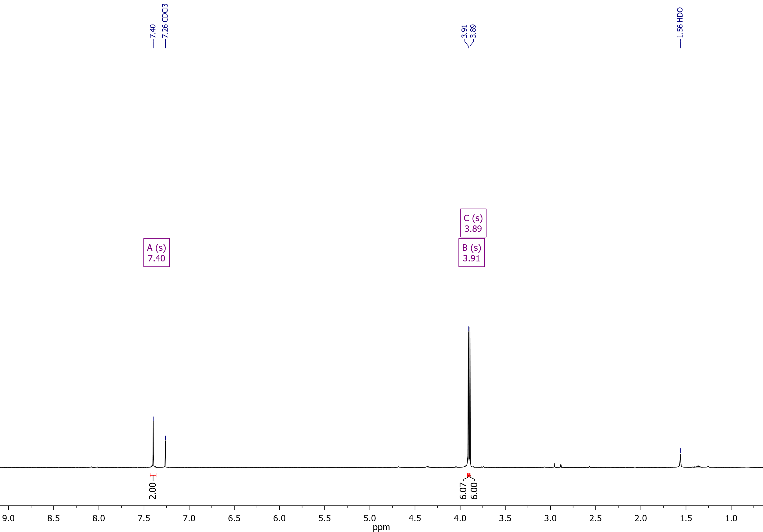

Tetramethyl 3,3'-thiobis(thiophene-2,5-dicarboxylate) (**2**)

13C NMR (126 MHz, CDCl3)

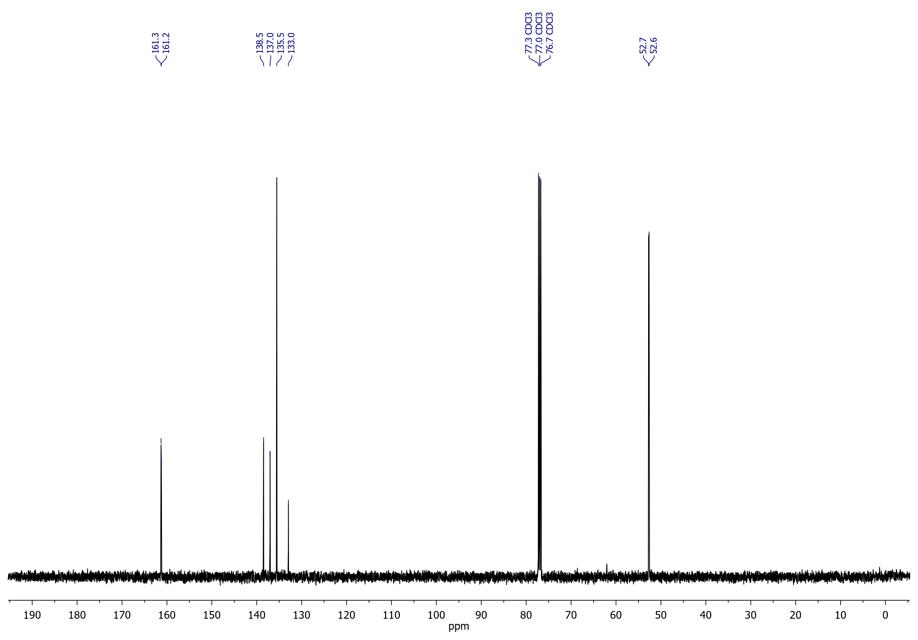

## Tetramethyl 3,3'-disulfanediylbis(thiophene-2,5-dicarboxylate) (**3**)

1H NMR (400 MHz, CDCl3)

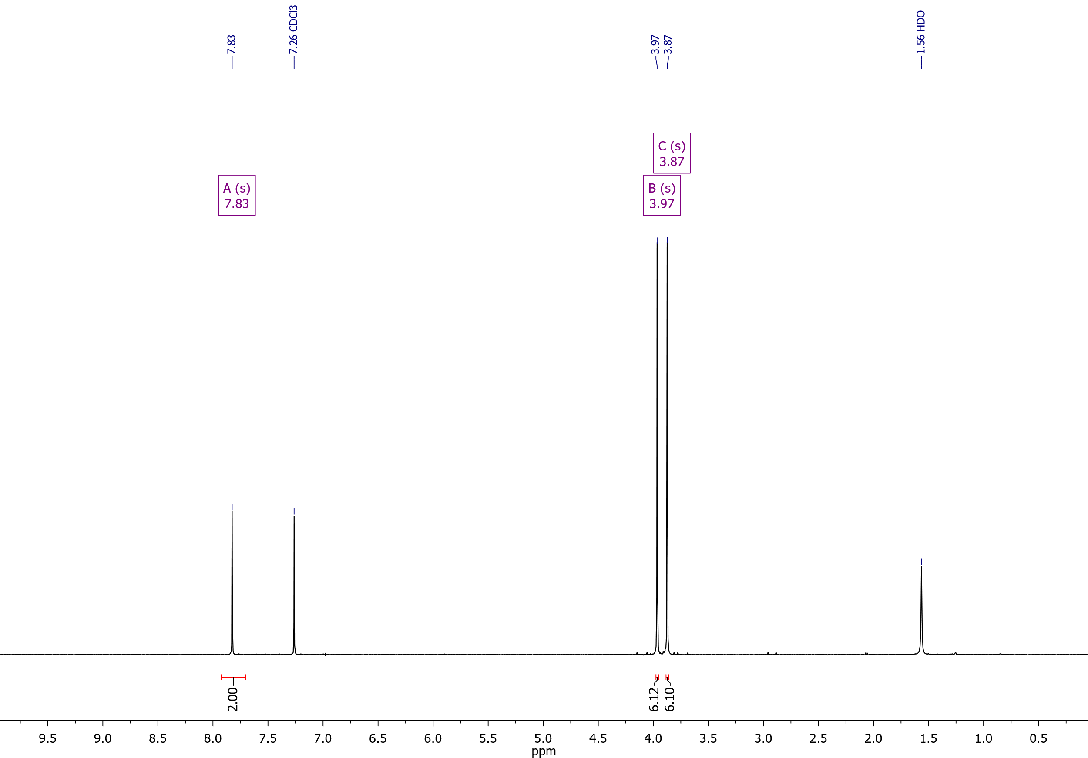

Tetramethyl 3,3'-disulfanediylbis(thiophene-2,5-dicarboxylate) (**3**)

13C NMR (126 MHz, CDCl3)

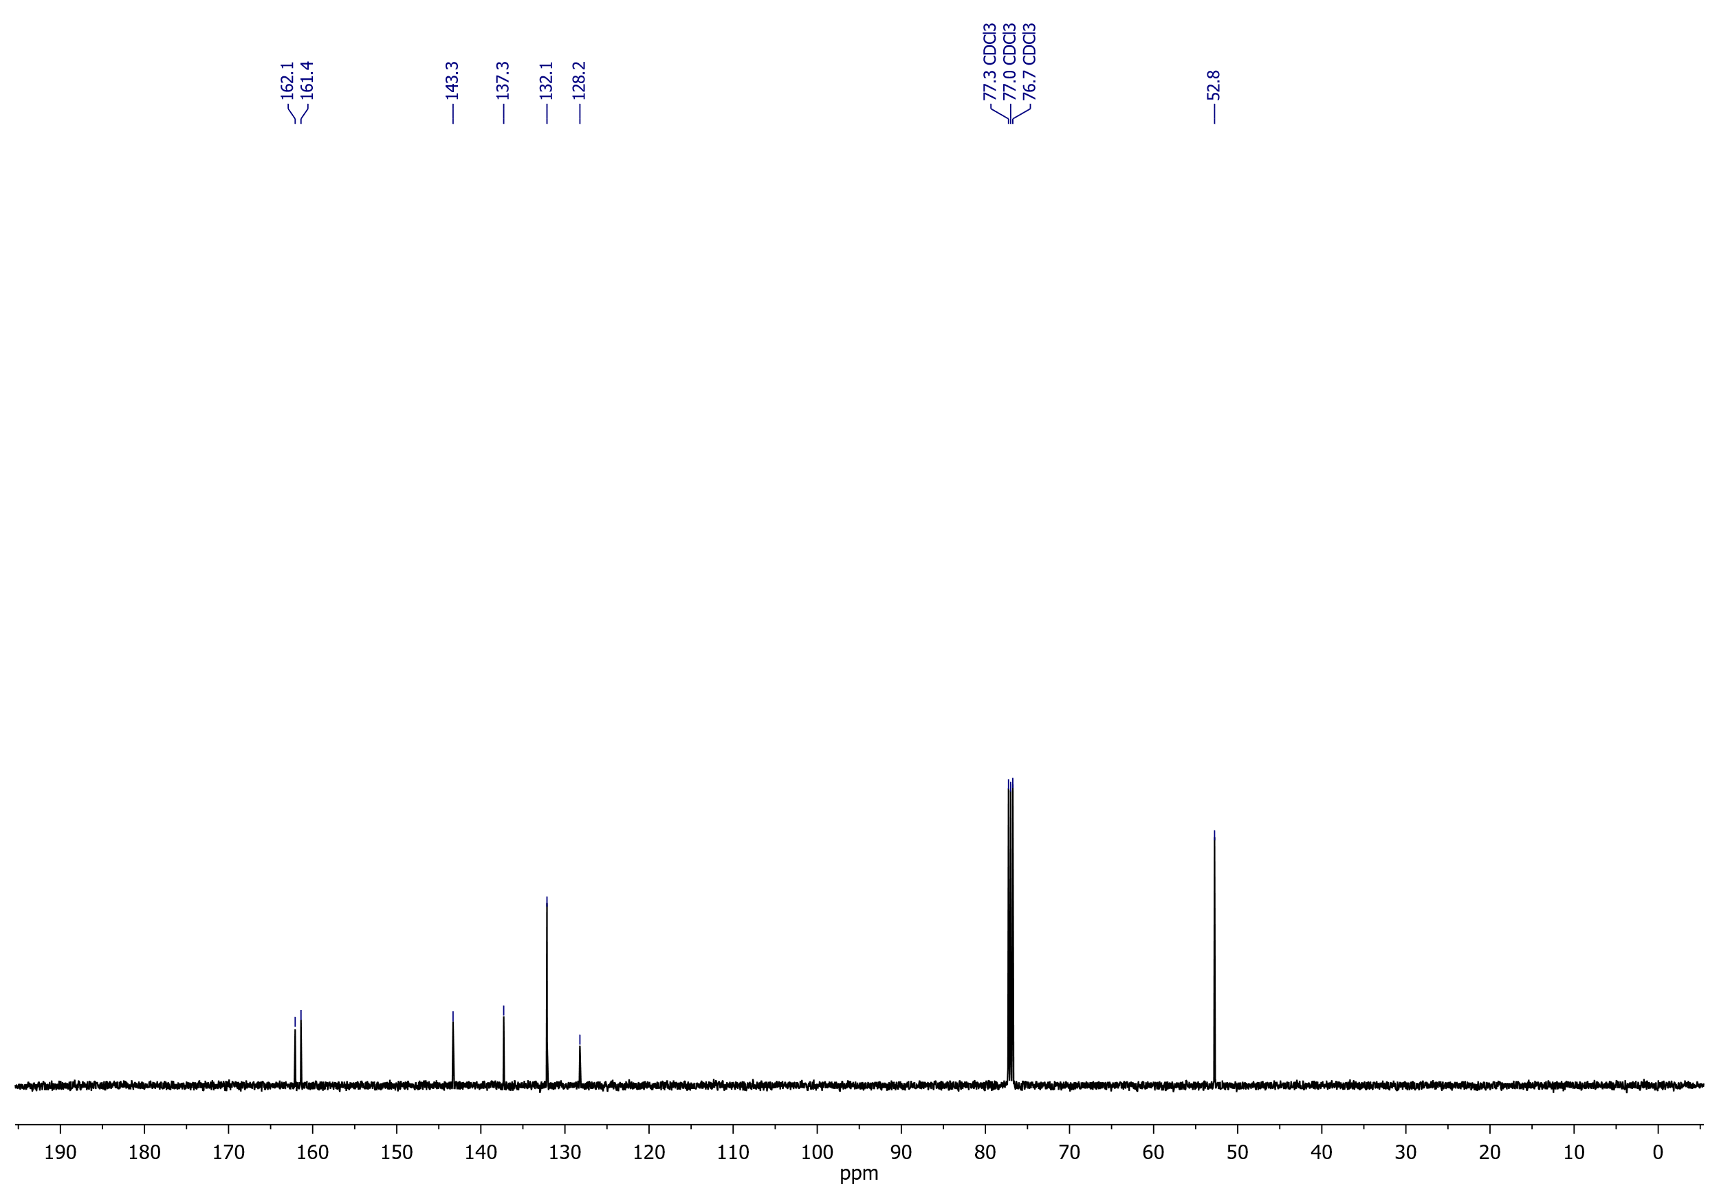

## A mixture of compounds **2** and **3** from the reaction of ester **1** with potassium thioacetate

1H NMR (400 MHz, CDCl3)

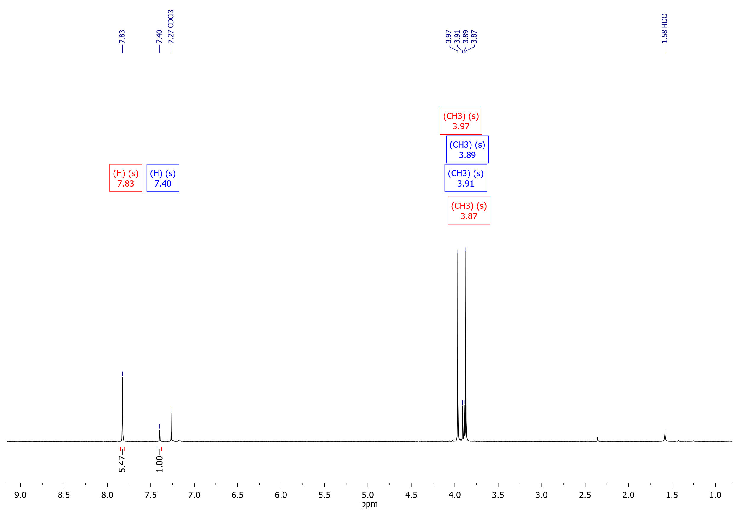

## A mixture of compounds **2** and **3** from the reaction of ester **1** with potassium xanthate

1H NMR (500 MHz, CDCl3)

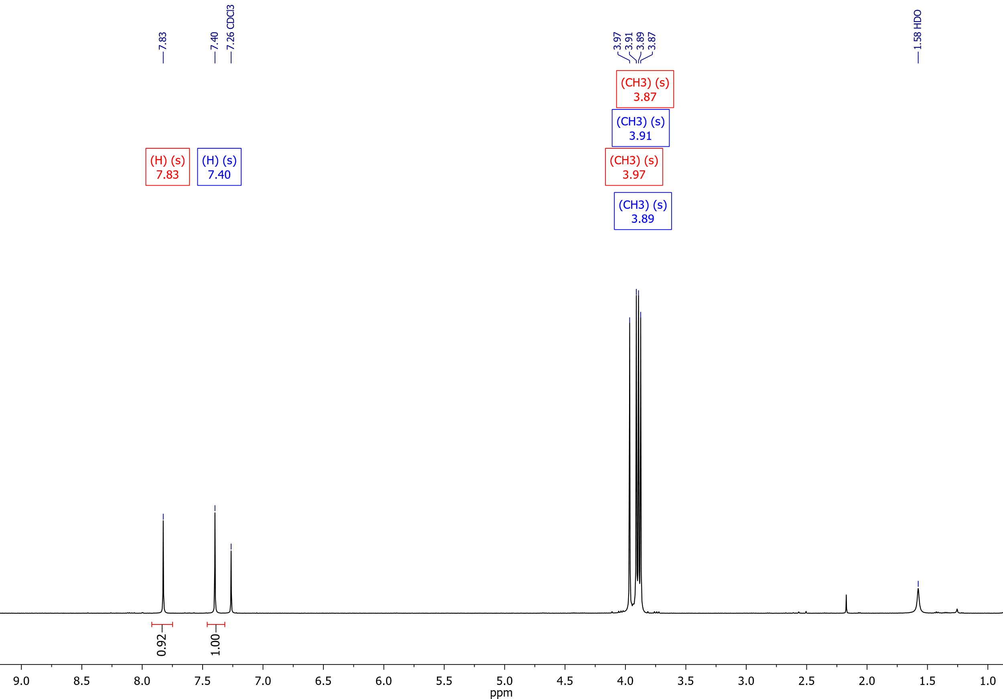

## A mixture of compounds **2** and **3** from the reaction of ester **1** with sodium diethyldithiocarbamate

1H NMR (400 MHz, CDCl3)

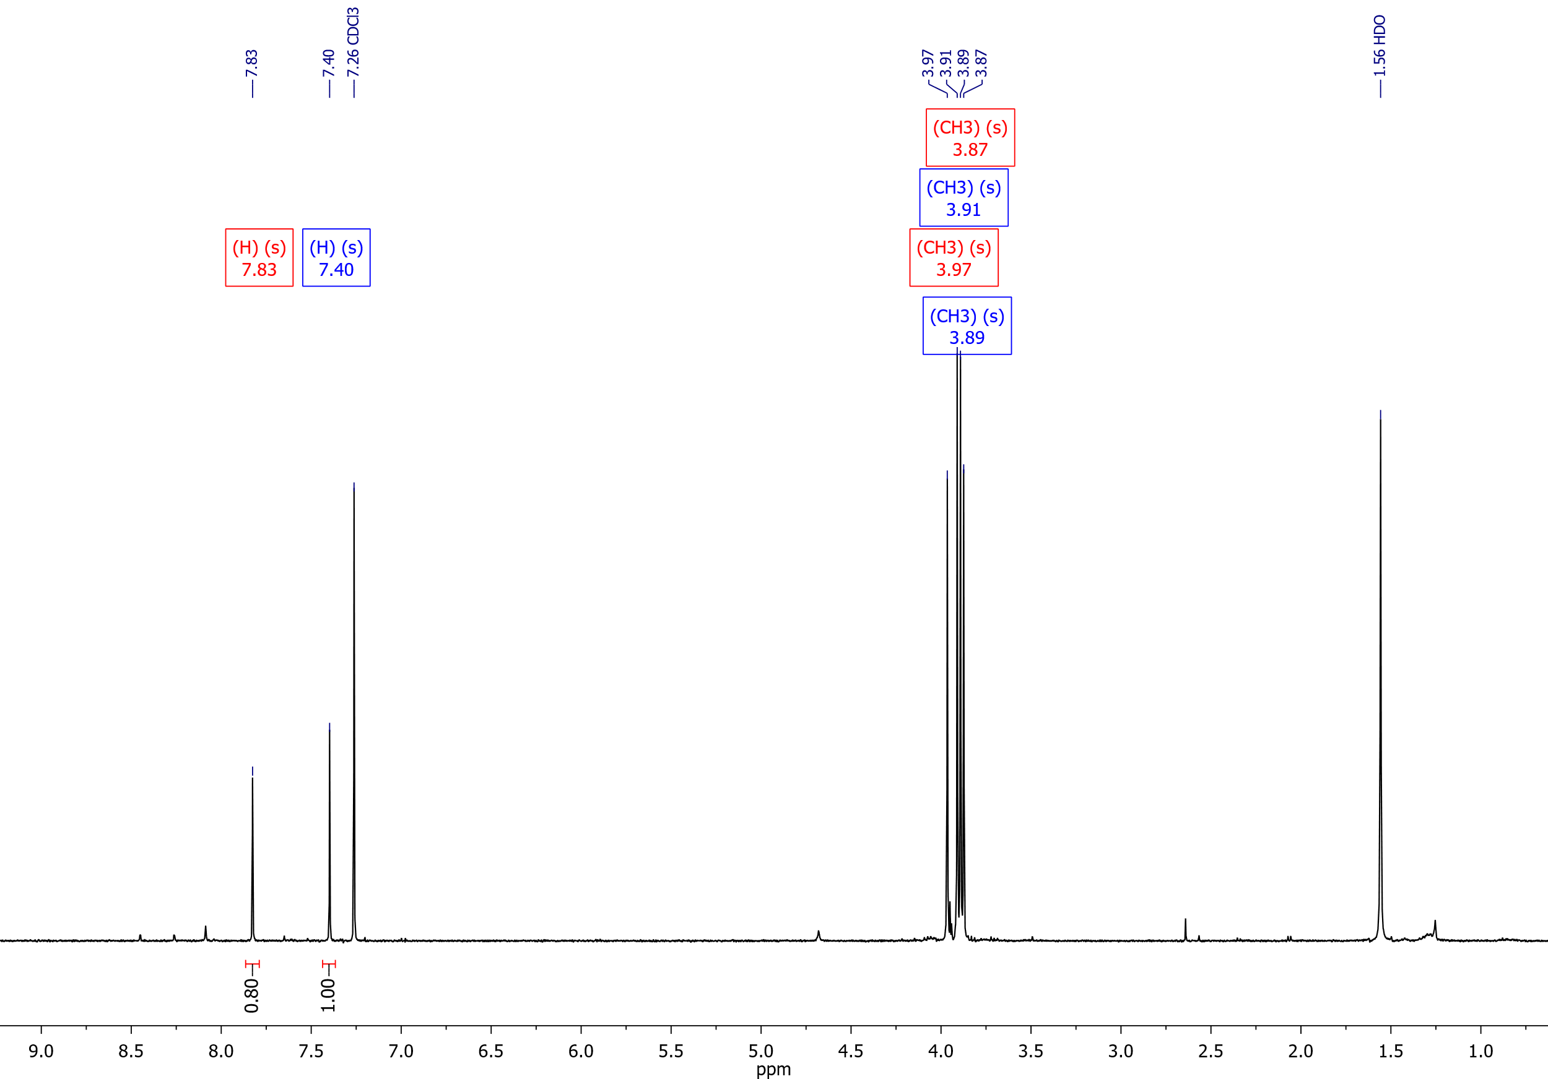

## A mixture of compounds **2** and **3** from the reaction of ester **1** with thioacetamide and K2CO3

1H NMR (400 MHz, CDCl3)

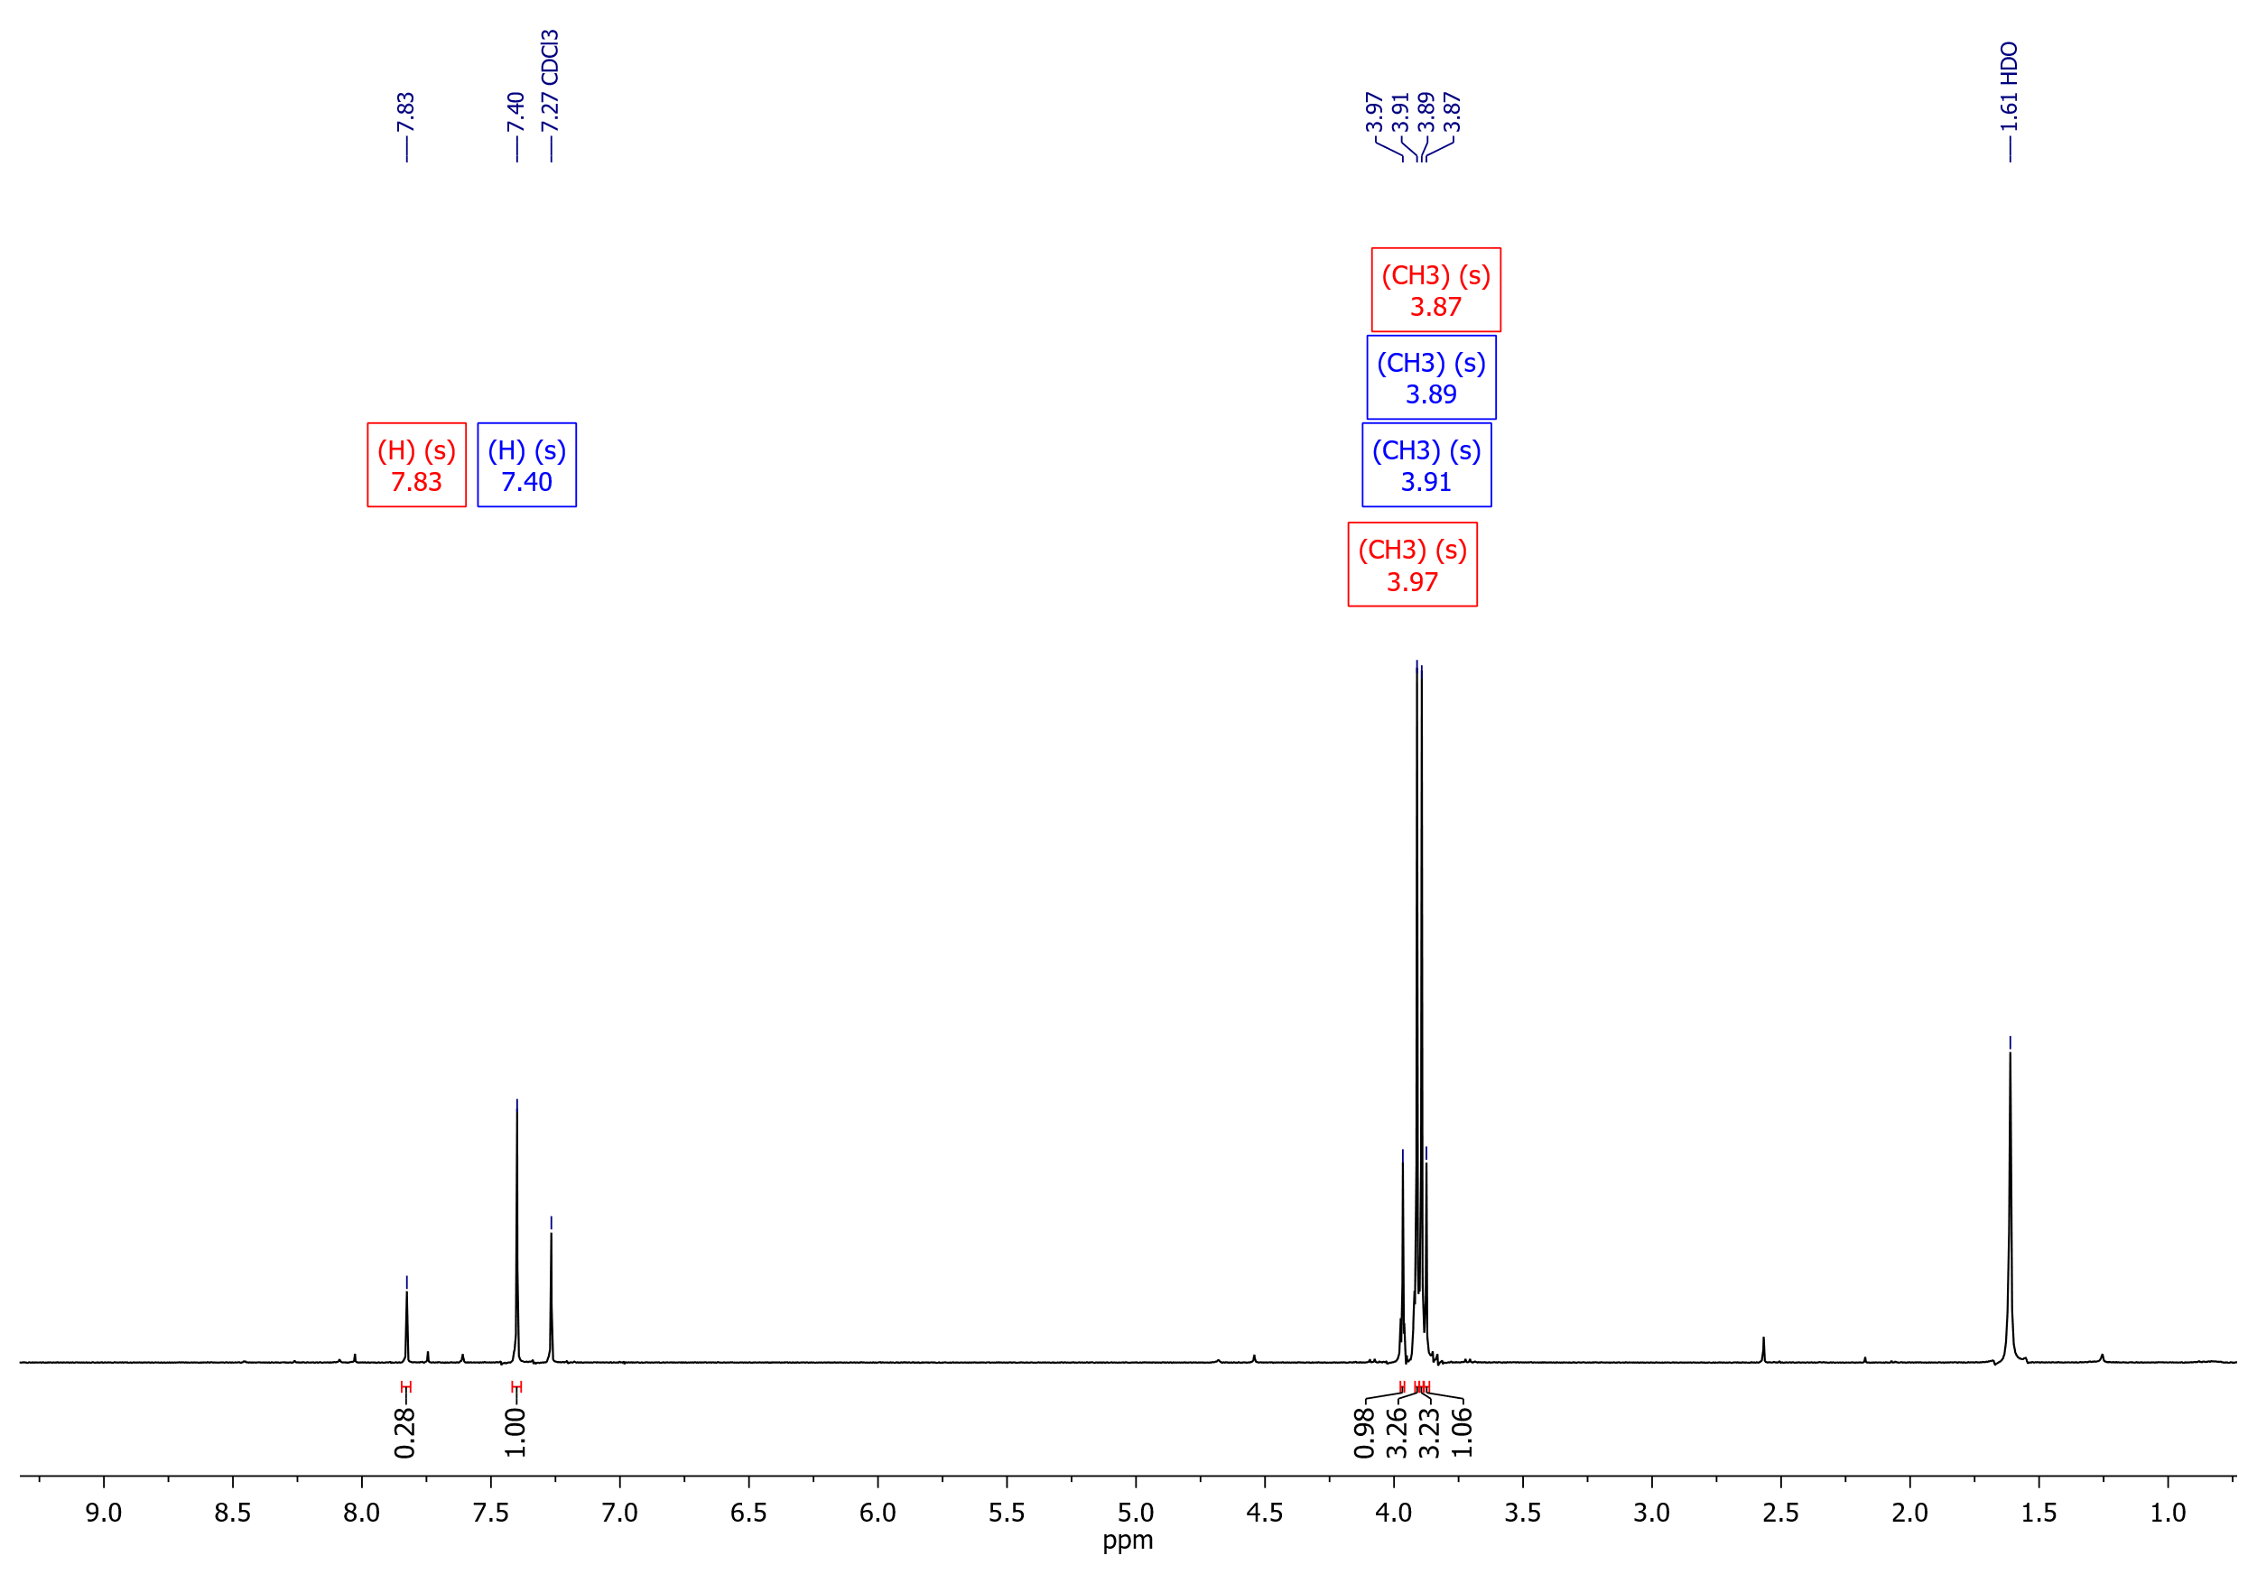

## A mixture of compounds **2** and **3** from the reaction of ester **1** with Na2S2

1H NMR (400 MHz, CDCl3)

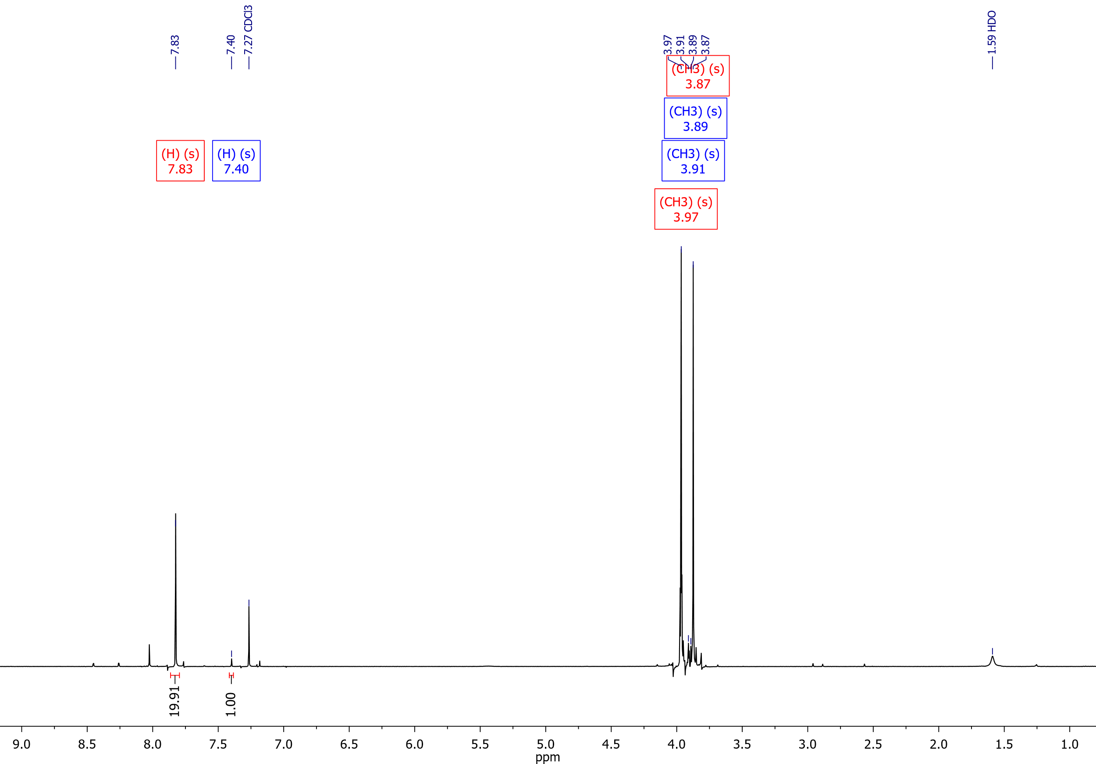

## Dimethyl 3-[(4-cyanobenzyl)thio]thiophene-2,5-dicarboxylate (**4a**)

1H NMR (400 MHz, CDCl3)

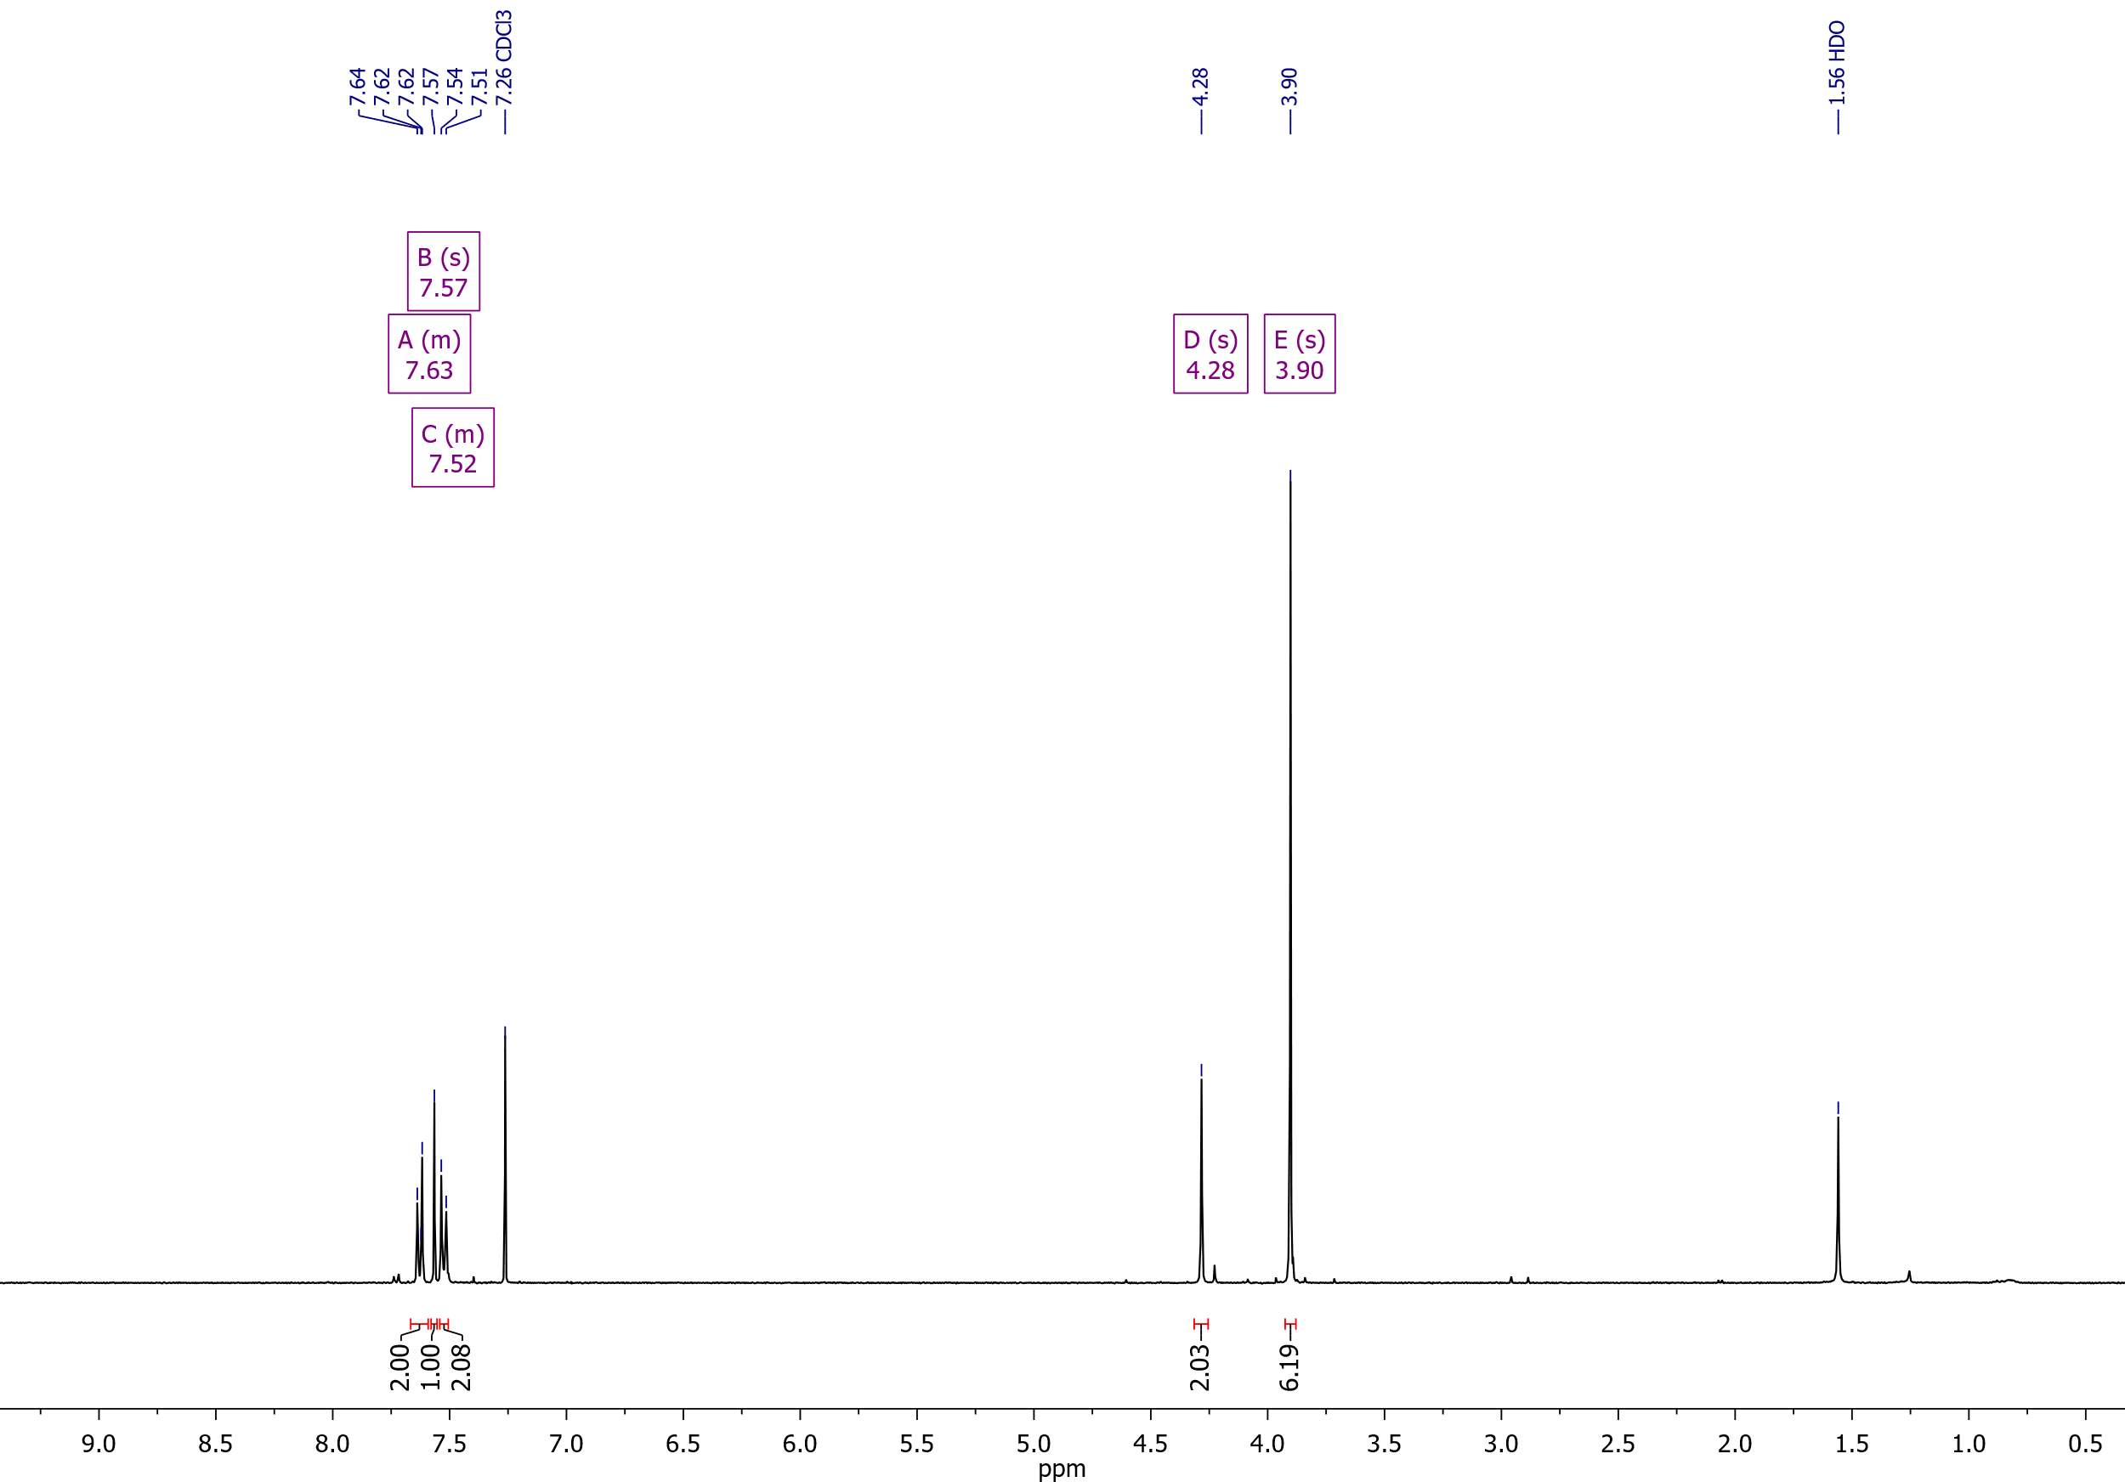

Dimethyl 3-[(4-cyanobenzyl)thio]thiophene-2,5-dicarboxylate (**4a**)

13C NMR (126 MHz, CDCl3)

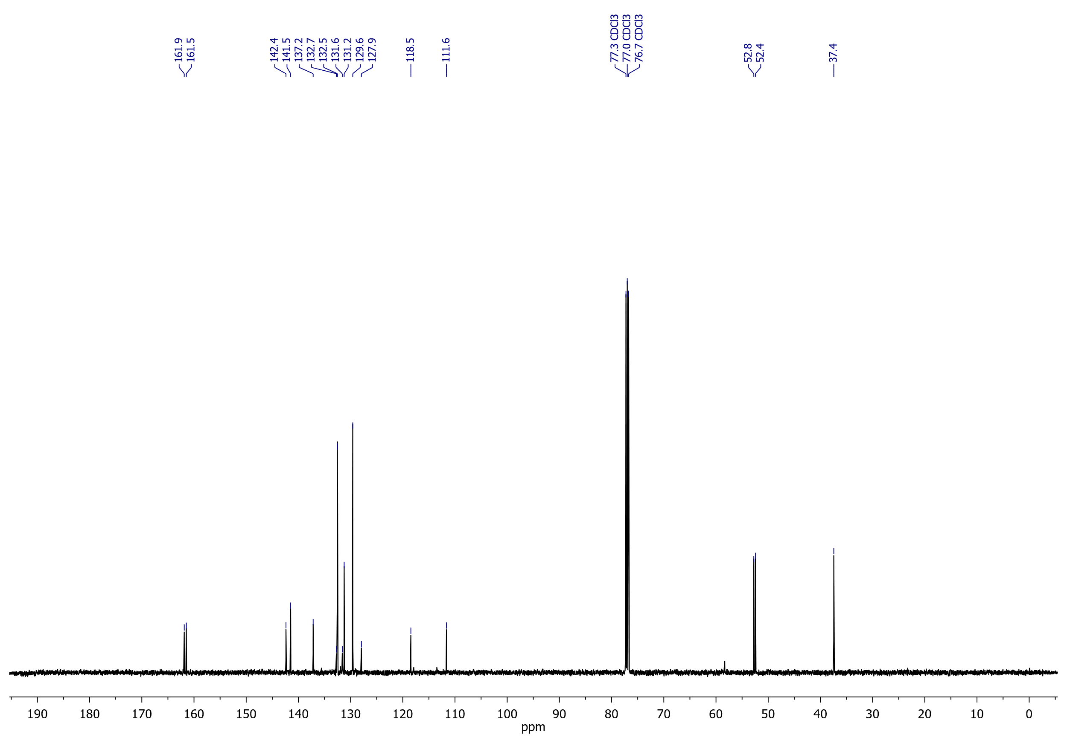

## Dimethyl 3-{[4-(methoxycarbonyl)benzyl]thio}thiophene-2,5-dicarboxylate (**4b**)

1H NMR (400 MHz, CDCl3)

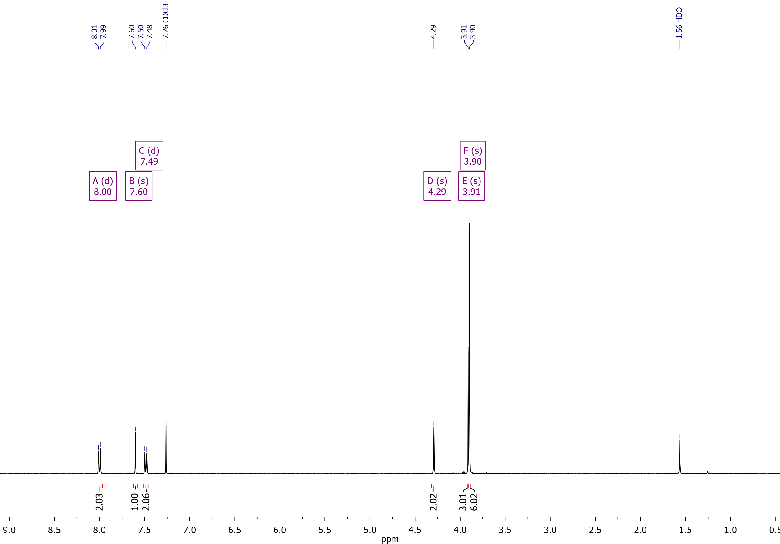

Dimethyl 3-{[4-(methoxycarbonyl)benzyl]thio}thiophene-2,5-dicarboxylate (**4b**)

13C NMR (126 MHz, CDCl3)

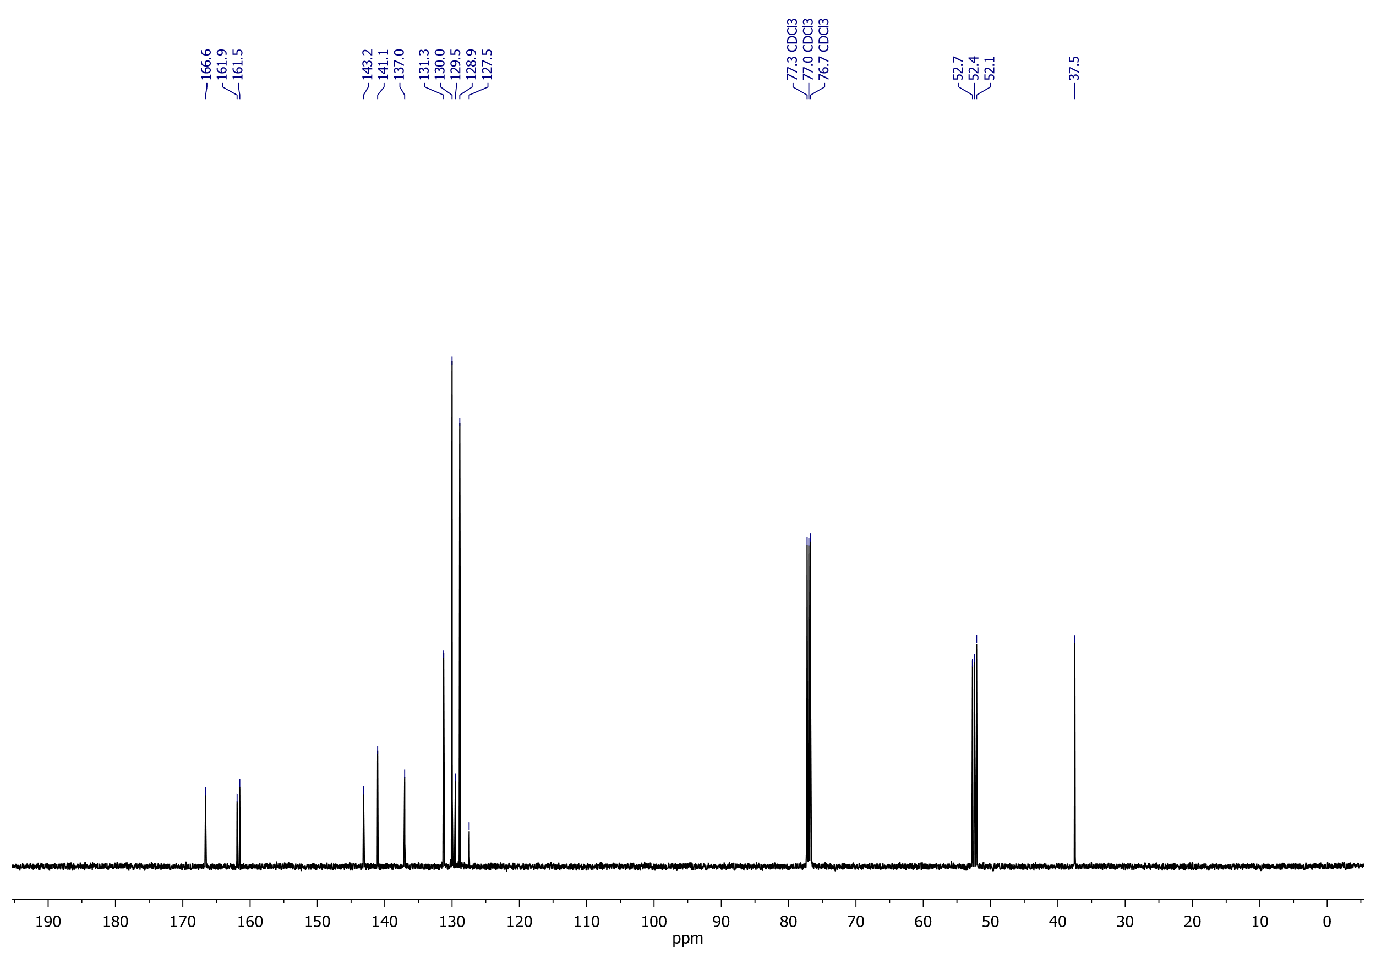

## Dimethyl 3-(benzylthio)thiophene-2,5-dicarboxylate (**4c**)

1H NMR (400 MHz, CDCl3)

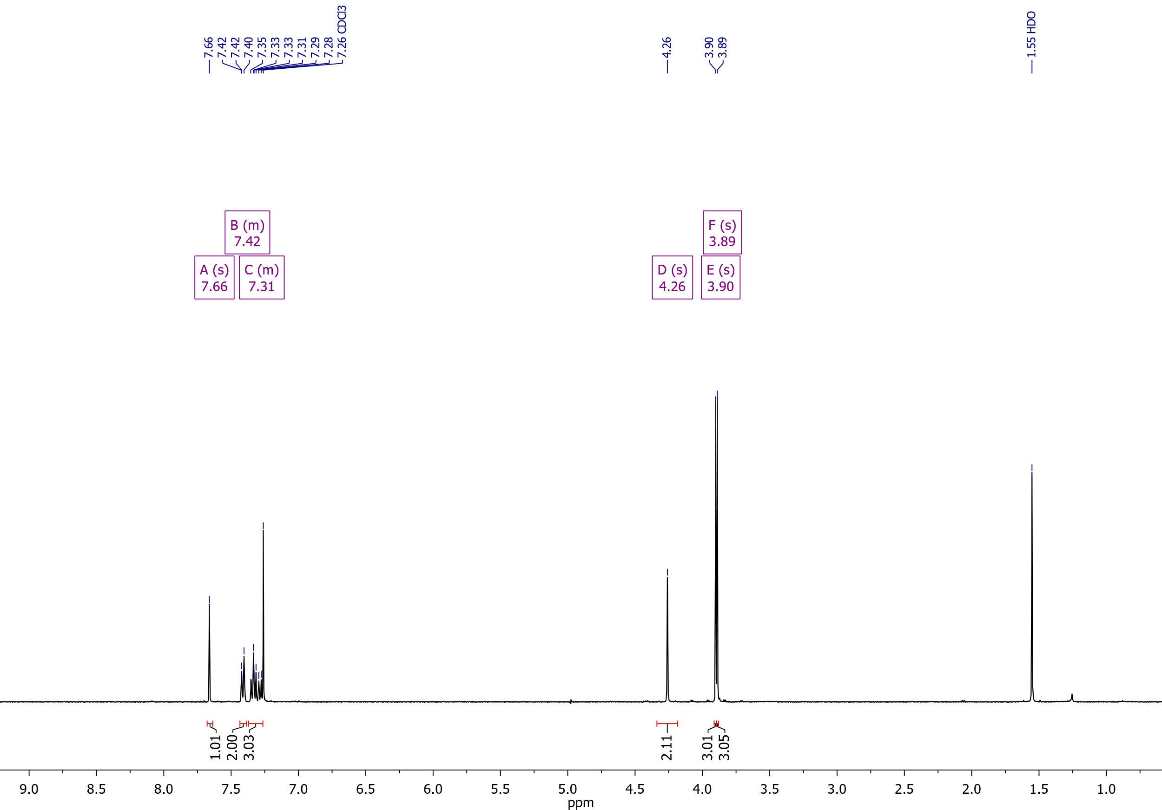

Dimethyl 3-(benzylthio)thiophene-2,5-dicarboxylate (**4c**)

13H NMR (126 MHz, CDCl3)

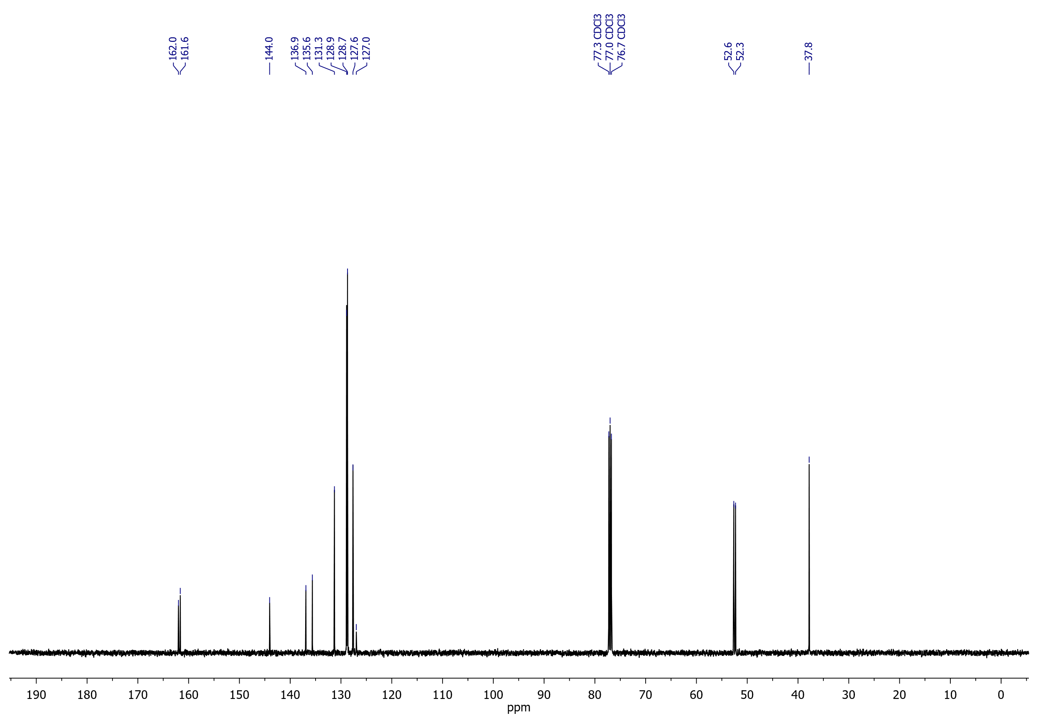

## Dimethyl 3-[(4-fluorobenzyl)thio]thiophene-2,5-dicarboxylate (**4d**)

1H NMR (500 MHz, CDCl3)

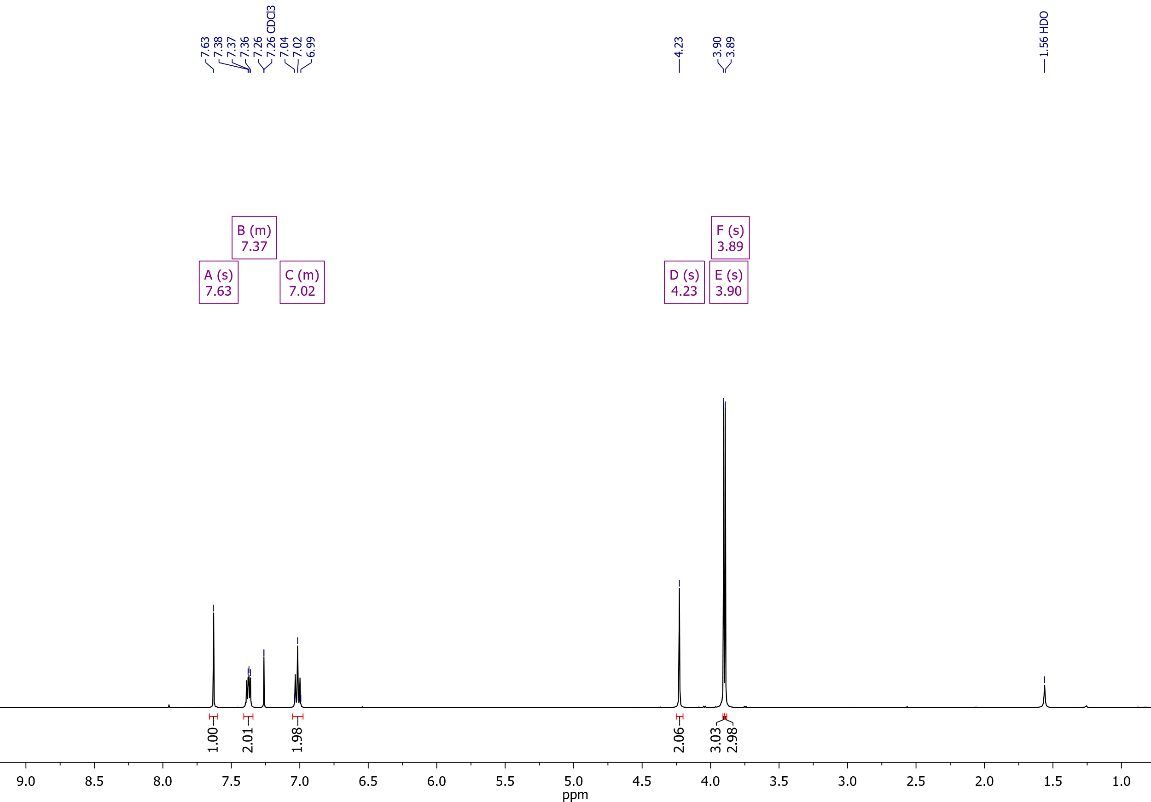

Dimethyl 3-[(4-fluorobenzyl)thio]thiophene-2,5-dicarboxylate (**4d**)

19F NMR (471 MHz, CDCl3)

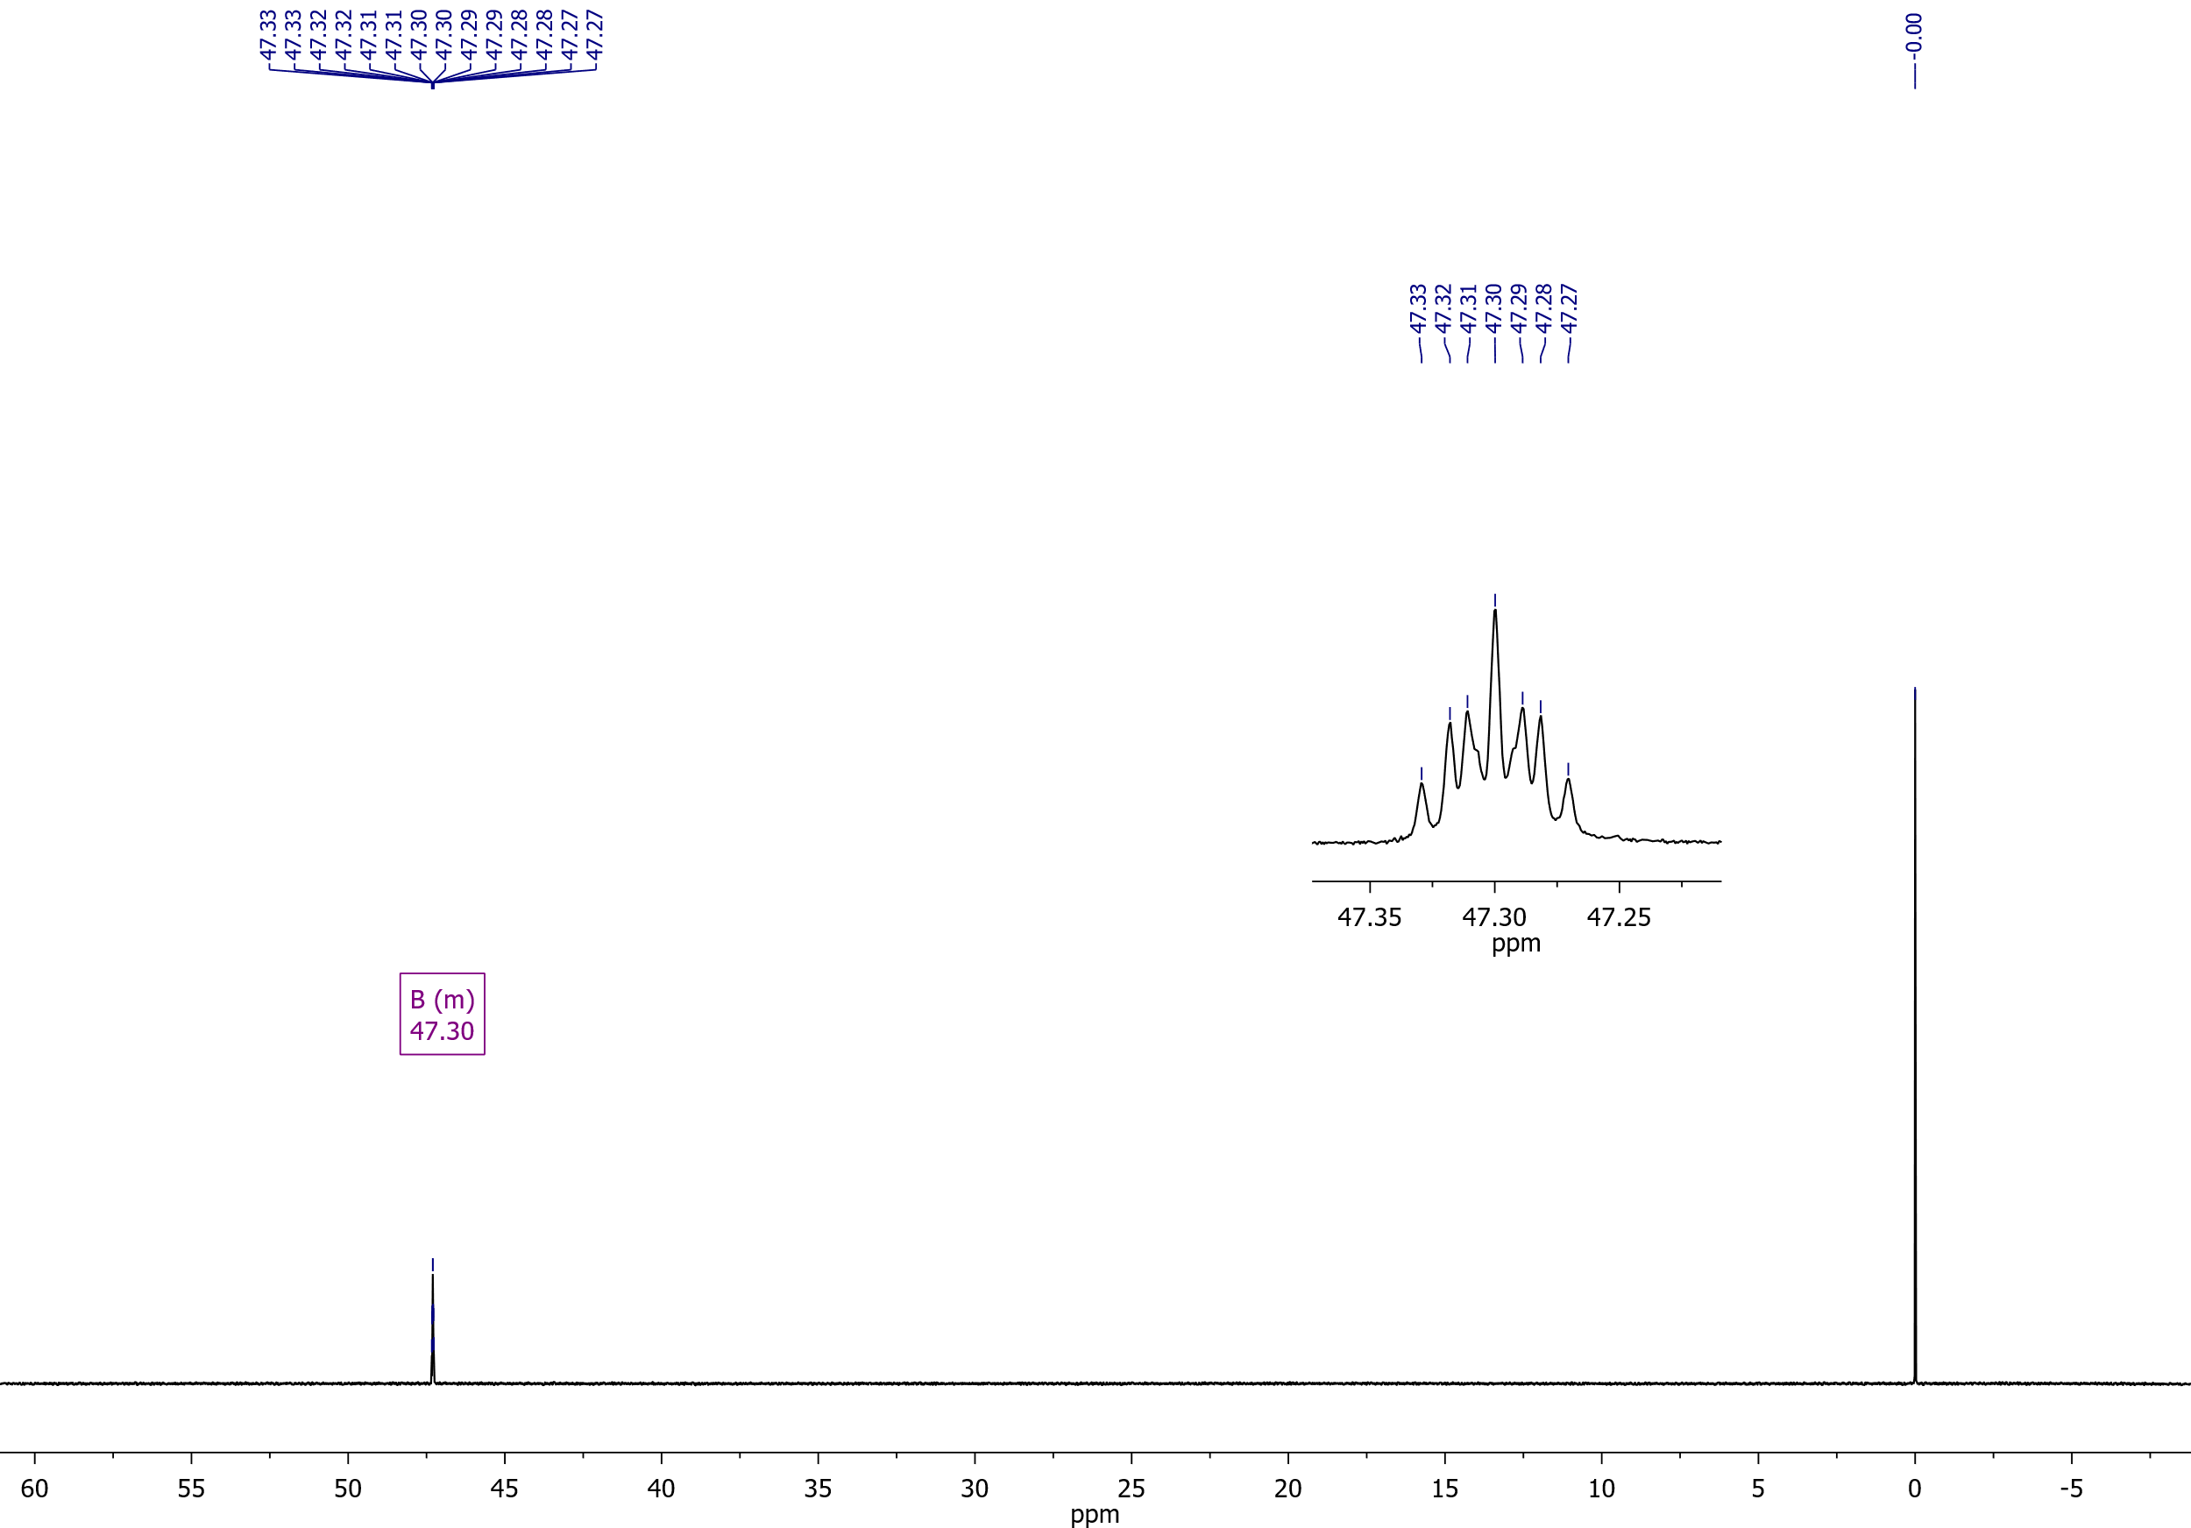

Dimethyl 3-[(4-fluorobenzyl)thio]thiophene-2,5-dicarboxylate (**4d**)

13C NMR (126 MHz, CDCl3)

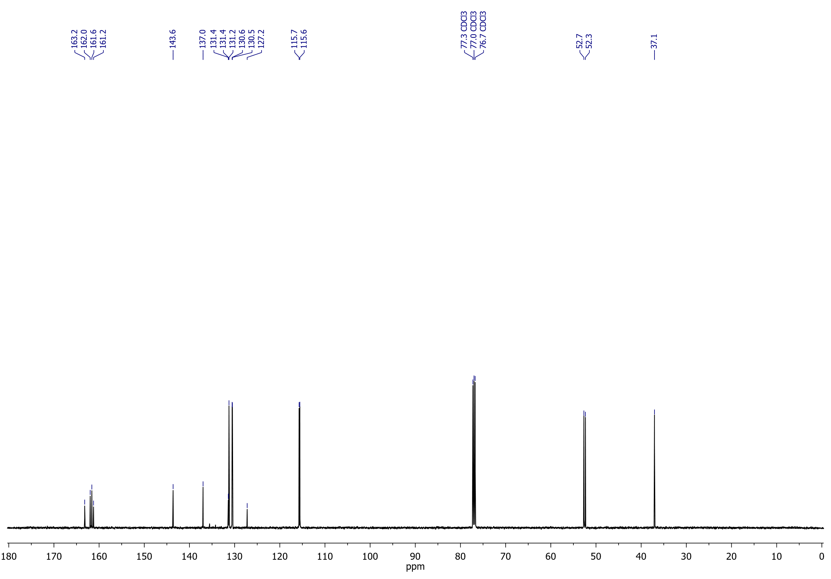

## Dimethyl 3-[(3,4-difluorobenzyl)thio]thiophene-2,5-dicarboxylate (**4e**)

1H NMR (400 MHz, DMSO-*d*6)

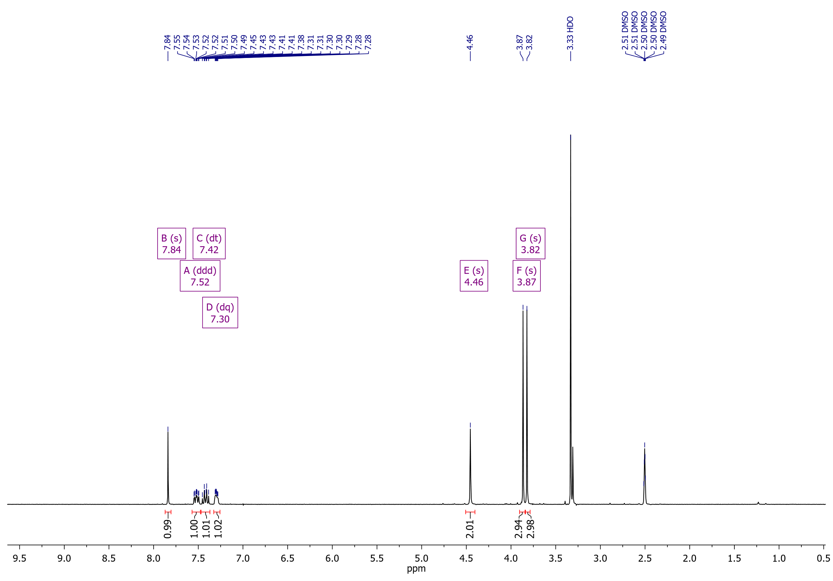

Dimethyl 3-[(3,4-difluorobenzyl)thio]thiophene-2,5-dicarboxylate (**4e**)

19F NMR (376 MHz, CDCl3)

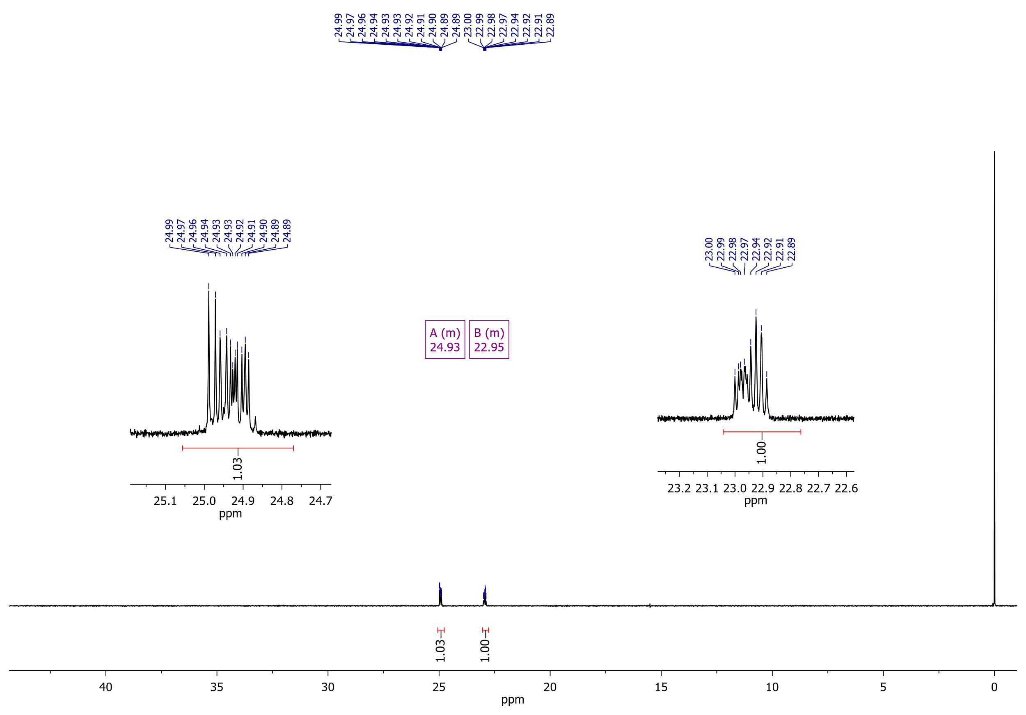

Dimethyl 3-[(3,4-difluorobenzyl)thio]thiophene-2,5-dicarboxylate (**4e**)

13C NMR (126 MHz, CDCl3)

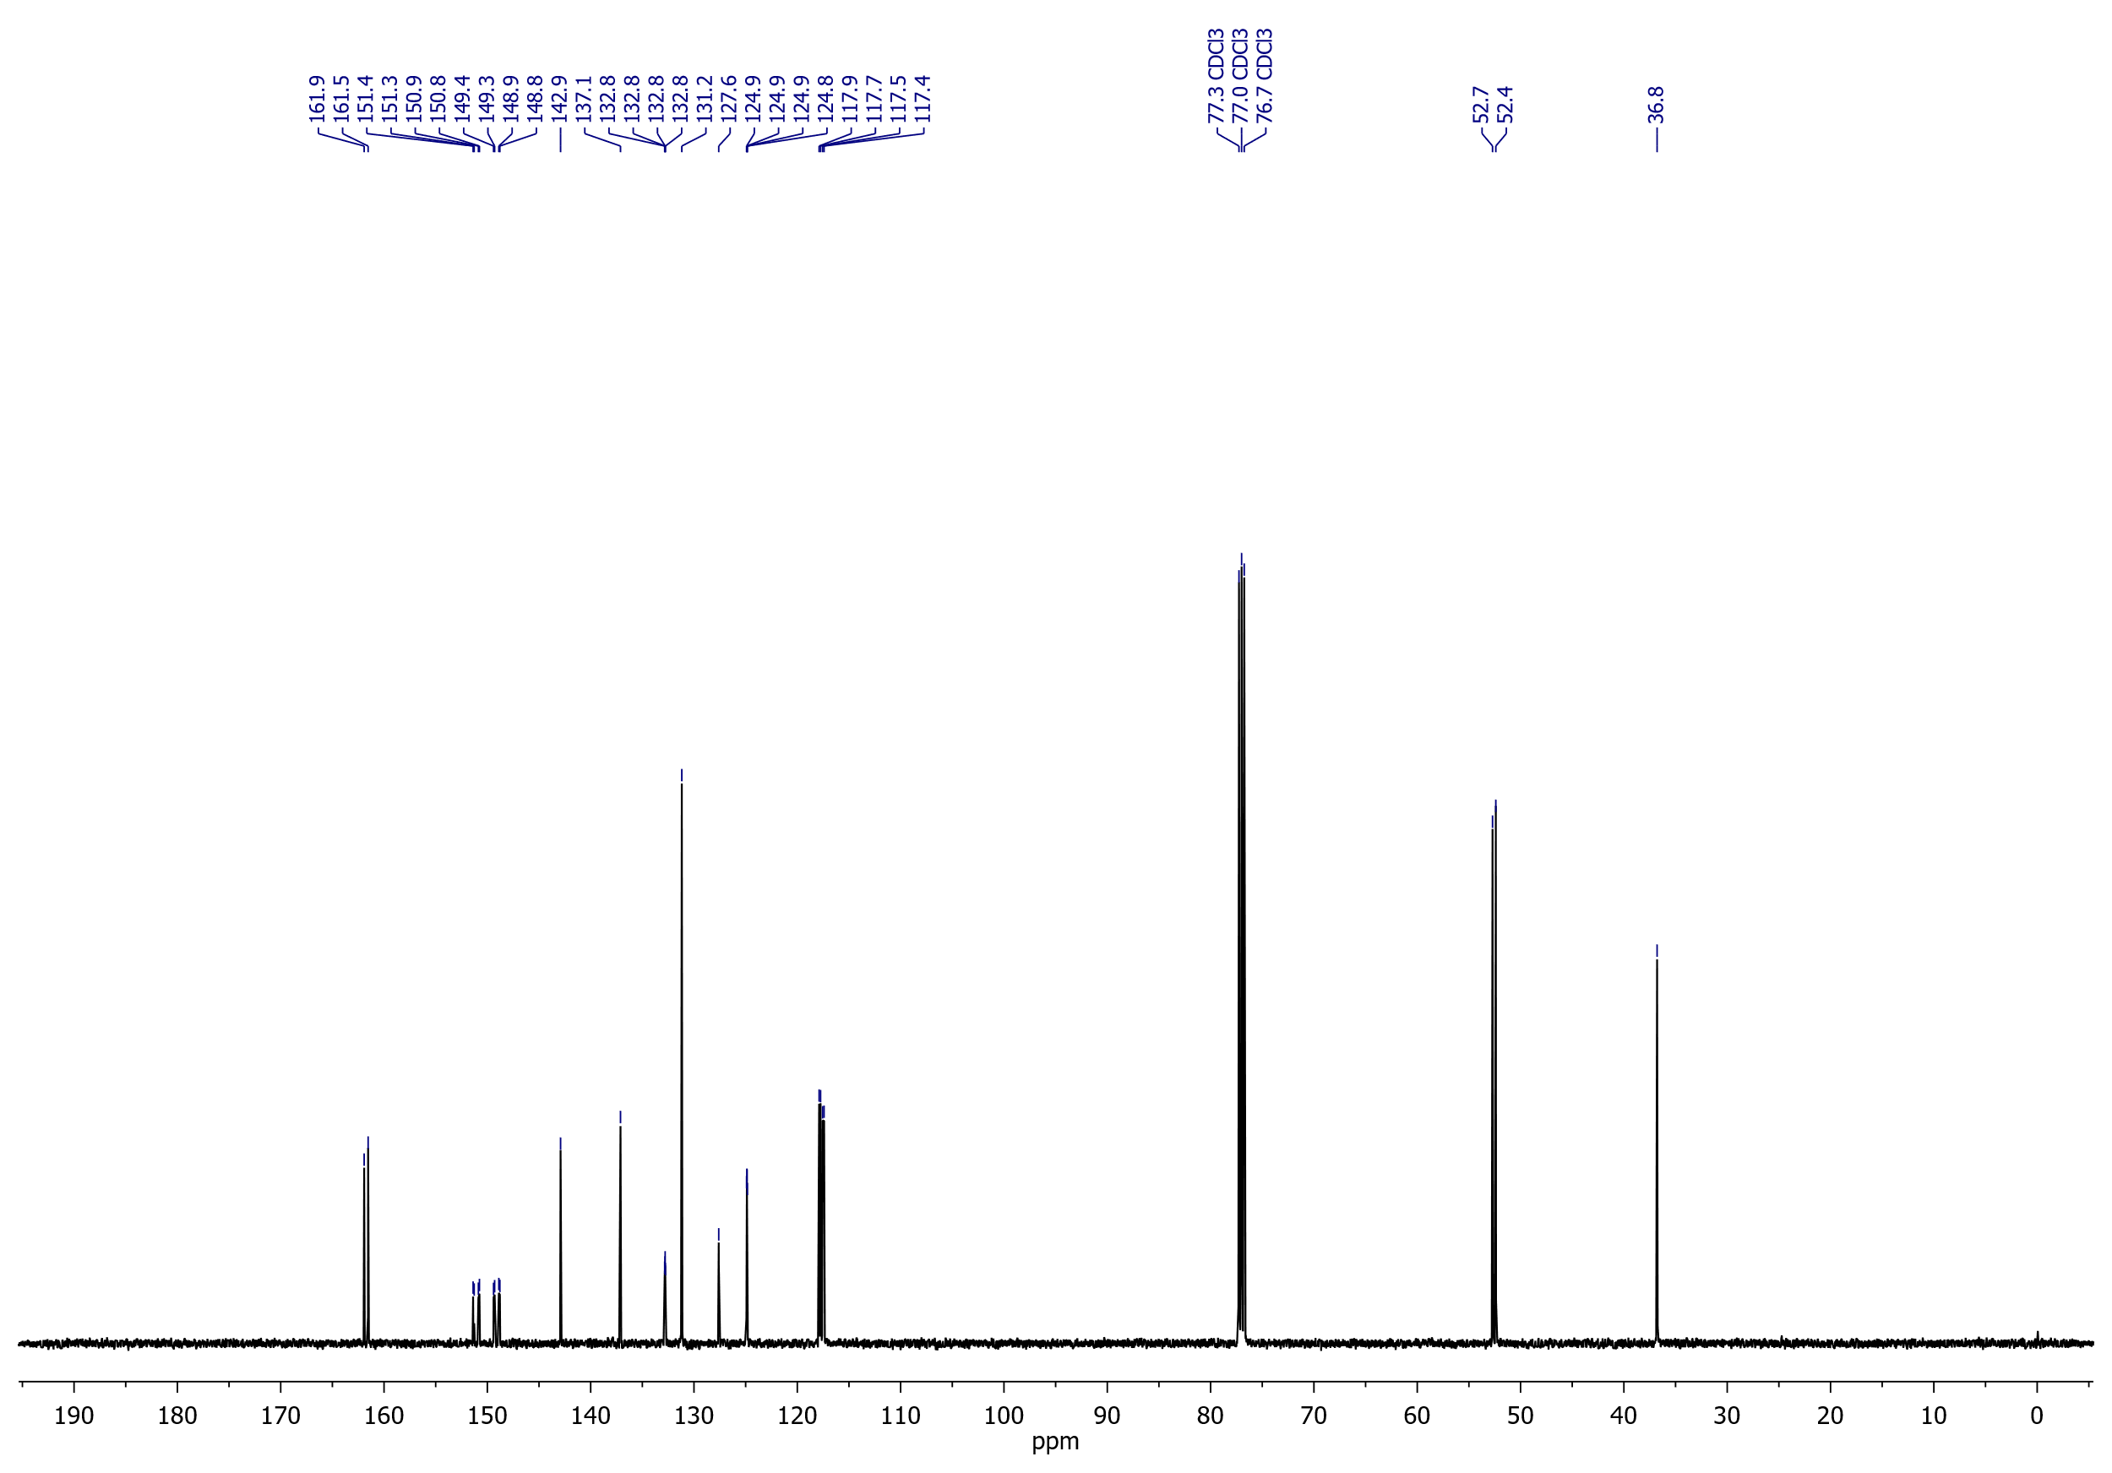

## Dimethyl 3-{[4-(trifluoromethyl)benzyl]thio}thiophene-2,5-dicarboxylate (**4f**)

1H NMR (400 MHz, CDCl3)

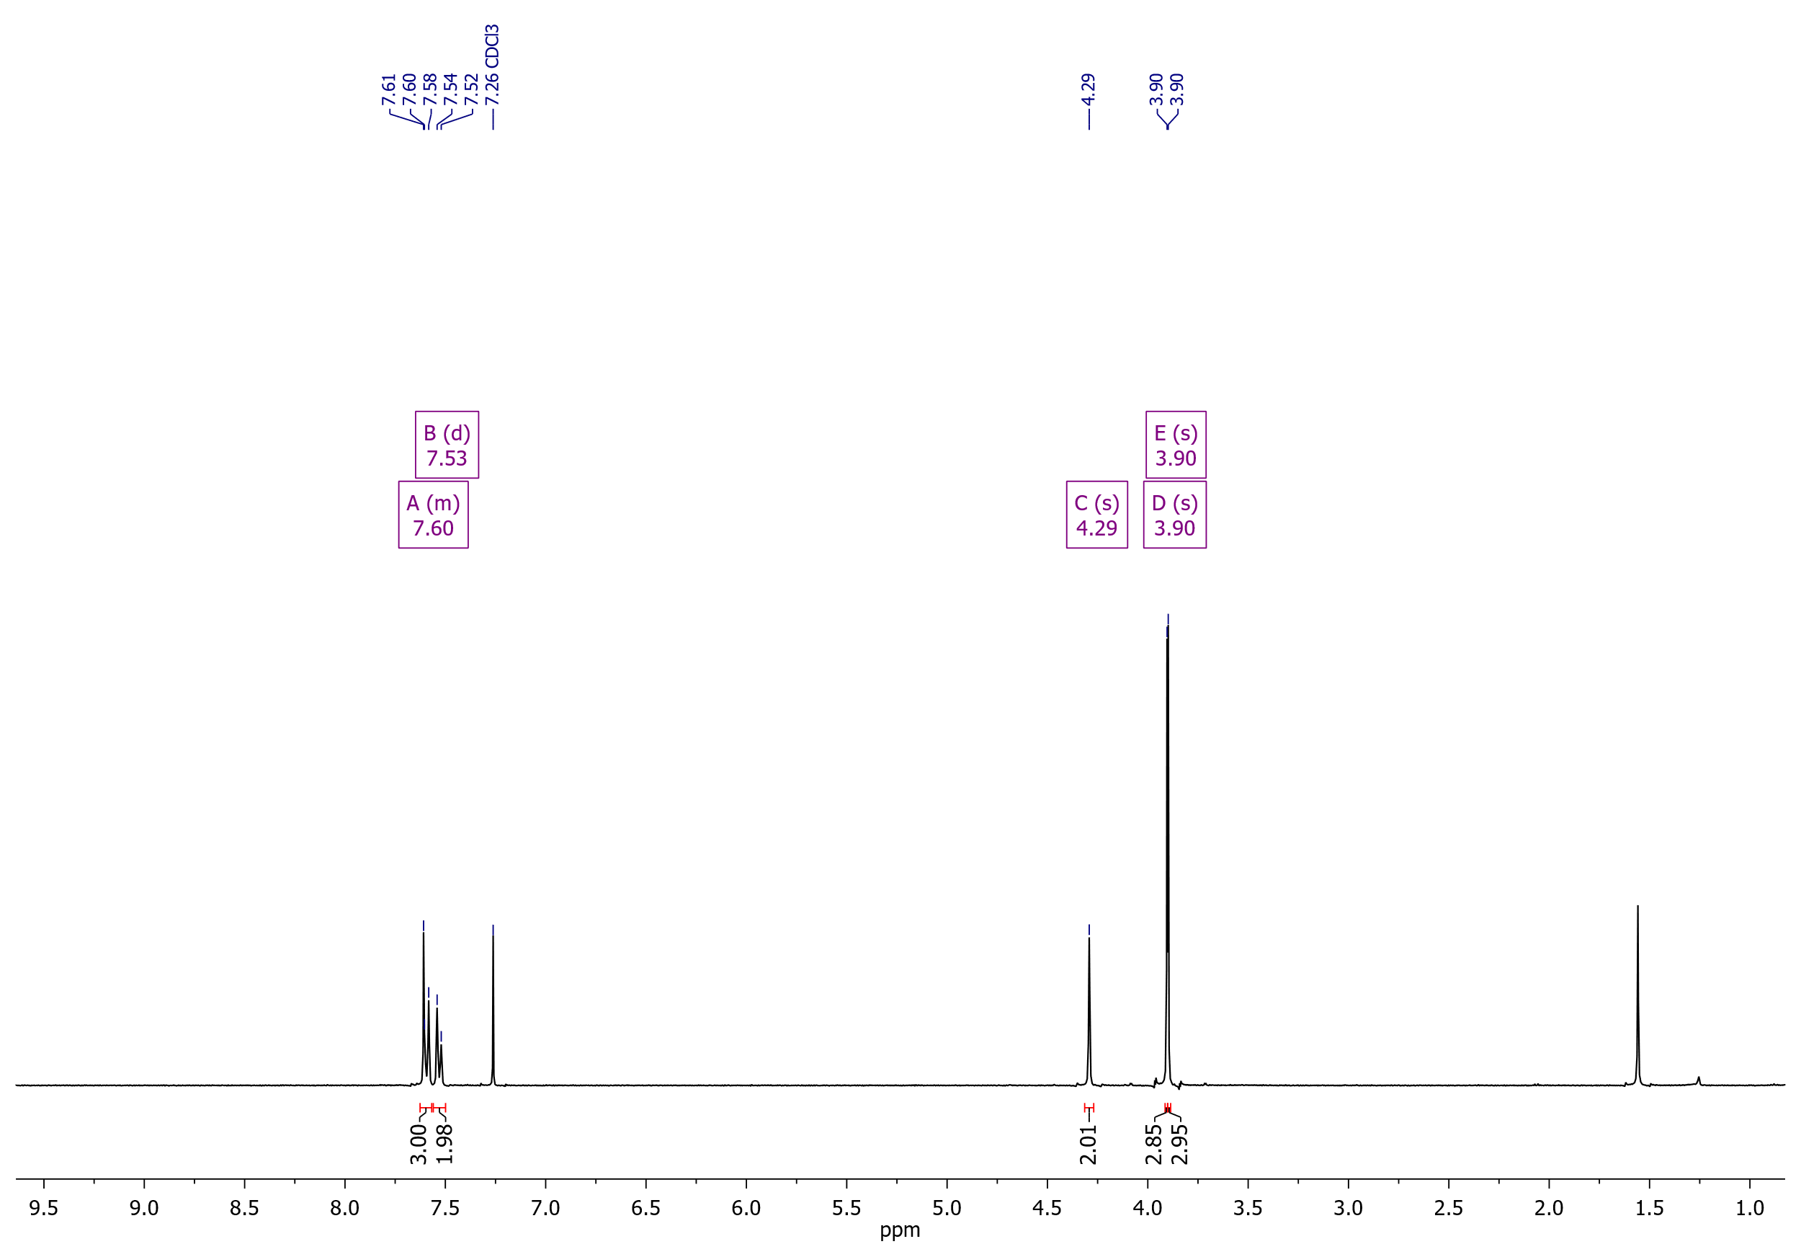

Dimethyl 3-{[4-(trifluoromethyl)benzyl]thio}thiophene-2,5-dicarboxylate (**4f**)

19F NMR (376 MHz, CDCl3)

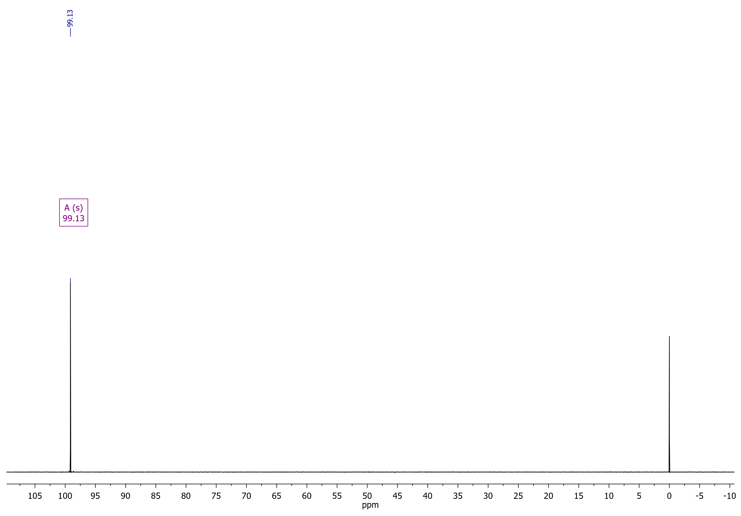

Dimethyl 3-{[4-(trifluoromethyl)benzyl]thio}thiophene-2,5-dicarboxylate (**4f**)

13C NMR (126 MHz, CDCl3)

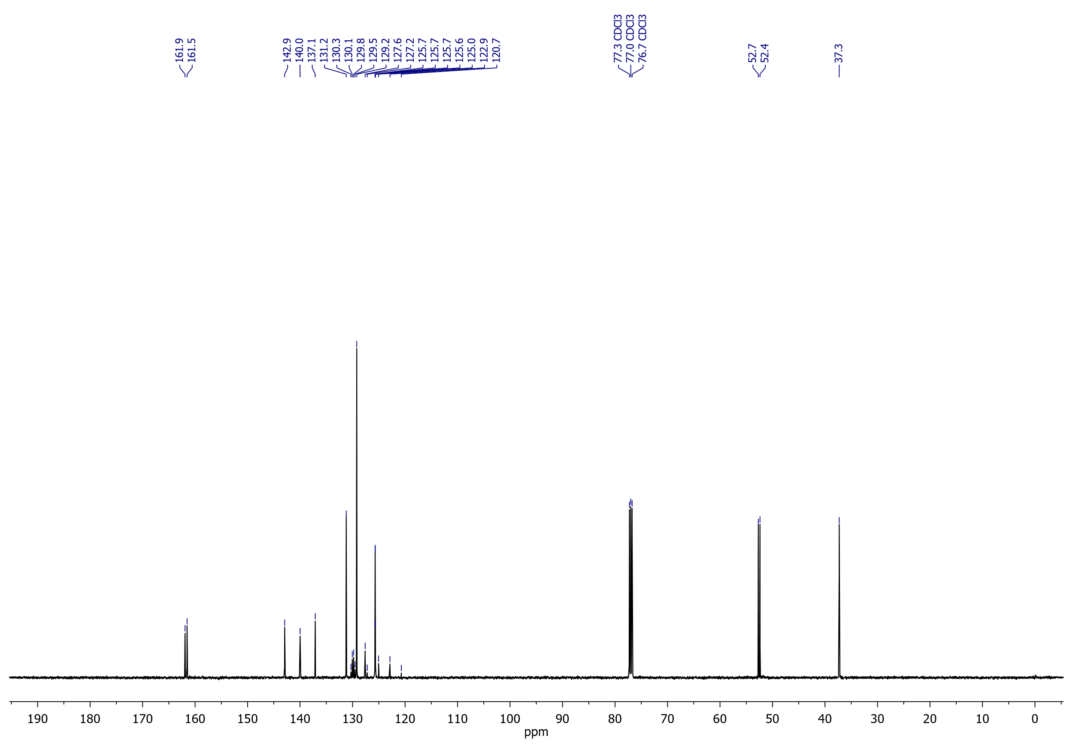

## Dimethyl 3-[(benzo[*d*][1,3]dioxol-5-ylmethyl)thio]thiophene-2,5-dicarboxylate (**4g**)

1H NMR (500 MHz, CDCl3)

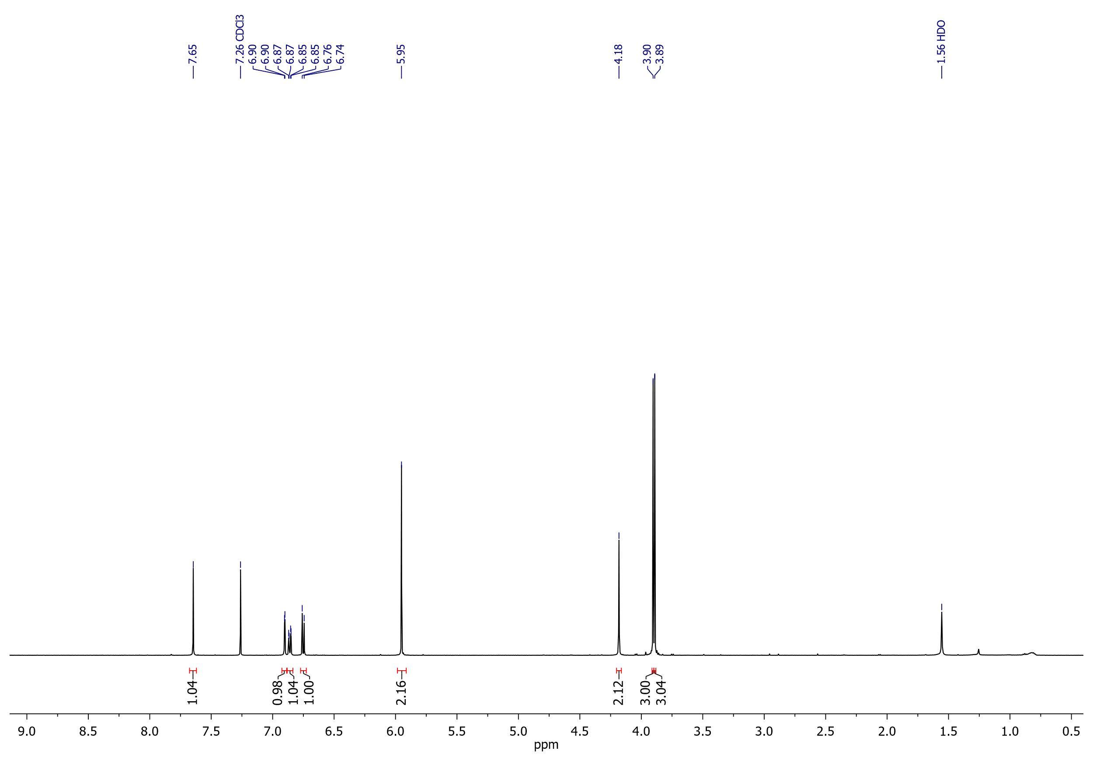

Dimethyl 3-[(benzo[*d*][1,3]dioxol-5-ylmethyl)thio]thiophene-2,5-dicarboxylate (**4g**)

13C NMR (126 MHz, CDCl3)

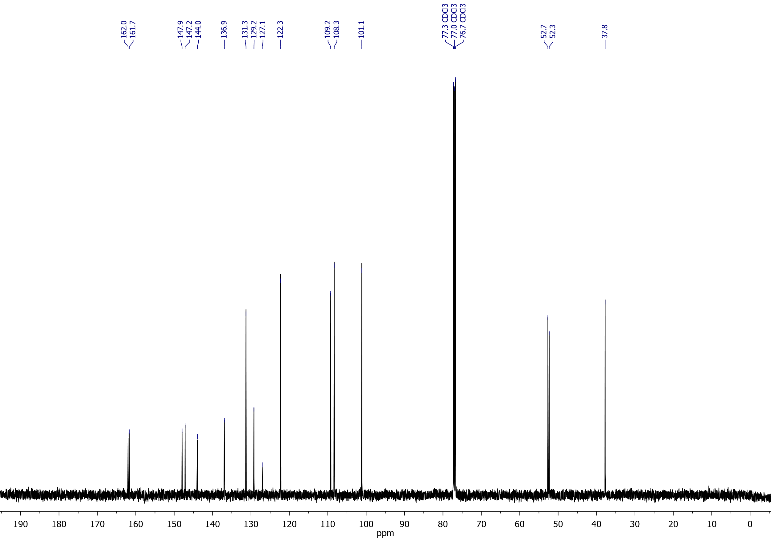

## Dimethyl 3-[(thiophen-2-ylmethyl)thio]thiophene-2,5-dicarboxylate (**4h**)

1H NMR (500 MHz, CDCl3)

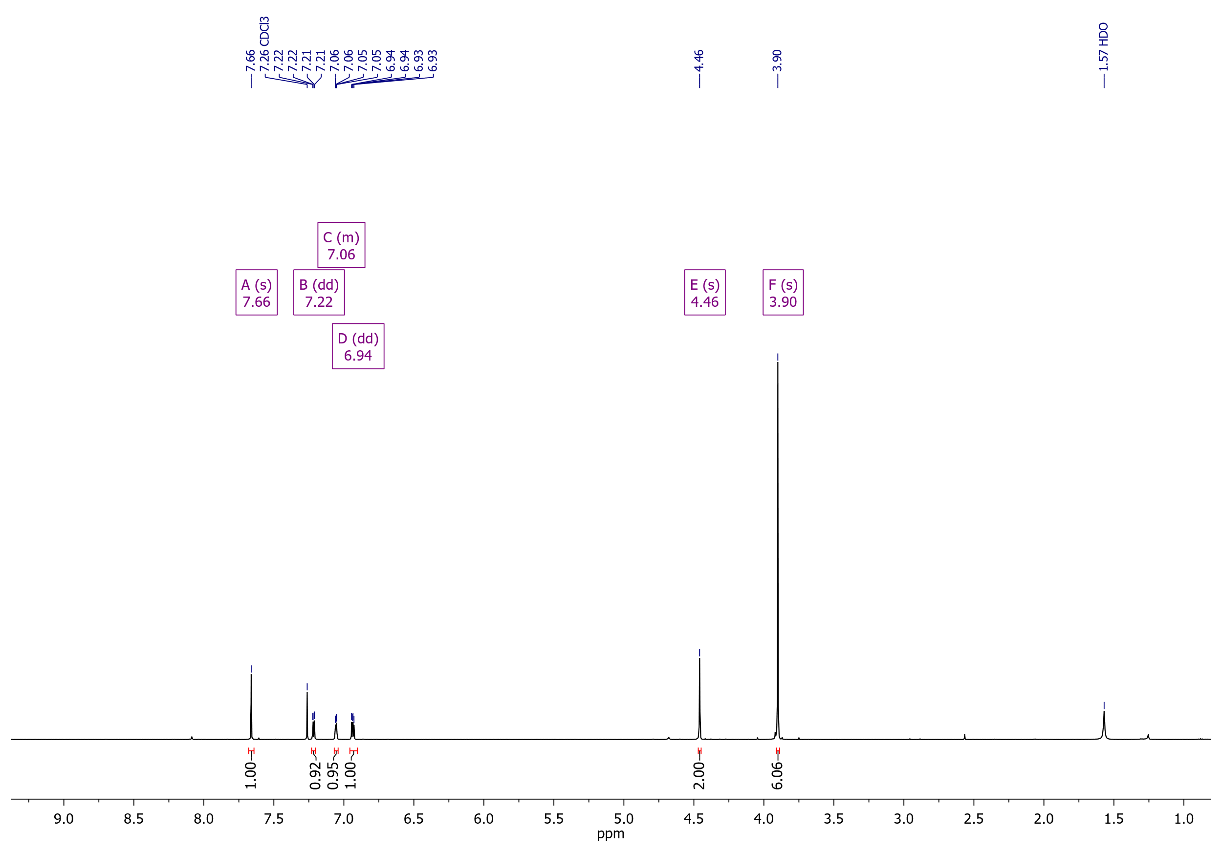

Dimethyl 3-[(thiophen-2-ylmethyl)thio]thiophene-2,5-dicarboxylate (**4h**)

13C NMR (126 MHz, CDCl3)

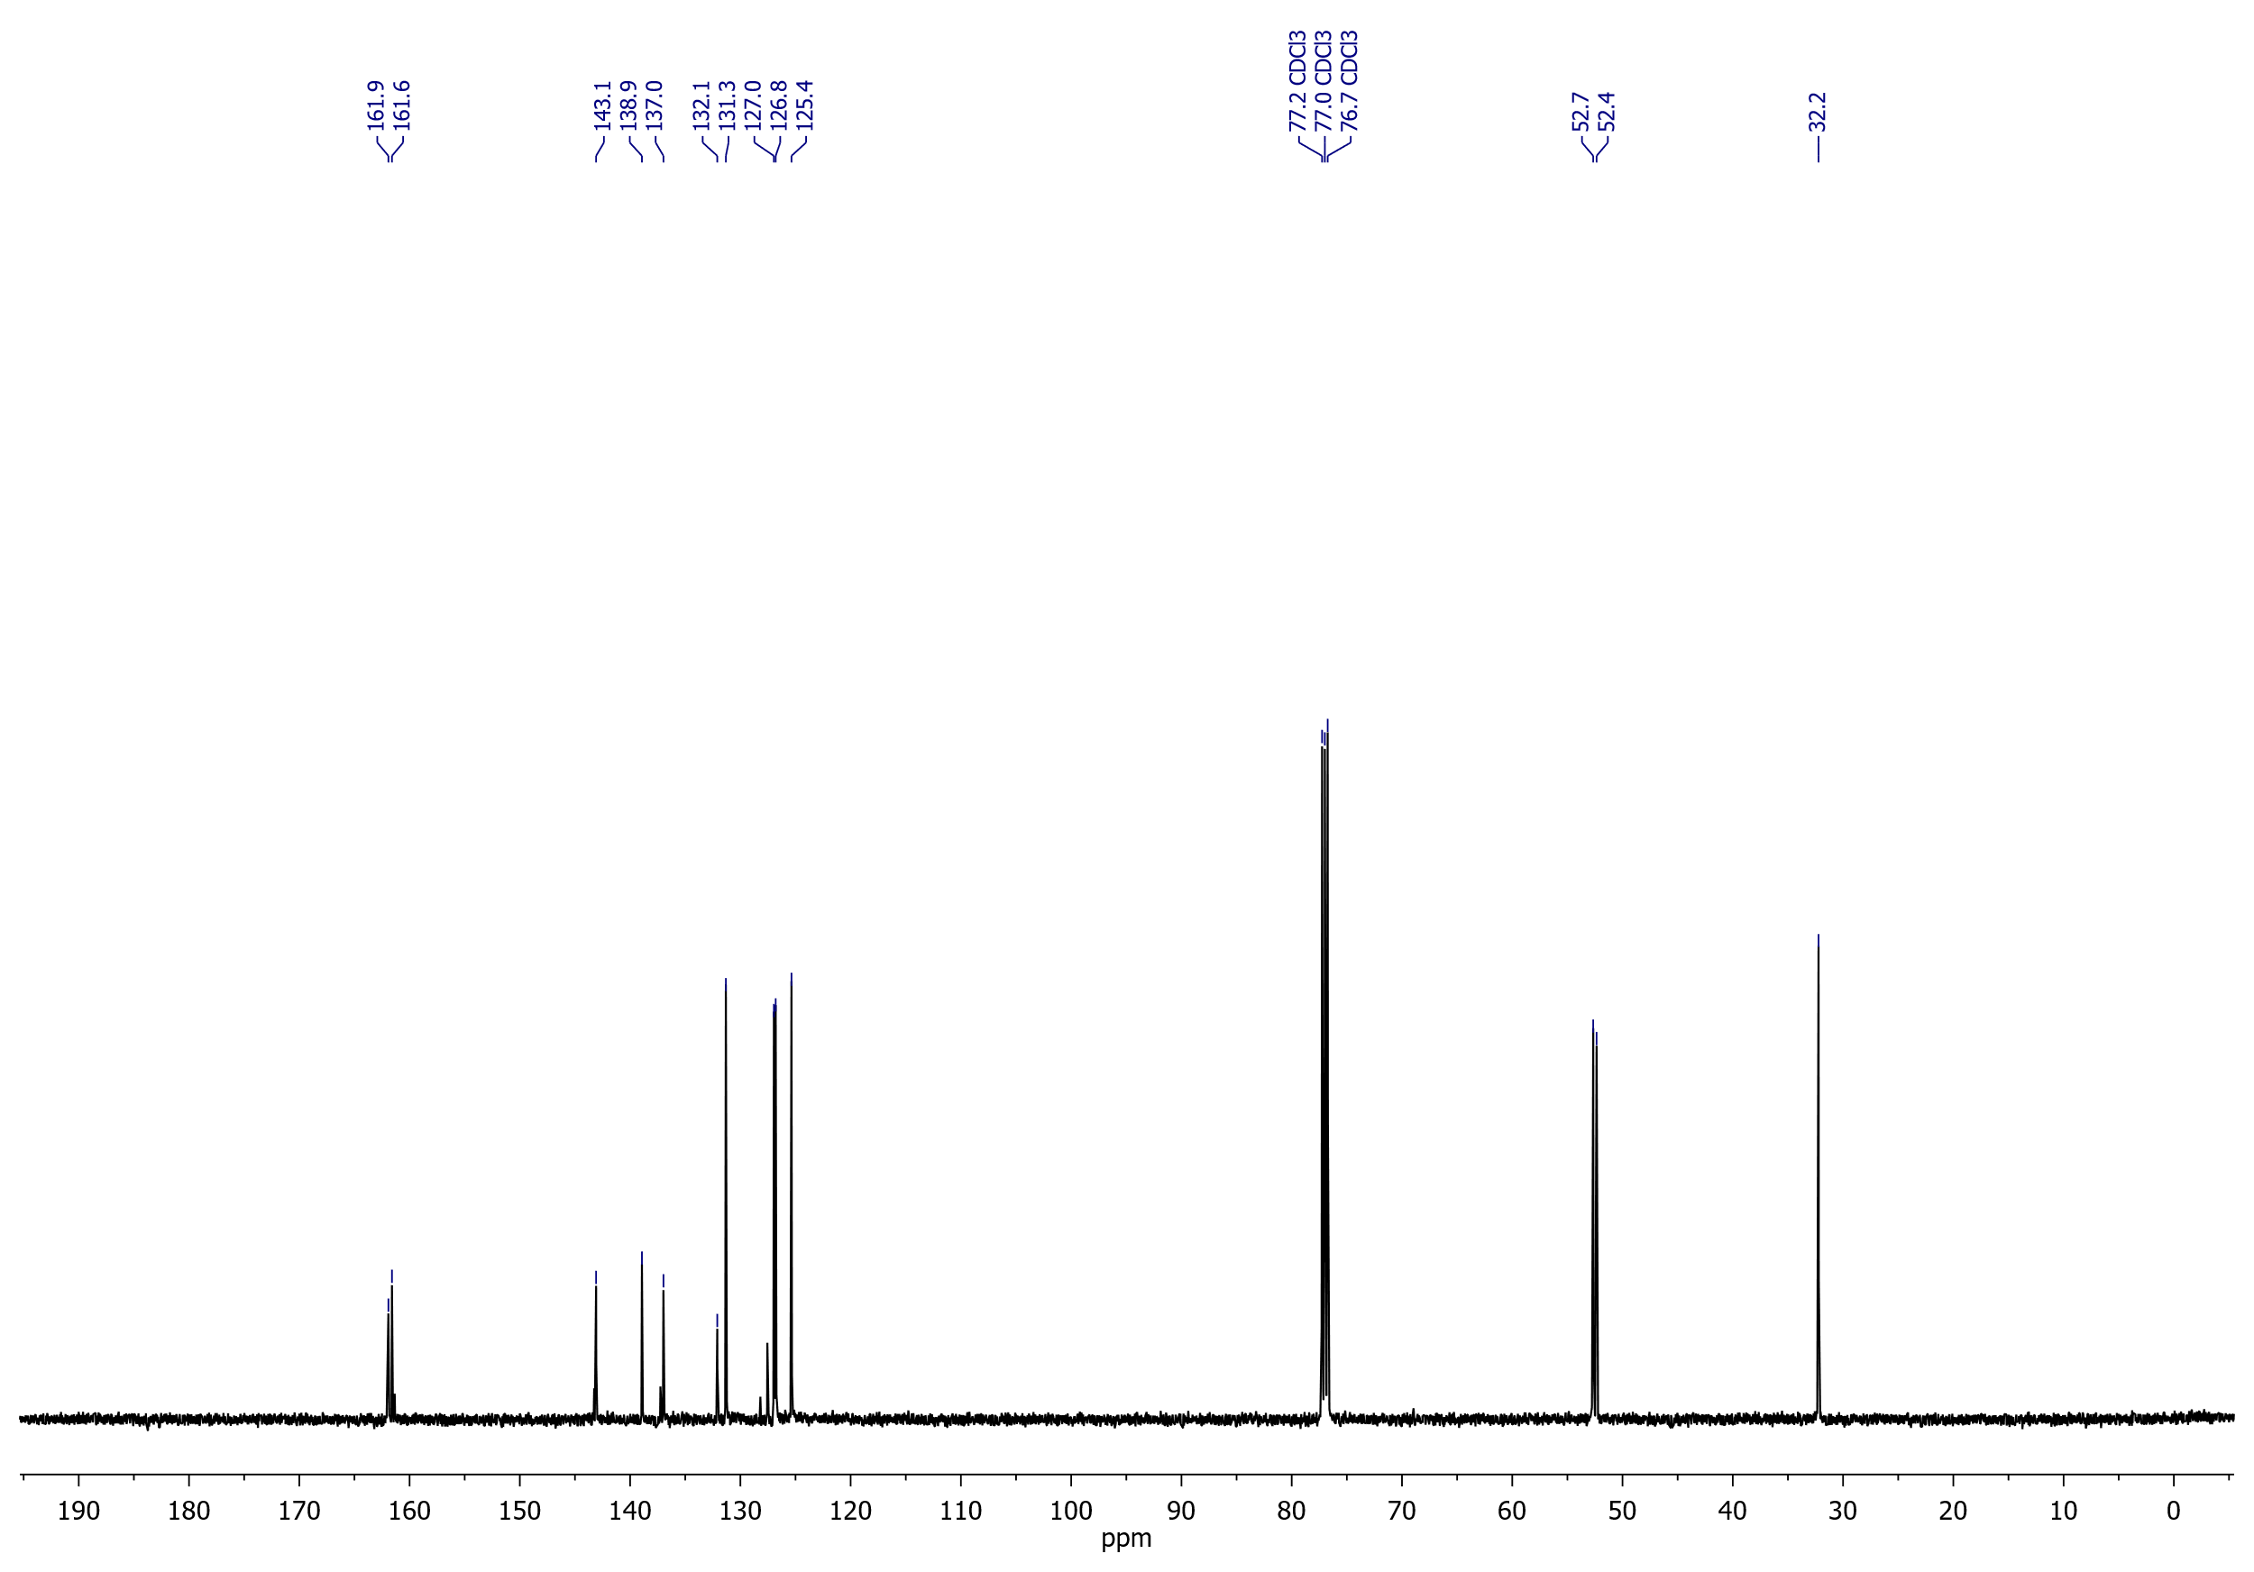

## Dimethyl 3-[(cyanomethyl)thio]thiophene-2,5-dicarboxylate (**5a**)

1H NMR (400 MHz, CDCl3)

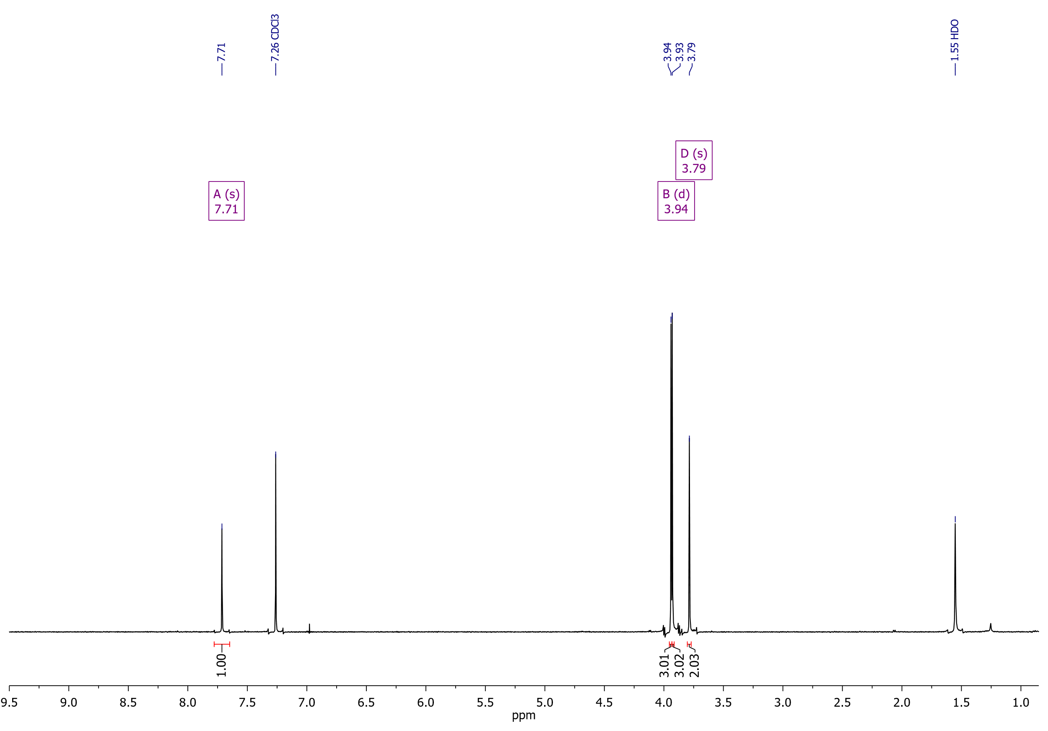

Dimethyl 3-[(cyanomethyl)thio]thiophene-2,5-dicarboxylate (**5a**)

13C NMR (126 MHz, CDCl3)

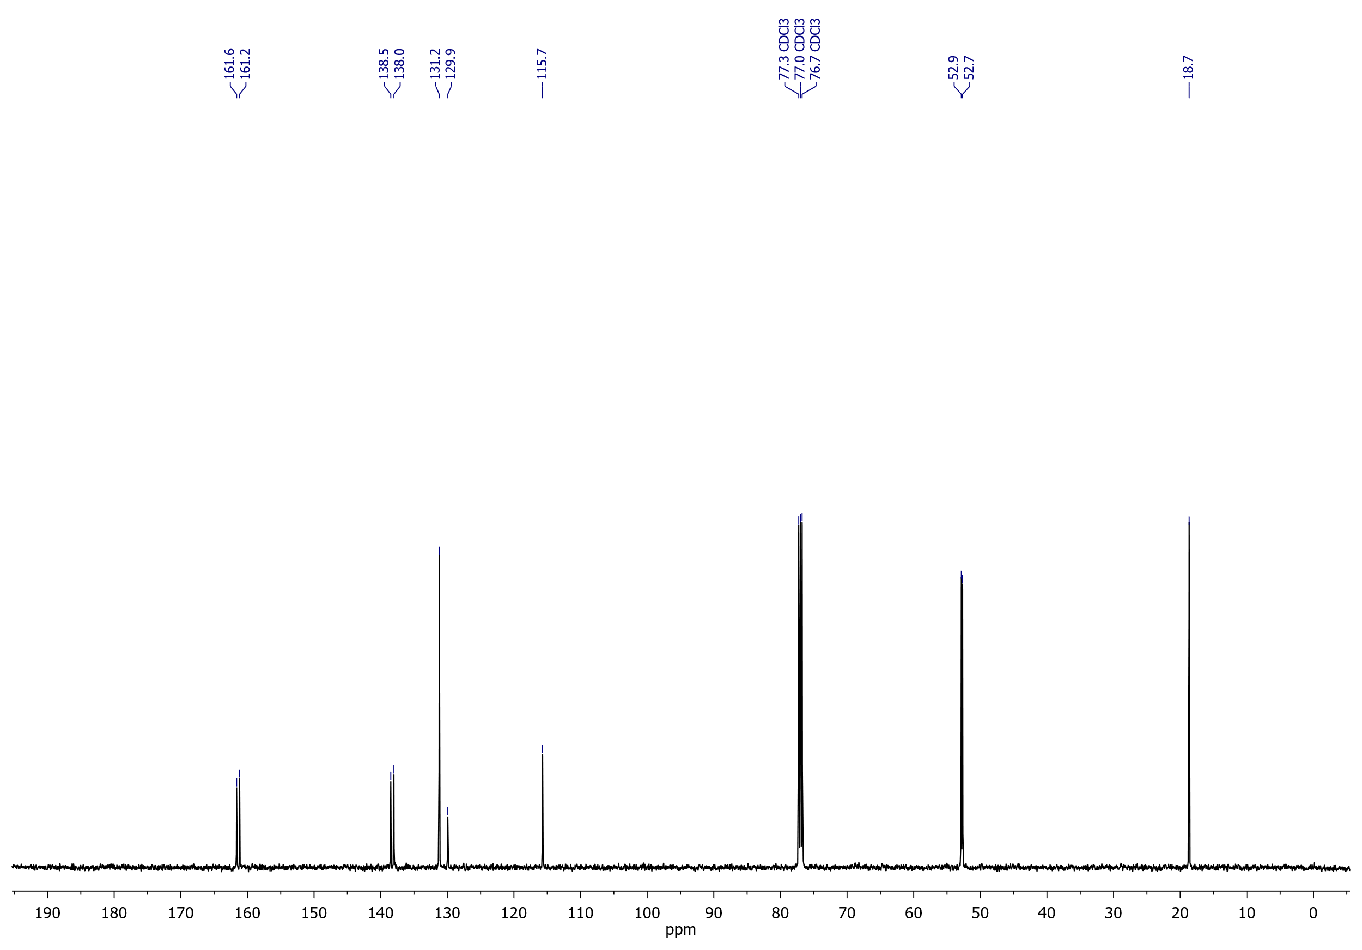

## Dimethyl 3-[(2-oxo-2-phenylethyl)thio]thiophene-2,5-dicarboxylate (**6a**)

1H NMR (400 MHz, CDCl3)



Dimethyl 3-[(2-oxo-2-phenylethyl)thio]thiophene-2,5-dicarboxylate (**6a**)

13C NMR (126 MHz, CDCl3)



## Dimethyl 3-{[2-(4-fluorophenyl)-2-oxoethyl]thio}thiophene-2,5-dicarboxylate (**6b**)

1H NMR (400 MHz, CDCl3)

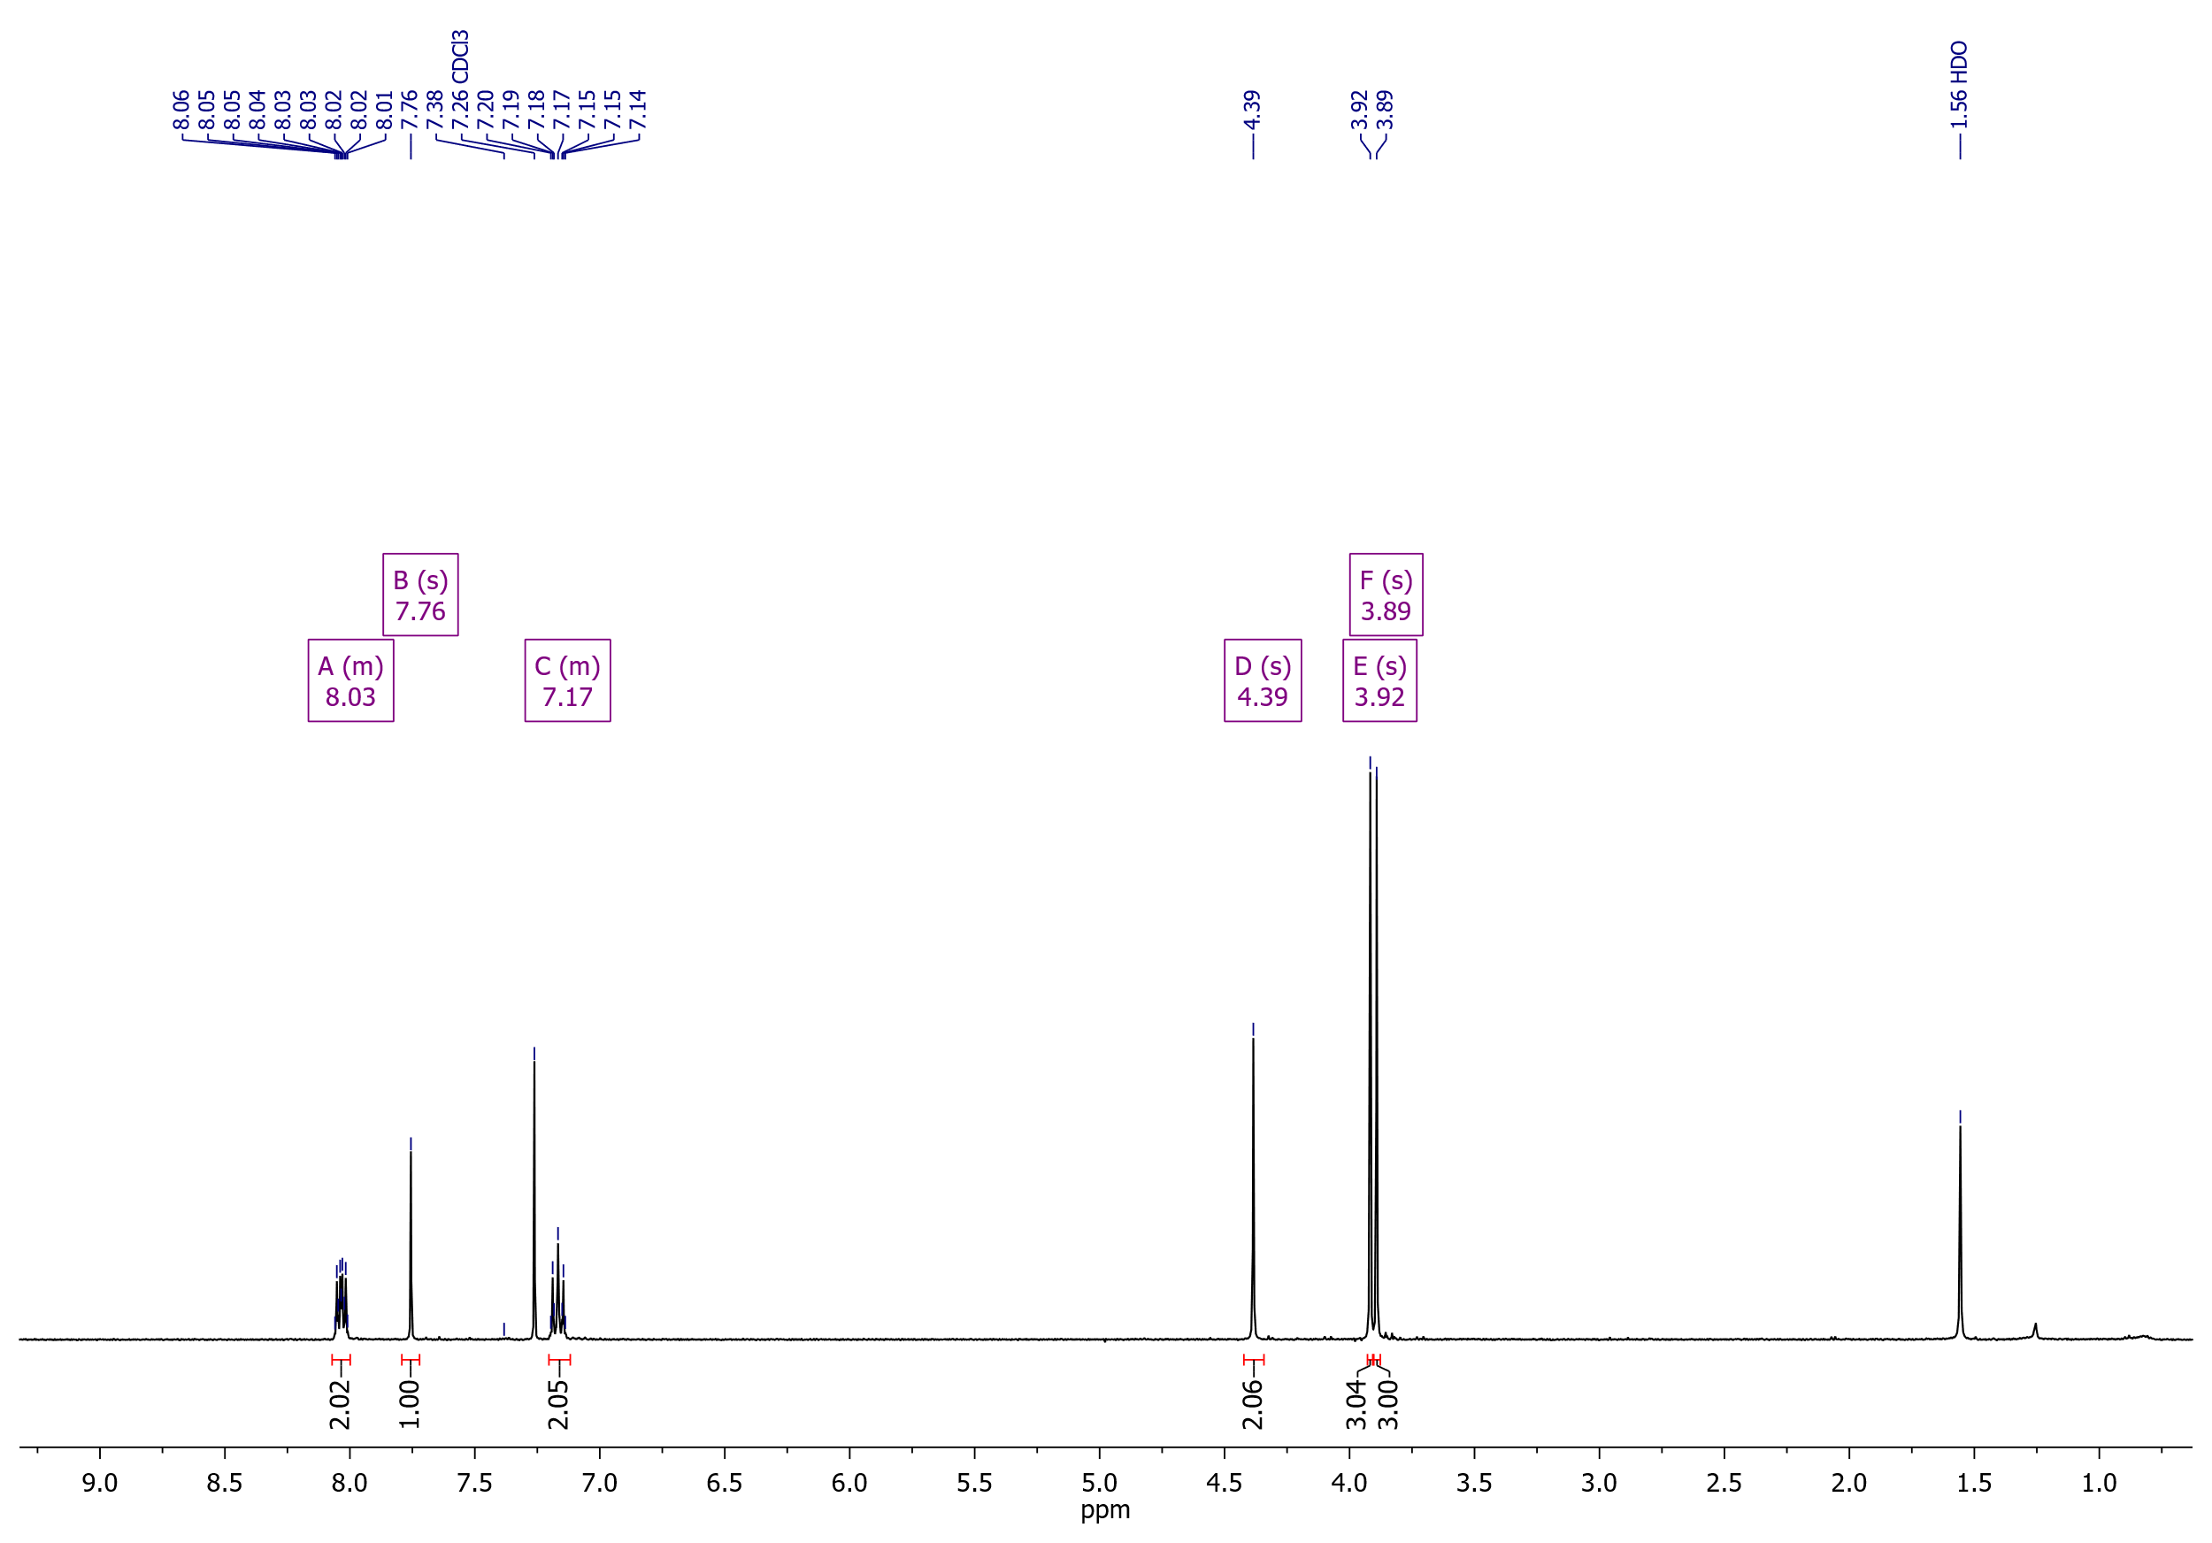

Dimethyl 3-{[2-(4-fluorophenyl)-2-oxoethyl]thio}thiophene-2,5-dicarboxylate (**6b**)

19F NMR (376 MHz, CDCl3)

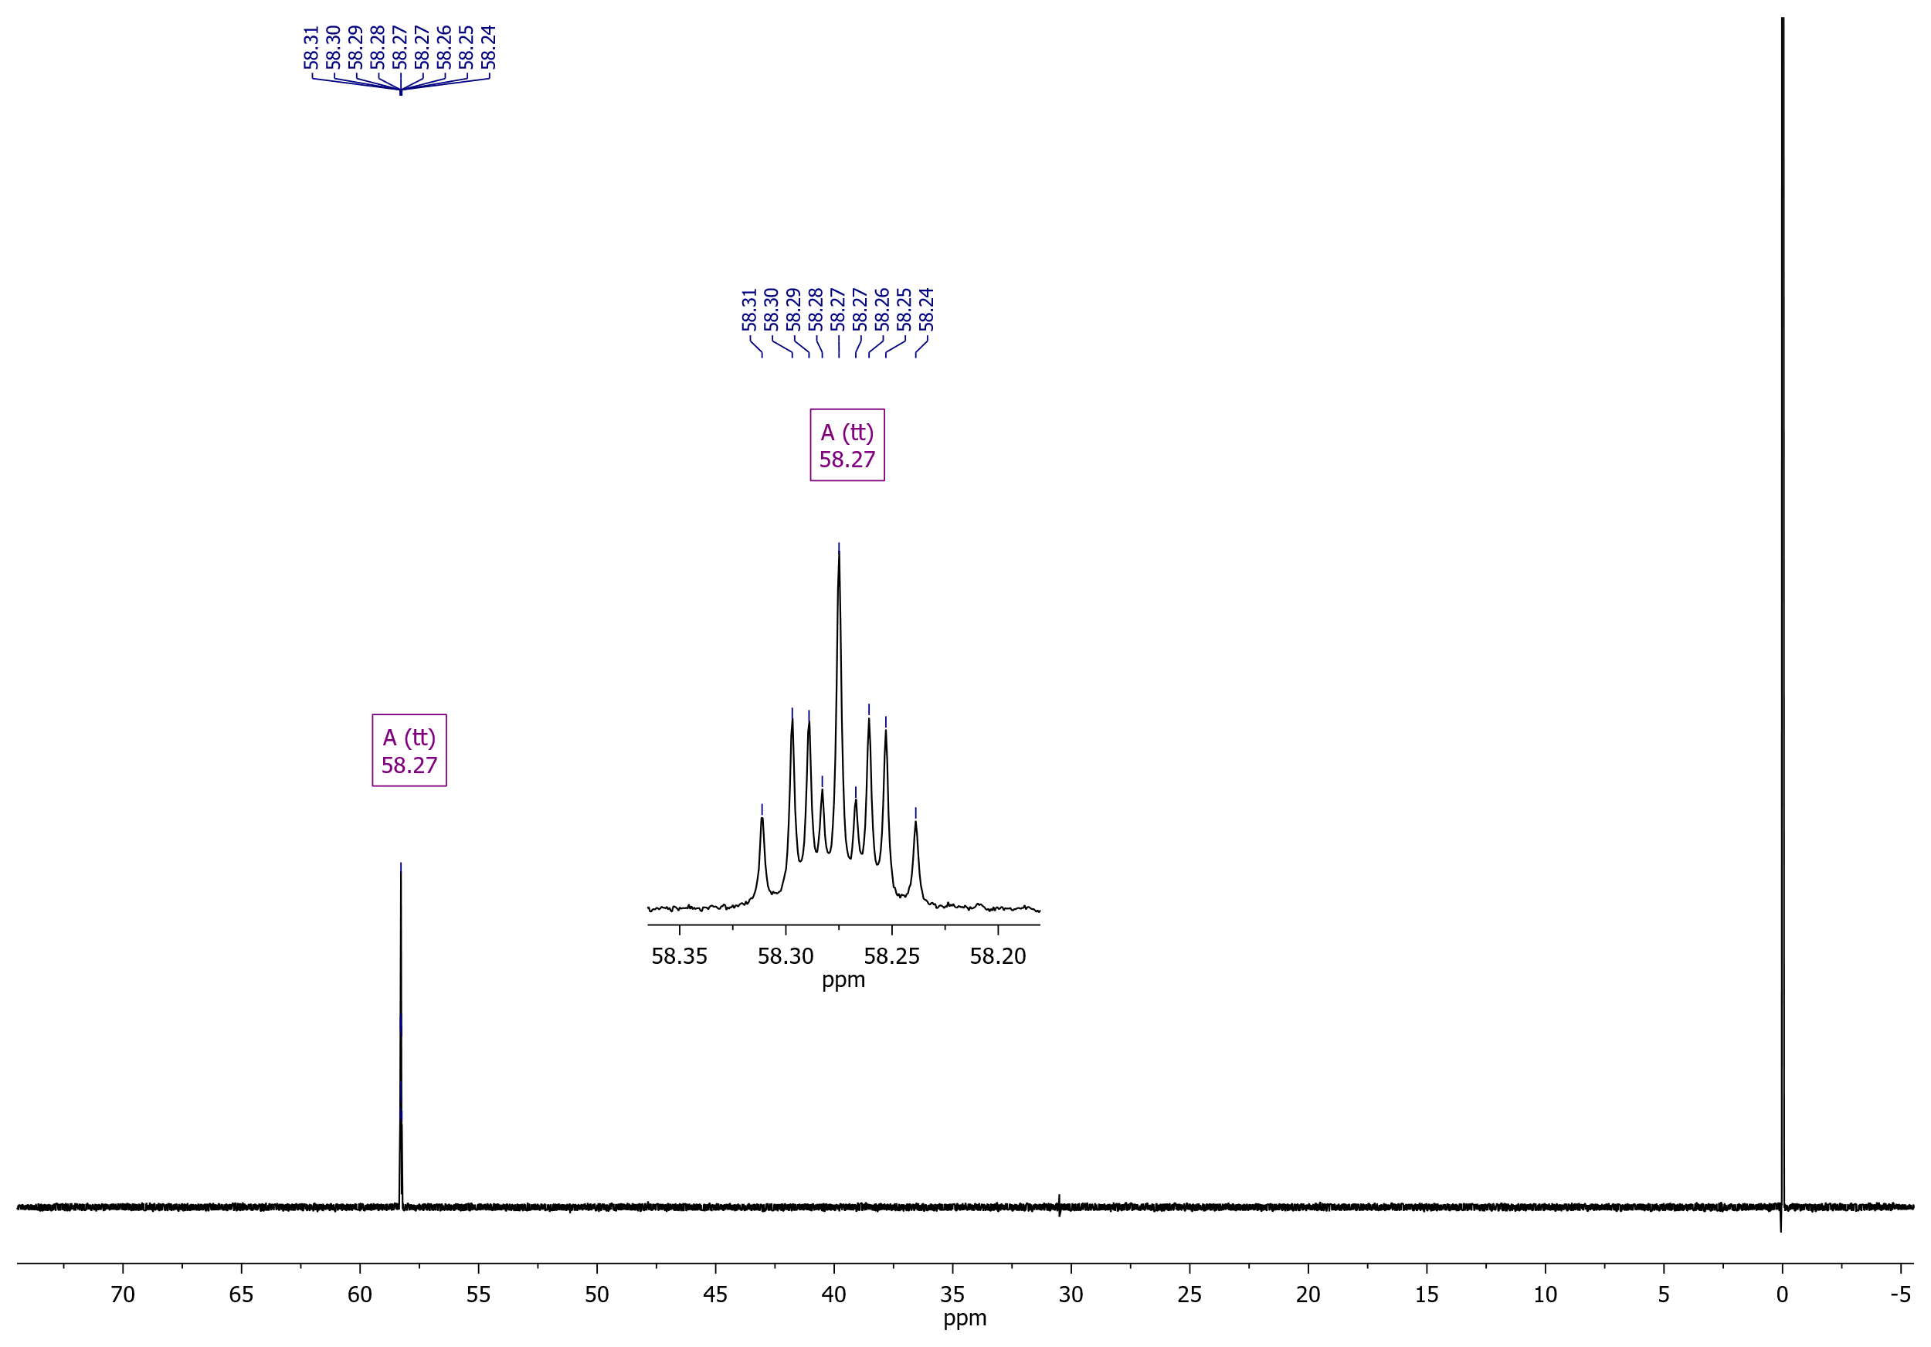

Dimethyl 3-{[2-(4-fluorophenyl)-2-oxoethyl]thio}thiophene-2,5-dicarboxylate (**6b**)

13C NMR (126 MHz, CDCl3)

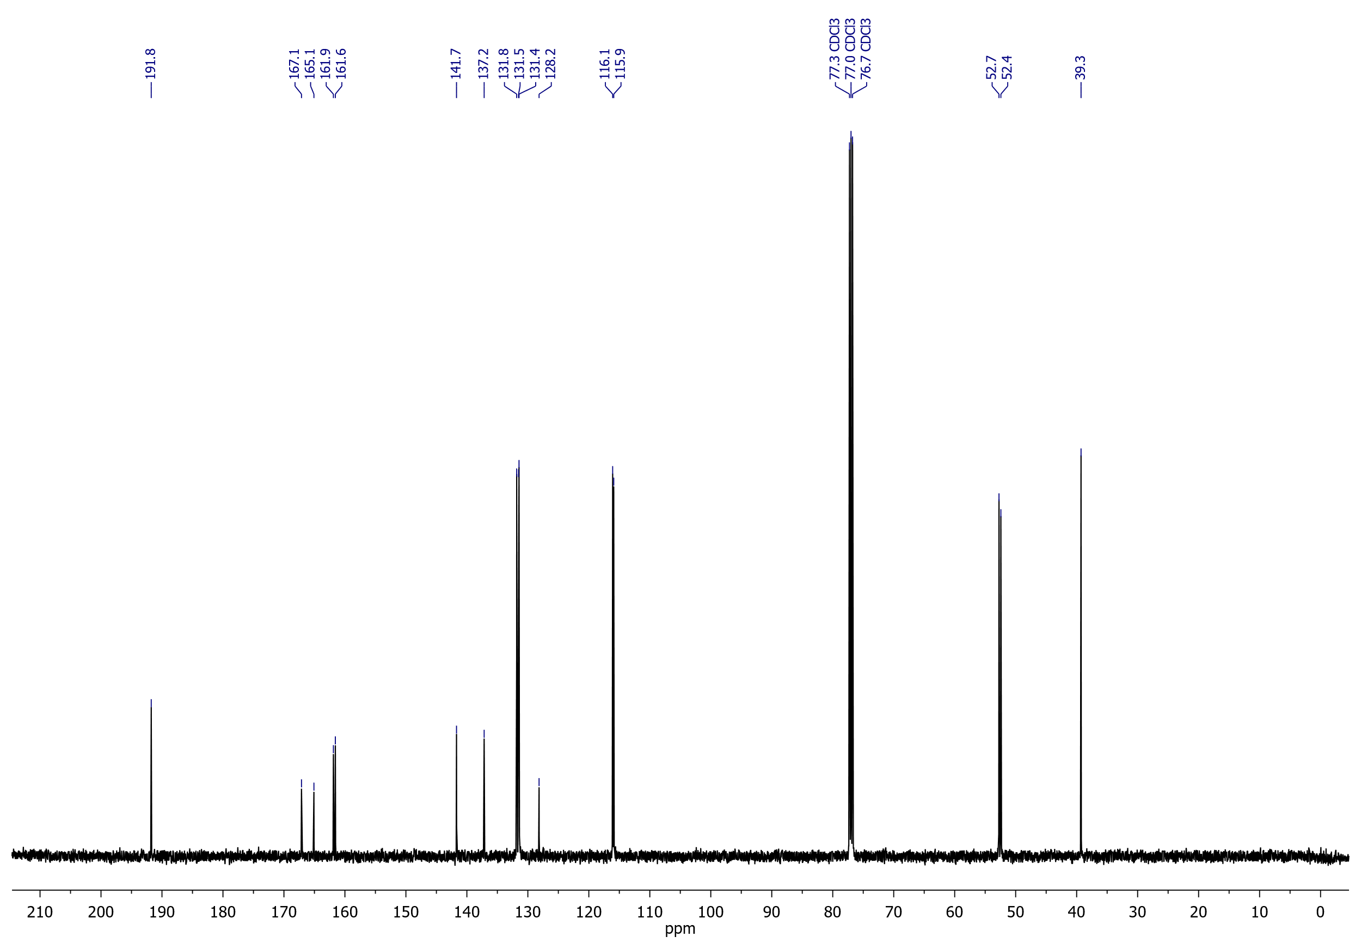

## Dimethyl 3-{[2-oxo-2-(thiophen-2-yl)ethyl]thio}thiophene-2,5-dicarboxylate (**6c**)

1H NMR (400 MHz, CDCl3)

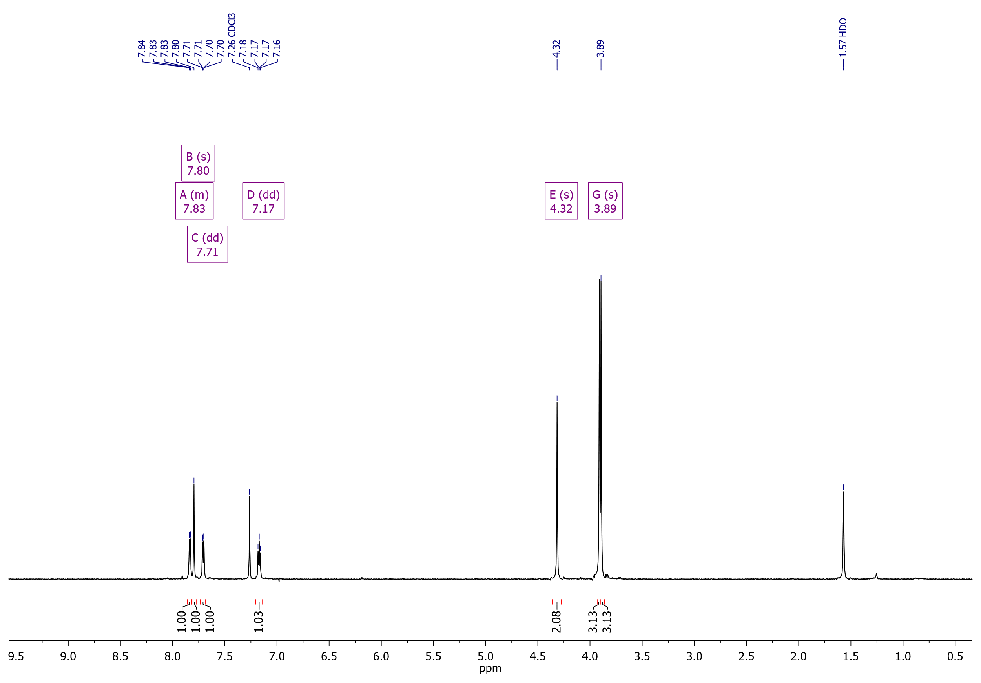

Dimethyl 3-{[2-oxo-2-(thiophen-2-yl)ethyl]thio}thiophene-2,5-dicarboxylate (**6c**)

13C NMR (126 MHz, CDCl3)

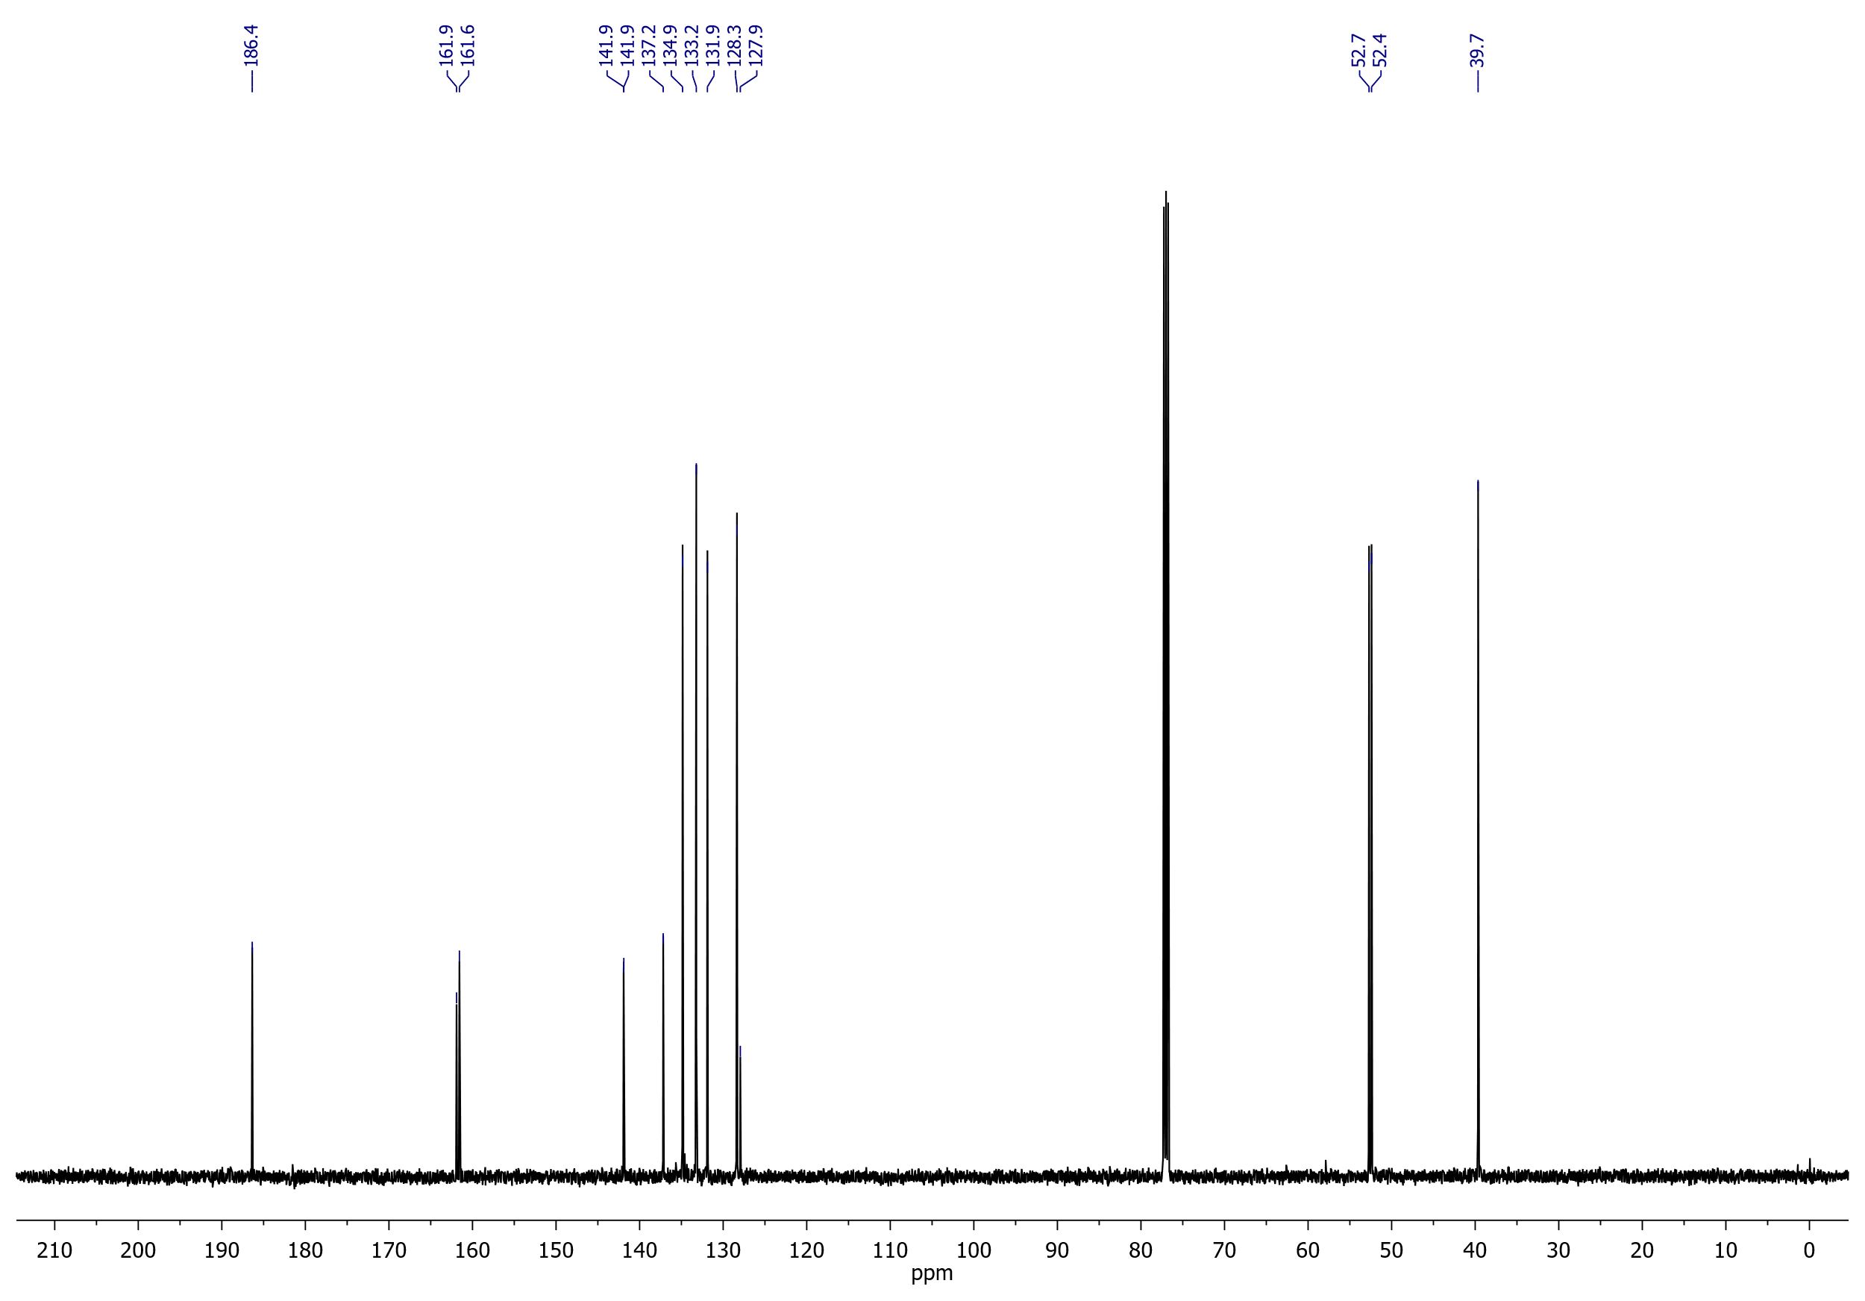

## Methyl 5-(4-cyanophenyl)-6-hydroxythieno[3,2-*b*]thiophene-2-carboxylate (**7a**)

1H NMR (400 MHz, DMSO-*d*6)

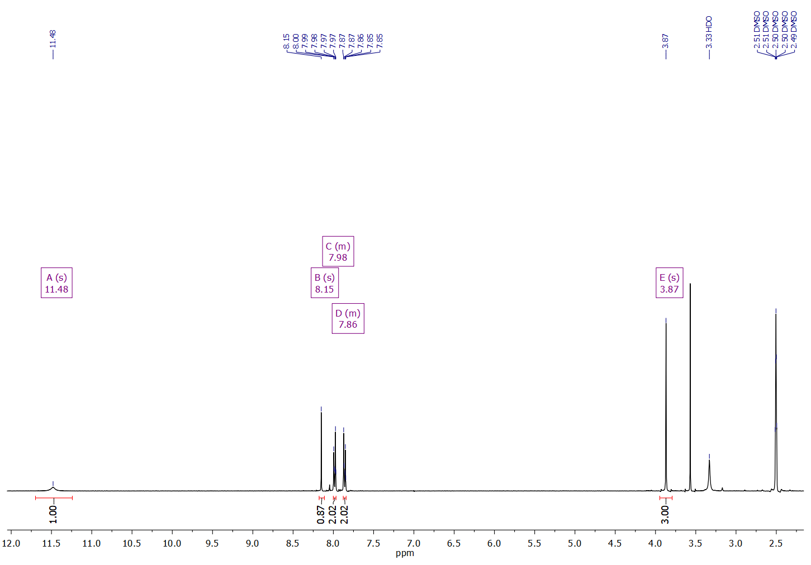

Methyl 5-(4-cyanophenyl)-6-hydroxythieno[3,2-*b*]thiophene-2-carboxylate (**7a**)

13C NMR (126 MHz, DMSO-*d*6)

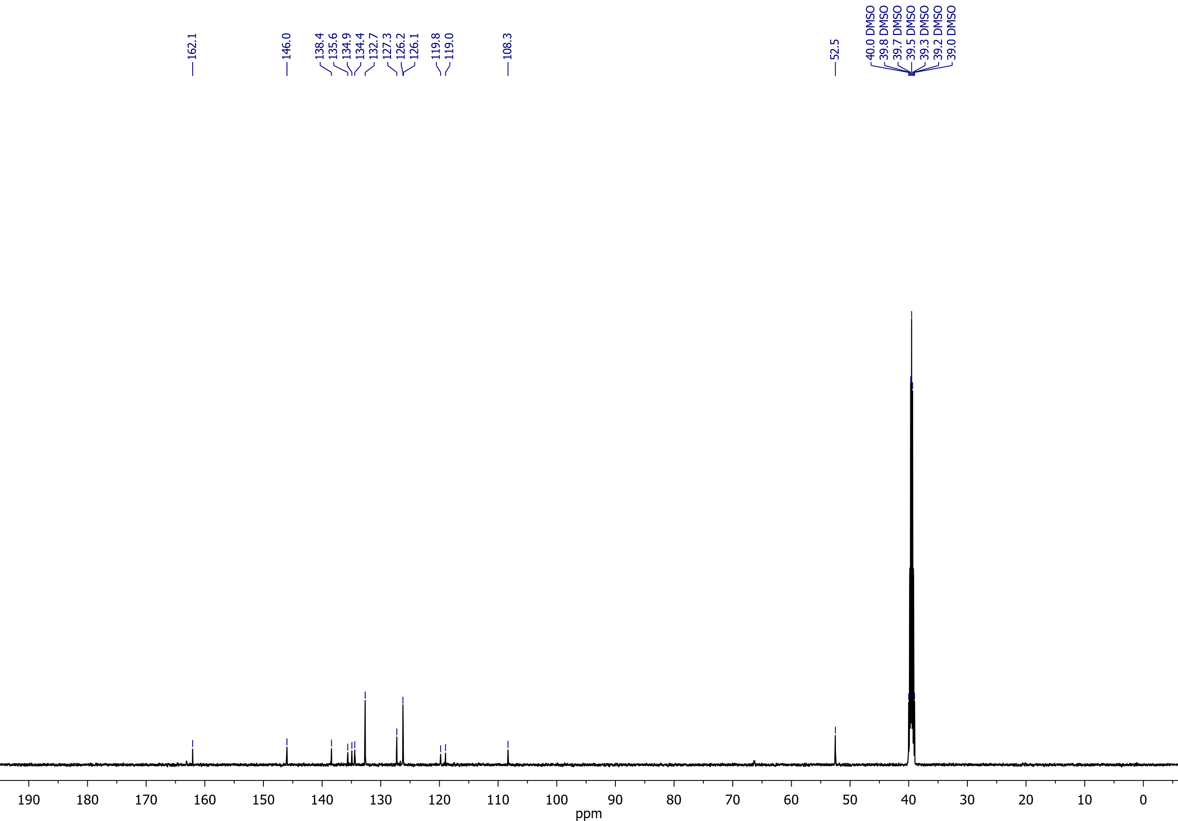

## Methyl 6-hydroxy-5-[4-(methoxycarbonyl)phenyl]thieno[3,2-*b*]thiophene-2-carboxylate (**7b**)

1H NMR (400 MHz, DMSO-*d*6)

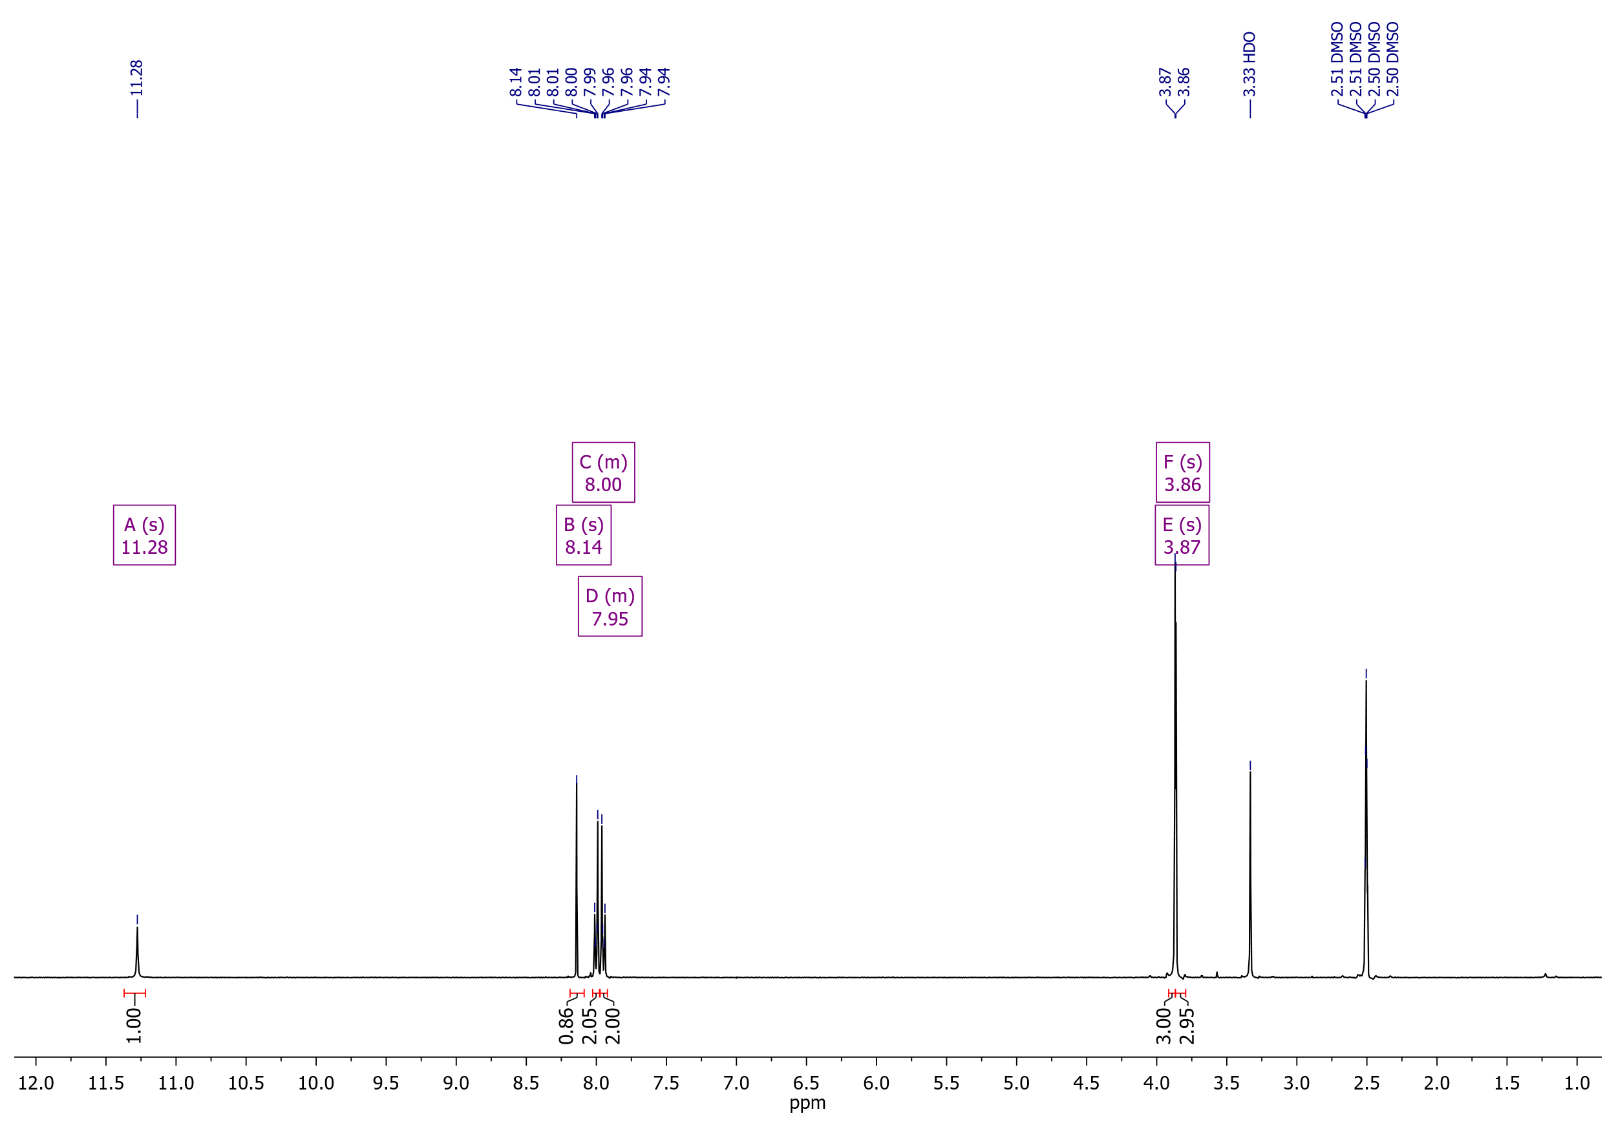

Methyl 6-hydroxy-5-[4-(methoxycarbonyl)phenyl]thieno[3,2-*b*]thiophene-2-carboxylate (**7b**)

13C NMR (126 MHz, DMSO-*d*6)

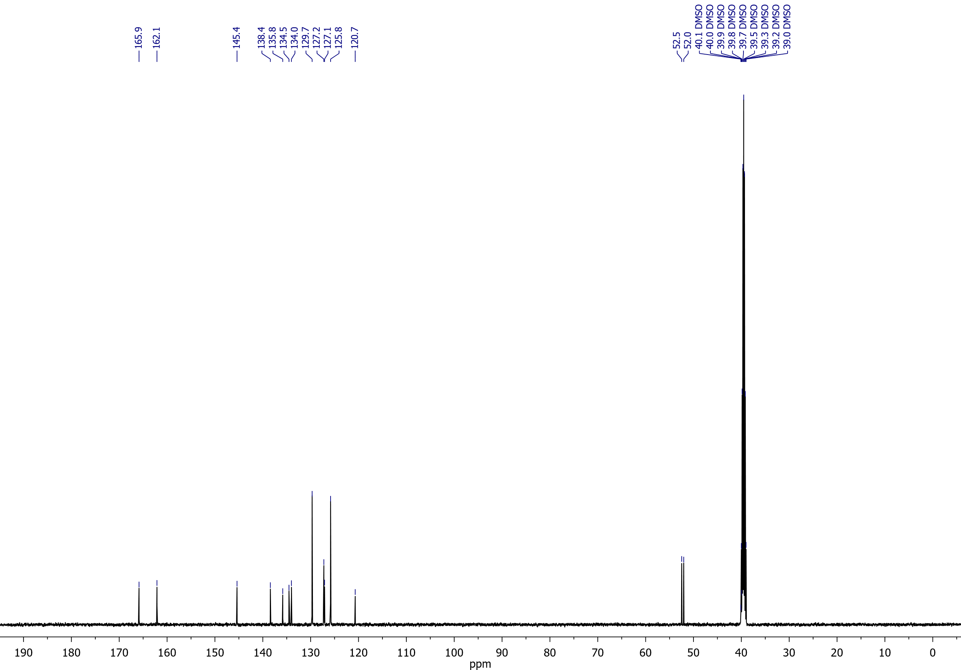

## Methyl 5-cyano-6-hydroxythieno[3,2-*b*]thiophene-2-carboxylate (**8a**)

1H NMR (400 MHz, DMSO-*d*6)

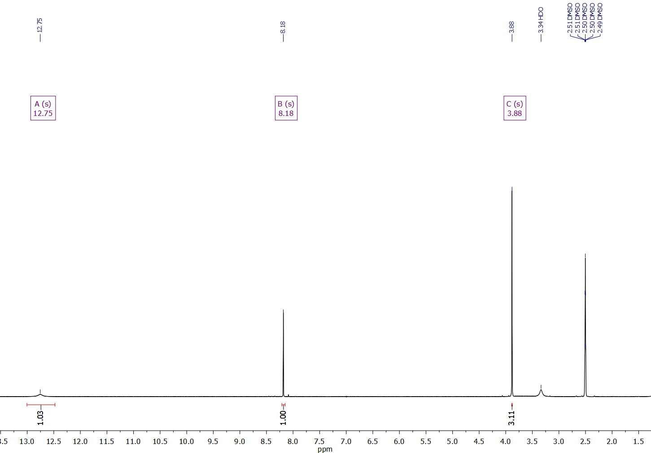

Methyl 5-cyano-6-hydroxythieno[3,2-*b*]thiophene-2-carboxylate (**8a**)

13С NMR (126 MHz, DMSO-*d*6)

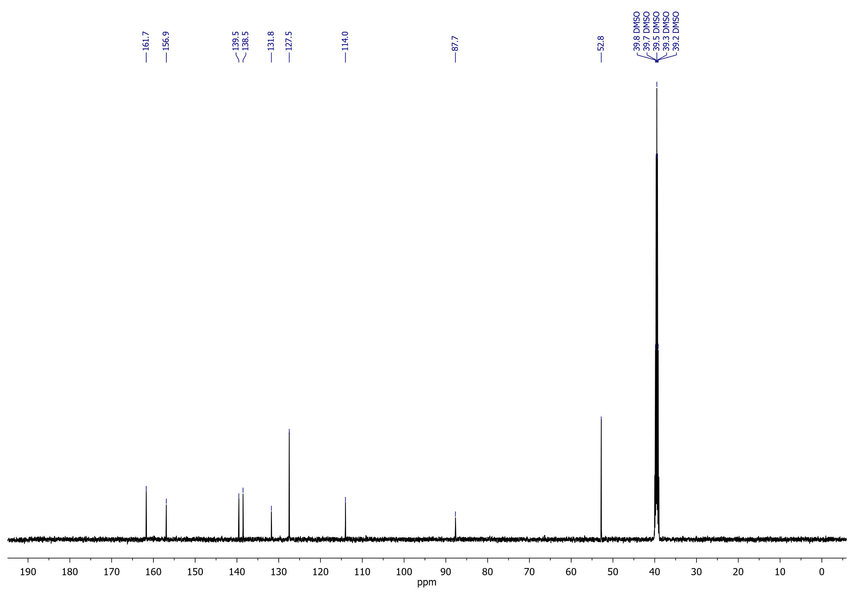

## 5-(4-Fluorobenzoyl)-6-hydroxythieno[3,2-*b*]thiophene-2-carboxylic acid (**9bA**)

1H NMR (400 MHz, DMSO-*d*6)

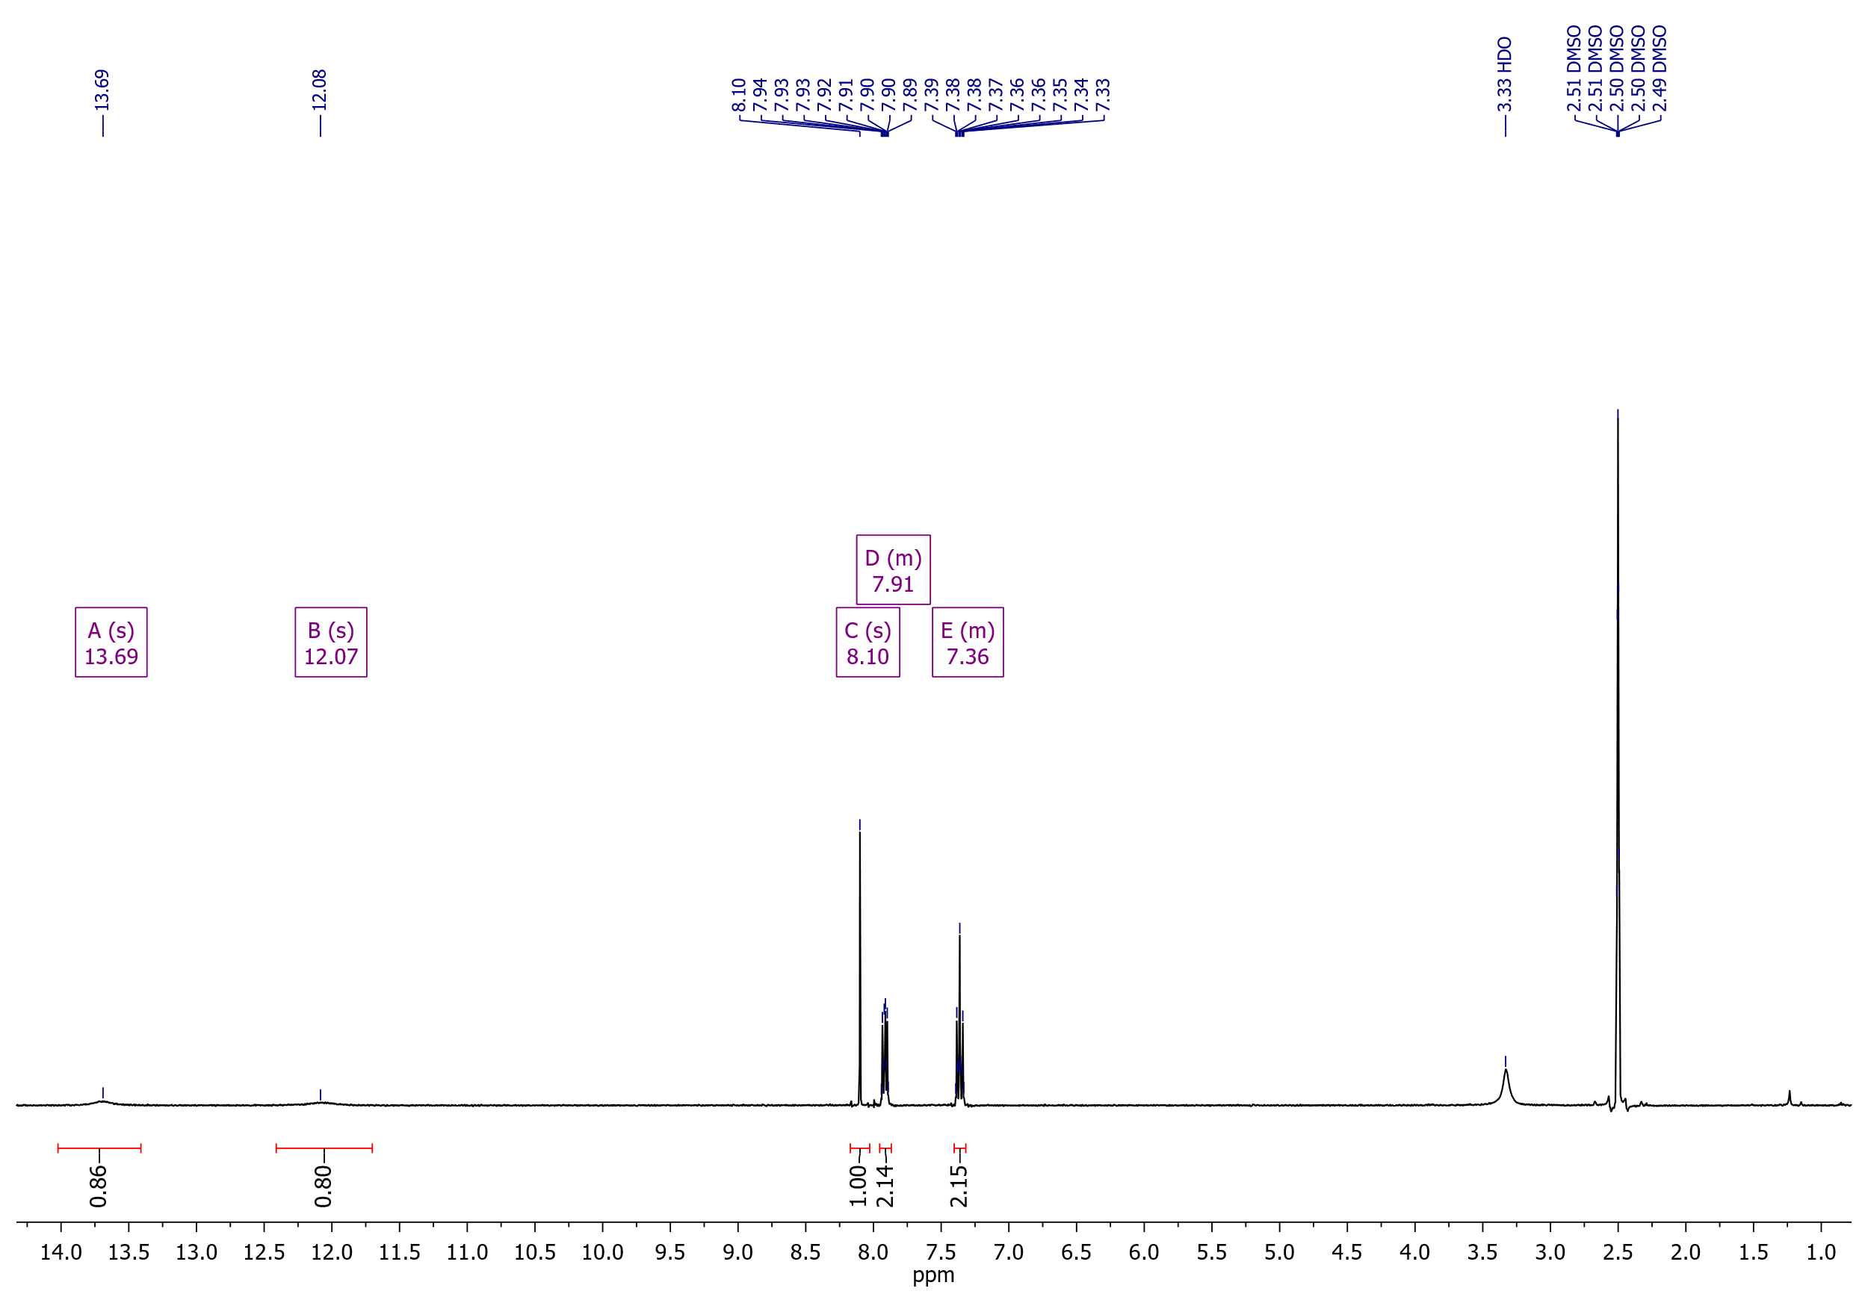

5-(4-Fluorobenzoyl)-6-hydroxythieno[3,2-*b*]thiophene-2-carboxylic acid (**9bA**)

19F NMR (376 MHz, DMSO-*d*6)

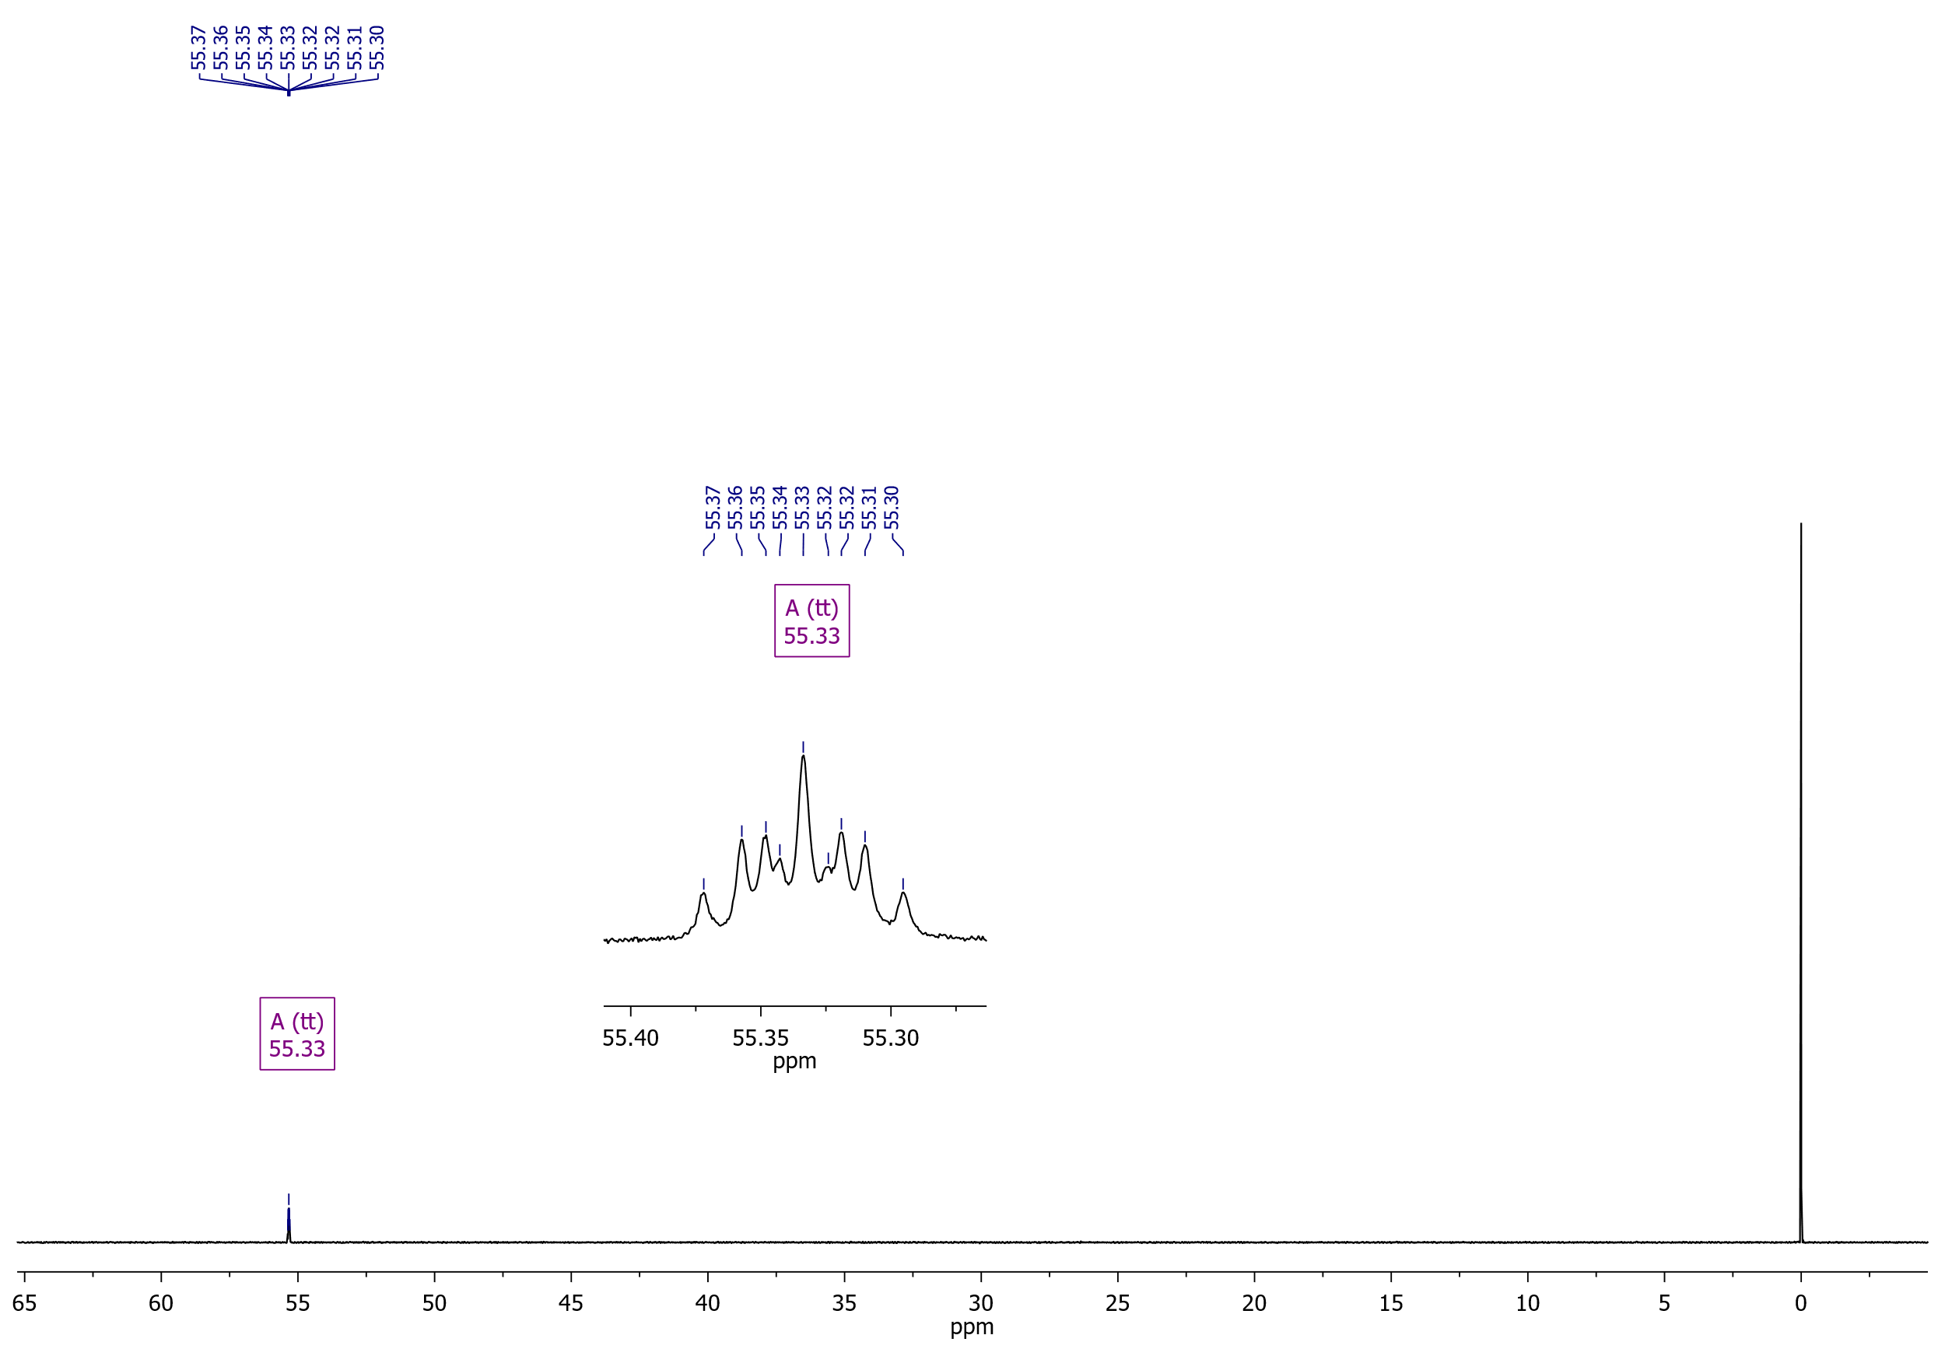

5-(4-Fluorobenzoyl)-6-hydroxythieno[3,2-*b*]thiophene-2-carboxylic acid (**9bA**)

13C NMR (126 MHz, DMSO-*d*6)

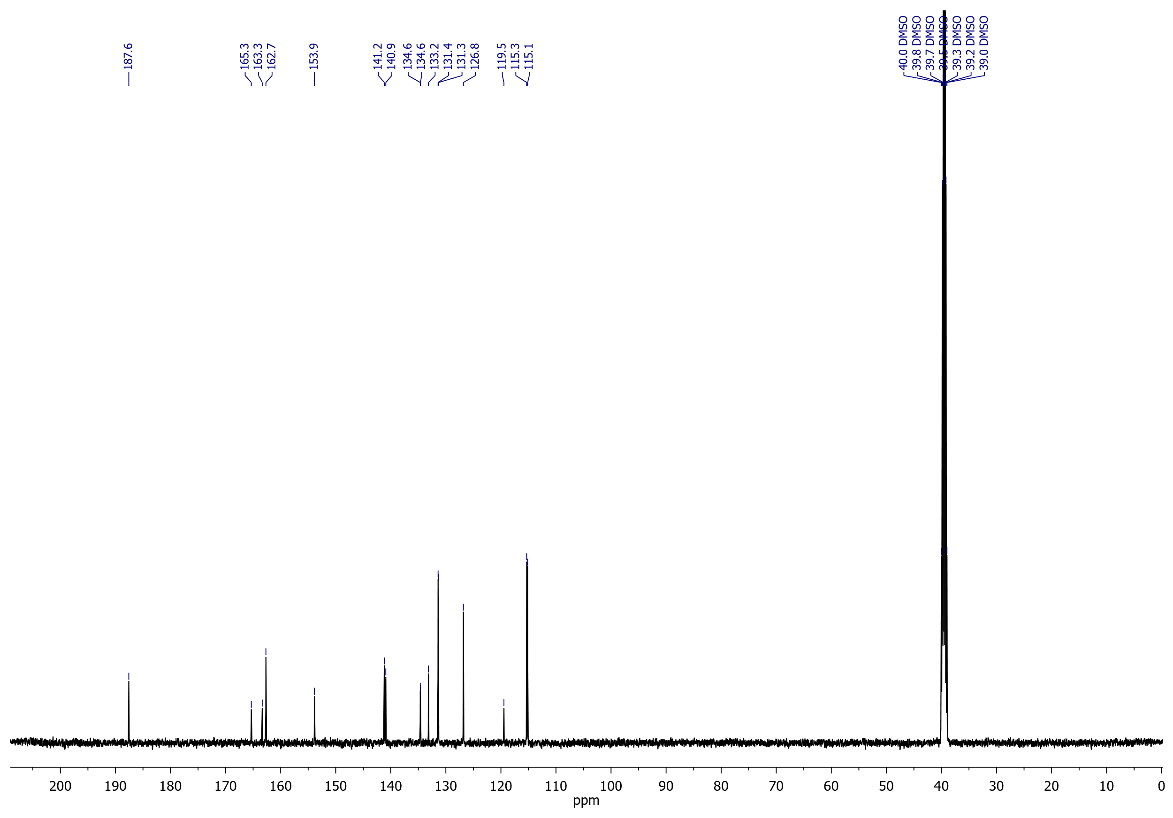

## Methyl 5-benzoyl-6-hydroxythieno[3,2-*b*]thiophene-2-carboxylate (**9a**)

1H NMR (400 MHz, DMSO-*d*6)

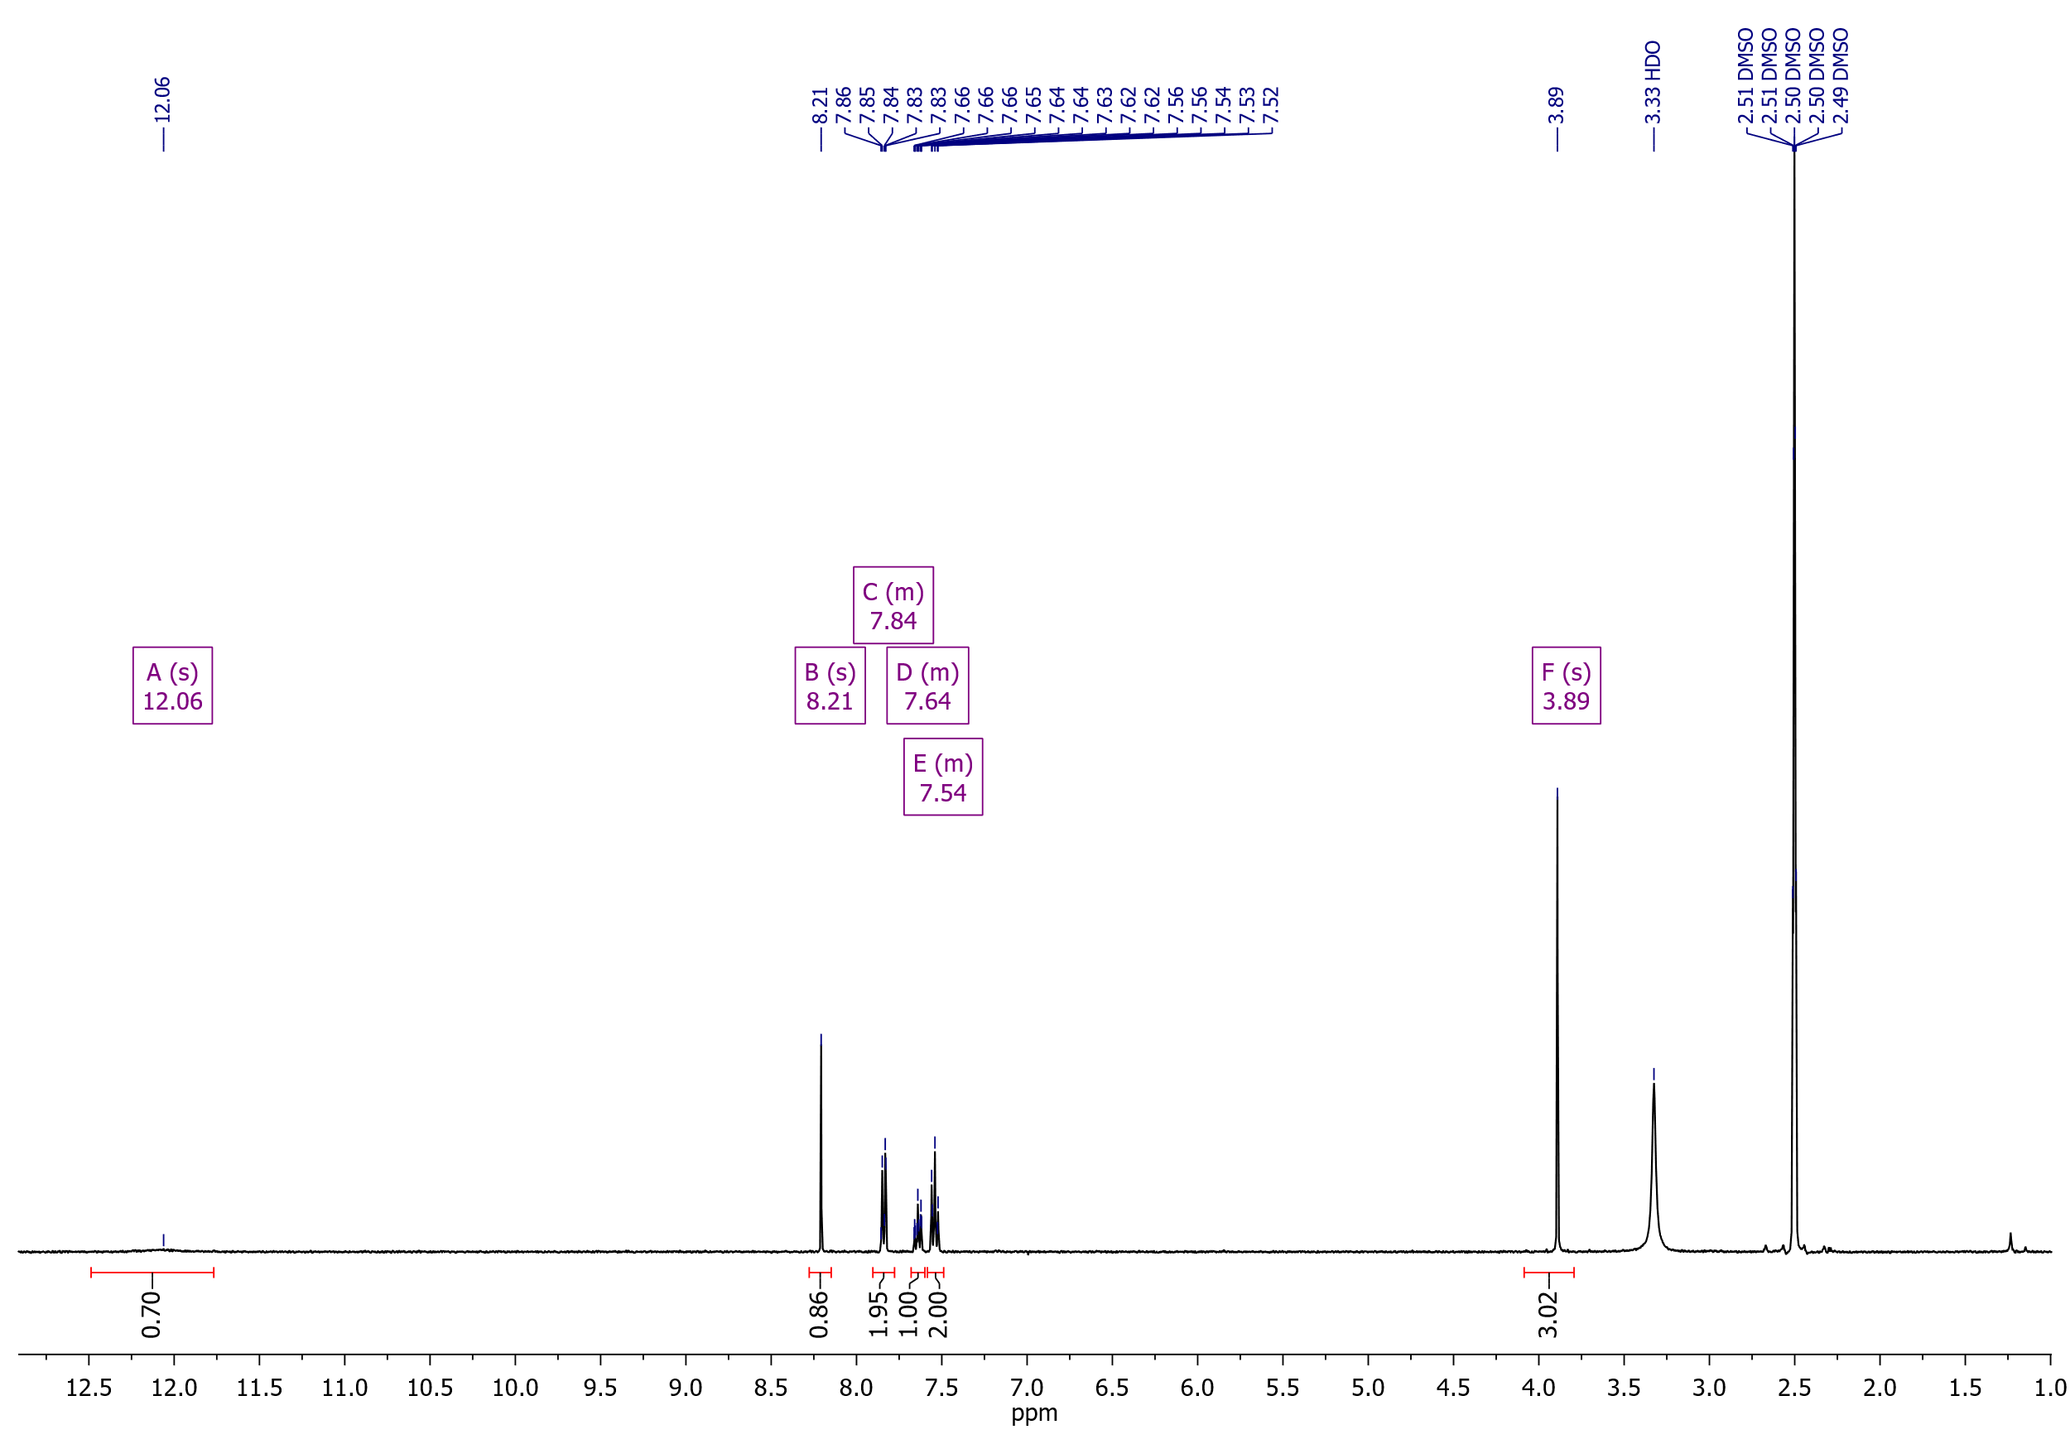

Methyl 5-benzoyl-6-hydroxythieno[3,2-*b*]thiophene-2-carboxylate (**9a**)

13C NMR (126 MHz, DMSO-*d*6)

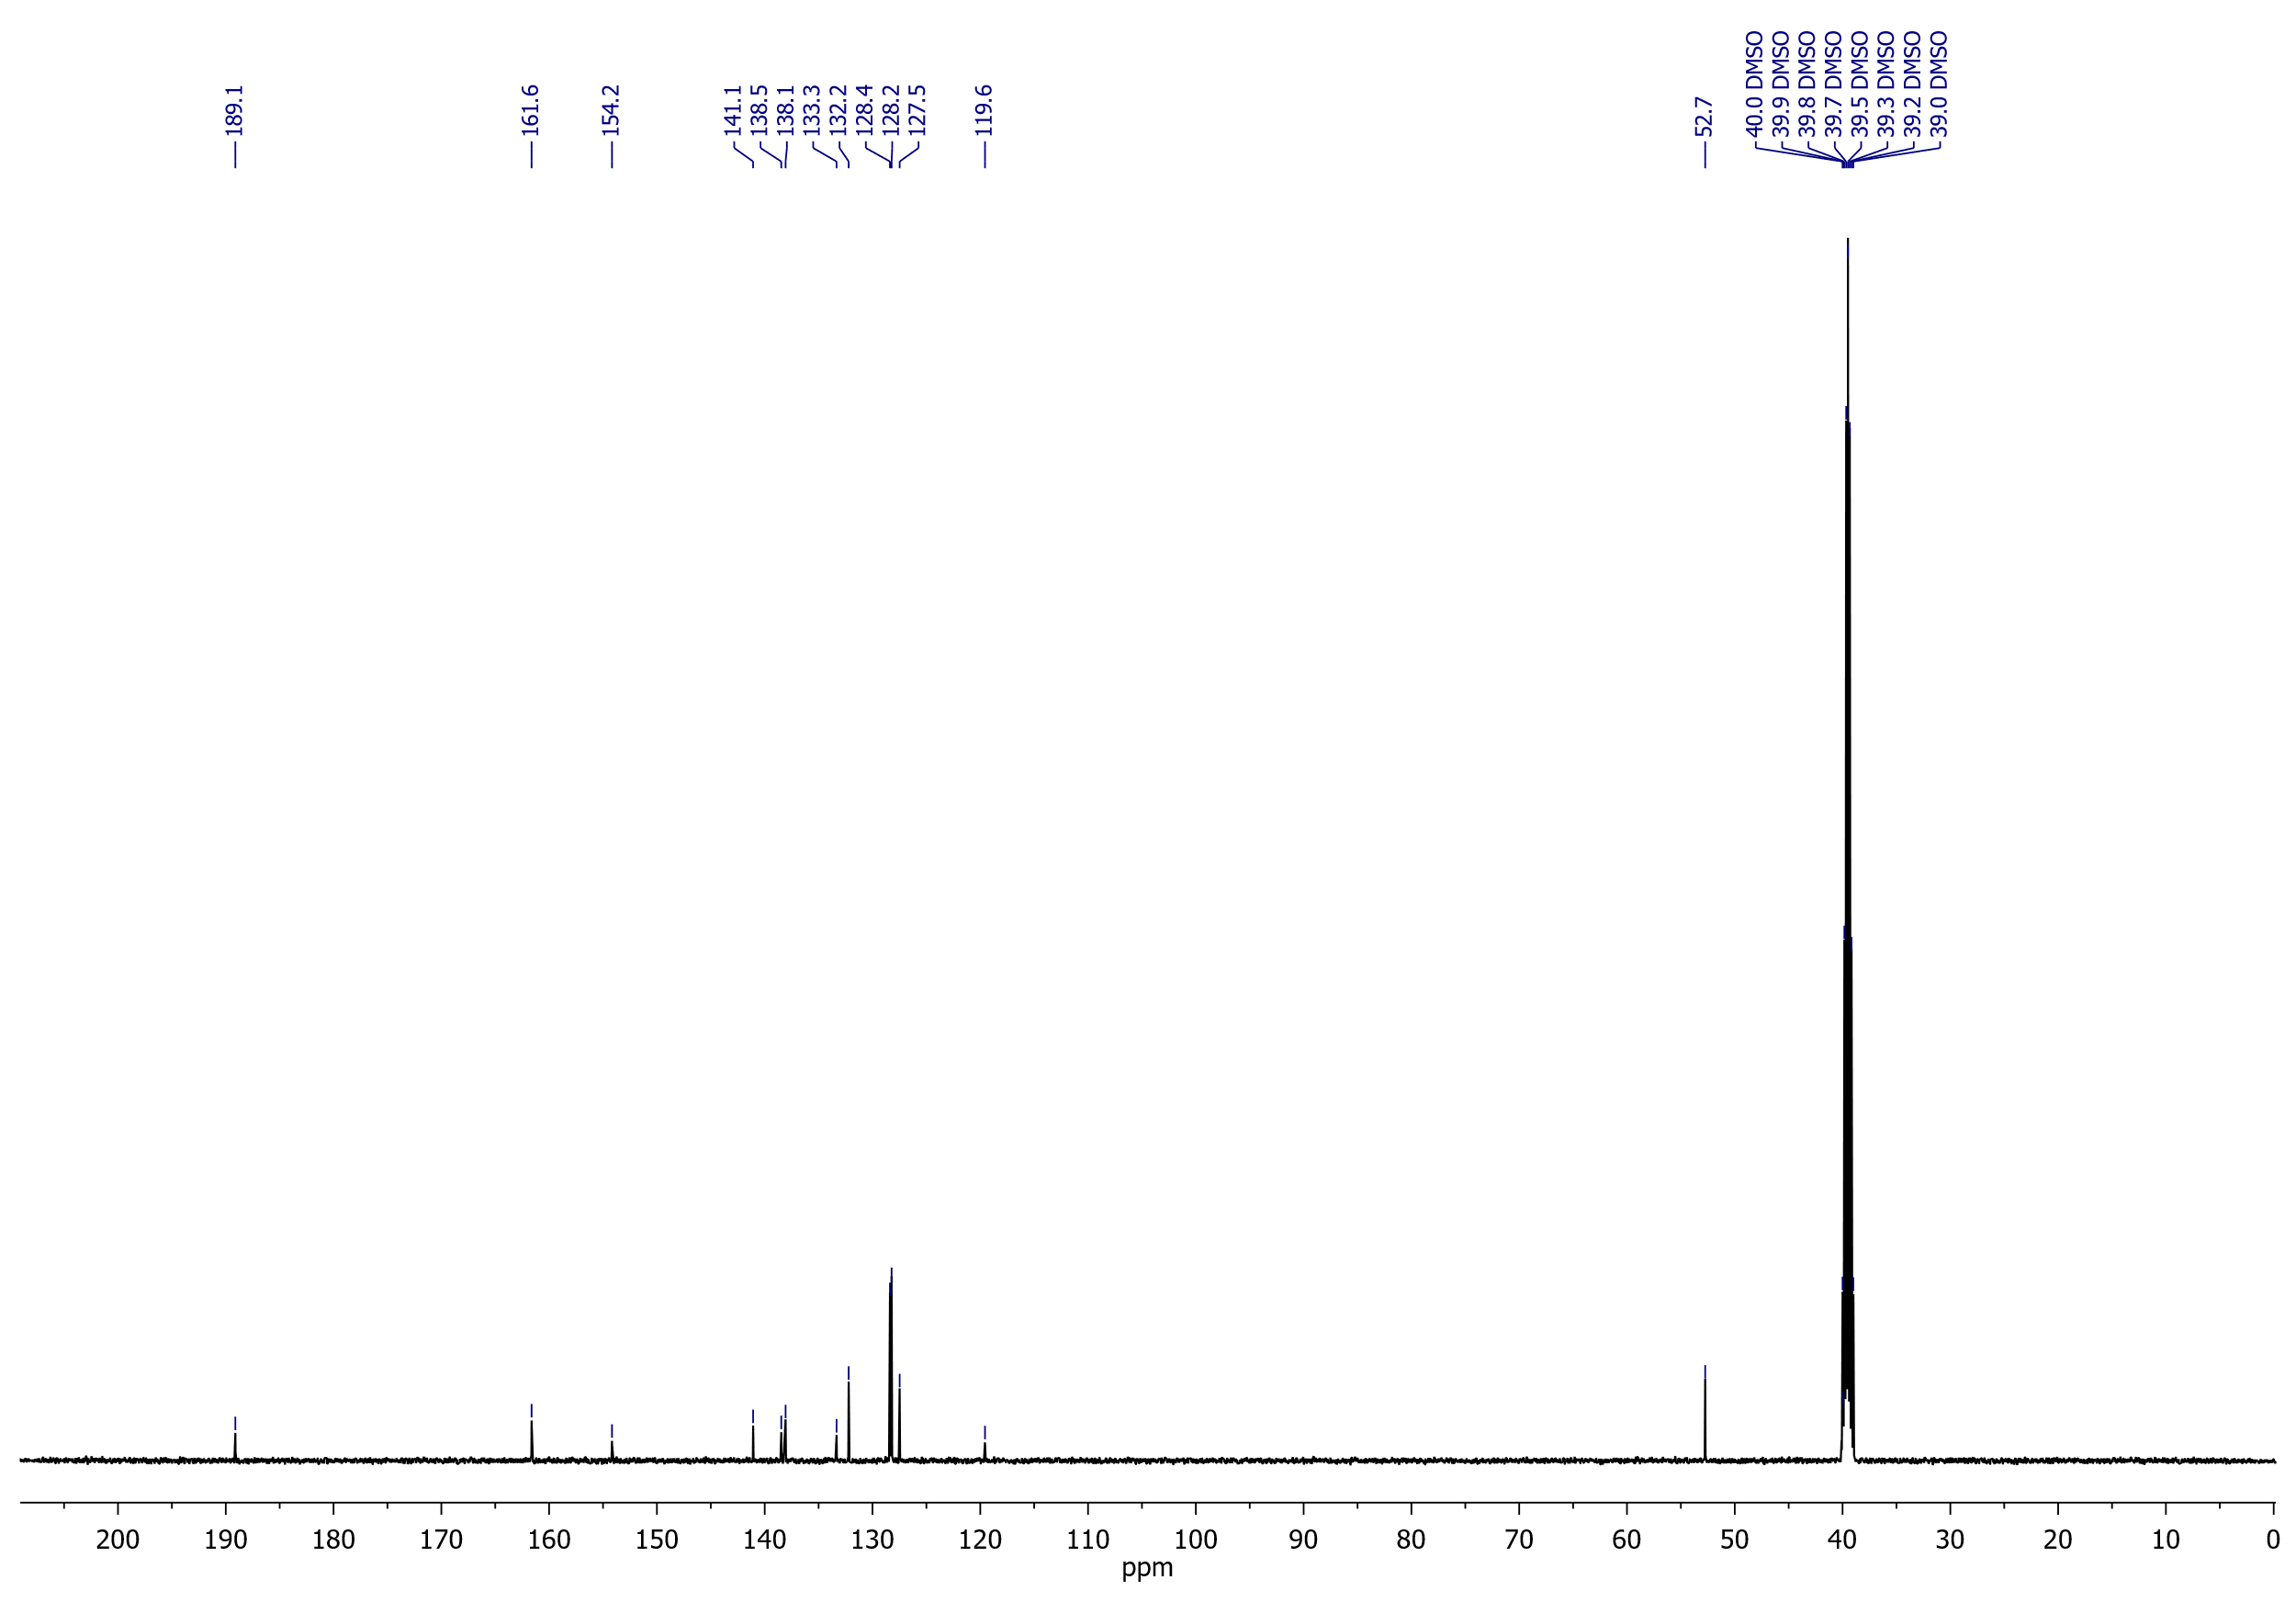

## Methyl 5-(4-fluorobenzoyl)-6-hydroxythieno[3,2-*b*]thiophene-2-carboxylate (**9b**)

1H NMR (400 MHz, DMSO-*d*6)

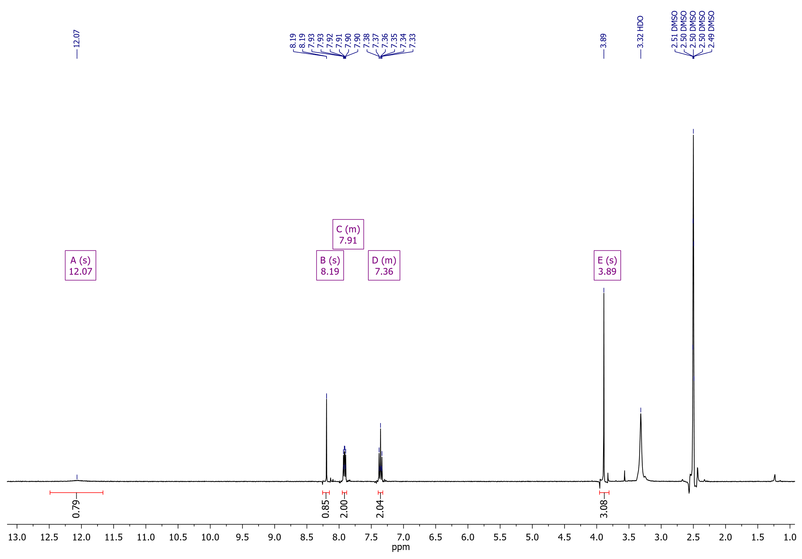

Methyl 5-(4-fluorobenzoyl)-6-hydroxythieno[3,2-*b*]thiophene-2-carboxylate (**9b**)

19F NMR (376 MHz, DMSO-*d*6)

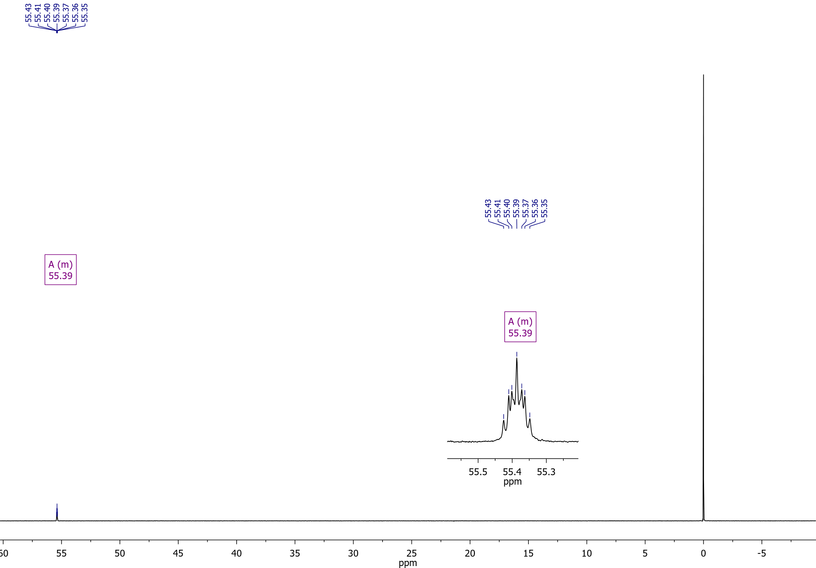

Methyl 5-(4-fluorobenzoyl)-6-hydroxythieno[3,2-*b*]thiophene-2-carboxylate (**9b**)

13C NMR (126 MHz, DMSO-*d*6)

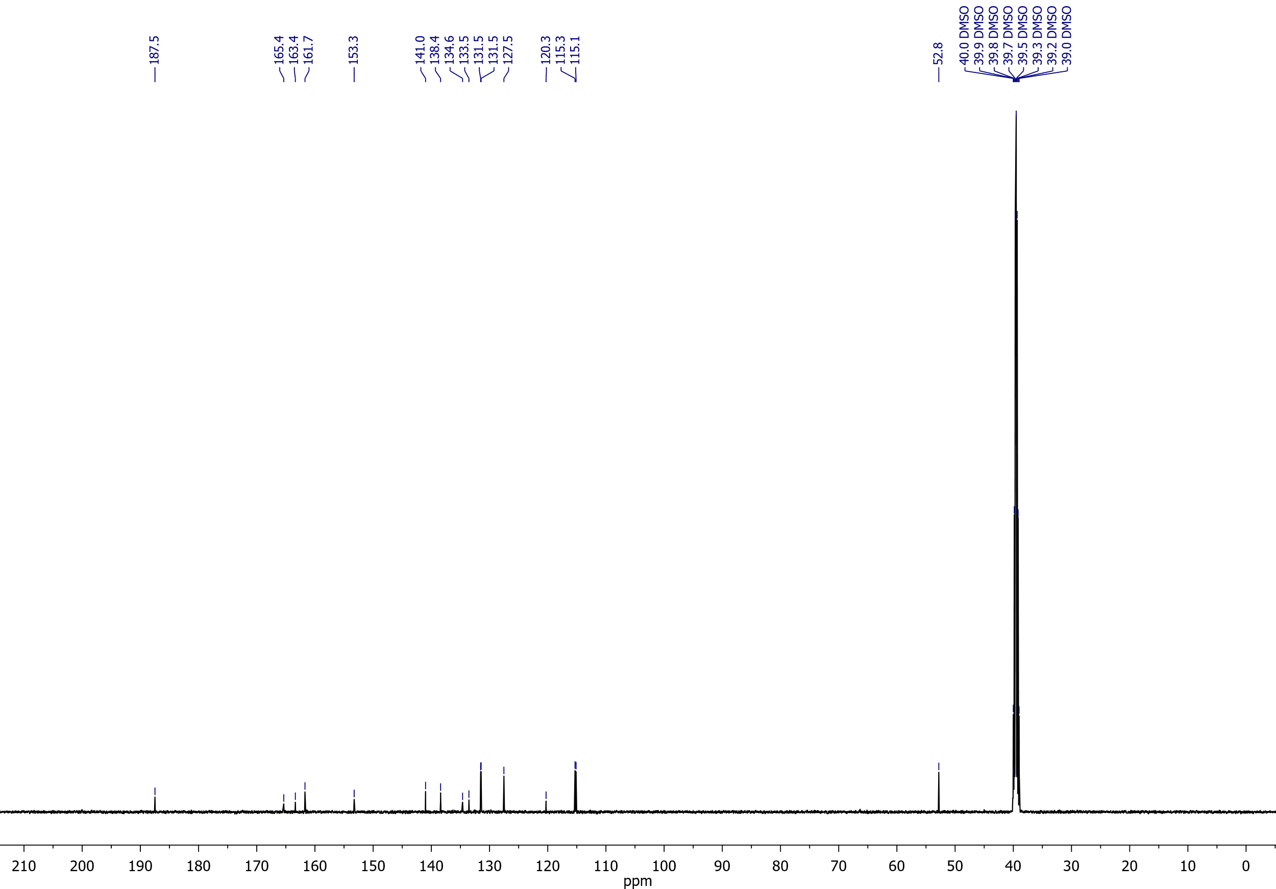

## Methyl 6-hydroxy-5-(thiophene-2-carbonyl)thieno[3,2-*b*]thiophene-2-carboxylate (**9c**)

1H NMR (400 MHz, CDCl3)

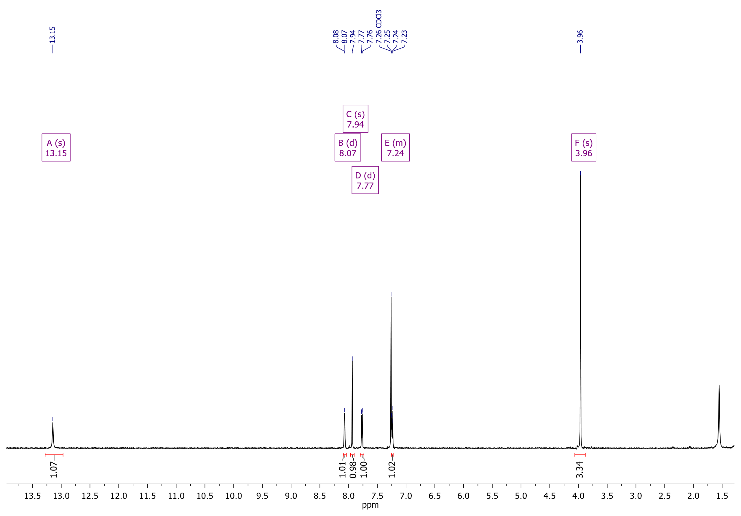

Methyl 6-hydroxy-5-(thiophene-2-carbonyl)thieno[3,2-*b*]thiophene-2-carboxylate (**9c**)

1H NMR (500 MHz, DMSO-*d*6)

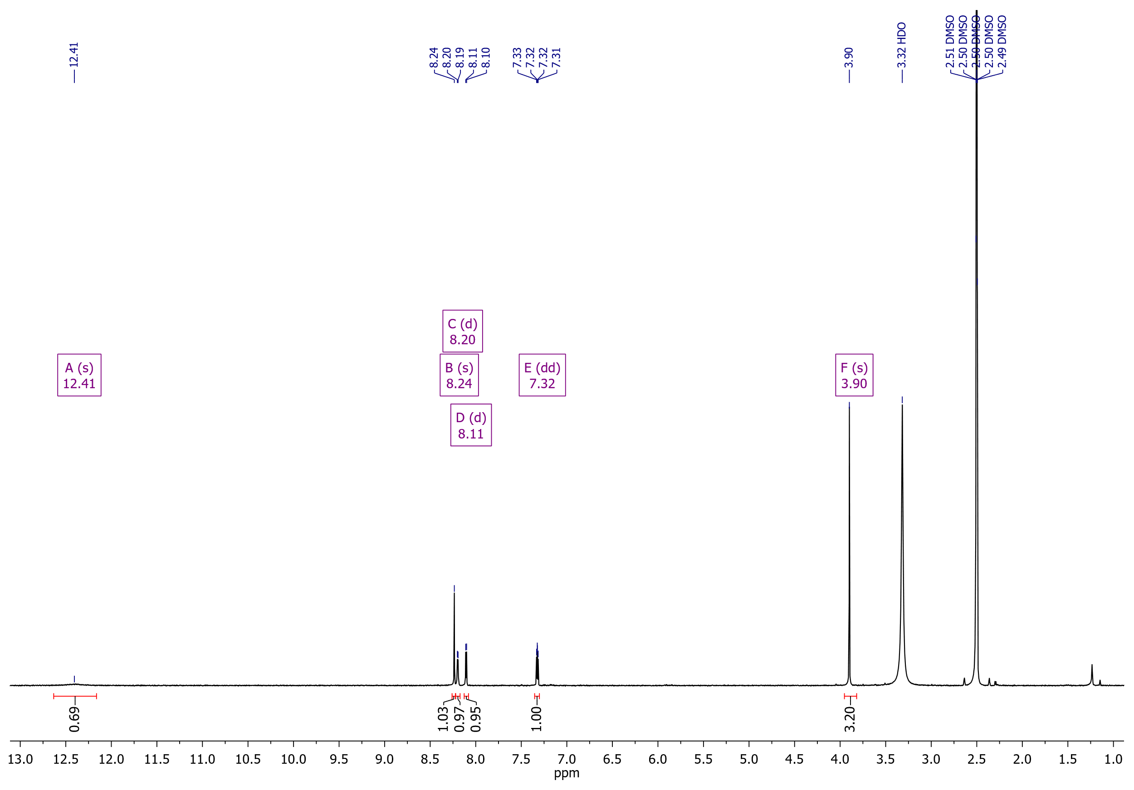

Methyl 6-hydroxy-5-(thiophene-2-carbonyl)thieno[3,2-*b*]thiophene-2-carboxylate (**9c**)

13C NMR (126 MHz, DMSO-*d*6)

