# Supporting Information

# Gold nanoparticle-decorated reduced graphene oxide (rGO) as a highly reactive catalyst for the selective α,β-dehydrogenation of N-methyl-4-piperidone

Brenda Flore Kenyim1, Mihir Tzalis1, Marilyn Kaul1, Robert Oestreich1, Aysenur Limon1, Chancellin Pecheu Nkepdep1, Christoph Janiak1*

Address: 1 Institut für Anorganische Chemie und Strukturchemie, Heinrich-Heine-Universität, 40204 Düsseldorf, Germany.

Emails: brenda.kenyim@uni-duesseldorf.de, tzalism@gmail.com, marilyn.kaul@ uni-duesseldorf.de, robert.oestreich@uni-duesseldorf.de, aysenur.limon@uni-duesseldorf.de, [chancellinpecheu20@gmail.com](mailto:chancellinpecheu20@gmail.com), janiak@uni-duesseldorf.de

* Corresponding author

**Additional experiment details**

**BET measurement**

**Table S1:** BET surface area and porosity data of the three carbon materials.

|  |  |  |  |
| --- | --- | --- | --- |
| Sample | BET surface area (m2 g-1) a | Micropore volume (cm3 g-1) b | Total pore volume (cm3 g-1) c |
| AC | 751 | 0.48 | 0.81 |
| rGO | 231 | 0.06 | 2.03 |
| CB | 167 | 0.07 | 0.57 |

**Table S2:** BET surface area and porosity data of rGO and its AuNP composites.

|  |  |  |  |
| --- | --- | --- | --- |
| Sample | BET surface  area (m2 g-1) a | Micropore volume (cm3 g-1) b | Total pore volume (cm3 g-1) c |
| rGO | 231 | 0.06 | 2.03 |
| Au-Cit/rGO | 117 | 0.027 | 0.61 |
| Au-SiW9/rGO | 106 | 0,026 | 0.60 |
| Au@SiW9/rGO | 100 | 0,022 | 0.59 |

a Calculated BET surface area from N2 adsorption at 77 K over a pressure range of the BET plot of P/P0 = 0.01-0.07.

b Micropore volume from the NL-DFT method using the N2 adsorption isotherm at 77 K at P/P0 = 0.1 for pores with d ≤ 2 nm (20 Å).

c Total pore volume from N2 adsorption isotherm at 77 K at P/P0 =0.90 for pores smaller than 40 nm.

**Powder X-ray diffraction (PXRD) measurement**

Powder X-ray diffraction (PXRD) was performed at ambient temperature on a Rigaku Miniflex powder diffractometer in θ/2θ geometry with Cu-Kα radiation (1.54184 Å) with the sample deposited on a rotating low-background silicon sample holder.

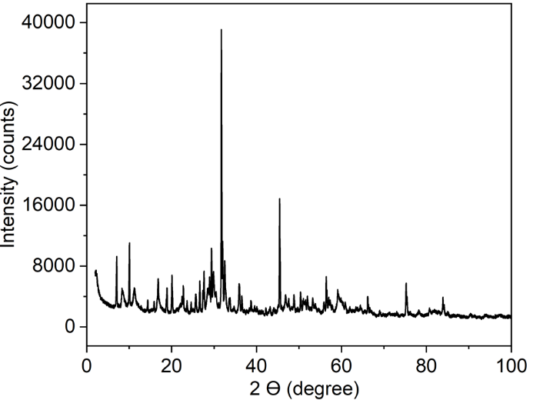

**Figure S1:** PXRD of POM SiW9.

**TEM analysis**

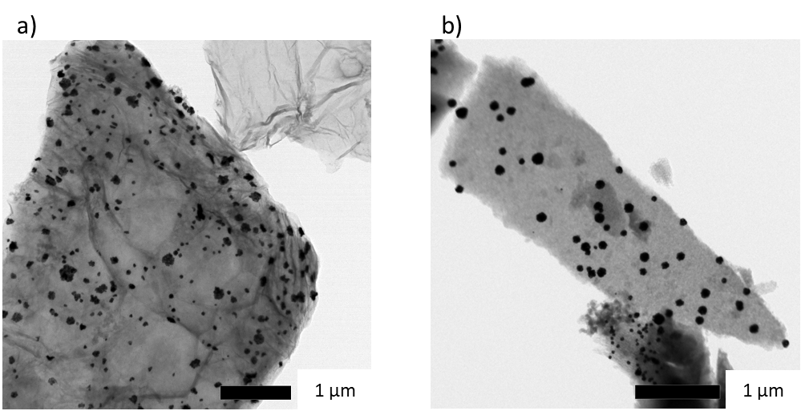

**Figure S2:** TEM images aggregates particles by deposition precipitation method of a) Au@SiW₉/rGO andb) Au@SiW₉/AC.

**Carbon supports images**

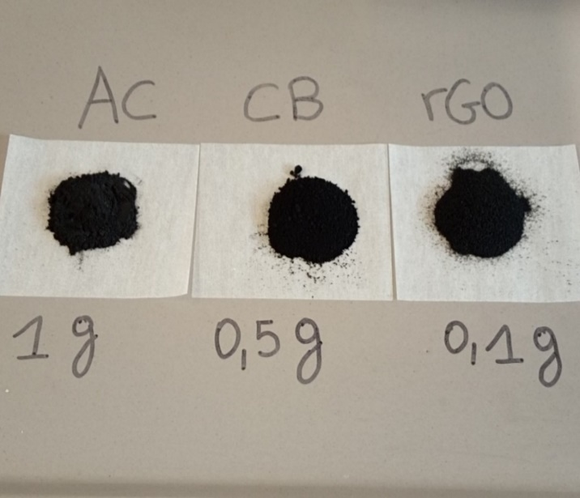

Figure S3**:** Illustrative image of the weight difference for similar volumes of the carbon supports AC, CB, and rGO.

**Gas Chromatography (GC)**

GC was employed to analyze the reaction mixture, providing detailed information on the composition and progress of the reaction. The sample was prepared by transferring 1 mL of the reaction mixture dissolved in acetone into a GC vial. The analysis was performed using the parameters given in the following Table S3.

**Table S3:** Conditions for GC measurements.

|  |  |
| --- | --- |
| Parameter | Value |
| Column | FS-Supreme-5ms 25 m; 0,25 mm; 0.25 µm |
| Carrier gas | H2 3.0 mL/min |
| Injection | 1 µL at 250° C |
| Split flow | 46,3 mL/min |
| Split ratio | 30 |
| Detection | FID |
| FID temperature | 350° C |
| Makeup gas | 100 kPa (Nitrogen) |
| Gradient | 0 min: 40° C; 3 min: 40° C; 30° C/min to 240° C; 6 min at 240° C |

a)

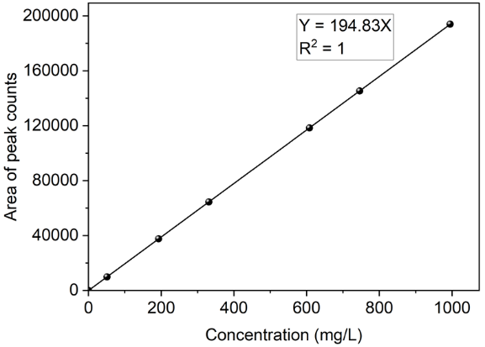

b)

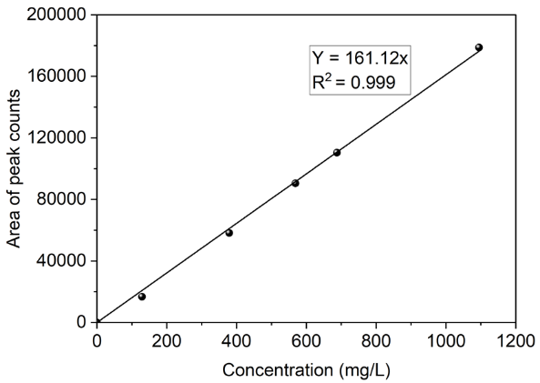

Figure S4**:** GC calibration curves of a) 1-methyl-4-piperidone and b) 1-methyl-2,3-dihydropyridin-4(1H)-one.

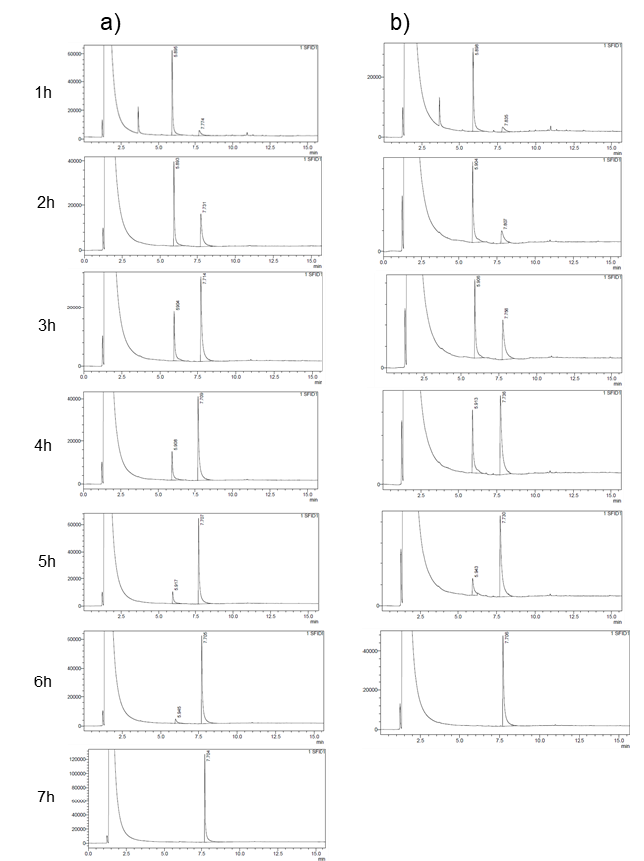

**Figure S5:** Monitoring the conversion of 4-methyl-piperidone to 1-methyl-2,3-dihydropyridin-4(1H)-one by GC over time with a) Au-Cit/rGO and b) Au-SiW9/rGO.

**Gas Chromatography-Mass Spectrometry (GC-MS)**

The sample was prepared by transferring 1 mL of the reaction mixture dissolved in acetone into a GC vial. The analysis was performed using the parameters given in the following Table S4.

**Table S4:** Conditions for GC-MS measurements

|  |  |
| --- | --- |
| Parameter | Value |
| Column | HP-5MS 30 m, 0,25 mm ID, 0,25 µ m |
| Carrier gas | Helium (He), 2,0 mL/min |
| Injection | 1 µ L @ 100 µ L/s, 250° C |
| Split flow | 20 mL/min |
| Split ratio | 10 |
| Detection | Agilent 5977E, Source : EI, FID |
| FID temperature | 300° C |
| Makeup gas | 25 mL/min (Helium) |
| Gradient | 0 min: 50° C; 0,5 min: 50° C; 30° C/min to 300° C; 2 min at 300° C |

The peak at 113.1 m/z in the mass spectrum in Figure S5 corresponds to the molecular ion of 1-methyl-4-piperidone, consistent with its molecular formula C6H11NO and a main isotope molecular weight of 113.16 g/mol. This peak is the most important indicator of the molecular identity.

Ein Bild, das Text, Reihe, Schrift, Zahl enthält.

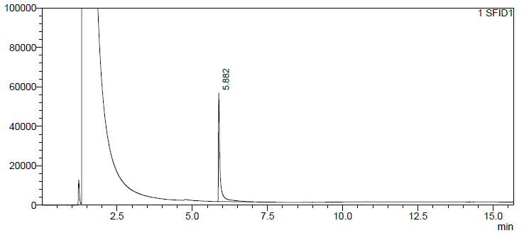

**Figure S6:** Mass spectrum and GC scan of 1-methyl-4-piperidone.

The mass spectrum of the product in Figure S7 shows a prominent peak at 111.1 m/z, which confirms the removal of two hydrogen atoms from the starting material 1-methyl-4-piperidone (molecular ion peak at 113.1 m/z). This decrease in molecular mass is consistent with the formation of a double bond during the ODH reaction, resulting in a molecular formula of C6H9NO. The presence of the 111.1 m/z peak provides supporting evidence of the successful dehydrogenation process and supports the structural changes observed in the 1H-NMR analysis.

Ein Bild, das Text, Reihe, Schrift, Diagramm enthält.

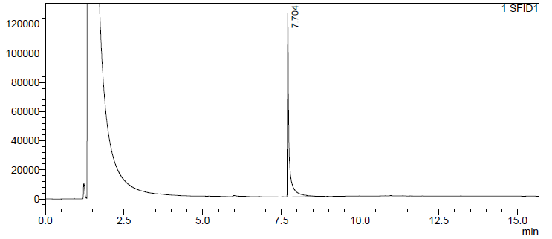

**Figure S7:** Mass spectrum of the reaction product 1-methyl-2,3-dihydropyridin-4(1H)-one.

**1H-NMR spectroscopy**

The 1H-NMR spectrum of 1-methyl-4-piperidone (Fig. S8) reveals the three expected signals.



**Figure S8:** 1H NMR spectrum (300 MHz) of 1-methyl-4-piperidone in CDCl3

The 1H-NMR spectrum of 1-methyl-2,3-dihydropyridin-4(1H)-one(Figure S9) reveals the expected signals.



**Figure S9:** 1H NMR spectrum (300 MHz) of the isolated product 1-methyl-2,3-dihydropyridin-4(1H)-one in CDCl3.

**Gold loading**

To emphasize the effect of gold loading on the catalytic activity of the rGO and CB carbon-based catalyst, we compare the catalysts synthesized by reduction deposition (Table S5), where a lower amount of gold was deposited on the rGO and CB carbon support.

**Preparation of Au-Cit/rGO, and Au-Cit/CB by RD method with lower gold loading**

The synthesis procedures were the same as given in the main text, except that for rGO the amount of 500 mg (instead of 100 mg) and for CB the amount of 1000 mg (instead of 500 mg) was used. The amount of AC (1000 mg) remained the same.

**Preparation of Au-SiW₉/rGO, and Au-SiW₉/CB by RD method with lower gold loading**

The synthesis procedures were the same as given in the main text, except that for rGO the amount of 350 mg (instead of 50 mg) and for CB the amount of 700 mg (instead of 350 mg) was used. The amount of AC (700 mg) remained the same.

The results in Table S5 are to be compared with entries 2, 3, 5 and 6 in Table 2 in the main text.

**Table S5:** Catalytic results in the selective ODH of 1-methyl-4-piperidone to 1-methyl-2,3-dihydropyridin-4(1H)-one with lower gold loading for Au/rGO and Au/CB samples.a

|  |  |  |  |  |  |  |  |
| --- | --- | --- | --- | --- | --- | --- | --- |
| Entry | Catalyst | Au  (wt%) b | Catalyst (mg) c | Au  (mol%) d | Time (h) | Conver-sion (%) e | Yield (%) f |
| 1 | Au-Cit/rGO | 2.08 | 10 | 0.42 | 8 | 60 | 57 |
| 2 | Au-Cit/CB | 1.04 | 50 | 1.06 | 8 | 11 | 3 |
| 3 | Au-SiW9/rGO | 0.85 | 10 | 0.17 | 8 | 78 | 74 |
| 4 | Au-SiW9/CB | 0.42 | 50 | 0.43 | 8 | 25 | 12 |

a Reaction conditions: 30 mg, 0.25 mmol of 1-methyl-4-piperidone, 2 mL of water, open air 1.013 bar, temperature 60°C.

b Weight fraction of Au in the composite, calculated by assuming quantitative uptake of the AuNPs or the gold precursor onto the carbon material.

c Amount of applied composite in the catalysis. The amount was chosen so as to achieve the same molar fraction of Au in the reaction mixture of the three Au-X/carbon catalysts.

c Molar ratio of gold to starting material (× 100%) in the reaction mixture: mol% Au = (mol Au / mol piperidone) × 100%.

d Conversion was determined from the molar concentration of the starting material before the reaction minus the starting material after the reaction divided by the concentration of the starting material before (× 100%).

e Yield was determined from the molar amount of the product divided by the used molar amount of the starting material (× 100%).

**Turnover number and Turnover frequency**

**Table S6:** TON (turnover number) and TOF (turnover frequency) of the rGO based catalyst determined at each hour of the reaction.

|  |  |  |  |  |  |  |
| --- | --- | --- | --- | --- | --- | --- |
| Time (h) | TON Au-Cit/rGO | TON Au-SiW9/rGO | TON Au-SiW9@rGO | TOF (h-1) Au-Cit/rGO | TOF (h-1) Au-SiW9/rGO | TOF (h-1) Au-SiW9@rGO |
| 1 | 29 | 25 | 22 | 290 | 25 | 22 |
| 2 | 60 | 41 | 35 | 300 | 21 | 18 |
| 3 | 86 | 65 | 60 | 29 | 22 | 20.00 |
| 4 | 92 | 80 | 75 | 23 | 20 | 19 |
| 5 | 99 | 102 | 93 | 20 | 20 | 19 |
| 6 | 108 | 118 | 1060 | 18 | 20 | 18 |