Supporting information:
Functionalized gold nanoflowers on carbon screen-printed electrodes: an electrochemical platform for biosensing hemagglutinin protein of influenza A H1N1 virus

Carlos Torres-Méndez†, Sharmilee Nandi‡, Klara Martinovic‡, Patrizia Kühne‡, Yifan Liu†, Sam Taylor†, Maria Lysandrou‡, Maria Ines Berrojo Romeyro Mascarenhas‡, Viktoria Langwallner‡, Javier Enrique Sebastián Alonso†, Ivana Jovanovic‡, Maike Lüftner‡, Georgia-Vasiliki Gkountana‡, David Bern†, Abdul-Raouf Atif †, Ehsan Manouchehri Doulabi‡, Gemma Mestres† and Masood Kamali-Moghaddam‡*.
† Division of Biomedical Engineering, Department of Materials Science and Engineering, Uppsala University, Uppsala, Sweden
‡ Department of Immunology, Genetics and Pathology, Science for Life Laboratory, Uppsala University, Uppsala, Sweden

Validation of mAb specificity and sensitivity. Sandwich enzyme-linked immunosorbent assay (ELISA) was performed to characterize the monoclonal antibodies specificity and sensitivity, a protocol from the company providing the monoclonal antibodies was followed. In short, in a polyvinylchloride (PVC) microtiter, 100 μL of antibody solution (0.228 µg/mL) was added to each well of the microtiter. The plate was incubated overnight at 4°C to allow for antibody binding to the bottom of the wells. The wells were washed thrice with PBS solution. The wells were filled with 200 µL of 3% BSA/PBS. The plate was incubated overnight in a humid atmosphere at room temperature. The wells were washed thrice with PBS solution. Subsequently, 100 μL of the H1 solution (1 µg/mL) in 3% BSA/PBS was added to each well. The plate was washed 3 times with PBS. The solution containing secondary antibody was added (100 µL). The plate was incubated for 30 min at 37 °C in the dark. The plate was washed 5 times with PBS. The substrate was added, the plate was incubated and optical densities at 568 nm was measured on an ELISA plate reader.

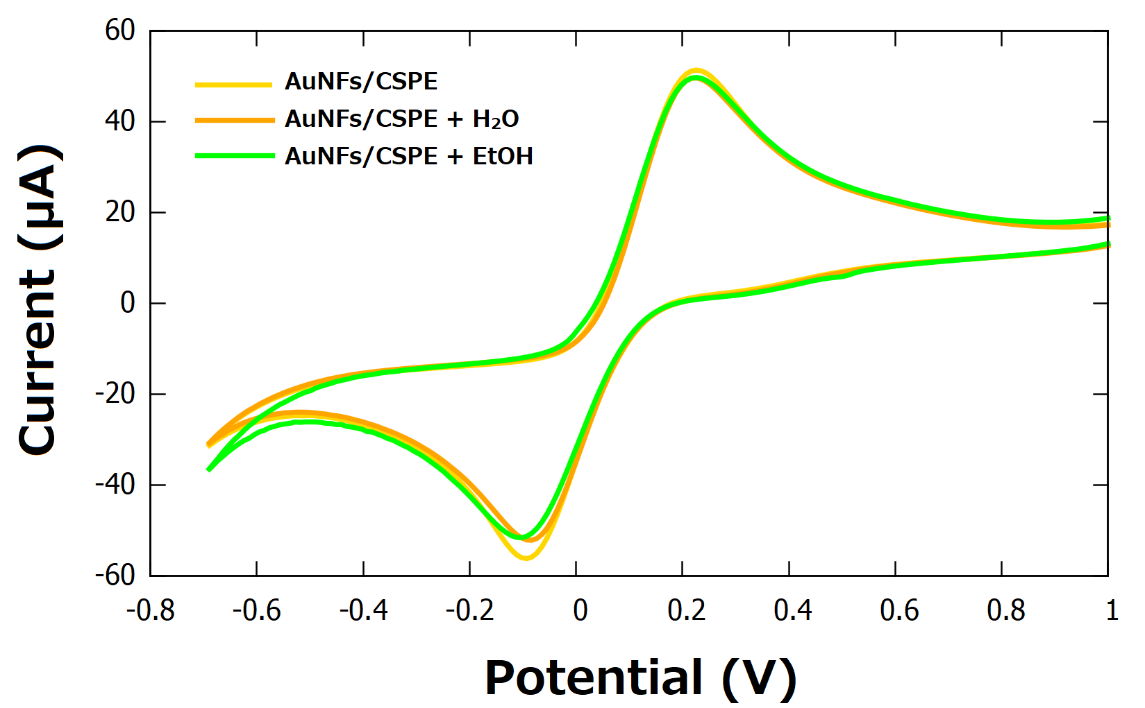
Figure S1. CV of AuNFs/CSPE upon addition of water and ethanol, recorded in 0.1 M KCl containing 5 mM [Fe(CN)₆]^{3−/4−}, with a scan rate of 100 mV/s.
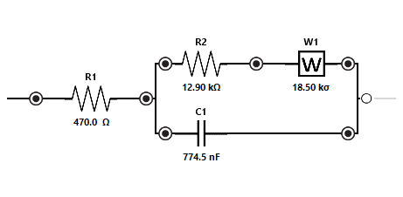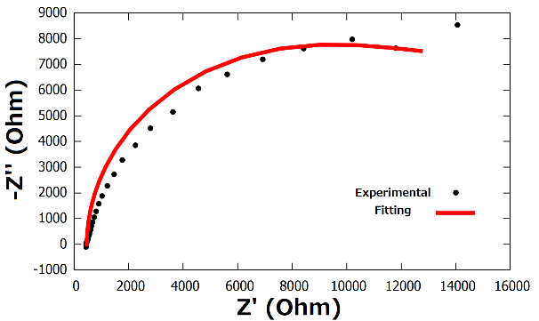
Figure S2. Equivalent circuit and Nyquist plot for CSPE.
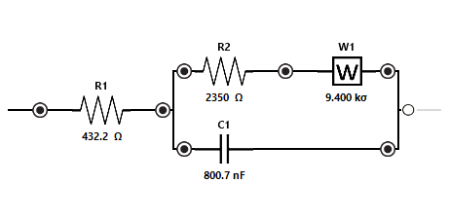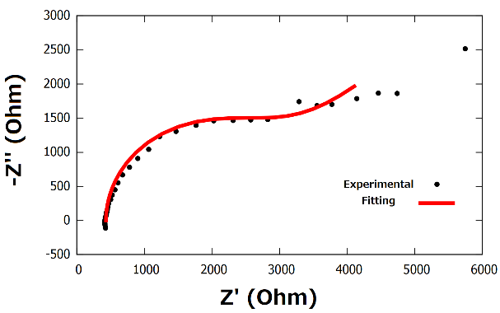Figure S3. Equivalent circuit and Nyquist plot for AuNFs/CSPE. 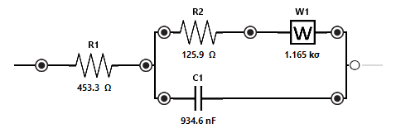 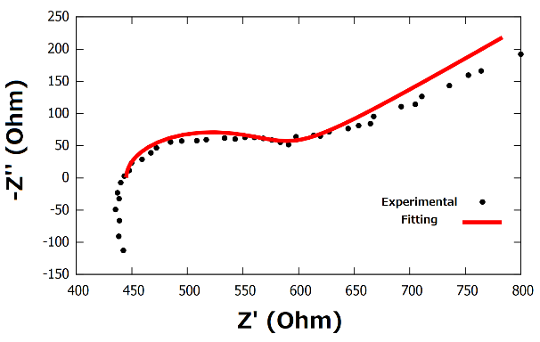 Figure S4. Equivalent circuit and Nyquist plot for 4-ATP/AuNFs/CSPE. 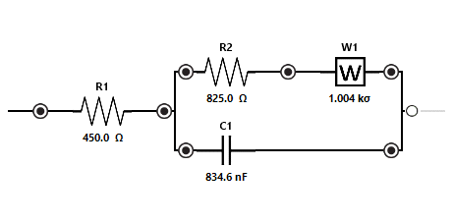 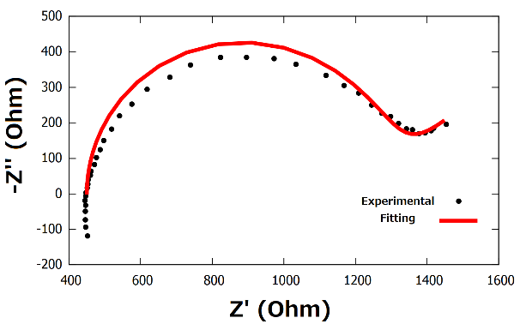 Figure S5. Equivalent circuit and Nyquist plot for mAbs/4-ATP/AuNFs/CSPE. 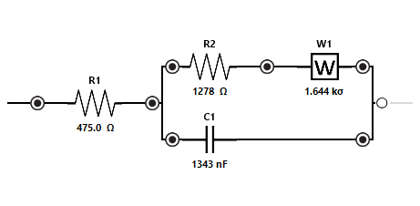 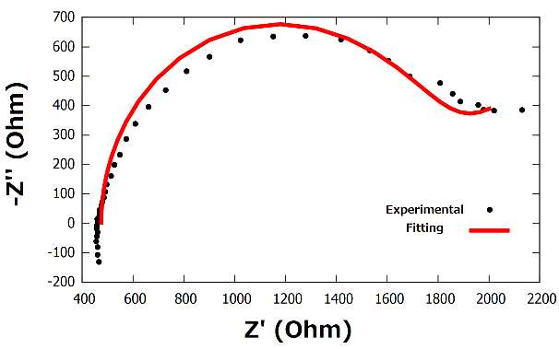
Figure S6. Equivalent circuit and Nyquist plot for BSA/mAbs/4-ATP/AuNFs/CSPE.

Supplementary table 1. Mouse monoclonal influenza A H1N1 (Swine Flu 2009) hemagglutinin antibody specificity in ELISA provided by SinoBiological
Cross-reactivity | No cross-reactivity
H1N1 (A/BrevigMission/1/1918) HA | H1N1 (A/Brisbane/59/2007) HA
H1N2 (A/swine/Guangxi/13/2006) HA | H1N1 (A/Solomon Islands/3/2006) HA
H1N3 (A/duck/NZL/160/1976) HA | H1N1 (A/Ohio/UR06-0091/2007) HA
 | H1N1 (A/New Caledonia/20/1999) HA
 | H1N1 (A/Puerto Rico/8/1934) HA
 | H1N1 (A/WSN/1933) HA
 | H3N2 (A/Brisbane/10/2007) HA
 | H5N1 (A/Anhui/1/2005) HA
 | H5N1 (A/Indonesia/5/2005) HA
 | H5N1 (A/Vietnam/1194/2004) HA
 | H5N1 (A/bar-headed goose/Qinghai/14/2008) HA
 | H5N1 (A/turkey/Turkey/1/2005) HA
 | Influenza B (B/Florida/4/2006) HA

