**Selectfluor and Alcohol Mediated Synthesis of Bicyclic Oxyfluorination Compounds by Wagner-Meerwein Rearrangement**

Ziya Dağalan1, Muhammed Hanifi Çelikoğlu1, Saffet Çelik2, Ramazan Koçak*1,3, Bilal Nişancı*1

Address: 1Department of Chemistry, Faculty of Science, Ataturk University, Erzurum, Turkey, 2Technology Research and Development Application and Research Center, Trakya University, Edirne, Turkey, 3Department of Chemistry, Faculty of Arts and Sciences, Amasya University, Amasya, Turkey

Email:

Ramazan Koçak* - [ramazan.kocak@amasya.edu.tr](mailto:ramazan.kocak@amasya.edu.tr)

Bilal Nişancı* [- bnisanci@atauni.edu.tr](mailto:-%20bnisanci@atauni.edu.tr)

**Table of Contents**

Experimental .............................................................................................................3

Genral procedure........................................................................................................3

1H NMR, 13C NMR, and HRMS Spectra....................................................................10

**Experimental**

**General**

All chemicals and solvents, purchased from Sigma-Aldrich, were used without further purification. Reactions that require heating were carried out under oil bath conditions. Reactions were monitored by thin layer chromatography using Merck TLC Silica gel 60 F254 and the plates were inspected by 254 nm or 365 nm UV-ligth and/or by acquiring 1H-NMR spectra. Column chromatography was performed over Merck Silica gel 60F (70-230 mesh ASTM). The 1H- and 13C-NMR spectra were recorded on a Varian-400 or a Bruker-400 spectrometer in CDCl3 using tetramethylsilane as the interrnal reference. All spectra were recorded at 25 oC and coupling constants (*J* values) are given in Hz. Chemical shifts are given in parts per million (ppm). Abbreviations used to define the multiplicities are as follows: s = singlet; d = doublet; dd = doublet of doublets; m = multiplet. Mass spectra of unknown compounds were recorded on an AB-Sciex 4600 QTOF-MS.

**General procedure**

Benzonorbornadiene (**1a**) or (+)-Camphene (**1b**) (0,5 mmol), Selectfluor (215 mg, 0,6 mmol) and alcohol derivatives (2.4 mmol) were dissolved in 2 mL CH3CN in an ACE pressure tube. The reaction mixture was stirred at 90 oC for 2 hours. The mixture was cooled to room temperature and the solvent was evaporated under reduced pressure. The crude reaction mixture was purified by column chromatography on silica gel (*n-* hexane/EtOAc (9:1)).

***(1R(S),4R(S),9R(S))-9-fluoro-1,2,3,4-tetrahydro-1,4-methanonaphthalen-2-ol* (3a):**



Colorless oil (97 mg, 94%). 1H NMR (400 MHz, CDCl3) δ 7.23 – 7.19 (m, 1H), 7.18 – 7.14 (m, 3H), 4.81 (d, *J* = 57.2 Hz, 1H), 4.00-3.88 (m, 1H), 3.54-3.47 (m, 2H), 2.18 (s, 1H), 2.10 – 2.01 (m, 2H). 13C NMR (101 MHz, CDCl3) δ 143.3 (d, *J* = 7.6 Hz), 139.4 (d, *J* = 10.4 Hz), 127.7, 127.2, 123.1, 122.2, 98.7 (d, *J* = 213.4 Hz), 74.1, 50.6 (d, *J* = 16.3 Hz), 46.3 (d, *J* = 18.6 Hz), 36.7. (TOF MS) m/z (%): [(M-H2O)+H]+ calcd for C11H9F 161.0761; found: 161,0773

***(1R(S),4R(S),9R(S))-9-fluoro-2-methoxy-1,2,3,4-tetrahydro-1,4-methanonaphthalene* (3b):**



Colorless oil (101 mg, 98%). 1H NMR (400 MHz, CDCl3) δ 7.24-7.20 (m, 1H), 7.19-7.11 (m, 3H), 4.68 (d, *J* = 57.3 Hz, 1H), 3.62-3.55 (m, 1H), 3.53-3.47 (m, 1H), 3.47-3.43 (m, 1H), 3.43-3.37 (S, 3H), 2.15-2.06 (m, 1H), 1.98-1.89 (m, 1H). 13C NMR (101 MHz, CDCl3) δ 143.3 (d, *J* = 7.6 Hz), 139.4 (d, *J* = 10.4 Hz), 127.5, 127.1, 122.9, 122.3, 98.7 (d, *J* = 213.4 Hz), 83.0 (d, *J* = 2.3 Hz), 57.7, 50.6 (d, *J* = 16.3 Hz), 46.3 (d, *J* = 18.6 Hz), 32.9. (TOF MS) m/z (%): (M+H)+ calcd for C12H13FO 193.1023; found: 193.1022

***(1R(S),4R(S),9R(S))-2-ethoxy-9-fluoro-1,2,3,4-tetrahydro-1,4-methanonaphthalene* (3c):**



Colorless oil (101 mg, 98%).1H NMR (400 MHz, CDCl3) δ 7.23 – 7.19 (m, 1H), 7.19 – 7.14 (m, 3H), 4.67 (d, *J* = 57.1 Hz, 1H), 3.63 – 3.51 (m, 4H), 3.47 – 3.40 (m, 1H), 2.19-2.10 (m, 1H), 1.96-1.86 (m, 1H), 1.26 (t, *J* = 7.0 Hz, 3H). 13C NMR (101 MHz, CDCl3) δ 143.2 (d, *J* = 7.6 Hz), 139.6 (d, *J* = 10.4 Hz), 127.4, 127.0, 122.7, 122.2, 98.6 (d, *J* = 213.3 Hz), 81.0, 65.3, 51.0(d, *J* = 16.0 Hz), 46.3 (d, *J* = 18.4 Hz), 33.1, 15.5. (TOF MS) m/z (%): (M+H)+ calcd for C15H19FO 207,1180; found: 207,1180

***(1R(S),4R(S),9R(S))-2-butoxy-9-fluoro-1,2,3,4-tetrahydro-1,4-methanonaphthalene* (3d):**



Colorless oil (98 mg, 95%). 1H NMR (400 MHz, CDCl3) δ 7.24 – 7.21 (m, 1H), 7.20 – 7.14 (m, 3H), 4.68 (d, *J* = 57.1 Hz, 1H), 3.65 – 3.42 (m, 5H), 2.21 – 2.09 (m, 1H), 2.00-1.86 (m, 1H), 1.68 – 1.56 (m, 2H), 1.50-1.36 (m, 2H), 0.96 (t, *J* = 7.4 Hz, 3H). 13C NMR (101 MHz, CDCl3) δ 143.2 (d, *J* = 7.7 Hz), 139.6 (d, *J* = 10.3 Hz), 127.3, 127.0, 122.7, 122.1, 98.6 (d, *J* = 213.9 Hz), 81.0, 69.8, 50.9 (d, *J* = 19.2 Hz), 46.2 (d, *J* = 18.3 Hz). 33.0, 32.0, 19.5, 14.0. (TOF MS) m/z (%): (M+H)+ calcd for C15H19FO 235,1493; found: 235,1495.

***(1R(S),4R(S),9R(S))-9-fluoro-2-(octyloxy)-1,2,3,4-tetrahydro-1,4-methanonaphthalene* (3e):**



Colorless oil (133 mg, 92%). 1H NMR (400 MHz, CDCl3) δ 7.24 – 7.20 (m, 1H), 7.20 – 7.12 (m, 3H), 4.68 (d, *J* = 57.1 Hz, 1H), 3.61 – 3.43 (m, 5H), 2.18-2.08 (m, 1H), 1.96-1.86 (m, 1H), 1.65 – 1.59 (m, 2H), 1.36 – 1.27 (m, 10H), 0.90 (t, *J* = 6.8 Hz, 3H). 13C NMR (101 MHz, CDCl3) δ 143.3 (d, *J* = 7.7 Hz), 139.6 (d, *J* = 10.5 Hz), 127.4, 127.00, 122.8, 122.2, 98.6 (d, *J* = 214.2 Hz), 81.1, 70.2, 50.9 (d, *J* = 17.2 Hz), 46.3 (d, *J* = 18.1 Hz), 33.0, 31.9, 30.0, 29.6, 29.4, 26.3, 22.8, 14.2. (TOF MS) m/z (%): (M+H)+ calcd for C19H27FO 291.2119; found: 291.2116.

***(1R(S),4R(S),9R(S))-9-fluoro-2-isopropoxy-1,2,3,4-tetrahydro-1,4-methanonaphthalene* (3f):**



Colorless oil (105 mg, 96%). 1H NMR (400 MHz, CDCl3) δ 7.25 – 7.21 (m, 1H), 7.20 – 7.15 (m, 3H), 4.68 (d, *J* = 57.2 Hz, 1H), 3.77 – 3.66 (m, 2H), 3.54-3.48 (m, 1H),3.47-3.40(m, 1H),2.19-2.08 (m, 1H), 1.97-1.87 (m, 1H), 1.24 (d, *J* = 6.1 Hz, 3H), 1.20 (d, *J* = 6.1 Hz, 3H). 13C NMR (101 MHz, CDCl3) δ 143.2 (d, *J* = 7.6 Hz), 139.8 (d, *J* = 10.4 Hz), 127.3, 126.9, 122.7, 122.2, 98.6 (d, *J* = 213.6 Hz), 78.5, 70.7 (d, *J* = 2.0 Hz).51.8 (d, *J* = 16.5 Hz), 46.4 (d, *J* = 18.4 Hz), 33.6, 22.6, 22.5. (TOF MS) m/z (%): (M+H)+ calcd for C14H17FO 221,1336; found: 221,1338.

***(1R(S),4R(S),9R(S))-9-fluoro-2-(isopentyloxy)-1,2,3,4-tetrahydro-1,4-methanonaphthalene* (3g):**



Colorless oil (116 mg, 94%). 1H NMR (400 MHz, CDCl3) δ 7.24 – 7.20 (m, 1H), 7.19 – 7.14 (m, 3H), 4.68 (d, *J* = 57.1 Hz, 1H), 3.64 – 3.40 (m, 5H), 2.20-2.05 (m, 1H), 2.00-1.83 (m, 1H), 1.77 – 1.68 (m, 1H), 1.57 – 1.47 (m, 2H), 0.94 (d, *J* = 2.5 Hz, 3H), 0.92 (d, *J* = 2.5 Hz, 3H). 13C NMR (101 MHz, CDCl3) δ 143.3 (d, *J* = 7.7 Hz), 139.6 (d, *J* = 10.0 Hz), 127.4, 127.0, 122.8, 122.2, 98.6 (d, *J* = 213.7 Hz), 81.1 (d, *J* = 2.1 Hz), 68.5, 50.9 (d, *J* = 16.2 Hz), 46.3 (d, *J* = 18.7 Hz), 38.8, 33.1, 25.2, 22.8. (TOF MS) m/z (%): (M+H)+ calcd for C16H21FO 249.1649; found: 249.1647.

***(1R(S),4R(S),9R(S))-2-(cyclopropylmethoxy)-9-fluoro-1,2,3,4-tetrahydro-1,4-methanonaphthalene* (3h):**



Colorless oil (106 mg, 92%). 1H NMR (400 MHz, CDCl3) δ 7.22-7.19 (m, 1H), 7.18-7.14 (m, 3H), 4.67 (d, *J* = 57.2 Hz, 1H), 3.66-3.60 (m, 1H), 3.60- 3.56 (m, 1H), 3.46-3.42 (m, 1H), 3.35 (d, *J* = 6.8 Hz, 2H), 2.18 – 2.11 (m, 1H), 1.95-1.86 (m, 1H), 1.14-1.06(m, 1H), 0.58-0.54 (m, 2H), 0.25 – 0.21 (m, 2H). 13C NMR (101 MHz, CDCl3) δ 143.3 (d, *J* = 7.7 Hz), 139.6 (d, *J* = 10.0 Hz), 127.4, 127.0, 122.8, 122.2, 98.6 (d, *J* = 213.3 Hz), 80.78 (d, *J* = 2.2 Hz), 74.8, 51.0 (d, *J* = 16.3 Hz), 46.31 (d, *J* = 18.6 Hz), 33.1, 10.9, 3.4. (TOF MS) m/z (%): (M+H)+ calcd for C15H17FO 233.1336; found: 233.1337.

***(1R(S),4R(S),9R(S))-2-(2-ethoxyethoxy)-9-fluoro-1,2,3,4-tetrahydro-1,4-methanonaphthalene* (3i):**



Colorless oil (117 mg, 94%). 1H NMR (400 MHz, CDCl3) δ 7.21 – 7.18 (m, 1H), 7.17 – 7.13 (m, 3H), 4.66 (dd, *J* = 57.0, 1.9 Hz, 1H), 3.69 – 3.59 (m, 6H), 3.55 (q, *J* = 6.8 Hz, 2H), 3.46-3.41 (m, 1H), 2.18-2.11 (m, 1H), 1.95-1.88 (m, 1H), 1.21 (t, *J* = 7.0 Hz, 3H).13C NMR (101 MHz, CDCl3) δ 143.2 (d, *J* = 7.7 Hz), 139.5 (d, *J* = 10.7 Hz), 127.4, 127.1, 122.9, 122.2, 98.6(d, *J* = 213.4 Hz), 81.7 (d, *J* = 2.2 Hz), 70.0, 69.4, 66.8, 50.9 (d, *J* = 16.6 Hz), 46.3 (d, *J* = 18.4 Hz), 33.1, 15.3. (TOF MS) m/z (%): [(M-C4H9O2)+H]+ calcd for C11H10F 161.0767; found: 161.0761

***(1R(S),4R(S),9R(S))-2-(cyclohexyloxy)-9-fluoro-1,2,3,4-tetrahydro-1,4-methanonaphthalene* (3j):**



Colorless oil (118 mg, 91%). 1H NMR (400 MHz, CDCl3) δ 7.23-7.18 (m, 1H), 7.18 – 7.09 (m, 3H), 4.65 (d, *J* = 57.2 Hz, 1H), 3.78-3.66 (m, 1H), 3.52 – 3.39 (m, 2H), 3.37-3.24 (m, 1H), 2.18-2.06 (m, 1H), 2.02 – 1.83 (m, 3H), 1.81 – 1.71 (m, 2H), 1.58 – 1.51 (m, 1H), 1.39 – 1.16 (m, 5H). 13C NMR (101 MHz, CDCl3) δ 143.1 (d, *J* = 7.6 Hz), 139.7 (d, *J* = 10.6 Hz), 127.2, 126.8, 122.6, 122.1, 98.6 (d, *J* = 213.8 Hz), 78.3, 77.2, 51.8 (d, *J* = 16.8 Hz), 46.3 (d, *J* = 18.3 Hz), 33.6, 32.9, 32.8, 25.7, 24.5, 24.5. (TOF MS) m/z (%): (M+H)+ calcd for C17H21FO 261.1649; found: 261.1648.

***(1R,4S)-1-(fluoromethyl)-7,7-dimethylbicyclo[2.2.1]heptan-2-ol* (4a):**



Colorless oil (79 mg, 92%).1H NMR (400 MHz, CDCl3) δ 4.79 (dd, *J* = 47.7, 9.3 Hz, 1H), 4.48 (dd, *J* = 47.7, 9.3 Hz, 1H), 3.95 (dd, *J* = 7.9, 3.9 Hz, 1H), 1.80 – 1.70 (m, 4H), 1.27 – 1.20 (m, 2H), 1.12 (s, 3H), 1.08 – 1.04 (m, 1H), 0.97-0.93 (m, 1H), 0.89 (s, 3H). 13C NMR (101 MHz, CDCl3) δ 84.8 (d, *J* = 161.9 Hz), 53.0, 52.8, 46.9 (d, *J* = 7.0 Hz), 46.2, 40.3, 29.4 (d, *J* = 2.5 Hz), 27.1, 21.1, 20.6. (TOF MS) m/z (%): (M+Na)+ calcd for C10H17FO 195.1156; found: 195.1154

***(1R,4S)-1-(fluoromethyl)-2-methoxy-7,7-dimethylbicyclo[2.2.1]heptane* (4b):**



Colorless oil (91mg, 98%).1H NMR (400 MHz, CDCl3) δ 4.71 (dd, *J* = 47.3, 9.3 Hz, 1H), 4.42 (dd, *J* = 48.1, 9.3 Hz, 1H), 3.36 (dd, *J* = 7.6, 3.5 Hz, 1H), 3.24 (s, 3H), 1.82 – 1.62 (m, 5H), 1.26 – 1.15 (m, 2H), 1.04 (s, 3H), 0.90 (s, 3H). 13C NMR (101 MHz, CDCl3) δ 86.2, 83.9 (d, *J* = 163.0 Hz), 56.9, 53.0, 46.9 (d, *J* = 6.3 Hz), 46.1, 38.0, 29.4 (d, *J* = 2.8 Hz), 27.1, 21.2, 20.6. (TOF MS) m/z (%): [(M-MeOH)+H]+ calcd for C10H15F 155.1231; found: 155.1230.

***(1R,4S)-2-ethoxy-1-(fluoromethyl)-7,7-dimethylbicyclo[2.2.1]heptane* (4c):**



Colorless oil (98 mg, 98%).1H NMR (400 MHz, CDCl3) δ 4.73 (dd, *J* = 47.3, 9.2 Hz, 1H), 4.42 (dd, *J* = 48.2, 9.2 Hz, 1H), 3.52 – 3.42 (m, 2H), 3.39 – 3.29 (m, 1H), 1.83 – 1.62 (m, 6H), 1.27 – 1.25 (m, 1H), 1.13 (s, 3H), 1.07 (s, 3H), 0.90 (s, 3H). 13C NMR (101 MHz, CDCl3) δ 84.1 (d, *J* = 2.6 Hz), 84.1 (d, *J* = 162.7 Hz), 64.8, 52.9, 46.9 (d, *J* = 6.2 Hz), 46.2, 38.9, 29.3 (d, *J* = 2.8 Hz), 27.1, 21.3, 20.6, 15.7. (TOF MS) m/z (%): [(M-EtOH)+H]+ calcd for C10H15F 155.1231; found: 155.1229.

***(1R,4S)-2-butoxy-1-(fluoromethyl)-7,7-dimethylbicyclo[2.2.1]heptane* (4d):**



Colorless oil (109 mg, 96%).1H NMR (400 MHz, Chloroform-*d*) δ 4.73 (dd, *J* = 47.3, 9.2 Hz, 1H), 4.42 (dd, *J* = 48.2, 9.2 Hz, 1H), 3.44 – 3.37 (m, 2H), 3.28-3.23(m, 1H), 1.82 – 1.68 (m, 5H), 1.64 – 1.58 (m, 2H), 1.51 – 1.43 (m, 2H), 1.37 – 1.33 (m, 2H), 1.06 (s, 3H), 0.92 – 0.87 (m, 6H). 13C NMR (101 MHz, CDCl3) δ 84.2, 84.1 (d, *J* = 162.3 Hz), 69.0, 52.9 (d, *J* = 16.4 Hz), 46.9 (d, *J* = 6.1 Hz), 46.1, 38.7, 32.3, 29.2 (d, *J* = 2.8 Hz), 27.1, 21.3, 20.6, 19.7, 14.1. (TOF MS) m/z (%): (M+Na)+ calcd for C14H25FO 251.1782; found: 251.1832.

***(1R,4S)-1-(fluoromethyl)-7,7-dimethyl-2-(octyloxy)bicyclo[2.2.1]heptane* (4e):**



Colorless oil (134 mg, 95%).1H NMR (400 MHz, Chloroform-*d*) δ 4.73 (dd, *J* = 47.3, 9.2 Hz, 1H), 4.43 (dd, *J* = 48.2, 9.2 Hz, 1H), 3.48 – 3.35 (m, 2H), 3.32 – 3.18 (m, 1H), 1.84 – 1.46 (m, 9H), 1.31 – 1.25 (m, 10H), 1.06 (s, 3H), 0.92 – 0.84 (m, 6H).13C NMR (101 MHz, CDCl3) δ 84.8, 84.3 (d, *J* = 2.9 Hz), 83.1, 69.4, 52.9 (d, *J* = 16.5 Hz), 46.9 (d, *J* = 5.9 Hz), 46.2, 38.8, 32.0, 30.2, 29.5 (d, *J* = 11.7 Hz), 29.3 (d, *J* = 2.9 Hz), 27.1, 26.5, 22.8, 21.3, 20.6, 14.2. (TOF MS) m/z (%): (M+Na)+ calcd for C18H35FO 309.2564; found: 309.2573.

***(1R,4S)-1-(fluoromethyl)-2-isopropoxy-7,7-dimethylbicyclo[2.2.1]heptane* (4f):**



Colorless oil (103 mg, 97%).1H NMR (101 MHz, CDCl3) δ 4.72 (dd, *J* = 47.3, 9.1 Hz, 1H), 4.40 (dd, *J* = 48.2, 9.1 Hz, 1H), 3.55 – 3.47 (m, 2H), 1.87 – 1.60 (m, 6H), 1.10 – 1.05 (m, 9H), 0.89 (s, 3H), 0.88 – 0.86 (m, 1H). 13C NMR (101 MHz, CDCl3) δ 84.3 (d, *J* = 162.4 Hz), 81.9 (d, *J* = 2.5 Hz), 70.9, 52.7 (d, *J* = 16.3 Hz), 47.0 (d, *J* = 6.8 Hz), 46.2, 40.2, 29.3 (d, *J* = 2.7 Hz), 27.1, 23.4, 22.3, 21.3, 20.7. (TOF MS) m/z (%): [(M-C3H7OH)+H]+ calcd for C10H15F 155.1231; found: 155.1229.

***(1R,4S)-1-(fluoromethyl)-2-(isopentyloxy)-7,7-dimethylbicyclo[2.2.1]heptane* (4g):**



Colorless oil (110 mg, 91%).1H NMR (101 MHz, CDCl3) δ 4.72 (dd, *J* = 47.3, 9.1 Hz, 1H), 4.42 (dd, *J* = 48.2, 9.2 Hz, 1H), 3.45 – 3.40 (m, 2H), 3.31 – 3.23 (m, 1H), 1.81 – 1.63 (m, 6H), 1.43 – 1.35 (m, 2H), 1.06 (s, 3H), 0.90 – 0.87 (m, 9H).13C NMR (101 MHz, CDCl3) δ 84.3 (d, *J* = 3.0 Hz), 84.1 (d, *J* = 162.6 Hz), 83.3, 67.6, 52.9 (d, *J* = 16.7 Hz), 46.1, 39.1, 38.7, 29.3, 29.2, 27.1, 25.2, 22.8 (d, *J* = 14.5 Hz), 21.3, 20.6. (TOF MS) m/z (%): [(M-C5H10OH)+H]+ calcd for C10H15F 155.1231; found: 155.1230.

***(1R,4S)-2-(cyclopropylmethoxy)-1-(fluoromethyl)-7,7-dimethylbicyclo [2.2.1]heptane* (4h):**



Colorless oil (100 mg, 90%).1H NMR (101 MHz, CDCl3) δ 4.73 (dd, *J* = 47.3, 9.2 Hz, 1H), 4.42 (dd, *J* = 48.2, 9.2 Hz, 1H), 3.45 (dd, *J* = 7.7, 3.5 Hz, 1H), 3.21 (dd, *J* = 6.4, 1.5 Hz, 2H), 1.81 – 1.67 (m, 4H), 1.63 – 1.58 (m, 1H), 1.27-1.22 (m, 1H), 1.07 (s, 3H), 1.04 (s, 1H), 0.93 (s, 1H), 0.89 (s, 3H), 0.46 – 0.42 (m, 2H), 0.19 – 0.13 (m, 2H). 13C NMR (101 MHz, CDCl3) δ 84.0 (d, *J* = 162.9 Hz), 83.9 (d, *J* = 2.8 Hz), 73.6, 67.2 (d, *J* = 3.5 Hz), 52.9 (d, *J* = 16.4 Hz), 46.9 (d, *J* = 5.7 Hz), 46.1, 38.8, 29.3 (d, *J* = 2.9 Hz), 27.1, 23.9, 23.1, 21.2, 20.6. (TOF MS) m/z (%): [(M-C4H7OH)+H]+ calcd for C10H15F 155.1231; found: 155.1230.

***(1R,4S)-2-(2-ethoxyethoxy)-1-(fluoromethyl)-7,7-dimethylbicyclo[2.2.1]heptane* (4i):**



Colorless oil (112 mg, 94%).1H NMR (101 MHz, CDCl3) δ 4.73 (dd, *J* = 47.2, 9.2 Hz, 1H), 4.41 (dd, *J* = 48.2, 9.2 Hz, 1H), 3.62 – 3.40 (m, 8H), 1.88– 1.56 (m, 6H), 1.17 (t, *J* = 7.0 Hz, 3H), 1.05 (s, 3H), 0.89 (s, 3H). 13C NMR (101 MHz, CDCl3) δ 84.8, 84.7 (d, *J* = 2.5 Hz), 83.1, 70.1, 69.0, 66.7, 52.9 (d, *J* = 16.8 Hz), 46.1, 38.6, 29.2 (d, *J* = 2.7 Hz), 27.0, 21.2, 20.6, 15.4. (TOF MS) m/z (%): [(M-C4H10O2)+H]+ calcd for C10H15F 155.1231; found: 155.1231.

***(1R,4S)-2-(cyclohexyloxy)-1-(fluoromethyl)-7,7-dimethylbicyclo[2.2.1]heptane* (4j):**



Colorless oil (118 mg, 93%).1H NMR (101 MHz, CDCl3) δ 4.74 (dd, *J* = 47.3, 9.1 Hz, 1H), 4.41 (dd, *J* = 48.2, 9.1 Hz, 1H), 3.54 (dd, *J* = 7.7, 3.5 Hz, 1H), 3.29-320 (m, 1H), 1.83 – 1.65 (m, 10H), 1.31 – 1.21 (m, 7H), 1.09 (s, 3H), 0.90 (s, 3H). 13C NMR (101 MHz, CDCl3) δ 84.3 (d, *J* = 162.5 Hz), 81.9 (d, *J* = 2.9 Hz), 52.8 (d, *J* = 16.5 Hz), 47.0 (d, *J* = 6.3 Hz), 46,4, 40.2, 33.6, 32.1, 29.3 (d, *J* = 2.8 Hz), 27.2, 26.1, 24.0 (d, *J* = 1.9 Hz), 21.3, 20.7. (TOF MS) m/z (%): (M+Na)+ calcd for C16H27FO 277.1938; found: 277.1936.

**1H NMR, 13C NMR, and HRMS Spectra**





400 MHz 1H-NMR (top) and 101 MHz 13C-NMR (bottom) spectra of **3a** (CDCl3)





400 MHz 1H-NMR (top) and 101 MHz 13C-NMR (bottom) spectra of **3b** (CDCl3)





400 MHz 1H-NMR (top) and 101 MHz 13C-NMR (bottom) spectra of **3c** (CDCl3)





400 MHz 1H-NMR (top) and 101 MHz 13C-NMR (bottom) spectra of **3d** (CDCl3)





400 MHz 1H-NMR (top) and 101 MHz 13C-NMR (bottom) spectra of **3e** (CDCl3)





400 MHz 1H-NMR (top) and 101 MHz 13C-NMR (bottom) spectra of **3f** (CDCl3)





400 MHz 1H-NMR (top) and 101 MHz 13C-NMR (bottom) spectra of **3g** (CDCl3)





400 MHz 1H-NMR (top) and 101 MHz 13C-NMR (bottom) spectra of **3h** (CDCl3)





400 MHz 1H-NMR (top) and 101 MHz 13C-NMR (bottom) spectra of **3i** (CDCl3)





400 MHz 1H-NMR (top) and 101 MHz 13C-NMR (bottom) spectra of **3j** (CDCl3)





400 MHz 1H-NMR (top) and 101 MHz 13C-NMR (bottom) spectra of **4a** (CDCl3)





400 MHz 1H-NMR (top) and 101 MHz 13C-NMR (bottom) spectra of **4b** (CDCl3)





400 MHz 1H-NMR (top) and 101 MHz 13C-NMR (bottom) spectra of **4c** (CDCl3)





400 MHz 1H-NMR (top) and 101 MHz 13C-NMR (bottom) spectra of **4d** (CDCl3)





400 MHz 1H-NMR (top) and 101 MHz 13C-NMR (bottom) spectra of **4e** (CDCl3)





400 MHz 1H-NMR (top) and 101 MHz 13C-NMR (bottom) spectra of **4f** (CDCl3)





400 MHz 1H-NMR (top) and 101 MHz 13C-NMR (bottom) spectra of **4g** (CDCl3)





400 MHz 1H-NMR (top) and 101 MHz 13C-NMR (bottom) spectra of **4h** (CDCl3)





400 MHz 1H-NMR (top) and 101 MHz 13C-NMR (bottom) spectra of **4i** (CDCl3)





400 MHz 1H-NMR (top) and 101 MHz 13C-NMR (bottom) spectra of **4j** (CDCl3)

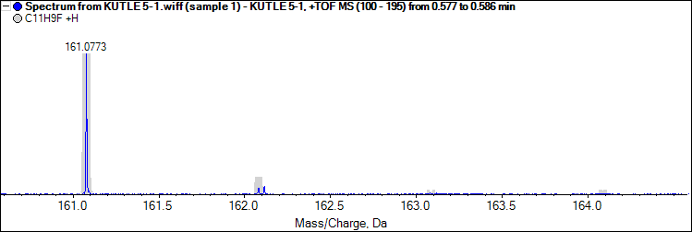

(TOF MS) spectrum of **3a**.

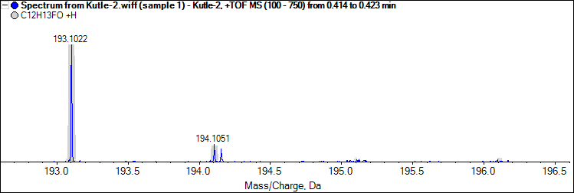

(TOF MS) spectrum of **3b**.

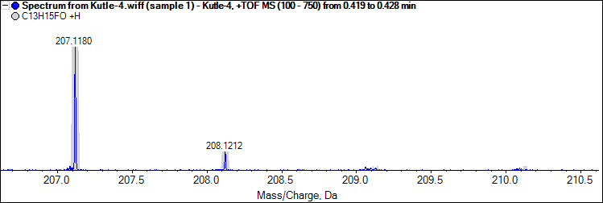

(TOF MS) spectrum of **3c**.

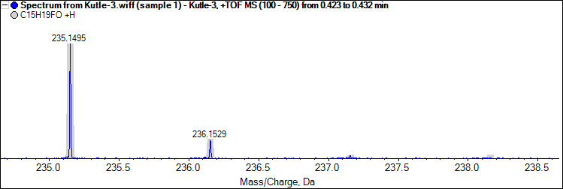

(TOF MS) spectrum of **3d**.

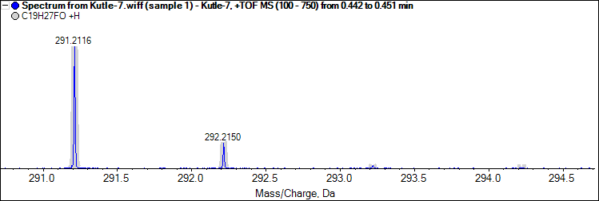

(TOF MS) spectrum of **3e**.

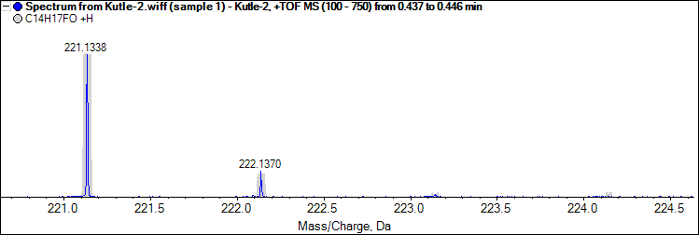

(TOF MS) spectrum of **3f**.

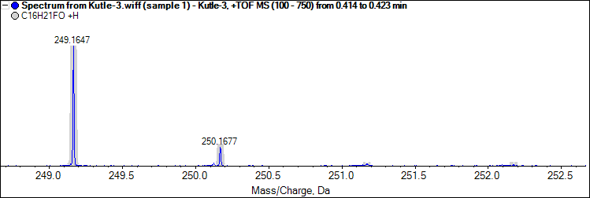

(TOF MS) spectrum of **3g**.

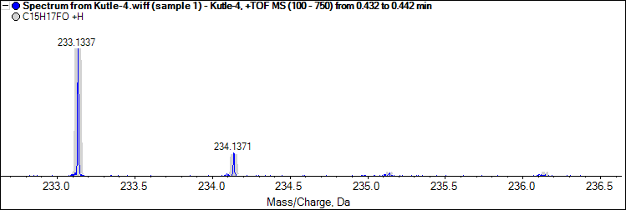

(TOF MS) spectrum of **3h**.

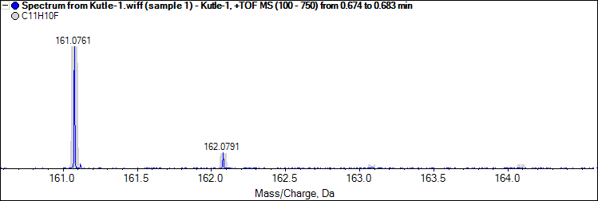

(TOF MS) spectrum of **3i**.

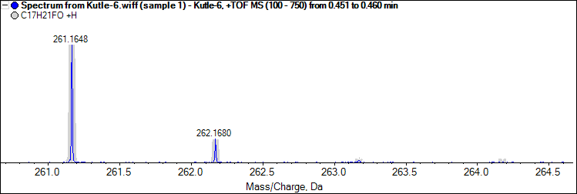

(TOF MS) spectrum of **3j**.

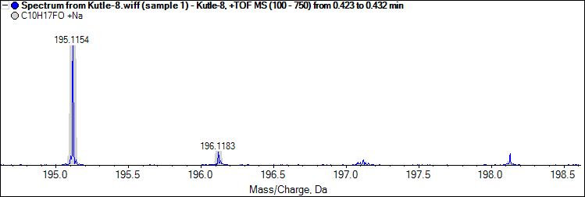

(TOF MS) spectrum of **4a**.

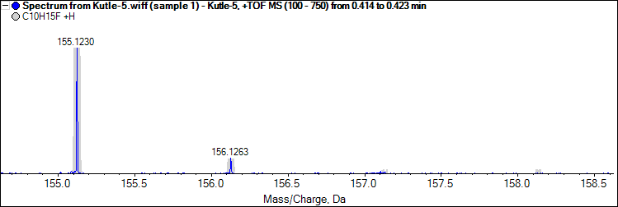

(TOF MS) spectrum of **4b**.

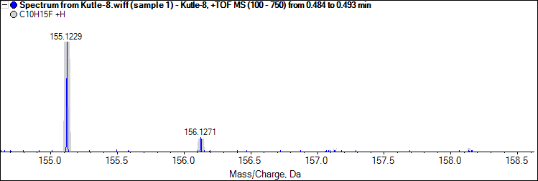

(TOF MS) spectrum of **4c**.

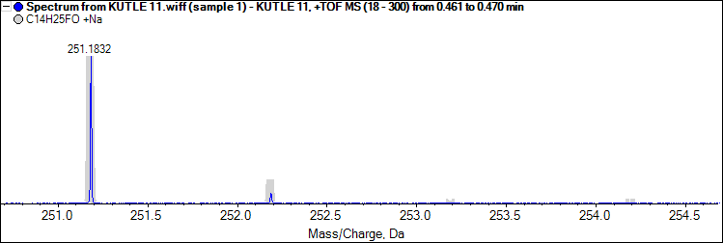

(TOF MS) spectrum of **4d**.

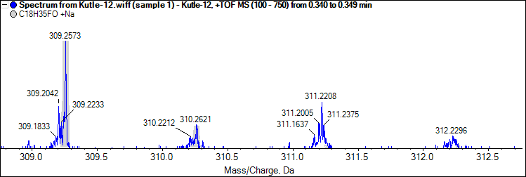

(TOF MS) spectrum of **4e**.

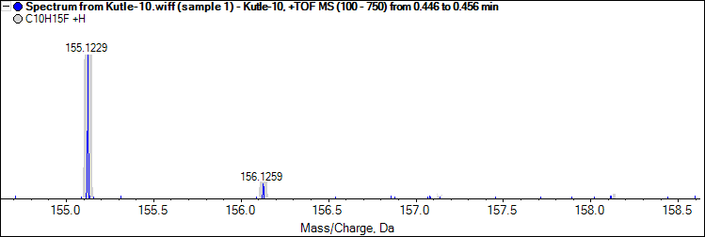

(TOF MS) spectrum of **4f**.

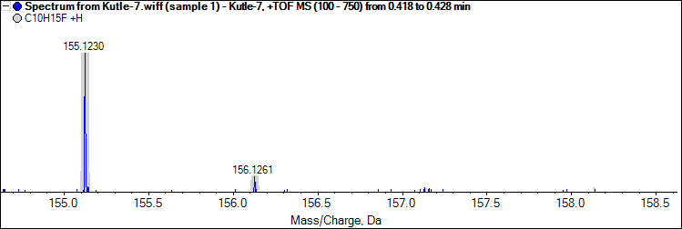

(TOF MS) spectrum of **4g**.

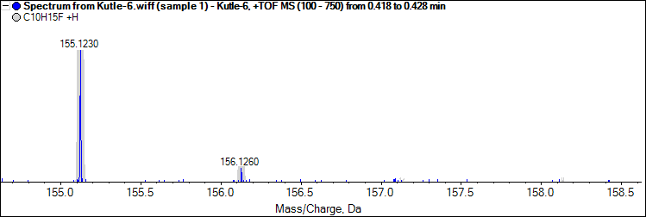

(TOF MS) spectrum of **4h**.

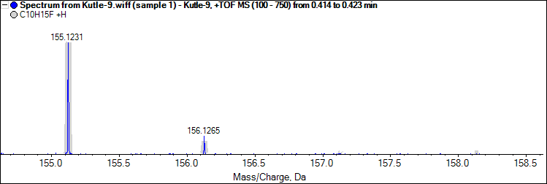

(TOF MS) spectrum of 4i.

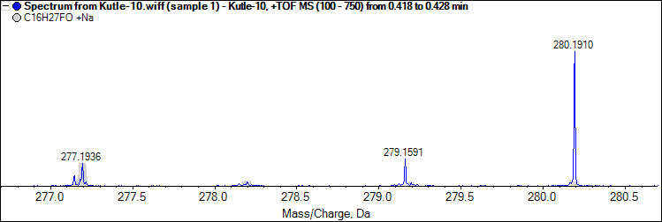

(TOF MS) spectrum of **4i**.