[Electronic supporting information]
Ultra-low energy amorphization of contaminated silicon samples investigated by Molecular Dynamics
Grégoire R.N. Defoort-Levkov*^{1,2}, Alan Bahm ³, Patrick Philipp ^{*1}

1 – Advanced Instrumentation for Nano-Analytics (AINA), Materials Research and Technology Department (MRT), Luxembourg Institute of Science and Technology (LIST), 4422 Belvaux, Luxembourg.
2 – University of Luxembourg, 4365 Esch-sur-Alzette, Luxembourg.
3 – Thermo Fisher Scientific, Hillsboro, OR, 97124, USA
Email: Patrick Philipp – Patrick.philipp@list.lu
* Corresponding author
The manuscript was written through contributions of all authors. All authors have given approval to the final version of the manuscript.

Index
Publication supplements
Figure S1 Evolution of the amorphization coefficient for a specific case comparing 50 and 500 eV for each incidence angle.
Figure S2 Evolution of the thickness of the crystalline slab with respect to the energy of impact and the angle
Figure S3 Implantation depth charts for each angle and energy for oxygen atoms, full display of the distributions.
Figure S4 Implantation depth charts for each angle and energy for hydrogen atoms, full display of the distributions.
Figure S5 Partial sputter yields for clusters with minimal sputter yields (O – O, H – H and O – H)

ReaxFF Potential
ReaxFF Potential: The force field parameters from the supporting information of J. Phys. Chem. C 2012, 116, 16111–16121 were also used in this study.
Publication supplements

Figure S1: Evolution of the amorphization coefficient with respect to the incidence angle for a) 400 eV and b) 500 eV impact energies.
Figure S2: Evolution of the thickness of the crystalline slab for each energy with respect to the angle.

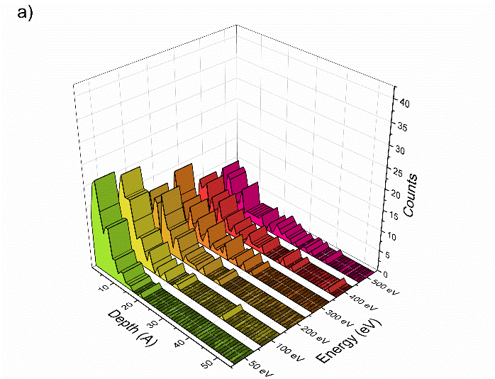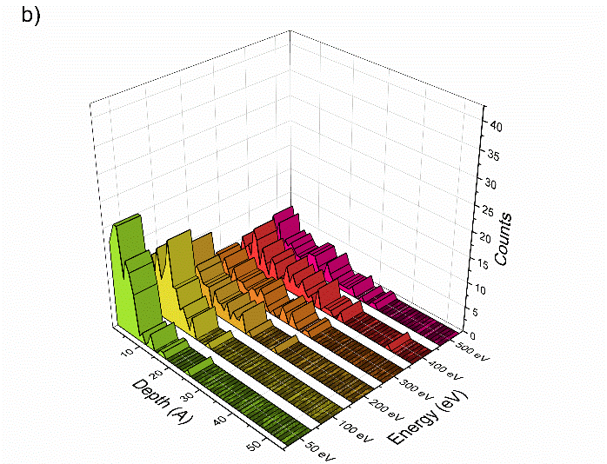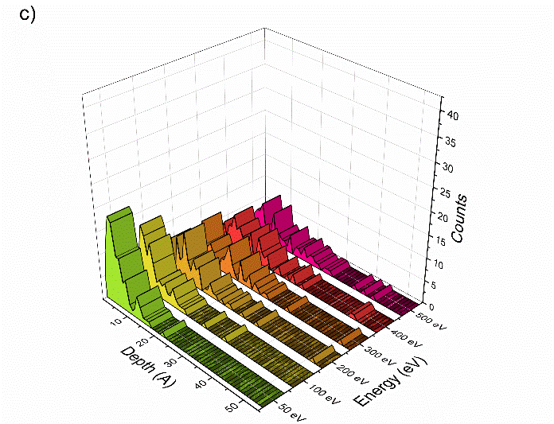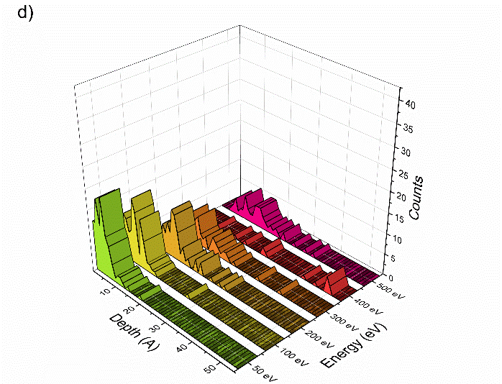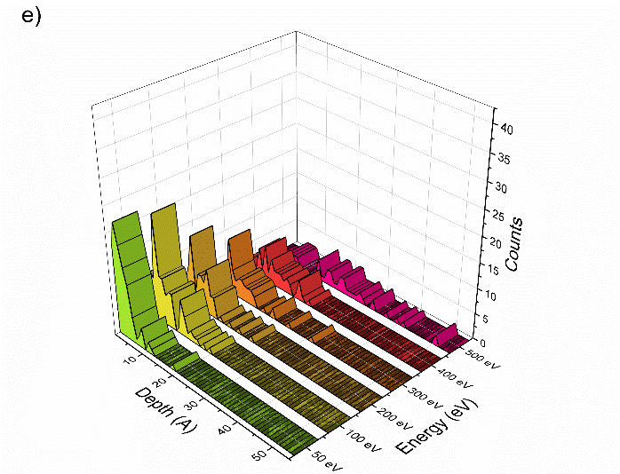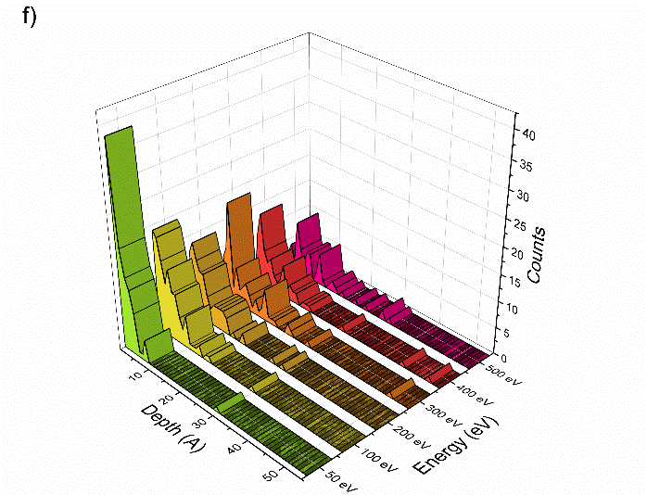
Figure S3: Implantation depths of oxygen for incidence angles of a) 0°, b) 30°, c) 45°, d) 60°, e) 75° and f) 83°. Each energy is displayed along the y axis, while the implantation depth is along the x and the number of counts is displayed along the z axis.
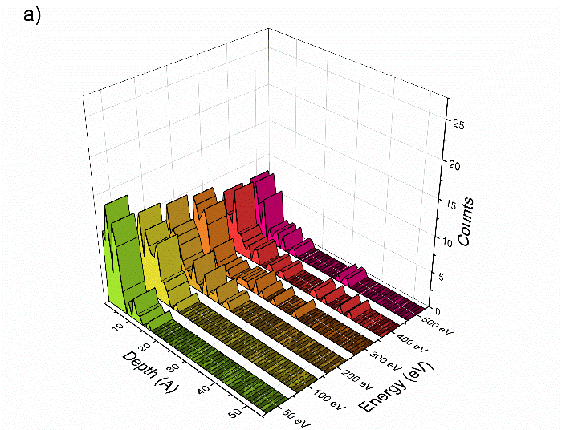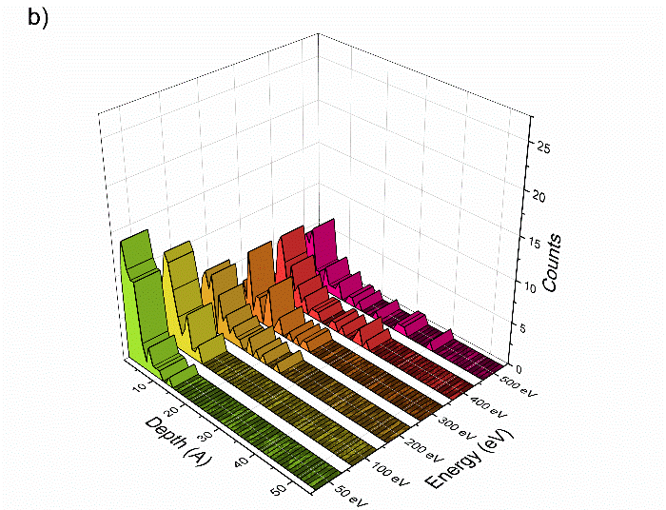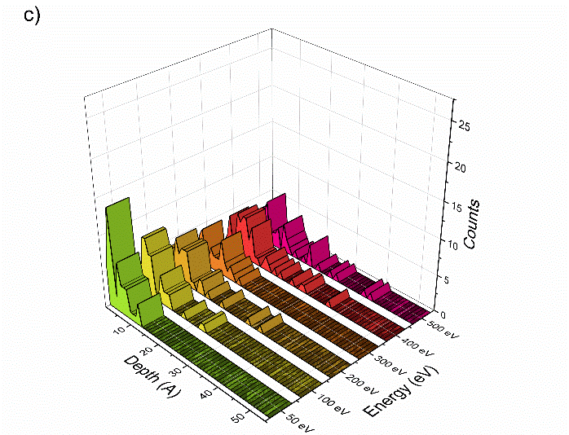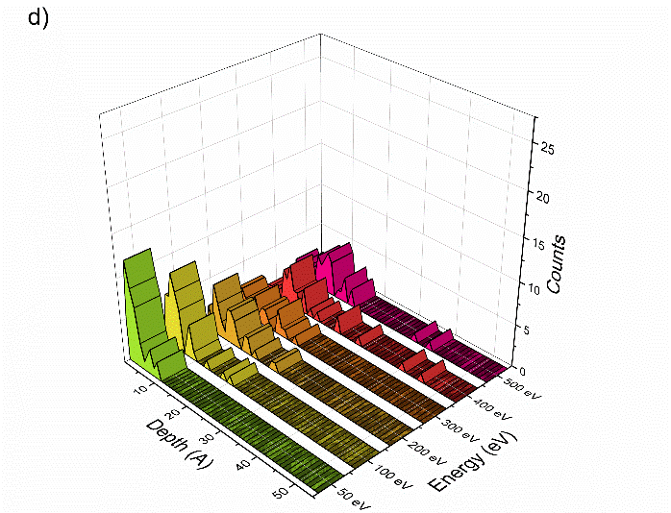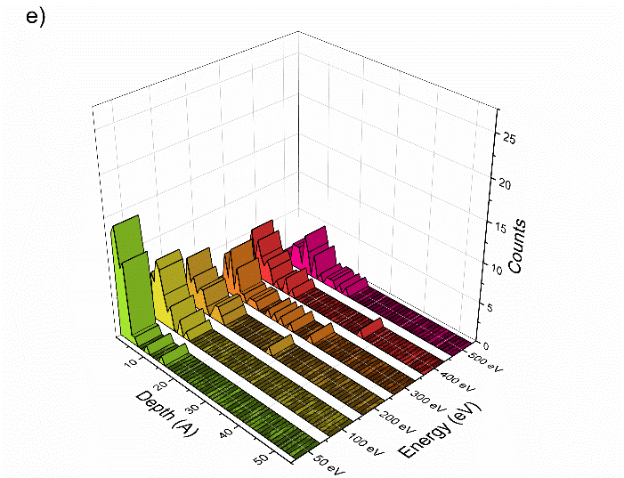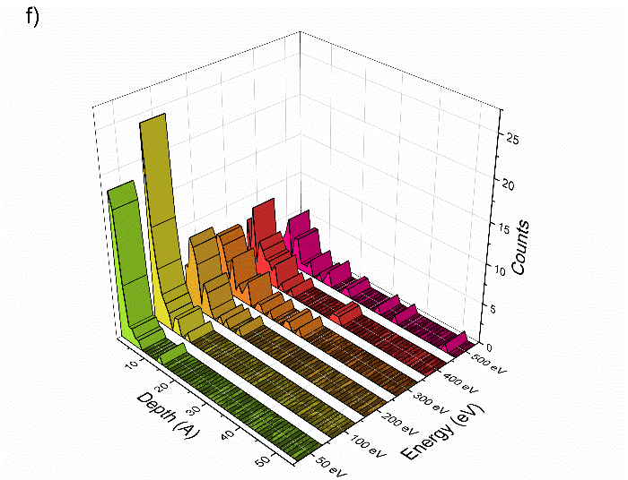
Figure S4: Implantation depths of hydrogen for incidence angles of a) 0°, b) 30°, c) 45°, d) 60°, e) 75° and f) 83°. Each energy is displayed along the y axis, while the implantation depth is along the x and the number of counts is displayed along the z axis.
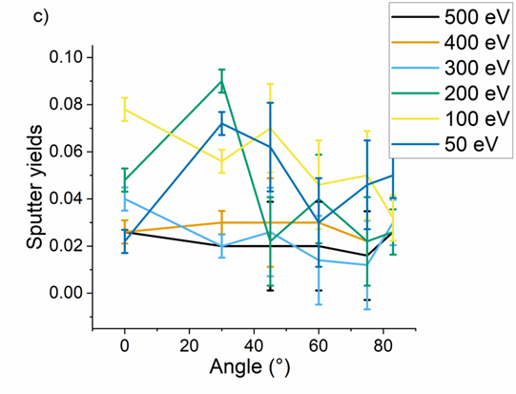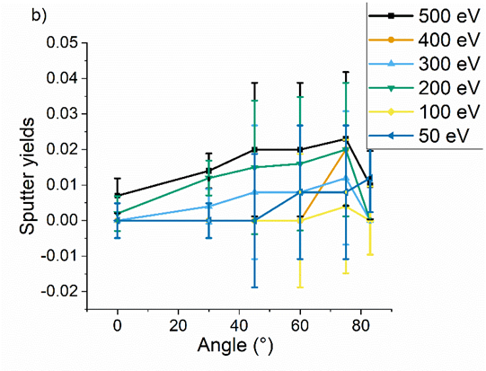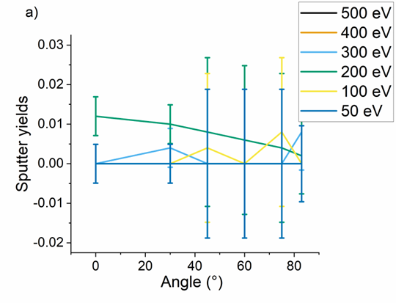
Figure S5: Partial sputter yields particles clusters: a) oxygen - oxygen, b) hydrogen – hydrogen and c) hydrogen – oyxgen

