# Facile Approach to the N,O,S-Heteropentacycles via Condensation of Sterically Crowded 3H-Phenoxazin-3-one with *ortho-*amino-, hydroxy and mercaptoanilines.

Eugeny Ivakhnenko*1, Vasily Malay1, Pavel Knyazev1, Nikita Merezhko1, Nadezhda Makarova1, Oleg Demidov2, Gennady Borodkin1, Andrey Starikov1 and Vladimir Minkin1

Address: 1Institute of Physical and Organic Chemistry, Southern Federal University, 194/2 Stachki St., 344090, Rostov-on-Don, Russian Federation and 2North Caucasus Federal University, 1 Pushkin St., 355017, Stavropol, Russian Federation.

Email: Eugeny Ivakhnenko – ivakhnenko@sfedu.ru

* Corresponding author

Table of Contents

1. XRD study 2
2. DFT study 13
3. UV/vis and luminescence spectra 14
4. Cyclic voltammetry 17
5. NMR spectra 18
6. HRMS spectra 52

# XRD study. Molecular geometries. Crystallographic parameters.

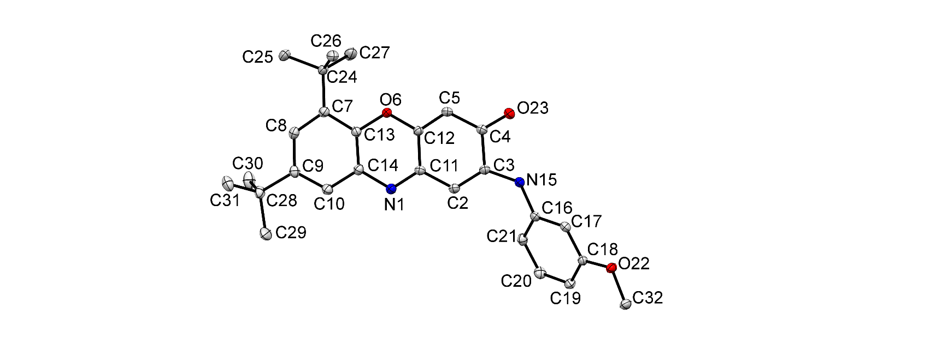

**Figure S1:** Molecular structure of 6,8-di-*tert*-butyl-2-((3-methoxyphenyl)amino)-3H-phenoxazin-3-one **3c.**

**Figure S2:** Molecular structure of 6,8-di-*tert*-butyl-2-((3-chlorophenyl)amino)-3H-phenoxazin-3-one **3d**.

**Table S1:** Crystal data and structure refinement for **3c**, **3d** and **3f**.

|  |  |  |  |  |
| --- | --- | --- | --- | --- |
| **Parameter** | **3c** | **3d** | **3f** | |
| CCDC Number | 2292841 | 2292840 | 2292847 |
| Empirical formula | C27H30N2O3 | C26H27ClN2O2 | C26H27N3O4 |
| Formula weight | 430.53 | 434.94 | 445.50 |
| Temperature/K | 100.01(10) | 100.01(13) | 100.00(10) |
| Crystal system | monoclinic | monoclinic | orthorhombic |
| Space group | P21/c | P21/n | P212121 |
| a/Å | 16.93490(10) | 18.2211(3) | 7.06800(10) |
| b/Å | 15.04900(10) | 18.0052(3) | 16.9207(2) |
| c/Å | 19.7911(2) | 21.6236(4) | 18.5820(2) |
| α/° | 90 | 90 | 90 |
| β/° | 114.6770(10) | 105.415(2) | 90 |
| γ/° | 90 | 90 | 90 |
| Volume/Å3 | 4583.20(7) | 6838.9(2) | 2222.32(5) |
| Z | 8 | 12 | 4 |
| ρcalcg/cm3 | 1.248 | 1.267 | 1.332 |
| μ/mm‑1 | 0.647 | 1.676 | 0.736 |
| F(000) | 1840.0 | 2760.0 | 944.0 |
| Crystal size/mm3 | 0.262 × 0.179 × 0.092 | 0.298 × 0.096 × 0.069 | 0.344 × 0.124 × 0.112 |
| Radiation | CuKα (λ = 1.54184) | CuKα (λ = 1.54184) | CuKα (λ = 1.54184) |
| 2Θ range for data collection/° | 7.66 to 152.642 | 7.03 to 152.84 | 7.066 to 152.536 |
| Index ranges | -21 ≤ h ≤ 21,  -15 ≤ k ≤ 18,  -24 ≤ l ≤ 24 | -22 ≤ h ≤ 14,  -22 ≤ k ≤ 22,  -23 ≤ l ≤ 27 | -8 ≤ h ≤ 8,  -21 ≤ k ≤ 21,  -23 ≤ l ≤ 23 |
| Reflections collected | 50573 | 60385 | 13501 |
| Independent reflections | 9568 [Rint = 0.0290, Rsigma = 0.0198] | 14134 [Rint = 0.0376, Rsigma = 0.0291] | 4476 [Rint = 0.0183, Rsigma = 0.0203] |
| Data/restraints/parameters | 9568/0/599 | 14134/99/887 | 4476/0/353 |
| Goodness-of-fit on F2 | 1.036 | 1.069 | 1.032 |
| Final R indexes [I>=2σ (I)] | R1 = 0.0358,  wR2 = 0.0908 | R1 = 0.0676,  wR2 = 0.1835 | R1 = 0.0286,  wR2 = 0.0774 |
| Final R indexes [all data] | R1 = 0.0401,  wR2 = 0.0949 | R1 = 0.0805,  wR2 = 0.1947 | R1 = 0.0298,  wR2 = 0.0786 |
| Largest diff. peak/hole / e Å-3 | 0.23/-0.27 | 1.09/-0.70 | 0.26/-0.19 |
|  | - | - | 0.65(6) |

**Table S2:** X-ray determined bond lengths, valence angles of **3c**.

Bond lengths, Å.

|  |  |  |  |
| --- | --- | --- | --- |
| O6-C12 | 1.3526(12) | C21-C20 | 1.3874(15) |
| O6-C13 | 1.3779(12) | C9-C28 | 1.5374(14) |
| O22-C18 | 1.3676(12) | C24-C26 | 1.5393(15) |
| O22-C32 | 1.4291(12) | C24-C25 | 1.5356(14) |
| O23-C4 | 1.2370(13) | C24-C27 | 1.5420(14) |
| N15-C3 | 1.3584(13) | C20-C19 | 1.3946(14) |
| N15-C16 | 1.4027(13) | C28-C30 | 1.5332(15) |
| N1-C11 | 1.3117(13) | C28-C31 | 1.5361(15) |
| N1-C14 | 1.3852(13) | C28-C29 | 1.5312(16) |
| C18-C17 | 1.3895(14) | C10-C14 | 1.4032(14) |
| C18-C19 | 1.3935(14) | C10-C9 | 1.3803(14) |
| C3-C2 | 1.3651(14) | C5-C4 | 1.4361(14) |
| C3-C4 | 1.5048(13) | C14-C13 | 1.3982(14) |
| C2-C11 | 1.4295(14) | C7-C8 | 1.3953(14) |
| C11-C12 | 1.4619(13) | C7-C13 | 1.4058(14) |
| C16-C17 | 1.3929(14) | C7-C24 | 1.5414(13) |
| C16-C21 | 1.3996(14) | C8-C9 | 1.4133(14) |
| C12-C5 | 1.3494(14) |  |  |

Valence Angles for **3c**, deg.

|  |  |  |  |
| --- | --- | --- | --- |
| C12-O6-C13 | 119.82(8) | C10-C9-C8 | 118.01(9) |
| C18-O22-C32 | 116.75(8) | C10-C9-C28 | 121.86(9) |
| C3-N15-C16 | 130.41(9) | C8-C9-C28 | 120.11(9) |
| C11-N1-C14 | 117.53(9) | C7-C24-C27 | 109.08(9) |
| O22-C18-C17 | 115.22(9) | C26-C24-C7 | 111.53(8) |
| O22-C18-C19 | 124.35(9) | C26-C24-C27 | 109.95(9) |
| C17-C18-C19 | 120.41(9) | C25-C24-C7 | 111.17(9) |
| N15-C3-C2 | 128.42(9) | C25-C24-C26 | 107.54(9) |
| N15-C3-C4 | 111.18(9) | C25-C24-C27 | 107.48(9) |
| C2-C3-C4 | 120.39(9) | C21-C20-C19 | 121.85(9) |
| C3-C2-C11 | 120.77(9) | C18-C19-C20 | 118.53(9) |
| N1-C11-C2 | 119.97(9) | C30-C28-C9 | 109.11(9) |
| N1-C11-C12 | 121.94(9) | C30-C28-C31 | 109.24(9) |
| C2-C11-C12 | 118.08(9) | C31-C28-C9 | 110.00(8) |
| C17-C16-N15 | 116.78(9) | C29-C28-C9 | 111.73(9) |
| C17-C16-C21 | 119.78(9) | C29-C28-C30 | 108.91(10) |
| C21-C16-N15 | 123.41(9) | C29-C28-C31 | 107.81(10) |
| O6-C12-C11 | 118.93(9) | C8-C7-C24 | 123.13(9) |
| C5-C12-O6 | 118.44(9) | C13-C7-C24 | 121.77(9) |
| C5-C12-C11 | 122.62(9) | C7-C8-C9 | 124.16(9) |
| C9-C10-C14 | 120.63(10) | O23-C4-C3 | 119.02(9) |
| C12-C5-C4 | 120.15(9) | O23-C4-C5 | 123.27(9) |
| N1-C14-C10 | 118.16(9) | C5-C4-C3 | 117.70(9) |
| N1-C14-C13 | 122.72(9) | O6-C13-C14 | 118.85(9) |
| C13-C14-C10 | 119.12(9) | O6-C13-C7 | 118.24(9) |
| C18-C17-C16 | 120.47(9) | C14-C13-C7 | 122.92(9) |
| C8-C7-C13 | 115.09(9) | C20-C21-C16 | 118.94(9) |

**Table S3:** X-ray determined bond lengths, valence angles of **3d**.

Bond lengths, Å.

|  |  |  |  |  |  |
| --- | --- | --- | --- | --- | --- |
| Cl1-C18 | | 1.734(3) | C17-C16 | | 1.389(3) |
| O6-C12 | | 1.353(3) | C17-C18 | | 1.386(4) |
| O6-C13 | | 1.378(3) | C28-C31 | | 1.535(4) |
| O23-C4 | | 1.233(3) | C28-C29 | | 1.519(4) |
| N1-C11 | | 1.311(3) | C28-C30 | | 1.536(4) |
| N1-C14 | | 1.387(3) | C28-C34 | | 1.501(19) |
| N15-C3 | | 1.365(3) | C28-C33 | | 1.559(18) |
| N15-C16 | | 1.400(3) | C28-C32 | | 1.546(19) |
| C12-C11 | | 1.465(3) | C18-C19 | | 1.379(4) |
| C12-C5 | | 1.345(3) | C19-C20 | | 1.385(4) |
| C13-C14 | | 1.395(3) | C21-C20 | | 1.387(4) |
| C13-C7 | | 1.403(3) | C5-C4 | | 1.442(3) |
| C11-C2 | | 1.423(3) | C4-C3 | | 1.496(3) |
| C9-C8 | | 1.407(3) | C7-C24 | | 1.537(3) |
| C9-C10 | | 1.381(3) | C2-C3 | | 1.362(3) |
| C9-C28 | | 1.531(3) | C24-C27 | | 1.540(3) |
| C14-C10 | | 1.403(3) | C24-C25 | | 1.526(3) |
| C7-C8 | | 1.391(3) | C24-C26 | | 1.542(3) |
|  |  |  |  |  |  |

Valence Angles for **3d**, deg.

|  |  |  |  |
| --- | --- | --- | --- |
| C12-O6-C13 | 119.85(18) | N15-C16-C21 | 122.0(2) |
| C11-N1-C14 | 117.3(2) | C17-C16-N15 | 118.5(2) |
| C3-N15-C16 | 127.3(2) | C17-C16-C21 | 119.4(2) |
| O6-C12-C11 | 118.9(2) | C9-C28-C31 | 111.4(2) |
| C5-C12-O6 | 118.9(2) | C9-C28-C30 | 111.1(2) |
| C5-C12-C11 | 122.2(2) | C9-C28-C33 | 113.5(12) |
| O6-C13-C14 | 118.8(2) | C9-C28-C32 | 109.6(19) |
| O6-C13-C7 | 118.7(2) | C31-C28-C30 | 107.6(2) |
| C14-C13-C7 | 122.5(2) | C29-C28-C9 | 107.9(2) |
| N1-C11-C12 | 122.0(2) | C29-C28-C31 | 108.4(3) |
| N1-C11-C2 | 119.6(2) | C29-C28-C30 | 110.5(3) |
| C2-C11-C12 | 118.4(2) | C34-C28-C9 | 105.1(18) |
| C8-C9-C28 | 120.5(2) | C34-C28-C33 | 112(2) |
| C10-C9-C8 | 117.8(2) | C34-C28-C32 | 117(3) |
| C10-C9-C28 | 121.5(2) | C32-C28-C33 | 99(2) |
| N1-C14-C13 | 123.0(2) | C17-C18-Cl1 | 119.5(2) |
| N1-C14-C10 | 117.8(2) | C19-C18-Cl1 | 117.7(2) |
| C13-C14-C10 | 119.1(2) | C19-C18-C17 | 122.8(2) |
| C13-C7-C24 | 122.6(2) | C18-C19-C20 | 117.7(2) |
| C8-C7-C13 | 115.6(2) | C20-C21-C16 | 119.8(2) |
| C8-C7-C24 | 121.7(2) | C19-C20-C21 | 121.4(2) |
| C7-C8-C9 | 124.2(2) | C2-C3-N15 | 126.9(2) |
| C3-C2-C11 | 121.1(2) | C2-C3-C4 | 119.9(2) |
| C12-C5-C4 | 119.9(2) | C9-C10-C14 | 120.7(2) |
| O23-C4-C5 | 122.2(2) | C18-C17-C16 | 118.9(2) |
| O23-C4-C3 | 119.5(2) | C25-C24-C7 | 112.14(19) |
| C5-C4-C3 | 118.4(2) | C25-C24-C27 | 107.4(2) |
| C7-C24-C27 | 108.97(19) | C25-C24-C26 | 107.7(2) |
| C7-C24-C26 | 110.2(2) | N15-C3-C4 | 113.2(2) |
| C27-C24-C26 | 110.4(2) |  |  |

**Table S4:** X-ray determined bond lengths, valence angles of **3f**.

Bond lengths, Å.

|  |  |  |  |
| --- | --- | --- | --- |
| O6-C12 | 1.3539(17) | C13-C7 | 1.405(2) |
| O6-C13 | 1.3813(17) | C13-C14 | 1.3997(19) |
| O23-C4 | 1.2314(19) | C11-C2 | 1.4374(19) |
| O31-N22 | 1.236(2) | C8-C7 | 1.392(2) |
| O32-N22 | 1.2247(19) | C7-C24 | 1.5444(18) |
| N15-C3 | 1.3765(19) | C3-C2 | 1.359(2) |
| N15-C16 | 1.383(2) | C24-C23 | 1.538(2) |
| N1-C11 | 1.3061(19) | C24-C26 | 1.534(2) |
| N1-C14 | 1.3836(18) | C24-C25 | 1.536(2) |
| N22-C17 | 1.458(2) | C16-C21 | 1.406(2) |
| C10-C9 | 1.377(2) | C16-C17 | 1.420(2) |
| C10-C14 | 1.398(2) | C21-C20 | 1.386(2) |
| C9-C8 | 1.413(2) | C17-C18 | 1.393(2) |
| C9-C27 | 1.5304(19) | C30-C27 | 1.534(2) |
| C12-C5 | 1.350(2) | C27-C28 | 1.537(2) |
| C12-C11 | 1.4578(19) | C27-C29 | 1.536(2) |
| C4-C5 | 1.444(2) | C18-C19 | 1.375(3) |
| C4-C3 | 1.508(2) | C20-C19 | 1.386(3) |

Valence Angles for **3f**, deg.

|  |  |  |  |
| --- | --- | --- | --- |
| C12-O6-C13 | 119.84(11) | N1-C14-C13 | 122.55(13) |
| C3-N15-C16 | 131.12(14) | C10-C14-C13 | 119.70(13) |
| C11-N1-C14 | 117.55(12) | N15-C3-C4 | 110.51(13) |
| O31-N22-C17 | 119.13(13) | C2-C3-N15 | 130.07(14) |
| O32-N22-O31 | 122.25(15) | C2-C3-C4 | 119.41(13) |
| O32-N22-C17 | 118.61(15) | C23-C24-C7 | 111.32(12) |
| C9-C10-C14 | 120.63(13) | C26-C24-C7 | 109.04(13) |
| C10-C9-C8 | 117.66(13) | C26-C24-C23 | 107.78(13) |
| C10-C9-C27 | 122.71(13) | C26-C24-C25 | 109.95(13) |
| C8-C9-C27 | 119.63(13) | C25-C24-C7 | 111.14(13) |
| O6-C12-C11 | 118.59(13) | C25-C24-C23 | 107.55(13) |
| C5-C12-O6 | 119.59(13) | N15-C16-C21 | 122.45(14) |
| C5-C12-C11 | 121.81(13) | N15-C16-C17 | 121.93(15) |
| O23-C4-C5 | 122.33(14) | C21-C16-C17 | 115.62(14) |
| O23-C4-C3 | 119.34(13) | C3-C2-C11 | 121.33(14) |
| C5-C4-C3 | 118.32(13) | C20-C21-C16 | 121.71(16) |
| O6-C13-C7 | 118.88(12) | C16-C17-N22 | 122.19(14) |
| O6-C13-C14 | 118.84(13) | C18-C17-N22 | 115.78(14) |
| C14-C13-C7 | 122.28(13) | C18-C17-C16 | 122.02(16) |
| C12-C5-C4 | 120.37(14) | C9-C27-C30 | 109.12(13) |
| N1-C11-C12 | 122.56(13) | C9-C27-C28 | 111.62(12) |
| N1-C11-C2 | 118.74(13) | C9-C27-C29 | 109.58(13) |
| C2-C11-C12 | 118.70(13) | C30-C27-C28 | 108.36(14) |
| C7-C8-C9 | 124.54(13) | C30-C27-C29 | 109.79(13) |
| C13-C7-C24 | 122.65(13) | C29-C27-C28 | 108.35(14) |
| C8-C7-C13 | 115.17(13) | C19-C18-C17 | 120.32(16) |
| C8-C7-C24 | 122.17(13) | C21-C20-C19 | 121.10(17) |
| N1-C14-C10 | 117.75(13) | C18-C19-C20 | 119.06(16) |

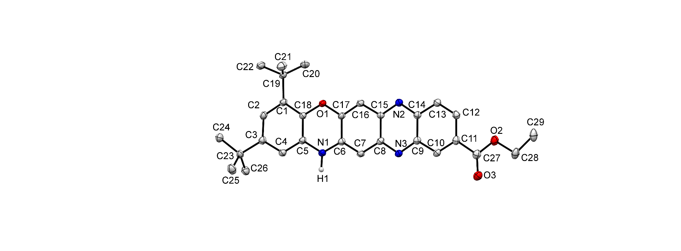

**Figure S3:** Molecular structure of ethyl 2,4-di-*tert*-butyl-14H-quinoxalino[2,3-b]phenoxazine-10-carboxylate **4c**.

с низким доверительным уровнем

**Figure S4:** Molecular structure of solvate **4с**.

**Table S5:** Crystal data and structure refinement for **4с**.

|  |  |
| --- | --- |
| **Parameter** | 4с |
| CCDC Number | 2308520 |
| Empirical formula | C32H43N3O6 |
| Formula weight | 565.69 |
| Temperature/K | 100.15 |
| Crystal system | triclinic |
| Space group | P-1 |
| a/Å | 8.8807(3) |
| b/Å | 9.8727(3) |
| c/Å | 17.3935(8) |
| α/° | 99.624(3) |
| β/° | 91.935(3) |
| γ/° | 97.449(3) |
| Volume/Å3 | 1488.46(9) |
| Z | 2 |
| ρcalcg/cm3 | 1.262 |
| μ/mm‑1 | 0.705 |
| F(000) | 608.0 |
| Crystal size/mm3 | 0.24 × 0.09 × 0.04 |
| Radiation | CuKα (λ = 1.54184) |
| 2Θ range for data collection/° | 9.172 to 152.93 |
| Index ranges | -11 ≤ h ≤ 11,  -12 ≤ k ≤ 12,  -21 ≤ l ≤ 21 |
| Reflections collected | 11566 |
| Independent reflections | 11566 [Rint = ?, Rsigma = 0.0372] |
| Data/restraints/parameters | 11566/2/414 |
| Goodness-of-fit on F2 | 1.026 |
| Final R indexes [I>=2σ (I)] | R1 = 0.0529, wR2 = 0.1599 |
| Final R indexes [all data] | R1 = 0.0693, wR2 = 0.1735 |
| Largest diff. peak/hole / e Å-3 | 0.56/-0.25 |

**Table S6:** X-ray determined bond lengths, valence angles of **4с**.

Bond lengths, Å.

|  |  |  |  |  |
| --- | --- | --- | --- | --- |
| O4-C30 | 1.442(3) |  | C19-C22 | 1.540(3) |
| O1-C18 | 1.396(2) |  | C19-C21 | 1.533(3) |
| O1-C17 | 1.369(2) |  | C17-C16 | 1.358(3) |
| O2-C27 | 1.348(3) |  | C1-C2 | 1.407(3) |
| O2-C28 | 1.452(3) |  | C4-C3 | 1.393(3) |
| O3-C27 | 1.203(3) |  | C13-C14 | 1.419(3) |
| N2-C15 | 1.336(3) |  | C13-C12 | 1.369(3) |
| N2-C14 | 1.362(3) |  | C9-C14 | 1.426(3) |
| N3-C9 | 1.355(3) |  | C9-C10 | 1.421(3) |
| N3-C8 | 1.337(3) |  | C30-C32 | 1.511(3) |
| N1-C5 | 1.391(3) |  | C30-C31 | 1.516(3) |
| N1-C6 | 1.365(3) |  | C7-C8 | 1.417(3) |
| C5-C18 | 1.394(3) |  | C12-C11 | 1.428(3) |
| C5-C4 | 1.391(3) |  | C2-C3 | 1.392(3) |
| C18-C1 | 1.399(3) |  | C10-C11 | 1.371(3) |
| C15-C16 | 1.432(3) |  | C3-C23 | 1.534(3) |
| C15-C8 | 1.453(3) |  | C11-C27 | 1.490(3) |
| C6-C17 | 1.441(3) |  | C23-C26 | 1.540(3) |
| C6-C7 | 1.373(3) |  | C23-C25 | 1.532(3) |
| C19-C1 | 1.530(3) |  | C23-C24 | 1.527(3) |
| C19-C20 | 1.532(3) |  | C29-C28 | 1.513(4) |

Valence Angles, deg.

|  |  |  |  |  |  |  |
| --- | --- | --- | --- | --- | --- | --- |
| C17-O1-C18 | | | 120.09(16) |  | N3-C9-C10 | 118.81(19) |
| C27-O2-C28 | | | 114.47(19) |  | C10-C9-C14 | 118.94(19) |
| C15-N2-C14 | | | 116.85(18) |  | N2-C14-C13 | 119.52(19) |
| C8-N3-C9 | | | 116.60(18) |  | N2-C14-C9 | 121.13(18) |
| C6-N1-C5 | | | 122.15(18) |  | C13-C14-C9 | 119.35(18) |
| N1-C5-C18 | | | 119.54(18) |  | O4-C30-C32 | 106.9(2) |
| C4-C5-N1 | | | 120.06(18) |  | O4-C30-C31 | 111.52(19) |
| C4-C5-C18 | | | 120.36(18) |  | C32-C30-C31 | 112.3(2) |
| O1-C18-C1 | | | 118.51(18) |  | C6-C7-C8 | 120.86(18) |
| C5-C18-O1 | | | 119.85(17) |  | C13-C12-C11 | 120.36(19) |
| C5-C18-C1 | | | 121.63(18) |  | C3-C2-C1 | 124.22(18) |
| N2-C15-C16 | | | 119.55(18) |  | C11-C10-C9 | 120.7(2) |
| N2-C15-C8 | | | 121.71(18) |  | C4-C3-C23 | 119.68(19) |
| C16 | C15 | C8 | 118.75(18) |  | C2-C3-C4 | 117.61(19) |
| N1-C6-C17 | | | 117.66(18) |  | C2-C3-C23 | 122.68(18) |
| N1-C6-C7 | | | 122.79(19) |  | C12-C11-C27 | 122.30(19) |
| C7-C6-C17 | | | 119.54(19) |  | C10-C11-C12 | 120.16(19) |
| C1-C19-C20 | | | 111.73(17) |  | C10-C11-C27 | 117.5(2) |
| C1-C19-C22 | | | 110.66(17) |  | C17-C16-C15 | 119.95(18) |
| C1-C19-C21 | | | 109.39(17) |  | N3-C8-C15 | 121.45(18) |
| C20-C19-C22 | | | 106.85(18) |  | N3-C8-C7 | 119.40(18) |
| C20-C19-C21 | | | 110.27(19) |  | C7-C8-C15 | 119.15(17) |
| C21-C19-C22 | | | 107.85(18) |  | C3-C23-C26 | 109.57(17) |
| O1-C17-C6 | | | 120.69(18) |  | C25-C23-C3 | 109.10(17) |
| C16-C17-O1 | | | 117.59(18) |  | C25-C23-C26 | 109.11(19) |
| C16-C17-C6 | | | 121.72(18) |  | C24-C23-C3 | 112.71(18) |
| C18-C1-C19 | | | 122.96(18) |  | C24-C23-C26 | 108.11(18) |
| C18-C1-C2 | | | 115.73(18) |  | C24-C23-C25 | 108.17(19) |
| C2-C1-C19 | | | 121.25(17) |  | O2-C27-C11 | 112.50(19) |
| C5-C4-C3 | | | 120.37(19) |  | O3-C27-O2 | 123.5(2) |
| C12-C13-C14 | | | 120.5(2) |  | O3-C27-C11 | 124.0(2) |
| N3-C9-C14 | | | 122.24(18) |  | O2-C28-C29 | 107.5(2) |

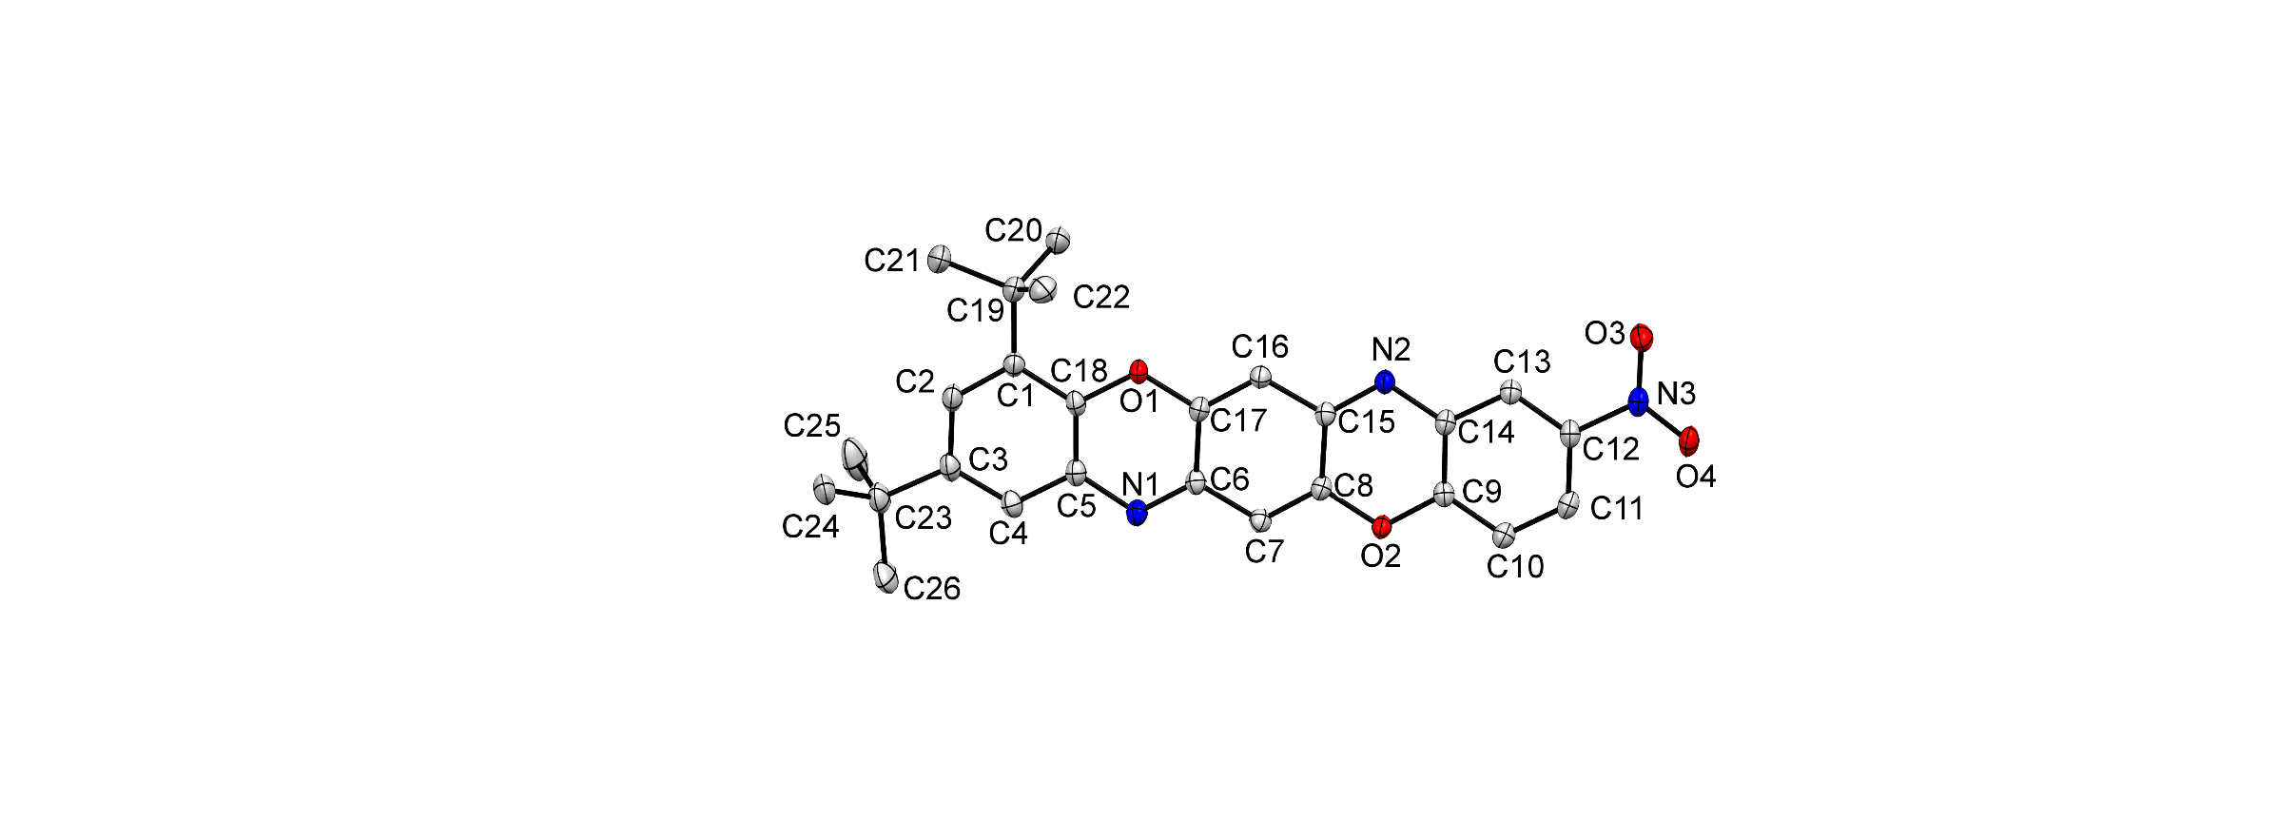

**Figure S5:** Molecular structure of 2,4-di-*tert*-butyl-9-nitrobenzo[5,6][1,4]oxazino[2,3-b]phenoxazine **6b**.

**Table S7:** Crystal data and structure refinement for **6b**

|  |  |
| --- | --- |
| **Parameter** | 6b |
| CCDC Number | 2292848 |
| Empirical formula | C26H25N3O4 |
| Formula weight | 443.49 |
| Temperature/K | 100.00(13) |
| Crystal system | monoclinic |
| Space group | P21/c |
| a/Å | 18.1069(4) |
| b/Å | 6.68620(10) |
| c/Å | 18.7628(3) |
| α/° | 90 |
| β/° | 96.324(2) |
| γ/° | 90 |
| Volume/Å3 | 2257.72(7) |
| Z | 4 |
| ρcalcg/cm3 | 1.305 |
| μ/mm‑1 | 0.724 |
| F(000) | 936.0 |
| Crystal size/mm3 | 0.339 × 0.182 × 0.07 |
| Radiation | Cu Kα (λ = 1.54184) |
| 2Θ range for data collection/° | 9.486 to 152.62 |
| Index ranges | -22 ≤ h ≤ 22,  -8 ≤ k ≤ 8,  -19 ≤ l ≤ 23 |
| Reflections collected | 23366 |
| Independent reflections | 4719 [Rint = 0.0332, Rsigma = 0.0229] |
| Data/restraints/parameters | 4719/0/304 |
| Goodness-of-fit on F2 | 1.037 |
| Final R indexes [I>=2σ (I)] | R1 = 0.0464, wR2 = 0.1296 |
| Final R indexes [all data] | R1 = 0.0545, wR2 = 0.1375 |
| Largest diff. peak/hole / e Å-3 | 0.29/-0.28 |

**Table S8:** X-ray determined bond lengths, valence angles of **6b**.

Bond lengths, Å.

|  |  |  |  |  |
| --- | --- | --- | --- | --- |
| O1-C18 | 1.3832(15) |  | C18-C1 | 1.4014(18) |
| O1-C17 | 1.3648(16) |  | C9-C14 | 1.4033(19) |
| O2-C8 | 1.3681(15) |  | C17-C16 | 1.3526(18) |
| O2-C9 | 1.3695(15) |  | C14-C13 | 1.3977(17) |
| O3-N3 | 1.2293(16) |  | C13-C12 | 1.3851(18) |
| O4-N3 | 1.2306(16) |  | C5-C4 | 1.4022(18) |
| N2-C15 | 1.3119(17) |  | C12-C11 | 1.389(2) |
| N2-C14 | 1.3926(16) |  | C1-C2 | 1.3982(19) |
| N1-C6 | 1.3107(17) |  | C1-C19 | 1.534(2) |
| N1-C5 | 1.3909(17) |  | C2-C3 | 1.405(2) |
| N3-C12 | 1.4650(16) |  | C4-C3 | 1.381(2) |
| C8-C15 | 1.4595(18) |  | C3-C23 | 1.5367(18) |
| C8-C7 | 1.3491(18) |  | C19-C22 | 1.539(2) |
| C6-C17 | 1.4549(19) |  | C19-C20 | 1.538(2) |
| C6-C7 | 1.4349(18) |  | C19-C21 | 1.5370(19) |
| C15-C16 | 1.4331(18) |  | C23-C24 | 1.536(2) |
| C10-C9 | 1.3881(18) |  | C23-C26 | 1.526(2) |
| C10-C11 | 1.3848(18) |  | C23-C25 | 1.534(2) |
| C18-C5 | 1.400(2) |  |  |  |

Valence Angles, deg.

|  |  |  |  |  |  |
| --- | --- | --- | --- | --- | --- |
| C17-O1-C18 | 119.12(11) | C8-C7-C6 | | | 119.98(12) |
| C8-O2-C9 | 118.37(10) | N1-C5-C18 | | | 122.58(12) |
| C15-N2-C14 | 116.19(11) | N1-C5-C4 | | | 118.23(12) |
| C6-N1-C5 | 116.96(12) | C18-C5-C4 | | | 119.19(12) |
| O3-N3-O4 | 123.65(11) | C13-C12-N3 | | | 118.70(12) |
| O3-N3-C12 | 118.56(11) | C13-C12-C11 | | | 123.03(12) |
| O4-N3-C12 | 117.79(12) | C11-C12-N3 | | | 118.26(11) |
| O2-C8-C15 | 118.82(11) | C17-C16-C15 | | | 120.18(12) |
| C7-C8-O2 | 118.02(12) | C10-C11-C12 | | | 118.57(12) |
| C7-C8-C15 | 123.16(12) | C18-C1-C19 | | | 122.29(12) |
| N1-C6-C17 | 123.07(12) | C2-C1-C18 | | | 115.45(13) |
| N1-C6-C7 | 119.98(12) | C2-C1-C19 | | | 122.26(12) |
| C7-C6-C17 | 116.95(11) | C1-C2-C3 | | | 124.09(13) |
| N2-C15-C8 | 123.57(12) | C3-C4-C5 | | | 120.69(13) |
| N2-C15-C16 | 119.75(12) | C2-C3-C23 | | | 119.49(13) |
| C16-C15-C8 | 116.67(11) | C4-C3-C2 | | | 118.01(12) |
| C11-C10-C9 | 118.99(12) | C4-C3-C23 | | | 122.49(14) |
| O1-C18-C5 | 119.42(11) | C1-C19-C22 | | | 110.17(12) |
| O1-C18-C1 | 118.05(12) | C1-C19-C20 | | | 110.08(12) |
| C5-C18-C1 | 122.52(12) | C1-C19-C21 | | | 111.42(12) |
| O2-C9-C10 | 116.70(12) | C20-C19-C22 | | | 110.34(12) |
| O2-C9-C14 | 120.59(11) | C21-C19-C22 | | | 107.30(13) |
| C10-C9-C14 | 122.70(12) | C21-C19-C20 | | | 107.46(12) |
| O1-C17-C6 | 118.76(11) | C24-C23-C3 | | | 110.25(13) |
| C16-C17-O1 | 118.28(12) | C26-C23-C3 | | | 111.54(12) |
| C16-C17-C6 | 122.96(12) | C26-C23-C24 | | | 107.80(13) |
| N2-C14-C9 | 122.40(11) | C26-C23-C25 | | | 109.64(15) |
| N2-C14-C13 | 119.77(12) | C25-C23-C3 | | | 108.43(12) |
| C13-C14-C9 | 117.82(12) | C25-C23-C24 | | | 109.16(14) |
| C12-C13-C14 | 118.86(12) |  |  |  |  |

1. DFT study

**Figure S6:** Geometries and relative stability of the tautomeric forms of quinoxaline[2,3-*b*]phenoxazine and it 6,8-di-(*tret*-butyl derivatives calculated using the DFT B3LYP/6-311++G(d,p) method.

1. UV/vis and luminescence spectra

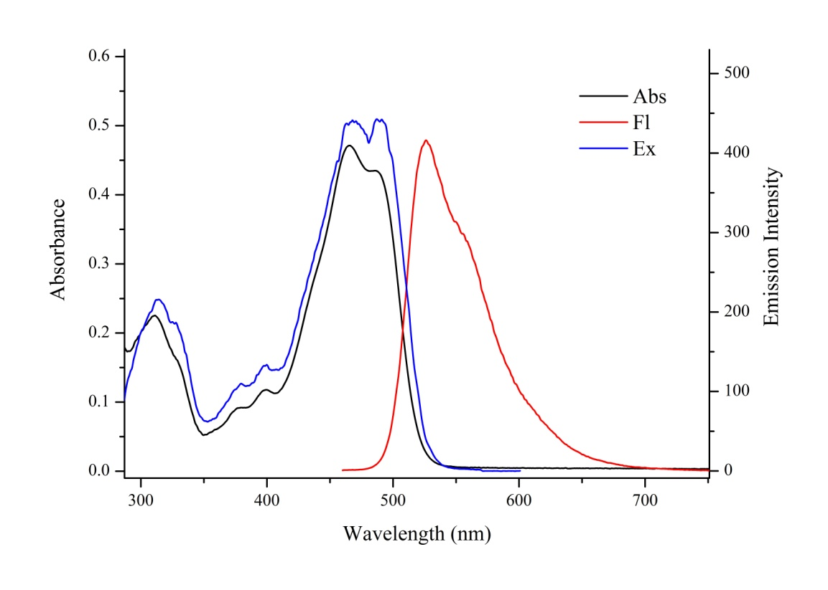

**Figure S7:** UV/vis, fluorescence emission (λex = 365 nm) and fluorescence excitation (λobs = 610 nm) spectra of compound **4a** (toluene, *C* = 2 ∙ 10-5 M, *l* = 1 cm, *T* = 293 K).

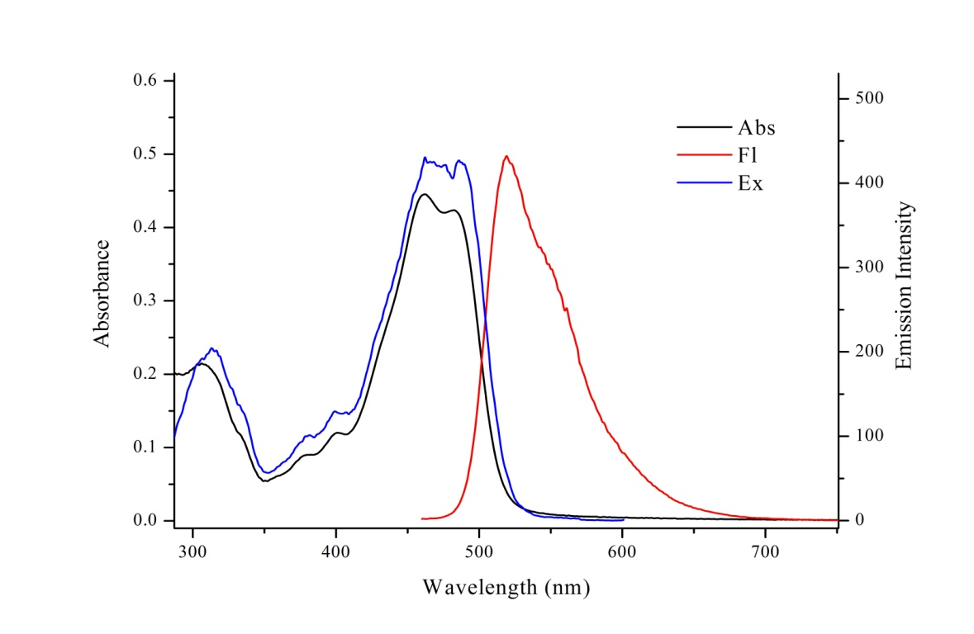

**Figure S8:** UV/vis, fluorescence emission (λex = 365 nm) and fluorescence excitation (λobs = 610 nm) spectra of compound **4b** (toluene, *C* = 2 ∙ 10 -5 M, *l* = 1 cm, *T* = 293 K).

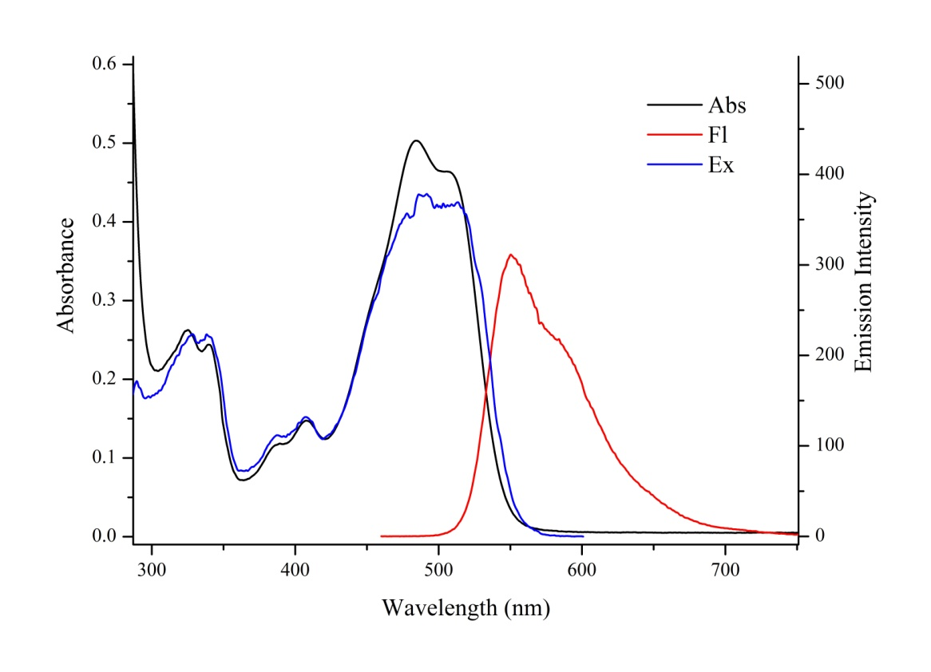

**Figure S9:** UV/vis, fluorescence emission (λex = 365 nm) and fluorescence excitation (λobs = 630 nm) spectra of compound **4c** (toluene, *C* = 2 ∙ 10 -5 M, *l* = 1 cm, *T* = 293 K).

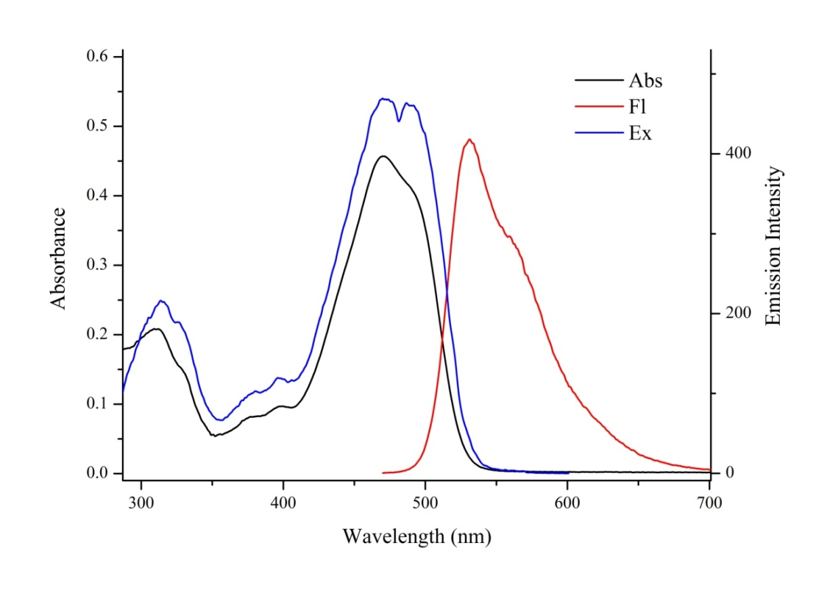

**Figure S10:** UV/vis, fluorescence emission (λex = 365 nm) and fluorescence excitation (λobs = 610 nm) spectra of compound **5a** (toluene, *C* = 2 ∙ 10 -5 M, *l* = 1 cm, *T* = 293 K).

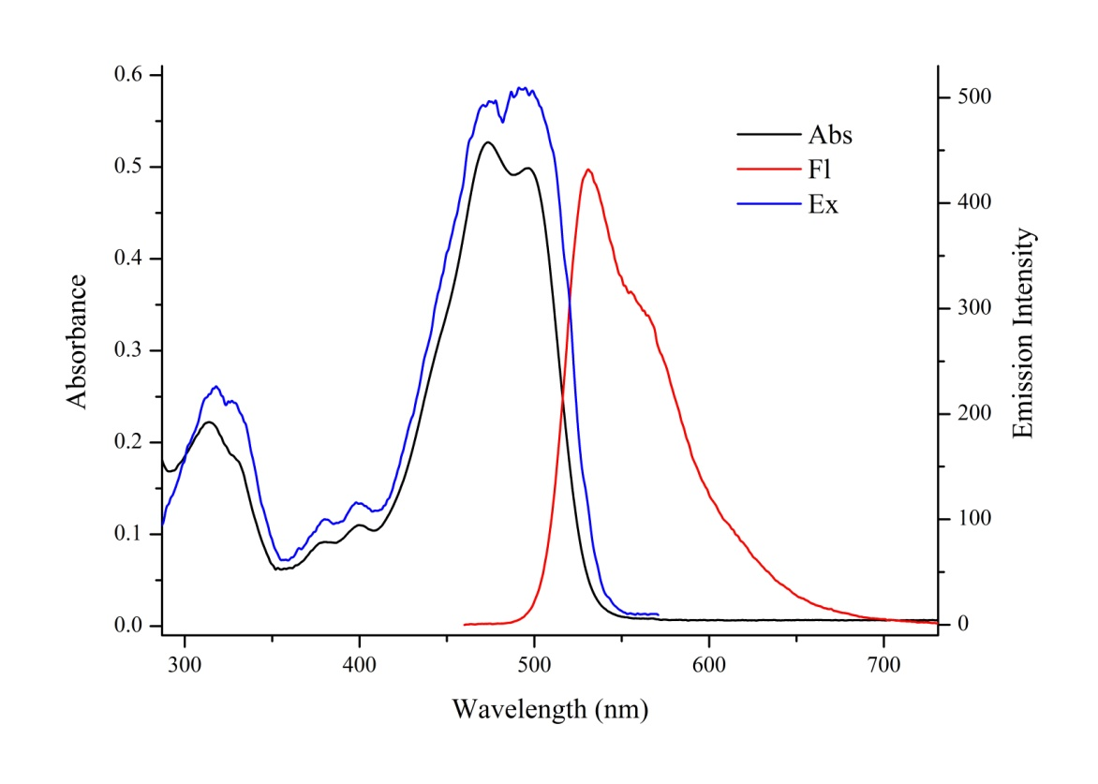

**Figure S11:** UV/vis, fluorescence emission (λex = 365 nm) and fluorescence excitation (λobs = 610 nm) spectra of compound **5b** (toluene, *C* = 2 ∙ 10 -5 M, *l* = 1 cm, *T* = 293).

1. Cyclic voltammetry

**Figure S12:** Cyclic voltammetry curves of **3a-h** (CH2Cl2, 50 mV/sec, C = 5 mM).

1. NMR spectra

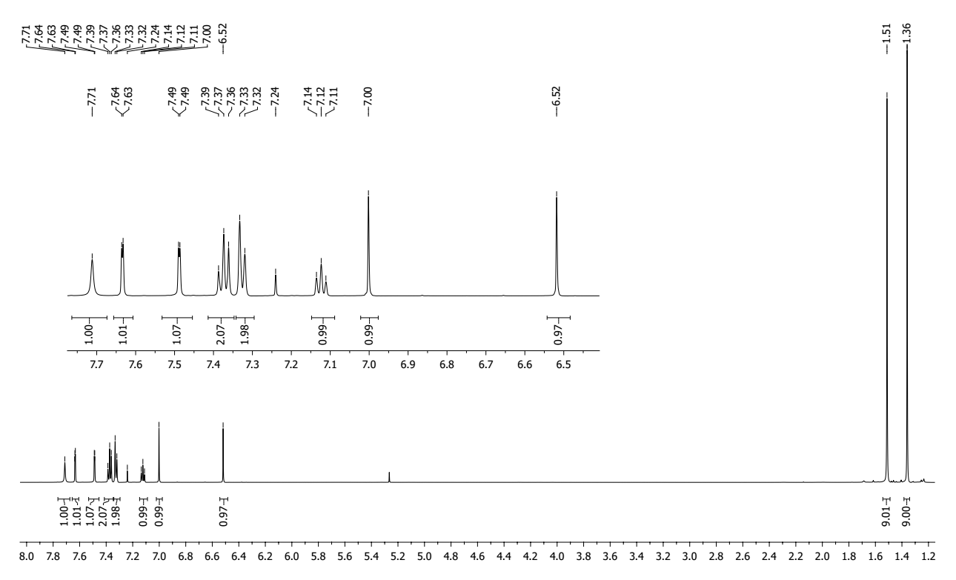

**Figure S13:** 1H NMR spectrum of 6,8-di-*tert*-butyl-2-(phenylamino)-3H-phenoxazin-3-one **3a**.

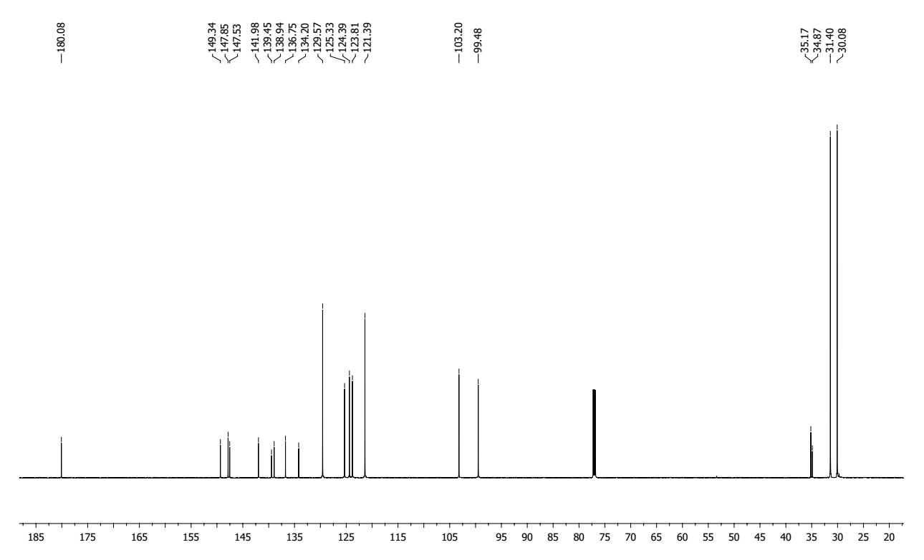

**Figure S14:** 13C NMR spectrum of 6,8-di-*tert*-butyl-2-(phenylamino)-3H-phenoxazin-3-one **3a**.

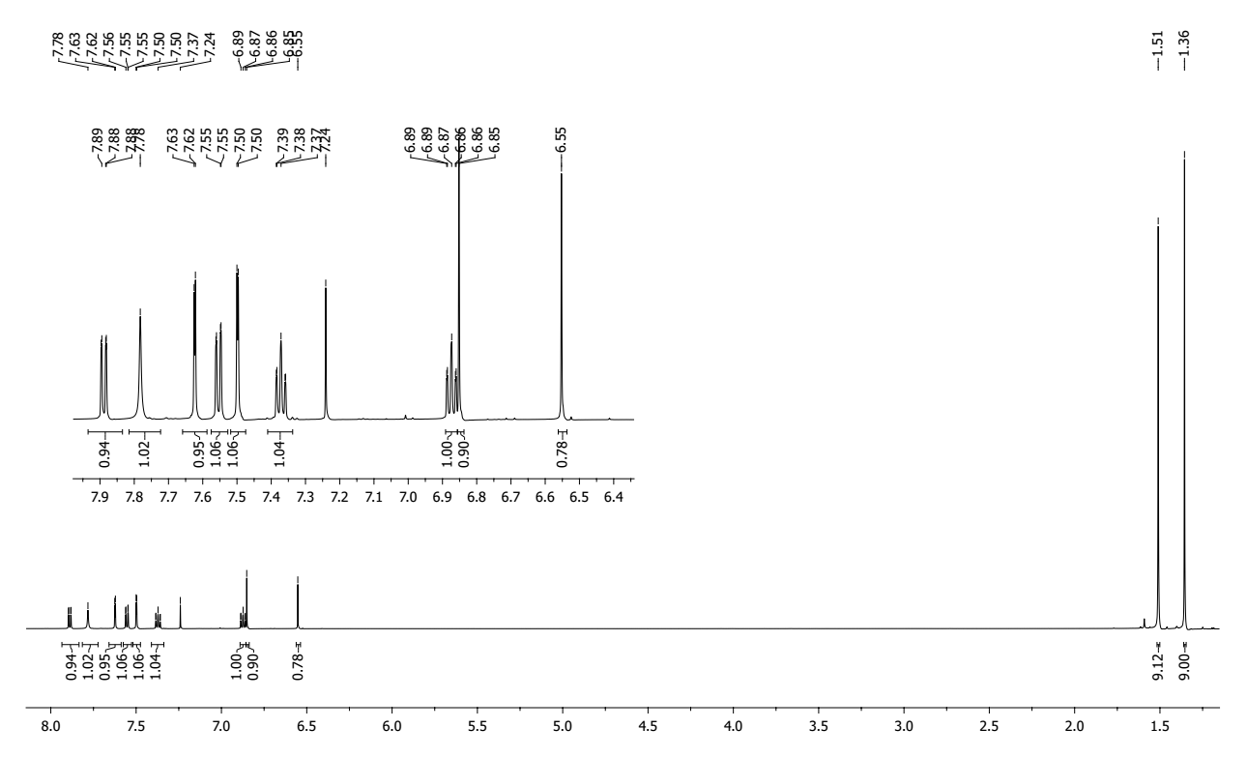

**Figure S15:** 1H NMR spectrum of 6,8-di-*tert*-butyl-2-((2-iodophenyl)amino)-3H-phenoxazin-3-one **3b**.

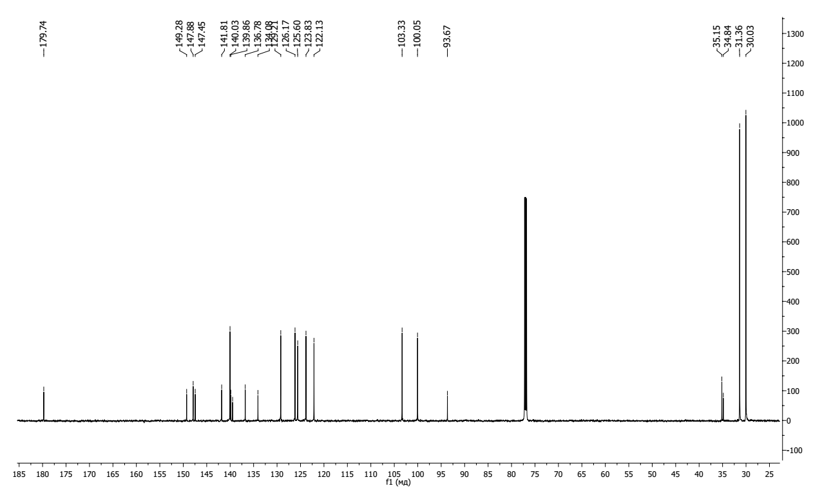

**Figure S16:** 13C NMR spectrum of 6,8-di-*tert*-butyl-2-((2-iodophenyl)amino)-3H-phenoxazin-3-one **3b**.

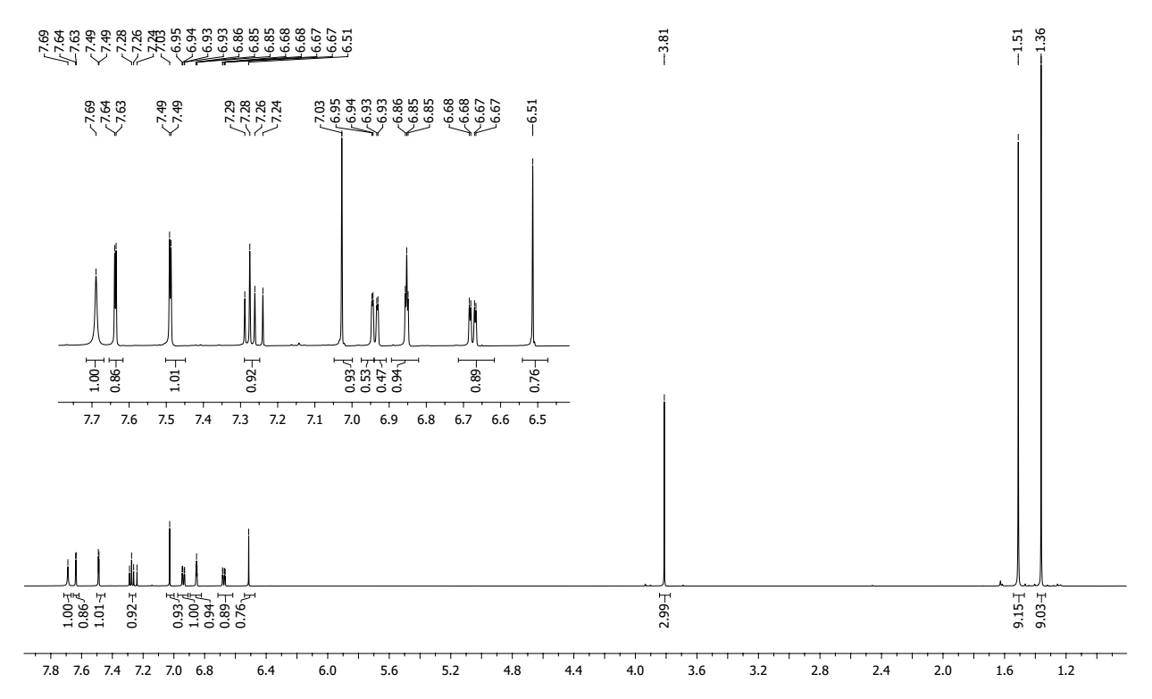

**Figure S17:** 1H NMR spectrum of 6,8-di-*tert*-butyl-2-((3-methoxyphenyl)amino)-3H-phenoxazin-3-one **3с**.

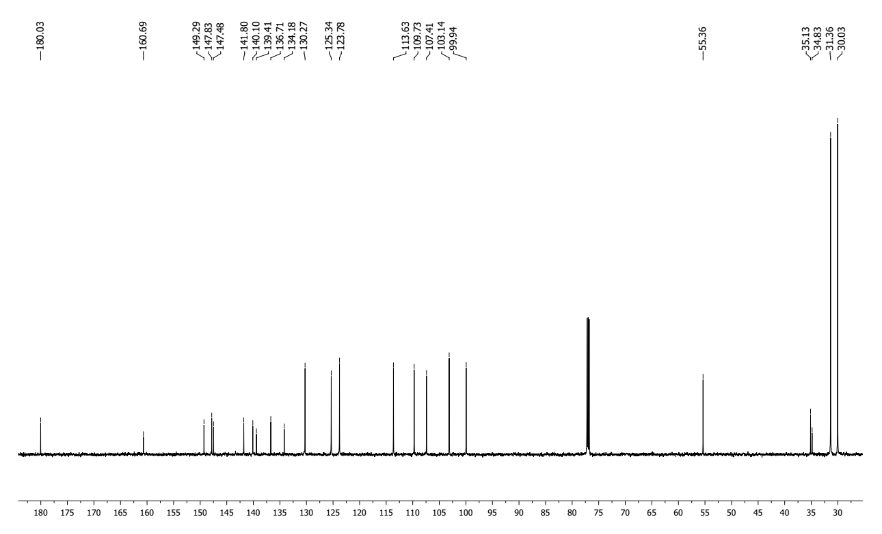

**Figure S18:** 13C NMR spectrum of 6,8-di-*tert*-butyl-2-((3-methoxyphenyl)amino)-3H-phenoxazin-3-one **3с**.

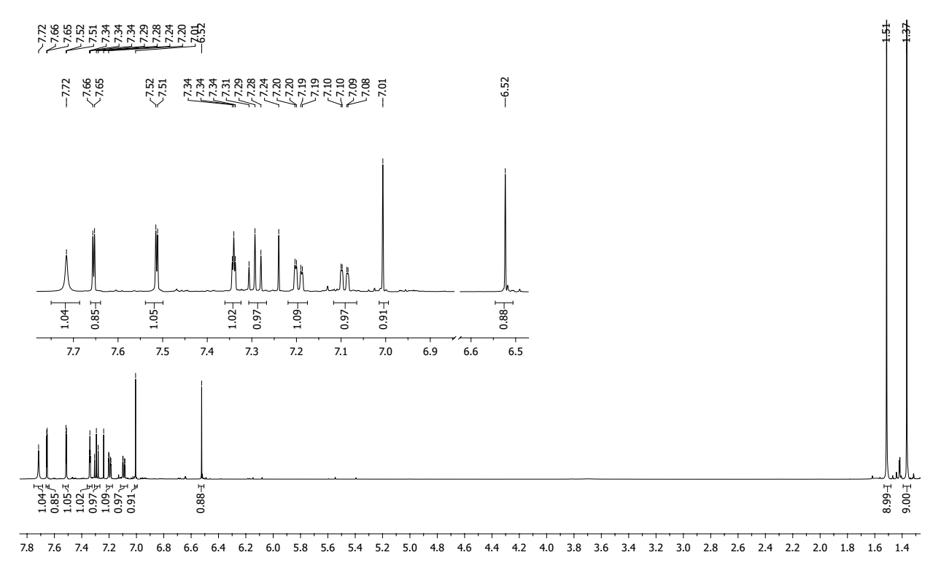

**Figure S19:** 1H NMR spectrum of 6,8-di-*tert*-butyl-2-((3-chlorophenyl)amino)-3H-phenoxazin-3-one **3d**.

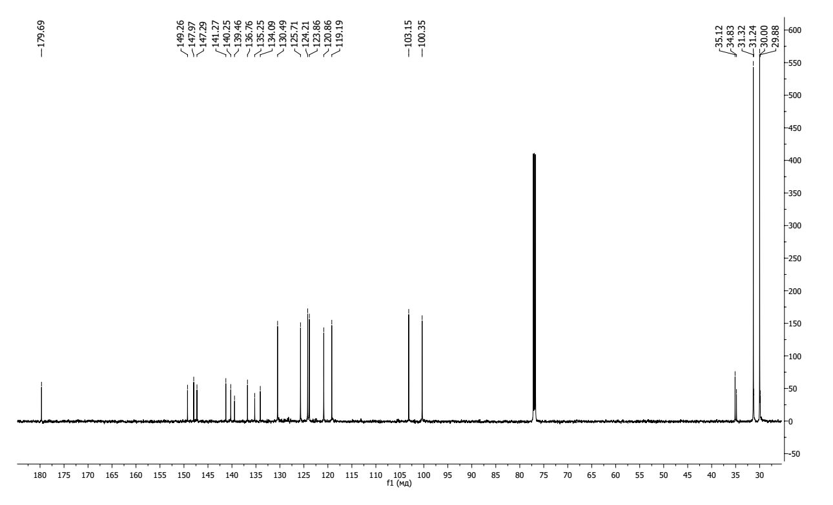

**Figure S20:** 13C NMR spectrum of 6,8-di-*tert*-butyl-2-((3-chlorophenyl)amino)-3H-phenoxazin-3-one **3d**.

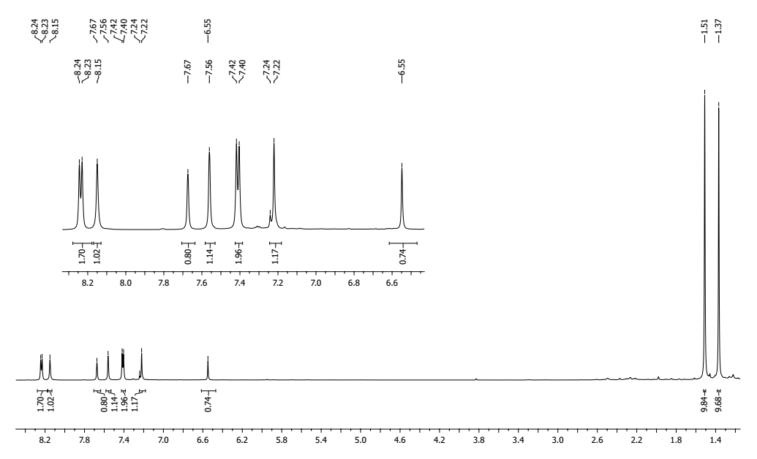

**Figure S21:** 1H NMR spectrum of 6,8-di-*tert*-butyl-2-((4-nitrophenyl)amino)-3H-phenoxazin-3-one **3e**.

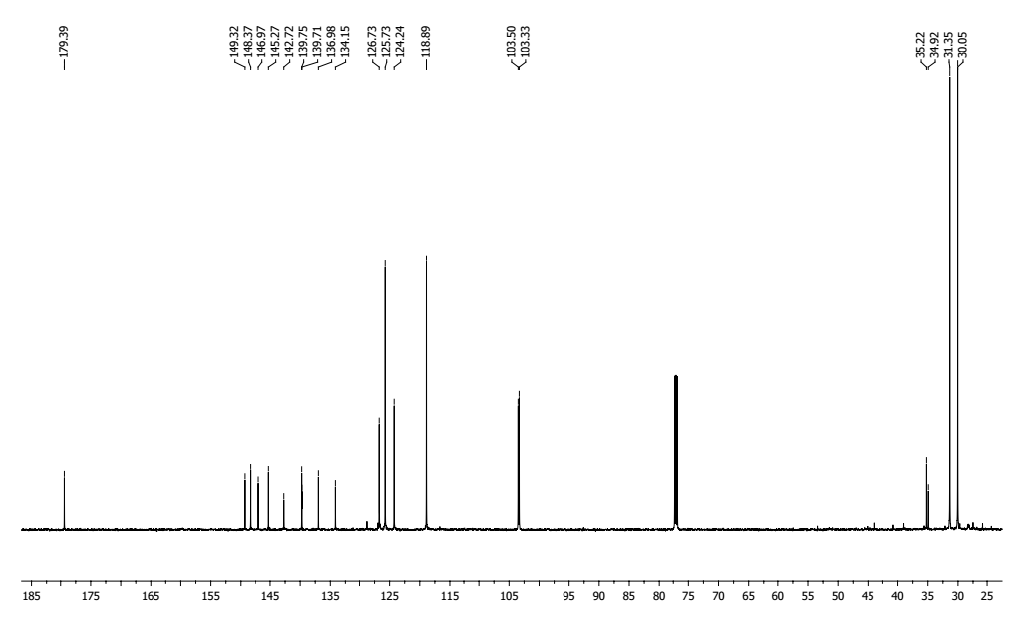

**Figure S22:** 13C NMR spectrum of 6,8-di-*tert*-butyl-2-((4-nitrophenyl)amino)-3H-phenoxazin-3-one **3e**.

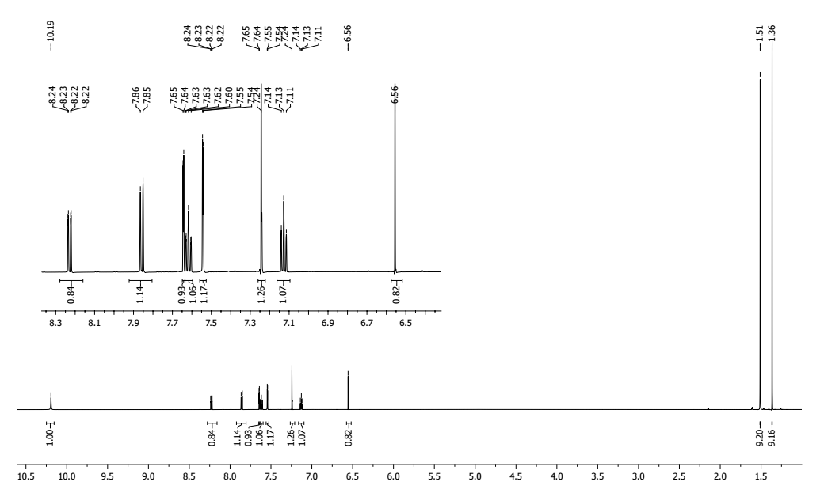

**Figure S23:** 1H NMR spectrum of 6,8-di-*tert*-butyl-2-((2-nitrophenyl)amino)-3H-phenoxazin-3-one **3f**.

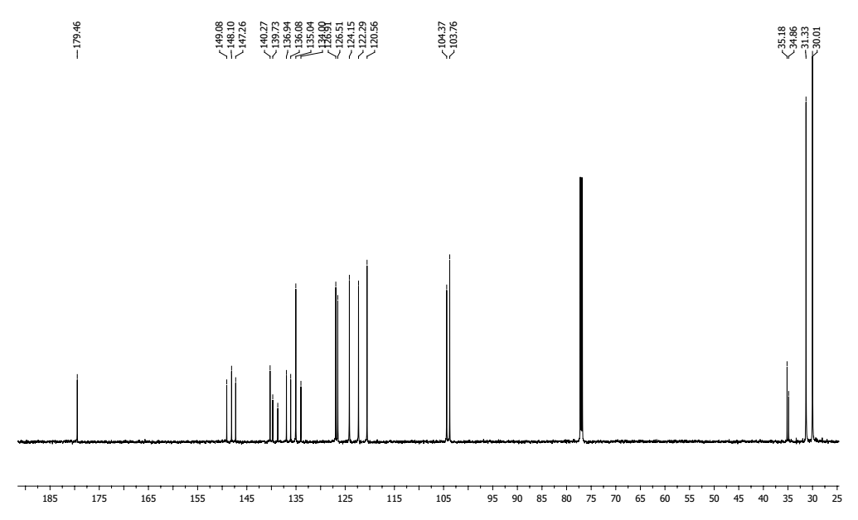

**Figure S24:** 13C NMR spectrum of 6,8-di-*tert*-butyl-2-((2-nitrophenyl)amino)-3H-phenoxazin-3-one **3f**.

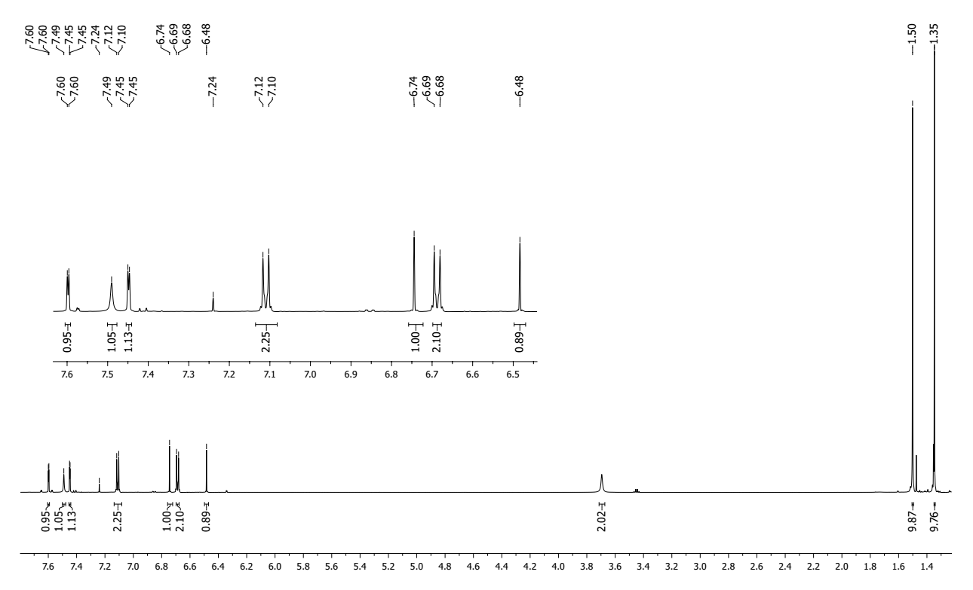

**Figure S25:** 1H NMR spectrum of 2-((4-aminophenyl)amino)-6,8-di-*tert*-butyl-3H-phenoxazin-3-one **3g**.

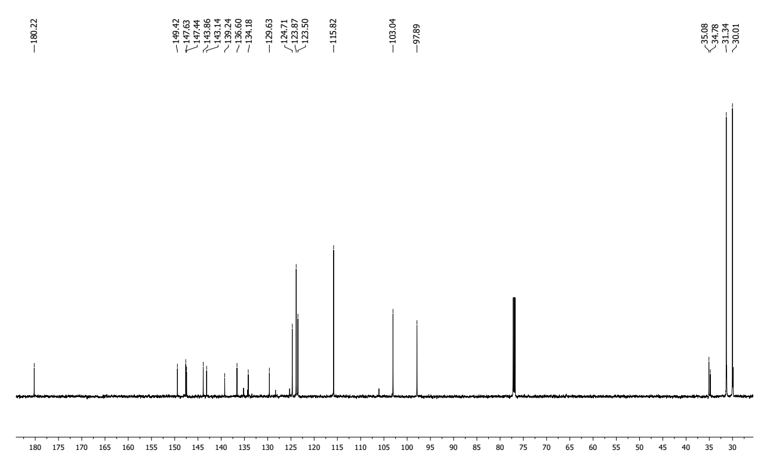

**Figure S26:** 13C NMR spectrum of 2-((4-aminophenyl)amino)-6,8-di-*tert*-butyl-3H-phenoxazin-3-one **3g**.

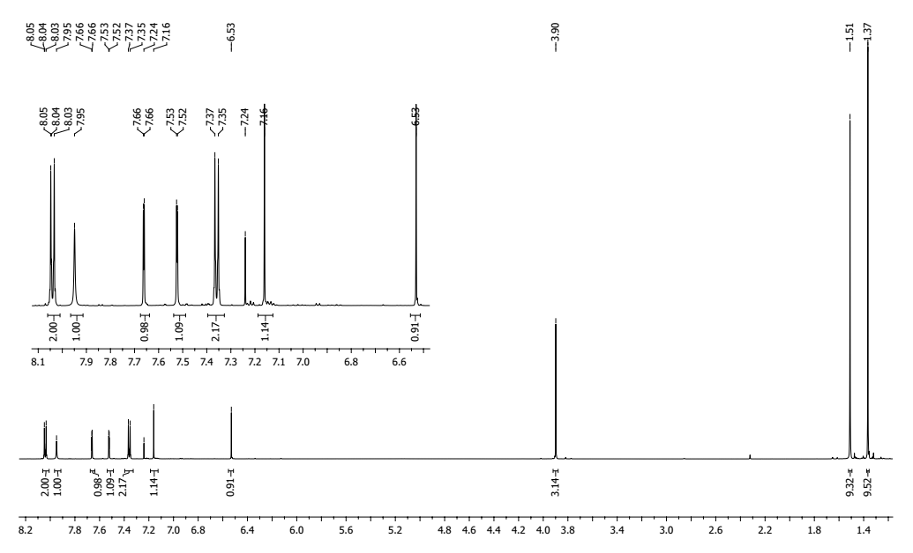

**Figure S27:** 1H NMR spectrum of methyl 4-((6,8-di-*tert*-butyl-3-oxo-3H-phenoxazin-2-yl)amino)benzoate **3h**.

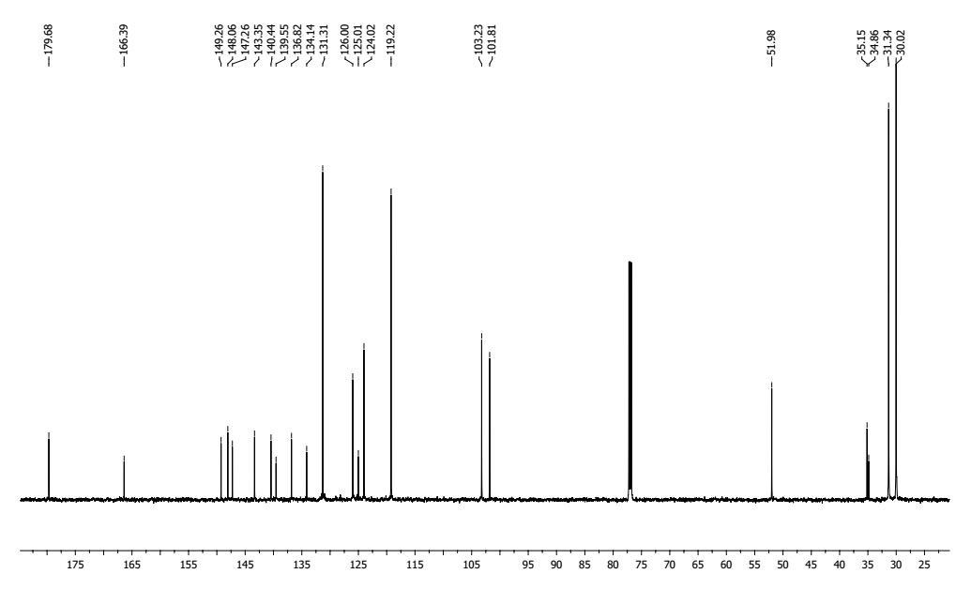

**Figure S28:** 13C NMR spectrum of methyl 4-((6,8-di-*tert*-butyl-3-oxo-3H-phenoxazin-2-yl)amino)benzoate **3h**.

**2,4-di-*tert*-butyl-14H-quinoxalino[2,3-b]phenoxazine (4a)**



**Table S9:** Chemical shifts 1H, 13C and 15N of compound **4a** in CDCl3 at 30°C δ (ppm) and spin-spin coupling constants *J* (Hz).

|  |  |  |  |  |  |  |  |  |  |  |  |  |  |  |  |
| --- | --- | --- | --- | --- | --- | --- | --- | --- | --- | --- | --- | --- | --- | --- | --- |
| Compound | Nucleus | 1 | 2 | 3 | 4 | 5 | 6 | 7 | 8 | 9(15N) | 10 | 11 | 12 | 13 | 14 |
| **4a** | 1H | 6.42 |  | 6.74 |  |  |  | 7.26 |  |  |  | 7.96 | 7.48 | 7.48 | 7.87 |
| *J*1H-1H | 2.4 |  | 2.4 |  |  |  |  |  |  |  | 7.8 | 7.8 | 7.8 | 7.8 |
| 13C/15N | 109.64 | 136.94 | 117.04 | 146.46 | 138.09 | 144.11 | 109.69 | 143.58 | 314.95 | 141.67 | 128.98 | 128.02 | 129.10 | 127.28 |

|  |  |  |  |  |  |  |  |  |  |  |  |  |
| --- | --- | --- | --- | --- | --- | --- | --- | --- | --- | --- | --- | --- |
| Compound | Nucleus | 15 | 16(15N) | 17 | 18 | 19 | 20(15N) | 21 | 22 | 23 | 24 | 25 |
| **4a** | 1H |  |  |  | 6.85 |  |  |  |  |  | 1.46 | 1.13 |
| *J*1H-1H |  |  |  |  |  |  |  |  |  |  |  |
| 13C/15N | 142.19 | 296.56 | 148.97 | 102.35 | 136.53 | 92.79 | 127.80 | 34.93 | 34.38 | 29.98 | 31.20 |

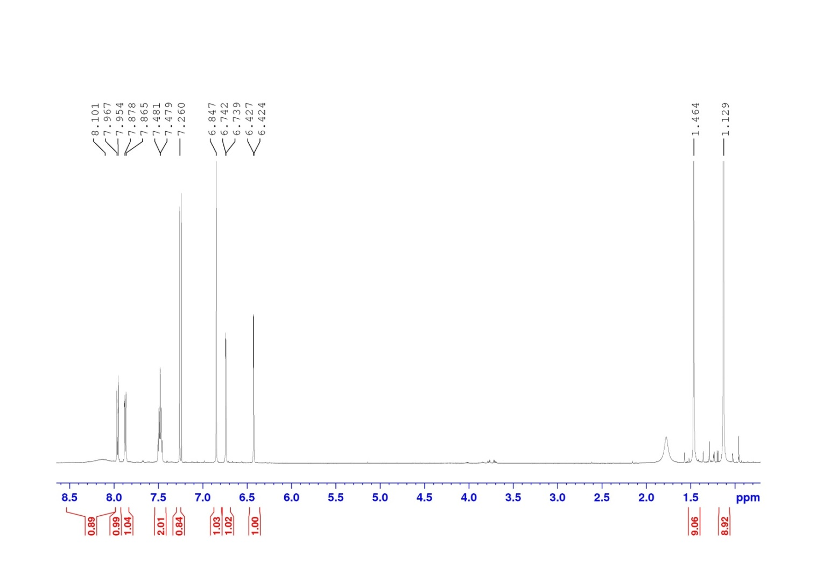

**Figure S29:** 1H NMR spectrum of 2,4-di-*tert*-butyl-14H-quinoxalino[2,3-b]phenoxazine **4a**.

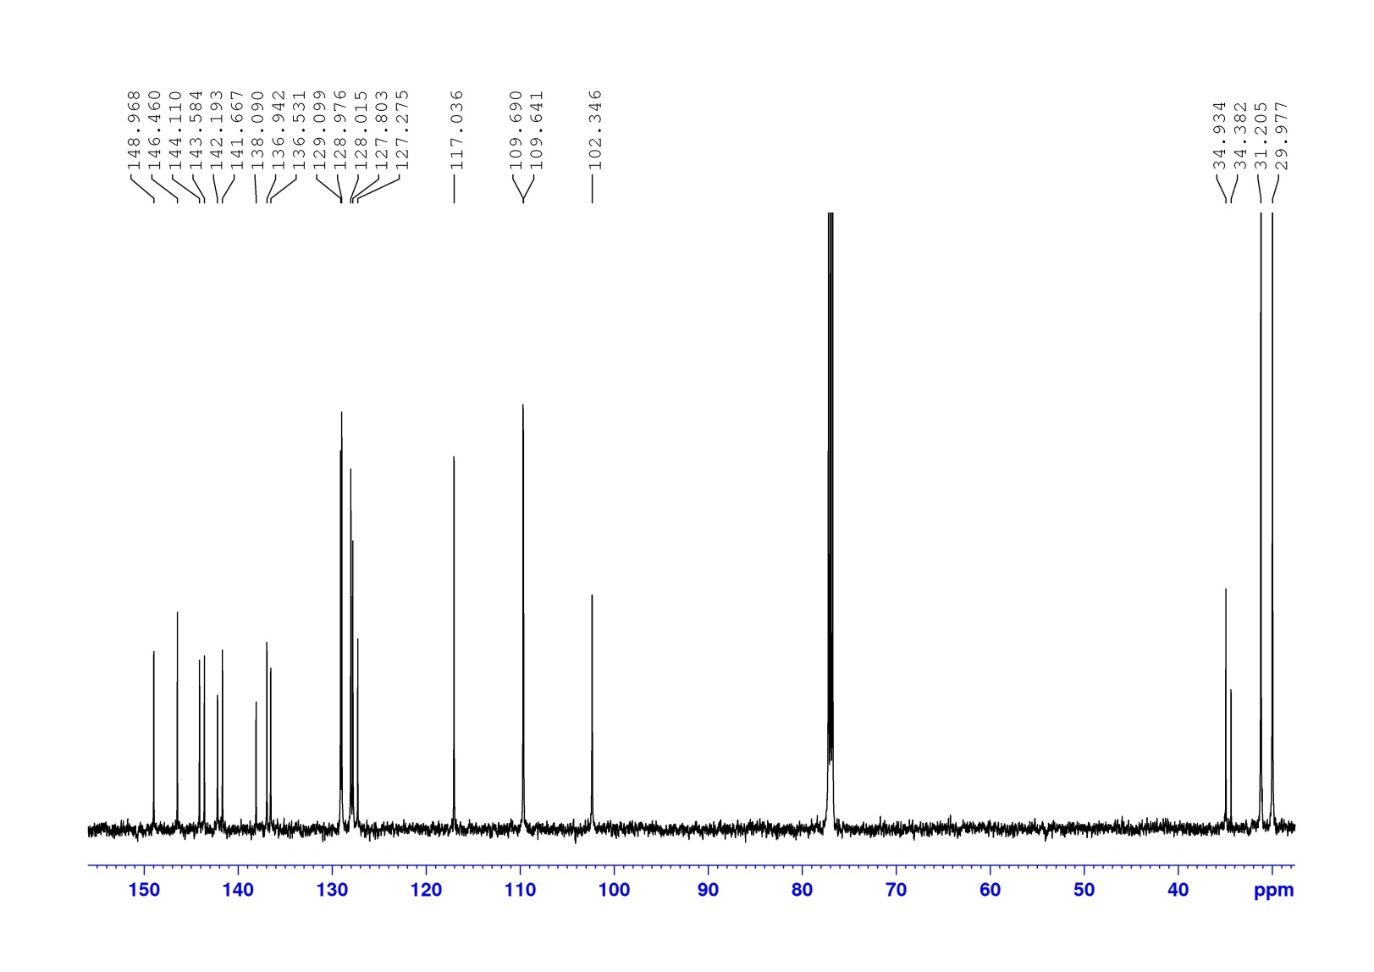

**Figure S30:** 13C NMR spectrum of 2,4-di-*tert*-butyl-14H-quinoxalino[2,3-b]phenoxazine **4a**.

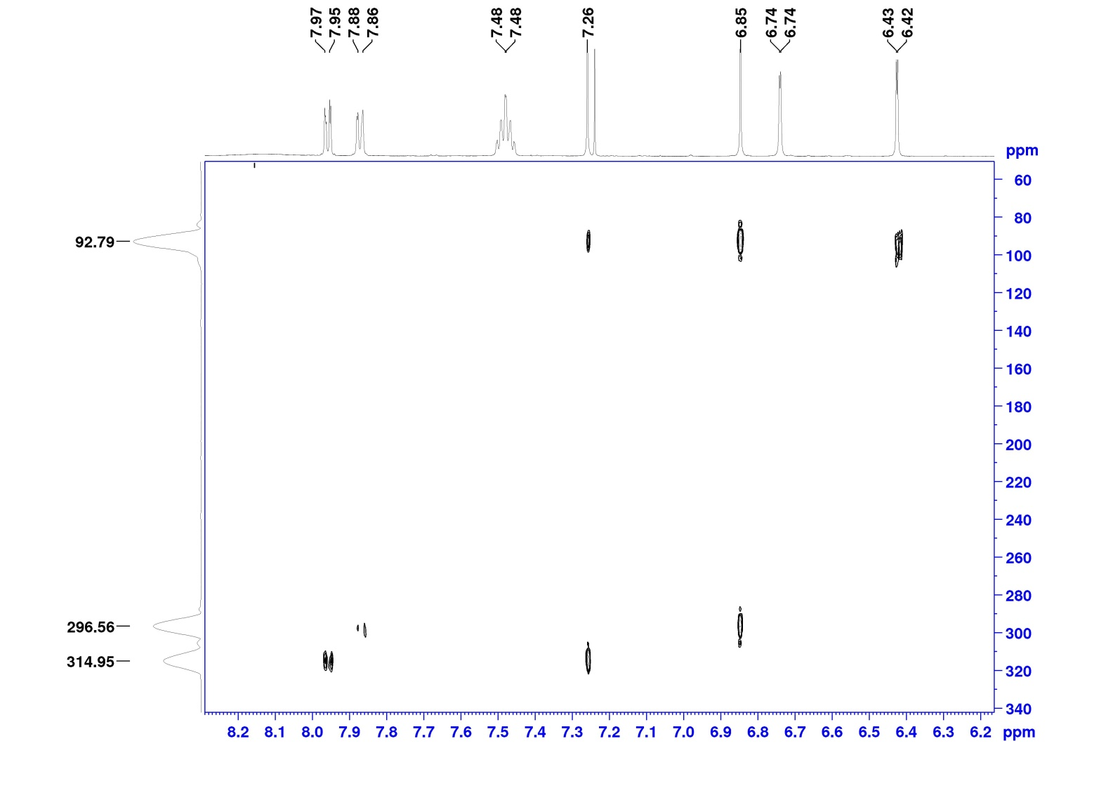

**Figure S31:** HMBC 1H-15N NMR spectrum of 2,4-di-*tert*-butyl-14H-quinoxalino[2,3-b]phenoxazine **4a**.

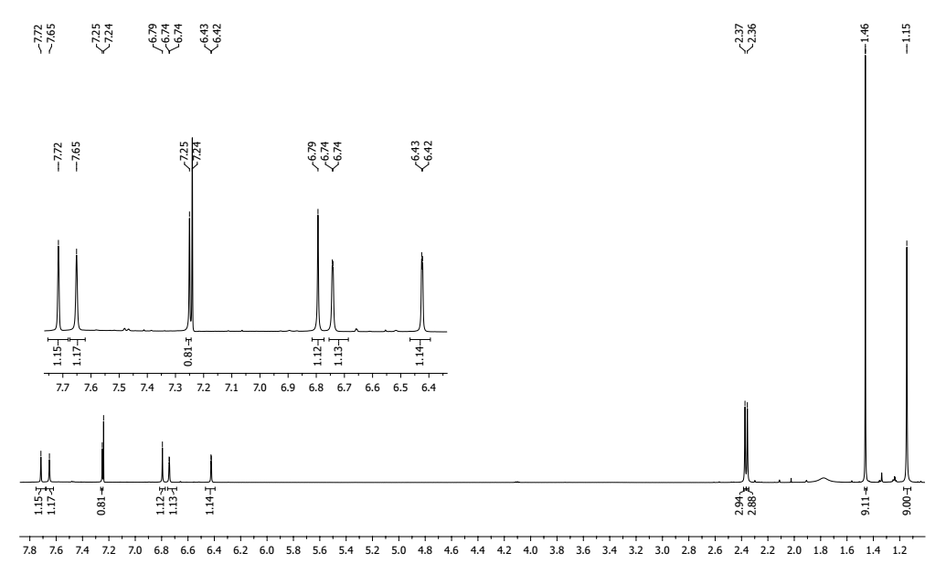

**Figure S32:** 1H NMR spectrum of 2,4-di-*tert*-butyl-9,10-dimethyl-14H-quinoxalino[2,3-b]phenoxazine **4b**.

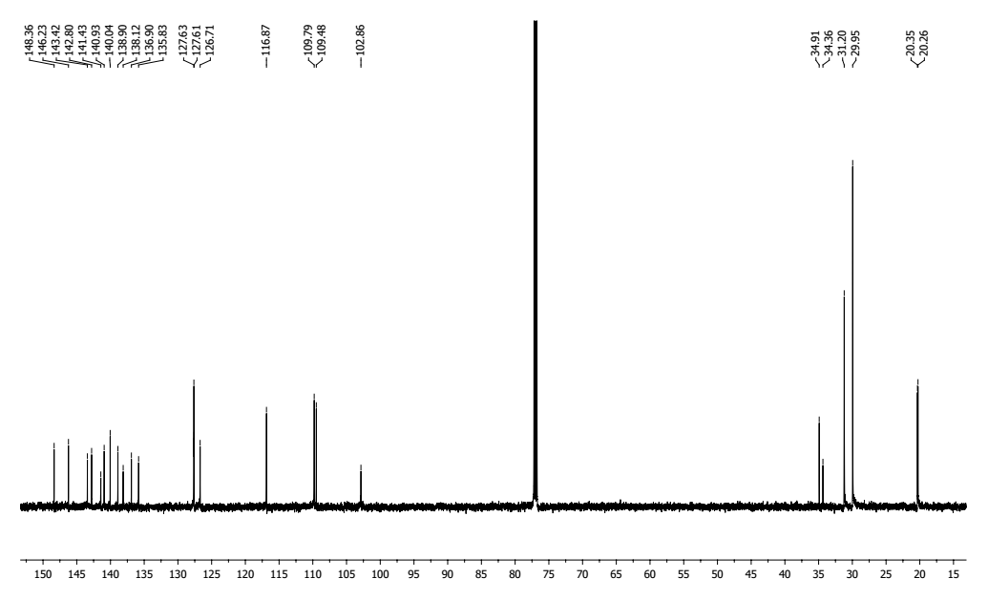

**Figure S33:** 13C NMR spectrum of 2,4-di-*tert*-butyl-9,10-dimethyl-14H-quinoxalino[2,3-b]phenoxazine **4b**.

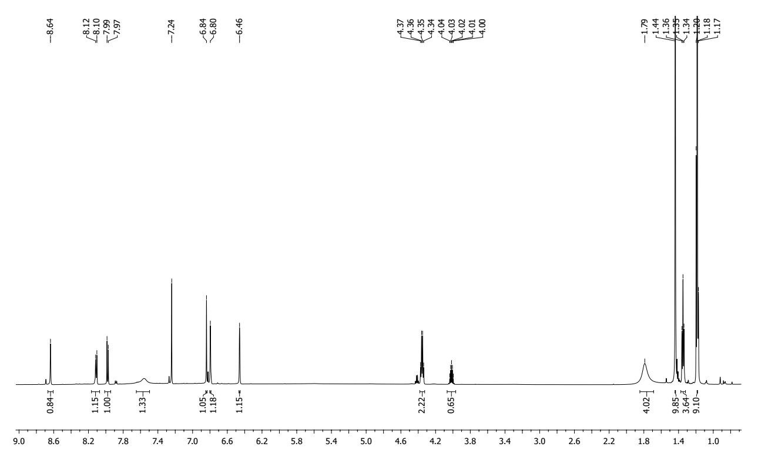

**Figure S34:** 1H NMR spectrum of ethyl 2,4-di-*tert*-butyl-14H-quinoxalino[2,3-b]phenoxazine-10-carboxylate **4c**.

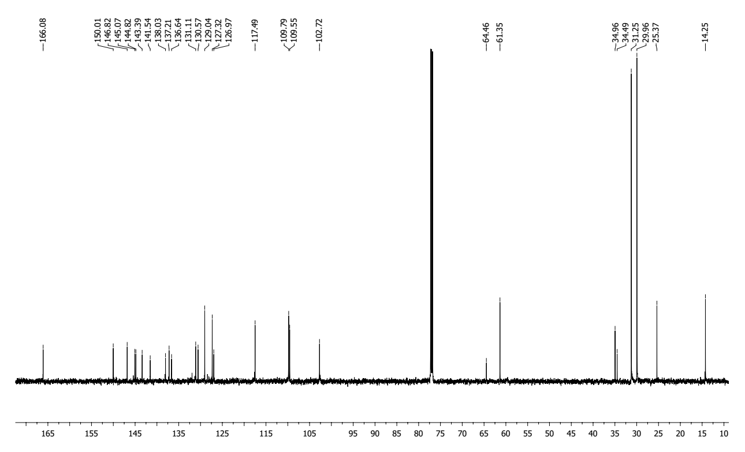

**Figure S35:** 13C NMR spectrum of ethyl 2,4-di-*tert*-butyl-14H-quinoxalino[2,3-b]phenoxazine-10-carboxylate **4c**.

**2,4-di-*tert*-butyl-14-methyl-14H-quinoxalino[2,3-b]phenoxazine (5a)**



**Table S10:** Chemical shifts 1H, 13C and 15N of compound **5a** in CDCl3 at 30°C δ (ppm) and spin-spin coupling constants *J* (Hz).

|  |  |  |  |  |  |  |  |  |  |  |  |  |  |  |  |
| --- | --- | --- | --- | --- | --- | --- | --- | --- | --- | --- | --- | --- | --- | --- | --- |
| Compound | Nucleus | 1 | 2 | 3 | 4 | 5 | 6 | 7 | 8 | 9(15N) | 10 | 11 | 12 | 13 | 14 |
| **5a** | 1H | 6.71 |  | 6.93 |  |  |  | 7.34 |  |  |  | 8.01 | 7.60 | 7.63 | 7.98 |
| *J*1H-1H | 2.1 |  | 2.1 |  |  |  |  |  |  |  | 8.1 | 8.1 | 8.1 | 8.1 |
| 13C/15N | 108.55 | 136.92 | 117.35 | 146.30 | 140.04 | 144.48 | 109.17 | 143.17 | 311.64 | 141.90 | 128.90 | 128.31 | 129.07 | 128.49 |

|  |  |  |  |  |  |  |  |  |  |  |  |  |  |
| --- | --- | --- | --- | --- | --- | --- | --- | --- | --- | --- | --- | --- | --- |
| Compound | Nucleus | 15 | 16(15N) | 17 | 18 | 19 | 20(15N) | 21 | 22 | 23 | 24 | 25 | 26 |
| **5a** | 1H |  |  |  | 6.94 |  |  |  |  |  | 1.46 | 1.31 | 3.37 |
| *J*1H-1H |  |  |  |  |  |  |  |  |  |  |  |  |
| 13C/15N | 142.70 | 305.64 | 150.45 | 103.54 | 139.19 | 83.69 | 130.84 | 34.83 | 34.97 | 30.03 | 31.45 | 32.45 |

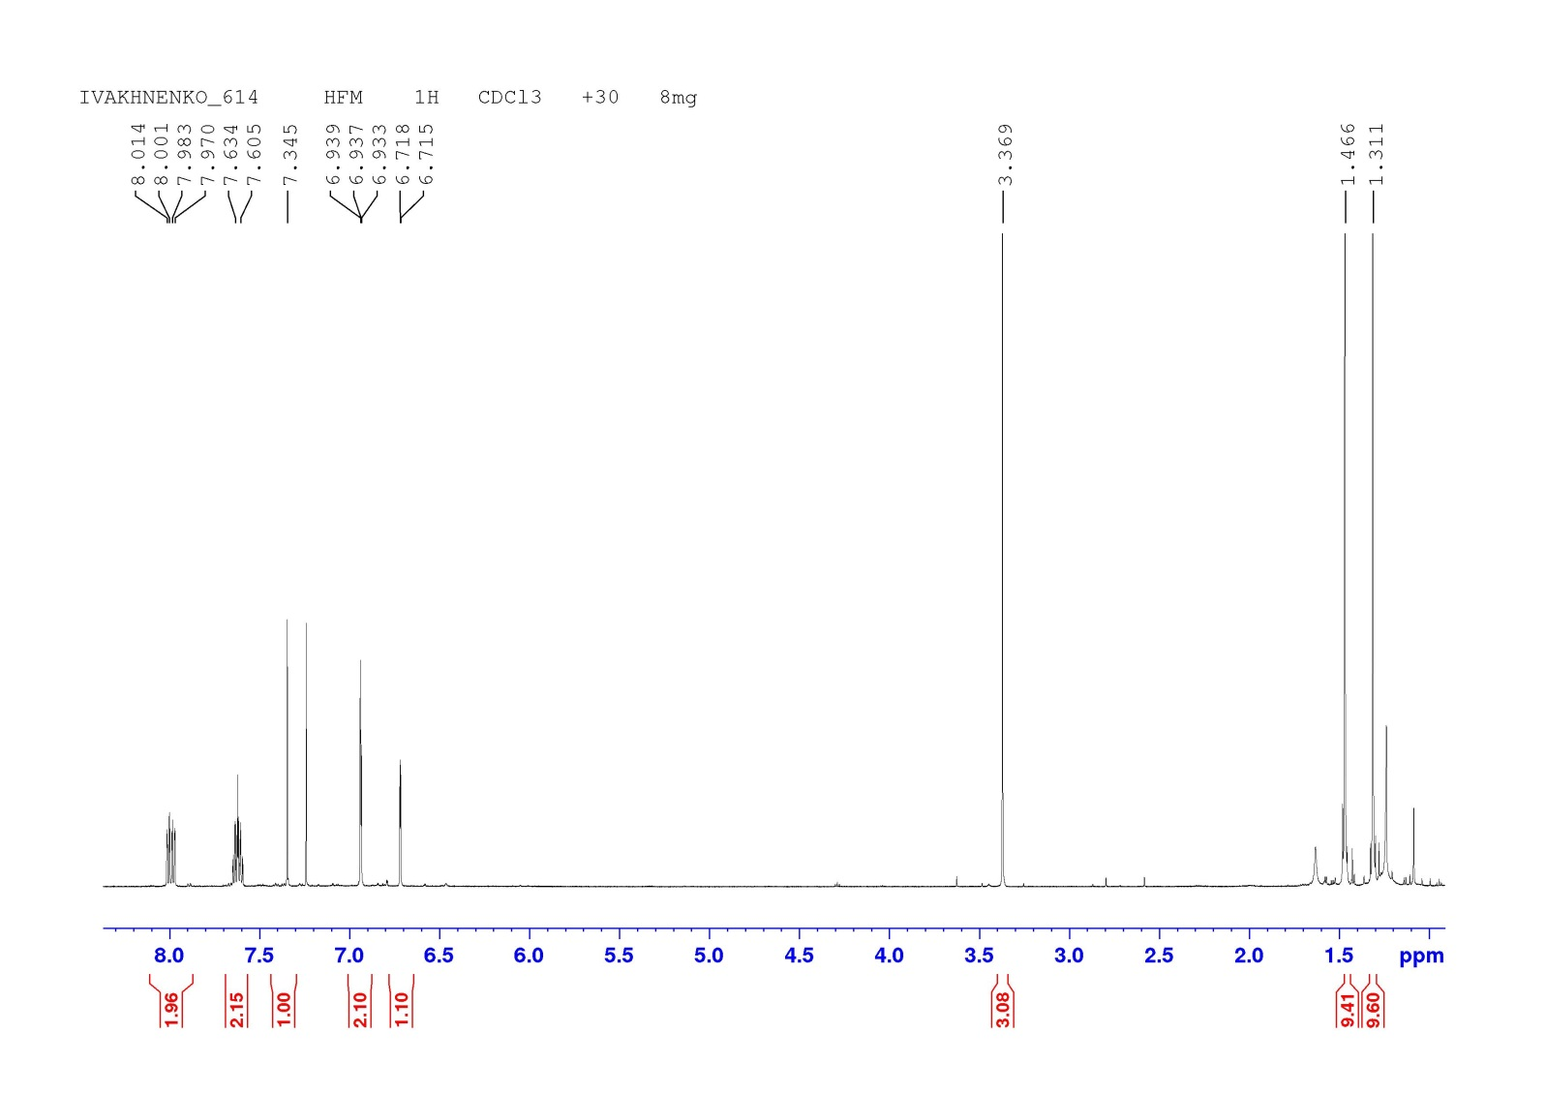

**Figure S36:** 1H NMR spectrum of 2,4-di-*tert*-butyl-14-methyl-14H-quinoxalino[2,3-b]phenoxazine **5a**.

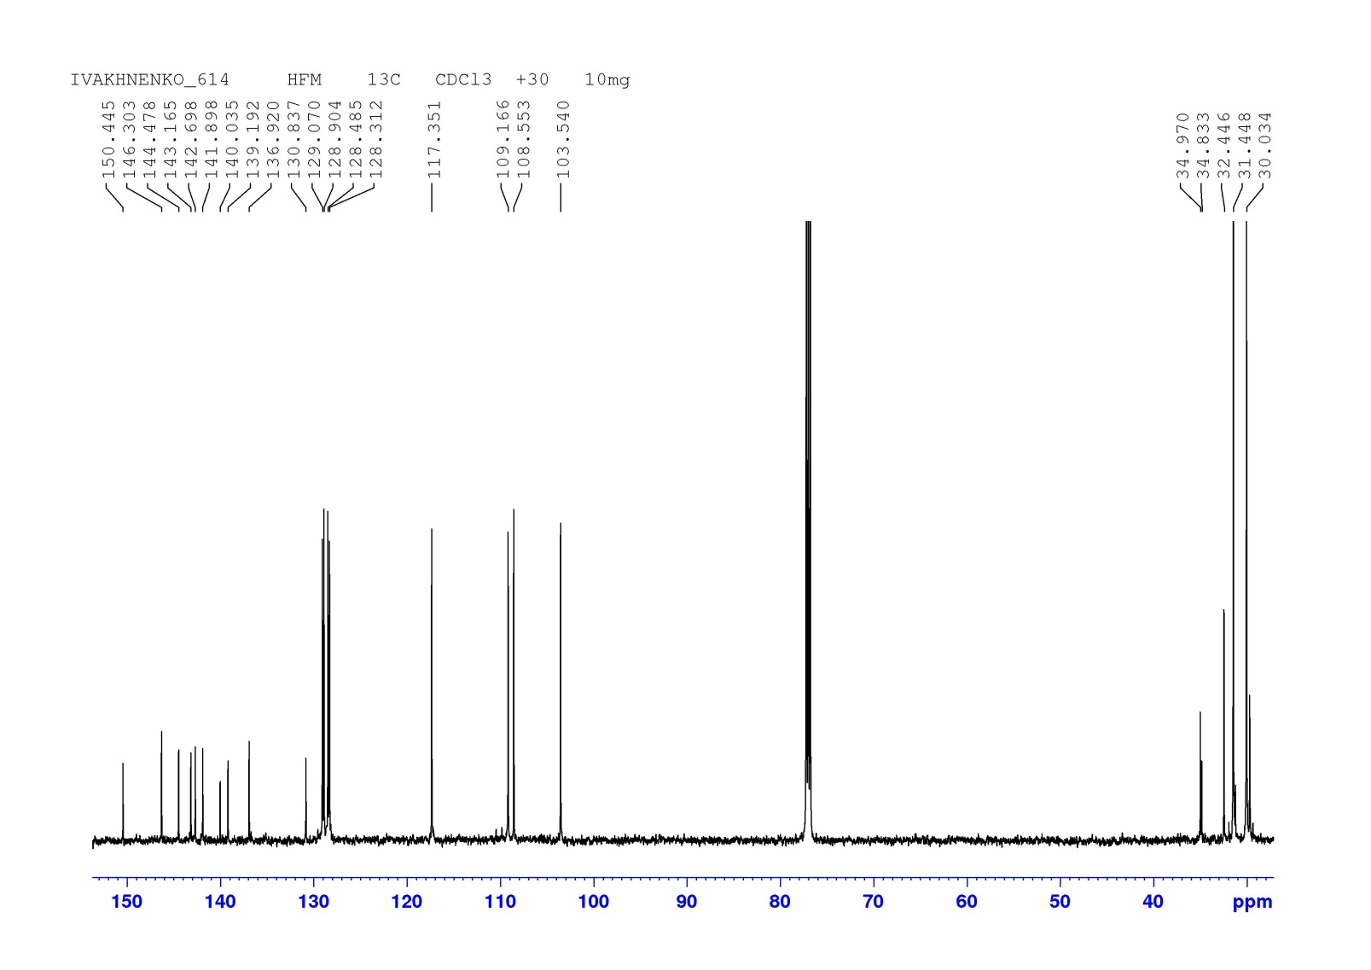

**Figure S37:** 13C NMR spectrum of 2,4-di-*tert*-butyl-14-methyl-14H-quinoxalino[2,3-b]phenoxazine **5a**.



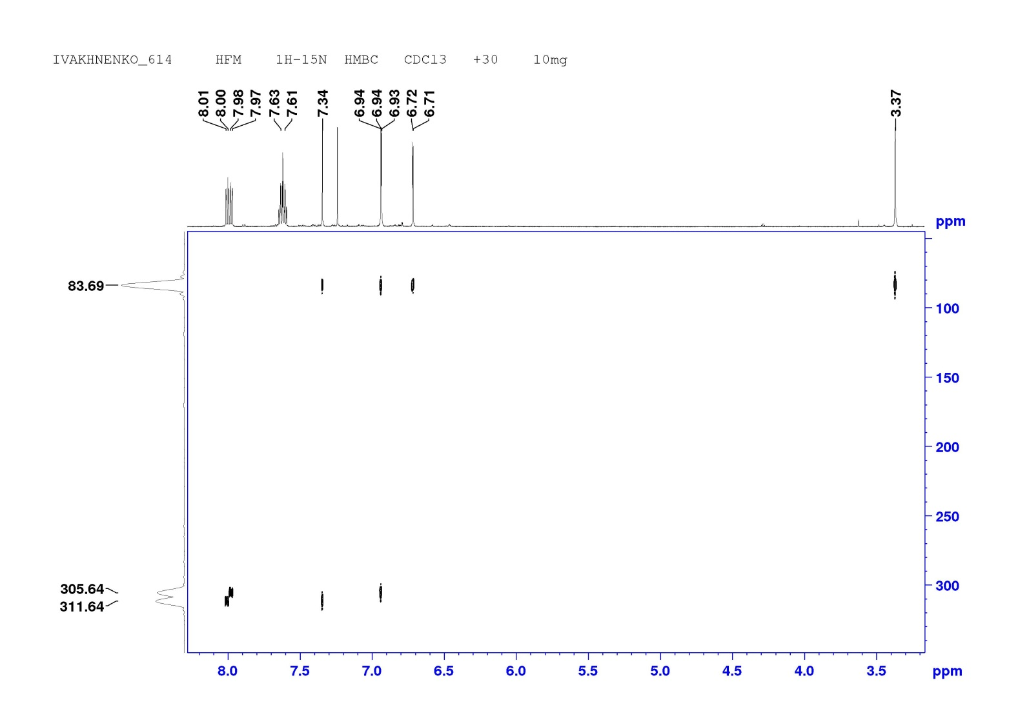

**Figure S38:** HMBC 1H-15N NMR spectrum of 2,4-di-*tert*-butyl-14-methyl-14H-quinoxalino[2,3-b]phenoxazine **5a**.

**2,4-di-*tert*-butyl-14-nonyl-14H-quinoxalino[2,3-b]phenoxazine (5b)**



**Table S11:** Chemical shifts 1H, 13C and 15N of compound **5b** in CDCl3 at 30°C δ (ppm) and spin-spin coupling constants *J* (Hz).

|  |  |  |  |  |  |  |  |  |  |  |  |  |  |  |  |
| --- | --- | --- | --- | --- | --- | --- | --- | --- | --- | --- | --- | --- | --- | --- | --- |
| Compound | Nucleus | 1 | 2 | 3 | 4 | 5 | 6 | 7 | 8 | 9(15N) | 10 | 11 | 12 | 13 | 14 |
| **5b** | 1H | 6.70 |  | 6.90 |  |  |  | 7.29 |  |  |  | 7.98 | 7.59 | 7.63 | 7.97 |
| *J*1H-1H | 2.1 |  | 2.1 |  |  |  |  |  |  |  | 8.1 | 8.1 | 8.1 | 8.1 |
| 13C/15N | 108.41 | 136.82 | 117.25 | 146.04 | 139.44 | 144.76 | 108.99 | 143.16 | 310.36 | 141.91 | 128.89 | 128.17 | 129.08 | 129.02 |

|  |  |  |  |  |  |  |  |  |  |  |  |  |
| --- | --- | --- | --- | --- | --- | --- | --- | --- | --- | --- | --- | --- |
| Compound | Nucleus | 15 | 16(15N) | 17 | 18 | 19 | 20(15N) | 21 | 22 | 23 | 24 | 25 |
| **5b** | 1H |  |  |  | 6.91 |  |  |  |  |  | 1.45 | 1.31 |
| *J*1H-1H |  |  |  |  |  |  |  |  |  |  |  |
| 13C/15N | 142.74 | 303.85 | 149.87 | 102.76 | 137.50 | 96.38 | 129.19 | 34.77 | 34.99 | 29.99 | 31.41 |

|  |  |  |  |  |  |  |  |  |  |  |
| --- | --- | --- | --- | --- | --- | --- | --- | --- | --- | --- |
| Compound | Nucleus | 26 | 27 | 28 | 29 | 30 | 31 | 32 | 33 | 34 |
| **5b** | 1H | 3.79 | 1.85 | 1.53 | 1.50 | 1.42 | 1.35 | 1.32 | 1.28 | 0.89 |
| *J*1H-1H | t,8.3 | qvin,7.6 |  |  |  |  |  |  | t,7.0 |
| 13C/15N | 45.61 | 24.74 | 26.97 | 31.83 | 29.54 | 29.39 | 29.21 | 22.65 | 14.07 |

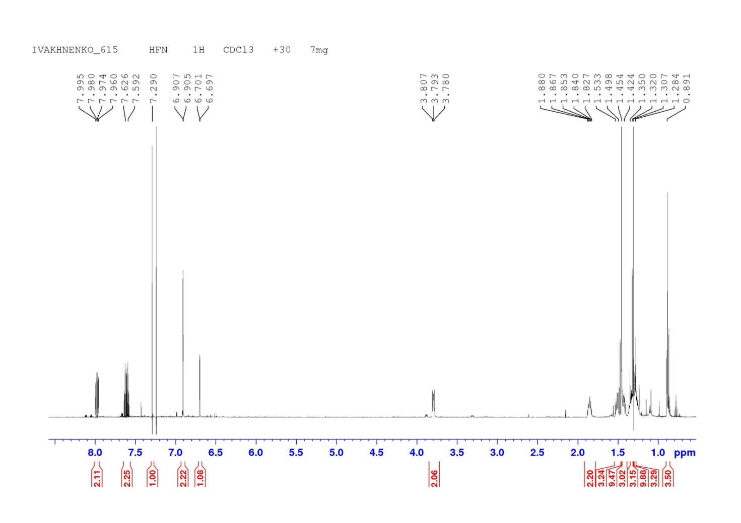

**Figure S39:** 1H NMR spectrum of 2,4-di-*tert*-butyl-14-nonyl-14H-quinoxalino[2,3-b]phenoxazine **5b**.

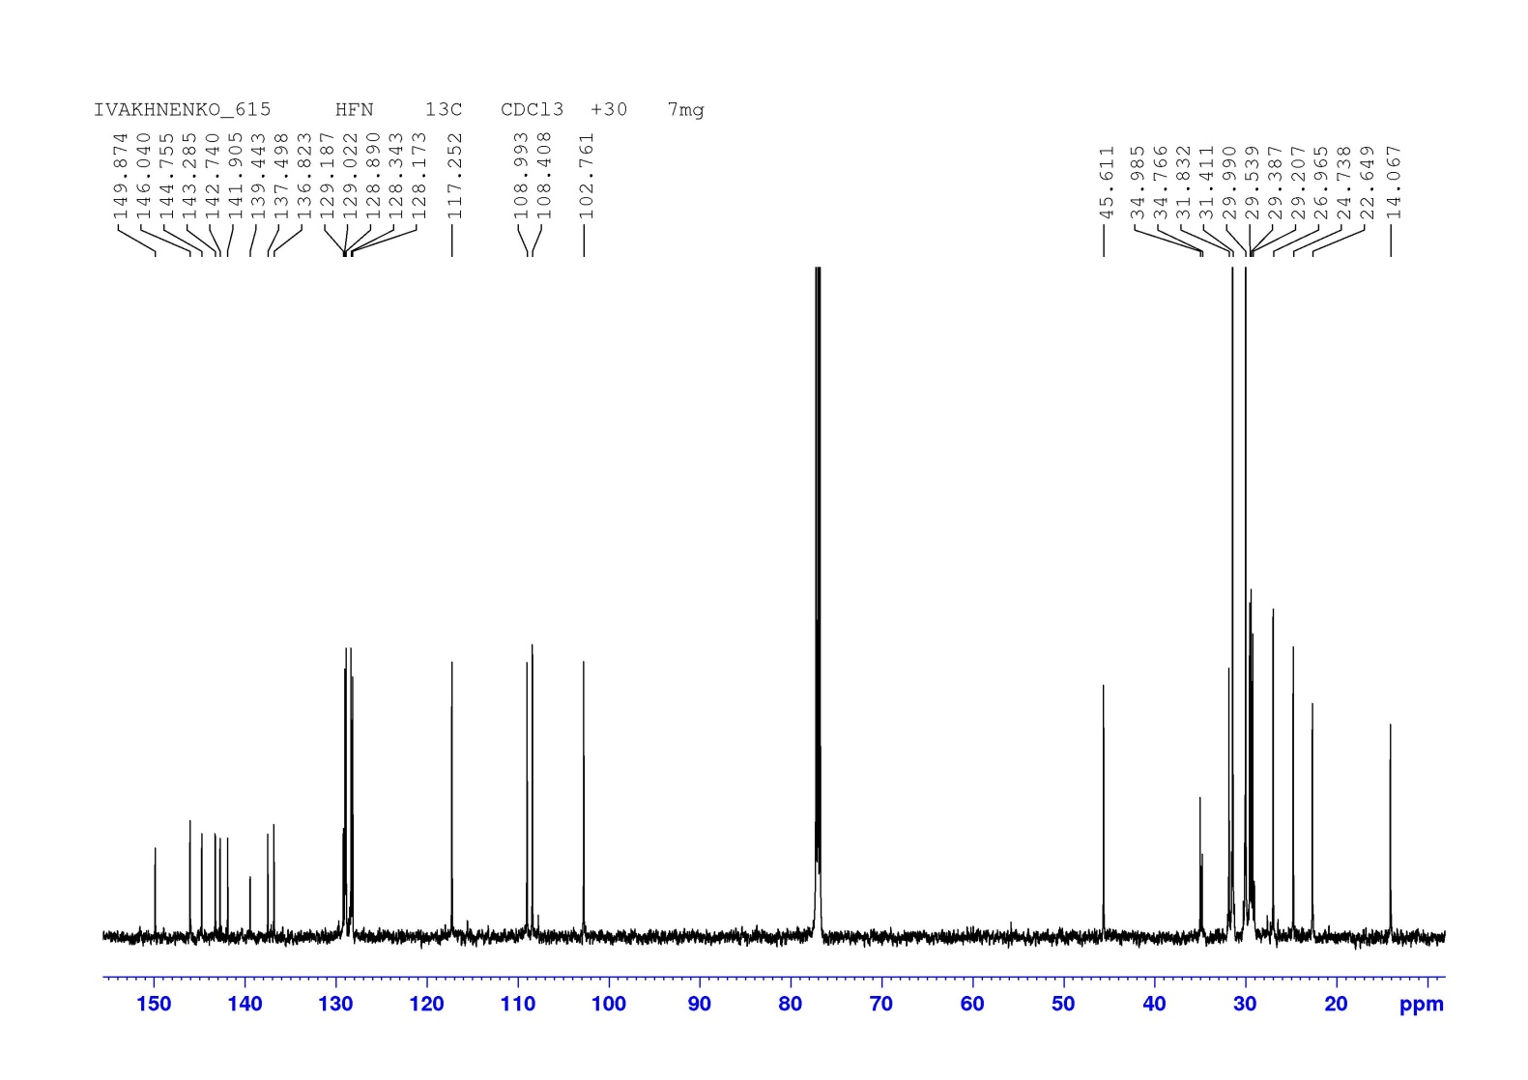

**Figure S40:** 13C NMR spectrum of 2,4-di-*tert*-butyl-14-nonyl-14H-quinoxalino[2,3-b]phenoxazine **5b**.

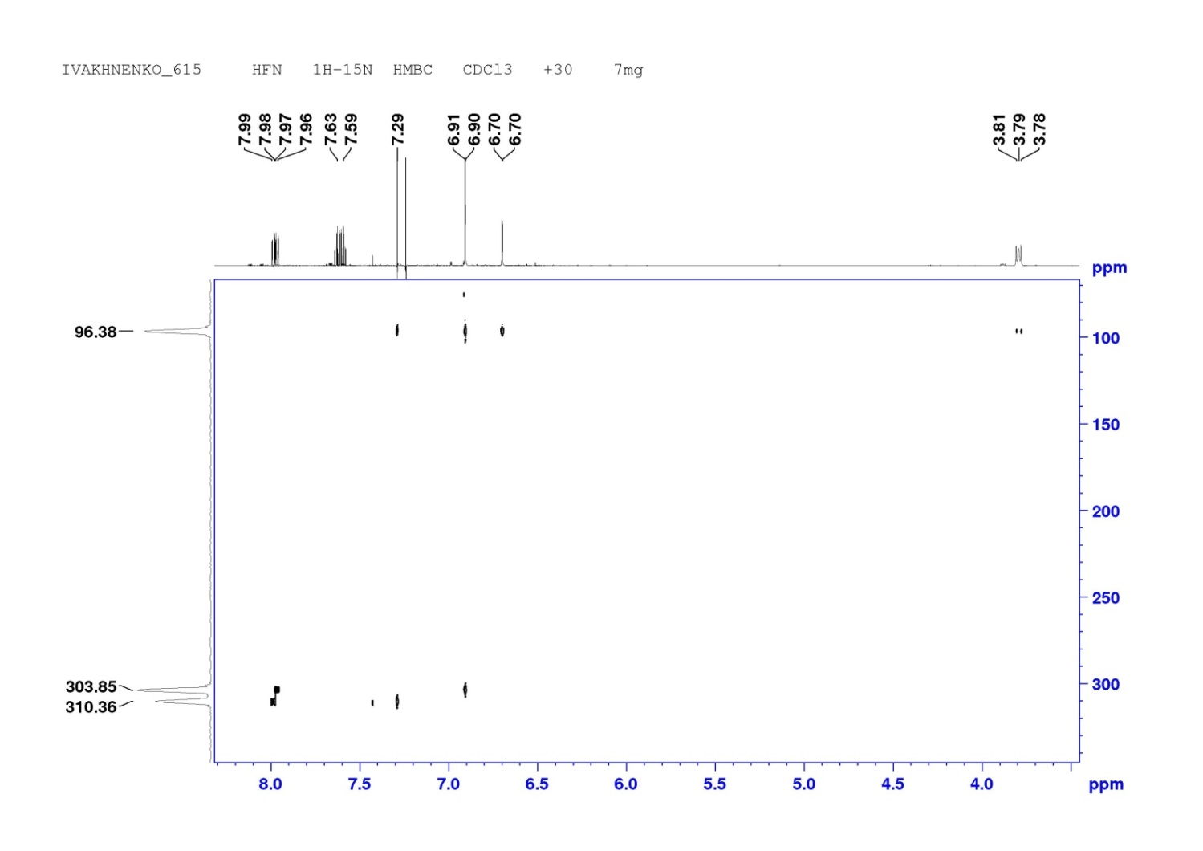

**Figure S41:** HMBC 1H-15N NMR spectrum of 2,4-di-*tert*-butyl-14-nonyl-14H-quinoxalino[2,3-b]phenoxazine **5b**.

**Figure S42:** 1H NMR spectrum of 2,4-di-*tert*-butylbenzo[5,6][1,4]oxazino[2,3-b]phenothiazine **6c**.

**Figure S43:** 13C NMR spectrum of 2,4-di-*tert*-butylbenzo[5,6][1,4]oxazino[2,3-b]phenothiazine **6c**.

1. HRMS spectra

|  |  |
| --- | --- |
|  |  |

**Figure S44:** HRMS spectrum of 6,8-di-*tert*-butyl-2-(phenylamino)-3H-phenoxazin-3-one **3a**.

|  |  |
| --- | --- |
|  |  |

**Figure S45:** HRMS spectrum of 6,8-di-*tert*-butyl-2-((3-methoxyphenyl)amino)-3H-phenoxazin-3-one **3с**.

|  |  |
| --- | --- |
|  |  |

**Figure S46:** HRMS spectrum of 6,8-di-*tert*-butyl-2-((3-chlorophenyl)amino)-3H-phenoxazin-3-one **3d**.

|  |  |
| --- | --- |
|  |  |

**Figure S47:** HRMS spectrum of 6,8-di-*tert*-butyl-2-((4-nitrophenyl)amino)-3H-phenoxazin-3-one **3e**.

|  |  |
| --- | --- |
|  |  |

**Figure S48:** HRMS spectrum of 6,8-di-*tert*-butyl-2-((2-nitrophenyl)amino)-3H-phenoxazin-3-one **3f**.

|  |  |
| --- | --- |
|  |  |

**Figure S49:** HRMS spectrum of 2-((4-aminophenyl)amino)-6,8-di-*tert*-butyl-3H-phenoxazin-3-one **3g**.

|  |  |
| --- | --- |
|  |  |

**Figure S50:** HRMS spectrum of methyl 4-((6,8-di-*tert*-butyl-3-oxo-3H-phenoxazin-2-yl)amino)benzoate **3h**.

|  |  |
| --- | --- |
|  |  |

**Figure S51:** HRMS spectrum of 2,4-di-*tert*-butyl-14H-quinoxalino[2,3-b]phenoxazine **4a**.

|  |  |
| --- | --- |
|  |  |

**Figure S52:** HRMS spectrum of 2,4-di-*tert*-butyl-9,10-dimethyl-14H-quinoxalino[2,3-b]phenoxazine **4b**.

|  |  |
| --- | --- |
|  |  |

**Figure S53:** HRMS spectrum of ethyl 2,4-di-*tert*-butyl-14H-quinoxalino[2,3-b]phenoxazine-10-carboxylate **4c**.

|  |  |
| --- | --- |
|  |  |

**Figure S54:** HRMS spectrum of 2,4-di-*tert*-butylbenzo[5,6][1,4]oxazino[2,3-b]phenothiazine **6b**.

|  |  |
| --- | --- |
|  |  |

**Figure S55:** HRMS spectrum of 2,4-di-*tert*-butyl-14-methyl-14H-quinoxalino[2,3-b]phenoxazine **5a**.

|  |  |
| --- | --- |
|  |  |

**Figure S56:** HRMS spectrum of 2,4-di-*tert*-butyl-14-nonyl-14H-quinoxalino[2,3-b]phenoxazine **5b**.