**Metal Catalyzed Coupling/Carbonylative Cyclizations for Accessing Dibenzodiazepinones: An expedient route to Clozapine and other drugs**

Amina Moutayakinea,b, Anthony J. Burkeb,c,d*

a Instituto Universitario de Bio-Orgánica “Antonio González” (IUBO-AG) University of la Laguna 38206 San Cristóbal de La Laguna, Santa Cruz de Tenerife, Spain.

b LAQV-REQUIMTE, University of Évora, Rua Romão Ramalho, 59, 7000 Évora, Portugal

c University of Évora, Department of Chemistry Rua Romão Ramalho, 59, 7000 Évora, Portugal.

d Current address: Department of Pharmaceutical Chemistry, Faculty of Pharmacy, University of Coimbra. ajburke@ff.uc.pt

**Table of content**

1. General experimental p-2
2. Synthesis of *o*-(2-bromophenyl)aminoanilines p-2
3. Synthesis of dibenzodiazepinones (DBDAs) p-8
4. Kinetic study of the molybdenum/palladium Buchwald-Hartwig coupling

reaction p-13

1. NMR spectra for *o*-(2-bromophenyl)aminoanilines p-15

## VI) Mass spectrum of *o*-(2-bromophenyl)amino(*N*-methyl)aniline (3h) p-22

1. NMR spectra of 5,10-dihydro-11*H*-dibenzo[b,e][1,4]diazepin-11-ones p-23
2. Mass spectrum of 10-methyl-5,10-dihydro-11*H*-dibenzo[b,e][1,4]diazepin-11-one **(4h)** p-30
3. References p-30

**Experimental**

General considerations*:* Reagents were obtained from Sigma Aldrich, Acros, Strem and Alfa Aesar and were used as received. The solvents used were dried using standard laboratory techniques. The catalytic reactions were conducted in a Radley's page19image76788972812-position carousel reactor under a nitrogen atmosphere or in round- bottom flasks. Column chromatography was carried out on silica gel (Carlo Erba, 40–63 μm (flash) and 60-200 μm, 60A). Thin-layer chromatography (TLC) was carried out on aluminum-backed Kieselgel 60 F254 plates (Merck and Machery Nagel).

Plates were visualized either by UV light or with phosphomolybdic acid in ethanol. Melting points (m.p.) were determined with a Barnstead Electrothermal 9100 apparatus and are uncorrected. NMR spectra were recorded with a Bruker Avance III instrument (400 MHz) with a broad band probe. Chemical shifts are quoted in parts per million (ppm) relative to page19image767892608= 0.0 ppm and were referenced to the appropriate non-deuterated solvent peak. Coupling constants (J) are reported in Hz and refer to apparent peak multiplicities. Splitting patterns are reported as s, singlet; d, doublet; t, triplet; m, multiplet; br, broad.

Low-resolution mass spectra (LRMS) were recorded with a quadrupole mass spectrometer Waters ZQ4000 and high-resolution mass spectra (HRMS) on a Thermo Orbitrap Q-exactive focus at a resolution of 70000 at the Chemistry Department, University of Salamanca (by Dr. César Raposo). ESI was used as ionization method, and the samples were dissolved in methanol. In the case of the HRMS, an alternating method between positive and negative modes was applied and the mode with best signal was used for the determination of the exact mass.

**I. Synthesis of *O*-(2-bromophenyl)aminoanilines (3)**

## I.1 – Synthesis of *O*-(2-bromophenyl)aminoaniline (3a)

H N

Br

NH2

**Via Buchwald-Hartwig coupling:** *o*-phenylene diamine **(1)** (0.05g, 1 equiv., 0.46 mmol) was added to a Radleys reaction tube (a Radleys® 12 position carousel reactor station was used) under N2 and dissolved in dry Dioxane (5 mL). Next, (0.055 mL, 0.46 mmol) of 1,2- dibromobenzene (**2**) was added to the reaction mixture, followed by the addition of Pd(OAc)2 (0.01g, 0.046 mmol), XPhos (0.032g, 0.069 mmol), and Cs2CO3 (0.18g , 0.05

mmol). The resulting reaction mixture was allowed to stir at 100 ºC. The reaction was left stirring for several hours, followed by TLC. After consumption of the starting material (verified through TLC). The reaction was allowed to cool down, and was filtered through a celite pad to remove the residual catalyst and base. The solvent was then evaportated under reduced pressure and the crude was purified by flash chromatography (Hexane/AcOEt) (9/1), to yield the *O*-(2-bromophenyl)aminoaniline (**3a**) compound as a purple oil (0.057g, 47% yield).

**Via Chan-Lam coupling:** *o*-phenylene diamine (**1**) (0.05g, 1 equiv., 0.46 mmol) was added to a round bottom flask and dissolved in dry Dioxane (5 mL). Next, (0.092g, 1 equiv.,

0.46 mmol) of 2-bromophenyl)boronic acid **(9)** was added, followed by the addition of Et3N (0.07 mL, 0.055 mmol), and molecular sieves 3Å. The reaction was left stirring at room temperature for several hours, and monitored by TLC. After consumption of the starting material (verified through TLC). The reaction mixture was filtered through a celite pad to remove the residual catalyst and base. The solvent was then evaporated under reduced pressure and the crude was purified by flash chromatography (Hexane/AcOEt) (9/1), to yield the *O*-(2-bromophenyl)aminoaniline (**3**) compound as a purple oil (0.07g, 59% yield).

**1H NMR (CDCl3, 400 MHz) δ:** 4.00 (s, NH2, 2H), 5.76 (s, NH, 1H), 6.59-6.61 (d, *J*= 8Hz,

Ar, 1H), 6.65-6.69 (t, *J*= 8Hz, Ar, 1H), 6.79-6-83 (t, *J*= 8Hz, Ar, 1H), 6.85-6.87 (d, *J*= 8Hz,

Ar, 1H), 7.09-7.13 (m, Ar, 3H), 7.49-7.51 (d, *J*= 8Hz, Ar, 1H).

**13C NMR (CDCl3, 100 MHz) δ:** 110.42, 114.41, 116.47, 119.48, 119.70, 127.00, 127.04,

128.39, 132.62, 142.45, 143.03.

**HRMS (ESI):** m/z [M + H+] calculated for C12H11BrN2: 263,0184**; Found:** 263.0178.

## I.2– Synthesis of Synthesis of *N*-(2-bromophenyl)-5-methylbenzene-1,2-diamine (3b)



Following the general Chan-Lam procedure, 4-methylbenzene-1,2-diamine **(1b)** (0.05 g, 1 equiv., 0.409 mmol) and 2-bromophenyl)boronic acid **(9)** (0.088g, 0.409 mmol) were dissolved in dioxane (5 mL) followed by addition of CuI (0.0156g, 0.082mmol), Et3N (0.068,

0.49 mmol) and allowed to react as described above. After purification by silica gel chromatography (Hexane/AcOEt) (9/1), the compounds *N*-(2-bromophenyl)-4- methylbenzene-1,2-diamine **(3c)** *N*-(2-bromophenyl)-5-methylbenzene-1,2-diamine **(3b)** and were obtained as a transparent oil (0.07 g, 60%). Further separation using the same eluent system allowed the separation of both compounds. The compound **(3b)** was eluted first to give (0.031g) while the the compound (**3c**) gave (0.038g).

**1H NMR (CDCl3, 400 MHz) δ:** 2.27 (s, CH3,3H), 3.57 (s, NH2, 2H), 5.74 (s, NH, 1H), 6.61-

6.63 (d, *J*= 8Hz, Ar, 1H), 6.67-6.71 (t, *J*=8Hz, Ar, 1H), 6.74-7.76 (d, *J*= 8Hz, Ar, 1H), 6.90-

6.94 (m, Ar, 2H), 7.11-7.15 (t, *J*= 8Hz, Ar, 1H), 7.51-7.53 (d, *J*=8Hz, Ar,1H).

**13C NMR (CDCl3, 100 MHz) δ:** 20.46, 110.27, 114.29, 116.24, 119.51, 126.71, 127.30,

127.57,128.37, 128.62, 132.57, 140.38, 143.10.

**MS (ESI) m/z:** 277.10 [M]+.

**I.3– Synthesis of *N*-(2-bromophenyl)-4-methylbenzene-1,2-diamine (3c)**



Following the general Chan-Lam procedure, 4-methylbenzene-1,2-diamine **(1b)** (0.05 g, 0.409 mmol) and 2-bromophenyl)boronic acid **(9)** (0.088g, 0.409 mmol) were dissolved in dioxane (5 mL) followed by addition of CuI (0.0156 g, 0.082 mmol), Et3N (0.068 mL, 0.49 mmol) and allowed to react as described above. After purification by silica gel chromatography (Hexane/AcOEt) (9/1), the compounds *N*-(2-bromophenyl)-4- methylbenzene-1,2-diamine **(3b)** *N*-(2-bromophenyl)-5-methylbenzene-1,2-diamine (**III.23**) and were obtained as a transparent oil (0.07 g, 60%). Further separation using the same eluent system allowed the separation of both compounds. The compound (**3b**) was eluted first to give (0.031g) whilst, the compound (**3c**) gave (0.038g).

**1H NMR (CDCl3, 400 MHz) δ:** 2.30 (s, CH3, 3H), 3.48 (s, NH2, 2H), 5.66 (s, NH, 1H), 6.52-

6.54 (d, *J*= 8Hz, Ar, 1H), 6.59-6.67 (m, Ar, 3H), 6.78-.6.70 (d, *J*= 8Hz, Ar, 1H), 7.06-7.10 (t,

*J*= 8Hz, Ar, 1H), 7.46-7.49 (d, *J*= 12Hz, Ar, 1H).

**13C NMR (CDCl3, 100 MHz) δ:** 21.22, 110.03, 114.00, 116.82, 119.30, 120.08, 124.09,

127.49, 128.37, 132.52, 137.26, 142.85, 143.47.

**HRMS (ESI):** m/z [M + H+] calculated for C13H13BrN2**:** 277.0340**; Found:** 277.0332.

## I.4– Synthesis of *N*-(2-bromo-4,5-dimethylphenyl)aminoaniline (3d)

Me

H N

Br

Me

NH2

Following the general Chan-Lam procedure, 4,5-dimethylbenzene-1,2-diamine (**1c**) (0.05 g, 0.367 mmol) and (2-bromophenyl)boronic acid (**9**) (0.073g, 0.367 mmol) were dissolved in dioxane (5 mL) followed by addition of CuI (0.014g, 0.0734mmol) Et3N (0.061 mL, 0.44 mmol) and allowed to react as described above. After purification by silica gel chromatography (Hexane/AcOEt) (9/1), the compound *N*-(2-bromo-4,5-dimethylphenyl) aminoaniline **(3d)** was obtained as a transparent oil (0.053g, 51% yield).

**1H NMR (CDCl3, 400 MHz) δ:** 2.15 (s, CH3, 3H), 2.22(s, CH3, 3H), 3.63 (s, NH2, 2H), 5.65

(s, NH, 1H), 6.52-6.54 (d, *J*= 8Hz, Ar, 1H), 6.61-6.65 (m, Ar, 2H), 6.88 (s, Ar, 1H), 7.07- 7.11 (t, *J*= 8Hz, Ar, 1H), 7.47-7.49 (d, *J*= 8Hz, Ar, 1H).

**13C NMR (CDCl3, 100 MHz) δ:** 18.79, 19.53, 109.93, 113.96, 117.61, 119.17, 124.06,

127.14, 128.38, 128.46, 132.50, 135.61, 140.99, 143.54.

**HRMS (ESI):** m/z [M + H+] calculated for C14H15BrN2**:** 291.0497; **Found:** 291.0491.

## I.5– Synthesis of *N*-(2-bromophenyl)-5-chlorobenzene-1,2-diamine (3e)



Following the general Chan-Lam procedure, 4-chlorobenzene-1,2-diamine **(1d)** (0.05 g,

0.35 mmol) and 2-bromophenyl)boronic acid **(9)** (0.070g, 0.35 mmol) were dissolved in dioxane (5 mL) followed by addition of CuI (20 mol%, 0.013g, 0.07mmol), Et3N (0.058 mL,

1.2 equiv, 0.42 mmol) and allowed to react as described above. After purification by silica gel chromatography (Hexane/AcOEt) (9/1), *N*-(2-bromophenyl)-5-chlorobenzene-1,2- diamine **(3e)** was obtained as a transparent oil (0.038 g, 37% yield).

**1H NMR (CDCl3, 400 MHz) δ:** 3.90 (s, NH2, 2H), 5.62 (s, NH, 1H), 6.52-6.54 (d, *J*= 8Hz,

Ar, 1H), 6.66-6.74 (m, Ar, 2H), 6.80 (s, Ar, 1H), 7.01-7.03 (d, *J*= 8Hz, Ar, 1H), 7.09-7.13 (t,

*J*= 8Hz, Ar, 1H), 7.48-7.50 (d, *J*= 8Hz, Ar, 1H).

**13C NMR (CDCl3, 100 MHz) δ:** 110.34, 114.19, 115.59, 118.79, 119.93, 125.07, 128.33,

128.44, 132.31, 132,66, 142.78, 144.38.

**HRMS (ESI):** m/z [M + H+] calculated for C12H10BrClN2**:** 296.9794**; Found:** 296.9788.

## I.6– Synthesis of *N*-(2-bromophenyl)-5-(trifluoromethyl)benzene-1,2-diamine (3f)



Following the general Chan-Lam procedure, 4-(trifluoromethyl)benzene-1,2-diamine **(1e)** (0.05 g, 0.28 mmol) and (2-bromophenyl)boronic acid **(9)** (0.057 g, 0.28 mmol) were dissolved in dioxane (5 mL) followed by addition of CuI (20 mol%, 0.056 mmol), Et3N (0.047 mL, 1.2 equiv, 0.36 mmol) and allowed to react as described above. After purification by silica gel chromatography (Hexane/AcOEt) (9/1), the compound *N*-(2-bromophenyl)-4- (trifluoromethyl)benzene-1,2-diamine **(3f)** was obtained as a transparent oil (0.026 g, 28% yield).

**1H NMR (CDCl3, 400 MHz) δ:** 4.14 (brs, NH2, 2H), 5.71 (brs, NH, 1H), 6.53-6.55 (d, *J*=8Hz, Ar, 1H), 6.70-6.73 (m, Ar, 1H), 6.83-6.85 (d, *J*=8Hz, Ar, 1H), 7.11-7.15 (t, *J*= 8Hz, Ar,1H), 7.32-7.34 (d, Ar, *J*= 8Hz,1H), 7.37 (s, Ar, 1H), 7.50-7.53 (d, *J*= 8Hz, Ar, 1H).

**13C NMR (CDCl3, 100 MHz) δ:** 110.57, 114.35, 115.25, 120.35, 124.18, 124.22, 124.25,

124.29, 126.07, 128.50, 132.75, 142.25, 146.13.

**HRMS (ESI):** m/z [M] + calculated for C13H10BrF3N2**:** 329.9979**; Found:** 328.9906.

## I.7– Synthesis of ethyl 3-amino-4-((2-bromophenyl) amino) benzoate (3g)

H N

Br

EtOOC

NH2

Following the general Chan-Lam procedure ethyl 3,4-diaminobenzoate **(1f)** (0.05 g, 0.277 mmol) and (2-bromophenyl)boronic acid (**9**) (0.055g, 0.277 mmol) were dissolved in dioxane (5 mL) followed by addition of CuI (20 mol%, 0.010 g, 0.055 mmol), Et3N (0.046 mL, 0.33 mmol) and allowed to react as described above. After purification by silica gel chromatography (Hexane/AcOEt) (9/1), the ethyl 3-amino-4-((2-bromophenyl) amino)benzoate (**3g**) was obtained as a transparent oil (0.039g, 43% yield).

**1H NMR (CDCl3, 400 MHz) δ:** 1.36-1.39 (m, CH3, 3H), 4.26 (brs.NH2, 2H), 4.28-4.35 (m,

CH2, 2H), 5.72 (s, NH, 1H), 6.50-6.52 (d, *J*=8Hz, Ar, 1H), 6.69-6.73 (t, *J*=8Hz, Ar, 1H),

6.81-6.83 (d, *J*=8Hz, Ar,1H), 7.10-7.12 (t, *J*=8Hz, Ar, 1H), 7.51-7.54 (d, *J*=8Hz, Ar, 1H),

7.83-7.85 (m, Ar, 2H).

**13C NMR (CDCl3, 100 MHz) δ:** 14.48, 60.60, 110.74, 112.80, 121.94, 122.33, 126.89,

128.47, 129.47, 131.35, 133.12, 135.45, 136.07, 139.88, 167.49

**HRMS (ESI):** m/z [M + H+] calculated for C15H15BrN2O2**:** 335.0340**; Found:** 335.0389.

## I.8 – Synthesis of *o*-(2-bromophenyl)amino(*N*-methyl)aniline (3h)



Following the general Chan-Lam procedure, *N*-methylbenzene-1,2-diamine **(1f)** (0.05 g,

0.409 mmol) and (2-bromophenyl)boronic acid **(9)** (0.082 g, 0.409 mmol) were dissolved in dioxane (5 mL) followed by addition of CuI (0.015 g, 0.082 mmol), Et3N (0.068 mL, 0.49 mmol) and allowed to react as described above. After purification by silica gel chromatography (Hexane/AcOEt) (9/1), the *o*-(2-bromophenyl)amino(*N*-methyl)aniline **(3h)** was obtained as a transparent oil (0.039g, 35% yield).

**1H NMR (CDCl3, 400 MHz) δ:** 1.56 (brs, NH,1H), 3.36 (s, CH3, 3H),6.71 (brs, NH, 1H), 7.01-7.15 (m, Ar, 4H), 7.29-7.31 (d, *J*= 8Hz, Ar, 1H), 7.35-7.38 (m, Ar, 1H), 7.46- 7.48 (d, *J*= 8Hz, Ar,1H), 7.62-7.64 (d, *J*= 8 Hz, Ar, 1H).

**HRMS (ESI):** m/z [M + H+] calculated for C13H13BrN2**:** 277.0340; **Found:** 277.0330.

**II – Synthesis of DIBENZODIAZAPINONAS (DBDAs)**

## II.1– Synthesis of 5,10-dihydro-11*H*-dibenzo[b,e][1,4]diazepin-11-one (4a)1

O

HN

N H

*o*-(2-bromophenyl)aminoaniline **(3a)** (0.05g, 0.19 mmol) was added to a Radley’s® 12 position carousel reactor tube to which DMF, then Pd(OAc)2 (4.26 mg, 0.019 mmol), DPEPhos (30 mg, 0.057 mmol), Mo(CO)6 (50 mg, 1 equiv., 0.19 mmol), and Et3N (0.026 mL, 0.19 mmol) were added. The reaction mixture was then stirred at 130 ºC under a nitrogen atmosphere. After completion of the reaction, as determined by TLC, the reaction mixture was allowed to cool to room temperature. The mixture was filtered through a pad of celite and washed with DCM, then the solvent was evaporated under reduced pressure to give a crude mixture. Further purification by flash chromatography (Hexane/AcOEt) (1/1), gave the desired compound 5,10-dihydro-11*H*-dibenzo[b,e][1,4]diazepin-11-one **(4a)** as a yellow solid yield (0.032 g, 80 %). **M.p.:** 249-251 ºC (Lit. 1 255-257 ºC)

**1H NMR (DMSO-d6, 400 MHz) δ:** 6.87-7.00 (m, Ar, 6H), 7.31-7.35 (t, *J*=8Hz, Ar, 1H),

7.66-7.68 (d, *J*=8Hz, Ar,1H), 7.81 (s, Ar, 1H), 9.85 (s, Ar, 1H).

**13C NMR (CDCl3, 100 MHz) δ:**119.52, 120.23, 121.17, 121.73, 123.24, 123.40, 124.95,

130.29, 132.56, 133.67, 140.43, 150.92, 168.40.

**MS (ESI) m/z:** 221.12 [M+H+]

## II.2– Synthesis of 7-methyl-5,10-dihydro-11*H*-dibenzo[b,e][1,4]diazepin-11- one (4b)

O

HN

Me

N H

Following the general procedure, *N*-(2-bromophenyl)-5-methylbenzene-1,2-diamine **(3b)** (0.05g, 0.18 mmol) was dissolved in DMF, then Pd(OAc)2 (4.05 mg, 0.018 mmol) and DPEPhos (29 mg, 0.054 mmol), Mo(CO)6 (47 mg, 0.18 mmol), and Et3N (0.026 mL, 0.19 mmol) were added to a Radley’s® 12 position carousel reactor tube. Purification with flash chromatography using (Hexane/AcOEt) (1/1), as eluant gave the desired compound 7- methyl-5,10-dihydro-11*H*-dibenzo[b,e][1,4]diazepin-11-one **(4c)** as a yellow solid yield (0.038 g, 95 %). **M.p.:** 205-210 ºC.

**1H NMR (DMSO-d6, 400 MHz) δ:** 1.33 (s, CH3, 3H), 5.86-5-88 (d, *J*=8Hz, Ar,1H), 5-96-

6.05(m, Ar, 3H), 6-12-6.14 (d, *J*=8Hz, Ar, 1H), 6.46-6.50 (t, *J*= 8Hz, Ar, 1H), 6.80-6.82 (d,

*J*= 8Hz, Ar, 1H), 6.90 (s, Ar, 1H), 8.91 (s, Ar, 1H)

## II.3 – Synthesis of 8-methyl-5,10-dihydro-11*H*-dibenzo [b,e][1,4] diazepin- 11-one (4c)1

O

HN

Me

N H

Following the general procedure, *N*-(2-bromophenyl)-4-methylbenzene-1,2-diamine **(3c)** (0.05g, 0.18 mmol) was dissolved in DMF, then Pd(OAc)2 (4.05 mg, 0.018 mmol), DPEPhos (29 mg, 0.054 mmol), Mo(CO)6 (47 mg, 0.18 mmol), and Et3N (0.026 mL, 0.19 mmol) were added to a Radley’s® 12 position carousel reactor tube. Purification with flash chromatography using (Hexane/AcOEt) (1/1), as eluant, gave the desired compound 8- methyl-5,10-dihydro-11*H*-dibenzo [b,e][1,4]diazepin-11-one **(4b)** as a yellow solid yield (0.037 g, 93 %). **M.p.:** 197-200 ºC. (Lit.1 200-204ºC)

**1H NMR (DMSO-d6, 400 MHz) δ:** 2.14 (s, CH3, 3H), 6.72-6.74 (m, Ar, 2H), 6.83-6.86 (m

Ar, 2H), 6.93-6.95(d, *J*=8Hz, Ar, 1H), 7.27-7-31(t, *J*= 8Hz, Ar, 1H), 7.62-7.64 (dd, *J*= 8Hz, Ar, 1H), 7.70 (s, Ar,1 H), 9.75 (s, Ar, 1H).

**13C NMR (DMSO-d6, 100 MHz) δ:** 20.64, 119.37, 120.13, 120.99, 122.00, 123.19, 125.41,

130.11, 132.37, 132.54, 133.57, 137.91, 151.19, 168.49.

**MS (ESI) m/z:** 225.15

**II.4 – Synthesis of 7,8-dimethyl-5,10-dihydro-11*H*-dibenzo[b,e][1,4]diazepin- 11-one (4d)**

O

HN

Me

Me

N H

Following the general procedure, *N*-(2-bromo-4,5-dimethylphenyl)aminoaniline **(3d)** (0.05g, 0.17 mmol) was dissolved in DMF, then Pd(OAc)2 (3.86 mg, 0.017 mmol) and DPEPhos (28 mg, 0.052 mmol), Mo(CO)6 (44 mg, 0.17 mmol), and Et3N (0.023 mL, 0.17 mmol) were added to a Radley’s® 12 position carousel reactor tube. Purification with flash chromatography using (Hexane/AcOEt) (1/1), as eluant gave the desired compound 7,8- dimethyl-5,10-dihydro-11*H*-dibenzo[b,e][1,4]diazepin-11-one **(4d)** as a yellow solid yield (0.03 g, 75 %). **M.p.:** 209-215 ºC.

**1H NMR (DMSO-d6, 400 MHz) δ:** 1.22 (d, *J*=8Hz, 6H), 5.68 (s, Ar, 1H), 5.91(s, Ar, 1H),

5.99-6.03 (t, *J*= 8Hz, Ar, 1H), 6.09-6.11(d, *J*= 8Hz, Ar,1H), 6.43-6.47(t, *J*= 8Hz, Ar, 1H),

6.79-6.80 (d, *J*=4Hz, Ar, 2H), 8.84(s, Ar, 1H).

**13C NMR (DMSO-d6, 100 MHz) δ:**31.17, 119.34, 120.92, 121.23, 122.62, 123.26, 127.70,

130.87, 132.53, 133.45, 137.99, 151.25, 168.46, 207.04.

**HRMS (ESI):** m/z [M+H+] calculated for C16H14N2O3**:** 239.1184**; Found** 239,1175.

## II.5 – Synthesis of 8-chloro-5,10-dihydro-11*H*-dibenzo[b,e][1,4]diazepin-11- one (4e) 1

O

HN

Cl

N H

Following the general procedure, *N*-(2-bromophenyl)-5-chlorobenzene-1,2-diamine **(3e)** (0.05g, 1 equiv., 0.168 mmol) was dissolved in DMF, then Pd(OAc)2 (3.77 mg, 10 mol%,

0.0168 mmol) and DPEPhos (27 mg, 30 mol%, 0.050 mmol), Mo(CO)6 (44 mg, 1 equiv.,0.168 mmol), and Et3N (0.023 mL, 1 equiv., 0.17 mmol) were added to a Radley’s® 12 position carousel reactor tube. Purification with flash chromatography using (Hexane/ AcOEt) (1/1) as eluant gave the desired compound 8-chloro-5,10-dihydro-11H- dibenzo[b,e][1,4]diazepin-11-one **(4e)** as a yellow solid yield (0.035 g, 85 %). **M.p.:** 235-237 ºC. (Lit. 1 237–239 °C).

**1H NMR (DMSO-d6, 400 MHz) δ:** 6.87-6.90 (m, Ar, 1H), 6.97-7.00 (m, Ar, 4H), 7.31-

7.35(t, *J*= 8Hz, Ar, 1H), 7.64-7.67 (d, *J*= 12Hz, Ar,1H), 7.96 (s, Ar, 1H), 9.91 (s, Ar,1H).

**13C NMR (DMSO-d6, 100 MHz) δ:** 119.56, 120.90, 121.43, 121.51, 122.82, 124.46, 126.71,

131.66, 132.66, 133.99, 139.19, 150.25, 168.12.

**HRMS (ESI):** m/z [M + H+] calculated for C16H14N2O3**:** 245.0482; **Found** 245.0475.

## II.6 – Synthesis of 7-(trifluoromethyl)-5,10-dihydro-11*H*-dibenzo[b,e][1,4] diazepin-11-one (4f)1



Following the general procedure, *N*-(2-bromophenyl)-4-(trifluoromethyl)benzene-1,2- diamine **(3f)** (0.05g, 0.15 mmol) was dissolved in DMF, then Pd(OAc)2 (3.36 mg, 0.015 mmol) and DPEPhos (24 mg, 0.045 mmol), Mo(CO)6 (39 mg, 0.15 mmol), and Et3N (0.020 mL, 0.17 mmol) were added to a Radley’s® 12 position carousel reactor tube. Purification with flash chromatography using (Hexane/AcOEt) (1/1), gave the desired compound **(4f)** as a yellow solid yield (0.023 g, 55 %). **M.p.:** 200-205 ºC. (Lit.1 202-203 ºC)

**1H NMR (DMSO-d6, 400 MHz) δ:** 6.91-6.95 (t, *J*=8Hz, Ar, 1H), 6.97-6.99 (d, *J*=8Hz, Ar,

1H), 7.11-7.13 (d, *J*= 8Hz, Ar, 1H), 7.24-7.26 (d, *J*=8Hz, Ar, 1H), 7.35-7.40 (m, Ar, 2H),

6.69-7.71(d, *J*= 8 Hz, Ar, 1H), 8.14 (s, Ar, 1H), 10.15 (s, Ar, 1H).**13C NMR (DMSO-d6, 100 MHz) δ:** 116.78, 119.63, 120.17, 121.69, 122.05, 122.78, 123.41, 126.44, 132.72, 133.93, 134.20, 140.28, 149.71, 167.95.

**HRMS (ESI):** m/z [M + H+] calculated for C14H9F3N2O**:** 279.0745; **Found:** 279.0734.

## II.7– Synthesis of ethyl 11-oxo-10,11-dihydro-5*H*-dibenzo[b,e][1,4]diazepine- 8-carboxylate (4g)

O

HN

EtOOC

N H

Following the general procedure, ethyl 3-amino-4-((2-bromophenyl) amino)benzoate **(3g)** (0.05g, 0.15 mmol) was dissolved in DMF, then Pd(OAc)2 (3.36 mg, 0.015 mmol) and DPEPhos (24 mg, 0.045 mmol), Mo(CO)6 (39 mg, 0.15 mmol), and Et3N (0.020 mL, 0.17 mmol) were added to a Radley’s® 12 position carousel reactor tube. Purification with flash chromatography using (Hexane/AcOEt) (1/1), gave the desired compound **(4g)** as a yellow solid yield (0.016 g, 40 %). **M.p.:** 225-230 ºC.

**1H NMR (DMSO-d6, 400 MHz) δ:** 1.29-1.31 (t, *J*= 4Hz, CH3), 4.23-4.29 (q, *J*=8Hz, CH2),6.91-6.94(m, Ar, 1H), 6.99-7.01 (d, *J*=8Hz, Ar,1H), 7.05-7.07 (d, *J*= 8Hz, Ar, 1H), 7.35-7.39(t, *J*= 8Hz, Ar, 1H), 7.55-7.59 (t, *J*= 8Hz, Ar, 2H), 7.70-7.72 (d, *J*= 8Hz, Ar, 1H), 8.34 (s, Ar, 1H), 9.97 (s, Ar, 1H).

**13C NMR (DMSO-d6, 100 MHz) δ:** 14.68, 31.18, 60.93, 119.70, 119.99, 121.61, 122.58,122.67, 124.50, 126.26, 129.80, 132.80, 134.07, 144.51, 149.08, 165.56, 167.75.

**HRMS (ESI):** m/z [M + H+] calculated for C16H14N2O3**:** 283.1083; **Found** 283.1073.

**III** **– Kinetic study of the Molybdenum/Palladium Buchwald-Hartwig coupling reaction**

In order to understand the role of the Molybdenum species in this reaction, and if it exerted a catalytic effect, a kinetic study was performed using the aforementioned model system described above with 5 mol% of Mo(CO)6. The standard reaction (benchmark) contained everything bar the Mo species. A 1 mL sample was collected every 10 mins. and the reaction progress was constantly monitored by 1H NMR (**Scheme s.I**). For practical reasons, the reaction was carried out at a larger scale than in the previous reactions, and the results are shown in **Figure s.I**. At the larger scale, we observed the formation of the usual black precipitate in the presence of Mo(CO)6 which could be due to the complexation of the palladium with the molybdenum, which may lead to a reduction in the catalytic activity of that particular system. Palladium catalysts have a tendency for aggregation which often lead to the formation of a black precipitate, we believe this phenomenon can also take place at the larger scale used here.2 The Mo(CO)6 may also exert a reducing effect on the Pd(II) catalyst, producing Pd(0) as black precipitate. For practical reasons, the reaction was only monitored for 90 mins. In all cases, except for the first 10 mins, the reaction without Mo gave the best yields, this was particularly evident after 30 mins.



Scheme I – Mo-catalyzed Buchwald-Hartwig coupling of bromobenzene with aniline.

Figure s.I – Comparative study of the Pd and Pd/Mo catalyzed B-H amination between bromobenzene and aniline (analysis conducted via 1H NMR with a mesitylene standard).

In a round bottom flask, aniline (0.45 mL, 5 mmol), *o*-bromobenzene (0.52 mL, 5 mmol) were dissolved in DMF (20 ml), then Pd(OAc)2 (56 mg, 0.25 mmol), DPEPhos (0.13 g, 0.25 mmol) and Mo(CO)6 (66 mg, 0.25 mmol) were added to the reaction mixture. The resulting mixture was allowed to stirr at 130 ºC under nitrogen atmosphere. A sample (1 mL) was taken from the reaction mixture After 5 min, 10 min, 20 min, 30 min, 40 min, 50 min, 60 min, 90 min. The sample was filtered through a glass pipette with flash silica and washed with DCM. The solvent was evaporated under reduced pressure, and mesitylene (0.08g, 0.48 mmol) was added as standard to each crude mixture and analysed by 1H NMR, the yields were determined afterwards.

Table s.I – Kinetic study of the Pd/Mo catalyzed B-H coupling of aniline with bromobenzene.

|  |  |  |
| --- | --- | --- |
| Time (min) | Without MoCO6 (%) | With MoCO6 (%) |
| 10 | 6 | 6 |
| 20 | 12 | 8 |
| 30 | 15 | 8 |
| 40 | 18 | 10 |
| 50 | 21 | 12 |
| 60 | 23 | 14 |
| 90 | 39 | 28 |

**IV NMR spectra of *o*-(2-bromophenyl)aminoanilines**

**IV.1– NMR spectra of *o*-(2-bromophenyl)aminoaniline**

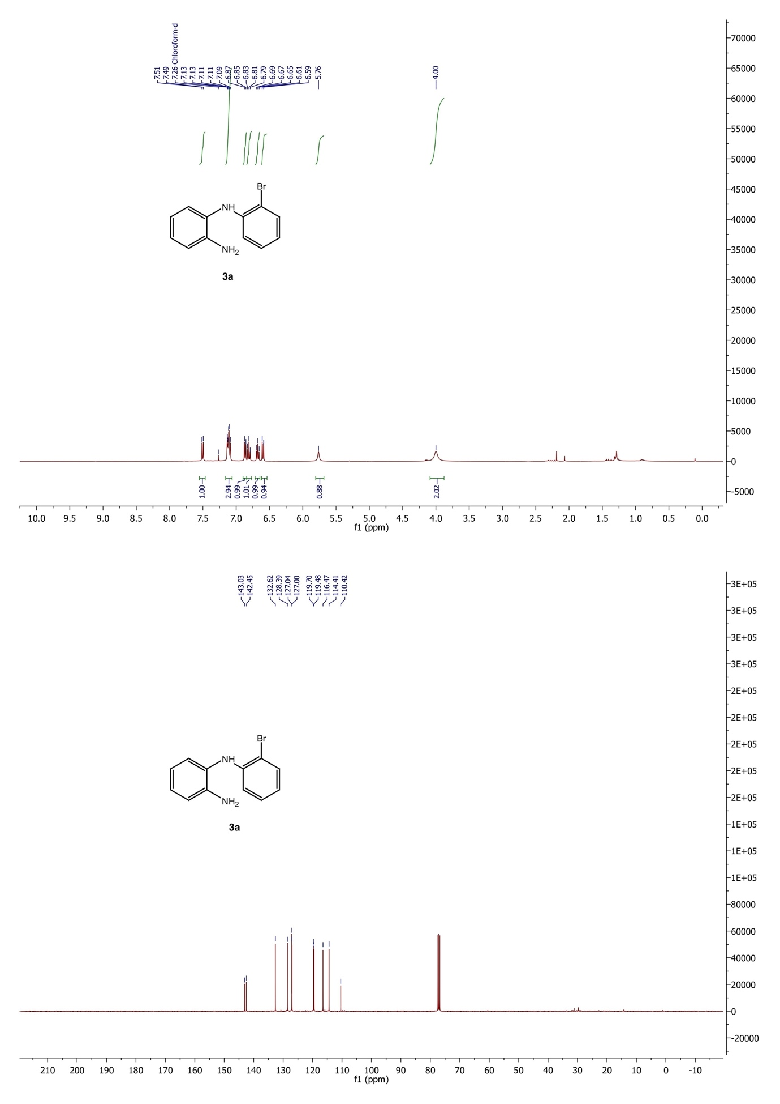

**IV.2– NMR spectra of *N*-(2-bromophenyl)-5-methylbenzene-1,2-diamine (3b)**

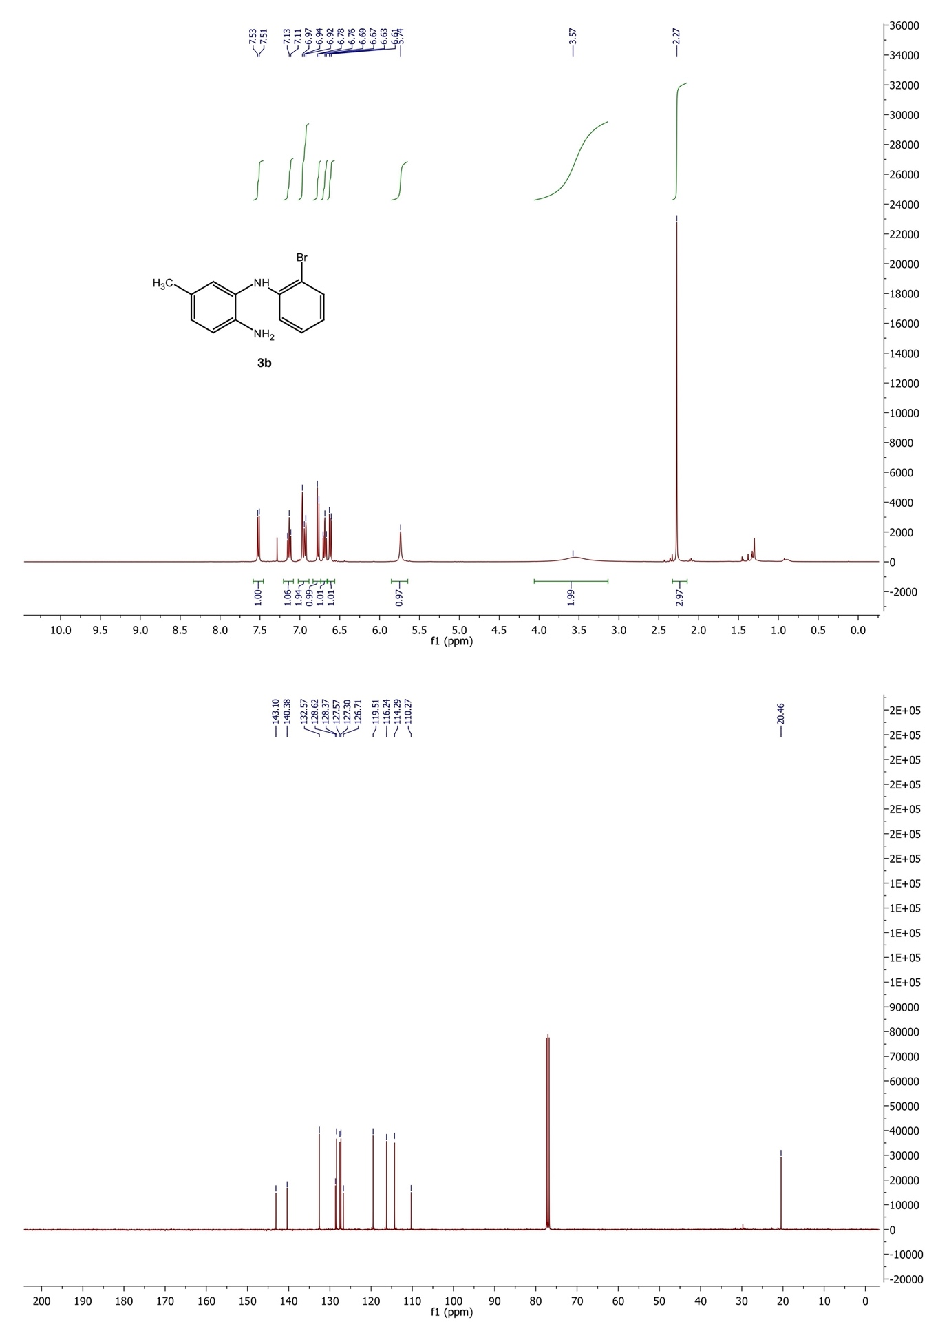

**IV.3– NMR of spectra *N*-(2-bromophenyl)-4-methylbenzene-1,2-diamine (3c)**

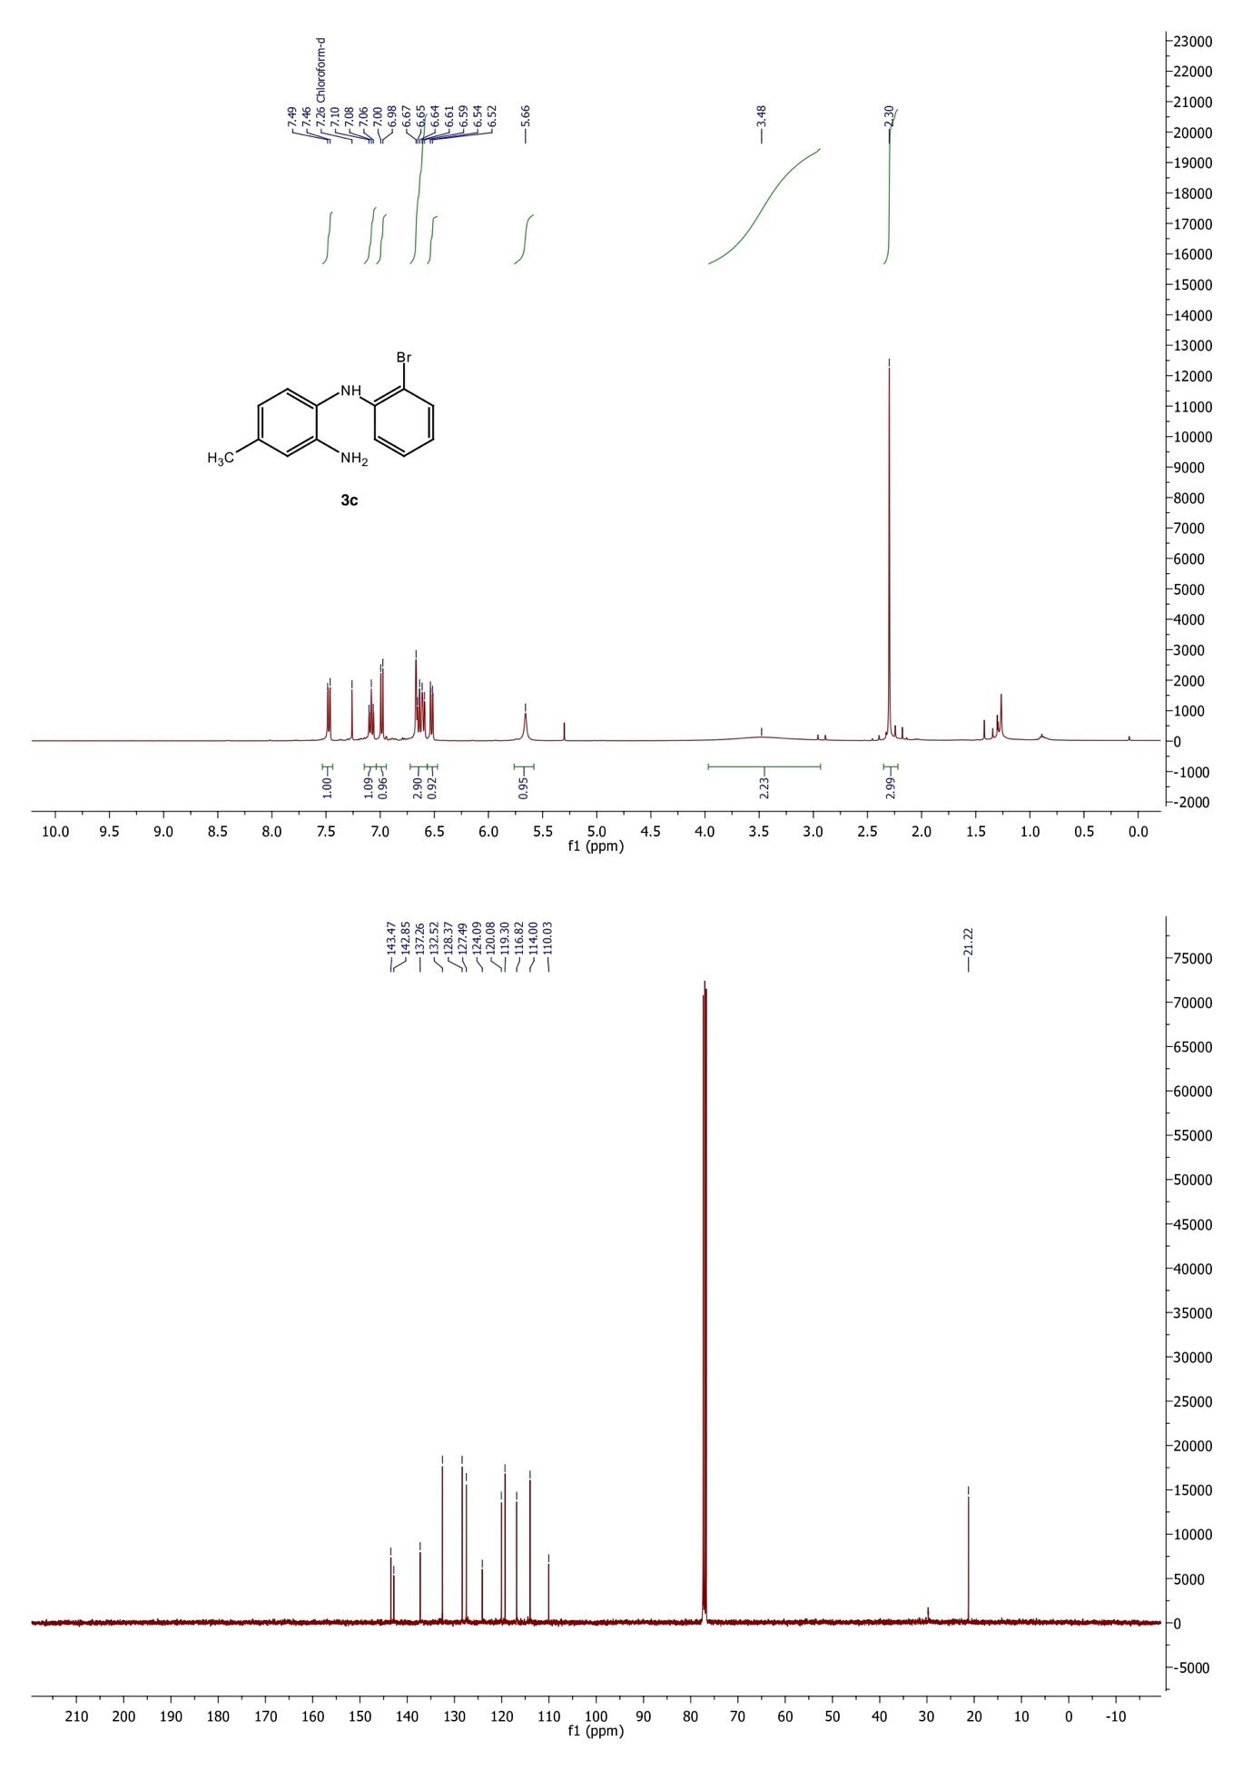

**IV.4– NMR spectra of *N*-(2-bromo-4,5-dimethylphenyl)aminoaniline (3d)**

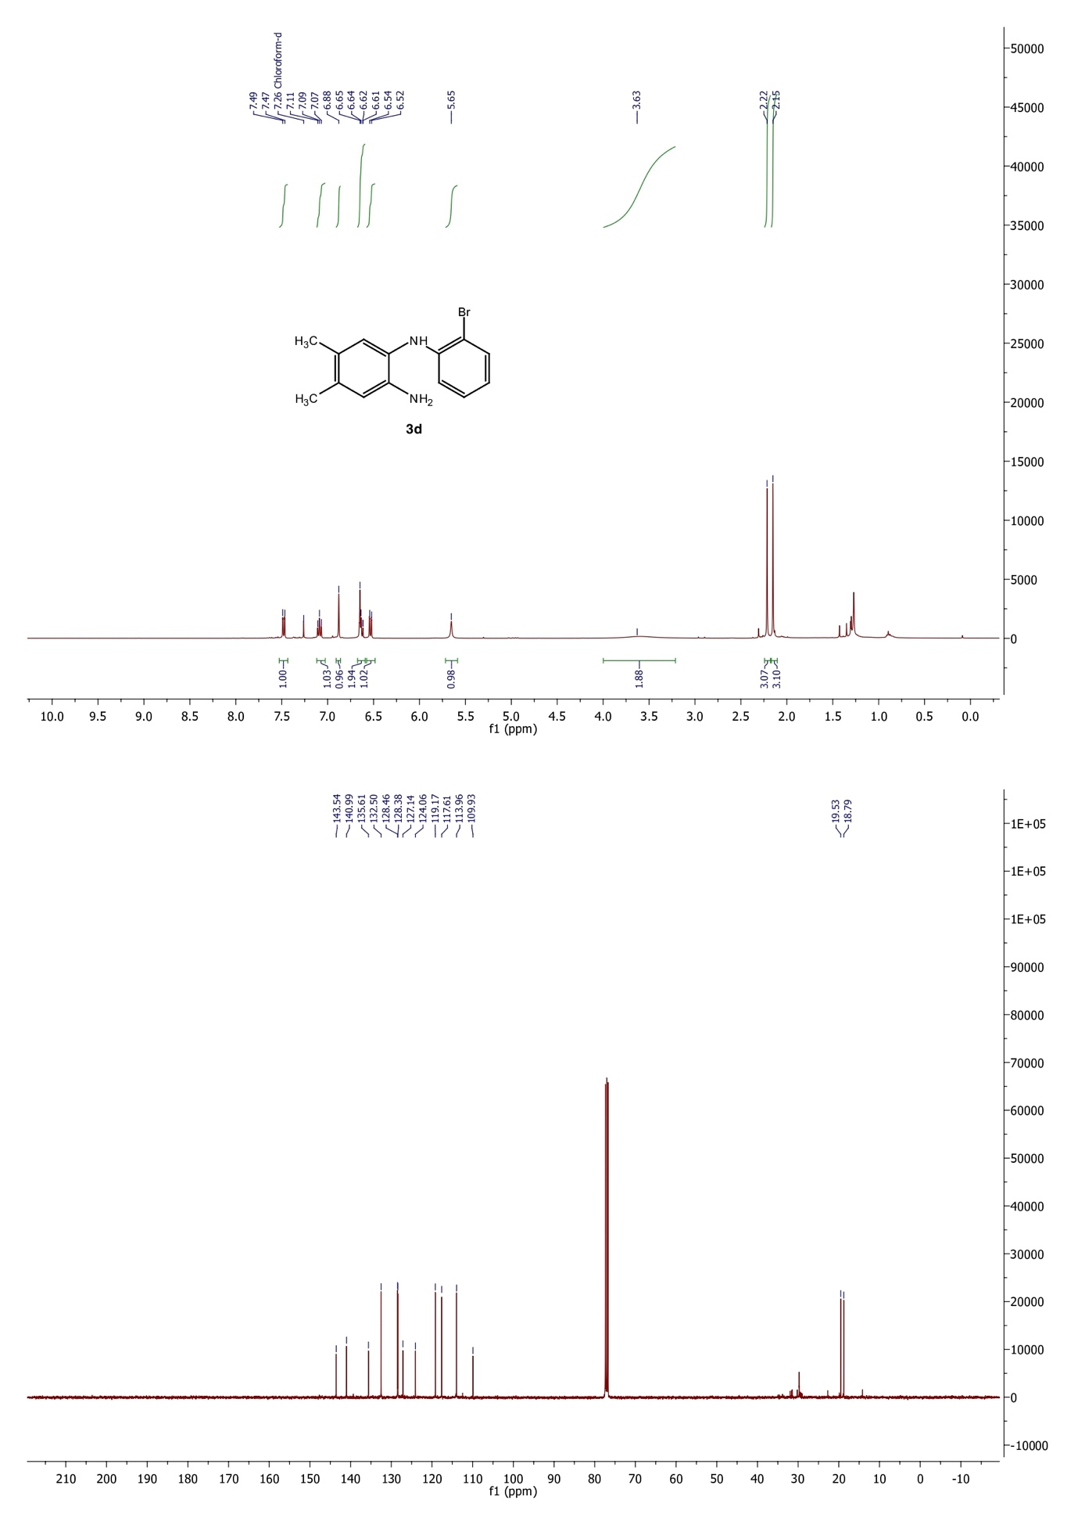

**IV.5– NMR of spectra *N*-(2-bromophenyl)-4-chlorobenzene-1,2-diamine (3e)**

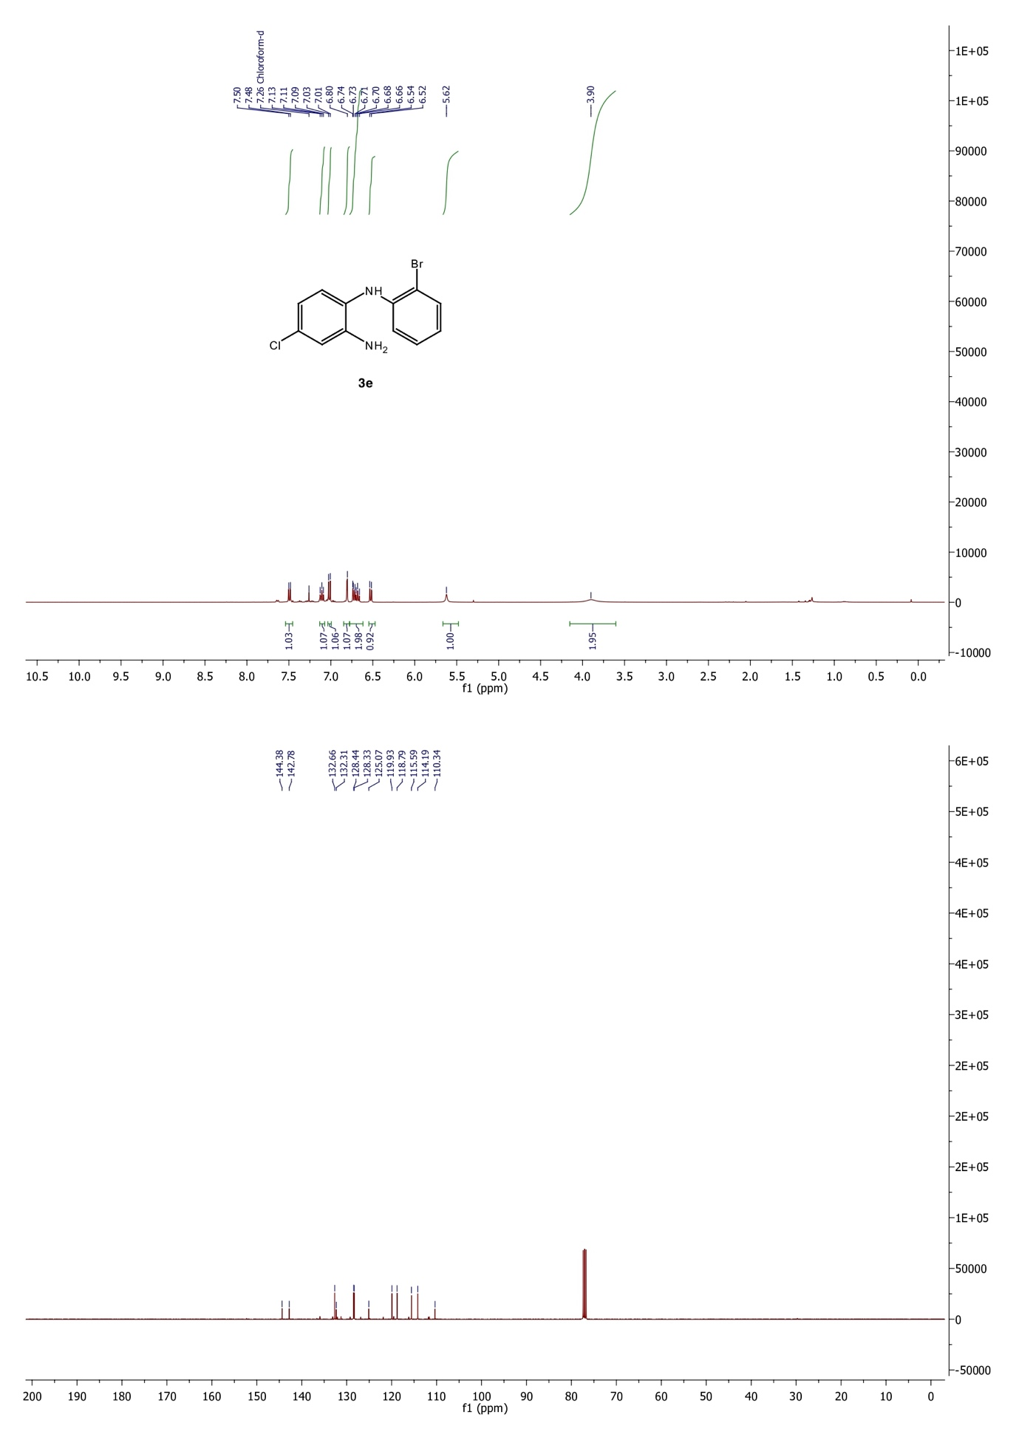

**IV.6– NMR spectra of *N*-(2-bromophenyl)-5-(trifluoromethyl)benzene-1,2- diamine (3f)**

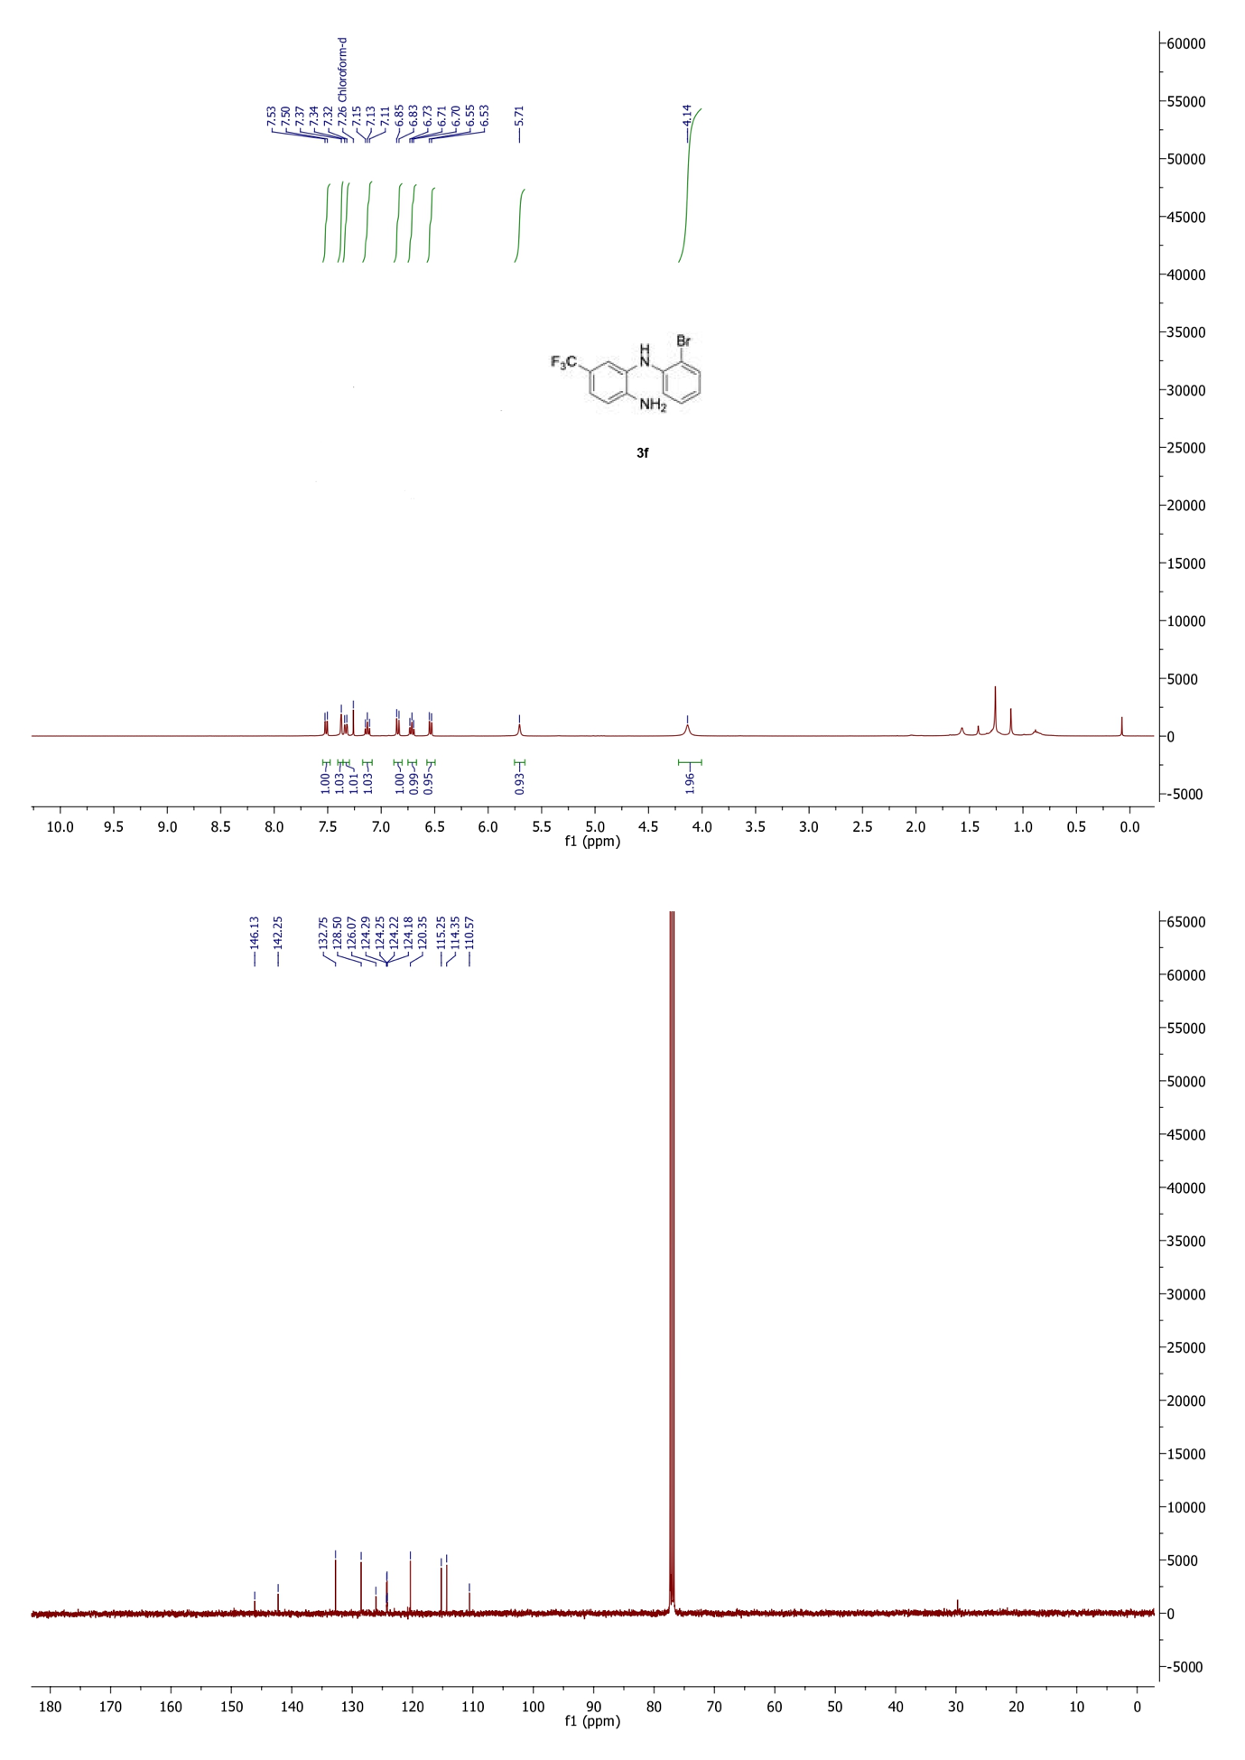

**IV.7– NMR spectra of ethyl 3-amino-4-((2-bromophenyl) amino) benzoate (3g)**

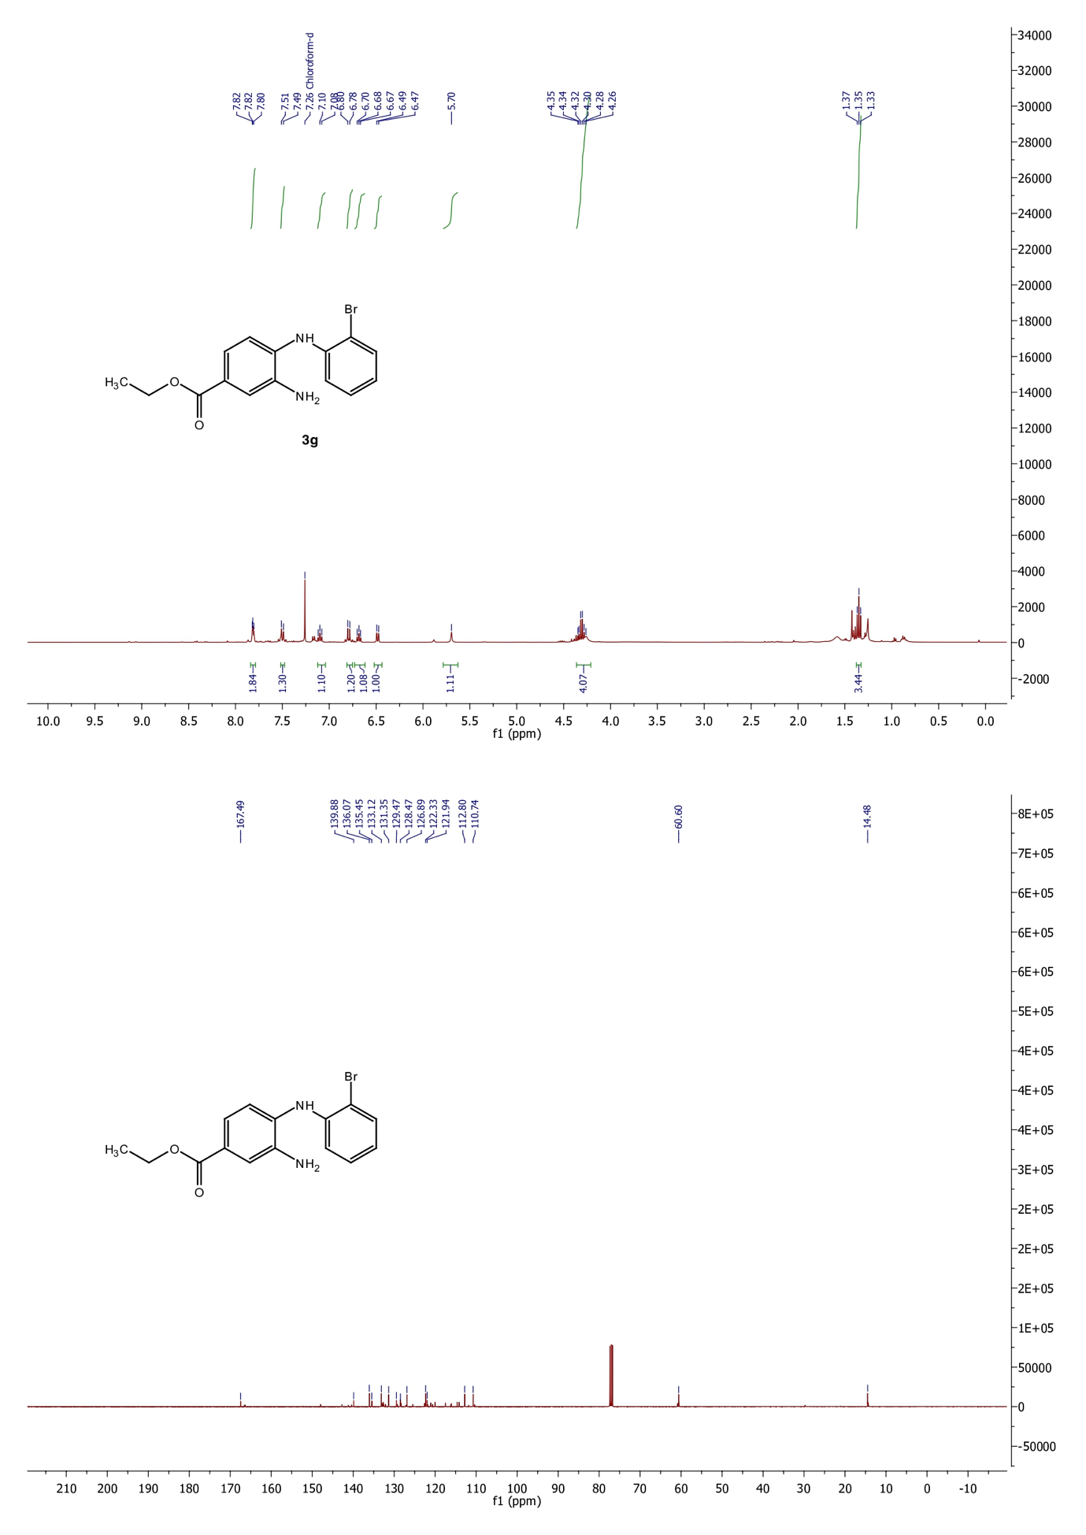

## IV.7– NMR spectra of *o*-(2-bromophenyl)amino(*N*-methyl)aniline (3h)

## 

## IV.8– Mass of *O*-(2-bromophenyl)amino(*N*-methyl)aniline (3h)

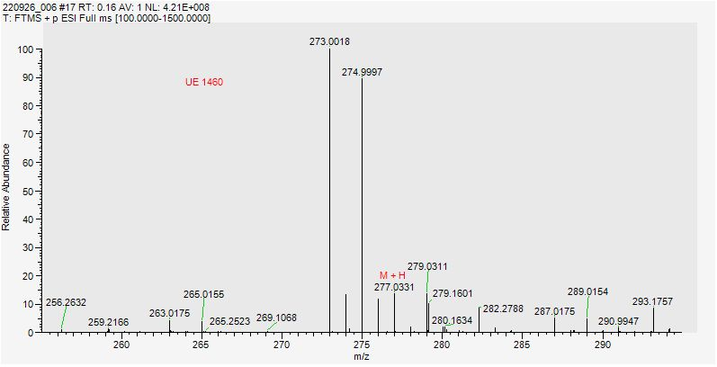

**V– NMR spectra of 5,10-dihydro-11*H*-dibenzo[b,e][1,4]diazepin-11-ones**

**V.1– NMR of 5,10-dihydro-11H-dibenzo[b,e][1,4]diazepin-11-one (4a)**

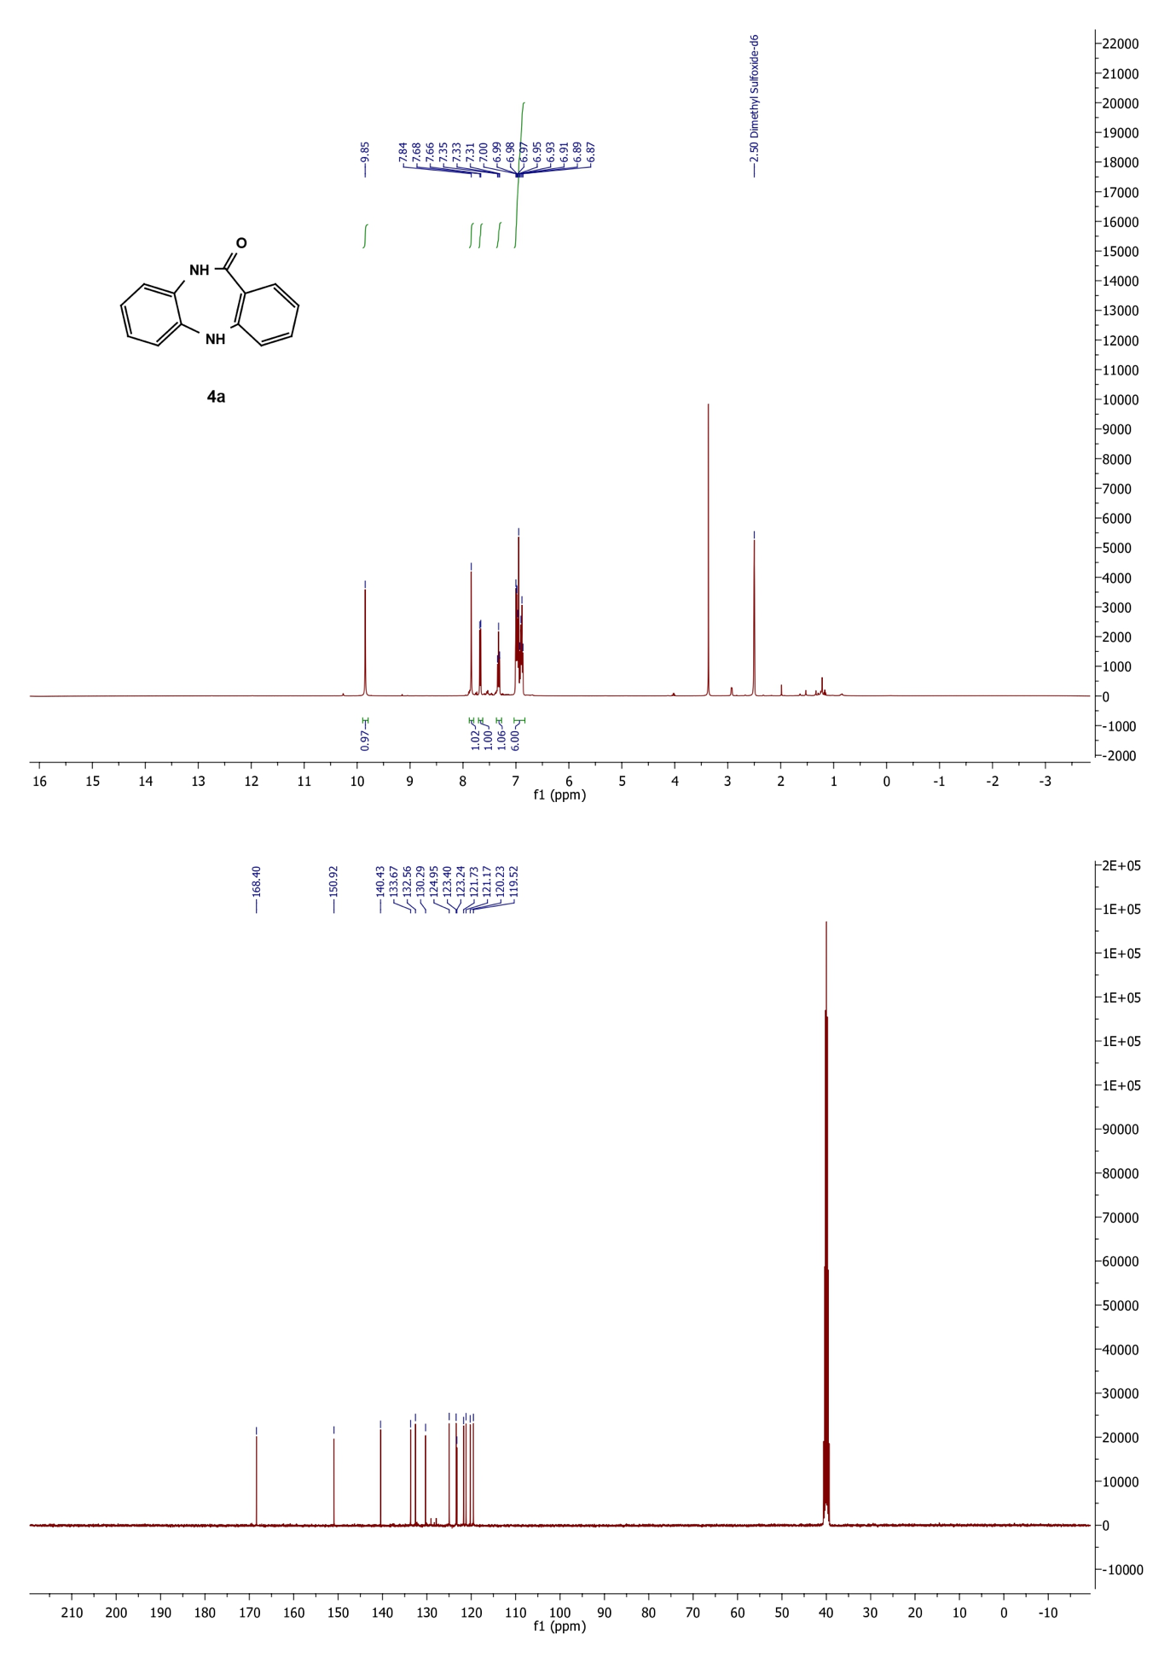

**V.2– NMR of 7-methyl-5,10-dihydro-11H-dibenzo[b,e][1,4]diazepin-11- one (4b)**

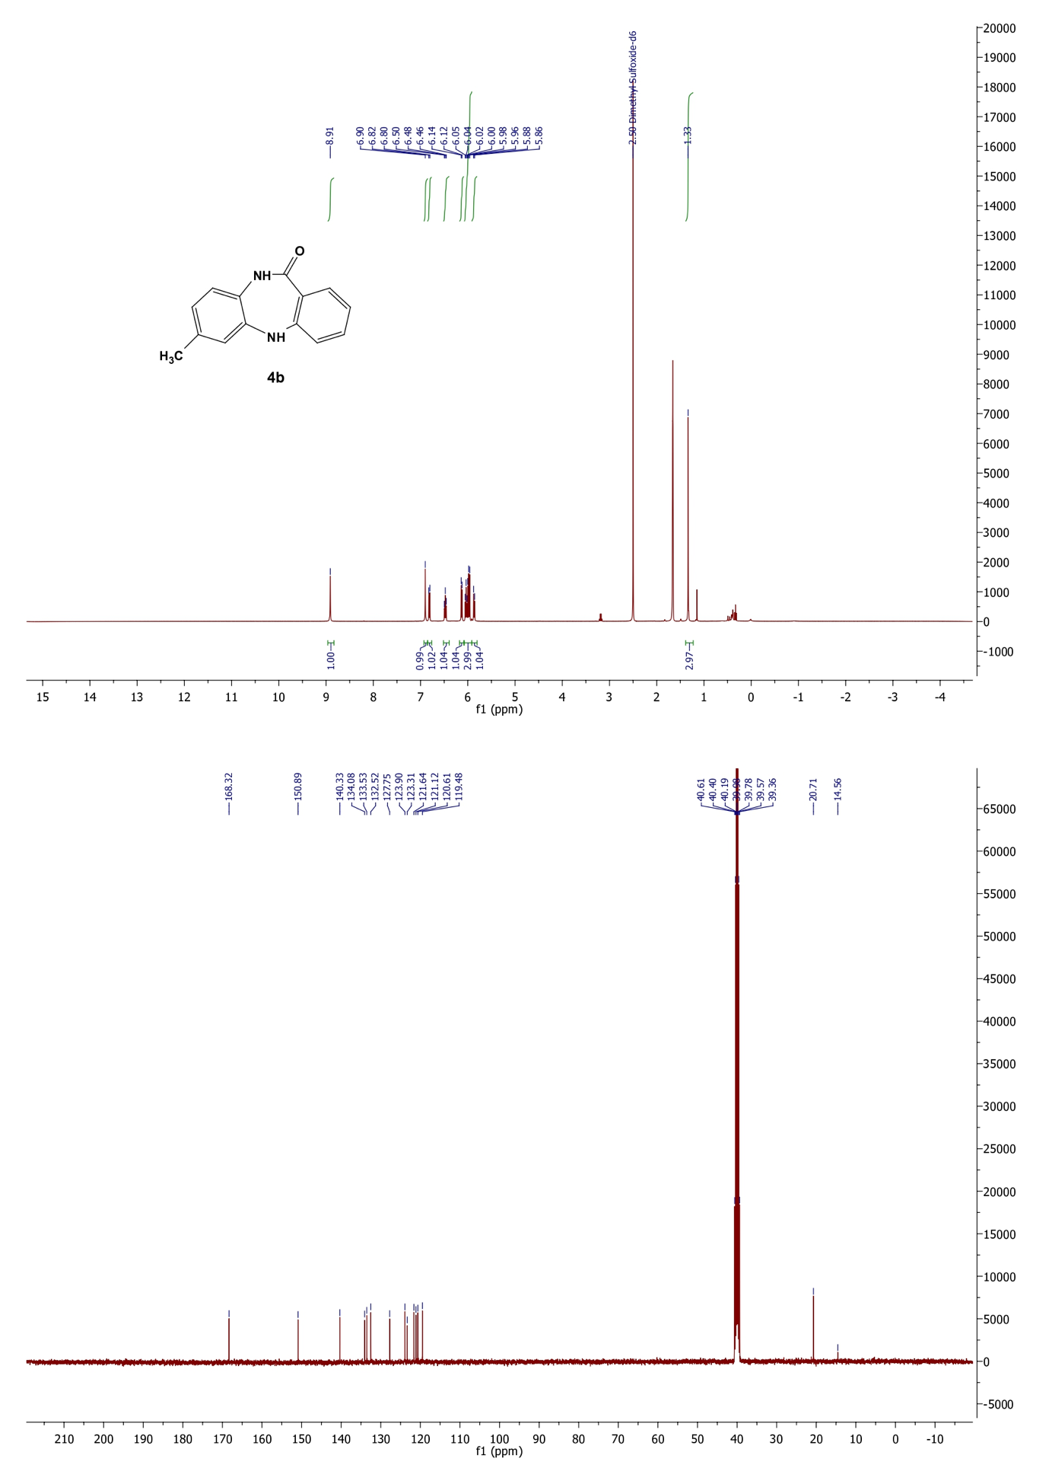

**V.3– NMR of 8-methyl-5,10-dihydro-11H-dibenzo [b,e][1,4] diazepin- 11-one (4c)**

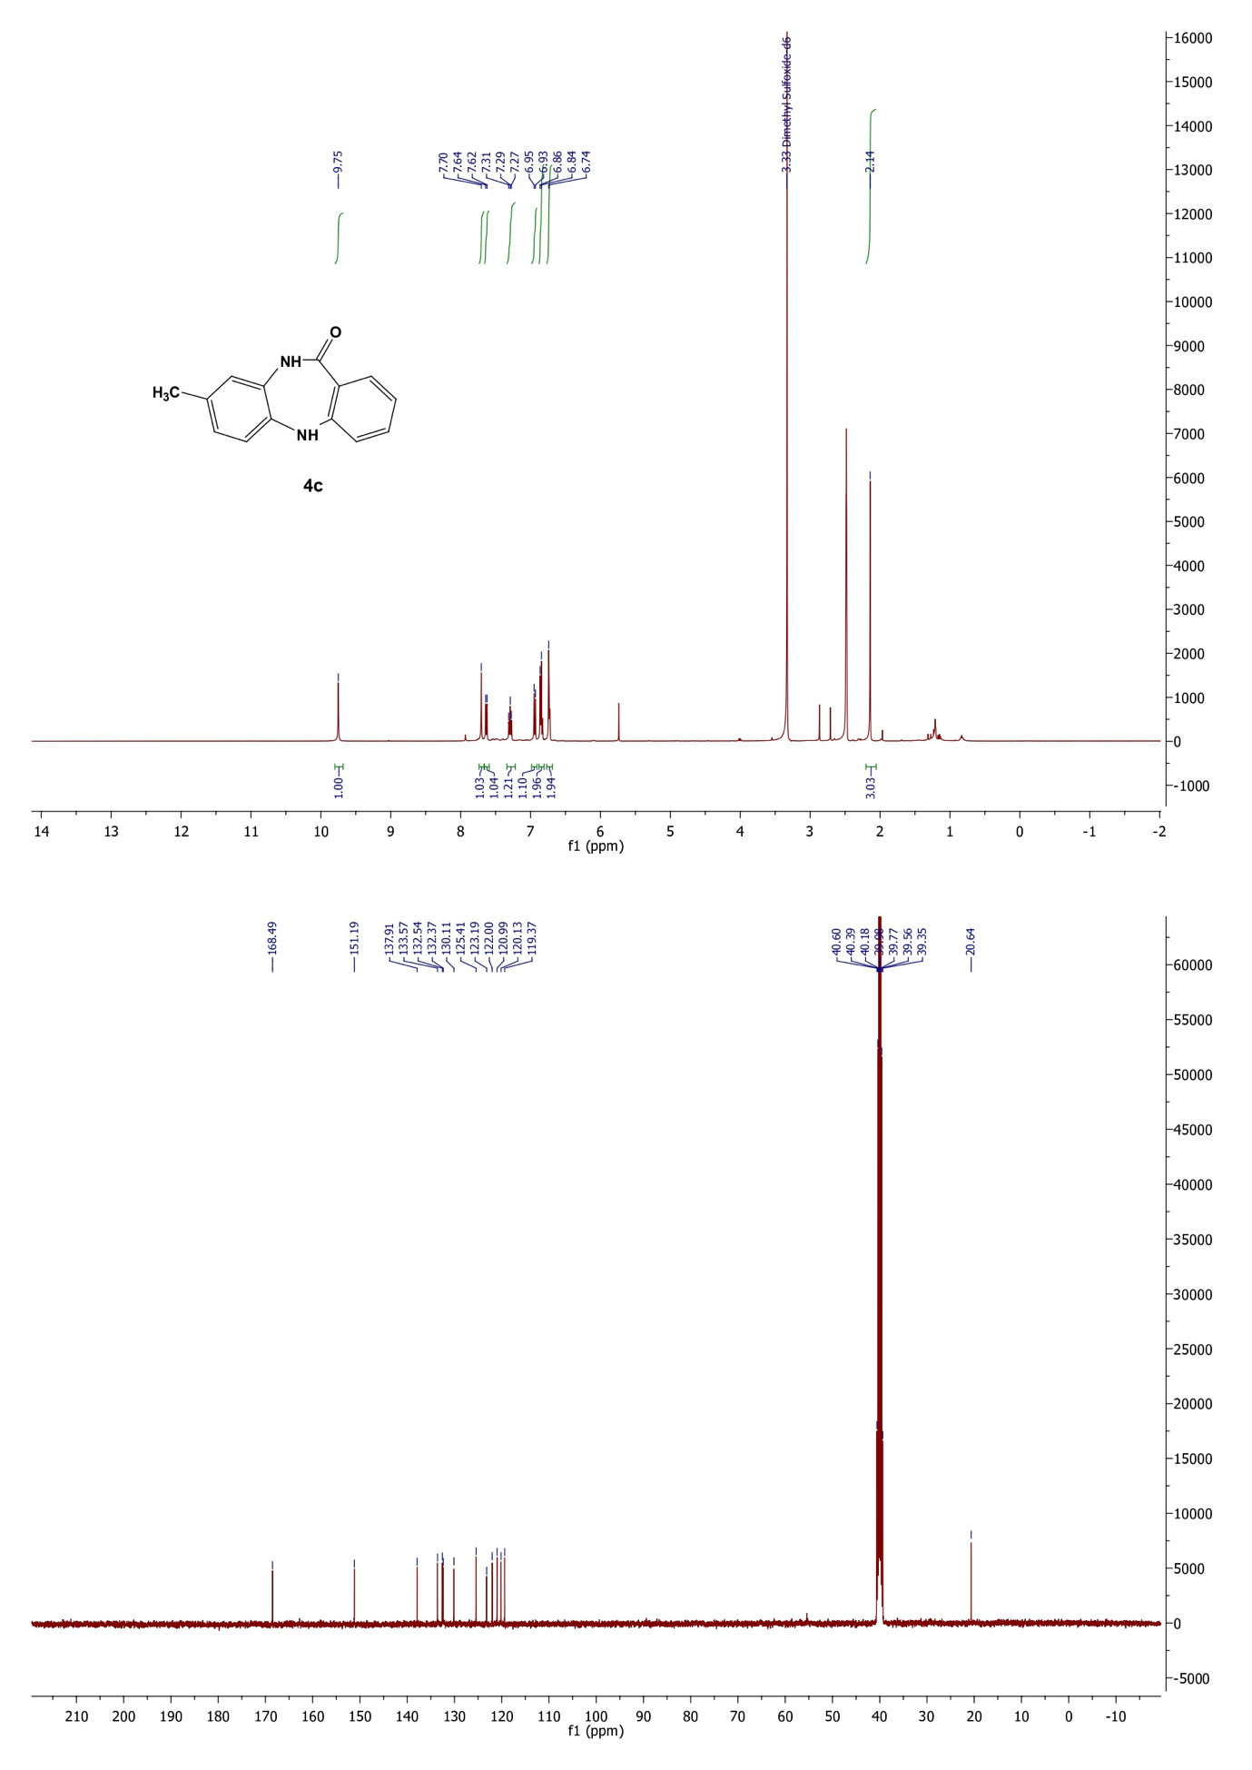

**V.4– NMR 7,8-dimethyl-5,10-dihydro-11H-dibenzo[b,e][1,4]diazepin- 11-one (4d)**

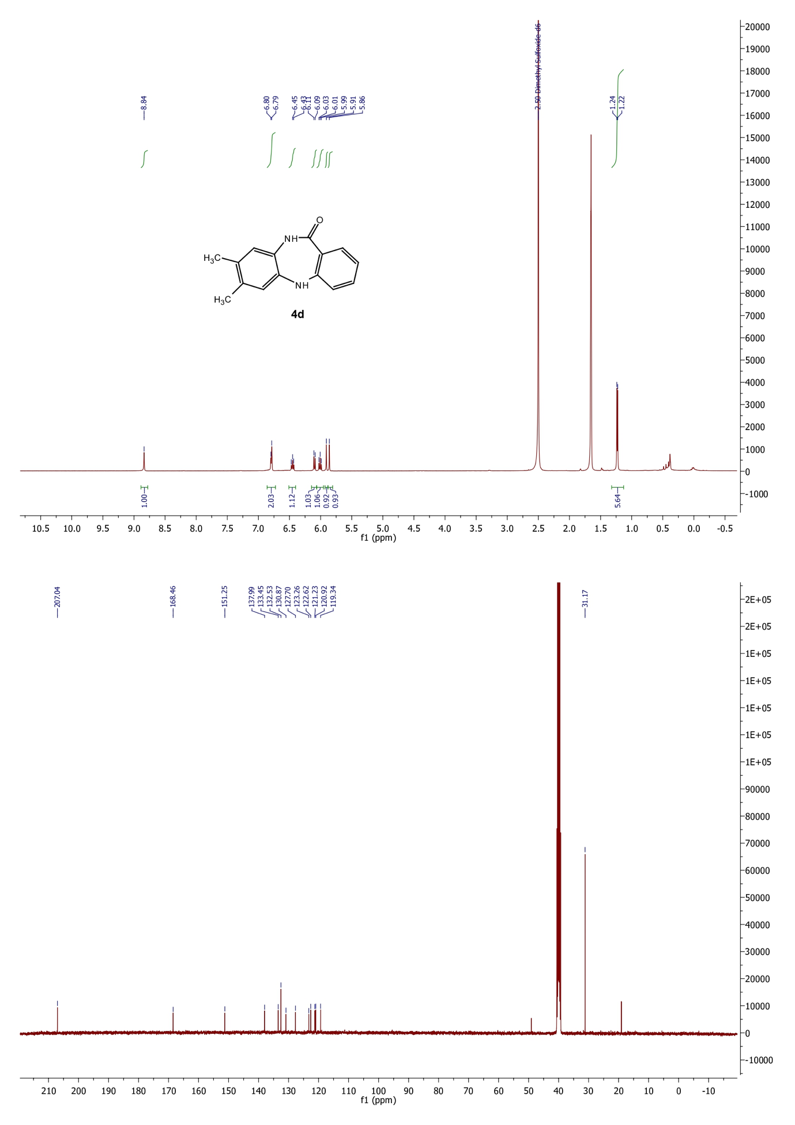

**V.5– NMR of 8-chloro-5,10-dihydro-11H-dibenzo[b,e][1,4]diazepin-11- one (4e)**

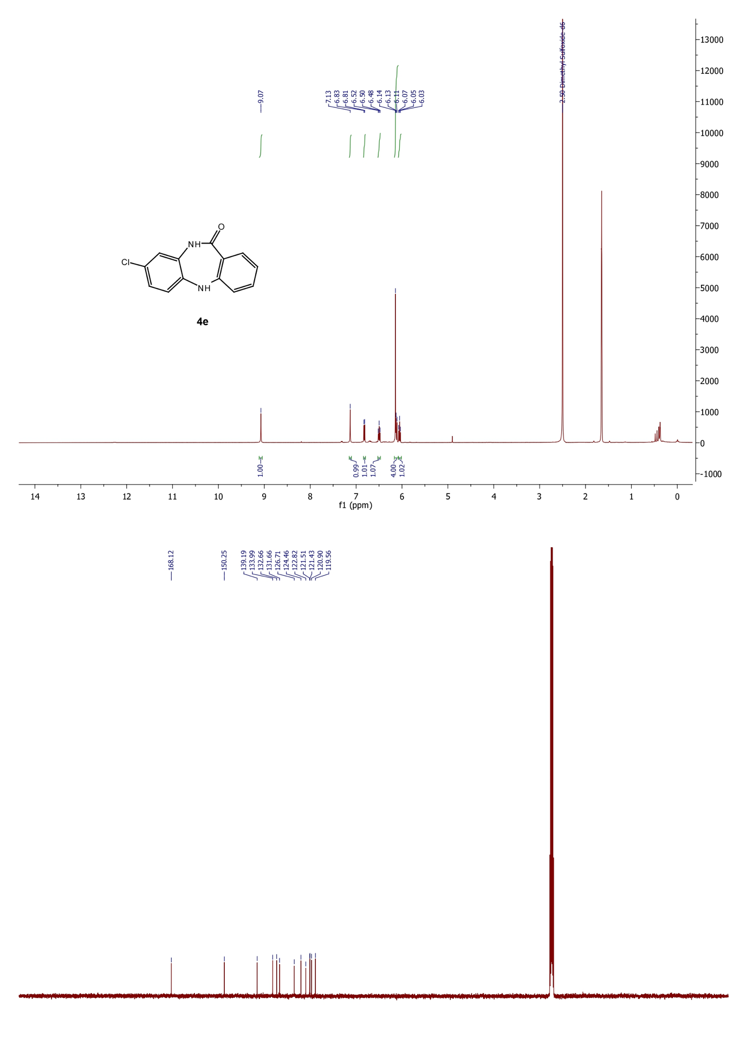

**V.6– NMR of 7-(trifluoromethyl)-5,10-dihydro-11H-dibenzo[b,e][1,4] diazepin-11-one (4f)**

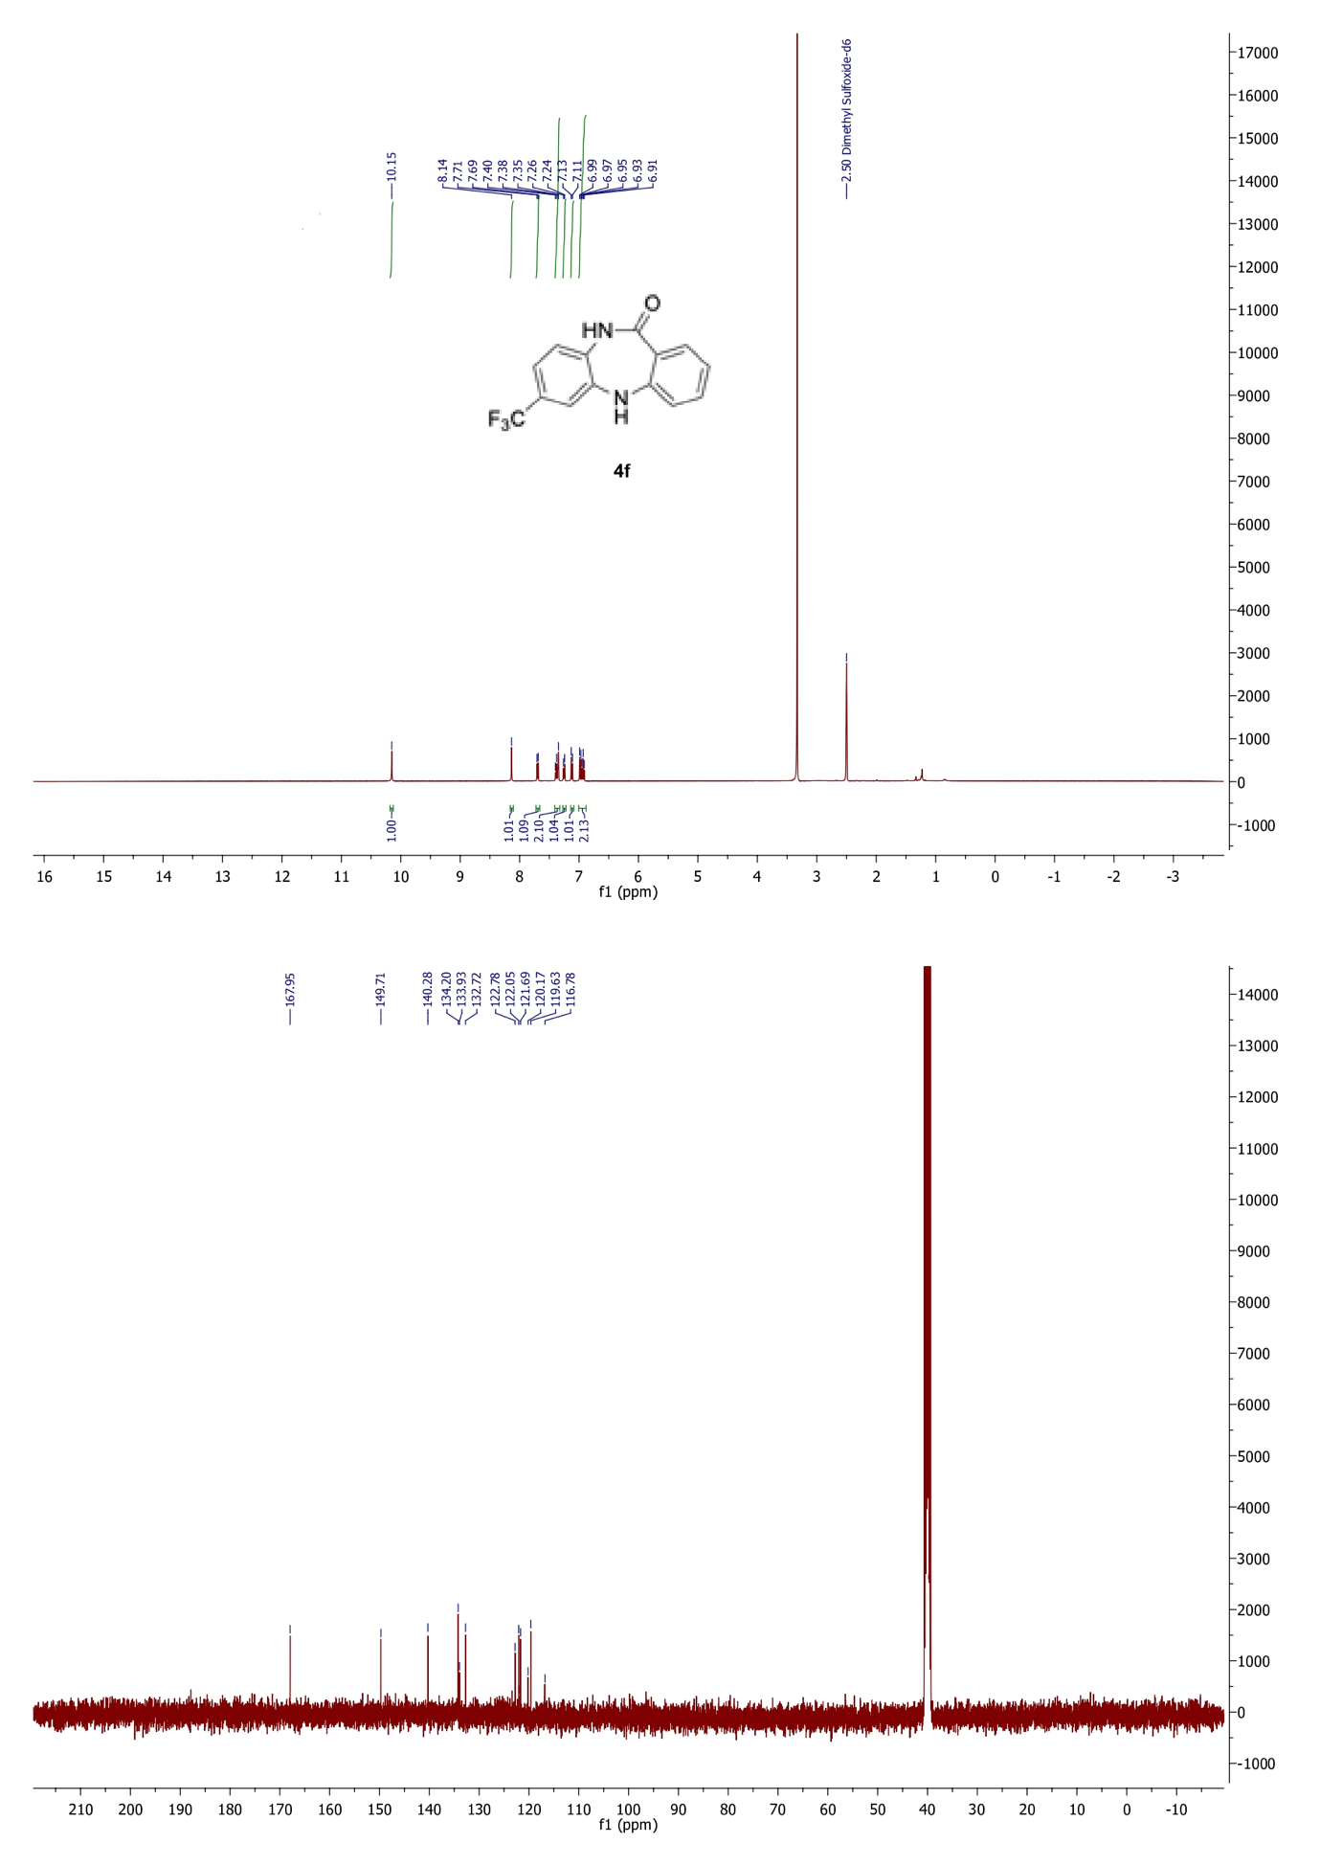

**IV.7– NMR of ethyl 11-oxo-10,11-dihydro-5H-dibenzo[b,e][1,4]diazepine- 8-carboxylate (4g)**

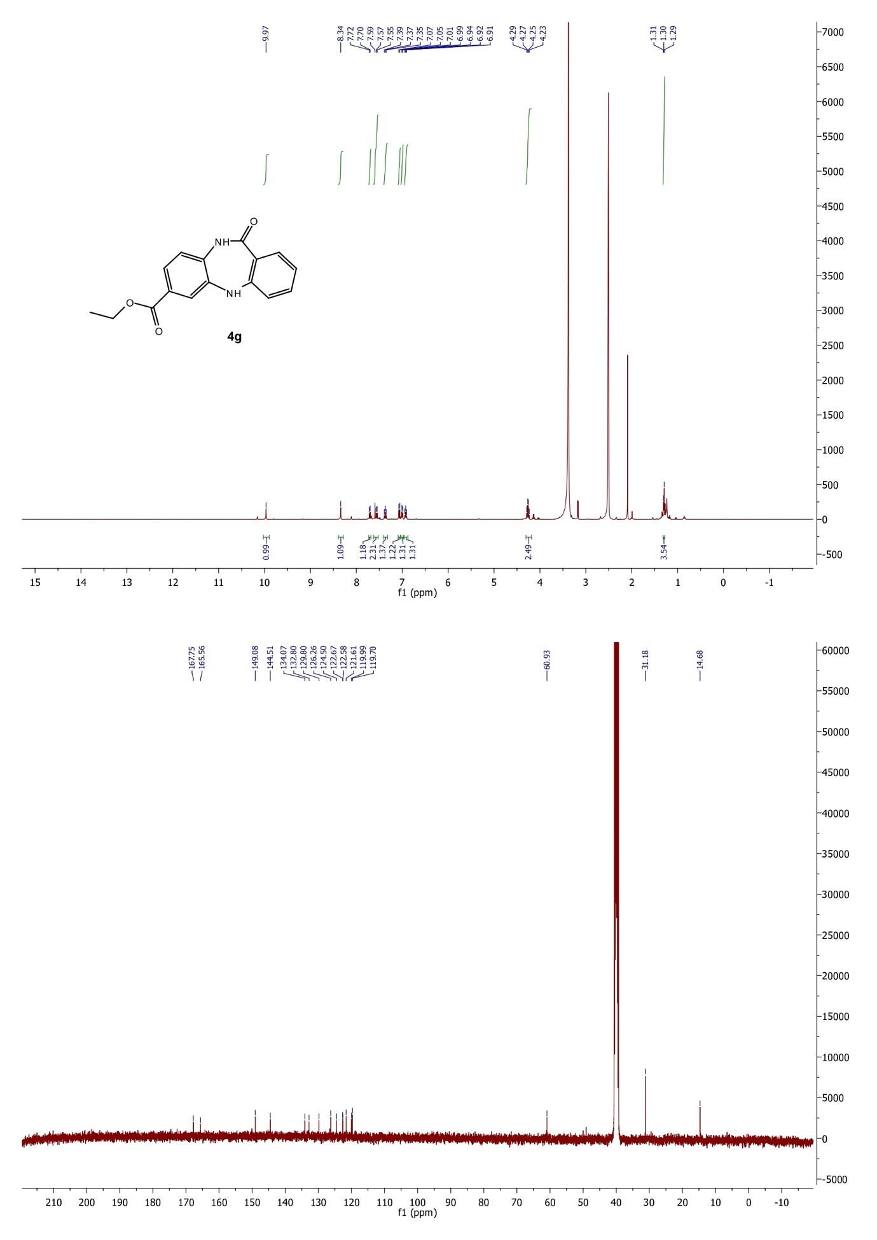

**V.8 – Mass spectrum of 10-methyl-5,10-dihydro-11H-dibenzo[b,e][1,4]diazepin-11-one (4h)**

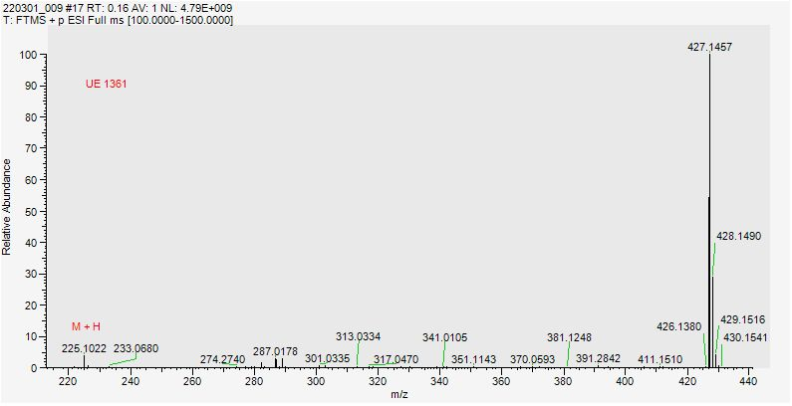

**References**

(1) Tryniszewski, M.; Bujok, R.; Gańczarczyk, R. Wróbel, Z. *Synthesis* **2020**, 52, 3086-3094.

(2) Iwasawa, T.; Tokunaga, M.; Obora, Y.; Tsuji, Y. *J. Am. Chem. Soc.* **2004**, 126, 6554-6555.