Supporting information for
Entry to new spiro heterocycles via tandem Rh(II)-catalyzed O‒H insertion – base-promoted cyclization involving diazo arylidene succinimides
Alexander Yanovich, Anastasia Vepreva, Ksenia Malkova, Grigory Kantin, Dmitry Dar’in*

Table of contents
I. Materials and Methods S2
II. Experimental procedures for the synthesis of target compounds S3
III. NMR spectra S13
IV. X-ray crystallographic data S41
V. References S44

I. Materials and Methods
Commercial grade reagents and solvents were used without further purification except as indicated below. Dichloromethane (DCM) was distilled from phosphorus pentoxide.
NMR spectra were recorded using a Bruker Avance III spectrometer in CDCl₃ (¹H: 400.13 MHz, ¹³C: 100.61 MHz; ¹⁹F: 376.50 MHz). All chemical shifts are reported in parts per million (ppm). The residual solvent peak was used as internal standard: CDCl₃ (7.26 for ¹H and 77.16 ppm for ¹³C). Standard abbreviations were used in the description of resonances. Coupling constants (J) are quoted to the nearest 0.1 Hz. Mass spectra were recorded with a HRMS-ESI-qTOF spectrometer (electrospray ionization mode, positive ion detection). Melting points were determined with a melting point apparatus Stuart SMP 10 in open capillary tubes. Single crystal X-ray data were obtained using SuperNova, Single source at offset/far, HyPix3000 and SuperNova, Dual, Cu at home/near, Atlas diffractometers at a temperature of 100 K.
Analytical thin layer chromatography was carried out on UV-254 silica gel plates using appropriate eluents. Compounds were visualized with short wave length UV light. Column chromatography was performed using silica gel Merk grade 60 (0.040−0.063 mm) 230−400 mesh.
Starting diazo compounds 1 (Figure S1) were obtained according to the literature procedure.[1]
Figure S1. Diazo compounds 1a-g used in this work.

II. Experimental procedures for the synthesis of target compounds
Preparation of compound 2a
(E)-7-Benzyl-9-benzylidene-4-phenyl-1-oxa-7-azaspiro[4.4]non-3-ene-2,6,8-trione (2a)
To a stirred solution of 3-phenylpropiolic acid (161 mg, 1.1 mmol, 1.1 equiv.) in dry DCM (1.6 mL) was added the catalyst solution (400 μL of 2.5 mM Rh₂(esp)₂ in DCM, 0.05 mol %) followed by dropwise addition of the solution of diazo compound 1a (303 mg, 1.0 mmol) in dry DCM (2 mL). The reaction mixture was stirred at ambient temperature for 1 hour (controlled by TLC), diluted with n-hexane (2 mL) and the resulting solution was subjected to column chromatography on silica gel (Eluent – n-hexane‒DCM, from 20 to 70% of DCM) to afford 371 mg (88%) of compound 10a as a white amorphous solid. ¹H NMR (400 MHz, CDCl₃): δ 7.83 (d, J = 2.2 Hz, 1H), 7.61 – 7.56 (m, 2H), 7.56 – 7.52 (m, 2H), 7.53 – 7.43 (m, 7H), 7.42 – 7.29 (m, 5H), 6.25 (d, J = 2.2 Hz, 1H), 4.89 (d, J = 14.2 Hz, 1H), 4.84 (d, J = 14.2 Hz, 1H).
The product of previous step (211 mg, 0.5 mmol) was dissolved in dry DCM (2 mL) followed by addition of DIPEA (32 mg 0.25 mmol, 50 mol%) and left stirring at room temperature for 7 days (controlled by TLC). The reaction mixture was diluted with n-hexane (2 mL) and the resulting solution was subjected to column chromatography on silica gel (Eluent – n-hexane‒DCM, from 60 to 100% of DCM) to afford 90 mg (75%) of the titled compound 2a. White solid, mp 171.1–171.4 °C. ¹H NMR (400 MHz, CDCl₃): δ 8.07 (s, 1H), 7.43 m, 2H), 7.42 – 7.35 (m, 1H), 7.33 (m, 4H), 7.17 (d, J = 7.5 Hz, 2H), 7.06 (t, J = 7.5 Hz, 2H), 6.73 – 6.69 (m, 2H), 6.37 (s, 1H), 4.97 (d, J = 13.9 Hz, 1H), 4.89 (d, J = 13.9 Hz, 1H)^{. 13}C{¹H} NMR (101 MHz, CDCl₃): δ 170.1, 169.3, 167.7, 162.6, 144.9, 134.5, 132.1, 131.3, 130.9, 129.6, 129.1, 128.9, 128.90, 128.5, 128.5, 126.6, 124.0, 118.9, 84.4, 43.7. HRMS (ESI-TOF), m/z calcd for C₂₇H₂₀NO₄ [M+H]⁺ 422.1387 found 422.1392.
General procedure (GP1) for the synthesis of compounds 2
To a stirred solution of the corresponding propiolic acid (0.55 mmol, 1.1 equiv.) in dry DCM (0.8 mL) was added the catalyst solution (200 μL of 2.5 mM Rh₂(esp)₂ in DCM, 0.05 mol%) followed by dropwise addition of the solution of diazo compound 1 (1.0 mmol, 1.0 equiv.) in dry DCM (1 mL). The reaction mixture was stirred at ambient temperature for 0.5‒1 hour (controlled by TLC). Upon completion of reaction, the solution of DIPEA (32 mg, 0.25 mmol, 50 mol%) in dry DCM (0.5 mL) was added and the reaction mixture was stirred at room temperature for 1-7 days (controlled by TLC). The reaction mixture was diluted with n-hexane (2 mL) and the resulting solution was subjected to column chromatography on silica gel to afford pure compound 2.
(E)-7-Benzyl-9-benzylidene-4-(4-fluorophenyl)-1-oxa-7-azaspiro[4.4]non-3-ene-2,6,8-trione (2b)
Prepared according to the general procedure GP1 from diazo compound 1a and 3-(4-fluorophenyl)propiolic acid (scale – 1.0 mmol). Yield: 315 mg (72%). Eluent – n-hexane–ethyl acetate (from 0 to 20% of ethyl acetate). White solid, mp 188.1–188.4 °C. ¹H NMR (400 MHz, CDCl₃): δ 8.08 (s, 1H), 7.43 (m, 2H), 7.41 – 7.37 (m, 1H), 7.37 – 7.33 (m, 4H), 7.33 – 7.30 (m, 1H), 7.19 – 7.15 (m, 2H), 6.76 – 6.70 (m, 2H), 6.70 – 6.65 (m, 2H), 6.33 (s, 1H), 4.97 (d, J = 13.8 Hz, 1H), 4.87 (d, J = 13.8 Hz, 1H). ¹³C{¹H} NMR (101 MHz, CDCl₃): δ 169.9, 169.2, 167.5, 164.2 (d, J_{C-F} = 254.3 Hz), 161.4, 145.0, 134.5, 132.1, 131.0, 129.6, 129.0 (d, J_{C-F} = 19.8 Hz), 128.8, 128.8, 128.6, 124.7 (d, J_{C-F} = 3.5 Hz), 123.8, 118.9 (d, J_{C-F} = 1.5 Hz), 116.4, 116.2, 84.3, 43.7. ¹⁹F{¹H} NMR (376 MHz, CDCl₃): δ -106.8. HRMS (ESI-TOF), m/z calcd for C₂₇H₁₉FNO₄ [M+H]⁺ 440.1293 found 440.1296.
(E)-7-Benzyl-9-benzylidene-4-(4-(trifluoromethyl)phenyl)-1-oxa-7-azaspiro[4.4]non-3-ene-2,6,8-trione (2c)
Prepared according to the general procedure GP1 from diazo compound 1a and 3-(4-(trifluoromethyl)phenyl)propiolic acid (scale – 1.0 mmol). Yield: 339 mg (69%). Eluent – n-hexane–acetone (from 10 to 50% of DCM). White solid, mp 165.1–165.2 °C. ¹H NMR (400 MHz, CDCl₃): δ 8.09 (s, 1H), 7.42 (m, 3H), 7.38 – 7.32 (m, 5H), 7.29 (s, 1H), 7.27 (s, 1H), 7.22 – 7.14 (m, 2H), 6.75 (d, J = 8.1 Hz, 2H), 6.42 (s, 1H), 4.99 (d, J = 13.8 Hz, 1H), 4.87 (d, J = 13.8 Hz, 1H). ¹³C{¹H} NMR (101 MHz, CDCl₃): δ 169.4, 168.9, 167.1, 160.9, 145.3, 134.5, 132.8 (q, J_{C-F} = 33.1 Hz), 131.9, 131.8, 131.2, 129.6, 129.1, 128.9, 128.7, 128.6, 126.9, 125.9 (q, J_{C-F} = 3.7 Hz), 123.31, 122.8 (q, J_{C-F} = 273.7 Hz), 121.0, 84.3, 43.7. ¹⁹F{¹H} NMR (376 MHz, CDCl₃): δ -63.3. HRMS (ESI-TOF), m/z calcd for HRMS (ESI-TOF), m/z calcd for C₂₈H₁₉F₃NO₄ [M+H]⁺ 490.1261 found 490.1270.
(E)-7-Benzyl-9-benzylidene-4-(2-chlorophenyl)-1-oxa-7-azaspiro[4.4]non-3-ene-2,6,8-trione (2d)
Prepared according to the general procedure GP1 from diazo compound 1a and 3-(2-chlorophenyl)propiolic acid (scale – 1.0 mmol). Yield: 268 mg (59%). Eluent – n-hexane–acetone (from 10 to 40% of acetone). White solid, mp 179.4‒179.6 °C. ¹H NMR (400 MHz, CDCl₃): δ 8.03 (s, 1H), 7.49 – 7.32 (m, 9H), 7.25 (d, J = 8.1 Hz, 1H), 7.16 (t, J = 7.7 Hz, 1H), 6.68 (m, 2H), 6.38 (d, J = 7.9 Hz, 1H), 4.97 (d, J = 13.9 Hz, 1H), 4.83 (d, J = 13.9 Hz, 1H). ¹³C{¹H} NMR (101 MHz, CDCl₃): δ 169.9, 169.3, 167.6, 158.4, 145.0, 134.4, 133.4, 132.1, 132.1, 131.3, 131.0, 130.3, 129.3, 128.9, 128.9, 128.5, 127.8, 127.3, 126.8, 124.4, 122.3, 85.5, 43.7. HRMS (ESI-TOF), m/z calcd for C₂₇H₁₉ClNO₄ [M+H]⁺ 456.0997 found 456.0992.
(E)-7-Benzyl-9-benzylidene-4-(4-(tert-butyl)phenyl)-1-oxa-7-azaspiro[4.4]non-3-ene-2,6,8-trione (2e)
Prepared according to the general procedure GP1 from diazo compound 1a and 3-(4-(tert-butyl)phenyl)propiolic acid (scale – 0.5 mmol). Yield: 135 mg (87%). Eluent – n-hexane–acetone (from 10 to 40% of acetone). White solid, mp 176.1‒177.7 °C. ¹H NMR (400 MHz, CDCl₃): δ 8.08 (s, 1H), 7.46 – 7.40 (m, 2H), 7.40 – 7.29 (m, 6H), 7.22 – 7.17 (m, 2H), 7.11 – 7.04 (m, 2H), 6.77 – 6.72 (m, 2H), 6.37 (s, 1H), 4.97 (d, J = 13.9 Hz, 1H), 4.90 (d, J = 13.9 Hz, 1H), 1.25 (s, 9H). ¹³C{¹H} NMR (101 MHz, CDCl₃): δ 170.4, 169.4, 167.8, 162.6, 155.2, 144.7, 134.6, 132.1, 130.8, 129.7, 129.1, 128.9, 128.5, 128.4, 126.5, 126.0, 125.4, 124.1, 117.6, 84.3, 43.6, 34.9, 30.9. HRMS (ESI-TOF), m/z calcd for C₃₁H₂₈NO₃ [M+H]⁺ 478.2013 found 478.2021.
(E)-7-Benzyl-9-benzylidene-4-methyl-1-oxa-7-azaspiro[4.4]non-3-ene-2,6,8-trione (2f)
Prepared according to the general procedure GP1 from diazo compound 1a and but-2-ynoic acid (scale – 1.0 mmol). Yield: 233 mg (65%). Eluent – n-hexane–acetone (from 10 to 40% of acetone). White solid, mp 167.2‒168.0 °C. ¹H NMR (400 MHz, CDCl₃): δ 8.15 (s, 1H), 7.46 – 7.28 (m, 9H), 6.00 (q, J = 1.5 Hz, 1H), 4.90 (d, J = 14.0 Hz, 1H), 4.84 (d, J = 14.0 Hz, 1H), 1.61 (d, J = 1.5 Hz, 3H). ¹³C{¹H} NMR (101 MHz, CDCl₃): δ 170.7, 169.3, 167.7, 162.5, 144.5, 134.9, 131.9, 131.2, 129.9, 128.9, 128.8, 128.7, 128.4, 122.5, 120.5, 85.8, 43.6, 12.8. HRMS (ESI-TOF), m/z calcd for C₂₂H₁₈NO₄ [M+H]⁺ 360.1230 found 360.1233.
(E)-9-Benzylidene-7-phenyl-1-oxa-7-azaspiro[4.4]non-3-ene-2,6,8-trione (2g)
Prepared according to the general procedure GP1 from diazo compound 1b and propiolic acid (scale – 1.0 mmol). Yield: 123 mg (37%). Eluent – n-hexane–acetone (from 5 to 15% of acetone). White solid, mp 231.4–231.6 °C. ¹H NMR (400 MHz, CDCl₃): δ 8.28 (s, 1H), 7.55 (m, 2H), 7.51 – 7.35 (m, 8H), 7.16 (d, J = 5.6 Hz, 1H), 6.38 (d, J = 5.6 Hz, 1H). ¹³C{¹H} NMR (101 MHz, CDCl₃): δ 170.8, 168.1, 166.7, 149.8, 145.9, 132.0, 131.3, 131.2, 130.0, 129.4, 129.3, 128.9, 126.1, 125.4, 122.3, 84.2. HRMS (ESI-TOF), m/z calcd for C₂₀H₁₄NO₄ [M+H]⁺ 332.0917 found 332.0921.
(E)-9-Benzylidene-4,7-diphenyl-1-oxa-7-azaspiro[4.4]non-3-ene-2,6,8-trione (2h)
Prepared according to the general procedure GP1 from diazo compound 1b and 3-phenylpropiolic acid (scale ‒ 0.5 mmol). Yield: 164 mg (88%). Eluent – n-hexane–acetone (from 10 to 50% of acetone). White solid, mp 182.2–183.4 °C. ¹H NMR (400 MHz, CDCl₃): δ 8.22 (s, 1H), 7.54 (m, 2H), 7.48 (m, 1H), 7.43 (m, 4H), 7.35 (m, 4H), 7.26 (d, J = 7.1 Hz, 2H), 7.12 (d, J = 7.1 Hz, 2H), 6.49 (s, 1H). ¹³C{¹H} NMR (101 MHz, CDCl₃): δ 170.0, 168.8, 167.1, 162.5, 145.8, 132.1, 131.7, 131.3, 131.1, 129.8, 129.4, 129.31, 129.3, 128.7, 128.6, 126.8, 126.0, 123.6, 119.2, 84.5. HRMS (ESI-TOF), m/z calcd for C₂₆H₁₈NO₄ [M+H]⁺ 408.1230 found 408.1234.
(E)-9-Benzylidene-4-(4-methoxyphenyl)-7-phenyl-1-oxa-7-azaspiro[4.4]non-3-ene-2,6,8-trione (2i)
Prepared according to the general procedure GP1 from diazo compound 1b and 3-(4-methoxyphenyl)propiolic acid (scale – 0.5 mmol). Yield: 162 mg (77%). Eluent – n-hexane–acetone (from 10 to 40% of acetone). White solid, mp 188.6‒189.9 °C. ¹H NMR (400 MHz, CDCl₃): δ 7.94 (d, J = 2.2 Hz, 1H), 7.74 – 7.67 (m, 2H), 7.53 (m, 7H), 7.46 (m, 3H), 6.96 – 6.83 (m, 2H), 6.26 (d, J = 2.2 Hz, 1H), 3.85 (s, 3H). ¹³C{¹H} NMR (101 MHz, CDCl₃): δ 170.0, 167.9, 161.9, 152.7, 140.5, 135.3, 132.4, 131.7, 131.4, 131.0, 129.3, 129.2, 128.9, 126.5, 122.1, 114.4, 110.6, 90.6, 78.6, 68.9, 55.5. HRMS (ESI-TOF), m/z calcd for C₂₇H₁₉NNaO₅ [M+Na]⁺ 460.1155 found 460.1151.
(E)-9-Benzylidene-7-phenyl-4-(thiophen-2-yl)-1-oxa-7-azaspiro[4.4]non-3-ene-2,6,8-trione (2j)
Prepared according to the general procedure GP1 from corresponding diazo compound 1b and 3-(thiophen-2-yl)propiolic acid (scale – 0.5 mmol). Yield: 138 mg (71%). Eluent – n-hexane–acetone (from 10 to 50% of acetone). White solid, mp 186.5 186.9 °C. ¹H NMR (400 MHz, CDCl₃): δ 8.31 (s, 1H), 7.58 – 7.51 (m, 3H), 7.50 – 7.45 (m, 1H), 7.46 – 7.40 (m, 3H), 7.35 (m, 4H), 7.24 (dd, J = 3.8, 1.1 Hz, 1H), 7.09 (dd, J = 5.1, 3.8 Hz, 1H), 6.42 (s, 1H). ¹³C{¹H} NMR (101 MHz, CDCl₃): δ 170.0, 168.5, 167.1, 155.5, 146.5, 132.1, 131.4, 131.3, 131.2, 130.5, 129.9, 129.4, 129.3, 128.8, 128.7, 126.0, 123.4, 115.6, 83.7. HRMS (ESI-TOF), m/z calcd for C₂₄H₁₅NNaO₄S [M+Na]⁺ 436.0614 found 436.0613.
(E)-9-Benzylidene-7-phenyl-4-propyl-1-oxa-7-azaspiro[4.4]non-3-ene-2,6,8-trione (2k)
Prepared according to the general procedure GP1 from diazo compound 1b and hex-2-ynoic acid (scale – 1.0 mmol). Yield: 344 mg (66%). Eluent – n-hexane–acetone (from 0 to 30% of acetone). White amorphous solid. ¹H NMR (400 MHz, CDCl₃): δ 8.27 (s, 1H), 7.54 (t, J = 7.6 Hz, 2H), 7.43 (m, 8H), 6.08 (s, 1H), 2.01 (t, J = 7.5 Hz, 2H), 1.50 (dq, J = 14.6, 7.5 Hz, 1H), 1.37 (dq, J = 14.6, 7.5 Hz, 1H), 0.80 (t, J = 7.5 Hz, 3H. ¹³C{¹H} NMR (101 MHz, CDCl₃): δ 170.7, 168.8, 167.2, 166.9, 145.4, 132.0, 131.4, 131.3, 130.1, 129.4, 129.2, 128.9, 126.0, 122.5, 119.6, 85.5, 29.3, 19.7, 13.4. HRMS (ESI-TOF), m/z calcd for C₂₃H₁₉NNaO₄ [M+Na]⁺ 396.1206 found 396.1205.
General procedure (GP2) for the synthesis of compounds 3a-d
To a stirred solution of diazo arylidene succinimide 1 (0.5 mmol, 1 equiv.) and allenic acid 11 (0.55 mmol, 1.1 equiv.) in dry DCM (1.9 mL per 0.5 mmol of diazo compound 1), a Rh₂(esp)₂ solution in dry DCM (100 µL per 0.5 mmol of diazo compound 1, 2 mg/mL, 0.05 mol%) was added at room temperature. After stirring for 15 min, DIPEA (30 mol%) was added. The solution was stirred for 3 days at 50 °C and then directly purified by flash column chromatography on silica gel (wet-loading method, n-hexane–acetone) to give product 3a-c.
In the case of 3d, the solution was stirred with 30 mol% DIPEA for 5 days at 50 °C and then for another 3 days with an additional portion of DIPEA (30 mol%) at 50 °C. Subsequent flash column chromatography on silica gel (wet-loading method, n-hexane–acetone) afforded product 3d.
(E)-7-Benzyl-9-benzylidene-3,4-dimethyl-1-oxa-7-azaspiro[4.4]non-3-ene-2,6,8-trione (3a)
Prepared according to the general procedure GP2 from diazo compound 1a and 2-methylbuta-2,3-dienoic acid. Eluent – n-hexane–acetone (from 0 to 20% of acetone). Yield: 148 mg (87%). Light yellow oil. ¹H NMR (CDCl₃, 400 MHz): δ 8.11 (s, 1H), 7.43 – 7.38 (m, 3H), 7.37 – 7.29 (m, 5H), 7.24 – 7.19 (m, 2H), 4.95 – 4.76 (m, 2H), 1.70 (q, J = 1.1 Hz, 3H), 1.45 (q, J = 1.1 Hz, 3H). ¹³C{¹H} NMR (CDCl₃, 101 MHz): δ 172.4, 170.1, 167.9, 152.7, 144.1, 135.2, 132.1, 131.0, 129.6, 129.0, 128.8, 128.7, 128.5, 128.4, 123.6, 84.5, 43.6, 10.9, 8.9. HRMS (ESI-TOF), m/z calcd for C₂₃H₂₀NO₄ [M+H]⁺ 374.1387; found 374.1388.
(E)-7-Benzyl-9-benzylidene-3-ethyl-4-(4-methylbenzyl)-1-oxa-7-azaspiro[4.4]non-3-ene-2,6,8-trione (3b)
Prepared according to the general procedure GP2 from diazo compound 1a and 2-ethyl-4-(p-tolyl)buta-2,3-dienoic acid. Eluent – n-hexane–acetone (from 0 to 15% of acetone). Yield: 180 mg (80%). White solid; mp 144–146 °C. ¹H NMR (CDCl₃, 400 MHz): δ 7.98 (s, 1H), 7.43 – 7.37 (m, 1H), 7.37 – 7.32 (m, 2H), 7.31 – 7.27 (m, 7H), 6.97 (d, J = 7.6 Hz, 2H), 6.69 (d, J = 7.8 Hz, 2H), 4.39 (d, J = 14.0 Hz, 1H), 4.22 (d, J = 14.0 Hz, 1H), 3.47 (d, J = 15.8 Hz, 1H), 3.01 (d, J = 15.8 Hz, 1H), 2.39 – 2.25 (m, 2H), 2.29 (s, 3H), 0.99 (t, J = 7.6 Hz, 3H). ¹³C{¹H} NMR (CDCl₃, 101 MHz): δ 171.9, 169.9, 167.7, 154.8, 143.6, 137.4, 134.9, 134.3, 132.4, 131.1, 130.6, 130.2, 129.5, 129.5, 128.9, 128.9 (d, J = 0.4 Hz), 128.4, 123.5, 83.9, 43.3, 32.5, 21.1, 17.7, 12.5. HRMS (ESI-TOF), m/z calcd for C₃₁H₂₇NO₄Na [M+Na]⁺ 500.1832; found 500.1837.
(E)-Methyl 4-((3,4-dimethyl-2,6,8-trioxo-7-phenyl-1-oxa-7-azaspiro[4.4]non-3-en-9-ylidene)methyl)benzoate (3c)
Prepared according to the general procedure GP2 from diazo compound 1c and 2-methylbuta-2,3-dienoic acid. Eluent – n-hexane–acetone (from 3 to 30% of acetone). Yield: 169 mg (83%). White solid; mp 220–222 °C. ¹H NMR (CDCl₃, 400 MHz): δ 8.25 (s, 1H), 8.03 (d, J = 8.3 Hz, 2H), 7.56 – 7.50 (m, 2H), 7.49 – 7.44 (m, 1H), 7.43 – 7.39 (m, 2H), 7.36 (d, J = 8.3 Hz, 2H), 3.94 (s, 3H), 1.74 (q, J = 1.1 Hz, 3H), 1.68 (q, J = 1.1 Hz, 3H). ¹³C{¹H} NMR (CDCl₃, 101 MHz): δ 172.1, 169.1, 166.9, 166.1, 152.4, 143.4, 136.3, 132.1, 131.3, 129.8, 129.5, 129.4, 129.4, 128.7, 126.1, 125.3, 84.2, 52.6, 11.2, 9.0. HRMS (ESI-TOF), m/z calcd for C₂₄H₁₉NO₆Na [M+Na]⁺ 440.1105; found 440.1109.
(E)-7-cyclopropyl-3,4-dimethyl-9-(4-methylbenzylidene)-1-oxa-7-azaspiro[4.4]non-3-ene-2,6,8-trione (3d)
Prepared according to the general procedure GP2 from diazo compound 1d and 2-methylbuta-2,3-dienoic acid. Eluent – n-hexane–acetone (from 1 to 25% of acetone). Yield: 122 mg (78%). White solid; mp 130–132 °C. ¹H NMR (CDCl₃, 400 MHz): δ 8.04 (s, 1H), 7.16 – 7.10 (m, 4H), 2.89 – 2.82 (m, 1H), 2.35 (s, 3H), 1.77 (q, J = 1.1 Hz, 3H), 1.54 (q, J = 1.1 Hz, 3H), 1.15 – 0.99 (m, 4H). ¹³C{¹H} NMR (CDCl₃, 101 MHz): δ 172.5, 170.6, 169.0, 152.9, 143.8, 141.9, 130.2, 129.5, 129.4, 128.5, 121.8, 84.3, 23.6, 21.6, 11.1, 9.0, 5.4, 5.3. HRMS (ESI-TOF), m/z calcd for C₂₀H₁₉NO₄Na [M+Na]⁺ 360.1206; found 360.1202.
General procedure (GP3) for the synthesis of compounds 4
To a stirred solution of 3-bromopropan-1-ol (83 mg, 0.6 mmol, 1.2 equiv.) in dry DCM (0.8 mL) was added the catalyst solution (200 μL of 2.5 mM Rh₂(esp)₂ in DCM, 0.05 mol %) followed by dropwise addition of the solution of diazo compound 1 (1.0 mmol, 1.0 equiv.) in dry DCM (1 mL). The reaction mixture was stirred at ambient temperature for 0.5‒1 hour (controlled by TLC). DCM was evaporated and the residue was dissolved in dry acetone (2 mL) followed by the addition of DBU (91 mg, 0.6 mmol, 1.2 equiv.). The mixture was stirred at room temperature for 1‒3 d (controlled by TLC). The reaction mixture was diluted with n-hexane (2 mL) and the resulting solution was subjected to column chromatography on silica gel (eluent – n-hexane–acetone, from 5 to 25% of acetone) to afford pure compound 4.
(E)-9-Benzylidene-7-phenyl-1-oxa-7-azaspiro[4.4]nonane-6,8-dione (4a)
Prepared according to the general procedure GP3 from diazo compound 1b and 3-bromopropan-1-ol (scale – 0.5 mmol). Yield: 109 mg (68%) White solid, mp 149.5‒150.8 °C. ¹H NMR (400 MHz, CDCl₃): δ 8.01 (s, 1H), 7.82 – 7.71 (m, 2H), 7.56 – 7.49 (m, 2H), 7.49 – 7.36 (m, 6H), 4.54 – 4.32 (m, 2H), 2.67 – 2.42 (m, 1H), 2.30 – 2.05 (m, 3H). ¹³C{¹H} NMR (101 MHz, CDCl₃): δ 176.6, 168.3, 140.8, 133.4, 131.7, 131.1, 130.4, 129.1, 128.6, 128.5, 128.2, 126.4, 81.8, 70.0, 32.2, 26.1. HRMS (ESI-TOF), m/z calcd for C₂₀H₁₇NNaO₃ [M+Na]⁺ 342.1101 found 342.1097.

(E)-9-Benzylidene-7-(p-tolyl)-1-oxa-7-azaspiro[4.4]nonane-6,8-dione (4b)
Prepared according to the general procedure GP3 from diazo compound 1e and 3-bromopropan-1-ol (scale – 0.5 mmol). Yield: 86 mg (57%) White solid, mp 156.4‒157.8 °C. ¹H NMR (400 MHz, CDCl₃): δ 8.00 (s, 1H), 7.83 – 7.70 (m, 2H), 7.52 – 7.40 (m, 3H), 7.31 (s, 4H), 4.56 – 4.30 (m, 2H), 2.50 (m, 1H), 2.42 (s, 3H), 2.31 – 2.04 (m, 3H). ¹³C{¹H} NMR (101 MHz, CDCl₃): δ 176.7, 168.5, 140.6, 138.6, 133.5, 131.1, 130.4, 129.3, 129.1, 128.6, 128.3, 126.2, 81.8, 70.0, 32.2, 26.1, 21.3. HRMS (ESI-TOF), m/z calcd for C₂₁H₁₉NNaO₃ [M+Na]⁺ 356.1257 found 356.1260.
(E)-9-Benzylidene-7-(4-(trifluoromethyl)phenyl)-1-oxa-7-azaspiro[4.4]nonane-6,8-dione (4c)
Prepared according to the general procedure GP3 from diazo compound 1f and 3-bromopropan-1-ol (scale – 0.5 mmol). Yield: 87 mg (45%) White solid, mp 164.7–164.9 °C. ¹H NMR (400 MHz, CDCl₃): δ 8.03 (s, 1H), 7.83 – 7.70 (m, 4H), 7.63 (d, J = 8.3 Hz, 2H), 7.52 – 7.43 (m, 3H), 4.52 – 4.34 (m, 2H), 2.51 (m, 1H), 2.31 – 2.06 (m, 3H). ¹³C{¹H} NMR (101 MHz, CDCl₃): δ 176.2, 167.9, 141.6, 134.8, 133.2, 131.2, 130.6, 130.4 (q, J_{C-F} = 32.9 Hz), 128.7, 127.6, 126.6, 126.2 (q, J_{C-F} = 3.7 Hz), 123.7 (q, J_{C-F} = 272.4 Hz), 81.8, 70.1, 32.2, 26.1. ¹⁹F{¹H} NMR (376 MHz, CDCl₃): δ -62.69. HRMS (ESI-TOF), m/z calcd for C₂₁H₁₇F₃NO₃ [M+H]⁺ 388.1155 found 388.1155.
(E)-Methyl 4-((6,8-dioxo-7-phenyl-1-oxa-7-azaspiro[4.4]nonan-9-ylidene)methyl)benzoate (4d)
Prepared according to the general procedure GP3 from diazo compound 1c and 3-bromopropan-1-ol (scale – 0.7 mmol). Yield: 90 mg (34%) White amorphous solid. ¹H NMR (400 MHz, CDCl₃): δ 8.13 (d, J = 8.4 Hz, 2H), 8.01 (s, 1H), 7.81 (d, J = 8.4 Hz, 2H), 7.55 – 7.51 (m, 2H), 7.48 – 7.40 (m, 3H), 4.54 – 4.29 (m, 2H), 3.98 (s, 3H), 2.61 – 2.42 (m, 1H), 2.37 – 2.20 (m, 1H), 2.19 – 1.98 (m, 2H). ¹³C{¹H} NMR (101 MHz, CDCl₃): δ 176.3, 167.9, 166.4, 139.3, 137.8, 131.5, 131.3, 130.8, 130.6, 129.7, 129.2, 128.7, 126.3, 81.6, 70.2, 52.4, 32.8, 26.2. HRMS (ESI-TOF), m/z calcd for C₂₂H₂₀NO₅ [M+H]⁺ 378.1336 found 378.1338.
General procedure (GP4) for the synthesis of compounds 5, 16, 18, 21, 24, and 25
Step 1 | To a stirred solution of the corresponding OH-substrate (0.6 mmol, 1.2 equiv.) in dry DCM (0.8 mL) was added the catalyst solution (200 μL of 2.5 mM Rh₂(esp)₂ in DCM, 0.05 mol %) followed by dropwise addition of the solution of diazo compound 1 (0.5 mmol, 1.0 equiv.) in dry DCM (1 mL). The reaction mixture was stirred at ambient temperature for 0.5‒1 hour (controlled by TLC) diluted with n-hexane and subjected to flash column chromatography (Eluent ‒ n-hexane–DCM, 1:1) to afford compound 16, which was pure enough for the next step.
Step 2 | The obtained substance (0.2 mmol) was dissolved in dry acetone (1 mL) followed by the addition of DBU (36 mg, 0.24 mmol, 1.2 equiv.). The mixture was stirred at room temperature for 15‒20 min (controlled by TLC). The reaction mixture was diluted with n-hexane (1 mL) and the resulting solution was subjected to column chromatography on silica gel (eluent – n-hexane–acetone, from 5 to 25% of acetone) to afford pure compound 5.
(E)-3-Benzylidene-4-(2-(bromomethyl)phenoxy)-1-phenylpyrrolidine-2,5-dione (16a)
Prepared according to the general procedure GP4 (Step 1) from diazo compound 1b and (2-(bromomethyl)phenyl)methanol (scale – 0.5 mmol).[2] Yield: 162 mg (72%). White amorphous solid. ¹H NMR (400 MHz, CDCl₃): δ 8.00 (d, J = 2.0 Hz, 1H), 7.72 (dd, J = 8.0, 1.7 Hz, 2H), 7.58 – 7.50 (m, 3H), 7.50 – 7.43 (m, 3H), 7.40 (dt, J = 8.0, 1.7 Hz, 3H), 7.37 – 7.29 (m, 3H), 5.33 (d, J = 2.0 Hz, 1H), 5.19 (d, J = 11.0 Hz, 1H), 4.93 (d, J = 11.0 Hz, 1H), 4.58 (d, J = 10.3 Hz, 1H), 4.56 (d, J = 10.3 Hz, 1H).
(E)-4'-Benzylidene-1'-phenylspiro[isochroman-3,3'-pyrrolidine]-2',5'-dione (5a)
Prepared according to the general procedure GP4 (Step 2) from compound 16a (scale – 0.2 mmol). Yield: 80 mg (87%) White solid, mp 156.7–156.9 °C. ¹H NMR (400 MHz, CDCl₃): δ 8.05 (s, 1H), 7.97 – 7.88 (m, 2H), 7.57 – 7.33 (m, 8H), 7.32 – 7.26 (m, 1H), 7.22 (m, 1H), 7.17 (d, J = 7.5 Hz, 1H), 7.07 (d, J = 7.5 Hz, 1H), 5.53 (d, J = 15.1 Hz, 1H), 5.20 (d, J = 15.1 Hz, 1H), 3.62 (d, J = 17.5 Hz, 1H), 2.99 (d, J = 17.5 Hz, 1H). ¹³C{¹H} NMR (101 MHz, CDCl₃): δ 173.2, 168.1, 141.1, 133.3, 132.7, 132.2, 131.5, 130.8, 129.7, 129.0, 128.8, 128.8, 128.6, 128.6, 126.86, 126.5, 126.4, 124.1, 73.3, 65.8, 29.9. HRMS (ESI-TOF), m/z calcd for C₂₅H₂₀NO₃ [M+H]⁺ 382.1438 found 382.1445.
(E)-Methyl 4-((4-((2-(bromomethyl)benzyl)oxy)-2,5-dioxo-1-phenylpyrrolidin-3-ylidene)methyl)benzoate (16b)
Prepared according to the general procedure GP4 (Step 1) from diazo compound 1c and (2-(bromomethyl)phenyl)methanol (scale – 0.5 mmol). Yield: 182 mg (70%) White amorphous solid. ¹H NMR (400 MHz, CDCl₃): δ 8.11 – 8.08 (d, J = 8.3 Hz, 2H), 8.00 (d, J = 2.0 Hz, 1H), 7.76 (d, J = 8.3 Hz, 2H), 7.54 (m, 2H), 7.50 – 7.43 (m, 1H), 7.42 – 7.39 (m, 3H), 7.35 (m, 1H), 7.32 – 7.29 (m, 2H), 5.31 (d, J = 2.0 Hz, 1H), 5.22 (d, J = 11.1 Hz, 1H), 4.94 (d, J = 11.1 Hz, 1H), 4.57 (d, J = 10.4 Hz, 1H), 4.53 (d, J = 10.4 Hz, 1H), 3.99 (s, 3H).
(E)-Methyl 4-((2',5'-dioxo-1'-phenylspiro[isochroman-3,3'-pyrrolidin]-4'-ylidene)methyl)benzoate (5b)
Prepared according to the general procedure GP4 (Step 2) from compound 16b (scale – 0.2 mmol).Yield: 83 mg (82%) White solid, mp 189.2–189.9 °C. ¹H NMR (400 MHz, CDCl₃): δ 8.08 – 7.97 (m, 3H), 7.93 (m, 2H), 7.55 – 7.48 (m, 2H), 7.48 – 7.39 (m, 2H), 7.27 (t, J = 6.6 Hz, 1H), 7.21 (d, J = 7.5 Hz, 1H), 7.16 (t, J = 6.6 Hz, 1H), 7.03 (d, J = 7.5 Hz, 1H), 5.50 (d, J = 15.0 Hz, 1H), 5.16 (d, J = 15.0 Hz, 1H), 3.92 (s, 3H), 3.48 (d, J = 17.3 Hz, 1H), 3.01 (d, J = 17.4 Hz, 1H). ¹³C{¹H} NMR (101 MHz, CDCl₃): δ 172.9, 167.7, 166.3, 139.5, 136.9, 133.2, 131.7, 131.5, 131.4, 131.1, 129.8, 129.4, 129.1, 128.7, 128.4, 127.0, 126.6, 126.3, 124.1, 73.3, 65.9, 52.4, 30.2. HRMS (ESI-TOF), m/z calcd for C₂₇H₂₁NNaO₅ [M+Na]⁺ 462.1312 found 462.1313.
(E)-3-((2-(Bromomethyl)benzyl)oxy)-4-(2-methoxybenzylidene)-1-phenylpyrrolidine-2,5-dione (16c)
Prepared according to the general procedure GP4 (Step 1) from diazo compound 1g and (2-(bromomethyl)phenyl)methanol (scale – 1.0 mmol). Yield: 170 mg (69%). White amorphous solid. ¹H NMR (400 MHz, CDCl₃): δ 8.39 (d, J = 2.0 Hz, 1H), 7.69 (dd, J = 7.9, 1.7 Hz, 1H), 7.57 – 7.48 (m, 2H), 7.49 – 7.44 (m, 2H), 7.43 – 7.39 (m, 2H), 7.39 – 7.27 (m, 4H), 7.29 – 7.19 (m, 3H), 7.03 – 6.95 (m, 2H), 5.30 (d, J = 2.1 Hz, 1H), 5.14 (d, J = 10.9 Hz, 1H), 4.84 (d, J = 10.9 Hz, 1H), 4.49 (d, J = 10.4 Hz, 1H), 4.45 (d, J = 10.4 Hz, 1H), 3.93 (s, 3H).
(E)-4'-(2-Methoxybenzylidene)-1'-phenylspiro[isochroman-3,3'-pyrrolidine]-2',5'-dione (5c)
Prepared according to the general procedure GP4 (Step 2) from compound 16c (scale – 0.6 mmol). Yield: 100 mg (44%). White solid, mp 161.4–162.7 °C. ¹H NMR (400 MHz, CDCl₃): δ 8.45 (s, 1H), 8.11 (dd, J = 7.6, 1.6 Hz, 1H), 7.53 – 7.33 (m, 7H), 7.27 – 7.21 (m, 1H), 7.17 (td, J = 7.6, 1.6 Hz, 1H), 7.12 (d, J = 7.5 Hz, 1H), 7.01 (d, J = 7.5 Hz, 1H), 6.97 – 6.91 (m, 1H), 6.80 (t, J = 7.6 Hz, 1H), 5.42 (d, J = 15.0 Hz, 1H), 5.13 (d, J = 15.0 Hz, 1H), 3.94 (s, 3H), 3.52 (d, J = 17.4 Hz, 1H), 2.94 (d, J = 17.4 Hz, 1H). ¹³C{¹H} NMR (101 MHz, CDCl₃): δ 173.2, 168.2, 158.9, 136.5, 133.4, 132.4, 132.5, 130.2, 128.9, 128.5, 128.5, 128.4, 128.1, 126.7, 126.4, 126.2, 123.9, 121.8, 120.6, 110.6, 73.3, 65.8, 55.7, 29.7. HRMS (ESI-TOF), m/z calcd for C₂₆H₂₂NO₄ [M+H]⁺ 412.1543 found 412.1555.
(E)-4-Benzylidene-2,5-dioxo-1-phenylpyrrolidin-3-yl 2-(bromomethyl)benzoate (18)
Prepared according to the general procedure GP4 (Step 1) from diazo compound 1b and 2-(bromomethyl)benzoic acid (scale – 0.5 mmol).[3] Yield: 202 mg (85%). White amorphous solid. ¹H NMR (400 MHz, CDCl₃): δ 7.95 (d, J = 2.2 Hz, 1H), 7.74 (dd, J = 7.9, 1.3 Hz, 1H), 7.70 – 7.66 (m, 2H), 7.57 – 7.41 (m, 10H), 7.29 (ddd, J = 7.8, 6.9, 1.8 Hz, 2H), 6.46 (d, J = 2.2 Hz, 1H), 4.93 (d, J = 10.0 Hz, 1H), 4.80 (d, J = 10.1 Hz, 1H). ¹³C{¹H} NMR (101 MHz, CDCl₃): δ 170.5, 167.9, 165.2, 140.0, 139.9, 133.3, 132.5, 131.8, 131.7, 131.3, 131.2, 130.8, 129.23, 129.18, 128.8, 128.5, 127.1, 126.5, 122.8, 68.5, 30.8. HRMS (ESI-TOF), m/z calcd for C₂₅H₁₈BrNNaO₄ [M+Na]⁺ 498.0311/500.0291 found 498.0288/500.0287.
(E)-3-Benzylidene-4-(2-bromoethoxy)-1-phenylpyrrolidine-2,5-dione (21)
Prepared according to the general procedure GP4 (Step 1) from diazo compound 1b and 2-bromoethanol (scale – 0.5 mmol). Yield: 143 mg (74%). White solid, mp 148.5–149.3 °C. ¹H NMR (400 MHz, CDCl₃): δ 8.00 (d, J = 1.9 Hz, 1H), 7.88 – 7.77 (m, 2H), 7.61 – 7.49 (m, 5H), 7.48 – 7.35 (m, 3H), 5.12 (d, J = 1.9 Hz, 1H), 4.47 (dt, J = 10.8, 5.5 Hz, 1H), 4.09 (ddd, J = 10.5, 7.0, 5.6 Hz, 1H), 3.61 – 3.48 (m, 2H). ¹³C{¹H} NMR (101 MHz, CDCl₃): δ 172.3, 168.3, 141.9, 132.9, 131.5, 131.44, 131.38, 129.19, 129.17, 128.8, 126.3, 123.2, 72.9, 69.1, 29.7. HRMS (ESI-TOF), m/z calcd for C₁₉H₁₆BrNNaO₃ [M+Na]⁺ 408.0206/410.0185 found 408.0203/410.0185.
(E)-3-Benzylidene-4-(2-(2-bromoethoxy)ethoxy)-1-phenylpyrrolidine-2,5-dione (24)
Prepared according to the general procedure GP4 (Step 1) from diazo compound 1b and 2-(2-bromoethoxy)ethan-1-ol (scale – 0.5 mmol).[4] Yield: 136 mg (63%). White amorphous solid. ¹H NMR (400 MHz, CDCl₃): δ 7.97 (d, J = 1.9 Hz, 1H), 7.82 (dd, J = 6.7, 3.0 Hz, 2H), 7.60 – 7.48 (m, 5H), 7.47 – 7.36 (m, 3H), 5.11 (d, J = 1.9 Hz, 1H), 4.26 (dt, J = 10.5, 3.9 Hz, 1H), 3.99 (dt, J = 10.4, 5.1 Hz, 1H), 3.85 – 3.69 (m, 4H), 3.40 (t, J = 6.3 Hz, 2H).

3-Benzyl-4-(2-(2-bromoethoxy)ethoxy)-1-phenyl-1H-pyrrole-2,5-dione (25)
Prepared according to the general procedure GP4 (Step 2) from compound 24 (scale – 0.2 mmol). Yield: 75 mg (87%). White amorphous solid. ¹H NMR (400 MHz, CDCl₃): δ 7.48 – 7.42 (m, 2H), 7.40 – 7.30 (m, 7H), 7.28 – 7.21 (m, 1H), 4.80 – 4.74 (m, 2H), 3.82 – 3.76 (m, 6H), 3.44 (t, J = 6.0 Hz, 2H). ¹³C{¹H} NMR (101 MHz, CDCl₃): δ 169.8, 165.3, 152.4, 138.0, 131.3, 129.0, 128.8, 128.7, 127.5, 126.7, 126.0, 115.8, 71.2, 71.0, 70.1, 30.2, 27.5. HRMS (ESI-TOF), m/z calcd for C₂₁H₂₀BrNNaO₄ [M+Na]⁺ 452.0468/453.0447 found 452.0463/453.0445.

III. NMR spectra
Copies of ¹H (400.13 MHz, CDCl₃) and ¹³C{¹H} (100.61 MHz, CDCl₃) spectra of 2a
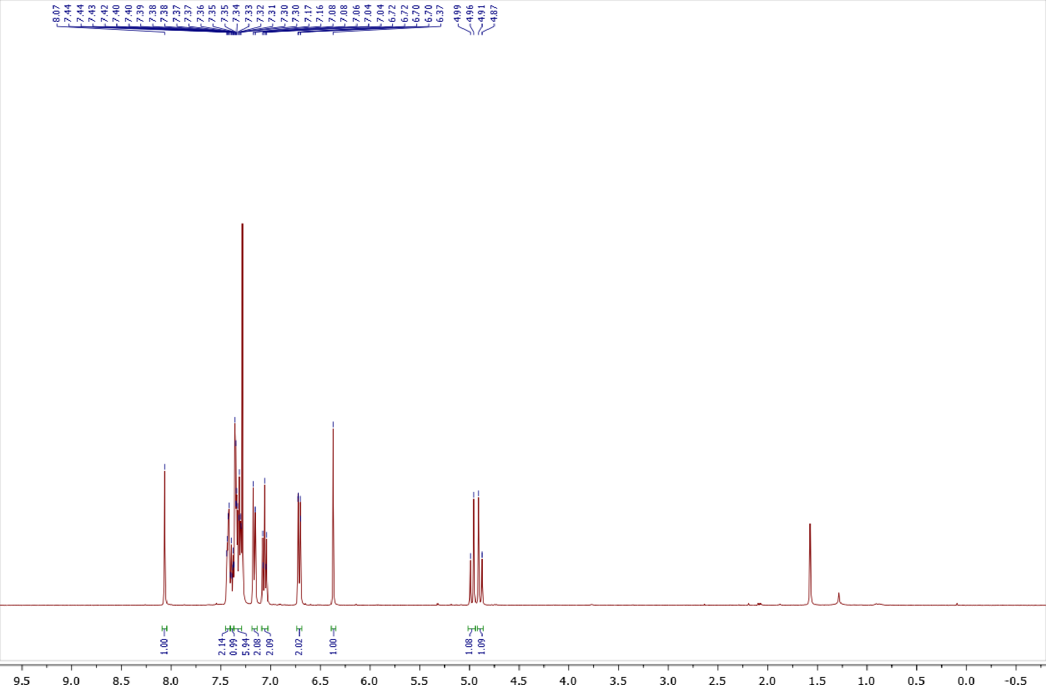
Copies of ¹H (400.13 MHz, CDCl₃) and ¹³C{¹H} (100.61 MHz, CDCl₃) spectra of 2b
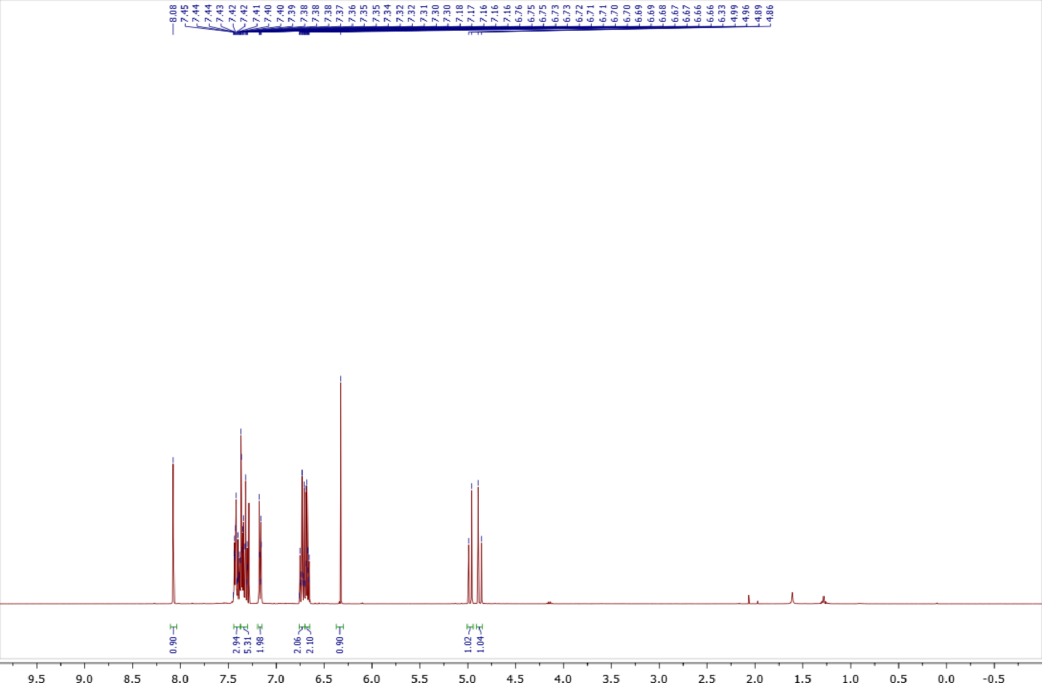
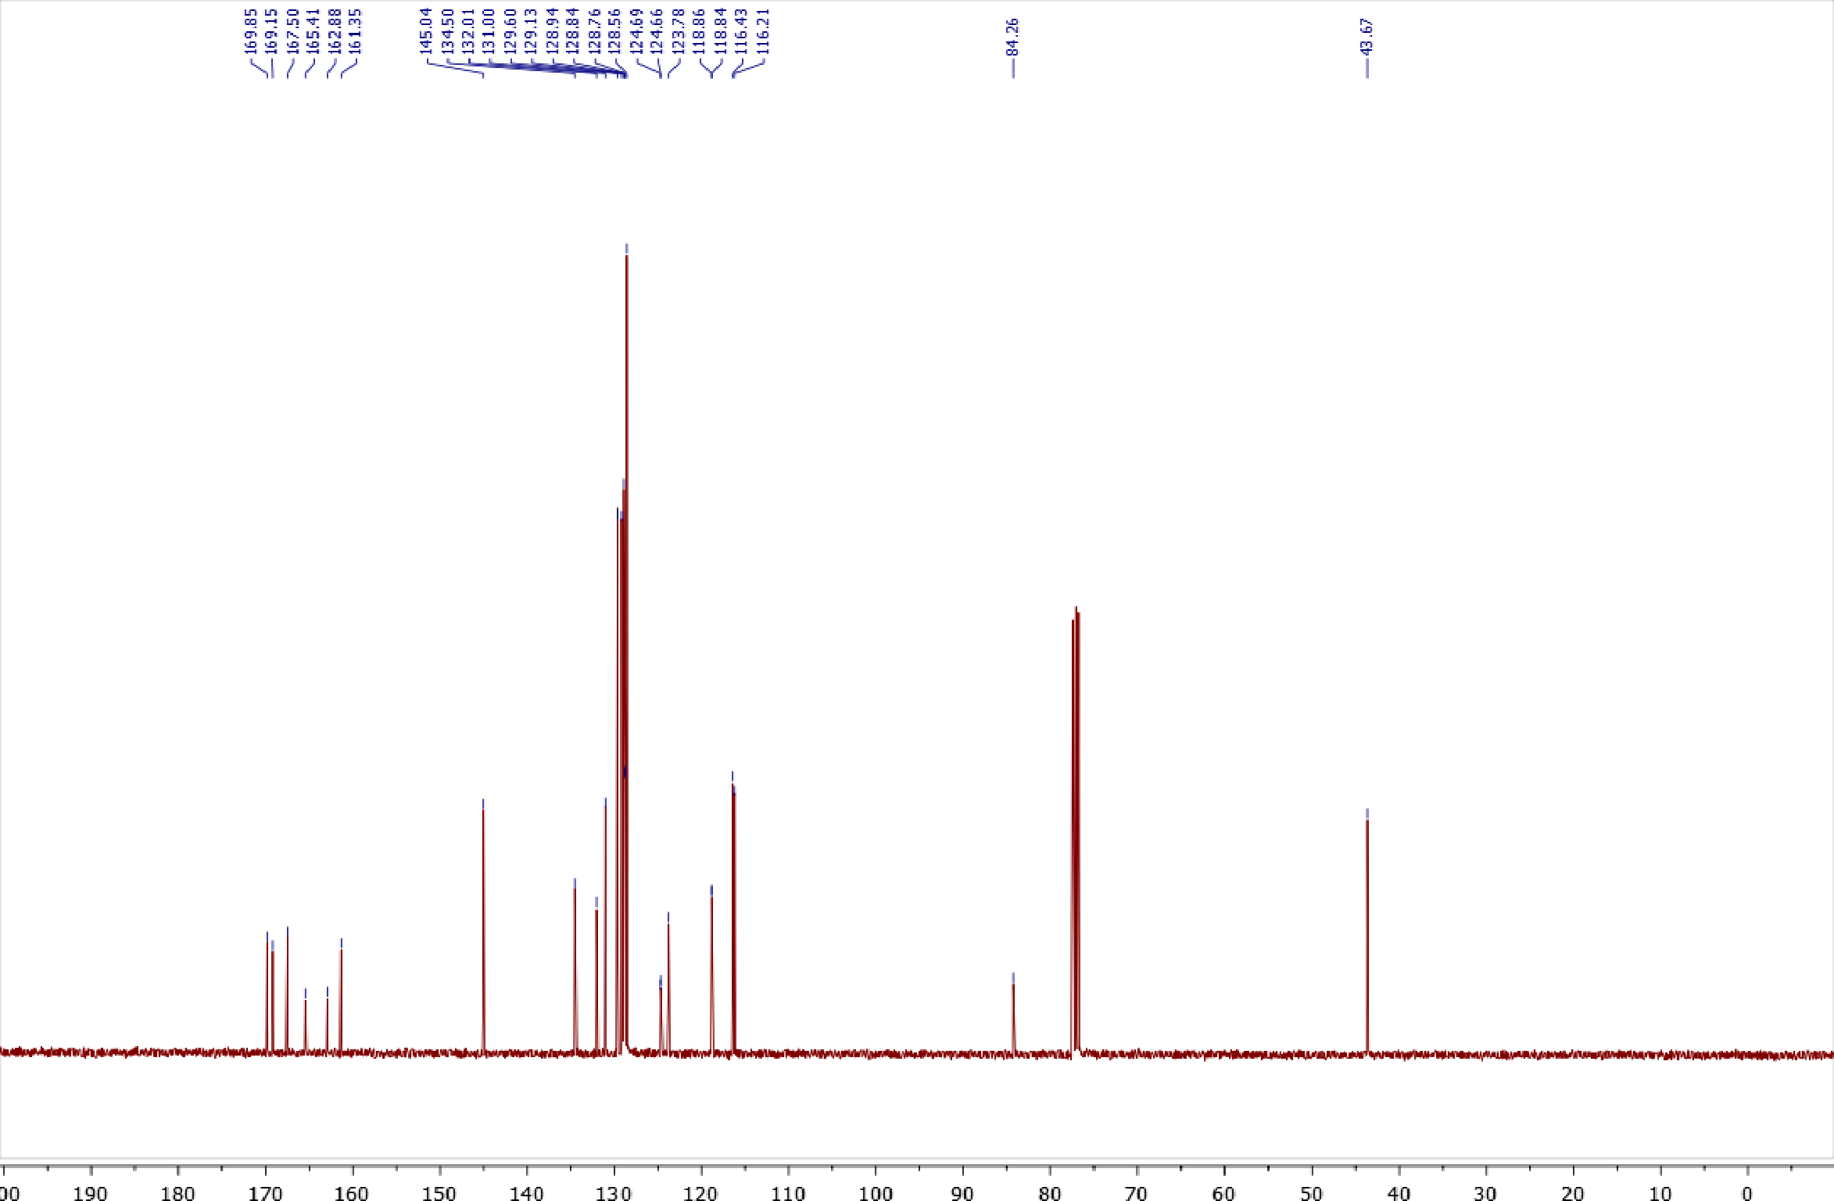
Copy of ¹⁹F{¹H} (376.50 MHz, CDCl₃) spectrum of 2b
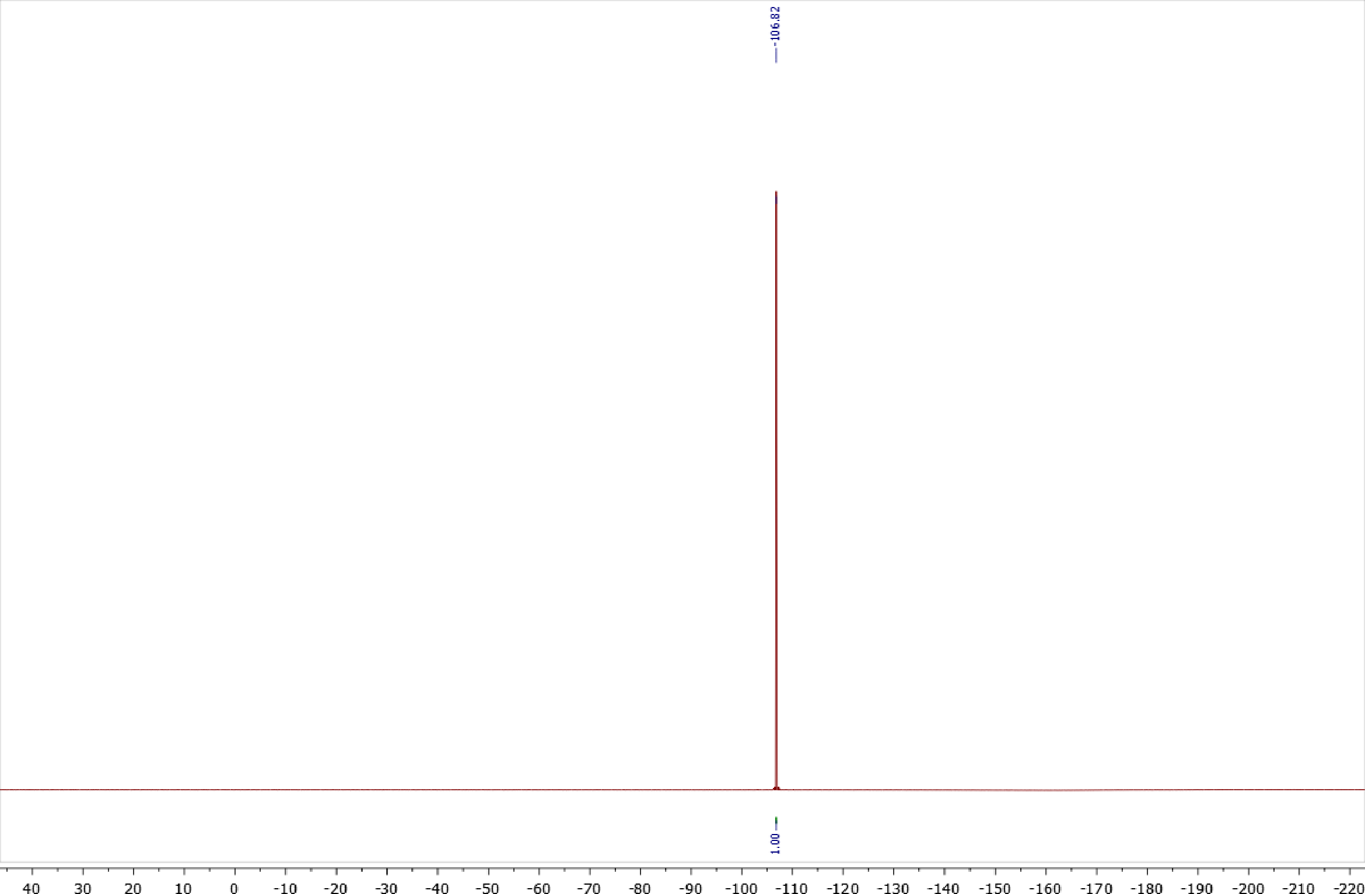

Copies of ¹H (400.13 MHz, CDCl₃) and ¹³C{¹H} (100.61 MHz, CDCl₃) spectra of 2c
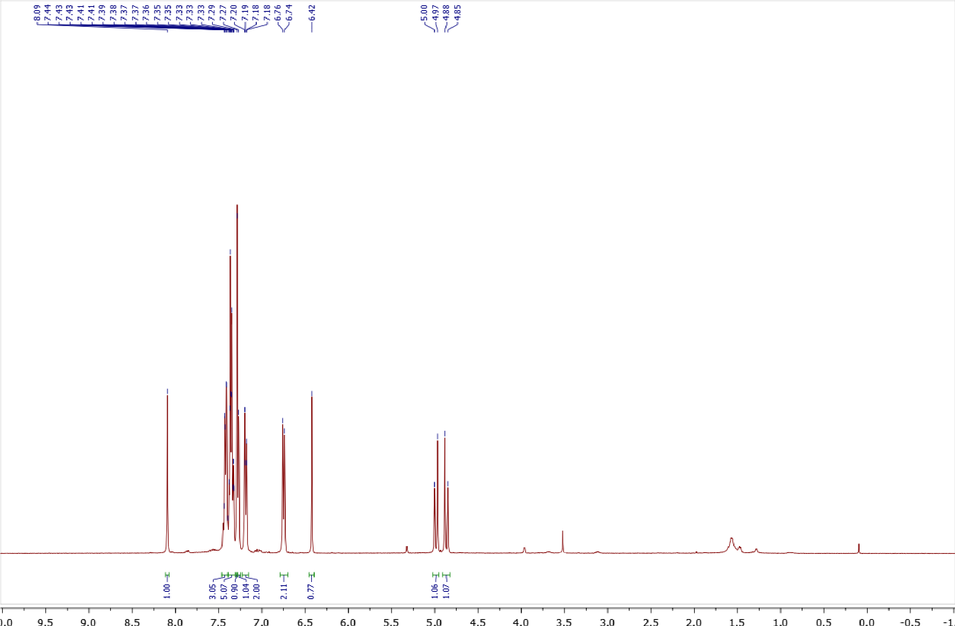
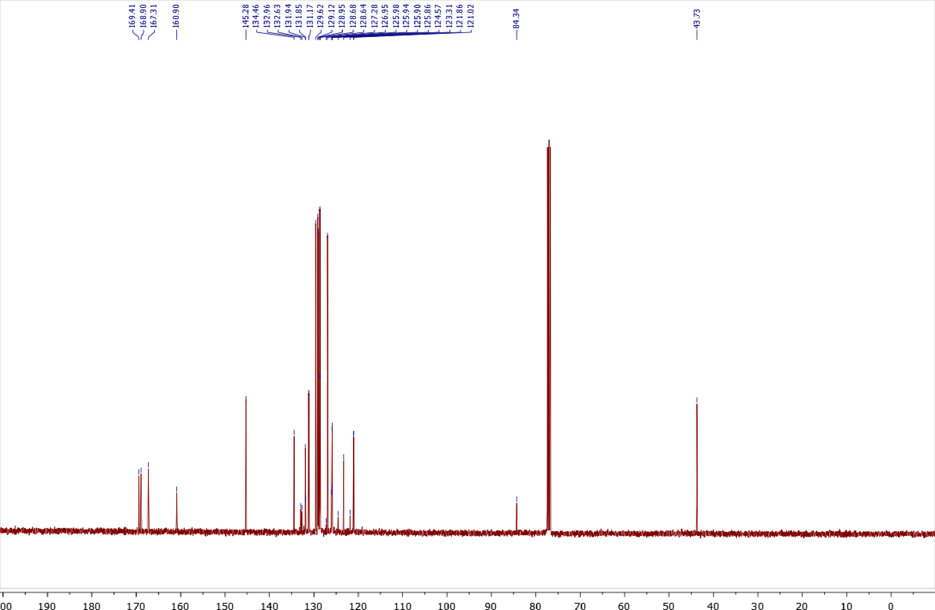
Copy of ¹⁹F{¹H} (376.50 MHz, CDCl₃) spectrum of 2c
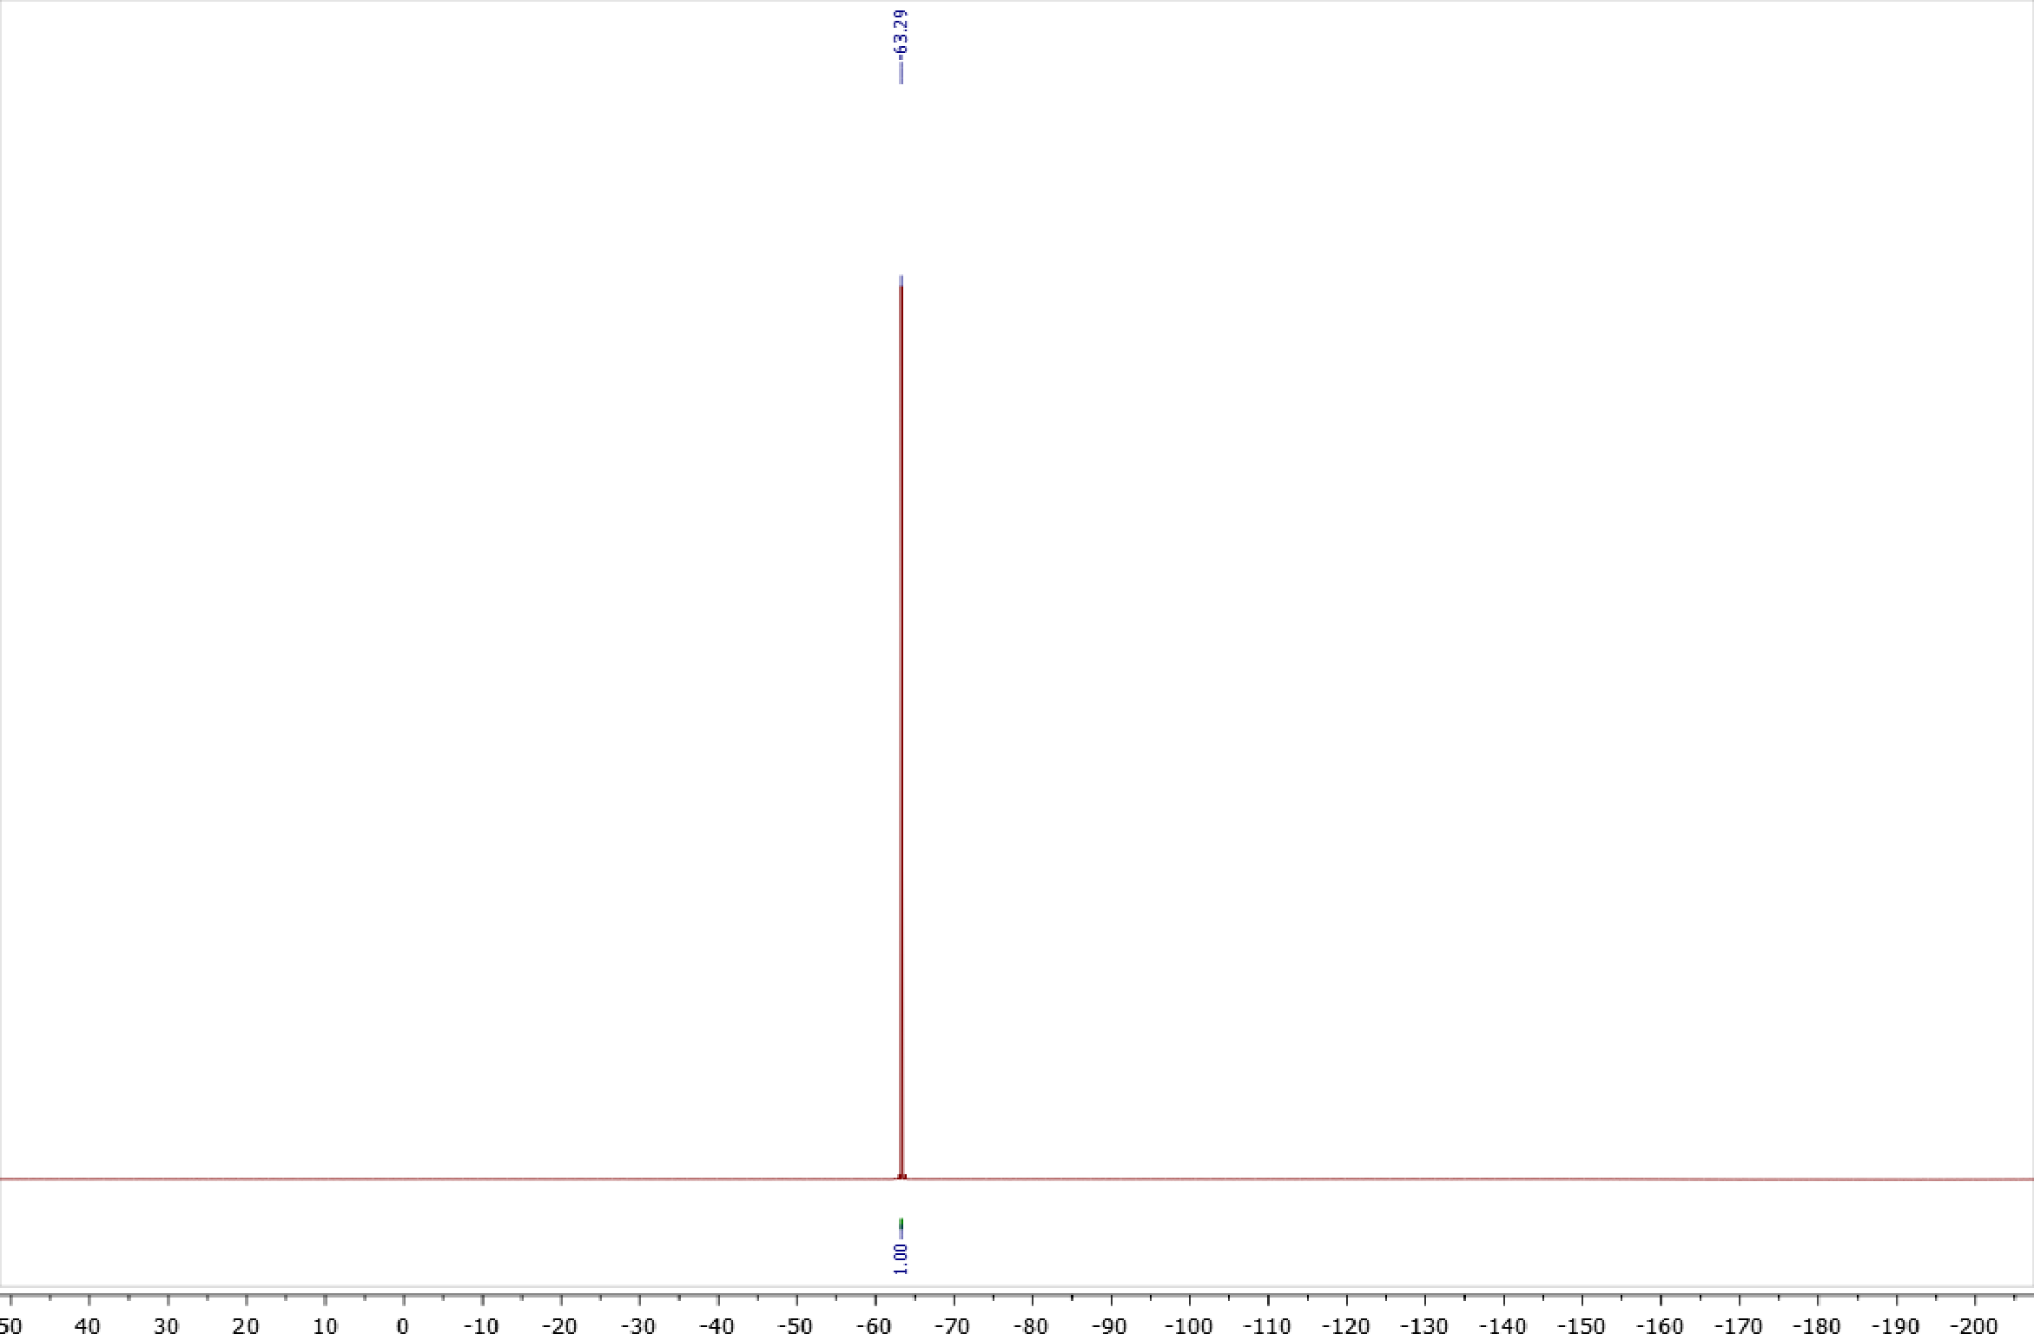

Copies of ¹H (400.13 MHz, CDCl₃) and ¹³C{¹H} (100.61 MHz, CDCl₃) spectra of 2d
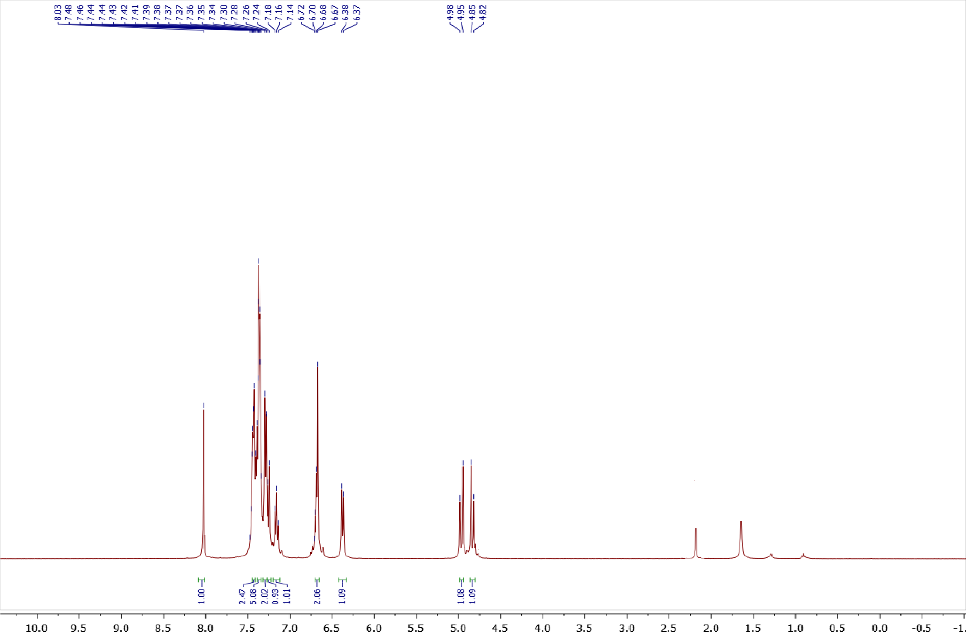
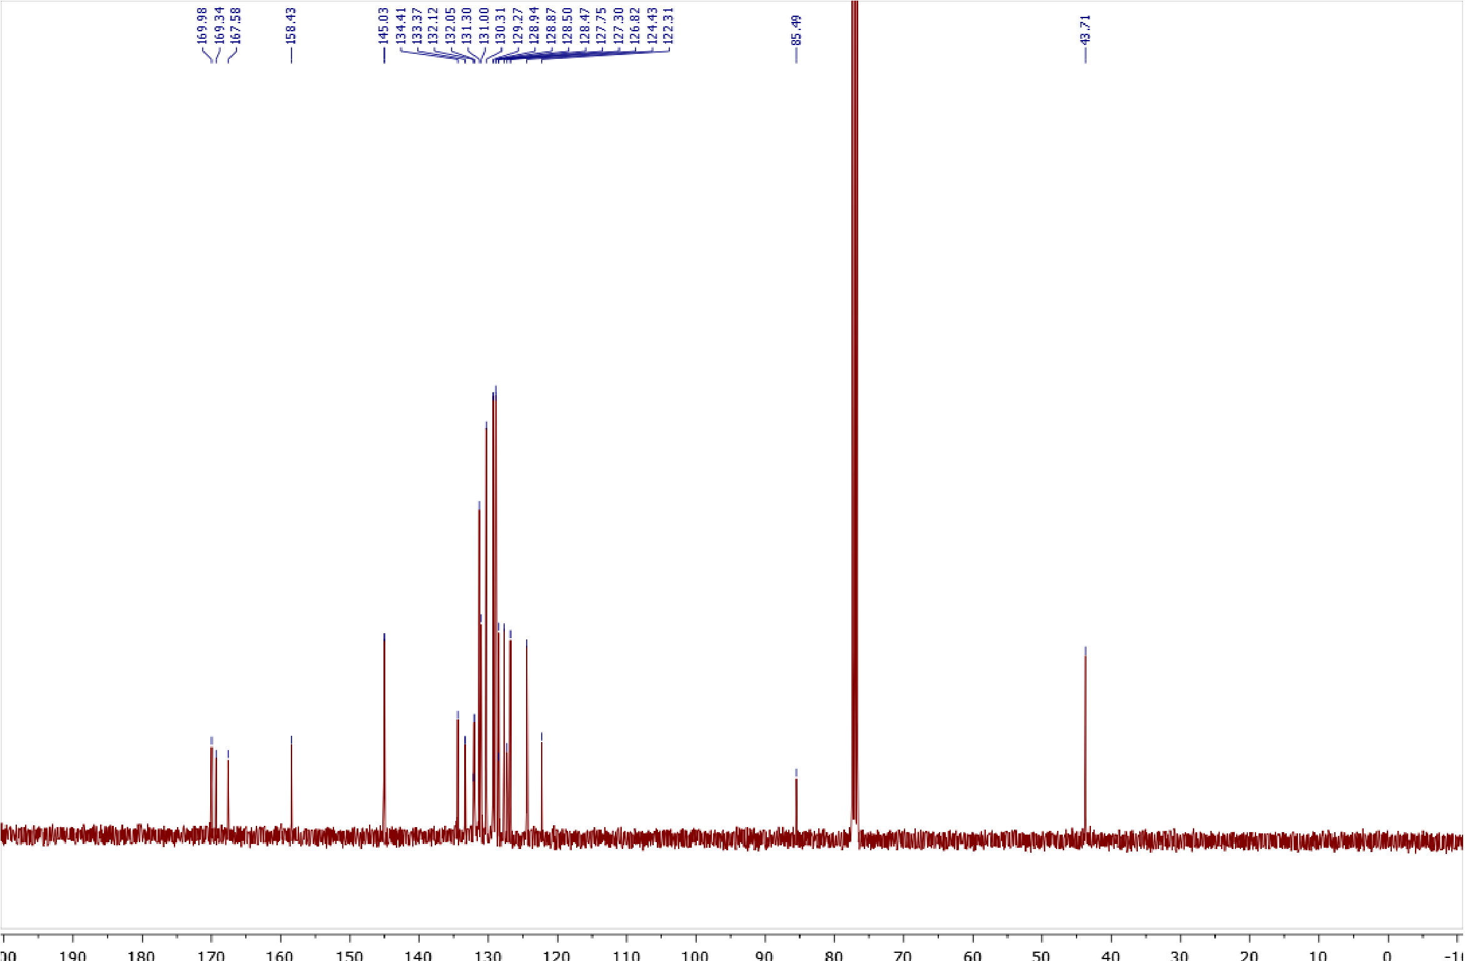

Copies of ¹H (400.13 MHz, CDCl₃) and ¹³C{¹H} (100.61 MHz, CDCl₃) spectra of 2e
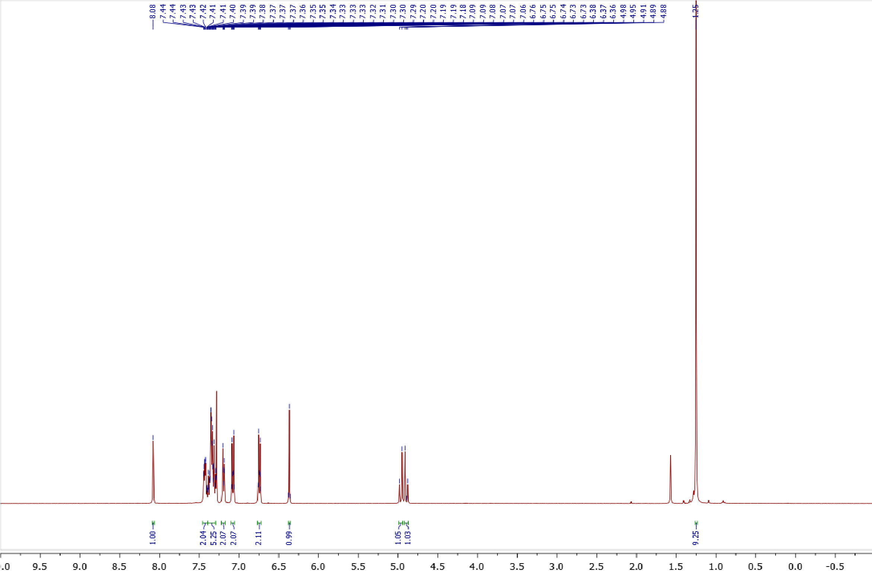
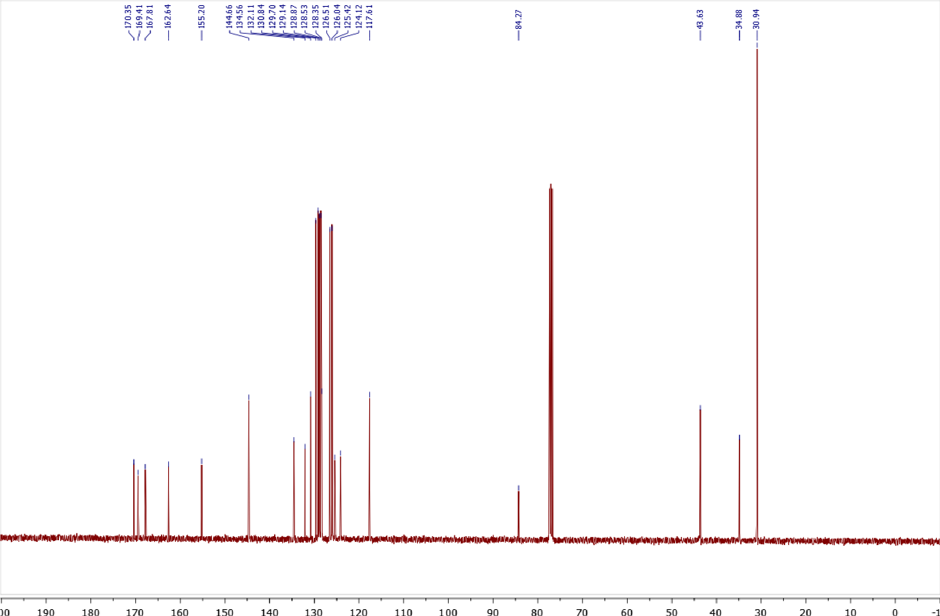

Copies of ¹H (400.13 MHz, CDCl₃) and ¹³C{¹H} (100.61 MHz, CDCl₃) spectra of 2f
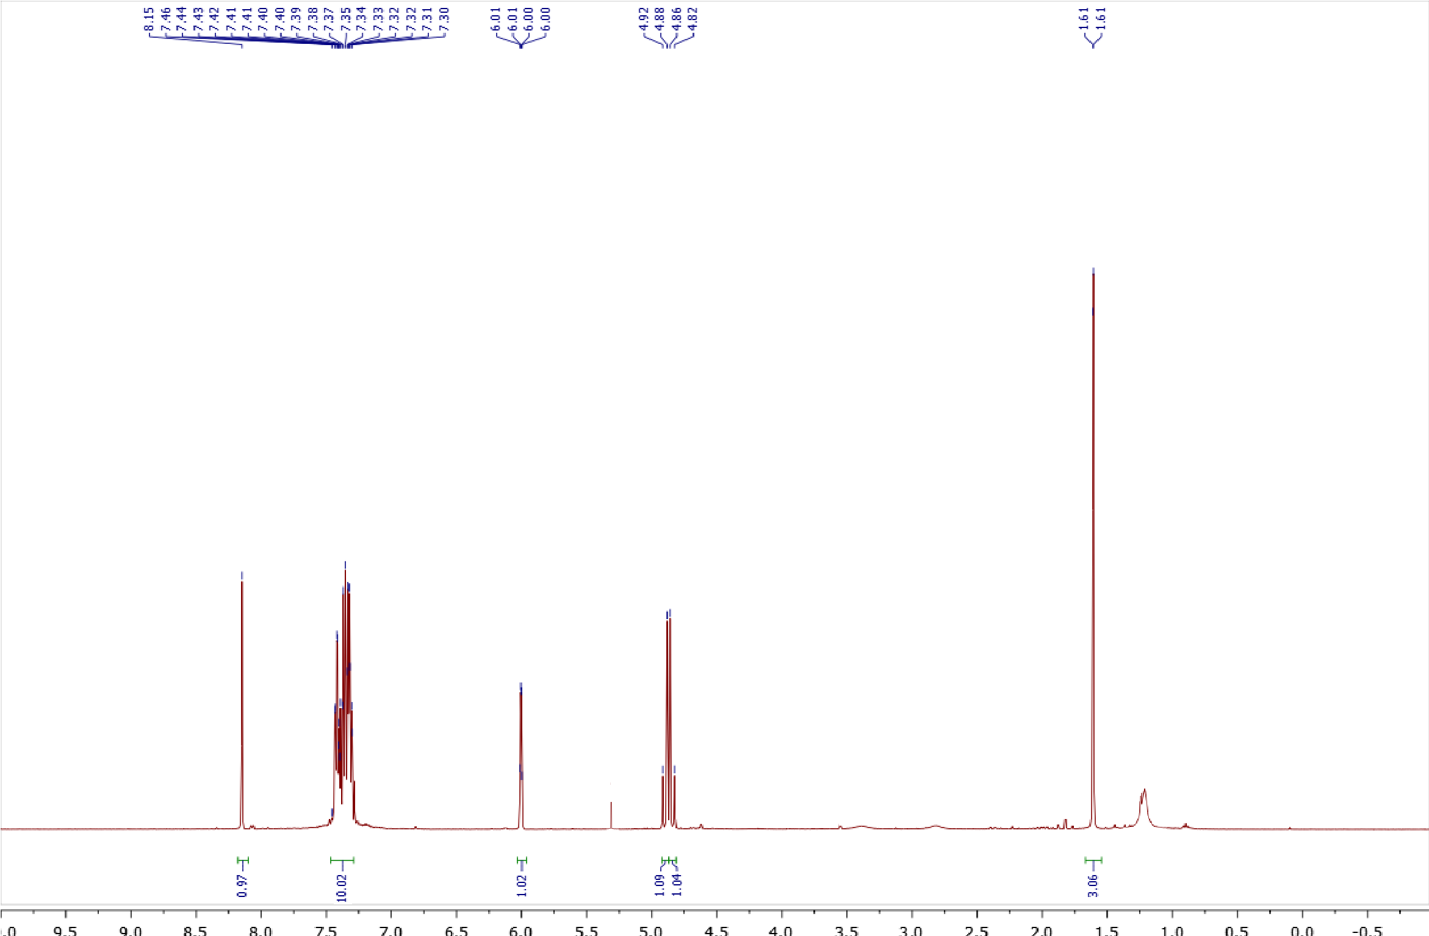
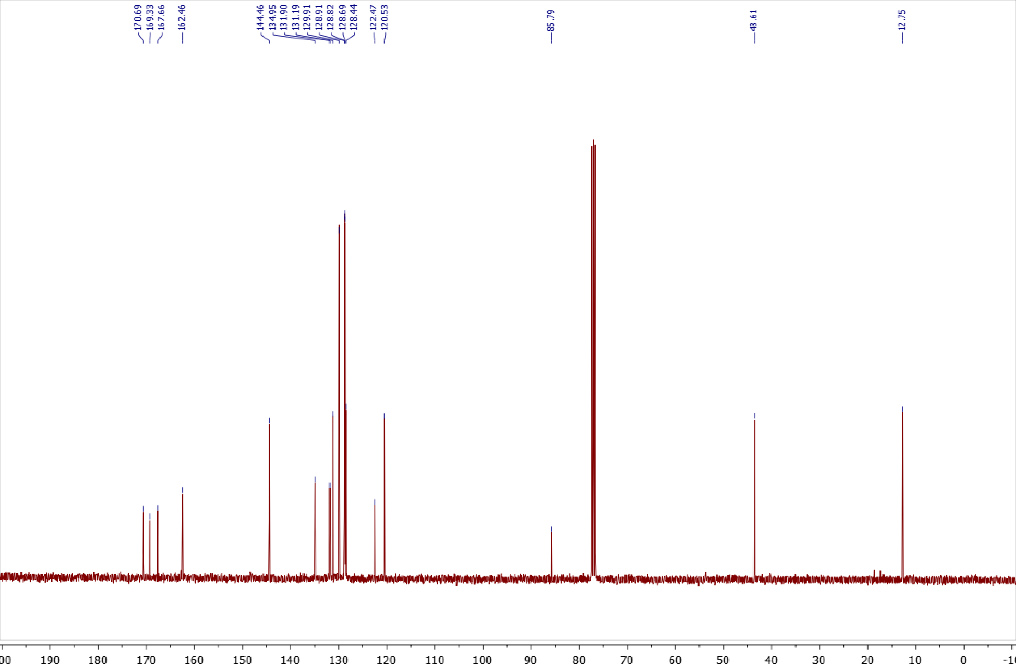
Copies of ¹H (400.13 MHz, CDCl₃) and ¹³C{¹H} (100.61 MHz, CDCl₃) spectra of 2g
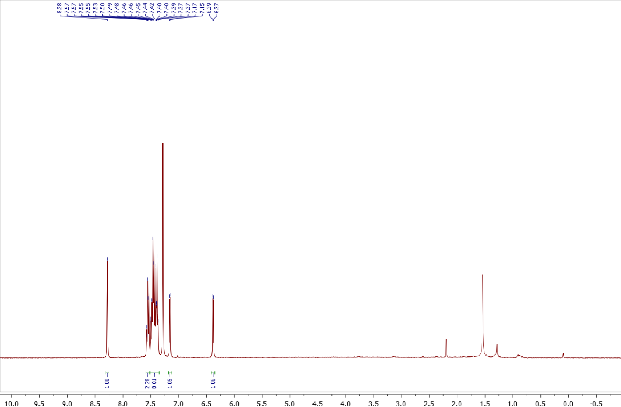
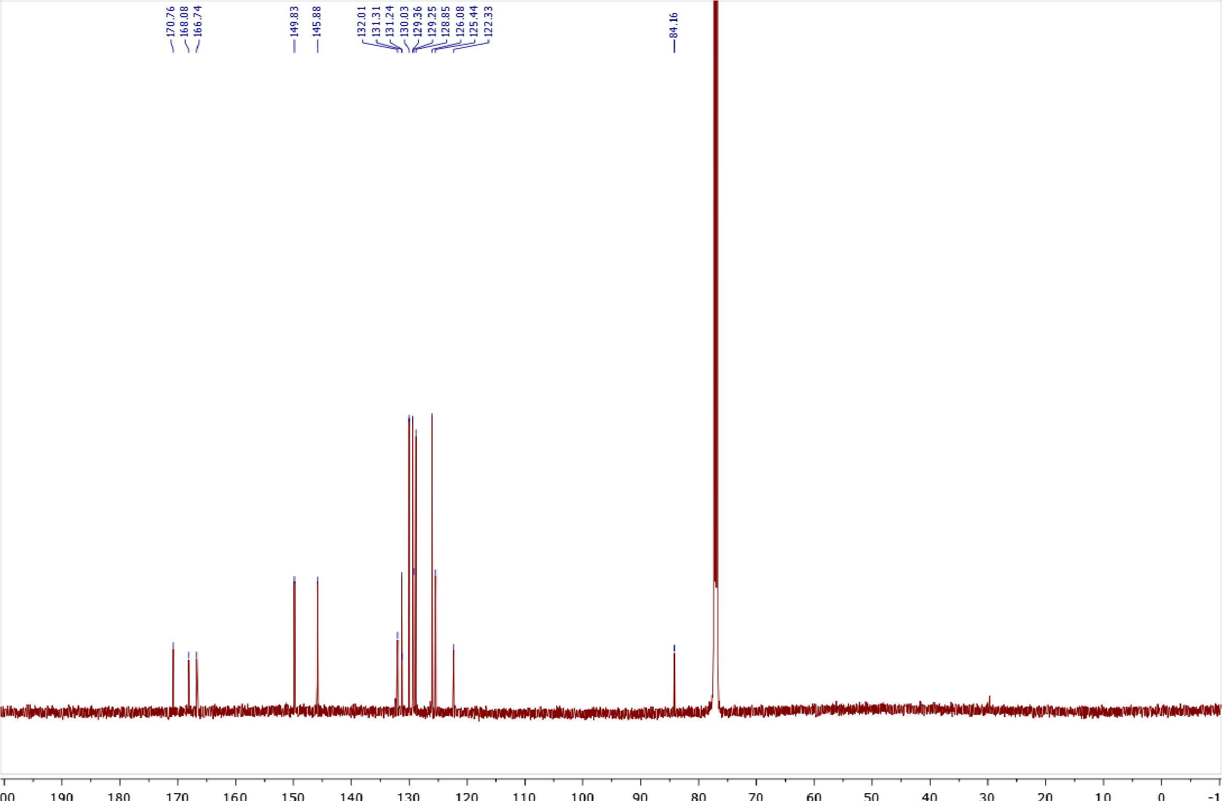
Copies of ¹H (400.13 MHz, CDCl₃) and ¹³C{¹H} (100.61 MHz, CDCl₃) spectra of 2h
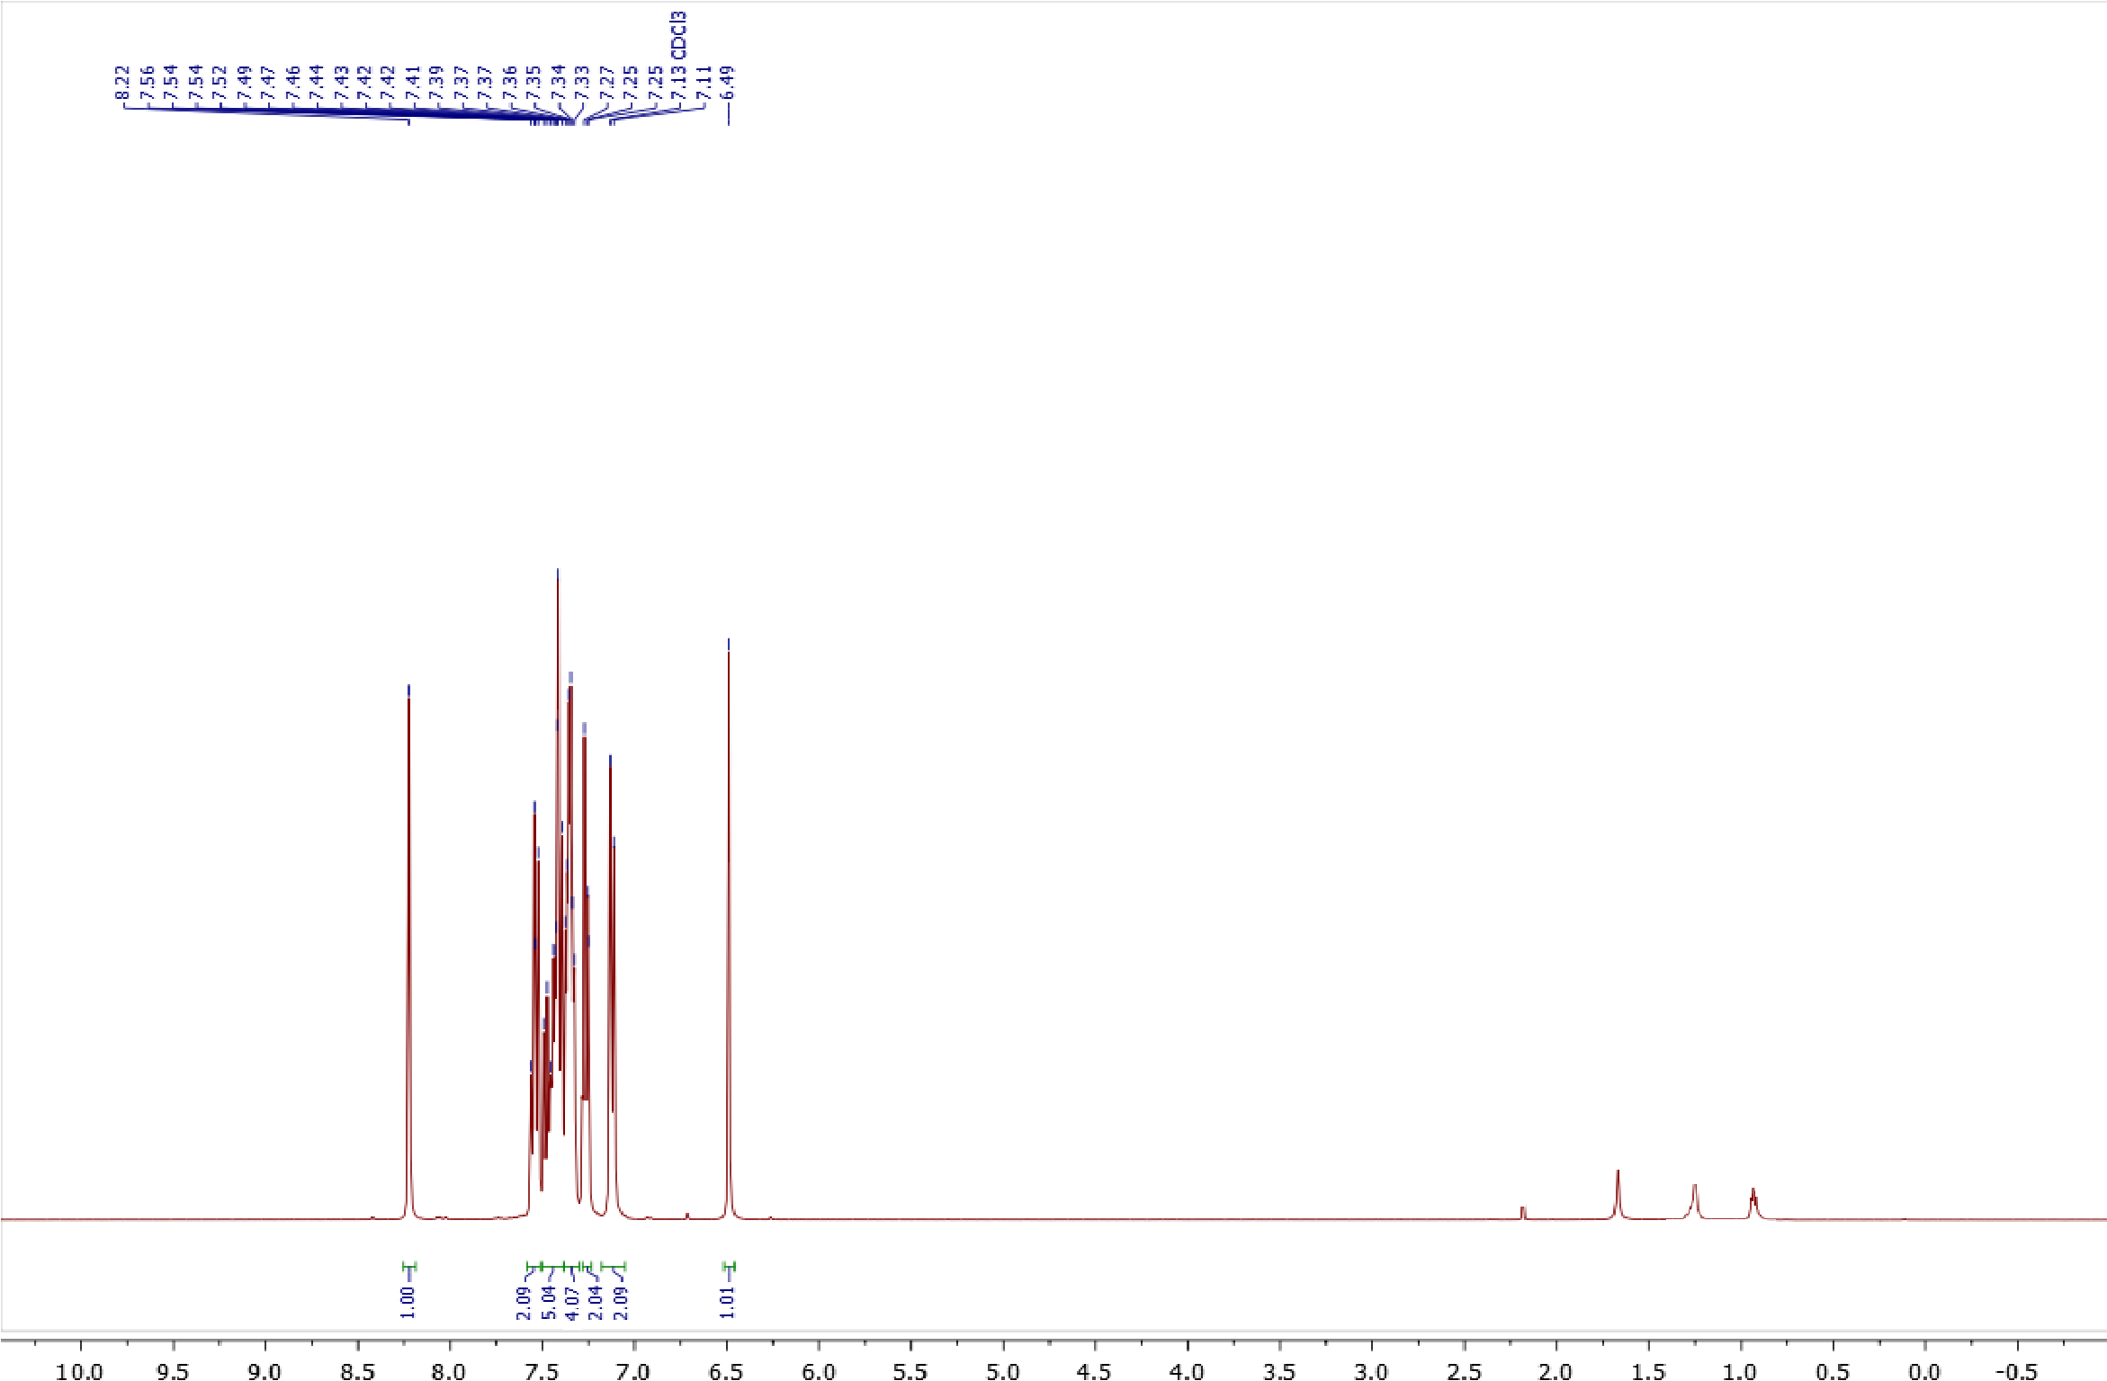
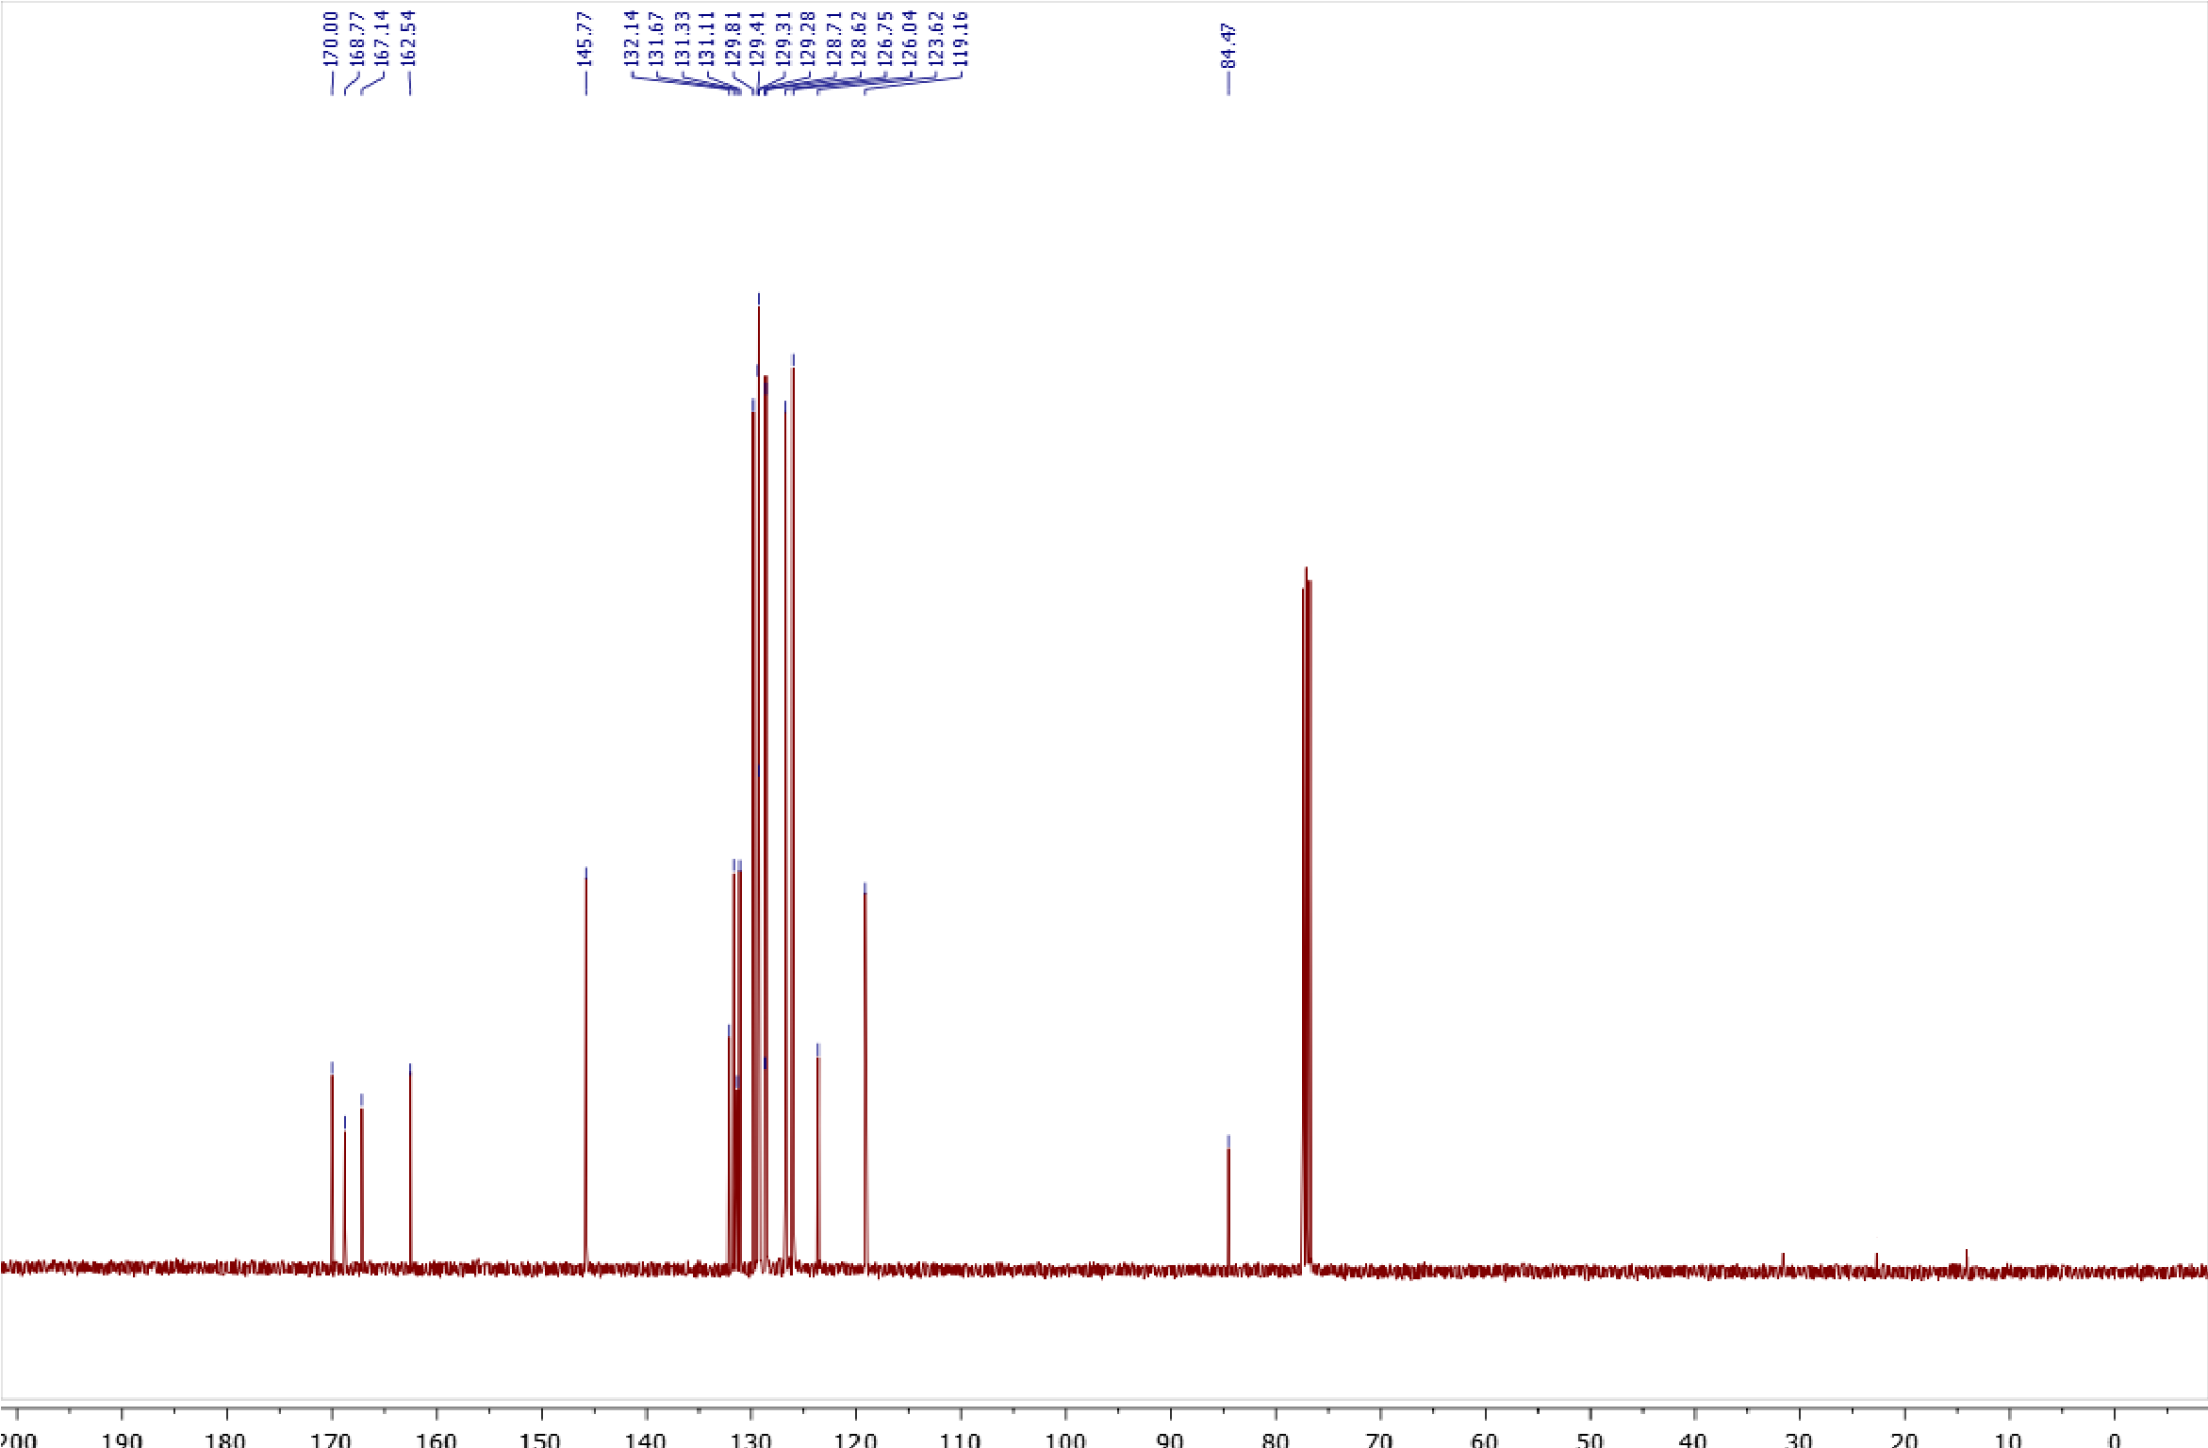

Copies of ¹H (400.13 MHz, CDCl₃) and ¹³C{¹H} (100.61 MHz, CDCl₃) spectra of 2i
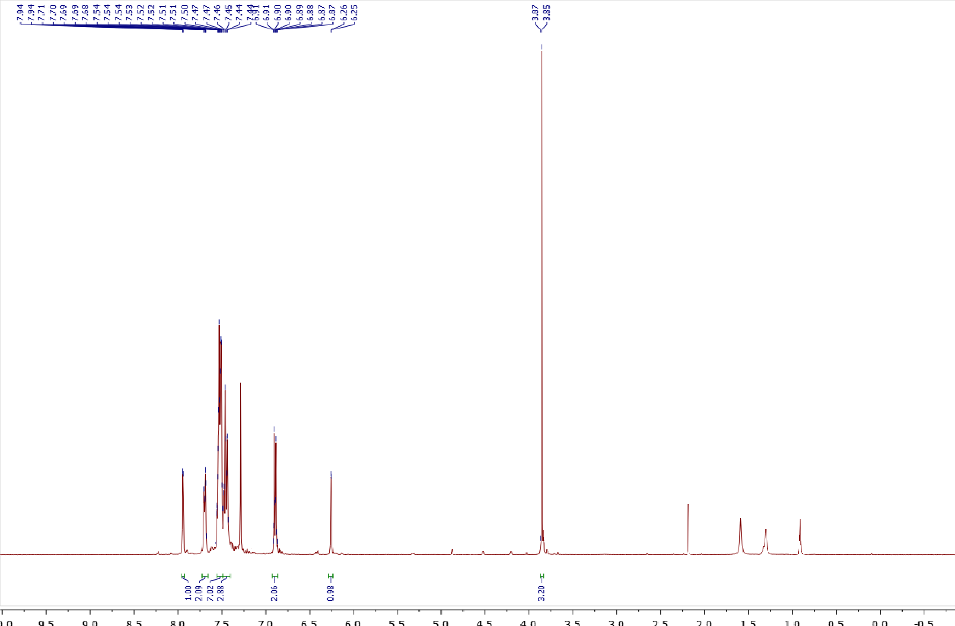
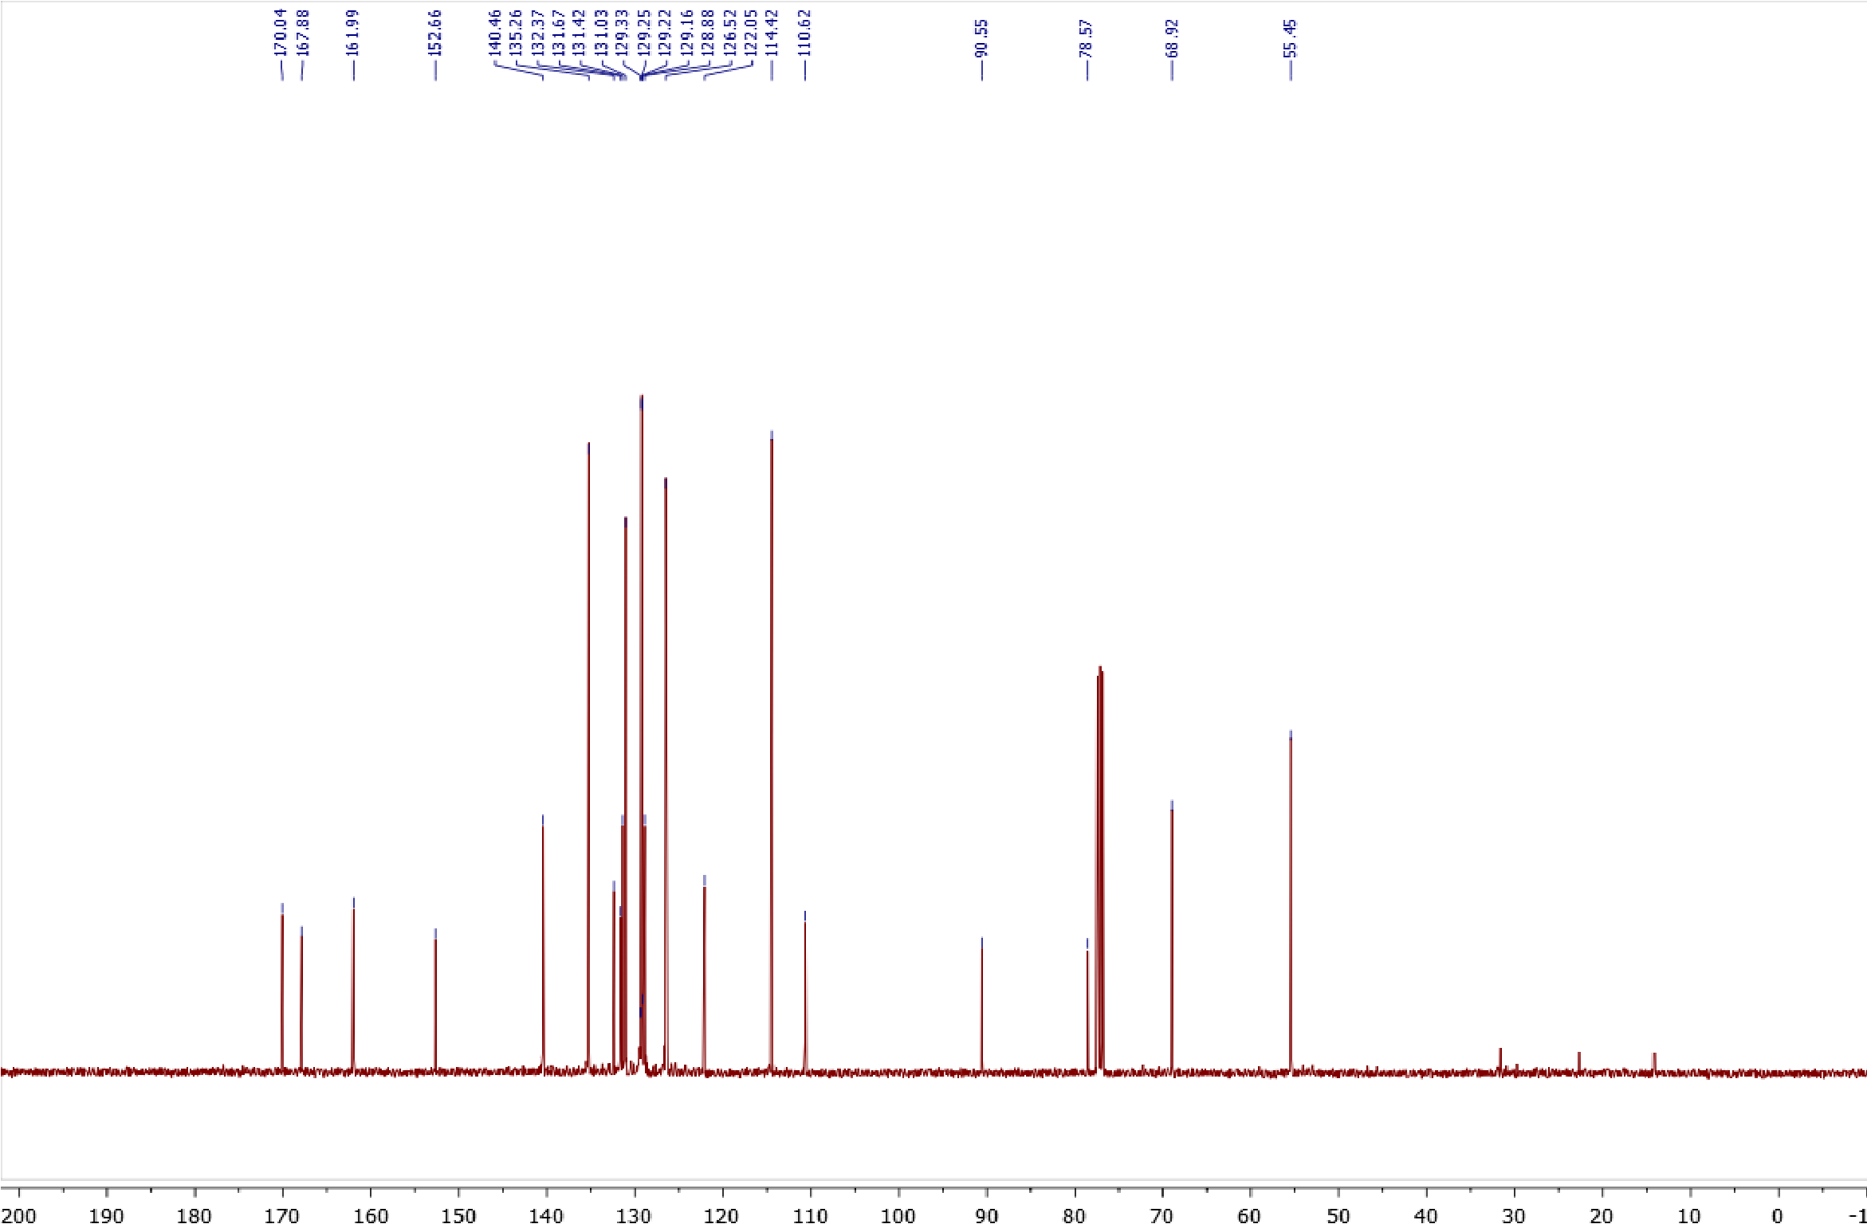
Copies of ¹H (400.13 MHz, CDCl₃) and ¹³C{¹H} (100.61 MHz, CDCl₃) spectra of 2j
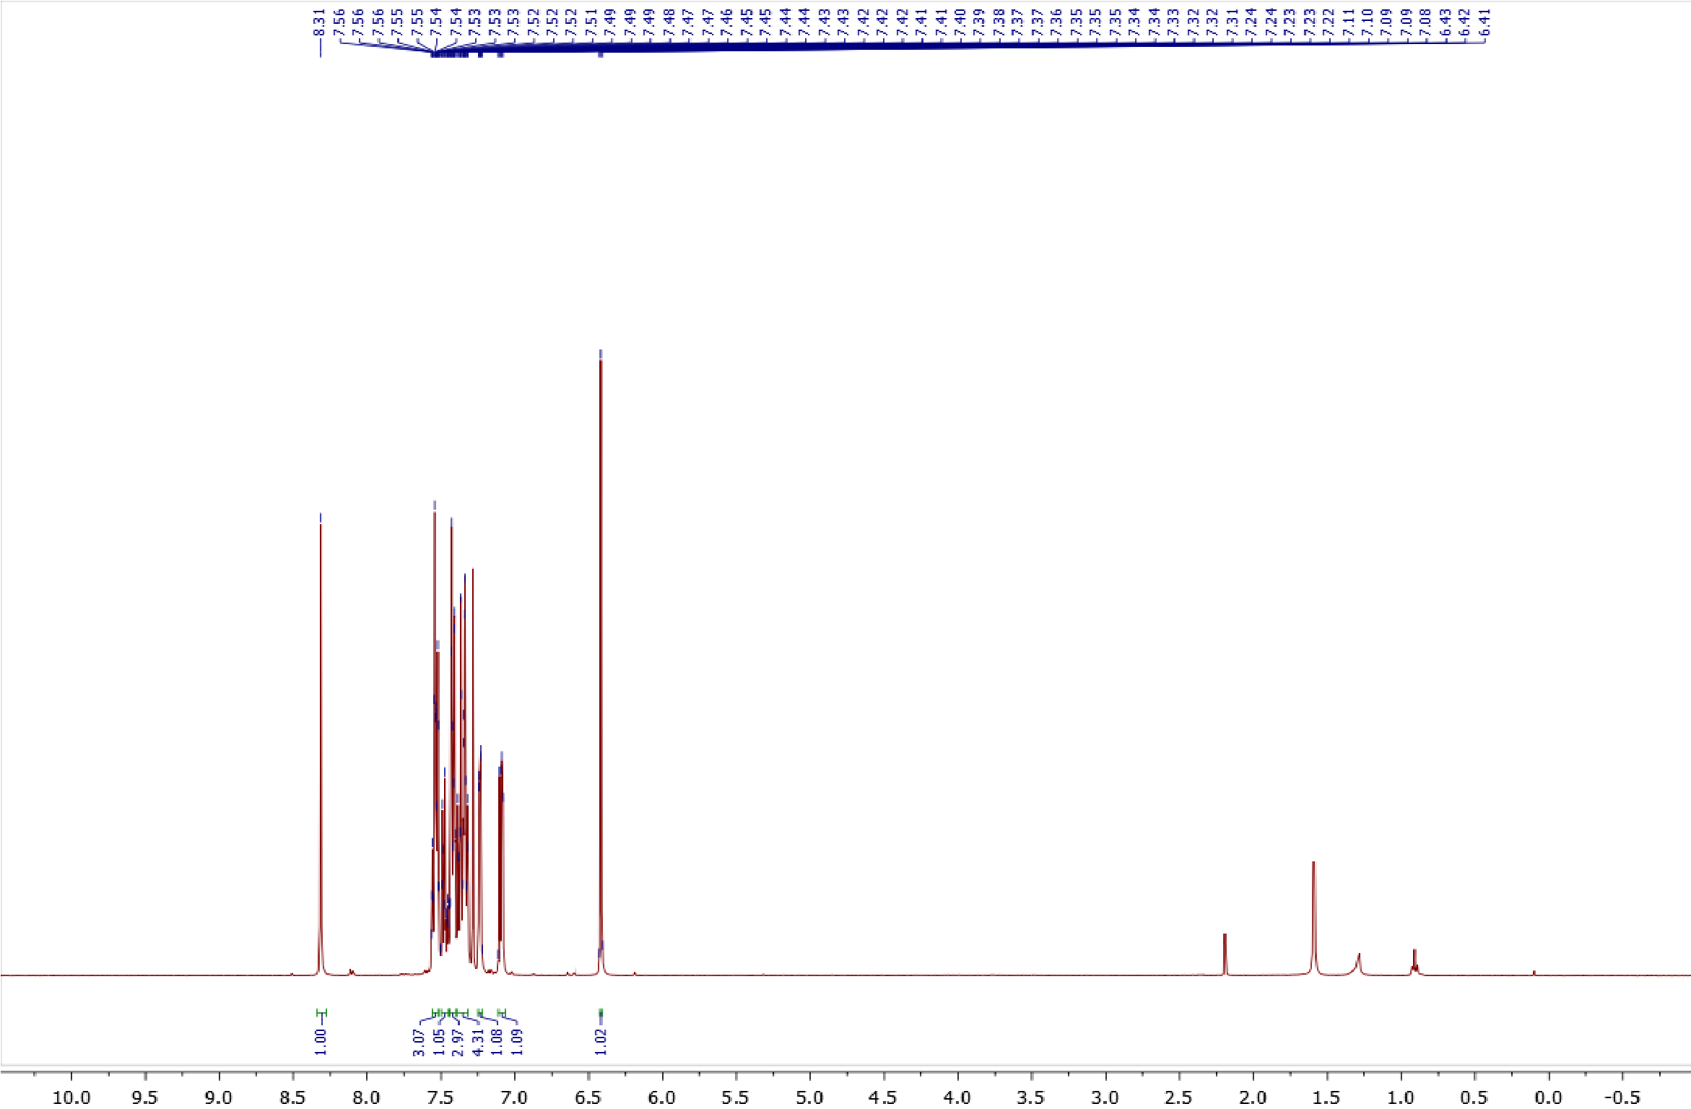
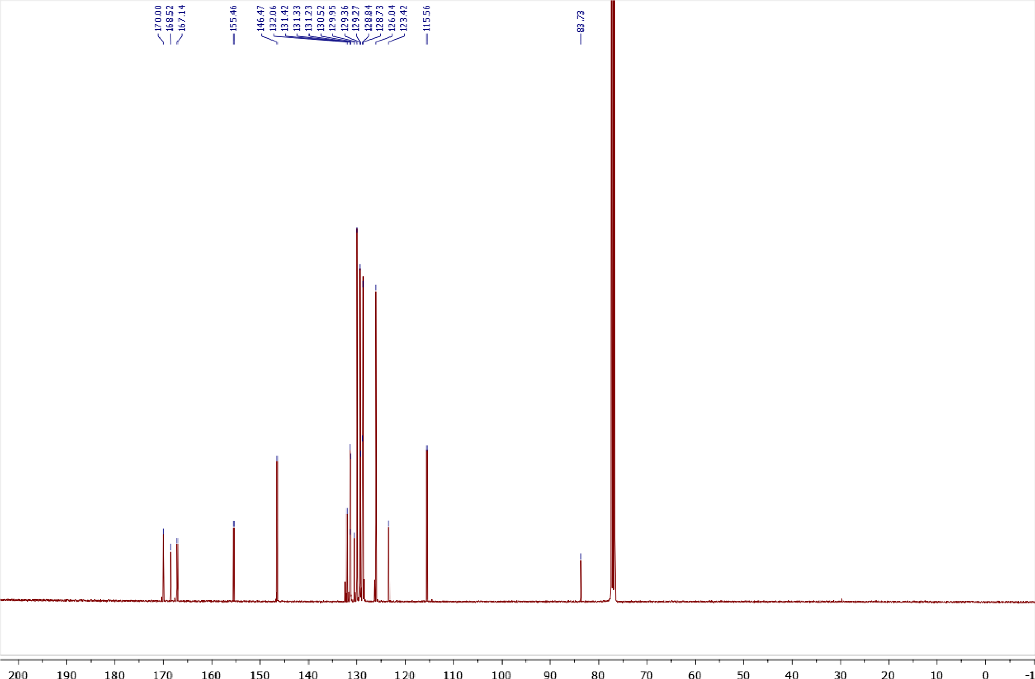
Copies of ¹H (400.13 MHz, CDCl₃) and ¹³C{¹H} (100.61 MHz, CDCl₃) spectra of 2k
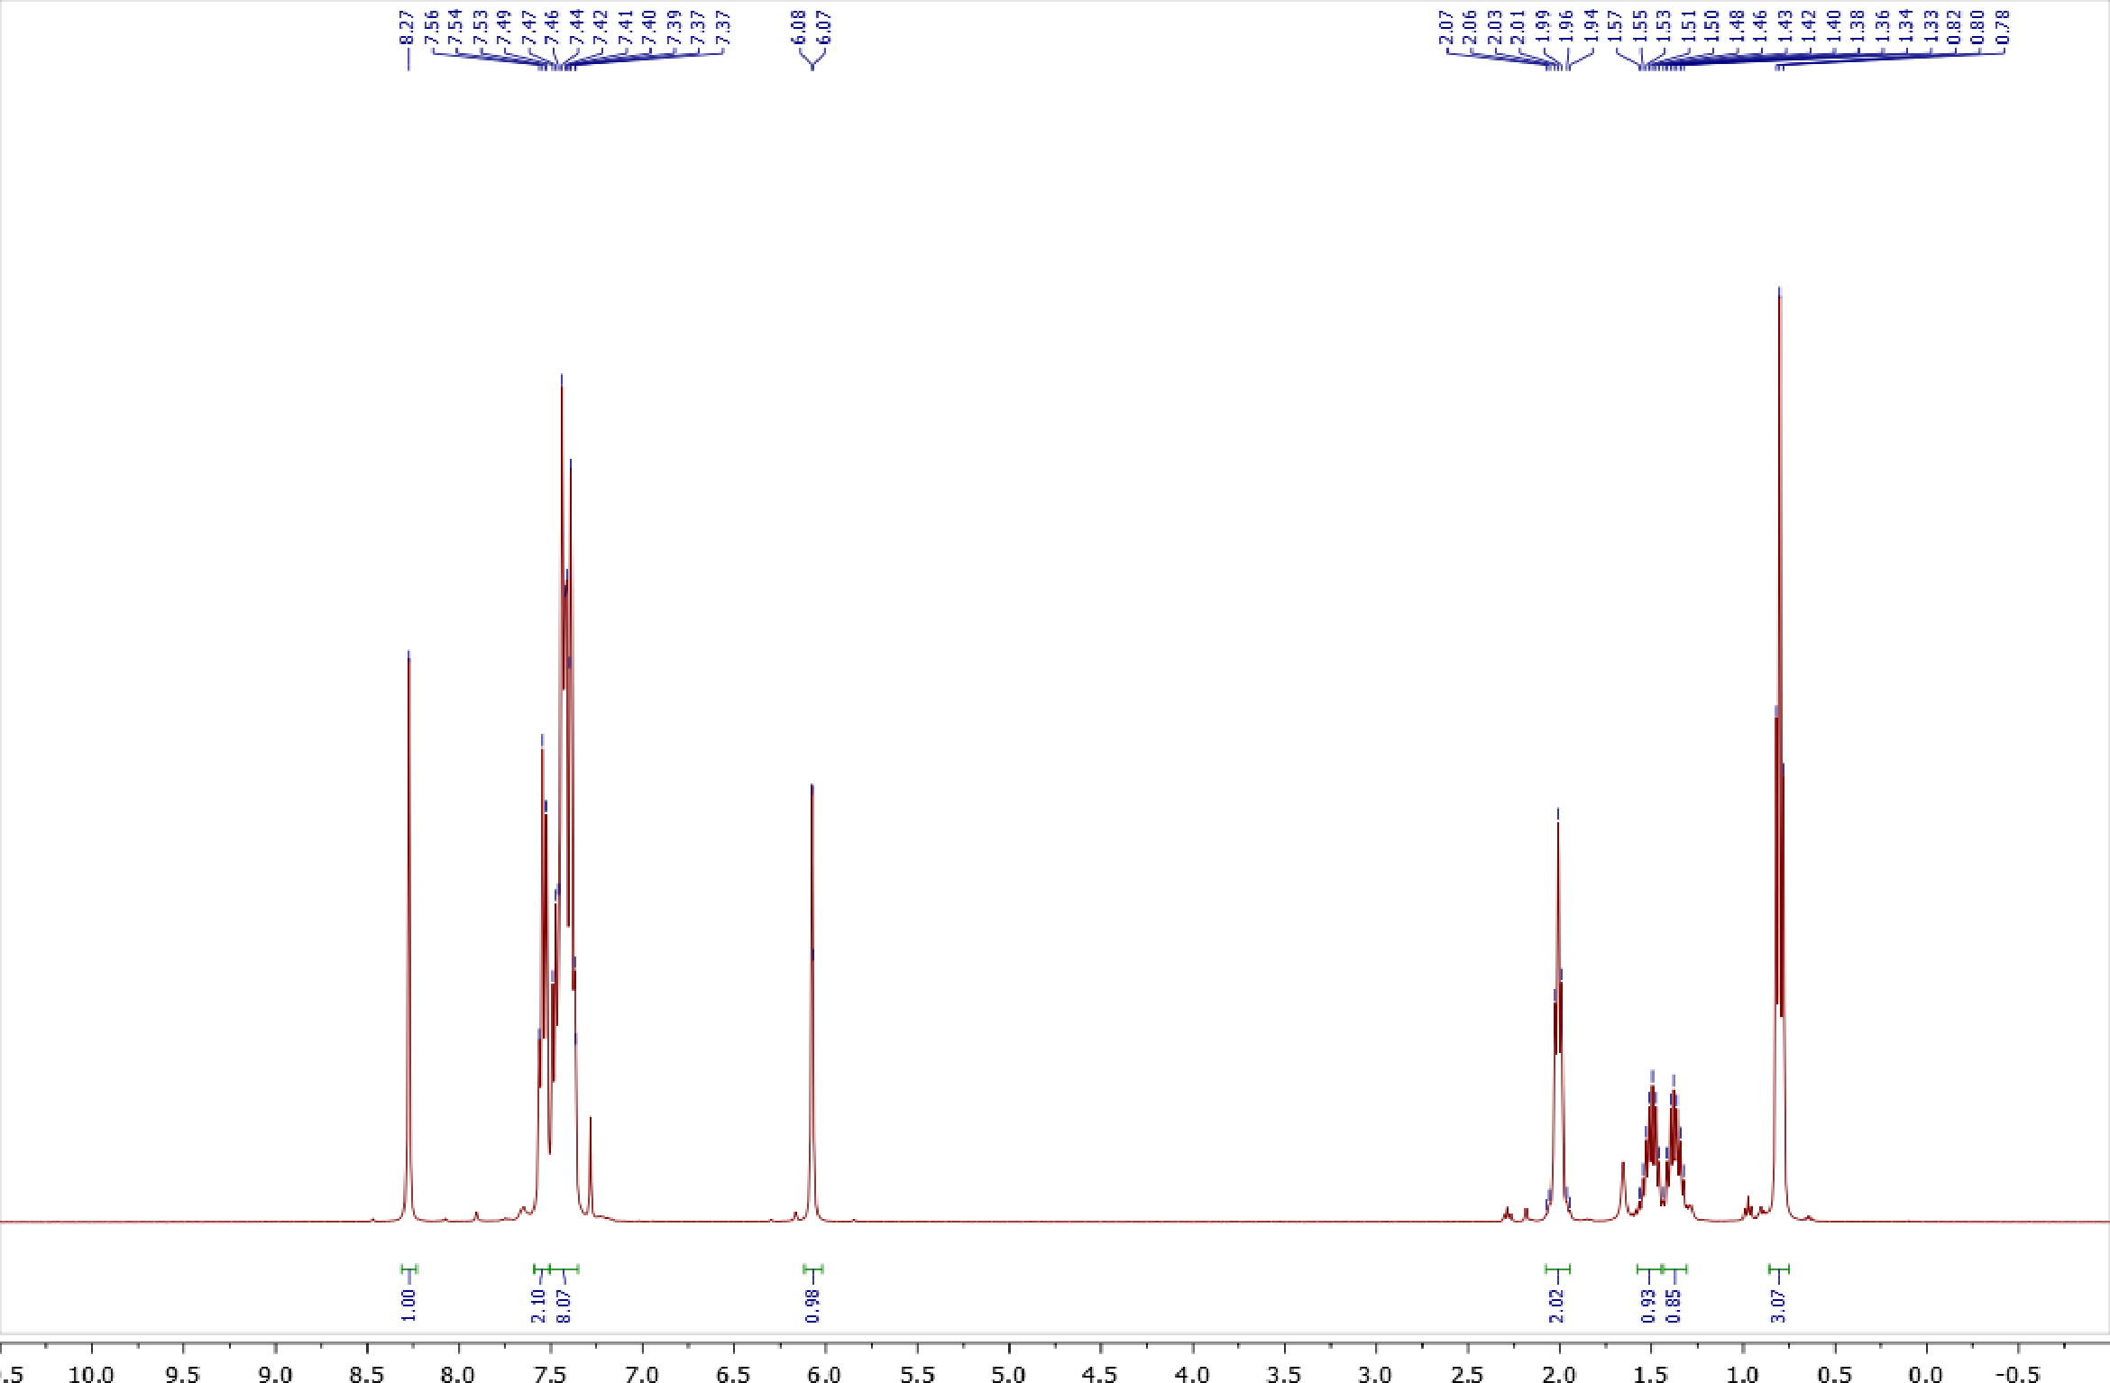
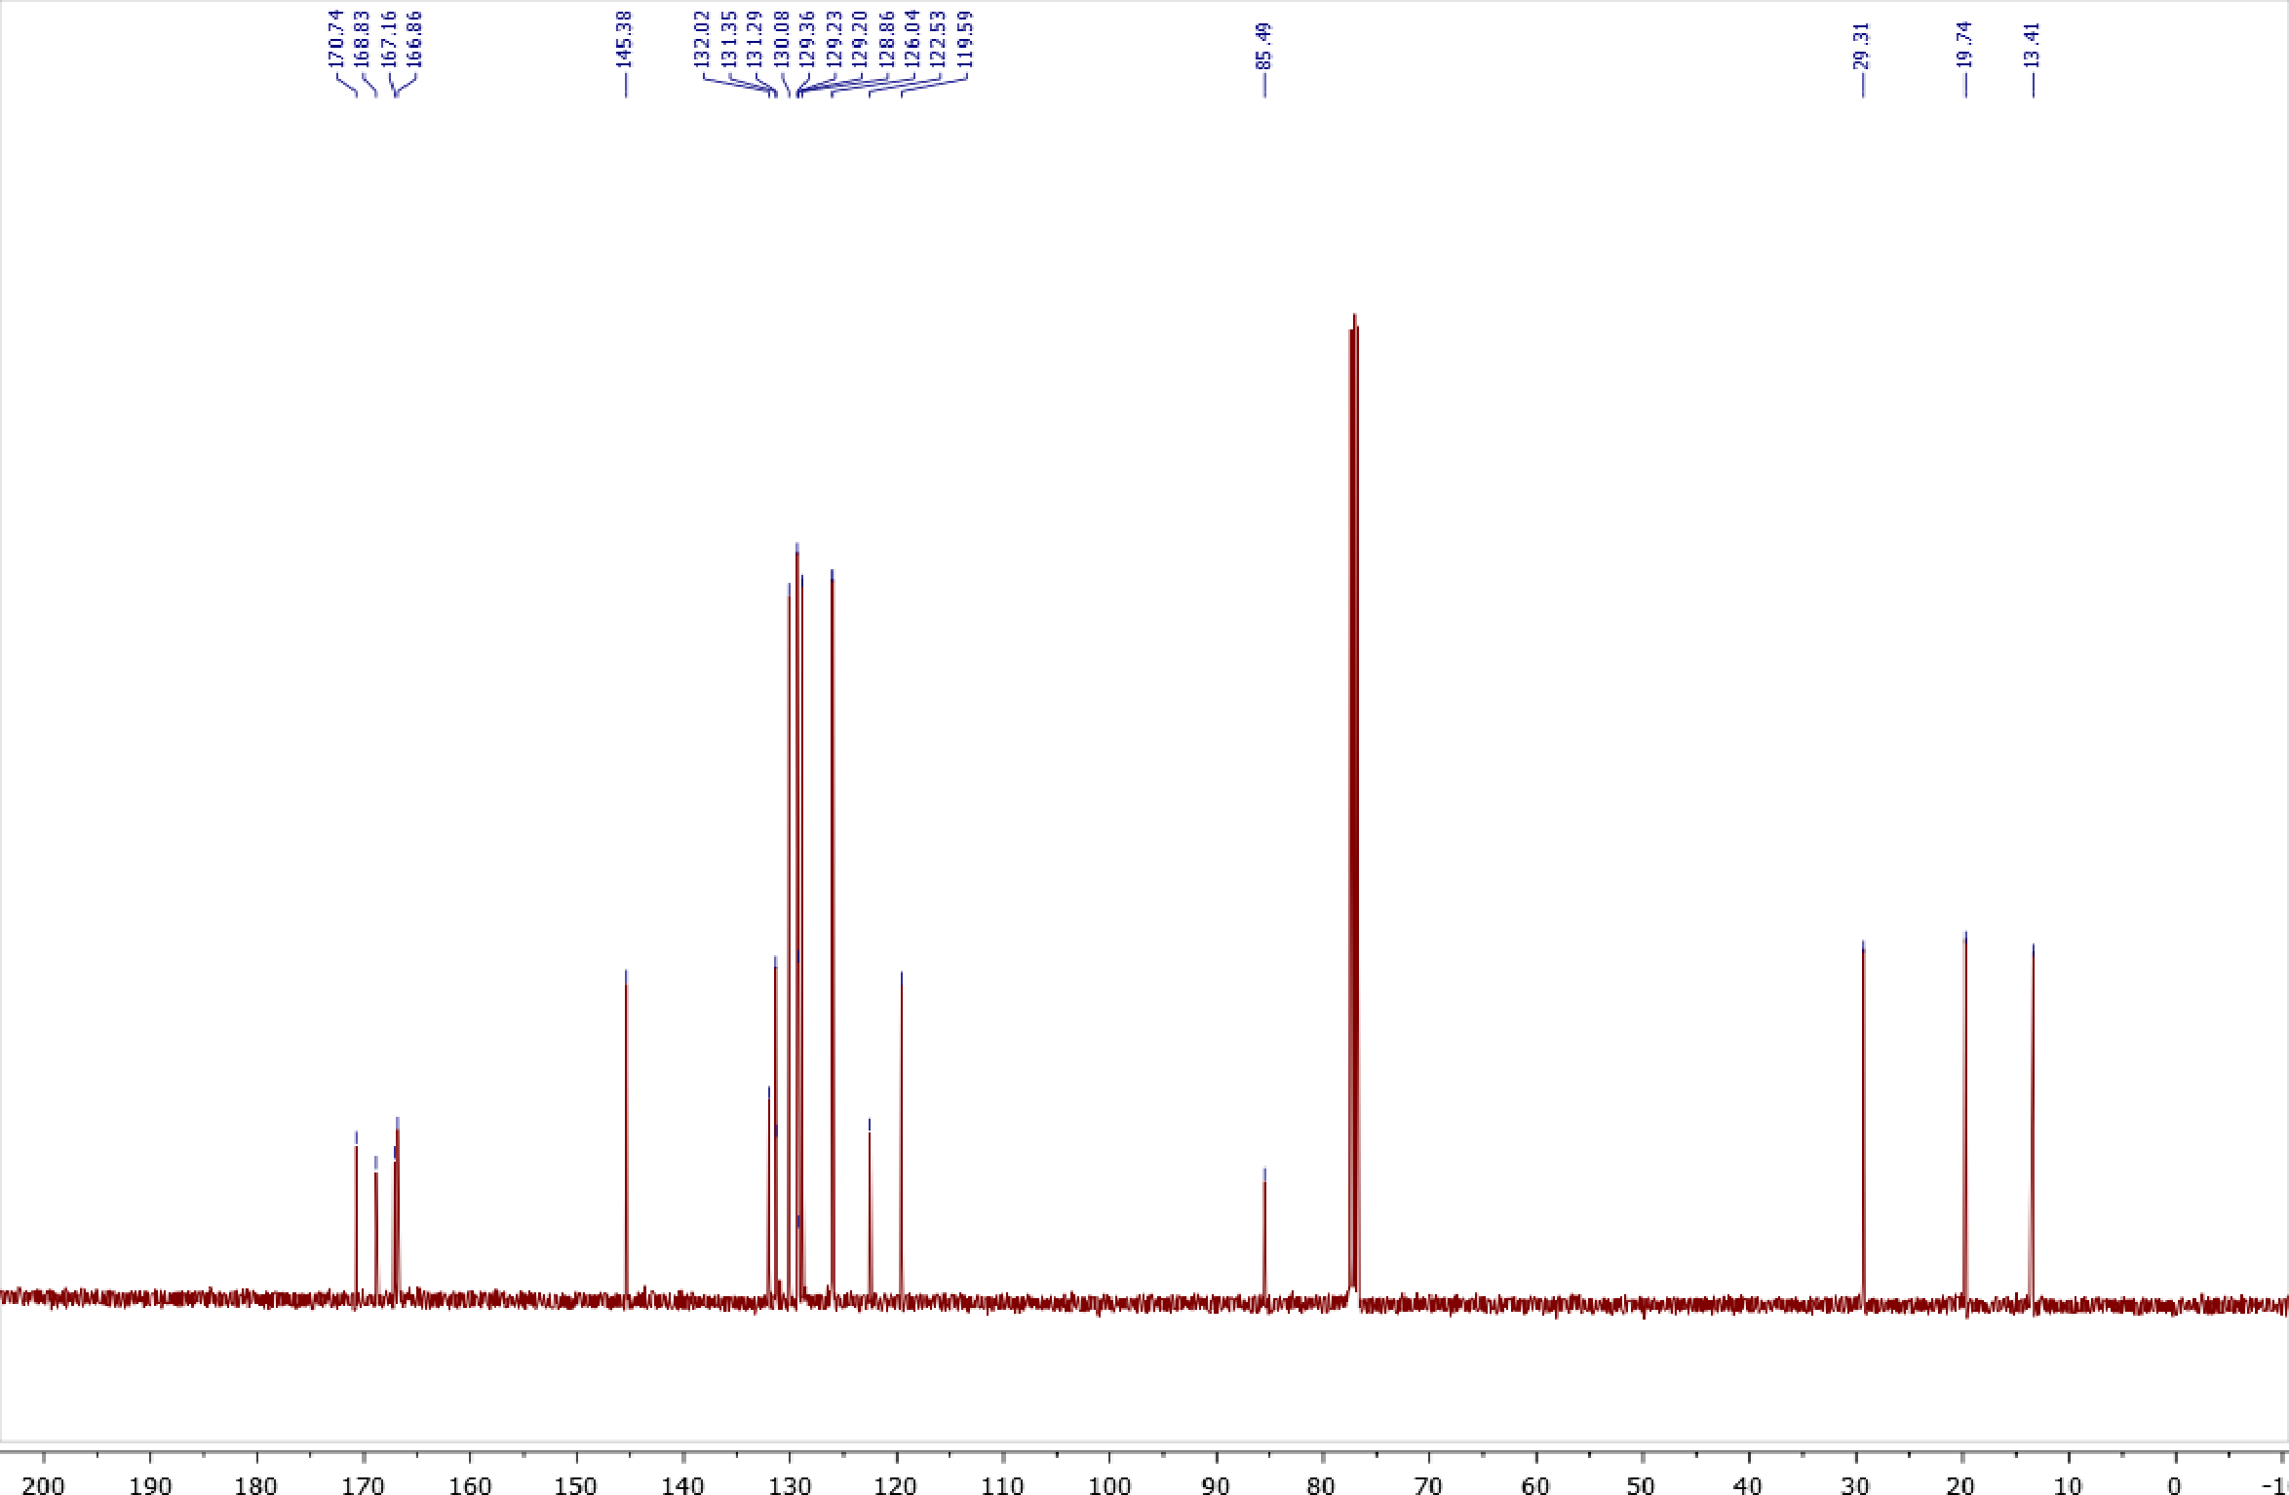

Copies of ¹H (400.13 MHz, CDCl₃) and ¹³C{¹H} (100.61 MHz, CDCl₃) spectra of 3a
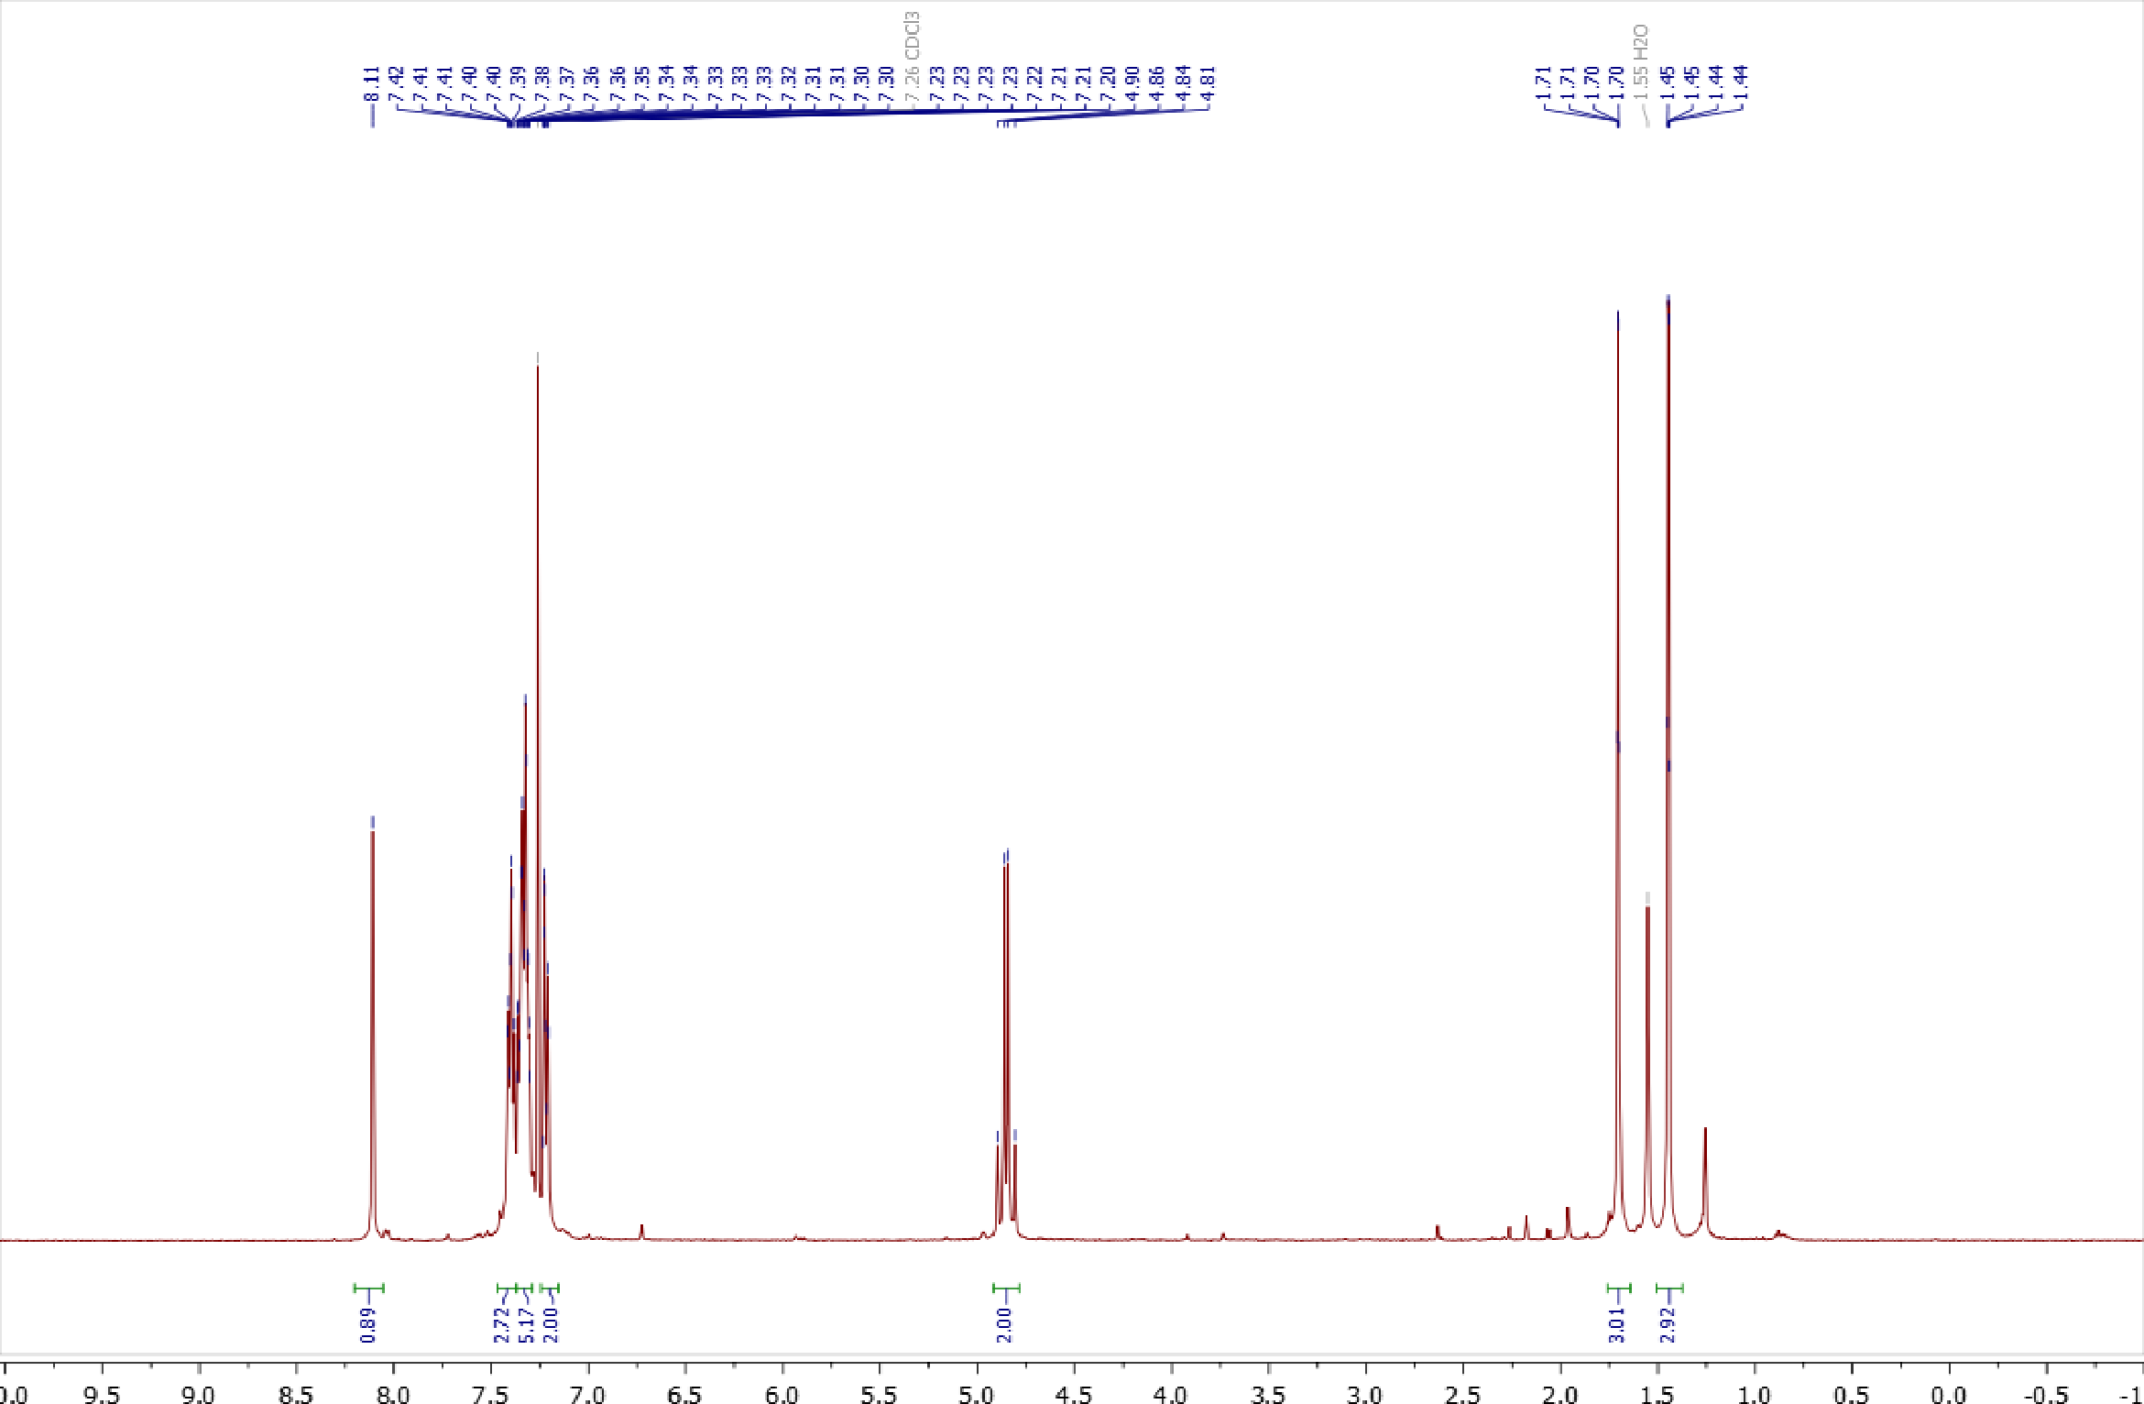
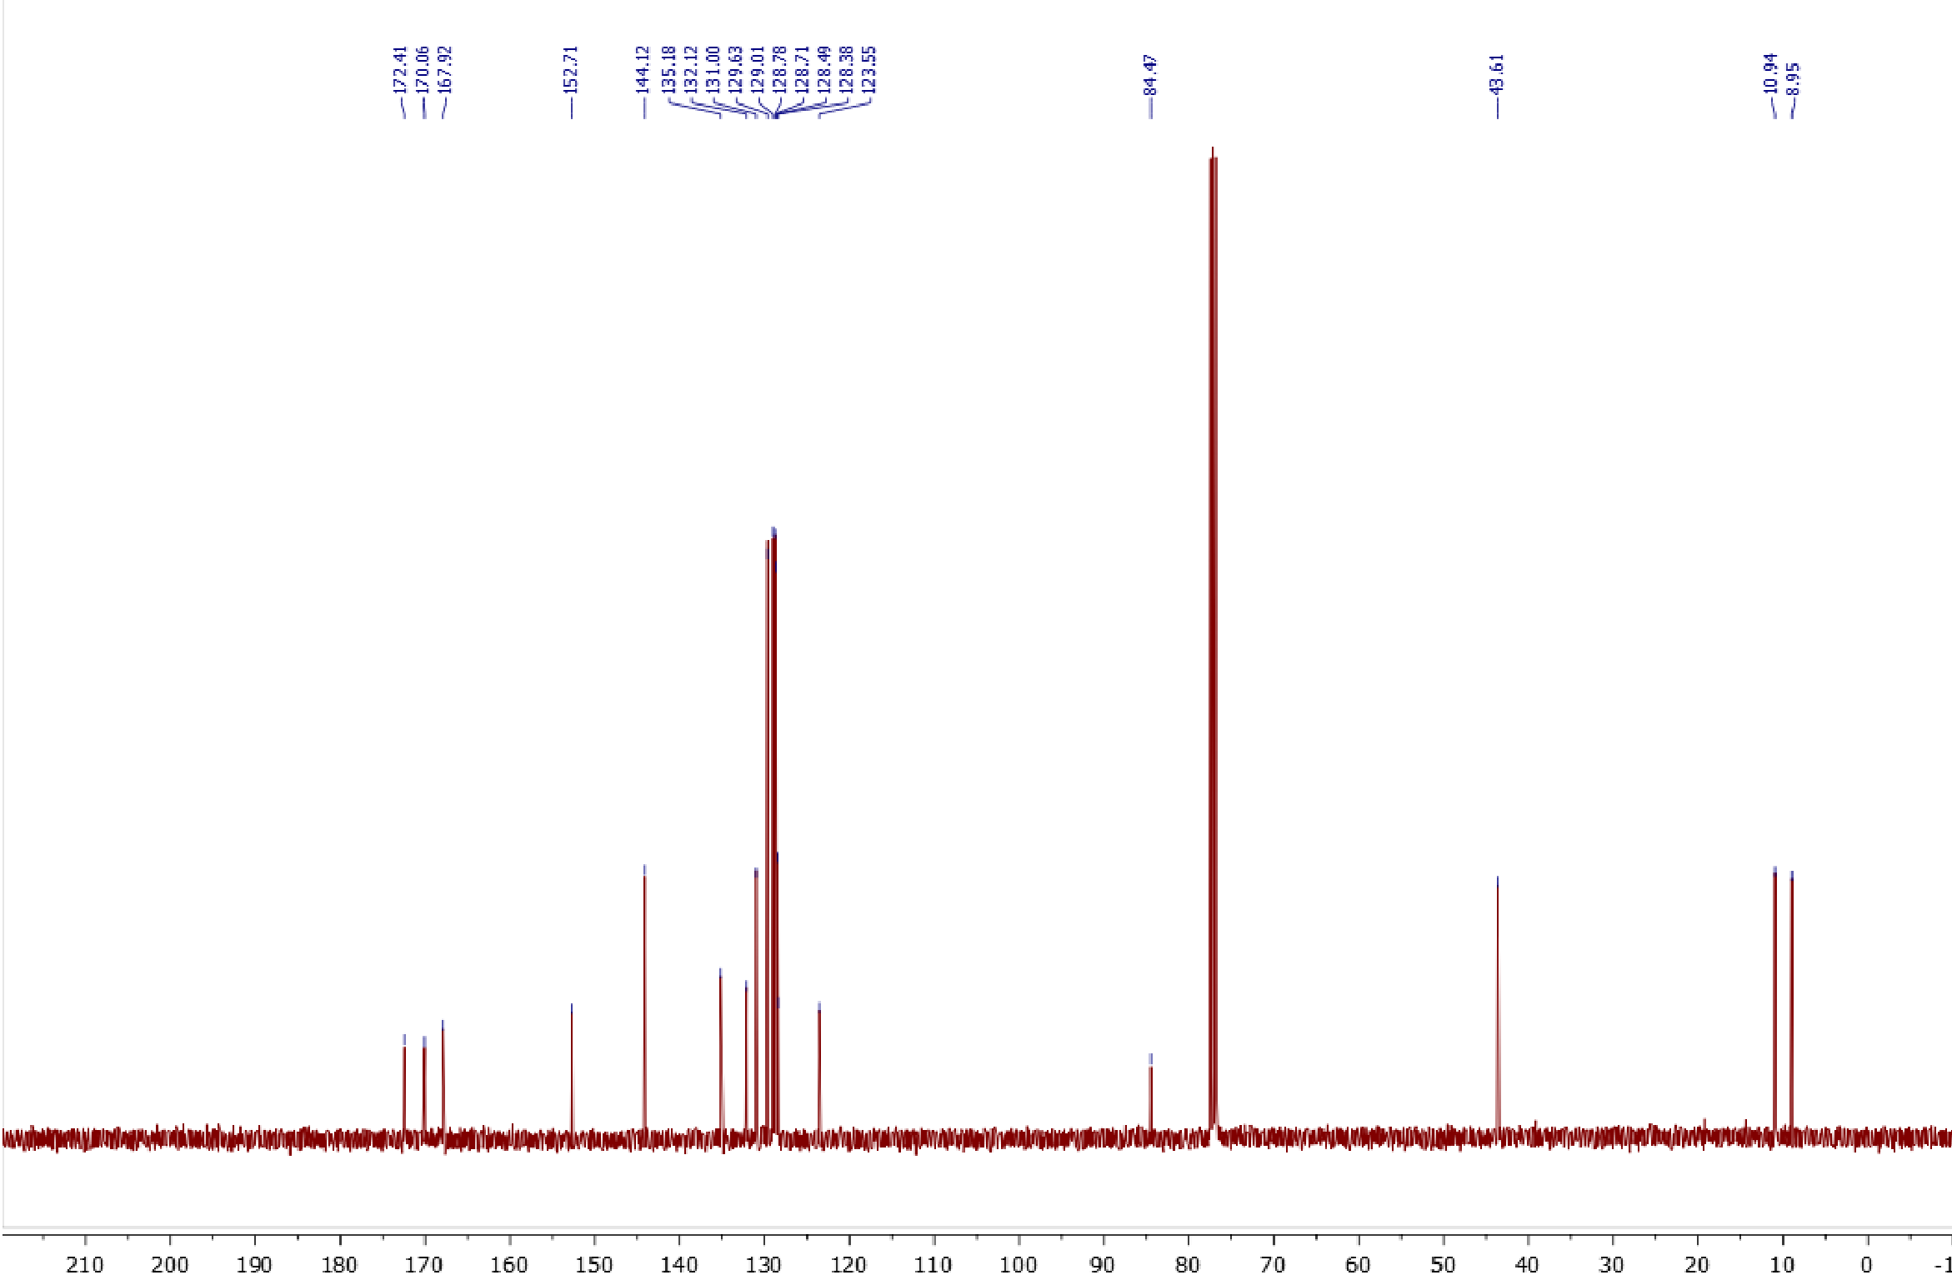

Copies of ¹H (400.13 MHz, CDCl₃) and ¹³C{¹H} (100.61 MHz, CDCl₃) spectra of 3b
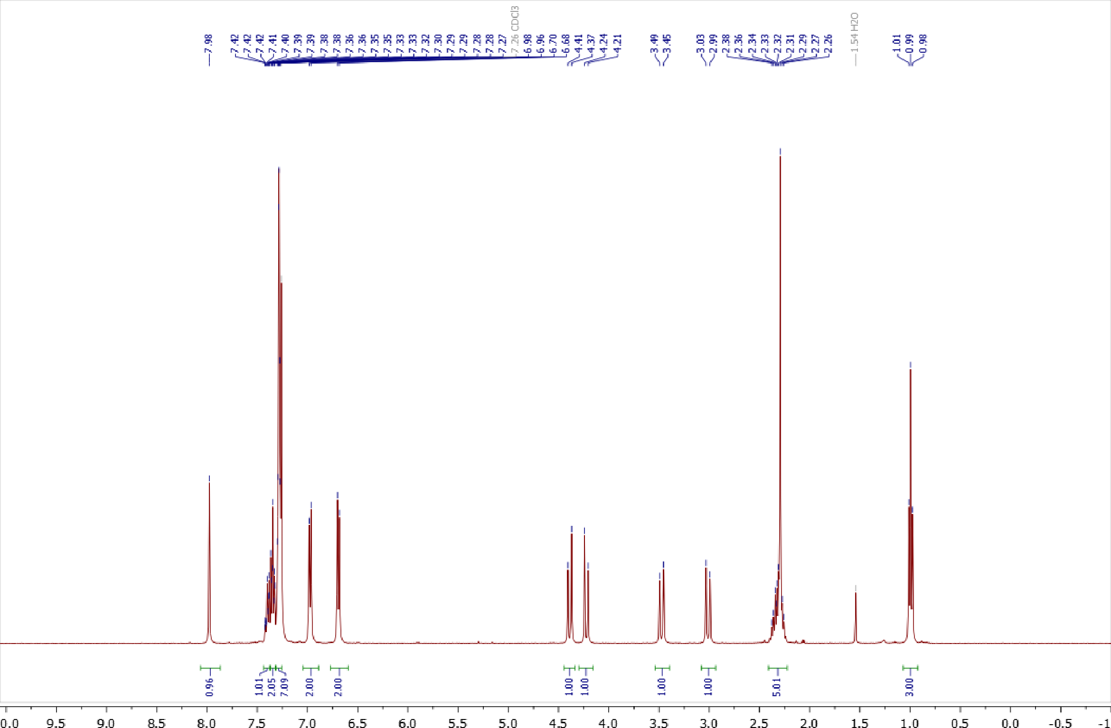
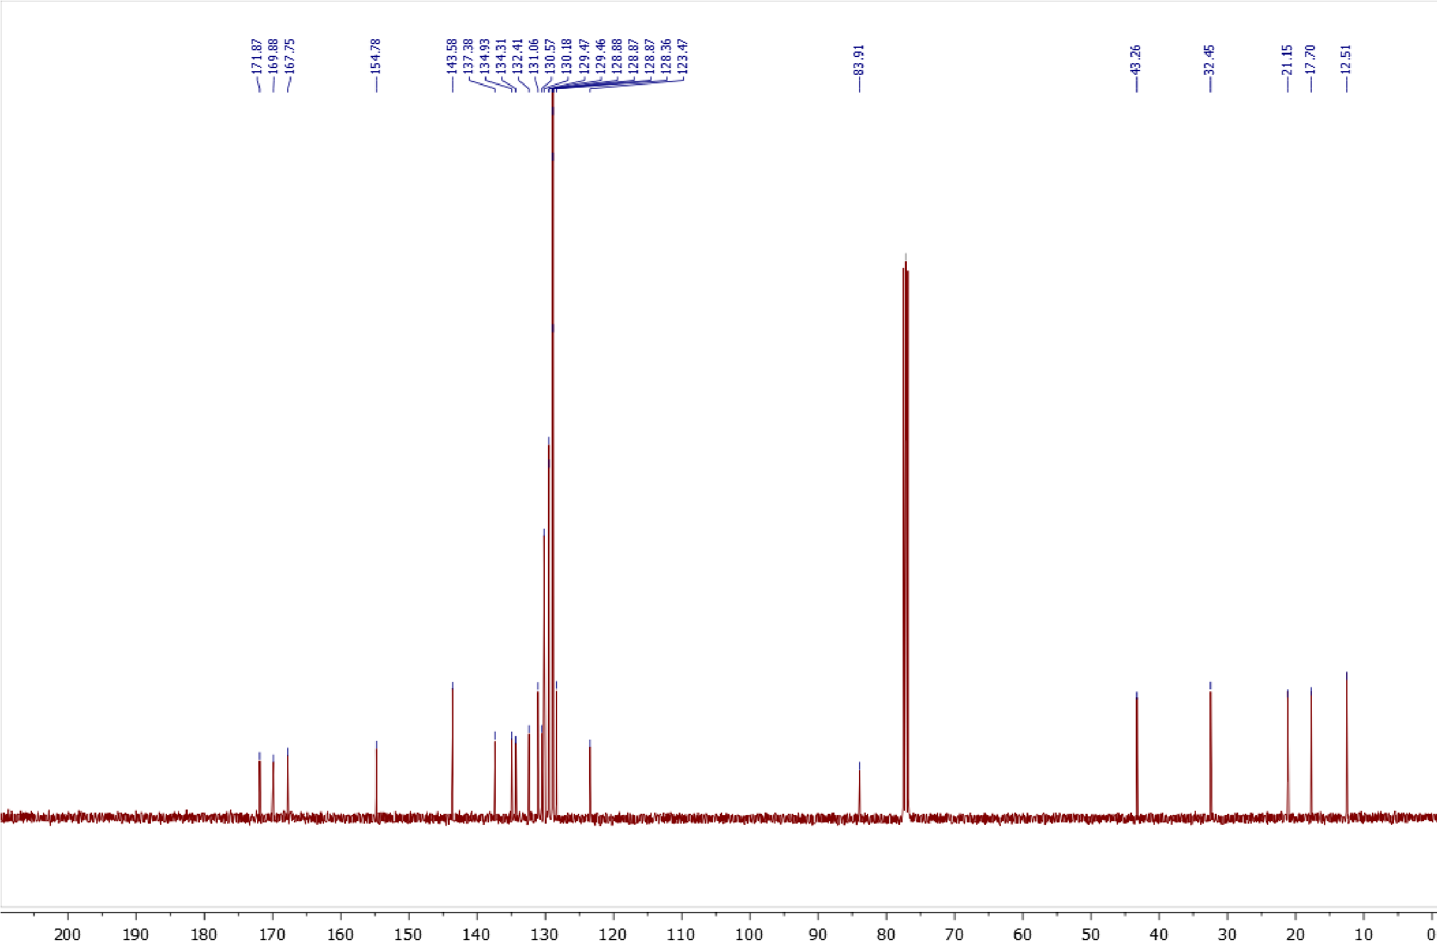

Copies of ¹H (400.13 MHz, CDCl₃) and ¹³C{¹H} (100.61 MHz, CDCl₃) spectra of 3c
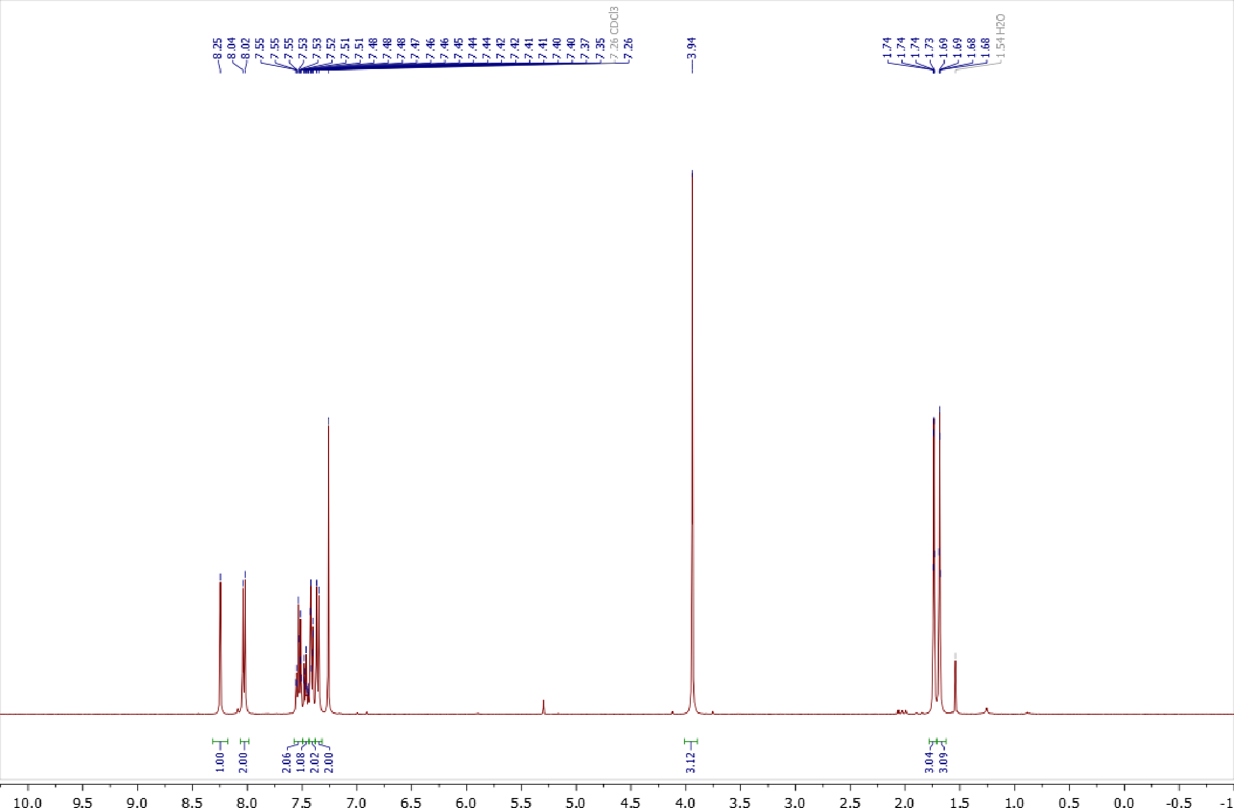
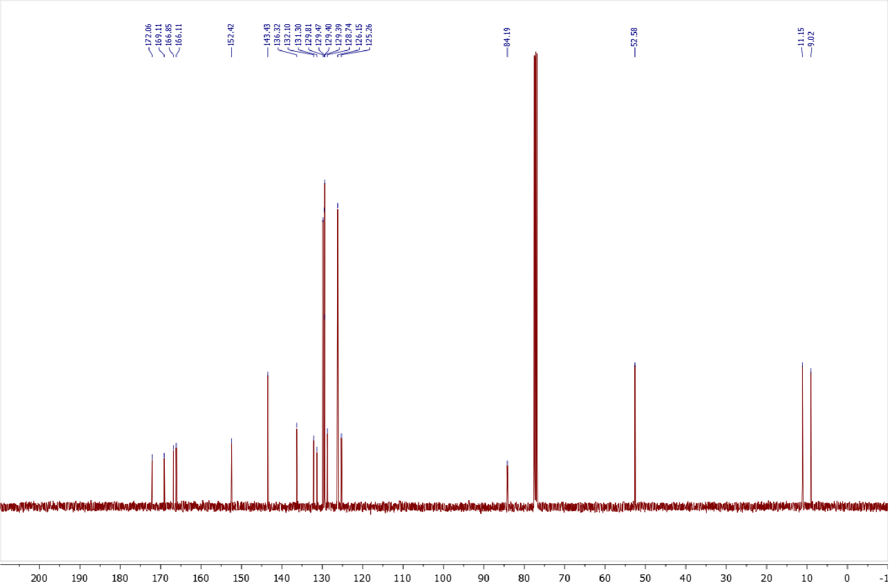

Copies of ¹H (400.13 MHz, CDCl₃) and ¹³C{¹H} (100.61 MHz, CDCl₃) spectra of 3d
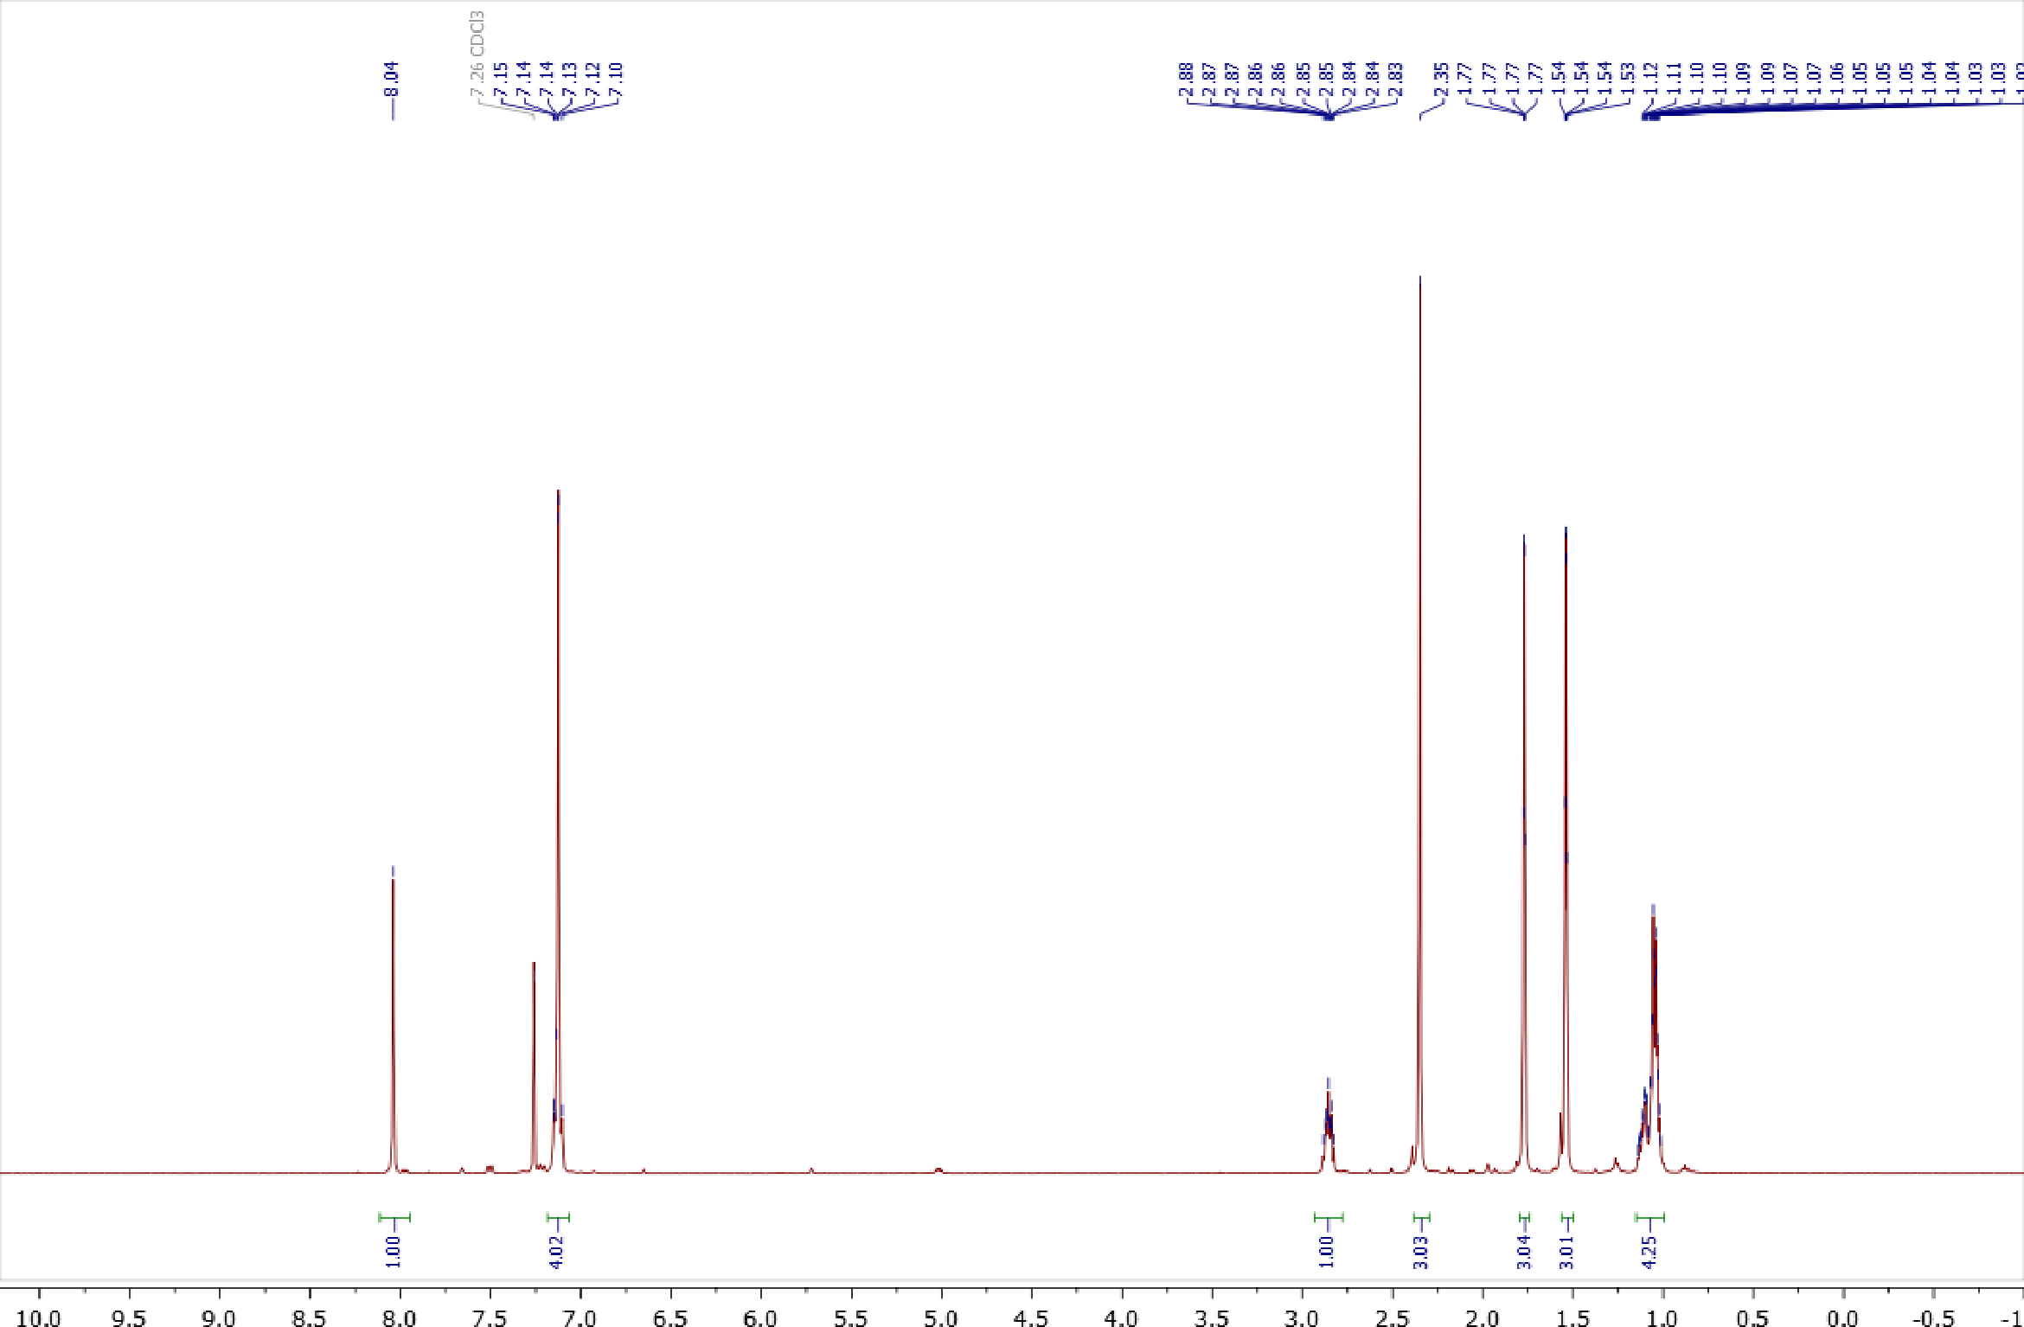
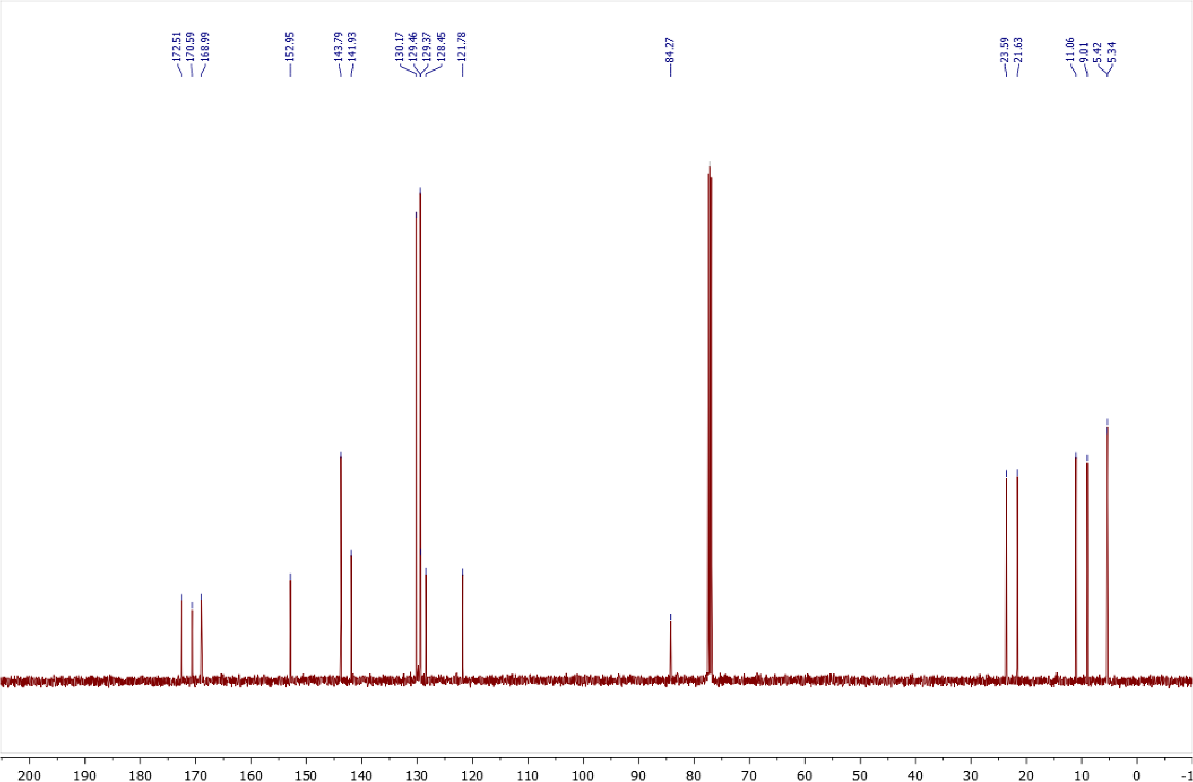
Copies of ¹H (400.13 MHz, CDCl₃) and ¹³C{¹H} (100.61 MHz, CDCl₃) spectra of 4a
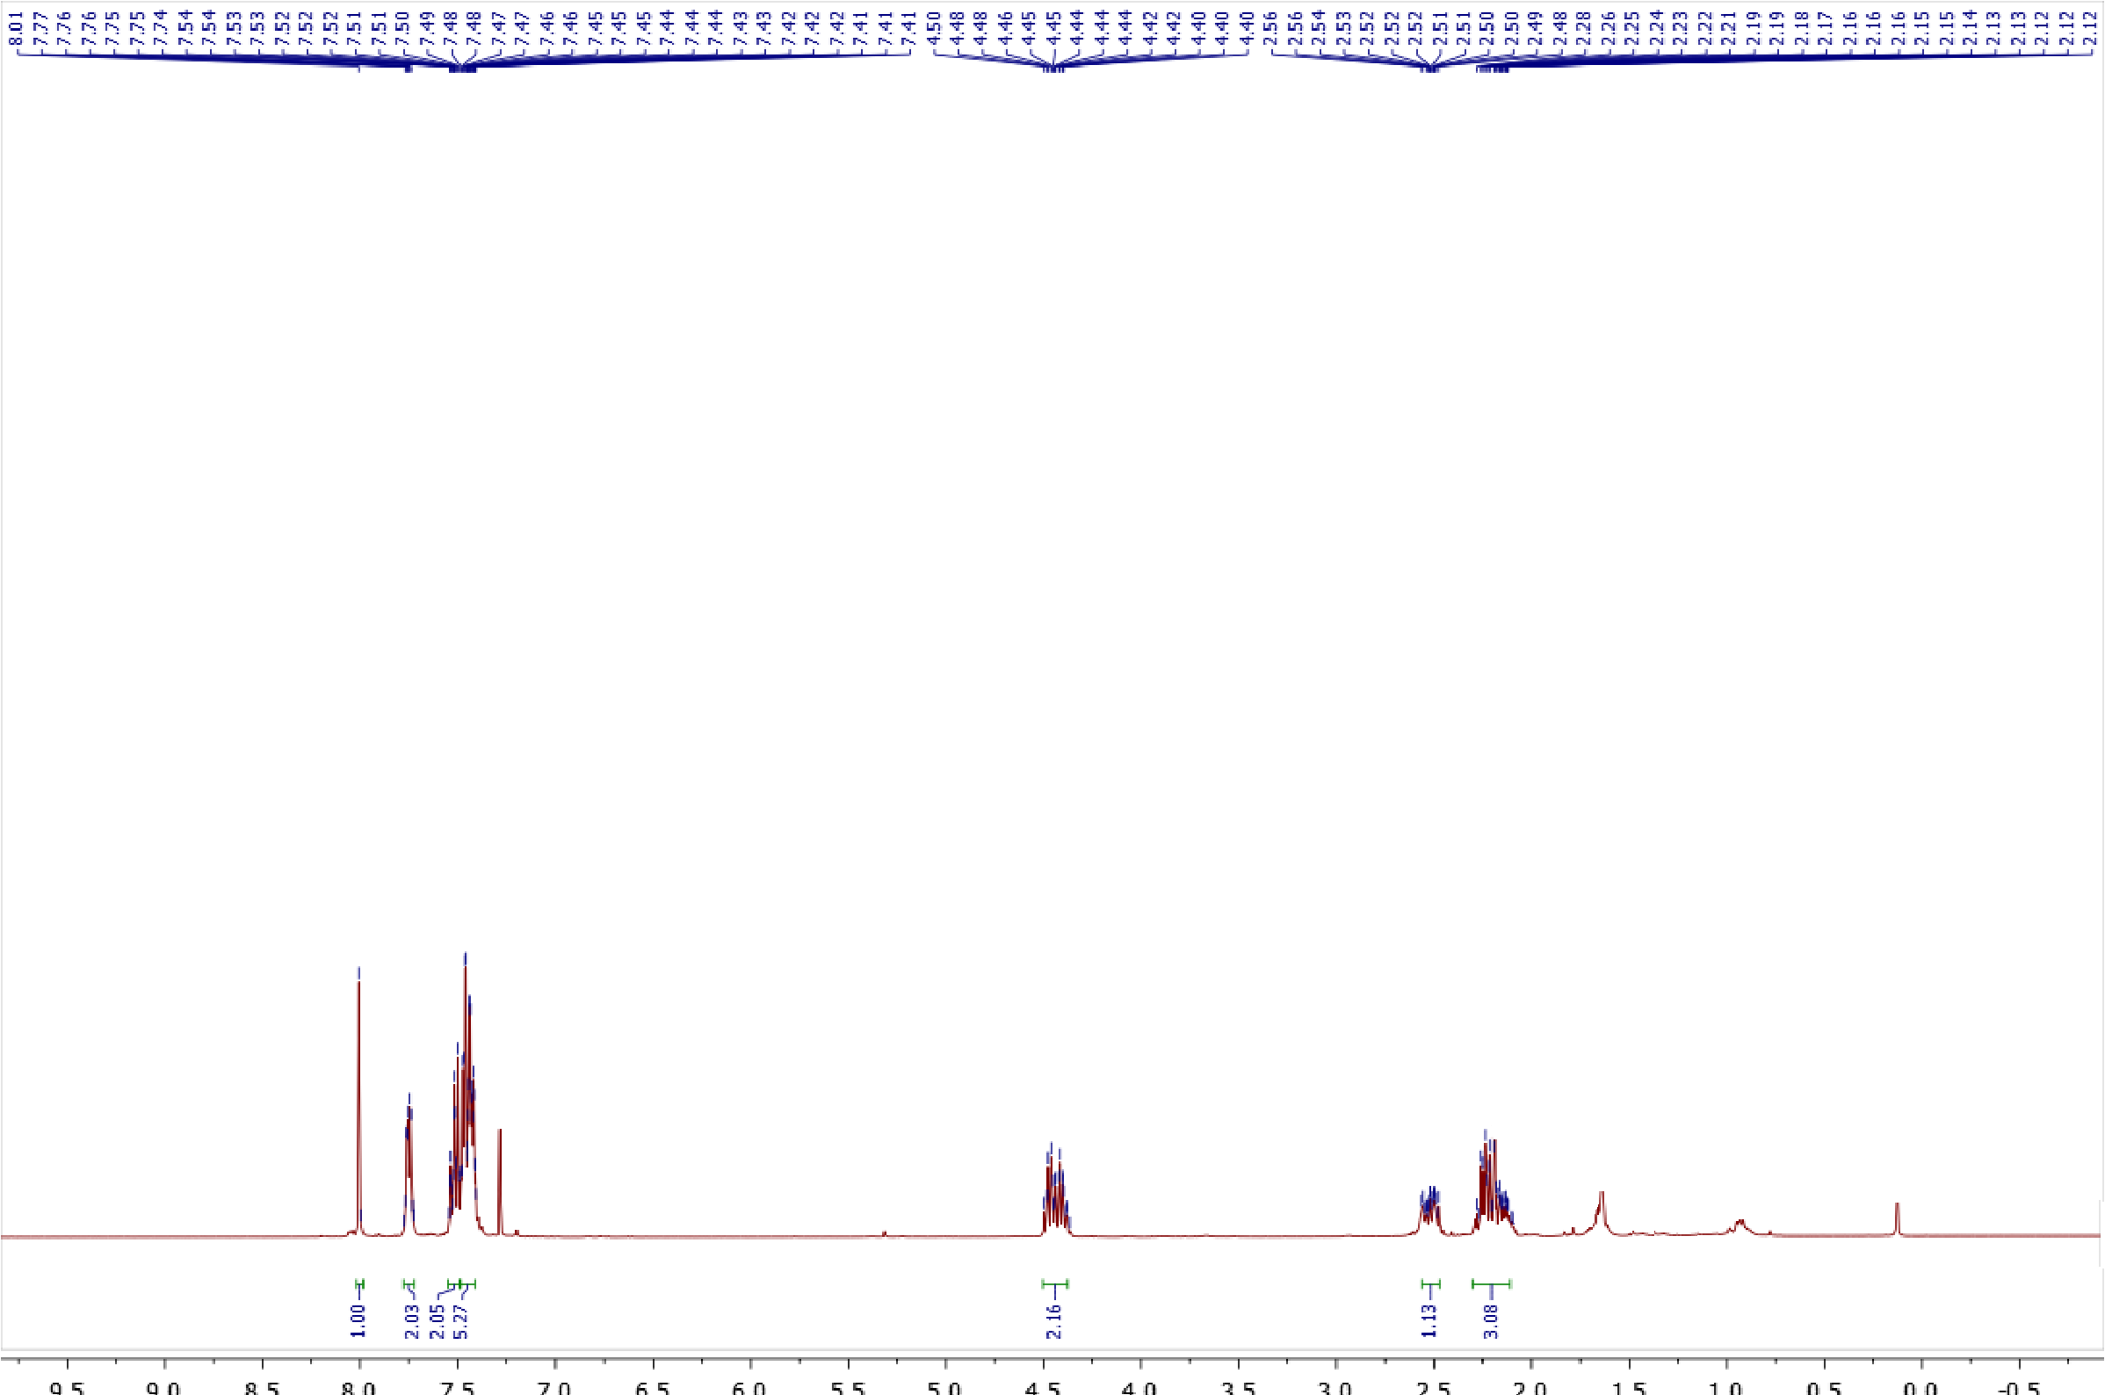
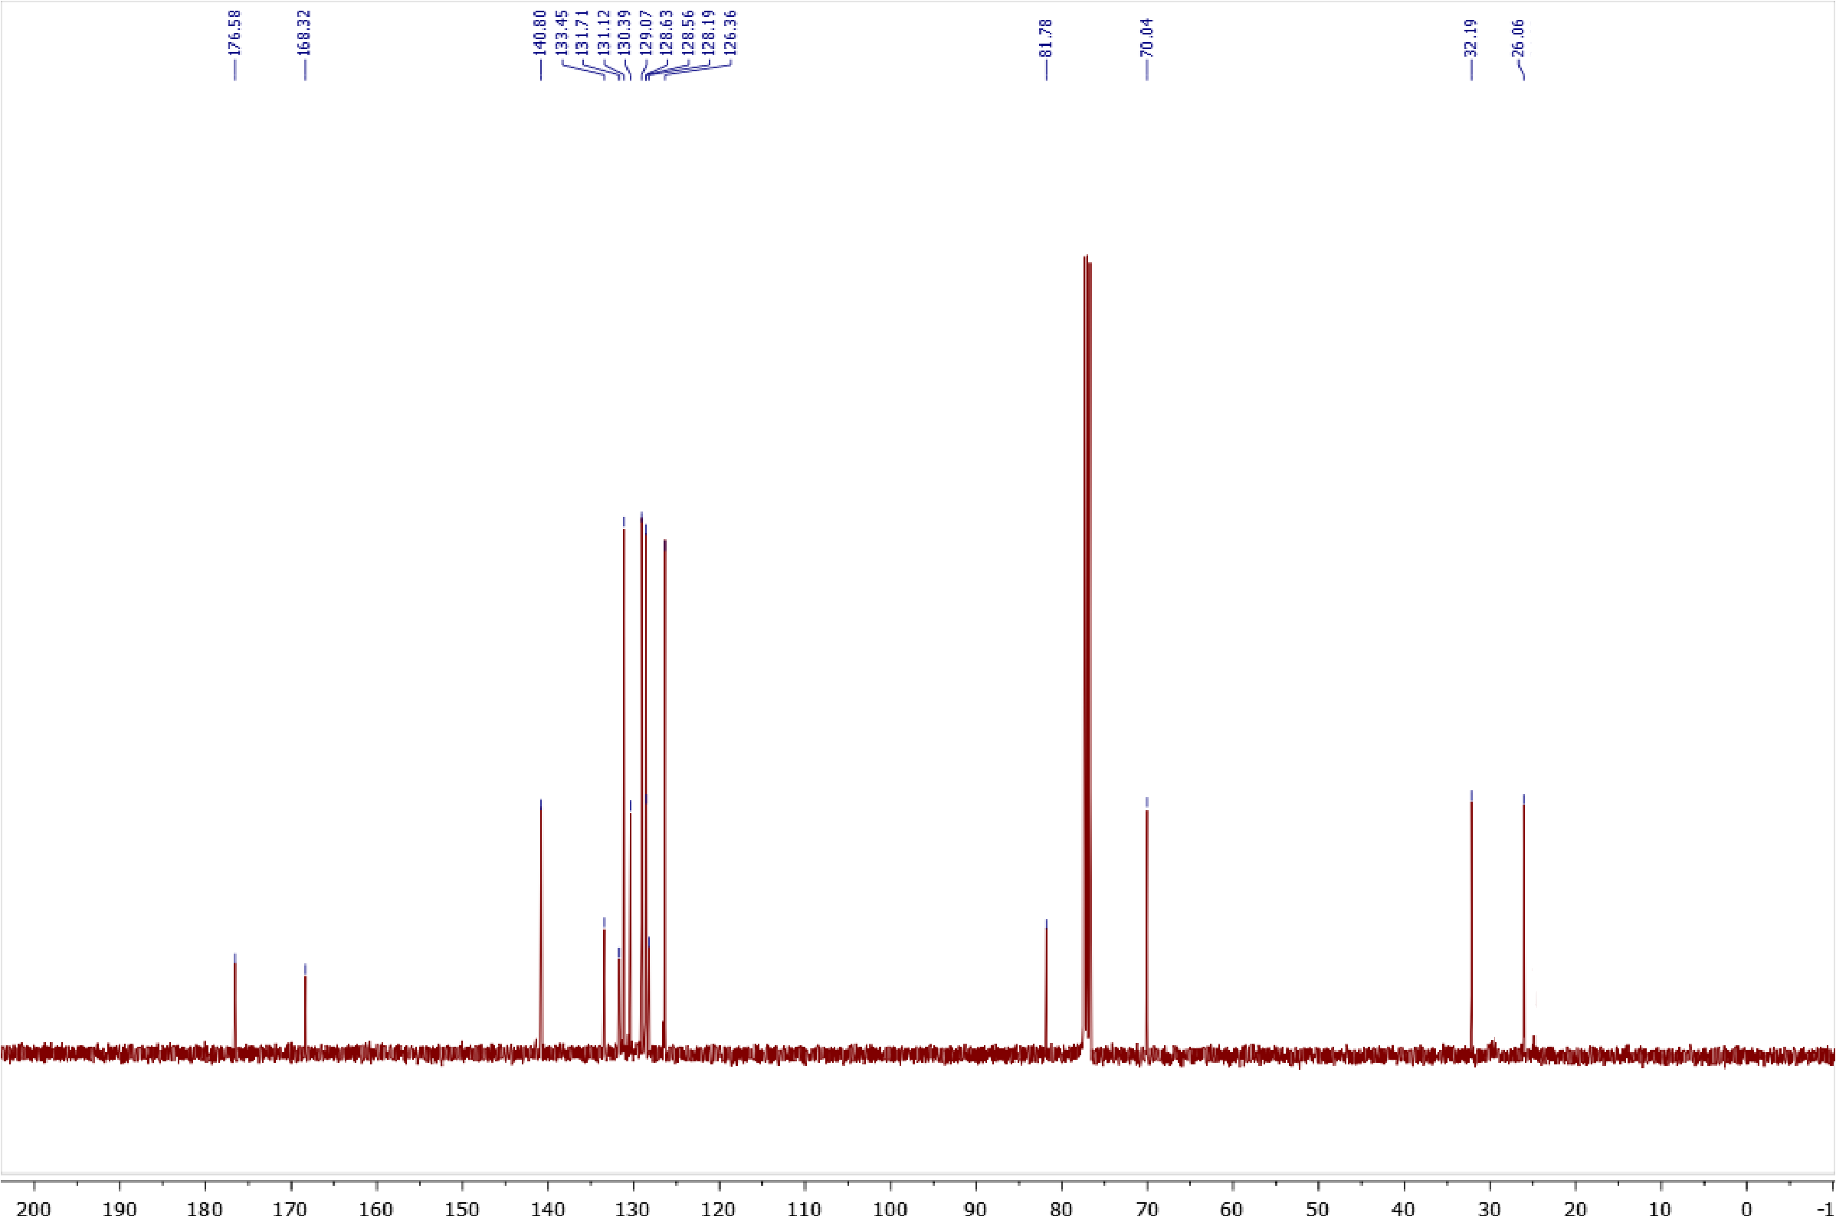

Copies of ¹H (400.13 MHz, CDCl₃) and ¹³C{¹H} (100.61 MHz, CDCl₃) spectra of 4b
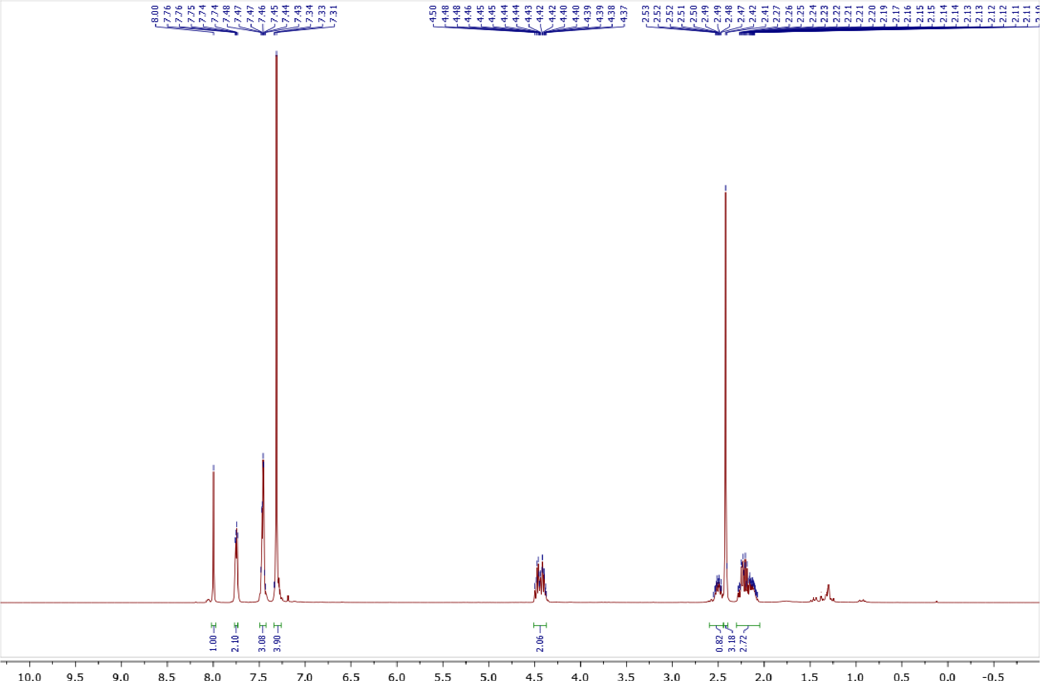
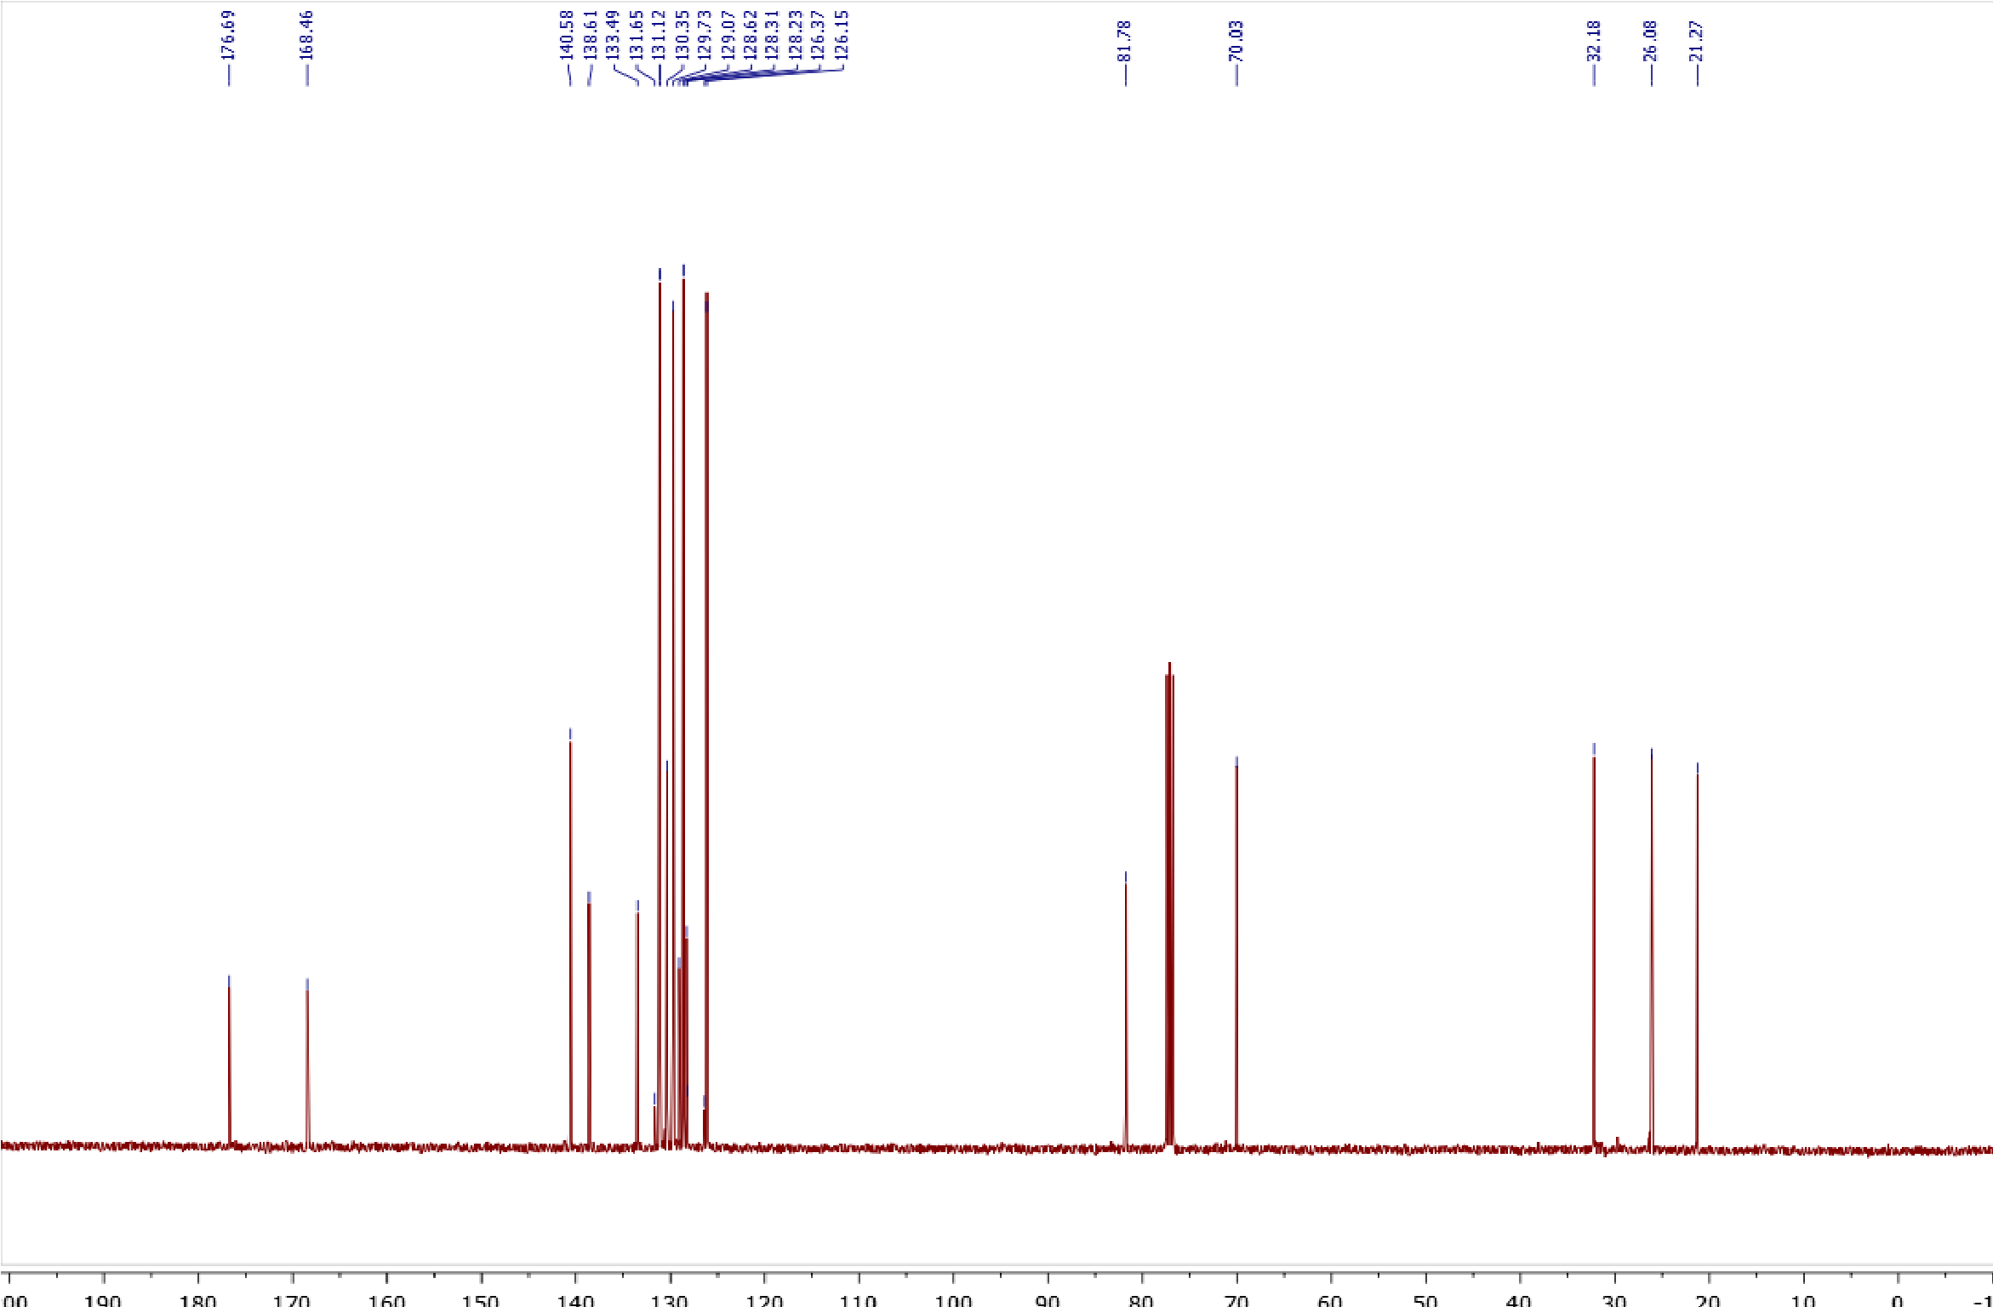
Copies of ¹H (400.13 MHz, CDCl₃) and ¹³C{¹H} (100.61 MHz, CDCl₃) spectra of 4c
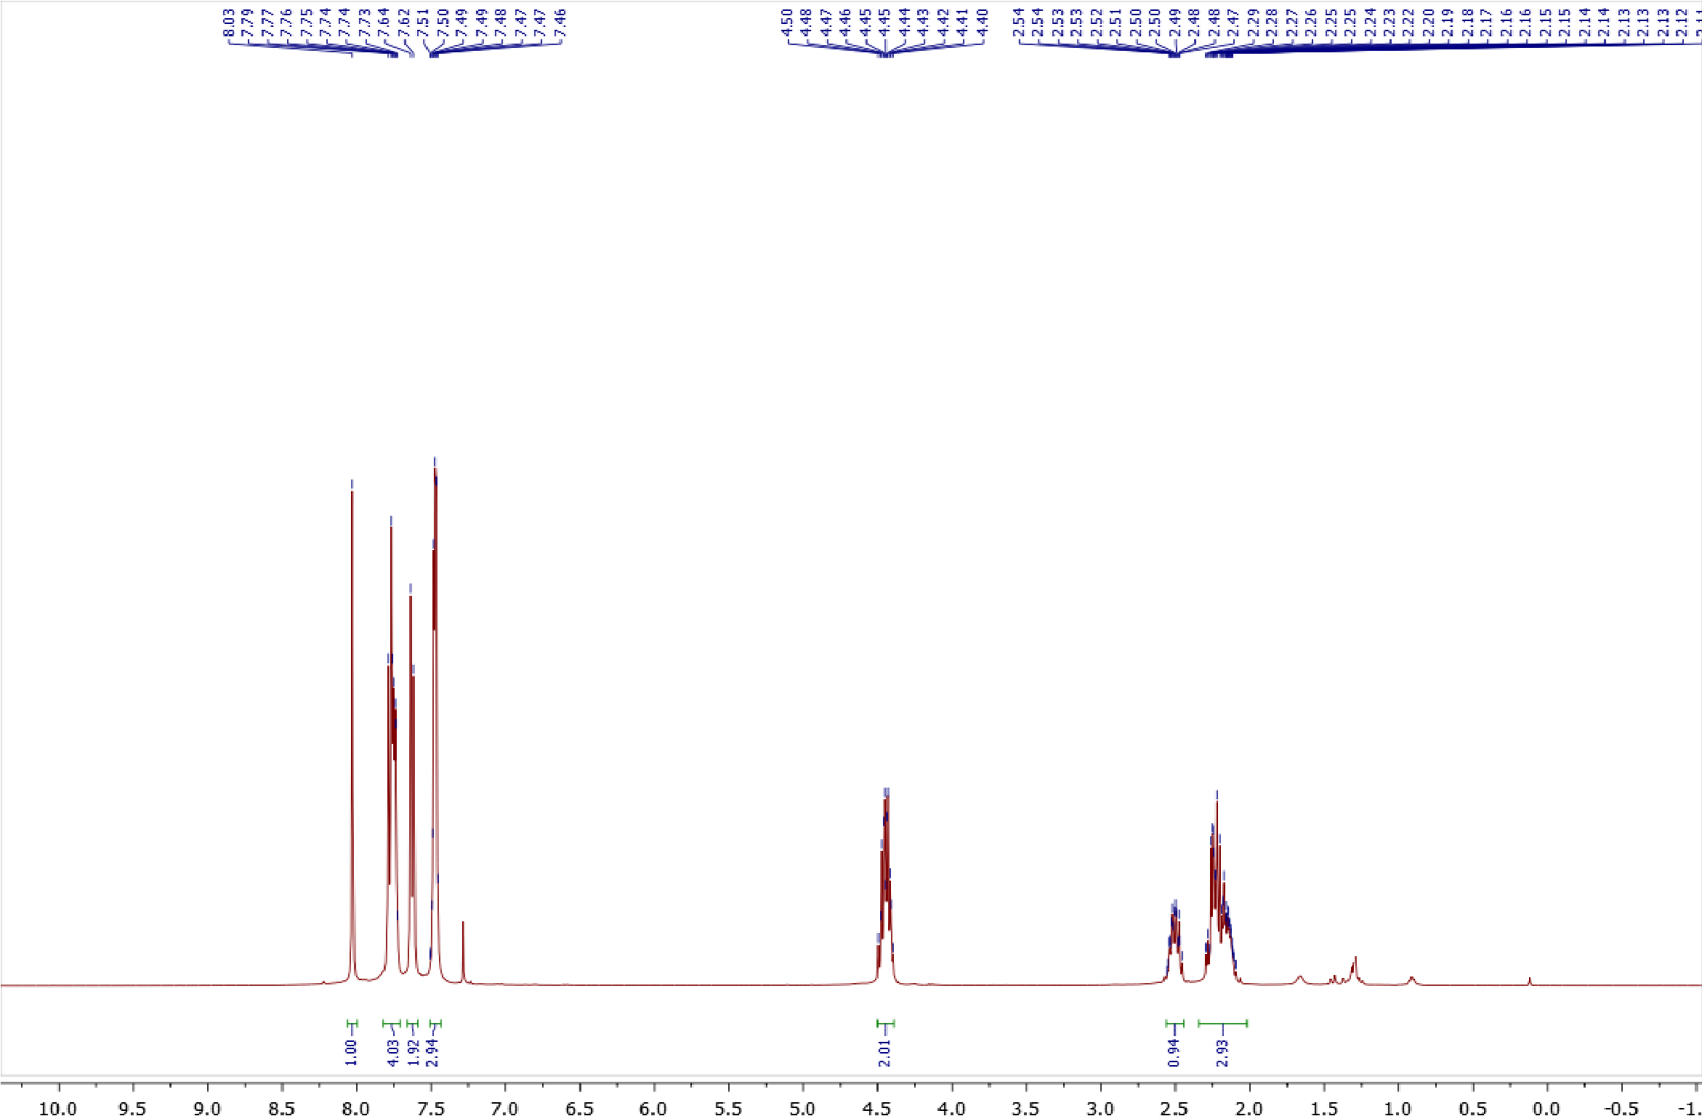
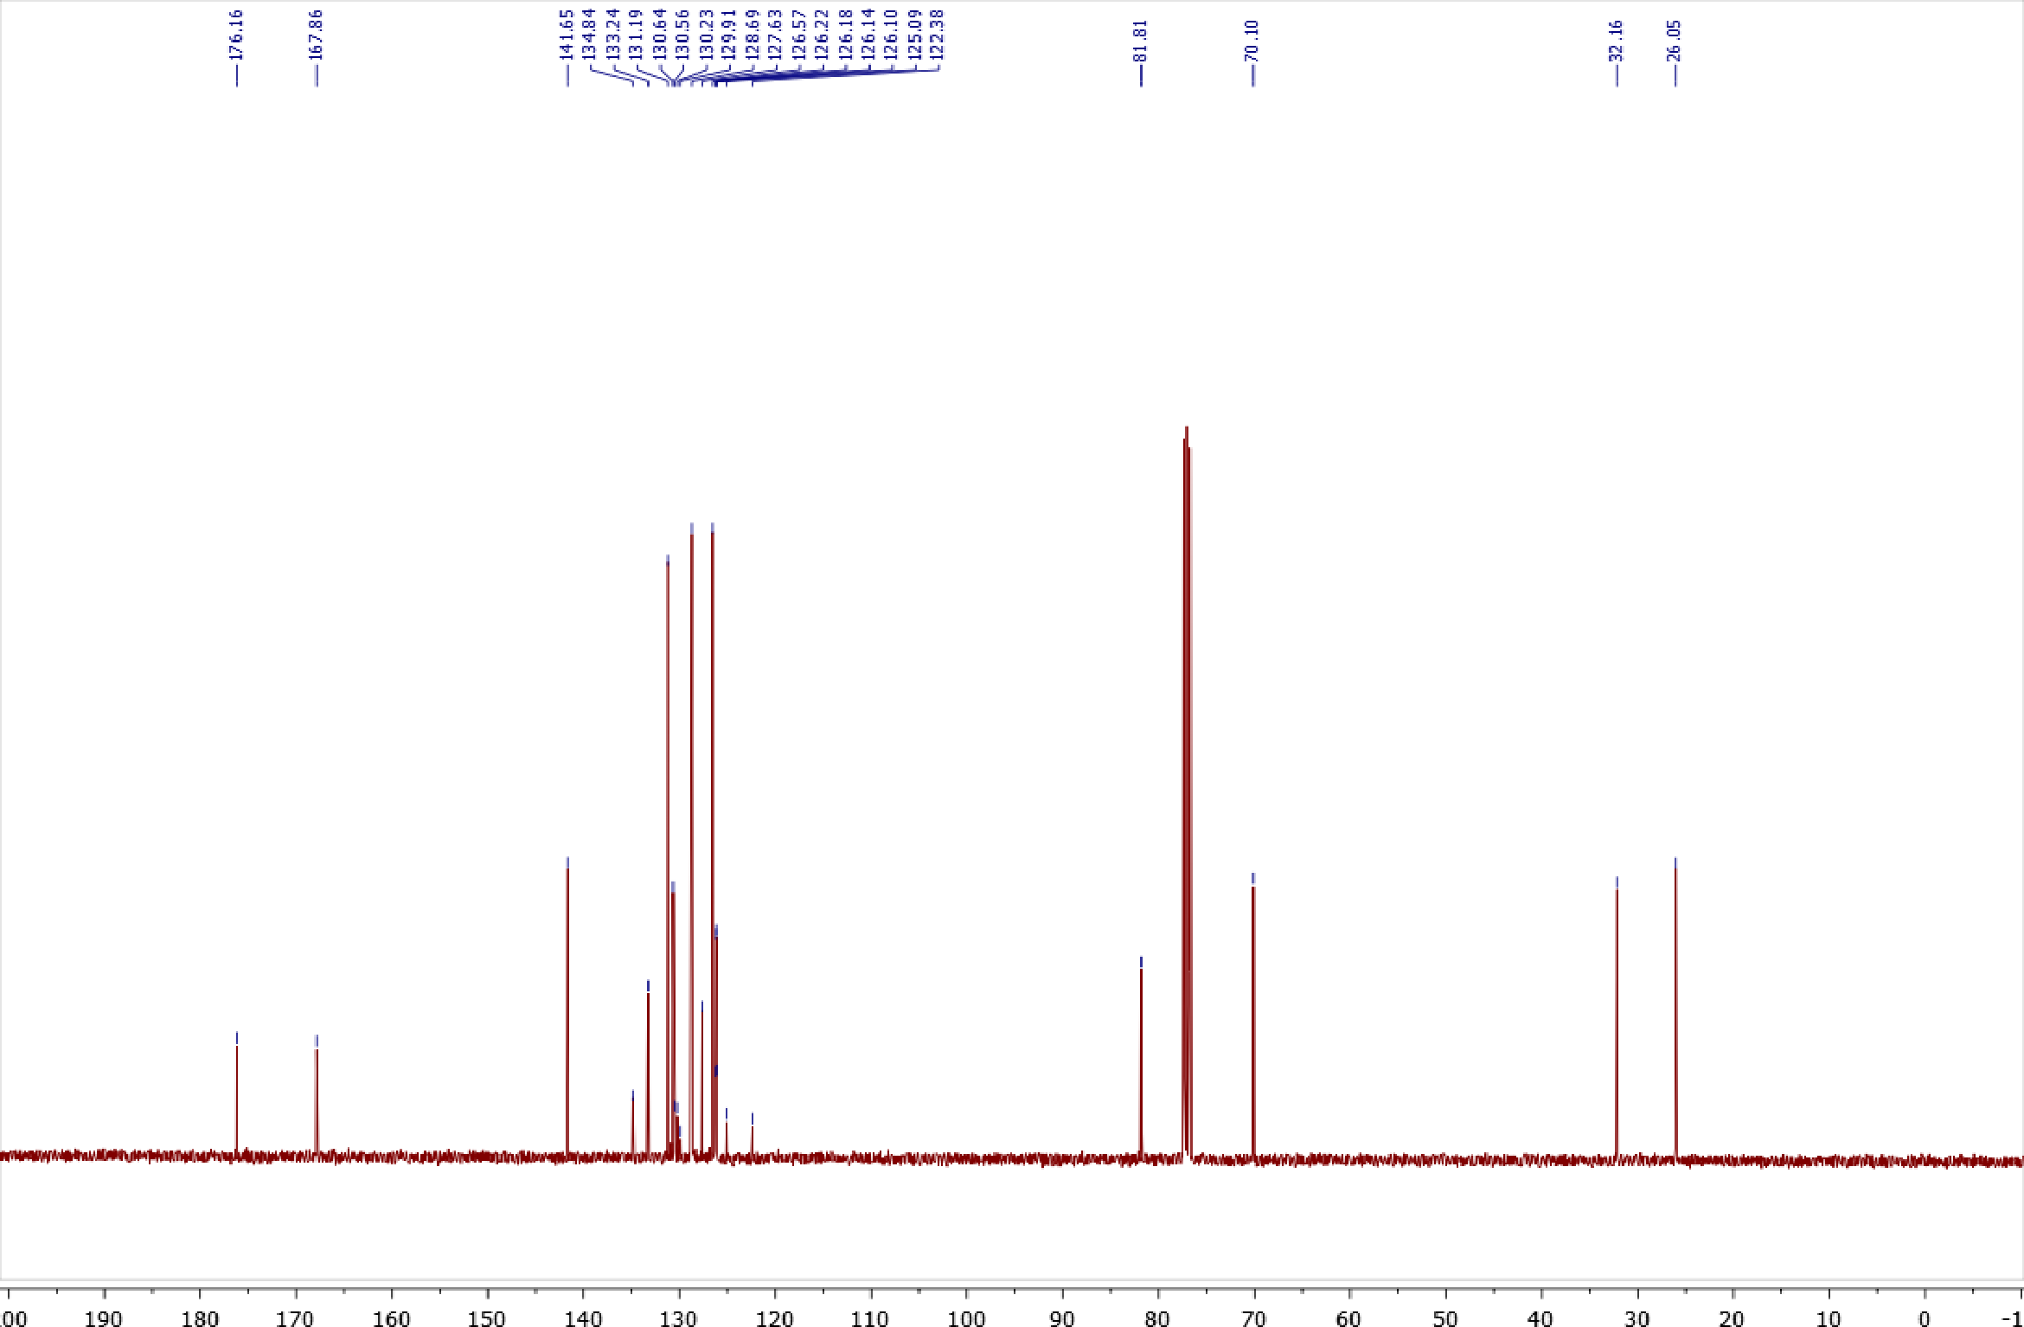
Copy of ¹⁹F{¹H} (376.50 MHz, CDCl₃) spectrum of 4c
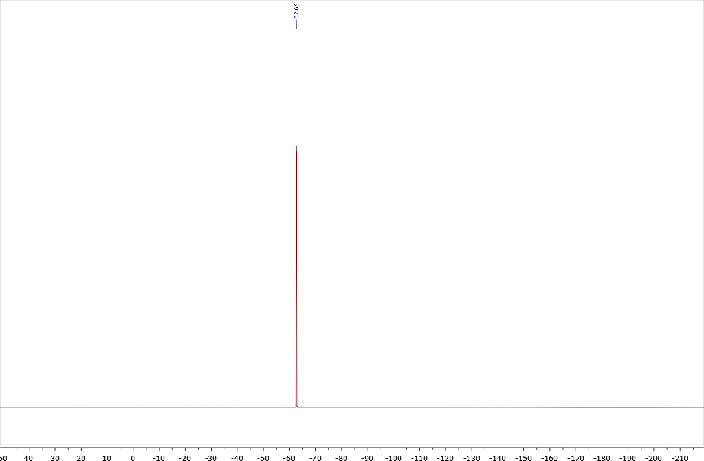

Copies of ¹H (400.13 MHz, CDCl₃) and ¹³C{¹H} (100.61 MHz, CDCl₃) spectra of 4d
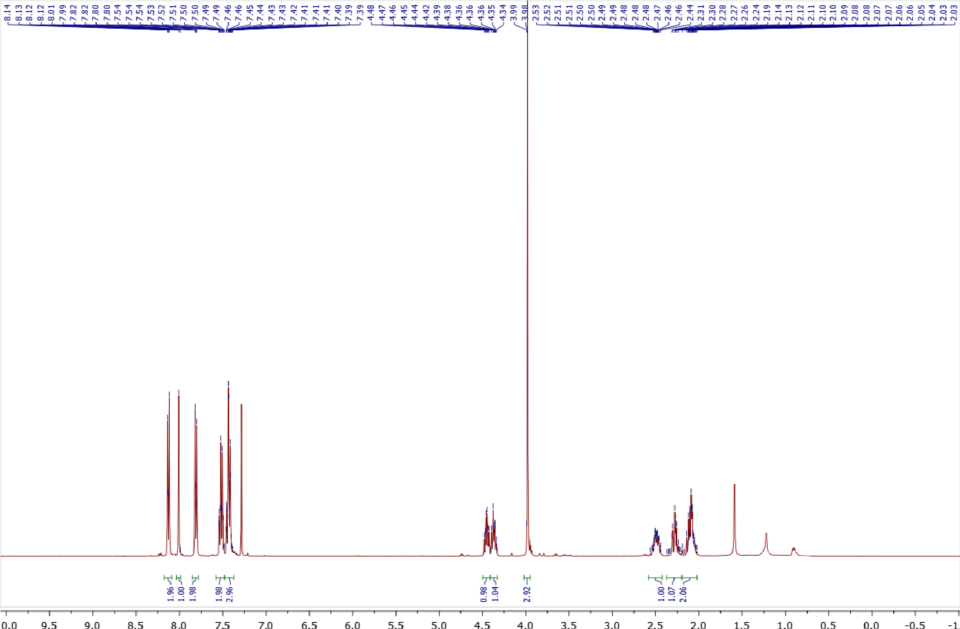

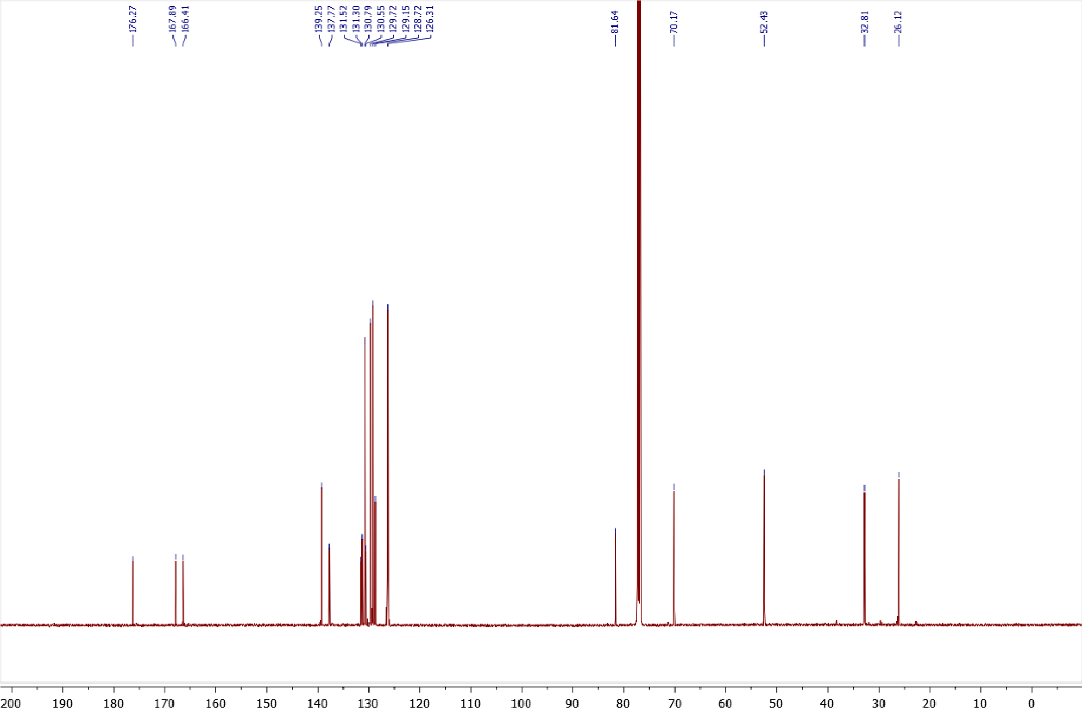
Copies of ¹H (400.13 MHz, CDCl₃) and ¹³C{¹H} (100.61 MHz, CDCl₃) spectra of 5a
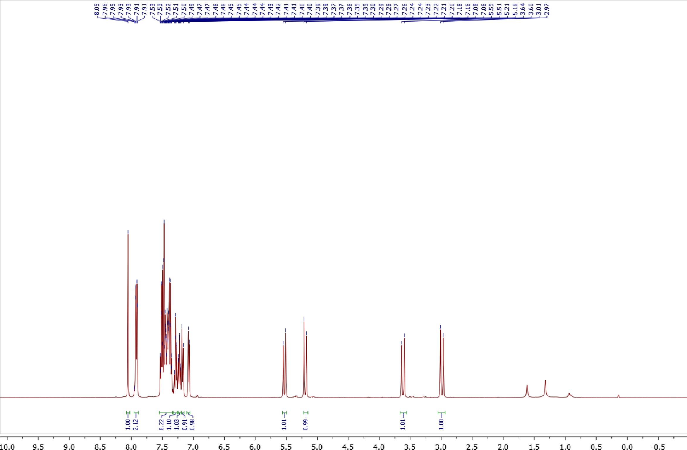
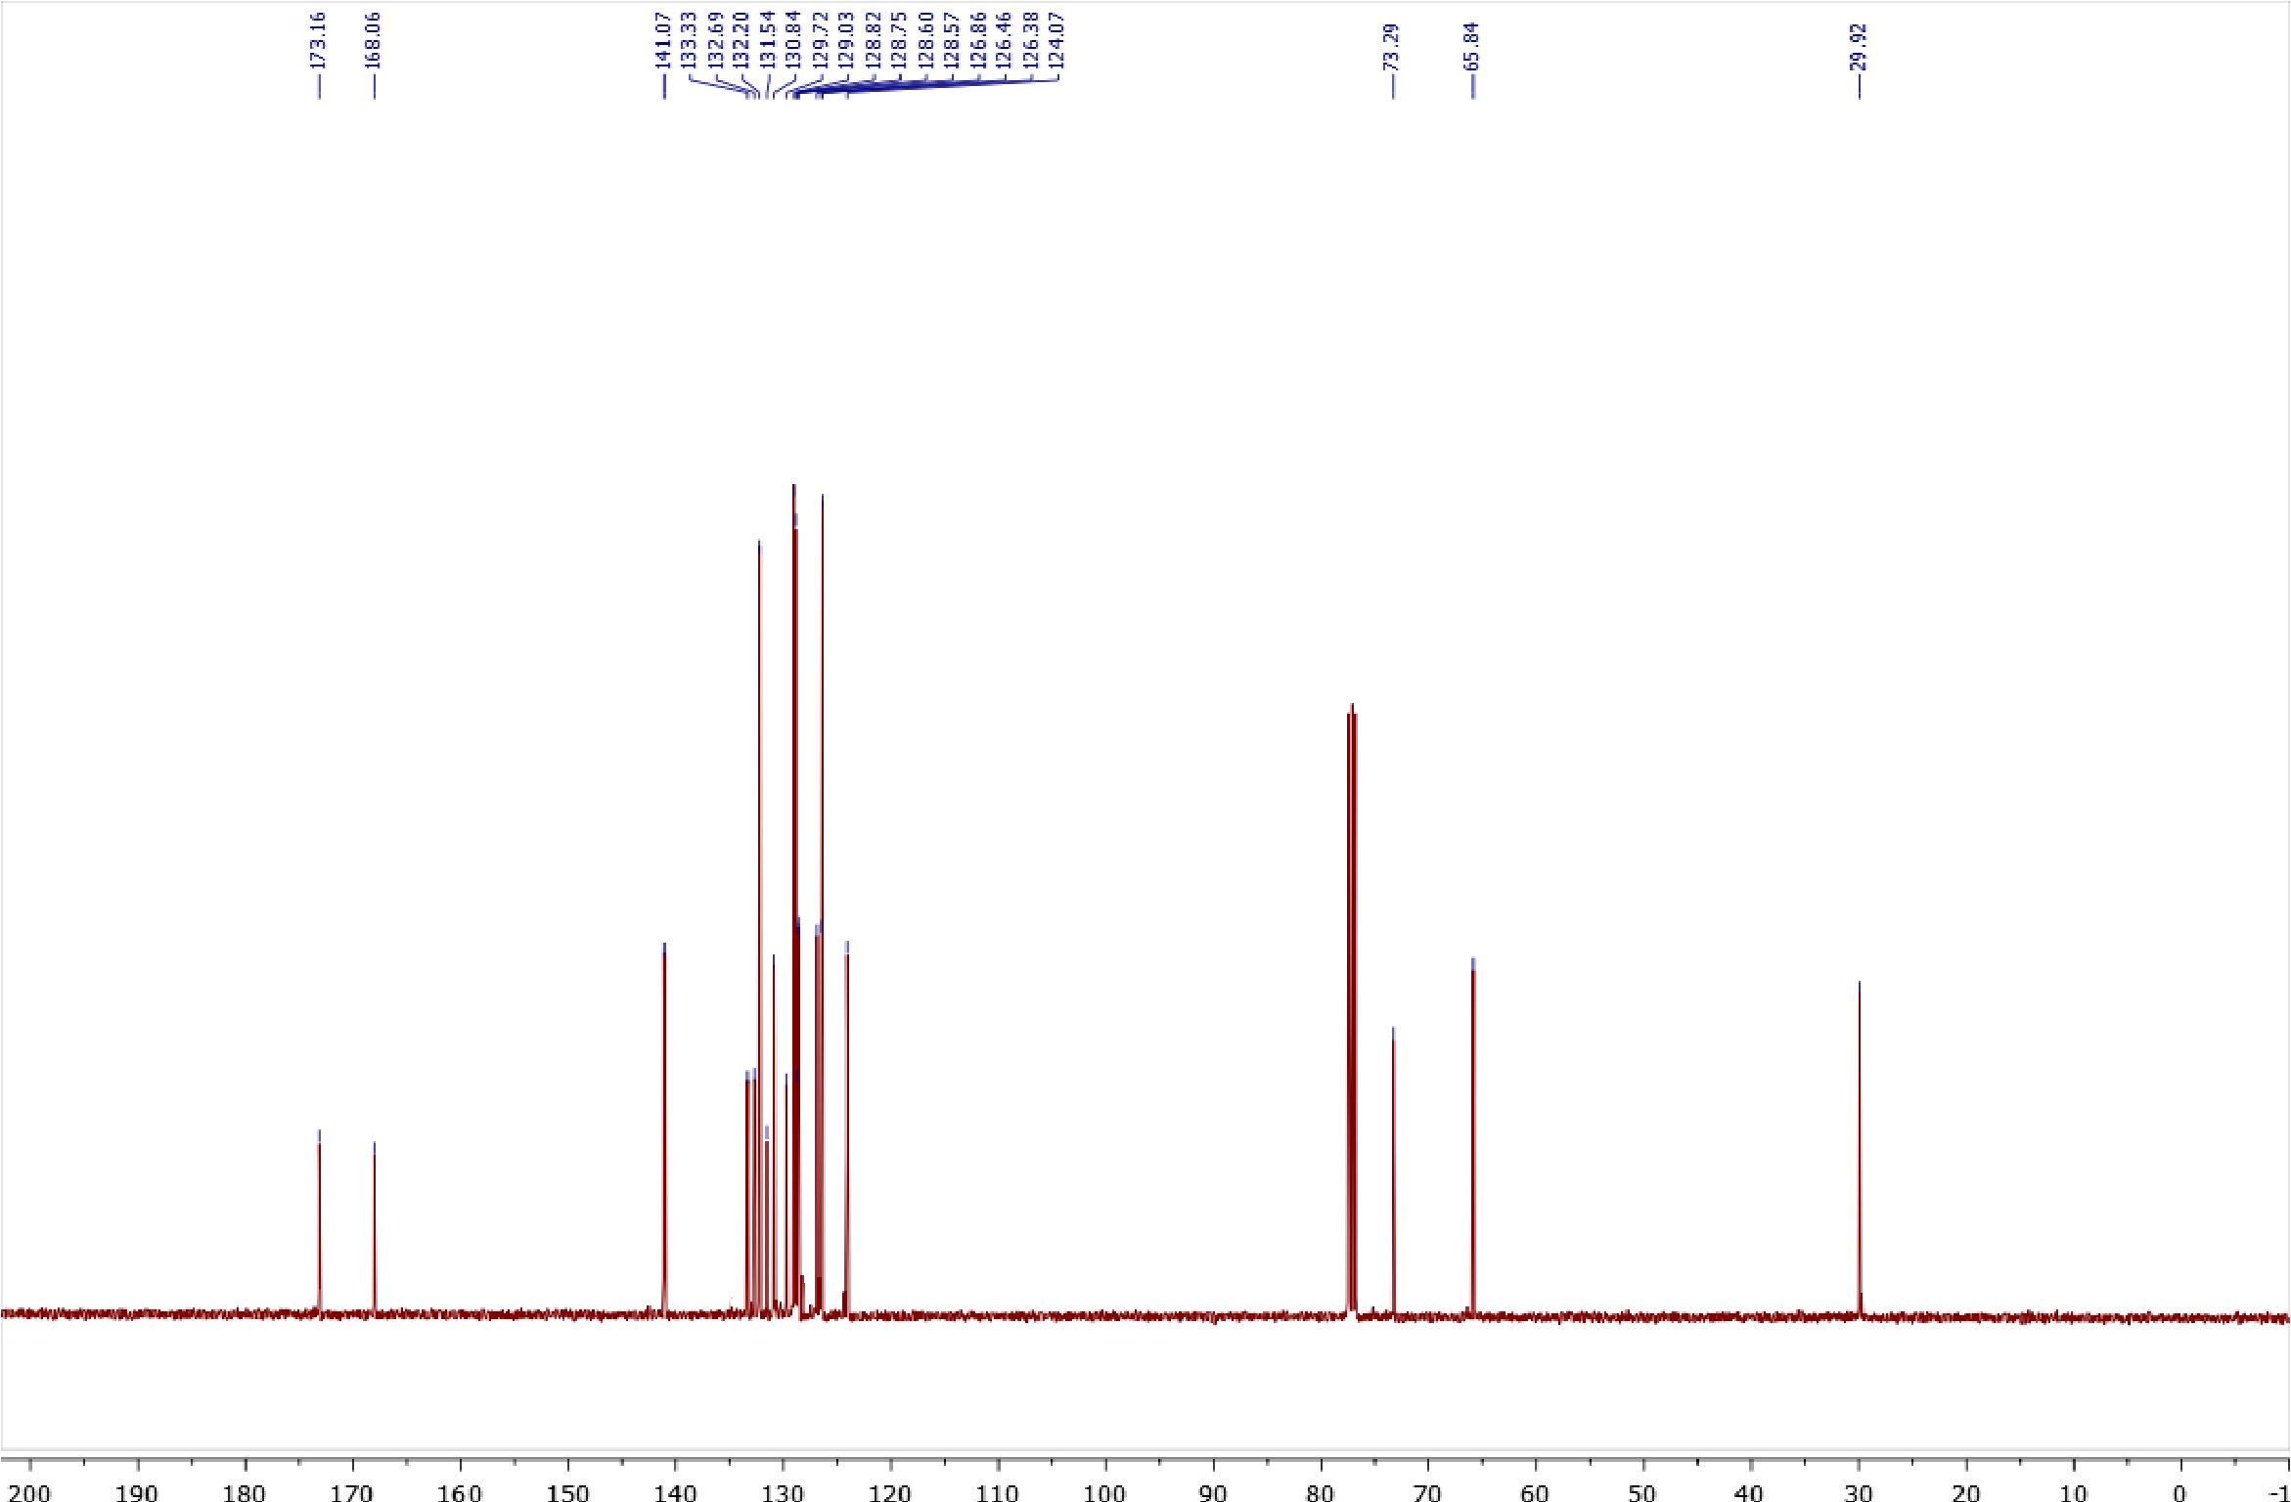
Copies of ¹H (400.13 MHz, CDCl₃) and ¹³C{¹H} (100.61 MHz, CDCl₃) spectra of 5b
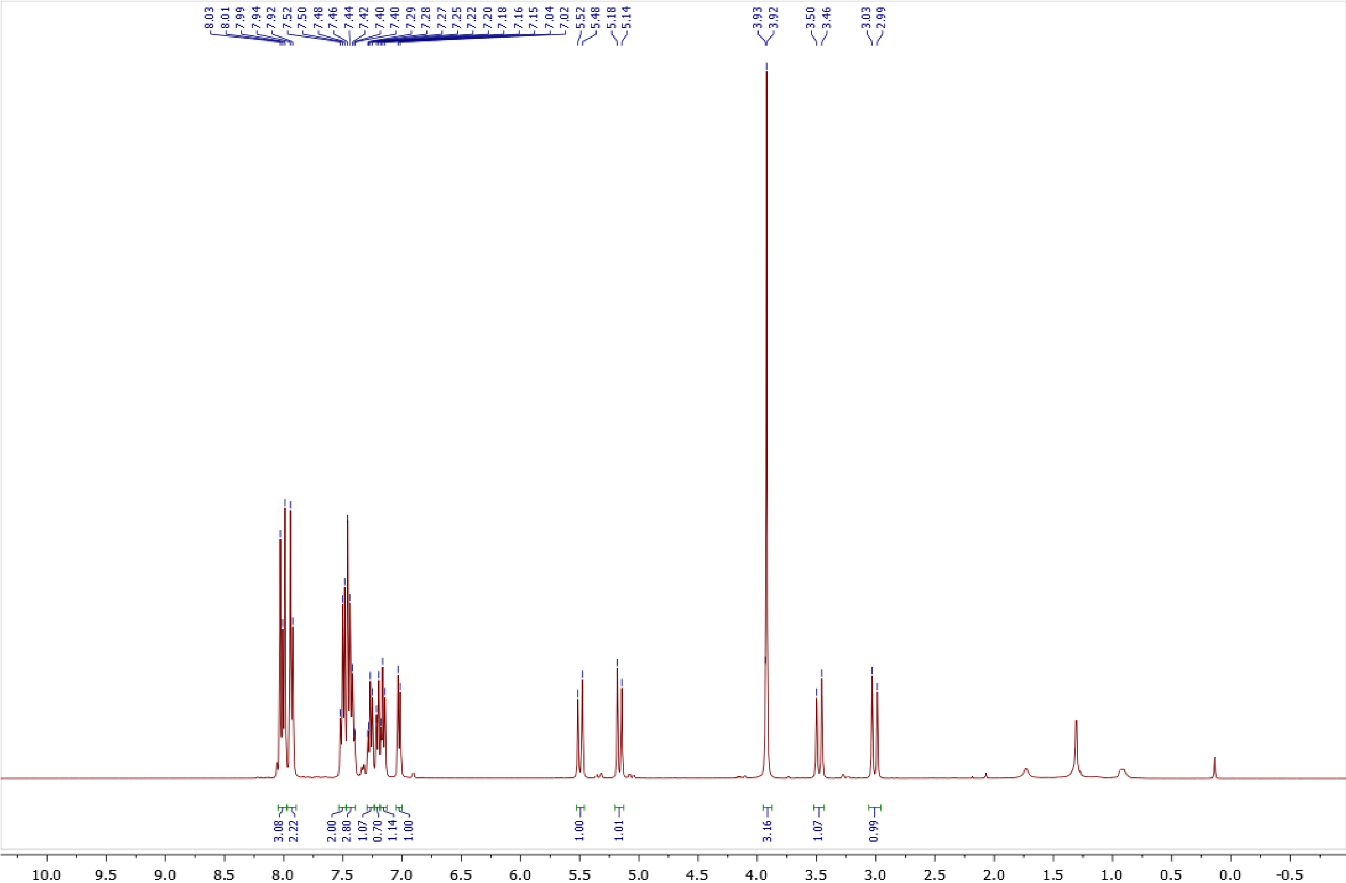
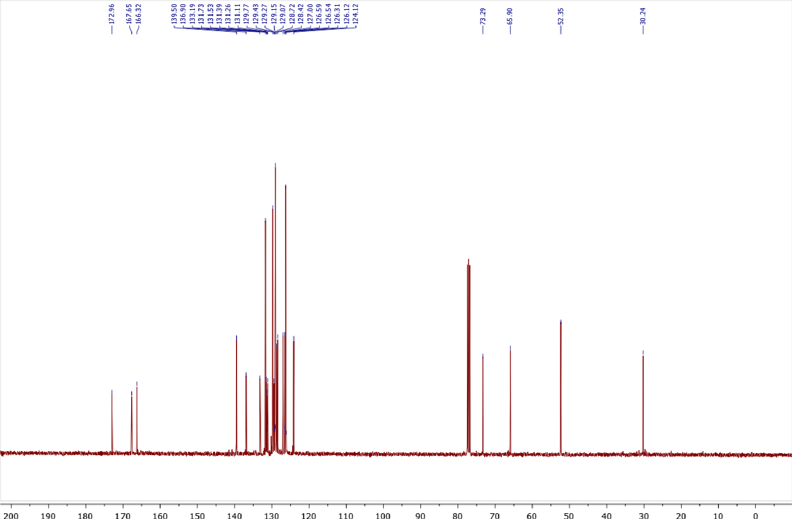
Copies of ¹H (400.13 MHz, CDCl₃) and ¹³C{¹H} (100.61 MHz, CDCl₃) spectra of 5c
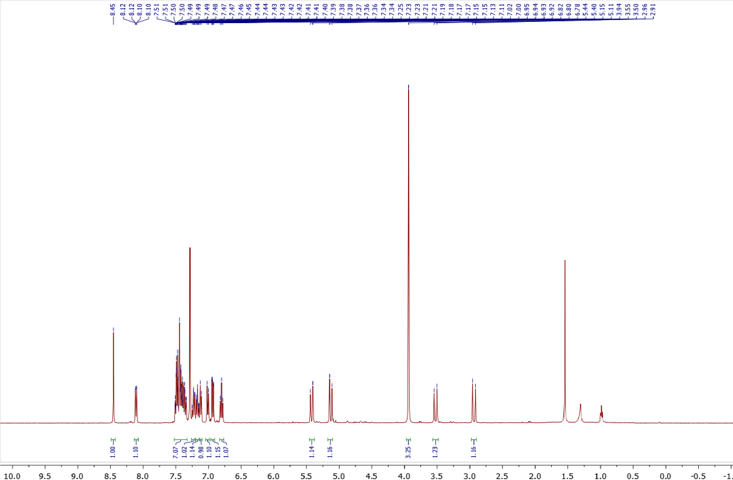
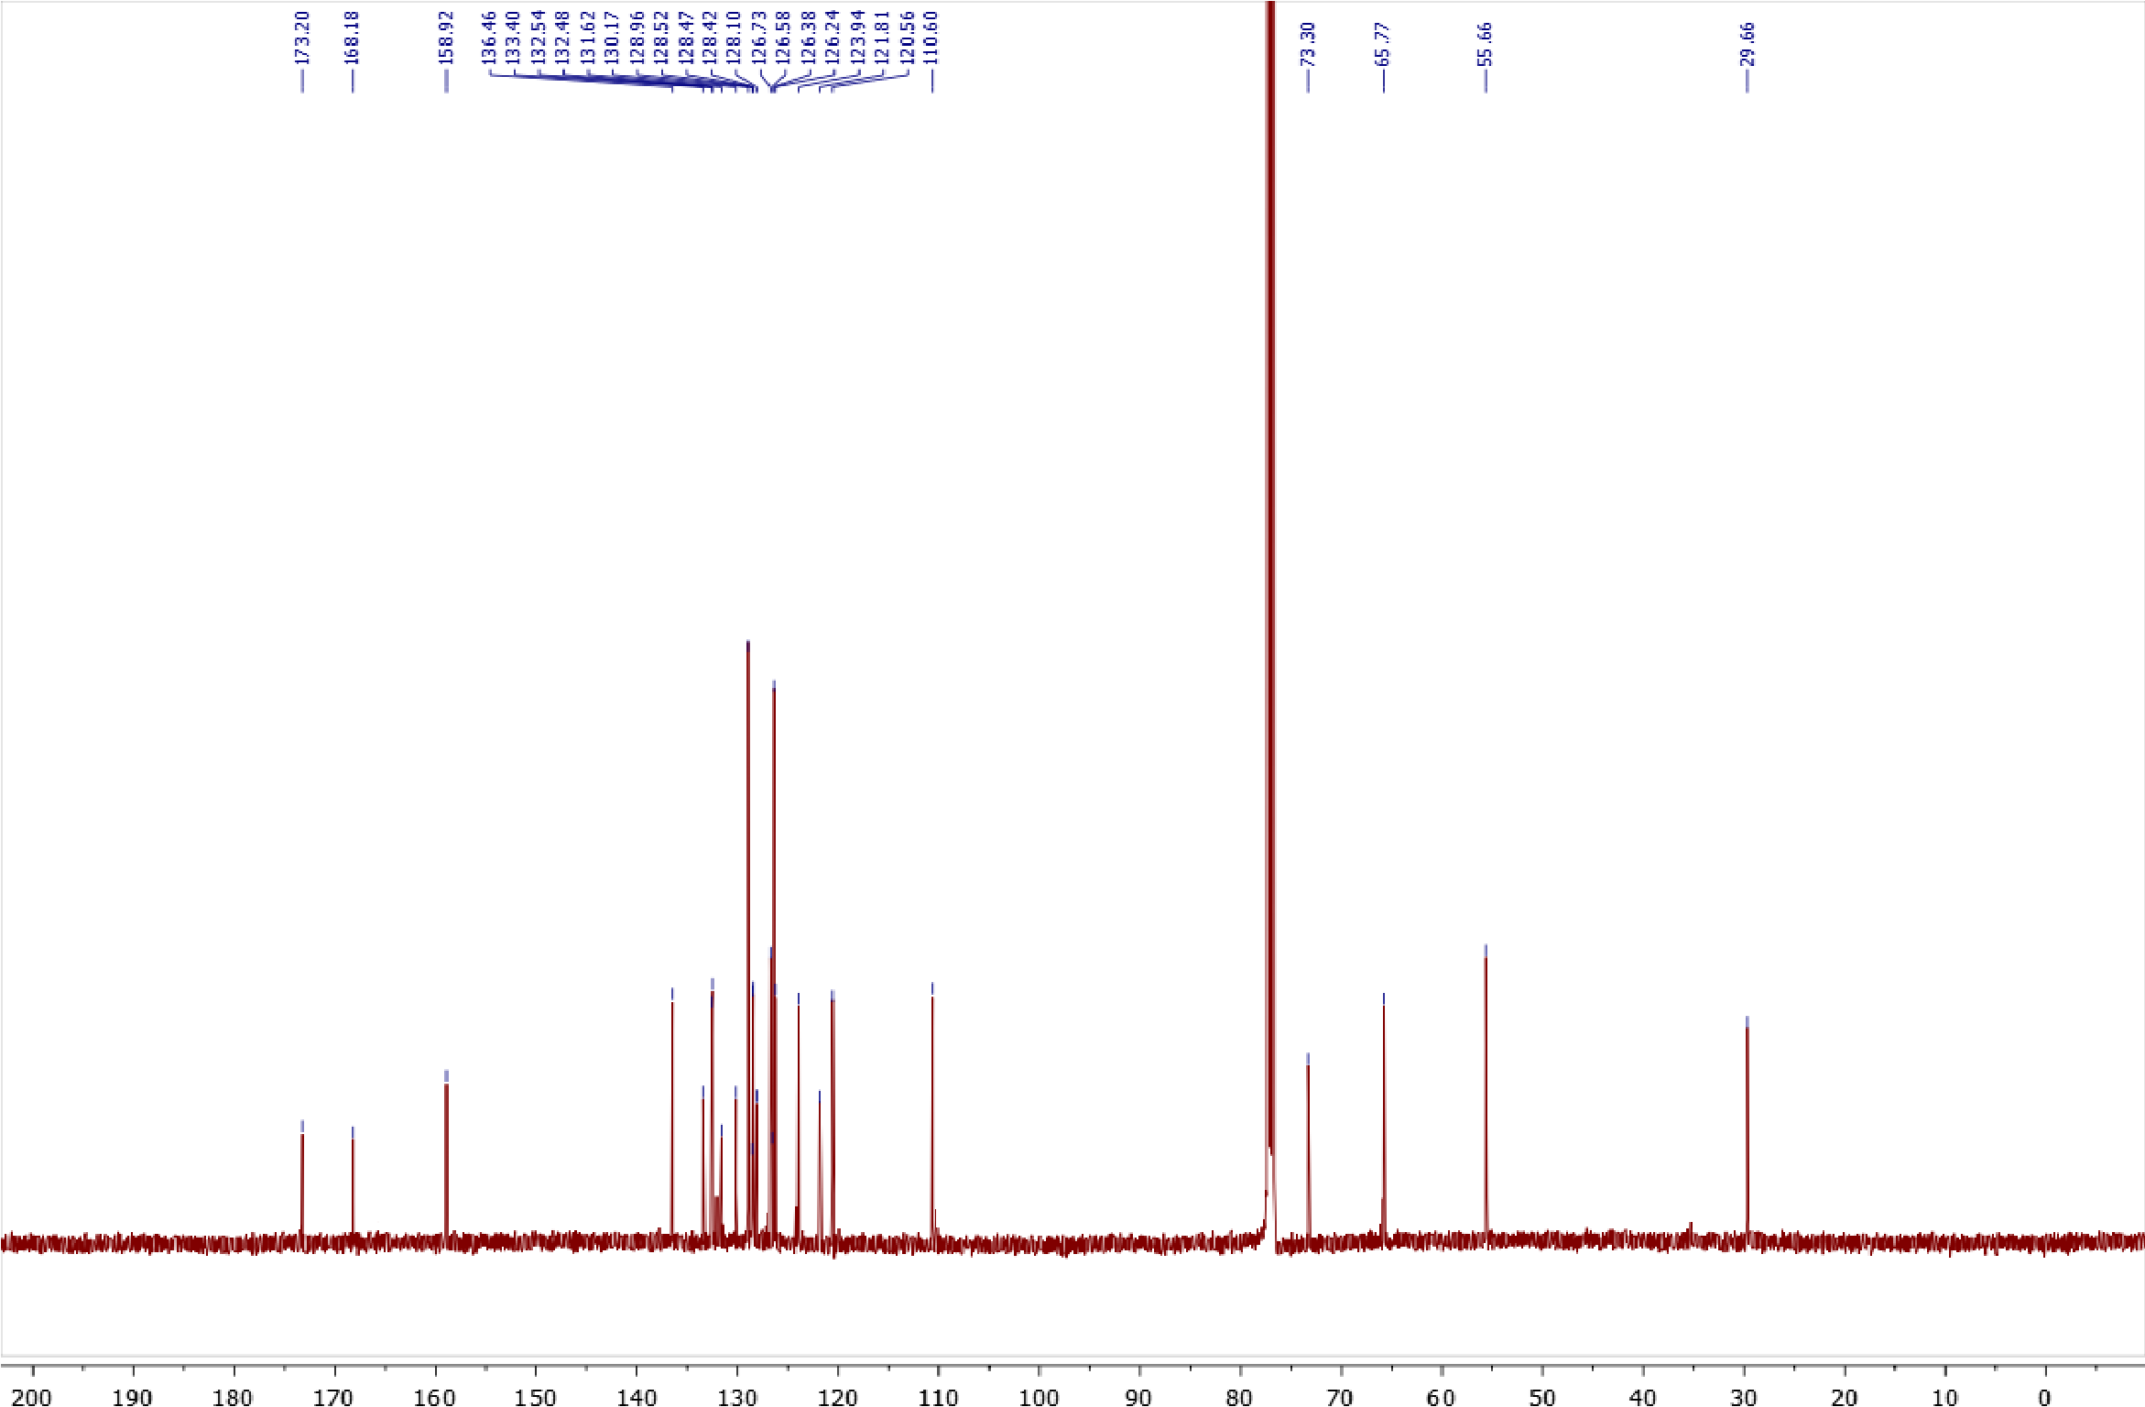
Copies of ¹H (400.13 MHz, CDCl₃) and ¹³C{¹H} (100.61 MHz, CDCl₃) spectra of 18
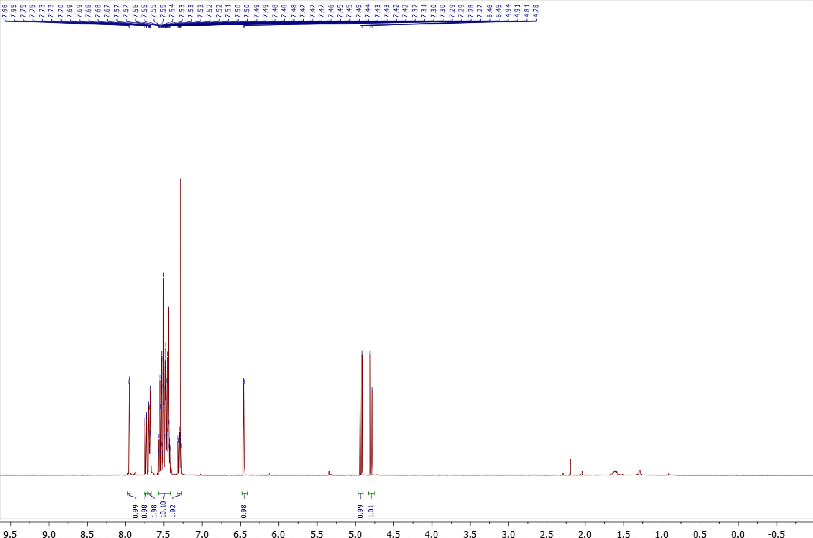
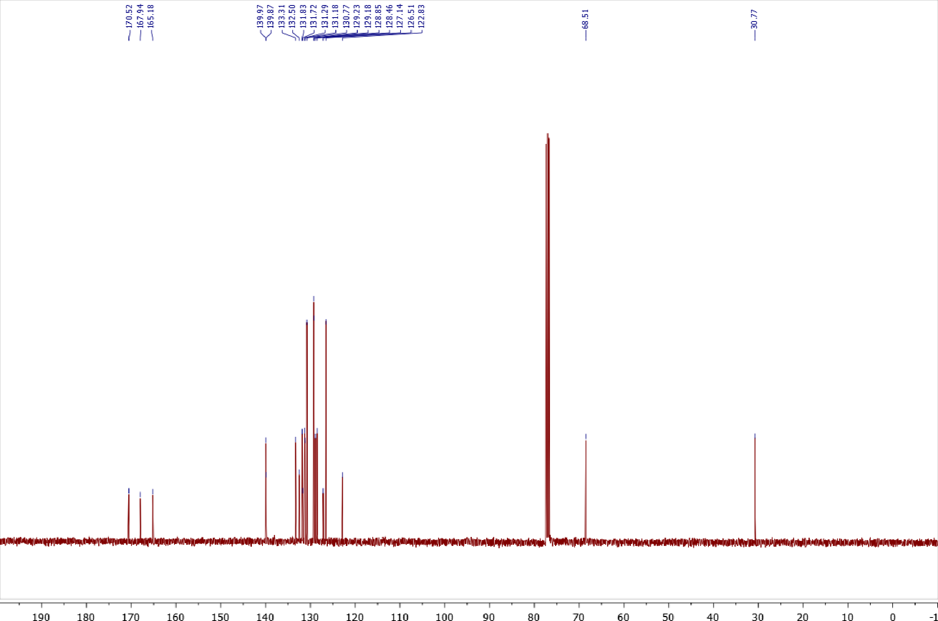

Copies of ¹H (400.13 MHz, CDCl₃) and ¹³C{¹H} (100.61 MHz, CDCl₃) spectra of 21
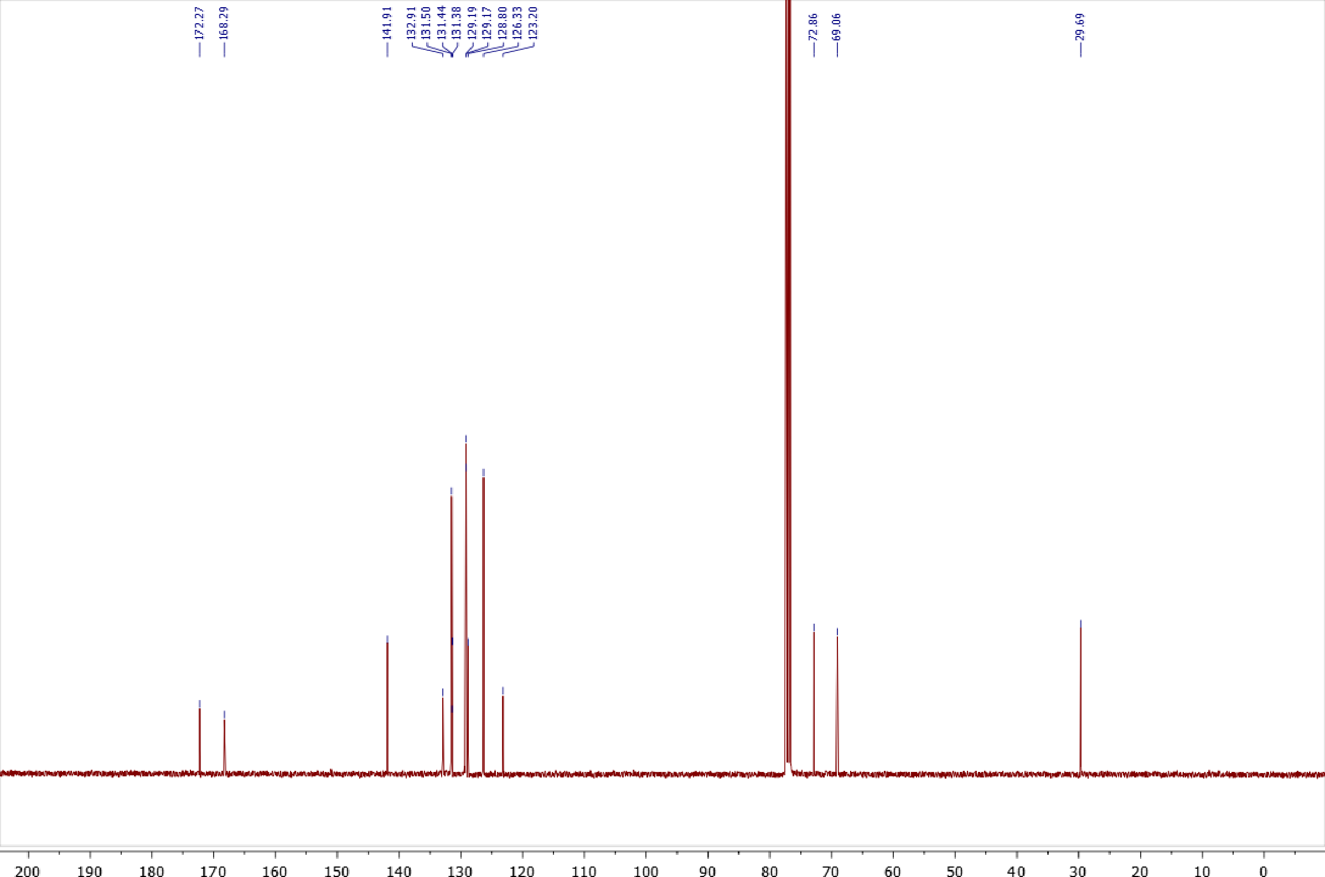
Copies of ¹H (400.13 MHz, CDCl₃) and ¹³C{¹H} (100.61 MHz, CDCl₃) spectra of 25
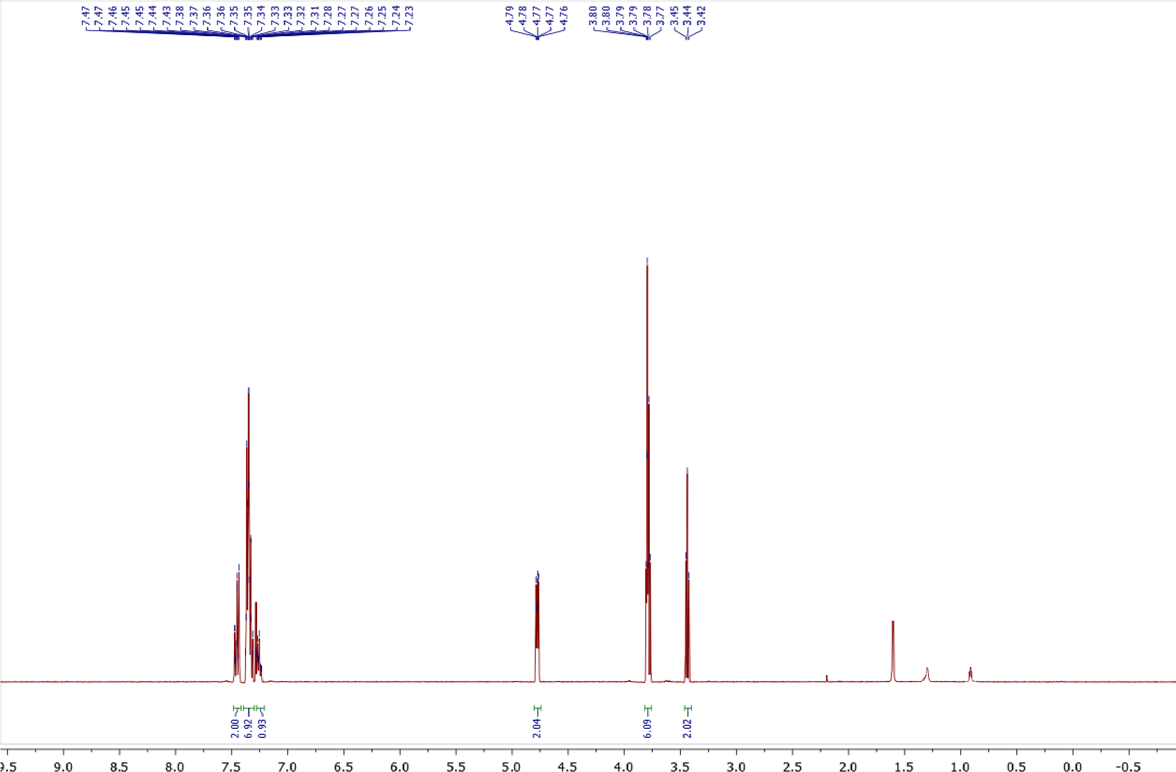
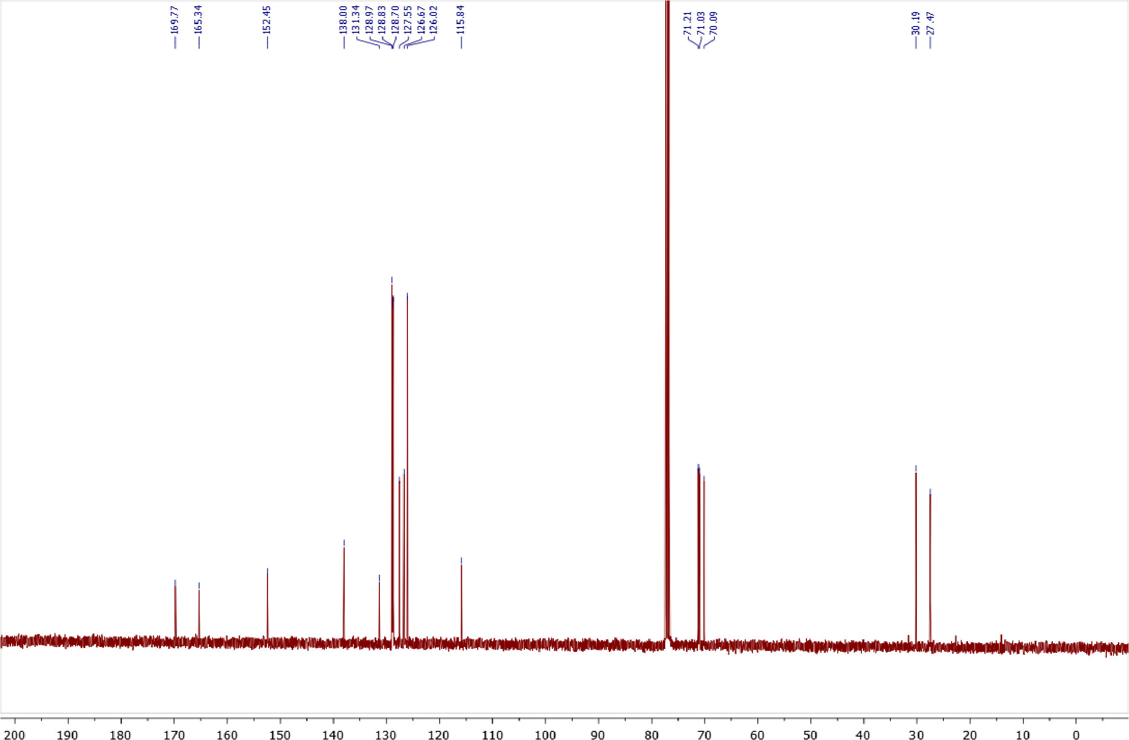

IV. X-ray crystallographic data
Crystallographic data for compounds 2a, 3b, and 4b. Single crystal X-Ray analysis was performed on a SuperNova, Single source at offset/far, HyPix3000 diffractometer (2a and 3b) and on a SuperNova, Dual, Cu at home/near, Atlas diffractometer (4b). Crystals were kept at 100(2) K during data collection. Using Olex2[5], the structures were solved with the SHELXT[6] structure solution program using Intrinsic Phasing and refined with the SHELXL[7] refinement package using Least Squares minimization. All hydrogen atoms were placed in accordance with neutron diffraction statistical data.[8]
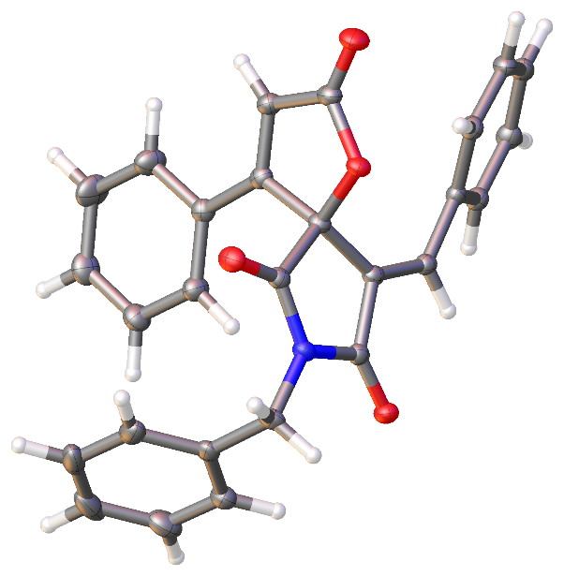

Figure S1. ORTEP representation of compound 2a (thermal ellipsoids are shown at 50% probability)
Table S1. Crystal data and structure refinement for 2a.
CCDC | 2295111
Empirical formula | C₂₇H₁₉NO₄
Formula weight | 421.43
Temperature/K | 100(2)
Crystal system | triclinic
Space group | P-1
a/Å | 9.6130(3)
b/Å | 9.7625(2)
c/Å | 12.5285(3)
α/° | 110.885(2)
β/° | 95.713(2)
γ/° | 106.391(2)
Volume/Å³ | 1027.26(5)
Z | 2
ρ_{calc}g/cm³ | 1.362
μ/mm⁻¹ | 0.745
F(000) | 440.0
Crystal size/mm³ | 0.2 × 0.18 × 0.12
Radiation | Cu Kα (λ = 1.54184)
2Θ range for data collection/° | 7.748 to 159.994
Index ranges | -12 ≤ h ≤ 12, -12 ≤ k ≤ 10, -15 ≤ l ≤ 15
Reflections collected | 12939
Independent reflections | 4299 [R_{int} = 0.0346, R_{sigma} = 0.0340]
Data/restraints/parameters | 4299/0/365
Goodness-of-fit on F² | 1.050
Final R indexes [I>=2σ (I)] | R₁ = 0.0399, wR₂ = 0.1052
Final R indexes [all data] | R₁ = 0.0426, wR₂ = 0.1086
Largest diff. peak/hole / e Å⁻³ | 0.25/-0.26
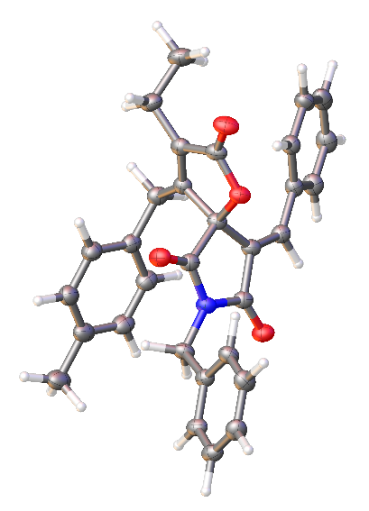

Figure S2. ORTEP representation of compound 3b (thermal ellipsoids are shown at 50% probability).
Table S2. Crystal data and structure refinement for 3b.
CCDC | 2308315
Empirical formula | C₃₁H₂₇NO₄
Formula weight | 477.53
Temperature/K | 100(2)
Crystal system | triclinic
Space group | P-1
a/Å | 9.5933(4)
b/Å | 10.4009(3)
c/Å | 13.1112(3)
α/° | 98.571(2)
β/° | 100.754(3)
γ/° | 101.537(3)
Volume/Å³ | 1235.45(7)
Z | 2
ρ_{calc}g/cm³ | 1.284
μ/mm⁻¹ | 0.679
F(000) | 504.0
Crystal size/mm³ | 0.12 × 0.08 × 0.04
Radiation | Cu Kα (λ = 1.54184)
2Θ range for data collection/° | 6.994 to 134.992
Index ranges | -11 ≤ h ≤ 11, -12 ≤ k ≤ 12, -14 ≤ l ≤ 15
Reflections collected | 10664
Independent reflections | 4453 [R_{int} = 0.0332, R_{sigma} = 0.0418]
Data/restraints/parameters | 4453/0/327
Goodness-of-fit on F² | 1.086
Final R indexes [I>=2σ (I)] | R₁ = 0.0540, wR₂ = 0.1578
Final R indexes [all data] | R₁ = 0.0596, wR₂ = 0.1633
Largest diff. peak/hole / e Å⁻³ | 0.35/-0.27
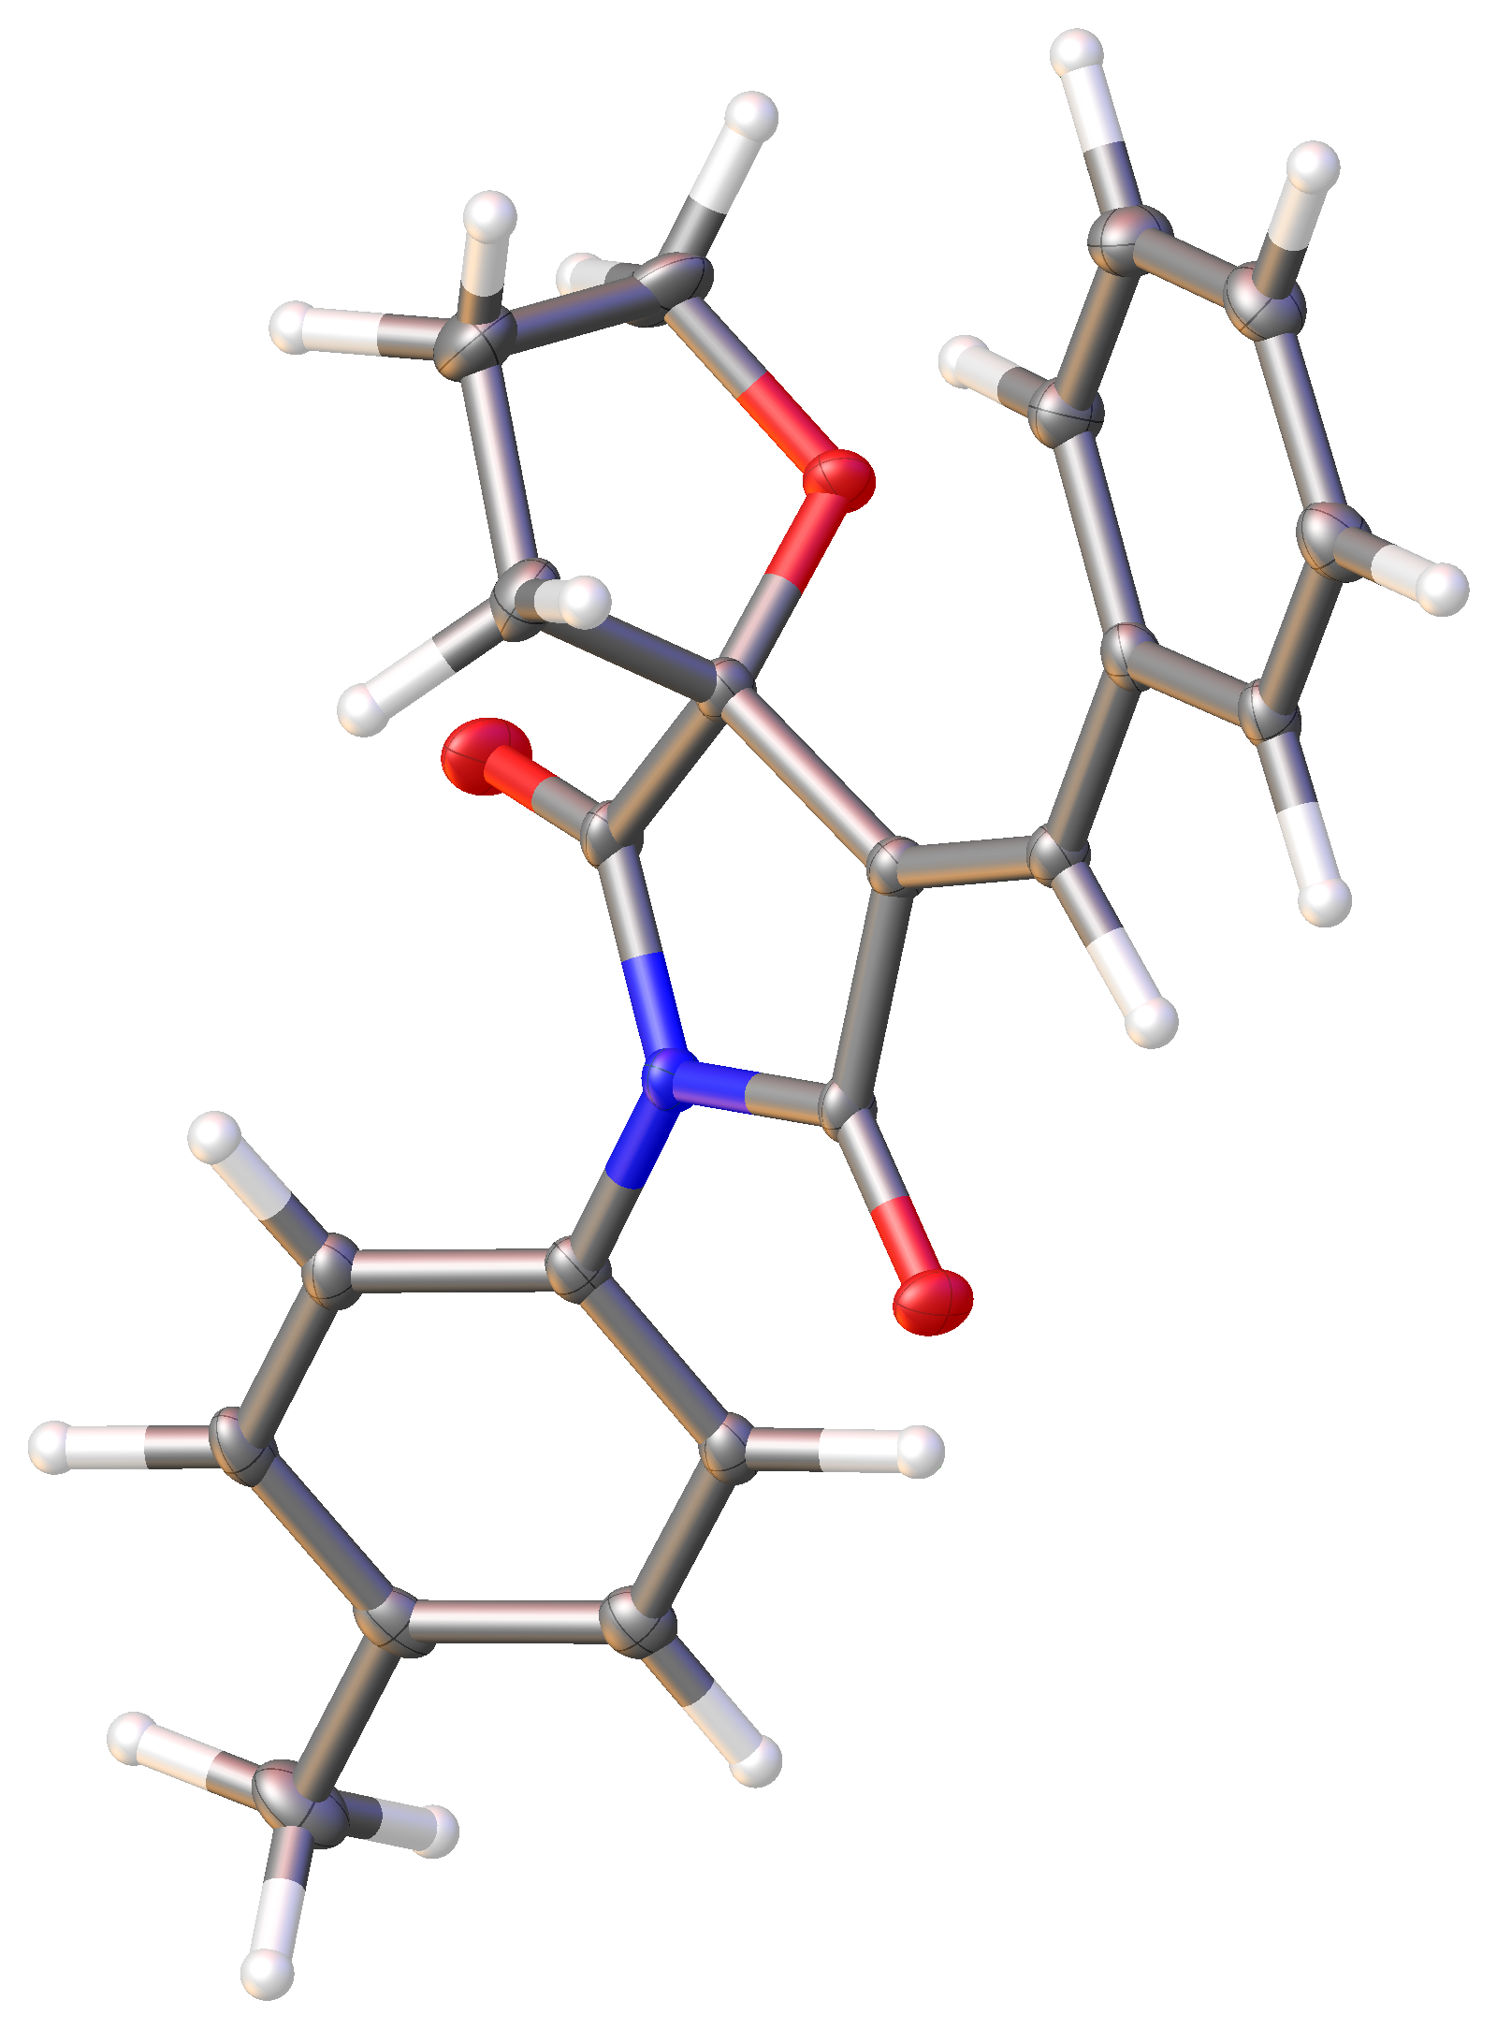

Figure S3. ORTEP representation of compound 4b (thermal ellipsoids are shown at 50% probability).
Table S3. Crystal data and structure refinement for 4b.
CCDC | 2305370
Empirical formula | C₂₁H₁₉NO₃
Formula weight | 333.37
Temperature/K | 100(2)
Crystal system | monoclinic
Space group | P2₁/c
a/Å | 6.8605(2)
b/Å | 19.2835(4)
c/Å | 12.6869(3)
α/° | 90
β/° | 98.215(2)
γ/° | 90
Volume/Å³ | 1661.18(7)
Z | 4
ρ_{calc}g/cm³ | 1.333
μ/mm⁻¹ | 0.719
F(000) | 704.0
Crystal size/mm³ | 0.7 × 0.19 × 0.13
Radiation | Cu Kα (λ = 1.54184)
2Θ range for data collection/° | 8.402 to 152.286
Index ranges | -8 ≤ h ≤ 8, -24 ≤ k ≤ 23, -13 ≤ l ≤ 15
Reflections collected | 11323
Independent reflections | 3419 [R_{int} = 0.0538, R_{sigma} = 0.0430]
Data/restraints/parameters | 3419/0/227
Goodness-of-fit on F² | 1.046
Final R indexes [I>=2σ (I)] | R₁ = 0.0470, wR₂ = 0.1240
Final R indexes [all data] | R₁ = 0.0547, wR₂ = 0.1318
Largest diff. peak/hole / e Å⁻³ | 0.37/-0.33

V. References
1. Chupakhin, E. G.; Kantin, G. P.; Dar’in, D. V.; Krasavin, M. Mendeleev Communications 2021, 31, 36-38.
2. Lindsell, W. E.; Palmer, D. D.; Preston, P. N.; Rosair, G. M.; Jones, R. V. H.; Whitton, A. J. Organometallics 2005, 24, 1119-1133.
3. McNulty, J.; Keskar, K. Organic & Biomolecular Chemistry 2013, 11, 2404-2407.
4. Koley, D.; Krishna, Y.; Srinivas, K.; Khan, A. A.; Kant, R. Angewandte Chemie International Edition 2014, 53, 13196-13200.
5. Dolomanov, O. V.; Bourhis, L. J.; Gildea, R. J.; Howard, J. A. K.; Puschmann, H. J. Appl. Crystallogr. 2009, 42, 339-341.
6. Sheldrick, G. Acta Crystallogr. A 2015, 71, 3-8.
7. Sheldrick, G. Acta Crystallogr. C 2015, 71, 3-8.
8. Allen, F. H.; Bruno, I. J. Acta Crystallogr. B 2010, 66, 380-386.

