Optimizations of Lipid II Synthesis: An Essential Glycolipid Precursor in Bacterial Cell Wall Synthesis and a Validated Antibiotic Target

Milandip Karak, Cian R. Cloonan, Brad R. Baker, Rachel V. K Cochrane, and Stephen A. Cochrane*

School of Chemistry and Chemical Engineering, Queen's University Belfast, David Keir Building, Stranmillis Road, Belfast, UK, BT9 5AG

*Address correspondence to the corresponding author:
Dr. Stephen A. Cochrane, Email: s.cochrane@qub.ac.uk
Table of Contents
General Experimental Information 4
Experimental Procedures and Characterization of Products 6
2-Deoxy-2-[[(2,2,2-trichloroethoxy)carbonyl]amino]-3,4,6-triacetyl-1-(2,2,2-trichloroethanimidate)-α-d-glucopyranose (1a) 6
2-(Acetoxymethyl)-5-(((2,2,2-trichloroethoxy)carbonyl)amino)-6-(2,2,2-trifluoro-1-(phenylimino)ethoxy)tetrahydro-2H-pyran-3,4-diyl diacetate (1b) 8
(2-(Acetoxymethyl)-5-(((2,2,2-trichloroethoxy)carbonyl)amino)-6-(2,2,2-trifluoro-1-(phenylimino)ethoxy)tetrahydro-2H-pyran-3,4-diyl diacetate (1c) 9
2-(Acetoxymethyl)-6-(p-tolylthio)-5-(((2,2,2-trichloroethoxy)carbonyl)amino) tetrahydro-2H-pyran-3,4-diyl diacetate (1d) 9
5-Acetamido-2-(acetoxymethyl)-6-(2,2,2-trichloro-1-iminoethoxy)tetrahydro-2H-pyran-3,4-diyl diacetate (1e) 10
5-Acetamido-2-(acetoxymethyl)-6-(phenylthio)tetrahydro-2H-pyran-3,4-diyl diacetate (1f) 12
5-Acetamido-2-(acetoxymethyl)-6-(2,2,2-trifluoro-1-(phenylimino)ethoxy)tetrahydro-2H-pyran-3,4-diyl diacetate (1g) 12
Alanine-2-(phenylsulfonyl)ethyl ester (S7) 14
N-Acetyl-1-O-(phenylmethyl)-4,6-O-(phenylmethylene)-α-d-muramic acid (S10) 15
Phenylmethyl-2-(acetylamino)-2-deoxy-3-O-[(1R)-1-methyl-2-[[(1S)-1-methyl-2-oxo-2-[2-(phenylsulfonyl)ethoxy]ethyl]amino]-2-oxoethyl]-4,6-O-[(R)-phenylmethylene]-α-d-glucopyranoside (S11) 16
Phenylmethyl-2-(acetylamino)-2-deoxy-3-O-[(1R)-1-methyl-2-[[(1S)-1-methyl-2-oxo-2-[2-(phenylsulfonyl)ethoxy]ethyl]amino]-2-oxoethyl]-6-O-(phenylmethyl)-α-d-glucopyranoside (2a) 17
Phenylmethyl-2-(acetylamino)-2-deoxy-3-O-[(1R)-1-methyl-2-[[(1S)-1-methyl-2-oxo-2-[2-(phenylsulfonyl)ethoxy]ethyl]amino]-2-oxoethyl]-6-O-(acetyl)-α-d-glucopyranoside (2b) 18
Phenylmethyl-2-(acetylamino)-2-deoxy-3-O-[(1R)-1-methyl-2-[[(1S)-1-methyl-2-oxo-2-[2-(phenylsulfonyl)ethoxy]ethyl]amino]-2-oxoethyl]-6-O-(phenylmethyl)-4-O-[3,4,6-tri-O-acetyl-2-deoxy-2-[[(2,2,2-trichloroethoxy)carbonyl]amino]-β-d-glucopyranosyl]-α-d-glucopyranoside (3a) 20
Phenylmethyl 2-(acetylamino)-2-deoxy-3-O-[(1R)-1-methyl-2-[[(1S)-1-methyl-2-oxo-2-[2-(phenylsulfonyl)ethoxy]ethyl]amino]-2-oxoethyl]-4-O-[3,4,6-tri-O-acetyl-2-(acetylamino)-2-deoxy-β-D-glucopyranosyl]-6-O-acetyl-α-d-glucopyranoside (4) 22
N-[N-Acetyl-6-O-acetyl-1-hydroxy-4-O-[3,4,6-tri-O-acetyl-2-(acetylamino)-2-deoxy-β-d-glucopyranosyl]-α-muramoyl]-l-alanine-2-(phenylsulfonyl)ethyl ester (5) 23
N-[N-Acetyl-6-O-acetyl-1-O-[bis(phenylmethoxy)phosphinyl]-4-O-[3,4,6-tri-O-acetyl-2-(acetylamino)-2-deoxy-β-d-glucopyranosyl]-α-muramoyl]-l-alanine-2-(phenylsulfonyl)ethyl ester (6) 24
Boc-d-Ala-d-Ala-OMe (S14) 26
Boc-Lys-d-Ala-d-Ala-OMe (S15) 26
H-γ-d-Glu(α-OMe)-Lys(TFA)-d-Ala-d-Ala-OMe trifluoroacetate salt (S16) 27
N-[N-Acetyl-6-O-acetyl-1-O-[bis(phenylmethoxy)phosphinyl]-4-O-[3,4,6-tri-O-acetyl-2-(acetylamino)-2-deoxy-β-d-glucopyranosyl]-α-muramoyl]-alanyl-d-γ-glutamyl-N6-(2,2,2-trifluoroacetyl)-lysyl-d-alanyl-d-alanyl-2,5-dimethyl ester (7) 29
Undecaprenol (S17) 30
Undecaprenyl phosphate bisammonium salt (Und-P, S18) 31
Farnesyl phosphate (S20) 33
Geranylgeranyl phosphate (S22) 33
Solanesyl phosphate (S24) 33
Lipid II diammonium salt (11) 34
Farnesyl lipid II analogue (8) 36
Geranylgeranyl lipid II analogue (9) 36
Solanesyl lipid II analogue (10) 36
References 37
Spectroscopic data of synthesized compounds 38

General Experimental Information
Solvents and Reagents
All experiments were conducted using flame-dried glassware under an inert atmosphere unless otherwise indicated. To safeguard against undesired reactions of air and moisture-sensitive reagents, they were introduced while maintaining the inert environment. Dry solvents were prepared by adding 20% w/v freshly activated 3 Å molecular sieves (MS) from HPLC grade solvents within an inert atmosphere, allowing them to stand for 24-48 hours. All remaining solvents and reagents were sourced directly from commercial suppliers.

Chromatography
Reactions were monitored through the use of thin-layer chromatography (TLC). We employed Merck Kieselgel 60 F254 silica plates with a particle size of 230-400 mesh for TLC. Visualization was achieved through staining with either aqueous potassium permanganate or phosphomolybdic acid solutions, or by employing UV light at wavelengths of 254 or 354 nm.

Spectroscopy
The ¹H- and ¹³C-Nuclear Magnetic Resonance (NMR) spectra were recorded at 400 MHz using a Bruker spectrometer with TopSpinTM software. The spectra are quoted in parts per million (ppm) relative to tetramethylsilane, and the samples were prepared by dissolving the material in CDCl₃, CD₃OD, or DMSO-d₆. The ¹H-, ¹³C-, and ³¹P-NMR spectra were acquired at 298 K and were processed and viewed using MestreNova. The chemical shifts (δ) are given in ppm and coupling constants (J) are given in Hertz (Hz). The multiplicity is abbreviated as app = apparent, br = broad, s = singlet, d = doublet, t = triplet, q = quartet, and m = multiplet. The ¹³C-NMR spectra are reported in δ / ppm. High-resolution mass spectra (HRMS) were recorded on a ToF mass spectrometer using the electrospray ionization (ESI) technique.

Purification of compounds using High-Performance Liquid Chromatography (HPLC)
After the final step, all lipid II analogues were purified by Reversed-Phase High-Performance Column Chromatography (RP-HPLC). Purification was performed on a Perkin Elmer HPLC system composed of a 200 series binary pump, UV/Vis detector, vacuum degasser, Rheodyne 7725i injector equipped with a 2 mL sample loop, and Phenomenex Luna C18 column (5 µm, 250 x 21.2 mm). The system was operated using ThermoFisher Chromeleon 7.2 software. Runs were performed at a flow rate of 10 mL/min with UV detection at 220 nm. Solvent A = 50 mM NH₄HCO₃ (aq), solvent B = MeOH. Gradient = 2 to 98 % B over 30 min, 98 % B for 10 min, 98 to 2 % B over 1 min and 2 % B for 4 min. Product-containing fractions were pooled, concentrated under vacuum to remove MeOH, frozen, and then lyophilized to yield pure lipid II analogues as white flocculent solids.

Experimental Procedures and Characterization of Products
Scheme S1. Synthesis of glycosyl donors 1a-d.

2-Deoxy-2-[[(2,2,2-trichloroethoxy)carbonyl]amino]-3,4,6-triacetyl-1-(2,2,2-trichloroethanimidate)-α-d-glucopyranose (1a)
Compound 1a was synthesized according to a previously reported procedure[1], with modifications. Initially, d-Glucosamine hydrochloride (S1, 20.0 g, 92.75 mmol) and sodium bicarbonate (15.6 g, 185.6 mmol) were dissolved in 240 mL of water and stirred vigorously for 5 minutes. Subsequently, 2,2,2-Trichloroethoxycarbonyl chloride (15.3 mL, 111.2 mmol) was added drop by drop, and the solution was stirred at room temperature for 2 hours, leading to the formation of a white precipitate. The suspension was filtered, washed with water, and co-evaporated with toluene (50 mLx3 times).
The resulting white powder was then dissolved in dry pyridine (150 mL) and acetic anhydride (75 mL) and stirred at room temperature for 18 hours. The reaction mixture was concentrated under vacuum and co-evaporated with toluene (50 mL×3 times). The oily residue obtained was dissolved in CHCl₃ (200 mL) and washed with 1 M HCl (100 mL). The aqueous phase was back-extracted with CHCl₃ (200 mL), and the combined organic extracts were washed with brine (100 mL). The organic phase was dried over anhydrous sodium sulfate and concentrated under vacuum, resulting in the formation of 1,3,4,6-tetra-O-acetyl-2-troc-d-glucosamine S2 as a white solid (26.2 g, 50.22 mmol).
Subsequently, compound S2 was dissolved in dry DMF (200 mL), and hydrazine acetate (5.56 g, 60.26 mmol) was added. The reaction mixture was stirred at room temperature for 40 minutes, then diluted with EtOAc (300 mL) and washed with water (300 mL), saturated sodium bicarbonate (200 mL), and water (200 mL). The combined aqueous phases were back-extracted with EtOAc (300 mL), and the combined organic extracts were washed with brine (200 mL), dried over anhydrous sodium sulfate, and concentrated under vacuum.
The resulting white solid was dissolved in CH₂Cl₂ (200 mL), and trichloroacetonitrile (50.3 mL, 502.2 mmol) was added. To this mixture, 1,8-Diazabicycloundec-7-ene (1.5 mL, 10 mmol) was introduced, and the reaction mixture was stirred at room temperature for 90 minutes. The crude reaction mixture was then purified via flash column chromatography (SiO₂, using a 2:1 hexane:EtOAc mixture with 0.1% triethylamine) to obtain product 1a as a light-yellow foam (48% yield over 4 steps). The spectroscopic data were in agreement with those previously reported.[1] ¹H-NMR (400 MHz, CDCl₃) δ 8.81 (s, 1H, acetimidate-NH), 6.43 (d, J = 3.6 Hz, 1H, H1), 5.36 (dd, J = 10.8, 9.5 Hz, H3), 5.29–5.19 (m, 2H, H4, Troc-NH), 4.76–4.68 (m, 2H, Troc-CH₂), 4.32–4.25 (m, 2H, H2 + H6), 4.17–4.09 (m, 2H, H5 + H6), 2.08 (s, 3H, 1 x Ac), 2.06 (s, 6H, 2 x Ac); ¹³C-NMR (100 MHz, CDCl₃) δ 171.1, 170.5, 169.3, 160.4, 154.1, 95.2, 94.5, 90.7, 74.7, 70.3, 67.4, 61.4, 53.9, 20.7, 20.6. HRMS (ESI) Calcd for C₁₇H₂₀N₂Cl₆O₁₀Na [M+Na]⁺ 644.9147, found 644.9172.

2-(Acetoxymethyl)-5-(((2,2,2-trichloroethoxy)carbonyl)amino)-6-(2,2,2-trifluoro-1-(phenylimino)ethoxy)tetrahydro-2H-pyran-3,4-diyl diacetate (1b)
Compound 1b was synthesized according to a previously reported procedure[2], with modifications. Dissolve Troc-protected 1,3,4,6-tetra-O-acetyl-d-glucosamine S2 (1 g, 2.08 mmol) in 20 mL of dry DMF, and add hydrazine acetate (212 mg, 2.08 mmol). Stir the reaction mixture at room temperature for 40 minutes. Next, dilute the mixture with 30 mL of EtOAc and wash it successively with 30 mL of water, 20 mL of saturated sodium bicarbonate, and 20 mL of water. The combined aqueous phases were back-extracted with 30 mL of EtOAc, and the combined organic extracts were washed with 20 mL of brine, dried using anhydrous sodium sulfate, and concentrated under vacuum. The resulting white solid was then dissolved in 50 mL of dry CH₂Cl₂, and (N-phenyl)-2,2,2-trifluoroacetimidoyl chloride (0.90 mL, 6.24 mmol) was added to the mixture. The reaction mixture was cooled to 0°C, and then1,8-Diazabicycloundec-7-ene (0.31 mL, 2.08 mmol) was added to it. Stir the reaction mixture at room temperature for 6 hours, and concentrate it under vacuum. The crude residue was purified by flash column chromatography using silica gel (SiO₂) with hexane:EtOAc (3:1) mixture to yield product 1b as a white solid (361 mg, 29% yield over 4 steps). The spectroscopic data were in agreement with those previously reported.[2] ¹H-NMR (400 MHz, CDCl₃) δ 7.35–7.28 (m, 2H, Ar-H), 7.17–7.10 (m, 1H, Ar-H), 6.82 (d, J = 7.7 Hz, 2H, Ar-H), 5.40–5.23 (m, 2H, H1 + H3), 5.14 (t, J = 9.5 Hz, 1H, H4), 4.81–4.68 (m, 2H, Troc-CH₂), 4.29 (dd, J = 12.7, 4.6 Hz, 1H, H6), 4.20–4.12 (m, 1H, H6’), 2.09 (s, 3H, Ac), 2.06 (s, 3H, AC), 2.03 (s, 3H, Ac). ¹³C-NMR (100 MHz, CDCl₃) δ 170.6, 169.3, 142.9, 128.9, 124.7, 119.2, 94.6, 76.7, 74.6, 72.9, 71.6, 68.0, 61.6, 55.3, 20.7, 20.6, 20.5. HRMS (ESI) Calcd for C₂₃H₂₅N₂Cl₃F₃O₁₀ [M+H]⁺ 651.0521, found 651.0436.

(2-(Acetoxymethyl)-5-(((2,2,2-trichloroethoxy)carbonyl)amino)-6-(2,2,2-trifluoro-1-(phenylimino)ethoxy)tetrahydro-2H-pyran-3,4-diyl diacetate (1c)
Compound 1c was synthesized according to a previously reported procedure[3], with modifications. Compound S2 (3.0 g, 5.75 mmol) was dissolved in 20 mL of anhydrous CH₂Cl₂. Then, thiophenol (0.88 mL, 8.62 mmol) and BF₃·OEt₂ (1.45 mL, 11.3 mmol) were added to the solution. Stir the reaction mixture at room temperature for 24 hours. Afterward, diluted the reaction mixture with 20 mL of CH₂Cl₂, then washed it with saturated NaHCO₃ solution (2 times x 20 mL), and dried it over MgSO₄. Filtered the mixture and concentrated it under vacuum. The resulting crude residue was purified through flash column chromatography on silica gel, using a gradient of 8:2 to 7:3 hexane:EtOAc, yielding product 1c as a white solid (1.51 g, 46% over 4 steps). The spectroscopic data were in agreement with those previously reported.[3] ¹H-NMR (400 MHz, CDCl₃) δ 7.56–7.48 (m, 2H, Ar-H), 7.31 (dd, J = 4.9, 1.9 Hz, 3H, Ar-H), 5.29 (t, J = 9.7 Hz, 1H, H1), 5.03 (t, J = 9.7 Hz, 1H, H3), 4.87 (d, J = 10.3 Hz, 1H, H4), 4.84–4.69 (m, 2H, Troc-CH₂), 4.20 (qd, J = 12.3, 3.9 Hz, 2H, H2 + H6), 3.78 – 3.64 (m, 2H, H5 + H6’), 2.08 (s, 3H, 1 x Ac), 2.01 (s, 6H, 2 x Ac). ¹³C-NMR (100 MHz, CDCl₃) δ 170.5, 169.4, 153.9, 133.0, 132.0, 129.0, 128.4, 95.4, 86.6, 75.9, 74.6, 73.2, 68.6, 62.3, 60.4, 55.2, 21.0, 20.7, 20.6, 20.5, 14.2. HRMS (ESI) Calcd for C₂₁H₂₄Cl₃NO₉SNa [M+Na]⁺ 594.0135, found 594.0123.

2-(Acetoxymethyl)-6-(p-tolylthio)-5-(((2,2,2-trichloroethoxy)carbonyl)amino) tetrahydro-2H-pyran-3,4-diyl diacetate (1d)
Compound 1d was synthesized according to a previously reported procedure[4], with modifications. Compound S2 (3 g, 5.75 mmol) was dissolved in anhydrous CH₂Cl₂ (20 mL). p-Toluenethiol (1.07 g, 8.62 mmol) and BF₃·OEt₂ (1.3 mL) were added, and the reaction mixture was stirred at room temperature for 24 h. Then, the reaction mixture was diluted with CH₂Cl₂ (20 mL), washed with saturated aqueous NaHCO₃ (2 x 20 mL), dried over MgSO₄, filtered, and concentrated under vacuum. The crude residue was purified by flash column chromatography on silica gel using a gradient of 8:2 to 7:3 hexane:EtOAc, yielding thioglycoside 1d as a white solid (1.65 g, 49% yield over 4 steps). The spectroscopic data were in agreement with those previously reported.[4] ¹H-NMR (400 MHz, CDCl₃) δ 7.45–7.38 (m, 2H, Ar-H), 7.12 (d, J = 7.9 Hz, 2H, Ar-H), 5.26 (td, J = 13.2, 11.4, 8.0 Hz, 2H, H1 + H3), 5.01 (t, J = 9.7 Hz, 1H, H4), 4.86 – 4.76 (m, 2H, Troc-CH2), 4.73 (d, J = 12.0 Hz, 1H, NH), 4.20 (qd, J = 12.3, 3.9 Hz, 2H, H6 + H6’), 3.74–3.59 (m, 2H, H5 + H2), 2.35 (s, 3H Tol-CH₃), 2.08 (s, 3H 1 x Ac), 2.00 (s, 6H 2 x Ac). ¹³C-NMR (100 MHz, CDCl₃) δ 170.6, 170.5, 169.4, 153.8, 138.7, 133.7, 129.7, 127.9, 95.4, 86.7, 75.8, 74.6, 73.2, 68.6, 62.3, 55.1, 21.2, 20.7, 20.6, 20.5. HRMS (ESI) Calcd for C₂₂H₂₆Cl₃NO₉SNa [M+Na]⁺ 608.0286, found: 608.0312.

Scheme S2. Synthesis of glycosyl donors 1e-g.

5-Acetamido-2-(acetoxymethyl)-6-(2,2,2-trichloro-1-iminoethoxy)tetrahydro-2H-pyran-3,4-diyl diacetate (1e)
Compound 1e was synthesized according to a previously reported procedure[5], with modifications. d-Glucosamine hydrochloride (S1, 20 g, 92.75 mmol) was dissolved in 150 mL of dry pyridine and 75 mL of acetic anhydride, and the mixture was stirred at room temperature for 18 hours. The resulting reaction mixture was concentrated under vacuum and co-evaporated with toluene (3x50 mL). The oily residue obtained was dissolved in 200 mL of CHCl₃ and washed with 100 mL of 1 M HCl. The aqueous phase was back-extracted with 200 mL of CHCl₃, and the combined organic extracts were washed with 100 mL of brine. After drying the organic phase with anhydrous sodium sulfate, it was concentrated under vacuum to yield 1,3,4,6-tetra-O-acetyl-2-acetyl-d-glucosamine S3 as a white solid.
Compound S3 (6 g, 15.41 mmol) was then dissolved in 40 mL of dry DMF, and hydrazine acetate (1.7 g, 18.4 mmol) was added to it. The reaction mixture was stirred at room temperature for 40 minutes, diluted with 100 mL of EtOAc, and washed with 100 mL of water, saturated sodium bicarbonate, and water. The combined aqueous phases were back-extracted with 100 mL of EtOAc, and the combined organic extracts were washed with 100 mL of brine. After drying with anhydrous sodium sulfate, the organic phase was concentrated under vacuum.
The resulting white solid was dissolved in 100 mL of CH₂Cl₂, and trichloroacetonitrile (15.5 mL, 154.1 mmol) was added to it. Then, 1,8-Diazabicycloundec-7-ene (0.46 mL, 3.08 mmol) was added, and the reaction mixture was stirred at room temperature for 90 minutes and concentrated under vacuum. The crude reaction mixture was purified via flash column chromatography on silica gel, using a 2:1 hexane:EtOAc mixture with 0.1% triethylamine, to obtain product 1e as a light-yellow foam (3.4 g, 45% yield in 3 steps). The spectroscopic data were in agreement with those previously reported.[5] ¹H-NMR (400 MHz, CDCl₃) δ 8.80 (s, 1H, acetimidate NH), 6.37 (d, J = 3.6 Hz, 1H, H1), 5.67 (d, J = 8.9 Hz, 1H, H3), 5.37–5.21 (m, 2H, H4 + NH), 4.56 (ddd, J = 10.5, 8.9, 3.7 Hz, 1H, H2), 4.25 (dd, J = 12.9, 4.7 Hz, 1H, H6), 4.12 (dq, J = 11.9, 2.5 Hz, 2H, H6’ + H5), 2.16–2.02 (m, 9H, 3 x Ac), 1.94 (s, 3H, Ac). ¹³C-NMR (100 MHz, CDCl₃) δ 171.6, 170.6, 170.0, 169.2, 160.3, 94.8, 75.6, 75.3, 75.0, 74.3, 74.0, 73.6, 70.7, 70.3, 67.3, 61.5, 51.8, 23.1, 20.8, 20.7, 20.6. HRMS (ESI) Calcd for C₁₆H₂₁N₂Cl₃O₉Na [M+Na]⁺ 513.0205, found 513.0218.

5-Acetamido-2-(acetoxymethyl)-6-(phenylthio)tetrahydro-2H-pyran-3,4-diyl diacetate (1f)
Compound 1f was synthesized according to a previously reported procedure[6], with modifications. Compound S3 (2 g, 5.14 mmol) was dissolved in 30 mL of anhydrous CH₂Cl₂. Then, thiophenol (0.80 mL, 7.71 mmol) and 1.3 mL of BF₃·OEt₂ were added to it. Stirred the reaction mixture at room temperature for 24 h. Following this, diluted the reaction mixture with 50 mL of CH₂Cl₂, then washed with saturated aqueous NaHCO₃ (2 x 50 mL), dried over MgSO₄, filtered, and concentrated under vacuum. Purified the compound by column chromatography using a gradient of 8:2 to 7:3 hexane:EtOAc, yielding thioglycoside 1f as a white solid (1.28 g, 57% in 2 steps). The spectroscopic data were in agreement with those previously reported.[6] ¹H-NMR (400 MHz, CDCl₃) δ 7.53–7.47 (m, 2H, Ar-H), 7.33–7.27 (m, 3H, Ar-H), 5.59 (d, J = 9.2 Hz, 1H), 5.22 (dd, J = 10.2, 9.4 Hz, 1H), 5.06 (dd, J = 10.0, 9.3 Hz, 1H), 4.85 (d, J = 10.4 Hz, 1H), 4.22 (dd, J = 12.2, 5.3 Hz, 1H), 4.17 (dd, J = 12.2, 2.6 Hz, 1H), 4.03 (td, J = 10.3, 9.1 Hz, 1H), 3.72 (ddd, J = 10.0, 5.3, 2.6 Hz, 1H), 2.08 (s, 3H, Ac), 2.02 (d, J = 2.6 Hz, 6H, 2 x Ac). ¹³C-NMR (100 MHz, CDCl₃) δ 171.0, 170.6, 170.0, 169.3, 132.5, 128.9, 128.1, 86.7, 75.9, 73.7, 68.4, 62.4, 53.5, 23.3, 20.8, 20.7, 20.6. HRMS (ESI) Calcd for C₂₀H₂₆NO₈S [M+H]⁺ 440.1374, found 440.1396.

5-Acetamido-2-(acetoxymethyl)-6-(2,2,2-trifluoro-1-(phenylimino)ethoxy)tetrahydro-2H-pyran-3,4-diyl diacetate (1g)
Compound 1g was synthesized according to a previously reported procedure[7], with modifications. Compound S3 (1 g, 2.57 mmol) was dissolved in dry DMF (10 mL), along with hydrazine acetate (284 mg, 3.08 mmol). The reaction mixture was stirred at room temperature for 40 minutes, then diluted with EtOAc (20 mL) and washed with water (20 mL), saturated sodium bicarbonate (10 mL), and water (20 mL). The combined aqueous phases were subsequently back-extracted with EtOAc (20 mL), and the combined organic extracts were washed with brine (20 mL), dried over anhydrous sodium sulfate, and concentrated under vacuum.
The resulting white solid was dissolved in dry CH₂Cl₂ (20 mL), and (N-phenyl)-2,2,2-trifluoroacetimidoyl chloride (1.22 mL, 7.71 mmol) was added after cooling the reaction mixture to 0°C. Then. 1,8-Diazabicycloundec-7-ene (0.31 ml, 2.08 mmol) was added, and the reaction mixture was stirred at room temperature for 12 hours, then concentrated under vacuum. The crude residue was purified by chromatography on silica gel, using a gradient of 8:2 to 3:2 hexane:EtOAc, resulting in the isolation of product 1g as a light-yellow solid (453 mg, 34% in 3 steps). The spectroscopic data were in agreement with those previously reported.[7] ¹H-NMR (400 MHz, CDCl₃) δ 7.36–7.28 (m, 2H, Ar-H), 7.18–7.10 (m, 1H, Ar-H), 6.81 (d, J = 7.8 Hz, 2H, Ar-H), 6.26 (s, 1H, NH), 5.74 (d, J = 8.8 Hz, 1H, H1 + H3), 5.34–5.17 (m, 2H, H4 + H2), 4.50 (t, J = 9.8 Hz, 1H), 4.25 (dd, J = 12.5, 4.5 Hz, 1H, H6), 4.10 (dd, J = 12.4, 2.3 Hz, 1H, H6’), 4.01 (d, J = 9.9 Hz, 1H, H5), 2.09 (s, 3H, AC), 2.06 (s, 6H, 2 x Ac), 1.97 (s, 3H, Ac). ¹³C-NMR (100 MHz, CDCl₃) δ 171.6, 170.5, 170.1, 169.1, 142.8, 128.9, 124.9, 119.3, 70.5, 70.0, 67.3, 61.5, 51.6, 49.8, 37.0, 30.3, 29.9, 29.7, 28.5, 23.4, 23.0, 20.7, 20.6, 20.5. HRMS (ESI) Calcd for C₂₂H₂₅F₃N₂O₉Na [M+Na]⁺ 541.1404, found 541.1398.

Scheme S3. Synthesis of alanine ester S7. Compound S7 was synthesized using our previously established synthetic method.[1]

Alanine-2-(phenylsulfonyl)ethyl ester (S7)
In an inert atmosphere, Boc-alanine (S4, 4.0 g, 21.1 mmol), 2-phenylsulfonylethanol (S5, 3.93 g, 21.1 mmol), 1-(3-Dimethylaminopropyl)-3-ethylcarbodiimide hydrochloride (4.1 g, 21.1 mmol), and 4-dimethylaminopyridine (258 mg, 0.21 mmol) were dissolved in 120 mL of dry CH₂Cl₂ and stirred at room temperature for 18 hours. The reaction mixture was subsequently treated with 1 M HCl (80 mL) and saturated NaHCO₃ (80 mL). Each aqueous phase was further extracted with CH₂Cl₂ (50 mL), and the combined organic extracts were washed with brine (100 mL). The organic extracts were then dried using anhydrous Na₂SO₄ and concentrated under reduced pressure. The resulting impure product underwent purification through silica gel column chromatography (3:7 EtOAc:hexane), resulting in the isolation of Boc-alanine ester S6 as a white solid. (5.97 g, 79%). ¹H-NMR (CDCl₃, 400 MHz) δ 7.95 – 7.89 (m, 2H, o-ArH), 7.72 – 7.65 (m, 1H, p-ArH), 7.63 – 7.55 (m, 2H, m-ArH), 4.87 (d, J = 2.8, BocNH), 4.46 (t, 2H, J = 5.8 Hz, O-CH₂), 4.05 (q, 1H, J = 6.7, 6.1 Hz, Ha); 3.46 (td, J = 6.1, 2.3, 2H, S-CH₂), 1.42 (s, 9H, Boc), 1.22 (d, J = 7.2 Hz, 3H, Hβ); ¹³C-NMR (CDCl₃, 100 MHz) δ 171.7, 154.0, 138.2, 133.1, 128.5, 127.1, 79.0, 57.2, 54.0, 48.0, 27.3, 17.2. Compound S6 was dissolved in 30 mL of CH₂Cl₂ and cooled to 0 ºC. Trifluoroacetic acid (30 mL) was gradually added, and the solution was allowed to warm to room temperature, where it was stirred for 2 h. The resulting solution, appearing in an orange hue, was then concentrated under reduced pressure, employing azeotropes with toluene (3 x 10 mL) to yield product S7 as a colourless oil in a quantitative yield.

Scheme S4. Synthesis of glycosyl acceptors 2a and 2b. Compound 2a was synthesized using our previously established synthetic method.[1]

N-Acetyl-1-O-(phenylmethyl)-4,6-O-(phenylmethylene)-α-d-muramic acid (S10)
Glycol S8 (10.0 g, 25.03 mmol) was suspended in 400 mL of dry dioxane under an argon atmosphere and stirred at 60 ºC. A 60% dispersion of NaH in mineral oil (2.0 grams, 50.06 millimoles) was added portion-wise, and the mixture was stirred for 5 minutes. Subsequently, S-2-chloropropionic acid (S9, 4.08 g, 37.55 mmol) was added, and the mixture was stirred at 60 ºC for an additional 10 minutes. Another portion of a 60% dispersion of NaH in mineral oil (5.0 grams, 125.15 millimoles) was added, and the mixture was stirred at 60 ºC for 16 hours. The reaction mixture was then cooled to room temperature, and 100 mL of water was slowly added with stirring. The dioxane was removed from the resulting yellow solution through concentration using vacuum. The resulting yellow solution was subjected to extraction with 150 mL of CHCl₃, cooled on ice water, acidified to a pH of 1 with 6 M HCl, and then extracted with CHCl₃ (3 x 150 mL). The combined organic extracts were washed with 200 mL of H₂O, dried over anhydrous Na₂SO₄, and concentrated under reduced pressure. The resulting yellow solid was washed with a mixture of hexane and diethyl ether (1:1, 50 mL x 3 times) to obtain product S10 as an off-white solid (7.68 g, 65%). ¹H-NMR (DMSO-d₆, 400 MHz) δ 12.92 (br s, 1H, COOH), 8.09 (br s, 1H, NHAc), 7.50-7.24 (m, 10H, Ar-H), 5.71 (s, 1H, PhCH), 5.05 (d, 1H, J = 3.4 Hz, H1), 4.70 (d, 1H, J = 12.4 Hz, PhCHH), 4.50 (d, 1H, J = 12.4 Hz, PhCHH), 4.28 (q, 1H, J = 6.9 Hz, Ala1-Hα), 4.15 (dd, 1H, J = 9.7, 3.8 Hz, H6), 3.83-3.67 (m, 4H, H6’ + H2 + H3 + H5), 1.85 (s, 3H, NHAc), 1.27 (d, J = 6.8 Hz, 3H, Ala1-Hβ). ¹³C-NMR (CDCl₃, 100 MHz) δ 175.7, 169.8, 138.1, 138.0, 129.3, 128.7, 128.6, 128.1, 128.0, 126.3, 100.7, 97.3, 82.0, 75.7, 75.5, 69.4, 68.3, 63.4, 54.0, 23.1, 19.2. HRMS (ESI) Calcd for C₂₅H₂₉NO₈Na [M+Na]⁺ 494.1791, found 494.1774.

Phenylmethyl-2-(acetylamino)-2-deoxy-3-O-[(1R)-1-methyl-2-[[(1S)-1-methyl-2-oxo-2-[2-(phenylsulfonyl)ethoxy]ethyl]amino]-2-oxoethyl]-4,6-O-[(R)-phenylmethylene]-α-d-glucopyranoside (S11)
Compound S10 (5.5 g, 11.66 mmol) was suspended in dry CH₂Cl₂ (80 mL) and cooled to 0 °C. NMM (1.28 mL, 11.66 mmol) and CDMT (2.46 g, 13.99 mmol) were added, and the resulting cloudy mixture was stirred at 0 °C for 45 minutes. A solution of amine S7 (3.3 g, 12.82 mmol) and NMM (1.28 mL, 11.66 mmol) in CH₂Cl₂ (80 mL) was then added, and the solution was stirred at room temperature. After 6 hours, DIPEA (2.3 mL, 23.32 mmol) was added to the reaction mixture and stirred overnight. The reaction mixture was subsequently filtered, and the filtrate was washed with 1M HCl (80 mL) and brine (100 mL), dried over anhydrous Na₂SO₄, and concentrated under reduced pressure. The resulting solid was subjected to azeotropic distillation with toluene (2 x 50 mL) and CHCl₃ (2 x 50 mL) to yield product S11 as a white solid (8.1 g, 98%). ¹H-NMR (CDCl₃, 400 MHz) δ 7.96-7.88 (m, 2H, ArH), 7.70-7.63 (m, 1H, ArH), 7.63-7.53 (m, 2H, ArH), 7.49-7.43 (m, 2H, ArH), 7.41-7.27 (m, 8H, ArH), 6.94 (d, J = 7.1 Hz, 1H, Ala1-NH), 6.19 (d, J = 9.0 Hz, 1H, AcNH), 5.57 (s, 1H, O₂CH), 4.95 (d, J = 3.8 Hz, 1H, H1), 4.71 (d, J = 11.8 Hz, 1H, PhCHH), 4.56 – 4.38 (m, 3H, PhCHH + OCH₂), 4.34-4.21 (m, 2H, H2 + H6), 4.16 (t, J = 7.2 Hz, 1H, Ala1-Hα), 4.07 (q, J = 6.7 Hz, 1H, OCH), 3.91-3.85 (m, 1H, H5), 3.80-3.64 (m, 3H, H6’ + H3 + H4), 3.49-3.34 (m, 2H, SCH₂), 1.93 (s, 3H, Ac), 1.37 (d, J = 6.8 Hz, 3H, MurNAc-CH₃), 1.30 (d, J = 7.3 Hz, 3H, Ala1-Hβ); ¹³C-NMR (CDCl₃, 100 MHz) δ 173.0, 171.8, 170. 5, 137.1, 136.7, 134.1, 129.5, 128.7, 128.4, 128.3, 128.2, 128.1, 125.9, 101.5, 97.6, 81.5, 78.5, 78.2, 70.2, 68.9, 63.2, 58.0, 55.0, 53.0, 48.0, 23.4, 19.4, 17.2. HRMS (ESI) Calcd for C₃₆H₄₂N₂NaO₁₁S [M+Na]⁺ 733.2402, found 733.2403.

Phenylmethyl-2-(acetylamino)-2-deoxy-3-O-[(1R)-1-methyl-2-[[(1S)-1-methyl-2-oxo-2-[2-(phenylsulfonyl)ethoxy]ethyl]amino]-2-oxoethyl]-6-O-(phenylmethyl)-α-d-glucopyranoside (2a)
Benzylidene S11 (8.00 g, 11.25 mmol) was initially dissolved in 100 mL of anhydrous CH₂Cl₂ and then cooled to 0°C. Following this, triethylsilane (8.98 mL, 56.27 mmol) was slowly added, and the solution was stirred for 5 minutes. Over 5 minutes, 4.31 mL of trifluoroacetic acid (56.27 mmol) was added, and the reaction mixture was maintained at 0°C for 6 h. Another portion of TFA (2.6 mL, 33.75 mmol) was added, and the reaction mixture was stirred for an additional 18 hours at 0°C. Subsequently, the reaction mixture was diluted with 100 mL of CH₂Cl₂ and washed with 100 mL of saturated aqueous NaHCO₃. The aqueous phase was then back-extracted using 2 x 100 mL of CH₂Cl₂, and the combined organic extracts were washed with 100 mL of brine. The organic phase was subsequently dried over anhydrous Na₂SO₄, followed by concentration under reduced pressure. The resulting crude product was further purified using column chromatography on silica gel, employing an eluent mixture of 8:2 to 10:0 EtOAc:hexane, resulting in the isolation of glycosyl acceptor 2a as a white solid (5.1 g, 63%) and S12 as an orange solid (1.1 g, 16%). Characteristic data for 2a: ¹H-NMR (CDCl₃, 400 MHz) δ 7.94-7.86 (m, 2H, ArH), 7.70-7.64 (m, 1H, ArH), 7.61-7.53 (m, 2H, ArH), 7.39-7.28 (m, 10H, ArH), 6.92 (d, J = 7.3 Hz, 1H, Ala1-NH), 6.07 (d, J = 9.0 Hz, 1H, MurNAc-NH), 4.92 (d, J = 3.6 Hz, 1H, H1), 4.70 (d, J = 11.7 Hz, 1H, OCHH), 4.65-4.53 (m, 2H, OCHH + OCHH), 4.49-4.36 (m, 3H, OCHH + OCH₂), 4.27-4.18 (m, 2H, H2 + Ala1-Hα), 4.14 (q, J = 6.7 Hz, 1H, MurNAc-OCH), 3.81 (dt, J = 9.2, 4.3 Hz, 1H, H5), 3.75 (dd, J = 10.2, 4.5 Hz, 1H, H6), 3.72-3.66 (m, 2H, H3 + H4), 3.53 (dd, J = 10.4, 8.6 Hz, 1H, H6), 3.47-3.33 (m, 2H, S-CH₂), 2.98 (d, J = 3.1, 1H, OH), 1.90 (s, 3H, NHAc), 1.41 (d, J = 6.7 Hz, 3H, MurNAc-CH₃), 1.31 (d, J = 7.2 Hz, 3H, Ala1-Hβ); ¹³C-NMR (CDCl₃, 100 MHz) δ 173.0, 171.9, 170.3, 139.1, 137.8, 137.0, 134.1, 129.5, 128.6, 128.5, 128.2, 128.1, 127.8, 127.7, 97.1, 80.5, 77.8, 73.7, 71.6, 70.4, 70.2, 69.9, 58.0, 54.9, 52.5, 47.9, 23.4, 19.0, 17.1. HRMS (ESI) Calcd for C₃₆H₄₄N₂O₁₁SNa [M+Na]⁺ 735.2558, found 735.2566. Characteristic data for S12: : ¹H-NMR (CDCl₃, 400 MHz) δ 7.93-7.89 (m, 2H, Ar-H), 7.70-7.65 (m, 1H, Ar-H), 7.61-7.56 (m, 2H, Ar-H), 7.36-7.28 (m, 5H, Ar-H), 7.11 (d, J = 7.3 Hz, 1H, Ala-NH), 6.47 (d, J = 8.2 Hz, 1H, AcNH), 4.95 (d, J = 3.6 Hz, 1H, H1), 4.68 (d, J = 11.8 Hz, 1H, H8), 4.48-4.32 (m, 3H, H8’ + H15 + H15’), 4.31-4.20 (m, 2H, H6 + H6’), 4.15 (ddd, J = 10.4, 8.6, 3.6 Hz, 1H, H9), 3.89-3.54 (m, 6H, H3 + H4 + H5 + H2 ), 3.49-3.31 (m, 2H, H16 + H16’), 1.92 (s, 3H, NHAc), 1.40 (d, J = 6.7 Hz, 3H, H11), 1.31 (d, J = 7.3 Hz, 3H, H10); ¹³C-NMR (CDCl₃, 100 MHz) δ 173.5, 172.1, 170.7, 139.1, 137.1, 134.2, 129.5, 128.6, 128.2, 128.1, 128.0, 97.1, 79.9, 77.2, 72.0, 70.1, 69.7, 61.9, 58.1, 54.9, 52.7, 47.9, 23.3, 19.2, 17.0. HRMS (ESI) Calcd for C₂₉H₃₉N₂O₁₁S [M+H]⁺ 623.2269, found 623.2298.

Phenylmethyl-2-(acetylamino)-2-deoxy-3-O-[(1R)-1-methyl-2-[[(1S)-1-methyl-2-oxo-2-[2-(phenylsulfonyl)ethoxy]ethyl]amino]-2-oxoethyl]-6-O-(acetyl)-α-d-glucopyranoside (2b)
800 mg (1.29 mmol) of diol S12 was dissolved in 20 mL of anhydrous CH₂Cl₂ and cooled to -40°C. Subsequently, 0.1 mL of pyridine (1.29 mmol) was added, and the solution was stirred for 5 minutes, after which 0.09 mL of acetyl chloride (1.29 mmol) was added dropwise. The reaction mixture was allowed to stir for 40 minutes at the same temperature. Following this, the reaction mixture was diluted with 20 mL of CH₂Cl₂ and washed with 20 mL of saturated aqueous NaHCO₃. The aqueous phase underwent back-extraction with 2 x 10 mL of CH₂Cl₂, and the combined organic extracts were further washed with 20 mL of brine. After drying over anhydrous Na₂SO₄, the organic phase was concentrated under reduced pressure. The resulting crude product was subsequently purified through column chromatography using silica gel with an eluent mixture ranging from 3:7 to 3:2 EtOAc:hexane, yielding glycosyl acceptor 2b as a white solid (780 mg, 73%). The spectroscopic data were in agreement with those previously reported.[8] ¹H-NMR (CDCl₃, 400 MHz) δ 7.93-7.90 (m, 2H, Ar-H), 7.71-7.67 (m, 1H, Ar-H), 7.61-7.57 (m, 2H, Ar-H), 7.38-7.30 (m, 5H, Ar-H), 6.92 (d, J = 7.4 Hz, 1H, Ala-NH), 6.13 (d, J = 9.0 Hz, 1H, AcNH), 4.93 (d, J = 3.7 Hz, 1H, H1), 4.69 (d, J = 11.7 Hz, 1H, H8), 4.54-4.39 (m, 4H, H8’ + H15 + H15’ + H9), 4.30-4.09 (m, 5H, H3 + H4 + H5 + H2), 3.80 (ddd, J = 9.6, 3.8, 2.1, 1H), 3.59-3.33 (m, 5H, + H16 + H16’), 3.15 (d, J = 4.0 Hz, 1H), 2.13 (s, 3H OAc), 1.92 (s, 3H, NHAc), 1.42 (d, J = 6.8 Hz, 3H, H13), 1.33 (d, J = 7.2 Hz, 3H, H10); ¹³C-NMR (CDCl₃, 100 MHz) δ 172.6, 171.9, 171.8, 170.4, 139.1, 136.9, 134.2, 129.5, 128.7, 128.3, 128.2, 128.1, 97.3, 80.0, 77.9, 70.5, 70.1, 69.7, 63.0, 58.0, 54.9, 52.6, 47.9, 23.4, 20.9, 19.0, 17.1 HRMS (ESI) Calcd for C₃₁H₄₁N₂O₁₂S [M+H]⁺ 665.2375, found 665.2346.

Scheme S5. Optimized glycosylation reaction 3a.

Phenylmethyl-2-(acetylamino)-2-deoxy-3-O-[(1R)-1-methyl-2-[[(1S)-1-methyl-2-oxo-2-[2-(phenylsulfonyl)ethoxy]ethyl]amino]-2-oxoethyl]-6-O-(phenylmethyl)-4-O-[3,4,6-tri-O-acetyl-2-deoxy-2-[[(2,2,2-trichloroethoxy)carbonyl]amino]-β-d-glucopyranosyl]-α-d-glucopyranoside (3a)
25 g of 4 Å molecular sieves were placed in a round-bottomed flask and heated under vacuum using a heat gun for 5 minutes before cooling to ambient temperature. The flask was then depressurized with argon and directly employed in the subsequent reaction. A solution of acceptor 1a (3.0 g, 4.2 mmol) in dry CH₂Cl₂ (50 mL) was added into this flask under an argon atmosphere, and the suspension was gently stirred. TMSOTf (0.91 mL, 5.04 mmol) was added, followed by a solution of acetimidate donor 2a (7.9 g, 12.6 mmol) in dry CH₂Cl₂ (50 mL). The resulting suspension was stirred at 0 °C for 3 hours. Subsequently, another portion of donor 2a (5.25 g, 8.4 mmol) and TMSOTf (0.76 mL, 4.2 mmol) were added, and the reaction continued to be stirred for an additional 3 hours at 0 °C. Then, the reaction mixture was filtered, and the filtrate was diluted with CH₂Cl₂ (100 mL). The organic part was washed with 100 mL of saturated sodium bicarbonate and 100 mL of brine and then dried over anhydrous sodium sulfate. The crude was concentrated under vacuum and subjected to purification through column chromatography using silica gel with a gradient eluent mixture of 3:2 EtOAc:hexane to yield product 3a in the form of a white foam (3.3 g, 68%). The spectroscopic data were in agreement with our previously reported data.[1] ¹H-NMR (CDCl₃, 400 MHz) δ 7.95-7.88 (m, 2H, ArH), 7.69-7.63 (m, 1H, ArH), 7.59-7.41 (m, 6H, ArH), 7.37-7.24 (m, 6H, ArH), 6.89 (d, J = 7.5 Hz, 1H, Ala1NH), 6.66 (d, J = 7.3 Hz, 1H, MurNAc-NH), 5.11 (d, J = 3.6 Hz, 1H, MurNAc-H1), 4.98 (t, J = 9.6 Hz, 1H, GlcNAc-H4), 4.87 (d, J = 11.9 Hz, 1H, MurNAc-1-CHHPh), 4.81-4.74 (m, 2H, GlcNAc-H3 + Troc-CHH), 4.64-4.55 (m, 2H, Troc-CHH + MurNAc-6-CHHPh), 4.49-4.30 (m, 4H, OCHH + MurNAc-6-CHHPh + OCHH + MurNAc-1-CHHPh), 4.27–4.06 (m, 5H, MurNAc-H2 + MurNAc-CHO + GlcNAc-H1 + GlcNAc-H6 + Ala1Hα), 3.98 (dd, J = 12.3, 2.2 Hz, 1H, GlcNAc-H6), 3.92 (t, J = 9.5 Hz, 1H, MurNAc-H3), 3.71-3.52 (m, 3H, MurNAc-H6 + MurNAc-H4 + MurNAc-H5), 3.47-3.37 (m, 4H, CH₂S + GlcNAc-H2 + GlcNAc-H5), 2.06 – 1.94 (m, 9H, 3 x Ac), 1.90 (s, 3H, Ac), 1.34 (d, J = 6.7 Hz, 3H, Ala1Hβ), 1.27-1.23 (m, 3H, MurNAc-CH₃). ¹³C-NMR (CDCl₃, 100 MHz) δ 173.5, 171.8, 170.7, 170.4, 170.3, 169.4, 154.2, 139.2, 137.4, 137.2, 134.1, 129.4, 129.3, 129.1, 129.0, 128.5, 128.1, 128.0, 99.9, 97.1, 95.6, 77.5, 77.3, 76.6, 75.6, 74.4, 73.7, 72.1, 71.2, 70.4, 70.2, 68.3, 67.2, 61.4, 58.1, 56.2, 54.9, 53.6, 47.7, 23.2, 20.6, 20.6, 18.3, 17.4; HRMS (ESI) Calcd for C₅₁H₆₂Cl₃N₃O₂₀SNa [M+Na]⁺ 1196.2604, found 1196.2579.

Scheme S6. Synthesis of GlcNAc-MurNAc disaccharide phosphate core 6. Compound 6 was synthesized using our previously established synthetic method.[1]

Phenylmethyl 2-(acetylamino)-2-deoxy-3-O-[(1R)-1-methyl-2-[[(1S)-1-methyl-2-oxo-2-[2-(phenylsulfonyl)ethoxy]ethyl]amino]-2-oxoethyl]-4-O-[3,4,6-tri-O-acetyl-2-(acetylamino)-2-deoxy-β-D-glucopyranosyl]-6-O-acetyl-α-d-glucopyranoside (4)
The Troc-disaccharide 3a (2.0 g, 1.70 mmol) was dissolved in Ac₂O (9 mL) and AcOH (4 mL), and to this solution, a solution of anhydrous ZnCl₂ (2.3 g, 17.0 mmol) in Ac₂O (4 mL) and AcOH (2 mL) was added. The reaction mixture was stirred for 24 hours at room temperature, after which zinc dust (4.45 g, 68.0 mmol) and a mixture of THF (18 mL), Ac₂O (10 mL), and AcOH (5 mL) were added. The reaction mixture was further stirred for 24 h at room temperature, filtered through celite, washed with 200 mL of EtOAc, and concentrated under reduced pressure. The resulting residue was co-evaporated with toluene (2 x 30 mL) and re-dissolved in EtOAc (200 mL). The organic layer was washed with saturated sodium bicarbonate (2 x 10 mL), which was then back-extracted with EtOAc (100 mL). The combined organic phases were washed with 100 mL of water and 100 mL of brine, dried over anhydrous Na₂SO₄, and concentrated under reduced pressure. The crude product underwent purification by silica gel column chromatography using an eluent mixture of EtOAc:MeOH ranging from 100:0 to 98:2, resulting in the isolation of product 4 as a white foam (1.27 grams, 75% yield). ¹H-NMR (CDCl₃, 400 MHz) δ 7.92-7.86 (m, 2H, o-ArH), 7.71-7.63 (m, 1H, p-ArH), 7.61-7.54 (m, 2H, m-ArH), 7.36-7.27 (m, 5H, ArH), 7.20 (d, J = 7.6 Hz, 1H, MurNAc-NH), 6.88 (d, J = 6.8 Hz, 1H, Ala1NH), 6.10 (d, J = 9.5 Hz, 1H, GlcNAc-NH), 5.16-5.09 (m, 2H, MurNAc-H1 + GlcNAc-H3), 4.65 (d, J = 12.1 Hz, 1H, MurNAc-1-CHHPh), 4.50 (d, J = 12.1 Hz, 1H, MurNAc-1-CHHPh), 4.45-4.24 (m, 7H, OCH₂ + MurNAc-CHO + GlcNAc-H1 + GlcNAc-H6 + MurNAc-H6 2H), 4.16 (d, J = 12.0 Hz, 1H, GlcNAc-H6), 4.11-3.96 (m, 3H, GlcNAc-H2 + MurNAc-H2 + MurNAc-H3), 3.78 (d, J = 5.2 Hz, MurNAc-H5), 3.63-3.49 (m, 2H, GlcNAc-H5 + MurNAc-H4), 3.40-3.30 (m, 2H, CH₂S), 2.15 (s, 3H), 2.03 (s, 3H), 2.02 (s, 3H), 2.01 (s, 3H), 1.96 (s, 3H), 1.94 (s, 3H), 1.37 (d, J = 6.6 Hz, 3H, MurNAc-CH₃), 1.29 (d, J = 7.2 Hz, 3H, Ala1Hβ); ¹³C-NMR (CDCl₃, 400 MHz) δ 173.8, 171.9, 171.3, 170.9, 170.8, 170.6, 170.6, 169.3, 139.2, 137.3, 134.1, 129.4, 128.5, 128.1, 128.0, 127.9, 100.3, 96.9, 76.0, 75.6, 72.5, 71.9, 70.3, 69.5, 68.1, 62.3, 61.6, 58.0, 54.9, 54.6, 53.6, 47.9, 23.2, 23.2, 21.0, 20.6, 20.6, 20.6, 18.4, 17.3. HRMS (ESI) Calcd for C₄₅H₆₀N₃O₂₀S [M+H]⁺ 994.3491, found 994.3489.

N-[N-Acetyl-6-O-acetyl-1-hydroxy-4-O-[3,4,6-tri-O-acetyl-2-(acetylamino)-2-deoxy-β-d-glucopyranosyl]-α-muramoyl]-l-alanine-2-(phenylsulfonyl)ethyl ester (5)
Conditions A: The benzylated sugar 4 (1.1 g, 1.11 mmol) was dissolved in a mixture of 32 mL of THF and 8 mL of MeOH, and the solution was degassed using an argon balloon. Then, 10% palladium on charcoal (2.3 g, 2.22 mmol) was portion-wise added to the solution. The reaction mixture was stirred under a hydrogen balloon at room temperature and atmospheric pressure overnight and subsequently filtered through a thin layer of celite. The celite was washed with 2 x 50 mL of MeOH, and the filtrate was concentrated under reduced pressure. The resulting solid was washed with a mixture of ether and hexanes (1:2) and dried under reduced pressure to obtain lactol 5 as a white solid (960 mg, 96%).
Conditions B: The benzylated sugar 4 (0.11 grams, 0.11 mmol) was first dissolved in 2 mL of ethyl acetate, and then a solution of NaBrO₃ (17 mg, 0.9 mmol) in 1 mL of water was added. To the vigorously stirred two-phase system, an aqueous solution of Na₂S₂O₄ (15 mg, dissolved in 1 mL of water) was added dropwise over 2 minutes at room temperature. Upon completion of the reaction, the reaction mixture was diluted with ethyl acetate, and the organic phase was washed with an aqueous solution of sodium thiosulfate. The crude product was subsequently purified through silica gel chromatography to obtain 5 as a white solid (51 mg, 51%). ¹H-NMR (DMSO-d₆, 400 MHz) δ 8.40 (d, J = 5.9 Hz, 1H, MurNAc-NH), 8.16-8.06 (m, 2H, Ala1NH and GlcNAc-NH), 8.03-7.94 (m, 2H, o-ArH), 7.88-7.79 (m, 1H, p-ArH), 7.78-7.68 (m, 2H, m-ArH), 6.81 (d, J = 4.6 Hz, 1H, MurNAc-OH), 5.27 (t, J = 9.9 Hz, 1H), 5.16 (t, J = 3.5 Hz, 1H), 4.96 (t, J = 9.8 Hz, 1H), 4.74 (d, J = 8.2 Hz, 1H), 4.53-4.25 (m, 5H), 4.14-3.99 (m, 3H), 3.93-3.76 (m, 5H), 3.72 (t, J = 9.3 Hz, 1H), 3.60-3.53 (m, 1H), 3.49-3.42 (m, 2H), 2.12 (s, 3H), 2.03 (s, 3H), 2.00 (s, 3H), 1.97 (s, 3H), 1.84 (m, 3H), 1.83 (s, 3H), 1.32 (d, J = 6.7 Hz, 3H, MurNAc-CH₃), 1.15 (d, J = 7.2 Hz, 3H, Ala1Hβ); ¹³C-NMR (DMSO-d₆, 100 MHz) δ 174.4, 172.0, 170.5, 170.4, 170.1, 170.0, 169.9, 169.8, 139.8, 134.5, 129.9, 128.2, 100.1, 90.2, 77.2, 76.3, 75.4, 72.9, 70.8, 68.9, 68.5, 63.0, 62.1, 58.6, 54.6, 54.5, 54.2, 47.7, 23.2, 23.1, 21.2, 20.9, 20.8, 20.8, 19.1, 17.2.

N-[N-Acetyl-6-O-acetyl-1-O-[bis(phenylmethoxy)phosphinyl]-4-O-[3,4,6-tri-O-acetyl-2-(acetylamino)-2-deoxy-β-d-glucopyranosyl]-α-muramoyl]-l-alanine-2-(phenylsulfonyl)ethyl ester (6)
Compound 5 (900 mg, 1 mmol) was dissolved in 10 mL of anhydrous CH₂Cl₂ and rapidly added via syringe to a vigorously stirred mixture of 5-ethylthio-1H-tetrazole (586 mg, 4.5 mmol) and dibenzyl-N, N’-diisopropylphosphoramidite (1.0 mL, 3.0 mmol) in anhydrous CH₂Cl₂ (10 mL) under an argon atmosphere at room temperature. After 2 hours, the reaction mixture was diluted with 60 mL of CH₂Cl₂ and subjected to washing with saturated sodium bicarbonate (50 mL), water (50 mL), and brine (50 mL). The organic solution was dried over anhydrous sodium sulfate and concentrated under reduced pressure to yield a colourless oil, which was then precipitated from a mixture of diethyl ether and hexanes (1:1), resulting in the formation of the phosphite as a light-yellow solid. The product was then dissolved in 20 mL of THF and cooled to -78 °C. Hydrogen peroxide (30%, 2.0 mL) was added dropwise via a syringe into the vigorously stirred solution. After the addition was complete, the cooling bath was removed, and the mixture was allowed to warm to room temperature for over 2 h. The reaction mixture was subsequently diluted with ice-cold saturated sodium sulfite (5 mL), followed by the addition of 50 mL of EtOAc, and stirred for 5 minutes. The organic layer was washed with 20 mL of saturated NaHCO₃ and 20 mL of brine, dried over anhydrous sodium sulfate, and concentrated under reduced pressure, yielding phosphate 6 as a light-yellow solid. (1.0 g, 89%). ¹H-NMR (DMSO-d₆, 400 MHz) δ 8.70 (d, J = 4.5 Hz, 1H, NHAc), 8.43 (d, J = 7.0 Hz, 1H, NHAc), 8.09 (d, J = 9.1 Hz, 1H, NHAc), 7.90-7.83 (m, 2H, o-ArH), 7.79-7.71 (m, 1H, p-ArH), 7.68-7.60 (m, 2H, m-ArH), 7.43-7.30 (m, 10H, 2 x Bn-ArH), 5.82 (dd, J = 6.5, 3.1 Hz, 1H, MurNAc-H1), 5.24 (t, J = 9.9 Hz, 1H, GlcNAc-H3), 5.05-4.96 (m, 4H, 2 x CH₂Ph), 4.92 (t, J = 9.7 Hz, 1H, GlcNAc-H4), 4.74 (d, J = 8.3 Hz, 1H, GlcNAc-H1), 4.61 (d, J = 6.7 Hz, 1H, MurNAc-CHO), 4.35-4.19 (m, 3H, MurNAc-H6 + GlcNAc-H6 + OCHH), 4.11-3.96 (m, 4H, MurNAc-H6 + GlcNAc-H6 + OCHH + Ala1Hα), 3.88-3.73 (m, 4H, GlcNAc-H2 + GlcNAc-H5 + MurNAc-H3 + MurNAc-H5), 3.68-3.52 (m, 3H, MurNAc-H2 + SCH₂), 3.43 (dd, J = 9.0, 6.8 Hz, 1H, MurNAc-H4), 1.98 (s, 3H), 1.97 (s, 3H), 1.96 (s, 3H), 1.93 (s, 3H), 1.76 (s, 3H), 1.70 (s, 3H), 1.30 (d, J = 6.7 Hz, 3H, MurNAc-CH₃), 1.11 (d, J = 7.4 Hz, 3H, AlaHβ); ¹³C-NMR (DMSO-d₆, 100 MHz) δ 175.0, 171.9, 170.4, 170.3, 170.1, 169.8, 139.8, 136.3, 134.4, 129.9, 129.0, 128.9, 128.9, 128.8, 128.3, 128.2, 128.2, 128.1, 100.1, 76.5, 76.3, 74.4, 72.9, 71.2, 70.9, 69.2, 69.2, 69.0, 68.9, 68.8, 62.1, 58.4, 54.6, 47.9, 23.1, 22.9, 22.5, 21.0, 20.9, 20.8, 19.5, 17.0; ³¹P-NMR (DMSO-d₆, 162 MHz) δ -2.76; HRMS (ESI) Calcd for C₅₂H₆₆N₃NaO₂₃PS [M+Na]⁺ 1186.3443, found 1186.3456.

Scheme S7. Synthesis of tetrapeptide S16. Compound S16 was synthesized using our previously established synthetic method.[1]

Boc-d-Ala-d-Ala-OMe (S14)
H-d-Ala-OMe.HCl S13 (5.0 g, 35.8 mmol), Boc-d-Ala-OH (6.78 g, 35.8 mmol), and HATU (13.6 g, 35.8 mmol) were dissolved in 100 mL of dry DMF and cooled to 0 °C. Subsequently, 6.25 mL of DIPEA (107.4 mmol) was added, and the reaction mixture was stirred at room temperature for 18 h. The solution was then concentrated under reduced pressure, re-dissolved in 200 mL of EtOAc, and washed with 100 mL of 1 M HCl, 100 mL of saturated sodium bicarbonate, and 100 mL of brine. The organic phase was dried over anhydrous sodium sulfate and concentrated under reduced pressure. The crude material was dissolved in 100 mL of CHCl₃, filtered through celite, and concentrated under reduced pressure to obtain Boc-dipeptide S14 as a white foam (7.86 g, 80%). ¹H-NMR (CDCl₃, 400 MHz) δ 6.70 (br, 1H, d-Ala5NH), 5.07 (br, 1H, d-Ala4NH), 4.57 (pentet, J = 7.3 Hz, 1H, d-Ala5Hα), 4.18 (br, 1H, d-Ala4Hα), 3.75 (s, 3H, d-Ala5-OMe), 1.45 (m, 9H, Boc), 1.41 (d, J = 7.2 Hz, 3H, d-Ala5Hβ), 1.36 (d, J = 7.1 Hz, 3H, d-Ala4Hβ). ¹³C-NMR (CDCl₃, 100 MHz) δ 173.2, 172.2, 52.5, 48.0, 28.3, 18.3, 18.2.

Boc-Lys-d-Ala-d-Ala-OMe (S15)
Boc-dipeptide S14 (2.1 g, 7.66 mmol) was dissolved in 20 mL of CH₂Cl₂ and cooled to 0°C. Subsequently, 30 mL of TFA was added, and the reaction mixture was stirred at room temperature for 2 h. The reaction mixture was then concentrated under reduced pressure, azeotroped with toluene, and dried under a high vacuum for 1 h. Simultaneously, in a separate flask, Boc-Lys(TFA)-OH (2.6 g, 7.66 mmol) and HATU (2.9 g, 7.66 mmol) were dissolved in 30 mL of dry DMF and cooled to 0 °C. 4.0 mL of DIPEA (22.98 mmol) was added, and the resulting yellow solution was stirred at 0 °C for 15 minutes. The deprotected dipeptide was dissolved in 7 mL of DMF and added to the activated acid solution. The resulting reaction mixture was stirred at room temperature for 18 h and then concentrated under reduced pressure. The resulting oil was redissolved in 100 mL of EtOAc, washed with 100 mL of 1M HCl, 100 mL of saturated aqueous NaHCO₃, and 100 mL of brine. After drying over anhydrous Na₂SO₄ and subsequent concentration under reduced pressure, the Boc-Tripeptide S15 was obtained as a white foam (3.5 g, 91%). ¹H-NMR (DMSO-d₆, 400 MHz) δ 9.38 (t, 1H, J = 5.8 Hz, Lys3-NHTFA), 8.20 (d, 1H, J = 7.1 Hz, d-Ala4-NH), 8.01 (d, 1H, J = 8.0 Hz, d-Ala5-NH), 6.92 (d, 1H, J = 7.5 Hz, Lys3-NH), 4.37-4.22 (m, 2H, Lys3-Hα + d-Ala4-Hα), 3.87 (q, J = 7.3 Hz, 1H, d-Ala5-Hα), 3.61 (s, 3H, OMe), 3.15 (q, J = 6.7 Hz, 2H, Lys3-Hε), 1.61-1.42 (m, 4H, Lys3-Hβ + Lys3-Hδ), 1.37 (s, 9H, tBu), 1.31-1.13 (m, 8H, Lys3-Hγ + d-Ala4-Hβ + d-Ala5-Hβ); ¹³C-NMR (DMSO-d₆, 100 MHz) δ 173.2, 172.4, 172.2, 156.6 (d, J = 35.9), 155.9, 116.5 (q, J = 288.3), 78.6, 54.7, 52.3, 48.0, 47.9, 39.5, 31.7, 28.6, 28.4, 23.1, 18.6, 17.2.

H-γ-d-Glu(α-OMe)-Lys(TFA)-d-Ala-d-Ala-OMe trifluoroacetate salt (S16)
Boc-Tripeptide S15 (2.7 g, 5.42 mmol) was dissolved in 15 mL of CH₂Cl₂ and cooled to 0°C. Subsequently, 15 mL of TFA was added, and the solution was stirred at room temperature for 2 h. The reaction mixture was then concentrated under reduced pressure, azeotroped with toluene, and dried under a high vacuum for 1 h. Concurrently, in a separate flask, Boc-γ-d-Glu(α-OMe)-OH (1.45 g, 5.42 mmol) and HATU (2.1 g, 5.42 mmol) were dissolved in 20 mL of dry DMF and cooled to 0 °C. Then, 2.83 mL of DIPEA (16.26 mmol) was added, and the resulting yellow solution was stirred at 0 °C for 15 minutes. The deprotected tripeptide was dissolved in 8 mL of DMF and added to the activated acid solution. The resulting reaction mixture was stirred at room temperature for 18 h and then concentrated under reduced pressure. The resulting oil was redissolved in 50 mL of EtOAc and 2 mL of DMF, washed with 50 mL of 1M HCl, 50 mL of saturated aqueous NaHCO₃, and 100 mL of brine. After drying over anhydrous Na₂SO₄ and subsequent concentration under reduced pressure, the Boc-tetrapeptide was obtained as a white powder. The crude Boc-tetrapeptide was suspended in 10 mL of CH₂Cl₂, and 10 mL of TFA was added. The reaction mixture was stirred for 2 hours at room temperature, concentrated under reduced pressure, and subjected to azeotroping with MeOH (2 x 8 mL) and CH₂Cl₂ (2 x 10 mL), resulting in the formation of the tetrapeptide S16 as an off-white solid (2.91 g, 82%). ¹H-NMR (DMSO-d₆, 400 MHz) δ 9.42 (t, 1H, J = 5.7 Hz, Lys3-NHTFA), 8.46 (br. s, 3H, d-Glu2-H₃N⁺), 8.26 (d, 1H, J = 7.0 Hz, d-Ala4-NH), 8.21 (d, 1H, J = 7.9 Hz, d-Ala5-NH), 8.13 (d, 1H, J = 7.7 Hz, Lys3-NH), 4.35-4.19 (m, 4H, d-Glu2-Hα + Lys3-Hα + d-Ala4-Hα + d-Ala5-Hα), 3.73 (s, 3H, d-Glu2-OMe), 3.61 (s, 3H, d-Ala5-OMe), 3.15 (q, 2H, J = 6.6 Hz, Lys3-Hε), 2.41-2.23 (m, 2H, d-Glu-Hγ), 2.06-1.91 (m, 2H d-Glu-Hβ), 1.67-1.39 (m, 4H, Lys3-Hβ + Lys3-Hδ), 1.31-1.14 (m, 8H, Lys3-Hγ + Ala4-Hβ + Ala5-Hβ); ¹³C-NMR (DMSO-d₆, 100 MHz) δ 173.3, 172.5, 171.7, 171.3, 170.2, 158.8 (q, J = 33.6), 156.6 (q, J = 35.8), 117.0 (q, J = 296.4), 116.4 (q, J = 288.2), 53.2, 53.0, 52.3, 52.1, 48.0, 39.5, 32.1, 30.7, 28.4, 26.4, 23.0, 18.5, 17.2.

Scheme S8. Synthesis of GlcNAc-MurNAc disaccharide pentapeptide core 7. Compound 7 was synthesized using our previously established synthetic method.[1]

N-[N-Acetyl-6-O-acetyl-1-O-[bis(phenylmethoxy)phosphinyl]-4-O-[3,4,6-tri-O-acetyl-2-(acetylamino)-2-deoxy-β-d-glucopyranosyl]-α-muramoyl]-alanyl-d-γ-glutamyl-N6-(2,2,2-trifluoroacetyl)-lysyl-d-alanyl-d-alanyl-2,5-dimethyl ester (7)
Disaccharide 6 (700 mg, 0.6 mmol) was dissolved in 6 mL of dry CH₂Cl₂ and stirred at room temperature under argon. A solution of diazabicycloundec-7-ene (90 μL, 0.6 mmol) was added, and the resulting solution was stirred for 30 minutes. The reaction mixture was then diluted with 30 mL of CH₂Cl₂, washed with 10 mL of 1 M HCl and 15 mL of brine, dried over anhydrous Na₂SO₄, and concentrated under reduced pressure. The crude oil was precipitated with Et₂O and dried under a high vacuum for 2 h, resulting in the formation of the corresponding acid as a white solid. The acid was dissolved in 10 mL of dry DMF and cooled to 0°C using an ice bath. Next, HATU (228 mg, 0.6 mmol), followed by 314 μL of DIPEA (1.8 mmol), was added, and the resulting yellow solution was stirred for 15 minutes. Subsequently, tetrapeptide S16 (382 mg, 0.6 mmol) was added, and the resulting solution was stirred at room temperature for 24 h. The reaction mixture was then concentrated under reduced pressure and re-dissolved in a mixture of CHCl₃ and IPA (9:1, 20 mL), washed with 10 mL of 1 M HCl and 10 mL of saturated sodium bicarbonate. Both aqueous washes were back-extracted with CHCl₃ (3 x 5 mL), and the combined organic extracts were washed with 2 x 5 mL of brine, dried over anhydrous sodium sulfate, and concentrated under reduced pressure. The crude product precipitated from Et₂O, yielding the pentapeptide disaccharide 7 as an off-white solid (628 mg, 69%), which was used directly in the next step without further purification. HRMS (ESI) Calcd for C₆₅H₉₁F₃N₈PO₂ [M+H]⁺ 1519.5632, found 1519.5546.

Scheme S9. Synthesis of undecaprenyl phosphate bisammonium salt (S18). Alcohol S17 was isolated using a protocol previously established by our research group.[9] Phosphate S18 was synthesized using our previously established synthetic method.[1]

Undecaprenol (S17)
Ground bay leaves (500 g, Laurus nobilis) were subjected to soxhlet extraction using 1200 mL of refluxing petroleum ether for 2 days. After this, methanol (300 mL) and anhydrous K₂CO₃ (20 g) were added, and the resulting mixture was stirred at room temperature for 3 days. Filtration through glass wool separated solids from the extract solution, resulting in the concentration of the extract to a sticky green tar. This crude extract was then dissolved in approximately 200 mL of a 5:95 mixture of EtOAc and hexanes. The entire solution was loaded onto a glass column containing 1 kg of silica gel, pre-wetted with a 5:95 EtOAc:hexanes mixture, for further purification. Fractions containing undecaprenol were isolated by comparison with a commercial standard from American Radiolabeled Chemicals, combined, and concentrated under reduced pressure to obtain crude undecaprenol in the form of orange oil. The crude undecaprenol was dissolved in pyridine (5 mL) and acetic anhydride (10 mL), and the mixture was stirred at room temperature for 6 h. The resulting solution was diluted with brine (50 mL) and extracted with EtOAc (3 x 50 mL). The organic phase underwent washing with 1M HCl (50 mL), saturated aqueous NaHCO₃ (50 mL), and brine (50 mL), followed by drying over anhydrous Na₂SO₄ and concentration under reduced pressure. The crude material was subsequently subjected to flash column chromatography using silica gel and a 3:97 mixture of EtOAc and hexanes as the eluent, leading to the isolation of undecaprenyl acetate as a light-yellow oil. Undecaprenyl acetate was dissolved in a mixture of 3:2 THF and MeOH (72 mL), and anhydrous K₂CO₃ (5.0 g) was added. The resulting suspension was stirred for 18 h at room temperature, then diluted with hexanes (100 mL), and washed with water (100 mL) and brine (100 mL). The organic phase was dried over anhydrous Na₂SO₄ and concentrated under reduced pressure, yielding pure undecaprenol S17 (1.1 g) as a light-yellow oil. The spectroscopic data were in agreement with our previously reported data.[9] ¹H-NMR (CDCl₃, 400 MHz) δ 5.44 (td, J = 7.2, 1.5 Hz, 1H, CHCH₂OH), 5.17-5.06 (m, 10H, prenyl alkene protons); 4.09 (t, 2H, J = 6.2, CH₂OH), 2.11-1.94 (m, 40H), 1.76-1.73 (m, 3H), 1.70-1.66 (m, 21H), 1.62-1.59 (m, 12H); HRMS (ESI) Calcd for C₅₅H₉₀NaO [M+Na]⁺ 789.6884, found 789.6851.

Undecaprenyl phosphate bisammonium salt (Und-P, S18)
Undecaprenol (S17, 356 mg, 0.50 mmol) was dissolved in anhydrous CH₂Cl₂ (5 mL) and rapidly added via a syringe into a vigorously stirred suspension of 5-ethylthio-1H-tetrazole (285 mg, 2.21 mmol) and bis(2-cyanoethyl)-N, N’-diisopropylphosphoramidite (0.37 mL, 1.43 mmol) in anhydrous CH₂Cl₂ (5 mL) under argon at room temperature. After 3 h, the mixture was diluted with CH₂Cl₂ (40 mL) and washed with saturated sodium bicarbonate (20 mL), water (20 mL), and brine (25 mL). The organic solution was dried over anhydrous sodium sulfate and concentrated under reduced pressure to obtain the phosphite in the form of a yellow oil. This product was dissolved in THF (10 mL) and cooled to -78 °C. Hydrogen peroxide (30%, 1.0 mL) was slowly added dropwise via a syringe into the vigorously stirred solution. After the completion of the addition, the ice bath was removed, and the mixture was allowed to warm to room temperature over 2 h. The reaction mixture was then diluted with ice-cold saturated sodium sulfite (5 mL) and stirred at 0 ºC for 5 minutes. After this, the reaction mixture was extracted with EtOAc (40 mL), and the organic layer was washed with saturated NaHCO₃ (30 mL), water (30 mL), and brine (50 mL). Subsequently, it was dried over anhydrous sodium sulfate and concentrated under reduced pressure, resulting the phosphate as a yellow oil. The crude phosphate was suspended in anhydrous MeOH (8 mL), and a 25% NaOMe in MeOH solution (0.35 mL) was added. The mixture was stirred at room temperature for 16 hours, and then further diluted with MeOH (15 mL) and CHCl₃ (15 mL). To neutralize it, DOWEX 50WX8 H+ form resin was used. After filtering the resin, the filtrate was concentrated under reduced pressure. The resulting yellow oil was subjected to purification through silica gel column chromatography using a gradient solvent system of CHCl₃, MeOH, H₂O, and NH₄OH (90:10:0:0.1 to 65:25:5:0.1), resulting in the formation of Und-P S18 as a light-yellow oil. The spectroscopic data are consistent with our previous findings documented in scientific literature.[1] HRMS (ESI) Calcd for C₅₅H₉₀O₄P [M-H]⁻ 845.6577, found 845.6598.

Scheme S10. Synthesis of farnesyl (S20), geranylgeranyl (S22), and solanesyl (S24) phosphates. The aforementioned phosphates were synthesized following established protocols outlined in the literature.[10]

Farnesyl phosphate (S20)
Farnesol (S19, 200 mg, 0.9 mmol) is dissolved in acetonitrile (1 mL), and trichloroacetonitrile (0.23 mL, 2.25 mmol) is added, followed by the dropwise addition of tetrabutylammonium dihydrogenphosphate (611 mg, 1.8 mmol) in acetonitrile (5 mL). The reaction mixture is stirred at room temperature for 8 h. After removing the solvent under vacuum, the crude material is preliminarily purified using silica gel flash chromatography (isopropanol: NH₄OH: H₂O, 7:2:1). The fractions from the column, showing the presence of phosphate via TLC (with PMA), are combined and concentrated under reduced pressure. For further purification, a Dowex 50WX8 ion-exchange column is loaded and equilibrated with a mixture of NH₄OH and H₂O in a 3:1 ratio. The residue left on the silica column is percolated through the DOWEX column using the same NH₄OH buffer, collected, and subsequently dried via lyophilization to obtain farnesyl phosphate S20 as a fluffy white solid (138 mg, 51%). The spectroscopic data were in agreement with those previously reported.[10] ³¹P-NMR (CDCl₃, 162 MHz) δ 0.46; HRMS (ESI) Calcd for C₁₅H₂₆O₄P [M-H]⁻ 301.1569, found 301.1578.

Geranylgeranyl phosphate (S22)
Geranylgeranyl phosphate S22 was synthesized using a method like that described for farnesyl phosphate and isolated as a fluffy off-white solid (75 mg, 59%). The spectroscopic data were in agreement with those previously reported.[11] ³¹P-NMR (CDCl₃, 162 MHz) δ 0.46; HRMS (ESI) Calcd for C₂₀H₃₄O₄P [M-H]⁻ 369.2195, found 369.2190.

Solanesyl phosphate (S24)
Solanesyl phosphate S24 was synthesized using a method like that described for farnesyl phosphate and isolated as a fluffy light-yellow solid (94 mg, 42%). The spectroscopic data were in agreement with those previously reported.[12] ³¹P-NMR (CDCl₃, 162 MHz) δ 1.72; HRMS (ESI) Calcd for C₄₅H₇₄O₄P [M-H]⁻ 709.5325, found 709.5425.

Scheme S11. Synthesis of lipid II diammonium salt (11). Lipid II 11 was synthesized using our previously established method.[1]

Lipid II diammonium salt (11)
In a sequential process, dibenzyl phosphate 7 (75 mg, 50 μmol) was dissolved in anhydrous MeOH (8 mL) with the flask purged using an argon balloon. Pd/C (10% w/w, 159 mg, 149 μmol) was introduced, and the resulting suspension was stirred under an H₂ atmosphere for 3 h. After filtration through celite, with MeOH washes (2 x 4 mL), pyridine (0.5 mL) was added to the filtrate, which was then concentrated in vacuo and subjected to high vacuum for 1 h to obtain the sugar-phosphate salt as a white solid. This salt was dissolved in dry DMF (1.5 mL) and dry THF (1.5 mL), followed by the addition of carbonyl diimidazole (40.2 mg, 247 μmol). The clear solution was stirred at room temperature for 3 h. Excess carbonyl diimidazole was quenched with dry MeOH (10.7 μL, 264 μmol), and stirring continued for 45 minutes. After concentration in vacuo and drying under high vacuum for 1 h, the resulting activated phosphate was combined with a solution of Und-P (S18) (45 mg, 50 μmol) in THF (2 mL) and 5-ethylthio-1H-tetrazole (6.4 mg, 50 μmol). The mixture was stirred under argon at room temperature for 96 h, followed by concentration in vacuo. To this crude mixture, 1,4-dioxane (2 mL) and a solution of sodium hydroxide (60 mg, 1 mmol) in water (2 mL) were added. The resulting mixture was stirred at 40 °C for 2 h, and filtered through an aqueous filter disc with a wash of 1:1 H₂O/1,4-dioxane (2 mL). The crude lipid II was subsequently purified by HPLC using a Phenomenex Luna C₁₈(2) 100 Å prep-scale column with a flow rate of 10 mL/min, UV detection at 220 nm, and a gradient of solvent A (50 mM aqs. NH₄HCO₃) and solvent B (MeOH). The eluted product-containing fractions were concentrated by rotary evaporation, diluted with H₂O, frozen, and lyophilized to yield Gram-positive lipid II (11) as a fluffy white powder (20.1 mg, 16% over 4 steps). Retention time (tR): 31.049 min; The spectroscopic data were in agreement with our previously reported data.[1] ³¹P-NMR (CD₃OD: CDCl₃ 1:1 162 MHz) δ -12.86, -10.44; HRMS (ESI) Calcd for C₉₄H₁₅₄N₈O₂₆P₂ [M-2H]²⁻ 936.5225, found 936.5221.

Scheme S12. Synthesis of farnesyl (8) geranylgeranyl (9), and solanesyl (10) analouges of lipid II. The aforementioned lipid II analogues were synthesized using our previously established method.[1]

Farnesyl lipid II analogue (8)
Compound 8 was synthesized using a method like that described for lipid II 11 and isolated as a fluffy white powder (9.5 mg, 13% over 4 steps). Retention time (tR): 28.329 min. The spectroscopic data were in agreement with those previously reported.[13] HRMS (ESI) Calcd for C₅₄H₉₂N₈O₂₆P₂ [M-H]⁻ 1329.5520, found 1329.5251; [M-2H]²⁻ 664.2721, found 664.2598.

Geranylgeranyl lipid II analogue (9)
Compound 9 was synthesized using a method like that described for lipid II 11 and isolated as a fluffy white powder (17.8 mg, 21% over 4 steps). Retention time (tR): 32.409 min. The spectroscopic data were in agreement with those previously reported.[14] ³¹P-NMR (CD₃OD: CDCl₃ 1:1 162 MHz) δ -12.66, -10.38; HRMS (ESI) Calcd for C₅₉H₁₀₀N₈O₂₆P₂ [M-H]⁻ 1397.6164, found 1397.5920; [M-2H]²⁻ 698.3034, found 698.2925.

Solanesyl lipid II analogue (10)
Compound 10 was synthesized using a method like that described for lipid II 11 and isolated as a fluffy white powder (14.6 mg, 11% over 4 steps). Retention time (tR): 32.863 min. The spectroscopic data were in agreement with those previously reported.[15] ³¹P-NMR (CD₃OD: CDCl₃ 1:1 162 MHz) δ -12.58, -10.42; HRMS (ESI) Calcd for C₈₄H₁₄₀N₈O₂₆P₂ [M-H]⁻ 1737.9276, found 1737.9263; [M-2H]²⁻ 868.4599, found 868.4505.

References
1. Dong, Y. Y.; Wang, H.; Pike, A. C. W.; Cochrane, S. A.; Hamedzadeh, S.; Wyszyński, F. J.; Bushell, S. R.; Royer, S. F.; Widdick, D. A.; Sajid, A.; Boshoff, H. I.; Park, Y.; Lucas, R.; Liu, W.-M.; Lee, S. S.; Machida, T.; Minall, L.; Mehmood, S.; Belaya, K.; Liu, W.-W.; Chu, A.; Shrestha, L.; Mukhopadhyay, S. M. M.; Strain-Damerell, C.; Chalk, R.; Burgess-Brown, N. A.; Bibb, M. J.; Barry Iii, C. E.; Robinson, C. V.; Beeson, D.; Davis, B. G.; Carpenter, E. P. Cell 2018, 175 (4), 1045-1058.e16.
2. Walczewska, A.; Grzywacz, D.; Bednarczyk, D.; Dawgul, M.; Nowacki, A.; Kamysz, W.; Liberek, B.; Myszka, H. Beilstein Journal of Organic Chemistry 2015, 11, 869-874.
3. Balmond, E. I.; Benito‐Alifonso, D.; Coe, D. M.; Alder, R. W.; McGarrigle, E. M.; Galan, M. C. Angewandte Chemie International Edition 2014, 53 (31), 8190-8194.
4. Grann Hansen, S.; Skrydstrup, T. European Journal of Organic Chemistry 2007, 2007 (20), 3392-3401.
5. Sudibya, H. G.; Ma, J.; Dong, X.; Ng, S.; Li, L. J.; Liu, X. W.; Chen, P. Angewandte Chemie International Edition 2009, 48 (15), 2723-2726.
6. Deng, S.; Gangadharmath, U.; Chang, C.-W. T. The Journal of Organic Chemistry 2006, 71 (14), 5179-5185.
7. Sun, J.; Han, X.; Yu, B. Carbohydrate Research 2003, 338 (9), 827-833.
8. Wang, Y.; Aleiwi, B. A.; Wang, Q.; Kurosu, M. Organic Letters 2012, 14 (18), 4910-4913.
9. Cochrane, R. V. K.; Alexander, F. M.; Boland, C.; Fetics, S. K.; Caffrey, M.; Cochrane, S. A. Chemical Communications 2020, 56 (61), 8603-8606.
10. Lira, L. M.; Vasilev, D.; Pilli, R. A.; Wessjohann, L. A. Tetrahedron Letters 2013, 54 (13), 1690-1692.
11. Huang, L. Y.; Huang, S. H.; Chang, Y. C.; Cheng, W. C.; Cheng, T. J. R.; Wong, C. H. Angewandte Chemie International Edition 2014, 53 (31), 8060-8065.
12. Hsu, T.-W.; Hsu, H.-C.; Chan, H.-Y.; Fang, J.-M. The Journal of Organic Chemistry 2020, 85 (19), 12747-12753.
13. Wingen, L. M.; Rausch, M.; Schneider, T.; Menche, D. The Journal of Organic Chemistry 2020, 85 (15), 10206-10215.
14. Shih, H. W.; Chang, Y. F.; Li, W. J.; Meng, F. C.; Huang, C. Y.; Ma, C.; Cheng, T. J. R.; Wong, C. H.; Cheng, W. C. Angewandte Chemie International Edition 2012, 51 (40), 10123-10126.
15. Ye, X.-Y.; Lo, M.-C.; Brunner, L.; Walker, D.; Kahne, D.; Walker, S. Journal of the American Chemical Society 2001, 123 (13), 3155-3156.

Spectroscopic data of synthesized compounds
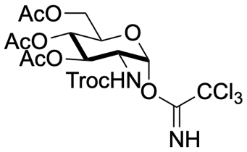
Figure S1: ¹H-NMR spectrum (400 MHz, CDCl₃) of compound 1a
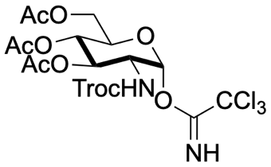
Figure S2: ¹³C-NMR spectrum (100 MHz, CDCl₃) of compound 1a
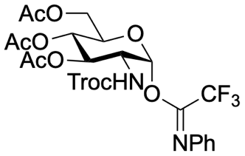
Figure S3: ¹H-NMR spectrum (400 MHz, CDCl₃) of compound 1b
Figure S4: ¹³C-NMR spectrum (100 MHz, CDCl₃) of compound 1b
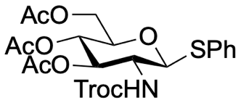
Figure S5: ¹H-NMR spectrum (400 MHz, CDCl₃) of compound 1c
Figure S6: ¹³C-NMR spectrum (100 MHz, CDCl₃) of compound 1c
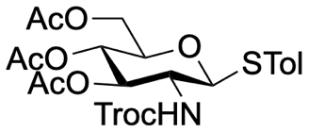
Figure S7: ¹H-NMR spectrum (400 MHz, CDCl₃) of compound 1d
Figure S8: ¹³C-NMR spectrum (100 MHz, CDCl₃) of compound 1d
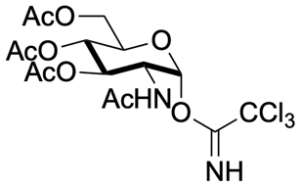
Figure S9: ¹H-NMR spectrum (400 MHz, CDCl₃) of compound 1e
Figure S10: ¹³C-NMR spectrum (100 MHz, CDCl₃) of compound 1e
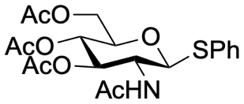
Figure S11: ¹H-NMR spectrum (400 MHz, CDCl₃) of compound 1f
Figure S12: ¹³C-NMR spectrum (100 MHz, CDCl₃) of compound 1f
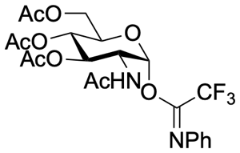
Figure S13: ¹H-NMR spectrum (400 MHz, CDCl₃) of compound 1g
Figure S14: ¹³C-NMR spectrum (100 MHz, CDCl₃) of compound 1g
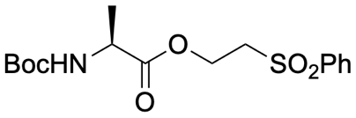
Figure S15: ¹H-NMR spectrum (400 MHz, CDCl₃) of compound S6
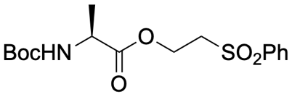
Figure S16: ¹³C-NMR spectrum (100 MHz, CDCl₃) of compound S6
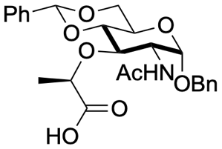
Figure S17: ¹H-NMR spectrum (400 MHz, DMSO-d₆) of compound S10
Figure S18: ¹³C-NMR spectrum (100 MHz, DMSO-d₆) of compound S10
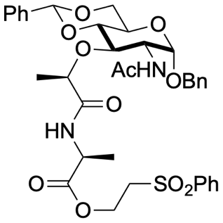
Figure S19: ¹H-NMR spectrum (400 MHz, CDCl₃) of compound S11
Figure S20: ¹H-NMR spectrum (100 MHz, CDCl₃) of compound S11
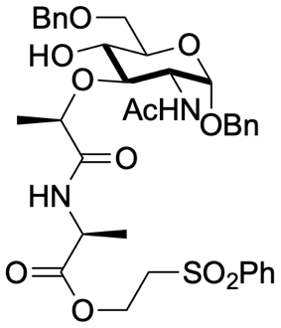
Figure S21: ¹H-NMR spectrum (400 MHz, CDCl₃) of compound 2a
Figure S22: ¹³C-NMR spectrum (100 MHz, CDCl₃) of compound 2a
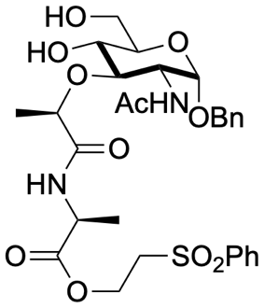
Figure S23: ¹H-NMR spectrum (400 MHz, CDCl₃) of compound S12
Figure S24: ¹³C-NMR spectrum (100 MHz, CDCl₃) of compound S12
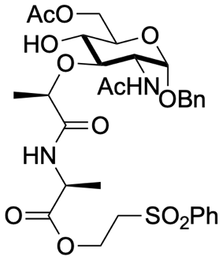
Figure S25: ¹H-NMR spectrum (400 MHz, CDCl₃) of compound 2b
Figure S26: ¹³C-NMR spectrum (100 MHz, CDCl₃) of compound 2b
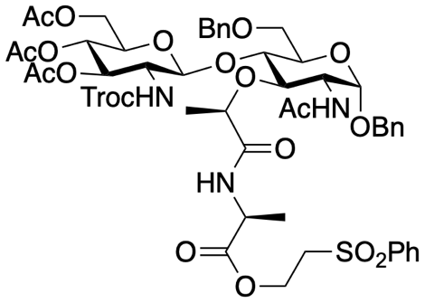
Figure S27: ¹H-NMR spectrum (400 MHz, CDCl₃) of compound 3a
Figure S28: ¹³C-NMR spectrum (100 MHz, CDCl₃) of compound 3a
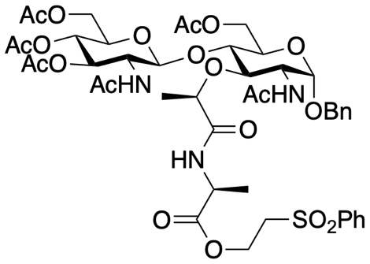
Figure S29: ¹H-NMR spectrum (400 MHz, CDCl₃) of compound 4
Figure S30: ¹³C-NMR spectrum (100 MHz, CDCl₃) of compound 4
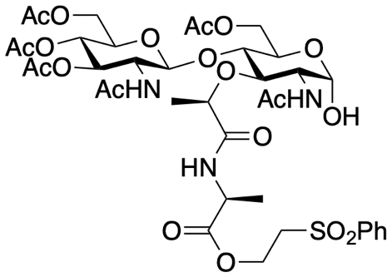
Figure S31: ¹H-NMR spectrum (400 MHz, DMSO-d₆) of compound 5
Figure S32: ¹H-NMR spectrum (100 MHz, DMSO-d₆) of compound 5
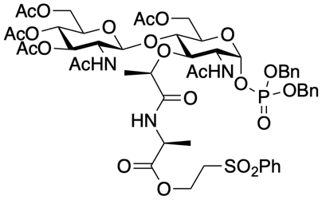
Figure S33: ¹H-NMR spectrum (400 MHz, DMSO-d₆) of compound 6
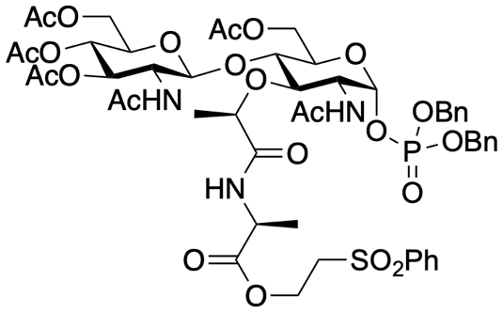
Figure S34: ¹³C-NMR spectrum (100 MHz, DMSO-d₆) of compound 6
Figure S35: ³¹P-NMR spectrum (162 MHz, DMSO-d₆) of compound 6
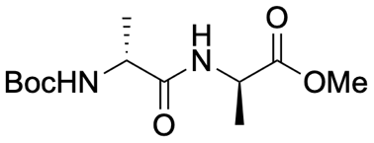
Figure S36: ¹H-NMR spectrum (400 MHz, CDCl₃) of compound S14
Figure S37: ¹³C-NMR spectrum (100 MHz, CDCl₃) of compound S14
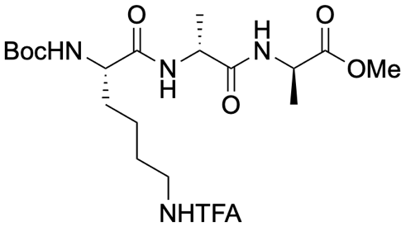
Figure S38: ¹H-NMR spectrum (400 MHz, DMSO-d₆) of compound S15
Figure S39: ¹³C-NMR spectrum (100 MHz, DMSO-d₆) of compound S15
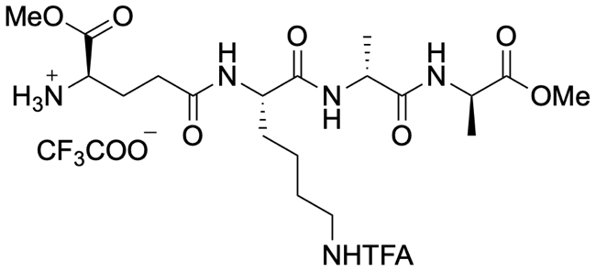
Figure S40: ¹H-NMR spectrum (400 MHz, DMSO-d₆) of compound S16
Figure S41: ¹H-NMR spectrum (100 MHz, DMSO-d₆) of compound S16
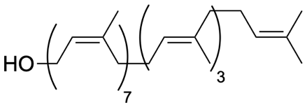
Figure S42: ¹H-NMR spectrum (400 MHz, CDCl₃) of compound S17
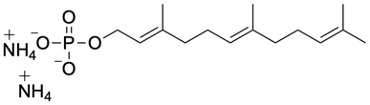
Figure S43: ³¹P-NMR spectrum (162 MHz, CDCl₃) of compound S20
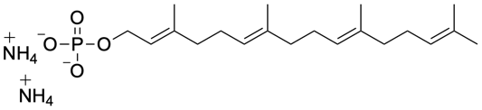
Figure S44: ³¹P-NMR spectrum (162 MHz, CDCl₃) of compound S22
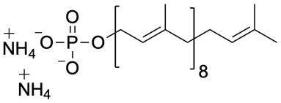
Figure S45: ³¹P-NMR spectrum (162 MHz, CDCl₃) of compound S24
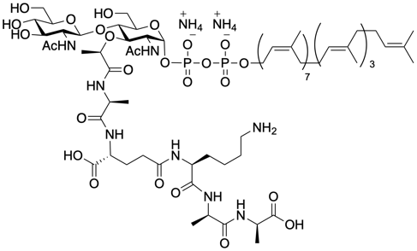
Figure S46: ³¹P-NMR spectrum (162 MHz, CDCl₃: CD₃OD 1:1) of compound 11
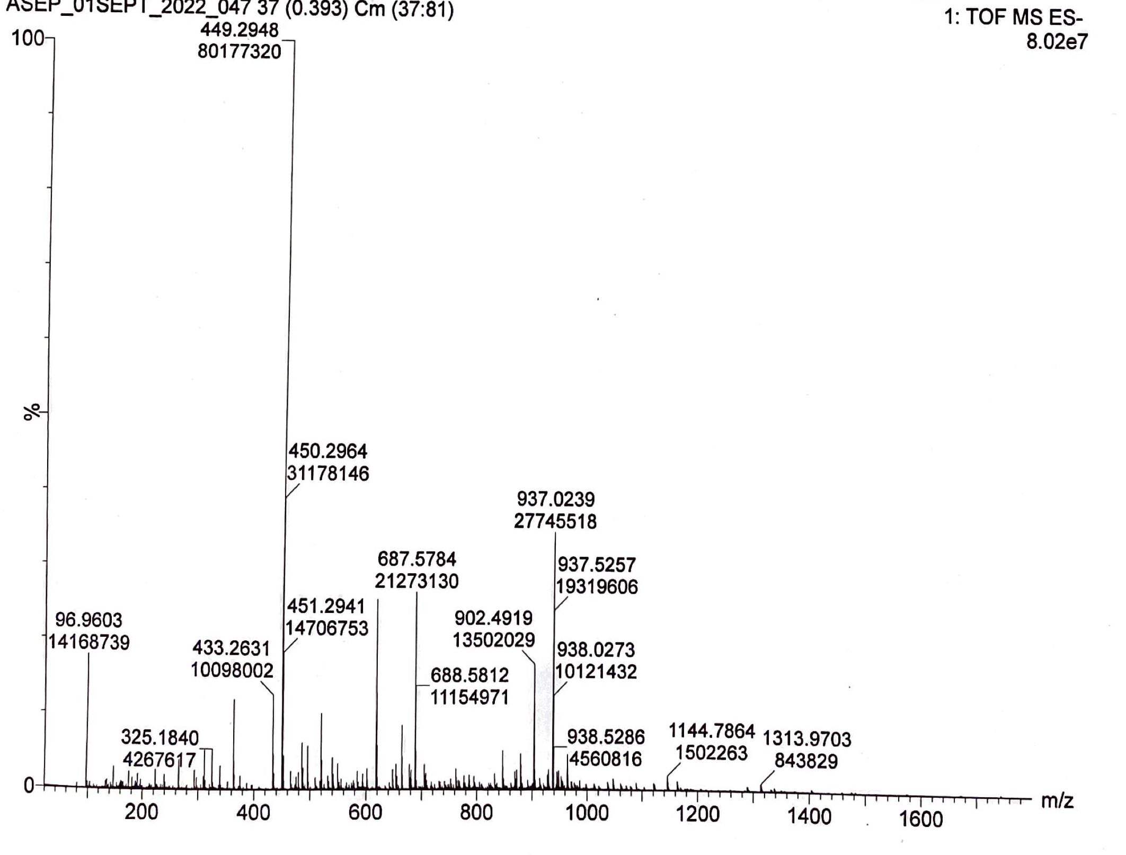
Figure S47: HRMS (ESI) of compound 11 (full spectrum)

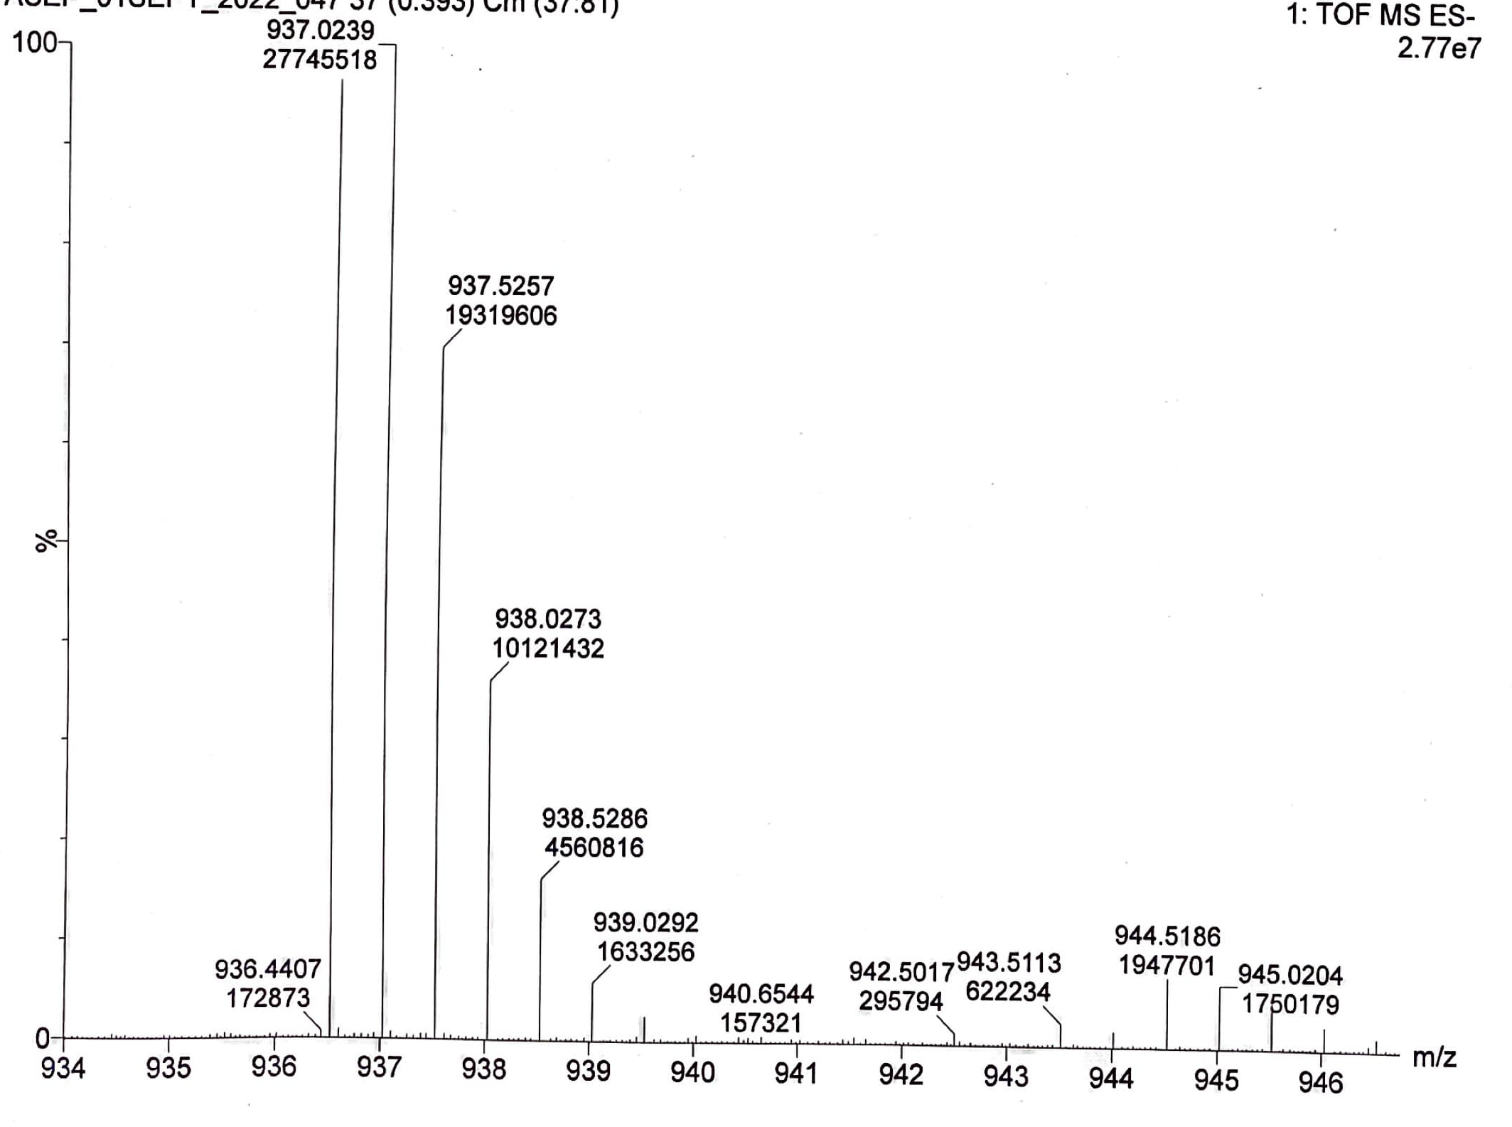
Figure S48: HRMS (ESI) of compound 11 (expanded; [M-2H]⁻)

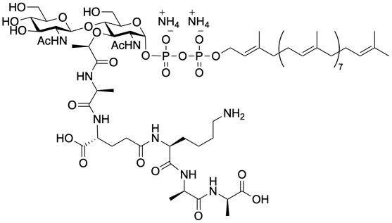
Figure S49: ³¹P-NMR spectrum (162 MHz, CDCl₃: CD₃OD 1:1) of compound 10

Figure S50: HRMS (ESI) of compound 10 (full spectrum)

Figure S51: HRMS (ESI) of compound 10 (expanded; [M-H]⁻)
Figure S52: HRMS (ESI) of compound 10 (expanded; [M-2H]⁻)
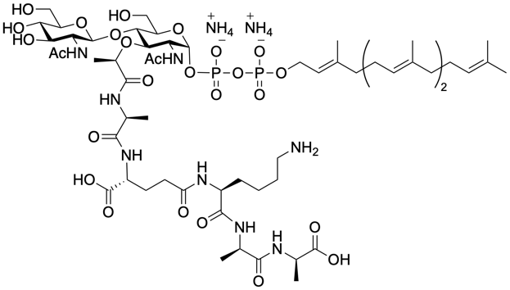
Figure S53: ³¹P-NMR spectrum (162 MHz, CDCl₃: CD₃OD 1:1) of compound 9
Figure S54: HRMS (ESI) of compound 9 (full spectrum)
Figure S55: HRMS (ESI) of compound 9 (expanded; [M-H]⁻)
Figure S56: HRMS (ESI) of compound 9 (expanded; [M-2H]⁻)

Figure S57: HRMS (ESI) of compound 8 (full spectrum)
Figure S58: HRMS (ESI) of compound 8 (expanded; [M-H]⁻)
Figure S59: HRMS (ESI) of compound 8 (expanded; [M-2H]⁻)

