Supporting Information for:
Determination of the Radii of Coated and Uncoated Silicon AFM Sharp Tips using Height Calibration Standard Grating and Nonlinear Regression Function
Perawat Boonpuek ¹, Jonathan R. Felts ²
¹ School of Manufacturing Engineering, Institute of Engineering, Suranaree University
of Technology, 111 University Avenue, Muang, Nakhon Ratchasima 30000, Thailand
² Advanced Manufacturing Laboratory, Department of Mechanical Engineering,
College of Engineering, Texas A&M University, College Station, Texas, 77843, USA

S1: Height images of the scanned specimens of calibration standard grating within 10 μm x 10 μm
The following figures show the top views of the height images of calibration standard grating scanned by the AFM tips from right to left (as shown in Figure 3 in Manuscript):
Si uncoated tip Pt coated tip
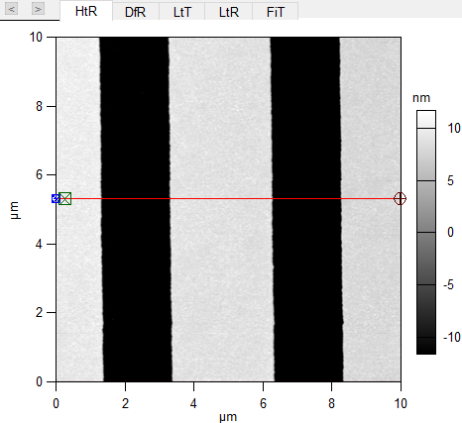
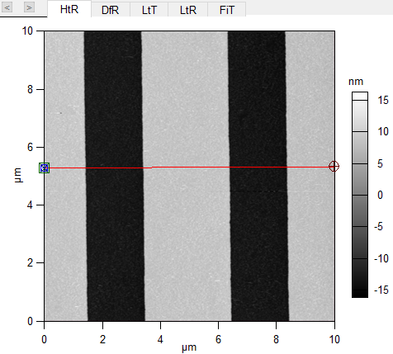

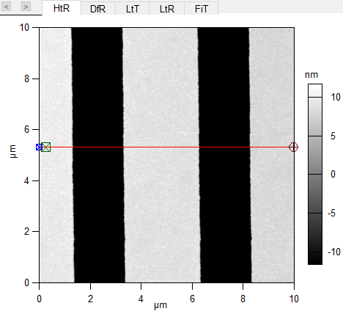
Au coated tip

Au coated tip

S2: Height images of the scanned corners of the calibration gate at smaller areas
Each of these images shows the height image at the smaller scanned area and was measured for the profiles of the grating structure scanned by the AFM tip from right to left (as shown in Figure 3 in Manuscript). Using the red cross-section lines in extracting the profiles of the single local grating structure to determine the real radius of the tip at the specific scanning line with curve fitting method in nonlinear regression function.
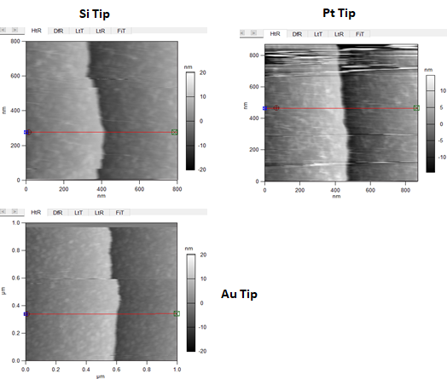
Note: when we measured the scan profiles by using the redline at many cross-section areas of the scanned image and took the average, we found large deviations of the estimated radius from the radius measured by the single cross-section redline.

S3: Nonlinear regression function used for tip arc curve fitting
Nonlinear Regression function: y = (x1^2 + x2^2 + b1*x1 + b2*x2 + b3) using MATLAB
Method: fitting x1 and x2 data to the circular curve created by the Nonlinear Regression function to find the center of the arc of the measured data points. Then, find the mean distance (Xm & Ym) from the center to those data arc curves. The outcome is tip radius: R = sqrt((Xm^2 + Ym^2)-B(3)).

MATLAB code:
%X0 = CrossSectionHeightProfileForRadiusCalibration(:,1:2);
%X = X0;
X = ArcProfilePtTip;
circlefun = @(b,X) (X(:,1).^2 + X(:,2).^2 + b(1)*X(:,1) + b(2)*X(:,2) + b(3));
y = zeros(length(X(:,1)),1);
beta0 = [0 0 400];
mdl = fitnlm(X,y,circlefun, beta0);
B = mdl.Coefficients.Estimate;
Xm = -B(1)/2;
Ym = -B(2)/2;
R = sqrt((Xm^2 + Ym^2) - B(3));
A = atan2(X(:,2)-Ym, X(:,1)-Xm);
Ycir = R*sin(A) + Ym;
Xcir = R*cos(A) + Xm;
figure
plot(X(:,1), X(:,2), 'p')
hold on
plot(Xcir, Ycir, '-r', 'LineWidth',2)
hold off
grid
axis('equal')

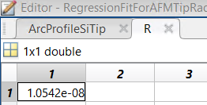
The curve fitting results are shown below:
Si tip
Root Mean Squared Error: 2.67e-18
R-Squared: -Inf

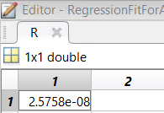
Pt tip
Root Mean Squared Error: 3.43e-18
R-Squared: -Inf

Au tip
Root Mean Squared Error: 4.82e-18
R-Squared: -Inf

