Indium-mediated Domino Lactonisation Approach towards Diastereoselective Synthesis of Pyrazole C-3 Linked Butyrolactones
Shubham Sharma^{1,2*} Virender Singh^{1,3*}, Manpreet Singh^{1,4} and Ashutosh Sharma⁵
¹Department of Chemistry, Dr B R Ambedkar National Institute of Technology (NIT) Jalandhar, Punjab, India-144027
² Department of ASHD, GB Pant Institute of Engineering and Technology, Pauri, Uttarakhand, India-246194
³Department of Chemistry, Central University of Punjab, Bathinda, Punjab, India-151001
⁴Department of Chemistry, National Central University, Taiwan
⁵Department of Applied Sciences (Chemistry), Doon Institute of Engineering and Technology, Rishikesh, Uttarakhand, India-249204
Email: rajshubh.9557@gmail.com; virender.singh@cup.edu.in

Supporting information
Table of contents
- Experimental data 3-9
- ¹H-NMR, ¹³C-NMR and NOESY (1C and 6B) spectrum of new
synthesized products (Figures S1-46) 10-36

5-(1,5-Diphenyl-1H-pyrazol-3-yl)-4-(4-fluorophenyl)-3-methylenedihydrofuran-2(3H)-one (1C). Yield: 60 % (0.147 g from 0.15 g) as a pale yellow solid; m.p. 128–130 ºC; R_{f} = 0.65 (hexane/EtOAc, 90:10, v/v); IR (neat): ν_{max}(cm⁻¹) = 1754 (CO₂CH); ¹H NMR (500 MHz, CDCl₃): δ = 4.77–4.79 (m, 1 H, CHC₆H₄), 5.49 (d, J = 7.4 Hz, 1 H, OCH), 5.53 (d, J = 2.8 Hz, 1 H, =CHH), 6.47 (d, J = 3.2 Hz, 1 H, =CHH), 6.58 (s, 1 H, ArH), 7.07 (t, J = 8.6 Hz, 2 H, ArH), 7.20 (d, J = 6.3 Hz, 2 H, ArH), 7.27 (m, 1H, ArH), 7.30–7.35 (m, 9 H, ArH) ppm; ¹³C NMR (125 MHz, CDCl₃): δ = 50.5, 80.8, 106.8, 116.1 (d, J = 21.3 Hz), 124.3, 125.3, 127.9, 128.6, 128.7, 128.8, 129.1, 130.0, 130.3 (d, J = 8.8 Hz), 134.6, 139.7, 139.8, 144.8, 149.4, 162.4 (d, J = 245 Hz), 169.4 ppm; HRMS (ESI) m/z: calcd. for C₂₆H₁₉FN₂O₂ [M + H⁺]: 411.1509, found: 411.1531.
5-(1-Methyl-5-phenyl-1H-pyrazol-3-yl)-3-methylene-4-(p-tolyl)dihydrofuran-2(3H)-one (2B). Yield: 78 % (0.289 g from 0.20 g) as a yellow solid; m.p. 145–147 ºC; R_{f} = 0.80 (hexane/EtOAc, 80:20, v/v); IR (neat): ν_{max}(cm⁻¹) = 1747 (CO₂CH); ¹H NMR (500 MHz, CDCl₃): δ = 2.34 (s, 3 H, ArCH₃), 3.85 (s, 3 H, NCH₃), 4.60–4.62 (m, 1 H, CHC₆H₄), 5.44 (d, J = 7.6 Hz, 1 H, OCH), 5.49 (d, J = 2.9 Hz, 1 H, =CHH), 6.36 (s, 1 H, ArH), 6.42 (d, J = 3.3 Hz, 1 H, =CHH), 7.13–7.16 (m, 1 H, ArH), 7.18 (m, 3 H, ArH), 7.37–7.38 (m, 1 H, ArH), 7.39 (d, J = 1.8 Hz, 1 H, ArH), 7.42–7.43 (m, 1 H, ArH), 7.44–7.46 (m, 2 H, ArH) ppm; ¹³C NMR (125 MHz, CDCl₃): δ = 21.2, 37.8, 51.3, 80.9, 106.1, 123.8, 128.4, 128.9, 129.5, 129.9, 130.3, 135.8, 137.7, 140.2, 145.2, 147.9, 169.6 ppm; HRMS (ESI) m/z: calcd. for C₂₂H₂₀N₂O₂ [M + H⁺]: 345.1603, found: 345.1623.
5-(5-(4-Fluorophenyl)-1-phenyl-1H-pyrazol-3-yl)-3-methylene-4-phenyldihydrofuran-2(3H)-one (3A). Yield: 82 % (0.252 g from 0.20 g) as a dull yellow solid; m.p. 91–93 ºC; R_{f} = 0.71 (hexane/EtOAc, 80:20, v/v); IR (neat): ν_{max}(cm⁻¹) = 1758 (CO₂CH); ¹H NMR (500 MHz, CDCl₃): δ = 4.76–4.79 (m, 1 H, CHC₆H₅), 5.53–5.56 (m, 2 H, OCH and =CHH), 6.46 (d, J = 3.0 Hz, 1 H, =CHH), 6.56 (s, 1 H, ArH), 6.99 (t, J = 8.6 Hz, 2 H, ArH), 7.16–7.18 (m, 2 H, ArH), 7.25 (s, 1 H, ArH), 7.33–7.38 (m, 9 H, ArH) ppm; ¹³C NMR (125 MHz, CDCl₃): δ = 51.2, 80.7, 106.8, 115.8 (d, J = 21.3 Hz), 124.3, 125.4, 126.2, 126.7, 128.0, 128.1, 128.6, 129.2 (d, J = 3.8 Hz), 130.7 (d, J = 12.5 Hz), 139.0, 139.6, 139.7, 143.7, 149.6, 162.8 (d, J = 247.5 Hz), 169.6 ppm; HRMS (ESI) m/z: calcd. for C₂₆H₁₉FN₂O₂ [M + H⁺]: 411.1509, found: 411.1501.
5-(5-(4-Fluorophenyl)-1-phenyl-1H-pyrazol-3-yl)-3-methylene-4-(p-tolyl)dihydrofuran-2(3H)-one (3B). Yield: 73 % (0.231 g from 0.20 g) as a white solid; m.p. 98–100 ºC; R_{f} = 0.61 (hexane/EtOAc, 80:20, v/v); IR (neat): ν_{max}(cm⁻¹) = 1772 (CO₂CH); ¹H NMR (400 MHz, CDCl₃): δ = 2.35 (s, 3 H, ArCH₃), 4.71–4.75 (m, 1 H, CHC₆H₄), 5.51 (d, J = 2.7 Hz, 1 H, OCH), 5.53 (d, J = 1.7 Hz, 1 H, =CHH), 6.44 (d, J = 3.2 Hz, 1 H, =CHH), 6.55 (s, 1 H, ArH), 6.96–7.02 (m, 3 H, ArH), 7.15–7.17 (m, 2 H, ArH), 7.19 (d, J = 2.3 Hz, 2 H, ArH), 7.21 (s, 1 H, ArH), 7.23–7.24 (m, 1 H, ArH), 7.25–7.26 (s, 1 H, ArH), 7.33–7.34 (m, 2 H, ArH), 7.35–7.36 (m, 1 H, ArH) ppm; ¹³C NMR (100 MHz, CDCl₃): δ = 21.2, 50.9, 80.8, 106.8, 115.8 (d, J = 22 Hz), 124.0, 125.4, 126.3 (d, J = 3 Hz), 128.0, 128.5, 129.2, 129.9, 130.7 (d, J = 8 Hz), 135.9, 137.7, 139.7, 139.9, 143.6, 149.7, 162.8 (d, J = 248 Hz), 169.6 ppm; HRMS (ESI) m/z: calcd. for C₂₇H₂₁FN₂O₂ [M + H⁺]: 425.1665, found: 425.1670.
4-(4-Chlorophenyl)-5-(5-(4-fluorophenyl)-1-phenyl-1H-pyrazol-3-yl)-3-methylenedihydrofuran-2(3H)-one (3D). Yield: 75 % (0.25 g from 0.20 g) as an off white solid; m.p. 114–116 ºC; R_{f} = 0.68 (hexane/EtOAc, 80:20, v/v); IR (neat): ν_{max}(cm⁻¹) = 1762 (CO₂CH); ¹H NMR (500 MHz, CDCl₃): δ = 4.76–4.79 (m, 1 H, CHC₆H₄), 5.48 (d, J = 7.4 Hz, 1 H, OCH), 5.53 (d, J = 2.9 Hz, 1 H, =CHH), 6.47 (d, J = 3.3 Hz, 1 H, =CHH), 6.56 (s, 1 H, ArH), 7.00 (t, J = 8.7 Hz, 2 H, ArH), 7.15–7.18 (m, 2 H, ArH), 7.23–7.26 (m, 2 H, ArH), 7.27 (m, 1 H, ArH), 7.29 (s, 1 H, ArH), 7.34–7.35 (m, 3 H, ArH), 7.36–7.37 (m, 2H, ArH) ppm; ¹³C NMR (125 MHz, CDCl₃): δ = 50.6, 80.5, 106.8, 115.8 (d, J = 22.5 Hz), 124.4, 125.4, 126.1 (d, J = 2.2 Hz), 128.1, 129.2, 129.4, 130.0, 130.7 (d, J = 7.5 Hz), 133.9, 137.3, 139.3, 139.6, 143.8, 149.3, 162.8 (d, J = 247.5 Hz), 169.6 ppm; HRMS (ESI) m/z: calcd. for C₂₆H₁₈ClFN₂O₂ [M + H⁺]: 445.1119, found: 445.1133.
4-(4-Bromophenyl)-5-(5-(4-fluorophenyl)-1-phenyl-1H-pyrazol-3-yl)-3-methylenedihydrofuran-2(3H)-one (3E). Yield: 47 % (0.086 g from 0.10 g) as a dull yellow solid; m.p. 140–142 ºC; R_{f} = 0.50 (hexane/EtOAc, 80:20, v/v); IR (neat): ν_{max}(cm⁻¹) = 1764 (CO₂CH); ¹H NMR (500 MHz, CDCl₃): δ = 4.75–4.78 (m, 1 H, CHC₆H₄), 5.47 (d, J = 7.3 Hz, 1 H, OCH), 5.53 (d, J = 2.8 Hz, 1 H, =CHH), 6.47 (d, J = 3.3 Hz, 1 H, =CHH), 6.55 (s, 1 H, ArH), 7.00 (t, J = 8.6 Hz, 2 H, ArH), 7.15–7.18 (m, 2 H, ArH), 7.21 (s, 1 H, ArH), 7.23–7.24 (m, 2 H, ArH), 7.25 (d, J = 1.9 Hz, 1 H, ArH), 7.33–7.36 (m, 3 H, ArH), 7.50–7.52 (m, 2 H, ArH) ppm; ¹³C NMR (125 MHz, CDCl₃): δ = 50.6, 80.5, 106.8, 115.9 (d, J = 21.3 Hz), 122.0, 124.5, 125.4, 126.2 (d, J = 3.8 Hz), 128.1, 129.2, 130.4, 130.7 (d, J = 7.5 Hz), 132.4, 137.9, 139.3, 139.6, 143.8, 149.3, 162.8 (d, J = 247.5 Hz), 169.2 ppm; HRMS (ESI) m/z: calcd. for C₂₆H₁₈BrFN₂O₂ [M + H⁺]: 489.0614, found: 489.0626.
5-(5-(4-Chlorophenyl)-1-phenyl-1H-pyrazol-3-yl)-4-(4-fluorophenyl)-3-methylenedihydrofuran-2(3H)-one (4C). Yield: 52 % (0.122 g from 0.15 g) as an off white solid; m.p. 148–150 ºC; R_{f} = 0.75 (hexane/EtOAc, 90:10, v/v); IR (neat): ν_{max}(cm⁻¹) = 1763 (CO₂CH); ¹H NMR (500 MHz, CDCl₃): δ = 4.76–4.78 (m, 1 H, CHC₆H₄), 5.48 (d, J = 7.4 Hz, 1 H, OCH), 5.53 (d, J = 2.9 Hz, 1 H, =CHH), 6.47 (d, J = 3.3 Hz, 1 H, =CHH), 6.58 (s, 1 H, ArH), 7.07 (t, J = 8.6 Hz, 2 H, ArH), 7.13 (d, J = 8.5 Hz, 2 H, ArH), 7.24 (d, J = 1.3 Hz, 1 H, ArH), 7.27 (s, 1 H, ArH), 7.28–7.33 (m, 4 H, ArH), 7.34–7.38 (m, 3 H, ArH) ppm; ¹³C NMR (125 MHz, CDCl₃): δ = 50.5, 80.7, 106.9, 116.2 (d, J = 21.3 Hz), 124.4, 125.4, 128.2, 128.5, 129.0, 129.3, 130.1, 130.3 (d, J = 8.8 Hz), 134.5, 134.6, 134.9, 139.6 (d, J = 2.5 Hz), 143.6, 149.5, 162.4 (d, J = 246.3 Hz), 169.3 ppm; HRMS (ESI) m/z: calcd. for C₂₆H₁₈ClFN₂O₂ [M + H⁺]: 445.1119, found: 445.1111.
4-(4-Chlorophenyl)-5-(5-(4-chlorophenyl)-1-phenyl-1H-pyrazol-3-yl)-3-methylenedihydrofuran-2(3H)-one (4D). Yield: 73 % (0.118 g from 0.10 g) as a dull yellow solid; m.p. 136–138 ºC; R_{f} = 0.66 (hexane/EtOAc, 90:10, v/v); IR (neat): ν_{max}(cm⁻¹) = 1772 (CO₂CH); ¹H NMR (400 MHz, CDCl₃): δ = 4.75–4.78 (m, 1 H, CHC₆H₄), 5.47 (d, J = 7.4 Hz, 1 H, OCH), 5.53 (d, J = 2.8 Hz, 1 H, =CHH), 6.47 (d, J = 3.2 Hz, 1 H, =CHH), 6.57 (s, 1 H, ArH), 7.12 (d, J = 8.4 Hz, 2 H, ArH), 7.24 (s, 1 H, ArH), 7.27–7.28 (m, 5 H, ArH), 7.34–7.37 (m, 5 H, ArH) ppm; ¹³C NMR (125 MHz, CDCl₃): δ = 50.6, 80.5, 107.0, 124.5, 125.4, 128.2, 128.5, 129.0, 129.3, 129.5, 130.0, 130.1, 134.0, 134.9, 137.3, 139.3, 139.5, 143.6, 149.4, 169.2 ppm; HRMS (ESI) m/z: calcd. for C₂₆H₁₈Cl₂N₂O₂ [M + H⁺]: 461.0823, found: 461.0813.
5-(1-Methyl-5-phenyl-1H-pyrazol-3-yl)-3-methylene-4-phenyldihydrofuran-2(3H)-one (5A). Yield: 65 % (0.215 g from 0.20 g) as a yellow solid; m.p. 145–147 ºC; R_{f} = 0.74 (hexane/EtOAc, 70:30, v/v); IR (neat): ν_{max}(cm⁻¹) = 1752 (CO₂CH); ¹H NMR (500 MHz, CDCl₃): δ = 3.84 (s, 3 H, NCH₃), 4.64–4.66 (m, 1 H, CHC₆H₅), 5.46 (d, J = 7.4 Hz, 1 H, OCH), 5.51 (d, J = 2.8 Hz, 1 H, =CHH), 6.36 (s, 1 H, ArH), 6.44 (d, J = 3.2 Hz, 1 H, =CHH), 7.30–7.31 (m, 2 H, ArH), 7.32–7.34 (m, 3 H, ArH), 7.36 (d, J = 7.6 Hz, 2 H, ArH), 7.44 (d, J = 8.4 Hz, 2 H, ArH) ppm; ¹³C NMR (125 MHz, CDCl₃): δ = 37.8, 51.5, 80.7, 105.3, 124.1, 127.9, 128.5, 128.6, 129.2, 130.1, 135.1, 138.9, 139.8, 144.0, 148.0, 169.5 ppm; HRMS (ESI) m/z: calcd. for C₂₁H₁₇ClN₂O₂ [M + H⁺]: 331.1446, found: 331.1451.
5-(4-Iodo-1,5-diphenyl-1H-pyrazol-3-yl)-3-methylene-4-(p-tolyl)dihydrofuran-2(3H)-one (6B). Yield: 57 % (0.112 g from 0.15 g) as an off white solid; m.p. 146–148 ºC; R_{f} = 0.83 (hexane/EtOAc, 90:10, v/v); IR (neat): ν_{max}(cm⁻¹) = 1776 (CO₂CH); ¹H NMR (500 MHz, CDCl₃): δ = 2.35 (s, 3 H, ArCH₃), 5.04–5.06 (m, 1 H, CHC₆H₄), 5.50 (d, J = 2.6, 1 H, OCH), 5.54 (d, J = 8.0, 1 H, =CHH), 6.44 (d, J = 3.1 Hz, 1 H, =CHH), 7.17–7.20 (m, 4 H, ArH), 7.21–7.25 (m, 4 H, ArH), 7.28–7.30 (m, 3 H, ArH), 7.35–7.36 (m, 3 H, ArH) ppm; ¹³C NMR (125 MHz, CDCl₃): δ = 21.3, 49.3, 65.8, 80.3, 123.8, 124.9, 128.0, 128.6, 128.7, 129.0, 129.1, 129.4, 129.9, 130.3, 135.7, 137.7, 139.7, 140.2, 145.5, 149.5, 169.6 ppm; HRMS (ESI) m/z: calcd. for C₂₇H₂₁IN₂O₂ [M + H⁺]: 533.0726, found: 533.0745.
5-(4-Iodo-1,5-diphenyl-1H-pyrazol-3-yl)-3-methylene-4-(p-tolyl)dihydrofuran-2(3H)-one (6C). Yield: 57 % (0.112 g from 0.15 g) as a yellow solid; m.p. 158–160 ºC; R_{f} = 0.30 (hexane/EtOAc, 90:10, v/v); IR (neat): ν_{max}(cm⁻¹) = 1755 (CO₂CH); ¹H NMR (500 MHz, CDCl₃): δ = 5.06–5.09 (m, 1 H, CHC₆H₄), 5.49–5.51 (m, 2 H, OCH and =CHH), 6.47 (d, J = 3.4 Hz, 1 H, =CHH), 7.08 (t, J = 8.6 Hz, 2 H, ArH), 7.17–7.19 (m, 2 H, ArH), 7.22–7.24 (m, 2 H, ArH), 7.29–7.31 (m, 3 H, ArH), 7.33–7.34 (m, 2 H, ArH), 7.36–7.37 (m, 3 H, ArH) ppm; ¹³C NMR (125 MHz, CDCl₃): δ = 49.0, 65.6, 80.3, 116.2 (d, J = 21.3 Hz), 124.0, 124.9, 128.1, 128.7, 129.1, 129.3, 129.4, 130.3, 130.5 (d, J = 8.8 Hz), 134.3 (d, J = 3.8 Hz), 139.6, 139.9, 145.7, 149.3, 162.4 (d, J = 245 Hz), 169.2 ppm; HRMS (ESI) m/z: calcd. for C₂₆H₁₈FIN₂O₂ [M + H⁺]: 537.0475, found: 537.0469.
4-(4-Chlorophenyl)-5-(4-iodo-1,5-diphenyl-1H-pyrazol-3-yl)-3-methylenedihydrofuran-2(3H)-one (6D). Yield: 75 % (0.152 g from 0.15 g) as a dull yellow solid; m.p. 146–148 ºC; R_{f} = 0.83 (hexane/EtOAc, 90:10, v/v); IR (neat): ν_{max}(cm⁻¹) = 1756 (CO₂CH); ¹H NMR (500 MHz, CDCl₃): δ = 5.06–5.07 (m, 1 H, CHC₆H₄), 5.46–5.53 (m, 2 H, OCH and =CHH), 6.48 (s, 1 H, =CHH), 7.18 (m, 2 H, ArH), 7.22–7.26 (m, 3 H, ArH), 7.30–7.32 (m, 5 H, ArH), 7.36–7.37 (m, 4H, ArH) ppm; ¹³C NMR (125 MHz, CDCl₃): δ = 49.1, 65.7, 80.1, 124.1, 124.9, 128.1, 128.7, 129.1, 129.2, 129.3, 129.5, 129.9, 130.2, 130.3, 134.0, 137.1, 139.6, 145.7, 149.2, 169.2 ppm; HRMS (ESI) m/z: calcd. for C₂₆H₁₈ClIN₂O₂ [M + H⁺]: 553.0179, found: 553.0192.
5-(5-(4-Fluorophenyl)-4-iodo-1-phenyl-1H-pyrazol-3-yl)-3-methylene-4-phenyldihydrofuran-2(3H)-one (8A). Yield: 75 % (0.187 g from 0.20 g) as a white solid; m.p. 161–163 ºC; R_{f} = 0.72 (hexane/EtOAc, 90:10, v/v); IR (neat): ν_{max}(cm⁻¹) = 1763 (CO₂CH); ¹H NMR (500 MHz, CDCl₃): δ = 5.06–5.09 (m, 1 H, CHC₆H₅), 5.51 (d, J = 3.2 Hz, 1 H, OCH), 5.55 (d, J = 8.1 Hz, 1 H, =CHH), 6.46 (d, J = 3.4 Hz, 1 H, =CHH), 7.06 (t, J = 8.6 Hz, 2 H, ArH), 7.16–7.18 (m, 2 H, ArH), 7.20–7.23 (m, 2 H, ArH), 7.31–7.33 (m, 3 H, ArH), 7.34–7.36 (m, 2 H, ArH), 7.37–7.39 (m, 3 H, ArH) ppm; ¹³C NMR (125 MHz, CDCl₃): δ = 49.6, 65.9, 80.2, 116.0 (d, J = 22.5 Hz), 124.0, 125.0, 125.4 (d, J = 2.5 Hz), 128.0, 128.2, 128.9, 129.1, 129.2, 132.3 (d, J = 8.8 Hz), 138.8, 139.5, 140.0, 144.7, 149.6, 163.1 (d, J = 248.8 Hz), 169.4 ppm; HRMS (ESI) m/z: calcd. for C₂₆H₁₈FIN₂O₂ [M + H⁺]: 537.0475, found: 537.0478.
5-(5-(4-Fluorophenyl)-4-iodo-1-phenyl-1H-pyrazol-3-yl)-3-methylene-4-(p-tolyl)dihydrofuran-2(3H)-one (8B). Yield: 52 % (0.144 g from 0.20 g) as a white solid; m.p. 168–170 ºC; R_{f} = 0.51 (hexane/EtOAc, 90:10, v/v); IR (neat): ν_{max}(cm⁻¹) = 1779 (CO₂CH); ¹H NMR (500 MHz, CDCl₃): δ = 2.35 (s, 3 H, ArCH₃), 5.02–5.05 (m, 1 H, CHC₆H₄), 5.49 (d, J = 2.9 Hz, 1 H, OCH), 5.52 (d, J = 7.8 Hz, 1 H, =CHH), 6.44 (d, J = 3.4 Hz, 1 H, =CHH), 7.05 (t, J = 8.6 Hz, 2 H, ArH), 7.16 (m, 1 H, ArH), 7.17–7.18 (m, 1 H, ArH), 7.19–7.20 (m, 2 H, ArH), 7.20–7.22 (m, 3 H, ArH), 7.24 (s, 1 H, ArH), 7.30–7.32 (m, 3 H, ArH) ppm; ¹³C NMR (125 MHz, CDCl₃): δ = 21.3, 49.3, 66.0, 80.2, 116.0 (d, J = 21.3 Hz), 123.8, 124.9, 125.4 (d, J = 2.5 Hz), 128.2, 128.7, 129.1, 129.9, 132.3 (d, J = 8.8 Hz), 135.6, 137.8, 139.6, 140.2, 144.6, 149.6, 163.1 (d, J = 248.8 Hz), 169.5 ppm; HRMS (ESI) m/z: calcd. for C₂₇H₂₀FIN₂O₂ [M + H⁺]: 551.0631, found: 551.0623.
4-(4-Chlorophenyl)-5-(5-(4-fluorophenyl)-4-iodo-1-phenyl-1H-pyrazol-3-yl)-3-methylenedihydrofuran-2(3H)-one (8D). Yield: 77 % (0.224 g from 0.20 g) as an off white solid; m.p. 180–182 ºC; R_{f} = 0.71 (hexane/EtOAc, 90:10, v/v); IR (neat): ν_{max}(cm⁻¹) = 1763 (CO₂CH); ¹H NMR (500 MHz, CDCl₃): δ = 5.04–5.07 (m, 1 H, CHC₆H₄), 5.47 (d, J = 8.0 Hz, 1 H, OCH), 5.51 (d, J = 3.0 Hz, 1 H, =CHH), 6.47 (d, J = 3.4 Hz, 1 H, =CHH), 7.06 (t, J = 8.6 Hz, 2 H, ArH), 7.16–7.18 (m, 2 H, ArH), 7.20–7.23 (m, 2 H, ArH), 7.29–7.30 (m, 1 H, ArH), 7.31–7.32 (m, 3 H, ArH), 7.33 (m, 1 H, ArH), 7.36–7.38 (m, 2 H, ArH) ppm; ¹³C NMR (125 MHz, CDCl₃): δ = 49.1, 65.8, 80.0, 116.0 (d, J = 21.3 Hz), 124.2, 125.0, 125.3 (d, J = 3.8 Hz), 128.3, 129.2, 129.5, 130.2, 132.3 (d, J = 7.5 Hz), 134.0, 137.1, 139.5, 139.6, 144.8, 149.3, 163.2 (d, J = 248.8 Hz), 169.1 ppm; HRMS (ESI) m/z: calcd. for C₂₆H₁₇ClFIN₂O₂ [M + H⁺]: 571.0085, found: 571.0089.
5-(5-(3-Bromophenyl)-4-iodo-1-phenyl-1H-pyrazol-3-yl)-3-methylene-4-(p-tolyl)dihydrofuran-2(3H)-one (9B). Yield: 49 % (0.132 g from 0.20 g) as a white solid; m.p. 122–124 ºC; R_{f} = 0.59 (hexane/EtOAc, 90:10, v/v); IR (neat): ν_{max}(cm⁻¹) = 1775 (CO₂CH); ¹H NMR (500 MHz, CDCl₃): δ = 2.35 (s, 3 H, ArCH₃), 5.00–5.03 (m, 1 H, CHC₆H₄), 5.50 (d, J = 3.0 Hz, 1 H, OCH), 5.52 (d, J = 8.0 Hz, 1 H, =CHH), 6.44 (d, J = 3.4 Hz, 1 H, =CHH), 7.10–7.12 (m, 1 H, ArH), 7.17–7.19 (m, 3 H, ArH), 7.20–7.22 (m, 2 H, ArH), 7.23–7.25 (m 2 H, ArH), 7.32–7.34 (m, 3 H, ArH), 7.42 (t, J = 1.7 Hz, 1 H, ArH), 7.50–7.52 (m, 1 H, ArH) ppm; ¹³C NMR (125 MHz, CDCl₃): δ = 21.3, 49.4, 66.1, 80.2, 122.6, 123.9, 124.9, 128.4, 128.7, 129.0, 129.2, 129.9, 130.2, 131.3, 132.5, 133.2, 135.5, 137.8, 139.4, 140.1, 143.9, 149.7, 169.5 ppm; HRMS (ESI) m/z: calcd. for C₂₇H₂₀BrIN₂O₂ [M + H⁺]: 610.9831, found: 610.9848.
Ethyl 4-(1-hydroxy-3-(methoxycarbonyl)-2-(p-tolyl)but-3-en-1-yl)-1-(p-tolyl)-1H-pyrazole-3-carboxylate (10B). Yield: 43 % (0.080 g from 0.20 g) as a pale yellow solid; m.p. 131–133 ºC; R_{f} = 0.84 (hexane/EtOAc, 70:30, v/v); IR (neat): ν_{max}(cm⁻¹) = 1714 (CO₂Et); ¹H NMR (400 MHz, CDCl₃): δ = 1.43 (t, J = 7.1 Hz, 3 H, CO₂CH₂CH₃), 2.32 (s, 3 H, ArCH₃), 2.39 (s, 3 H, ArCH₃), 3.60 (s, 3 H, OCH₃), 3.97 (d, J = 7.6 Hz, 1 H, OH), 4.38 (d, J = 7.9 Hz, 1 H, CHC₆H₄CH₃), 4.44 (q, J = 7.1 Hz, 2 H, CO₂CH₂CH₃), 5.61 (t, J = 7.7 Hz, 1 H, CHOH), 5.90 (s, 1 H, =CHH), 6.25 (s, 1 H, =CHH), 7.13 (d, J = 7.7 Hz, 2 H, ArH), 7.22–7.24 (m, 4 H, ArH), 7.53 (d, J = 8.2 Hz, 2 H, ArH), 7.72 (s, 1 H, ArH) ppm; ¹³C NMR (125 MHz, CDCl₃): δ = 14.4, 21.1, 21.2, 52.1, 52.7, 61.8, 67.9, 120.2, 126.6, 127.7, 128.8, 129.2, 129.3, 130.1, 135.8, 136.7, 137.2, 137.9, 141.5, 141.8, 163.9, 167.4 ppm; HRMS (ESI) m/z: calcd. for C₂₆H₂₈N₂O₅ [M + H⁺]: 449.2076, found: 449.2071.
Ethyl 1-(4-chlorophenyl)-4-(1-hydroxy-3-(methoxycarbonyl)-2-(p-tolyl)but-3-en-1-yl)-1H-pyrazole-3-carboxylate (11B). Yield: 21 % (0.035 g from 0.10 g) as a pale yellow solid; m.p. 120–122 ºC; R_{f} = 0.32 (hexane/EtOAc, 70:30, v/v); IR (neat): ν_{max}(cm⁻¹) = 1713 (CO₂Et); ¹H NMR (500 MHz, CDCl₃): δ = 1.44 (t, J = 7.1 Hz, 3 H, CO₂CH₂CH₃), 2.32 (s, 3 H, ArCH₃), 3.61 (s, 3 H, OCH₃), 3.86 (d, J = 7.5 Hz, 1 H, OH), 4.37 (d, J = 7.7 Hz, 1 H, CHC₆H₄CH₃), 4.44 (q, J = 7.1 Hz, 2 H, CO₂CH₂CH₃), 5.62 (t, J = 7.6 Hz, 1 H, CHOH), 5.90 (s, 1 H, =CHH), 6.26 (s, 1 H, =CHH), 7.13 (d, J = 7.8 Hz, 2 H, ArH), 7.22 (d, J = 7.9 Hz, 2 H, ArH), 7.42–7.44 (m, 2 H, ArH), 7.60–7.62 (m, 2 H, ArH), 7.73 (s, 1 H, ArH) ppm; ¹³C NMR (125 MHz, CDCl₃): δ = 14.4, 21.2, 52.1, 52.7, 61.9, 67.8, 121.3, 126.6, 127.7, 129.1, 129.2, 129.3, 129.8, 133.6, 135.6, 136.8, 138.0, 141.7, 142.1, 163.7, 167.4 ppm; HRMS (ESI) m/z: calcd. for C₂₅H₂₅ClN₂O₅ [M + H⁺]: 469.153, found: 469.1541.
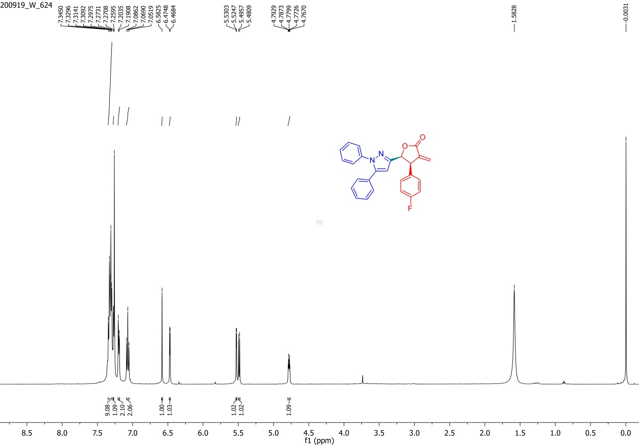
Figure S1. ¹H-NMR spectrum of 1C
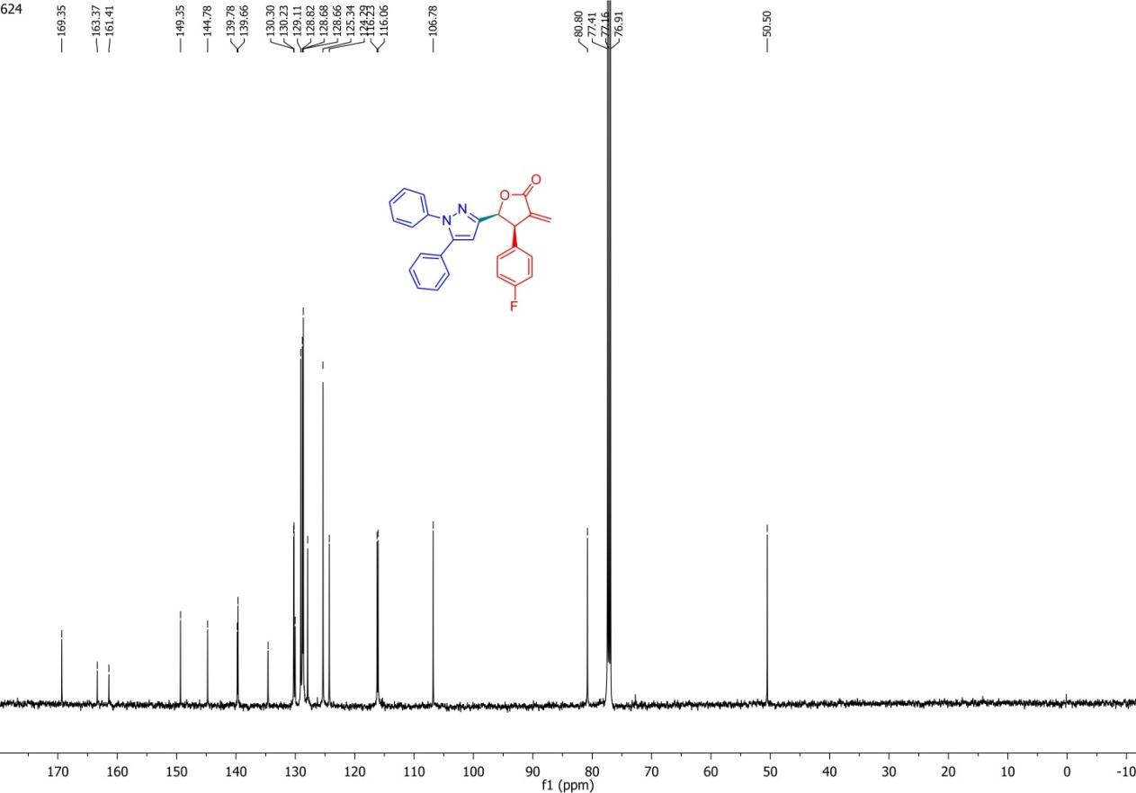
Figure S2. ¹³C-NMR spectrum of 1C
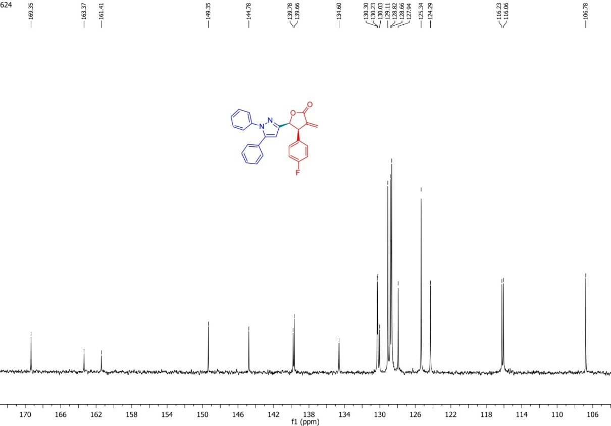
Figure S3. Expansion ¹³C-NMR spectrum of 1C
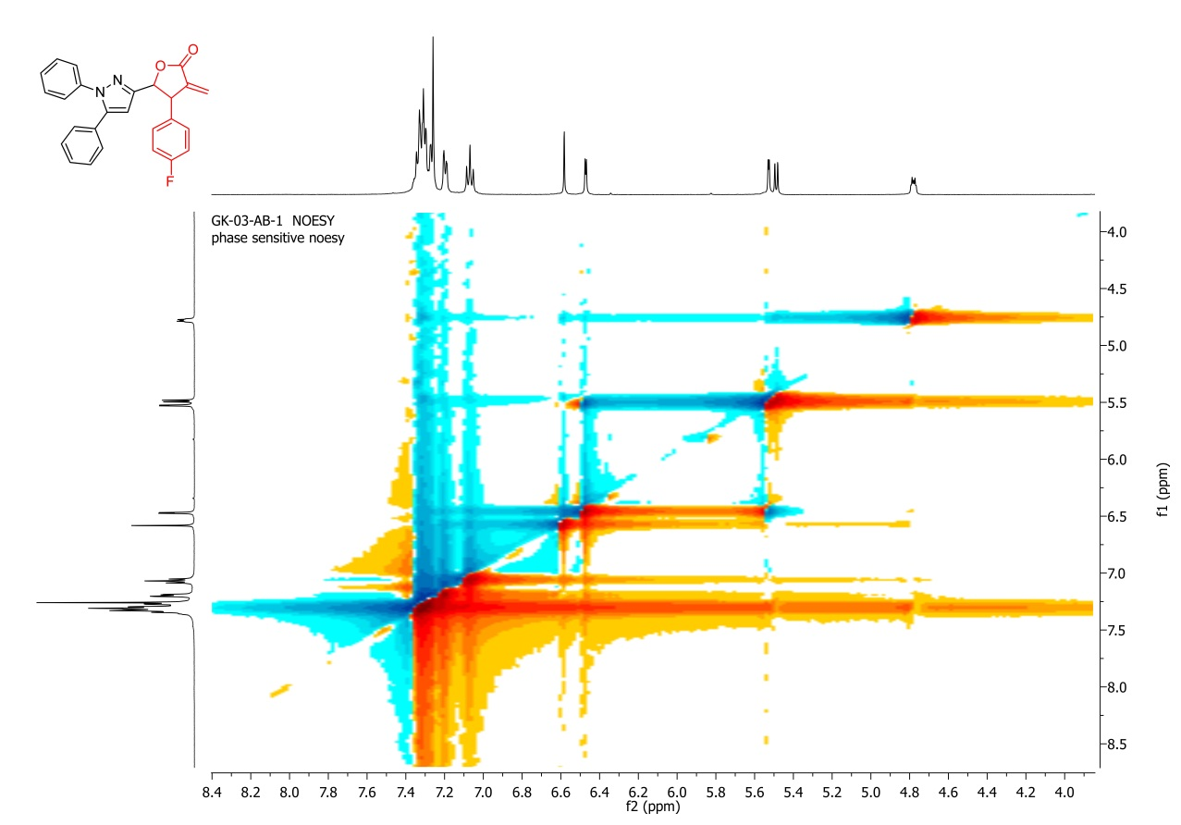
Figure S4. NOESY spectrum of 1C
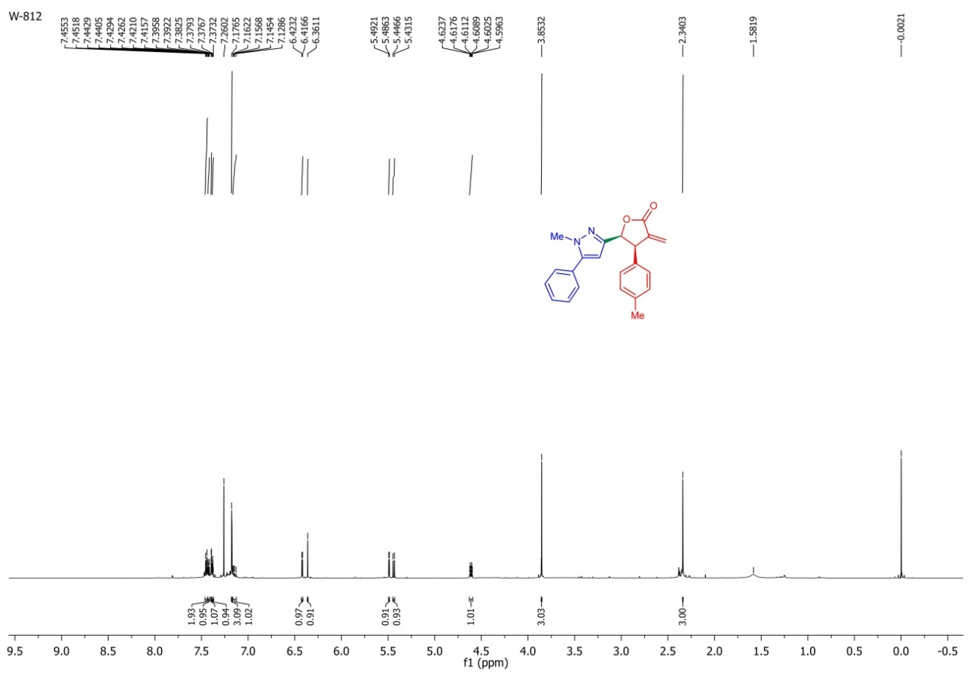
Figure S5. ¹H-NMR spectrum of 2B
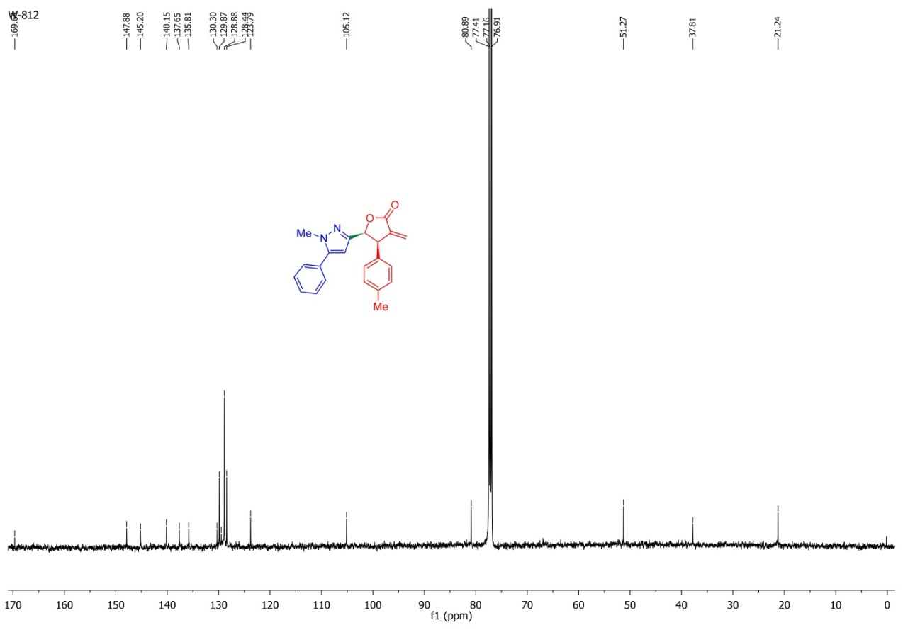
Figure S6. ¹³C-NMR spectrum of 2B
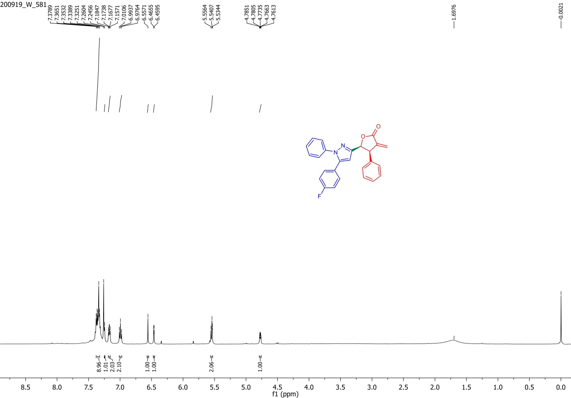
Figure S7. ¹H-NMR spectrum of 3A
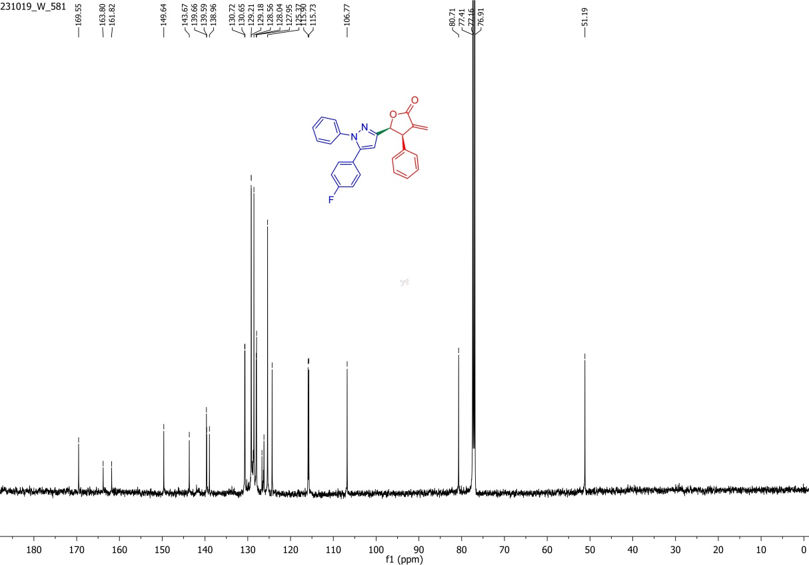
Figure S8. ¹³C-NMR spectrum of 3A
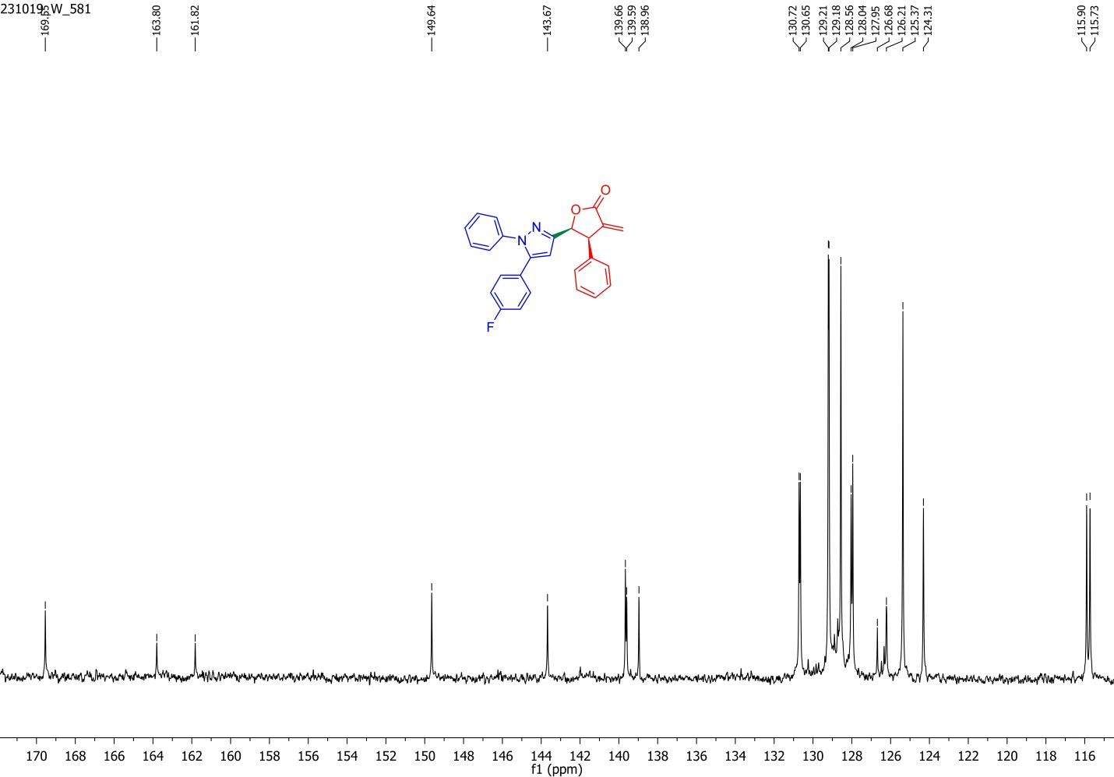
Figure S9. Expansion of ¹³C-NMR spectrum of 3A
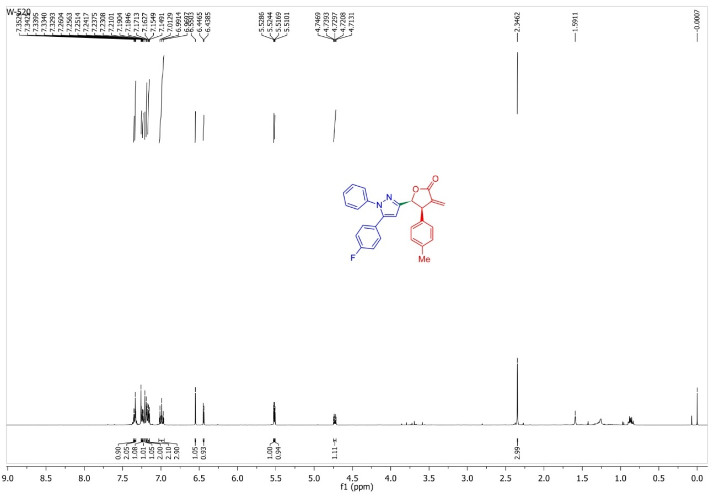
Figure S10. ¹H-NMR spectrum of 3B
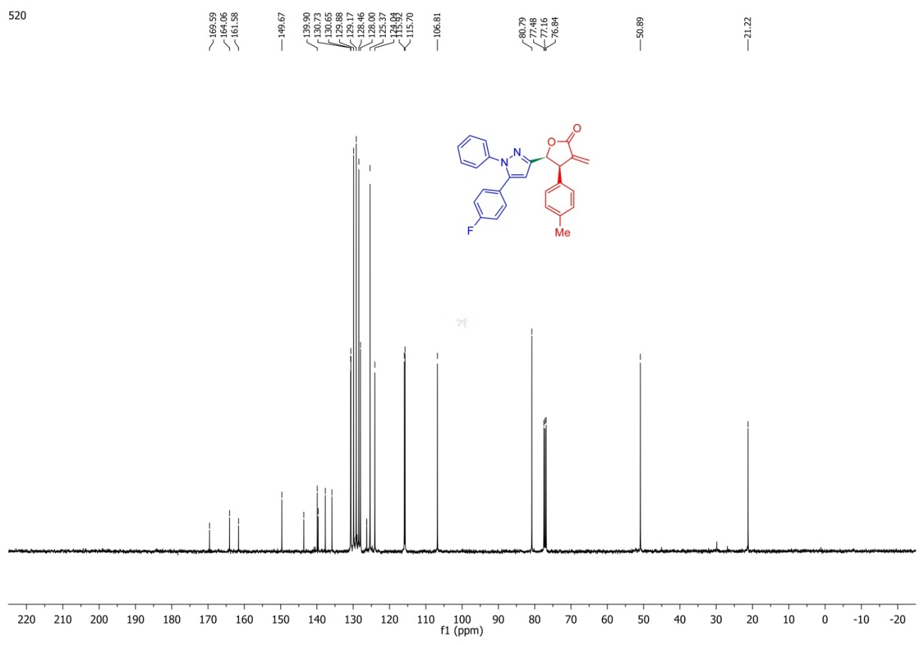
Figure S11. ¹³C-NMR spectrum of 3B
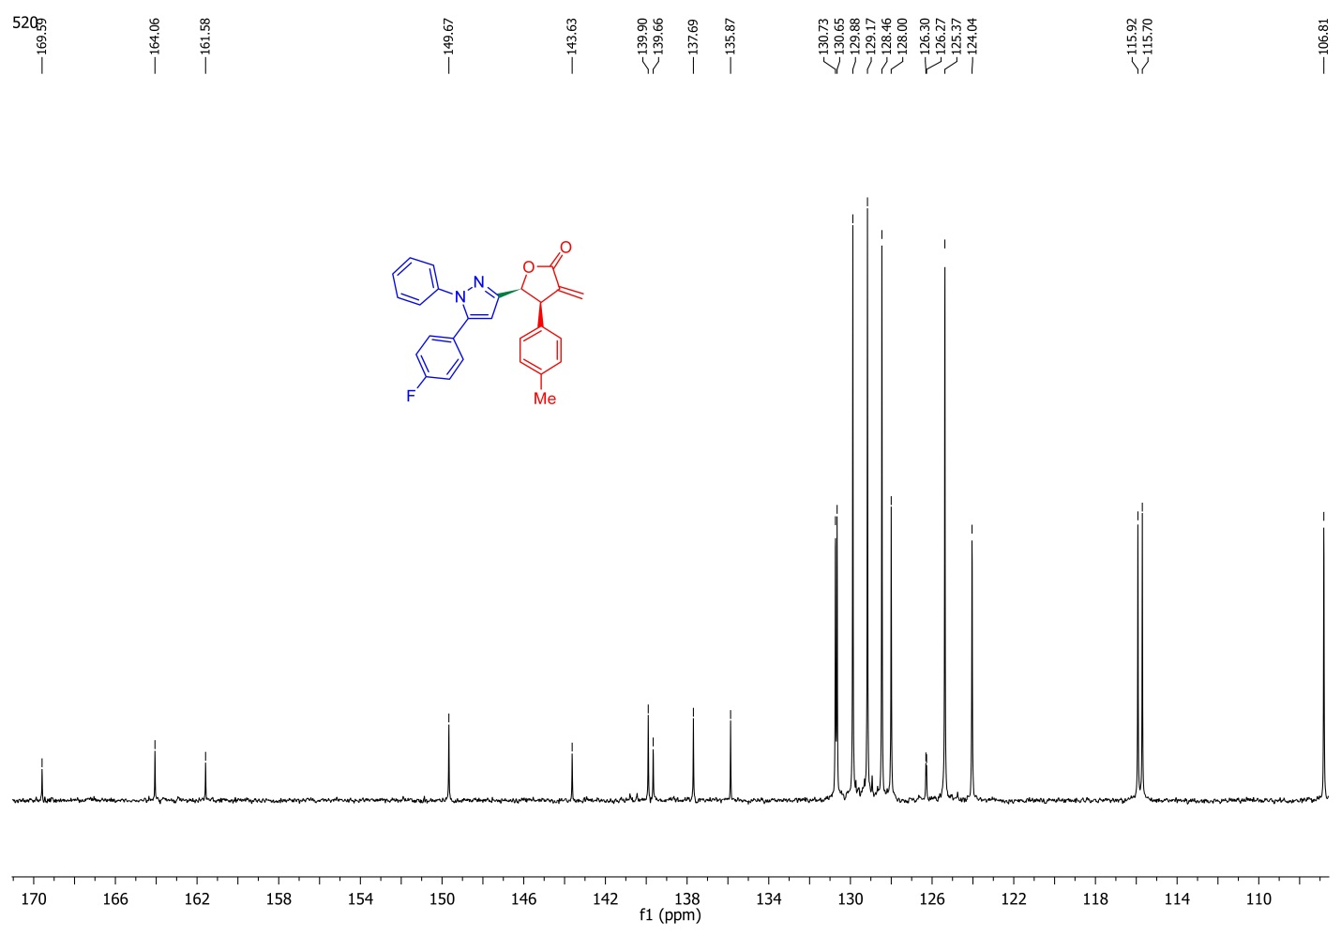
Figure S12. Expansion of ¹³C-NMR spectrum of 3B
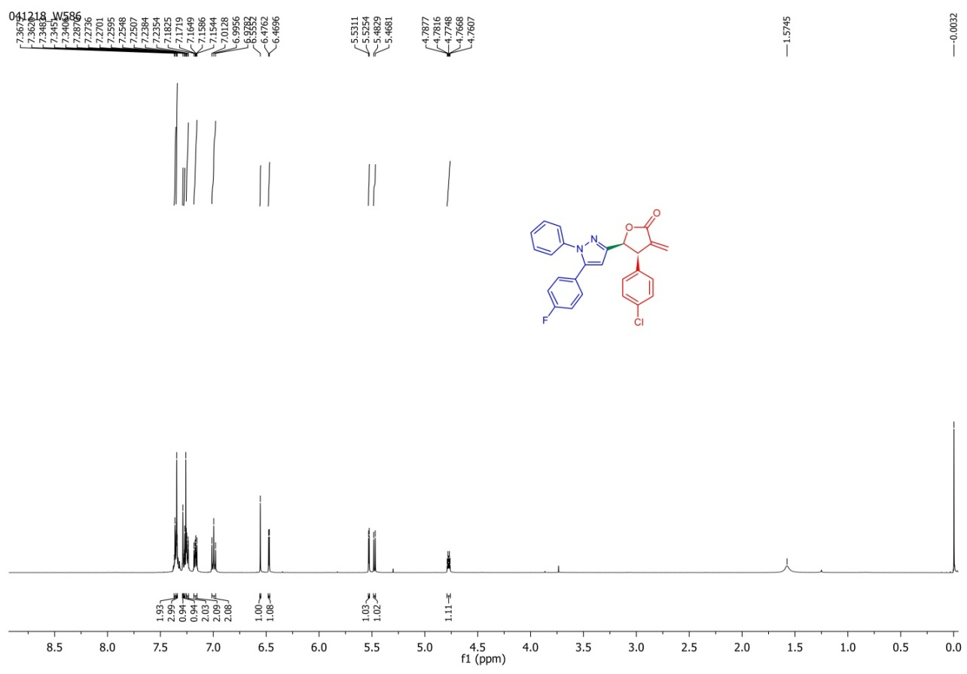
Figure S13. ¹H-NMR spectrum of 3D
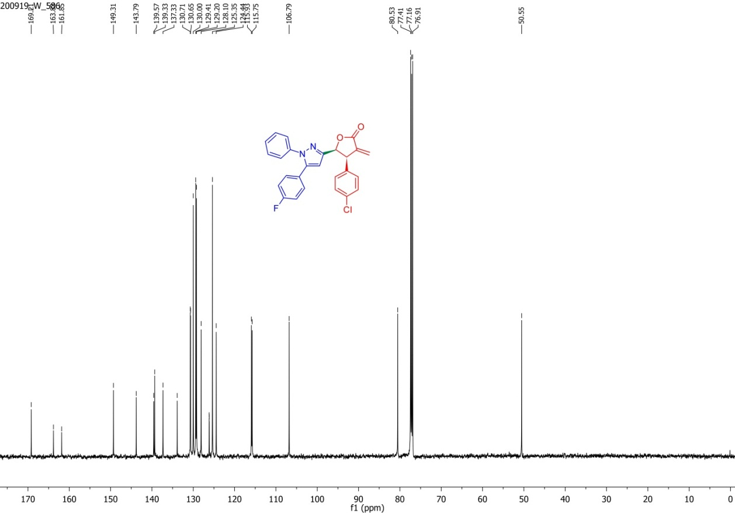
Figure S14. ¹³C-NMR spectrum of 3D
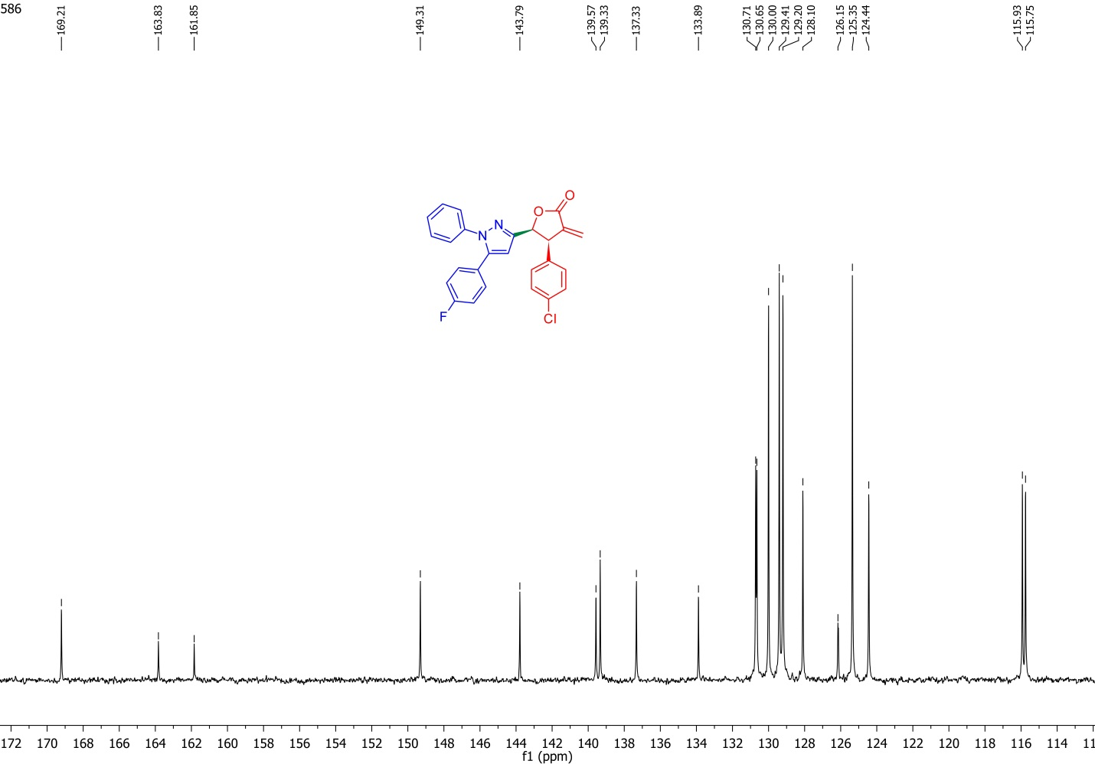
Figure S15. Expansion ¹³C-NMR spectrum of 3D
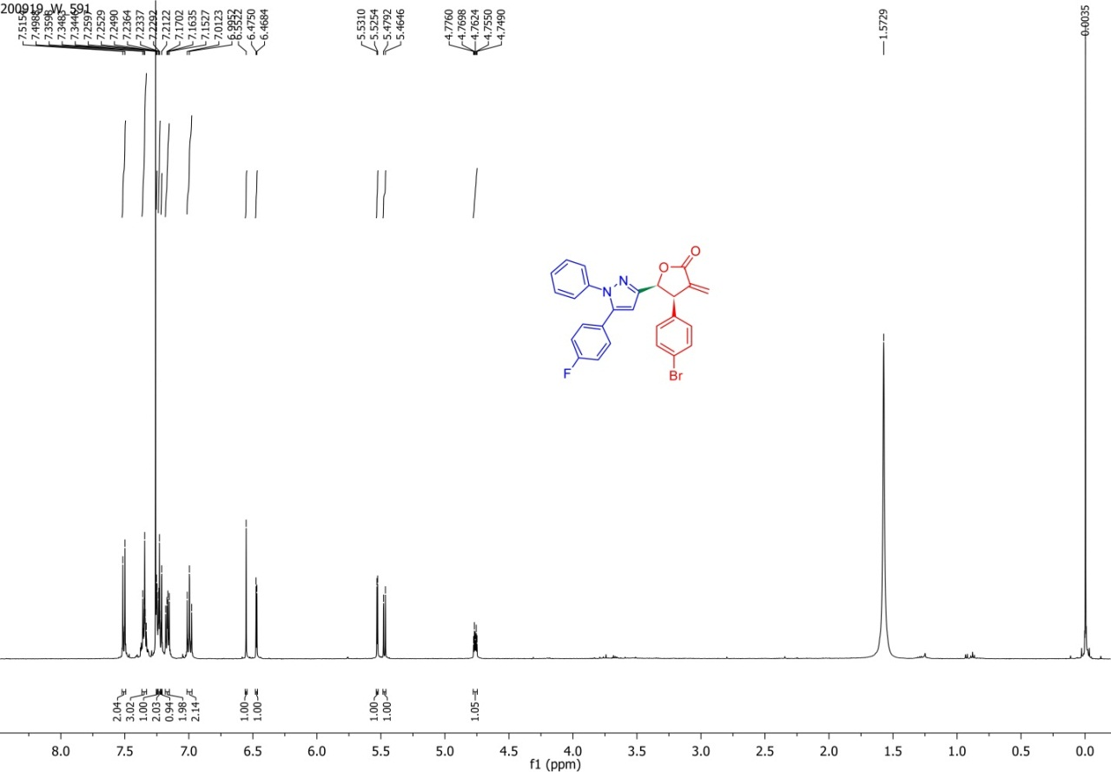
Figure S16. ¹H-NMR spectrum of 3E
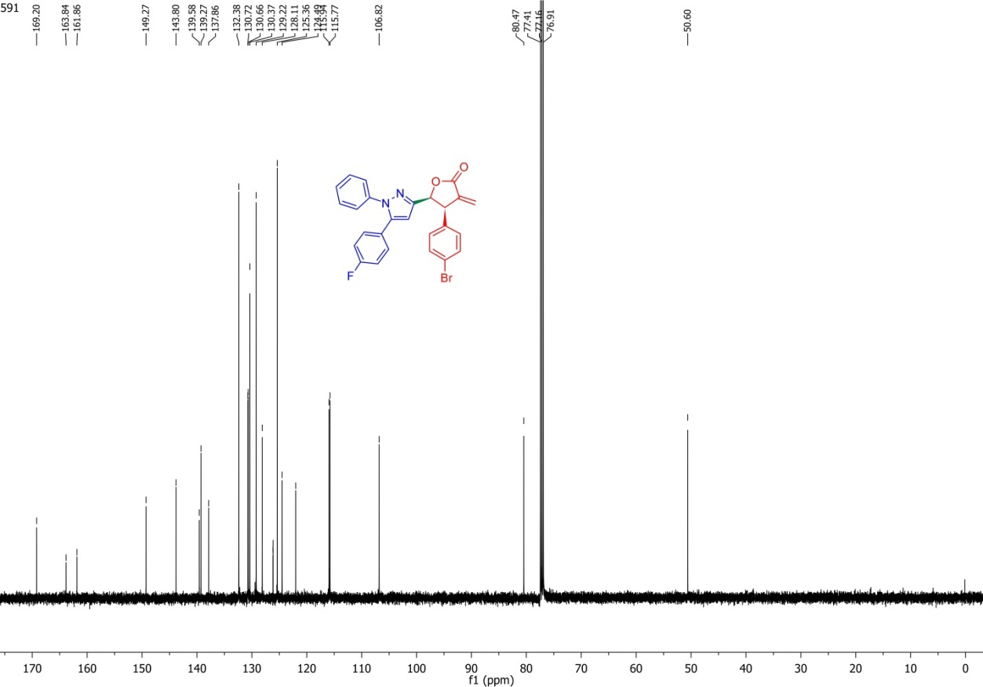
Figure S17. ¹³C-NMR spectrum of 3E
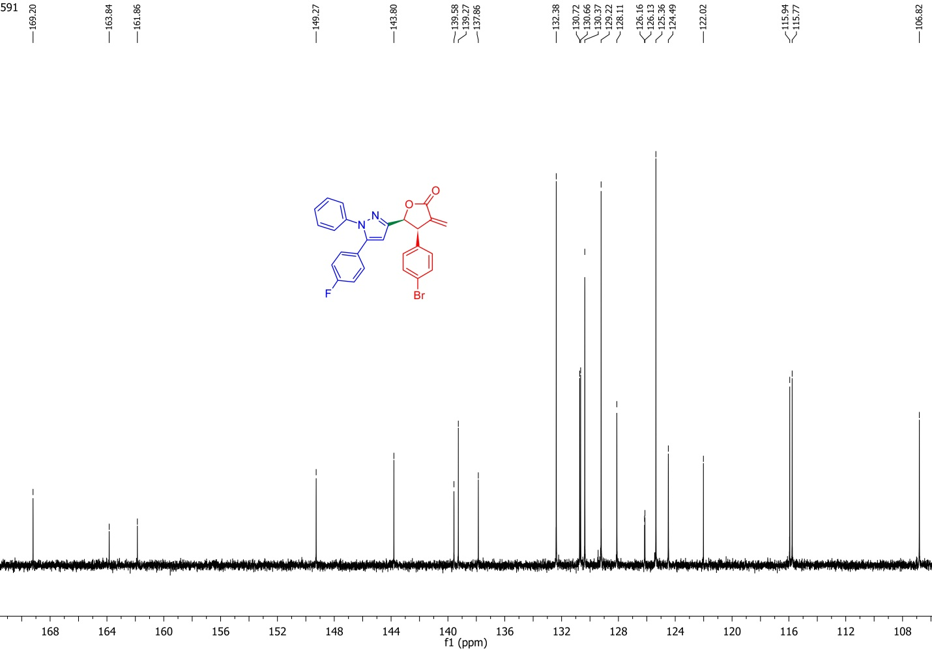
Figure S18. Expansion ¹³C-NMR spectrum of 3E
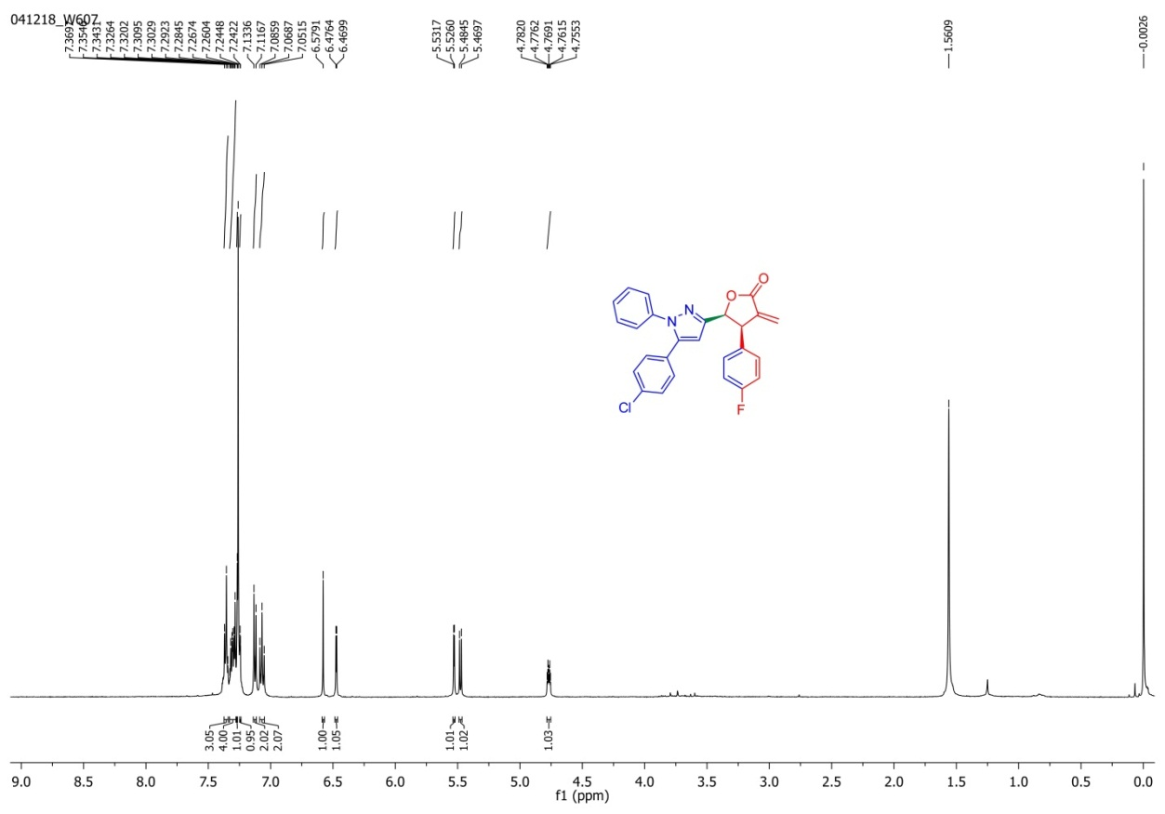
Figure S19. ¹H-NMR spectrum of 4C
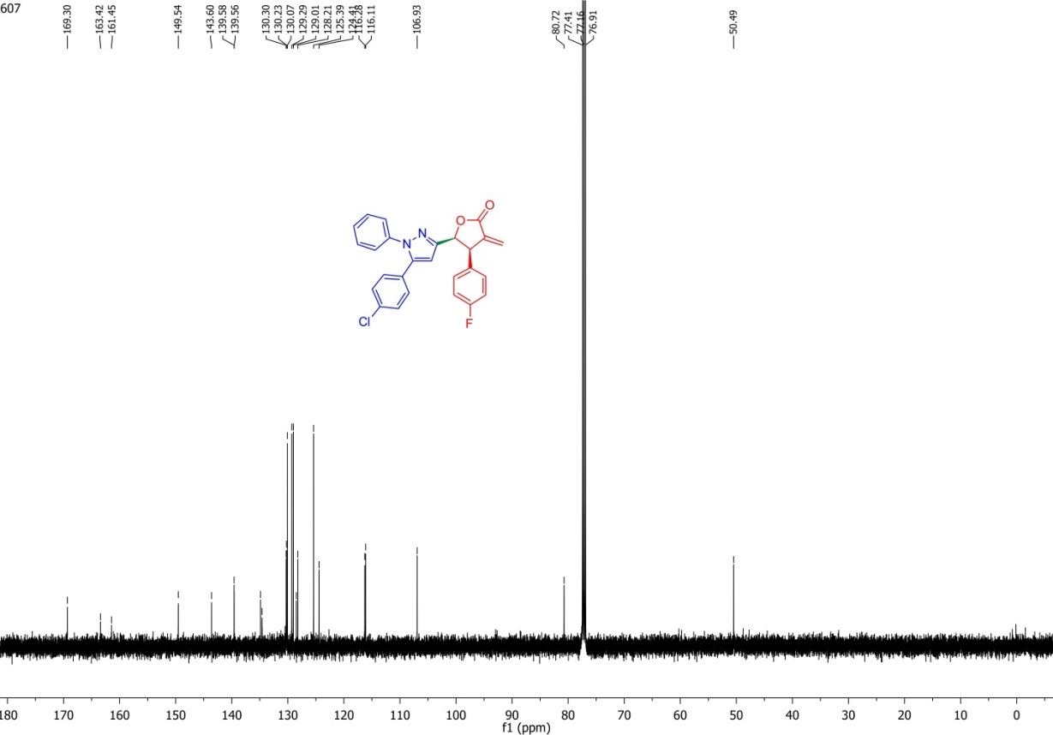
Figure S20. ¹³C-NMR spectrum of 4C
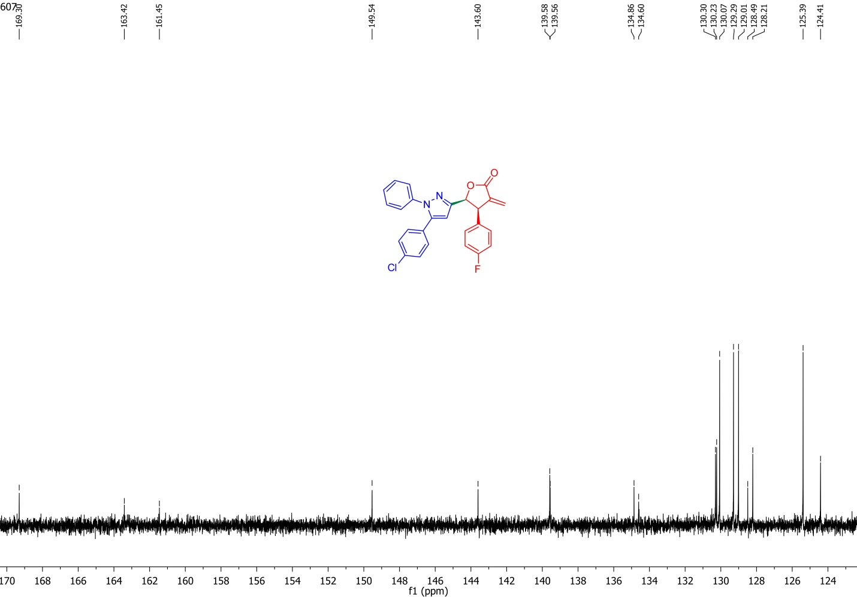
Figure S21. Expansion ¹³C-NMR spectrum of 4C
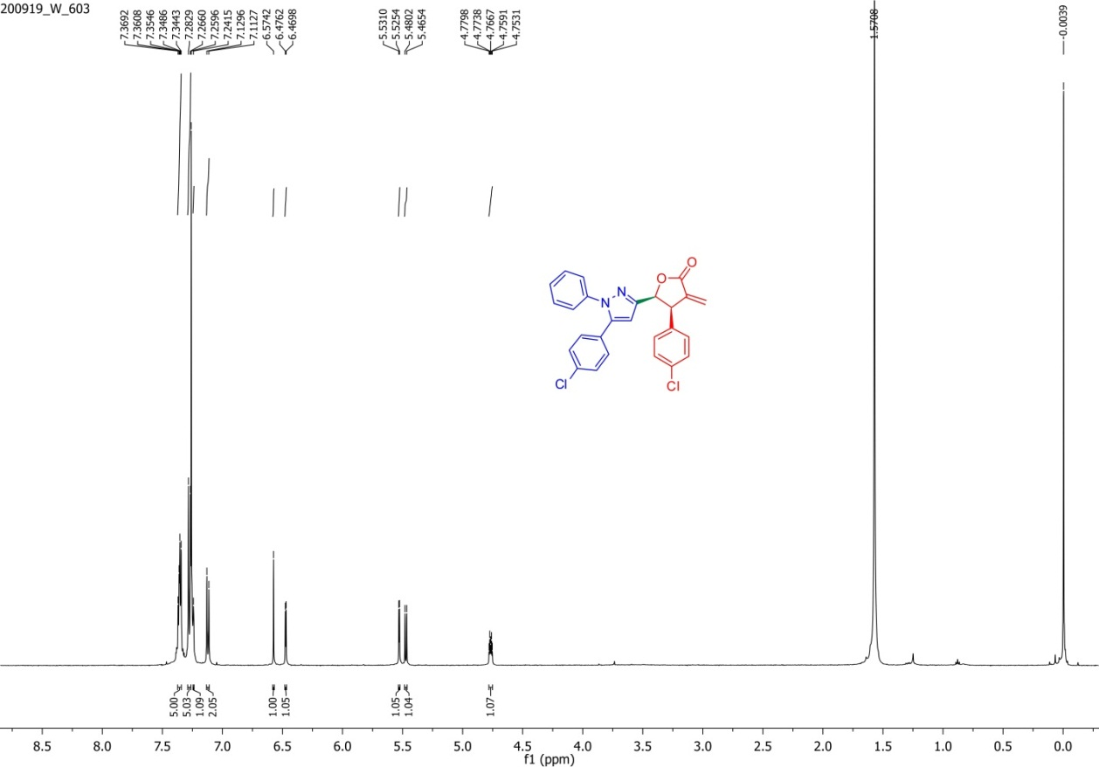
Figure S22. ¹H-NMR spectrum of 4D
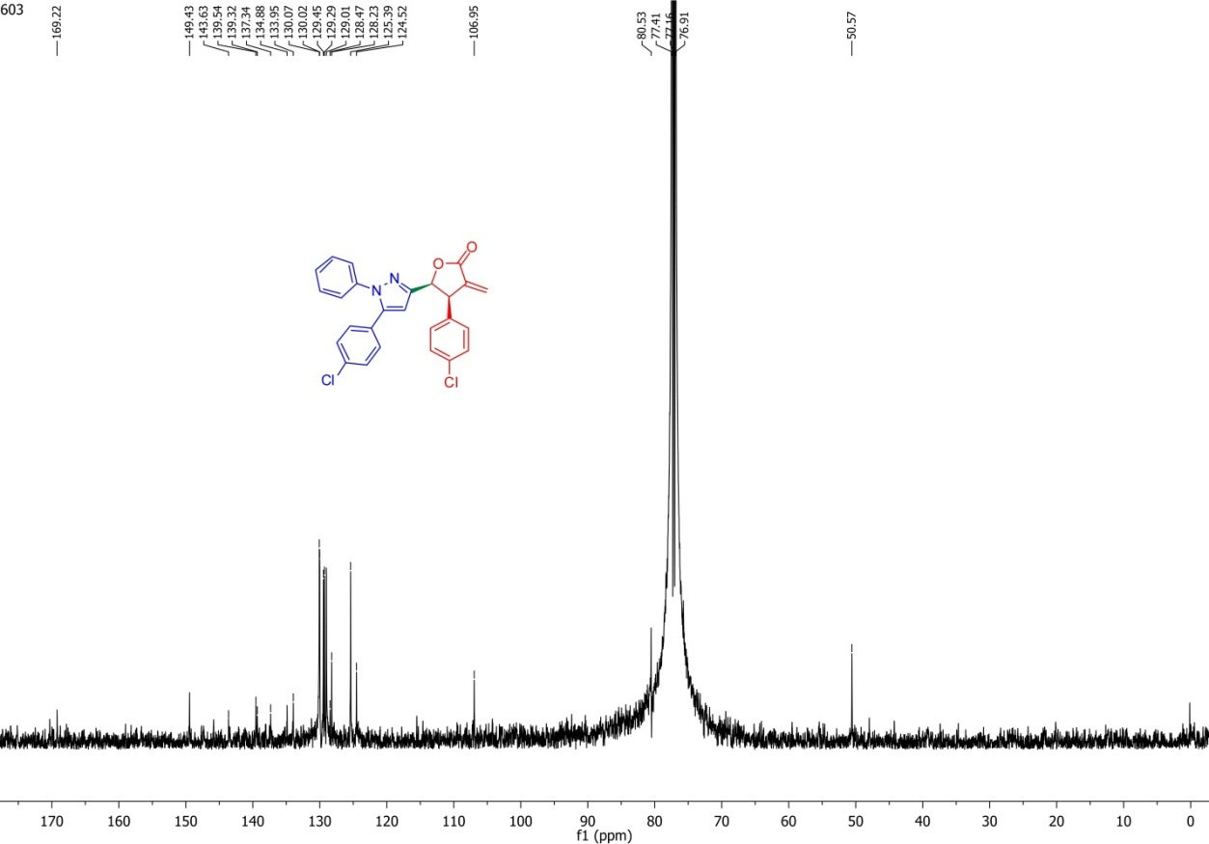
Figure S23. ¹³C-NMR spectrum of 4D
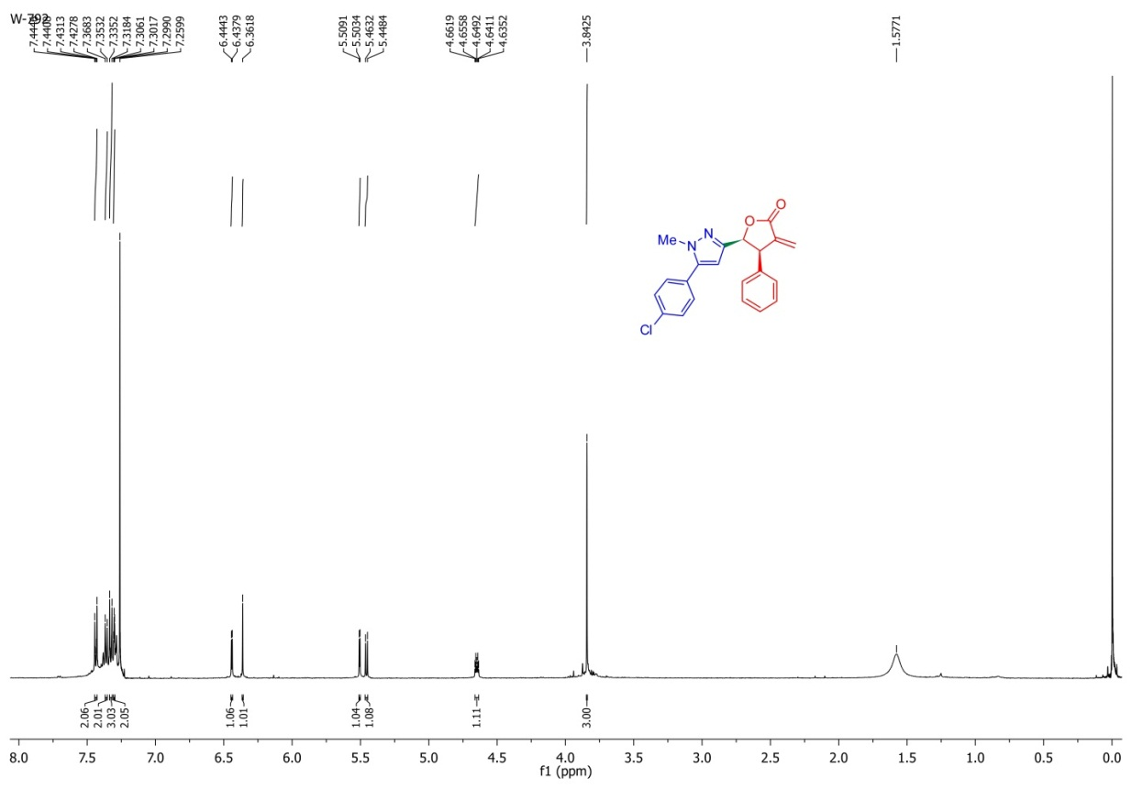
Figure S24. ¹H-NMR spectrum of 5A
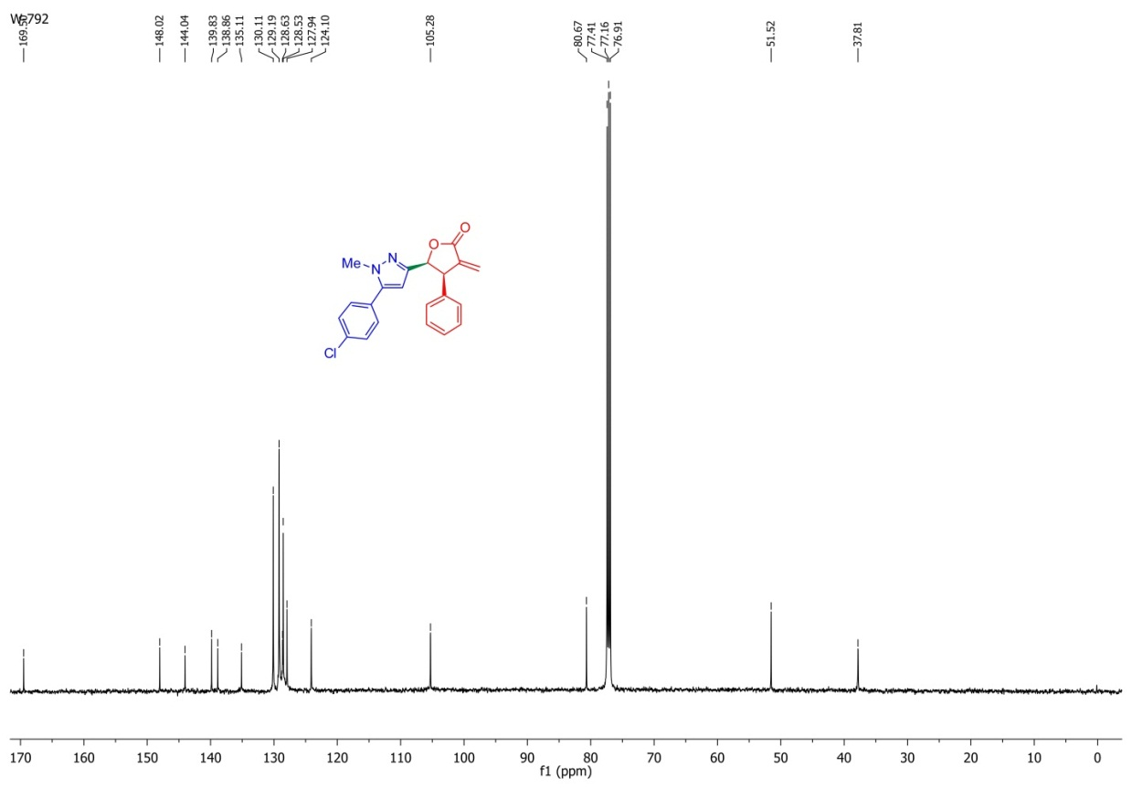
Figure S25. ¹³C-NMR spectrum of 5A
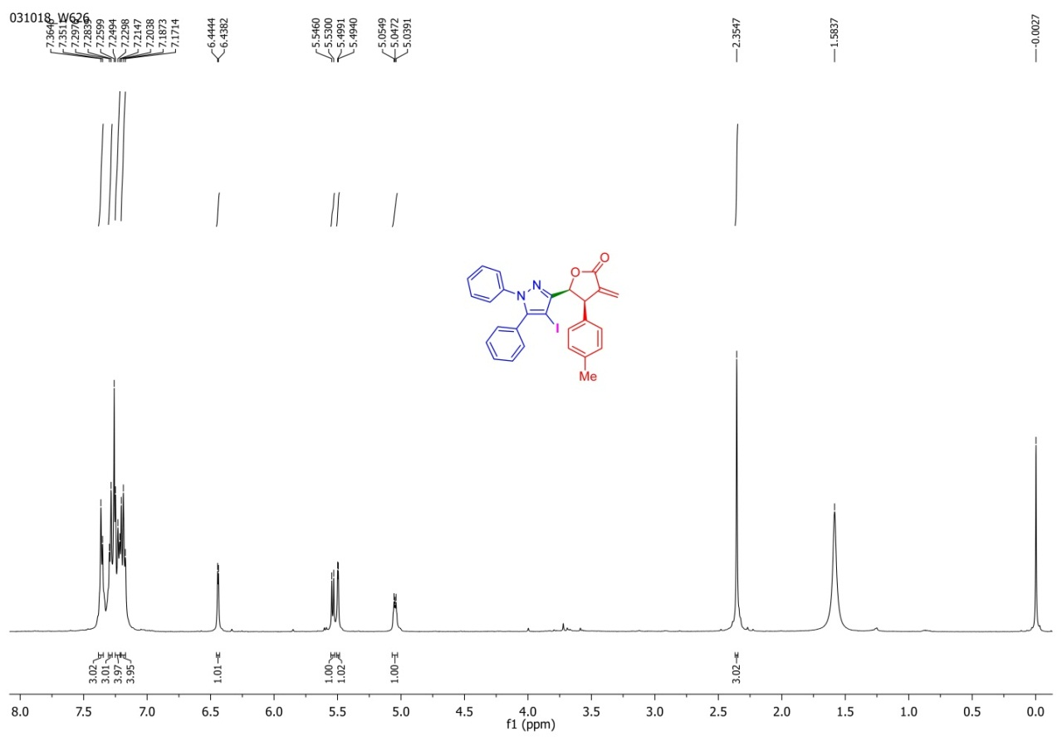
Figure S26. ¹H-NMR spectrum of 6B
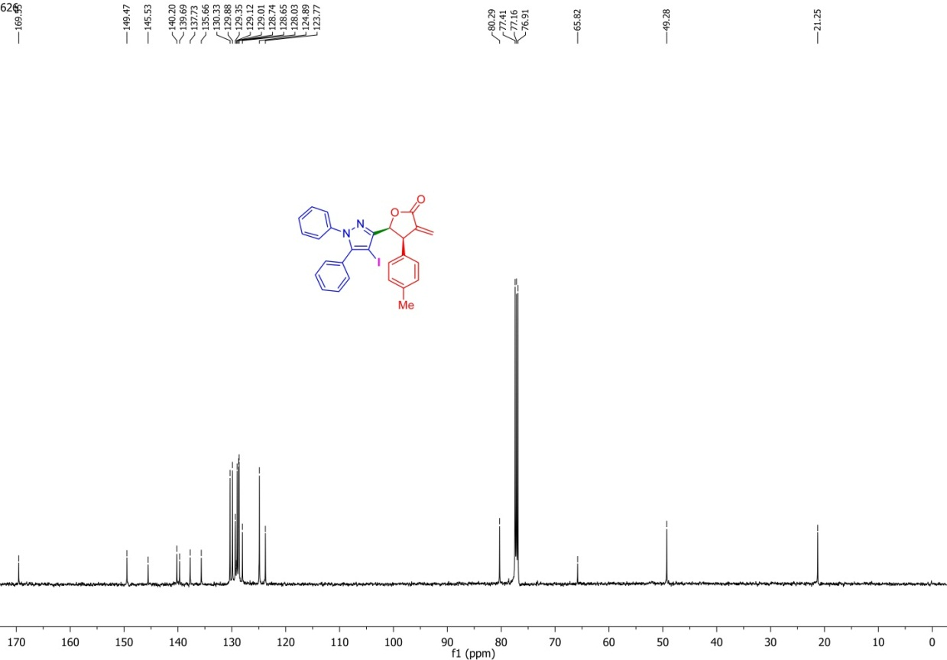
Figure S27. ¹³C-NMR spectrum of 6B
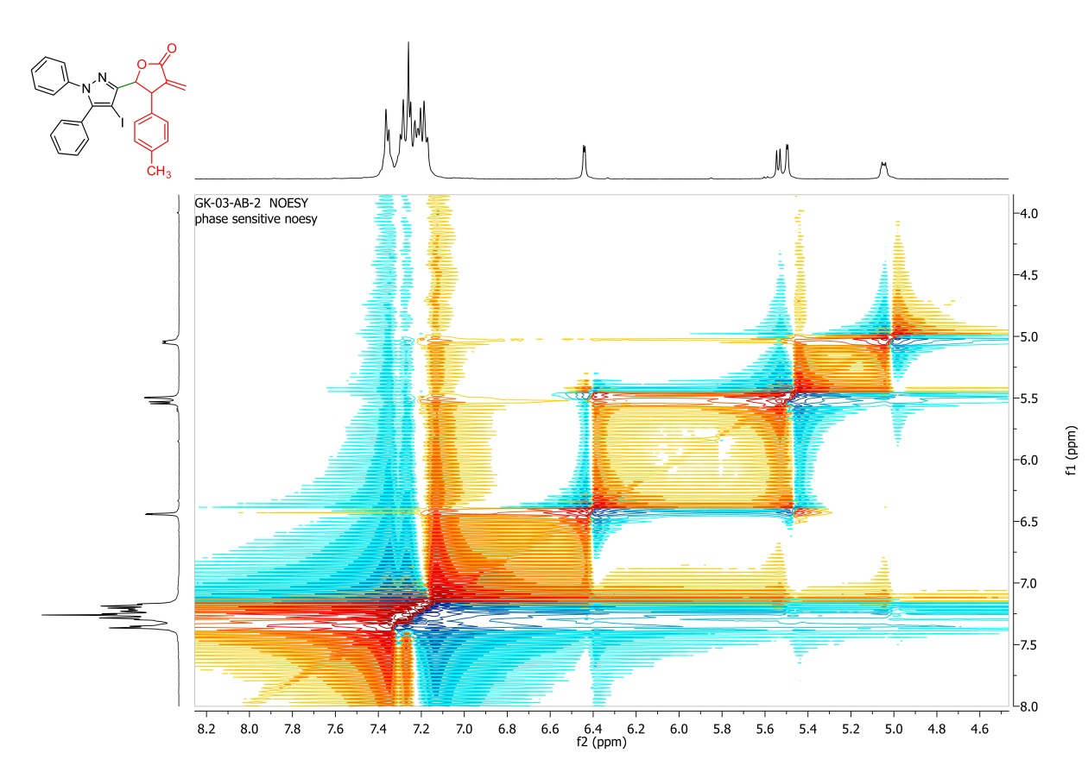
Figure S28. NOESY spectrum of 6B
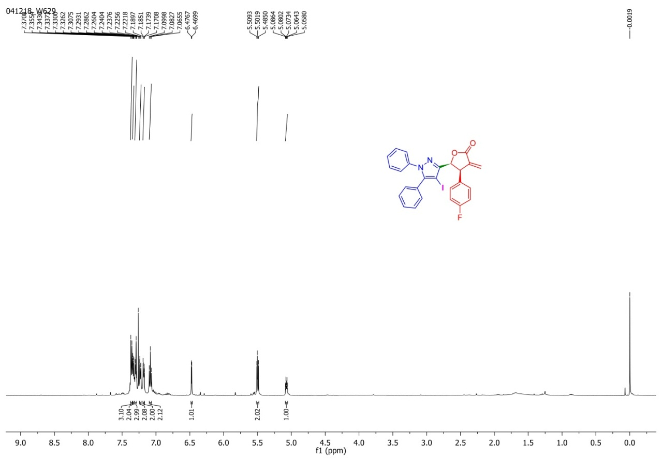
Figure S29. ¹H-NMR spectrum of 6C
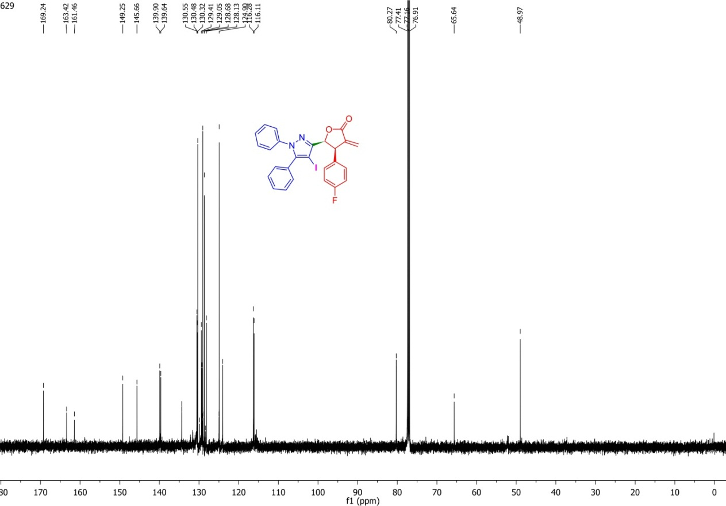
Figure S30. ¹³C-NMR spectrum of 6C
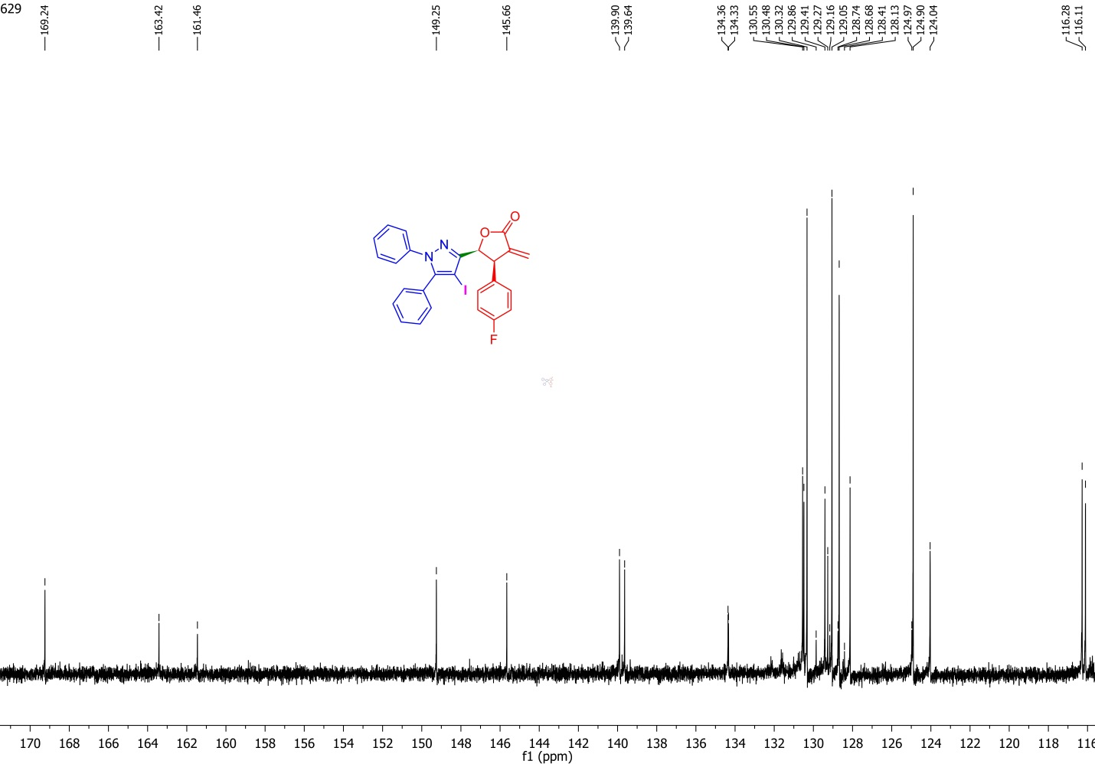
Figure S31. Expansion ¹³C-NMR spectrum of 6C
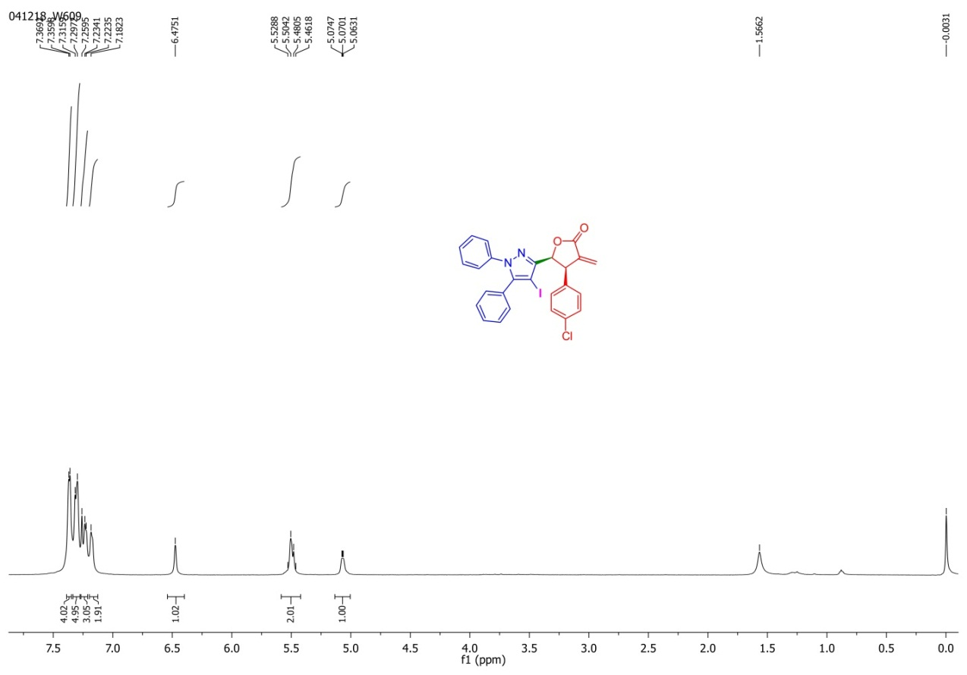
Figure S32. ¹H-NMR spectrum of 6D
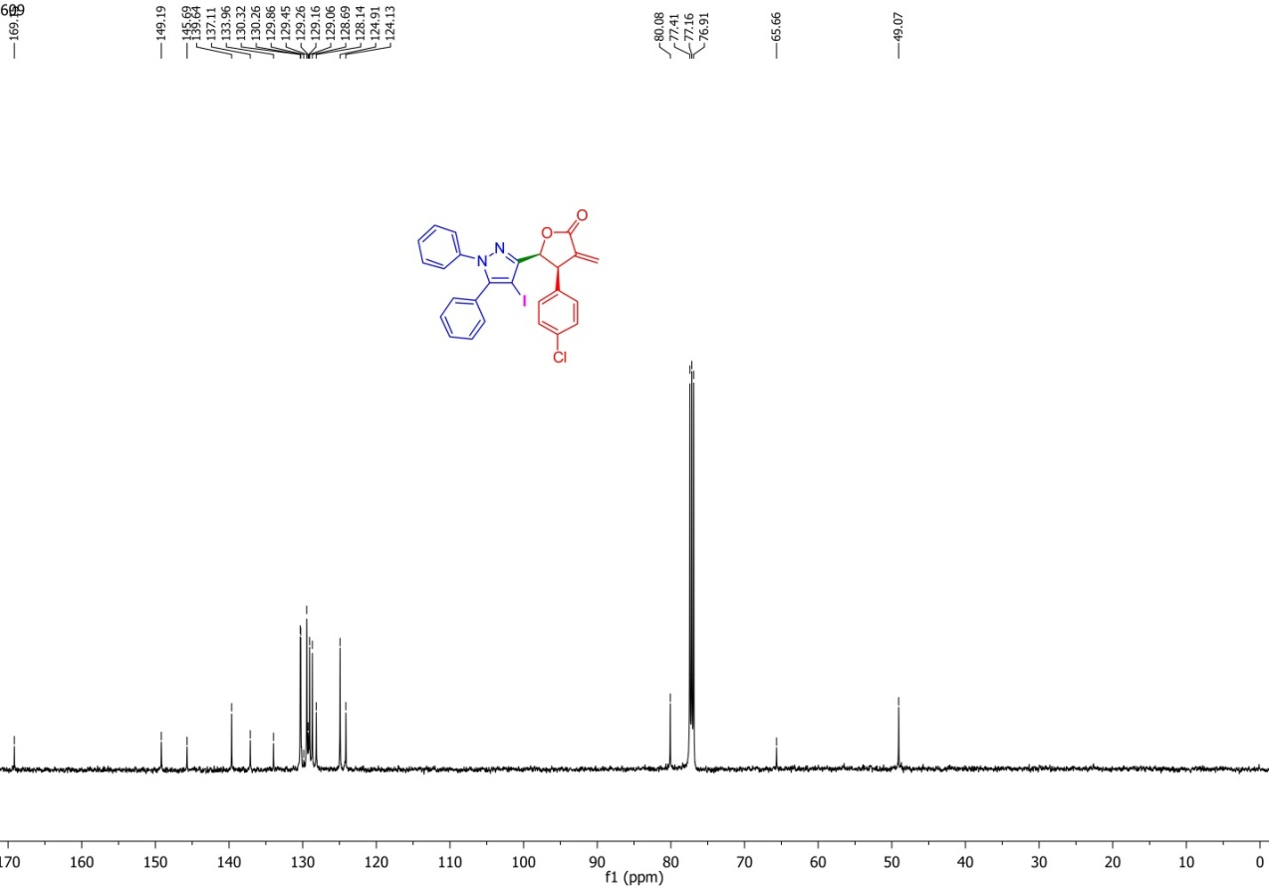
Figure S33. ¹³C-NMR spectrum of 6D
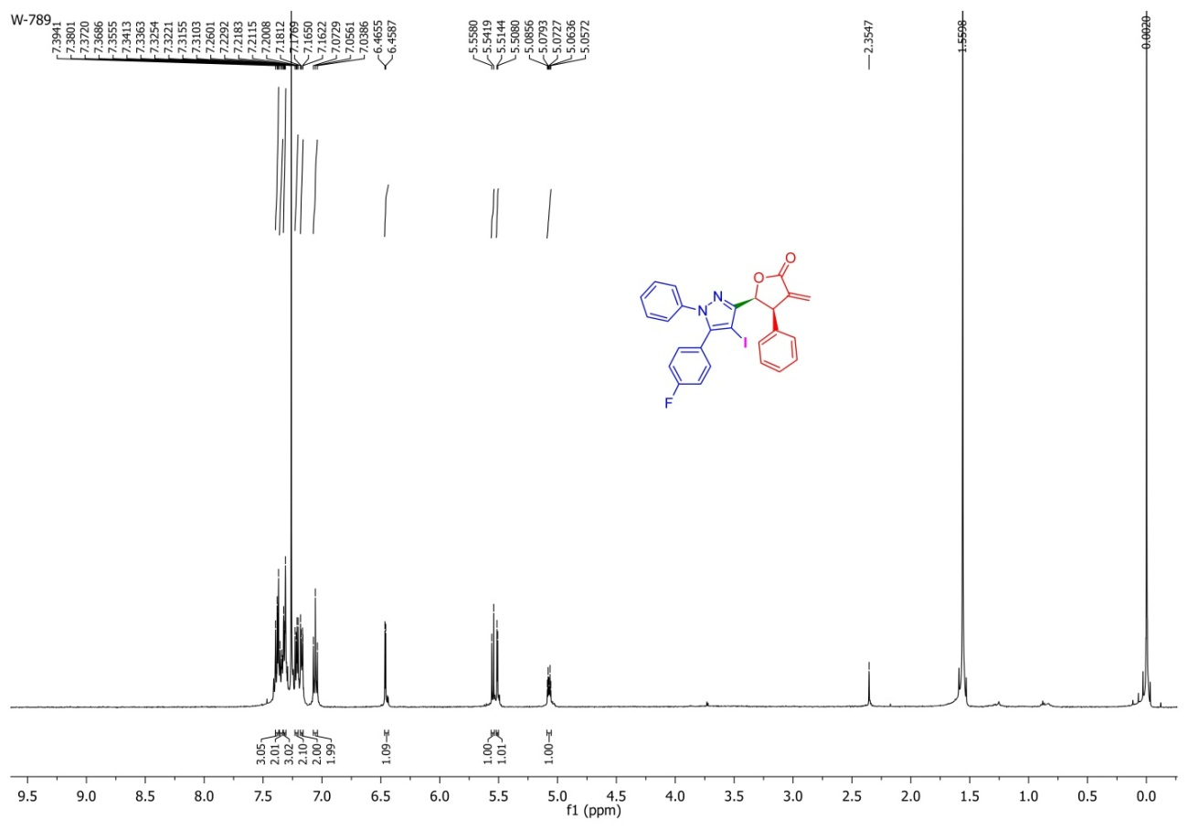
Figure S34. ¹H-NMR spectrum of 8A
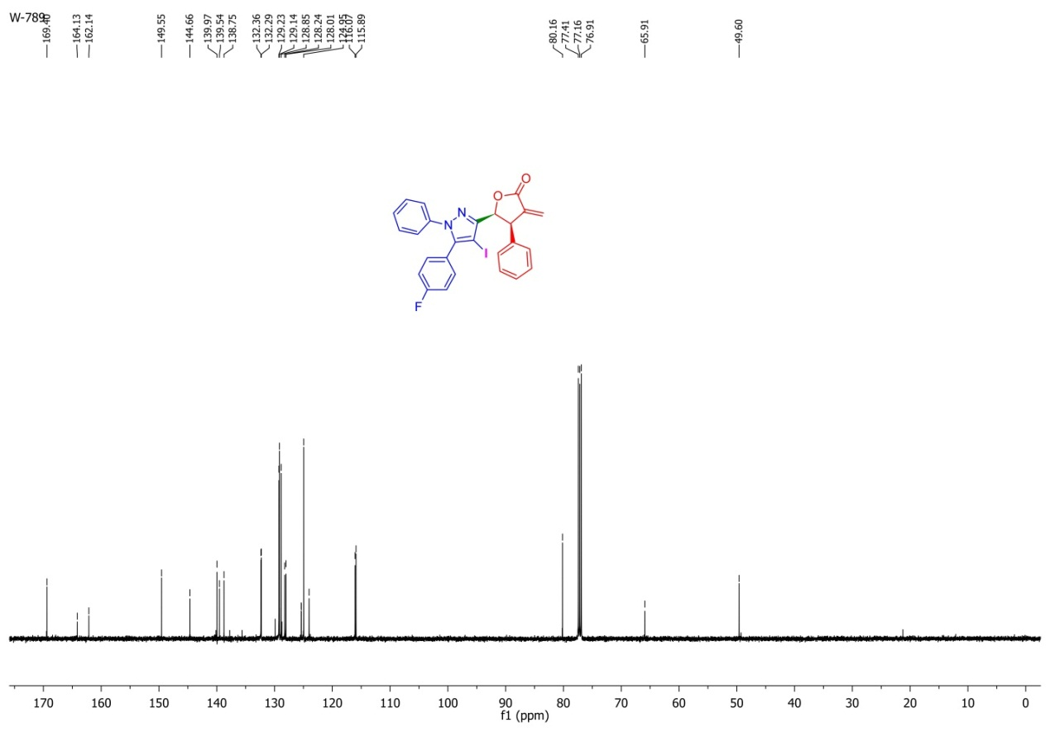
Figure S35. ¹³C-NMR spectrum of 8A
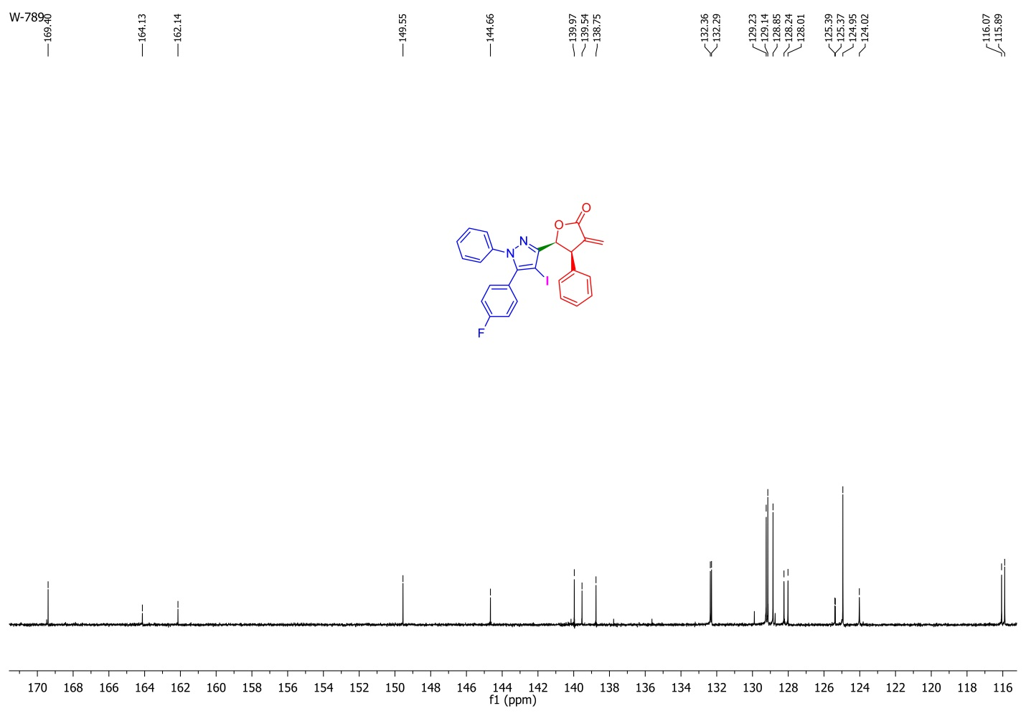
Figure S36. Expansion ¹³C-NMR spectrum of 8A
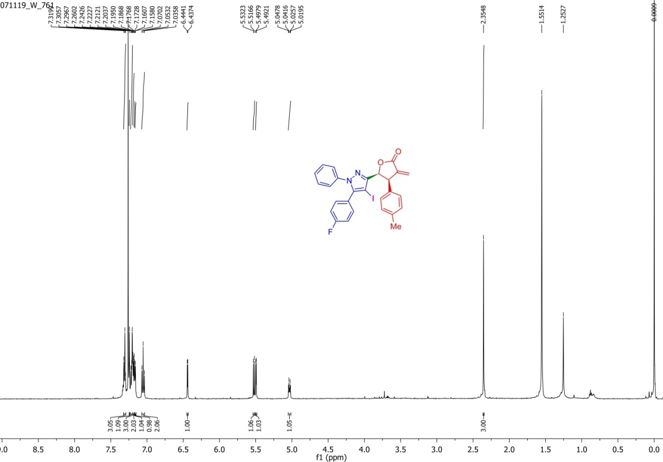
Figure S37. ¹H-NMR spectrum of 8B
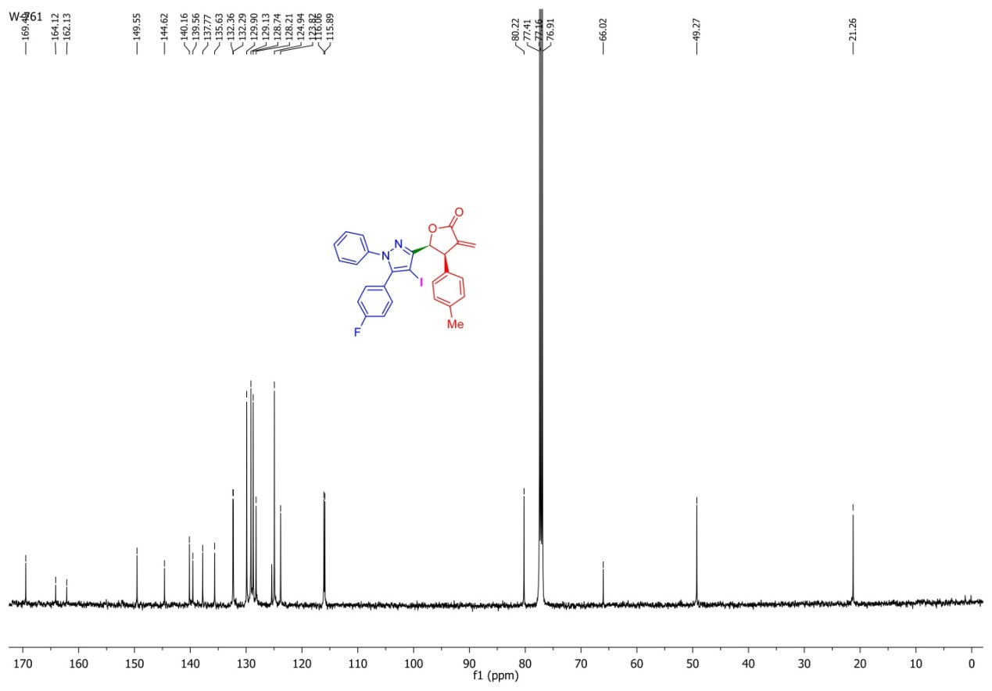
Figure S38. ¹³C-NMR spectrum of 8B
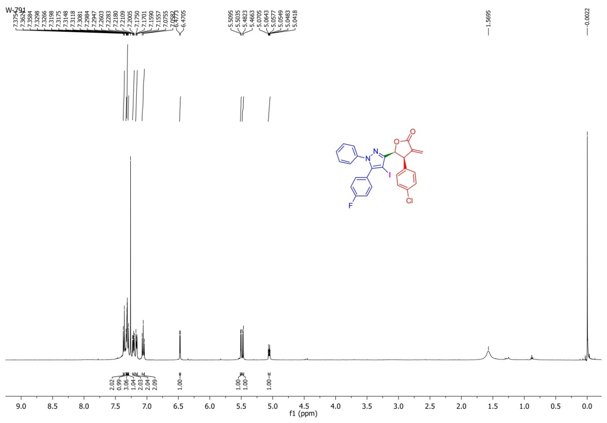
Figure S39. ¹H-NMR spectrum of 8D
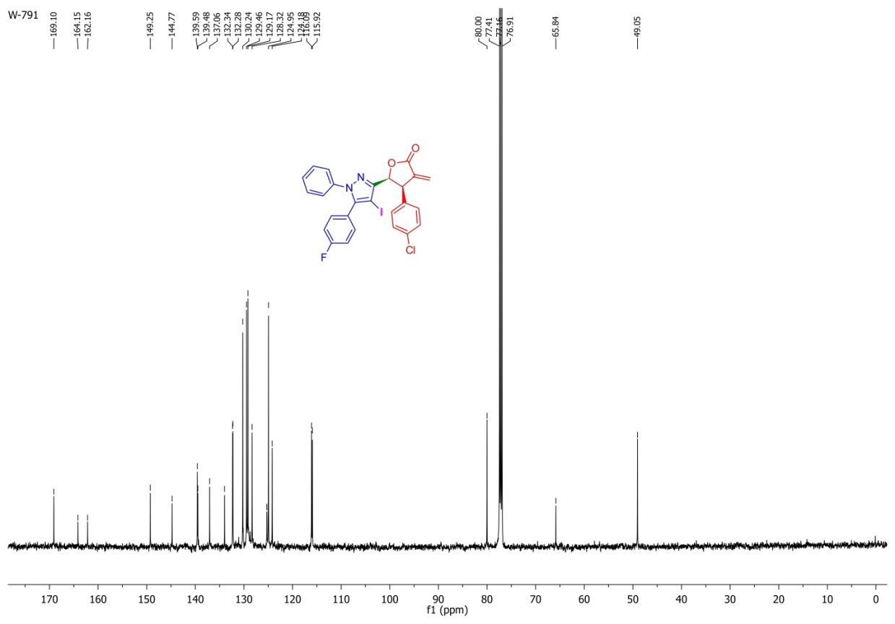
Figure S40. ¹³C-NMR spectrum of 8D
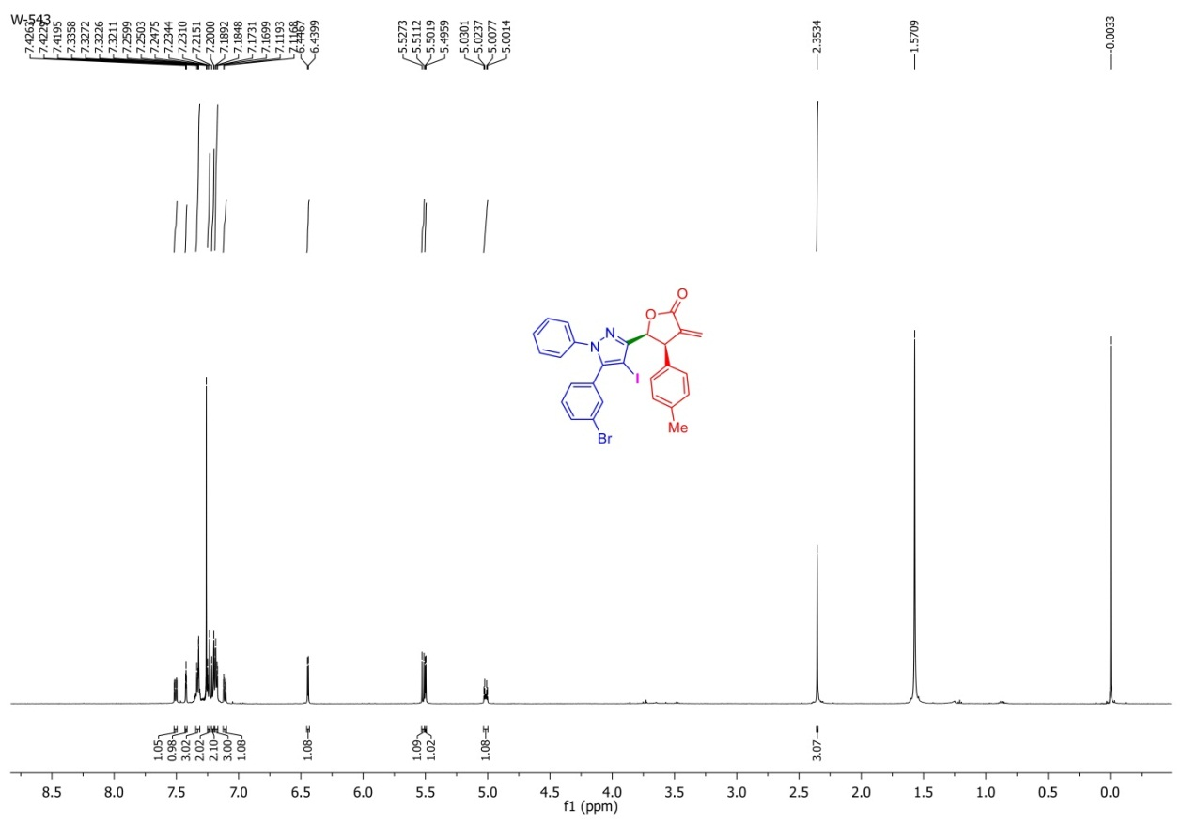
Figure S41. ¹H-NMR spectrum of 9D
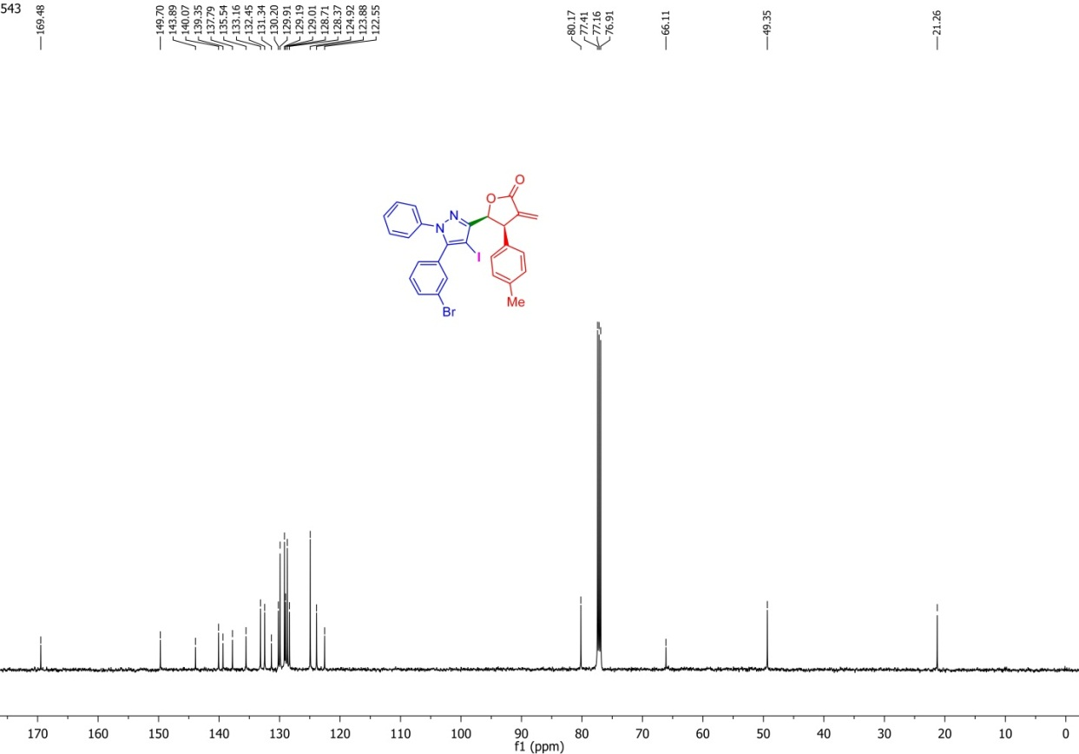
Figure S42. ¹³C-NMR spectrum of 9D
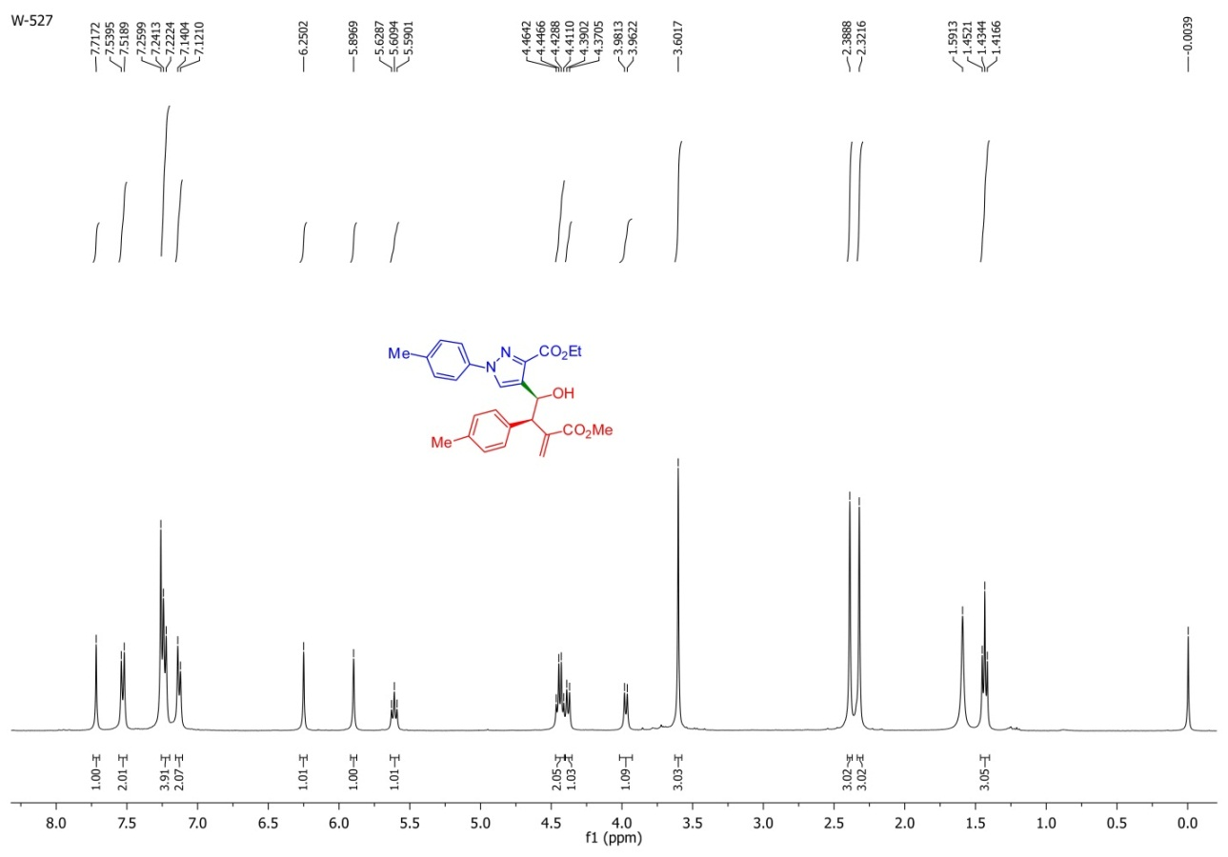
Figure S43. ¹H-NMR spectrum of 10B
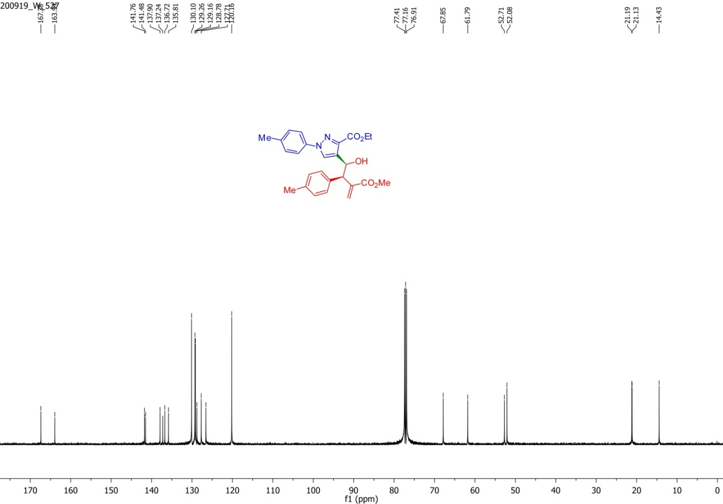
Figure S44. ¹³C-NMR spectrum of 10B
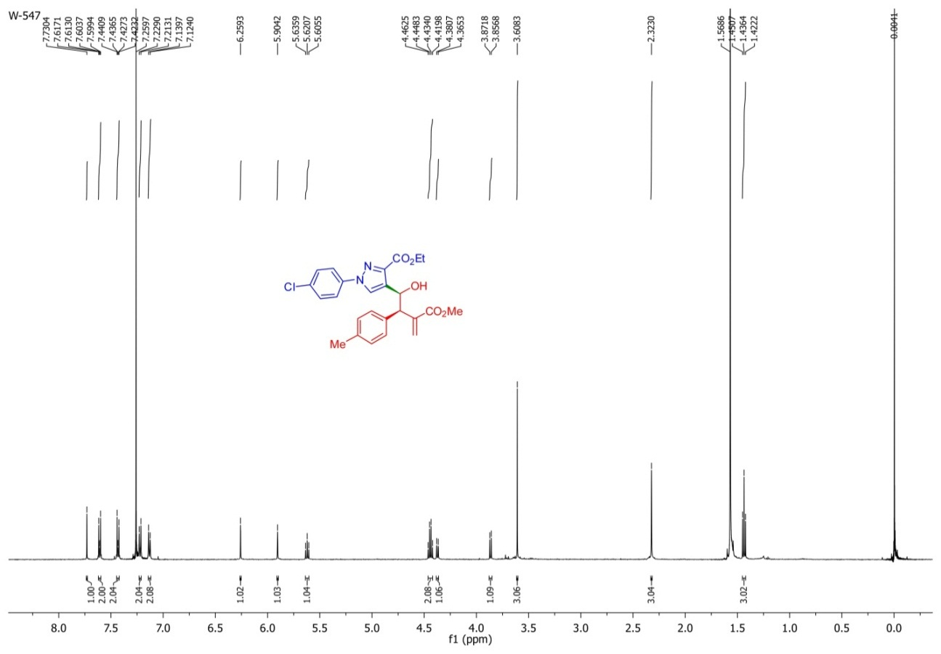
Figure S45. ¹H-NMR spectrum of 11B
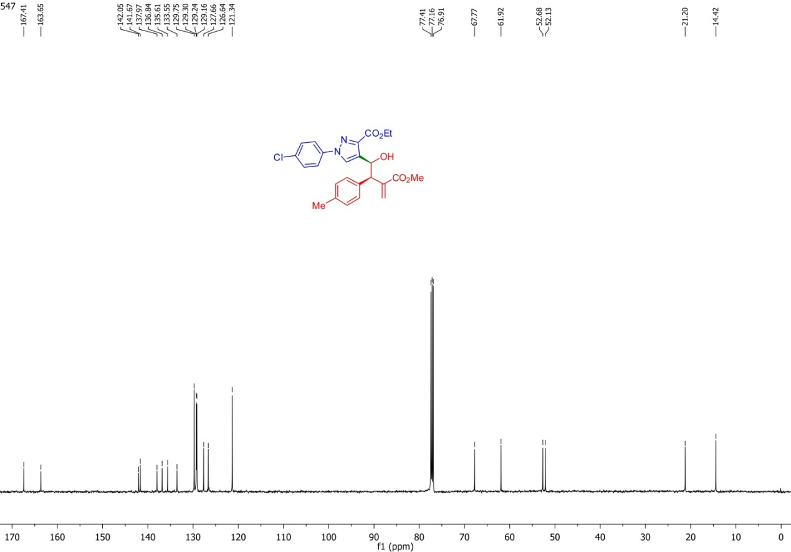
Figure S46. ¹³C-NMR spectrum of 11B

