**Supporting Information**

for

**Five new sesquiterpenoids from the agarwood of *Aquilaria sinensis***

Hong Zhou, Xu-Yang Li, Hong-Bin Fang, He-Zhong Jiang, Yong-Xian Cheng

**MS, UV, and NMR spectra of compounds 1–5, NMR and ECD calculations, and bioactivity assay date.**

### Contents

**Figure S1**: The lowest energy conformers of **1** (the relative populations are in parentheses).

**Figure S2**: The lowest energy conformers of **2** (the relative populations are in parentheses).

**Figure S3**: The lowest energy conformers of **3** (the relative populations are in parentheses).

**Figure S4**: The lowest energy conformers of **4** (the relative populations are in parentheses).

**Figure S5**: The lowest energy conformers of **5** (the relative populations are in parentheses).

**Table S1**: Extracted heats and weighting factors of the optimized conformers of **1**‒**5** at B3LYP/6-31G(d,p) level.

**Table S2.** The Cartesian coordinates of the lowest energy conformers for

**Figure S6**: DP4+ results of candidate(7*R*,10*R*)-**1** (Isomer 1) and (7*R*,11*S*)-**1** (Isomer 2).

**Figure S7**: DP4+ results of candidate (7*R*,10*R,* 11*R)*-**3** (Isomer 1) and (7*R*,10*R,*11*S*)-**3** (Isomer 2).

**Figure S8**: DP4+ results of candidate(7*S*,10*S,*11*S)*-**5** (Isomer 1) and (7*R*,10*R,*11*S*)-**5** (Isomer 2).

**Figure S9**: 1H NMR (500 MHz) spectrum of **1** in CD3OD.

**Figure S10**: 13C NMR and DEPT (125 MHz) spectra of **1** in CD3OD.

**Figure S11**: 1H-1H COSY (500 MHz) spectrum of **1** in CD3OD.

**Figure S12**: HSQC (500 MHz) spectrum of **1** in CD3OD.

**Figure S13**: HSBC (500 MHz) spectrum of **1** in CD3OD.

**Figure S14**: ROSEY (500 MHz) spectrum of **1** in CD3OD.

**Figure S15**: HRESIMS of **1**.

**Figure S16**: 1H NMR (500 MHz) spectrum of **2** in CD3OD.

**Figure S17**: 13C NMR (125MHz) spectrum of **2** in CD3OD.

**Figure S18**: 1H-1H COSY (500 MHz) spectrum of **2** in CD3OD

**Figure S19**: HSQC (500 MHz) spectrum of **2** in CD3OD.

**Figure S20**: HSBC (500 MHz) spectrum of **2** in CD3OD.

**Figure S21**: ROSEY (500 MHz) spectrum of **2** in CD3OD.

**Figure S22**:HRESIMS of **2**.

**Figure S23**: 1H NMR (500 MHz) spectrum of **3** in CD3OD.

**Figure S24**: 13C NMR and DEPT (150 MHz) spectra of **3** in CD3OD.

**Figure S25**: 1H-1H COSY (600 MHz) spectrum of **3** in CD3OD.

**Figure S26**: HSQC (600 MHz) spectrum of **3** in CD3OD.

**Figure S27**: HSBC (600 MHz) spectrum of **3** in CD3OD.

**Figure S28**: ROSEY (600 MHz) spectrum of **3** in CD3OD.

**Figure S29**:HRESIMS of **3**.

**Figure S30**: 1H NMR (500 MHz) spectrum of **4** in CD3OD.

**Figure S31**: 13C NMR and DEPT (150 MHz) spectra of **4** in CD3OD.

**Figure S32**: 1H-1H COSY (600 MHz) spectrum of **4** in CD3OD.

**Figure S33**: HSQC (600 MHz) spectrum of **4** in CD3OD.

**Figure S34**: HSBC (600 MHz) spectrum of **4** in CD3OD.

**Figure S35**: ROSEY (600 MHz) spectrum of **4** in CD3OD

**Figure S36**:HRESIMS of **4**

**Figure S37**: 1H NMR (500 MHz) spectrum of **5** in CDCl3.

**Figure S38**: 13C NMR and DEPT (150 MHz) spectra of **5** in CDCl3

**Figure S39**: 1H-1H COSY (600 MHz) spectrum of **5** in CDCl3.

**Figure S40**: HSQC (600 MHz) spectrum of **5** in CDCl3.

**Figure S41**: HSBC (600 MHz) spectrum of **5** in CDCl3

**Figure S42**: ROSEY (600 MHz) spectrum of **5** in CDCl3.

**Figure S43**: HRESIMS of **5**.

**Figure S44**: UV-vis spectrum of **1**–**5**

**Fig A**:human breast cancer cell line (MCF-7) were treated with 40 μM with conpounds**1**-**5** for 24 h, and cell viability was determined by CCK-8 assay.

**Fig B**: RAW 264.7 were treated with 20 μM with conpounds**1**-**5** for 24 h, and cell viability was determined by CCK-8 assay.

**Fig C**: Compounds suppress LPS-induced INOS and COX-2 expression in RAW 264.7 cells.

Selected conformation of **1** and their percentage

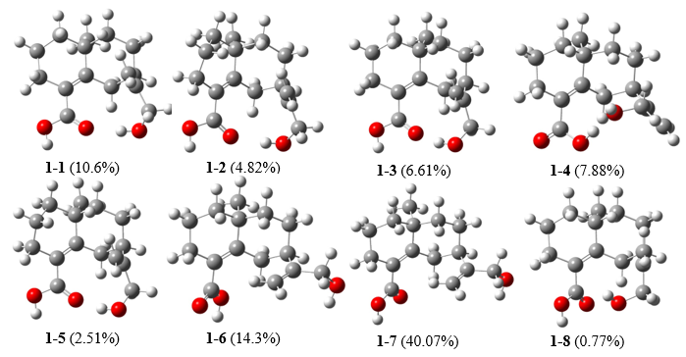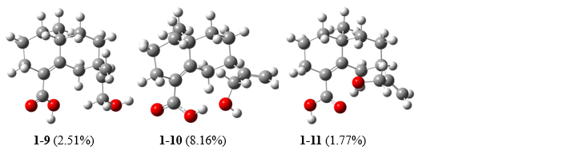

**Figure S1**: The lowest energy conformers of **1** (the relative populations are in parentheses).

Selected conformation of **2** and their percentage

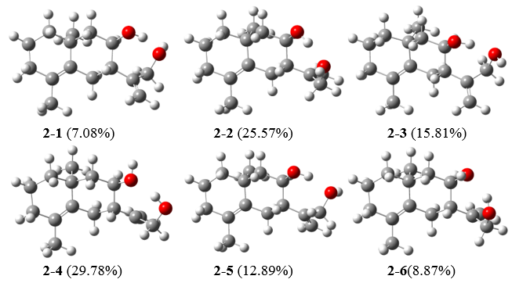

**Figure S2**: The lowest energy conformers of **2** (the relative populations are in parentheses).

Selected conformation of **3** and their percentage

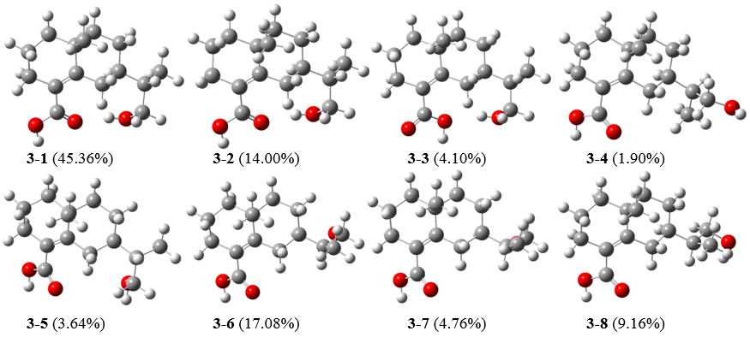

**Figure S3**: The lowest energy conformers of **3** (the relative populations are in parentheses).

Selected conformation of **4** and their percentage

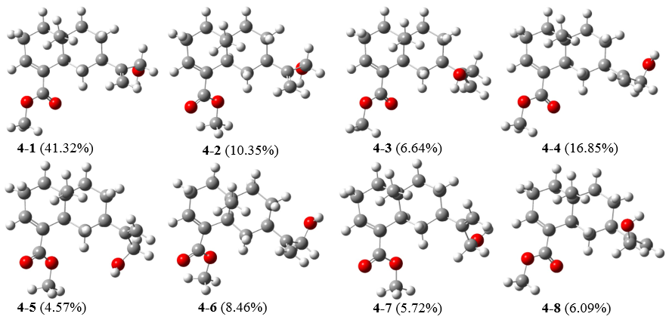

**Figure S4**: The lowest energy conformers of **4** (the relative populations are in parentheses).

Selected conformation of **5** and their percentage

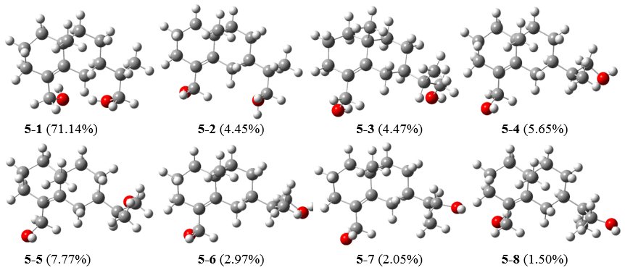

**Figure S5**: The lowest energy conformers of **5** (the relative populations are in parentheses).

**Table S1**: Extracted heats and weighting factors of the optimized conformers of **1**‒**5** at B3LYP/6-31G(d,p) level.

|  |  |  |  |
| --- | --- | --- | --- |
|  | | B3LYP/6-31G(d,p) | |
|  | Conformer | Extracted heats | Boltzmann-calculated contribution (%) |
| 1 | 1 | -810.42627 | 10.6 |
| 2 | -810.425526 | 4.82 |
| 3 | -810.425823 | 6.61 |
| 4 | -810.42599 | 7.88 |
| 5 | -810.424909 | 2.51 |
| 6 | -810.426552 | 14.3 |
| 7 | -810.427525 | 40.07 |
| 8 | -810.423792 | 0.77 |
| 9 | -810.424911 | 2.51 |
| 10 | -810.426023 | 8.16 |
| 11 | -810.424577 | 1.77 |
| 2 | 1 | -736.181953 | 7.08 |
| 2 | -736.183165 | 25.57 |
| 3 | -736.182711 | 15.81 |
| 4 | -736.183309 | 29.78 |
| 5 | -736.182518 | 12.89 |
| 6 | -736.182165 | 8.87 |
| 3 | 1 | -811.452558 | 45.36 |
| 2 | -811.451448 | 14.00 |
| 3 | -811.450288 | 4.10 |
| 4 | -811.449562 | 1.90 |
| 5 | -811.450176 | 3.64 |
| 6 | -811.451636 | 17.08 |
| 7 | -811.45043 | 4.76 |
| 8 | -811.451047 | 9.16 |
| 4 | 1 | -849.51583 | 41.32 |
| 2 | -849.514523 | 10.35 |
| 3 | -849.514104 | 6.64 |
| 4 | -849.514983 | 16.85 |
| 5 | -849.513751 | 4.57 |
| 6 | -849.514333 | 8.46 |
| 7 | -849.513963 | 5.72 |
| 8 | -849.514023 | 6.09 |
| 5 | 1 | -737.384987 | 71.14 |
| 2 | -737.38237 | 4.45 |
| 3 | -737.382375 | 4.47 |
| 4 | -737.382596 | 5.65 |
| 5 | -737.382896 | 7.77 |
| 6 | -737.381988 | 2.97 |
| 7 | -737.381638 | 2.05 |
| 8 | -737.381342 | 1.5 |

**Table S2.** The Cartesian coordinates of the lowest energy conformers for **1‒5**

|  |  |  |  |  |  |  |  |
| --- | --- | --- | --- | --- | --- | --- | --- |
| **1-1** | X axis(Å) | Y axis(Å) | Z axis(Å) | **1-2** | X axis(Å) | Y axis(Å) | Z axis(Å) |
| C | -1.3963 | -1.4589 | -0.5995 | C | -1.1888 | -1.6092 | -0.4689 |
| C | -0.5173 | -2.701 | -0.3208 | C | -0.1583 | -2.6951 | -0.0635 |
| C | 0.8191 | -2.425 | 0.3812 | C | 1.1886 | -2.1799 | 0.4746 |
| C | 1.6341 | -1.2305 | -0.1806 | C | 1.8169 | -1.0318 | -0.3549 |
| C | 0.705 | -0.0307 | -0.4031 | C | 0.7293 | 0.0357 | -0.5441 |
| C | -0.5323 | -0.3481 | -1.2251 | C | -0.5008 | -0.4797 | -1.2678 |
| C | 2.7577 | -0.9124 | 0.8489 | C | 3.0766 | -0.4883 | 0.3789 |
| C | 3.3461 | 0.4785 | 0.6543 | C | 2.749 | 0.5582 | 1.4342 |
| C | 2.2608 | 1.538 | 0.8198 | C | 2.0205 | 1.7328 | 0.7914 |
| C | 0.9895 | 1.1966 | 0.0916 | C | 0.8471 | 1.2852 | -0.0365 |
| C | -2.2859 | -0.9581 | 0.546 | C | -2.0918 | -1.0843 | 0.6558 |
| C | -2.0438 | -1.1379 | 1.8568 | C | -1.7544 | -1.0252 | 1.9567 |
| C | -3.5769 | -0.281 | 0.1309 | C | -3.4896 | -0.6732 | 0.2416 |
| C | 2.2979 | -1.634 | -1.5175 | C | 2.319 | -1.5842 | -1.7108 |
| O | -3.3213 | 0.9454 | -0.5273 | O | -3.4539 | 0.4631 | -0.6015 |
| C | 0.0252 | 2.3085 | -0.0357 | C | -0.2281 | 2.2944 | -0.1656 |
| O | -1.1235 | 2.3199 | 0.3702 | O | -1.4098 | 2.1522 | 0.0906 |
| O | 0.5678 | 3.3554 | -0.6765 | O | 0.2672 | 3.4634 | -0.6052 |
| H | -2.0994 | -1.789 | -1.3792 | H | -1.8701 | -2.1193 | -1.1664 |
| H | -1.0827 | -3.4472 | 0.2512 | H | -0.5988 | -3.3884 | 0.6639 |
| H | -0.295 | -3.1777 | -1.2852 | H | 0.0493 | -3.3048 | -0.9531 |
| H | 0.627 | -2.2654 | 1.4465 | H | 1.0628 | -1.8569 | 1.5124 |
| H | 1.4278 | -3.3385 | 0.3396 | H | 1.8853 | -3.0277 | 0.5214 |
| H | -1.1257 | 0.5407 | -1.445 | H | -1.2006 | 0.3176 | -1.5211 |
| H | -0.204 | -0.6831 | -2.2177 | H | -0.201 | -0.8688 | -2.2482 |
| H | 2.3638 | -0.9699 | 1.8729 | H | 3.6345 | -1.3128 | 0.8406 |
| H | 3.5563 | -1.6624 | 0.7898 | H | 3.7624 | -0.0278 | -0.3462 |
| H | 3.8067 | 0.5629 | -0.337 | H | 3.6722 | 0.9127 | 1.9066 |
| H | 4.1426 | 0.6532 | 1.3868 | H | 2.1337 | 0.1197 | 2.2289 |
| H | 2.6661 | 2.4962 | 0.4748 | H | 2.7127 | 2.2983 | 0.1552 |
| H | 2.0279 | 1.6563 | 1.8857 | H | 1.6904 | 2.4082 | 1.5902 |
| H | -2.7339 | -0.7711 | 2.6123 | H | -2.4525 | -0.6563 | 2.7036 |
| H | -1.1652 | -1.6378 | 2.2367 | H | -0.7849 | -1.3211 | 2.331 |
| H | -4.1441 | -0.9276 | -0.5467 | H | -3.9836 | -1.4899 | -0.2948 |
| H | -4.2246 | -0.0698 | 0.9887 | H | -4.1186 | -0.4287 | 1.1045 |
| H | 3.0373 | -2.4288 | -1.3648 | H | 3.1584 | -2.2741 | -1.5623 |
| H | 1.5745 | -2.0148 | -2.2455 | H | 1.5534 | -2.1385 | -2.2611 |
| H | 2.8135 | -0.7872 | -1.9838 | H | 2.6671 | -0.7727 | -2.3608 |
| H | -2.6516 | 1.4237 | 0.0085 | H | -2.8303 | 1.1008 | -0.1901 |
| H | -0.1615 | 4.0069 | -0.7261 | H | -0.5188 | 4.0439 | -0.669 |
| **1-3** | X axis(Å) | Y axis(Å) | Z axis(Å) | **1-4** | X axis(Å) | Y axis(Å) | Z axis(Å) |
| C | -1.307 | -1.5306 | -0.7969 | C | -1.8802 | -0.7691 | -0.9117 |
| C | -0.4232 | -2.7431 | -0.4303 | C | -1.5885 | -2.1926 | -0.4017 |
| C | 0.7957 | -2.4054 | 0.4362 | C | -0.345 | -2.3143 | 0.4828 |
| C | 1.6531 | -1.2176 | -0.0725 | C | 0.9279 | -1.6412 | -0.0901 |
| C | 0.7399 | -0.0351 | -0.4252 | C | 0.6002 | -0.202 | -0.5014 |
| C | -0.4157 | -0.3951 | -1.3458 | C | -0.6068 | -0.0584 | -1.4116 |
| C | 2.6583 | -0.8609 | 1.0604 | C | 2.0156 | -1.6936 | 1.0218 |
| C | 3.2659 | 0.5227 | 0.8806 | C | 3.1573 | -0.719 | 0.7631 |
| C | 2.1709 | 1.5842 | 0.8849 | C | 2.6299 | 0.7107 | 0.7019 |
| C | 0.977 | 1.2128 | 0.045 | C | 1.361 | 0.8412 | -0.0943 |
| C | -2.3004 | -1.0368 | 0.2589 | C | -2.7488 | 0.1006 | 0.0033 |
| C | -2.3176 | -1.4097 | 1.552 | C | -3.7884 | 0.7807 | -0.5196 |
| C | -3.39 | -0.1143 | -0.2511 | C | -2.4864 | 0.1759 | 1.4803 |
| C | 2.4572 | -1.6461 | -1.3218 | C | 1.4409 | -2.4311 | -1.3159 |
| O | -3.5003 | 1.0296 | 0.5809 | O | -1.271 | 0.8781 | 1.7043 |
| C | 0.0354 | 2.3212 | -0.2204 | C | 1.0228 | 2.2453 | -0.4303 |
| O | -1.1633 | 2.3197 | -0.0042 | O | 1.75 | 2.9765 | -1.0804 |
| O | 0.6601 | 3.3839 | -0.7507 | O | -0.1348 | 2.6399 | 0.1357 |
| H | -1.9356 | -1.8762 | -1.6316 | H | -2.4887 | -0.9283 | -1.8166 |
| H | -1.0209 | -3.5194 | 0.063 | H | -2.4584 | -2.5939 | 0.1329 |
| H | -0.0654 | -3.1999 | -1.3625 | H | -1.4529 | -2.8477 | -1.2722 |
| H | 0.4533 | -2.1918 | 1.4543 | H | -0.5713 | -1.888 | 1.4663 |
| H | 1.4217 | -3.3035 | 0.523 | H | -0.1499 | -3.3796 | 0.6648 |
| H | -1.0211 | 0.4739 | -1.6147 | H | -0.8391 | 0.9859 | -1.6445 |
| H | 0.007 | -0.7222 | -2.305 | H | -0.3333 | -0.4955 | -2.3817 |
| H | 2.1555 | -0.8841 | 2.037 | H | 1.5738 | -1.4465 | 1.9971 |
| H | 3.4579 | -1.6104 | 1.1138 | H | 2.4151 | -2.7109 | 1.1187 |
| H | 3.8342 | 0.5723 | -0.0554 | H | 3.6696 | -0.9705 | -0.1727 |
| H | 3.9765 | 0.7268 | 1.6898 | H | 3.9053 | -0.7993 | 1.5602 |
| H | 2.6152 | 2.5267 | 0.5447 | H | 3.4162 | 1.3511 | 0.2846 |
| H | 1.8292 | 1.7482 | 1.9149 | H | 2.4353 | 1.0675 | 1.7214 |
| H | -3.0784 | -1.02 | 2.2255 | H | -4.4323 | 1.4059 | 0.0926 |
| H | -1.61 | -2.1001 | 1.9888 | H | -4.0173 | 0.7513 | -1.5813 |
| H | -3.2104 | 0.2252 | -1.2751 | H | -3.2815 | 0.719 | 2.0035 |
| H | -4.3513 | -0.6396 | -0.2508 | H | -2.4313 | -0.8189 | 1.9292 |
| H | 3.1709 | -2.4409 | -1.0755 | H | 1.7292 | -3.4501 | -1.0327 |
| H | 1.8171 | -2.0338 | -2.1204 | H | 0.6859 | -2.5219 | -2.1031 |
| H | 3.0257 | -0.8094 | -1.7426 | H | 2.3167 | -1.9523 | -1.7674 |
| H | -2.6437 | 1.5028 | 0.5013 | H | -1.1415 | 0.8692 | 2.6716 |
| H | -0.0547 | 4.0401 | -0.8827 | H | -0.5778 | 1.9137 | 0.6434 |
| **1-5** | X axis(Å) | Y axis(Å) | Z axis(Å) | **1-6** | X axis(Å) | Y axis(Å) | Z axis(Å) |
| C | -0.9711 | -1.7554 | -0.6651 | C | 1.8218 | -0.2982 | 0.6513 |
| C | 0.1144 | -2.739 | -0.1634 | C | 1.7048 | -1.8248 | 0.5104 |
| C | 1.32 | -2.0875 | 0.5347 | C | 0.5265 | -2.2341 | -0.3711 |
| C | 1.9327 | -0.8921 | -0.237 | C | -0.8393 | -1.6852 | 0.1148 |
| C | 0.7818 | 0.0755 | -0.5559 | C | -0.7607 | -0.1738 | 0.3689 |
| C | -0.3204 | -0.5524 | -1.3912 | C | 0.4738 | 0.2974 | 1.1296 |
| C | 3.0551 | -0.242 | 0.6225 | C | -1.8853 | -2.0361 | -0.9809 |
| C | 2.5279 | 0.7797 | 1.6183 | C | -3.1912 | -1.2718 | -0.81 |
| C | 1.7844 | 1.8848 | 0.878 | C | -2.9399 | 0.2306 | -0.854 |
| C | 0.7455 | 1.3365 | -0.0634 | C | -1.7367 | 0.6625 | -0.0608 |
| C | -2.0181 | -1.3068 | 0.3592 | C | 2.4584 | 0.3476 | -0.5882 |
| C | -1.899 | -1.4174 | 1.6952 | C | 1.7965 | 1.0658 | -1.5135 |
| C | -3.2987 | -0.7484 | -0.2301 | C | 3.9522 | 0.1599 | -0.7268 |
| C | 2.6247 | -1.3978 | -1.526 | C | -1.2481 | -2.386 | 1.4325 |
| O | -3.6867 | 0.4338 | 0.4529 | O | 4.6076 | 0.8593 | 0.3203 |
| C | -0.381 | 2.2603 | -0.3265 | C | -1.7193 | 2.1169 | 0.2031 |
| O | -1.5705 | 2.0187 | -0.2364 | O | -1.82 | 2.9908 | -0.6379 |
| O | 0.0694 | 3.475 | -0.6822 | O | -1.6702 | 2.3912 | 1.5166 |
| H | -1.5396 | -2.3184 | -1.4208 | H | 2.523 | -0.1069 | 1.4764 |
| H | -0.3265 | -3.4948 | 0.4983 | H | 2.6242 | -2.257 | 0.0999 |
| H | 0.4865 | -3.3006 | -1.0304 | H | 1.593 | -2.2698 | 1.5064 |
| H | 1.0232 | -1.7614 | 1.537 | H | 0.7246 | -1.891 | -1.3952 |
| H | 2.0844 | -2.86 | 0.6924 | H | 0.4887 | -3.3302 | -0.4223 |
| H | -1.0771 | 0.1732 | -1.6988 | H | 0.5703 | 1.3883 | 1.1278 |
| H | 0.1052 | -0.897 | -2.3414 | H | 0.3316 | 0.017 | 2.1822 |
| H | 3.624 | -1.0144 | 1.1553 | H | -1.4816 | -1.8009 | -1.9755 |
| H | 3.7776 | 0.2693 | -0.0292 | H | -2.0897 | -3.1142 | -0.9814 |
| H | 3.3605 | 1.2124 | 2.1847 | H | -3.6731 | -1.5436 | 0.136 |
| H | 1.8647 | 0.2974 | 2.3463 | H | -3.8924 | -1.549 | -1.6057 |
| H | 2.4953 | 2.4974 | 0.3097 | H | -3.8395 | 0.7423 | -0.49 |
| H | 1.3175 | 2.5395 | 1.6242 | H | -2.7968 | 0.5413 | -1.8969 |
| H | -2.7031 | -1.085 | 2.3486 | H | 2.3092 | 1.5056 | -2.3649 |
| H | -1.0305 | -1.8319 | 2.1875 | H | 0.7289 | 1.2429 | -1.4726 |
| H | -3.1976 | -0.5036 | -1.2914 | H | 4.2315 | -0.8956 | -0.6721 |
| H | -4.1031 | -1.4862 | -0.1409 | H | 4.3319 | 0.546 | -1.679 |
| H | 3.4894 | -2.0263 | -1.2814 | H | -1.331 | -3.4697 | 1.2907 |
| H | 1.9697 | -2 | -2.1617 | H | -0.5252 | -2.219 | 2.2373 |
| H | 2.985 | -0.5585 | -2.1328 | H | -2.2147 | -2.0262 | 1.8016 |
| H | -2.9446 | 1.0643 | 0.3251 | H | 4.2495 | 1.7635 | 0.3124 |
| H | -0.7455 | 3.9979 | -0.8287 | H | -1.705 | 3.3686 | 1.5533 |
| **1-7** | X axis(Å) | Y axis(Å) | Z axis(Å) | **1-8** | X axis(Å) | Y axis(Å) | Z axis(Å) |
| C | 1.8293 | -0.3432 | 0.6339 | C | 1.3444 | -1.528 | 0.7593 |
| C | 1.7029 | -1.8617 | 0.429 | C | 0.4149 | -2.7337 | 0.4954 |
| C | 0.5018 | -2.2304 | -0.44 | C | -0.7998 | -2.4008 | -0.3778 |
| C | -0.8488 | -1.6948 | 0.0999 | C | -1.6244 | -1.1807 | 0.1031 |
| C | -0.7564 | -0.1923 | 0.4002 | C | -0.6923 | -0.0052 | 0.4193 |
| C | 0.4937 | 0.2415 | 1.159 | C | 0.5003 | -0.3499 | 1.2984 |
| C | -1.926 | -2.0068 | -0.9765 | C | -2.6369 | -0.8313 | -1.0268 |
| C | -3.2229 | -1.2446 | -0.7411 | C | -3.2341 | 0.5618 | -0.8672 |
| C | -2.9657 | 0.2575 | -0.7494 | C | -2.133 | 1.6168 | -0.8847 |
| C | -1.7338 | 0.6644 | 0.0153 | C | -0.9475 | 1.2393 | -0.0451 |
| C | 2.4506 | 0.3496 | -0.5878 | C | 2.3112 | -1.1381 | -0.3707 |
| C | 1.7737 | 1.0863 | -1.4872 | C | 2.3313 | -1.6843 | -1.6009 |
| C | 3.9457 | 0.1828 | -0.7403 | C | 3.395 | -0.1443 | -0.0071 |
| C | -1.2249 | -2.4384 | 1.4043 | C | -2.4203 | -1.5556 | 1.3754 |
| O | 4.6021 | 0.8514 | 0.326 | O | 2.9251 | 1.1842 | -0.1567 |
| C | -1.688 | 2.1001 | 0.3737 | C | -0.0648 | 2.367 | 0.2974 |
| O | -1.4899 | 2.5756 | 1.4755 | O | 0.009 | 2.9284 | 1.3729 |
| O | -1.9082 | 2.8733 | -0.7027 | O | 0.6949 | 2.7019 | -0.7588 |
| H | 2.5446 | -0.1913 | 1.4552 | H | 1.9998 | -1.8459 | 1.5844 |
| H | 2.6106 | -2.2774 | -0.0229 | H | 0.9749 | -3.5641 | 0.0484 |
| H | 1.6144 | -2.3497 | 1.407 | H | 0.0577 | -3.1139 | 1.4613 |
| H | 0.677 | -1.8477 | -1.4542 | H | -0.4597 | -2.2236 | -1.4039 |
| H | 0.4568 | -3.3233 | -0.5333 | H | -1.4455 | -3.2873 | -0.4321 |
| H | 0.6001 | 1.33 | 1.1999 | H | 1.1429 | 0.5127 | 1.4912 |
| H | 0.3671 | -0.0794 | 2.2019 | H | 0.116 | -0.6255 | 2.2896 |
| H | -1.55 | -1.7401 | -1.974 | H | -2.1409 | -0.8753 | -2.0063 |
| H | -2.1346 | -3.0837 | -1.0066 | H | -3.4431 | -1.5748 | -1.0609 |
| H | -3.6763 | -1.5423 | 0.2111 | H | -3.8031 | 0.6283 | 0.0673 |
| H | -3.95 | -1.4956 | -1.5222 | H | -3.9432 | 0.7594 | -1.6794 |
| H | -3.8503 | 0.7624 | -0.3422 | H | -2.5563 | 2.5687 | -0.5419 |
| H | -2.8565 | 0.5927 | -1.7889 | H | -1.7952 | 1.7705 | -1.9174 |
| H | 2.2759 | 1.5576 | -2.3279 | H | 3.0716 | -1.3836 | -2.3385 |
| H | 0.7038 | 1.2438 | -1.4346 | H | 1.6369 | -2.4489 | -1.9256 |
| H | 4.2352 | -0.8713 | -0.7241 | H | 3.7325 | -0.2869 | 1.0244 |
| H | 4.3152 | 0.6059 | -1.6807 | H | 4.276 | -0.2597 | -0.6481 |
| H | -1.3187 | -3.5161 | 1.2278 | H | -3.1384 | -2.3572 | 1.1667 |
| H | -0.4791 | -2.3037 | 2.194 | H | -1.7741 | -1.9099 | 2.1846 |
| H | -2.1783 | -2.0862 | 1.8129 | H | -2.9831 | -0.7013 | 1.7673 |
| H | 4.2086 | 1.7393 | 0.3798 | H | 2.2493 | 1.1743 | -0.8607 |
| H | -1.8525 | 3.7832 | -0.3446 | H | 1.3049 | 3.3748 | -0.386 |
| **1-9** | X axis(Å) | Y axis(Å) | Z axis(Å) | **1-10** | X axis(Å) | Y axis(Å) | Z axis(Å) |
| C | 1.6314 | -1.1012 | 0.6224 | C | -1.9793 | -0.4815 | -0.9318 |
| C | 0.9696 | -2.4938 | 0.536 | C | -1.8844 | -1.9812 | -0.6058 |
| C | -0.3348 | -2.49 | -0.2679 | C | -0.775 | -2.3239 | 0.3848 |
| C | -1.3726 | -1.4326 | 0.1932 | C | 0.6145 | -1.7578 | -0.0015 |
| C | -0.7001 | -0.0664 | 0.3949 | C | 0.5413 | -0.2725 | -0.3903 |
| C | 0.5924 | -0.1087 | 1.1957 | C | -0.6015 | 0.1013 | -1.3212 |
| C | -2.4861 | -1.3796 | -0.8926 | C | 1.5569 | -1.9816 | 1.2132 |
| C | -3.3577 | -0.1363 | -0.7761 | C | 2.8863 | -1.254 | 1.0622 |
| C | -2.5067 | 1.1208 | -0.9158 | C | 2.67 | 0.2447 | 0.8867 |
| C | -1.2386 | 1.0687 | -0.11 | C | 1.5012 | 0.5986 | 0.0055 |
| C | 2.3411 | -0.5917 | -0.6466 | C | -2.7782 | 0.29 | 0.1239 |
| C | 2.4906 | -1.3015 | -1.7811 | C | -4.0928 | 0.5174 | -0.0671 |
| C | 2.9594 | 0.7875 | -0.5706 | C | -2.1189 | 0.7779 | 1.3824 |
| C | -2.0115 | -1.88 | 1.5293 | C | 1.1647 | -2.5516 | -1.2132 |
| O | 3.868 | 0.8334 | 0.5195 | O | -1.4594 | 2.0053 | 1.1033 |
| C | -0.6264 | 2.3983 | 0.0843 | C | 1.5845 | 1.9836 | -0.5194 |
| O | -0.2827 | 3.158 | -0.8022 | O | 2.4558 | 2.3474 | -1.292 |
| O | -0.5622 | 2.7346 | 1.3825 | O | 0.657 | 2.8046 | -0.0017 |
| H | 2.4262 | -1.1962 | 1.3766 | H | -2.5749 | -0.4212 | -1.8563 |
| H | 1.6638 | -3.2314 | 0.1164 | H | -2.8416 | -2.3524 | -0.2179 |
| H | 0.7578 | -2.8456 | 1.5539 | H | -1.7124 | -2.5329 | -1.5386 |
| H | -0.0944 | -2.3253 | -1.3246 | H | -1.0687 | -1.9723 | 1.3796 |
| H | -0.7798 | -3.4926 | -0.2202 | H | -0.7153 | -3.4169 | 0.4755 |
| H | 1.0509 | 0.8758 | 1.311 | H | -0.7006 | 1.1835 | -1.4506 |
| H | 0.3458 | -0.413 | 2.2216 | H | -0.3422 | -0.2839 | -2.317 |
| H | -2.0371 | -1.3834 | -1.8954 | H | 1.0735 | -1.6251 | 2.1334 |
| H | -3.1161 | -2.2763 | -0.8384 | H | 1.7427 | -3.0532 | 1.3589 |
| H | -3.8859 | -0.1281 | 0.1843 | H | 3.4445 | -1.6524 | 0.2074 |
| H | -4.1277 | -0.1457 | -1.5562 | H | 3.5108 | -1.4321 | 1.9456 |
| H | -3.1136 | 1.984 | -0.616 | H | 3.5981 | 0.6826 | 0.4997 |
| H | -2.2436 | 1.2663 | -1.9714 | H | 2.4965 | 0.6969 | 1.8719 |
| H | 3.0148 | -0.8916 | -2.6407 | H | -4.6959 | 1.0518 | 0.6617 |
| H | 2.1116 | -2.3088 | -1.9059 | H | -4.6092 | 0.171 | -0.9585 |
| H | 3.5162 | 1.0438 | -1.4787 | H | -2.8463 | 0.9598 | 2.1816 |
| H | 2.2011 | 1.5619 | -0.4348 | H | -1.3882 | 0.0743 | 1.7794 |
| H | -2.5526 | -2.8256 | 1.4084 | H | 1.2981 | -3.6099 | -0.9611 |
| H | -1.2677 | -2.0369 | 2.3168 | H | 0.495 | -2.5074 | -2.0782 |
| H | -2.7238 | -1.1377 | 1.9063 | H | 2.134 | -2.167 | -1.5488 |
| H | 4.4936 | 0.1014 | 0.3835 | H | -2.1616 | 2.6112 | 0.7918 |
| H | -0.1597 | 3.6267 | 1.3751 | H | -0.0108 | 2.3397 | 0.5608 |
| **1-11** | X axis(Å) | Y axis(Å) | Z axis(Å) |  |  |  |  |
| C | -1.9252 | -0.6804 | -0.9093 |  |  |  |  |
| C | -1.6901 | -2.1245 | -0.4318 |  |  |  |  |
| C | -0.4507 | -2.313 | 0.4455 |  |  |  |  |
| C | 0.8494 | -1.682 | -0.1177 |  |  |  |  |
| C | 0.583 | -0.2217 | -0.5018 |  |  |  |  |
| C | -0.6252 | -0.0122 | -1.3978 |  |  |  |  |
| C | 1.9325 | -1.8065 | 0.9931 |  |  |  |  |
| C | 3.1064 | -0.8638 | 0.7681 |  |  |  |  |
| C | 2.6251 | 0.5831 | 0.7536 |  |  |  |  |
| C | 1.378 | 0.7827 | -0.0628 |  |  |  |  |
| C | -2.7566 | 0.208 | 0.0206 |  |  |  |  |
| C | -3.7545 | 0.9567 | -0.4899 |  |  |  |  |
| C | -2.5034 | 0.2274 | 1.5052 |  |  |  |  |
| C | 1.3283 | -2.4679 | -1.3594 |  |  |  |  |
| O | -1.2425 | 0.7958 | 1.7981 |  |  |  |  |
| C | 1.0178 | 2.1929 | -0.3084 |  |  |  |  |
| O | -0.0237 | 2.7335 | 0.0216 |  |  |  |  |
| O | 1.9945 | 2.8484 | -0.9533 |  |  |  |  |
| H | -2.541 | -0.7964 | -1.8159 |  |  |  |  |
| H | -2.5741 | -2.5026 | 0.0966 |  |  |  |  |
| H | -1.5819 | -2.7656 | -1.3165 |  |  |  |  |
| H | -0.66 | -1.8959 | 1.437 |  |  |  |  |
| H | -0.299 | -3.3885 | 0.6076 |  |  |  |  |
| H | -0.8176 | 1.0439 | -1.6113 |  |  |  |  |
| H | -0.3741 | -0.4397 | -2.3783 |  |  |  |  |
| H | 1.4976 | -1.5758 | 1.9754 |  |  |  |  |
| H | 2.2971 | -2.8393 | 1.0585 |  |  |  |  |
| H | 3.6123 | -1.1014 | -0.1749 |  |  |  |  |
| H | 3.8489 | -0.9947 | 1.5637 |  |  |  |  |
| H | 3.4423 | 1.21 | 0.3782 |  |  |  |  |
| H | 2.4213 | 0.9078 | 1.782 |  |  |  |  |
| H | -4.3712 | 1.5929 | 0.1388 |  |  |  |  |
| H | -3.9774 | 0.9672 | -1.5527 |  |  |  |  |
| H | -3.2578 | 0.8212 | 2.0337 |  |  |  |  |
| H | -2.5538 | -0.779 | 1.9291 |  |  |  |  |
| H | 1.5678 | -3.5053 | -1.0985 |  |  |  |  |
| H | 0.5721 | -2.5058 | -2.1498 |  |  |  |  |
| H | 2.2272 | -2.0207 | -1.7977 |  |  |  |  |
| H | -1.1354 | 1.5763 | 1.2166 |  |  |  |  |
| H | 1.6404 | 3.7549 | -1.0583 |  |  |  |  |
| **2-1** | X axis(Å) | Y axis(Å) | Z axis(Å) | **2-2** | X axis(Å) | Y axis(Å) | Z axis(Å) |
| C | -3.8776 | -0.7045 | 0.0523 | C | -3.9174 | -0.5331 | -0.2083 |
| C | -3.699 | 0.7758 | -0.2565 | C | -3.595 | 0.8762 | -0.6873 |
| C | -2.3052 | 1.3122 | 0.0044 | C | -2.2171 | 1.3704 | -0.2945 |
| C | -1.2418 | 0.5013 | 0.2295 | C | -1.2558 | 0.541 | 0.1808 |
| C | -1.3523 | -1.0342 | 0.1641 | C | -1.4562 | -0.9807 | 0.2827 |
| C | -2.6914 | -1.4961 | -0.4724 | C | -2.735 | -1.453 | -0.4625 |
| C | 0.1536 | 1.0082 | 0.5698 | C | 0.0995 | 1.0115 | 0.6822 |
| C | 1.2226 | 0.4443 | -0.3844 | C | 1.2773 | 0.2975 | -0.0145 |
| C | 1.181 | -1.0995 | -0.3465 | C | 1.1246 | -1.2389 | 0.096 |
| C | -0.213 | -1.6114 | -0.7156 | C | -0.2575 | -1.7023 | -0.3767 |
| C | 2.5939 | 1.0594 | -0.0844 | C | 2.6379 | 0.7833 | 0.5108 |
| C | 3.0542 | 2.0896 | -0.819 | C | 2.9162 | 0.9564 | 1.8165 |
| C | 3.4115 | 0.4957 | 1.0424 | C | 3.6801 | 1.0743 | -0.5348 |
| O | 3.9646 | -0.7394 | 0.6084 | O | 4.0428 | -0.1577 | -1.1399 |
| C | -2.2619 | 2.8206 | -0.0227 | C | -2.0649 | 2.8586 | -0.4903 |
| O | 2.114 | -1.6523 | -1.2768 | O | 2.0704 | -1.9327 | -0.726 |
| C | -1.2617 | -1.6163 | 1.5946 | C | -1.5721 | -1.3967 | 1.7674 |
| H | -3.9919 | -0.852 | 1.1321 | H | -4.1717 | -0.5194 | 0.8577 |
| H | -4.8033 | -1.0661 | -0.4103 | H | -4.8028 | -0.906 | -0.7361 |
| H | -4.4291 | 1.339 | 0.3381 | H | -4.3591 | 1.5548 | -0.2884 |
| H | -3.942 | 0.9544 | -1.3119 | H | -3.6744 | 0.9138 | -1.7814 |
| H | -2.8533 | -2.5661 | -0.291 | H | -2.995 | -2.4776 | -0.1684 |
| H | -2.6554 | -1.3742 | -1.5638 | H | -2.5552 | -1.4847 | -1.546 |
| H | 0.2119 | 2.0993 | 0.5636 | H | 0.2337 | 2.0908 | 0.5732 |
| H | 0.3832 | 0.7222 | 1.6043 | H | 0.125 | 0.8356 | 1.7641 |
| H | 0.9548 | 0.7443 | -1.4095 | H | 1.2296 | 0.5635 | -1.081 |
| H | 1.449 | -1.4794 | 0.6455 | H | 1.297 | -1.5669 | 1.1272 |
| H | -0.395 | -1.3703 | -1.7731 | H | -0.3 | -1.5665 | -1.4678 |
| H | -0.2168 | -2.7091 | -0.6719 | H | -0.3401 | -2.7879 | -0.2273 |
| H | 4.0268 | 2.5351 | -0.6328 | H | 3.8932 | 1.2974 | 2.1477 |
| H | 2.4764 | 2.5049 | -1.6399 | H | 2.1965 | 0.7385 | 2.5987 |
| H | 4.235 | 1.1629 | 1.3192 | H | 3.2857 | 1.7525 | -1.2985 |
| H | 2.7985 | 0.3266 | 1.9329 | H | 4.5807 | 1.5264 | -0.1063 |
| H | 4.5731 | -1.0301 | 1.3099 | H | 4.7079 | 0.0539 | -1.8186 |
| H | -1.264 | 3.2332 | -0.178 | H | -1.0277 | 3.193 | -0.5454 |
| H | -2.8729 | 3.1995 | -0.8501 | H | -2.5271 | 3.1625 | -1.4365 |
| H | -2.6655 | 3.2242 | 0.9114 | H | -2.5638 | 3.3973 | 0.3215 |
| H | 2.9972 | -1.3905 | -0.9369 | H | 2.9003 | -1.4082 | -0.7384 |
| H | -1.3822 | -2.7057 | 1.5823 | H | -1.7764 | -2.4698 | 1.8589 |
| H | -0.3007 | -1.4074 | 2.0745 | H | -0.6555 | -1.2005 | 2.3323 |
| H | -2.0374 | -1.2045 | 2.2493 | H | -2.3814 | -0.8605 | 2.275 |
| **2-3** | X axis(Å) | Y axis(Å) | Z axis(Å) | **2-4** | X axis(Å) | Y axis(Å) | Z axis(Å) |
| C | -3.8915 | -0.693 | 0.0342 | C | -3.9195 | -0.5837 | -0.2007 |
| C | -3.7014 | 0.7818 | -0.2938 | C | -3.621 | 0.8253 | -0.696 |
| C | -2.3079 | 1.3144 | -0.0241 | C | -2.2503 | 1.3464 | -0.3128 |
| C | -1.2518 | 0.5013 | 0.2259 | C | -1.2752 | 0.5409 | 0.175 |
| C | -1.3697 | -1.0339 | 0.181 | C | -1.4523 | -0.9814 | 0.3021 |
| C | -2.7034 | -1.4982 | -0.4649 | C | -2.7203 | -1.486 | -0.4399 |
| C | 0.1415 | 1.0055 | 0.5772 | C | 0.0753 | 1.0439 | 0.6623 |
| C | 1.2208 | 0.4263 | -0.3571 | C | 1.2545 | 0.3393 | -0.0409 |
| C | 1.1697 | -1.1178 | -0.2989 | C | 1.1301 | -1.1912 | 0.1292 |
| C | -0.223 | -1.627 | -0.6776 | C | -0.2386 | -1.6975 | -0.3388 |
| C | 2.5865 | 1.0479 | -0.0416 | C | 2.6273 | 0.8598 | 0.4108 |
| C | 3.0164 | 2.1329 | -0.7127 | C | 2.9125 | 1.2392 | 1.6706 |
| C | 3.4279 | 0.4292 | 1.036 | C | 3.6796 | 0.9803 | -0.6686 |
| O | 4.0955 | -0.6937 | 0.4742 | O | 4.2499 | -0.2849 | -0.9527 |
| C | -2.2556 | 2.822 | -0.0719 | C | -2.1203 | 2.8335 | -0.5351 |
| O | 2.1073 | -1.689 | -1.2128 | O | 2.1278 | -1.8525 | -0.663 |
| C | -1.2984 | -1.5971 | 1.62 | C | -1.5682 | -1.3721 | 1.7937 |
| H | -4.0193 | -0.8242 | 1.1146 | H | -4.1775 | -0.5613 | 0.8642 |
| H | -4.8136 | -1.0565 | -0.4341 | H | -4.7966 | -0.9787 | -0.7262 |
| H | -4.4354 | 1.3573 | 0.2838 | H | -4.395 | 1.4962 | -0.3033 |
| H | -3.9309 | 0.9463 | -1.3546 | H | -3.7034 | 0.8486 | -1.7903 |
| H | -2.8732 | -2.5646 | -0.2701 | H | -2.963 | -2.511 | -0.1326 |
| H | -2.6539 | -1.3922 | -1.5575 | H | -2.5368 | -1.5289 | -1.5224 |
| H | 0.2029 | 2.0963 | 0.5604 | H | 0.1881 | 2.1241 | 0.5403 |
| H | 0.3591 | 0.7305 | 1.6175 | H | 0.1158 | 0.8766 | 1.7453 |
| H | 0.9714 | 0.7151 | -1.39 | H | 1.1678 | 0.569 | -1.1134 |
| H | 1.4255 | -1.4871 | 0.7004 | H | 1.3077 | -1.4728 | 1.1736 |
| H | -0.3914 | -1.3984 | -1.7402 | H | -0.2787 | -1.5905 | -1.433 |
| H | -0.2328 | -2.7241 | -0.6204 | H | -0.3009 | -2.78 | -0.1609 |
| H | 3.9778 | 2.5933 | -0.5052 | H | 3.9012 | 1.6069 | 1.9339 |
| H | 2.4149 | 2.5904 | -1.4938 | H | 2.1963 | 1.1742 | 2.4816 |
| H | 4.1807 | 1.1215 | 1.4288 | H | 3.2528 | 1.394 | -1.5881 |
| H | 2.8169 | 0.099 | 1.8813 | H | 4.492 | 1.65 | -0.3668 |
| H | 4.7805 | -0.3263 | -0.1144 | H | 3.5123 | -0.9319 | -0.9583 |
| H | -1.2542 | 3.226 | -0.228 | H | -1.0881 | 3.1801 | -0.6077 |
| H | -2.8597 | 3.1932 | -0.9079 | H | -2.5965 | 3.1155 | -1.4812 |
| H | -2.6618 | 3.2411 | 0.8541 | H | -2.6178 | 3.3791 | 0.2729 |
| H | 2.9843 | -1.5403 | -0.8016 | H | 2.0432 | -2.8079 | -0.4884 |
| H | -1.4245 | -2.686 | 1.621 | H | -1.7564 | -2.4464 | 1.9039 |
| H | -0.3419 | -1.3868 | 2.1081 | H | -0.6573 | -1.1512 | 2.3587 |
| H | -2.0794 | -1.1725 | 2.2601 | H | -2.3878 | -0.8394 | 2.2884 |
| **2-5** | X axis(Å) | Y axis(Å) | Z axis(Å) | **2-6** | X axis(Å) | Y axis(Å) | Z axis(Å) |
| C | -3.9291 | -0.6661 | -0.0327 | C | -3.897 | -0.5156 | -0.2752 |
| C | -3.694 | 0.7212 | -0.6159 | C | -3.5606 | 0.9115 | -0.6866 |
| C | -2.3188 | 1.2924 | -0.3338 | C | -2.1889 | 1.3847 | -0.2479 |
| C | -1.2994 | 0.5333 | 0.1377 | C | -1.2397 | 0.5356 | 0.217 |
| C | -1.4284 | -0.9825 | 0.3444 | C | -1.4501 | -0.9893 | 0.2608 |
| C | -2.7237 | -1.5529 | -0.2966 | C | -2.7098 | -1.4279 | -0.5352 |
| C | 0.0585 | 1.0862 | 0.5338 | C | 0.1116 | 0.9867 | 0.7533 |
| C | 1.2436 | 0.3958 | -0.183 | C | 1.2803 | 0.2873 | 0.0326 |
| C | 1.1513 | -1.1405 | 0.0214 | C | 1.1264 | -1.2473 | 0.141 |
| C | -0.2364 | -1.6851 | -0.3409 | C | -0.2368 | -1.7038 | -0.3866 |
| C | 2.6139 | 0.9871 | 0.2207 | C | 2.6537 | 0.7585 | 0.5191 |
| C | 2.8288 | 1.7843 | 1.2855 | C | 2.984 | 0.8679 | 1.8189 |
| C | 3.7659 | 0.6847 | -0.7026 | C | 3.6465 | 1.1061 | -0.5613 |
| O | 4.3159 | -0.5681 | -0.3136 | O | 3.8829 | -0.0341 | -1.3734 |
| C | -2.2378 | 2.7689 | -0.6333 | C | -2.0279 | 2.8786 | -0.3891 |
| O | 2.0557 | -1.8505 | -0.8312 | O | 2.136 | -1.9286 | -0.6139 |
| C | -1.4427 | -1.3127 | 1.8546 | C | -1.6122 | -1.4493 | 1.7285 |
| H | -4.1249 | -0.5939 | 1.0433 | H | -4.1806 | -0.5452 | 0.783 |
| H | -4.8252 | -1.1068 | -0.4847 | H | -4.7685 | -0.8643 | -0.8413 |
| H | -4.4631 | 1.3939 | -0.2165 | H | -4.3303 | 1.5757 | -0.2744 |
| H | -3.8346 | 0.6851 | -1.7038 | H | -3.6188 | 0.9953 | -1.7794 |
| H | -2.9226 | -2.5661 | 0.0743 | H | -2.979 | -2.4626 | -0.2884 |
| H | -2.602 | -1.6468 | -1.3846 | H | -2.5015 | -1.417 | -1.6139 |
| H | 0.1538 | 0.9627 | 1.62 | H | 0.2518 | 2.0682 | 0.6818 |
| H | 0.125 | 2.1641 | 0.3645 | H | 0.1346 | 0.7707 | 1.8283 |
| H | 1.1316 | 0.6005 | -1.2583 | H | 1.2076 | 0.5607 | -1.031 |
| H | 1.4002 | -1.4045 | 1.0557 | H | 1.2481 | -1.5705 | 1.1808 |
| H | -0.347 | -1.6144 | -1.4337 | H | -0.2477 | -1.5445 | -1.4749 |
| H | -0.2613 | -2.7632 | -0.1285 | H | -0.3241 | -2.7917 | -0.2611 |
| H | 3.8148 | 2.1899 | 1.4986 | H | 3.9696 | 1.2054 | 2.1283 |
| H | 2.0495 | 2.0644 | 1.9856 | H | 2.2934 | 0.6095 | 2.6153 |
| H | 3.4388 | 0.6237 | -1.7452 | H | 3.2591 | 1.9112 | -1.1937 |
| H | 4.5557 | 1.4424 | -0.6525 | H | 4.6069 | 1.4359 | -0.1517 |
| H | 4.7284 | -0.4225 | 0.5571 | H | 4.009 | -0.7843 | -0.7589 |
| H | -1.2201 | 3.1311 | -0.7886 | H | -0.9888 | 3.2107 | -0.4148 |
| H | -2.779 | 2.9957 | -1.5591 | H | -2.4724 | 3.2172 | -1.332 |
| H | -2.6956 | 3.343 | 0.1785 | H | -2.5391 | 3.3907 | 0.4321 |
| H | 2.9677 | -1.5785 | -0.5956 | H | 2.2003 | -1.4814 | -1.4807 |
| H | -1.5973 | -2.3854 | 2.0197 | H | -1.8188 | -2.5245 | 1.7815 |
| H | -0.5044 | -1.0494 | 2.3525 | H | -0.7146 | -1.269 | 2.3279 |
| H | -2.2436 | -0.7779 | 2.3769 | H | -2.4371 | -0.9283 | 2.2266 |
| **3-1** | X axis(Å) | Y axis(Å) | Z axis(Å) | **3-2** | X axis(Å) | Y axis(Å) | Z axis(Å) |
| C | 3.6311 | -0.5554 | -0.3088 | C | 3.1718 | -0.4694 | -1.2252 |
| C | 3.0041 | 0.8216 | -0.5124 | C | 2.8989 | 0.8853 | -0.58 |
| C | 1.5812 | 0.9077 | -0.0232 | C | 1.5412 | 0.9426 | 0.0663 |
| C | 0.844 | -0.1763 | 0.3188 | C | 0.8709 | -0.1609 | 0.4756 |
| C | 1.3396 | -1.6111 | 0.0932 | C | 1.4276 | -1.5794 | 0.3003 |
| C | 2.6579 | -1.647 | -0.7311 | C | 2.887 | -1.5899 | -0.2351 |
| C | -0.5552 | -0.0981 | 0.8982 | C | -0.5539 | -0.1366 | 0.9875 |
| C | -1.5598 | -0.7406 | -0.0697 | C | -1.465 | -0.7412 | -0.0968 |
| C | -1.1771 | -2.2285 | -0.2228 | C | -1.0104 | -2.1949 | -0.3724 |
| C | 0.2676 | -2.3949 | -0.7165 | C | 0.4901 | -2.2951 | -0.7111 |
| C | -3.0299 | -0.53 | 0.3939 | C | -2.9692 | -0.6305 | 0.2842 |
| C | -3.3956 | 0.9575 | 0.5861 | C | -3.4148 | 0.8212 | 0.5602 |
| O | -3.0859 | 1.7326 | -0.5638 | O | -3.0938 | 1.6888 | -0.5182 |
| C | 1.5893 | -2.3055 | 1.4503 | C | 1.4533 | -2.3603 | 1.6348 |
| C | -4.0229 | -1.1555 | -0.5979 | C | -3.8694 | -1.2231 | -0.8106 |
| C | 0.9824 | 2.2665 | -0.011 | C | 0.9082 | 2.2845 | 0.0815 |
| O | -0.1517 | 2.5626 | -0.3485 | O | -0.245 | 2.5539 | -0.2074 |
| O | 1.8515 | 3.1954 | 0.4162 | O | 1.7846 | 3.2312 | 0.4543 |
| H | 4.5528 | -0.6278 | -0.8975 | H | 2.5561 | -0.59 | -2.1245 |
| H | 3.9181 | -0.686 | 0.7412 | H | 4.2177 | -0.5168 | -1.5496 |
| H | 3.0193 | 1.0725 | -1.5807 | H | 2.9895 | 1.6537 | -1.3574 |
| H | 3.6392 | 1.5544 | -0.0019 | H | 3.663 | 1.0999 | 0.1773 |
| H | 2.444 | -1.5125 | -1.8002 | H | 3.1141 | -2.5571 | -0.7011 |
| H | 3.1412 | -2.6279 | -0.641 | H | 3.5919 | -1.483 | 0.6014 |
| H | -0.5831 | -0.6145 | 1.8656 | H | -0.6403 | -0.7014 | 1.9222 |
| H | -0.828 | 0.9266 | 1.1451 | H | -0.8609 | 0.8713 | 1.2649 |
| H | -1.4482 | -0.2681 | -1.0564 | H | -1.3153 | -0.1782 | -1.0298 |
| H | -1.3089 | -2.7516 | 0.7319 | H | -1.5666 | -2.6143 | -1.2178 |
| H | -1.8321 | -2.7237 | -0.947 | H | -1.2376 | -2.8254 | 0.4954 |
| H | 0.5184 | -3.4633 | -0.7355 | H | 0.7628 | -3.3551 | -0.7922 |
| H | 0.2871 | -2.0606 | -1.7634 | H | 0.6326 | -1.8672 | -1.7124 |
| H | -3.1725 | -1.0305 | 1.3608 | H | -3.1449 | -1.2078 | 1.2015 |
| H | -4.4695 | 1.0619 | 0.776 | H | -4.5001 | 0.8619 | 0.7051 |
| H | -2.8901 | 1.3932 | 1.4536 | H | -2.9699 | 1.2175 | 1.4781 |
| H | -2.1324 | 1.9577 | -0.5324 | H | -2.1492 | 1.9399 | -0.4376 |
| H | 0.67 | -2.4386 | 2.029 | H | 0.4566 | -2.5578 | 2.0392 |
| H | 2.0175 | -3.3043 | 1.3068 | H | 1.9364 | -3.3361 | 1.504 |
| H | 2.2852 | -1.733 | 2.0735 | H | 2.0146 | -1.8114 | 2.4002 |
| H | -5.0558 | -0.9236 | -0.3157 | H | -4.9274 | -1.0588 | -0.578 |
| H | -3.9404 | -2.2462 | -0.6122 | H | -3.7323 | -2.305 | -0.8976 |
| H | -3.8592 | -0.7842 | -1.6151 | H | -3.6636 | -0.7702 | -1.7861 |
| H | 1.3443 | 4.032 | 0.3727 | H | 1.265 | 4.0608 | 0.4258 |
| **3-3** | X axis(Å) | Y axis(Å) | Z axis(Å) | **3-4** | X axis(Å) | Y axis(Å) | Z axis(Å) |
| C | 3.6501 | -0.5565 | -0.2827 | C | 3.5561 | -1.2164 | 0.2204 |
| C | 3.0367 | 0.827 | -0.4762 | C | 3.342 | 0.2583 | -0.0987 |
| C | 1.6037 | 0.9198 | -0.0176 | C | 1.9129 | 0.7062 | 0.0654 |
| C | 0.8509 | -0.1593 | 0.3045 | C | 0.8567 | -0.1394 | 0.1425 |
| C | 1.3462 | -1.5957 | 0.0843 | C | 1.0425 | -1.664 | 0.0673 |
| C | 2.6713 | -1.6342 | -0.7284 | C | 2.4638 | -2.0578 | -0.4246 |
| C | -0.5491 | -0.0755 | 0.8791 | C | -0.5856 | 0.3208 | 0.3104 |
| C | -1.5561 | -0.743 | -0.0733 | C | -1.5251 | -0.3044 | -0.7387 |
| C | -1.1609 | -2.2275 | -0.2249 | C | -1.4152 | -1.8372 | -0.7058 |
| C | 0.2807 | -2.3814 | -0.7283 | C | 0.0291 | -2.2844 | -0.9289 |
| C | -3.0265 | -0.5538 | 0.4028 | C | -3.0043 | 0.1609 | -0.6176 |
| C | -3.4099 | 0.9247 | 0.6233 | C | -3.6213 | -0.0695 | 0.7698 |
| O | -3.1298 | 1.7271 | -0.5165 | O | -5.0191 | 0.1964 | 0.7207 |
| C | 1.5861 | -2.2865 | 1.4458 | C | 0.8265 | -2.2647 | 1.4768 |
| C | -4.0194 | -1.1747 | -0.5922 | C | -3.1576 | 1.6344 | -1.0262 |
| C | 1.1107 | 2.3165 | 0.0579 | C | 1.7503 | 2.1718 | 0.2049 |
| O | 1.7298 | 3.2656 | 0.5025 | O | 1.1263 | 2.7619 | 1.0665 |
| O | -0.0911 | 2.4792 | -0.5291 | O | 2.4135 | 2.8266 | -0.7626 |
| H | 4.5771 | -0.6299 | -0.863 | H | 4.5383 | -1.5323 | -0.1499 |
| H | 3.926 | -0.7017 | 0.7682 | H | 3.5682 | -1.3688 | 1.3057 |
| H | 3.076 | 1.0928 | -1.5404 | H | 3.6514 | 0.4485 | -1.1345 |
| H | 3.6605 | 1.5539 | 0.0577 | H | 4.0028 | 0.85 | 0.5468 |
| H | 2.4674 | -1.4855 | -1.7978 | H | 2.5356 | -1.9307 | -1.5136 |
| H | 3.1448 | -2.6204 | -0.645 | H | 2.6554 | -3.1204 | -0.2291 |
| H | -0.5758 | -0.5702 | 1.8578 | H | -0.9112 | 0.0587 | 1.3234 |
| H | -0.8237 | 0.9561 | 1.0974 | H | -0.6718 | 1.4062 | 0.2324 |
| H | -1.4601 | -0.2779 | -1.065 | H | -1.171 | 0.0153 | -1.7304 |
| H | -1.2826 | -2.7494 | 0.7317 | H | -1.783 | -2.2394 | 0.2434 |
| H | -1.8161 | -2.7303 | -0.9436 | H | -2.044 | -2.2708 | -1.493 |
| H | 0.5386 | -3.4479 | -0.7538 | H | 0.0753 | -3.3799 | -0.8792 |
| H | 0.2952 | -2.0404 | -1.7731 | H | 0.3083 | -2.013 | -1.9564 |
| H | -3.1563 | -1.0713 | 1.3625 | H | -3.5957 | -0.4123 | -1.3455 |
| H | -4.4811 | 1.0129 | 0.8354 | H | -3.4961 | -1.1049 | 1.0968 |
| H | -2.8919 | 1.3523 | 1.4873 | H | -3.1773 | 0.5927 | 1.5199 |
| H | -2.1606 | 1.7668 | -0.6266 | H | -5.3648 | 0.0716 | 1.6211 |
| H | 0.6635 | -2.4151 | 2.0202 | H | -0.1847 | -2.0891 | 1.8573 |
| H | 2.0129 | -3.2868 | 1.3081 | H | 0.9826 | -3.3497 | 1.4687 |
| H | 2.279 | -1.7138 | 2.0722 | H | 1.5187 | -1.8365 | 2.2101 |
| H | -5.0528 | -0.959 | -0.2991 | H | -4.2147 | 1.9094 | -1.1059 |
| H | -3.9249 | -2.2639 | -0.6252 | H | -2.6986 | 1.8185 | -2.0032 |
| H | -3.8672 | -0.785 | -1.6042 | H | -2.6947 | 2.3082 | -0.2984 |
| H | -0.2338 | 3.4484 | -0.4676 | H | 2.2279 | 3.7689 | -0.5713 |
| **3-5** | X axis(Å) | Y axis(Å) | Z axis(Å) | **3-6** | X axis(Å) | Y axis(Å) | Z axis(Å) |
| C | 3.5907 | -0.9467 | -0.181 | C | 3.375 | -1.4711 | -0.3348 |
| C | 3.1681 | 0.4942 | -0.4399 | C | 3.2547 | 0.0334 | -0.5463 |
| C | 1.7501 | 0.7875 | -0.0225 | C | 1.9545 | 0.6085 | -0.0462 |
| C | 0.82 | -0.1675 | 0.2244 | C | 0.8584 | -0.1359 | 0.2388 |
| C | 1.1506 | -1.6598 | 0.0921 | C | 0.8571 | -1.6642 | 0.0671 |
| C | 2.4998 | -1.9029 | -0.6411 | C | 2.0839 | -2.1638 | -0.7468 |
| C | -0.6093 | 0.1344 | 0.6532 | C | -0.4532 | 0.4438 | 0.7495 |
| C | -1.6842 | -0.6 | -0.1794 | C | -1.6651 | -0.0176 | -0.0866 |
| C | -1.3695 | -2.1054 | -0.243 | C | -1.718 | -1.5513 | -0.1431 |
| C | 0.0523 | -2.3701 | -0.7333 | C | -0.4118 | -2.1213 | -0.6978 |
| C | -3.1227 | -0.3413 | 0.3779 | C | -2.9899 | 0.6399 | 0.4071 |
| C | -3.466 | 1.1532 | 0.5152 | C | -4.1707 | 0.3872 | -0.546 |
| O | -3.2992 | 1.8205 | -0.7275 | O | -3.8622 | 0.802 | -1.8696 |
| C | 1.2398 | -2.2845 | 1.5043 | C | 0.8928 | -2.3268 | 1.4649 |
| C | -4.1949 | -1.0166 | -0.492 | C | -3.3976 | 0.2366 | 1.8275 |
| C | 1.4612 | 2.2291 | 0.1639 | C | 1.9853 | 2.0733 | 0.1755 |
| O | 0.9254 | 2.7548 | 1.1217 | O | 1.6063 | 2.677 | 1.1614 |
| O | 1.8966 | 2.949 | -0.8839 | O | 2.5232 | 2.7117 | -0.8773 |
| H | 4.5229 | -1.1573 | -0.7179 | H | 4.2119 | -1.8583 | -0.9273 |
| H | 3.8043 | -1.091 | 0.8842 | H | 3.609 | -1.6864 | 0.714 |
| H | 3.2692 | 0.7096 | -1.5114 | H | 3.3446 | 0.2518 | -1.6182 |
| H | 3.8649 | 1.1572 | 0.0877 | H | 4.1024 | 0.5196 | -0.0478 |
| H | 2.3704 | -1.7745 | -1.7247 | H | 1.9269 | -1.98 | -1.8187 |
| H | 2.8333 | -2.9381 | -0.4957 | H | 2.1988 | -3.2496 | -0.6382 |
| H | -0.7196 | -0.1267 | 1.713 | H | -0.5686 | 0.1475 | 1.7977 |
| H | -0.8094 | 1.2043 | 0.5777 | H | -0.4495 | 1.5368 | 0.7395 |
| H | -1.6363 | -0.2089 | -1.2058 | H | -1.4904 | 0.3408 | -1.1117 |
| H | -1.5246 | -2.5672 | 0.7388 | H | -1.9132 | -1.9725 | 0.8485 |
| H | -2.0535 | -2.6078 | -0.9356 | H | -2.5367 | -1.8816 | -0.7915 |
| H | 0.2296 | -3.4534 | -0.7397 | H | -0.4742 | -3.2171 | -0.7009 |
| H | 0.1098 | -2.0449 | -1.7815 | H | -0.3365 | -1.8169 | -1.7511 |
| H | -3.1909 | -0.7813 | 1.3819 | H | -2.8143 | 1.725 | 0.411 |
| H | -4.5052 | 1.2818 | 0.8376 | H | -4.4459 | -0.6714 | -0.5763 |
| H | -2.834 | 1.6387 | 1.2649 | H | -5.056 | 0.944 | -0.2193 |
| H | -3.4779 | 2.7632 | -0.5691 | H | -3.6345 | 1.7468 | -1.8343 |
| H | 0.2985 | -2.2081 | 2.0577 | H | 0.0128 | -2.0818 | 2.0679 |
| H | 1.4931 | -3.3494 | 1.4465 | H | 0.9295 | -3.4191 | 1.3802 |
| H | 2.0057 | -1.7949 | 2.1157 | H | 1.7692 | -2.0101 | 2.041 |
| H | -5.201 | -0.7443 | -0.1542 | H | -4.3004 | 0.7776 | 2.133 |
| H | -4.1301 | -2.107 | -0.432 | H | -2.6196 | 0.4781 | 2.5567 |
| H | -4.1003 | -0.7236 | -1.5428 | H | -3.6174 | -0.833 | 1.8987 |
| H | 1.6425 | 3.8659 | -0.6537 | H | 2.489 | 3.6547 | -0.616 |
| **3-7** | X axis(Å) | Y axis(Å) | Z axis(Å) | **3-8** | X axis(Å) | Y axis(Å) | Z axis(Å) |
| C | 3.3776 | -1.4709 | -0.342 | C | 3.5555 | -1.3215 | -0.1976 |
| C | 3.2575 | 0.0333 | -0.5564 | C | 3.3696 | 0.1683 | -0.4592 |
| C | 1.9595 | 0.6083 | -0.0529 | C | 2.015 | 0.6856 | -0.0482 |
| C | 0.8638 | -0.1339 | 0.2378 | C | 0.9446 | -0.1083 | 0.1981 |
| C | 0.8605 | -1.6619 | 0.0706 | C | 1.0321 | -1.6384 | 0.0696 |
| C | 2.0842 | -2.1643 | -0.7465 | C | 2.3275 | -2.0926 | -0.6603 |
| C | -0.4453 | 0.4514 | 0.7493 | C | -0.4209 | 0.4144 | 0.6218 |
| C | -1.6607 | -0.0121 | -0.0804 | C | -1.5576 | -0.1305 | -0.2672 |
| C | -1.7152 | -1.5461 | -0.1306 | C | -1.5287 | -1.6659 | -0.2867 |
| C | -0.4117 | -2.1199 | -0.6881 | C | -0.1659 | -2.1795 | -0.7528 |
| C | -2.9834 | 0.6486 | 0.4158 | C | -2.9369 | 0.4681 | 0.1324 |
| C | -4.1695 | 0.3916 | -0.5286 | C | -4.0012 | 0.178 | -0.9398 |
| O | -3.8542 | 0.8212 | -1.8454 | O | -5.1949 | 0.9069 | -0.6778 |
| C | 0.9009 | -2.3202 | 1.4702 | C | 1.0216 | -2.2634 | 1.4849 |
| C | -3.3834 | 0.2539 | 1.8409 | C | -3.4383 | 0.0175 | 1.5108 |
| C | 1.9893 | 2.0726 | 0.1657 | C | 1.9576 | 2.155 | 0.1325 |
| O | 1.649 | 2.6728 | 1.1677 | O | 1.5022 | 2.7625 | 1.0828 |
| O | 2.4794 | 2.7123 | -0.9093 | O | 2.5062 | 2.7931 | -0.915 |
| H | 4.2118 | -1.8601 | -0.9372 | H | 4.4437 | -1.6789 | -0.7313 |
| H | 3.6161 | -1.6839 | 0.7063 | H | 3.7402 | -1.4965 | 0.8684 |
| H | 3.3436 | 0.2496 | -1.629 | H | 3.5083 | 0.3632 | -1.5304 |
| H | 4.1068 | 0.5208 | -0.062 | H | 4.1612 | 0.7122 | 0.0708 |
| H | 1.923 | -1.9839 | -1.8183 | H | 2.2224 | -1.9454 | -1.7441 |
| H | 2.1991 | -3.2499 | -0.6349 | H | 2.4922 | -3.1675 | -0.5142 |
| H | -0.5576 | 0.16 | 1.7992 | H | -0.581 | 0.1396 | 1.67 |
| H | -0.4381 | 1.5447 | 0.7346 | H | -0.4716 | 1.5056 | 0.5816 |
| H | -1.4893 | 0.3417 | -1.1075 | H | -1.3498 | 0.2141 | -1.2915 |
| H | -1.9071 | -1.9632 | 0.8634 | H | -1.7566 | -2.0737 | 0.7036 |
| H | -2.5365 | -1.8783 | -0.7746 | H | -2.2931 | -2.0533 | -0.9691 |
| H | -0.4756 | -3.2157 | -0.6871 | H | -0.1718 | -3.2769 | -0.7303 |
| H | -0.3399 | -1.8193 | -1.7427 | H | -0.0463 | -1.8964 | -1.8079 |
| H | -2.8074 | 1.7336 | 0.4109 | H | -2.8232 | 1.5598 | 0.1869 |
| H | -4.4398 | -0.6684 | -0.5598 | H | -3.6461 | 0.4646 | -1.9351 |
| **4-1** | X axis(Å) | Y axis(Å) | Z axis(Å) | **4-2** | X axis(Å) | Y axis(Å) | Z axis(Å) |
| C | -2.8328 | 2.3204 | -0.3816 | C | 3.1734 | -1.9746 | -0.4265 |
| C | -2.97 | 0.8263 | -0.3176 | C | 3.1453 | -0.5095 | -0.0984 |
| C | -1.9228 | -0.0239 | -0.3179 | C | 2.0138 | 0.2202 | -0.0501 |
| C | -0.4874 | 0.4622 | -0.4042 | C | 0.6457 | -0.3733 | -0.3128 |
| C | -0.346 | 1.937 | 0.1035 | C | 0.634 | -1.9205 | -0.0727 |
| C | -1.3985 | 2.7979 | -0.6374 | C | 1.8139 | -2.5335 | -0.8679 |
| C | 0.5763 | -0.4306 | 0.2715 | C | -0.5338 | 0.2855 | 0.4337 |
| C | 2.0064 | 0.0687 | -0.0513 | C | -1.8856 | -0.2777 | -0.0693 |
| C | 2.1857 | 1.5518 | 0.3207 | C | -1.932 | -1.8143 | 0.0226 |
| C | 1.0734 | 2.4405 | -0.245 | C | -0.7039 | -2.4834 | -0.6046 |
| C | 3.1322 | -0.7775 | 0.5482 | C | -3.1207 | 0.3377 | 0.5914 |
| C | 2.9993 | -1.5561 | 1.6378 | C | -3.1334 | 0.8726 | 1.8261 |
| C | 4.4602 | -0.7089 | -0.1695 | C | -4.3835 | 0.321 | -0.237 |
| O | 4.322 | -1.2588 | -1.4704 | O | -4.2159 | 1.1744 | -1.3587 |
| C | -0.5703 | 2.0826 | 1.6325 | C | 0.7858 | -2.3116 | 1.4218 |
| H | -0.2546 | 0.4553 | -1.4811 | H | 0.4666 | -0.2013 | -1.3863 |
| C | -2.1967 | -1.4832 | -0.3657 | C | 2.1802 | 1.668 | 0.2126 |
| O | -1.5888 | -2.2639 | -1.0813 | O | 2.8502 | 2.1308 | 1.1221 |
| O | -3.1802 | -1.8064 | 0.513 | O | 1.5137 | 2.3706 | -0.737 |
| C | -3.4894 | -3.1993 | 0.5442 | C | 1.6355 | 3.7854 | -0.5959 |
| H | -3.4831 | 2.7094 | -1.1737 | H | 3.9067 | -2.1535 | -1.2214 |
| H | -3.2018 | 2.7425 | 0.5607 | H | 3.529 | -2.5201 | 0.4556 |
| H | -3.9896 | 0.4464 | -0.2905 | H | 4.1087 | -0.0403 | 0.0967 |
| H | -1.2042 | 2.7592 | -1.7182 | H | 1.6794 | -2.3229 | -1.9379 |
| H | -1.3113 | 3.8533 | -0.3502 | H | 1.8229 | -3.6264 | -0.7715 |
| H | 0.4974 | -1.4629 | -0.0866 | H | -0.5394 | 1.3689 | 0.2686 |
| H | 0.3963 | -0.4667 | 1.3514 | H | -0.4139 | 0.1433 | 1.5131 |
| H | 2.1009 | -0.0055 | -1.1444 | H | -1.9313 | -0.0154 | -1.1364 |
| H | 3.1438 | 1.924 | -0.0622 | H | -2.0325 | -2.1259 | 1.0692 |
| H | 2.236 | 1.6635 | 1.4104 | H | -2.8246 | -2.1954 | -0.4887 |
| H | 1.1889 | 2.485 | -1.3363 | H | -0.7533 | -2.3445 | -1.6929 |
| H | 1.2132 | 3.4659 | 0.1196 | H | -0.757 | -3.5656 | -0.4313 |
| H | 3.8309 | -2.1417 | 2.0208 | H | -4.039 | 1.2982 | 2.2504 |
| H | 2.0705 | -1.6378 | 2.1914 | H | -2.2563 | 0.8988 | 2.4634 |
| H | 4.8096 | 0.3234 | -0.2601 | H | -4.6107 | -0.6876 | -0.5938 |
| H | 5.2409 | -1.2727 | 0.3524 | H | -5.2538 | 0.6719 | 0.3277 |
| H | 3.8324 | -2.0935 | -1.3696 | H | -3.8786 | 2.0192 | -1.0147 |
| H | -0.5371 | 3.1388 | 1.9248 | H | 0.8511 | -3.4011 | 1.5268 |
| H | -1.5367 | 1.6855 | 1.9567 | H | 1.6834 | -1.8861 | 1.8801 |
| H | 0.1898 | 1.5659 | 2.2241 | H | -0.0581 | -1.9844 | 2.0346 |
| H | -3.8444 | -3.536 | -0.4349 | H | 1.2204 | 4.1127 | 0.3625 |
| H | -2.6169 | -3.779 | 0.8614 | H | 2.682 | 4.092 | -0.6909 |
| H | -4.2899 | -3.3524 | 1.2734 | H | 1.0627 | 4.2565 | -1.3994 |
| **4-3** | X axis(Å) | Y axis(Å) | Z axis(Å) | **4-4** | X axis(Å) | Y axis(Å) | Z axis(Å) |
| C | -2.7987 | 2.3179 | 0.1526 | C | -2.7428 | 2.4212 | -0.2863 |
| C | -2.8931 | 0.8244 | 0.0284 | C | -2.9565 | 0.9351 | -0.2579 |
| C | -1.8446 | 0.0291 | -0.2667 | C | -1.9558 | 0.0325 | -0.3128 |
| C | -0.4559 | 0.5839 | -0.5228 | C | -0.4998 | 0.4449 | -0.4286 |
| C | -0.2575 | 1.9833 | 0.1535 | C | -0.2654 | 1.8971 | 0.1102 |
| C | -1.4399 | 2.8883 | -0.2716 | C | -1.2937 | 2.8307 | -0.5744 |
| C | 0.7243 | -0.3469 | -0.1685 | C | 0.5314 | -0.523 | 0.1913 |
| C | 2.063 | 0.2603 | -0.6396 | C | 1.9745 | -0.078 | -0.1389 |
| C | 2.281 | 1.6866 | -0.1054 | C | 2.2468 | 1.3851 | 0.2492 |
| C | 1.0706 | 2.5919 | -0.3567 | C | 1.1673 | 2.3375 | -0.2727 |
| C | 3.2649 | -0.6365 | -0.3565 | C | 3.024 | -1.0129 | 0.4534 |
| C | 4.0822 | -1.0198 | -1.3552 | C | 3.0875 | -1.308 | 1.7646 |
| C | 3.5408 | -1.0668 | 1.0619 | C | 3.9959 | -1.6158 | -0.5268 |
| O | 2.6614 | -2.1193 | 1.4242 | O | 4.802 | -0.5839 | -1.0741 |
| C | -0.2168 | 1.9116 | 1.7035 | C | -0.4348 | 2.011 | 1.6488 |
| H | -0.412 | 0.732 | -1.6138 | H | -0.2974 | 0.4546 | -1.5116 |
| C | -2.0911 | -1.4213 | -0.4711 | C | -2.3072 | -1.4086 | -0.3922 |
| O | -1.6097 | -2.0665 | -1.3897 | O | -1.7676 | -2.1964 | -1.1532 |
| O | -2.8896 | -1.9059 | 0.514 | O | -3.2736 | -1.7074 | 0.5136 |
| C | -3.1455 | -3.3059 | 0.4113 | C | -3.6523 | -3.0834 | 0.5178 |
| H | -3.5837 | 2.7814 | -0.4562 | H | -3.0609 | 2.8352 | 0.6778 |
| H | -3.0078 | 2.5926 | 1.1933 | H | -3.3952 | 2.8654 | -1.0471 |
| H | -3.8843 | 0.3989 | 0.174 | H | -3.9933 | 0.6073 | -0.2103 |
| H | -1.4345 | 3.0038 | -1.3643 | H | -1.1343 | 2.8119 | -1.6615 |
| H | -1.326 | 3.8983 | 0.1418 | H | -1.1429 | 3.8719 | -0.2628 |
| H | 0.61 | -1.3212 | -0.6562 | H | 0.3987 | -1.5349 | -0.2079 |
| H | 0.731 | -0.5438 | 0.9087 | H | 0.3708 | -0.6042 | 1.2722 |
| H | 1.9763 | 0.3588 | -1.7328 | H | 2.0618 | -0.133 | -1.2342 |
| H | 3.1589 | 2.1315 | -0.5915 | H | 3.217 | 1.7003 | -0.1558 |
| H | 2.5085 | 1.6725 | 0.9658 | H | 2.3318 | 1.4872 | 1.3374 |
| H | 0.9971 | 2.7808 | -1.436 | H | 1.2542 | 2.3942 | -1.3659 |
| H | 1.2477 | 3.5672 | 0.1138 | H | 1.3679 | 3.3484 | 0.1038 |
| H | 4.9477 | -1.651 | -1.1748 | H | 3.8392 | -1.9846 | 2.1609 |
| H | 3.9091 | -0.7154 | -2.3836 | H | 2.3933 | -0.8801 | 2.4813 |
| H | 4.5664 | -1.4334 | 1.1794 | H | 4.6567 | -2.3519 | -0.057 |
| H | 3.4129 | -0.2422 | 1.768 | H | 3.4644 | -2.1189 | -1.3408 |
| H | 2.6078 | -2.7163 | 0.6578 | H | 5.1544 | -0.0812 | -0.3201 |
| H | -0.1476 | 2.9189 | 2.1309 | H | -0.3265 | 3.0539 | 1.9691 |
| H | -1.1076 | 1.4388 | 2.1274 | H | -1.4144 | 1.6654 | 1.992 |
| H | 0.6402 | 1.3471 | 2.0801 | H | 0.3076 | 1.4296 | 2.2016 |
| H | -3.6687 | -3.5329 | -0.523 | H | -4.0604 | -3.3725 | -0.4558 |
| H | -2.212 | -3.8732 | 0.4812 | H | -2.7993 | -3.7153 | 0.7846 |
| H | -3.789 | -3.5952 | 1.2468 | H | -4.4317 | -3.218 | 1.273 |
| **4-5** | X axis(Å) | Y axis(Å) | Z axis(Å) | **4-6** | X axis(Å) | Y axis(Å) | Z axis(Å) |
| C | 3.3342 | -1.6803 | -0.3604 | C | 3.0164 | -2.1923 | -0.3565 |
| C | 3.1267 | -0.2398 | 0.0092 | C | 3.1147 | -0.7237 | -0.0594 |
| C | 1.9207 | 0.3605 | 0.0134 | C | 2.0534 | 0.1061 | -0.0491 |
| C | 0.6423 | -0.3677 | -0.3448 | C | 0.642 | -0.3673 | -0.3266 |
| C | 0.7881 | -1.9156 | -0.1563 | C | 0.4854 | -1.9022 | -0.0576 |
| C | 2.0713 | -2.3664 | -0.8983 | C | 1.6206 | -2.6361 | -0.8147 |
| C | -0.6395 | 0.1347 | 0.3521 | C | -0.4853 | 0.4136 | 0.3815 |
| C | -1.8881 | -0.5694 | -0.2235 | C | -1.8717 | -0.0512 | -0.1197 |
| C | -1.7719 | -2.1041 | -0.1989 | C | -2.0611 | -1.5744 | -0.0108 |
| C | -0.4473 | -2.6006 | -0.7873 | C | -0.8869 | -2.3556 | -0.6093 |
| C | -3.1714 | -0.0895 | 0.4453 | C | -3.0173 | 0.6996 | 0.5511 |
| C | -3.4189 | -0.2572 | 1.7571 | C | -3.1737 | 0.757 | 1.8861 |
| C | -4.172 | 0.5847 | -0.4553 | C | -3.9765 | 1.4017 | -0.374 |
| O | -3.6171 | 1.7999 | -0.9345 | O | -4.6581 | 0.4347 | -1.1573 |
| C | 0.898 | -2.3425 | 1.3319 | C | 0.5714 | -2.2712 | 1.4476 |
| H | 0.5023 | -0.1764 | -1.4208 | H | 0.4982 | -0.2033 | -1.4067 |
| C | 1.9115 | 1.8082 | 0.3255 | C | 2.3462 | 1.5385 | 0.1872 |
| O | 2.4731 | 2.3097 | 1.2864 | O | 3.0441 | 1.9581 | 1.0967 |
| O | 1.2275 | 2.4653 | -0.6435 | O | 1.7585 | 2.2779 | -0.786 |
| C | 1.1812 | 3.8794 | -0.4578 | C | 2.0033 | 3.6791 | -0.6694 |
| H | 4.1258 | -1.7497 | -1.1155 | H | 3.7454 | -2.4543 | -1.132 |
| H | 3.6983 | -2.2159 | 0.5243 | H | 3.3044 | -2.7478 | 0.5439 |
| H | 4.0204 | 0.3244 | 0.2728 | H | 4.1129 | -0.339 | 0.1454 |
| H | 1.9739 | -2.1321 | -1.9674 | H | 1.5263 | -2.4382 | -1.8914 |
| H | 2.1957 | -3.4547 | -0.8352 | H | 1.5291 | -3.723 | -0.6957 |
| H | -0.7628 | 1.2134 | 0.2006 | H | -0.399 | 1.4871 | 0.1774 |
| H | -0.5638 | -0.0062 | 1.4365 | H | -0.3925 | 0.3089 | 1.4684 |
| H | -1.9383 | -0.285 | -1.285 | H | -1.8993 | 0.1921 | -1.1923 |
| H | -2.5986 | -2.5427 | -0.7727 | H | -2.9801 | -1.8704 | -0.5327 |
| H | -1.8829 | -2.4874 | 0.8219 | H | -2.2045 | -1.8718 | 1.0345 |
| H | -0.4572 | -2.4156 | -1.8697 | H | -0.9049 | -2.2271 | -1.6998 |
| H | -0.3843 | -3.6889 | -0.6626 | H | -1.0365 | -3.4267 | -0.4242 |
| H | -4.3425 | 0.0883 | 2.2128 | H | -3.9936 | 1.305 | 2.3417 |
| H | -2.7065 | -0.7467 | 2.4146 | H | -2.4908 | 0.2544 | 2.5645 |
| H | -4.4155 | -0.054 | -1.3103 | H | -4.7238 | 1.9892 | 0.1696 |
| H | -5.1077 | 0.8178 | 0.0635 | H | -3.4404 | 2.0831 | -1.0423 |
| H | -3.2855 | 2.2778 | -0.1551 | H | -5.0212 | -0.2178 | -0.5344 |
| H | 1.0647 | -3.4235 | 1.408 | H | 0.5254 | -3.3589 | 1.5776 |
| H | 1.7234 | -1.8484 | 1.8526 | H | 1.499 | -1.9267 | 1.914 |
| H | -0.0051 | -2.119 | 1.9057 | H | -0.2455 | -1.846 | 2.0364 |
| H | 0.6778 | 4.1267 | 0.4821 | H | 1.6069 | 4.0605 | 0.2769 |
| H | 2.1903 | 4.3027 | -0.4809 | H | 3.0738 | 3.8901 | -0.7553 |
| H | 0.606 | 4.3107 | -1.2817 | H | 1.4844 | 4.183 | -1.4895 |
| **4-7** | X axis(Å) | Y axis(Å) | Z axis(Å) | **4-8** | X axis(Å) | Y axis(Å) | Z axis(Å) |
| C | 3.2764 | -1.7939 | -0.4479 | C | -2.6381 | 2.5024 | 0.0302 |
| C | 3.1472 | -0.3479 | -0.0637 | C | -2.9021 | 1.0241 | 0.0493 |
| C | 1.97 | 0.3051 | -0.0093 | C | -1.9609 | 0.091 | -0.2008 |
| C | 0.6485 | -0.3644 | -0.3233 | C | -0.5304 | 0.4589 | -0.5491 |
| C | 0.7323 | -1.9168 | -0.1407 | C | -0.1516 | 1.8808 | -0.0122 |
| C | 1.9634 | -2.4231 | -0.9335 | C | -1.242 | 2.8738 | -0.484 |
| C | -0.5894 | 0.1965 | 0.4092 | C | 0.5538 | -0.5672 | -0.1508 |
| C | -1.8871 | -0.4468 | -0.1289 | C | 1.9339 | -0.1551 | -0.71 |
| C | -1.831 | -1.9869 | -0.0779 | C | 2.3249 | 1.2772 | -0.3108 |
| C | -0.5569 | -2.5445 | -0.722 | C | 1.214 | 2.2867 | -0.6171 |
| C | -3.1106 | 0.1692 | 0.5486 | C | 3.0072 | -1.1876 | -0.3769 |
| C | -3.7058 | -0.3387 | 1.643 | C | 3.5128 | -1.983 | -1.3381 |
| C | -3.6355 | 1.436 | -0.083 | C | 3.4648 | -1.3327 | 1.0517 |
| O | -4.1809 | 1.128 | -1.3566 | O | 4.4069 | -0.3159 | 1.3546 |
| C | 0.8836 | -2.3495 | 1.3423 | C | -0.0582 | 1.9414 | 1.536 |
| H | 0.4835 | -0.1662 | -1.3947 | H | -0.5156 | 0.5049 | -1.65 |
| C | 2.0384 | 1.7491 | 0.3118 | C | -2.3771 | -1.3333 | -0.2637 |
| O | 2.6584 | 2.217 | 1.2535 | O | -2.007 | -2.1089 | -1.1312 |
| O | 1.3496 | 2.4447 | -0.6267 | O | -3.1856 | -1.6337 | 0.7848 |
| C | 1.3745 | 3.8578 | -0.4288 | C | -3.6113 | -2.9955 | 0.8118 |
| H | 4.0315 | -1.8928 | -1.2363 | H | -3.39 | 2.9955 | -0.5968 |
| H | 3.6546 | -2.3496 | 0.4183 | H | -2.7751 | 2.8917 | 1.046 |
| H | 4.0745 | 0.1741 | 0.1684 | H | -3.9282 | 0.7298 | 0.2619 |
| H | 1.8334 | -2.1837 | -1.998 | H | -1.2669 | 2.8912 | -1.5824 |
| H | 2.0421 | -3.5159 | -0.8747 | H | -1.0004 | 3.8967 | -0.1689 |
| H | -0.656 | 1.2801 | 0.263 | H | 0.3124 | -1.5565 | -0.5555 |
| H | -0.5016 | 0.0478 | 1.4922 | H | 0.5818 | -0.6874 | 0.9378 |
| H | -1.9517 | -0.1956 | -1.1978 | H | 1.8226 | -0.1375 | -1.8052 |
| H | -1.8943 | -2.3532 | 0.9515 | H | 3.2338 | 1.575 | -0.8489 |
| H | -2.7024 | -2.4015 | -0.6008 | H | 2.5711 | 1.3331 | 0.7543 |
| H | -0.6027 | -2.3592 | -1.8034 | H | 1.1205 | 2.3817 | -1.7071 |
| H | -0.5386 | -3.6345 | -0.5974 | H | 1.5148 | 3.275 | -0.2473 |
| H | -4.572 | 0.1406 | 2.0915 | H | 4.2652 | -2.7356 | -1.1199 |
| H | -3.3482 | -1.2332 | 2.1411 | H | 3.1838 | -1.9103 | -2.3709 |
| H | -4.4215 | 1.9045 | 0.5187 | H | 2.6308 | -1.2615 | 1.7548 |
| H | -2.8367 | 2.1725 | -0.2114 | H | 3.9486 | -2.3003 | 1.2242 |
| H | -4.7801 | 0.3734 | -1.2251 | H | 5.0239 | -0.277 | 0.604 |
| H | 0.9925 | -3.4382 | 1.4132 | H | 0.1523 | 2.9654 | 1.8664 |
| H | 1.7579 | -1.9035 | 1.8253 | H | -0.9831 | 1.6251 | 2.0273 |
| H | 0.0217 | -2.0747 | 1.9556 | H | 0.7353 | 1.3068 | 1.939 |
| H | 0.9186 | 4.1188 | 0.5314 | H | -4.1911 | -3.2346 | -0.0853 |
| H | 2.4002 | 4.2354 | -0.4872 | H | -2.7505 | -3.6648 | 0.9076 |
| H | 0.7888 | 4.322 | -1.227 | H | -4.2544 | -3.1323 | 1.6856 |
| **5-1** | X axis(Å) | Y axis(Å) | Z axis(Å) | **5-2** | X axis(Å) | Y axis(Å) | Z axis(Å) |
| C | 3.7578 | 0.1774 | -0.2218 | C | 3.7389 | -0.3445 | -0.1466 |
| C | 2.949 | 1.4674 | -0.3158 | C | 3.15 | 1.0583 | -0.2113 |
| C | 1.5209 | 1.3324 | 0.1618 | C | 1.7041 | 1.1508 | 0.2361 |
| C | 0.9482 | 0.125 | 0.3897 | C | 0.9078 | 0.0575 | 0.3594 |
| C | 1.6311 | -1.2063 | 0.055 | C | 1.4065 | -1.3602 | 0.038 |
| C | 2.9438 | -0.9953 | -0.7494 | C | 2.7596 | -1.3512 | -0.7241 |
| C | -0.455 | -0.0224 | 0.9455 | C | -0.5451 | 0.1249 | 0.8107 |
| C | -1.357 | -0.7259 | -0.0805 | C | -1.5234 | -0.59 | -0.1455 |
| C | -0.775 | -2.1321 | -0.3368 | C | -1.0545 | -2.0373 | -0.3772 |
| C | 0.6782 | -2.0605 | -0.8274 | C | 0.3886 | -2.0885 | -0.8736 |
| C | -2.8447 | -0.7502 | 0.3745 | C | -2.9946 | -0.54 | 0.3804 |
| C | -3.408 | 0.6566 | 0.6688 | C | -3.4826 | 0.8855 | 0.6988 |
| O | -3.1825 | 1.5519 | -0.4121 | O | -3.2847 | 1.742 | -0.4168 |
| C | 1.9668 | -1.9669 | 1.357 | C | 1.5871 | -2.1438 | 1.3588 |
| C | -3.7386 | -1.4269 | -0.6763 | C | -3.9702 | -1.1811 | -0.62 |
| C | 0.8006 | 2.6508 | 0.3316 | C | 1.2788 | 2.5715 | 0.522 |
| O | -0.3925 | 2.655 | -0.4509 | O | 0.9213 | 3.1961 | -0.7005 |
| H | 4.6822 | 0.2823 | -0.8013 | H | 3.9866 | -0.6007 | 0.8899 |
| H | 4.0577 | -0.0031 | 0.8171 | H | 4.6799 | -0.3731 | -0.708 |
| H | 2.9339 | 1.8126 | -1.3573 | H | 3.2159 | 1.4344 | -1.2402 |
| H | 3.4652 | 2.2368 | 0.2713 | H | 3.7783 | 1.7112 | 0.4068 |
| H | 2.7172 | -0.8003 | -1.8066 | H | 2.5987 | -1.0996 | -1.7815 |
| H | 3.555 | -1.9063 | -0.7342 | H | 3.2113 | -2.3511 | -0.7153 |
| H | -0.4253 | -0.5961 | 1.8798 | H | -0.6231 | -0.3103 | 1.8147 |
| H | -0.8638 | 0.9449 | 1.237 | H | -0.8662 | 1.1619 | 0.9069 |
| H | -1.3063 | -0.1721 | -1.0292 | H | -1.4868 | -0.0701 | -1.1137 |
| H | -0.8341 | -2.737 | 0.5758 | H | -1.1611 | -2.6229 | 0.5431 |
| H | -1.3555 | -2.6576 | -1.102 | H | -1.6785 | -2.5258 | -1.1332 |
| H | 1.0724 | -3.0798 | -0.9283 | H | 0.6834 | -3.1382 | -1.001 |
| H | 0.6525 | -1.6435 | -1.8441 | H | 0.4086 | -1.6424 | -1.8779 |
| H | -2.9245 | -1.3364 | 1.2995 | H | -3.0542 | -1.1186 | 1.3119 |
| H | -4.4894 | 0.6055 | 0.8369 | H | -4.5493 | 0.8828 | 0.9492 |
| H | -2.978 | 1.0848 | 1.5798 | H | -2.9503 | 1.3021 | 1.5595 |
| H | -2.2829 | 1.9278 | -0.3086 | H | -3.6412 | 2.6145 | -0.1756 |
| H | 1.0714 | -2.2605 | 1.9136 | H | 0.6481 | -2.2594 | 1.9092 |
| H | 2.5202 | -2.8882 | 1.1413 | H | 1.9728 | -3.1518 | 1.1673 |
| H | 2.5824 | -1.3607 | 2.0308 | H | 2.2903 | -1.6431 | 2.0334 |
| H | -4.7949 | -1.3581 | -0.3937 | H | -5.0075 | -1.0539 | -0.2908 |
| H | -3.5093 | -2.4924 | -0.7702 | H | -3.8017 | -2.2581 | -0.7098 |
| H | -3.6213 | -0.9611 | -1.6604 | H | -3.8742 | -0.7332 | -1.6146 |
| H | 0.5448 | 2.8283 | 1.3809 | H | 0.4428 | 2.6526 | 1.2196 |
| H | 1.4144 | 3.4921 | -0.0062 | H | 2.0969 | 3.1423 | 0.9741 |
| H | -0.1327 | 2.3401 | -1.3358 | H | 0.2929 | 2.5952 | -1.1393 |
| **5-3** | X axis(Å) | Y axis(Å) | Z axis(Å) | **5-4** | X axis(Å) | Y axis(Å) | Z axis(Å) |
| C | 3.6187 | -0.9022 | -0.3709 | C | 3.6812 | -0.9864 | -0.27 |
| C | 3.3557 | 0.5919 | -0.2416 | C | 3.4045 | 0.4482 | -0.7002 |
| C | 1.9897 | 0.944 | 0.3179 | C | 2.0232 | 0.9586 | -0.3371 |
| C | 0.9787 | 0.0406 | 0.3905 | C | 1.0274 | 0.1337 | 0.0747 |
| C | 1.1328 | -1.4072 | -0.1132 | C | 1.1988 | -1.3952 | 0.1382 |
| C | 2.4106 | -1.5962 | -0.9749 | C | 2.4863 | -1.8689 | -0.5894 |
| C | -0.3975 | 0.3542 | 0.963 | C | -0.3431 | 0.6186 | 0.5252 |
| C | -1.5372 | -0.0098 | -0.0095 | C | -1.4782 | -0.0608 | -0.2634 |
| C | -1.4387 | -1.4907 | -0.4023 | C | -1.3731 | -1.5875 | -0.1171 |
| C | -0.0708 | -1.8008 | -1.0102 | C | 0.0014 | -2.0902 | -0.5644 |
| C | -2.9313 | 0.399 | 0.5574 | C | -2.8716 | 0.5135 | 0.1197 |
| C | -4.0524 | 0.2907 | -0.4893 | C | -3.9578 | 0.0412 | -0.8604 |
| O | -3.7345 | 1.0748 | -1.6307 | O | -5.1558 | 0.7764 | -0.6403 |
| C | 1.2124 | -2.3591 | 1.1036 | C | 1.2752 | -1.8449 | 1.6162 |
| C | -3.3433 | -0.3686 | 1.8171 | C | -3.2951 | 0.215 | 1.5642 |
| C | 1.9138 | 2.3818 | 0.7742 | C | 1.9059 | 2.4553 | -0.4962 |
| O | 1.8301 | 3.2188 | -0.3693 | O | 2.5094 | 3.0858 | 0.6228 |
| H | 4.4992 | -1.0657 | -1.0032 | H | 4.5715 | -1.3592 | -0.7895 |
| H | 3.8568 | -1.3284 | 0.6103 | H | 3.9091 | -1.02 | 0.8015 |
| H | 3.4552 | 1.0635 | -1.2276 | H | 3.5221 | 0.5266 | -1.7887 |
| H | 4.1427 | 1.0157 | 0.3941 | H | 4.1716 | 1.0905 | -0.2507 |
| H | 2.2528 | -1.1882 | -1.9829 | H | 2.3347 | -1.857 | -1.6775 |
| H | 2.6281 | -2.6632 | -1.1094 | H | 2.7154 | -2.9091 | -0.3259 |
| H | -0.5038 | -0.1934 | 1.906 | H | -0.4408 | 0.4094 | 1.5964 |
| H | -0.5074 | 1.4102 | 1.2176 | H | -0.4521 | 1.7017 | 0.4362 |
| H | -1.3713 | 0.5835 | -0.9204 | H | -1.3188 | 0.1804 | -1.3252 |
| H | -1.6118 | -2.1377 | 0.464 | H | -1.5544 | -1.8929 | 0.9188 |
| H | -2.2067 | -1.7424 | -1.1414 | H | -2.1355 | -2.0827 | -0.7284 |
| H | -0.0235 | -2.8702 | -1.2536 | H | 0.0525 | -3.1754 | -0.4071 |
| H | -0.0055 | -1.267 | -1.9686 | H | 0.0725 | -1.9355 | -1.6501 |
| H | -2.8562 | 1.4618 | 0.8278 | H | -2.8161 | 1.608 | 0.0346 |
| H | -4.2123 | -0.7443 | -0.8067 | H | -3.6453 | 0.2115 | -1.8958 |
| H | -4.9942 | 0.6676 | -0.0755 | H | -4.1827 | -1.0219 | -0.73 |
| H | -4.4749 | 0.9847 | -2.2549 | H | -5.8112 | 0.4535 | -1.2821 |
| H | 0.2992 | -2.346 | 1.7067 | H | 0.3519 | -1.6397 | 2.1667 |
| H | 1.3681 | -3.3953 | 0.7815 | H | 1.4554 | -2.9237 | 1.6887 |
| H | 2.038 | -2.093 | 1.7727 | H | 2.0843 | -1.3369 | 2.1523 |
| H | -4.2942 | 0.0154 | 2.2033 | H | -4.2356 | 0.7223 | 1.8056 |
| H | -2.6064 | -0.2598 | 2.6174 | H | -2.5514 | 0.5678 | 2.2839 |
| H | -3.4794 | -1.4357 | 1.6161 | H | -3.4504 | -0.856 | 1.7272 |
| H | 1.0702 | 2.605 | 1.4282 | H | 2.4263 | 2.7865 | -1.4016 |
| H | 2.8118 | 2.6563 | 1.3382 | H | 0.8796 | 2.8141 | -0.5902 |
| H | 1.1186 | 2.8523 | -0.923 | H | 2.173 | 2.6268 | 1.4114 |
| **5-5** | X axis(Å) | Y axis(Å) | Z axis(Å) | **5-6** | X axis(Å) | Y axis(Å) | Z axis(Å) |
| C | 3.5254 | -1.1044 | -0.3933 | C | 3.7423 | -0.8765 | -0.1987 |
| C | 3.2871 | 0.349 | -0.7815 | C | 3.4612 | 0.6198 | -0.1856 |
| C | 1.9516 | 0.9088 | -0.3315 | C | 2.061 | 0.9945 | 0.2655 |
| C | 0.9465 | 0.1182 | 0.1223 | C | 1.0535 | 0.087 | 0.339 |
| C | 1.0542 | -1.4171 | 0.1474 | C | 1.2496 | -1.3907 | -0.0518 |
| C | 2.2775 | -1.9295 | -0.6604 | C | 2.5768 | -1.6227 | -0.8236 |
| C | -0.3752 | 0.6511 | 0.657 | C | -0.3556 | 0.4208 | 0.8112 |
| C | -1.583 | 0.0371 | -0.0764 | C | -1.4347 | -0.0271 | -0.1947 |
| C | -1.5343 | -1.4954 | 0.0345 | C | -1.2994 | -1.5298 | -0.4782 |
| C | -0.2095 | -2.0455 | -0.4993 | C | 0.1035 | -1.8616 | -0.9861 |
| C | -2.9286 | 0.6605 | 0.4054 | C | -2.8596 | 0.4011 | 0.259 |
| C | -4.1238 | 0.2421 | -0.4667 | C | -3.884 | 0.2171 | -0.8726 |
| O | -3.8817 | 0.5786 | -1.8254 | O | -5.1083 | 0.8498 | -0.5193 |
| C | 1.193 | -1.9009 | 1.61 | C | 1.2672 | -2.2545 | 1.2316 |
| C | -3.2567 | 0.3809 | 1.8752 | C | -3.347 | -0.3016 | 1.5334 |
| C | 1.8865 | 2.4115 | -0.461 | C | 1.9522 | 2.4584 | 0.623 |
| O | 2.5663 | 2.9976 | 0.6388 | O | 1.9736 | 3.2228 | -0.5734 |
| H | 4.3685 | -1.5036 | -0.969 | H | 4.6594 | -1.0719 | -0.7664 |
| H | 3.811 | -1.1694 | 0.6628 | H | 3.9258 | -1.2336 | 0.8211 |
| H | 3.3471 | 0.4444 | -1.8733 | H | 3.6175 | 1.0254 | -1.1933 |
| H | 4.1047 | 0.9496 | -0.3646 | H | 4.2052 | 1.0938 | 0.4664 |
| H | 2.0661 | -1.889 | -1.7378 | H | 2.475 | -1.2849 | -1.8642 |
| H | 2.4761 | -2.9835 | -0.4291 | H | 2.8095 | -2.6939 | -0.8729 |
| H | -0.4209 | 0.4237 | 1.728 | H | -0.5095 | -0.06 | 1.7835 |
| H | -0.4417 | 1.7395 | 0.5947 | H | -0.4905 | 1.4905 | 0.9832 |
| H | -1.4694 | 0.2937 | -1.1397 | H | -1.231 | 0.5052 | -1.1361 |
| H | -2.3487 | -1.9459 | -0.5431 | H | -1.5146 | -2.1182 | 0.4198 |
| H | -1.6712 | -1.8155 | 1.0727 | H | -2.023 | -1.8418 | -1.2391 |
| H | -0.1967 | -3.135 | -0.3662 | H | 0.1754 | -2.9443 | -1.1519 |
| H | -0.1925 | -1.8704 | -1.5841 | H | 0.2181 | -1.3935 | -1.9738 |
| H | -2.8226 | 1.7488 | 0.2923 | H | -2.8276 | 1.4748 | 0.4917 |
| H | -4.318 | -0.8328 | -0.3992 | H | -3.5241 | 0.6769 | -1.7988 |
| H | -5.0288 | 0.7703 | -0.1468 | H | -4.0901 | -0.8411 | -1.061 |
| H | -4.6646 | 0.3036 | -2.3324 | H | -5.7239 | 0.7151 | -1.26 |
| H | 0.3117 | -1.6682 | 2.2156 | H | 0.3204 | -2.2117 | 1.7791 |
| H | 1.3296 | -2.9877 | 1.652 | H | 1.4512 | -3.3084 | 0.9926 |
| H | 2.0522 | -1.4394 | 2.109 | H | 2.0498 | -1.9313 | 1.9268 |
| H | -4.1764 | 0.9009 | 2.166 | H | -4.3106 | 0.1066 | 1.8572 |
| H | -2.4658 | 0.7355 | 2.5416 | H | -2.6491 | -0.1622 | 2.3634 |
| H | -3.4119 | -0.6863 | 2.0609 | H | -3.4835 | -1.376 | 1.3759 |
| H | 2.3766 | 2.739 | -1.3845 | H | 1.055 | 2.7229 | 1.1833 |
| H | 0.8717 | 2.811 | -0.5003 | H | 2.7988 | 2.7673 | 1.2455 |
| H | 2.2568 | 2.5288 | 1.4326 | H | 1.3223 | 2.8153 | -1.1695 |
| **5-7** | X axis(Å) | Y axis(Å) | Z axis(Å) | **5-8** | X axis(Å) | Y axis(Å) | Z axis(Å) |
| C | 3.6923 | -0.8095 | 0.1324 | C | -3.6926 | -0.8724 | -0.2518 |
| C | 3.3777 | 0.6034 | -0.341 | C | -3.3937 | 0.6185 | -0.1767 |
| C | 1.9191 | 0.9996 | -0.2135 | C | -1.9307 | 0.9789 | -0.3622 |
| C | 0.9372 | 0.095 | 0.0304 | C | -0.9377 | 0.0561 | -0.2791 |
| C | 1.217 | -1.4166 | 0.1231 | C | -1.2207 | -1.4266 | 0.0331 |
| C | 2.6407 | -1.7795 | -0.3795 | C | -2.6668 | -1.6529 | 0.5507 |
| C | -0.5235 | 0.4681 | 0.2438 | C | 0.5377 | 0.3794 | -0.4811 |
| C | -1.453 | -0.2904 | -0.7197 | C | 1.4132 | -0.1144 | 0.6859 |
| C | -1.2514 | -1.8066 | -0.5518 | C | 1.2076 | -1.6224 | 0.8972 |
| C | 0.2119 | -2.1953 | -0.7681 | C | -0.2661 | -1.9397 | 1.1439 |
| C | -2.9521 | 0.1021 | -0.5917 | C | 2.9209 | 0.2381 | 0.5383 |
| C | -3.5231 | -0.0578 | 0.8252 | C | 3.5606 | -0.2762 | -0.76 |
| O | -4.9296 | 0.1588 | 0.8012 | O | 4.9665 | -0.0576 | -0.7192 |
| C | 1.0828 | -1.8759 | 1.5941 | C | -1.0212 | -2.2595 | -1.2553 |
| C | -3.1961 | 1.53 | -1.1049 | C | 3.1543 | 1.7502 | 0.6828 |
| C | 1.7119 | 2.4839 | -0.3981 | C | -1.7417 | 2.4495 | -0.6535 |
| O | 2.0593 | 3.1511 | 0.8053 | O | -1.9525 | 3.1832 | 0.5435 |
| H | 4.6832 | -1.1054 | -0.2312 | H | -4.6986 | -1.0644 | 0.1391 |
| H | 3.7413 | -0.8371 | 1.2269 | H | -3.6969 | -1.2029 | -1.2967 |
| H | 3.6676 | 0.7027 | -1.395 | H | -3.7215 | 1.0039 | 0.7973 |
| H | 4.006 | 1.2993 | 0.2283 | H | -4.0035 | 1.1201 | -0.9381 |
| H | 2.6712 | -1.7672 | -1.4777 | H | -2.7474 | -1.3409 | 1.6012 |
| H | 2.9048 | -2.8014 | -0.0796 | H | -2.9187 | -2.7207 | 0.5304 |
| H | -0.785 | 0.238 | 1.2833 | H | 0.8607 | -0.0797 | -1.4225 |
| H | -0.6905 | 1.5408 | 0.1409 | H | 0.7039 | 1.4501 | -0.5991 |
| H | -1.1445 | -0.0406 | -1.7459 | H | 1.0579 | 0.3852 | 1.5997 |
| H | -1.5737 | -2.1392 | 0.44 | H | 1.5673 | -2.1951 | 0.0366 |
| H | -1.8714 | -2.3455 | -1.2786 | H | 1.7913 | -1.9589 | 1.7626 |
| H | 0.3224 | -3.275 | -0.604 | H | -0.3816 | -3.0243 | 1.2673 |
| H | 0.448 | -2.0216 | -1.8272 | H | -0.5465 | -1.4913 | 2.1072 |
| H | -3.5274 | -0.5557 | -1.2584 | H | 3.4555 | -0.2263 | 1.3789 |
| H | -3.3529 | -1.0654 | 1.2132 | H | 3.3991 | -1.3497 | -0.8871 |
| H | -3.0818 | 0.6655 | 1.5181 | H | 3.1632 | 0.2459 | -1.636 |
| H | -5.2525 | 0.0484 | 1.7119 | H | 5.3336 | -0.3956 | -1.5539 |
| H | 0.0685 | -1.7472 | 1.9843 | H | 0.0074 | -2.2176 | -1.627 |
| H | 1.3309 | -2.9386 | 1.697 | H | -1.2555 | -3.3159 | -1.0796 |
| H | 1.7511 | -1.3141 | 2.2559 | H | -1.6658 | -1.9084 | -2.0686 |
| H | -4.2685 | 1.7391 | -1.1822 | H | 4.2234 | 1.9742 | 0.7624 |
| H | -2.7655 | 1.6654 | -2.1026 | H | 2.6729 | 2.1351 | 1.588 |
| H | -2.7601 | 2.2813 | -0.4392 | H | 2.7635 | 2.3057 | -0.1754 |
| H | 2.3527 | 2.864 | -1.2013 | H | -0.7594 | 2.7107 | -1.0482 |
| H | 0.6918 | 2.7598 | -0.671 | H | -2.4664 | 2.7913 | -1.4003 |
| H | 1.6526 | 2.645 | 1.529 | H | -1.4286 | 2.7403 | 1.2329 |

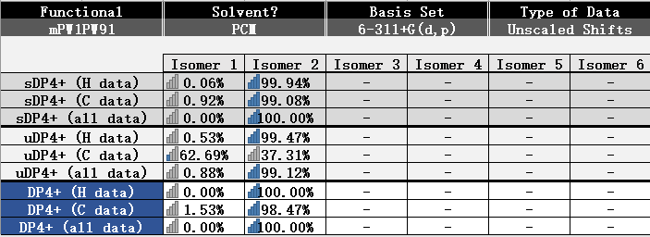

**Figure S6**: DP4+ results of candidate(7*R*,10*R*)-**1** (Isomer 1) and (7*R*,11*S*)-**1** (Isomer 2).

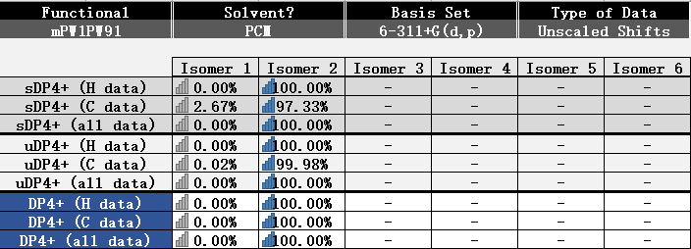

**Figure S7**: DP4+ results of candidate(7*R*,10*R,* 11*R)*-**3** (Isomer 1) and (7*R*,10*R,*11*S*)-**3** (Isomer 2).

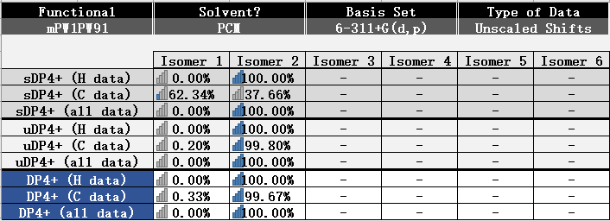

**Figure S8**: DP4+ results of candidate(7*S*,10*S,*11*S)*-**5** (Isomer 1) and (7*R*,10*R,*11*S*)-**5** (Isomer 2).

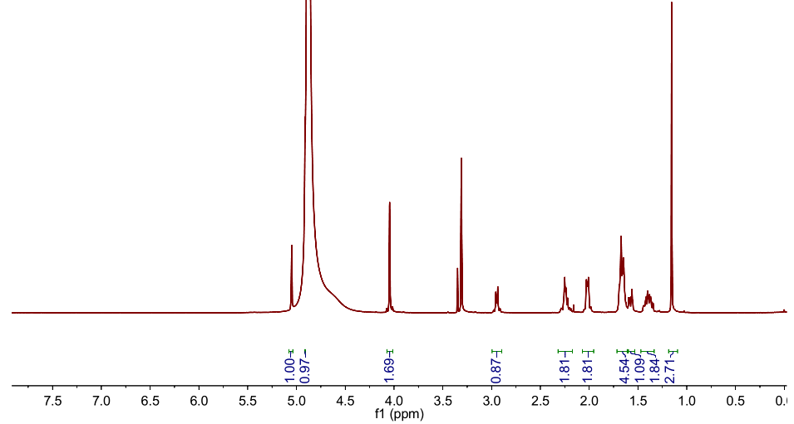

**Figure S9**: 1H NMR (500 MHz) spectrum of **1** in CD3OD.

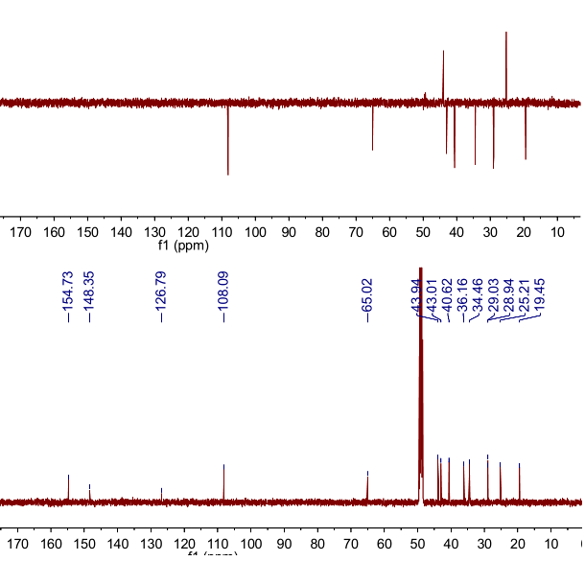

**Figure S10**: 13C NMR and DEPT (125 MHz) spectra of **1** in CD3OD.

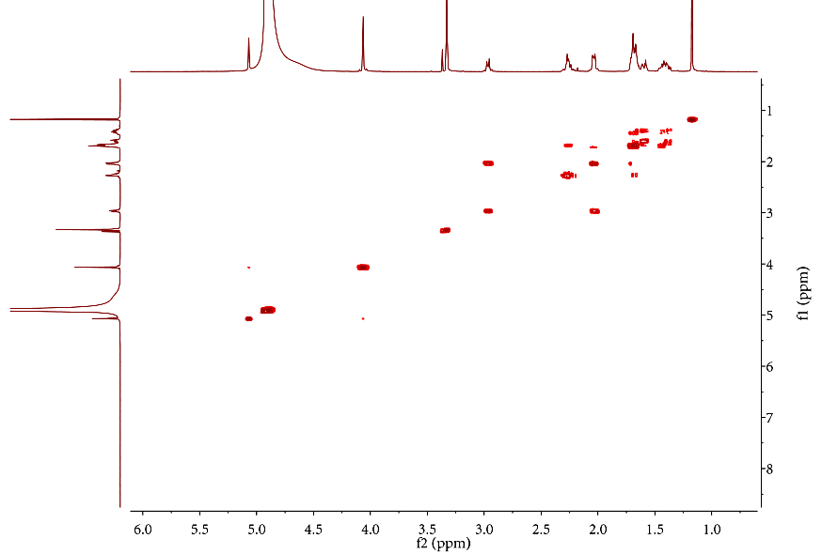

**Figure S11**: 1H-1H COSY (500 MHz) spectrum of **1** in CD3OD.

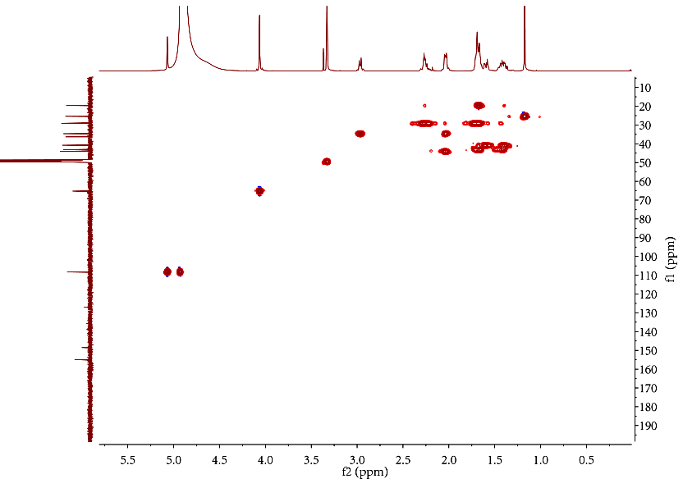

**Figure S12**: HSQC (500 MHz) spectrum of **1** in CD3OD.

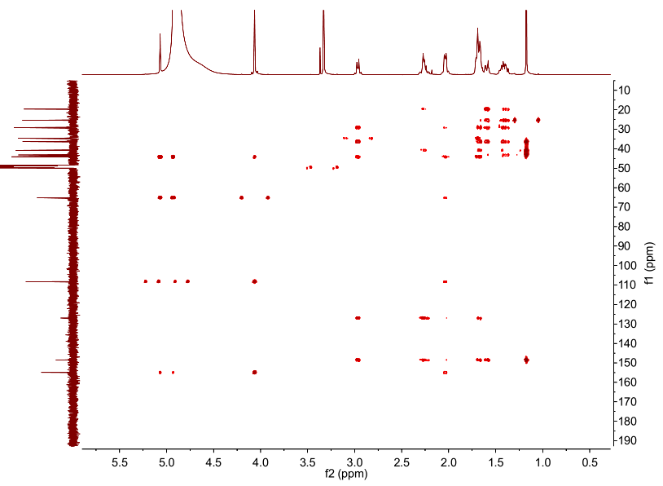

**Figure S13**: HSBC (500 MHz) spectrum of **1** in CD3OD.

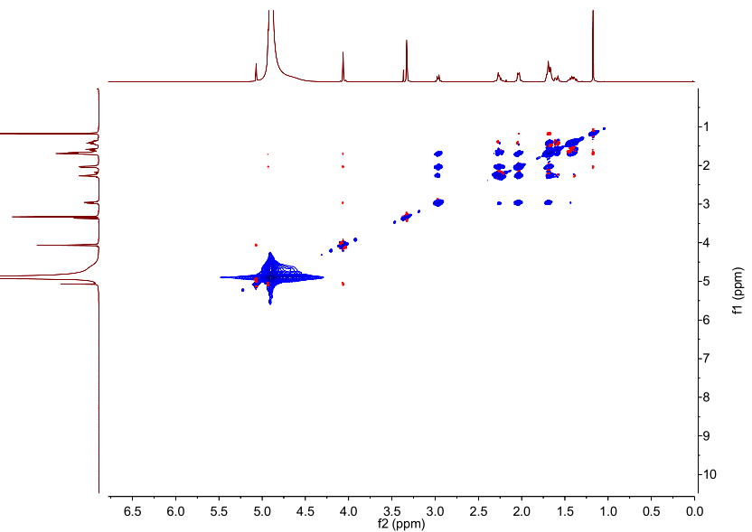

**Figure S14**: ROSEY (500 MHz) spectrum of **1** in CD3OD.

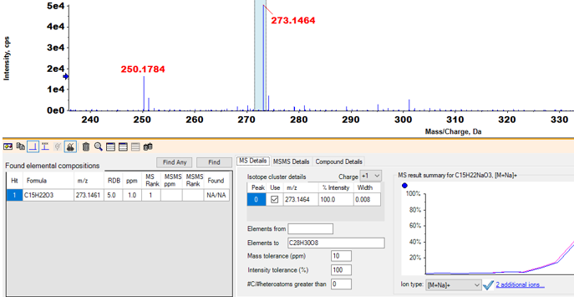

**Figure S15**: HRESIMS of **1**.

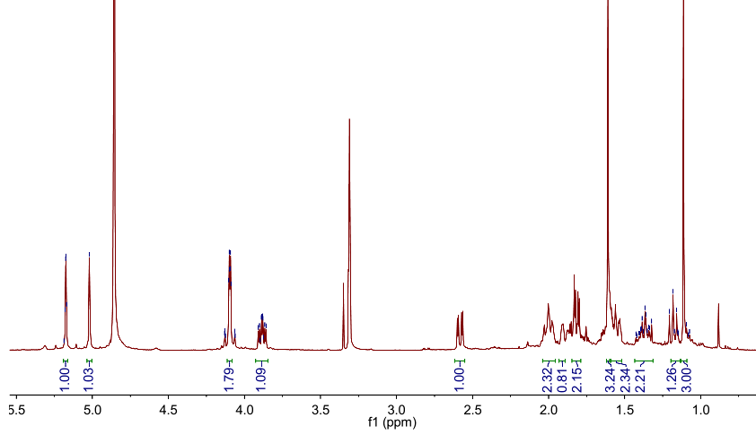

**Figure S16**: 1H NMR (500 MHz) spectrum of **2** in CD3OD.

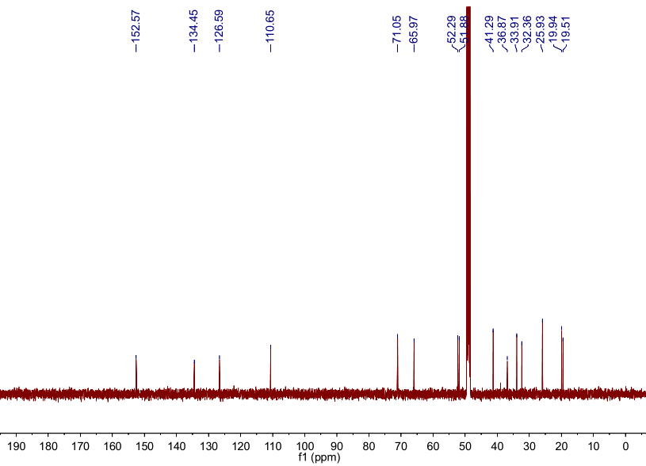

**Figure S17**: 13C NMR (125MHz) spectrum of **2** in CD3OD.

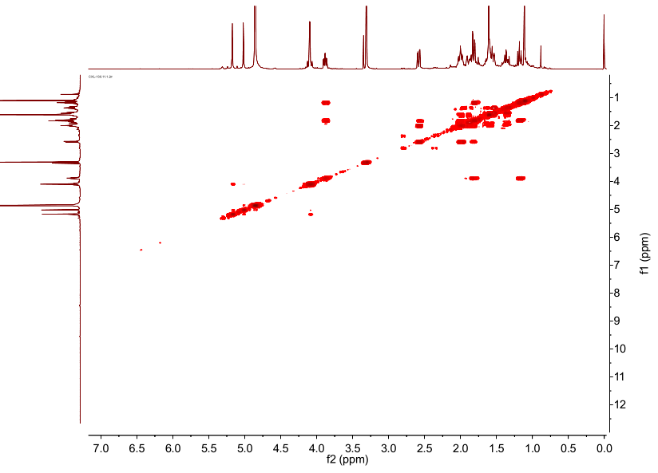

**Figure S18**: 1H-1H COSY (500 MHz) spectrum of **2** in CD3OD.

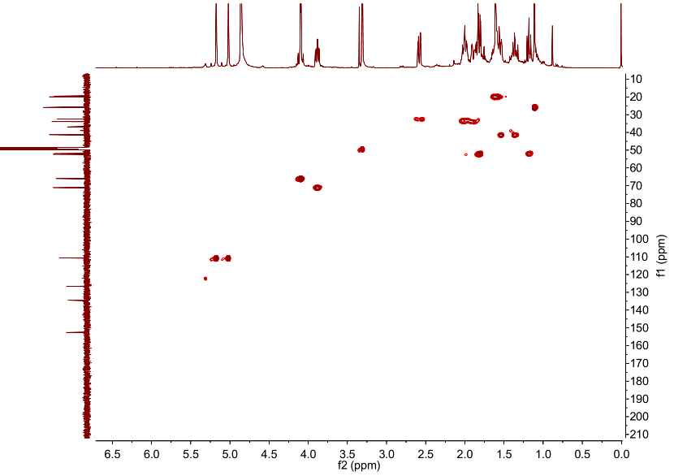

**Figure S19**: HSQC (500 MHz) spectrum of **2** in CD3OD.

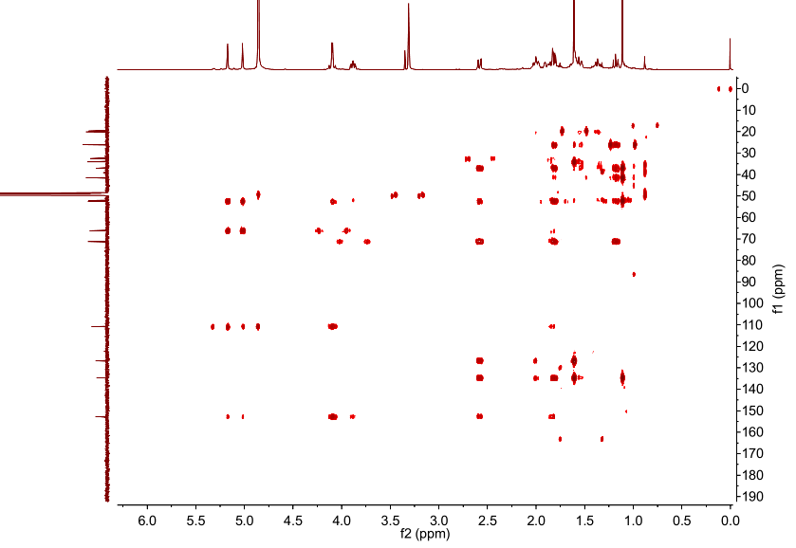

**Figure S20**: HSBC (500 MHz) spectrum of **2** in CD3OD.

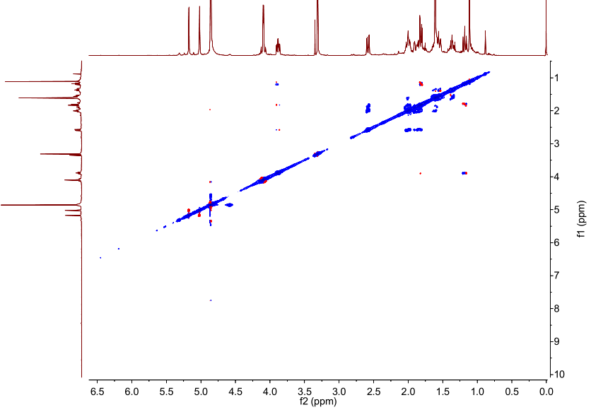

**Figure S21**: ROSEY (500 MHz) spectrum of **2** in CD3OD.

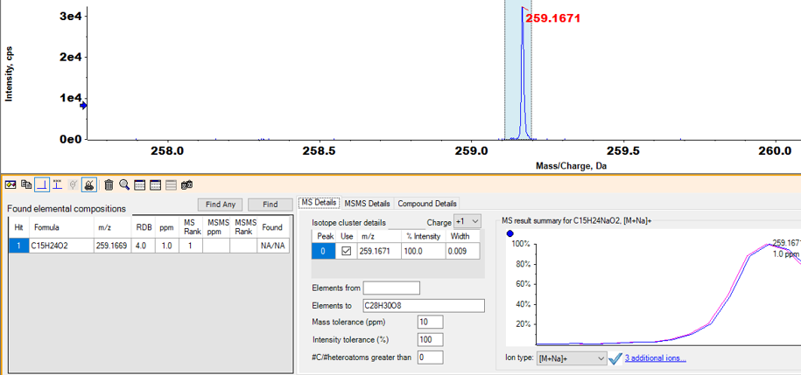

**Figure S22**:HRESIMS of **2**.

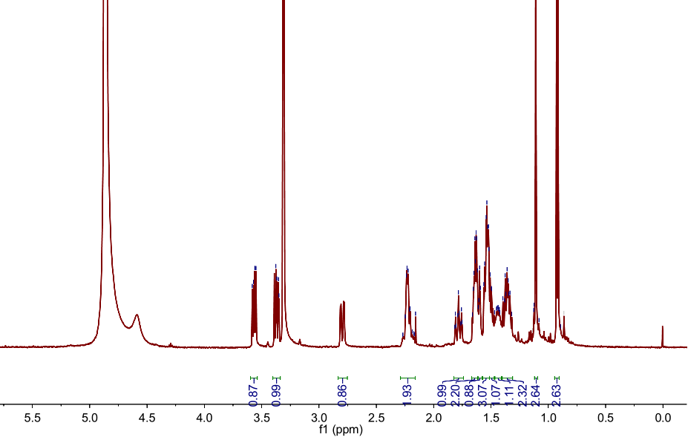

**Figure S23**: 1H NMR (500 MHz) spectrum of **3** in CD3OD.

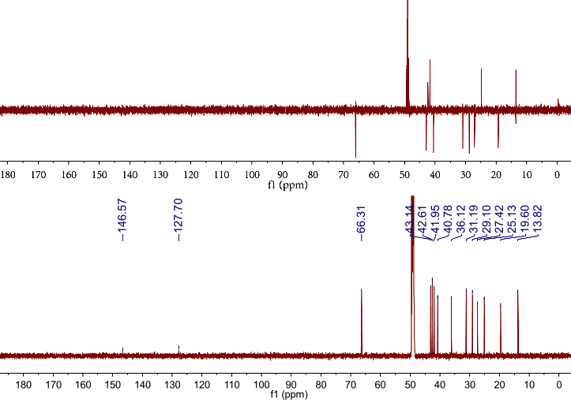

**Figure S24**: 13C NMR and DEPT (150 MHz) spectra of **3** in CD3OD.

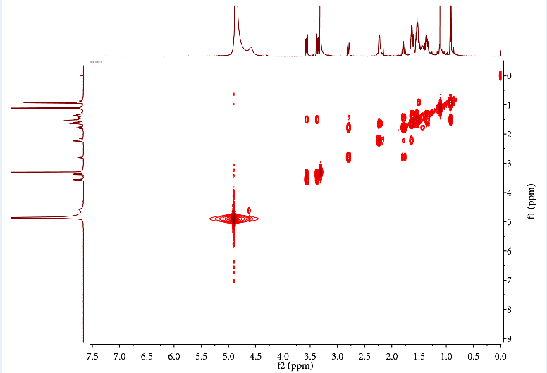

**Figure S25**: 1H-1H COSY (600 MHz) spectrum of **3** in CD3OD.

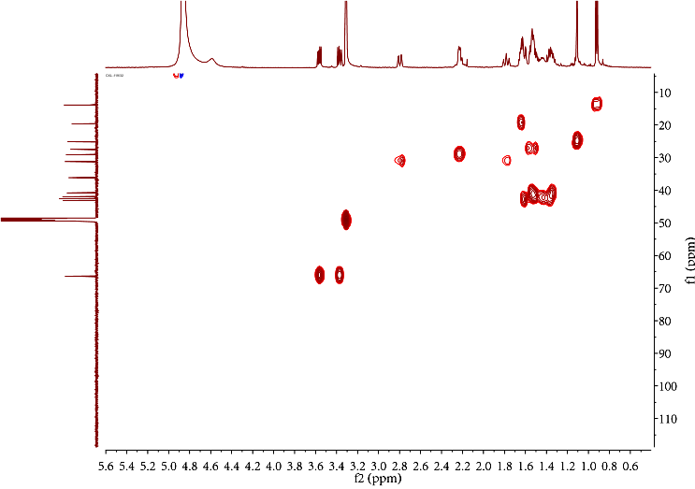

**Figure S26**: HSQC (600 MHz) spectrum of **3** in CD3OD.

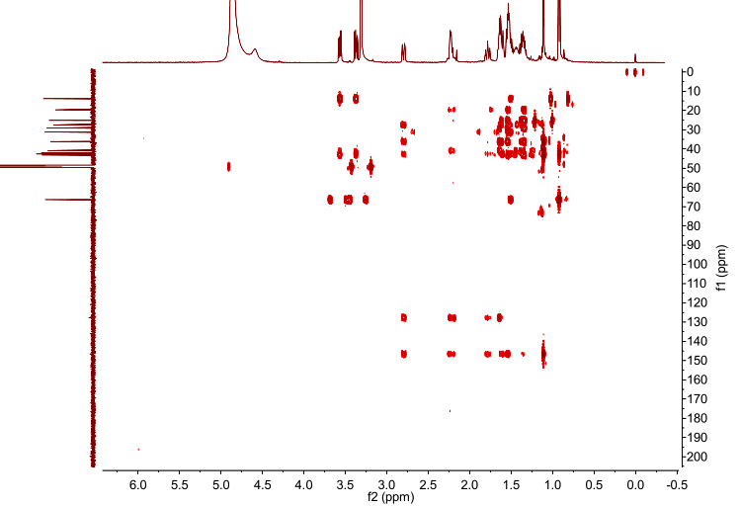

**Figure S27**: HSBC (600 MHz) spectrum of **3** in CD3OD.

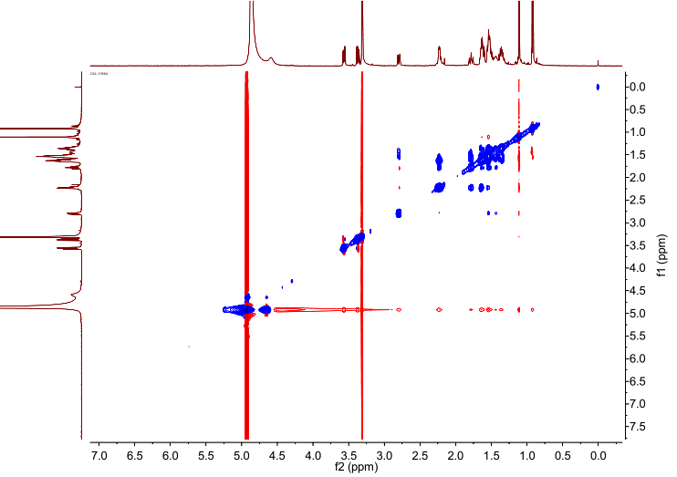

**Figure S28**: ROSEY (600 MHz) spectrum of **3** in CD3OD.

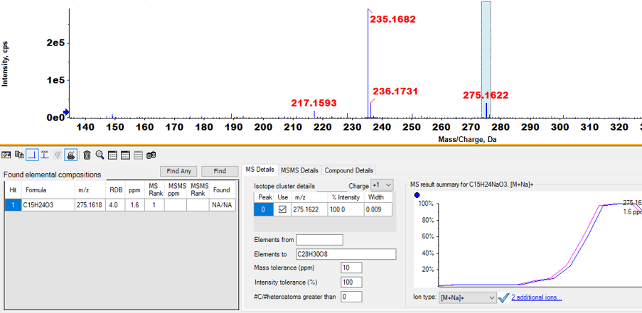

**Figure S29**:HRESIMS of **3**.

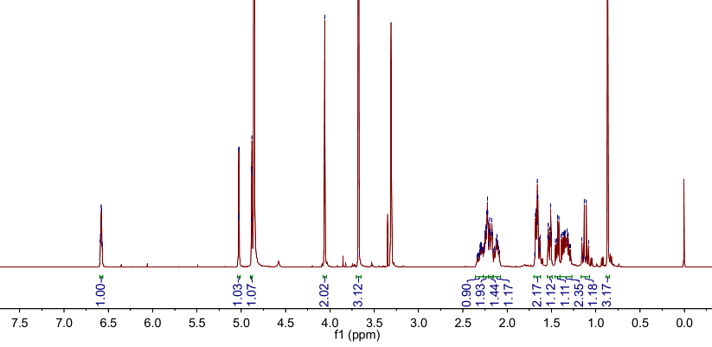

**Figure S30**: 1H NMR (500 MHz) spectrum of **4** in CD3OD.

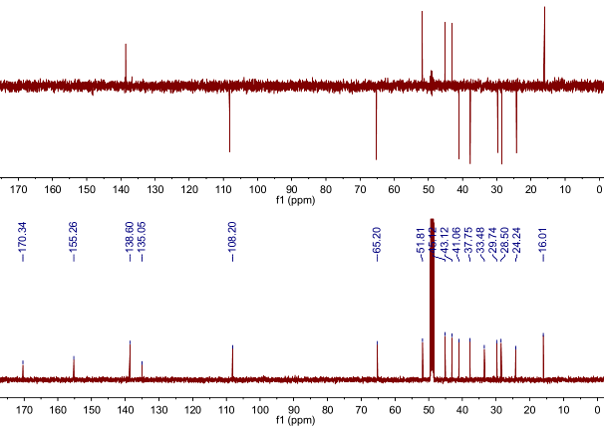

**Figure S31**: 13C NMR and DEPT (150 MHz) spectra of **4** in CD3OD.

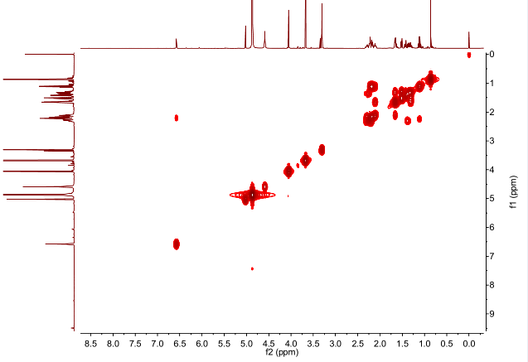

**Figure S32**: 1H-1H COSY (600 MHz) spectrum of **4** in CD3OD.

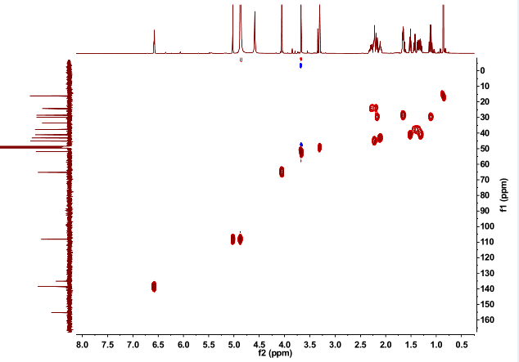

**Figure S33**: HSQC (600 MHz) spectrum of **4** in CD3OD.

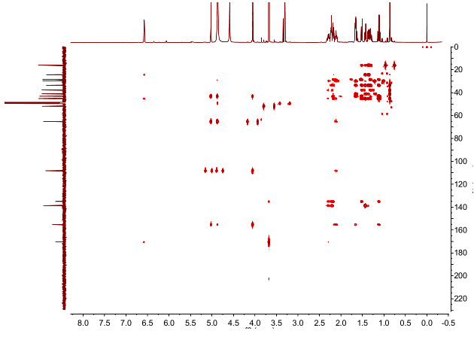

**Figure S34**: HSBC (600 MHz) spectrum of **4** in CD3OD.

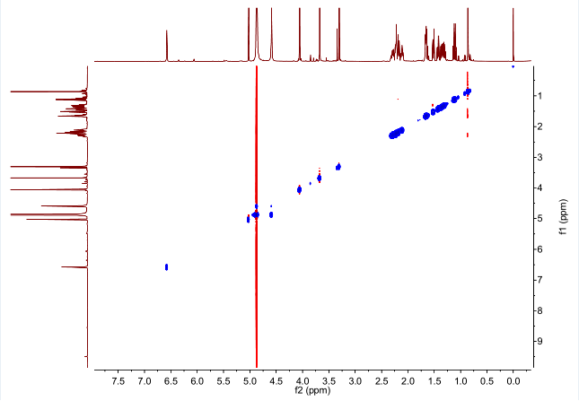

**Figure S35**: ROSEY (600 MHz) spectrum of **4** in CD3OD.

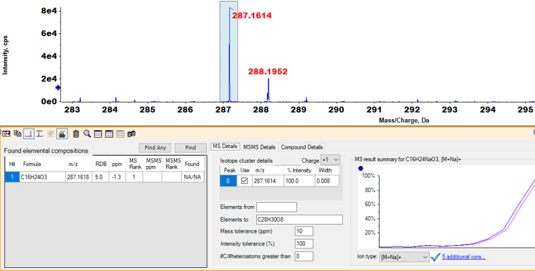

**Figure S36**:HRESIMS of **4**.

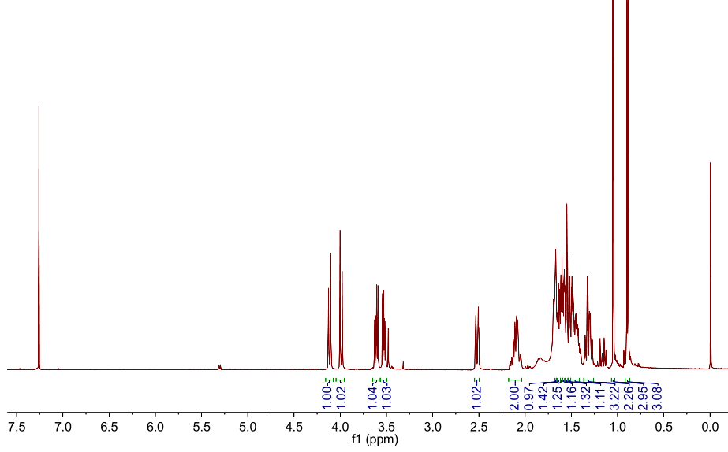

**Figure S37**: 1H NMR (500 MHz) spectrum of **5** in CDCl3.

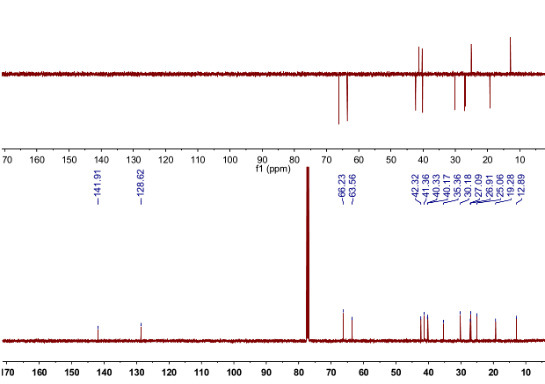

**Figure S38**: 13C NMR and DEPT (150 MHz) spectra of **5** in CDCl3.

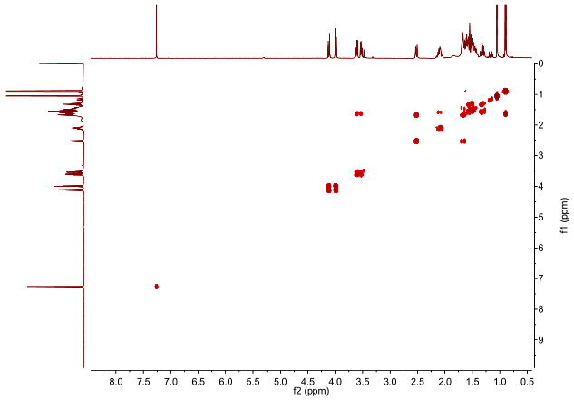

**Figure S39**: 1H-1H COSY (600 MHz) spectrum of **5** in CDCl3.

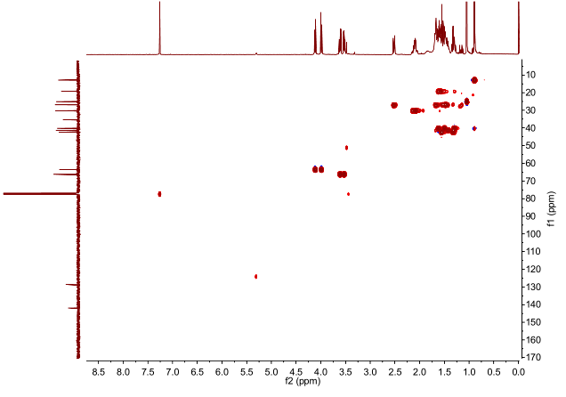

**Figure S40**: HSQC (600 MHz) spectrum of **5** in CDCl3.

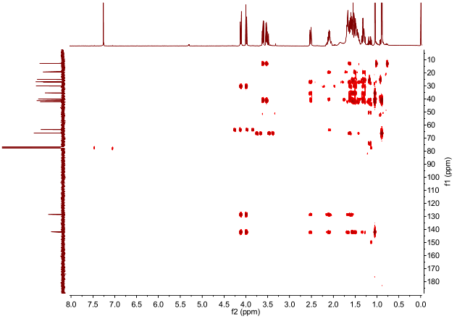

**Figure S41**: HSBC (600 MHz) spectrum of **5** in CDCl3.

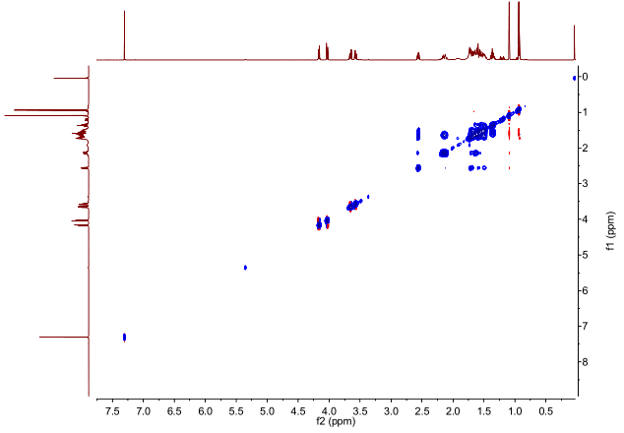

**Figure S42**: ROSEY (600 MHz) spectrum of **5** in CDCl3.

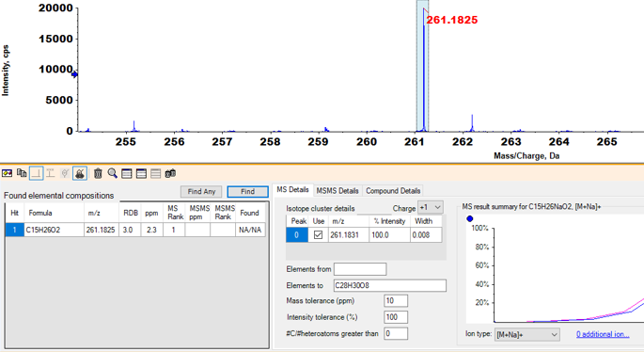

**Figure S43**: HRESIMS of **5**.

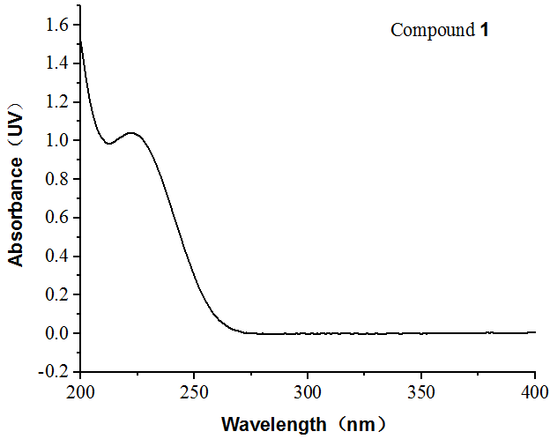 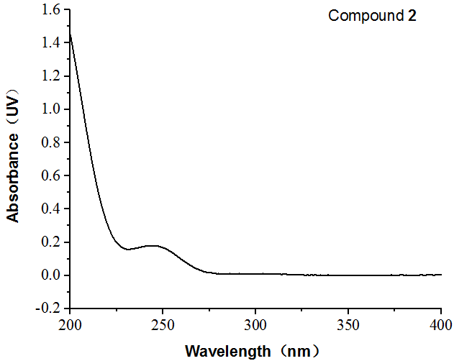

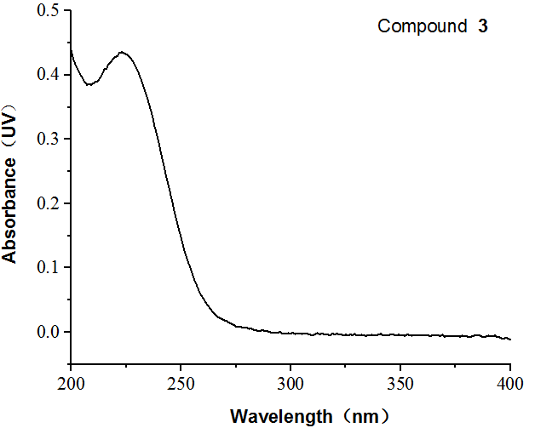 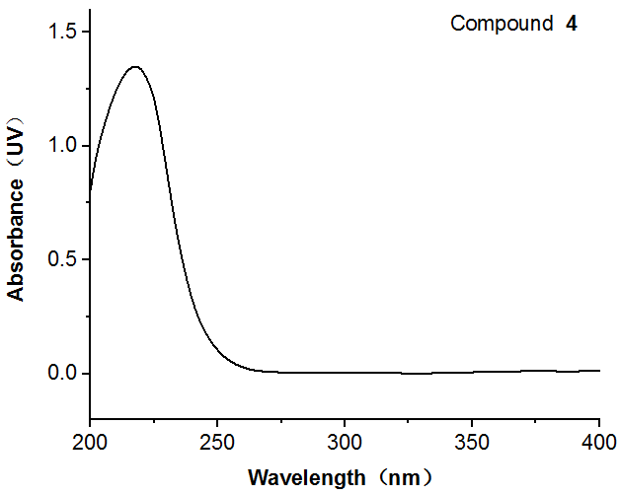

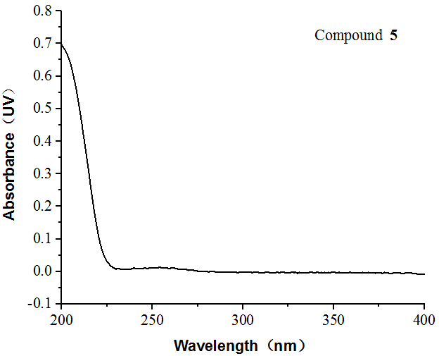

**Figure S44**: UV-vis spectrum of **1**–**5**

**bioactivity assay date**

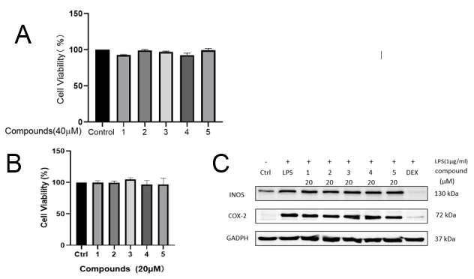

**Fig A**:human breast cancer cell line (MCF-7) were treated with 40 μM with conpounds**1**-**5** for 24 h, and cell viability was determined by CCK-8 assay. **Fig B**: RAW 264.7 were treated with 20 μM with conpounds**1**-**5** for 24 h, and cell viability was determined by CCK-8 assay. **Fig C**: Compounds suppress LPS-induced INOS and COX-2 expression in RAW 264.7 cells. Data represent mean ±SEM values of three experiments.