**Supporting Information**

for

# Heterogeneous metallaphotoredox catalysis in a continuous-flow packed bed reactor

W.-H. Hsu1,2, S. Reischauer1,2, P.H. Seeberger1,2, B. Pieber1,* and D. Cambié1,*

or

1. General remarks 3

2. Flow setup 3

3. Preparation of the packed bed reactor 4

4. General reaction procedure 5

5. Reaction optimization 6

5.1. Flow setup (injection loop vs. continuous operation) 6

5.2. Conversion vs. time 6

5.3. Optimization of temperature and light intensity 6

5.4. Catalyst loading 7

6. Residence Time Distribution analysis 8

7. Nickel content 9

8. Compound characterization 9

9. NMR spectra 11

# General remarks

All Chemicals and solvents were acquired from Sigma Aldrich and used without further purification. Analytical thin layer chromatography (TLC) was performed on pre-coated TLC-sheets, ALUGRAM Xtra SIL G/UV254 sheets (Macherey-Nagel) and visualized with 254 nm light. 1H-, 13C-, and 19F- spectra for compound characterization were recorded on a Varian 400 spectrometer (400 MHz, Agilent), the spectrometer used for in line experiment was a Spinsolve (40 MHz, Magritek). Purification of final compound was carried out by flash chromatography using silica gel pore size 60Å 230-400 mesh particle size (Sigmal Aldrich #60752). Inductively coupled plasma-optical emission spectroscopy was carried out using an ICP-OES 715 ES (Varian, USA) after digesting the polymers in a mixture of nitric acid and sulfuric acid (V:V = 2:1). The static mixer used was an Helical Static Mixer with 15 mixing elements (L/D= 1.04), polished surfaces, Length= 100 mm in stainless steel 316L (Cat No. HT50-6.4-15-316L) from Stamixco AG (Switzerland).

# Flow setup

A commercially available Vapourtec R-series equipped with an immobilized photoreactor module was employed in this study. The photoreactor module is comprised of a 440 nm LED (input power 60 W, radiant power 24 W) that irradiates a cavity that hosts a 100 mm long glass column (Omnifit, 6.6 mm inner diameter ID) packed with the polymeric ligand. The reaction mixture was charged in two glass syringes loaded on a syringe pump (Harvard Apparatus Elite11). The outlet of the two syringes, combined with a Tee piece, was routed to the Vapourtec pressure sensor with PTFE tubing (1/16” OD, 1 mm ID) to monitor the reactor pressure drop and then to the column inlet. The reactor outlet was optionally connected with a Magritek Spinsolve benchtop NMR for the experiment with in-line analysis and then to a multiposition valve (Knauer V2.1S) controlled via Ethernet to collect and fractionate the reactor outlet into different vials.

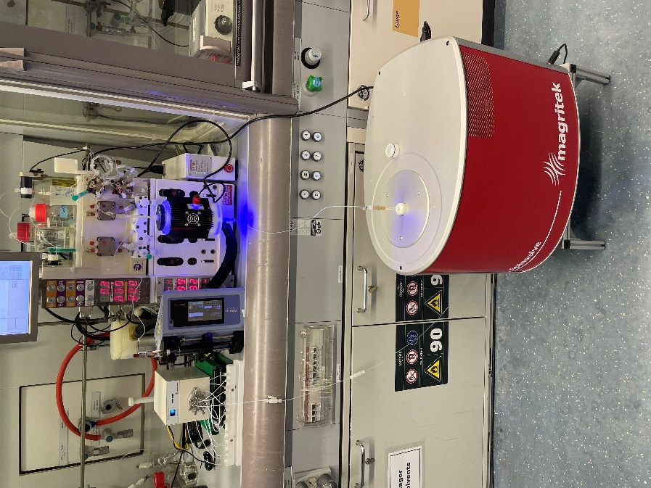

**Figure S1** Experimental setup used for the flow experiments. The immobilised photoreactor module (in black) is connected to the bay 3 of the VapourtecR4, the blue halo is the marginal stray light escaping from the light filters at the top and bottom of the column holder. The syringe pump in purple is used to pump the reaction mixture, that is routed to the R4 pressure sensor, photoreactor module before flowing through the flow cell of the NMR and reaching the multi-position valve (in white, on the left) where the reactor outlet is fractionated into different vials for collection.

# Preparation of the packed bed reactor

A 1.6 wt.% poly-czbpy mixture was prepared by mixing in an agate mortar 35 mg of poly-czbpy with 665 mg of silica (230~400 mesh particle size, Sigma-Aldrich Cat no. 60752), starting with a 1:1 ratio and progressively adding more silica until a uniform mixture was obtained. The resulting yellowish powder was further mixed with glass beads (1.4 g, 250 µm acid-washed/silanized, Sigma-Aldrich Cat no. 59203). The glass column was plugged with a small cotton filter, charged with the glass bead/poly-czbpy/silica mixture and equilibrated with dry dimethylacetamide (DMAc). A solution of 7.5 mg of NiCl2∙glyme (about 0.5 equiv. vs. the bipyridine, calculated from the polymer mass based on the monomer molecular weight) in 8 mL of dry DMAc was used to load the nickel in the column by recirculating it for 3 hours, resulting in the active Ni@poly-czbpy. The reactor dead volume was measured in 2.0 mL.

# General reaction procedure

A solution of 4-iodobenzotrifluoride (25 mM) and sodium p-toluensulfinate (50 mM, 2 equiv.) was prepared in *N, N*-dimethylacetamide (DMAc) for the C-S coupling reaction. The reaction mixture was sonicated to accelerate the slow dissolution of the sulfinate until a clear solution was achieved (generally 5 to 10 min). The reactor temperature and light intensity were controlled directly from the Vapourtec R4 reactor, while the flow rate was set on syringe pump (Harvard Apparatus Elite 11) used for the infusion. Unless otherwise specified, a temperature of 55 °C and a 100% light intensity were used. In-line 19F-NMR spectra were automatically acquired by a Magritek Spinsolve 40 MHz spectrometer controlled by a custom Python script (SI3, NMRcontrol_autointegration pdf). The reaction was run until stable conditions were obtained, defined as 7 consecutive spectra in which the CV% of the auto-integrated product yield was below 3.0%.

To evaluate the accuracy and precision of the in-line analysis, 2 mL of reaction solution collected during steady state was measured by 375 Hz 19F-NMR (Varian 400 spectrometer) with hexafluorobenzene as an internal standard. The results show minor different between two analytic methods (Table S1), indicating the results collected by the in-line are trustable.

**Table S1** Comparison on in-line benchtop and off-line high-field NMR



|  |  |  |  |
| --- | --- | --- | --- |
| Entry | Analytic method | Conversion [%] | Yield [%] |
| 1 | In-line analysis | 45 | 37 |
| 2 | Off-line analysis | 43 | 37 |

# Reaction optimization

## Flow setup (injection loop vs. continuous operation)

For the experiments performed with the injection loop, a 2.0 ml PTFE tubing loop was connected to the 6-way valve of the Vapourtec R-series reactor and the reaction mixture was loaded on the loop with a syringe and injected in the stream of solvent (DMAc) pumped by a syringe pump to the reactor. On the other hand, for the experiment under continuous-flow conditions, the reaction mixture was directly pumped from the syringe loaded on the syringe pump as described in the general reaction procedure.

## Conversion vs. time

The data for Figure 1 of the manuscript is presented in tabular format in Table S2.

**Table S2** Comparison on coupling of 4-iodobenzotrifluoride and sodium p-toluensulfinate.



|  |  |  |  |  |
| --- | --- | --- | --- | --- |
| Entrya | Reaction time [h] | Conversion [%] | Yield [%] | Selectivity [%] |
| 1 | 0.3 | 13 | 8 | 62 |
| 2 | 1 | 22 | 19 | 87 |
| 3 | 3 | 43 | 37 | 86 |
| 4 | 5 | 69 | 42 | 61 |
| 5 | 10 | 86 | 70 | 81 |
| 6 | 15 | 92 | 79 | 85 |

­­a Conversion and yield are calculated by (high-field, 376 MHz) 19F-NMR.

## Optimization of temperature and light intensity

The effect of temperature and light intensity on the reaction were evaluated by one-variable-at-a-time method, i.e. all the other parameters were kept constant while changing either temperature or light intensity. High temperature darkened the material in the packed-bed column (Figure S2).

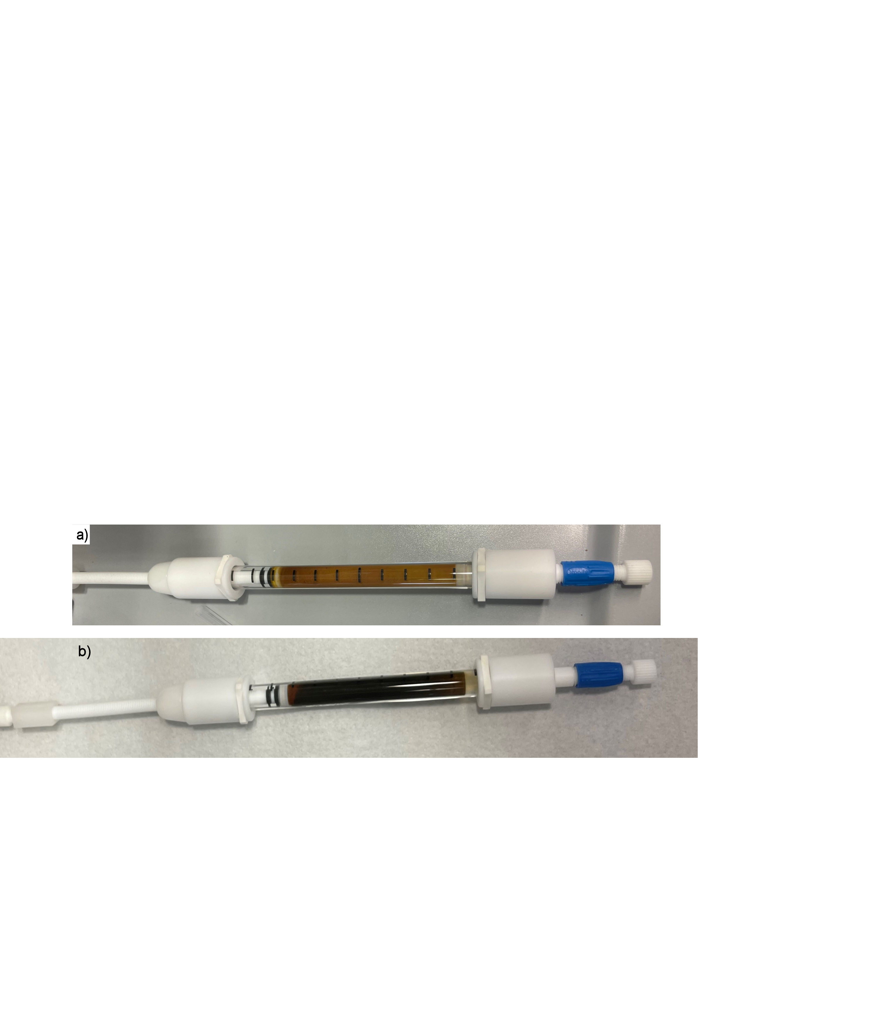

**Figure S2** Photos of the packed column (a) before reaction (b) after irradiation at 70 °C for 12 hours.

## Catalyst loading

The impact of the catalyst loading was evaluated by preparing packed bed with different poly-czbpy content, ranging between 3.3 and 0.8% w/w. A trend for higher selectivity with lower catalyst loading is observed, while the change in conversion was relatively minor and could partly be attributed to the difference in packed bed volumes. We selected the ratio of 1.6% for further experiment since it balances the amount of poly-czbpy needed and the selectivity while maintaining essentially the same activity of the 3.3% w/w loading.

**Table S3** Optimization of catalyst weight ratio for coupling of 4-iodobenzotrifluoride andsodium p-toluensulfinate. 

|  |  |  |  |  |
| --- | --- | --- | --- | --- |
| Entrya | poly-czbpy ratio [% w/w] | Conversion [%] | Yield [%] | Selectivity [%] |
| 1 | 3.3 | 46 | 36 | 78 |
| **2** | **1.6** | **45** | **37** | **82** |
| 3 | 1.2 | 38 | 34 | 89 |
| 4 | 0.8 | 35 | 32 | 91 |

a Data was collect by 37.6 MHz 19F-NMR

# Residence Time Distribution analysis

The residence time distribution was determined by pulsed input experiment injecting acetone as a tracer. The experiment was carried out by injecting 75 µL of acetone with the sample loop of a 6-way valve (Knauer V2.1S). In particular, acetone was injected in the stream generated by a syringe pump (Harvard Apparatus Elite 11) set on the same flowrate used for the majority of the experiments, i.e. 10 μL/min. The mean residence time and variance were monitored with the absorption at 305 nm with an HPLC PDA detector (Knauer PLATINblue, Figure S3) and calculated by custom Python script (SI2, RTDcalculation.pdf).

The distribution showed no difference Omnifit column with and without mixer. Addition of static mixers to the column did not improve the mixing efficiency. 5/32” ID tube had better mixing efficiency, corresponding to the performance of better conversion of the reaction.



**Figure S3** UV trace of the RTD experiment with pulse tracer in the 5/32” ID tubing reactor.

# Nickel content

Overall 1973 mg of 1.6 wt.% poly-czbpy mixture was used for the stability test (i.e. 33 mg of poly-czbpy). 7.54 mg of NiCl2∙glyme (measured by precision balance) dissolved in 8 mL DMAc and recirculated through the packed bed with an HPLC pump (Knauer P4.1S) a flow rate of 0.5 mL/min for 3 hours (residence time ≅ 5 min). 30 mL of DMAc were used to wash the packed bed after the recirculation. The initially nickel amount after complexation was quantified by weight of initially loading amount of nickel species and the remaining amount of nickel in the washing solution after complexation. 7 days reaction solution was collected and then evaporated under reduced pressure. The residue was analysed by ICP-OES, resulting in 416.7 µg of nickel was leached (256 ppm over 1625 mg as an average of three samples, %CV 2.3) in the long-run experiment.

# Compound characterization



**4-tosylbenzotrifluoride (1)** was obtained from 20 mL reaction mixture (i.e. approximately 136 mg starting material, 4-iodobenzotrifluoride). Purification by flash chromatography (1:10 ethyl acetate to hexane) after evaporating the reaction solvent, DMAc under reducing pressure. White solid. Rf value: 0.4 (20% ethyl acetate/hexane). 1H-NMR (400 MHz, CDCl3) δ 8.05 (d, J = 8.1 Hz, 2H), 7.84 (d, J = 8.3 Hz, 2H), 7.75 (d, J = 8.3 Hz, 2H), 7.33 (d, J = 8.1 Hz, 2H), 2.41 (s, 3H). 13C-NMR (101 MHz, CDCl3) δ 145.71, 145.08, 137.70, 134.77 (q, J = 33.1 Hz), 130.31, 128.17, 128.08, 126.51 (q, J = 3.7 Hz), 123.25 (q, J = 273.1 Hz), 21.75. 19F-NMR (376 MHz, CDCl3) δ -63.19.



**1-(*tert*-butyl) 2-(4-(trifluoromethyl)phenyl) pyrrolidine-1,2-dicarboxylate (2)** was obtain from was obtained from 4 mL reaction mixture (i.e. approximately 62 mg starting material, 4-iodobenzotrifluoride). Reaction solution was prepared with 4-iodobenzotrifluoride (50 mM), N-(*tert*-butoxycarbonyl)-*L*-proline(*N*-Boc-proline, 75 mM, 1.5 equiv.), and *N*-*tert*-butylisopropylamine (BIPA, 150 mM, 3 equiv.) in dimethyl sulfoxide (DMSO). Purification by flash chromatography (1:10 ethyl acetate to hexane) after evaporating the reaction solvent and extraction by ammonium chloride(aq) and brine. Colorless oil. Rf value: 0.24 (20% ethyl acetate/hexane). Rotameric mixture. 1H NMR (400 MHz, CDCl3) δ 7.67 (m, 2H), 7.28 – 7.24 (m, 2H, contains residual solvent signal of CDCl3), 4.57– 4.44 (m, 1H), 3.67 – 3.47 (m, 2H), 2.46 – 2.37 (m, 1H), 2.22 – 2.15 (m, 1H), 2.10 – 1.96 (m, 2H), 1.48 (m, 9H). 13C NMR (101 MHz, CDCl3) δ (171.27) 171.16, (154.51) 153.63, (153.31) 153.06, 128.17 (d, J = 32.6 Hz) (127.99 (d, J = 32.8 Hz)), 126.91 (q, J = 3.7 Hz) (126.74 (q, J = 3.8 Hz)), (122.03) 121.65, 80.39 (80.20), 59.17 (59.08), (46.66) 46.48, 31.05 (29.99), 29.72, 28.42, (24.59) 23.76. 19F-NMR (376 MHz, CDCl3) δ -62.22, -62.27.

# NMR spectra











