Supporting Information
Additional figures
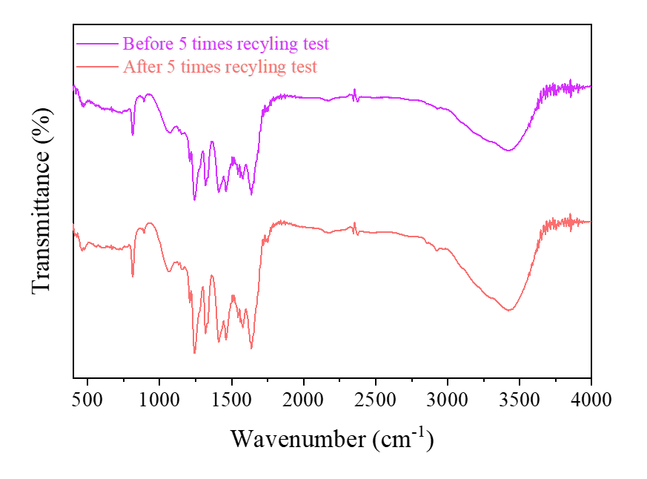
Fig. S1. FTIR spectrum of the 3%MgO@g-C₃N₄ before and after recycling tests.
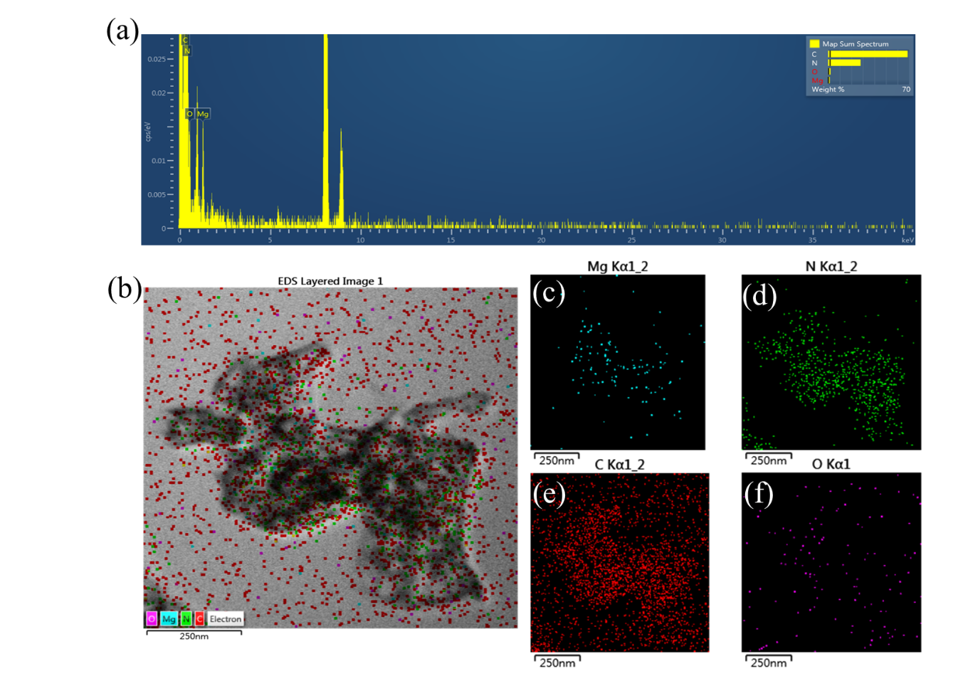
Fig. S2. TEM-EDS-mapping of the 3%MgO@g-C₃N₄.

