Supplementary Information

Alcohol-Perturbed Self-Assembly of Tobacco Mosaic Virus Coat Protein

Ismael Abu-Baker, Amy Szuchmacher Blum*

Department of Chemistry, McGill University, Montréal, Québec, Canada

EXPERIMENTAL SECTION

Materials

All chemicals were reagent grade or better. 100% ethanol was purchased from Commercial Alcohols. Potassium phosphate monobasic, Potassium phosphate dibasic, 2-propanol, methanol, and sodium chloride were purchased from Fisher Scientific. Terrific Broth and LB media were purchased from MP Biomedicals. Ampicillin and chloramphenicol were purchased from Research Products International (RPI).

TMV-cp Expression and Purification

Tuner(DE3)pLysS competent cells (Novagen) were transformed with a pET20b plasmid (NorClone Biotech) containing the sequence for wild-type TMV-cp, and streaked on an LB agar plate supplemented with 100 *u*g/mL ampicillin and 34 *u*g/mL chloramphenicol. After overnight incubation at 37 oC, a single colony was used to inoculate 10 mL of LB and grown overnight with constant shaking at 37 oC. This saturated growth was used to make frozen glycerol stocks of transformed cells stored at -80 oC. For a typical expression, 20 mL of TB media supplemented with 100 *u*g/mL ampicillin and 34 *u*g/mL chloramphenicol was inoculated with a small portion of cells from frozen glycerol stocks and grown overnight at 37 oC with constant shaking at 250 RPM. A 1 mL aliquot of the resulting culture was used to inoculate 1 L of TB, grown for 2.5 hours at 37 oC, and then grown overnight at 30 oC. No isopropylthio-β-galactoside (IPTG) was necessary for high levels of protein expression due to a combination of leaky expression of the promoter and compromised cell growth upon induction by IPTG.[1, 2] Cultures were harvested by centrifugation and frozen at -80 oC. Frozen cell pellets were thawed, resuspended in lysis buffer (20 mM triethanolamine, 1 mM EDTA, pH 7.4), and lysed by sonication at 50% duty cycle and 60% amplitude. The resulting lysate was clarified by centrifugation at 15,000 RPM for 45 minutes. The supernatant was collected, and saturated ammonium sulfate solution was added dropwise to a final concentration of 35% (v/v). The precipitate was isolated by centrifugation at 15,000 RPM for 45 minutes and resuspended in lysis buffer. The resulting solution was dialyzed overnight at 4 oC against the same buffer to remove residual ammonium sulfate. Any remaining precipitate was removed by centrifugation, the solution was diluted, and loaded on a DEAE Sepharose anion exchange column (Cytiva). The protein was eluted using a 0-300 mM NaCl gradient. Fractions were analyzed by SDS-PAGE, and pure fractions were combined and concentrated. Pure protein was dialyzed into 20 mM potassium phosphate buffer at pH 8.5, concentrated to 2.7 mg/mL, and frozen at -80 oC until further use.

Assembly and Characterization of TMV-cp

Stock TMV-cp frozen at 2.7 mg/mL was thawed and diluted to 1.0 mg/mL with a mixture of water and alcohol to obtain the desired alcohol concentration. This solution was dialyzed overnight against the desired buffer, with one buffer change. For pH 5.5 and 5.0, 100 mM sodium acetate buffer was used. 30 mM potassium phosphate buffer was used for pH 6.5 and 7.5. All solutions were adjusted to 100 mM total ionic strength with sodium chloride. Samples were allowed to equilibrate for 24 hours after dialysis before characterization. Transmission electron microscopy (TEM) was performed on a 200 kV Talos F200X (Thermo Scientific) and a 5 kV LVEM5 benchtop electron microscope (Delong). Grids were stained with uranyl acetate. Dynamic light scattering (DLS) was performed on a Zetasizer Nano ZS (Malvern).

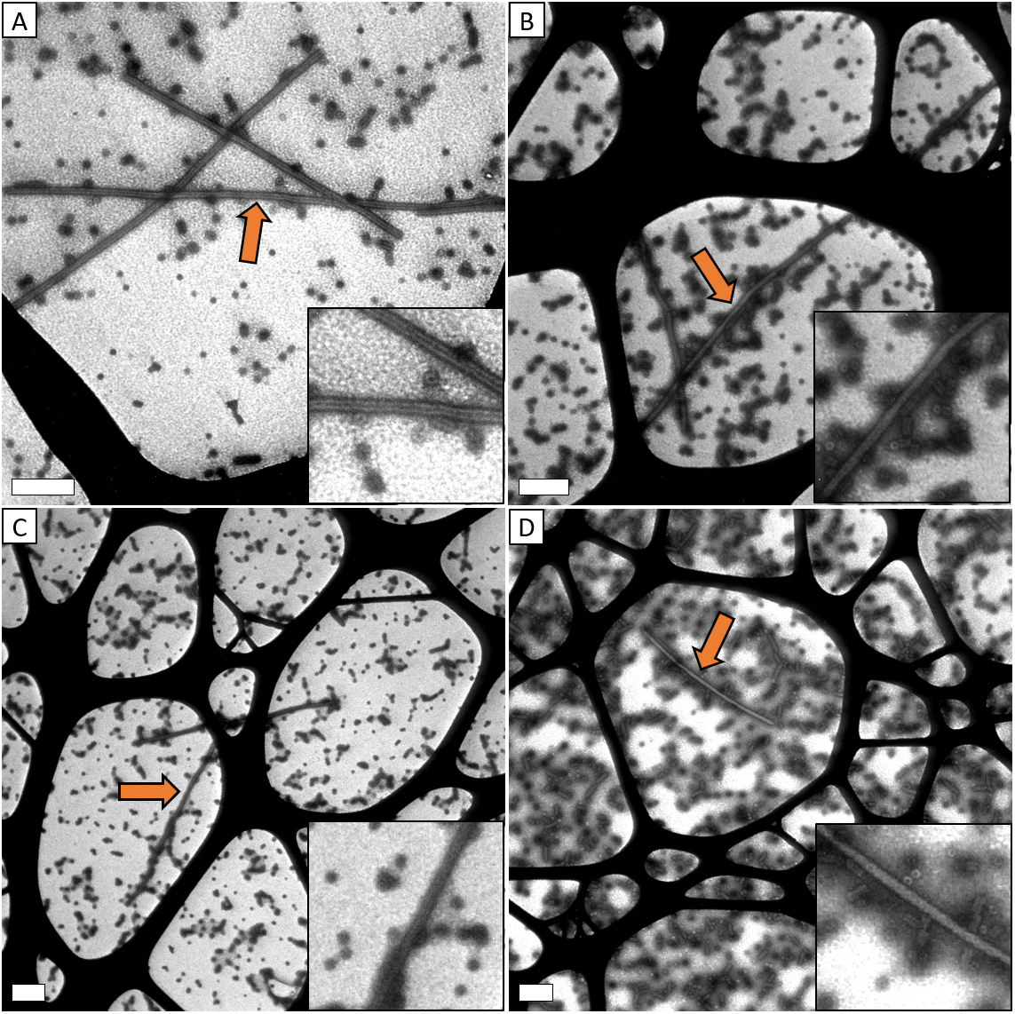

**Figure S1.** TEM images of A) pH 5.5, 1.0 mol% EtOH, B) pH 5.5, 2.0 mol% EtOH, C) pH 5.5, 2.5 mol% EtOH, D) pH 5.5, 3.0 mol% EtOH. Scale bars are 200 nm. Orange arrows indicate helical rods.

**Figure S2.** TEM images of samples after 2 weeks at room temperature A) pH 6.8, no additive, B) pH 5.5, 3.5 mol% EtOH, C) pH 5.5, 5.0 mol% EtOH, D) pH 5.5, 10.0 mol% EtOH. Scale bars are 200 nm.

**Figure S4.** TEM images of A) pH 7.5, 0 mol% EtOH, B) pH 7.5, 3.5 mol% EtOH, C) pH 6.8, 3.5 mol% EtOH, D) pH 5.0, 3.5 mol% EtOH, E) pH 5.0, 10.0 mol% EtOH. Scale bars are 200 nm.

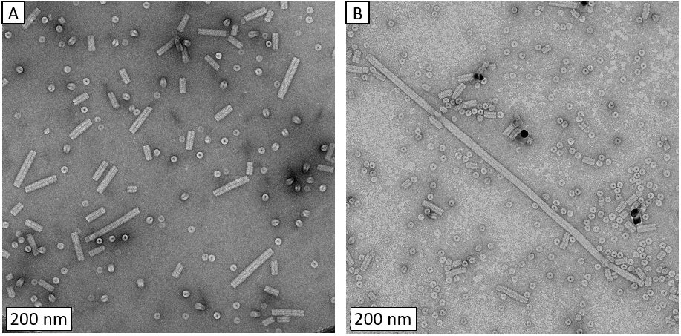

**Figure S3.** TEM images of TMV-cp at pH 5.5. A) With 3.5 mol% ethanol, B) Same sample after removal of ethanol by dialysis.

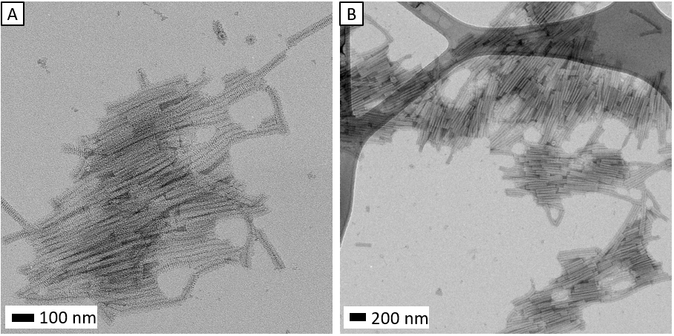

**Figure S5.** Representative TEM images of TMV-cp showing large raft-like structures at pH 5.0 with 10.0 mol% ethanol.

**Figure S6.** TEM images of A) pH 5.5, 3.5 mol% MeOH, B) pH 5.5, 5.0 mol% IPA, C) pH 5.5, 5.0 mol% IPA showing clustering, D) pH 5.5, 10.0 mol% IPA. Scale bars are 200 nm.

**Figure S7.** SDS-PAGE gel of fractions from a typical WT-TMV-cp purification. The target protein shows heavy bands at ~17.5 kDa.

**Figure S8.** DLS data of A) pH 8.5 stock solution, B) pH 6.8, no additive, C) pH 5.5, no additive, D) pH 5.5, 3.5 mol% EtOH, E) pH 5.5, 5.0 mol% EtOH, F) pH 5.5, 10.0 mol% EtOH. Line colour indicates averaging type as follows: Black – Intensity, Red – Volume, Blue – Number.

**Figure S9.** DLS data of A) pH 5.5, 3.5 mol% MeOH, B) pH 5.5, 3.5 mol% IPA. Line colour indicates averaging type as follows: Black – Intensity, Red – Volume, Blue – Number.

References

1. Dubendorf, J. W.; Studier, F. W. *Journal of Molecular Biology* **1991**,*219* (1), 45-59.

2. Kadri, A.; Wege, C.; Jeske, H. *Journal of Virological Methods* **2013**,*189* (2), 328-340.