Terpenoids from Glechoma hederacea var. longituba and Their Biological Activities

Dong Hyun Kim¹, Zahra Khan^{2,3}, Sun Yeou Kim^{2,3}, Sang Un Choi⁴, Chung Sub Kim^{1,5}, Kang Ro Lee^{1,*}
¹School of Pharmacy, Sungkyunkwan University, Suwon 16419, Republic of Korea
²College of Pharmacy, Gachon University #191, Hambakmeoro, Yeonsu-gu, Incheon 21936, Republic of Korea
³Gachon Institute of Pharmaceutical Science, Gachon University, Incheon 21936, Republic of Korea
⁴Korea Research Institute of Chemical Technology, Daejeon 34114, Republic of Korea
⁵Department of Biopharmaceutical Convergence, Sungkyunkwan University, Suwon 16419, Republic of Korea

*Corresponding Author
Kang Ro Lee – School of Pharmacy, Sungkyunkwan University, Suwon 16419, Republic of Korea; http://orcid.org/0000-0002-3725-5192; Tel: +82-31-290-7710; Fax: +82-31-290-7730; E-mail: krlee@skku.edu
Contents
S1. Detailed experimental procedures 1
Figure S1. HRESIMS data of 1 3
Figure S2. ¹H NMR data of 1 in CD₃OD 4
Figure S3. ¹³C NMR data of 1 in CD₃OD 5
Figure S4. ¹H-¹H COSY spectrum of 1 in CD₃OD 6
Figure S5. HSQC spectrum of 1 in CD₃OD 7
Figure S6. HMBC spectrum of 1 in CD₃OD 8
Figure S7. NOESY spectrum of 1 in CD₃OD 9
Figure S8. Comparison of standard D-glucopyranose and monosaccharide obtained by hydrolysis of 1 10
Figure S9. ECD spectrum of 1 11
Figure S10. HRESIMS data of 2 12
Figure S11. ¹H NMR data of 2 in CD₃OD 13
Figure S12. ¹³C NMR data of 2 in CD₃OD 14
Figure S13. ¹H-¹H COSY spectrum of 2 in CD₃OD 15
Figure S14. HSQC spectrum of 2 in CD₃OD 16
Figure S15. HMBC spectrum of 2 in CD₃OD 17
Figure S16. NOESY spectrum of 2 in CD₃OD 18
Figure S17. Comparison of standard D-glucopyranose and monosaccharide obtained by hydrolysis of 2 19
Figure S18. ECD spectrum of 2 20
Figure S19. Comparison of ECD spectra of 1 and 2 21
Figure S20. HRESIMS data of 3 22
Figure S21. ¹H NMR data of 3 in CD₃OD 23
Figure S22. ¹³C NMR data of 3 in CD₃OD 24
Figure S23. ¹H-¹H COSY spectrum of 3 in CD₃OD 25
Figure S24. HSQC spectrum of 3 in CD₃OD 26
Figure S25. HMBC spectrum of 3 in CD₃OD 27
Figure S26. NOESY spectrum of 3 in CD₃OD 28
Figure S27. Comparison of standard D-glucopyranose and monosaccharide obtained by hydrolysis of 3 29
Figure S28. ECD spectrum of 3 30
Figure S29. HRESIMS data of 4 30
Figure S30. ¹H NMR data of 4 in CD₃OD 31
Figure S31. ¹³C NMR data of 4 in CD₃OD 32
Figure S32. ¹H-¹H COSY spectrum of 4 in CD₃OD 33
Figure S33. HSQC spectrum of 4 in CD₃OD 34
Figure S34. HMBC spectrum of 4 in CD₃OD 35
Figure S35. NOESY spectrum of 4 in CD₃OD 36
Figure S36. Comparison of standard D-glucopyranose and monosaccharide obtained by hydrolysis of 4 37
Figure S37. HRESIMS data of 5 38
Figure S38. ¹H NMR data of 5 in CD₃OD 39
Figure S39. ¹³C NMR data of 5 in CD₃OD 40
Figure S40. ¹H-¹H COSY spectrum of 5 in CD₃OD 41
Figure S41. HSQC spectrum of 5 in CD₃OD 42
Figure S42. HMBC spectrum of 5 in CD₃OD 43
Figure S43. NOESY spectrum of 5 in CD₃OD 44
Figure S44. Comparison of standard D-glucopyranose and monosaccharide obtained by hydrolysis of 5 45
Coordinates of the conformers 46

S1. Detailed experimental procedures
Evaluation of NO Production and Cell viability in LPS-stressed BV-2 cells.
The inhibitory effect of the compounds on NO production was tested using BV-2 cells [1,2]. BV-2 cells were seeded on a 96-well plate (4 × 10⁴ cells/well), which treated with or without different concentrations of the compounds. LPS (100 ng/mL) was added to BV-2 cells followed by incubation for 24 h. The concentration of nitrite (NO₂) in the culture medium was evaluated using Gries reagent (0.1% N-1-naphthylethylenediamine dihydrochloride and 1% sulfanilamide in 5% phosphoric acid). 50 μL of supernatant was mixed with an equal volume of Gries reagent. Absorbance was measured after 10 min using a microplate reader (Emax, Molecular Devices, Sunnyvale, CA, USA) at 570 nm wavelength. L-NMMA, well-known nitric oxide synthase (NOS) inhibitor [3], was used as a positive control. Graded sodium nitrite solution was used as a standard to calculate nitrite concentrations. Cell viability was assessed by observing the ability of viable cells to reduce the yellow-colored MTT to a purple-colored formazan, using an MTT assay, as described previously [1].

NGF and Cell viability Assays.
The C6 glioma cells (Korean Cell Line Bank, Seoul, Republic of Korea) were used to assess the release of NGF into the culture medium. The test cells were seeded onto 24-well plates at a density of 1 × 10⁵ cells/well. After 24 h, cells were treated with serum-free Dulbecco’s modified Eagle’s medium and incubated with the designated concentrations of compounds for an additional 24 h. The medium supernatant was collected from the culture plates, and NGF levels were evaluated using an ELISA development kit. Cell viability was also assessed with a 3- [4,5-dimethylthiazol-2-yl]-2,5-diphenyltetrazolium bromide (MTT) assay in which the results were expressed as a percentage of the control group (untreated cells).

Cytotoxicity assay against four human cancer cell lines using SRB assay
A sulforhodamine B bioassay (SRB) was used to determine the cytotoxicity of each compound on four cultured human cancer cell lines [4]. The assays were performed at the Korea Research Institute of Chemical Technology. The cell lines used were A549 (non small cell lung adenocarcinoma), SK-OV-3 (ovarian cancer cells), SK-MEL-2 (skin melanoma), and HCT15 (colon cancer cells). Doxorubicin (Sigma Chemical Co., C98 %) was used as a positive control [4].
Reference
1. Blasi, E.; Barluzzi, R.; Bocchini, V.; Mazzolla, R.; Bistoni, F. J. Neuroimmunol. 1990, 27, 229-237. doi: 10.1016/0165-5728(90)90073-V
2. Choi, Y.; Lee, M.; Lim, S.; Sung, S.; Kim, Y. Br. J. Pharmacol. 2009, 156, 933-940. doi: 10.1111/j.1476-5381.2009.00022.x
3. Reif, D. W.; McCreedy, S. A. Arch. Biochem. Biophys 1995, 320, 170-176. doi: 10.1006/abbi.1995.1356
4. Skehan, P.; Storeng, R.; Scudiero, D.; Monks, A.; McMahon, J.; Vistica, D.; Warren, J. T.; Bokesch, H.; Kenney, S.; Boyd, M. R. J. Natl Cancer Inst. 1990, 82, 1107-1112. doi: 10.1093/jnci/82.13.1107

Figure S1. HRESIMS data of 1

Figure S2. ¹H NMR data of 1 in CD₃OD

Figure S3. ¹³C NMR data of 1 in CD₃OD

Figure S4. ¹H-¹H COSY spectrum of 1 in CD₃OD

Figure S5. HSQC spectrum of 1 in CD₃OD
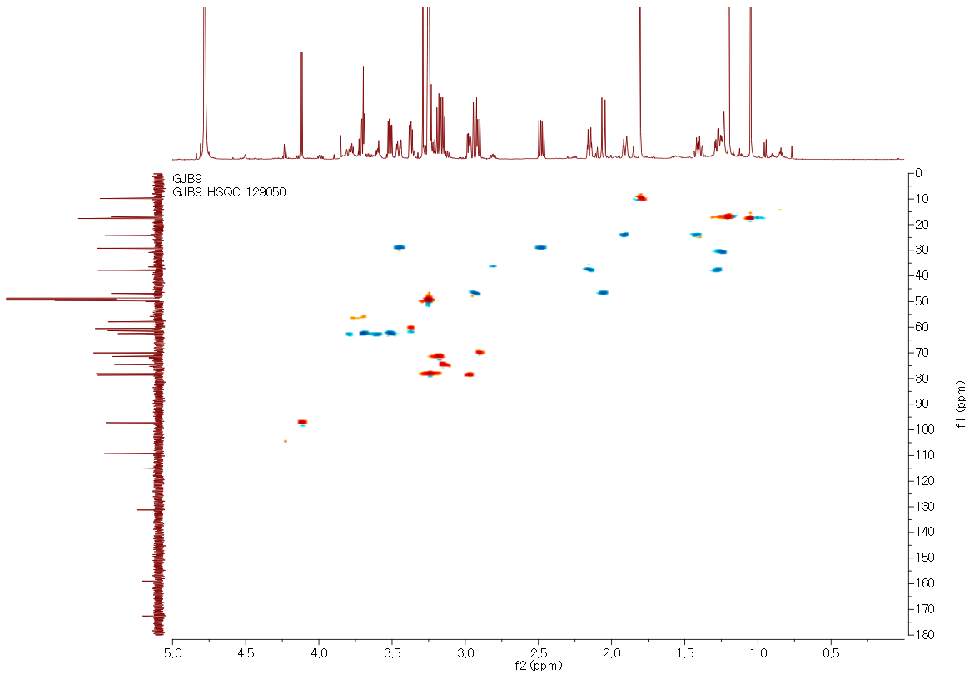

Figure S6. HMBC spectrum of 1 in CD₃OD
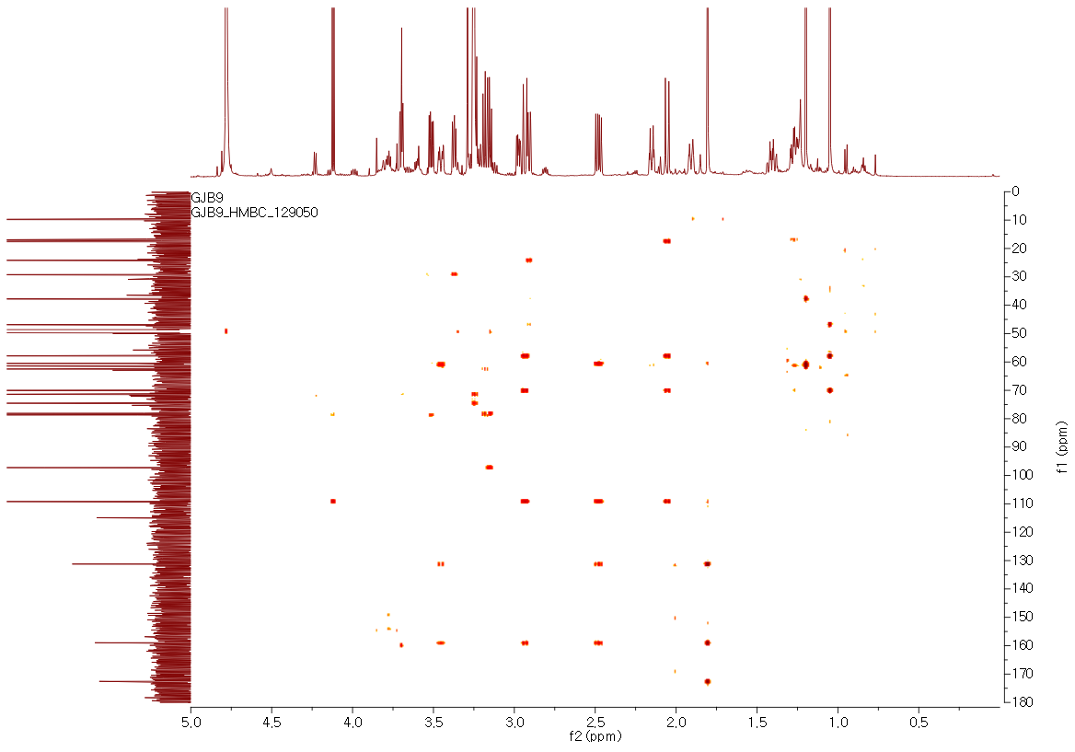

Figure S7. NOESY spectrum of 1 in CD₃OD
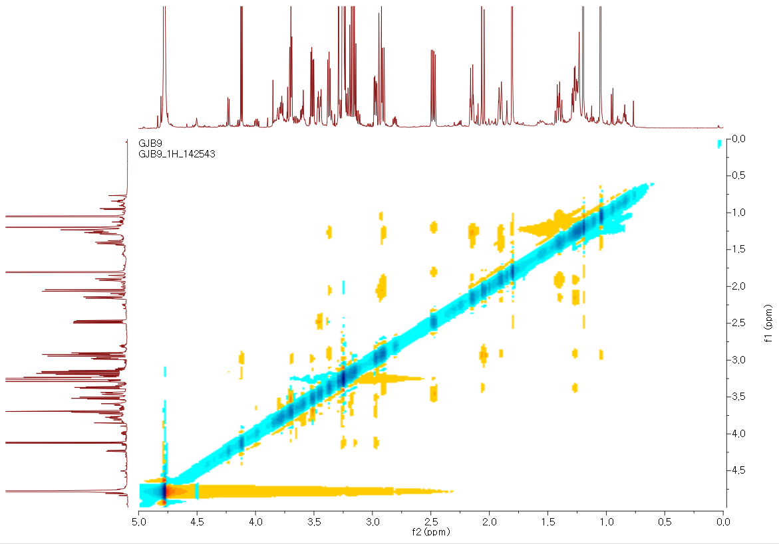

Figure S8. Comparison of standard D-glucopyranose and monosaccharide obtained by hydrolysis of 1
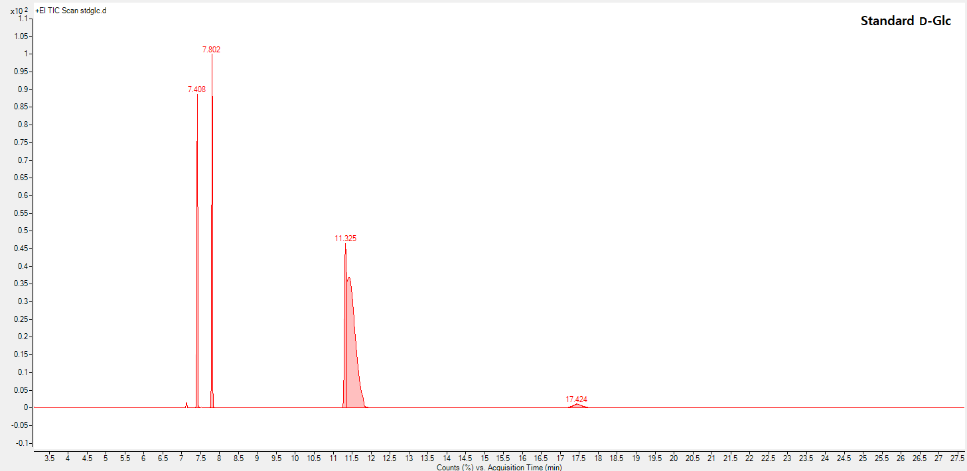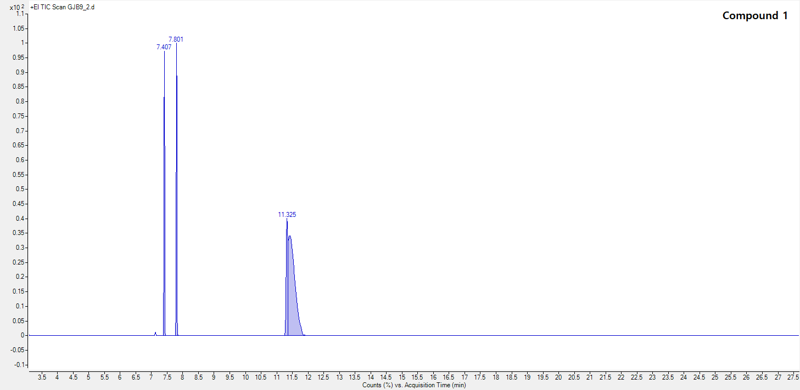

Figure S9. ECD spectrum of 1

Figure S10. HRESIMS data of 2

Figure S11. ¹H NMR data of 2 in CD₃OD

Figure S12. ¹³C NMR data of 2 in CD₃OD

Figure S13. ¹H-¹H COSY spectrum of 2 in CD₃OD

Figure S14. HSQC spectrum of 2 in CD₃OD

Figure S15. HMBC spectrum of 2 in CD₃OD

Figure S16. NOESY spectrum of 2 in CD₃OD

Figure S17. Comparison of standard D-glucopyranose and monosaccharide obtained by hydrolysis of 2
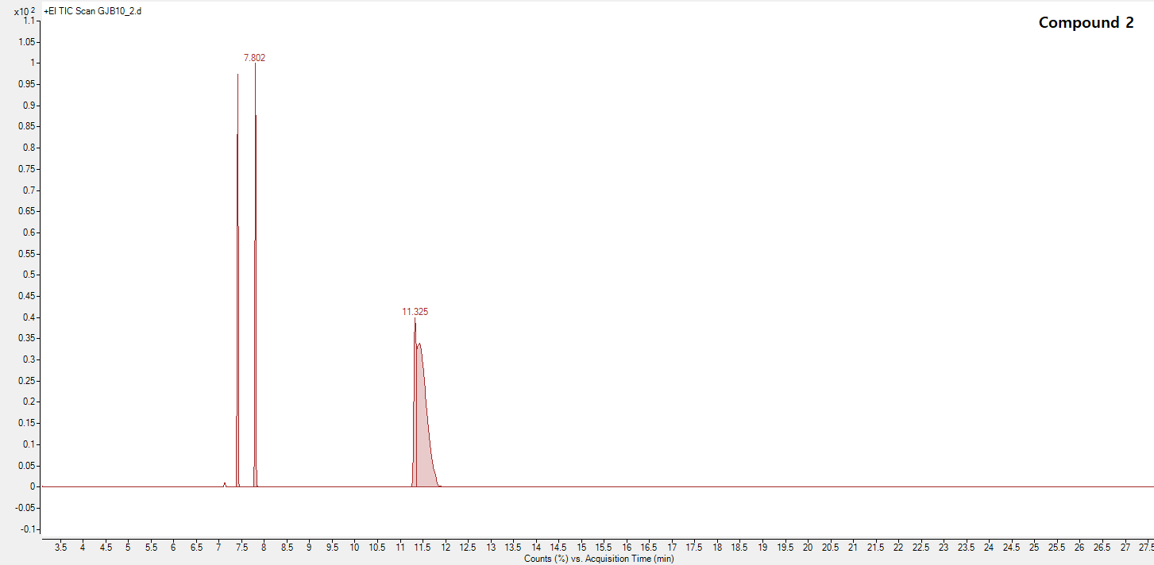

Figure S18. ECD spectrum of 2

Figure S19. Comparison of ECD spectra of 1 and 2
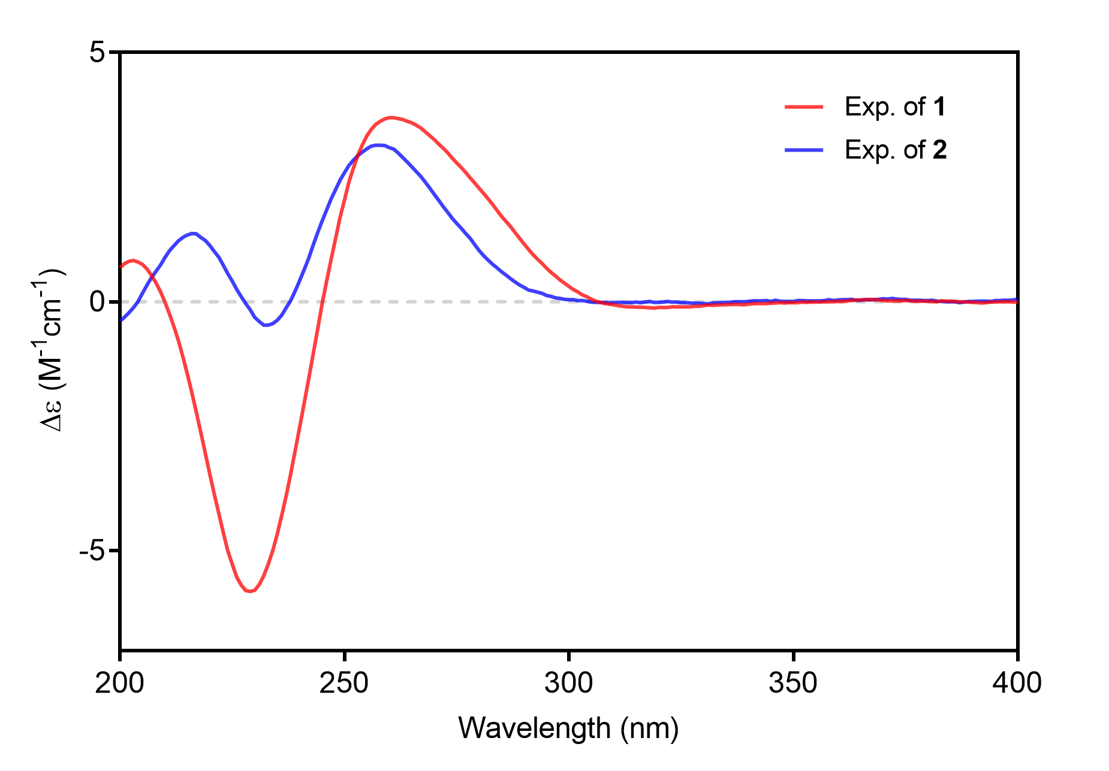

Figure S20. HRESIMS data of 3

Figure S21. ¹H NMR data of 3 in CD₃OD

Figure S22. ¹³C NMR data of 3 in CD₃OD
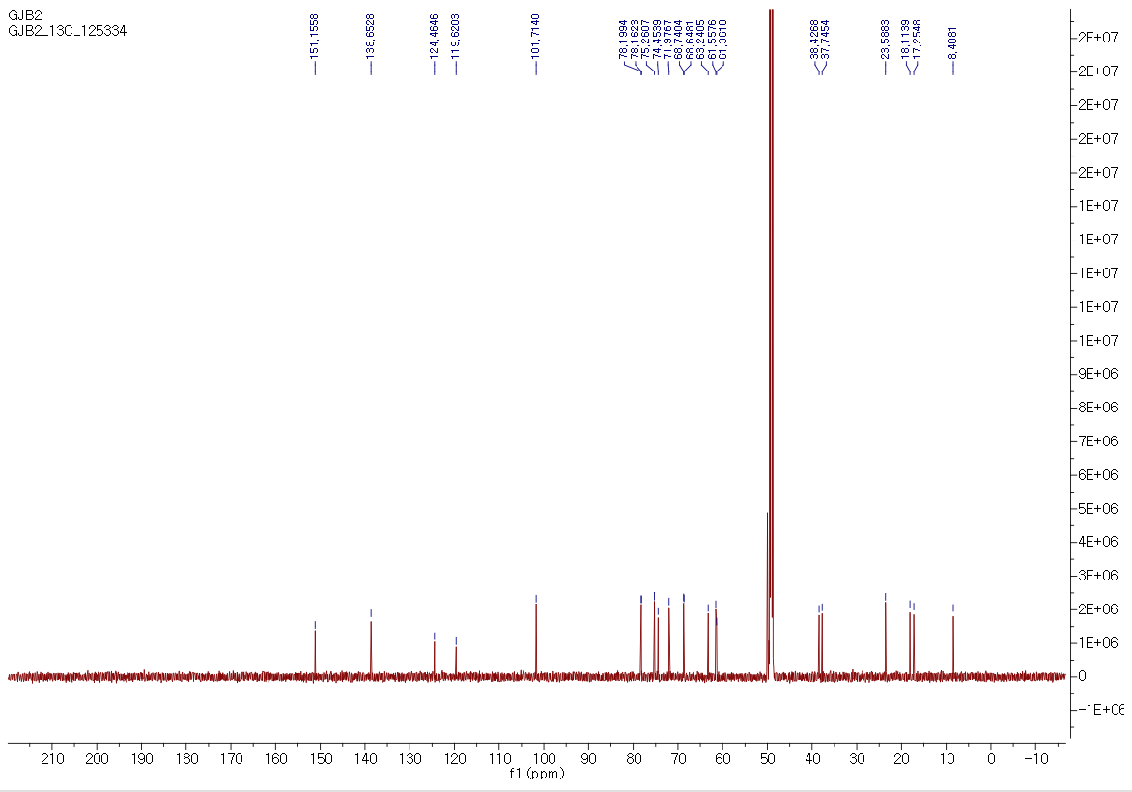

Figure S23. ¹H-¹H COSY spectrum of 3 in CD₃OD
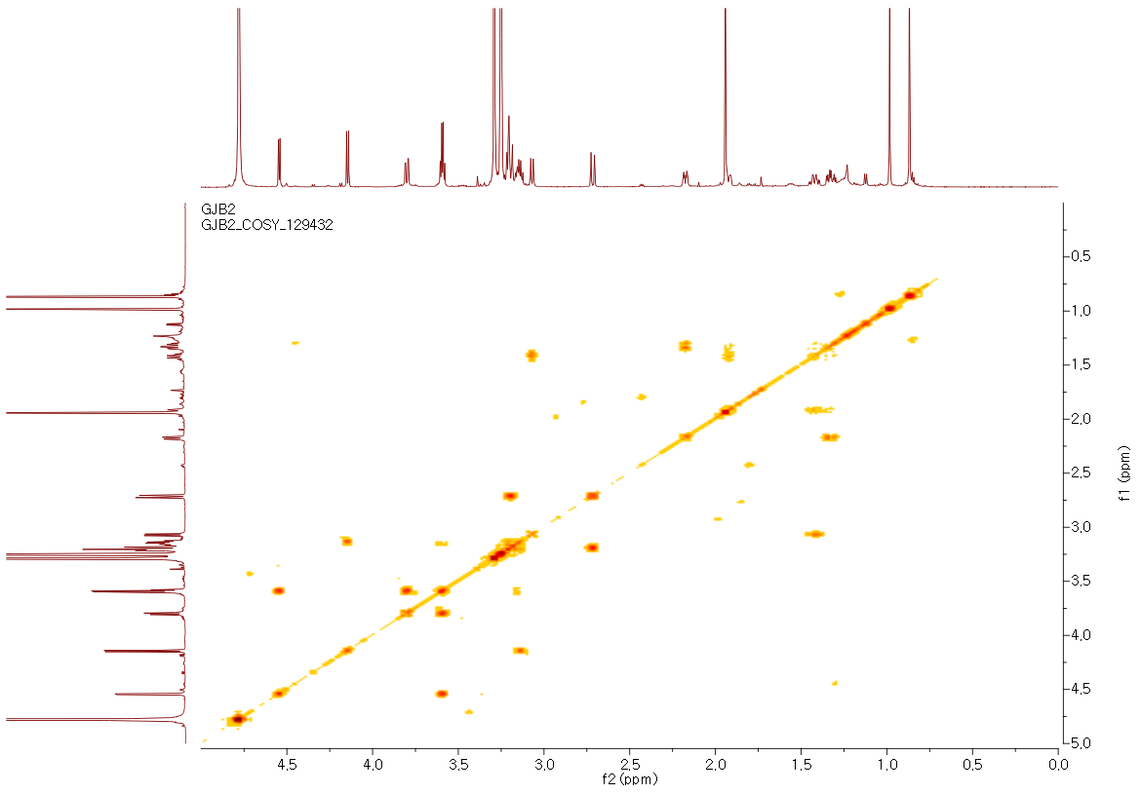

Figure S24. HSQC spectrum of 3 in CD₃OD
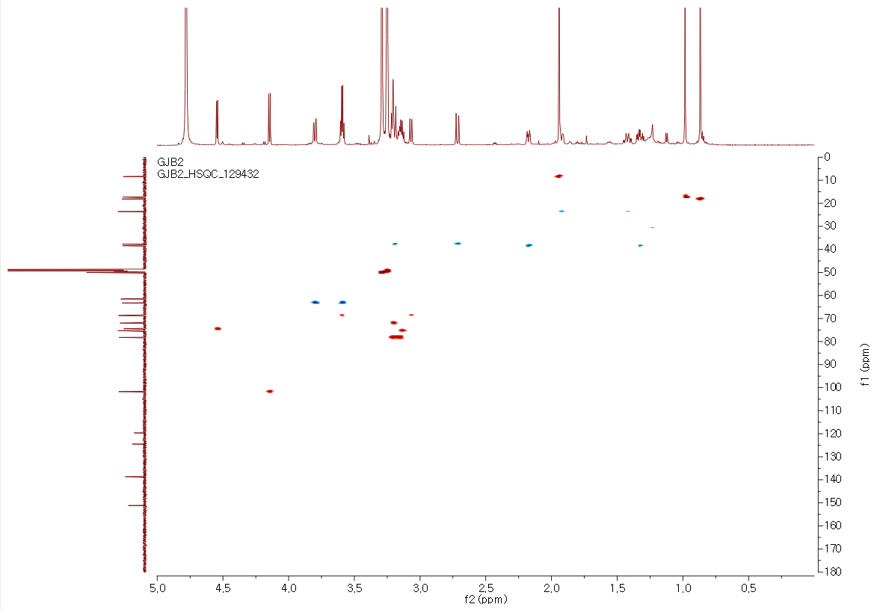

Figure S25. HMBC spectrum of 3 in CD₃OD
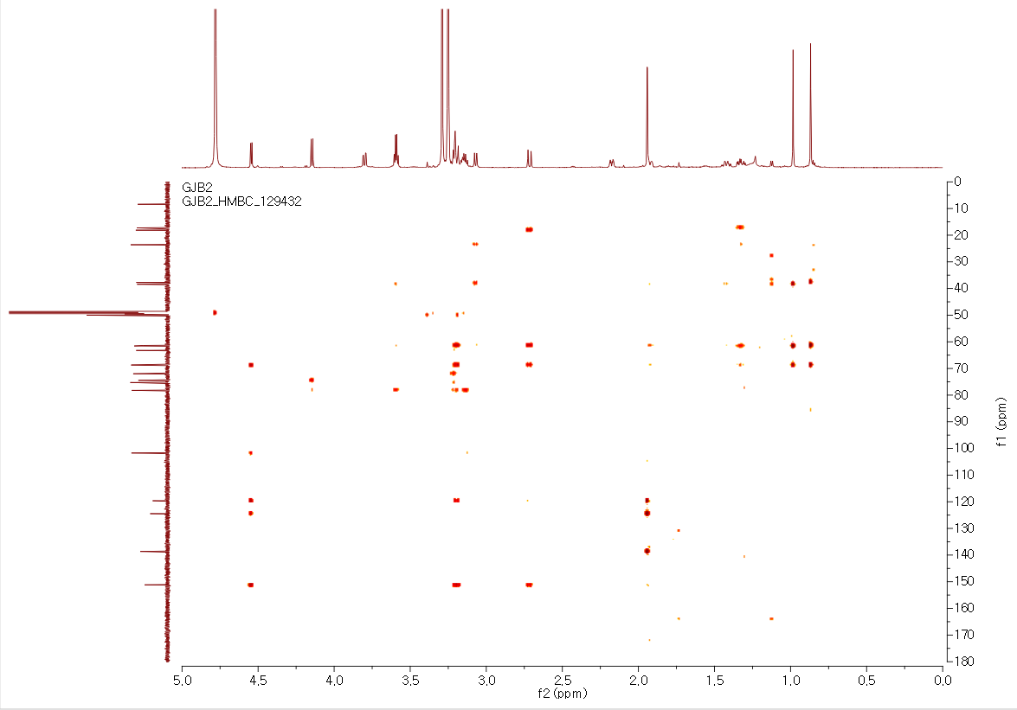

Figure S26. NOESY spectrum of 3 in CD₃OD
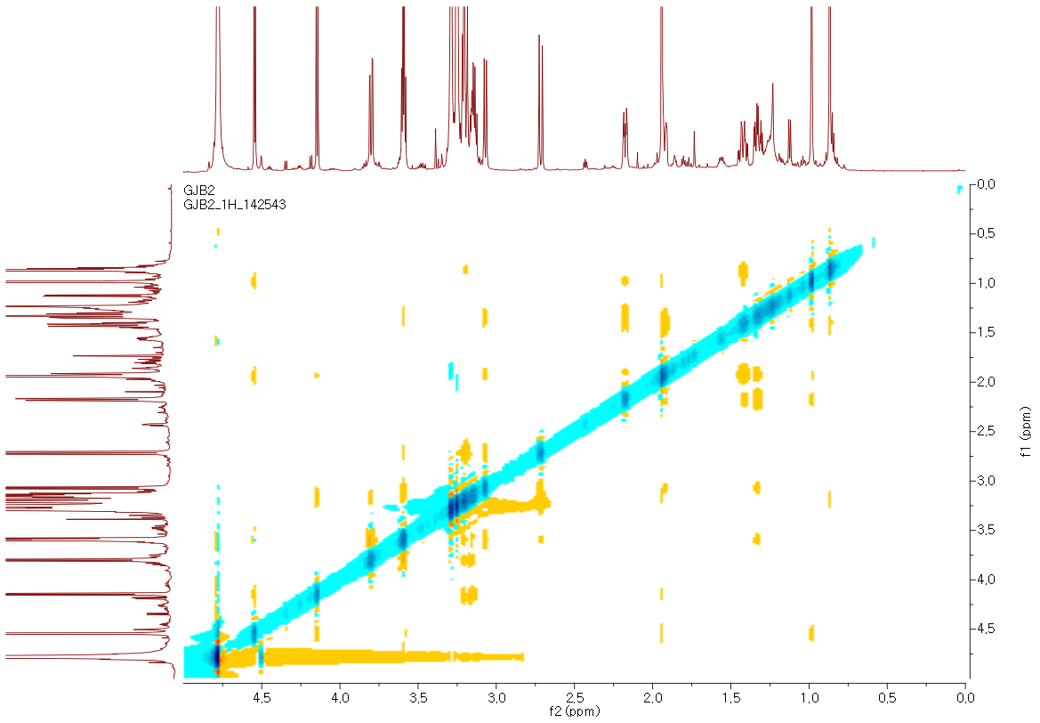

Figure S27. Comparison of standard D-glucopyranose and monosaccharide obtained by hydrolysis of 3
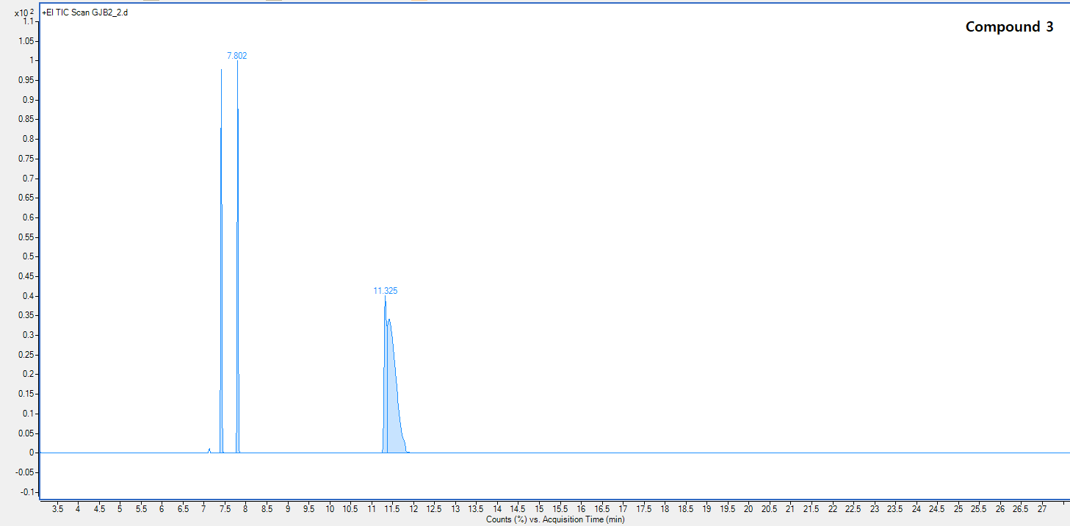

Figure S28. ECD spectrum of 3

Figure S29. HRESIMS data of 4

Figure S30. ¹H NMR data of 4 in CD₃OD
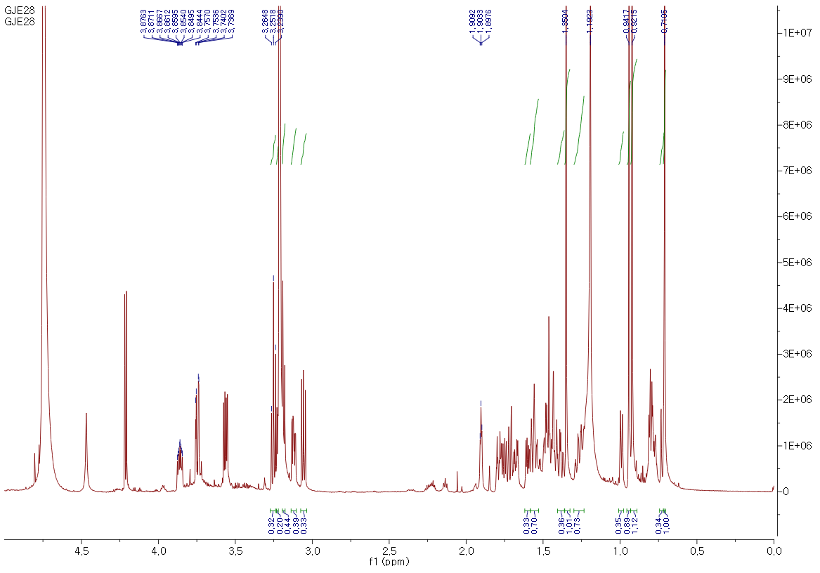

Figure S31. ¹³C NMR data of 4 in CD₃OD
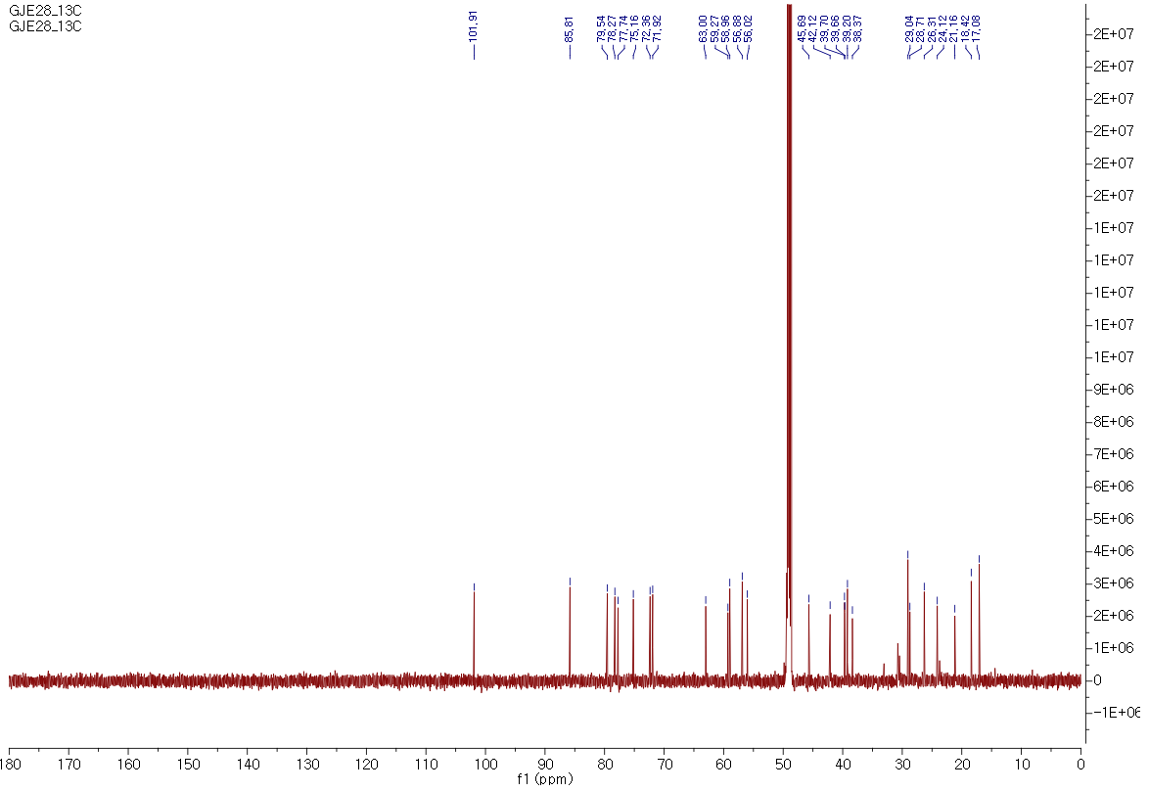

Figure S32. ¹H-¹H COSY spectrum of 4 in CD₃OD
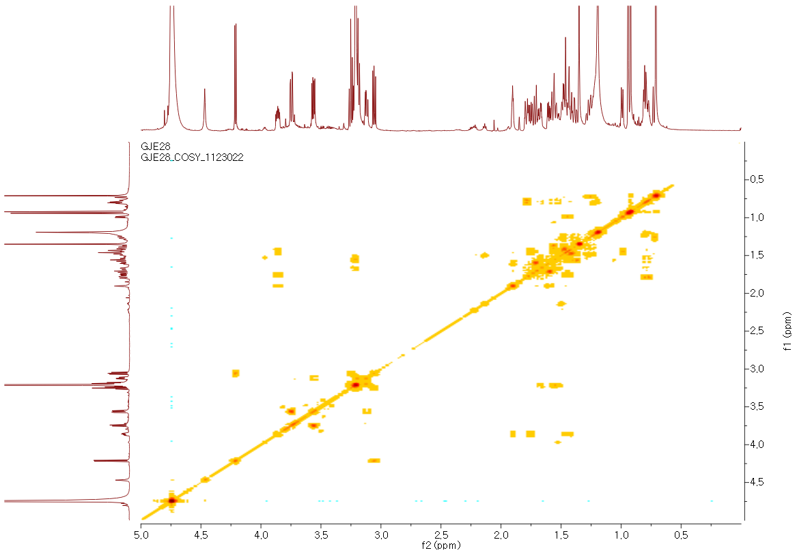

Figure S33. HSQC spectrum of 4 in CD₃OD
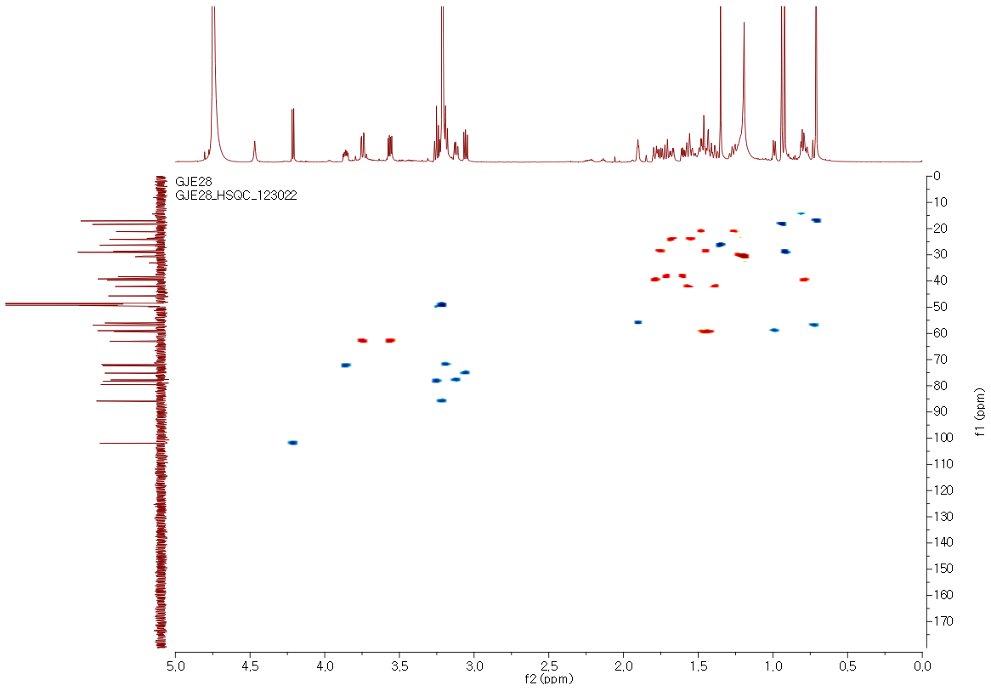

Figure S34. HMBC spectrum of 4 in CD₃OD
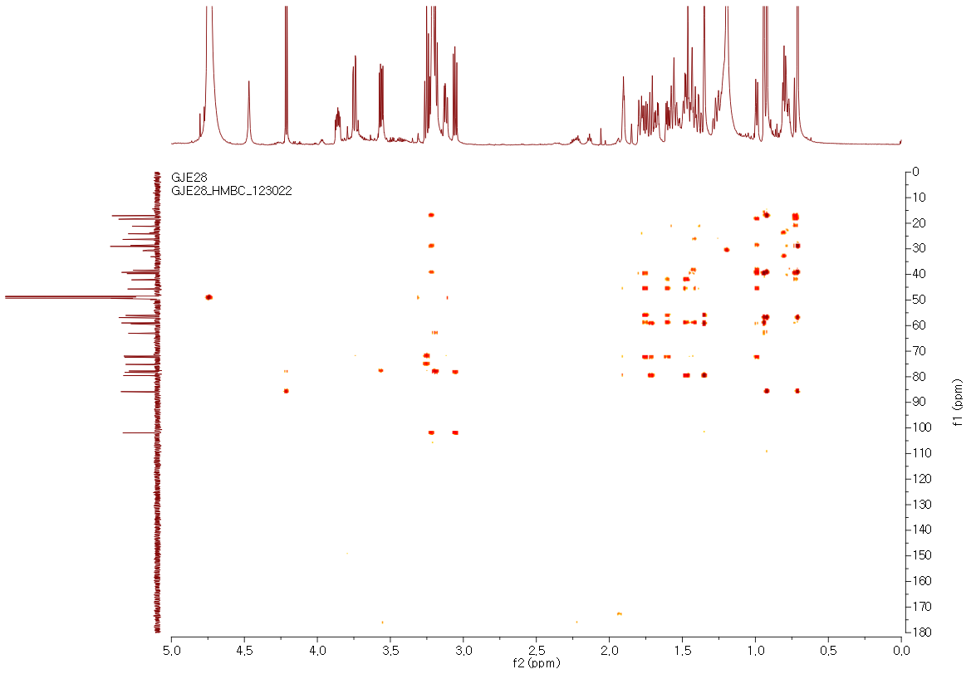

Figure S35. NOESY spectrum of 4 in CD₃OD
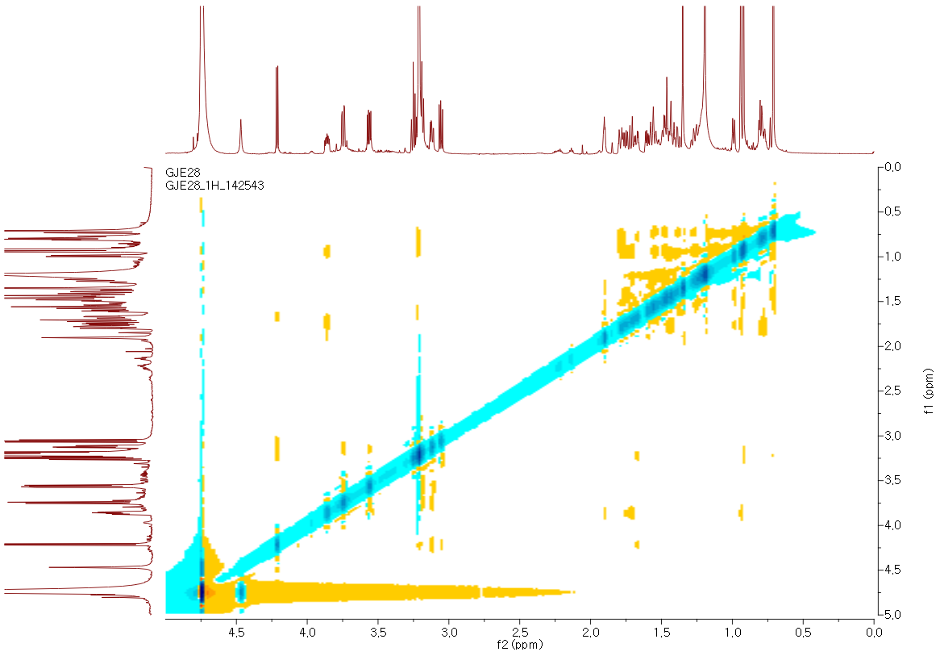

Figure S36. Comparison of standard D-glucopyranose and monosaccharide obtained by hydrolysis of 4
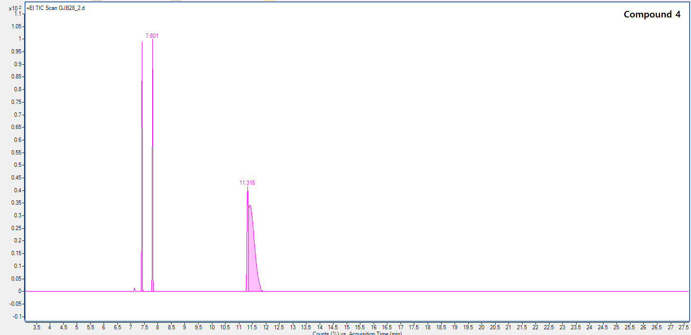

Figure S37. HRESIMS data of 5

Figure S38. ¹H NMR data of 5 in CD₃OD
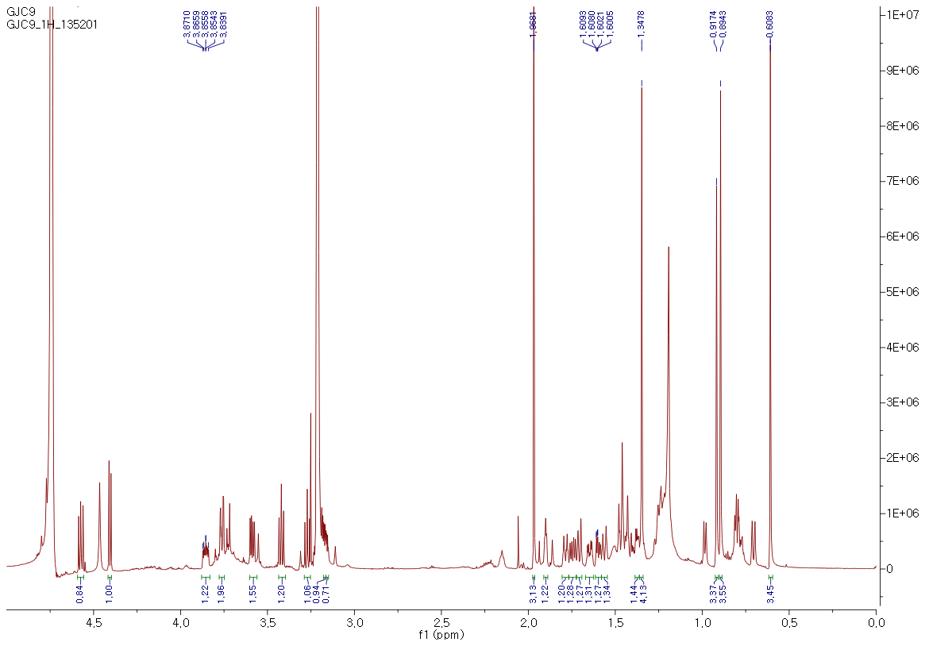

Figure S39. ¹³C NMR data of 5 in CD₃OD
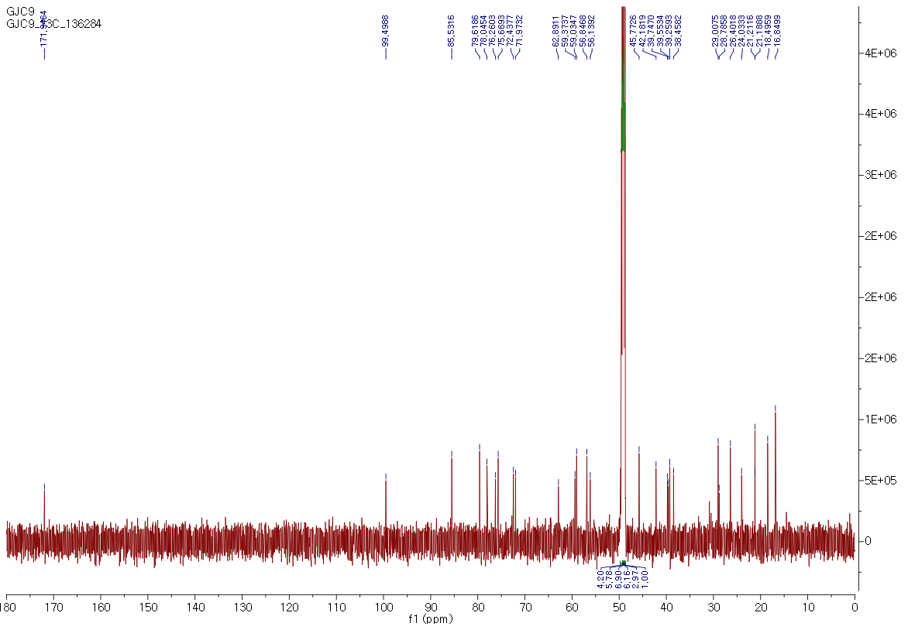

Figure S40. ¹H-¹H COSY spectrum of 5 in CD₃OD
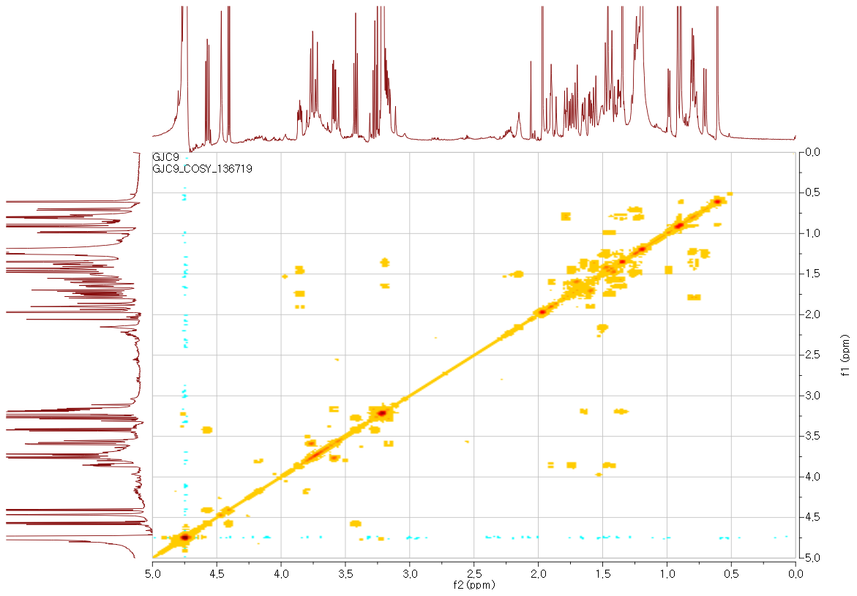

Figure S41. HSQC spectrum of 5 in CD₃OD
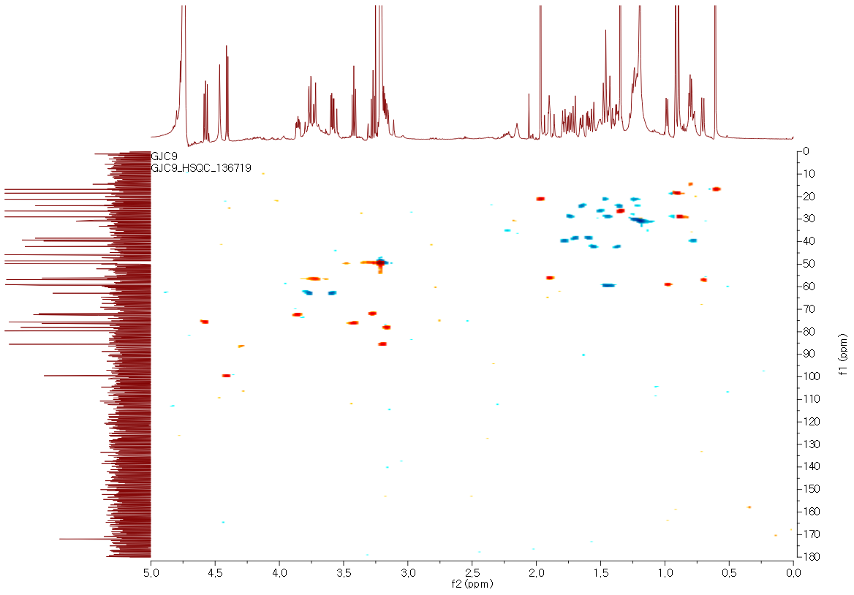

Figure S42. HMBC spectrum of 5 in CD₃OD
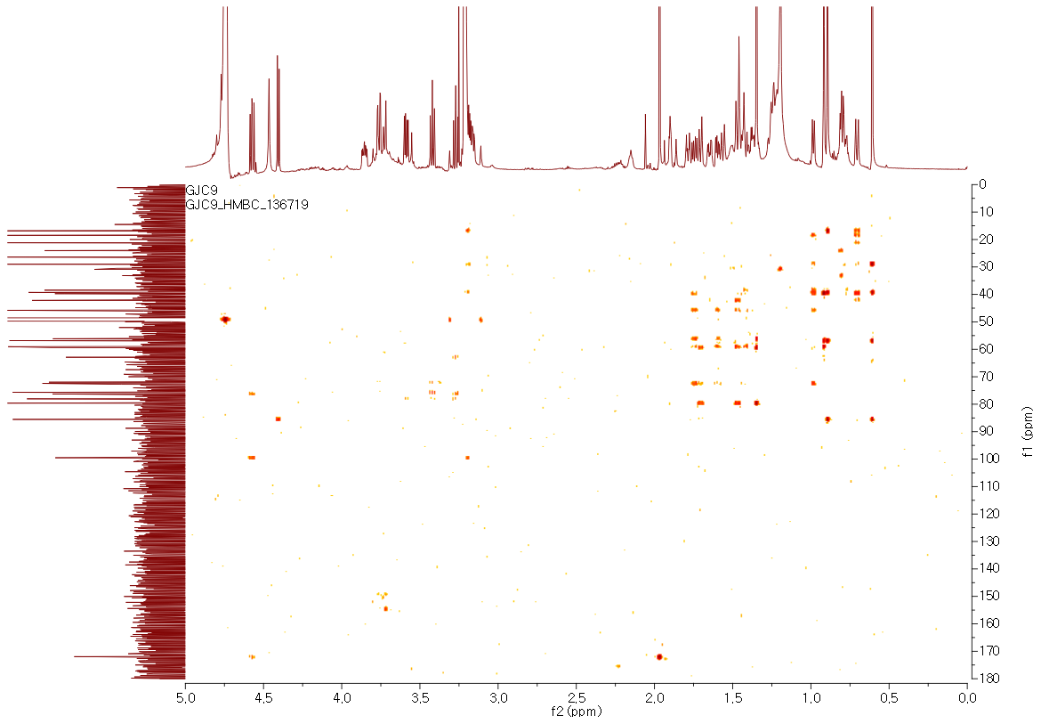

Figure S43. NOESY spectrum of 5 in CD₃OD
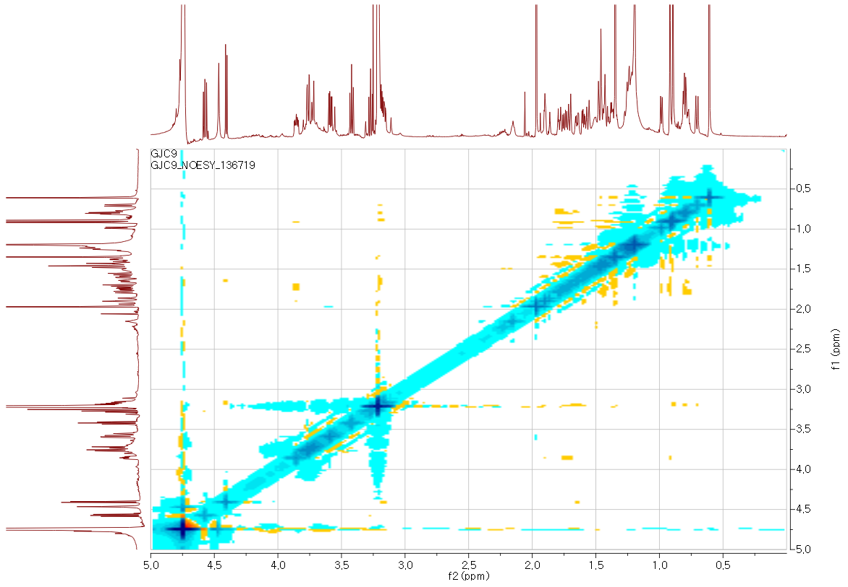

Figure S44. Comparison of standard D-glucopyranose and monosaccharide obtained by hydrolysis of 5
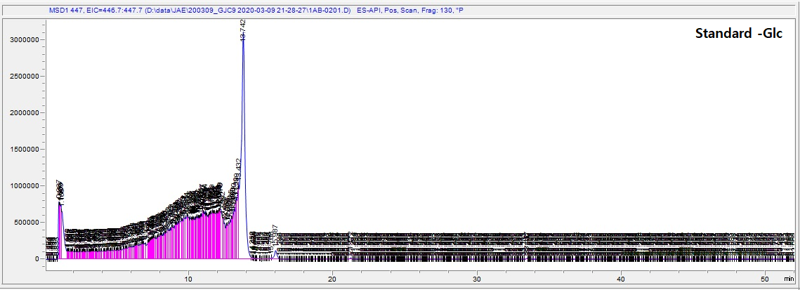
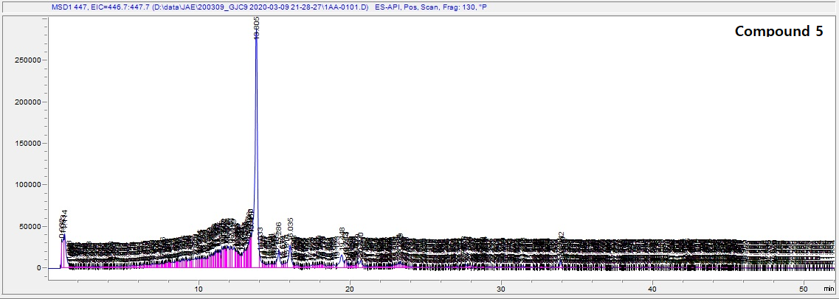

Coordinates of the conformers
1-1
---------------------------------------------------------------------
Center Atomic Atomic Coordinates (Angstroms)
Number Number Type X Y Z
---------------------------------------------------------------------
1 8 0 -3.396661 -0.667399 -2.027154
2 6 0 -2.559948 -0.614402 -1.160467
3 6 0 -1.414773 -1.522029 -0.910615
4 6 0 -1.185850 -2.706445 -1.795017
5 6 0 -0.740753 -1.074440 0.159321
6 6 0 0.472238 -1.727722 0.772808
7 8 0 0.695678 -1.285798 2.098408
8 6 0 1.737249 -1.589135 -0.089872
9 6 0 2.764443 -0.533791 -0.055899
10 8 0 2.956455 -1.808195 0.643031
11 6 0 3.657411 -0.397597 -1.274420
12 6 0 2.721439 0.674138 0.873173
13 6 0 2.522769 2.045397 0.197390
14 6 0 1.328423 2.267097 -0.723842
15 6 0 -0.113253 2.030410 -0.477197
16 8 0 0.664963 1.137748 -1.315642
17 6 0 -1.092185 2.902615 -1.247046
18 6 0 -0.635008 1.449708 0.834927
19 6 0 -1.461478 0.151001 0.724117
20 8 0 -1.992430 -0.252561 1.957695
21 6 0 -2.905058 0.633831 2.601118
22 8 0 -2.544433 0.377640 -0.209232
23 1 0 0.267930 -2.814327 0.786997
24 1 0 1.664020 -2.160228 -1.018005
25 1 0 1.526971 3.062928 -1.448230
26 1 0 -2.144298 -3.092877 -2.154559
27 1 0 -0.600662 -2.428587 -2.680846
28 1 0 -0.650737 -3.509059 -1.276325
29 1 0 1.607355 -1.572403 2.296147
30 1 0 3.777711 -1.366033 -1.768089
31 1 0 4.652677 -0.036880 -0.987558
32 1 0 3.227106 0.306002 -1.994090
33 1 0 1.982456 0.502999 1.652616
34 1 0 3.698124 0.712439 1.376652
35 1 0 2.497957 2.814588 0.982215
36 1 0 3.418130 2.269671 -0.396121
37 1 0 -1.343539 3.796734 -0.662710
38 1 0 -0.650185 3.223444 -2.194927
39 1 0 -2.019664 2.365399 -1.456799
40 1 0 -1.275155 2.211545 1.292661
41 1 0 0.167008 1.245516 1.543156
42 1 0 -2.395850 1.491274 3.060393
43 1 0 -3.674583 0.989263 1.907800
44 1 0 -3.375350 0.045310 3.391904
---------------------------------------------------------------------

1-2
---------------------------------------------------------------------
Center Atomic Atomic Coordinates (Angstroms)
Number Number Type X Y Z
---------------------------------------------------------------------
1 8 0 3.484816 0.523902 1.878385
2 6 0 2.643730 0.185062 1.081702
3 6 0 1.615944 -0.877286 1.211862
4 6 0 1.539870 -1.705330 2.455011
5 6 0 0.875637 -0.890119 0.092431
6 6 0 -0.256253 -1.843791 -0.195201
7 8 0 -0.533452 -1.907884 -1.581922
8 6 0 -1.526266 -1.578320 0.629853
9 6 0 -2.676615 -0.717402 0.308844
10 8 0 -2.709092 -2.161554 0.052910
11 6 0 -3.578652 -0.311558 1.458766
12 6 0 -2.780877 0.135247 -0.949451
13 6 0 -2.746035 1.663161 -0.736387
14 6 0 -1.592277 2.289389 0.041083
15 6 0 -0.134266 2.158506 -0.185916
16 8 0 -0.793442 1.469017 0.909214
17 6 0 0.744143 3.317766 0.253841
18 6 0 0.425351 1.281472 -1.298623
19 6 0 1.406944 0.171347 -0.881548
20 8 0 1.884116 -0.332098 -2.093629
21 6 0 2.775309 -1.440850 -2.035848
22 8 0 2.510743 0.769823 -0.149815
23 1 0 0.081393 -2.840281 0.147485
24 1 0 -1.380294 -1.812397 1.686643
25 1 0 -1.887750 3.232883 0.509641
26 1 0 2.539478 -1.831847 2.881395
27 1 0 0.927546 -1.207981 3.217908
28 1 0 1.104096 -2.692463 2.266394
29 1 0 -1.408897 -2.336306 -1.635399
30 1 0 -3.576758 -1.082364 2.234606
31 1 0 -4.611208 -0.180219 1.113242
32 1 0 -3.239408 0.628616 1.904784
33 1 0 -2.028094 -0.187013 -1.665783
34 1 0 -3.755789 -0.095304 -1.402342
35 1 0 -2.800945 2.147860 -1.721254
36 1 0 -3.667424 1.958117 -0.218707
37 1 0 0.888226 4.019389 -0.577047
38 1 0 0.276653 3.855489 1.084083
39 1 0 1.729879 2.970022 0.571547
40 1 0 0.979716 1.915747 -1.998862
41 1 0 -0.361586 0.796907 -1.873753
42 1 0 3.138196 -1.577869 -3.056578
43 1 0 3.628264 -1.240000 -1.377351
44 1 0 2.261064 -2.354395 -1.714320
---------------------------------------------------------------------

1-3
---------------------------------------------------------------------
Center Atomic Atomic Coordinates (Angstroms)
Number Number Type X Y Z
---------------------------------------------------------------------
1 8 0 -3.431301 -0.602321 -2.017655
2 6 0 -2.576491 -0.570691 -1.170765
3 6 0 -1.441334 -1.495518 -0.939139
4 6 0 -1.246014 -2.690343 -1.817047
5 6 0 -0.748869 -1.057242 0.122185
6 6 0 0.428048 -1.710304 0.817732
7 8 0 0.640166 -1.203476 2.123629
8 6 0 1.706478 -1.632958 -0.023829
9 6 0 2.762460 -0.604972 -0.039686
10 8 0 2.943432 -1.878486 0.640680
11 6 0 3.604410 -0.483440 -1.296970
12 6 0 2.773205 0.600211 0.892388
13 6 0 2.583820 1.978236 0.221447
14 6 0 1.408653 2.227641 -0.720508
15 6 0 -0.043663 2.033341 -0.499058
16 8 0 0.717986 1.119611 -1.324155
17 6 0 -0.995090 2.927091 -1.277344
18 6 0 -0.587102 1.462683 0.807169
19 6 0 -1.439094 0.184489 0.682808
20 8 0 -1.941340 -0.227001 1.952224
21 6 0 -2.865040 0.645949 2.609404
22 8 0 -2.534694 0.421967 -0.206519
23 1 0 0.201997 -2.790622 0.882041
24 1 0 1.576459 -2.195999 -0.953226
25 1 0 1.639050 3.016080 -1.443492
26 1 0 -2.215732 -3.084352 -2.136363
27 1 0 -0.694176 -2.420687 -2.726233
28 1 0 -0.688380 -3.483331 -1.308369
29 1 0 -0.240854 -1.077183 2.521228
30 1 0 3.667154 -1.449994 -1.805381
31 1 0 4.625003 -0.167411 -1.047224
32 1 0 3.176193 0.245139 -1.992544
33 1 0 2.063849 0.426737 1.698959
34 1 0 3.766135 0.621551 1.363830
35 1 0 2.556284 2.745614 1.008393
36 1 0 3.487428 2.199598 -0.360632
37 1 0 -1.240355 3.823043 -0.693292
38 1 0 -0.533700 3.243962 -2.217155
39 1 0 -1.929306 2.407824 -1.504689
40 1 0 -1.209105 2.236037 1.271398
41 1 0 0.215555 1.231708 1.506595
42 1 0 -3.306107 0.055789 3.415326
43 1 0 -2.366490 1.521968 3.042104
44 1 0 -3.651166 0.967144 1.920372
---------------------------------------------------------------------

1-4
---------------------------------------------------------------------
Center Atomic Atomic Coordinates (Angstroms)
Number Number Type X Y Z
---------------------------------------------------------------------
1 8 0 -3.273283 -2.405748 -1.482347
2 6 0 -2.496968 -1.698489 -0.889050
3 6 0 -1.270574 -2.082650 -0.148981
4 6 0 -0.911631 -3.532463 -0.030602
5 6 0 -0.711675 -0.974100 0.366883
6 6 0 0.491603 -0.969629 1.282200
7 8 0 0.731013 0.314538 1.820064
8 6 0 1.733135 -1.581547 0.621392
9 6 0 2.899141 -0.913205 0.001988
10 8 0 2.954012 -1.435605 1.361981
11 6 0 3.715741 -1.722003 -0.988837
12 6 0 3.059978 0.592450 -0.126426
13 6 0 2.180562 1.245921 -1.224871
14 6 0 1.383852 2.390663 -0.635090
15 6 0 -0.068269 2.417364 -0.369045
16 8 0 0.517212 3.145328 -1.486731
17 6 0 -0.570932 3.313337 0.743280
18 6 0 -1.020387 1.345866 -0.889981
19 6 0 -1.597206 0.237059 0.022598
20 8 0 -2.144216 0.679295 1.236296
21 6 0 -3.378616 1.396676 1.169605
22 8 0 -2.647434 -0.343536 -0.796895
23 1 0 0.249675 -1.665948 2.107379
24 1 0 1.550164 -2.605727 0.292499
25 1 0 1.989846 3.023242 0.022153
26 1 0 -1.817846 -4.136372 -0.133644
27 1 0 -0.227566 -3.847492 -0.828603
28 1 0 -0.438209 -3.764441 0.929382
29 1 0 1.540671 0.223405 2.351327
30 1 0 3.565247 -2.796455 -0.849647
31 1 0 4.782750 -1.505806 -0.860782
32 1 0 3.442113 -1.462465 -2.018568
33 1 0 2.832088 1.047556 0.837959
34 1 0 4.119845 0.798480 -0.320519
35 1 0 2.804703 1.644240 -2.033855
36 1 0 1.517215 0.508032 -1.687825
37 1 0 -0.724860 2.735732 1.657835
38 1 0 0.151928 4.111219 0.937847
39 1 0 -1.519407 3.785832 0.461326
40 1 0 -0.569713 0.847892 -1.752352
41 1 0 -1.888806 1.880303 -1.294987
42 1 0 -3.578888 1.722157 2.192459
43 1 0 -3.315261 2.278113 0.521542
44 1 0 -4.190645 0.752832 0.819756
---------------------------------------------------------------------

1-5
---------------------------------------------------------------------
Center Atomic Atomic Coordinates (Angstroms)
Number Number Type X Y Z
---------------------------------------------------------------------
1 8 0 -4.186705 1.139435 -0.796736
2 6 0 -3.110060 0.689608 -0.491300
3 6 0 -2.670519 -0.736382 -0.497335
4 6 0 -3.639697 -1.795928 -0.910752
5 6 0 -1.395920 -0.786898 -0.078118
6 6 0 -0.568356 -2.035593 0.128345
7 8 0 -0.309337 -2.207436 1.514139
8 6 0 0.730939 -2.132848 -0.694181
9 6 0 2.075485 -1.598857 -0.360848
10 8 0 1.710105 -2.990318 -0.089884
11 6 0 3.077651 -1.470931 -1.491851
12 6 0 2.359809 -0.779968 0.901204
13 6 0 3.090868 0.575421 0.772299
14 6 0 2.453387 1.853428 0.226500
15 6 0 1.159972 2.137930 -0.436326
16 8 0 2.393093 2.068980 -1.197186
17 6 0 0.569536 3.527598 -0.313030
18 6 0 0.189770 1.047204 -0.850768
19 6 0 -0.891909 0.642172 0.173228
20 8 0 -0.403669 0.900079 1.451353
21 6 0 -1.290242 0.637472 2.545948
22 8 0 -2.070386 1.465028 -0.059936
23 1 0 -1.177823 -2.882815 -0.226131
24 1 0 0.535937 -2.346809 -1.748698
25 1 0 2.875042 2.723863 0.738114
26 1 0 -4.553212 -1.722534 -0.310129
27 1 0 -3.943036 -1.647208 -1.953941
28 1 0 -3.231410 -2.803888 -0.806211
29 1 0 0.470689 -2.795253 1.549507
30 1 0 2.842257 -2.173541 -2.296538
31 1 0 4.088093 -1.696545 -1.130738
32 1 0 3.080163 -0.452344 -1.893931
33 1 0 1.446460 -0.645939 1.478924
34 1 0 3.025017 -1.412894 1.505801
35 1 0 3.392747 0.827351 1.796870
36 1 0 4.032681 0.445469 0.222521
37 1 0 0.088777 3.821291 -1.253419
38 1 0 -0.189764 3.550399 0.474781
39 1 0 1.346249 4.262211 -0.081071
40 1 0 0.772297 0.177110 -1.131745
41 1 0 -0.334704 1.373190 -1.756153
42 1 0 -0.752179 0.965569 3.437460
43 1 0 -2.213394 1.217157 2.446441
44 1 0 -1.509970 -0.430554 2.626197
---------------------------------------------------------------------

1-6
---------------------------------------------------------------------
Center Atomic Atomic Coordinates (Angstroms)
Number Number Type X Y Z
---------------------------------------------------------------------
1 8 0 -3.764850 -1.299472 -1.728480
2 6 0 -2.853398 -0.863091 -1.067783
3 6 0 -1.790947 -1.617561 -0.354056
4 6 0 -1.813500 -3.114853 -0.364876
5 6 0 -0.978104 -0.739490 0.258704
6 6 0 0.146417 -1.133407 1.188723
7 8 0 0.629621 -0.017073 1.909338
8 6 0 1.257256 -1.940135 0.503475
9 6 0 2.581791 -1.503180 0.009773
10 8 0 2.427823 -2.143131 1.310623
11 6 0 3.269588 -2.385734 -1.014892
12 6 0 3.061904 -0.064331 0.034859
13 6 0 2.495750 0.800462 -1.120872
14 6 0 1.963112 2.103855 -0.568807
15 6 0 0.542248 2.450256 -0.355225
16 8 0 1.313473 3.015674 -1.456340
17 6 0 0.212444 3.455789 0.729166
18 6 0 -0.605299 1.613740 -0.914400
19 6 0 -1.471565 0.697016 -0.022348
20 8 0 -1.837466 1.416740 1.108540
21 6 0 -2.722707 0.786934 2.030019
22 8 0 -2.663893 0.465635 -0.840419
23 1 0 -0.293610 -1.855385 1.904101
24 1 0 0.868455 -2.860540 0.063304
25 1 0 2.671548 2.593910 0.107872
26 1 0 -2.838626 -3.461324 -0.524200
27 1 0 -1.209738 -3.519786 -1.186869
28 1 0 -1.433688 -3.541212 0.570091
29 1 0 1.384957 -0.353478 2.423020
30 1 0 2.885016 -3.409244 -0.982783
31 1 0 4.347303 -2.418386 -0.817185
32 1 0 3.125663 -1.990801 -2.027430
33 1 0 2.778626 0.382213 0.987976
34 1 0 4.158573 -0.071609 0.004188
35 1 0 3.275116 1.025230 -1.859024
36 1 0 1.709461 0.264654 -1.662359
37 1 0 -0.676544 4.037808 0.462611
38 1 0 0.011686 2.949337 1.675444
39 1 0 1.051694 4.146804 0.854894
40 1 0 -0.251234 1.018110 -1.759026
41 1 0 -1.318645 2.332763 -1.333826
42 1 0 -2.972297 1.552891 2.766684
43 1 0 -3.640609 0.449070 1.536854
44 1 0 -2.240695 -0.055615 2.540808
---------------------------------------------------------------------

1-7
---------------------------------------------------------------------
Center Atomic Atomic Coordinates (Angstroms)
Number Number Type X Y Z
---------------------------------------------------------------------
1 8 0 3.429405 0.416258 1.957100
2 6 0 2.592139 0.115458 1.146180
3 6 0 1.580240 -0.968445 1.190585
4 6 0 1.514723 -1.897600 2.360957
5 6 0 0.849026 -0.901337 0.067221
6 6 0 -0.253452 -1.827323 -0.402668
7 8 0 -0.543197 -1.685895 -1.782770
8 6 0 -1.519043 -1.679038 0.450215
9 6 0 -2.684521 -0.797259 0.257933
10 8 0 -2.730023 -2.213197 -0.077153
11 6 0 -3.512784 -0.453922 1.482823
12 6 0 -2.851911 0.125836 -0.942670
13 6 0 -2.810431 1.640921 -0.647085
14 6 0 -1.652361 2.249230 0.139435
15 6 0 -0.191931 2.158254 -0.093972
16 8 0 -0.829829 1.417600 0.976230
17 6 0 0.664148 3.321452 0.379003
18 6 0 0.391111 1.324405 -1.228794
19 6 0 1.385179 0.226627 -0.812116
20 8 0 1.880663 -0.293130 -2.049439
21 6 0 3.084866 -1.065421 -1.988305
22 8 0 2.456748 0.792148 -0.054897
23 1 0 0.090362 -2.861446 -0.212085
24 1 0 -1.310516 -1.974800 1.483078
25 1 0 -1.957048 3.171596 0.643261
26 1 0 2.518276 -2.073272 2.760306
27 1 0 0.919552 -1.459063 3.171635
28 1 0 1.062395 -2.858261 2.094397
29 1 0 0.289859 -1.457936 -2.235385
30 1 0 -3.456281 -1.262363 2.217646
31 1 0 -4.566813 -0.320771 1.208883
32 1 0 -3.158322 0.467635 1.955163
33 1 0 -2.144549 -0.169540 -1.714565
34 1 0 -3.850141 -0.079179 -1.355175
35 1 0 -2.891442 2.181238 -1.601157
36 1 0 -3.720397 1.903857 -0.092726
37 1 0 0.795118 4.050317 -0.430441
38 1 0 0.185887 3.825511 1.223902
39 1 0 1.656011 2.983914 0.689485
40 1 0 0.937973 1.985272 -1.910212
41 1 0 -0.390260 0.839413 -1.811723
42 1 0 3.925822 -0.449290 -1.659091
43 1 0 2.984978 -1.931504 -1.321882
44 1 0 3.259412 -1.412628 -3.008339
---------------------------------------------------------------------

1-8
---------------------------------------------------------------------
Center Atomic Atomic Coordinates (Angstroms)
Number Number Type X Y Z
---------------------------------------------------------------------
1 8 0 -3.475386 -2.179869 -1.468571
2 6 0 -2.621914 -1.556450 -0.891320
3 6 0 -1.402388 -2.047183 -0.205424
4 6 0 -1.141251 -3.519495 -0.118344
5 6 0 -0.751826 -0.992892 0.314016
6 6 0 0.432501 -1.022282 1.263278
7 8 0 0.724317 0.250036 1.805027
8 6 0 1.657954 -1.669915 0.616609
9 6 0 2.871151 -1.047013 0.046015
10 8 0 2.881048 -1.678136 1.350994
11 6 0 3.640178 -1.820901 -1.008814
12 6 0 3.082769 0.454430 0.032022
13 6 0 2.311744 1.154329 -1.118793
14 6 0 1.529261 2.338985 -0.601795
15 6 0 0.066159 2.423198 -0.410429
16 8 0 0.723342 3.078163 -1.529193
17 6 0 -0.454342 3.416381 0.611047
18 6 0 -0.912280 1.364227 -0.919312
19 6 0 -1.542442 0.286456 0.000763
20 8 0 -1.975788 0.770149 1.264943
21 6 0 -3.194295 1.523407 1.295131
22 8 0 -2.672150 -0.188576 -0.753740
23 1 0 0.157721 -1.713202 2.082562
24 1 0 1.392453 -2.648487 0.209420
25 1 0 2.121238 2.981547 0.057717
26 1 0 -2.087716 -4.062636 -0.194573
27 1 0 -0.507187 -3.864133 -0.944784
28 1 0 -0.647338 -3.794654 0.819325
29 1 0 -0.118494 0.611098 2.132332
30 1 0 3.427688 -2.892596 -0.950390
31 1 0 4.717564 -1.678594 -0.863065
32 1 0 3.389631 -1.470287 -2.017137
33 1 0 2.760538 0.846879 0.996789
34 1 0 4.158554 0.651408 -0.057613
35 1 0 3.004133 1.517701 -1.888235
36 1 0 1.642871 0.450176 -1.625452
37 1 0 -1.373370 3.893689 0.250208
38 1 0 -0.669971 2.936200 1.568981
39 1 0 0.286595 4.203944 0.773891
40 1 0 -0.462387 0.836569 -1.764335
41 1 0 -1.758798 1.916614 -1.346459
42 1 0 -3.289200 1.885071 2.320862
43 1 0 -3.165577 2.378876 0.612514
44 1 0 -4.047885 0.888983 1.043877
---------------------------------------------------------------------

2-1
---------------------------------------------------------------------
Center Atomic Atomic Coordinates (Angstroms)
Number Number Type X Y Z
---------------------------------------------------------------------
1 6 0 3.329953 -0.771561 -1.416486
2 6 0 2.595264 -0.838372 -0.091480
3 6 0 1.466635 -1.778230 0.032636
4 6 0 0.317862 -1.692288 1.029684
5 8 0 2.747100 -2.113045 0.587986
6 6 0 2.764612 0.362185 0.831064
7 6 0 2.621246 1.754842 0.178950
8 6 0 1.385717 2.082730 -0.656901
9 6 0 -0.046098 2.010971 -0.280730
10 8 0 0.553666 1.019160 -1.148152
11 6 0 -1.010066 2.950200 -0.984600
12 6 0 -0.485483 1.513560 1.092283
13 6 0 -1.425602 0.291722 1.124402
14 8 0 -1.760028 -0.012131 2.459024
15 6 0 -0.912303 -1.002861 0.508641
16 6 0 -1.777094 -1.404817 -0.434121
17 6 0 -1.790534 -2.624181 -1.299131
18 6 0 -2.864914 -0.401003 -0.532888
19 8 0 -2.616842 0.602886 0.382767
20 8 0 -3.826994 -0.386310 -1.258149
21 1 0 1.214178 -2.343232 -0.868269
22 1 0 1.605575 2.830580 -1.424519
23 1 0 4.388473 -0.527425 -1.262268
24 1 0 2.891148 -0.015270 -2.074947
25 1 0 3.278850 -1.739976 -1.922253
26 1 0 0.654659 -1.218033 1.954367
27 1 0 0.057637 -2.724361 1.303697
28 1 0 3.784019 0.308988 1.237661
29 1 0 2.106040 0.255454 1.695147
30 1 0 2.719226 2.517735 0.964334
31 1 0 3.486244 1.907789 -0.478194
32 1 0 -0.633451 3.204859 -1.979516
33 1 0 -1.997048 2.492814 -1.089965
34 1 0 -1.127518 3.877818 -0.410540
35 1 0 0.372279 1.269046 1.720160
36 1 0 -1.014592 2.333807 1.596723
37 1 0 -2.169652 0.779002 2.847852
38 1 0 -1.457922 -2.384642 -2.316969
39 1 0 -2.809215 -3.016471 -1.383165
40 1 0 -1.139314 -3.410345 -0.905080
---------------------------------------------------------------------

2-2
---------------------------------------------------------------------
Center Atomic Atomic Coordinates (Angstroms)
Number Number Type X Y Z
---------------------------------------------------------------------
1 6 0 3.322964 -0.776201 -1.425373
2 6 0 2.593311 -0.840894 -0.097579
3 6 0 1.461043 -1.775483 0.028431
4 6 0 0.316057 -1.686783 1.029988
5 8 0 2.740495 -2.118411 0.579482
6 6 0 2.771309 0.357724 0.825210
7 6 0 2.624296 1.750740 0.174878
8 6 0 1.383774 2.079734 -0.653188
9 6 0 -0.045192 2.008846 -0.267860
10 8 0 0.548671 1.017671 -1.142964
11 6 0 -1.010616 2.953134 -0.963136
12 6 0 -0.475818 1.513101 1.106308
13 6 0 -1.421243 0.302175 1.129643
14 8 0 -1.735863 0.124989 2.492021
15 6 0 -0.915912 -0.998414 0.510523
16 6 0 -1.781873 -1.403570 -0.431592
17 6 0 -1.800928 -2.624189 -1.294979
18 6 0 -2.855178 -0.384031 -0.543683
19 8 0 -2.621906 0.602970 0.390859
20 8 0 -3.803843 -0.357364 -1.286907
21 1 0 1.201684 -2.337727 -0.872246
22 1 0 1.599770 2.829333 -1.420166
23 1 0 3.266476 -1.743966 -1.931868
24 1 0 4.382807 -0.535747 -1.275016
25 1 0 2.884002 -0.017623 -2.081005
26 1 0 0.654700 -1.207889 1.951972
27 1 0 0.061892 -2.720362 1.306096
28 1 0 3.793769 0.302507 1.223769
29 1 0 2.119256 0.251642 1.694199
30 1 0 2.726386 2.512572 0.960589
31 1 0 3.485694 1.904152 -0.486944
32 1 0 -1.119460 3.879028 -0.385021
33 1 0 -0.640486 3.208544 -1.960395
34 1 0 -2.001084 2.501823 -1.061368
35 1 0 0.383697 1.259006 1.727521
36 1 0 -1.005110 2.318785 1.626719
37 1 0 -2.372001 -0.607804 2.553282
38 1 0 -1.460408 -2.386031 -2.310466
39 1 0 -2.821522 -3.009827 -1.387003
40 1 0 -1.156459 -3.414573 -0.898124
---------------------------------------------------------------------

2-3
---------------------------------------------------------------------
Center Atomic Atomic Coordinates (Angstroms)
Number Number Type X Y Z
---------------------------------------------------------------------
1 6 0 2.787170 -2.676358 -1.138980
2 6 0 2.296061 -1.797288 -0.006290
3 6 0 0.949689 -2.035864 0.556342
4 6 0 0.086394 -1.004971 1.274990
5 8 0 2.119990 -2.490520 1.250500
6 6 0 2.951986 -0.432305 0.100378
7 6 0 2.445931 0.575279 -0.965169
8 6 0 2.078778 1.896615 -0.326831
9 6 0 0.709961 2.417280 -0.086460
10 8 0 1.540955 2.925694 -1.161765
11 6 0 0.523523 3.421290 1.037165
12 6 0 -0.549794 1.757407 -0.646137
13 6 0 -1.473243 0.899037 0.251678
14 8 0 -1.704245 1.454262 1.522358
15 6 0 -1.119297 -0.569629 0.482739
16 6 0 -2.105551 -1.335057 -0.013247
17 6 0 -2.328767 -2.815304 0.017287
18 6 0 -3.132008 -0.449920 -0.621800
19 8 0 -2.721628 0.850836 -0.476960
20 8 0 -4.167614 -0.751731 -1.159726
21 1 0 0.378144 -2.848907 0.105696
22 1 0 2.845888 2.262677 0.363838
23 1 0 2.248984 -3.628529 -1.158979
24 1 0 3.855205 -2.890921 -1.014116
25 1 0 2.655064 -2.182122 -2.108909
26 1 0 0.680917 -0.140081 1.575402
27 1 0 -0.261003 -1.468329 2.210189
28 1 0 4.038830 -0.558225 0.022402
29 1 0 2.771446 -0.044765 1.108056
30 1 0 3.219825 0.766716 -1.718246
31 1 0 1.588711 0.166248 -1.510011
32 1 0 1.454413 3.971162 1.201813
33 1 0 -0.250244 4.154158 0.773289
34 1 0 0.230785 2.930314 1.968992
35 1 0 -1.181785 2.578448 -1.012307
36 1 0 -0.297151 1.171947 -1.533824
37 1 0 -2.045293 2.355612 1.394670
38 1 0 -1.961296 -3.295526 -0.898641
39 1 0 -3.402254 -3.020352 0.071083
40 1 0 -1.833847 -3.289116 0.870357
---------------------------------------------------------------------

2-4
---------------------------------------------------------------------
Center Atomic Atomic Coordinates (Angstroms)
Number Number Type X Y Z
---------------------------------------------------------------------
1 6 0 -2.219731 3.329198 -0.339322
2 6 0 -1.698538 1.935593 -0.040146
3 6 0 -1.040027 1.704948 1.268425
4 6 0 -0.042829 0.593282 1.619059
5 8 0 -2.397786 1.285164 1.043140
6 6 0 -1.386692 1.085601 -1.276128
7 6 0 -2.259731 -0.163369 -1.497643
8 6 0 -2.220241 -1.298135 -0.476696
9 6 0 -1.049876 -2.124381 -0.078514
10 8 0 -2.002088 -2.605543 -1.047105
11 6 0 -1.125072 -2.928017 1.210209
12 6 0 0.339032 -1.878631 -0.664636
13 6 0 1.381514 -1.136343 0.203631
14 8 0 1.724436 -1.845945 1.367696
15 6 0 1.071479 0.291182 0.648624
16 6 0 2.010156 1.111495 0.153270
17 6 0 2.211630 2.583407 0.317507
18 6 0 2.957995 0.307526 -0.662383
19 8 0 2.551615 -1.004598 -0.634355
20 8 0 3.931364 0.677394 -1.269638
21 1 0 -0.974471 2.574816 1.925933
22 1 0 -3.030584 -1.272193 0.251883
23 1 0 -3.138723 3.270332 -0.935044
24 1 0 -1.484932 3.906268 -0.913515
25 1 0 -2.446886 3.870099 0.584062
26 1 0 -0.622488 -0.310193 1.807735
27 1 0 0.420397 0.853232 2.580133
28 1 0 -0.332285 0.803095 -1.274859
29 1 0 -1.515115 1.724949 -2.158053
30 1 0 -3.307442 0.146784 -1.596920
31 1 0 -1.975742 -0.594722 -2.464034
32 1 0 -2.170317 -3.069665 1.498627
33 1 0 -0.689812 -3.921981 1.043888
34 1 0 -0.582010 -2.463896 2.036259
35 1 0 0.785636 -2.854710 -0.907942
36 1 0 0.247519 -1.351901 -1.616999
37 1 0 1.957766 -2.752617 1.105538
38 1 0 1.960790 3.118298 -0.607413
39 1 0 3.264969 2.798648 0.525869
40 1 0 1.598995 2.993436 1.125414
---------------------------------------------------------------------

2-5
---------------------------------------------------------------------
Center Atomic Atomic Coordinates (Angstroms)
Number Number Type X Y Z
---------------------------------------------------------------------
1 6 0 2.771749 -2.697797 -1.137935
2 6 0 2.279131 -1.822003 -0.003470
3 6 0 0.925472 -2.051770 0.544648
4 6 0 0.069138 -1.018725 1.268918
5 8 0 2.083926 -2.523799 1.246298
6 6 0 2.942850 -0.462281 0.116109
7 6 0 2.452179 0.547348 -0.954001
8 6 0 2.101885 1.879025 -0.327481
9 6 0 0.739982 2.418452 -0.084923
10 8 0 1.570408 2.898054 -1.176706
11 6 0 0.569270 3.447873 1.016754
12 6 0 -0.527398 1.762823 -0.633953
13 6 0 -1.457564 0.917922 0.261247
14 8 0 -1.628913 1.583979 1.485592
15 6 0 -1.132169 -0.563637 0.480124
16 6 0 -2.130527 -1.313655 -0.017949
17 6 0 -2.377082 -2.790411 0.001364
18 6 0 -3.136192 -0.405714 -0.630327
19 8 0 -2.724452 0.888180 -0.443312
20 8 0 -4.166581 -0.690194 -1.188173
21 1 0 0.347774 -2.854435 0.082971
22 1 0 2.877763 2.246704 0.352718
23 1 0 2.225782 -3.645281 -1.168722
24 1 0 3.836807 -2.922143 -1.005491
25 1 0 2.652013 -2.195745 -2.105326
26 1 0 0.668918 -0.160278 1.577929
27 1 0 -0.278683 -1.492380 2.199404
28 1 0 4.029740 -0.594392 0.049959
29 1 0 2.753236 -0.074833 1.122171
30 1 0 3.228911 0.722108 -1.708336
31 1 0 1.589581 0.147172 -1.497051
32 1 0 1.509218 3.988694 1.161457
33 1 0 -0.205129 4.173570 0.744010
34 1 0 0.269070 2.982648 1.958022
35 1 0 -1.158764 2.585066 -0.990957
36 1 0 -0.281511 1.167761 -1.516714
37 1 0 -2.327787 1.119813 1.977188
38 1 0 -2.025103 -3.264853 -0.923542
39 1 0 -3.452525 -2.983022 0.062810
40 1 0 -1.878765 -3.280650 0.843152
---------------------------------------------------------------------

3-1
---------------------------------------------------------------------
Center Atomic Atomic Coordinates (Angstroms)
Number Number Type X Y Z
---------------------------------------------------------------------
1 6 0 -1.566805 -2.289575 1.643963
2 6 0 -1.589399 -1.813403 0.204391
3 6 0 -2.921378 -1.243203 -0.269624
4 6 0 -3.213521 0.180233 0.245954
5 6 0 -2.532259 1.280135 -0.544396
6 6 0 -1.210074 1.894506 -0.272832
7 8 0 -2.435676 2.554934 0.109597
8 6 0 -0.478395 2.590548 -1.404309
9 6 0 -0.344980 1.468500 0.923810
10 6 0 1.054961 1.033387 0.603107
11 6 0 1.677582 -0.125572 0.210788
12 6 0 3.094531 0.175034 0.124158
13 6 0 4.235269 -0.732115 -0.235330
14 6 0 3.203541 1.488793 0.455848
15 8 0 1.987158 2.027662 0.749058
16 6 0 1.058164 -1.479756 -0.028911
17 8 0 1.832699 -2.154147 -1.026166
18 6 0 -0.371106 -1.425087 -0.537662
19 8 0 -0.970285 -2.722384 -0.737301
20 1 0 -2.881968 1.345810 -1.580351
21 1 0 1.090305 -2.067912 0.901399
22 1 0 -0.492289 -0.760639 -1.395219
23 1 0 -0.594794 -2.696584 1.928475
24 1 0 -1.818543 -1.480420 2.338703
25 1 0 -2.313459 -3.082057 1.773481
26 1 0 -2.929583 -1.255808 -1.366318
27 1 0 -3.722885 -1.919700 0.054199
28 1 0 -4.293374 0.368218 0.183813
29 1 0 -2.959224 0.275590 1.306801
30 1 0 0.082118 3.451245 -1.022319
31 1 0 0.235804 1.918438 -1.891407
32 1 0 -1.193588 2.949513 -2.149982
33 1 0 -0.858150 0.698974 1.505583
34 1 0 -0.260562 2.344622 1.577715
35 1 0 4.252212 -1.628089 0.394889
36 1 0 5.189732 -0.209554 -0.108094
37 1 0 4.161222 -1.078927 -1.269623
38 1 0 4.047358 2.158542 0.532953
39 1 0 1.371715 -2.994319 -1.189942
---------------------------------------------------------------------

3-2
---------------------------------------------------------------------
Center Atomic Atomic Coordinates (Angstroms)
Number Number Type X Y Z
---------------------------------------------------------------------
1 6 0 -1.942659 3.391751 -0.487183
2 6 0 -1.440708 1.961704 -0.437188
3 6 0 -0.033541 1.739284 -0.974780
4 6 0 1.075048 2.101715 0.039071
5 6 0 2.383767 1.418526 -0.293986
6 6 0 2.763448 0.064324 0.162309
7 8 0 3.339142 1.244037 0.767526
8 6 0 3.742560 -0.749592 -0.658831
9 6 0 1.851241 -0.752241 1.092770
10 6 0 0.686635 -1.399546 0.409923
11 6 0 -0.662450 -1.151931 0.391462
12 6 0 -1.248991 -2.107781 -0.529559
13 6 0 -2.693277 -2.256733 -0.905080
14 6 0 -0.204864 -2.845319 -0.989740
15 8 0 0.978425 -2.433088 -0.436495
16 6 0 -1.400643 -0.151597 1.237732
17 8 0 -2.475219 -0.783304 1.956256
18 6 0 -2.059631 1.034988 0.535269
19 8 0 -2.421592 0.977935 -0.849125
20 1 0 2.836309 1.750072 -1.233364
21 1 0 -0.696406 0.280738 1.968142
22 1 0 -2.842664 1.449754 1.174914
23 1 0 -2.956796 3.467226 -0.084411
24 1 0 -1.289420 4.057356 0.090133
25 1 0 -1.957254 3.751542 -1.523027
26 1 0 0.055960 0.689658 -1.259686
27 1 0 0.091565 2.326138 -1.894623
28 1 0 1.236700 3.187187 0.067140
29 1 0 0.772452 1.816476 1.050872
30 1 0 4.423915 -1.298705 0.002581
31 1 0 3.217244 -1.480123 -1.281860
32 1 0 4.343338 -0.098425 -1.300600
33 1 0 1.485073 -0.097936 1.887199
34 1 0 2.465215 -1.522507 1.579480
35 1 0 -3.317684 -2.417930 -0.020503
36 1 0 -2.833356 -3.099666 -1.589880
37 1 0 -3.058365 -1.346731 -1.391644
38 1 0 -0.134603 -3.671947 -1.681056
39 1 0 -2.102882 -1.572126 2.381769
---------------------------------------------------------------------

3-3
---------------------------------------------------------------------
Center Atomic Atomic Coordinates (Angstroms)
Number Number Type X Y Z
---------------------------------------------------------------------
1 6 0 -1.231548 -2.187267 1.776809
2 6 0 -1.480417 -1.827183 0.324877
3 6 0 -2.892920 -1.354135 -0.006499
4 6 0 -3.208447 0.095380 0.405046
5 6 0 -2.606397 1.138856 -0.514816
6 6 0 -1.293330 1.808157 -0.354298
7 8 0 -2.522151 2.472567 0.010307
8 6 0 -0.616075 2.419733 -1.564866
9 6 0 -0.389496 1.519275 0.850382
10 6 0 1.014590 1.066695 0.568242
11 6 0 1.649644 -0.078583 0.148880
12 6 0 3.075889 0.193874 0.219971
13 6 0 4.217769 -0.733148 -0.080089
14 6 0 3.180306 1.476200 0.654907
15 8 0 1.951474 2.022291 0.869408
16 6 0 1.100752 -1.413232 -0.304812
17 8 0 1.796748 -1.872040 -1.476130
18 6 0 -0.387028 -1.462221 -0.604414
19 8 0 -0.959512 -2.775278 -0.629659
20 1 0 -2.999343 1.095526 -1.536273
21 1 0 1.327909 -2.182183 0.440779
22 1 0 -0.663937 -0.850839 -1.469136
23 1 0 -0.198840 -2.495478 1.952427
24 1 0 -1.457549 -1.346994 2.443266
25 1 0 -1.884364 -3.021042 2.061561
26 1 0 -3.042028 -1.476112 -1.086404
27 1 0 -3.606085 -2.031744 0.481066
28 1 0 -4.296462 0.242021 0.386905
29 1 0 -2.902843 0.288729 1.438595
30 1 0 -0.079878 3.332123 -1.278521
31 1 0 0.113174 1.732790 -2.006921
32 1 0 -1.359965 2.683056 -2.322181
33 1 0 -0.883941 0.815861 1.525028
34 1 0 -0.298050 2.460293 1.404818
35 1 0 4.144021 -1.659313 0.502556
36 1 0 5.172473 -0.257117 0.167606
37 1 0 4.238665 -1.031739 -1.131824
38 1 0 4.024485 2.117188 0.862580
39 1 0 1.720345 -1.169751 -2.143261
---------------------------------------------------------------------

3-4
---------------------------------------------------------------------
Center Atomic Atomic Coordinates (Angstroms)
Number Number Type X Y Z
---------------------------------------------------------------------
1 6 0 -1.887064 3.402510 -0.504706
2 6 0 -1.416772 1.961594 -0.448393
3 6 0 -0.025479 1.705592 -1.008807
4 6 0 1.090973 2.082545 -0.008477
5 6 0 2.398668 1.385884 -0.315339
6 6 0 2.768609 0.044636 0.184552
7 8 0 3.338696 1.239718 0.764177
8 6 0 3.760559 -0.791995 -0.597603
9 6 0 1.834857 -0.744038 1.117770
10 6 0 0.674521 -1.387876 0.425264
11 6 0 -0.674888 -1.151026 0.407222
12 6 0 -1.245059 -2.097979 -0.532074
13 6 0 -2.686341 -2.278082 -0.908947
14 6 0 -0.194003 -2.818260 -1.003164
15 8 0 0.979882 -2.405506 -0.439148
16 6 0 -1.425978 -0.157677 1.259083
17 8 0 -2.464885 -0.799920 2.015300
18 6 0 -2.025775 1.069373 0.562519
19 8 0 -2.438597 1.000988 -0.813371
20 1 0 2.863441 1.692121 -1.257282
21 1 0 -0.749550 0.225520 2.031982
22 1 0 -2.772444 1.527101 1.217821
23 1 0 -2.887320 3.507860 -0.074784
24 1 0 -1.202463 4.060651 0.043661
25 1 0 -1.922819 3.747124 -1.545148
26 1 0 0.049829 0.649047 -1.270006
27 1 0 0.094500 2.272164 -1.941795
28 1 0 1.259068 3.167421 -0.006997
29 1 0 0.785928 1.824859 1.010123
30 1 0 4.375163 -0.157823 -1.243385
31 1 0 4.427802 -1.325284 0.090572
32 1 0 3.245554 -1.536751 -1.211965
33 1 0 1.463956 -0.073910 1.896502
34 1 0 2.431438 -1.513041 1.627506
35 1 0 -3.275092 -2.691654 -0.078261
36 1 0 -2.785840 -2.976629 -1.746119
37 1 0 -3.134737 -1.325554 -1.210272
38 1 0 -0.116345 -3.632173 -1.708741
39 1 0 -3.151809 -1.074493 1.387522
---------------------------------------------------------------------

3-5
---------------------------------------------------------------------
Center Atomic Atomic Coordinates (Angstroms)
Number Number Type X Y Z
---------------------------------------------------------------------
1 6 0 2.714135 -1.991705 -1.563236
2 6 0 1.922677 -1.641006 -0.312512
3 6 0 2.612187 -0.650055 0.618534
4 6 0 2.849646 0.760150 0.019827
5 6 0 1.948395 1.821435 0.613594
6 6 0 0.589985 2.168379 0.151873
7 8 0 1.726239 2.995009 -0.187890
8 6 0 -0.374690 2.811460 1.127876
9 6 0 -0.046711 1.476386 -1.059280
10 6 0 -1.292540 0.707915 -0.747509
11 6 0 -1.590828 -0.461584 -0.096494
12 6 0 -3.035033 -0.566266 -0.081036
13 6 0 -3.860445 -1.661738 0.525404
14 6 0 -3.490580 0.540291 -0.724246
15 8 0 -2.451092 1.324236 -1.133385
16 6 0 -0.674697 -1.464362 0.547511
17 8 0 -0.241545 -0.986655 1.821955
18 6 0 0.471214 -1.955699 -0.331743
19 8 0 1.396914 -2.824205 0.347169
20 1 0 2.163043 2.041427 1.663826
21 1 0 -1.276086 -2.375785 0.707064
22 1 0 0.093470 -2.368646 -1.272303
23 1 0 2.213819 -2.783632 -2.127576
24 1 0 2.840379 -1.126429 -2.222954
25 1 0 3.712486 -2.350058 -1.285209
26 1 0 2.039445 -0.562530 1.542125
27 1 0 3.576728 -1.104102 0.880871
28 1 0 3.884821 1.071747 0.206263
29 1 0 2.737909 0.762641 -1.068184
30 1 0 -1.073684 3.473667 0.603568
31 1 0 -0.954142 2.049137 1.657796
32 1 0 0.178342 3.407127 1.859823
33 1 0 0.686502 0.834503 -1.554609
34 1 0 -0.317781 2.257008 -1.779708
35 1 0 -3.667477 -2.632190 0.050524
36 1 0 -4.928932 -1.449906 0.417046
37 1 0 -3.649949 -1.776541 1.595627
38 1 0 -4.478248 0.900950 -0.970096
39 1 0 0.318941 -1.697083 2.181932
---------------------------------------------------------------------

