Supporting information

Local strain and tunneling current modulated excitonic luminescence in MoS₂ monolayers
Yalan Ma*¹, Romana Alice Kalt¹, and Andreas Stemmer*¹

Address: ¹Nanotechnology Group, ETH Zürich, Säumerstrasse 4, 8803, Rüschlikon, Switzerland

Email: Yalan Ma* - mayala@ethz.ch, Andreas Stemmer* - astemmer@ethz.ch
* Corresponding author

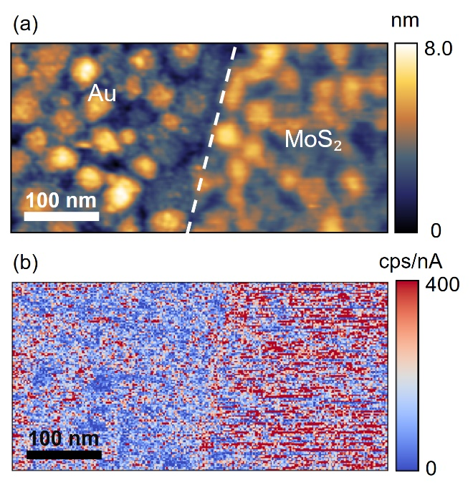
Figure S1: (a) STM topography of MoS₂ on evaporated Au surface. Tip bias: -3.25 V. Tunneling current: 1 nA. (b) Corresponding photon count map simultaneously acquired by the photon counter when scanning the area in (a) by STM tip.
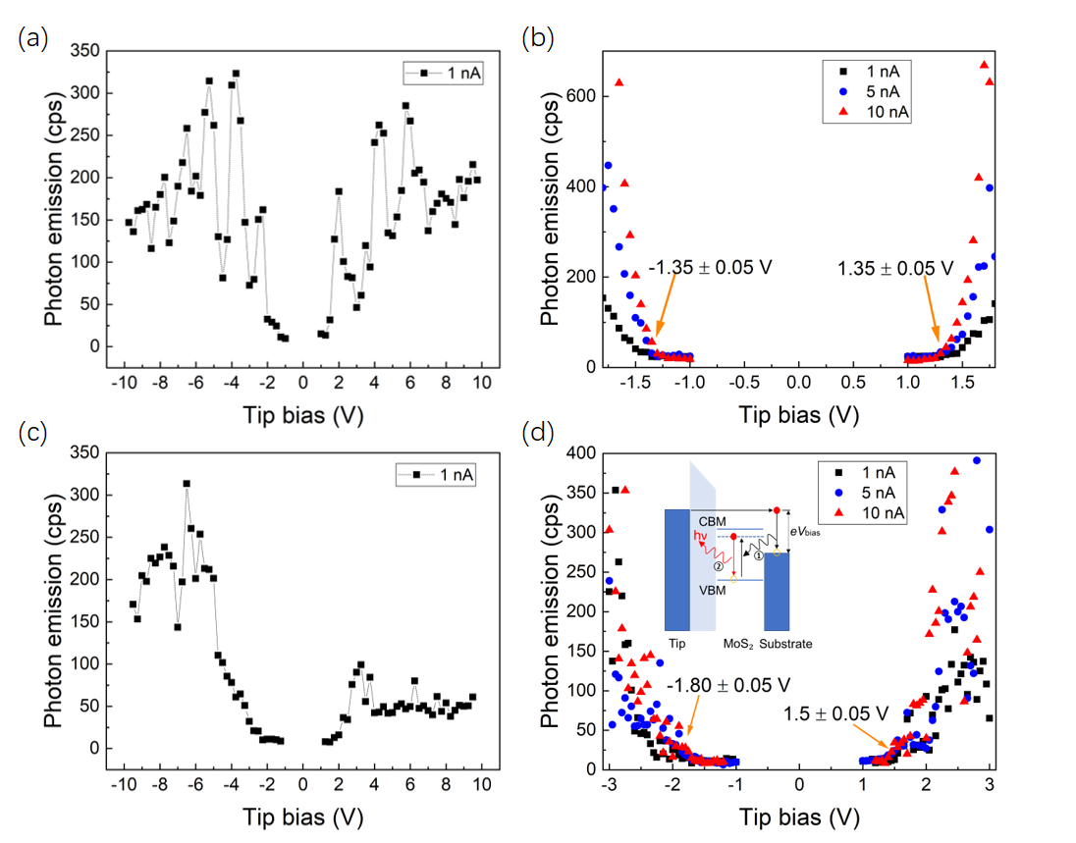
Figure S2: (a) and (b) show the photon counts of bare gold surface detected by the photon counter, as a function of tip bias. (c) and (d) show the photon counts of monolayer MoS₂ detected by photon counter, as a function of tip bias. Inset in (d) displays a schematic on resonant energy transfer mechanism for negative tip bias. When tip bias is ≤ -1.80 V (optical gap of monolayer MoS₂: ~1.80 eV), the tunneling excitons ① transfer their energy to MoS₂ via virtual photon coupling, generating excitons in MoS₂. The excitons then decay radiatively and emit photons ②. For positive tip bias, light emission of monolayer MoS₂ differs from the one for negative tip bias. Additional experiments are needed to elucidate the mechanisms behind.

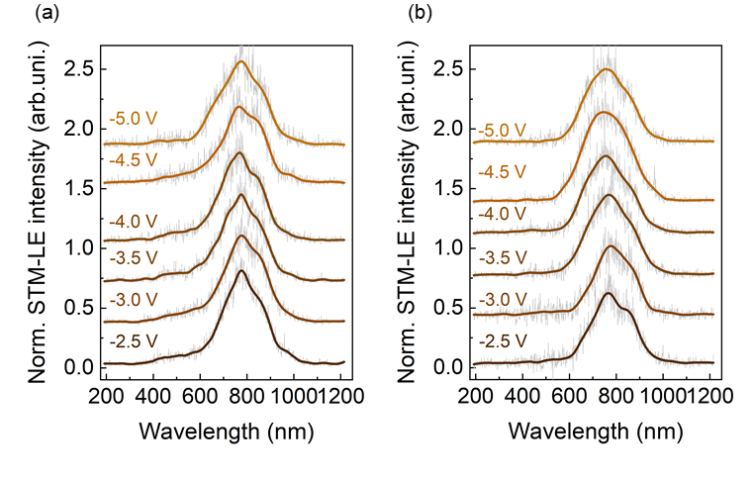
Figure S3: (a) and (b) show the spectra with variable tip bias, obtained from bare Au surface at two different locations. The peak wavelengths show no dependence on the tip bias, confirming the radiative decay of surface plasmonic modes. These spectra were acquired by a high-performance CCD (Andor Newton) with enhanced quantum efficiency.

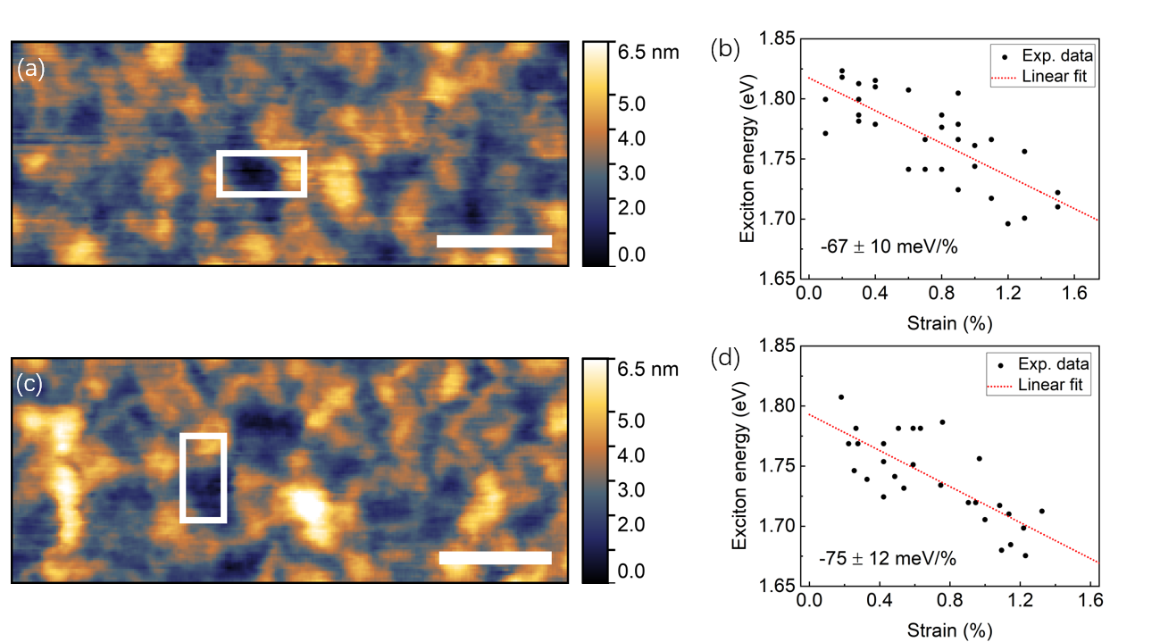
Figure S4: Strain measurements on different monolayer MoS₂ flakes transferred from the same CVD-synthesis onto the same evaporated Au substrate. (a) and (c) show STM topography of different monolayer MoS₂ flakes on evaporated Au substrate. Tip bias: -3 V. Tunneling current: 100 pA. Scale bar: 100 nm. (b) and (d) show A exciton energy as a function of strain obtained in the region indicated with white boxes in (a) and (c), respectively. Pixel size: 10 $×$ 10 nm².

