Supporting Information

**First Total Synthesis of Hoshinoamides A**

Haipin Zhoua, Zihan Ruia, Yiming Yanga, Shengtao Xua,b, Yutian Shao a,*and Long Liuc,*

aCollege of Materials & Chemical Engineering, Chuzhou University, Chuzhou 239000, China

bState Key Laboratory of Natural Medicines and Department of Medicinal Chemistry, China Pharmaceutical University, 24 Tong Jia Xiang, Nanjing 210009, China

cTaizhou Medical Hi-Tech Development Public Services Platform, Taizhou 225300, China;

**Table of Contents  
1. General Methods and Materials .........................................................2**

**2. Experimental and Analytical Data .....................................................3**

**2.1 Synthesis of Fmoc-*N*-Me-D-Phe/Val-OH and Fmoc-Aha-OH.......................3**

**2.2 Solid phase synthesis of intermediate A.....................................................6**

**2.3 Synthesis of tripeptide intermediate .........................................................7**

**2.4 Synthesis of Hoshinoamides A .................................................................8**

**3. Reference.............................................................................................14**

**4. 1H-NMR and 13C-NMR Spectra........................................................15**

**5. 1H-NMR and 13C-NMR Spectra, High Resolution Mass spectra, and analytical HPLC Spectra of Hoshinoamides A ...........................21**

**1. General Methods and Materials**

All commercial materials were used as received unless otherwise noted. DCM was dried by distillation over CaH2. THF were dried by distillation over sodium/benzophenone. TLC were performed on silica gel Huanghai HSGF254 plates and visualization of the developed chromatogram was performed by fluorescence quenching (λmax = 254 nm). Flash chromatography was performed using Silica gel (200-300 mesh) purchased from Qingdao Haiyang Chemical Co., China.

Fmoc protected amino acids, HATU, DIPEA, were purchased from TCI Chemical. Ph3SiH, TFA, Et3SiH, 2-CTC Resin, H-Ala-2-CTC Resin and PyBop were purchased from *J&K* Chemical. LiOH, and AcOH were purchased from Bide Pharmatech Ltd.

1H-NMR spectra were obtained using a Bruker AVANCE AV 400 at frequencies of 400 MHz respectively in CDCl3 , CD3OD or D2O. Chemical shifts are reported in parts per million (ppm) and coupling constants in Hertz (Hz). The residual solvent peaks were used as internal standards. 1H-NMR data is reported as follows: chemical shift values (ppm), multiplicity (s = singlet, d = doublet, t = triplet, q = quartet, m = multiplet), coupling constant and relative integral. 13C-NMR spectra were obtained using a Bruker AVANCE AV 400 at 100 MHz in CDCl3, CD3OD or D2O. 13C-NMR data is reported as chemical shift values (ppm).

LC-MS was performed on a Thermo Scientific MSQ instrument with the spectrometer operating in positive mode. Separations on the LC-MS system were performed on two methods using a thermo accucore C18 (2.6 µm, 100 x 2.1 mm) column. Method **A**: Linear gradient of 10-90% CH3CN/H2O and 0.1% TFA over 40 min was applied at a flow rate of 1.0 mL/min and detection at 220 nm. Method **B**: Linear gradient of 10-90-90-10% CH3CN/H2O and 0.1% TFA over 10 min (10-90 vol% MeCN over 6 min, 90-90 vol% over 3 min, 90-10 vol% MeCN over 1min) was applied at a flow rate of 1.0 mL/min and detection at 220 nm. Preparative reverse-phase HPLC was performed using Thermo Scientific Ultimate 3000 equipped with a Thermo Hypersil Gold (5 µm, 150 x 21.2 mm) column using the following buffer systems: A: 0.1% TFA in water. B: 0.1% TFA in MeCN using a 10-90-90-10 vol% MeCN gradient (10-90 vol% MeCN over 30 min, 90-90 vol% over 10 min, 90-10 vol% MeCN over 10 min) at a flow rate of 8 mL/min.

Standard SPPS (solid phase peptide synthesis) method:

1. General procedure for coupling on resin: The loaded resin was shaken for 2 h at room temperature with a solution of the desired Fmoc-AA-OH (4 equiv), HATU/Coupling reagent (4 equiv) and DIPEA (8 equiv) in DMF (20 mL)). The coupling mixture was filtered and the resin was washed with CH2Cl2 (10 mL x 20) and CH3OH (10 mL x 20).
2. General procedure for deprotection of Fmoc: The loaded resin was treated with a solution of 20 vol% piperidine in DMF (20 mL) for 30 min and then filtered. The resin was washed with CH2Cl2 (20 mL x 5) and CH3OH (20 mL x 5).
3. General procedure for cleavage the peptide from the resin: 0.5% TFA in DCM (20 mL) were added on the resin and the mixture was shaken for 2h before filtered. The resin was washed with CH2Cl2 (20 mL x 5) and CH3OH (20 mL x 5).

**2. Experimental and Analytical Data**

**2.1 Synthesis of Fmoc-*N*-Me-D-Phe/Val-OH and Fmoc-Aha-OH**

Fmoc-*N*-Me-D-Phe-OH and Fmoc-*N*-Me-D-Val-OH were synthesized using a modified procedure reported by Boc-D-Phe-OH 1 and Boc-D-Val-OH 2. Fmoc-Aha-OH was synthesized using a modified procedure reported by Aminocaproic acid 3. All data for known compounds are consistent with those reported in literature.



Boc-D-Phe-OH (5.00 g, 18.9 mmol) and MeI (1.8 mL, 28.4 mmol)were dissolved in DMF (50 mL). The reaction mixture was stirred at 0 oC for 45 min, then NaH (2.27 g, 56.7 mmol, 60%) was slowly added to the reaction mixture. The reaction mixture was stirred at room temperature for an additional 3 h, then quenched with water (150 mL) and extracted with ethyl acetate (3 x 50 mL). The combined organic phases were washed with water (100 mL) and brine (100 mL). The organic phase was dried over Na2SO4, filtered and concentrated to afford Boc-*N*-Me-D-Phe-OHwhich was used without purification.

Boc-*N*-Me-D-Phe-OHwas dissolved in 10% HCl-dioxanne (50 mL). The mixture was stirred at room temperature for 4 h, then concentrated to give a brown oil. The resulting crude oil was azeotroped with toluene (3 x 10 mL) and concentrated *in vacuo* to remove any residual HCl. The concentrated crude material was then dissolved in a mixture of THF (25 mL), H2O (25 mL) and NaHCO3 (3.2 g, 37.8 mmol), Fmoc-OSu (9.5 g, 28.4 mmol) was added to this mixture and the reaction mixture was stirred at room temperature for 8 h. Then added with water (150 mL) and extracted with ethyl acetate (3 x 50 mL). The combined organic phases were washed with water (100 mL) and brine (100 mL).The mixture was concentratedto give a crude white foam which was purified by flash chromatography (*n*-hexanes:EA = 2:1) to afford Fmoc-*N*-Me-D-Phe-OH (5.6 g, 14.0 mmol, 74%) as a white foam.**1H NMR** (400 MHz, DMSO-*d*6) δ 12.97 (s, 1H), 7.85 (d, *J* = 7.4 Hz, 2H), 7.52 (td, *J* = 20.2, 19.4, 7.4 Hz, 2H), 7.40 (q, *J* = 7.3 Hz, 2H), 7.33 – 7.05 (m, 7H), 4.79 (ddd, *J* = 45.7, 11.3, 4.7 Hz, 1H), 4.24 (dtt, *J* = 43.4, 12.1, 6.1 Hz, 3H), 3.33 – 2.82 (m, 2H), 2.72 (d, *J* = 6.5 Hz, 3H). **13C NMR** (101 MHz, DMSO) δ 172.56, 172.41, 156.23, 156.03, 144.35, 144.25, 144.13, 141.23, 141.20, 138.38, 138.21, 129.24, 129.21, 128.74, 128.10, 127.57, 126.82, 125.52, 125.42, 125.36, 120.54, 67.31, 60.70, 60.16, 47.18, 47.03, 40.63, 40.42, 40.21, 40.00, 39.79, 39.58, 39.37, 34.85, 34.56, 32.19, 31.79. **HRMS:** (+ESI) Calc. for C25H23NO4: 402.1700 [M+H]+, Found: 402.1698 [M+H]+.



Boc-D-Val-OH (5.0 g, 23.0 mmol) and MeI (2.2 mL, 28.4 mmol)were dissolved in DMF (50 mL). The reaction mixture was stirred at 0 oC for 45 min, then NaH (2.7 g, 68.0 mmol, 60%) was slowly added to the reaction mixture. The reaction mixture was stirred at room temperature for an additional 5 h, then quenched with water (150 mL) and extracted with ethyl acetate (3 x 50 mL). The combined organic phases were washed with water (100 mL) and brine (100 mL). The organic phase was dried over Na2SO4, filtered and concentrated to afford Boc-*N*-Me-D-Val-OHwhich was used without purification.

Boc-*N*-Me-D-Val-OHwas dissolved in 10% HCl-dioxanne (50 mL). The mixture was stirred at room temperature for 3 h, then concentrated to give a brown oil. The resulting crude oil was azeotroped with toluene (3 x 10 mL) and concentrated *in vacuo* to remove any residual HCl. The concentrated crude material was then dissolved in a mixture of THF (25 mL), H2O (25 mL) and NaHCO3 (3.8 g, 45.4 mmol), Fmoc-OSu (11.4 g, 34.1 mmol) was added to this mixture and the reaction mixture was stirred at room temperature for 8 h. Then added with water (150 mL) and extracted with ethyl acetate (3 x 50 mL). The combined organic phases were washed with water (100 mL) and brine (100 mL).The mixture was concentratedto give a crude white foam which was purified by flash chromatography (DCM:MeOH = 100:1) to afford Fmoc-*N*-Me-D-Phe-OH (6.6 g, 18.6 mmol, 81%) as a white foam.**1H NMR** (400 MHz, DMSO-*d*6) δ 12.78 (s, 1H), 7.85 (d, *J* = 7.1 Hz, 2H), 7.71 – 7.58 (m, 2H), 7.38 (t, *J* = 7.1 Hz, 2H), 7.31 (t, *J* = 7.1 Hz, 2H), 4.39 (dd, *J* = 25.4, 6.0 Hz, 2H), 4.25 (d, *J* = 10.2 Hz, 2H), 2.76 (s, 3H), 2.05 (ddd, *J* = 25.2, 10.6, 5.5 Hz, 1H), 0.99 – 0.56 (m, 6H).**13C NMR** (101 MHz, DMSO) δ 172.50, 172.33, 156.61, 156.00, 144.39, 144.25, 141.37, 128.13, 127.58, 125.49, 125.44, 120.56, 67.34, 64.33, 47.33, 47.26, 40.63, 40.42, 40.21, 40.00, 39.79, 39.58, 39.37, 30.66, 27.49, 27.37, 20.22, 20.15, 19.32, 19.02. **HRMS:** (+ESI) Calc. for C21H23NO4: 354.1700 [M+H]+, Found: 354.1696 [M+H]+.



Aminocaproic acid (2.0g, 15.2 mmol) dissolved in a mixture of THF (25 mL), H2O (25 mL) and NaHCO3 (2.5 g, 30.4 mmol), Fmoc-OSu (10.2 g, 30.4 mmol) was added to this mixture and the reaction mixture was stirred at room temperature for 7 h. Then added with water (150 mL) and extracted with ethyl acetate (3 x 50 mL). The combined organic phases were washed with water (100 mL) and brine (100 mL). The mixture was concentratedto give a crude white foam which was purified by flash chromatography (DCM:MeOH = 50:1) to afford Fmoc-Aha-OH (4.8 g, 13.7 mmol, 90%) as a white foam. **1H NMR** (400 MHz, CDCl3) δ 10.70 (s, 1H), 7.71 (d, *J* = 7.5 Hz, 2H), 7.55 (d, *J* = 6.9 Hz, 2H), 7.31 (dt, *J* = 33.4, 7.3 Hz, 4H), 4.97 (s, 1H), 4.53 – 4.30 (m, 2H), 4.24 – 4.09 (m, 1H), 3.13 (d, *J* = 6.0 Hz, 1H), 3.00 (s, 1H), 2.29 (t, *J* = 7.2 Hz, 2H), 1.67 – 1.51 (m, 2H), 1.50 – 1.40 (m, 1H), 1.39 – 1.15 (m, 3H). **13C NMR** (101 MHz, CDCl3) δ 179.02, 157.88, 156.62, 143.98, 141.31, 127.68, 127.05, 125.05, 124.87, 119.97, 77.48, 77.16, 76.84, 67.18, 66.57, 47.27, 41.35, 40.80, 34.06, 29.53, 26.13, 24.34. **HRMS:** (+ESI) Calc. for C21H23NO4: 354.1700 [M+H]+, Found: 354.1696 [M+H]+.

**2.2 Solid phase synthesis of intermediate A**



Fmoc-Pro-OH (674 mg, 2 mmol) was then dissolved in a mixture of DCM (10 mL) and DMF (10 mL). DIPEA (1.7 mL, 10 mmol), 2-CTC resin (1 g) were added to this mixture and the reaction was stirred at room temperature was for 2h. The resin was filtered and washed with MeOH (3 x 20 mL), DCM (3 x 20 mL). The unreacted resin was capped with MeOH in a mixture of MeOH:DIPEA:DCM (1:2:7, 10 mL) for 3h. The resin-bound peptide was added to a mixture of 20% piperidine in DMF (20 mL), and the mixture was shaken to for 30 minutes. Then the mixture was filtered, the resin was washed with MeOH (3 x 20 mL) and DCM (3 x 20 mL). Fmoc-*N*-Me-D-Phe-OH (1000 mg, 2.5 mmol), HATU (950 mg, 2.5 mmol) and DIPEA (871 µL, 5.0 mmol) in DMF were added on the resin and the reactor was shaken for 1h at room temperature. Then the mixture was filtered, the resin was washed with MeOH (3 x 20 mL) and DCM (3 x 20 mL) to afford the resin-bound dipeptide. The resin-bound dipeptide was added to a mixture of 20% piperidine in DMF (20 mL), and the mixture was shaken to for 30 minutes. Then the mixture was filtered, the resin was washed with MeOH (3 x 20 mL) and DCM (3 x 20 mL). Fmoc-Val-OH (848 mg, 2.5 mmol), HATU (950 mg, 2.5 mmol) and DIPEA (871 µL, 5.0 mmol) in DMF were added on the resin and the reactor was shaken for 1h at room temperature. The resulting tripeptide was analysed on a Thermo Scientific MSQ instrument, and few product was observed.

**2.3 Synthesis of tripeptide intermediate**

 Pro-OBn.HCl (2.41 g, 10 mmol), Fmoc-*N*-Me-D-Phe-OH (4.01 g, 10 mmol) and DIPEA (5.2 mL, 30 mmol) was dissolved in 50 mL anhydrous DCM. HATU (5.7 g, 15 mmol) was added to the solution and the mixture was stirred at room temperature for 6 h. The reaction mixture was then washed by 1.0 M HCl (20 mL), aqueous NaHCO3 (20 mL) and brine (20 mL). The organic phase was dried with anhydrous Na2SO4 and concentrated *in vacuo*. The crude residue was purified by flash column chromatography (*n*-hexanes: EA=2:1) to afford **dipeptide** (4.9 g, 83%). **1H NMR** (400 MHz, Methanol-*d*4) δ 7.39 – 7.27 (m, 19H), 5.20 – 5.12 (m, 4H), 4.85 (s, 6H), 4.44 (ddd, *J* = 13.1, 9.5, 4.8 Hz, 4H), 3.50 (ddd, *J* = 10.0, 7.4, 5.4 Hz, 2H), 3.31 – 3.23 (m, 4H), 3.07 (dd, *J* = 12.8, 10.3 Hz, 2H), 2.57 (s, 6H), 2.46 (dt, *J* = 9.9, 7.0 Hz, 2H), 2.03 – 1.94 (m, 2H), 1.89– 1.71 (m, 4H), 1.48 (dddd, *J* = 12.5, 7.1, 5.4, 1.6 Hz, 2H). 13C NMR (101 MHz, MeOD) δ 171.21, 165.90, 135.71, 133.51, 129.37, 128.70, 128.24, 128.07, 127.93, 127.74, 66.74, 60.75, 59.32, 48.27, 48.06, 47.84, 47.63, 47.41, 47.21, 46.99, 46.88, 36.55, 30.88, 28.45, 23.94. HRMS: (+ESI) Calc. for C22H26N2O3: 588.2671[M+H]+, Found:588.2668[M+H]+.

Dipeptide (118 mg, 0.20 mmol), Fmoc-Val-OH (71 mg, 0.20 mmol) was dissolved in 10 mL anhydrous DMF. Coupling reagents was added to the solution and the mixture was stirred at room temperature for 3 h. This mixture poured onto water (10 mL) and extracted with CH2Cl2 (3 x 10 mL). Then washed by 1.0 M HCl (10 mL), aqueous NaHCO3 (10 mL) and brine (10 mL). The organic phase was dried with anhydrous Na2SO4 and concentrated *in vacuo*. The crude residue was purified by flash column chromatography (*n*-hexanes: EA=2:1) to afford **tripeptide**. 1H NMR (400 MHz, Chloroform-*d*) δ 7.75 (d, *J* = 7.7 Hz, 2H), 7.57 (t, *J* = 7.2 Hz, 2H), 7.40 – 7.17 (m, 14H), 5.72 (dd, *J* = 8.9, 6.5 Hz, 1H), 5.46 (d, *J* = 9.5 Hz, 1H), 5.23 – 5.20 (m, 1H), 5.06 (d, *J* = 12.2 Hz, 1H), 4.50 – 4.18 (m, 5H), 3.48 – 3.43 (m, 1H), 3.28 (dt, *J* = 11.3, 5.8 Hz, 2H), 3.10 (s, 1H), 2.95 – 2.86 (m, 3H), 2.21 – 2.14 (m, 2H), 1.78 – 1.62 (m, 5H), 1.28 (s, 2H), 0.76 (dd, *J* = 66.2, 6.8 Hz, 3H), 0.47 (dd, *J* = 46.7, 6.7 Hz, 3H). 13C NMR (101 MHz, CDCl3) δ 171.70, 171.60, 168.26, 156.39, 143.88, 141.30, 137.01, 129.54, 128.88, 128.69, 128.60, 128.50, 128.39, 128.31, 128.20, 127.72, 127.08, 126.65, 125.17, 125.08, 119.99, 77.40, 77.09, 76.77, 67.04, 66.84, 59.43, 55.87, 55.59, 47.17, 46.92, 35.00, 30.72, 30.47, 28.78, 25.25, 19.82, 16.33. HRMS**:** (+ESI) Calc. for C42H45N3O6: 688.3381 [M+H]+, Found: 688.3379 [M+H]+. Comparison of the effects of different coupling reagents on the reaction yield (**Table S1**).

**2.4 Synthesis of Hoshinoamides A**



Compound **tripeptide** (2.3 g, 3.3 mmol) was was dissolved in 30 mL of MeOH/HCOOH(v/v=9:1) and hydrogenized with Pd(OH)2 (500 mg, 10% on carbon) under H2 for 10 hours to remove the Bn groups. The reaction mixture was filtered through a pad of celite and the filtrate was concentrated in vacuoto give brown oil which was purified by flash chromatography (*n*-hexanes:EA = 2:1), affording **tripeptide** (1.87 g, 95%) as a white foam. 1H NMR (400 MHz, Methanol-*d*4) δ 7.59 (d, J = 8 Hz, 2H), 7.45 (d, *J* = 8 Hz, 2H), 7.21 – 6.96 (m, 10H), 5.52 (ddd, *J* = 43.6, 9.9, 5.6 Hz, 1H), 4.81 (s, 2H), 4.20 – 3.98 (m, 4H), 3.29 – 3.10 (m, 2H), 3.04– 2.91 (m, 4H), 2.80 – 2.67 (m, 2H), 2.62 (s, 3H), 2.01 – 1.83 (m, 2H), 1.53 (ddq, *J* = 50.8, 19.7, 6.9 Hz, 4H), 1.13 – 1.09 (m, 2H), 0.52 – 0.45 (m, 4H). 13C NMR (101 MHz, MeOD) δ 175.49, 175.06, 174.95, 173.81, 173.14, 171.16, 170.16, 167.42, 164.85, 158.64, 158.58, 158.53, 145.38, 145.35, 145.20, 145.13, 145.09, 142.88, 142.55, 138.50, 138.41, 131.03, 130.75, 130.66, 130.27, 129.77, 129.64, 129.57, 129.42, 128.86, 128.83, 128.55, 128.28, 128.21, 127.77, 127.66, 126.35, 126.29, 126.21, 125.76, 121.02, 70.63, 68.11, 68.04, 66.85, 60.78, 60.68, 59.15, 58.19, 57.76, 57.67, 57.41, 57.06, 56.41, 56.08, 49.75, 49.54, 49.32, 49.11, 48.90, 48.68, 48.47, 48.41, 48.25, 47.74, 38.96, 37.58, 37.01, 36.60, 35.79, 35.61, 33.11, 32.20, 31.89, 31.73, 31.53, 31.40, 30.88, 30.83, 30.66, 30.53, 30.39, 29.98, 29.64, 28.18, 26.97, 26.10, 23.80, 23.34, 19.88, 19.48, 18.17, 18.07, 17.64, 14.58. **HRMS:** (+ESI) Calc. for C35H39N3O6: 598.2912 [M+H]+, Found:598.2910 [M+H]+.

Compound **tripeptide** (1.20 g, 2 mmol) was then dissolved in a mixture of DCM (10 mL) and DMF (10 mL). DIPEA (1.7 mL, 10 mmol), 2-CTC resin (1 g) were added to this mixture and the reaction was stirred at room temperature was for 3h. The resin was filtered and washed with MeOH (3 x 20 mL), DCM (3 x 20 mL). The unreacted resin was capped with MeOH in a mixture of MeOH:DIPEA:DCM (1:2:7, 10 mL) for 5 h. Fmoc protecting group was removed following the general procedure and the remain amino acids were successively coupled using the standard SPPS method. (Ile6 and Aha8 are coupled with coupling reagengt. Gln4, *N*-Me-D-Val5, *N*-Me-L-Leu7 and Hba9 are coupled with HATU and DIPEA.) 0.5% TFA in DCM (20 mL) were added on the resin and the mixture was shaken for 2h to cleavage the peptide from the resin. The mixture was filtered and the filtrate was concentrated *in vacuo* to give a white foam. The peptide was re-dissolved in a mixture of TFA:Et3SiH:H2O (10 mL, 50/50/50 v/v/v). The reaction mixture was stirred for 3 h, and then concentrated *in vacuo*. The crude peptide was precipitated using cold Et2O and centrifuged at 7000 rpm to give a white solid. This solid was further purified by RP-HPLC using protocols described in the general method. Fractions were collected, concentrated and lyophilized to give nanopeptide 10 as a white solid. Nanopetide 10 was dissolved in dry DMF (5 mL). K2CO3 (3.1 mg, 0.022 mmol) and MeI (3.13 mg, 0.022 mmol) was added to this solution. The reaction mixture was stirred for 3 h. This mixture poured onto water (5 mL) and extracted with CH2Cl2 (3 x 5 mL). Then washed by 1.0 M HCl (10 mL), aqueous NaHCO3 (10 mL) and brine (10 mL). The organic phase was dried with anhydrous Na2SO4 and concentrated in vacuoto give brown oil . This oil was further purified by RP-HPLC using protocols described in the general method. Fractions were collected, concentrated and lyophilized to give Hoshinoamides A as a white solid.(10 mg, 2% yield). HRMS: (+ESI) Calc. for C61H95N9O12: 1146.7173 [M+H]+, Found: 1146.7173 [M+H]+; The 1H NMR and 13C NMR spectra of synthetic product were fully consistent with the data of isolated samples reported in the literature.4 See table S2 and table S3 for details. **1H NMR** (400 MHz, Methanol-*d*4) δ 7.30 – 7.11 (m, 6H), 7.02 – 6.94 (m, 2H), 6.72 – 6.65 (m, 2H), 5.73 (dd, *J* = 9.2, 6.4 Hz, 1H), 4.82 – 4.73 (m, 1H), 4.64 – 4.53 (m, 2H), 4.43 – 4.25 (m, 2H), 3.69 (s, 2H), 3.50 (dt, *J* = 11.2, 6.0 Hz, 1H), 3.41 – 3.31 (m, 1H), 3.20 – 3.06 (m, 9H), 2.99 – 2.92 (m, 3H), 2.91 – 2.86 (m, 1H), 2.52 (t, *J* = 7.6 Hz, 2H), 2.47 – 2.38 (m, 2H), 2.29 – 2.22 (m, 3H), 2.18 (q, *J* = 7.7 Hz, 3H), 2.05 – 1.99 (m, 1H), 1.99 – 1.71 (m, 9H), 1.68 – 1.46 (m, 6H), 1.46 – 1.34 (m, 4H), 1.11 – 0.97 (m, 3H), 0.97 – 0.81 (m, 16H), 0.68 – 0.55 (m, 6H). **13C NMR** (101 MHz, MeOD) δ 177.43, 176.52, 176.00, 174.55, 173.86, 173.15, 173.09, 172.87, 171.89, 170.47, 156.60, 138.40, 133.75, 130.69, 130.40, 129.45, 127.70, 116.18, 64.21, 60.84, 57.23, 55.69, 55.64, 55.52, 54.32, 52.69, 49.68, 49.46, 49.25, 49.25, 49.04, 48.83, 48.81, 48.61, 48.40, 40.23, 38.43, 37.82, 36.62, 35.76, 35.51, 34.59, 32.62, 31.80, 31.59, 31.56, 30.22, 29.98, 29.20, 27.72, 26.21, 26.17, 26.06, 25.95, 25.90, 25.11, 23.80, 22.17, 20.39, 19.90, 19.49, 18.13, 16.50, 11.60.



Table S1. 1H and 13C NMR Spectroscopic Data of Naturally Occurring and Synthetic Hoshinoamides A

|  |  |  |  |  |
| --- | --- | --- | --- | --- |
| Postition | natural product | | synthetic product | |
| δH (CD3OD, 400 MHz) | δC (CD3OD, 100 MHz) | δH (CD3OD, 400 MHz) | δC (CD3OD, 100 MHz) |
| 1 | 3.7 | 52.7 | 3.69 | 52.7 |
| 2 |  | 173.8 |  | 173.9 |
| 3 | 4.38 | 60.8 | 4.38 | 60.8 |
| 4a | 2.23 | 29.7 | 2.24 |  |
| 4b | 1.86 |  | 1.85 |  |
| 5a | 1.97 | 26.2 | 1.96 | 26.2 |
| 5b | 1.87 |  | 1.87 |  |
| 6a | 3.5 | 48.2 | 3.50 |  |
| 6b | 3.34 |  | 3.35 |  |
| 7 |  | 170.5 |  | 170.5 |
| 8 | 5.74 | 57.2 | 5.74 | 57.2 |
| 9a | 3.17 | 35.7 | 3.16 | 35.7 |
| 9b | 2.9 |  | 2.89 |  |
| 10 |  | 138.4 |  | 138.4 |
| 11 | 7.24 | 130.7 | 7.24 | 130.7 |
| 12 | 7.25 | 129.4 | 7.25 | 129.5 |
| 13 | 7.16 | 127.7 | 7.16 | 127.7 |
| 16 | 3.09 | 31.5 | 3.08 | 31.6 |
| 17 |  | 173.14 |  | 173.15 |
| 18 | 4.57 | 55.6 | 4.57 | 55.6 |
| 19 | 1.76 | 31.5 | 1.77 | 31.6 |
| 20 | 0.65 | 18.1 | 0.64 | 18.1 |
| 21 | 0.6 | 19.9 | 0.59 | 19.9 |
| 22 |  | 173.06 |  | 173.09 |
| 23 | 4.3 | 54.3 | 4.30 | 54.3 |
| 24a | 2.02 | 26 | 2.01 | 26 |
| 24b | 1.93 |  | 1.93 |  |
| 25a | 2.25 | 29.9 | 2.25 | 30.0 |
| 25b | 1.87 |  | 1.87 |  |
| 26 |  | 177.4 |  | 177.4 |
| 27 |  | 171.9 |  | 171.9 |
| 28 | 4.61 | 64.1 | 4.61 | 64.2 |
| 29 | 2.28 | 27.7 | 2.27 | 27.7 |
| 30 | 0.98 | 20.3 | 0.98 | 20.4 |
| 31 | 0.85 | 19.5 | 0.85 | 19.5 |
| 32 | 3.09 | 32.6 | 3.08 | 32.6 |
| 33 |  | 174.5 |  | 174.6 |
| 34 | 4.78 | 55.5 | 4.78 | 55.5 |
| 35 | 1.84 | 38.4 | 1.83 | 38.4 |
| 36a | 1.46 | 25.1 | 1.46 | 25.1 |
| 36b | 1.07 |  | 1.07 |  |
| 37 | 0.86 | 11.6 | 0.85 | 11.6 |
| 38 | 0.93 | 16.5 | 0.93 | 16.5 |
| 39 |  | 172.9 |  | 172.9 |
| 40 | 5.52 | 55.6 | 5.52 | 55.7 |
| 41a | 1.75 | 37.8 | 1.75 | 37.8 |
| 41b | 1.59 |  | 1.59 |  |
| 42 | 1.4 | 26.7 | 1.40 |  |
| 43 | 0.94 | 23.8 | 0.94 | 23.8 |
| 44 | 0.89 | 22.1 | 0.89 | 22.2 |
| 45 | 2.97 | 31.8 | 2.96 | 31.8 |
| 46 |  | 176.5 |  | 176.5 |
| 47 | 2.43 | 34.6 | 2.42 | 34.6 |
| 48 | 1.64 | 25.9 | 1.63 | 25.9 |
| 49 | 1.39 | 27.7 | 1.39 |  |
| 50 | 1.53 | 30.2 | 1.52 | 30.2 |
| 51 | 3.17 | 40.2 | 3.16 | 40.2 |
| 52 |  | 176 |  | 176 |
| 53 | 2.16 | 36.6 | 2.17 | 36.6 |
| 54 | 1.86 | 29.2 | 1.86 | 29.2 |
| 55 | 2.52 | 35.5 | 2.52 | 35.5 |
| 56 |  | 133.7 |  | 133.8 |
| 57/61 | 6.99 | 130.4 | 6.99 | 130.4 |
| 58/60 | 6.7 | 116.1 | 6.69 | 116.2 |
| 59 |  | 156.6 |  | 156.6 |

**3. Reference**

1 A. M. Giltrap, L. J. Dowman, G. Nagalingam, J. L. Ochoa, R. G. Linington, W. J.Britton and R. J. Payne, *Org. Lett.,* **2016**, *18*, 2788-2791.

2 C. Rodriguez, W. Boręcka, J. H. Sattler, W. Kroutil, l. Lavandera and V. Gotor, *Org. Biomol. Chem.*, **2014**, *12*, 673-681.

3 **a)** K. Feichtinger, H. L. Sings, T. J. Baker, K. Matthews and M. Goodman, *J. Org. Chem.,* **1998**, *63*, 8432-8439. **b)** K. Feichtinger, C. Zapf; H. L. Sings and M. Goodman, *J. Org. Chem*. **1998**, *63*, 3804−3805.

4 A. Iwasaki, T. Tadenuma, S. Sumimoto, I. Shiota, T. Matsubara, Y. Saito-Nakano, T. Nozaki, T. Sato, K. Suenaga, *J. Nat. Prod.,* **2018**, *81*, 2545.

1. **1H-NMR and 13C-NMR Spectra**

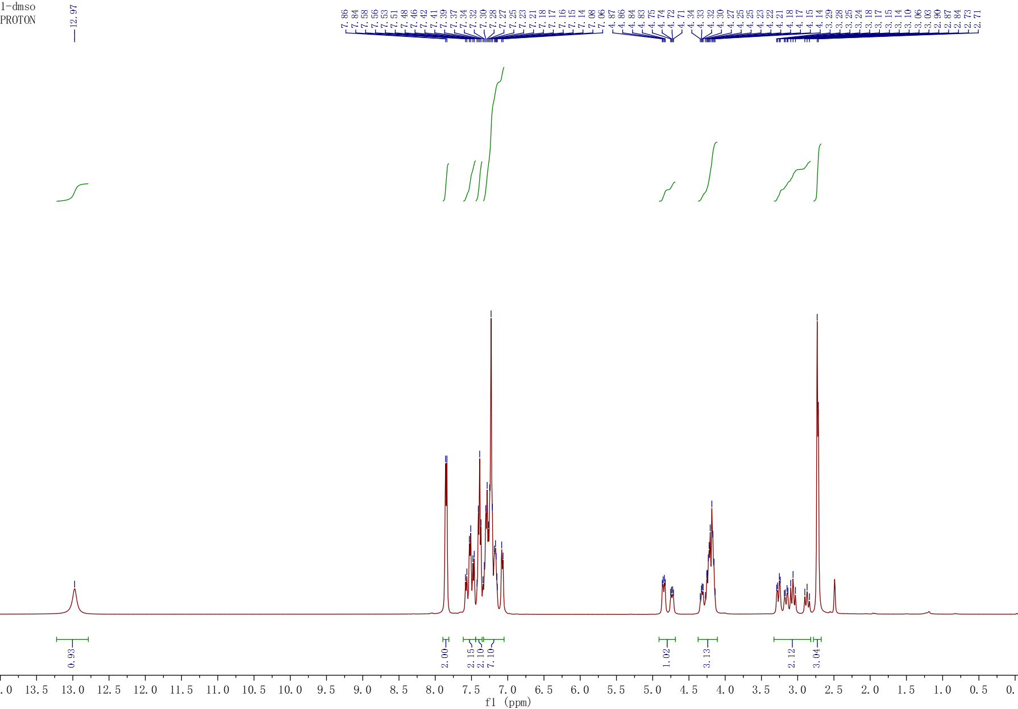



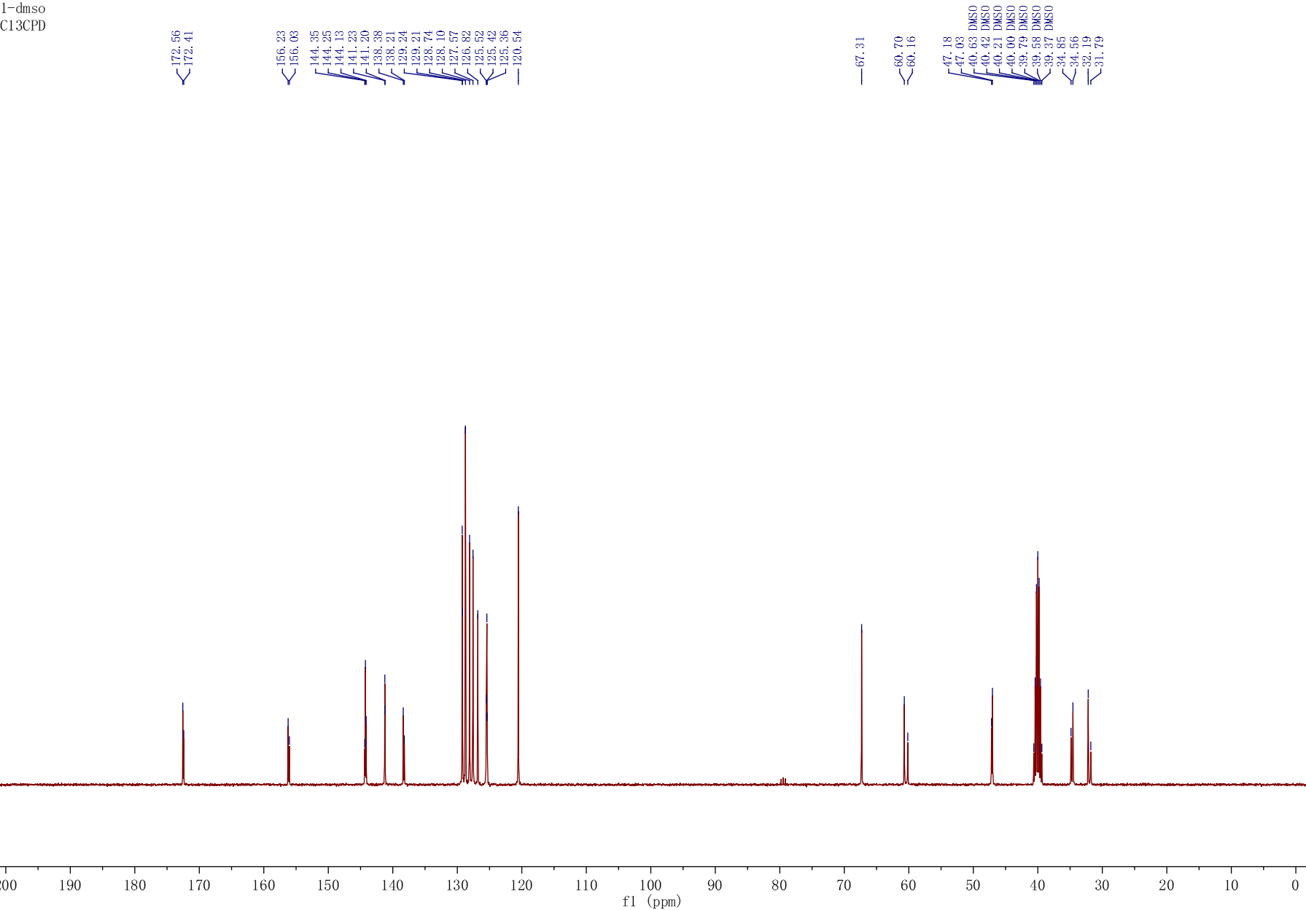



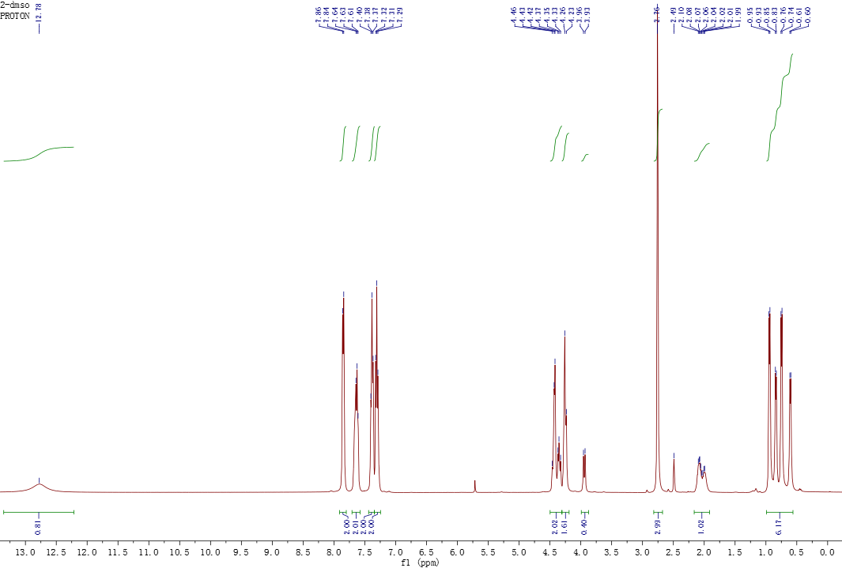



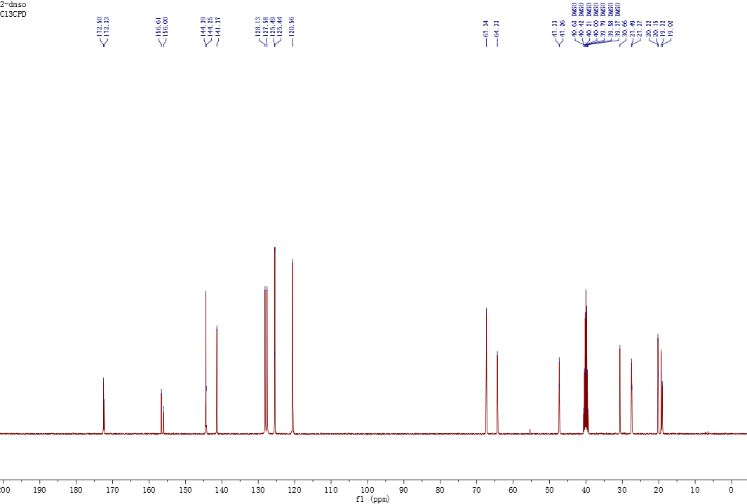



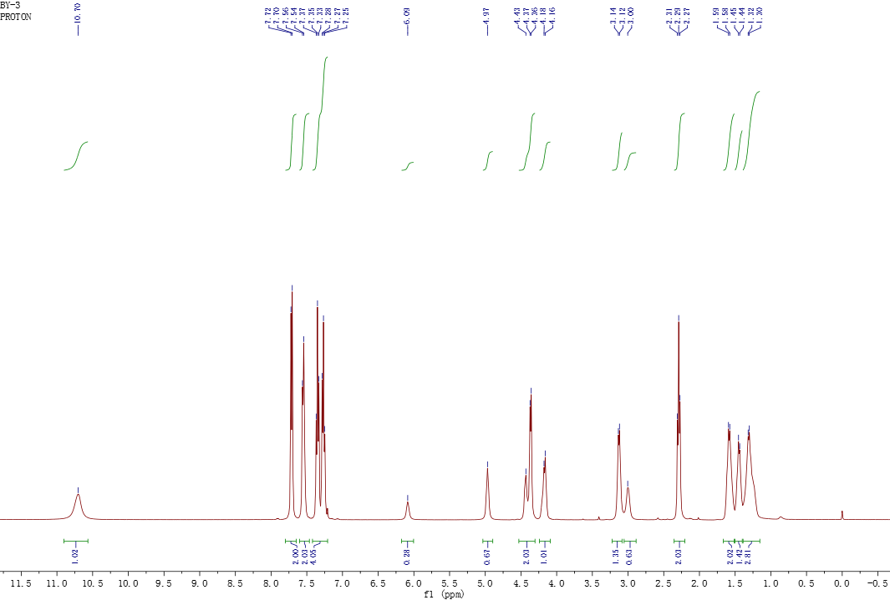



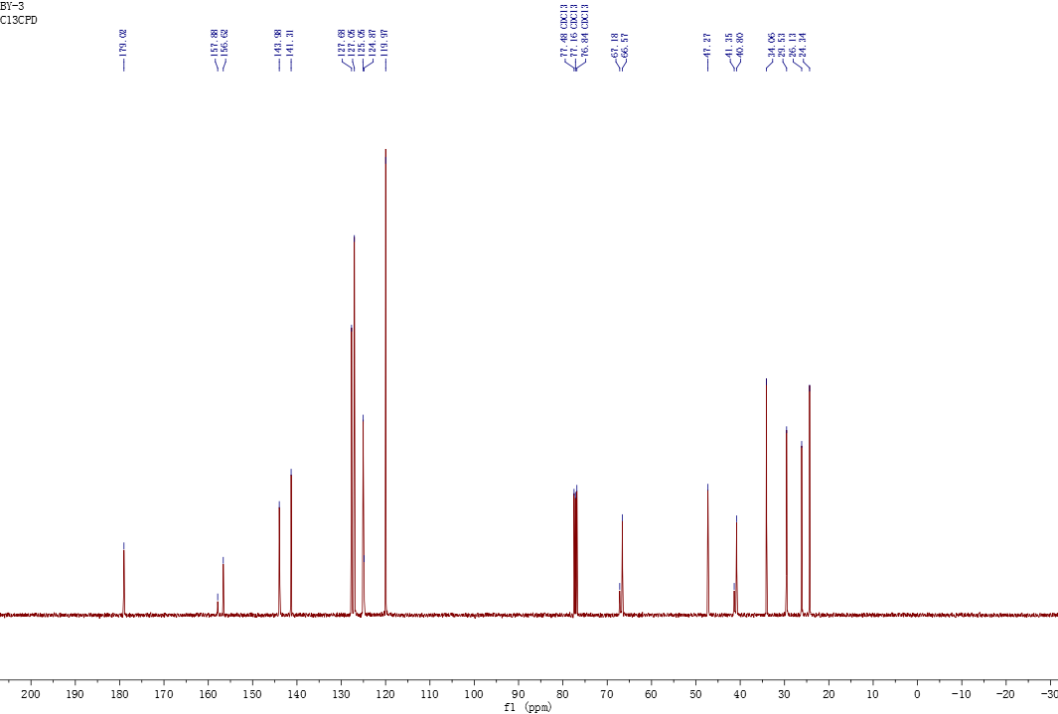



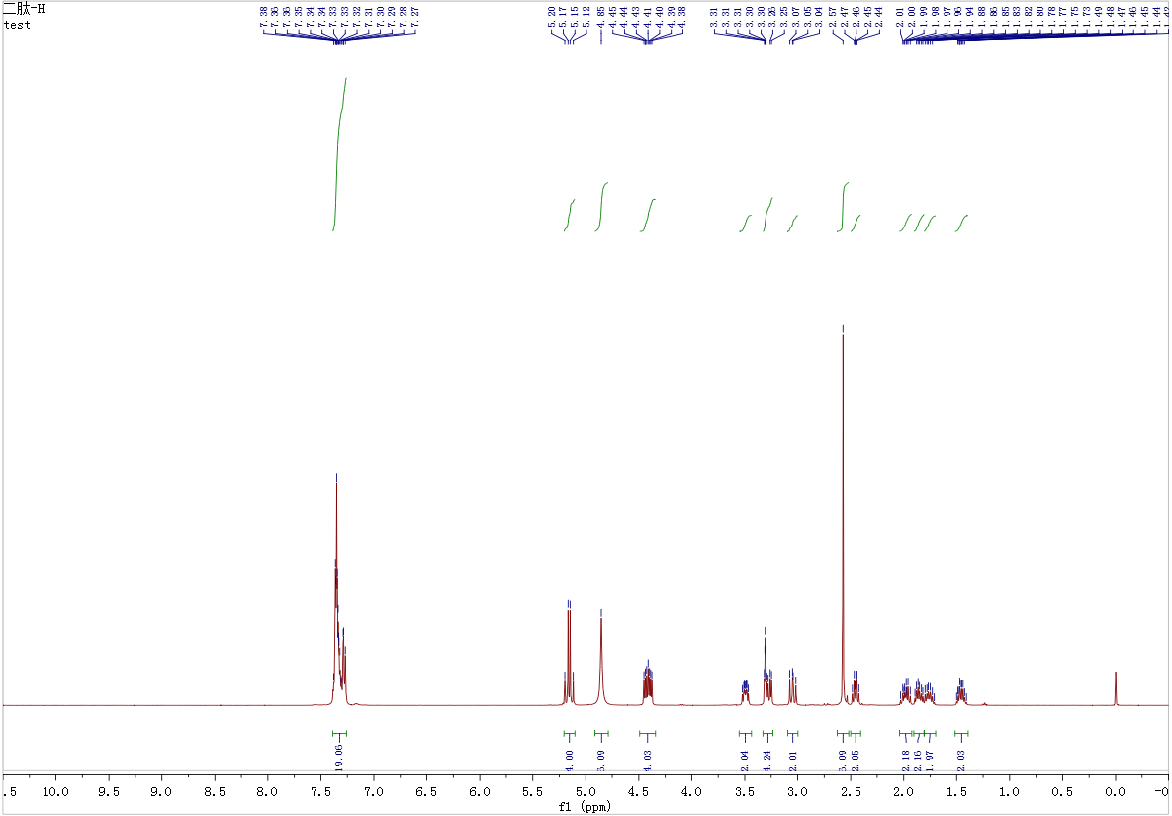



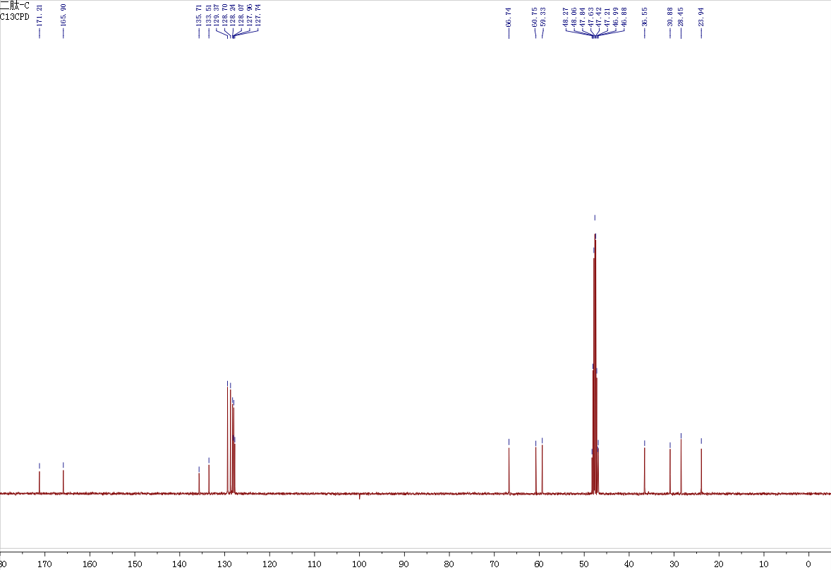



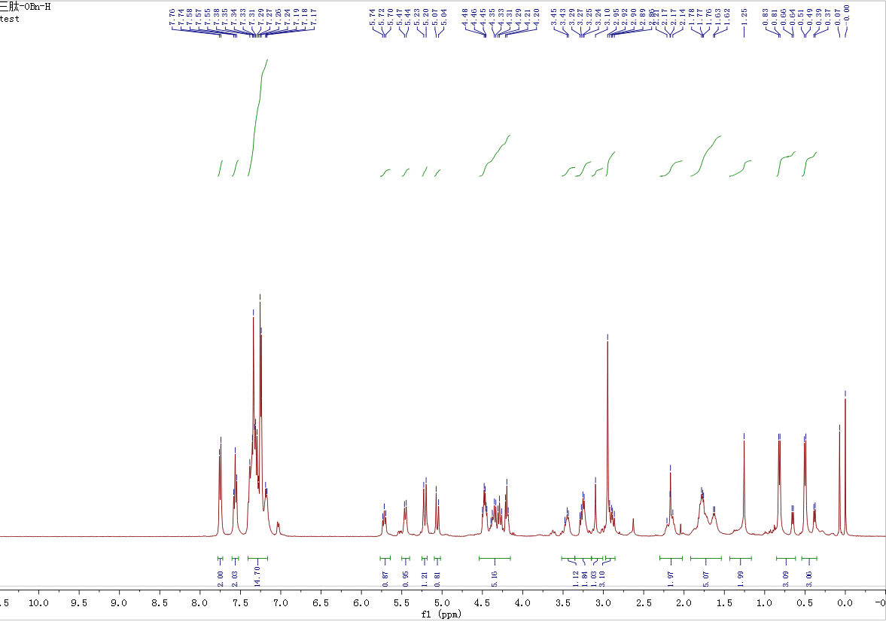



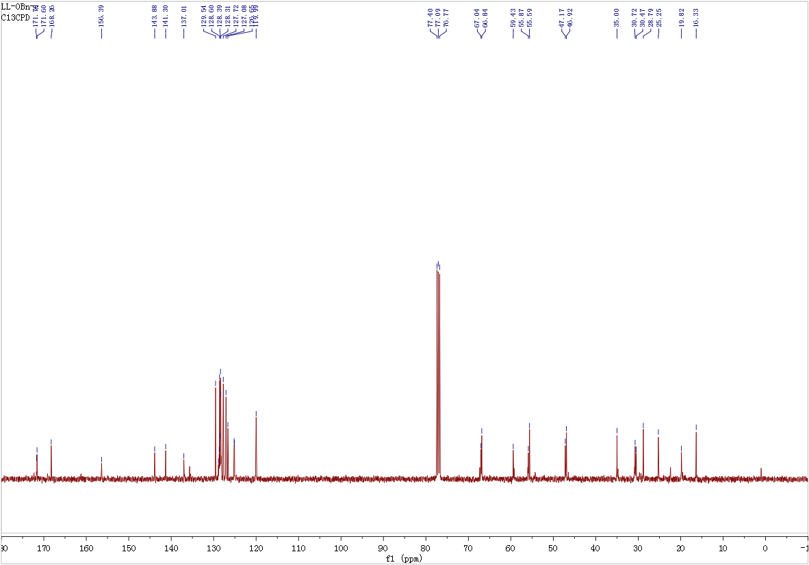



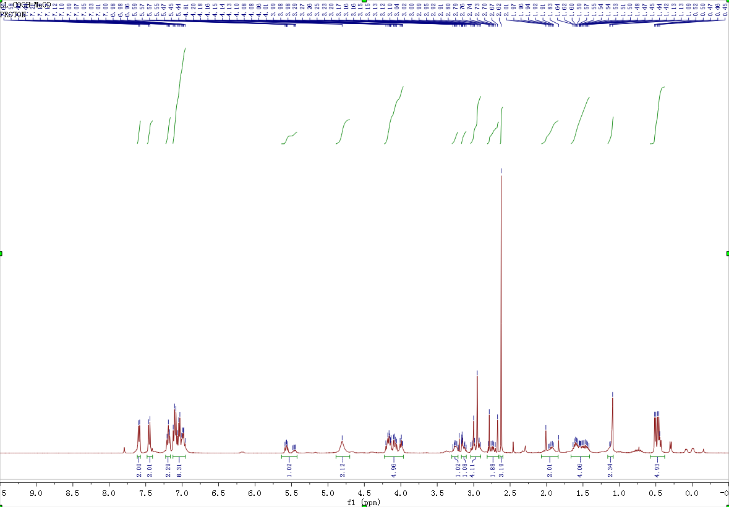



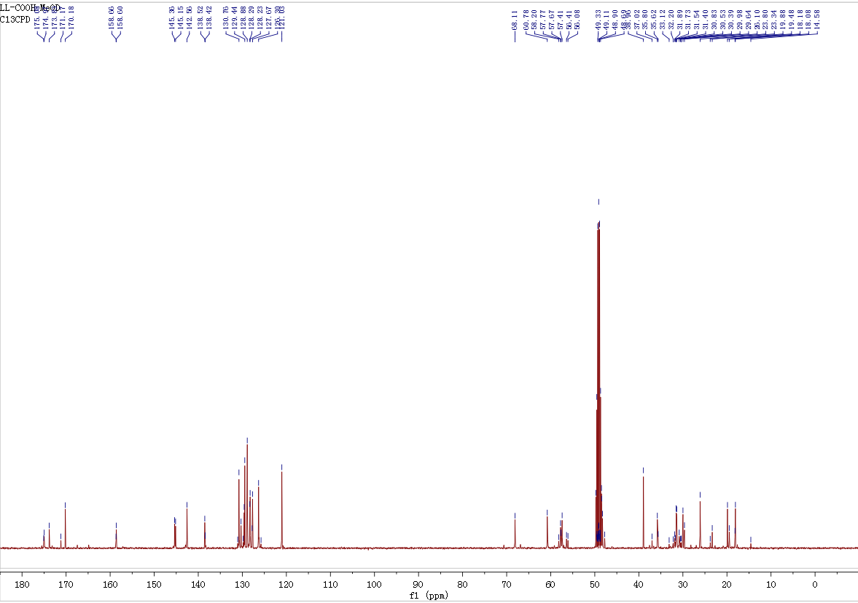



**5. 1H-NMR spectra, high resolution mass spectra, and analytical HPLC spectra of Hoshinoamides A**

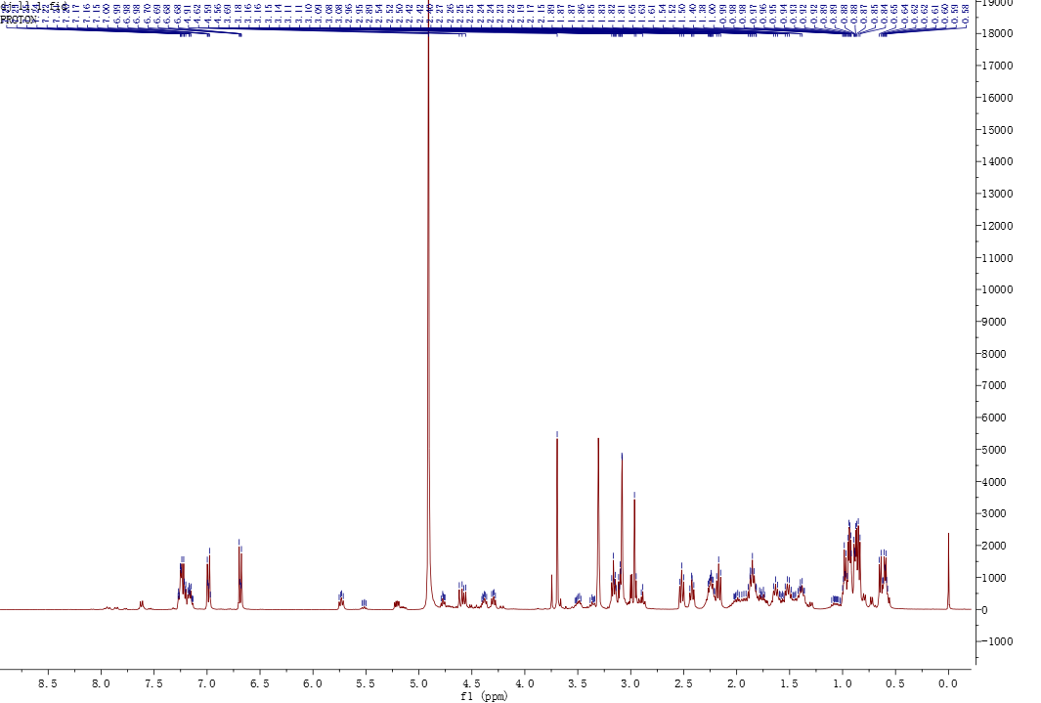



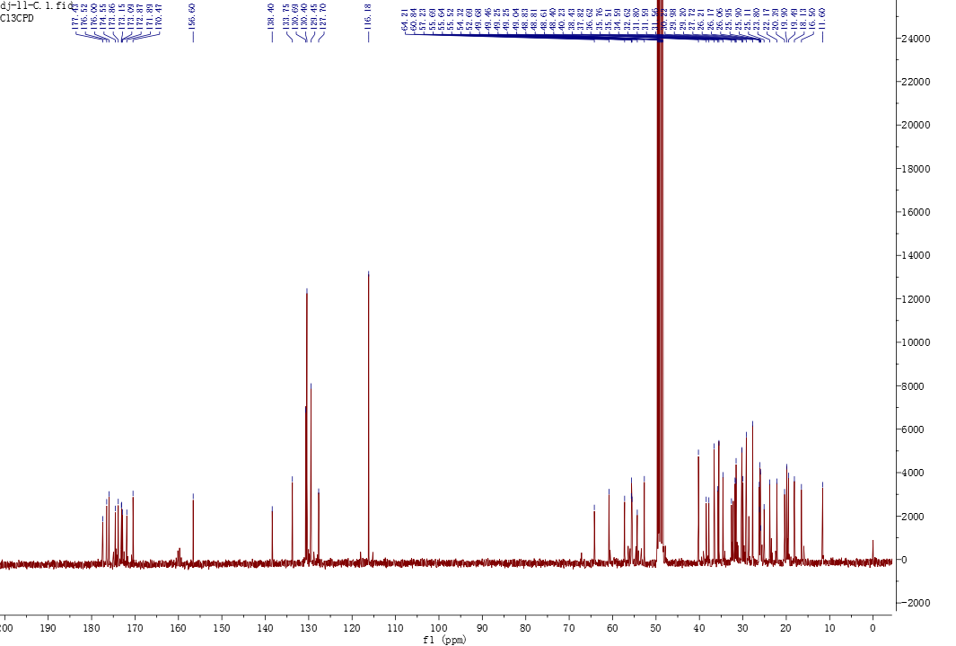



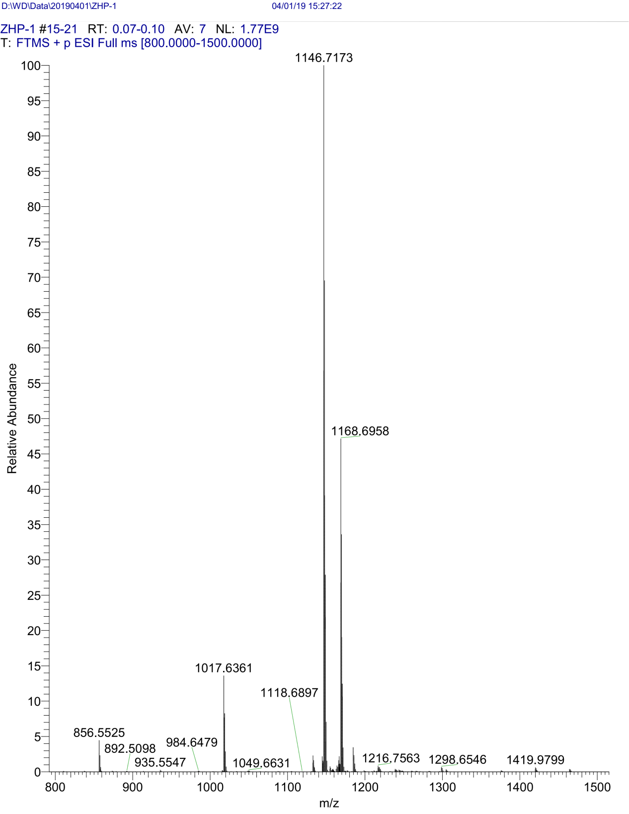

**Figure Sx**. High Resolution Mass spectra of Hoshinoamides A