SUPPORTING INFORMATION FILE 1
Reactivity of tetrazolo [1,5-a]pyrimidines in click chemistry and hydrogenation
Elisandra Scapin,^{a,b} Geórgia C. Zimmer,ª Jean C. B. Vieira,ª Catarina A. B. Rodrigues^{c}, Carlos A. M. Afonso^{c}, Nilo Zanatta,ª Helio G. Bonacorso,ª Clarissa P. Frizzoª* and Marcos A. P. Martinsª*

ªNúcleo de Química de Heterociclos (NUQUIMHE), Departamento de Química, Universidade Federal de Santa Maria, 97105-900, Santa Maria, RS, Brazil.
^{b}Laboratório de Química, Universidade Federal do Tocantins, 77001-900, Palmas, TO, Brazil.
^{c}Research Institute for Medicines (iMed.ULisboa) Faculty of Pharmacy, Universidade de Lisboa,Av. Porf. Gama Pinto, 1649-003, Lisboa, Portugal.

Corresponding Authors
*E-mail: marcos.nuquimhe@gmail.com
*E-mail: clarissa.frizzo@gmail.com
Table of Contents
Fig. S1 ¹H NMR of 6a in CDCl₃. 3
Fig. S2 ¹³C NMR of 6a in CDCl₃. 3
Fig. S3 ¹H NMR of 6b in CDCl₃. 4
Fig. S4 ¹³C NMR of 6b in CDCl₃. 4
Fig. S5 ¹H NMR of 6c in CDCl₃. 5
Fig. S6 ¹³C NMR of 6c in CDCl₃. 5
Fig. S7 ¹H NMR of 6d in CDCl₃. 6
Fig. S8 ¹³C NMR of 6d in CDCl₃. 6
Fig. S9 ¹H NMR of 6e in CDCl₃. 7
Fig. S10 ¹³C NMR of 6e in CDCl₃. 7
Fig. S11 ¹H NMR of 6f in CDCl₃. 8
Fig. S12 ¹³C NMR of 6f in CDCl₃. 8
Fig. S13 ¹H NMR of 7a in CDCl₃. 9
Fig. S14 ¹³C NMR of 7a in CDCl₃. 9
Fig. S15 ¹H NMR of 7b in CDCl₃. 10
Fig. S16 ¹³C NMR of 7b in CDCl₃. 10
Fig. S17 ¹H NMR of 7c in CDCl₃. 11
Fig. S18 ¹³C NMR of 7c in CDCl₃. 11
Fig. S19 ¹H NMR of 7e in CDCl₃. 12
Fig. S20 ¹³C NMR of 7e in CDCl₃. 12
Fig. S21 ¹H NMR of 8a in DMSO-d₆. 13
Fig. S22 ¹³C NMR of 8a in DMSO-d₆. 13
Fig. S23 ¹H NMR of 9a in CDCl₃. 14
Fig. S24 ¹³C NMR of 9a in CDCl₃. 15
Fig. S25 ¹H NMR of 9b in DMSO-d₆. 16
Fig. S26 ¹³C NMR of 9b in DMSO-d₆. 17
Fig. S27 ¹H NMR of 9c in DMSO-d₆. 18
Fig. S28 ¹³C NMR of 9c in DMSO-d₆. 19
Fig. S29 ¹H NMR of 9d in CDCl₃. 20
Fig. S30 ¹³C NMR of 9d in CDCl₃. 21
Fig. S31 ¹H NMR of 9e in DMSO-d₆. 22
Fig. S32 ¹³C NMR of 9e in DMSO-d₆. 23
Fig. S33 ¹H NMR of 9f in CDCl₃. 24
Fig. S34 ¹³C NMR of 9f in CDCl₃. 25
Fig. S35 ¹H NMR of 9h in DMSO-d₆. 26
Fig. S36 ¹³C NMR of 9h in DMSO-d₆. 27
Fig. S37 ¹H NMR of 10a in DMSO-d₆. 28
Fig. S38 ¹³C NMR of 10a in DMSO-d₆. 29
Fig. S39 ¹H NMR of 10e in DMSO-d₆. 30
Fig. S40 ¹³C NMR of 10e in DMSO-d₆. 31
Fig. S41 ¹H NMR of 13a in DMSO-d₆. 32
Fig. S42 ¹³C NMR of 13a in DMSO-d₆. 33
Fig. S43 ¹H NMR of 13b in DMSO-d₆. 34
Fig. S44 ¹³C NMR of 13b in DMSO-d₆. 35
Fig. S45 ¹H NMR of 14a in CDCl₃. 36
Fig. S46 ¹³C NMR of 14a in CDCl₃. 37
Fig. S47 ¹H NMR of 14b in DMSO-d₆. 38
Fig. S48 ¹³C NMR of 14b in DMSO-d₆. 39
Fig. S49 ¹H NMR of 14e in DMSO-d₆. 40
Fig. S50 ¹³C NMR of 14e in DMSO-d₆. 41
Fig. S51 HMQC ¹H-¹³C spectrum of compound 6b. 42
Fig. S52 HMBC ¹H-¹³C spectrum of compound 6b. 42
Table S1. Crystallographic data of new structures reported (7b, 9c, 14a)…………………..43

- NMR of ¹H and ¹³C
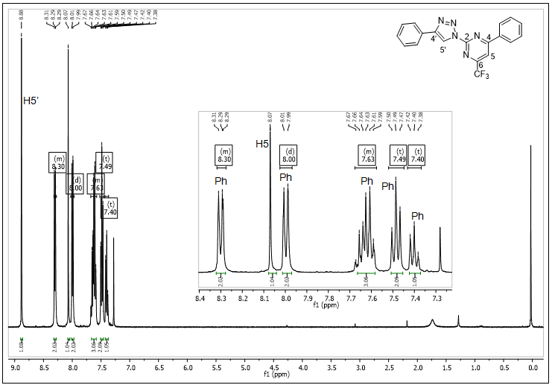
Fig. S1 ¹H NMR of 6a in CDCl₃.

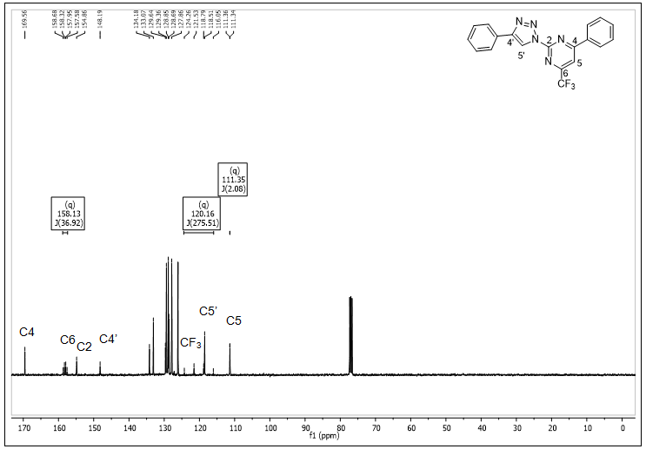
Fig. S2 ¹³C NMR of 6a in CDCl₃.

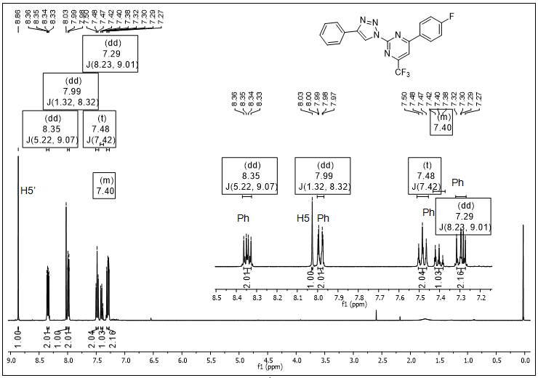
Fig. S3 ¹H NMR of 6b in CDCl₃.

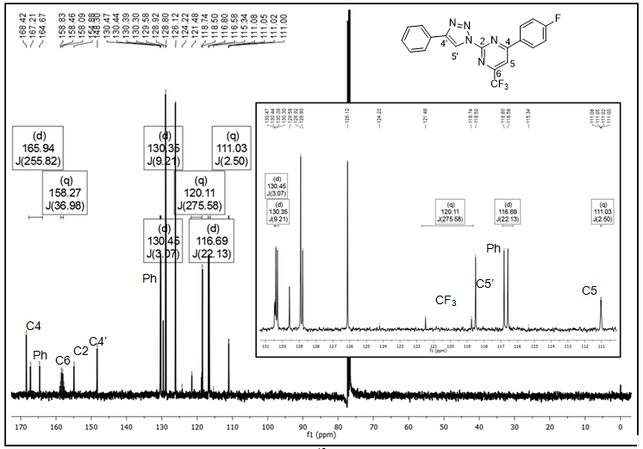
Fig. S4 ¹³C NMR of 6b in CDCl₃.

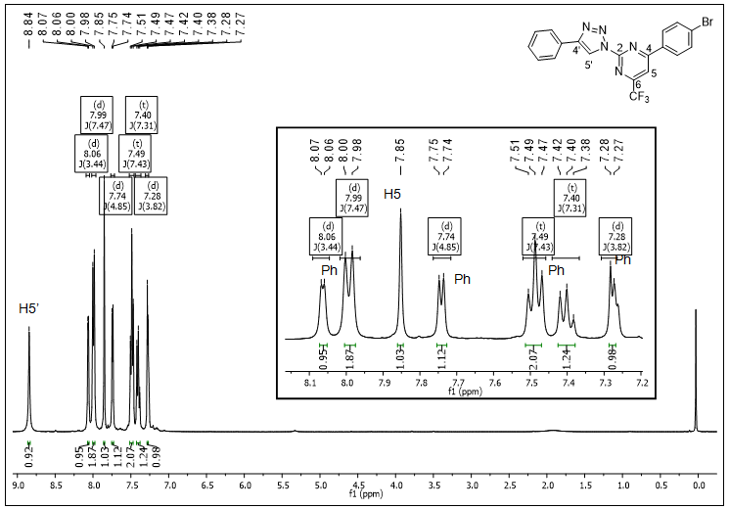
Fig. S5 ¹H NMR of 6c in CDCl₃.

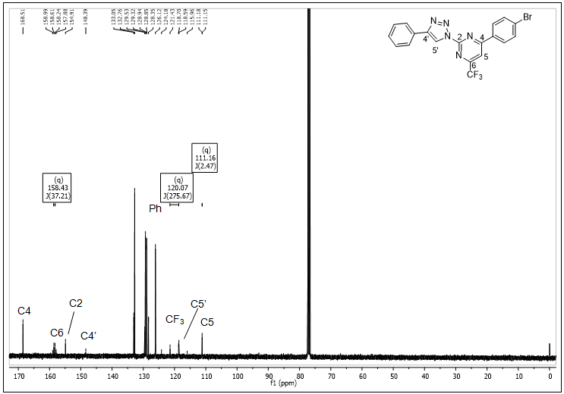
Fig. S6 ¹³C NMR of 6c in CDCl₃.

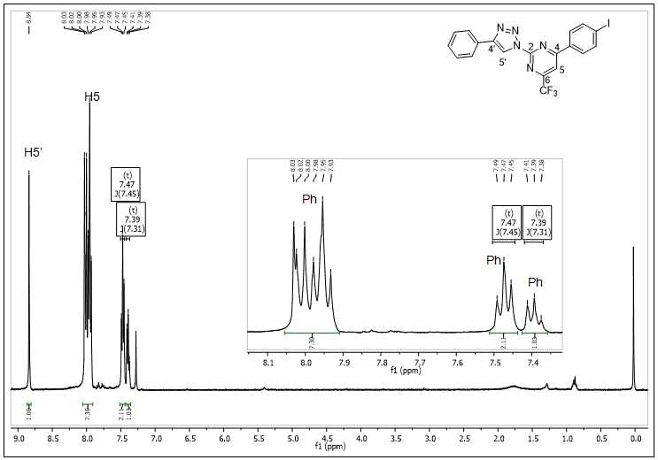
Fig. S7 ¹H NMR of 6d in CDCl₃.

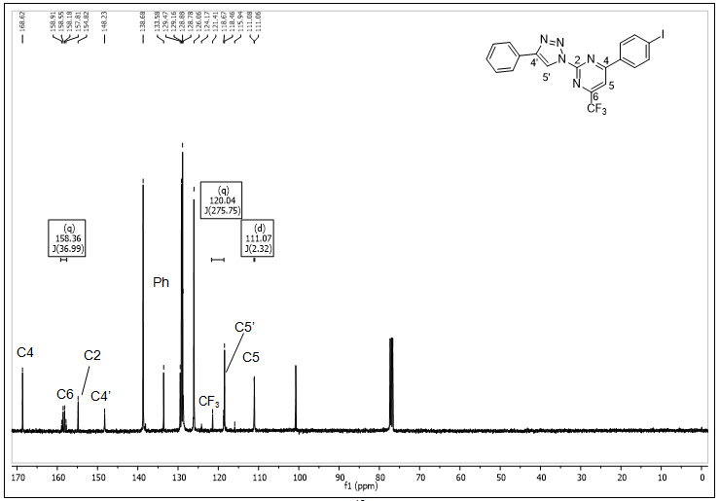
Fig. S8 ¹³C NMR of 6d in CDCl₃.

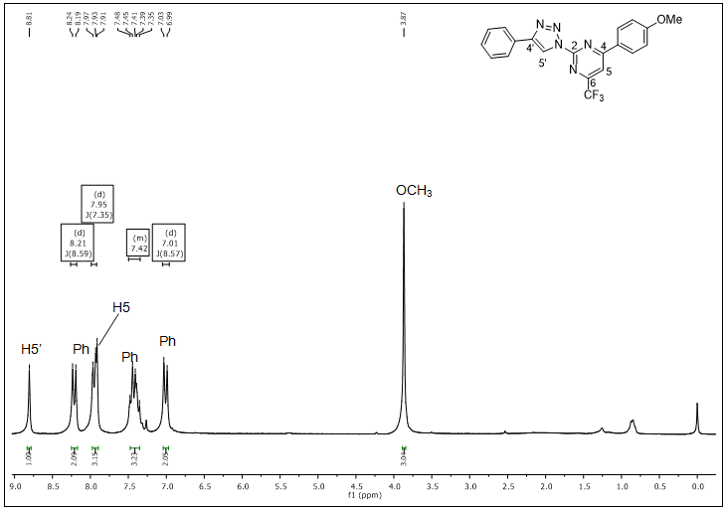
Fig. S9 ¹H NMR of 6e in CDCl₃.

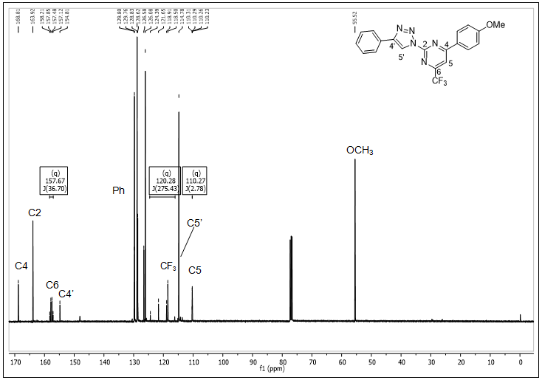
Fig. S10 ¹³C NMR of 6e in CDCl₃.

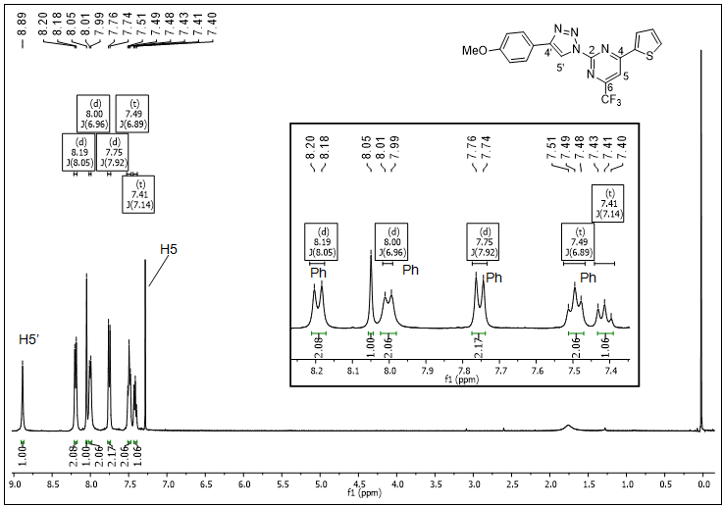
Fig. S11 ¹H NMR of 6f in CDCl₃.

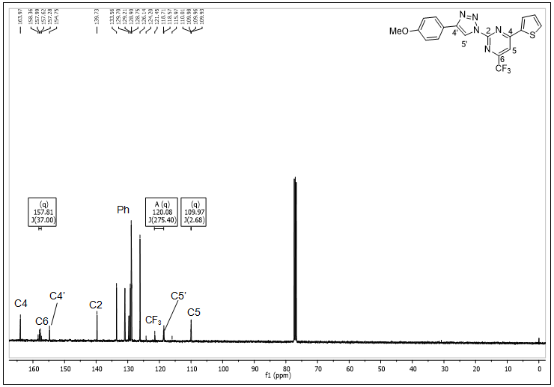
Fig. S12 ¹³C NMR of 6f in CDCl₃.

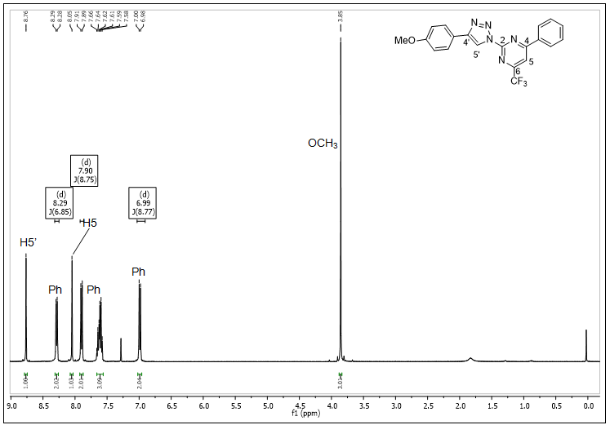
Fig. S13 ¹H NMR of 7a in CDCl₃.

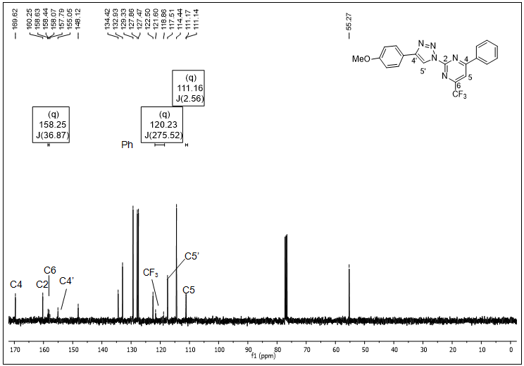
Fig. S14 ¹³C NMR of 7a in CDCl₃.

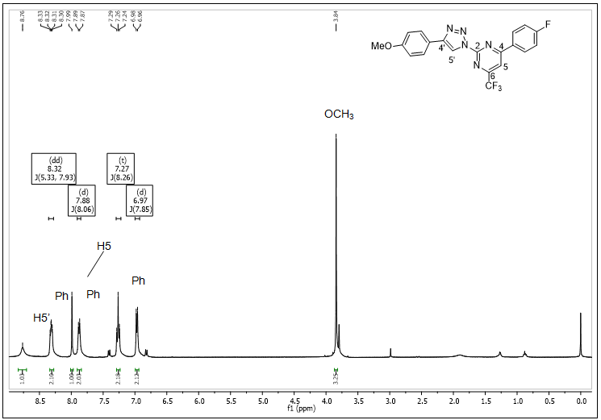
Fig. S15 ¹H NMR of 7b in CDCl₃.

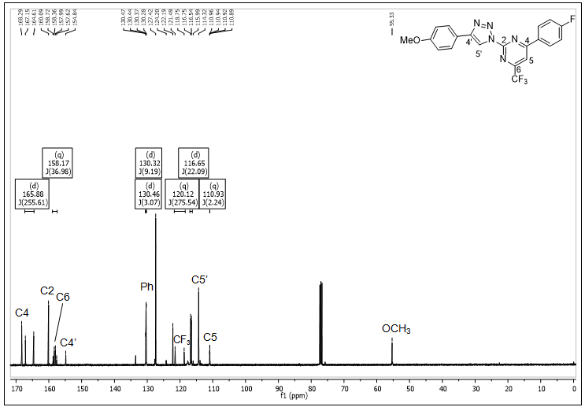
Fig. S16 ¹³C NMR of 7b in CDCl₃.

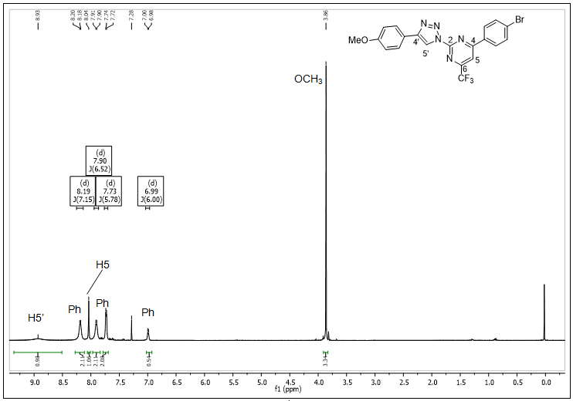
Fig. S17 ¹H NMR of 7c in CDCl₃.

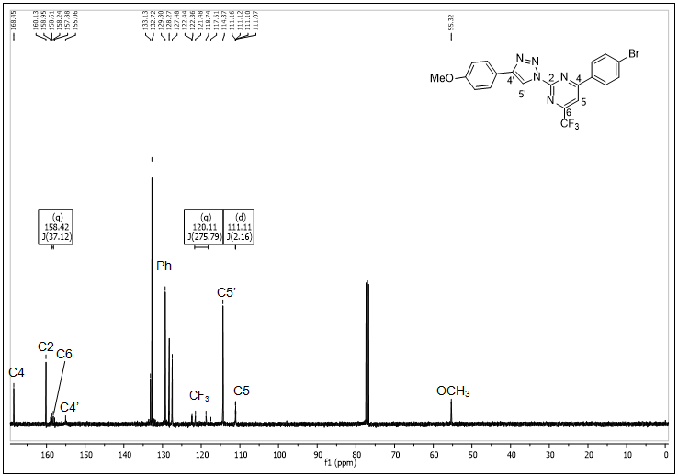
Fig. S18 ¹³C NMR of 7c in CDCl₃.

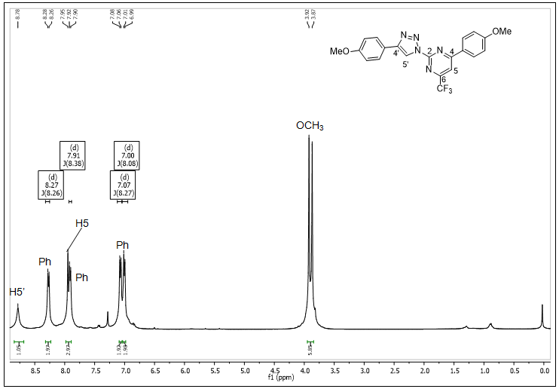
Fig. S19 ¹H NMR of 7e in CDCl₃.

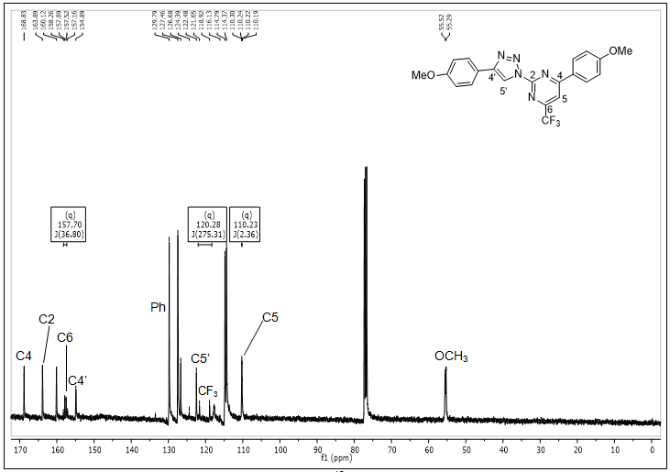
Fig. S20 ¹³C NMR of 7e in CDCl₃.

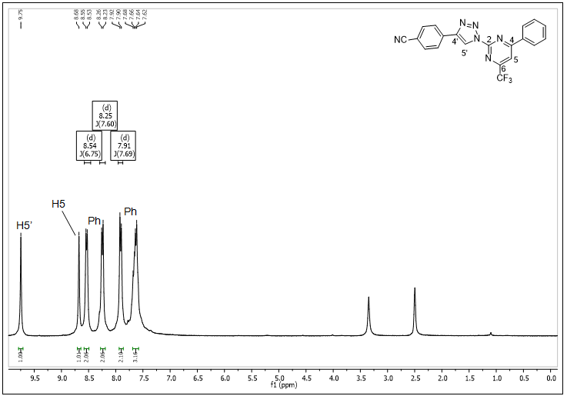
Fig. S21 ¹H NMR of 8a in DMSO-d₆.

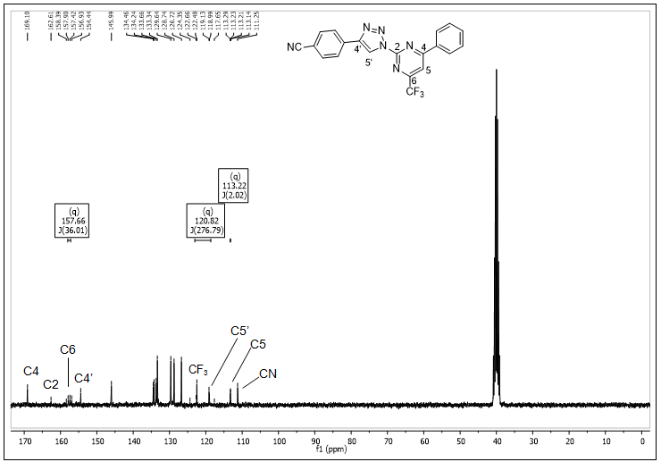
Fig. S22 ¹³C NMR of 8a in DMSO-d₆.

NH₂
Ph
H5
Ph
Fig. S23 ¹H NMR of 9a in CDCl₃.

C6
C2
C4
Ph
CF₃
C5
Fig. S24 ¹³C NMR of 9a in CDCl₃.

Ph
H5
Ph
NH₂
Fig. S25 ¹H NMR of 9b in DMSO-d₆.
C2
C6
C4
Ph
CF₃
Ph
C5
Fig. S26 ¹³C NMR of 9b in DMSO-d₆.

Ph
Ph
H5
NH₂
Fig. S27 ¹H NMR of 9c in DMSO-d₆.

C2
C6
C4
Ph
CF₃
C5
Fig. S28 ¹³C NMR of 9c in DMSO-d₆.

Ph
Ph
H5
NH₂
Fig. S29 ¹H NMR of 9d in CDCl₃.

C2
C6
C4
Ph
CF₃
C5
Fig. S30 ¹³C NMR of 9d in CDCl₃.
Ph
H5
Ph
NH₂
OCH₃
Fig. S31 ¹H NMR of 9e in DMSO-d₆.

C2
C6
C4
Ph
CF₃
C5
CH₃
Fig. S32 ¹³C NMR of 9e in DMSO-d₆.

Ph
H5
Ph
NH₂
Fig. S33 ¹H NMR of 9f in CDCl₃.

C2
C6
C4
CF₃
Ph
C5
Fig. S34 ¹³C NMR of 9f in CDCl₃.
Ph
H5
Ph
NH₂
CH₃
Fig. S35 ¹H NMR of 9h in DMSO-d₆.

C2
C6
C4
Ph
CF₃
CH₃
C5
Fig. S36 ¹³C NMR of 9h in DMSO-d₆.

NH₂
NH
Ph
H4
H6
H5
H5
Fig. S37 ¹H NMR of 10a in DMSO-d₆.

C2
Ph
CF₃
C6
C4
C5
Fig. S38 ¹³C NMR of 10a in DMSO-d₆.

Ph
Ph
H4
H6
H5
H5
OCH₃
Fig. S39 ¹H NMR of 10e in DMSO-d₆.
C2
Ph
CF₃
Ph
OCH₃
C4
C6
C5
Fig. S40 ¹³C NMR of 10e in DMSO-d₆.

H6
Ph
Ph
H5
NH₂→
Fig. S41 ¹H NMR of 13a in DMSO-d₆.
C2
C4
C6
Ph
CF₃
C5
Fig. S42 ¹³C NMR of 13a in DMSO-d₆.

H6
Ph
Ph
H5
NH₂→
Fig. S43 ¹H NMR of 13b in DMSO-d₆.
C2
C4
C6
Ph
C5
Fig. S44 ¹³C NMR of 13b in DMSO-d₆.

Ph
NH
H5
H7’→
H7
H6’→
H6
Fig. S45 ¹H NMR of 14a in CDCl₃.
C3a
Ph
C5
C7
C6
Fig. S46 ¹³C NMR of 14a in CDCl₃.
NH
Ph
H5
H7’→
H7
H6’→
H6
Fig. S47 ¹H NMR of 14b in DMSO-d₆.
Ph
C3a
Ph
C5
C7
C6
Fig. S48 ¹³C NMR of 14b in DMSO-d₆.
NH
Ph
H5
H7’→
H7
H6’→
H6
Fig. S49 ¹H NMR of 14e in DMSO-d₆.
C3a
Ph
Ph
OCH₃
C5
C7
C6
Fig. S50 ¹³C NMR of 14e in DMSO-d₆.

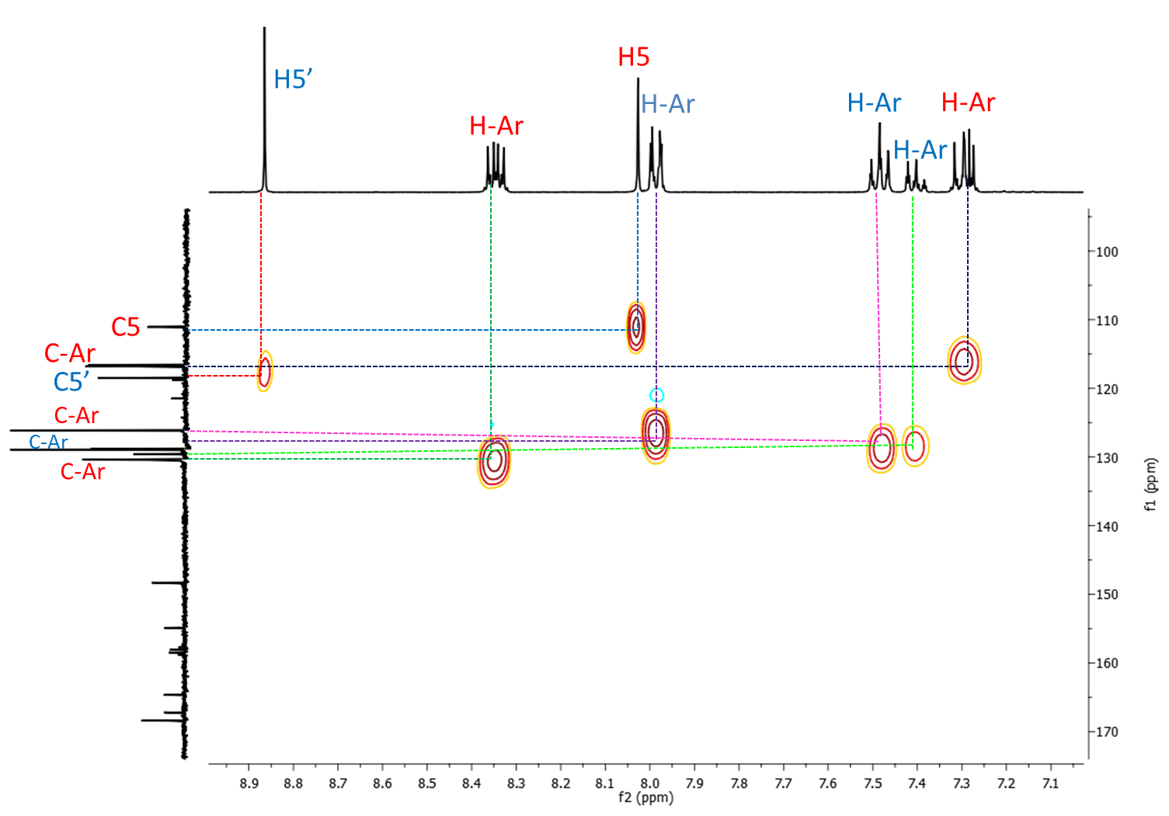
Fig. S51 HMQC ¹H-¹³C spectrum of compound 6b.

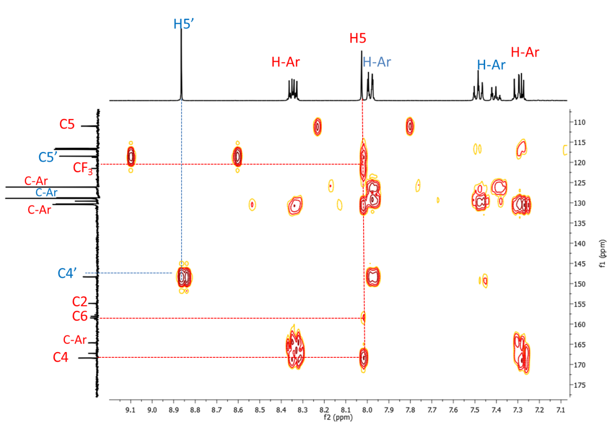
Fig. S52 HMBC ¹H-¹³C spectrum of compound 6b.

- Crystallographic data
Table S1. Crystallographic data of new structures reported (7b, 9c, 14a).
Compound  CCDC number  Empirical formula  Mw  T [K]  λ [Å]  Crystal system  Space group  a [Å]  b [Å]  c [Å]  α [°]  β [°]  γ [°]  V [Å³]  Z  D_{calcd.} [g cm⁻³]  μ[mm⁻¹ ]  F(000)  Crystal size (mm)  θ range for data  Collection (deg) h, k, l range  Reflections collected/unique  Data/restraints/parameters  Absoption correction  Refinement method  Final R indices  R all data  Goodness of fit on F²  Largest diff. peak and hole (e Å³) | 7b  2077854  C₂₀H₁₃F₄N₅O  415.35  293  0.71073  Triclinic  P-1  8.0109(2)  14.2627(3)  16.7899(4)  85.4030(10)  81.9090(10)  80.2900(10)  1868.93(8)  4  1.476  0.123  848  0.84 x 0.61 x 0.55  1.23 to 27.26  -10≤h≤10  -18≤k≤15,  -21≤l≤21  58864 / 8318  [R(int) = 0.0267]  8318 / 0 / 541  Gaussian  Full-matrix least-squares on F²  R1 = 0.0666,  wR2 = 0.1844  R1 = 0.0983,  wR2 = 0.2100  1.074  0.737 and -0.483 | 9c  1045310  C₁₁H₇BrF₃N₃  318.11  293(2)  0.71073  Triclinic  P-1  5.0190(2) 10.1810(5)  11.2141(5)  88.690(2)  78.487(2)  78.239(2)  549.61(4)  2  1.922  3.764  312  0.46 x 0.39 x 0.39  1.85 to 27.20  -6≤h≤6,  -13≤k≤13,  -14≤l≤14  15464 / 2434 [R(int) = 0.0285]  2434 / 0 / 163  Gaussian  Full-matrix least-squares on F²  R1 = 0.0209, wR2 = 0.0556  R1 = 0.0220, wR2 = 0.0561  1.046  0.551 and -0.477 | 14a  1045311  C₁₀ H₁₁ N₅  201.24  293(2)  0.71073  Monoclinic  P₂1/n  8.4951(5)  12.4455(8)  9.9802(6)  90  107.012(3)  90  1008.99(11)  4  1.325  0.087  424  0.47 x 0.29 x 0.20  2.69 to 27.26  -10≤h≤10,  -15≤k≤15,  -12≤l≤12  27283 / 2238 [R(int) = 0.0341]  2238 / 0 / 136  Gaussian  Full-matrix least-squares on F²  R1 = 0.0447, wR2 = 0.1171  R1 = 0.0490, wR2 = 0.1209  1.048  0.540 and -0.564

