Molecular rearrangement of pyrazino[2,3-c]quinolin-5(6H)-ones during their reaction with isocyanic acid.
Antonín Klásek,*ª Antonín Lyčka,^{b} Filip Křemen,ª Aleš Růžička^{c} and Michal Rouchalª

- Department of Chemistry, Faculty of Technology, Tomas Bata University, CZ-762 72 Zlín, Czeh Republic; (e-mail: klasek@utb.cz)
^{b)} University of Hradec Králové, Faculty of Science, Rokitanského 62, CZ-530 03 Hradec Králové, Czech Republic
^{c)} Department of General and Inorganic Chemistry, Faculty of Chemical Technology¨, University of Pardubice, CZ-532 10 Pardubice, Czech Republic

SUPPORTING INFORMATION

Table of Contents

¹H, ¹³C and ¹⁵N NMR spectra of compounds 2, 3, 4, 5, 6, 7, 8 S2
Crystal data and structure refinement of compounds 5d, 7a, 7b S35

¹H, ¹³C and ¹⁵N NMR spectra of compounds 2, 3, 4, 5, 6, 7, 8

Table S1: ¹H, ¹³C and ¹⁵N chemical shifts of compounds 2 in DMSO-d₆.
Position | 2a |  | 2b |  | 2c |  | 2d |  | 2e |  | 2f
 | δH) | δC) | δH) | δC) | δH) | δC) | δH) | δC) | δH) | δC) | δH) | δC)
1 | - | - | - | -52.7ª | - | - | - | - | - | - | - | -53.0ª
2 | 3.82 | 50.2 | 3.64 | 49.8 | 3.96 | 49.9 | 3.88 | 50.2 | 3.73 | 49.8 | 3.97 | 49.9
 | 3.49 |  | 3.02 |  | 3.81 |  | 3.57 |  | 3.10 |  | 3.94
3 | 2.90 | 39.2 | 2.88 | 38.8 | 2.71 | 37.8 | 2.93 | 39.3 | 2.95 | 38.6 | 2.72 | 37.5
 | 2.44 |  | 2.45 |  | 2.65 |  | 2.54 |  | 2.56 |  | 2.60
4 | 3.13 | - | 3.02 | -351.7ª | - | - | 3.17 | - | - | - | 3.32 | -339.3ª
4a | - | 63.2 | - | 64.1 | - | 65.6 | - | 63.5 | - | 64.4 | - | 66.1
5 | - | 171.7 | - | 170.8 | - | 169.2 | - | 171.8 | - | 170.9 | - | 169.4
6 | - | - | - | -257.6ª | - | - | - | - | - | - | - | -234.3ª
6a | - | 139.1 | - | 139.1 | - | 138.8 | - | 139.9 | - | 140.0 | - | 139.7
7 | 7.21 | 114.9 | 7.12 | 115.1 | 7.12 | 115.1 | 6.26 | 115.9 | 6.34 | 116.2 | 6.09 | 116.0
8 | 7.49 | 131.4 | 7.24 | 131.6 | 7.43 | 131.5 | 7.29 | 131.1 | 7.35 | 131.2 | 7.16 | 131.2
9 | 7.18 | 123.3 | 7.19 | 123.3 | 7.14 | 123.4 | 7.13 | 123.4 | 7.19 | 123.5 | 7.08 | 123.5
10 | 7.65 | 125.1 | 7.64 | 125.3 | 7.81 | 125.1 | 7.74 | 125.3 | 7.73 | 125.6 | 7.83 | 125.5
10a | - | 123.9 | - | 123.8 | - | 124.2 | - | 123.3 | - | 123.4 | - | 123.7
10b | - | 162.7 | - | 161.7 | - | 160.6 | - | 162.4 | - | 161.5 | - | 160.2
1´(R¹) | 3.33 | 30.1 | 3.35 | 30.1 | 3.39 | 30.1 | - | 139.1 | - | 137.9 | - | 137.8
2´(R¹) | - | - | - | - | - | - | 7.25^{b} | b | b | b | 7.20^{b} | b
3´(R¹) | - | - | - | - | - | - | 7.57 | 130.2 | 7.58 | 130.1 | 7.56 | 130.3
4´(R¹) | - | - | - | - | - | - | 7.50 | 128.7 | 7.51 | 128.7 | 7.52 | 129.5
1´(R²) | 1.45 | 39.0 | 2.75 | 44.9 | - | 139.9 | 1.73 | 39.0 | 3.06 | 44.7 | - | 139.4
 | 1.31 |  | 2.68 |  |  |  | 1.59 |  | 2.91
2´(R²) | 1.31 | 25.4 | - | 135.2 | 7.18 | 126.9 | 1.38 | 25.4 | - | 135.2 | 7.26 | 127.0
 | 1.05 |  |  |  |  |  | 1.15
3´(R²) | 1.05 | 22.0 | 6.94 | 130.4 | 7.29 | 128.5 | 1.15 | 22.0 | 7.10 | 130.6 | 7.35 | 129.5
4´(R²) | 0.69 | 13.8 | 7.16 | 127.4 | 7.24 | 127.9 | 0.77 | 13.9 | 7.22 | 127.5 | 7.28 | 128.7
5´(R²) | - | - | 7.16 | 126.8 | - | - | - | - | 7.22 | 126.9 | - | -
ª δN) ^{b} broad overlapped signals

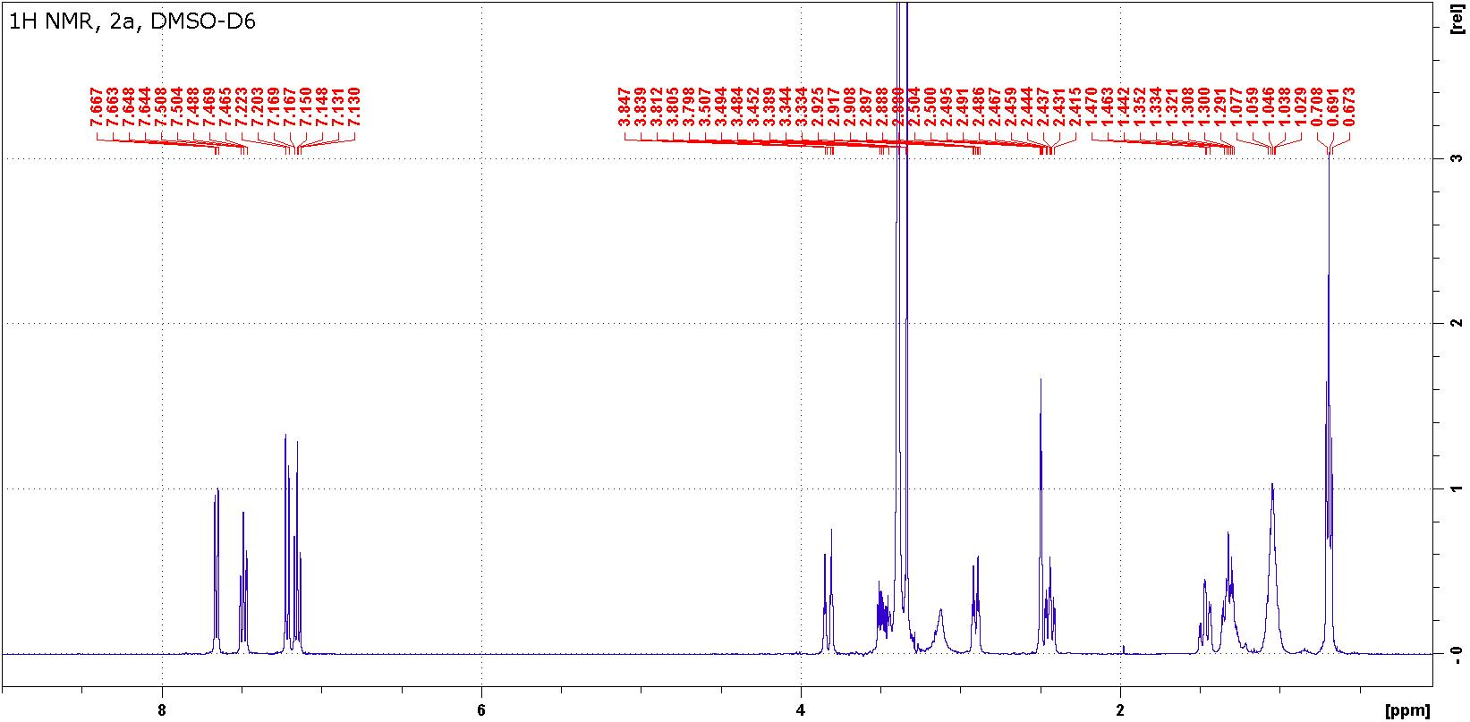

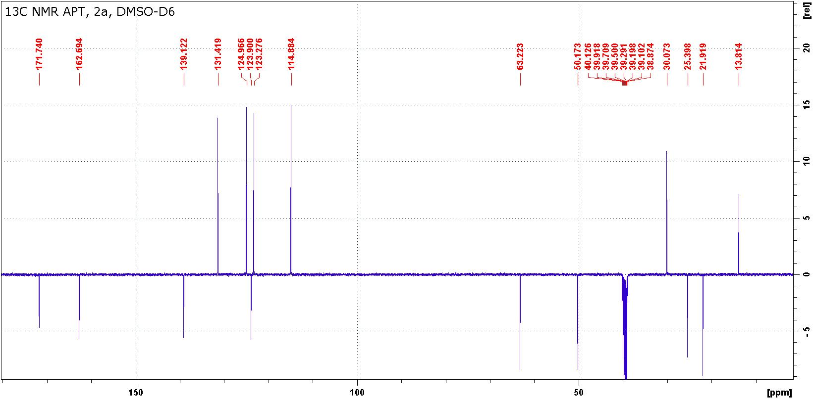

Figure S1: ¹H and ¹³C NMR spectra of compound 2a.

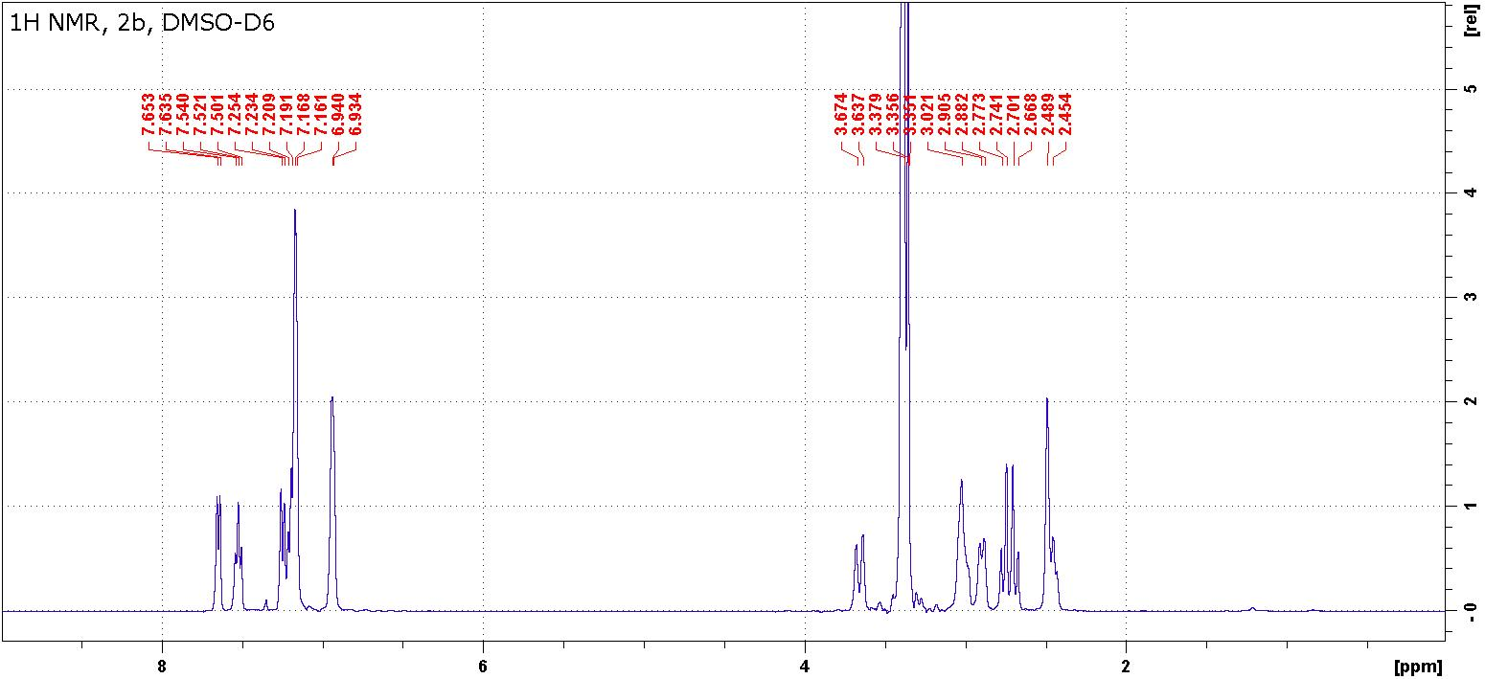

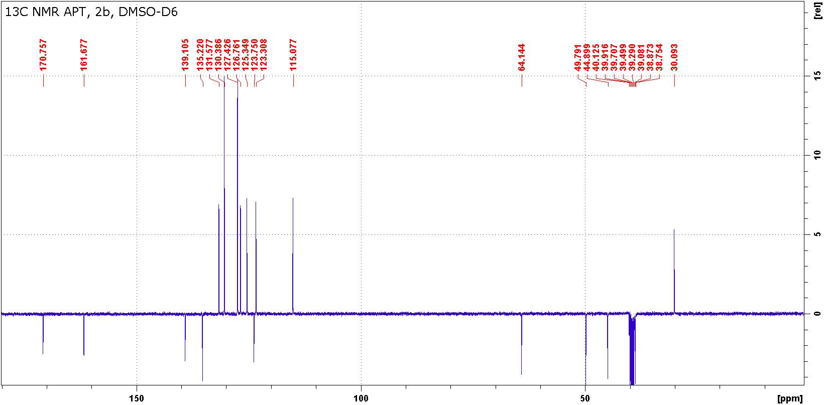
Figure S2: ¹H and ¹³C NMR spectra of compound 2b.

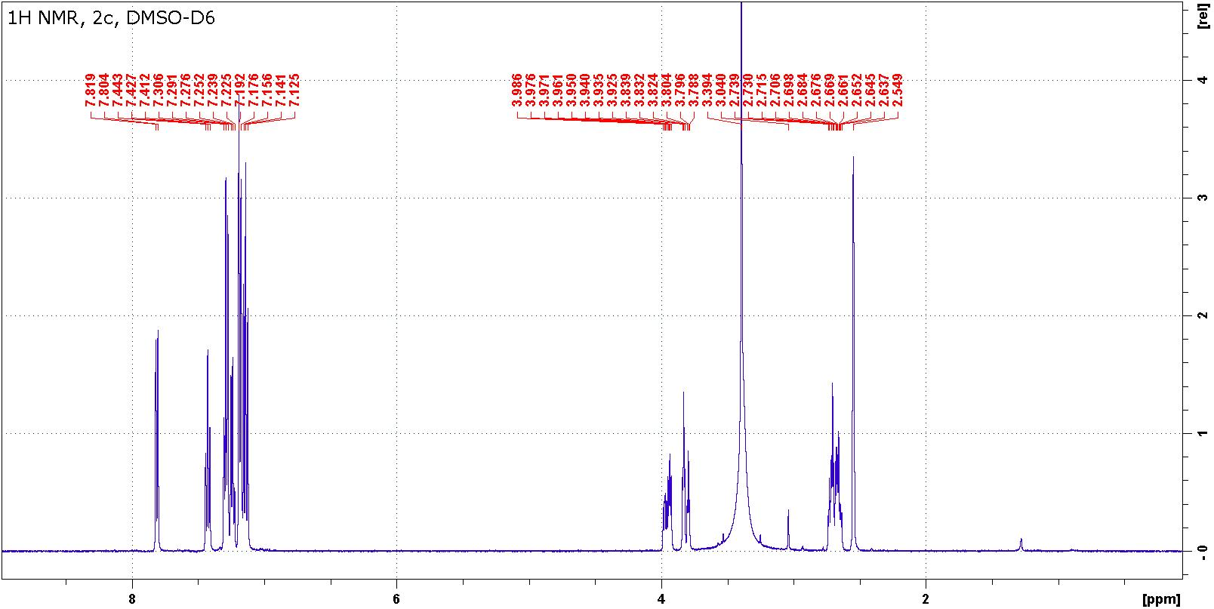

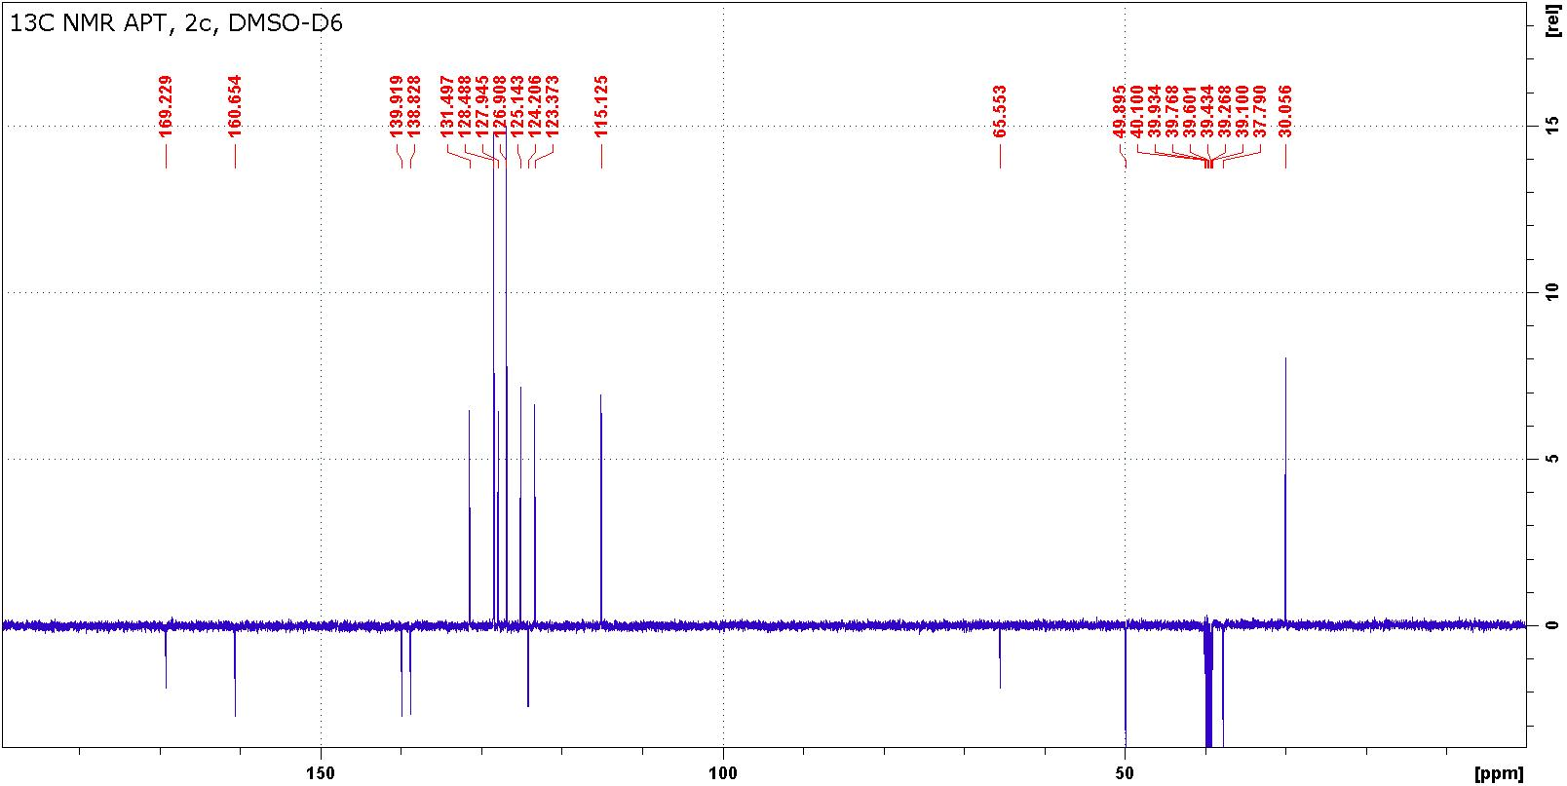
Figure S3: ¹H and ¹³C NMR spectra of compound 2c.

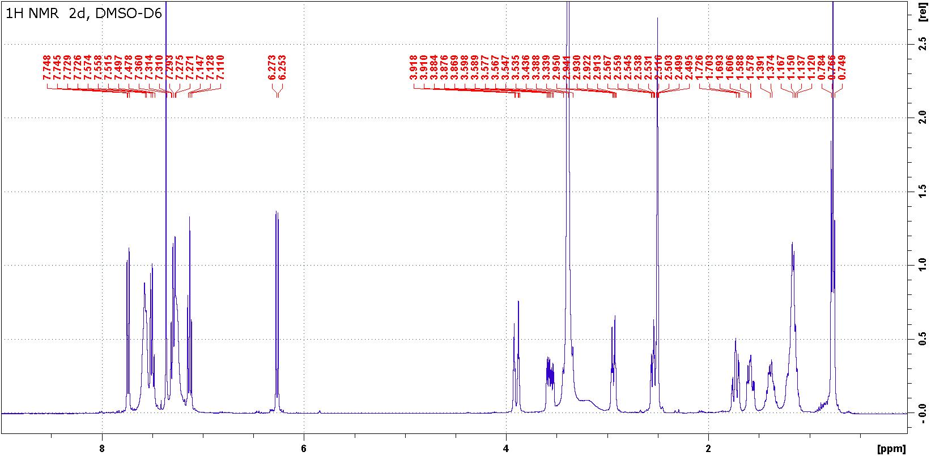

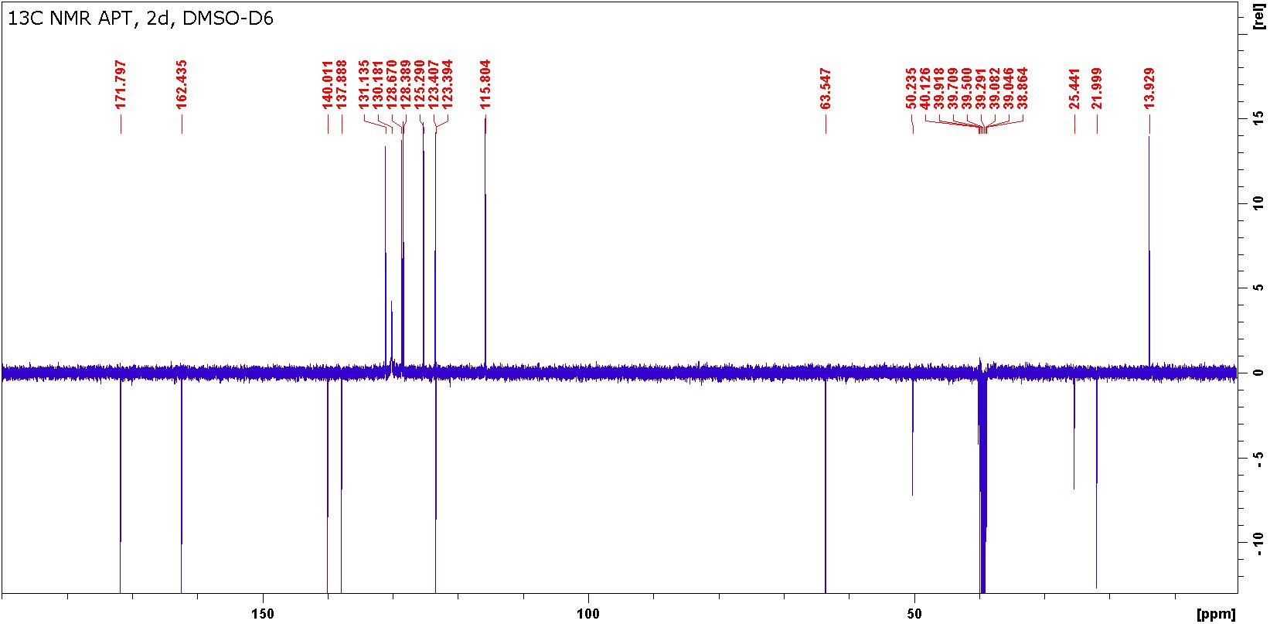
Figure S4: ¹H and ¹³C NMR spectra of compound 2d.

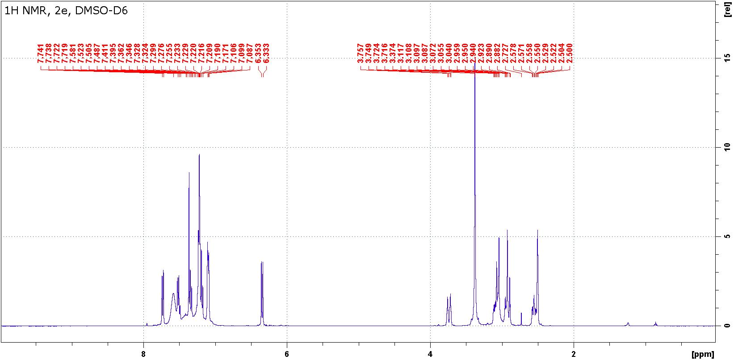

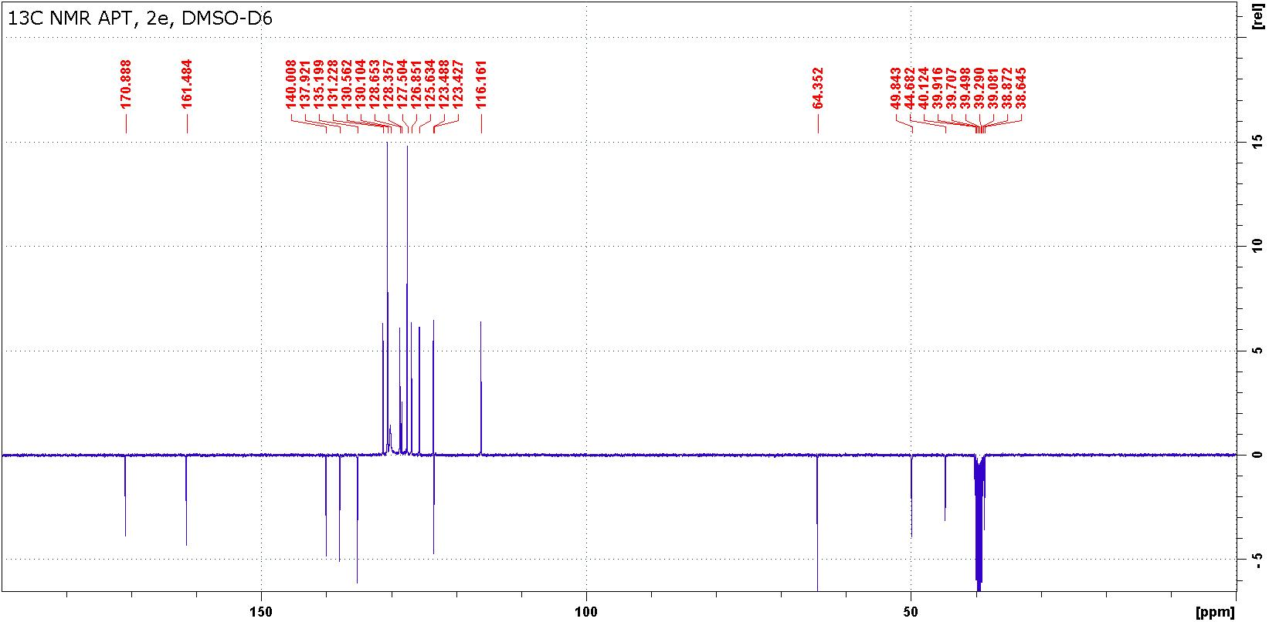
Figure S5: ¹H and ¹³C NMR spectra of compound 2e.

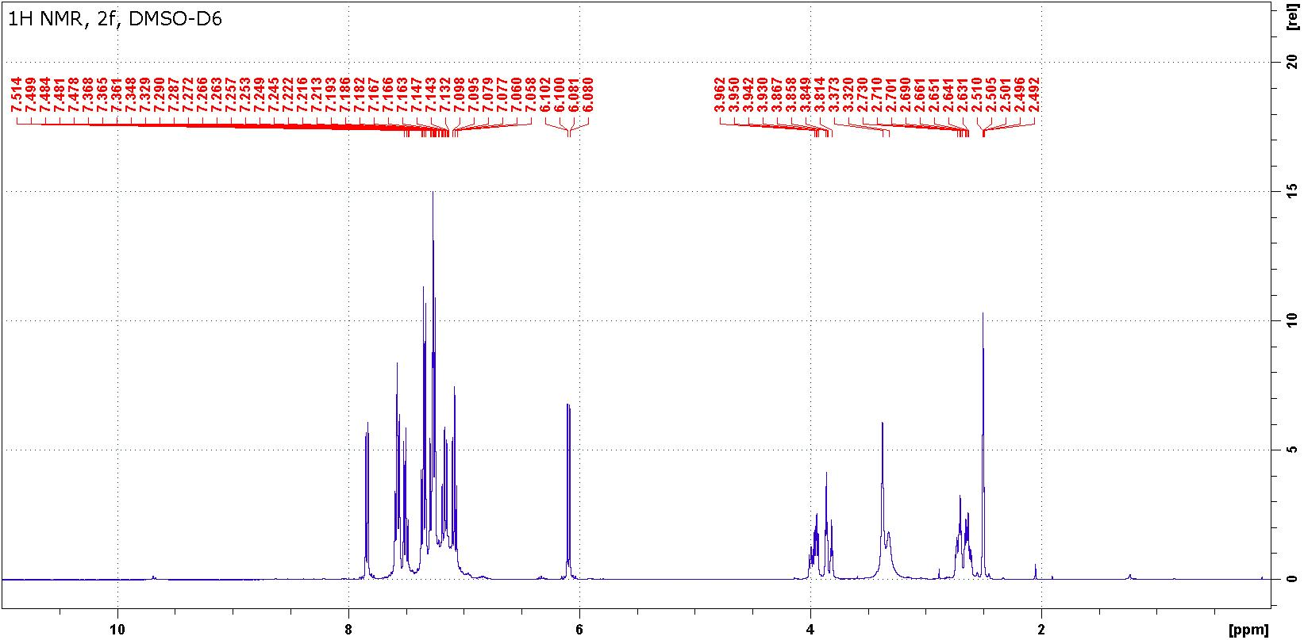

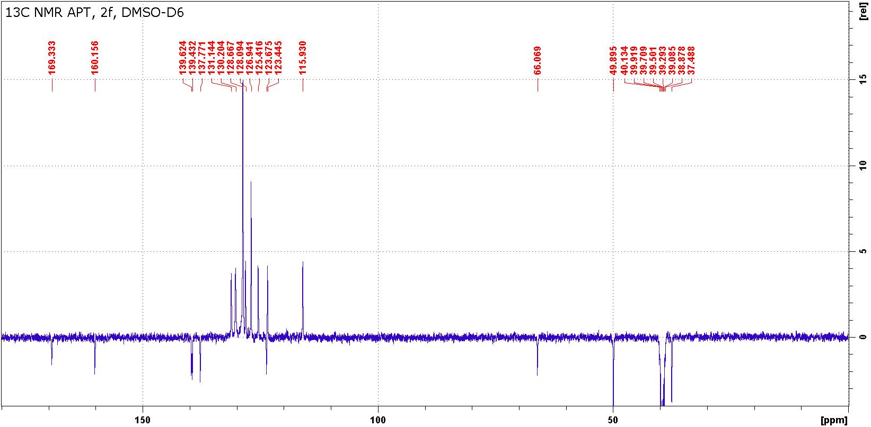
Figure S6: ¹H and ¹³C NMR spectra of compound 2f.

Table S2: ¹H and ¹³C chemical shifts of diastereoisomers of compound 3c and 3f in DMSO-d₆.
Position | 3c |  | 3f
 | δ(H) | δ(C) | δ(H) | δ(C)
2 | - | 171.32, 171.23 | - | 171.33, 171.26
3 | - | 76.98, 76.96 | - | 77.23, 77.19
4 | - | 193.27, 192.72 | - | 193.10, 192.64
4a | - | 120.71, 120.60 | - | 120.50, 120.44
5 | 7.75 | 127.48, 127.39 | a | a
6 | 7.17 | 123.29, 123.27 | a | 123.48, 123.40
7 | 7.69 | 136.41, 136.39 | 7.46 | 135.93
 | 7.39 | 115.99, 115.96 | 6.32 | 116.59, 116.55
8a | - | 142.3 | - | 142.0
NH | 2.60 | - | - | -
CH₂ | 2.59, 2.48 | 45.38, 45.17 | 2.58, 2.51 | 45.33, 45.17
1´(R¹) | 3.53, 3.50 | 30.03, 30.00 | - | 139.63, 139.43
2´(R¹) | - | - | a | a
3´(R¹) | - | - | a | a
4´(R¹) | - | - | a | a
1´(R²) | - | 137.91, 137.86 | - | 137.78, 137.44
2´(R²) | 7.31 | 126.69, 126.64 | a | a
3´(R²) | 7.28 | 128.84, 128.79 | a | a
4´(R²) | 7.28 | 128.66, 128.62 | a | a
ª Very low soluble compound, broadened overlapped signals, 7.12-7.82/126.9 – 131.2

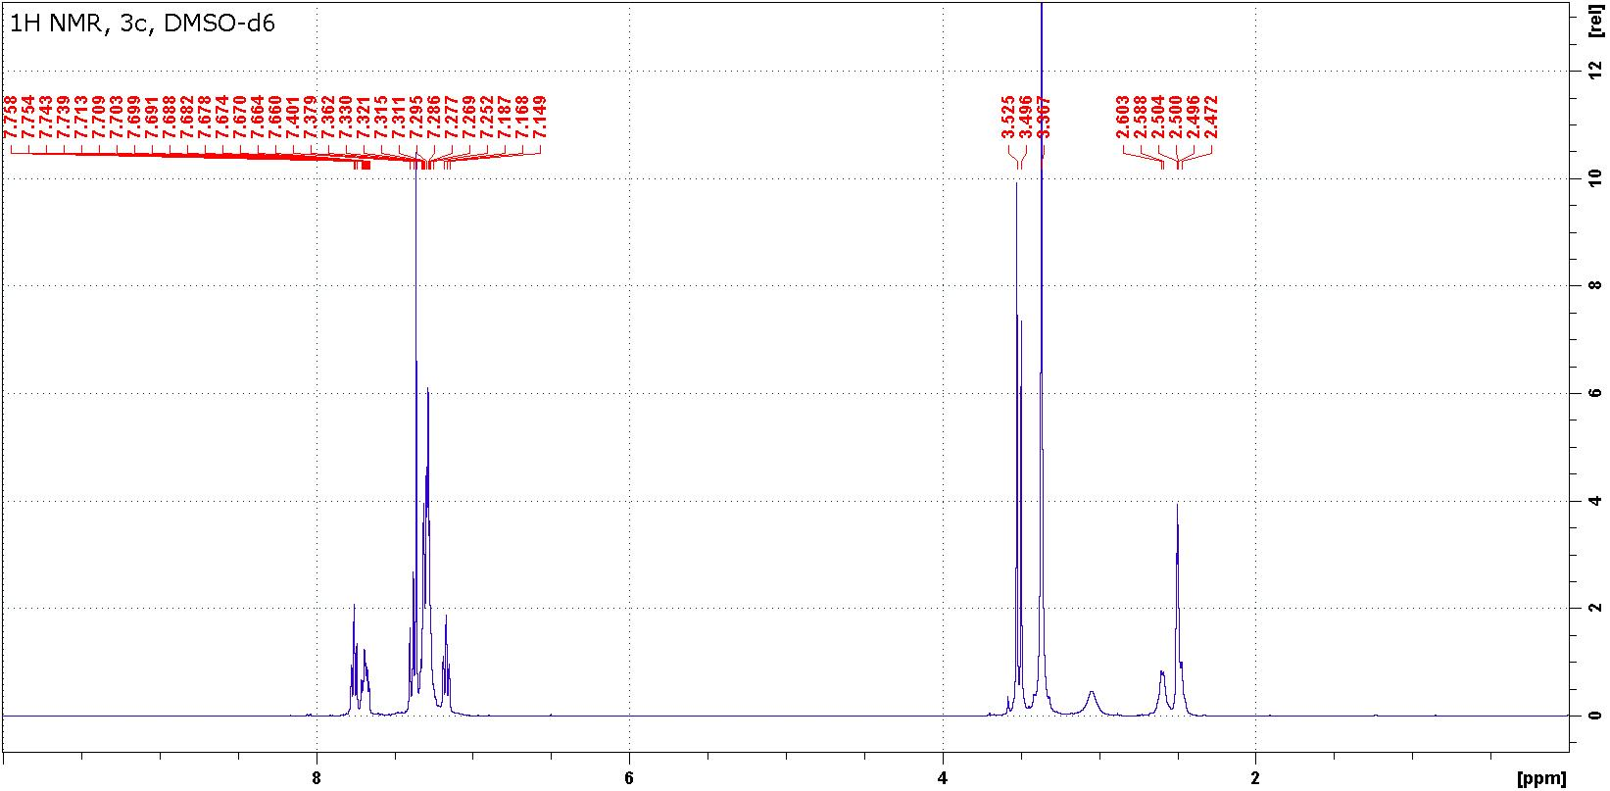

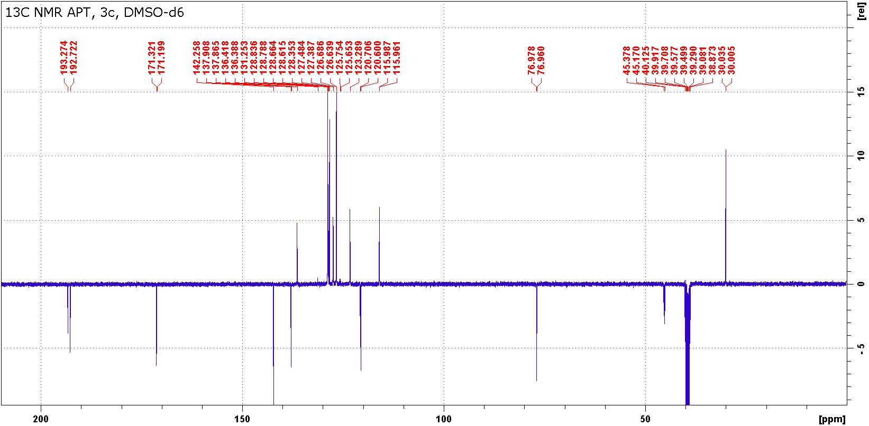

Figure S7: ¹H and ¹³C NMR spectra of compound 3c.

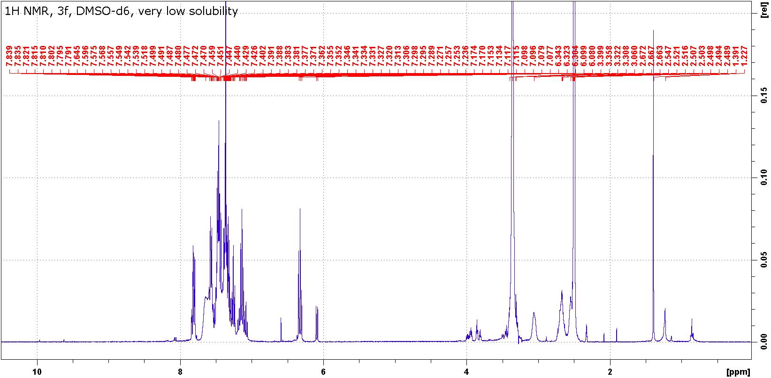

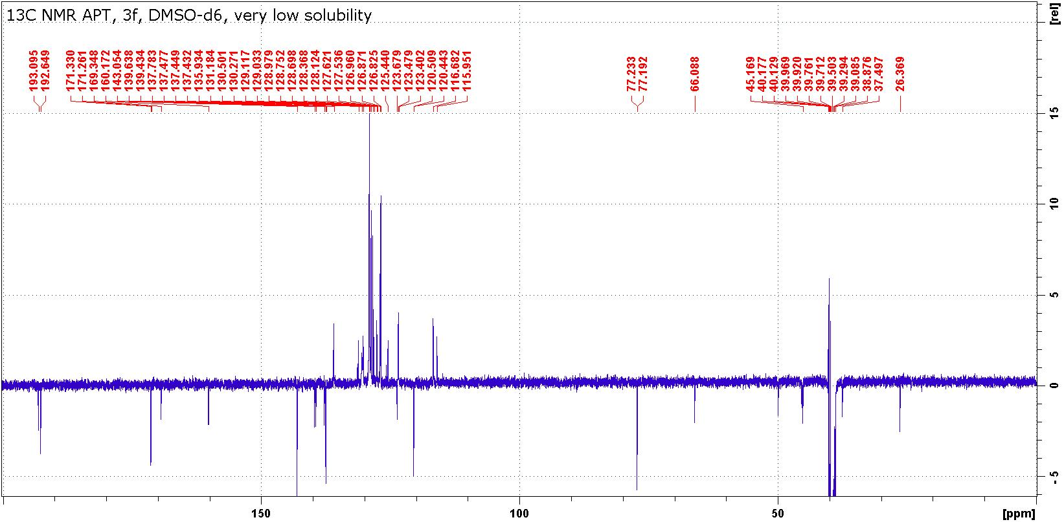
Figure S8: ¹H and ¹³C NMR spectra of compound 3f.

Table S3: ¹H, ¹³C and ¹⁵N chemical shifts of compounds 4 in DMSO-d₆.
Position | 4a |  | 4b |  | 4c |  | 4d |  | 4e |  | 4f
 | δ(H) | δ(C) | δ(H) | δ(C) | δ(H) | δ(C) | δ(H) | δ(C) | δ(H) | δ(C | δ(H) | δ(C
1 | - | - | a | - | - | - | - | -344.6^{b} | - |  | -
2 | 2.90 | 45.4 | 3.11 | 45.5 | 2.99 | 46.1 | 2.96 | 45.4 | 3.08 | 45.5 | 3.09 | 45.5
 | 2.68 |  | 3.03 |  | 2.87 |  | 2.74 |  | 2.82 |  | 2.96
3 | 2.65 | 39.9 | 2.77 | 40.1 | 2.60 | 40.4 | 2.73 | 39.7 | 3.15 | 40.4 | 2.70 | 40.1
 | 2.61 |  | 2.71 |  | 2.32 |  | 2.66 |  | 2.74 |  | 2.43
4 | - | - | a | - | - | - | - | -354.2^{b} | - | - | - | -
4a | - | 56.9 | - | 58.6 | - | 59.7 | - | 57.5 | - | 58.8 | - | 60.3
5 | - | 171.6 | - | 170.4 | - | 170.4 | - | 171.8 | - | 170.4 | - | 170.2
6 | - | - | - | - | - | - | - | -235.0^{b} | - | - | - | -
6a | - | 138.1 | - | 138.2 | - | 138.0 | - | 138.6 | - | 138.5 | - | 138.2
7 | 7.06 | 114.1 | 7.13 | 114.3 | 6.95 | 114.7 | 6.15 | 115.5 | 6.29 | 116.1 | 6.01 | 115.8
8 | 7.27 | 127.6 | 7.37 | 127.8 | 7.20 | 127.4 | 7.07 | 127.4 | 7.14 | 127.5 | 6.98 | 127.1
9 | 7.27 | 123.4 | 7.32 | 123.5 | 7.13 | 123.1 | 7.04 | 123.9 | 7.14 | 123.8 | 7.11 | 123.3
10 | 7.06 | 122.7 | 7.13 | 122.8 | 7.49 | 122.8 | 7.35 | 123.0 | 7.44 | 123.1 | 7.53 | 123.2
10a | - | 127.4 | - | 127.3 | - | 128.3 | - | 127.1 | - | 127.4 | - | 127.8
10b | 3.87 | 58.2 | 3.98 | 58.4 | 4.25 | 58.0 | 4.15 | 58.¨2 | 4.27 | 58.6 | 4.55 | 57.5
1´(R¹) | 3.24 | 29.3 | 3.24 | 29.3 | 3.23 | 29.8 | - | 139.2 | - | 139.2 | - | 138.2
2´(R¹) | - | - | - | - | - | - | 7.15 | 129.2 | 7.16 | 129.1 | 7.08 | 128.7
3´(R¹) | - | - | - | - | - | - | 7.54 | 130.0 | 7.52 | 129.8 | 7.52 | 129.9
4´(R¹) | - | - | - | - | - | - | 7.44 | 128.2 | 7.43 | 128.0 | 7.43 | 128.2
1´(R²) | 1.96 | 22.6 | 3.21 | 29.7 | - | 137.4 | 2.08 | 22.7 | 3.36 | 29.8 | - | 136.9
 | 0.57 |  | 2.04 |  |  |  | 0.89 |  | 2.27
2´(R²) | 1.14 | 24.1 | - | 136.7 | 7.46 | 129.1 | 1.26 | 24.3 | - | 136.7 | 7.64 | 129.3
 | 0.86 |  |  |  |  |  | 1.02
3´(R²) | 1.05 | 22.4 | 6.80 | 129.7 | 7.05 | 127.3 | 1.18 | 22.5 | 7.04 | 129.9 | 7.16 | 127.5
4´(R²) | 0.73 | 14.0 | 7.15 | 127.9 | 7.05 | 126.7 | 0.80 | 14.1 | 7.26 | 128.1 | 7.16 | 127.1
5´(R²) | - | - | 7.15 | 126.1 | - | - | - | - | 7.16 | 126.2 | - | -
ª δ(NH) = 2.92 and 2.12 ^{b} δ(¹⁵N)

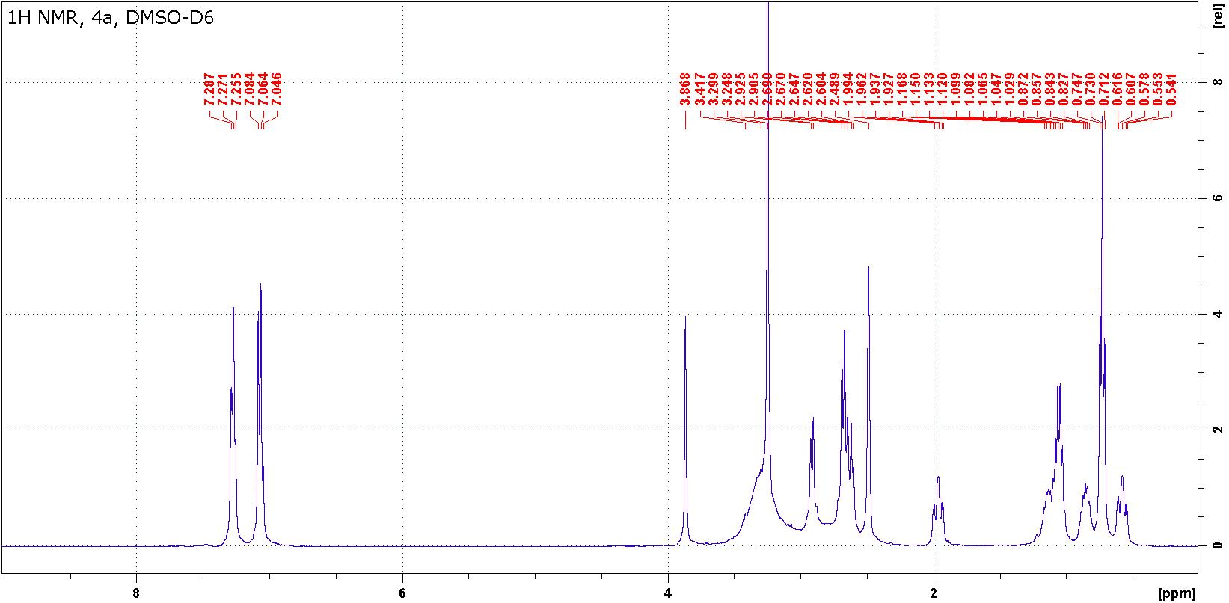

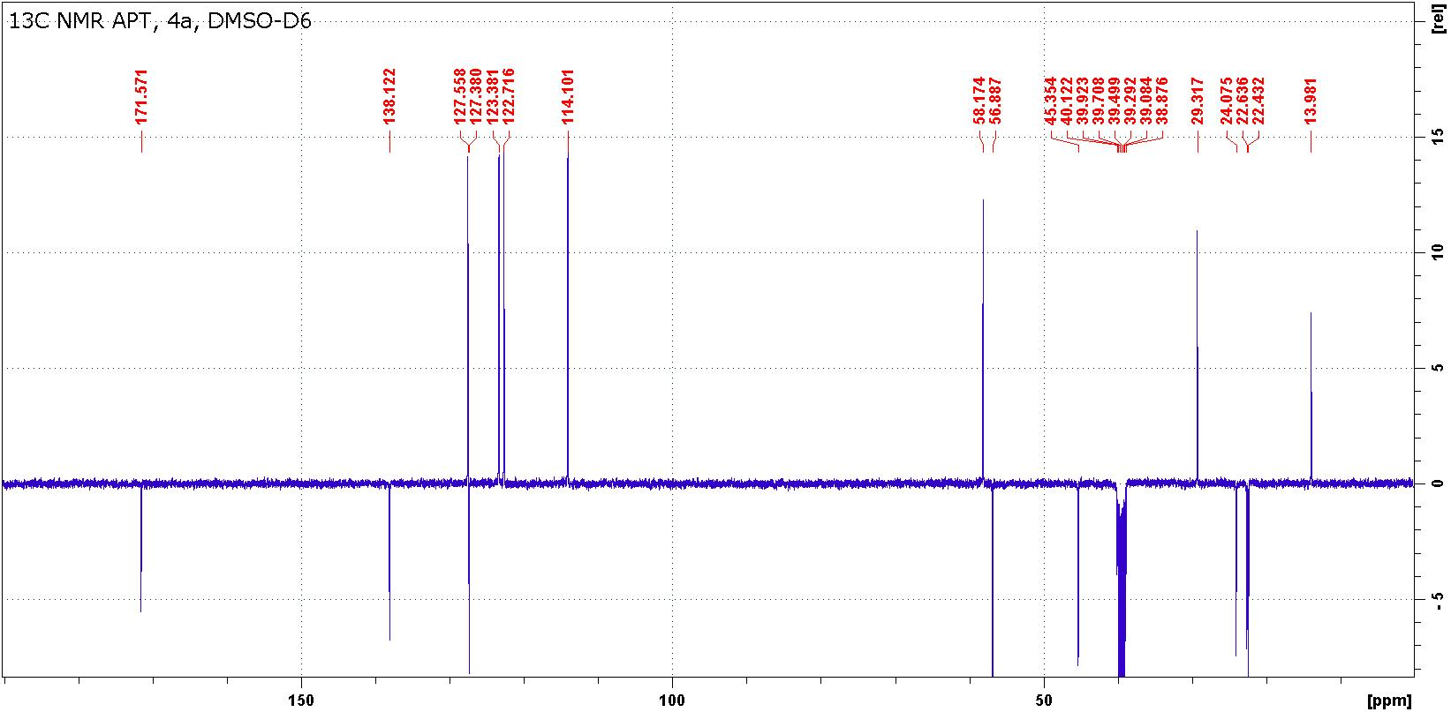

Figure S9: ¹H and ¹³C NMR spectra of compound 4a.

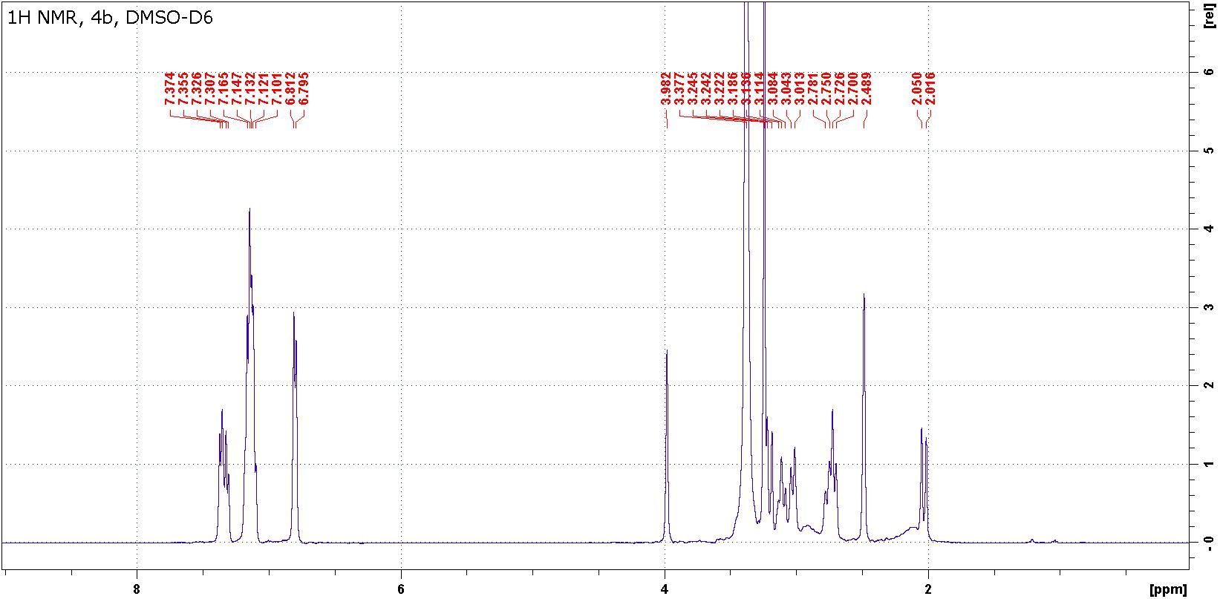

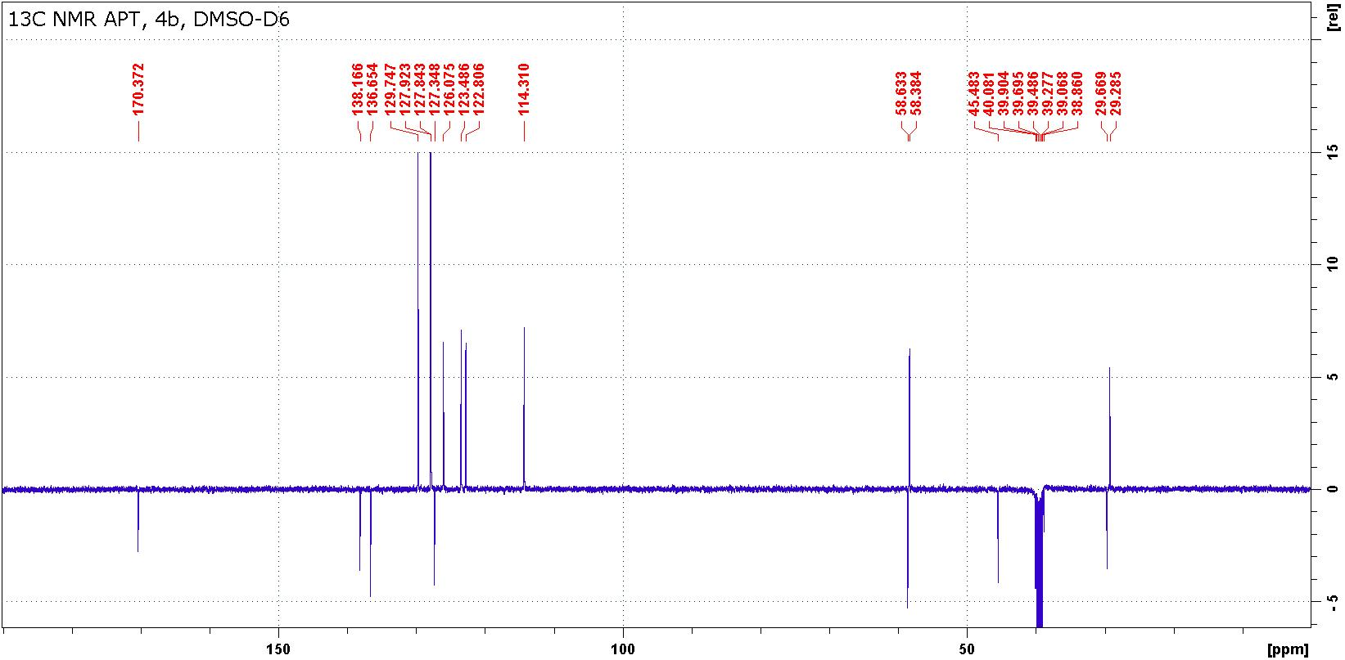

Figure S10: ¹H and ¹³C NMR spectra of compound 4b.

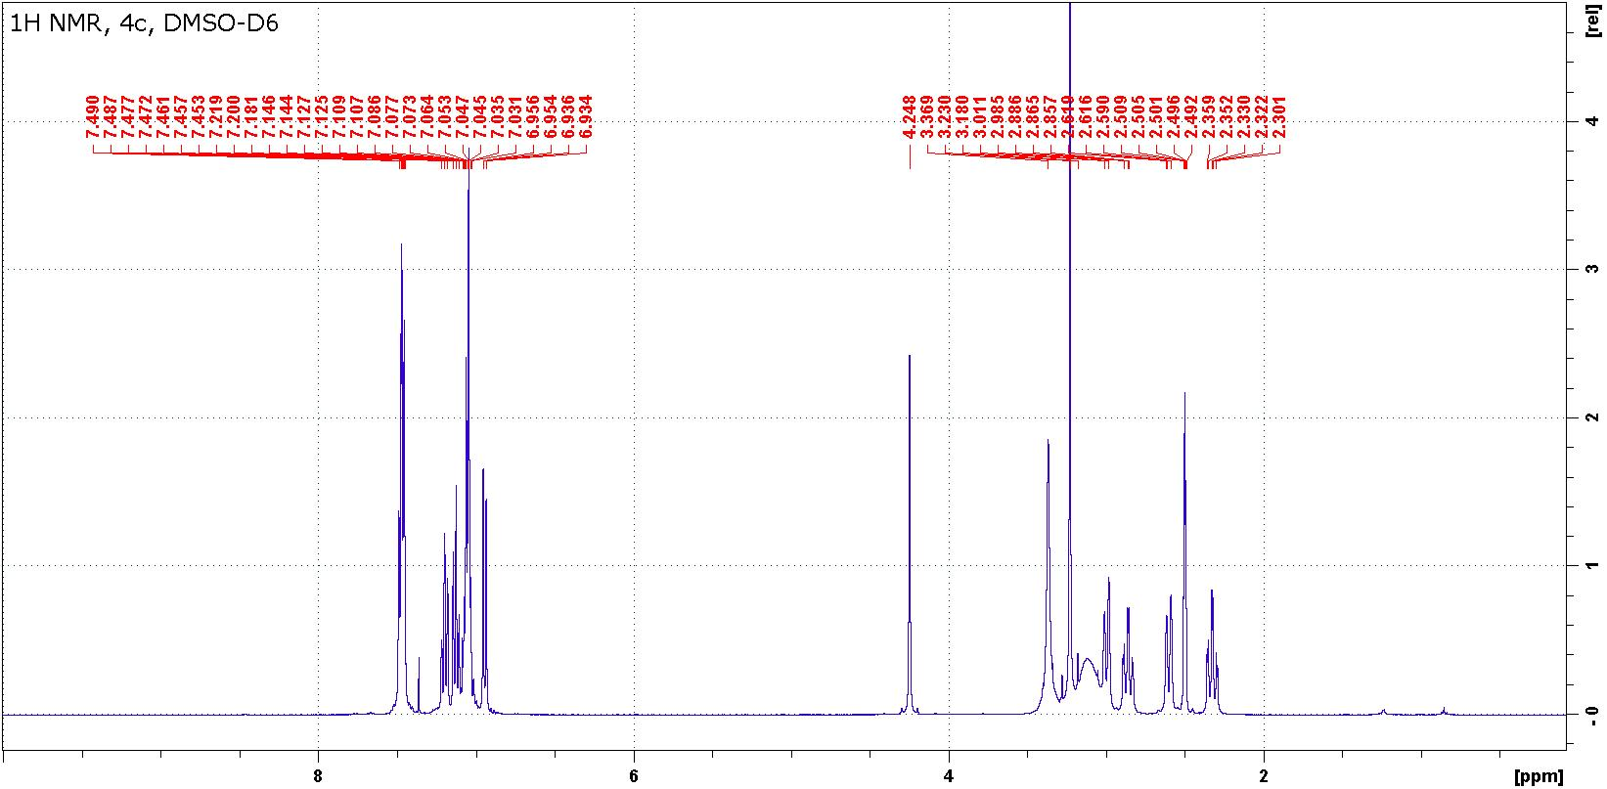

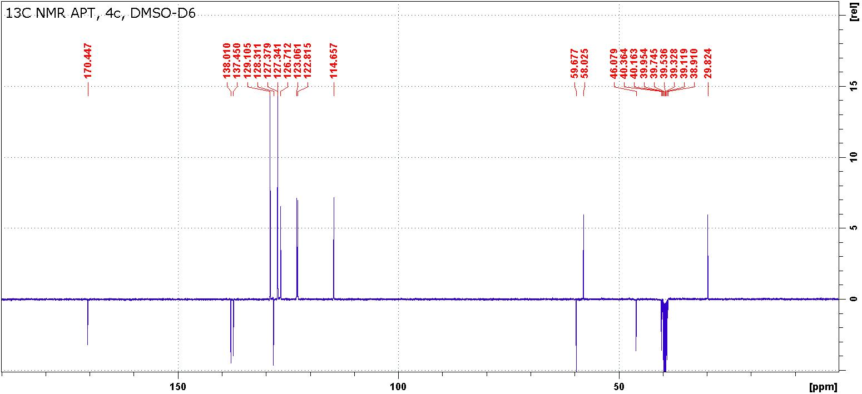
Figure S11: ¹H and ¹³C NMR spectra of compound 4c.

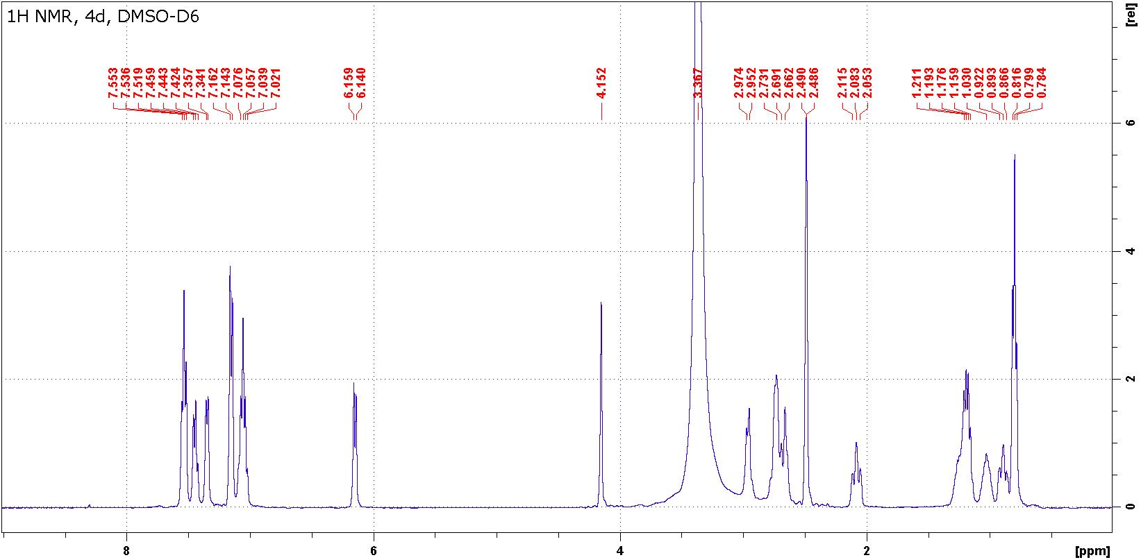

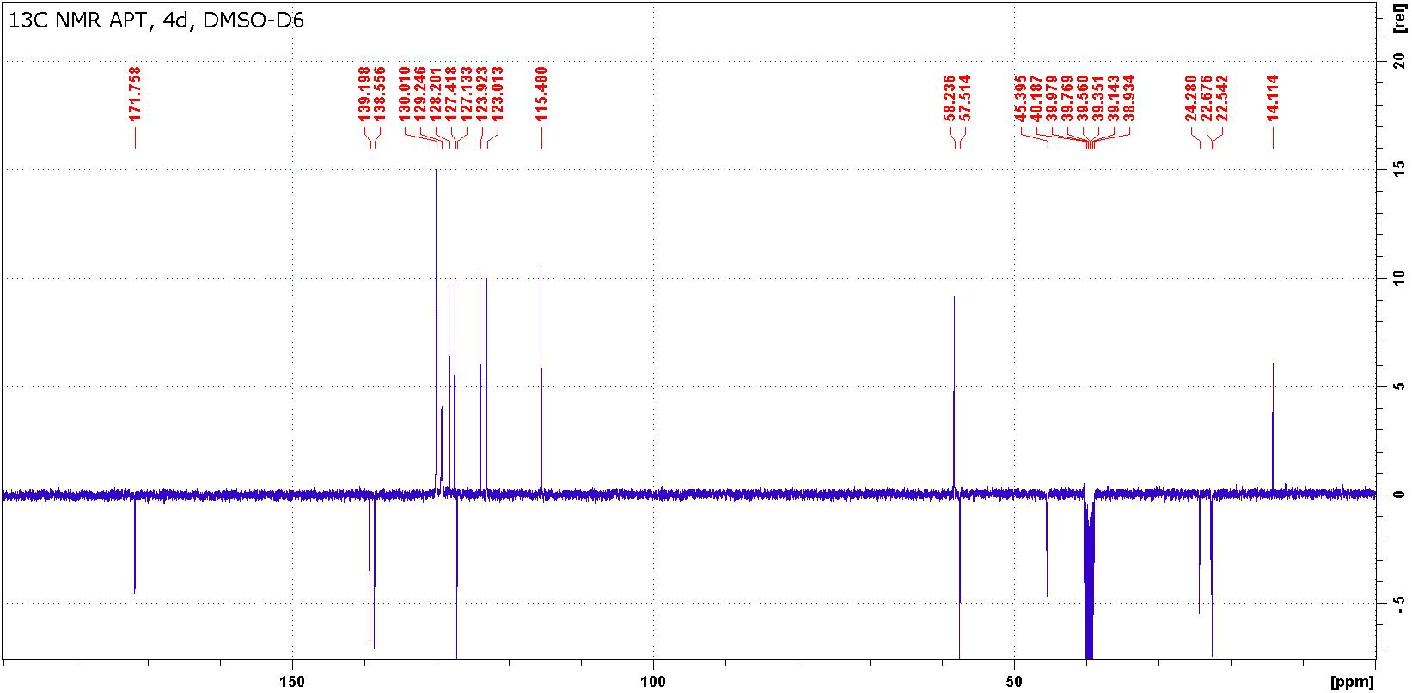
Figure S12: ¹H and ¹³C NMR spectra of compound 4d.

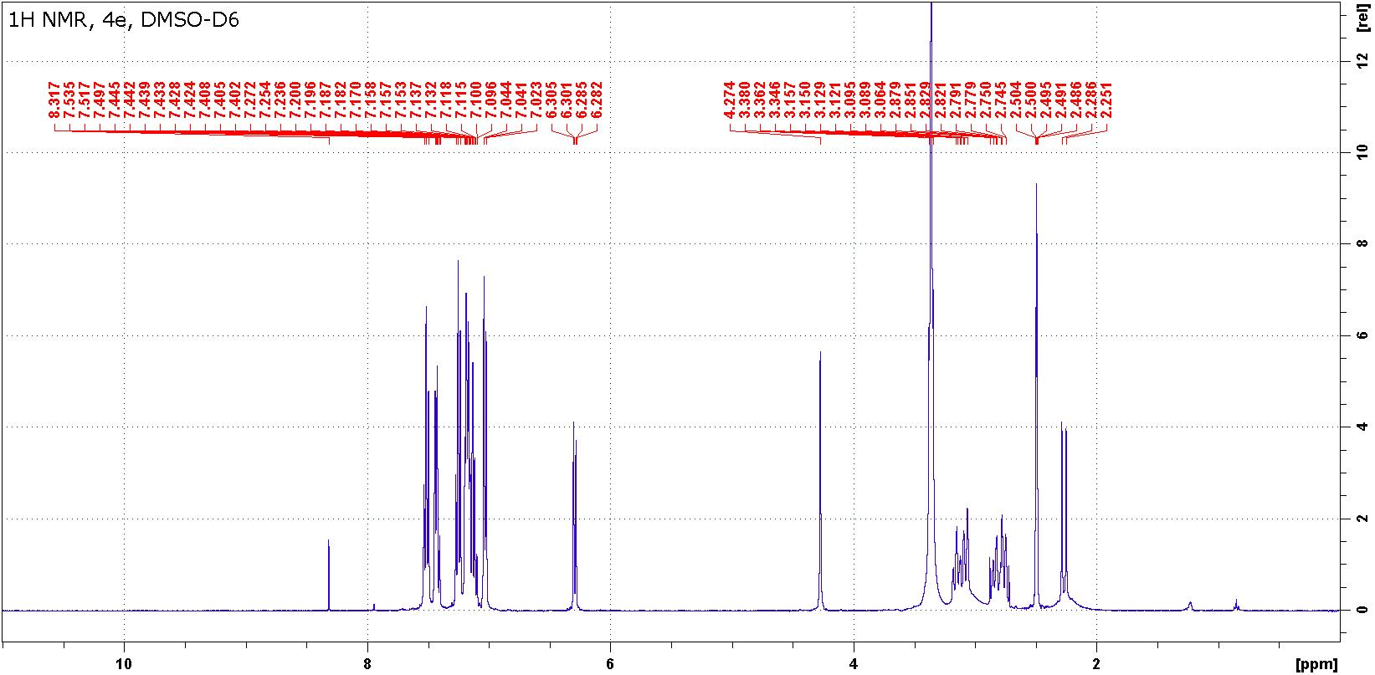

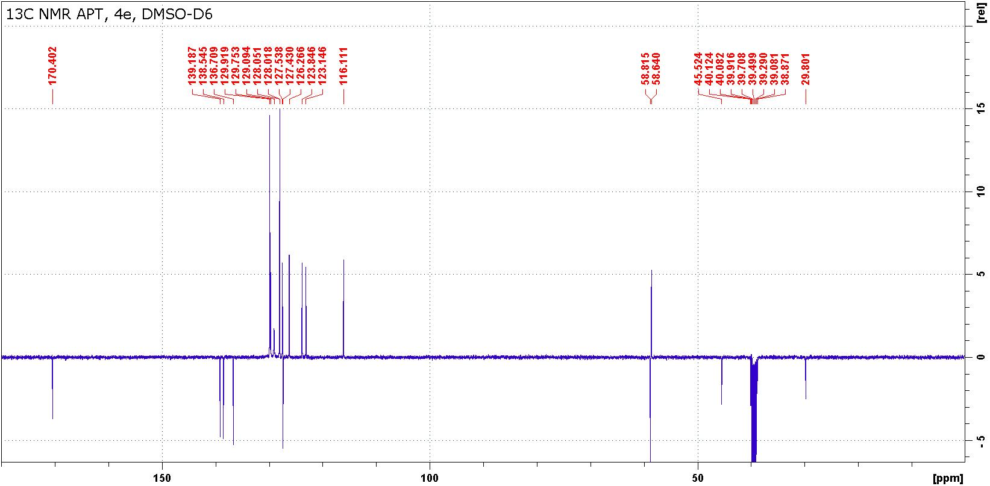

Figure S13: ¹H and ¹³C NMR spectra of compound 4e.

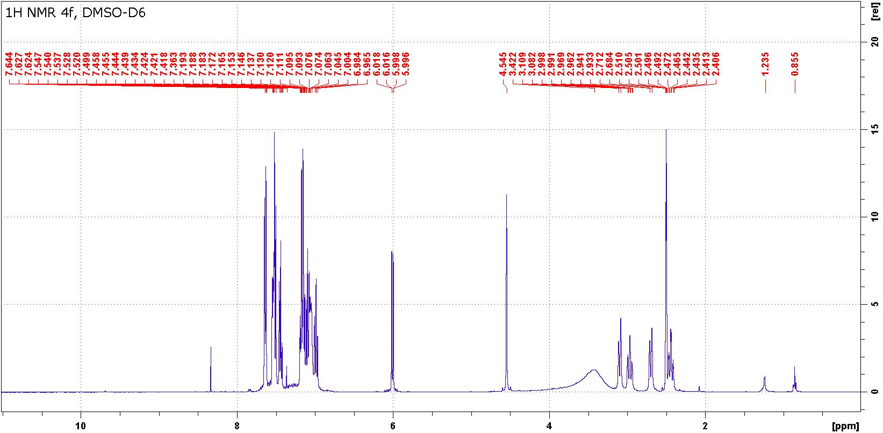

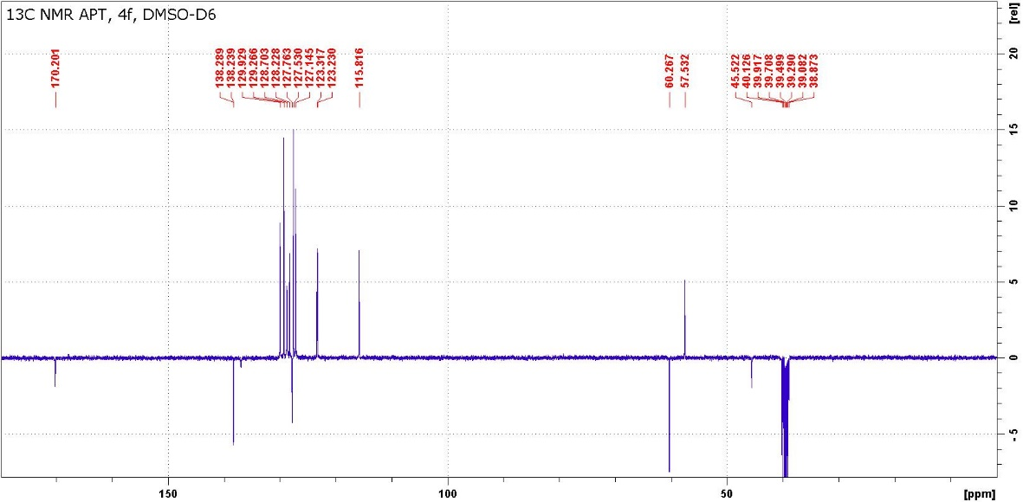
Figure S15: ¹H and ¹³C NMR spectra of compound 4f.

Table S4: ¹H, ¹³C and ¹⁵N chemical shifts and ¹J( ¹⁵N, ¹H) coupling constants of compounds 5 in DMSO-d₆.
Position | 5b |  | 5d |  | 5e
 | δ(H) | δ(C) | δ(H) | δ(C) | δ(H) | δ(C
1 | - | -286.8ª | - | -286.4ª | - | -287.6ª
2 | - | 156.5 | - | 156.92 | - | 156.6
3 | 10.53 | n.o.  95.2 ^{b} | 10.78 | n.o.  90.8 ^{b} | 10.58 | 232.2ª  94.6 ^{b}
4 | - | 173.8 | - | 174.6 | - | 173.8
5 | 4.55 | 60.6 | 4.26 | 59.9 | 4.60 | 60.6
6 | 3.61 | 38.7 | 3.67 | 38.8 | 3.69 | 38.8
7 | 3.85  3.17 | 38.1 | 3.82  3.24 | 38.6 | 3.82  3.20 | 38.2
8 | 8.37 | -286.8ª  88.5 ^{b} | 8.58 | -285.0ª  92.4 ^{b} | 8.56 | -285.0ª  92.7 ^{b}
1´ | - | -262.9ª | - | -241.2ª | - | -241.1ª
2´ | - | 155.2 | - | 154.6 | - | 154.5
3´ | - | -171.2ª | - | -171.4ª | - | -171.7ª
4´ | - | 160.0 | - | 160.6 | - | 160.6
4a´ | - | 109.8 | - | 109.4 | - | 109.4
5´ | 7.95 | 123.7 | 8.04 | 123.7 | 8.02 | 123.6
6´ | 7.20 | 121.0 | 7.19 | 121.4 | 7.21 | 121.3
7´ | 7.67 | 133.9 | 7.45 | 133.6 | 7.49 | 133.5
8´ | 7.34 | 114.4 | 6.40 | 115.0 | 6.41 | 115.0
8a´ | - | 142.8 | - | 143.7 | - | 143.7
1´(R¹) | 3.43 | 30.0 | - | 138.2 | - | 138.2
2´(R¹) | - | - | 7.26 | 128.3 | 7.24 | 128.2
3´(R¹) | - | - | 7.58 | 129.9 | 7.59 | 129.9
4´(R¹) | - | - | 7.49 | 128.3 | 7.50 | 128.2
1´(R²) | 3.14 | 33.4 | 1.76 | 27.4 | 3.20 | 30.9
 | 3.01 |  | 1.73 |  | 3.05
2´(R²) | - | 135.4 | 1.20 | 25.0 | - | 135.4
 |  |  | 1.04
3´(R²) | 7.10 | 128.2 | 1.20 | 21.9 | 7.14 | 128.2
4´(R²) | 7.20 | 129.4 | 0.79 | 13.8 | 7.28 | 129.4
5(R²) | 7.20 | 126.7 | - | - | 7.22 | 126.7
ª δ(¹⁵N) ^{b 1}J( ¹⁵N, ¹H)

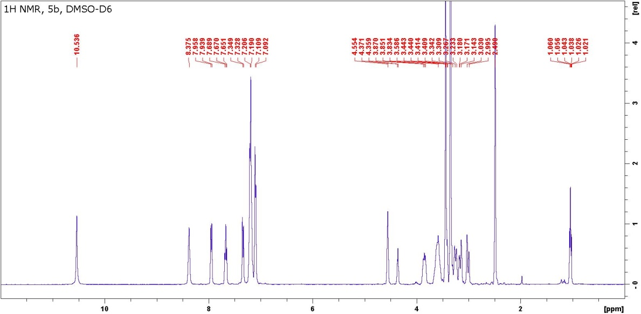

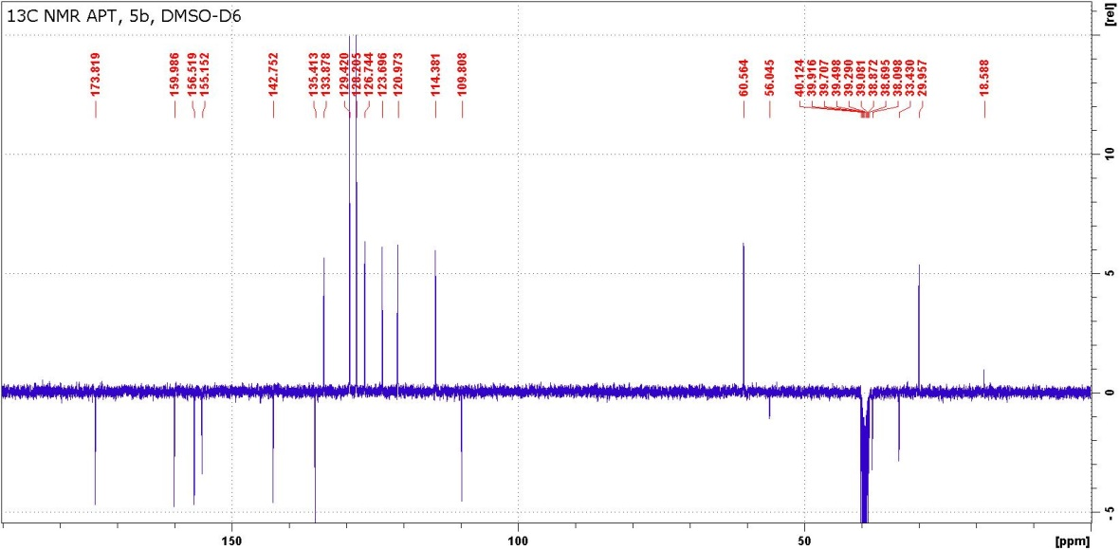

Figure S16: ¹H and ¹³C NMR spectra of compound 5b.

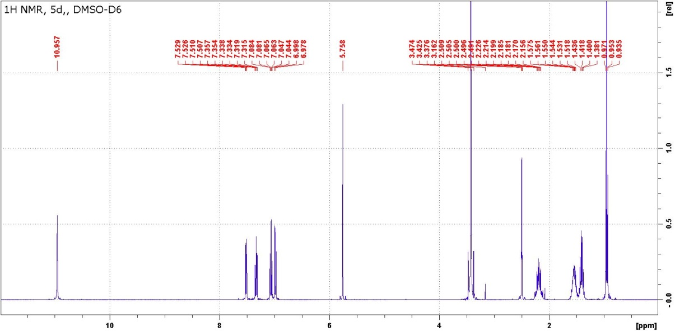

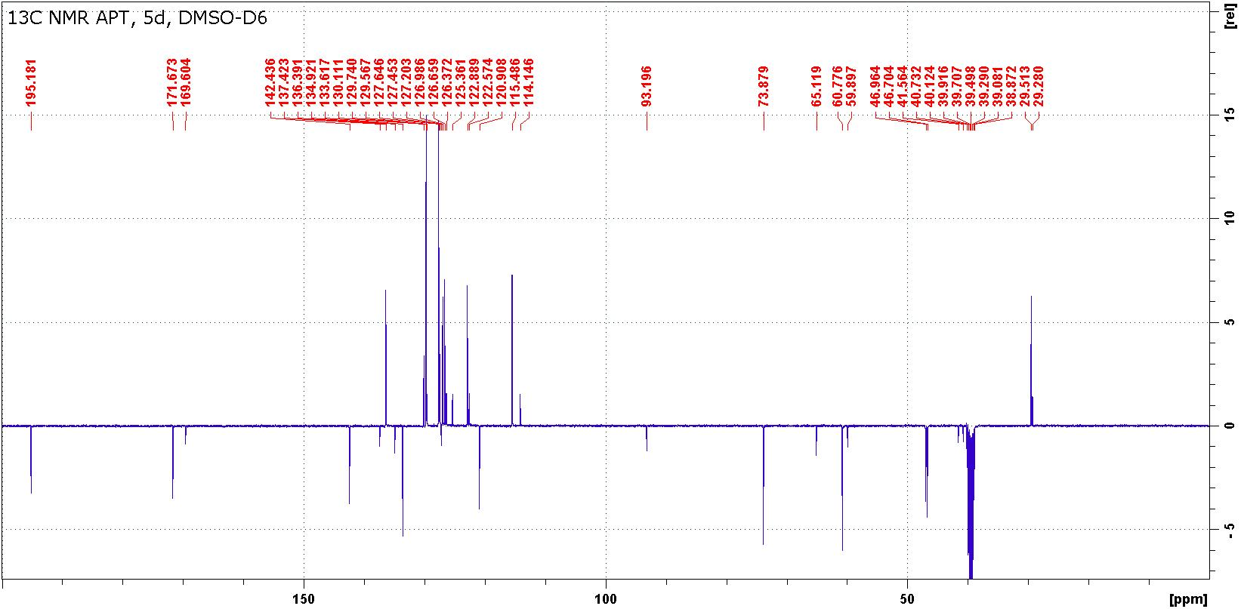
Figure S17: ¹H and ¹³C NMR spectra of compound 5d.

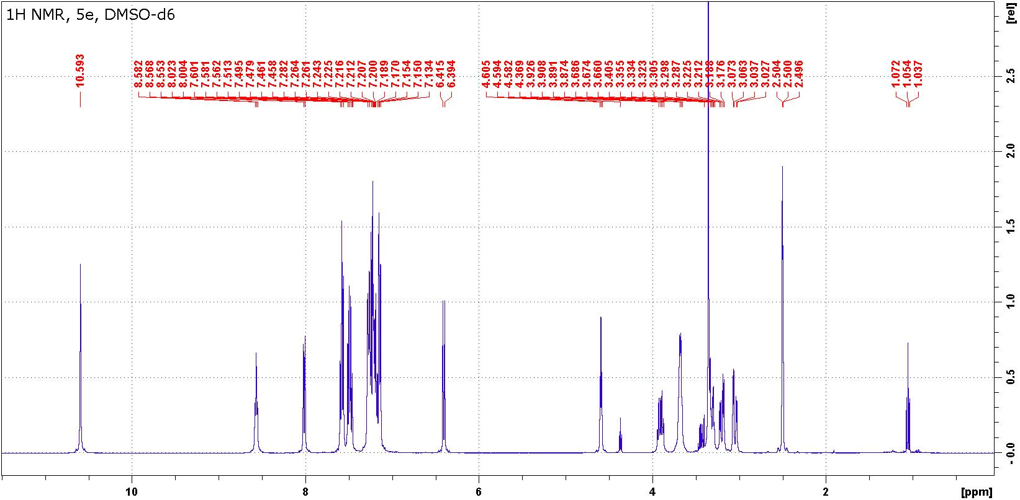

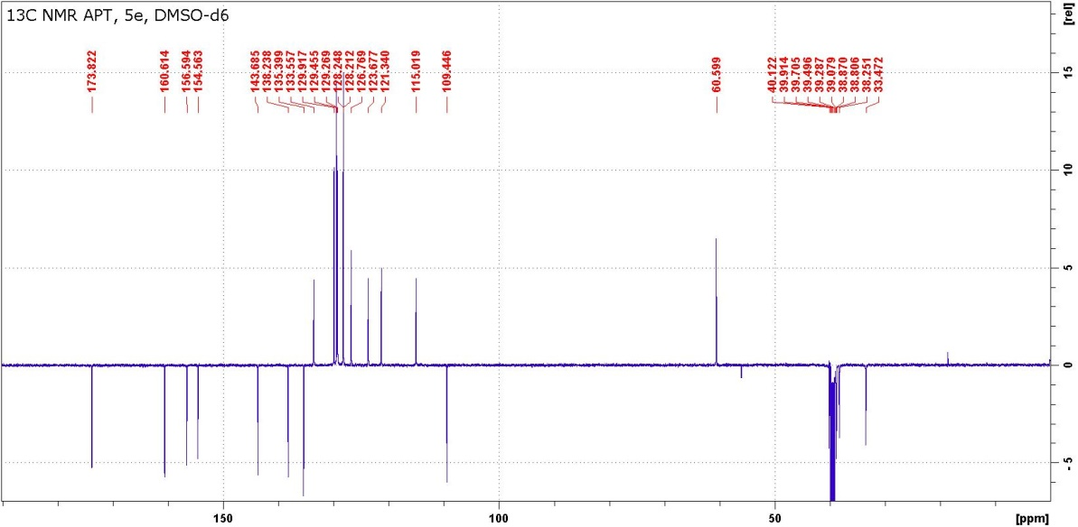

Figure S18: ¹H and ¹³C NMR spectra of compound 5e.

Table S5: ¹H, ¹³C and ¹⁵N chemical shifts of compounds 6 in DMSO-d₆
Position | 6d |  | 6e |  | 6f
 | δ(Η) | δ(C) | δ(Η) | δ(C) | δ(Η) | δ(C)
1 | - | 170.6 | - | 169.9 | - | 170.3
2 | 11.01 | n.o. ª | 10.68 | n.o. ª | 11.05 | n.o. ª
3 | - | 156.2 | - | 155.8 | - | 155.4
4 | - | -290.8ª | - | -291.4ª | - | -285.5ª
5 | 3.82 | 46.4 | 3.93 | 46.6 | 4.03 | 45.5
 |  |  | 3.86 |  | 3.55
6 | 3.82 | 33.9 | 3.78 | 34.0 | 3.48 | 36.2
 | 3.15 |  | 3.42 |  | 3.34
7 | - | -53.7ª | - | -50.6ª | - | -58.2ª
8 | - | 163.1 | - | 162.9 | - | 165.0
8a | - | 68.0 | - | 68.3 | - | 68.9
1´ | - | 128.3 | - | 128.2 | - | 125.3
2´ | - | 141.7 | - | 142.1 | - | 138.8
3´ | 7.10 | 117.9 | 7.12 | 117.7 | 7.19 | 118.9
4´ | 7.19 | 128.7 | 7.22 | 128.9 | 7.23 | 130.8
5´ | 6.86 | 119.7 | 6.93 | 120.1 | 6.82 | 119.4
6´ | 7.10 | 129.3 | 7.22 | 129.4 | 7.25 | 131.6
2´ | 7.15 | -295.9ª | 7.37 | -295.6ª | 8.85 | -292.2ª
 |  | 90.3 ^{b} |  | 90.4^{b} |  | 87.2 ^{b}
1´(R¹) | - | 143.6 | - | 143.5 | - | 142.8
2´(R¹) | 7.02 | 118.6 | 7.02 | 119.1 | 7.01 | 118.9
3´(R¹) | 7.19 | 128.7 | 7.21 | 128.7 | 7.22 | 128.9
4´(R¹) | 6.83 | 120.3 | 6.83 | 120.5 | 6.89 | 120.9
1´(R²) | 1.94 | 32.7 | 3.26 | 38.5 | - | 137.3
 |  |  | 3.36
2´(R²) | 1.15 | 24.7 | - | 133.8 | 7.39 | 126.5
 | 0.98
3´(R²) | 1.15 | 21.7 | 7.02 | 131.2 | 7.42 | 128.9
4´(R²) | 0.74 | 13.7 | 7.20 | 128.3 | 7.42 | 130.0
5´(R²) | - | - | 7.22 | 127.1 | - | -
ª δ(¹⁵N) ^{b 1}J( ¹⁵N, ¹H) ^{c} prochiral NCH₂ 3.41, 3.43/38.5,
COO -/167.0, CH₂ 3.96/61.3, CH₃ 1.03/13.8

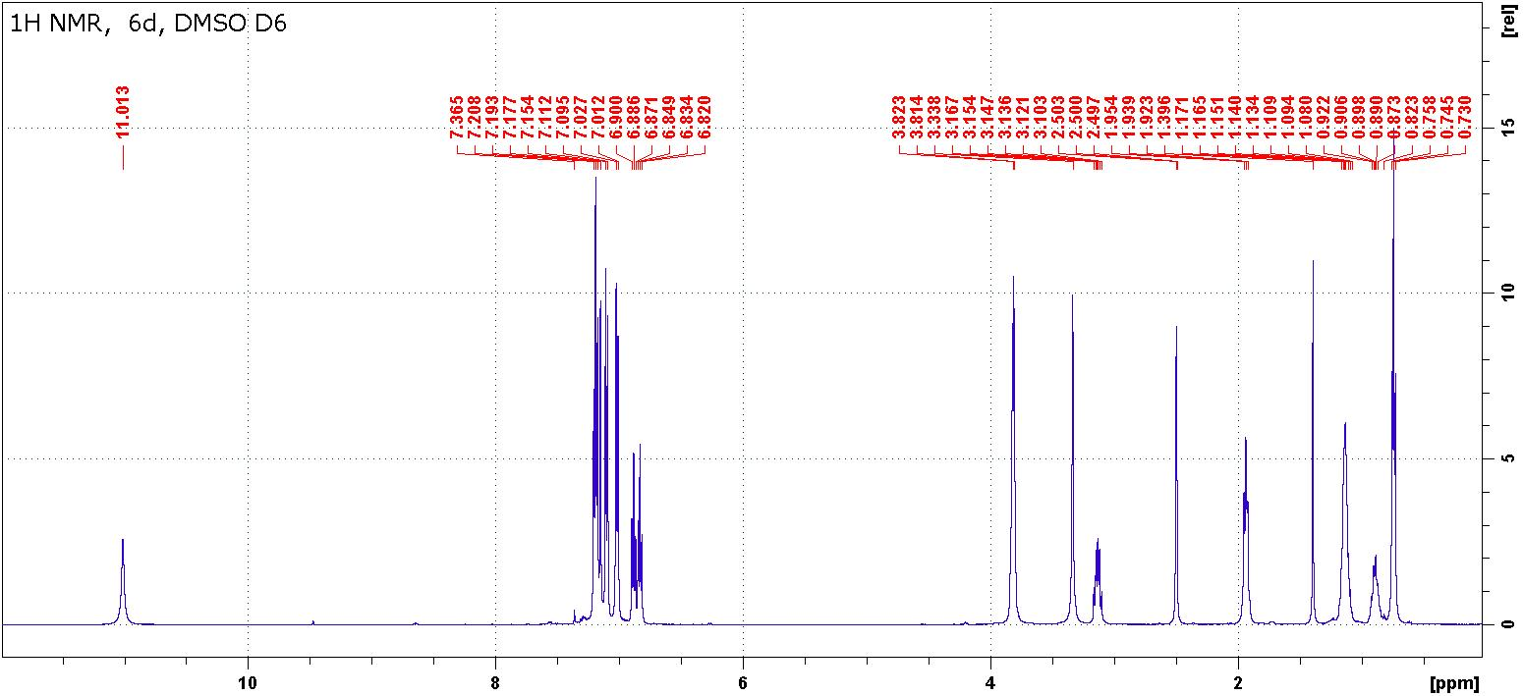

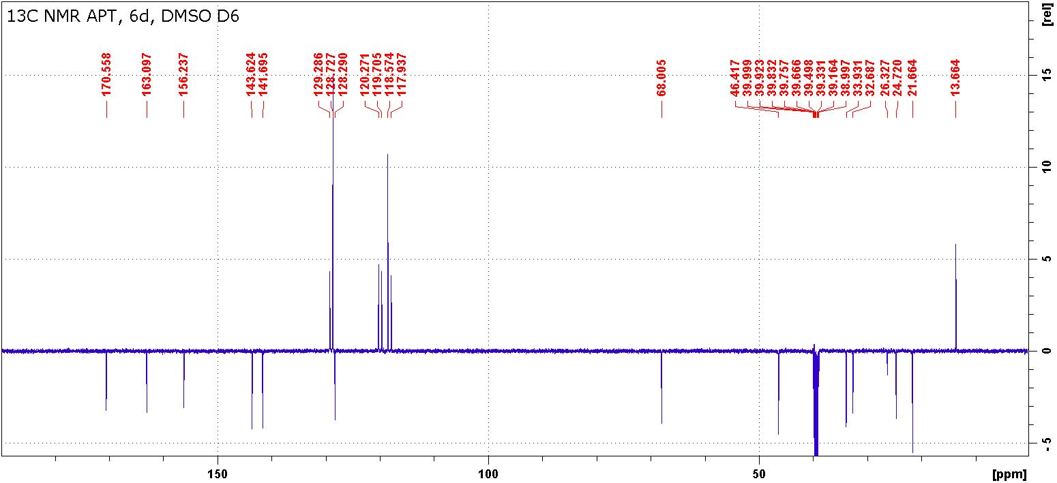
Figure S19: ¹H and ¹³C NMR spectra of compound 6d.

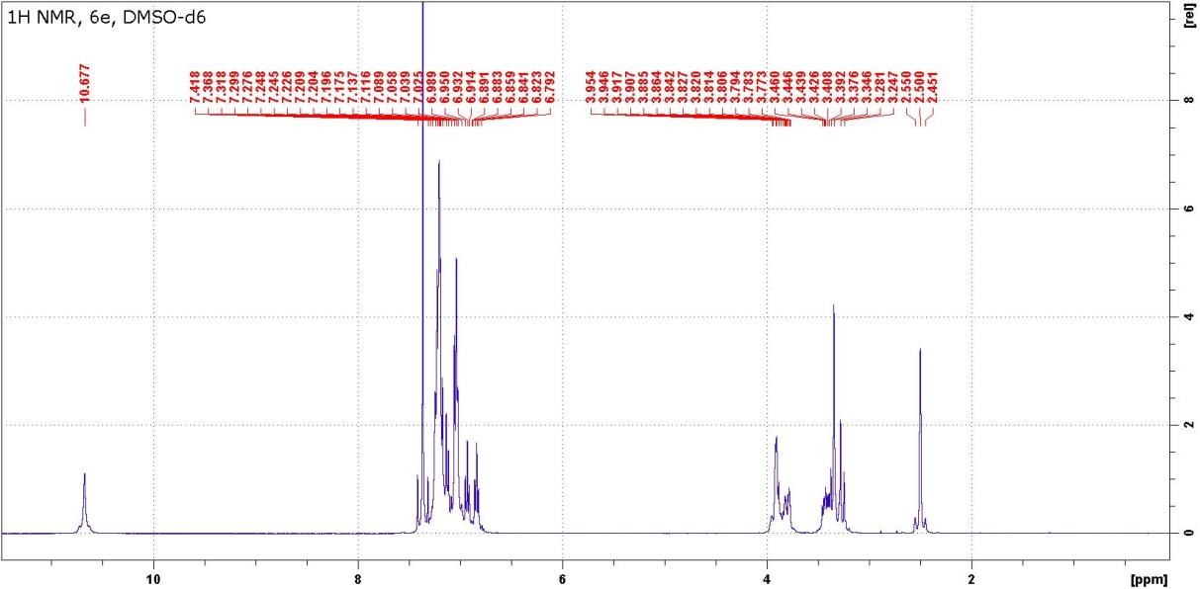

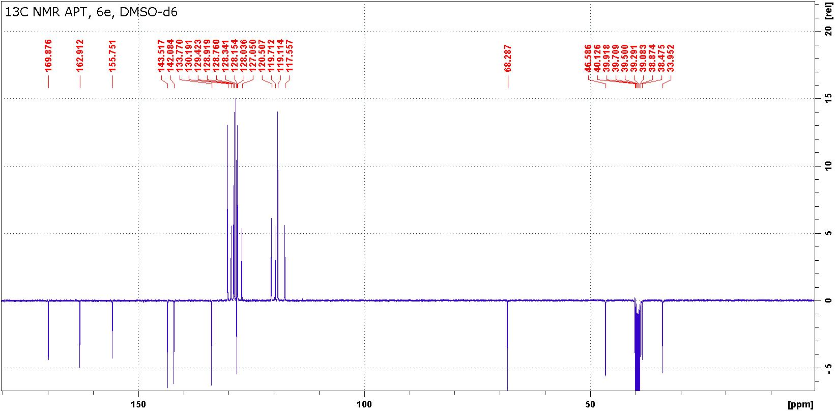
Figure S20: ¹H and ¹³C NMR spectra of compound 6e.

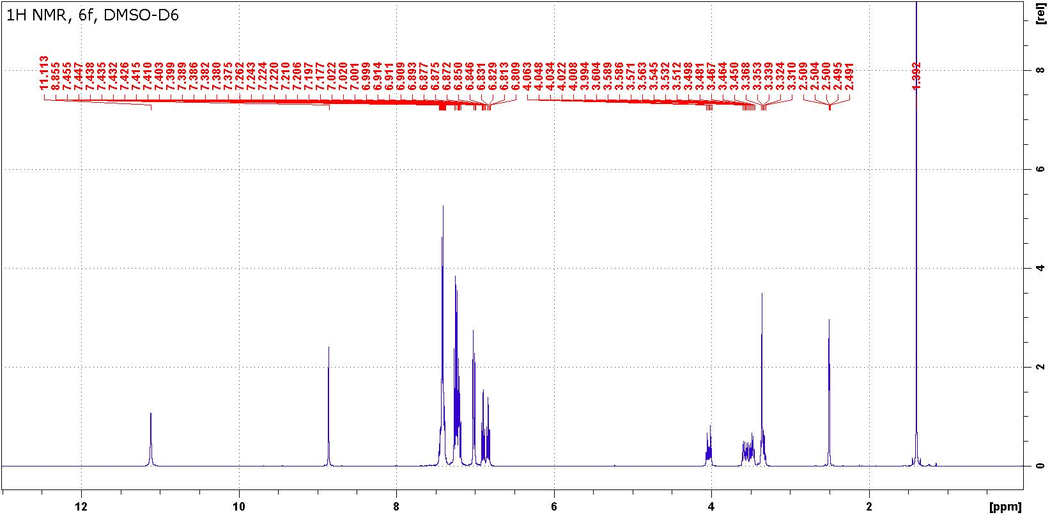

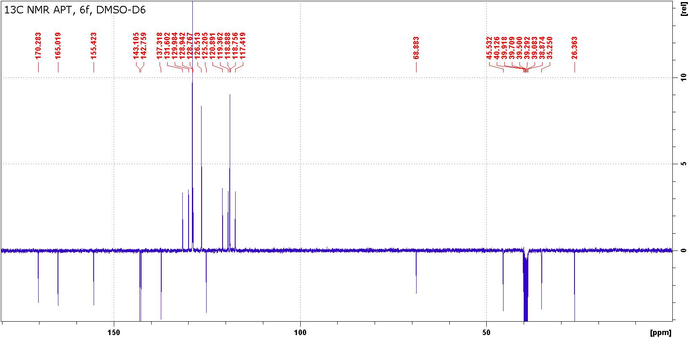
Figure S21: ¹H and ¹³C NMR spectra of compound 6f.

Table S6: ¹H, ¹³C and ¹⁵N chemical shifts and ¹J(¹⁵N, ¹H ) coupling constants of compounds 7 in DMSO-d₆ or in CDCl₃.
Position | 7a |  | 7b |  | 7cª |  | 7dª |  | 7e
 | δ(H) | δ(C) | δ(H) | δ(C) | δ(H) | δ(C) | δ(H) | δ(C) | δ(H) | δ(C
1 | - |  | - | - | - | -62.7^{b} | - | -54.1^{b} | - | -
2 | 3.94 | n.o. | 3.66 | 48.6 | 4.70 | 50.5 | 4.21 | 50.4 | 3.66 | 48.5
 |  |  |  |  | 2.83 |  | 3.69 | -
3 | 3.80 | 40.1 | 3.61 | 40.4 | 4.27 | 39.7 | 3.48 | 40.1 | 3.74 | 40.4
 | 3.49 |  | 2.74 |  | 4.00 |  | 2.77 | - | 2.74
4 | - |  | - | - | - | -288.5^{b} | - | -296.1^{b} | - | -
C=O | - | 159.9 | - | 160.3 | - | 159.7 | - | 160.7 | - | 160.3
NH₂ | 6.12 | - | 6.22 | - | 4.53 | -300.9^{b, c} | 5.21 | -301.9^{b,d} | 6.24 | -
4a | - | n.o. | - | 69.2 | - | 71.3 | - | 68.8 | - | 69.2
5 | - | 168.5 | - | 167.8 | - | 167.6 | - | 171.5 | - | 167.7
6 | - |  | - | - | - | -252.1^{b} | - | -234.8^{b} | - | -
6a | - | 139.3 | - | 139.6 | - | 138.2 | - | 137.5 | - | 138.4
7 | 7.20 | 114.8 | 7.20 | 115.1 | 7.01 | 114.4 | 6.42 | 116.4 | 6.24 | 115.9
8 | 7.51 | 131.7 | 7.53 | 131.9 | 7.33 | 131.4 | 7.27 | 131.4 | 7.32 | 131.5
9 | 7.13 | 122.8 | 7.20 | 123.0 | 6.98 | 124.1 | 7.17 | 124.2 | 7.19 | 123.0
10 | 7.74 | 125.2 | 7.75 | 125.9 | 7.51 | 126.1 | 7.96 | 126.2 | 7.84 | 127.0
10a | - | 124.6 | - | 122.9 | - | 124.6 | - | 123.1 | - | 122.5
10b | - | 162.5 | - | 161.1 | - | 161.1 | - | 161.3 | - | 161.4
1´(R¹) | 3.31 | 30.3 | 3.35 | 30.7 | 3.59 | 30.8 | - | 139.2 | - | 140.3
2´(R¹) | - | - | - | - | - | - | 7.29 | 129.2 | 7.25 | 128.3
 |  |  |  |  |  |  | 7.19 | 128.2
3´(R¹) | - | - | - | - | - | - | 7.56 | 130.1 | 7.52 | 130.1
4´(R¹) | - | - | - | - | - | - | 7.50 | 129.0 | 7.43 | 128.5
1´(R²) | 1.58 | 30.3 | 2.60, | 39.7 | - | 137.7 | 3.19 | 34.8 | 3.05, | 39.8
 |  |  | 2.32 |  |  |  | 1.95 | - | 2.99
2´(R²) | 1.19 | 25.2 | - | 135.4 | 7.20 | 126.3 | 1.36 | 25.2 | - | 135.3
 | 0.85 |  |  |  |  |  | 1.06 | -
3´(R²) | 1.03 | 21.7 | 6.91 | 129.8 | 7.20 | 129.4 | 1.21 | 22.1 | 6.99 | 129.5
4´(R²) | 0.66 | 13.7 | 7.20 | 127.5 | 7.20 | 129.1 | 0.81 | 13.7 | 7.20 | 127.6
5(R²) | - | - | 7.20 | 129.8 | - | - | . | - | 7.20 | 129.8
ª in CDCl₃ ^{b} δ(¹⁵N) ^{¨c} ¹J(¹⁵N, ¹H) = 86.4 Hz ^{d,1}J(¹⁵N, ¹H) = 83.6 Hz

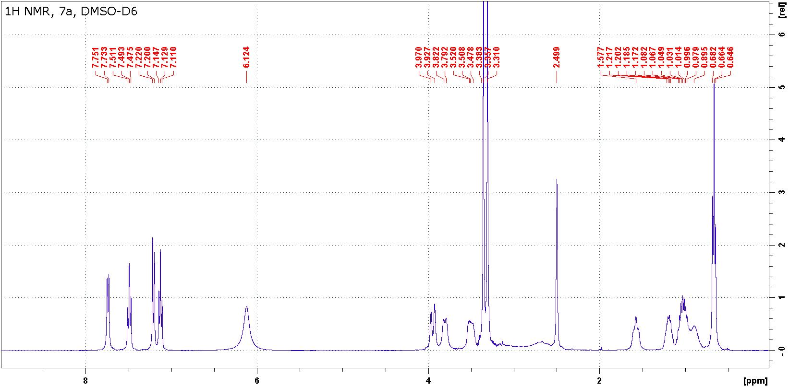

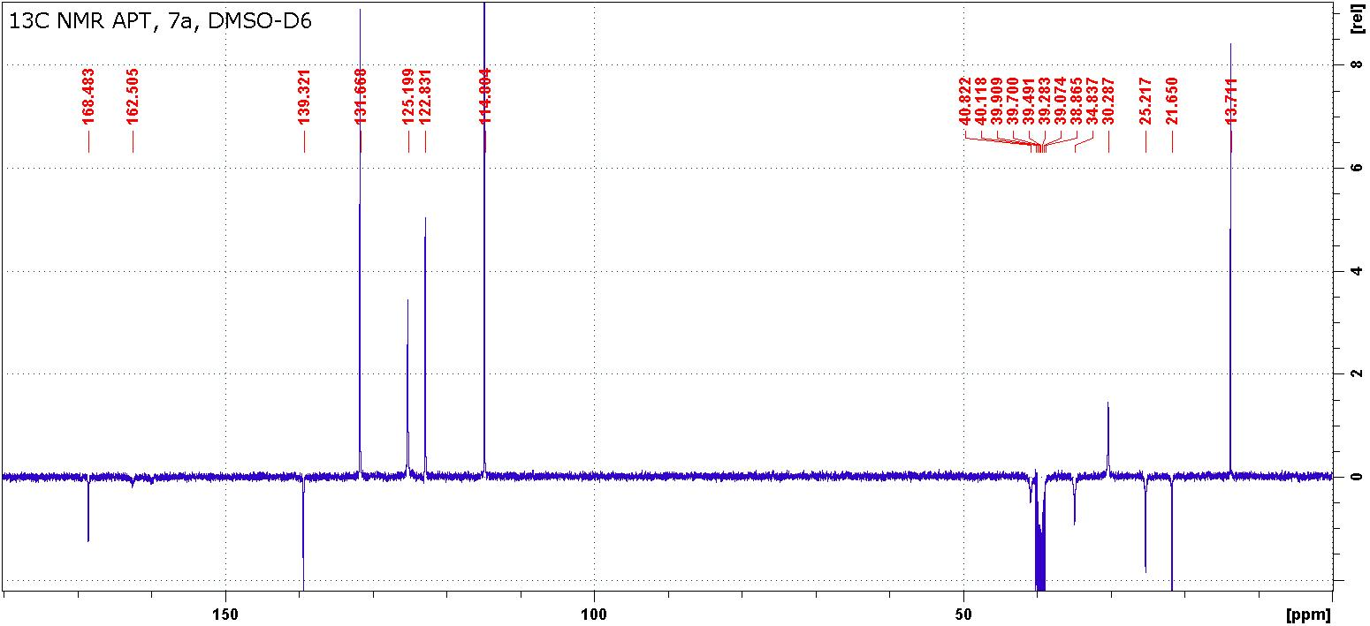

Figure S22: ¹H and ¹³C NMR spectra of compound 7a.

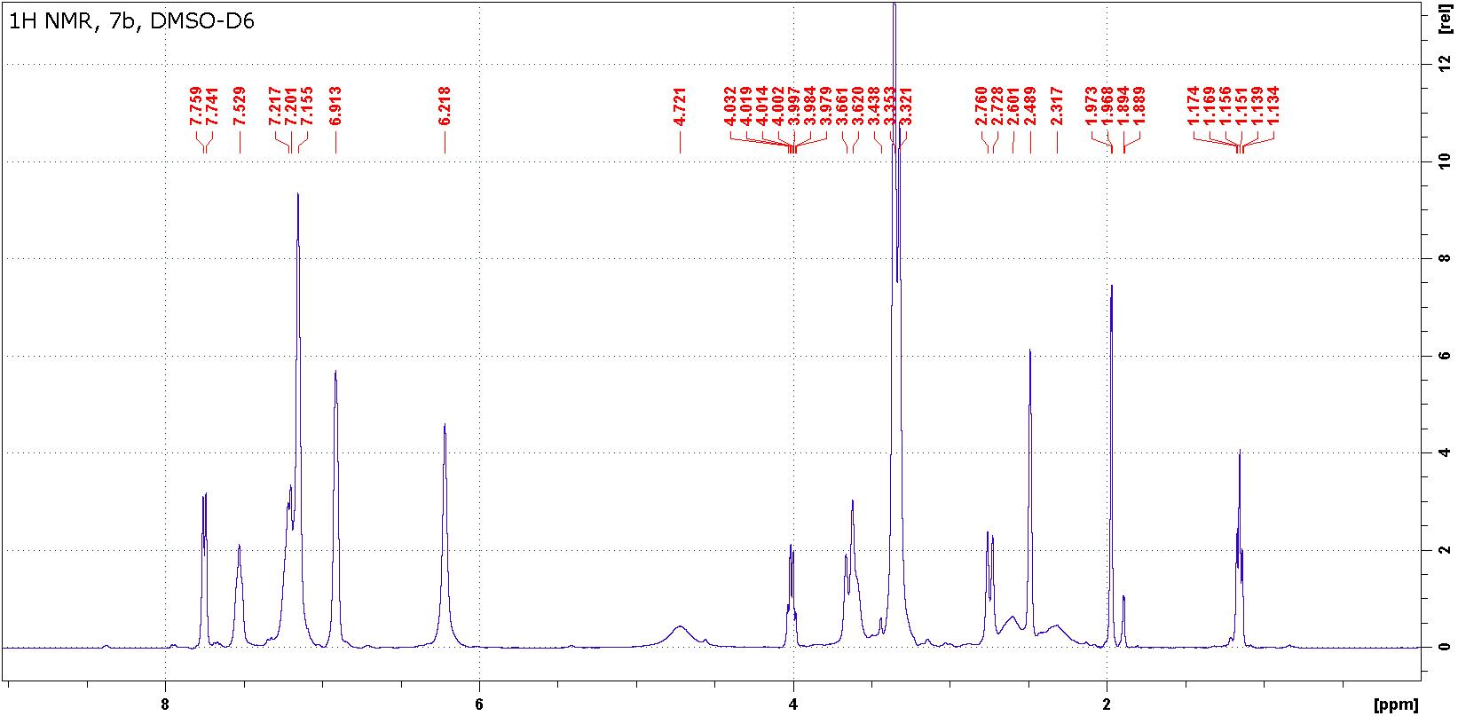

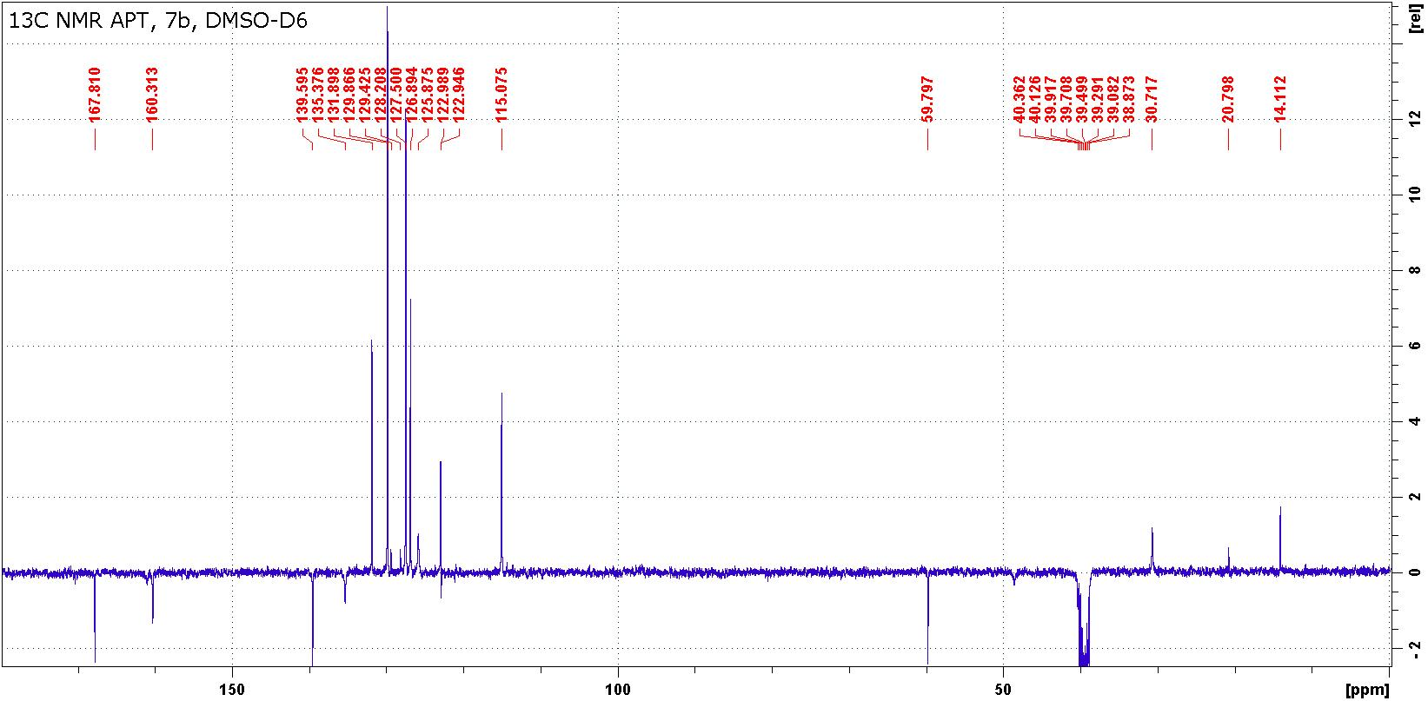

Figure S23: ¹H and ¹³C NMR spectra of compound 7b (contains ethanol).

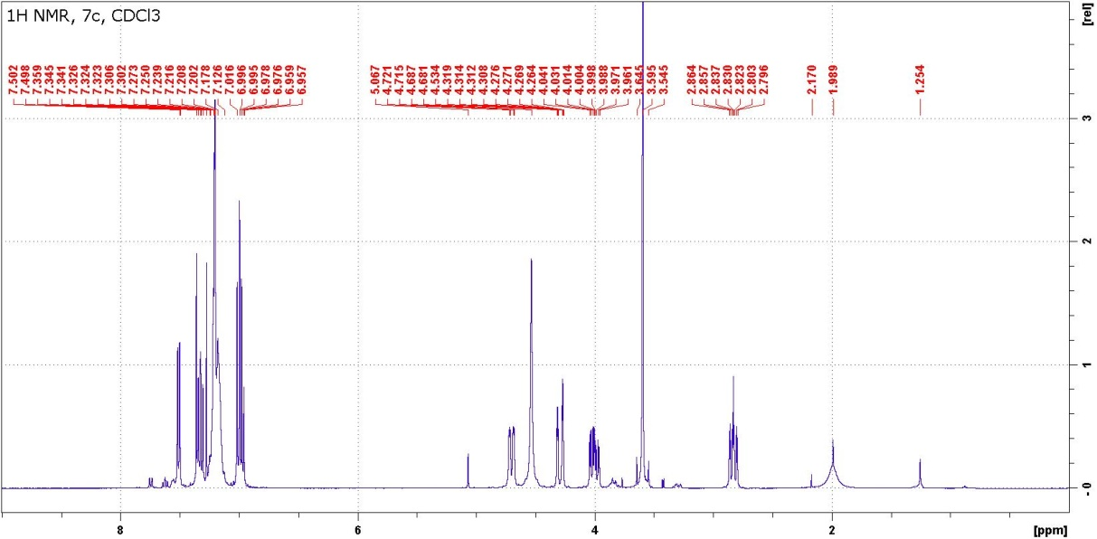

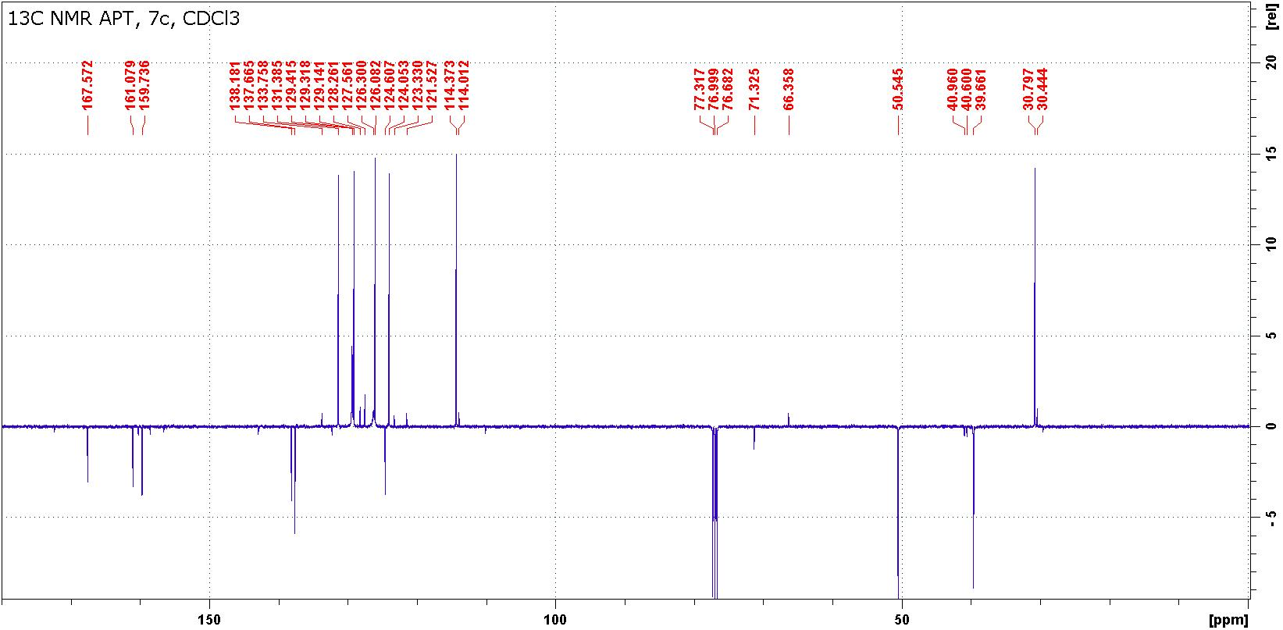
Figure S24: ¹H and ¹³C NMR spectra of compound 7c.

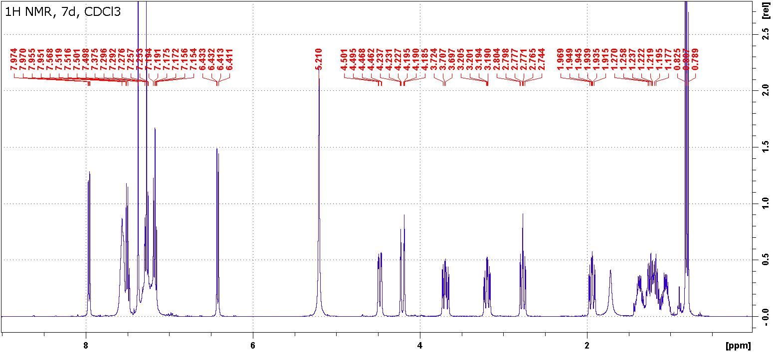

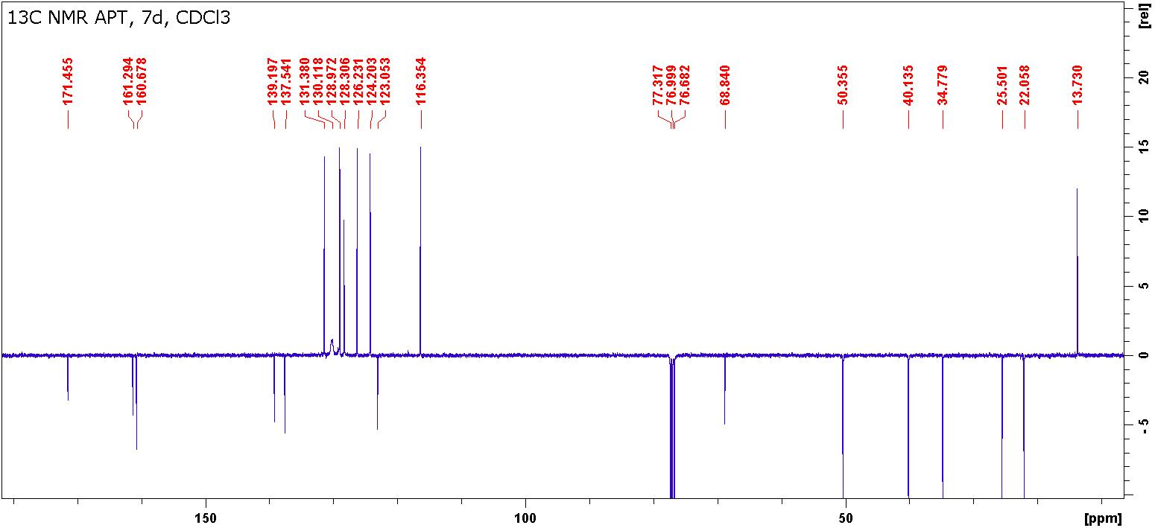

Figure S25: ¹H and ¹³C NMR spectra of compound 7d.

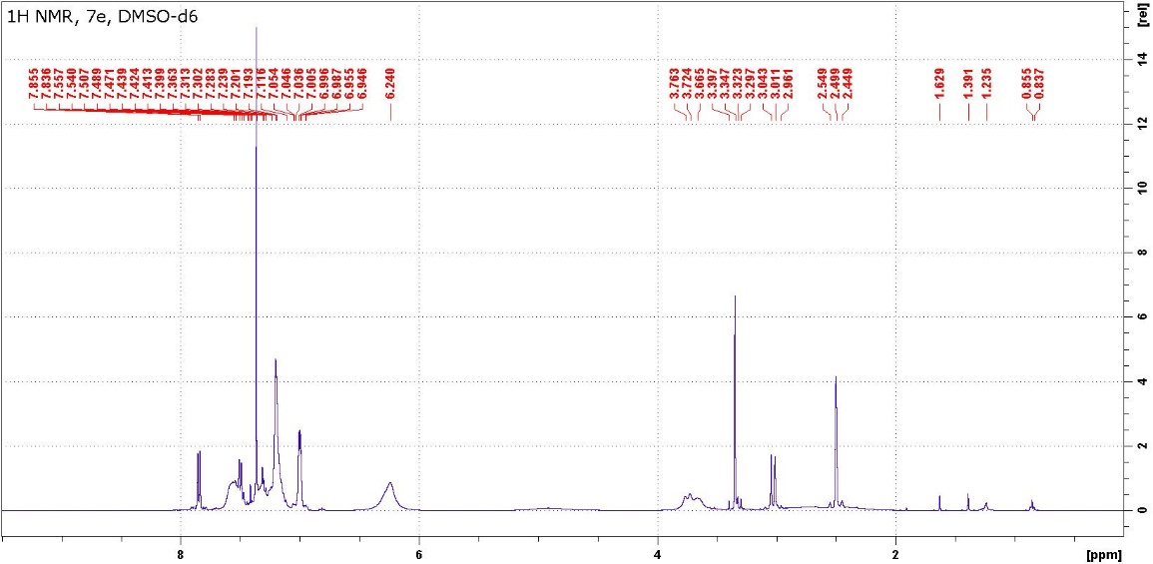

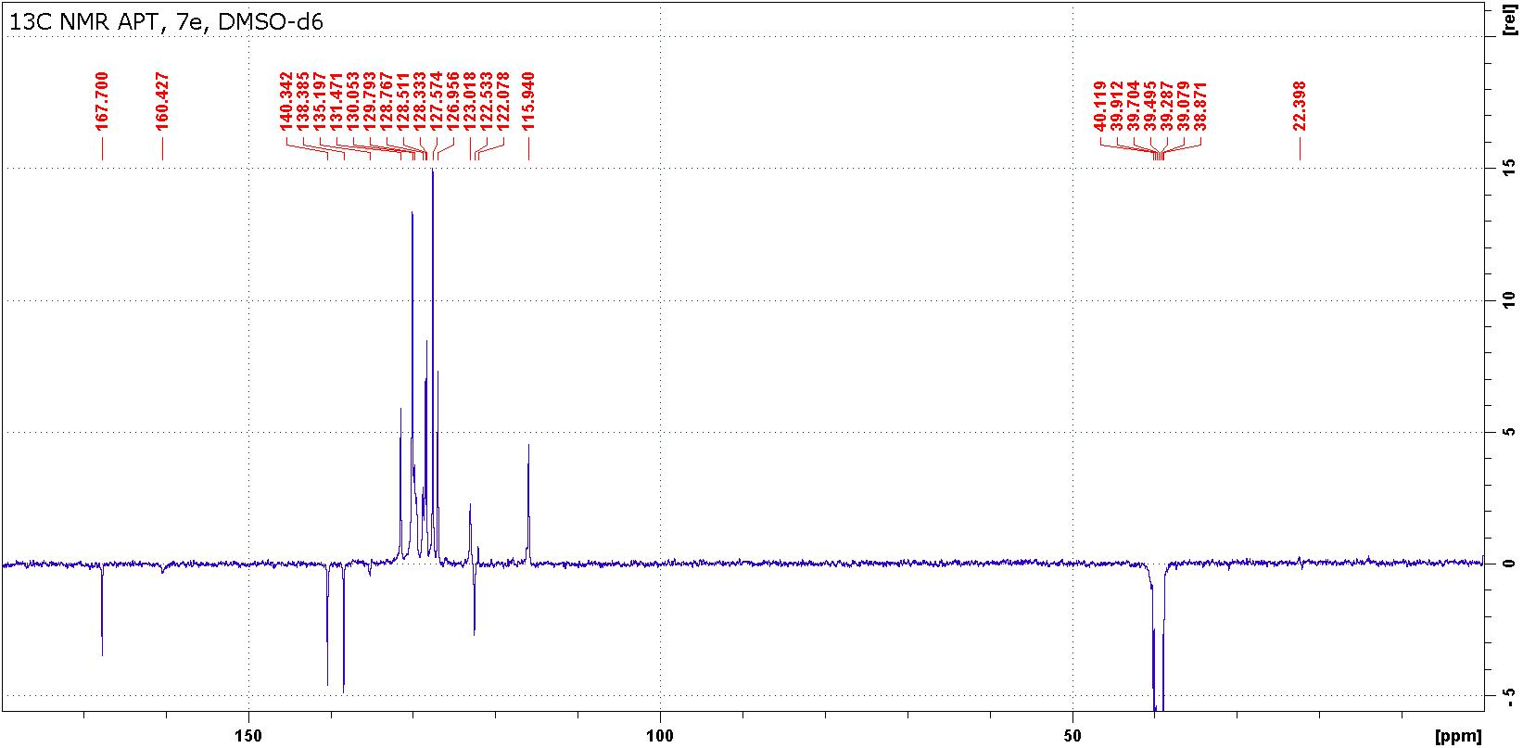
Figure S26: ¹H and ¹³C NMR spectra of compound 7e.

Comment: Signals of C(4a) in DMSO-D6 are very broad and they are visible after application of line broadening (lb = 10-20z) as very broad singlets while in CDCl3 solutions, these resonances (compounds 7c and 7d) are easily detectable.

Table S7: ¹H, ¹³C and ¹⁵N chemical shifts and ¹J(¹⁵N, ¹H ) coupling constants of compound 8f in DMSO-d₆.
Position | 8f |  | Position | 8f
 | δ(H) | δ(C) |  | δ(H) | δ(C)
1 | - | -284.5ª | 11 | - | -292.2^{a,d}
2 | - | 158.8 | 12 | 7.29 | 114.9
3 | 11.03 | -235.5^{a,b} | 13 | 7.32 | 131.9
4 | - | 172.9 | 14 | 6.83 | 118.1
5 | 5.22 | 64.3 | 15 | 7.57 | 128.9
6 | 3.38 | 36.6 | 1´(R¹) | - | 141.5
 | 3.31 | - | 2´(R¹) | 7.15 | 119.4
7 | 3.77 | 39.6 | 3´(R¹) | 7.30 | 1294
 | 2.78 | - | 4´(R¹) | 6.97 | 121.7
8 | 9.44 | -269.^{0a,c} | 1´(R²) | - | 133.8
9 | - | 169.1 | 2´(R²) | 7.26 | 127.6
10 | - | 119.0 | 3´(R²) | 7.36 | 129.1
11 | - | 144.0 | 4´(R²) | 7.36 | 128.8
ªδ (¹⁵N) ^{b 1}J (¹⁵N, ¹H) = 94.6 Hz ^{c 1}J (¹⁵N, ¹H) = 91.5 Hz ^{d 1}J (¹⁵N, ¹H) = 89.5 Hz

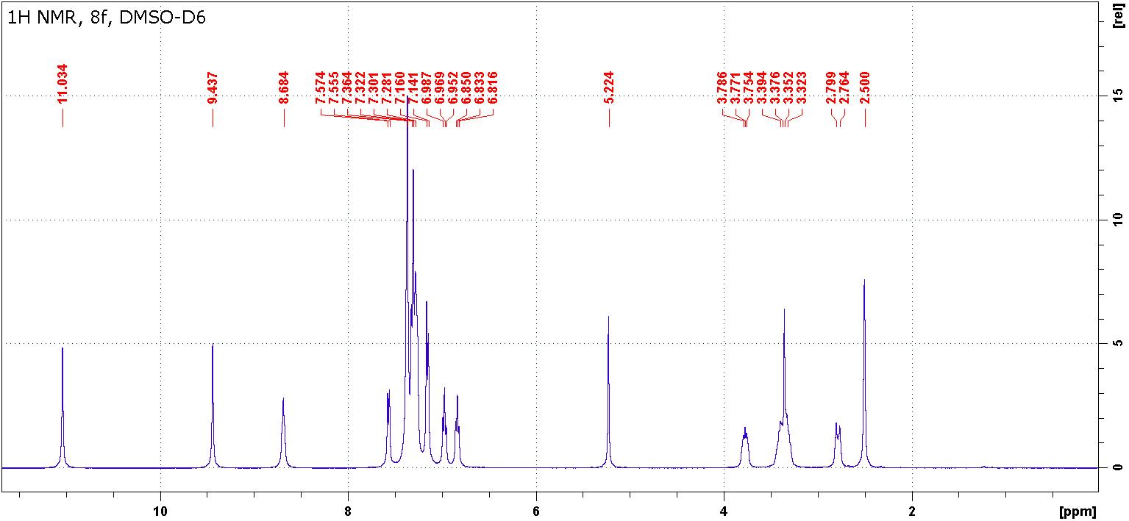
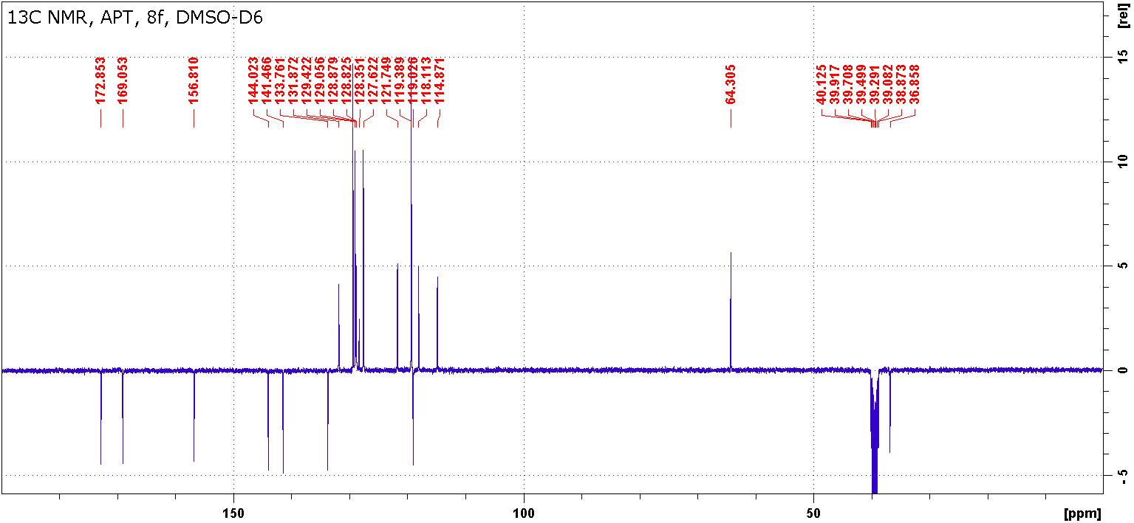

Figure S27: ¹H and ¹³C NMR spectra of compound 8f.

Crystal data and structure refinement of compounds 5d, 7a, 7b

X-ray crystallography-experimental details
Full-sets of diffraction data for 5d (yellow) and 7a (colourless) were collected at 150(2)K with a Bruker D8-Venture diffractometer equipped with Cu (Cu/K_{α} radiation; λ =1.54178 Å) or Mo (Mo/K_{α} radiation; λ = 0.71073 Å) microfocus X-ray (IµS) sources, Photon CMOS detector and Oxford Cryosystems cooling device was used for data collection. The frames were integrated with the Bruker SAINT software package using a narrow-frame algorithm. Data were corrected for absorption effects using the Multi-Scan method (SADABS). Obtained data were treated by XT-version 2018/1 and SHELXL-2017/1 software implemented in APEX3 v2016.5-0 (Bruker AXS) system.¹ Hydrogen atoms were mostly localized on a difference Fourier map, however to ensure uniformity of treatment of crystal, all hydrogen atoms were recalculated into idealized positions (riding model) and assigned temperature factors H_{iso}(H) = 1.2 U_{eq} (pivot atom) or of 1.5U_{eq} (methyl). H atoms in methyl, methylene and hydrogen atoms in aromatic rings were placed with C-H distances of 0.98, 0.97 and 0.95Å, respectively, and hydrogen atom of N-H or O-H (H3 fixed in appropriate position) group refined freely. Crystallographic data for structural analysis have been deposited with the Cambridge Crystallographic Data Centre, CCDC nos. 2047078, 2047079 and 2055718, respectively. Copies of this information may be obtained free of charge from The Director, CCDC, 12 Union Road, Cambridge CB2 1EY, UK (fax: +44-1223-336033; e-mail: deposit@ccdc.cam.ac.uk or www: http://www.ccdc.cam.ac.uk).

[1] G. M. Sheldrick, Crystal structure refinement with SHELXL; Acta Cryst. (2015). C71, 3-8 https://doi.org/10.1107/S2053229614024218]

Figure S28: Molecular structure of 5d – ORTEP view, 40% probability level.

Figure S29: Molecular structure of 5d – H-bonding representation.
Table S8: Experimental details for 5d.
Crystal data
Chemical formula | C₂₃H₂₅N₅O₃
M_{r} | 419.48
Crystal system, space group | Monoclinic, P2₁/c
Temperature (K) | 150
a, b, c (Å) | 15.5947 (11), 9.8133 (7), 14.8551 (12)
β (°) | 114.200 (2)
V (Å³) | 2073.6 (3)
Z | 4
Radiation type | Mo Kα
µ (mm⁻¹) | 0.09
Crystal size (mm) | 0.59 × 0.31 × 0.06
Data collection
Diffractometer | Bruker D8 - Venture
Absorption correction | Multi-scan  SADABS2016/2 - Bruker AXS area detector scaling and absorption correction
T_{min}, T_{max} | 0.640, 0.746
No. of measured, independent and  observed [I > 2σ(I)] reflections | 45891, 4767, 3859
R_{int} | 0.101
(sin θ/λ)_{max} (Å⁻¹) | 0.651
Refinement
R[F² > 2σ(F²)], wR(F²), S | 0.083, 0.163, 1.25
No. of reflections | 4767
No. of parameters | 285
No. of restraints | 243
H-atom treatment | H atoms treated by a mixture of independent and constrained refinement
Δρ_{max}, Δρ_{min} (e Å⁻³) | 0.37, −0.41
Computer programs: Bruker Instrument Service vV6.2.3, APEX3 v2016.5-0 (Bruker AXS), SAINT V8.37A (Bruker AXS Inc., 2015), XT, VERSION 2014/5, SHELXL2014/7 (Sheldrick, 2014), PLATON (Spek, 2009).

Table S9: Geometric parameters (Å, º) for 5d.
O1-C1 | 1.232 (3) | C10-C11 | 1.382 (4)
N1-C2 | 1.328 (3) | C10-H10 | 0.9500
N1-C1 | 1.368 (3) | C11-C12 | 1.386 (4)
C1-N2 | 1.398 (3) | C11-H11 | 0.9500
N2-C4 | 1.395 (3) | C12-C13 | 1.379 (4)
N2-C9 | 1.446 (3) | C12-H12 | 0.9500
O2-C17 | 1.226 (3) | C13-C14 | 1.385 (4)
C2-N3 | 1.334 (3) | C13-H13 | 0.9500
C2-C3 | 1.458 (3) | C14-H14 | 0.9500
O3-C18 | 1.209 (3) | C15-C16 | 1.520 (4)
N3-C15 | 1.459 (3) | C15-H15A | 0.9900
N3-H3 | 0.80 (3) | C15-H15B | 0.9900
C3-C5 | 1.399 (3) | C16-H16A | 0.9900
C3-C4 | 1.401 (3) | C16-H16B | 0.9900
C4-C8 | 1.398 (4) | C18-C19 | 1.528 (3)
N4-C17 | 1.347 (3) | C19-C20 | 1.531 (3)
N4-C16 | 1.456 (3) | C19-H19 | 1.0000
N4-C19 | 1.462 (3) | C20-C21 | 1.512 (4)
C5-C6 | 1.375 (4) | C20-H20A | 0.9900
C5-H5 | 0.9500 | C20-H20B | 0.9900
N5-C18 | 1.366 (3) | C21-C22 | 1.524 (4)
N5-C17 | 1.391 (3) | C21-H21A | 0.9900
N5-H5A | 0.8800 | C21-H21B | 0.9900
C6-C7 | 1.390 (4) | C22-C23 | 1.511 (4)
C6-H6 | 0.9500 | C22-H22A | 0.9900
C7-C8 | 1.380 (4) | C22-H22B | 0.9900
C7-H7 | 0.9500 | C23-H23A | 0.9800
C8-H8 | 0.9500 | C23-H23B | 0.9800
C9-C10 | 1.381 (4) | C23-H23C | 0.9800
C9-C14 | 1.388 (3)
C2-N1-C1 | 120.6 (2) | C13-C14-C9 | 119.2 (2)
O1-C1-N1 | 122.0 (2) | C13-C14-H14 | 120.4
O1-C1-N2 | 118.9 (2) | C9-C14-H14 | 120.4
N1-C1-N2 | 119.1 (2) | N3-C15-C16 | 111.6 (2)
C4-N2-C1 | 121.8 (2) | N3-C15-H15A | 109.3
C4-N2-C9 | 118.7 (2) | C16-C15-H15A | 109.3
C1-N2-C9 | 119.28 (19) | N3-C15-H15B | 109.3
N1-C2-N3 | 118.9 (2) | C16-C15-H15B | 109.3
N1-C2-C3 | 122.4 (2) | H15A-C15-H15B | 108.0
N3-C2-C3 | 118.7 (2) | N4-C16-C15 | 113.4 (2)
C2-N3-C15 | 125.4 (2) | N4-C16-H16A | 108.9
C2-N3-H3 | 119 (2) | C15-C16-H16A | 108.9
C15-N3-H3 | 115 (2) | N4-C16-H16B | 108.9
C5-C3-C4 | 119.2 (2) | C15-C16-H16B | 108.9
C5-C3-C2 | 124.2 (2) | H16A-C16-H16B | 107.7
C4-C3-C2 | 116.6 (2) | O2-C17-N4 | 127.7 (2)
N2-C4-C8 | 121.6 (2) | O2-C17-N5 | 124.4 (2)
N2-C4-C3 | 118.7 (2) | N4-C17-N5 | 107.9 (2)
C8-C4-C3 | 119.7 (2) | O3-C18-N5 | 127.4 (2)
C17-N4-C16 | 123.3 (2) | O3-C18-C19 | 125.9 (2)
C17-N4-C19 | 111.79 (19) | N5-C18-C19 | 106.67 (19)
C16-N4-C19 | 121.7 (2) | N4-C19-C18 | 101.41 (19)
C6-C5-C3 | 120.7 (2) | N4-C19-C20 | 113.99 (19)
C6-C5-H5 | 119.7 | C18-C19-C20 | 112.6 (2)
C3-C5-H5 | 119.7 | N4-C19-H19 | 109.5
C18-N5-C17 | 111.8 (2) | C18-C19-H19 | 109.5
C18-N5-H5A | 124.1 | C20-C19-H19 | 109.5
C17-N5-H5A | 124.1 | C21-C20-C19 | 113.5 (2)
C5-C6-C7 | 119.8 (2) | C21-C20-H20A | 108.9
C5-C6-H6 | 120.1 | C19-C20-H20A | 108.9
C7-C6-H6 | 120.1 | C21-C20-H20B | 108.9
C8-C7-C6 | 120.7 (3) | C19-C20-H20B | 108.9
C8-C7-H7 | 119.7 | H20A-C20-H20B | 107.7
C6-C7-H7 | 119.7 | C20-C21-C22 | 114.8 (2)
C7-C8-C4 | 119.8 (2) | C20-C21-H21A | 108.6
C7-C8-H8 | 120.1 | C22-C21-H21A | 108.6
C4-C8-H8 | 120.1 | C20-C21-H21B | 108.6
C10-C9-C14 | 120.7 (2) | C22-C21-H21B | 108.6
C10-C9-N2 | 119.4 (2) | H21A-C21-H21B | 107.6
C14-C9-N2 | 119.9 (2) | C23-C22-C21 | 112.6 (2)
C9-C10-C11 | 119.5 (3) | C23-C22-H22A | 109.1
C9-C10-H10 | 120.2 | C21-C22-H22A | 109.1
C11-C10-H10 | 120.2 | C23-C22-H22B | 109.1
C10-C11-C12 | 120.3 (3) | C21-C22-H22B | 109.1
C10-C11-H11 | 119.8 | H22A-C22-H22B | 107.8
C12-C11-H11 | 119.8 | C22-C23-H23A | 109.5
C13-C12-C11 | 119.8 (2) | C22-C23-H23B | 109.5
C13-C12-H12 | 120.1 | H23A-C23-H23B | 109.5
C11-C12-H12 | 120.1 | C22-C23-H23C | 109.5
C12-C13-C14 | 120.5 (2) | H23A-C23-H23C | 109.5
C12-C13-H13 | 119.7 | H23B-C23-H23C | 109.5
C14-C13-H13 | 119.7

Table 10: Hydrogen-bond geometry (Å, º) for 5d.
D—H···A | D—H | H···A | D···A | D—H···A
N3—H3···O1^{i} | 0.80 (3) | 2.29 (3) | 3.080 (3) | 167 (3)
N5—H5A···O2^{ii} | 0.88 | 2.07 | 2.858 (3) | 148
Symmetry codes: (i) x, −y+1/2, z−1/2; (ii) −x+1, −y+1, −z+1.
Figure S30: Molecular structure of 7a – ORTEP view, 40% probability level.

Figure S31: Molecular structure of 7a – H-bonding representation (left) supramolecular architecture, view along c axis.

Table S11: Experimental details for 7a.
Crystal data
Chemical formula | C₁₇H₂₂N₄O₂·0.67(H₂O)
M_{r} | 326.40C
Crystal system, space group | Triclinic, P-1
Temperature (K) | 150
a, b, c (Å) | 13.0440 (4), 13.4973 (5), 16.1736 (6)
α, β, γ (°) | 95.036 (2), 110.468 (2), 104.772 (2)
V (Å³) | 2529.88 (16)
Z | 6
Radiation type | Mo Kα
µ (mm⁻¹) | 0.09
Crystal size (mm) | 0.74 × 0.42 × 0.38
Data collection
Diffractometer | Bruker D8 - Venture
Absorption correction | Multi-scan  SADABS2016/2 - Bruker AXS area detector scaling and absorption correction
T_{min}, T_{max} | 0.684, 0.746
No. of measured, independent and  observed [I > 2σ(I)] reflections | 72323, 11662, 9083
R_{int} | 0.049
(sin θ/λ)_{max} (Å⁻¹) | 0.652
Refinement
R[F² > 2σ(F²)], wR(F²), S | 0.056, 0.148, 1.04
No. of reflections | 11662
No. of parameters | 665
No. of restraints | 7
H-atom treatment | H atoms treated by a mixture of independent and constrained refinement
Δρ_{max}, Δρ_{min} (e Å⁻³) | 1.21, −0.53
Computer programs: Bruker Instrument Service vV6.2.3, APEX3 v2016.5-0 (Bruker AXS), SAINT V8.37A (Bruker AXS Inc., 2015), XT, VERSION 2014/5'_computing_structure_refinement 'SHELXL2017/1 (Sheldrick, 2017), PLATON (Spek, 2009).

Table S12: Geometric parameters (Å, º) for 7a.
O1-C1 | 1.214 (2) | N3A-C9A | 1.468 (2)
C1-N3 | 1.379 (2) | O2W-H3 | 0.967 (9)
C1-C2 | 1.543 (2) | O2W-H5 | 0.944 (10)
N1-C3 | 1.381 (2) | C4A-C5A | 1.502 (3)
N1-C2 | 1.460 (2) | C4A-H4AA | 0.9900
N1-C4 | 1.461 (2) | C4A-H4AC | 0.9900
O2-C3 | 1.236 (2) | N4A-H4AD | 0.8800
C2-C6 | 1.524 (3) | N4A-H4AE | 0.8800
C2-C14 | 1.563 (2) | N3B-C8B | 1.415 (2)
N2-C6 | 1.264 (2) | N3B-C9B | 1.467 (2)
N2-C5 | 1.459 (3) | C3B-N4B | 1.335 (2)
C3-N4 | 1.350 (2) | C5A-H5AA | 0.9900
N3-C8 | 1.409 (3) | C5A-H5AC | 0.9900
N3-C9 | 1.463 (3) | N4B-H4BA | 0.8800
C4-C5 | 1.506 (3) | N4B-H4BB | 0.8800
C4-H4A | 0.9900 | C4B-C5B | 1.507 (3)
C4-H4AB | 0.9900 | C4B-H4BC | 0.9900
N1B-C3B | 1.378 (2) | C4B-H4BD | 0.9900
N1B-C2B | 1.461 (2) | C6A-C7A | 1.475 (3)
N1B-C4B | 1.461 (2) | C5B-H5BA | 0.9900
O1B-C1B | 1.220 (2) | C5B-H5BB | 0.9900
C1B-N3B | 1.364 (2) | C7A-C10A | 1.387 (3)
C1B-C2B | 1.548 (2) | C7A-C8A | 1.404 (3)
C1A-O1A | 1.219 (2) | C6B-C7B | 1.476 (2)
C1A-N3A | 1.355 (3) | C8A-C13A | 1.398 (3)
C1A-C2A | 1.549 (3) | C7B-C10B | 1.387 (3)
N1A-C3A | 1.379 (2) | C7B-C8B | 1.400 (2)
N1A-C2A | 1.458 (3) | C9A-H9AA | 0.9800
N1A-C4A | 1.468 (3) | C9A-H9AB | 0.9800
N4-H4' | 0.85 (3) | C9A-H9AC | 0.9800
N4-H4 | 0.87 (3) | C8B-C13B | 1.394 (3)
C5-H5A | 0.9900 | C10A-C11A | 1.386 (3)
C5-H5AB | 0.9900 | C10A-H10A | 0.9500
C6-C7 | 1.484 (3) | C9B-H9BA | 0.9800
C7-C10 | 1.391 (3) | C9B-H9BB | 0.9800
C7-C8 | 1.398 (3) | C9B-H9BC | 0.9800
C8-C13 | 1.400 (3) | C11A-C12A | 1.381 (3)
C9-H9A | 0.9800 | C11A-H11A | 0.9500
C9-H9B | 0.9800 | C10B-C11B | 1.383 (3)
C9-H9C | 0.9800 | C10B-H10B | 0.9500
N2B-C6B | 1.267 (2) | C12A-C13A | 1.377 (3)
N2B-C5B | 1.455 (2) | C12A-H12A | 0.9500
O2B-C3B | 1.247 (2) | C11B-C12B | 1.376 (3)
C2B-C6B | 1.527 (2) | C11B-H11B | 0.9500
C2B-C14B | 1.558 (2) | C13A-H13A | 0.9500
C2A-C6A | 1.532 (2) | C12B-C13B | 1.384 (3)
C2A-C14A | 1.559 (3) | C12B-H12B | 0.9500
N2A-C6A | 1.273 (2) | C14A-C15A | 1.519 (3)
N2A-C5A | 1.459 (3) | C14A-H14C | 0.9900
O2A-C3A | 1.229 (2) | C14A-H14D | 0.9900
C10-C11 | 1.389 (3) | C13B-H13B | 0.9500
C10-H10 | 0.9500 | C15A-C16A | 1.521 (3)
C11-C12 | 1.380 (4) | C15A-H15C | 0.9900
C11-H11 | 0.9500 | C15A-H15D | 0.9900
C13-C12 | 1.375 (4) | C14B-C15B | 1.515 (2)
C13-H13 | 0.9500 | C14B-H14E | 0.9900
C14-C15 | 1.519 (2) | C14B-H14F | 0.9900
C14-H14A | 0.9900 | C16A-C17A | 1.519 (3)
C14-H14B | 0.9900 | C16A-H16C | 0.9900
C15-C16 | 1.529 (3) | C16A-H16D | 0.9900
C15-H15A | 0.9900 | C15B-C16B | 1.520 (3)
C15-H15B | 0.9900 | C15B-H15E | 0.9900
C16-C17 | 1.499 (4) | C15B-H15F | 0.9900
C16-H16A | 0.9900 | C17A-H17D | 0.9800
C16-H16B | 0.9900 | C17A-H17E | 0.9800
C17-H17A | 0.9800 | C17A-H17F | 0.9800
C17-H17B | 0.9800 | C17B-C16B | 1.508 (3)
C17-H17C | 0.9800 | C17B-H17G | 0.9800
O1W-H1 | 1.0669 (17) | C17B-H17H | 0.9800
O1W-H2 | 0.967 (10) | C17B-H17I | 0.9800
C12-H12 | 0.9500 | C16B-H16E | 0.9900
C3A-N4A | 1.361 (3) | C16B-H16F | 0.9900
N3A-C8A | 1.417 (3)
O1-C1-N3 | 122.99 (17) | C1B-N3B-C9B | 117.75 (16)
O1-C1-C2 | 121.79 (16) | C8B-N3B-C9B | 118.90 (16)
N3-C1-C2 | 115.21 (16) | O2B-C3B-N4B | 120.72 (16)
C3-N1-C2 | 119.96 (14) | O2B-C3B-N1B | 121.26 (16)
C3-N1-C4 | 122.56 (15) | N4B-C3B-N1B | 117.88 (15)
C2-N1-C4 | 114.99 (14) | N2A-C5A-C4A | 111.48 (17)
N1-C2-C6 | 111.79 (14) | N2A-C5A-H5AA | 109.3
N1-C2-C1 | 110.13 (14) | C4A-C5A-H5AA | 109.3
C6-C2-C1 | 106.38 (14) | N2A-C5A-H5AC | 109.3
N1-C2-C14 | 112.54 (13) | C4A-C5A-H5AC | 109.3
C6-C2-C14 | 106.21 (14) | H5AA-C5A-H5AC | 108.0
C1-C2-C14 | 109.55 (14) | C3B-N4B-H4BA | 120.0
C6-N2-C5 | 116.47 (17) | C3B-N4B-H4BB | 120.0
O2-C3-N4 | 120.07 (17) | H4BA-N4B-H4BB | 120.0
O2-C3-N1 | 122.28 (16) | N1B-C4B-C5B | 109.07 (15)
N4-C3-N1 | 117.62 (16) | N1B-C4B-H4BC | 109.9
C1-N3-C8 | 121.41 (16) | C5B-C4B-H4BC | 109.9
C1-N3-C9 | 118.12 (18) | N1B-C4B-H4BD | 109.9
C8-N3-C9 | 119.87 (17) | C5B-C4B-H4BD | 109.9
N1-C4-C5 | 109.62 (16) | H4BC-C4B-H4BD | 108.3
N1-C4-H4A | 109.7 | N2A-C6A-C7A | 119.71 (16)
C5-C4-H4A | 109.7 | N2A-C6A-C2A | 127.85 (18)
N1-C4-H4AB | 109.7 | C7A-C6A-C2A | 112.43 (15)
C5-C4-H4AB | 109.7 | N2B-C5B-C4B | 112.37 (15)
H4A-C4-H4AB | 108.2 | N2B-C5B-H5BA | 109.1
C3B-N1B-C2B | 120.10 (14) | C4B-C5B-H5BA | 109.1
C3B-N1B-C4B | 120.14 (15) | N2B-C5B-H5BB | 109.1
C2B-N1B-C4B | 115.11 (13) | C4B-C5B-H5BB | 109.1
O1B-C1B-N3B | 122.58 (16) | H5BA-C5B-H5BB | 107.9
O1B-C1B-C2B | 120.87 (16) | C10A-C7A-C8A | 119.13 (18)
N3B-C1B-C2B | 116.52 (15) | C10A-C7A-C6A | 121.89 (16)
O1A-C1A-N3A | 122.70 (18) | C8A-C7A-C6A | 118.96 (17)
O1A-C1A-C2A | 120.63 (19) | N2B-C6B-C7B | 119.19 (16)
N3A-C1A-C2A | 116.64 (17) | N2B-C6B-C2B | 127.82 (16)
C3A-N1A-C2A | 120.97 (16) | C7B-C6B-C2B | 112.97 (14)
C3A-N1A-C4A | 122.70 (17) | C13A-C8A-C7A | 119.28 (18)
C2A-N1A-C4A | 113.31 (15) | C13A-C8A-N3A | 121.10 (17)
C3-N4-H4' | 122.1 (17) | C7A-C8A-N3A | 119.58 (18)
C3-N4-H4 | 114.8 (16) | C10B-C7B-C8B | 119.56 (17)
H4'-N4-H4 | 122 (2) | C10B-C7B-C6B | 121.31 (16)
N2-C5-C4 | 113.11 (16) | C8B-C7B-C6B | 119.11 (16)
N2-C5-H5A | 109.0 | N3A-C9A-H9AA | 109.5
C4-C5-H5A | 109.0 | N3A-C9A-H9AB | 109.5
N2-C5-H5AB | 109.0 | H9AA-C9A-H9AB | 109.5
C4-C5-H5AB | 109.0 | N3A-C9A-H9AC | 109.5
H5A-C5-H5AB | 107.8 | H9AA-C9A-H9AC | 109.5
N2-C6-C7 | 119.95 (18) | H9AB-C9A-H9AC | 109.5
N2-C6-C2 | 128.03 (17) | C13B-C8B-C7B | 119.40 (17)
C7-C6-C2 | 111.95 (16) | C13B-C8B-N3B | 120.79 (17)
C10-C7-C8 | 119.57 (19) | C7B-C8B-N3B | 119.75 (16)
C10-C7-C6 | 120.91 (19) | C11A-C10A-C7A | 121.29 (18)
C8-C7-C6 | 119.51 (18) | C11A-C10A-H10A | 119.4
C7-C8-C13 | 119.4 (2) | C7A-C10A-H10A | 119.4
C7-C8-N3 | 119.83 (17) | N3B-C9B-H9BA | 109.5
C13-C8-N3 | 120.8 (2) | N3B-C9B-H9BB | 109.5
N3-C9-H9A | 109.5 | H9BA-C9B-H9BB | 109.5
N3-C9-H9B | 109.5 | N3B-C9B-H9BC | 109.5
H9A-C9-H9B | 109.5 | H9BA-C9B-H9BC | 109.5
N3-C9-H9C | 109.5 | H9BB-C9B-H9BC | 109.5
H9A-C9-H9C | 109.5 | C12A-C11A-C10A | 119.1 (2)
H9B-C9-H9C | 109.5 | C12A-C11A-H11A | 120.5
C6B-N2B-C5B | 116.85 (15) | C10A-C11A-H11A | 120.5
N1B-C2B-C6B | 111.02 (13) | C11B-C10B-C7B | 120.77 (18)
N1B-C2B-C1B | 109.49 (14) | C11B-C10B-H10B | 119.6
C6B-C2B-C1B | 107.80 (13) | C7B-C10B-H10B | 119.6
N1B-C2B-C14B | 113.26 (14) | C13A-C12A-C11A | 120.9 (2)
C6B-C2B-C14B | 106.08 (14) | C13A-C12A-H12A | 119.5
C1B-C2B-C14B | 109.01 (13) | C11A-C12A-H12A | 119.5
N1A-C2A-C6A | 110.41 (15) | C12B-C11B-C10B | 119.48 (19)
N1A-C2A-C1A | 111.61 (16) | C12B-C11B-H11B | 120.3
C6A-C2A-C1A | 106.68 (14) | C10B-C11B-H11B | 120.3
N1A-C2A-C14A | 112.15 (15) | C12A-C13A-C8A | 120.25 (19)
C6A-C2A-C14A | 107.20 (15) | C12A-C13A-H13A | 119.9
C1A-C2A-C14A | 108.54 (15) | C8A-C13A-H13A | 119.9
C6A-N2A-C5A | 117.45 (16) | C11B-C12B-C13B | 120.90 (19)
C11-C10-C7 | 120.5 (2) | C11B-C12B-H12B | 119.5
C11-C10-H10 | 119.7 | C13B-C12B-H12B | 119.5
C7-C10-H10 | 119.7 | C15A-C14A-C2A | 113.95 (16)
C12-C11-C10 | 119.5 (2) | C15A-C14A-H14C | 108.8
C12-C11-H11 | 120.3 | C2A-C14A-H14C | 108.8
C10-C11-H11 | 120.3 | C15A-C14A-H14D | 108.8
C12-C13-C8 | 120.1 (2) | C2A-C14A-H14D | 108.8
C12-C13-H13 | 119.9 | H14C-C14A-H14D | 107.7
C8-C13-H13 | 119.9 | C12B-C13B-C8B | 119.88 (19)
C15-C14-C2 | 113.23 (15) | C12B-C13B-H13B | 120.1
C15-C14-H14A | 108.9 | C8B-C13B-H13B | 120.1
C2-C14-H14A | 108.9 | C14A-C15A-C16A | 111.14 (17)
C15-C14-H14B | 108.9 | C14A-C15A-H15C | 109.4
C2-C14-H14B | 108.9 | C16A-C15A-H15C | 109.4
H14A-C14-H14B | 107.7 | C14A-C15A-H15D | 109.4
C14-C15-C16 | 111.55 (17) | C16A-C15A-H15D | 109.4
C14-C15-H15A | 109.3 | H15C-C15A-H15D | 108.0
C16-C15-H15A | 109.3 | C15B-C14B-C2B | 112.86 (14)
C14-C15-H15B | 109.3 | C15B-C14B-H14E | 109.0
C16-C15-H15B | 109.3 | C2B-C14B-H14E | 109.0
H15A-C15-H15B | 108.0 | C15B-C14B-H14F | 109.0
C17-C16-C15 | 114.17 (19) | C2B-C14B-H14F | 109.0
C17-C16-H16A | 108.7 | H14E-C14B-H14F | 107.8
C15-C16-H16A | 108.7 | C17A-C16A-C15A | 113.1 (2)
C17-C16-H16B | 108.7 | C17A-C16A-H16C | 109.0
C15-C16-H16B | 108.7 | C15A-C16A-H16C | 109.0
H16A-C16-H16B | 107.6 | C17A-C16A-H16D | 109.0
C16-C17-H17A | 109.5 | C15A-C16A-H16D | 109.0
C16-C17-H17B | 109.5 | H16C-C16A-H16D | 107.8
H17A-C17-H17B | 109.5 | C14B-C15B-C16B | 112.89 (16)
C16-C17-H17C | 109.5 | C14B-C15B-H15E | 109.0
H17A-C17-H17C | 109.5 | C16B-C15B-H15E | 109.0
H17B-C17-H17C | 109.5 | C14B-C15B-H15F | 109.0
H1-O1W-H2 | 106 (2) | C16B-C15B-H15F | 109.0
C13-C12-C11 | 120.9 (2) | H15E-C15B-H15F | 107.8
C13-C12-H12 | 119.5 | C16A-C17A-H17D | 109.5
C11-C12-H12 | 119.5 | C16A-C17A-H17E | 109.5
O2A-C3A-N4A | 120.36 (17) | H17D-C17A-H17E | 109.5
O2A-C3A-N1A | 122.88 (19) | C16A-C17A-H17F | 109.5
N4A-C3A-N1A | 116.76 (17) | H17D-C17A-H17F | 109.5
C1A-N3A-C8A | 122.24 (16) | H17E-C17A-H17F | 109.5
C1A-N3A-C9A | 118.57 (17) | C16B-C17B-H17G | 109.5
C8A-N3A-C9A | 118.51 (17) | C16B-C17B-H17H | 109.5
H3-O2W-H5 | 114.3 (17) | H17G-C17B-H17H | 109.5
N1A-C4A-C5A | 109.35 (17) | C16B-C17B-H17I | 109.5
N1A-C4A-H4AA | 109.8 | H17G-C17B-H17I | 109.5
C5A-C4A-H4AA | 109.8 | H17H-C17B-H17I | 109.5
N1A-C4A-H4AC | 109.8 | C17B-C16B-C15B | 111.76 (19)
C5A-C4A-H4AC | 109.8 | C17B-C16B-H16E | 109.3
H4AA-C4A-H4AC | 108.3 | C15B-C16B-H16E | 109.3
C3A-N4A-H4AD | 120.0 | C17B-C16B-H16F | 109.3
C3A-N4A-H4AE | 120.0 | C15B-C16B-H16F | 109.3
H4AD-N4A-H4AE | 120.0 | H16E-C16B-H16F | 107.9
C1B-N3B-C8B | 122.70 (14)

Table S13: Hydrogen-bond geometry (Å, º) for 7a.
D—H···A | D—H | H···A | D···A | D—H···A
O1W—H1···O1A | 1.07 (1) | 1.81 (1) | 2.777 (2) | 149 (1)
O1W—H2···O2B | 0.97 (1) | 1.80 (1) | 2.755 (2) | 170 (3)
O2W—H3···O1W | 0.97 (1) | 1.78 (1) | 2.742 (3) | 171 (2)
N4—H4′···O1B | 0.85 (3) | 2.31 (3) | 3.039 (2) | 144 (2)
N4—H4′···O2B | 0.85 (3) | 2.58 (2) | 3.079 (2) | 119 (2)
N4—H4···O2W | 0.87 (3) | 2.32 (3) | 3.170 (3) | 164 (2)
C5—H5AB···O1W^{i} | 0.99 | 2.58 | 3.362 (3) | 135
O2W—H5···N4A | 0.94 (1) | 2.00 (3) | 2.932 (2) | 168 (9)
C9—H9B···N2B^{ii} | 0.98 | 2.54 | 3.460 (3) | 156
C14—H14B···O2 | 0.99 | 2.21 | 2.801 (2) | 117
C4A—H4AC···O2W^{iii} | 0.99 | 2.33 | 3.253 (3) | 155
N4A—H4AD···O2 | 0.88 | 2.09 | 2.966 (2) | 173
N4A—H4AE···O2W^{iii} | 0.88 | 2.09 | 2.942 (2) | 162
N4B—H4BA···O2B^{i} | 0.88 | 2.13 | 2.977 (2) | 161
N4B—H4BB···O2A^{i} | 0.88 | 2.27 | 3.142 (2) | 171
C4B—H4BC···O2A^{i} | 0.99 | 2.28 | 3.084 (2) | 138
C9A—H9AA···N2A^{iv} | 0.98 | 2.52 | 3.482 (3) | 166
C9A—H9AB···O1^{v} | 0.98 | 2.60 | 3.496 (3) | 151
C9A—H9AC···O1B^{i} | 0.98 | 2.60 | 3.276 (2) | 126
C13A—H13A···O1^{v} | 0.95 | 2.35 | 3.202 (2) | 149
C14A—H14D···O2A | 0.99 | 2.24 | 2.848 (3) | 118
C14B—H14E···O2B | 0.99 | 2.31 | 2.869 (2) | 114
Symmetry codes: (i) −x+1, −y+1, −z+1; (ii) −x+1, −y+2, −z+1; (iii) −x, −y+1, −z+1; (iv) −x, −y, −z+1; (v) x, y−1, z.

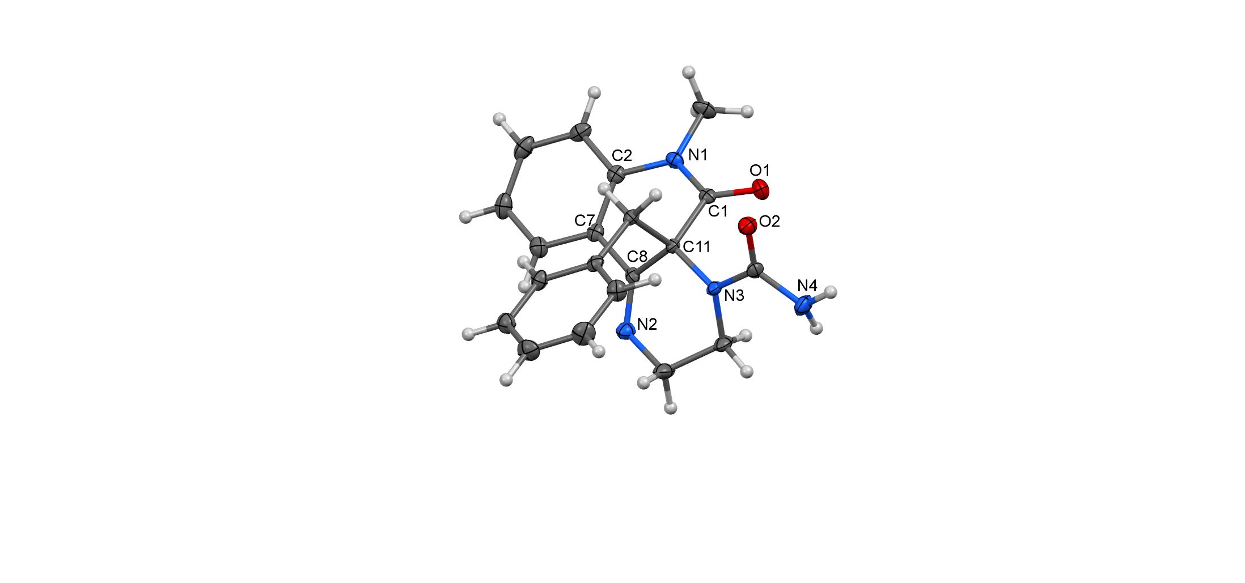
Figure S32: Molecular structure of 7b – ORTEP view, 40% probability level

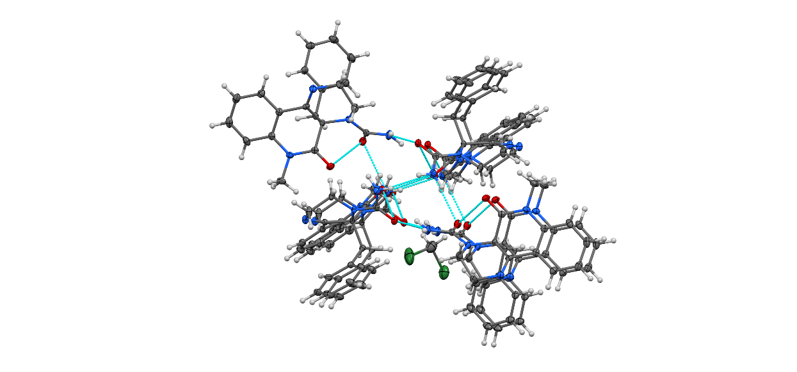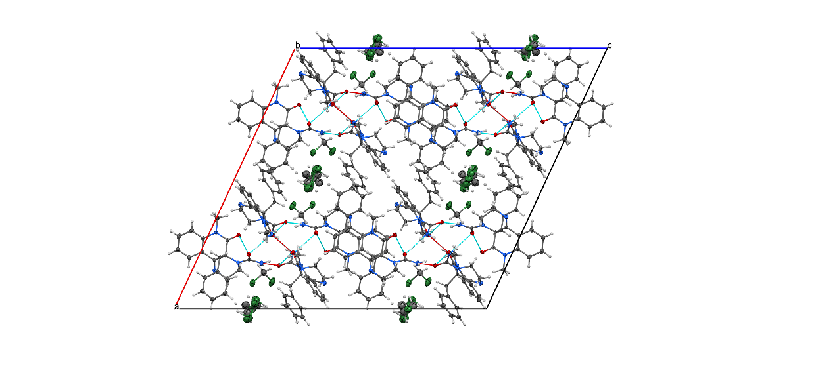
Figure S33: Molecular structure of 7b – H-bonding representation (left) supramolecular architecture, view along b axis

Table S14: Experimental details for 7b.
Crystal data
Chemical formula | 2(C₂₀H₂₀N₄O₂)·1.5(CH₂Cl₂)
M_{r} | 824.19
Crystal system, space group | Monoclinic, C2/c
Temperature (K) | 150
a, b, c (Å) | 28.5456 (10), 9.6974 (3), 30.9033 (11)
β (°) | 114.810 (1)
V (Å³) | 7765.0 (5)
Z | 8
Radiation type | Mo Kα
µ (mm⁻¹) | 0.29
Crystal size (mm) | 0.59 × 0.43 × 0.13
Data collection
Diffractometer | Bruker D8 - Venture
Absorption correction | Multi-scan  SADABS2016/2 - Bruker AXS area detector scaling and absorption correction
No. of measured, independent and  observed [I > 2σ(I)] reflections | 90897, 8953, 7534
R_{int} | 0.040
(sin θ/λ)_{max} (Å⁻¹) | 0.651
Refinement
R[F² > 2σ(F²)], wR(F²), S | 0.054, 0.239, 1.06
No. of reflections | 8953
No. of parameters | 545
No. of restraints | 20
H-atom treatment | H atoms treated by a mixture of independent and constrained refinement
Δρ_{max}, Δρ_{min} (e Å⁻³) | 0.96, −1.04
Computer programs: Bruker Instrument Service vV6.2.3, APEX3 v2016.5-0 (Bruker AXS), SAINT V8.37A (Bruker AXS Inc., 2015), XT, VERSION 2014/5'_computing_structure_refinement 'SHELXL2017/1 (Sheldrick, 2017), PLATON (Spek, 2009).

Table S15: Geometric parameters (Å, º) for 7b.
Cl1—C21 | 1.756 (3) | C18—H18 | 0.9500
O1—C1 | 1.214 (2) | C19—C20 | 1.396 (3)
N1—C1 | 1.365 (2) | C19—H19 | 0.9500
N1—C2 | 1.418 (2) | C20—H20 | 0.9500
N1—C12 | 1.471 (2) | C21—H21A | 0.9900
C1—C11 | 1.559 (2) | C21—H21B | 0.9900
Cl2—C21 | 1.754 (3) | C101—C111 | 1.547 (2)
O2—C13 | 1.240 (2) | C102—C107 | 1.398 (2)
N2—C8 | 1.269 (2) | C102—C103 | 1.400 (2)
N2—C9 | 1.461 (3) | C103—C104 | 1.382 (3)
C2—C3 | 1.391 (3) | C103—H103 | 0.9500
C2—C7 | 1.399 (3) | C104—C105 | 1.383 (3)
O3—C101 | 1.232 (2) | C104—H104 | 0.9500
N3—C13 | 1.373 (2) | C105—C106 | 1.381 (3)
N3—C11 | 1.455 (2) | C105—H105 | 0.9500
N3—C10 | 1.459 (2) | C106—C107 | 1.391 (2)
C3—C4 | 1.385 (3) | C106—H106 | 0.9500
C3—H3 | 0.9500 | C107—C108 | 1.482 (2)
N4—C13 | 1.362 (2) | C108—C111 | 1.535 (2)
N4—H4A | 0.96 (3) | C109—C110 | 1.509 (3)
N4—H4B | 0.86 (3) | C109—H10C | 0.9900
O4—C113 | 1.227 (2) | C109—H10D | 0.9900
C4—C5 | 1.392 (3) | C110—H11A | 0.9900
C4—H4 | 0.9500 | C110—H11B | 0.9900
N5—C101 | 1.361 (2) | C111—C114 | 1.577 (2)
N5—C102 | 1.414 (2) | C112—H11C | 0.9800
N5—C112 | 1.469 (2) | C112—H11D | 0.9800
C5—C6 | 1.373 (3) | C112—H11E | 0.9800
C5—H5 | 0.9500 | C114—C115 | 1.508 (2)
N6—C108 | 1.267 (2) | C114—H11F | 0.9900
N6—C109 | 1.460 (2) | C114—H11G | 0.9900
C6—C7 | 1.395 (2) | C115—C120 | 1.389 (3)
C6—H6 | 0.9500 | C115—C116 | 1.394 (3)
N7—C113 | 1.385 (2) | C116—C117 | 1.385 (3)
N7—C111 | 1.454 (2) | C116—H116 | 0.9500
N7—C110 | 1.464 (2) | C117—C118 | 1.381 (3)
C7—C8 | 1.479 (3) | C117—H117 | 0.9500
N8—C113 | 1.359 (2) | C118—C119 | 1.376 (3)
N8—H8A | 0.82 (3) | C118—H118 | 0.9500
N8—H8B | 0.86 (3) | C119—C120 | 1.389 (3)
C8—C11 | 1.531 (2) | C119—H119 | 0.9500
C9—C10 | 1.512 (3) | C120—H120 | 0.9500
C9—H9A | 0.9900 | C22—C22^{i} | 1.12 (3)
C9—H9B | 0.9900 | C22—Cl3^{i} | 1.124 (18)
C10—H10A | 0.9900 | C22—Cl4 | 1.730 (12)
C10—H10B | 0.9900 | C22—Cl3 | 1.748 (12)
C11—C14 | 1.566 (2) | C22—H22A | 0.979 (9)
C12—H12A | 0.9800 | C22—H22B | 0.977 (9)
C12—H12B | 0.9800 | Cl3—Cl3^{i} | 1.95 (4)
C12—H12C | 0.9800 | Cl3—H22D^{i} | 0.83 (5)
C14—C15 | 1.508 (2) | C22A—C22A^{i} | 1.53 (3)
C14—H14A | 0.9900 | C22A—Cl3A^{i} | 1.56 (2)
C14—H14B | 0.9900 | C22A—Cl3A | 1.675 (12)
C17—C18 | 1.384 (3) | C22A—Cl4A | 1.799 (12)
C17—C16 | 1.388 (3) | C22A—Cl4A^{i} | 1.876 (15)
C17—H17 | 0.9500 | C22A—H22C | 1.011 (9)
C16—C15 | 1.391 (3) | C22A—H22D | 1.001 (9)
C16—H16 | 0.9500 | Cl4A—Cl4A^{i} | 1.183 (10)
C15—C20 | 1.391 (3) | Cl3A—Cl3A^{i} | 2.22 (4)
C18—C19 | 1.381 (3)
C1—N1—C2 | 122.67 (15) | C105—C104—H104 | 119.5
C1—N1—C12 | 118.44 (16) | C106—C105—C104 | 119.89 (18)
C2—N1—C12 | 118.22 (16) | C106—C105—H105 | 120.1
O1—C1—N1 | 122.82 (16) | C104—C105—H105 | 120.1
O1—C1—C11 | 121.20 (16) | C105—C106—C107 | 120.20 (18)
N1—C1—C11 | 115.96 (14) | C105—C106—H106 | 119.9
C8—N2—C9 | 116.80 (16) | C107—C106—H106 | 119.9
C3—C2—C7 | 120.16 (17) | C106—C107—C102 | 119.89 (17)
C3—C2—N1 | 120.69 (17) | C106—C107—C108 | 121.33 (16)
C7—C2—N1 | 119.12 (16) | C102—C107—C108 | 118.78 (15)
C13—N3—C11 | 120.39 (14) | N6—C108—C107 | 118.96 (15)
C13—N3—C10 | 120.42 (15) | N6—C108—C111 | 127.97 (16)
C11—N3—C10 | 116.41 (14) | C107—C108—C111 | 112.94 (14)
C4—C3—C2 | 119.48 (18) | N6—C109—C110 | 112.22 (15)
C4—C3—H3 | 120.3 | N6—C109—H10C | 109.2
C2—C3—H3 | 120.3 | C110—C109—H10C | 109.2
C13—N4—H4A | 114.9 (15) | N6—C109—H10D | 109.2
C13—N4—H4B | 121.8 (18) | C110—C109—H10D | 109.2
H4A—N4—H4B | 119 (2) | H10C—C109—H10D | 107.9
C3—C4—C5 | 120.84 (19) | N7—C110—C109 | 109.04 (15)
C3—C4—H4 | 119.6 | N7—C110—H11A | 109.9
C5—C4—H4 | 119.6 | C109—C110—H11A | 109.9
C101—N5—C102 | 122.35 (15) | N7—C110—H11B | 109.9
C101—N5—C112 | 117.74 (15) | C109—C110—H11B | 109.9
C102—N5—C112 | 119.67 (15) | H11A—C110—H11B | 108.3
C6—C5—C4 | 119.31 (19) | N7—C111—C108 | 111.07 (13)
C6—C5—H5 | 120.3 | N7—C111—C101 | 109.63 (13)
C4—C5—H5 | 120.3 | C108—C111—C101 | 108.03 (13)
C108—N6—C109 | 115.97 (15) | N7—C111—C114 | 112.52 (13)
C5—C6—C7 | 121.12 (19) | C108—C111—C114 | 106.11 (13)
C5—C6—H6 | 119.4 | C101—C111—C114 | 109.33 (13)
C7—C6—H6 | 119.4 | N5—C112—H11C | 109.5
C113—N7—C111 | 121.24 (14) | N5—C112—H11D | 109.5
C113—N7—C110 | 120.73 (14) | H11C—C112—H11D | 109.5
C111—N7—C110 | 115.88 (14) | N5—C112—H11E | 109.5
C6—C7—C2 | 119.03 (17) | H11C—C112—H11E | 109.5
C6—C7—C8 | 121.70 (16) | H11D—C112—H11E | 109.5
C2—C7—C8 | 119.24 (16) | O4—C113—N8 | 120.98 (17)
C113—N8—H8A | 115.6 (17) | O4—C113—N7 | 123.45 (16)
C113—N8—H8B | 116.9 (16) | N8—C113—N7 | 115.36 (16)
H8A—N8—H8B | 117 (2) | C115—C114—C111 | 112.53 (13)
N2—C8—C7 | 119.61 (16) | C115—C114—H11F | 109.1
N2—C8—C11 | 127.62 (17) | C111—C114—H11F | 109.1
C7—C8—C11 | 112.53 (14) | C115—C114—H11G | 109.1
N2—C9—C10 | 112.45 (16) | C111—C114—H11G | 109.1
N2—C9—H9A | 109.1 | H11F—C114—H11G | 107.8
C10—C9—H9A | 109.1 | C120—C115—C116 | 117.81 (17)
N2—C9—H9B | 109.1 | C120—C115—C114 | 120.78 (16)
C10—C9—H9B | 109.1 | C116—C115—C114 | 121.41 (16)
H9A—C9—H9B | 107.8 | C117—C116—C115 | 121.07 (18)
N3—C10—C9 | 109.91 (15) | C117—C116—H116 | 119.5
N3—C10—H10A | 109.7 | C115—C116—H116 | 119.5
C9—C10—H10A | 109.7 | C118—C117—C116 | 120.15 (19)
N3—C10—H10B | 109.7 | C118—C117—H117 | 119.9
C9—C10—H10B | 109.7 | C116—C117—H117 | 119.9
H10A—C10—H10B | 108.2 | C119—C118—C117 | 119.68 (19)
N3—C11—C8 | 111.49 (13) | C119—C118—H118 | 120.2
N3—C11—C1 | 109.79 (13) | C117—C118—H118 | 120.2
C8—C11—C1 | 106.80 (14) | C118—C119—C120 | 120.2 (2)
N3—C11—C14 | 112.20 (14) | C118—C119—H119 | 119.9
C8—C11—C14 | 106.97 (13) | C120—C119—H119 | 119.9
C1—C11—C14 | 109.40 (13) | C115—C120—C119 | 121.11 (19)
O2—C13—N4 | 120.00 (17) | C115—C120—H120 | 119.4
O2—C13—N3 | 123.24 (16) | C119—C120—H120 | 119.4
N4—C13—N3 | 116.61 (17) | C22^{i}—C22—Cl3^{i} | 102.1 (18)
N1—C12—H12A | 109.5 | C22^{i}—C22—Cl4 | 71.1 (5)
N1—C12—H12B | 109.5 | Cl3^{i}—C22—Cl4 | 149.9 (18)
H12A—C12—H12B | 109.5 | C22^{i}—C22—Cl3 | 39.0 (9)
N1—C12—H12C | 109.5 | Cl3^{i}—C22—Cl3 | 82 (2)
H12A—C12—H12C | 109.5 | Cl4—C22—Cl3 | 105.1 (7)
H12B—C12—H12C | 109.5 | C22^{i}—C22—H22A | 104.3 (17)
C15—C14—C11 | 112.02 (14) | Cl3^{i}—C22—H22A | 41 (2)
C15—C14—H14A | 109.2 | Cl4—C22—H22A | 110.5 (12)
C11—C14—H14A | 109.2 | Cl3—C22—H22A | 109.4 (12)
C15—C14—H14B | 109.2 | C22^{i}—C22—H22B | 140.1 (18)
C11—C14—H14B | 109.2 | Cl3^{i}—C22—H22B | 93 (2)
H14A—C14—H14B | 107.9 | Cl4—C22—H22B | 110.8 (12)
C18—C17—C16 | 120.02 (19) | Cl3—C22—H22B | 109.5 (12)
C18—C17—H17 | 120.0 | H22A—C22—H22B | 111.3 (13)
C16—C17—H17 | 120.0 | C22—Cl4—C22^{i} | 37.9 (10)
C17—C16—C15 | 121.21 (18) | C22^{i}—Cl3—C22 | 38.9 (14)
C17—C16—H16 | 119.4 | C22^{i}—Cl3—Cl3^{i} | 62.8 (17)
C15—C16—H16 | 119.4 | C22—Cl3—Cl3^{i} | 34.9 (8)
C16—C15—C20 | 118.19 (17) | C22^{i}—Cl3—H22A^{i} | 59.0 (10)
C16—C15—C14 | 120.85 (16) | C22—Cl3—H22A^{i} | 71 (2)
C20—C15—C14 | 120.95 (16) | Cl3^{i}—Cl3—H22A^{i} | 106 (3)
C19—C18—C17 | 119.70 (18) | C22^{i}—Cl3—H22D^{i} | 90.2 (18)
C19—C18—H18 | 120.2 | C22—Cl3—H22D^{i} | 71.6 (10)
C17—C18—H18 | 120.2 | Cl3^{i}—Cl3—H22D^{i} | 93.0 (16)
C18—C19—C20 | 120.1 (2) | H22A^{i}—Cl3—H22D^{i} | 48 (3)
C18—C19—H19 | 119.9 | C22A^{i}—C22A—Cl3A^{i} | 65.7 (11)
C20—C19—H19 | 119.9 | C22A^{i}—C22A—Cl3A | 57.8 (9)
C15—C20—C19 | 120.73 (19) | Cl3A^{i}—C22A—Cl3A | 86.6 (19)
C15—C20—H20 | 119.6 | C22A^{i}—C22A—Cl4A | 68.0 (8)
C19—C20—H20 | 119.6 | Cl3A^{i}—C22A—Cl4A | 96.5 (11)
Cl2—C21—Cl1 | 111.09 (17) | Cl3A—C22A—Cl4A | 118.4 (7)
Cl2—C21—H21A | 109.4 | C22A^{i}—C22A—H22C | 153.1 (17)
Cl1—C21—H21A | 109.4 | Cl3A^{i}—C22A—H22C | 141 (2)
Cl2—C21—H21B | 109.4 | Cl3A—C22A—H22C | 111.6 (11)
Cl1—C21—H21B | 109.4 | Cl4A—C22A—H22C | 103.3 (11)
H21A—C21—H21B | 108.0 | Cl4A^{i}—C22A—H22C | 94.4 (15)
O3—C101—N5 | 121.62 (15) | C22A^{i}—C22A—H22D | 101.4 (17)
O3—C101—C111 | 120.34 (15) | Cl3A^{i}—C22A—H22D | 37 (2)
N5—C101—C111 | 118.04 (14) | Cl3A—C22A—H22D | 112.6 (11)
C107—C102—C103 | 119.53 (17) | Cl4A—C22A—H22D | 104.2 (11)
C107—C102—N5 | 119.50 (15) | Cl4A^{i}—C22A—H22D | 140.9 (13)
C103—C102—N5 | 120.95 (16) | H22C—C22A—H22D | 105.5 (12)
C104—C103—C102 | 119.53 (18) | Cl4A^{i}—Cl4A—C22A | 74.8 (7)
C104—C103—H103 | 120.2 | C22A^{i}—Cl3A—C22A | 56.5 (12)
C102—C103—H103 | 120.2 | C22A^{i}—Cl3A—Cl3A^{i} | 49.0 (11)
C103—C104—C105 | 120.90 (18) | C22A—Cl3A—Cl3A^{i} | 44.5 (10)
C103—C104—H104 | 119.5 | H22A^{i}—Cl3A—H22D^{i} | 41 (3)
Symmetry code: (i) −x+1, y, −z+1/2.

Table S16: Hydrogen-bond geometry (Å, º) for 7b.
D—H···A | D—H | H···A | D···A | D—H···A
N4—H4A···O3 | 0.96 (3) | 2.51 (3) | 3.240 (2) | 132.6 (19)
N4—H4B···O4 | 0.86 (3) | 2.14 (3) | 2.847 (2) | 139 (2)
C10—H10^{A···Cl4A}b | 0.99 | 2.88 | 3.675 (5) | 138
C14—H14A···O2 | 0.99 | 2.25 | 2.876 (2) | 120
C21—H21A···O2 | 0.99 | 2.59 | 3.476 (3) | 148
C114—H11G···O4 | 0.99 | 2.34 | 2.899 (2) | 115
N8—H8A···O3^{i} | 0.82 (3) | 2.25 (3) | 3.051 (2) | 164 (2)
N8—H8B···O2^{i} | 0.86 (3) | 2.17 (3) | 3.020 (2) | 170 (2)
C112—H11C···O1^{ii} | 0.98 | 2.37 | 3.305 (2) | 159
C110—H11B···O1^{i} | 0.99 | 2.39 | 3.260 (2) | 147
Symmetry codes: (i) −x+3/2, y+1/2, −z+1/2; (ii) −x+3/2, y−1/2, −z+1/2.

