Supporting Information for

Transition Metal-Free Intramolecular Friedel-Crafts Reaction by Alkene Activation: A Method for the Synthesis of Some Novel Xanthene Derivatives

Tülay Yıldız,* İrem Baştaş and Hatice Başpınar Küçük

Istanbul University-Cerrahpasa, Department of Chemistry, Istanbul, Avcilar, 34320, Turkey

tulayyil@iuc.edu.tr

Experimental

1.General information
The majority of the chemicals used in this work were commercially available from Merck or Aldrich. The starting compounds 1a-1m were prepared by Ullmann coupling of 2-fluoro benzaldehyde and substituted phenols. The further starting compounds 2a-2m were synthesized Grignard reaction of 1a-1m and aryl(or alkyl)magnesium bromide. Then 3a-3m were prepared from oxidation of 2a-2m using PCC. The final starting alkene compounds 4a-4m were obtained with Wittig reaction using Me(Ph)₃PBr, t-BuOK, NaH. All substrates were purified by crystallization or column chromatography and were characterized by IR and GC-MS. All novel pruducts were characterized by IR, ¹H-NMR, ¹³C-NMR, elementel analysis and GC-MS. The reactions were monitored by TLC using silica gel plates and the products were purified by flash column chromatography on silica gel (Merck; 230–400 mesh), eluting with hexane-ethyl acetate (v/v 9:1). NMR spectra were recorded at 500 MHz for ¹H and 125 MHz for ¹³C using Me₄Si as the internal standard in CDCl₃. GC-MS were recorded on Shimadzu/ QP2010 Plus. IR spectra were recorded on a Mattson 1000 spectrometer. Melting points were determined with Büchi Melting Point B-540.
2. General procedure for reduction of the Ullmann coupling:¹
To a solution of DMF (10 mL) containing 2- fluorobenzaldehyde (4 mmol) and phenol (4 mmol) was added K₂CO₃ (6 mmol) and the reaction mixture was stirred for 2 hours at 175 ⁰C. It was cooled to room temperature and after usual workup and concentration, the product was purified over silica gel.
Thus, 2- arenoxybenzaldehydes were prepared in good yields with 85-95% (Scheme 1).

Scheme 1. The Ullmann type reaction of 2-fluorobenzaldehyde and hydroxy aryls.

3.General procedure for Grignard reaction:
For grignard solution, to Mg (2 mmol) was added bromo substrates (1.2 mmol) in dry THF and the mixture was heated under reflux and N₂ for 0,5-1 h then cooled to room temperature. 2-arenoxybenzaldehydes (1 mmol) was solved in dry THF and cooled to 0 °C. Then grignard solution was added to aldehyde solution and stirred for 1 hours. The end of the reaction was quenched with saturated NH₄Cl solution, extracted DCM and water 2 times. After usual workup and concentration, the crude was purified over silica gel.

Diarylcarbinol compounds including arenoxy group were obtained with very high yields (85-90%) (Scheme 2).
Scheme 2. The Grignard reaction of 2-arenoxybenzaldehyde.

4. General procedure for Alcohol oxidation:
To the alcohol compound (1 mmol) were added PCC (1.5 mmol) and DCM (5 ml) as solvent then stirred for 2 hours. The end of the reaction was extracted DCM and water 2 times. After usual reaction workup and concentration, the product was charged on silica gel (Scheme 3).

Scheme 3. The oxidation of diarylcarbinol compounds.

5. General procedure for Wittig reaction:
To the ketone compound (1 mmol) in dry THF were added Me(Ph)₃PBr (2.2 mmol), t-BuOK (2.7 mmol) and NaH (2.5 mmol) and the reaction was stirred for 1-2 hours. The end of the reaction was extracted DCM and water 2 times. After usual reaction workup and concentration, the product was charged on silica gel (Scheme 4).

Scheme 4. Wittig reaction of ketones 3a–3m.

6. General procedure for intramolecular FCA of vinyl compounds

TFA (10 mol%) was added to a stirred solution of a starting alkene compound (4a–4m) (0.1 mmol) in DCM (1 mL), and the reaction was stirred for 6-24 h under room temperature. After the finishing of the reaction, as monitored with TLC. Then the reaction was washed with water two times. After the usual reaction workup and concentration, the product was charged on silica gel.

Scheme 5. The intramolecular FCA of vinyl compounds 4a–4m.

7.Experimental Characterization Data of 4a-4m and 5a-5m

1-Phenoxy-2-(1-phenyl-vinyl)-benzene 4a:
¹H NMR (500 MHz, CDCl₃) δ 5.37 (d, J = 1.5 Hz, 1H), 5.63 (d, J = 1.5 Hz, 1H), 6.72 (d, J = 8.5 Hz, 1H), 6.96 − 7.01 (m, 2H), 7.17 − 7.40 (m, 10H). ¹³C NMR (150MHz, CDCl₃) δ 116.3, 117.9, 117.8, 119.9, 122.4, 123.7, 126.7, 127.3, 127.9, 129.0, 129.1, 129.2, 131.7, 134.0, 141.0, 146.3, 154.0, 157.4. MS (m/z) = 152, 165, 181, 194, 272 (M⁺). Anal. Calcd. for C₂₀H₁₆O: C, 88.20; H, 5.92. Found: C, 88.33; H, 5.93.

1-[4-Methyl-phenoxy]-2-(1-phenyl-vinyl)-benzene 4b:
¹H NMR (500 MHz, CDCl₃) δ 2.30 (s, 3H), 5.40 (d, J = 1.5 Hz, 1H), 5.67 (d, J = 1.5 Hz, 1H), 6.66 (d, J = 8.5 Hz, 2H), 6.92 (d, J = 9.0 Hz, 1H), 6.95 − 7.18 (m, 4H), 7.24 − 7.39 (m, 6H). ¹³C NMR (150MHz, CDCl₃) δ 20.6, 116.1, 118.2, 118.3, 119.1, 119.1, 123.2, 126.7, 127.3, 128.0, 128.9, 129.8, 130.2, 131.6, 132.1, 133.6, 141.1, 146.4, 154.6, 155.0. MS (m/z) = 77, 105, 211, 288 (M⁺). Anal. Calcd. for C₂₁H₁₈O: C, 88.08; H, 6.34. Found: C, 88.23; H, 6.26.

1-[2-(1-Phenyl-vinyl)-phenoxy]-naphthalene 4c:
¹H NMR (500 MHz, CDCl₃) δ 5.40 (d, J = 1.5 Hz, 1H), 5.62 (d, J = 1.5 Hz, 1H), 6.97 (dd, J₁ = 2.5 Hz, J₂ = 9.0 Hz, 1H), 7.05 − 7.07 (m, 1H), 7.24 − 7.32 (m, 5H), 7.35 − 7.49 (m, 6H), 7.63 − 7.88 (m, 3H). ¹³C NMR (150MHz, CDCl₃) δ 112.7, 114.1, 116.4, 119.1, 119.3, 120.0, 123.3, 123.4, 123.4, 124.0, 124.2, 126.3, 126.7, 127.6, 128.0, 129.1, 129.4, 129.8, 131.8, 134.1, 141.0, 146.3, 153.8, 155.3. MS (m/z) = 194, 215, 321, 322 (M⁺). Anal. Calcd. for C₂₄H₁₈O: C, 89.41; H, 5.63. Found: C, 89.56; H, 5.54.

1-[4-Chloro-phenoxy]-2-(1-phenyl-vinyl)-benzene 4d:
¹H NMR (500 MHz, CDCl₃) δ 5.34 (d, J = 1.5 Hz, 1H), 5.62 (d, J = 1.5 Hz, 1H), 6.62 (d, J = 9.0 Hz, 1H), 6.96 − 6.99 (m, 1H), 7.15 (d, J = 9.0 Hz, 2H), 7.22 − 7.43 (m, 9H). ¹³C NMR (150MHz, CDCl₃) δ 116.5, 118.8, 118.9, 120.0, 120.2, 123.6, 124.3, 126.6, 127.2, 127.5, 128.0, 129.2, 129.7, 129.8, 131.8, 134.2, 140.9, 146.3, 153.4, 456.1. MS (m/z) = 152, 165, 181, 194, 306 (M⁺). Anal. Calcd. for C₂₀H₁₅ClO: C, 78.30; H, 4.93. Found: C, 78.48; H, 4.86.

4-[2-(1-Phenyl-vinyl)-phenoxy]-benzonitrile 4e:
¹H NMR (500 MHz, CDCl₃) δ 5.29 (d, J = 1.0 Hz, 1H), 5.55 (d, J = 1.0 Hz, 1H), 6.65 (d, J = 1.0 Hz, 2H), 7.06 (dd, J₁ = 1.5 Hz, J₂ = 8.0 Hz, 1H), 7.13 − 7.16 (m, 2H), 7.21 − 7.27 (m, 3H), 7.32 (dd, J₁ = 1.0 Hz, J₂ = 7.5 Hz, 1H), 7.40 − 7.48 (m, 4H). ¹³C NMR (150MHz, CDCl₃) δ 105.0, 116.9, 117.9, 118.9, 120.4, 121.8, 125.7, 126.6, 127.6, 128.0, 129.5, 130.2, 132.1, 133.6, 134.1, 135.0, 140.5, 146.0, 151.4, 161.2. MS (m/z) = 152, 165, 181, 194, 296 (M⁺). Anal. Calcd. for C₂₁H₁₅NO: C, 84.82; H, 5.08; N, 4.71. Found: C, 84.75; H, 5.19; N, 4.54.

1-[4-Fluoro-phenoxy]-2-(1-phenyl-vinyl)-benzene 4f:
¹H NMR (500 MHz, CDCl₃) δ 5.36 (s, 1H), 5.65 (s, 1H), 6.66 (dd, J₁ = 4.5 Hz, J₂ = 9.0 Hz, 1H), 6.88 − 6.92 (m, 2H), 6.99 − 7.07 (m, 2H), 7.21 − 7.27 (m, 1H), 7.25 − 7.41 (m, 7H). ¹³C NMR (150MHz, CDCl₃) δ 115.6, 115.8, 116.2, 118.2, 119.2, 119.3, 120.5, 120.5, 123.1, 123.7, 126.6, 127.4, 128.0, 129.1, 129.7, 131.8, 140.9, 146.4, 154.3, 159.2. MS (m/z) = 152, 165, 181, 194, 290 (M⁺). Anal. Calcd. for C₂₀H₁₅FO: C, 82.74; H, 5.21. Found: C, 82.81; H, 5.29.

1-Phenoxy-2-(1-4-methylphenyl-vinyl)-benzene 4g:
¹H NMR (500 MHz, CDCl₃) δ 2.37 (s, 3H), 5.34 (d, J = 1.5 Hz, 1H), 5.64 (d, J = 1.5 Hz, 1H), 6.81 (d, J = 8.5 Hz, 2H), 7.00 − 7.05 (m, 2H), 7.11 − 7.12 (m, 2H), 7.19 − 7.28 (m, 5H), 7.28 − 7.33 (m, 1H), 7.40 (dd, J₁ = 1.5 Hz, J₂ = 9.0 Hz, 1H). ¹³C NMR (150MHz, CDCl₃) δ 21.1, 115.5, 117.9, 118.9, 120.0, 122.4, 123.7, 126.6, 128.7, 128.9, 129.3, 129.7, 131.7, 134.3, 137.1, 138.2, 146.0, 154.0, 157.6. MS (m/z) = 165, 178, 195, 271, 286 (M⁺). Anal. Calcd. for C₂₁H₁₈O: C, 88.08; H, 6.35. Found: C, 88.12; H, 6.29.

1-Phenoxy-2-(1-4-methoxyphenyl-vinyl)-benzene 4h:
¹H NMR (500 MHz, CDCl₃) δ 3.81 (s, 3H), 5.25 (d, J = 1.5 Hz, 1H), 5.56 (d, J = 1.5 Hz, 1H), 6.80 (d, J = 9.0 Hz, 2H), 7.01 − 7.06 (m, 2H), 7.17 − 7.24 (m, 5H), 7.31 − 7.39 (m, 4H). ¹³C NMR (150MHz, CDCl₃) δ 55.2, 113.3, 114.6, 117.9, 118.8, 120.0, 122.4, 123.2, 123.7, 127.8, 128.9, 129.2, 129.7, 131.7, 133.6, 134.3, 145.6, 153.9, 157.2, 157.5, 159.1. MS (m/z) = 165, 211, 271, 287, 302 (M⁺). Anal. Calcd. for C₂₁H₁₈O₂: C, 83.42; H, 6.00. Found: C, 83.52; H, 6.08.

2-[1-(2-Phenoxy-phenyl)-vinyl]-naphthalene 4i:
¹H NMR (500 MHz, CDCl₃) δ 5.56 (d, J = 1.5 Hz, 1H), 5.98 (d, J = 1.5 Hz, 1H), 6.60 (d, J = 10.0 Hz, 2H), 6.92 − 7.49 (m, 14H). ¹³C NMR (150MHz, CDCl₃) δ 117.2, 118.8, 120.6, 120.8, 122.1, 124.0, 122.1, 124.0, 125.1, 125.3, 125.5, 126.1, 126.5, 127.4, 128.1, 128.8, 129.2, 129.7, 130.8, 144.9, 153.3, 157.4. MS (m/z) = 77, 115, 127, 155, 197, 231, 247, 324 (M⁺). Anal. Calcd. for C₂₄H₁₈O: C, 89.41; H, 5.63. Found: C, 89.48; H, 5.69.

1-(1-Cyclopentyl-vinyl)-2-phenoxy-benzene 4j:
IR (cm^{–1}) ν. ¹H NMR (500 MHz, CDCl₃) δ 1.27− 1.30 (m, 8H), 1.57− 1.58 (m, 1H), 5.28 (dd, J₁ = 1.5 Hz, J₂ = 11.0 Hz, 1H), 5.79 (dd, J₁ = 1.5 Hz, J₂ = 19.0 Hz, 1H), 6.92 − 7.28 (m, 9H). ¹³C NMR (150MHz, CDCl₃) δ 22.6, 29.7, 31.9, 115.3, 117.7, 120.0, 119.4, 122.6, 124.0, 126.6, 128.9, 129.6, 130.0, 130.9, 135.7, 153.5, 157.8. MS (m/z) = 77, 93, 115, 127,169, 171, 187, 195, 250, 264 (M⁺). Anal. Calcd. for C₁₉H₂₀O: C, 86.32; H, 7.63. Found: C, 86.41; H, 7.71.

2-[1-(2-Phenoxy-phenyl)-vinyl]-thiophene 4k:
IR (cm^{–1}) ν. ¹H NMR (500 MHz, CDCl₃) δ 5.19 (s, 1H), 5.70 (s, 1H), 6.82 (dd, J₁ = 1.0 Hz, J₂ = 3.5 Hz, 1H), 6.86 − 6.88 (m, 2H), 6.93 (dd, J₁ = 3.5 Hz, J₂ = 5.0 Hz, 1H), 6.98 (dd, J₁ = 1.0 Hz, J₂ = 8.0 Hz, 1H), 7.02 − 7.05 (m, 1H), 7.16 − 7.20 (m, 2H), 7.24 − 7.28 (m, 2H), 7.32 − 7.38 (m, 1H), 7.40 (dd, J₁ = 3.5 Hz, J₂ = 5.0 Hz, 1H). ¹³C NMR (150MHz, CDCl₃) δ 114.8, 118.2, 118.8, 119.6, 122.7, 123.5, 124.5, 125.5, 127.1, 129.2, 129.4, 129.7, 131.3, 133.1, 139.4, 144.9, 154.1, 157.5. MS (m/z) = 77, 83, 93, 127, 169, 171, 185, 201, 250, 264, 278 (M⁺). Anal. Calcd. for C₁₈H₁₄OS: C, 77.66; H, 5.07; S, 11.52. Found: C, 77.58; H, 5.12; S, 11.42.

1-[4-Bromo-phenoxy]-2-(1-phenyl-vinyl)-benzene 4l:
¹H NMR (500 MHz, CDCl₃) δ 5.32 (d, 1H, J = 1.5 Hz), 5.60 (d, 1H, J = 1.5 Hz), 6.55 (d, J = 9.0 Hz, 1H), 6.90 (d, J = 9.0 Hz, 1H), 6.93 − 7.03 (dd, J₁ = 15.5 Hz, J₂ = 9.0 Hz, 2H), 7.22 − 7.38 (m, 8H), 7.44 (d, J = 9.0 Hz, 1H). ¹³C NMR (150MHz, CDCl₃) δ 116.5, 119.0, 119.2, 120.4, 124.4, 126.5, 127.5, 128.8, 129.2, 129.8, 132.1, 132.6, 134.3, 140.8, 145.2, 153.2, 156.7. MS (m/z) =154, 170, 179, 195, 271, 336, 350 (M⁺). Anal. Calcd. for C₂₀H₁₅BrO: C, 68.39; H, 4.30. Found: C, 68.51; H, 4.28.

9-Methyl-9-phenyl-9H-xanthene 5a:²
IR (cm^{–1}) ν = 3018, 2958, 1594, 1597, 1468, 1431, 1245, 1021. ¹H NMR (500 MHz, CDCl₃) δ 1.96 (s, 3H), 6.87 (dd, J₁ = 2.0 Hz, J₂ = 7.5 Hz, 2H), 6.96 (ddd, J₁ = 1.5 Hz, J₂ = J₃= 7.5 Hz, 2H), 7.13 (dd, J₁ = 1.5 Hz, J₂ = 8.0 Hz, 2H), 7.19 − 7.38 (m, 7H). ¹³C NMR (150MHz, CDCl₃) δ 32.1, 42.9, 116.1, 118.8, 123.0, 126.2, 127.4, 127.8, 128.0, 128.6, 128.9, 129.7, 130.0, 130.1, 149.0, 150.2, 157.2. MS (m/z) = 195, 257, 272 (M⁺). Anal. Calcd. for C₂₀H₁₆O: C, 88.20; H, 5.92. Found: C, 88.12; H, 5.83.

2,9-Dimethyl-9-phenyl-9H-xanthene 5b:
IR (cm^{–1}) ν = 3018, 2965, 2908, 1591, 1574, 1475, 1445, 1245, 750. ¹H NMR (500 MHz, CDCl₃) δ 1.95 (s, 3H), 2.21 (s, 3H), 6.66 (d, J = 2.0 Hz, 1H), 6.85 (dd, J₁ = 1.5 Hz, J₂ = 8.0 Hz, 1H), 6.92 − 7.38 (m, 10H). ¹³C NMR (150MHz, CDCl₃) δ 20.8, 32.1, 42.9, 115.9, 116.1, 118.3, 119.1, 122.8, 126.1, 127.3, 128.0, 128.2, 128.6, 129.0, 129.0, 129.6, 130.2, 132.2, 148.1, 150.3, 150.3. MS (m/z) = 209, 286, 271 (M⁺). Anal. Calcd. for C₂₁H₁₈O: C, 88.08; H, 6.34. Found: C, 88.13; H, 6.41.

7-Methyl-7-phenyl-7H-benzo[c]xanthene 5c:
IR (cm^{–1}) ν = 3041, 3024, 2961, 2911, 1584, 1485, 1448, 1245, 743. ¹H NMR (500 MHz, CDCl₃) δ 2.29 (s, 3H), 6.91 − 6.96 (m, 2H), 7.08 − 7.60 (m, 11H), 7.72 − 7.87 (m, 2H). ¹³C NMR (150MHz, CDCl₃) δ 30.3, 42.9, 114.0, 115.8, 118.1, 119.1, 119.9, 123.2, 123.4, 124.6, 125.6, 125.8, 126.0, 126.5, 127.1, 127.7, 127.8, 128.4, 128.9, 129.6, 131.4, 148.2, 150.1, 155.0. MS (m/z) = 245, 307, 308, 322 (M⁺). Anal. Calcd. for C₂₄H₁₈O: C, 89.41; H, 5.63. Found: C, 89.78; H, 5.71.

2-Chloro-9-methyl-9-phenyl-9H-xanthene 5d:
IR (cm^{–1}) ν = 3051, 3018, 2965, 2911, 1594, 1561, 1468, 1438, 1269, 1235, 750. ¹H NMR (500 MHz, CDCl₃) δ 1.93 (s, 3H), 6.83 (d, J = 2.5 Hz, 1H), 6.84 (dd, J₁ = 2.0 Hz, J₂ = 7.5 Hz, 1H), 6.95 − 7.35 (m, 10H). ¹³C NMR (150MHz, CDCl₃) δ 32.1, 43.1, 116.1, 117.6, 118.9, 120.0, 123.3, 126.5, 127.6, 128.2, 128.5, 128.6, 128.9, 129.5, 129.7, 129.8, 131.0, 148.2, 148.8, 149.9. MS (m/z) = 51, 75, 152, 165, 181, 194, 271, 306 (M⁺). Anal. Calcd. for C₂₀H₁₅ClO: C, 78.30; H, 4.93. Found: C, 78.41; H, 4.89.

9-Methyl-9-phenyl-9H-xanthene-2-carbonitrile 5e:
IR (cm^{–1}) ν = 3049, 2970, 2225, 1600, 1479, 1447, 1240, 1044. ¹H NMR (500 MHz, CDCl₃) δ 1.93 (s, 3H), 7.01 − 7.79 (m, 12H). ¹³C NMR (150MHz, CDCl₃) δ 32.5, 42.9, 105.0, 116.9, 118.9, 121.8, 124.1, 125.7, 126.6, 127.6, 128.0, 128.4, 129.0, 129.5, 132.1, 133.6, 134.0, 135.0, 146.0, 151.4, 161.2. MS (m/z) = 51, 77, 152, 165, 181, 194, 296 (M⁺). Anal. Calcd. for C₂₁H₁₅NO: C, 84.82; H, 5.08; N, 4.71. Found: C, 84.75; H, 5.15; N, 4.59.

2-Fluoro-9-methyl-9-phenyl-9H-xanthene 5f:
IR (cm^{–1}) ν = 3054, 3028, 2961, 2921, 1598, 1471, 1448, 1259, 750. ¹H NMR (500 MHz, CDCl₃) δ 1.94 (s, 3H), 6.56 (dd, J₁ = 3.0 Hz, J₂ = 9.5 Hz, 1H), 6.85 (dd, J₁ = 1.5 Hz, J₂ = 8.0 Hz, 1H), 6.89 − 7.35 (m, 10H). ¹³C NMR (150MHz, CDCl₃) δ 31.9, 43.3, 114.4, 114.7, 114.9, 116.1, 117.3, 118.2, 120.5, 123.2, 126.5, 127.6, 128.1, 128.8, 129.2, 129.7, 148.2, 150.2, 157.5, 159.4. MS (m/z) = 213, 275, 290 (M⁺). Anal. Calcd. for C₂₀H₁₅FO: C, 82.74; H, 5.21. Found: C, 82.68; H, 5.28.

9-Methyl-9-p-tolyl-9H-xanthene 5g:
IR (cm^{–1}) ν = 3018, 2958, 2918, 1568, 1468, 1441, 1298, 1239, 746. ¹H NMR (500 MHz, CDCl₃) δ 1.94 (s, 3H), 2.36 (s, 3H), 6.89 (dd, J₁ = 1.5 Hz, J₂ = 8.0 Hz, 2H), 6.99 (ddd, J₁ = 1.5 Hz, J₂ = J₃= 7.5 Hz, 2H), 7.05 − 7.28 (m, 8H). ¹³C NMR (150MHz, CDCl₃) δ 20.9, 32.2, 42.5, 116.1, 118.9, 123.0, 123.2, 127.3, 128.5, 128.7, 128.9, 129.7, 130.3, 135.7, 146.1, 150.2, 157.2. MS (m/z) = 195, 255, 271, 286 (M⁺). Anal. Calcd. for C₂₁H₁₈O: C, 88.08; H, 6.34. Found: C, 88.13; H, 6.41.

9-(4-Methoxy-phenyl)-9-methyl-9H-xanthene 5h:
IR (cm^{–1}) ν = 3068, 3018, 2955, 2918, 1594, 1438, 1239, 1022, 750. ¹H NMR (500 MHz, CDCl₃) δ 1.91 (s, 3H), 3.81 (s, 3H), 6.84 (d, J = 8.5 Hz, 1H), 6.87 (dd, J₁ = 1.5 Hz, J₂ = 8.0 Hz, 2H), 6.95 (ddd, J₁ = 1.5 Hz, J₂ = J₃= 7.5 Hz, 2H), 7.10 (dd, J₁ = 1.5 Hz, J₂ = 8.5 Hz, 2H), 7.19 (ddd, J₁ = 1.5 Hz, J₂ = J₃= 8.0 Hz, 2H), 7.25 (d, J = 8.5 Hz, 2H), 7. 28 (s, 1H). ¹³C NMR (150MHz, CDCl₃) δ 32.4, 42.3, 55.2, 113.2, 116.1, 123.0, 127.3, 128.9, 129.6-130.4 (10C), 141.2, 150.2, 157.7. MS (m/z) = 152, 165, 195, 243, 287, 302 (M⁺). Anal. Calcd. for C₂₁H₁₈O₂: C, 83.42; H, 6.00. Found: C, 83.51; H, 6.08.

9-Methyl-9-naphthalen-1-yl-9H-xanthene 5i:
IR (cm^{–1}) ν = 3044, 2965, 1594, 1568, 1475, 1438, 1298, 1242, 743. ¹H NMR (500 MHz, CDCl₃) δ 2.00 (s, 3H), 6.59 (dd, J₁ = 1.5 Hz, J₂ = 8.0 Hz, 2H), 6.78 (ddd, J₁ = 1.5 Hz, J₂ = J₃= 7.5 Hz, 2H), 7.00 − 7.28 (m, 9H), 7.05 − 7.28 (m, 1H), 7.92 (dd, J₁ = 1.5 Hz, J₂ = 15.0 Hz, 1H). ¹³C NMR (150MHz, CDCl₃) δ 35.6, 43.3, 116.1, 118.9, 123.2, 113.3, 124.4, 125.0, 126.1, 127.4-129.7 (10C), 131.2, 135.2, 141.0, 149.8, 157.2. MS (m/z) = 153, 165, 195, 307, 322 (M⁺). Anal. Calcd. for C₂₄H₁₈O: C, 89.41; H, 5.63. Found: C, 89.54; H, 5.73.

9-Cyclopentyl-9-methyl-9H-xanthene 5j:
IR (cm–1) ν = 3061, 3034, 2958, 2918, 1688, 1574, 1475, 1451, 1222, 1009, 796, 750. ¹H NMR (500 MHz, CDCl₃) δ 1.33 − 1.39 (m, 2H), 1.56 − 1.66 (m, 6H), 1.67 (s, 3H), 2.54 (q, J = 7.5 Hz, 1H), 6.91 (dd, J1 = 1.0 Hz, J2 = 8.0 Hz, 1H), 7.08 (dd, J1 = 1.5 Hz, J2 = 8.0 Hz, 2H), 7.21 (dd, J1 = J2 = 7.5 Hz, 2H), 7.41 (dd, J1 = 7.5 Hz, J2 = 8.5 Hz, 2H), 7.53 (ddd, J1 = 2.0 Hz, J2 = J3= 8.0 Hz, 1H). ¹³C NMR (150MHz, CDCl₃) δ 29.3, 29.7, 30.2, 31.9, 53.4, 118.4, 119.4, 123.3, 124.3, 124.3, 128.4, 130.0, 135.7, 156.3, 159.9. MS (m/z) = 77, 104, 180, 189, 195, 249, 264 (M⁺). Anal. Calcd. for C₁₉H₂₀O: C, 86.32; H, 7.63. Found: C, 86.48; H, 7.76.

9-Methyl-9-thiophen-2-yl-9H-xanthene 5k:
IR (cm^{–1}) ν = 3064, 3024, 2958, 2915, 1598, 1468, 1431, 1235, 750. ¹H NMR (500 MHz, CDCl₃) δ 2.02 (s, 3H), 6.97 (dd, J₁ = 4.0 Hz, J₂ = 5.0 Hz, 1H), 7.01 − 7.05 (m, 3H), 7.13 (ddd, J₁ =1.5 Hz, J₂ = J₃= 8.0 Hz, 4H), 7.22 − 7.28 (m, 3H). ¹³C NMR (150MHz, CDCl₃) δ 33.7, 40.9, 116.3, 118.8, 123.1, 125.3-125.9 (7C), 127.9, 128.4, 129.2, 129.7, 149.7, 154.9. MS (m/z) = 83, 92, 110, 173, 180, 195, 264, 278 (M⁺). Anal. Calcd. for C₁₈H₁₄OS: C, 77.66; H, 5.07; S, 11.52. Found: C, 77.71; H, 5.12; S, 11.41.

2-Bromo-9-methyl-9-phenyl-9H-xanthene 5l:
IR (cm^{–1}) ν = 3066, 3025, 2987, 2933, 1594, 1463, 1451, 1278, 758. ¹H NMR (500 MHz, CDCl₃) δ 1.93 (s, 3H), 6.89 − 6.91 (m, 3H), 7.01 − 7.03 (d, J = 8.5 Hz, 2H), 7.13 − 7.16 (m, 1H), 7.34 − 7.45 (m, 6H). ¹³C NMR (150MHz, CDCl₃) δ 29.7, 43.0, 110.3, 115.5, 119.02, 119.1, 119.9, 120.4, 123.5, 123.7, 129.8, 132.6, 132.8, 136.1, 147.7, 153.3, 156.5, 156.7. MS (m/z) = 78, 152, 168, 181, 257, 271, 335, 350 (M⁺). Anal. Calcd. for C₂₀H₁₅BrO: C, 68.39; H, 4.30. Found: C, 68.45; H, 4.24.

References

1. Yeager, G. W.; Schissel, D. N. Synthesis 1995, 1, 28.
2. Lambelet, P.; Lucken, E. A. C. J. Chem. Soc., Perkin Trans. 1975, 2, 1652.

NMR Spectra of all the reported compounds:

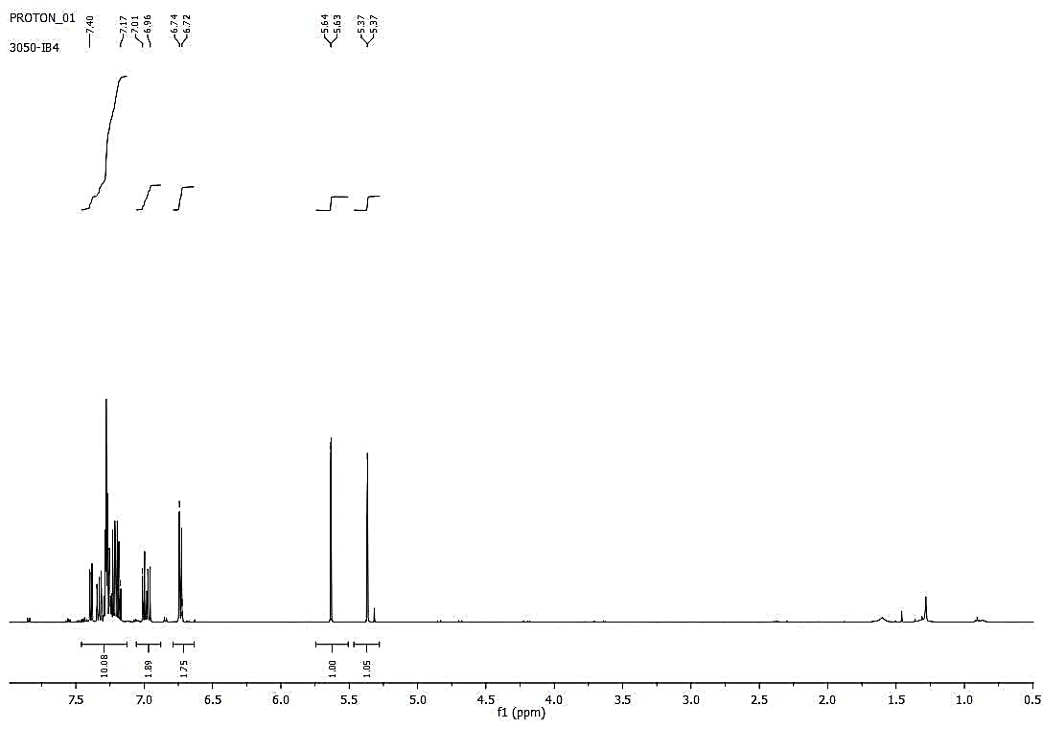
4a
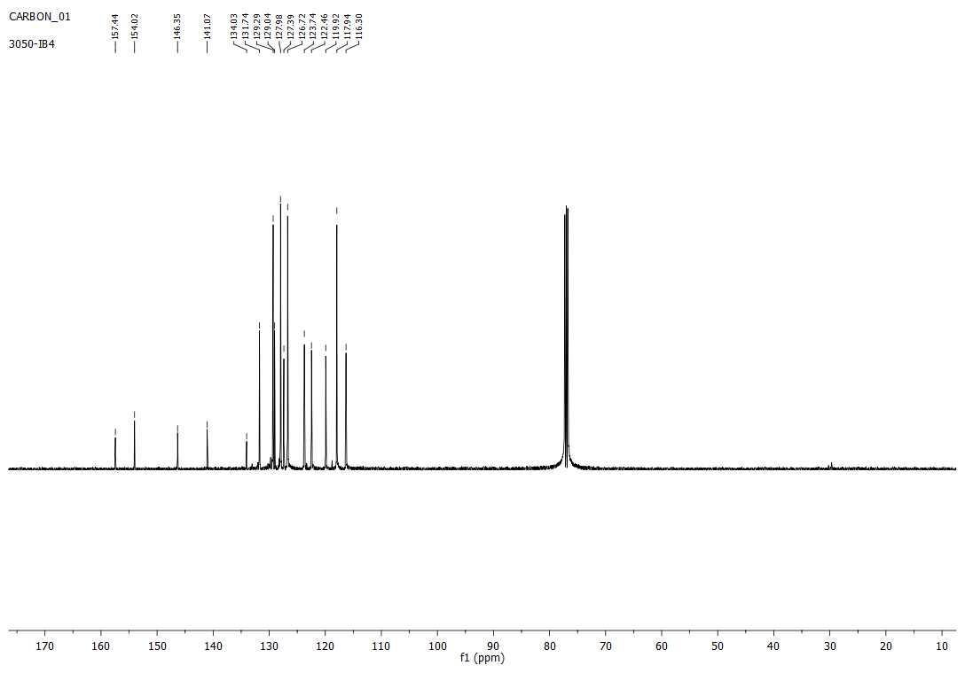
4a
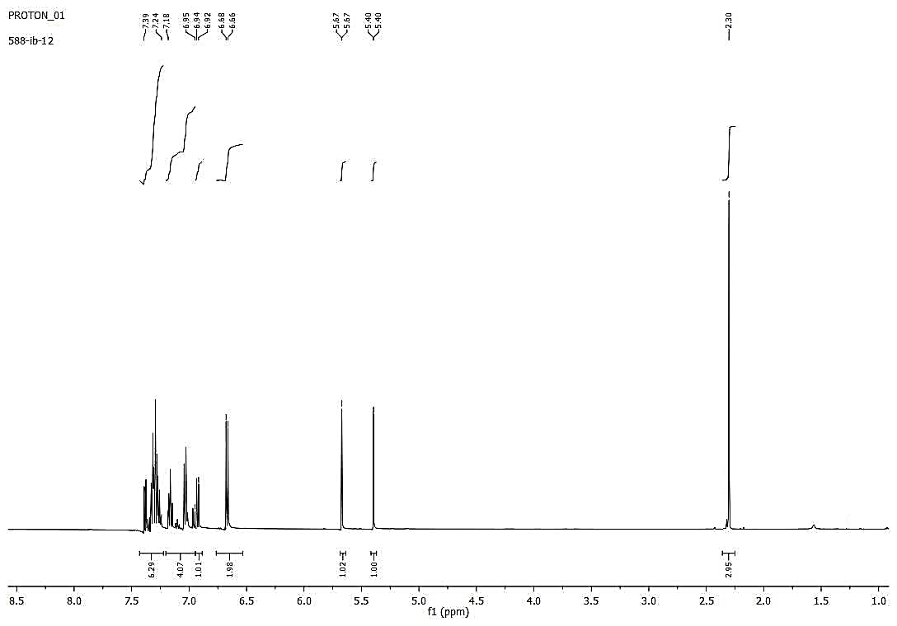
4b
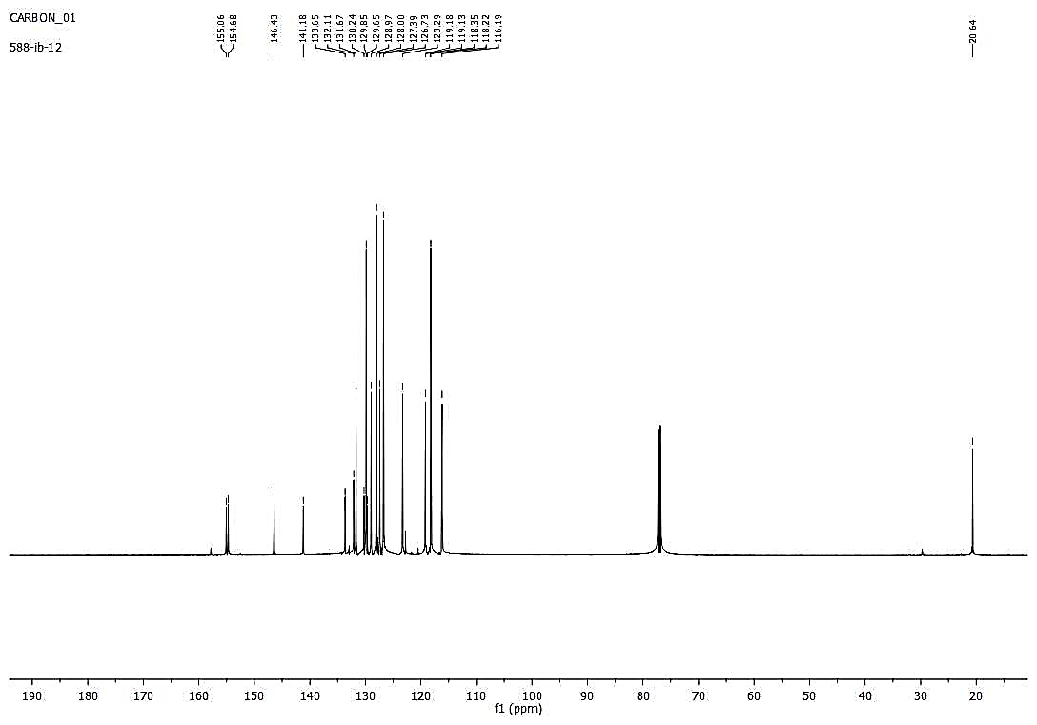
4b
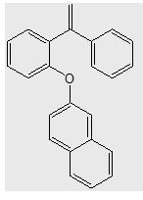
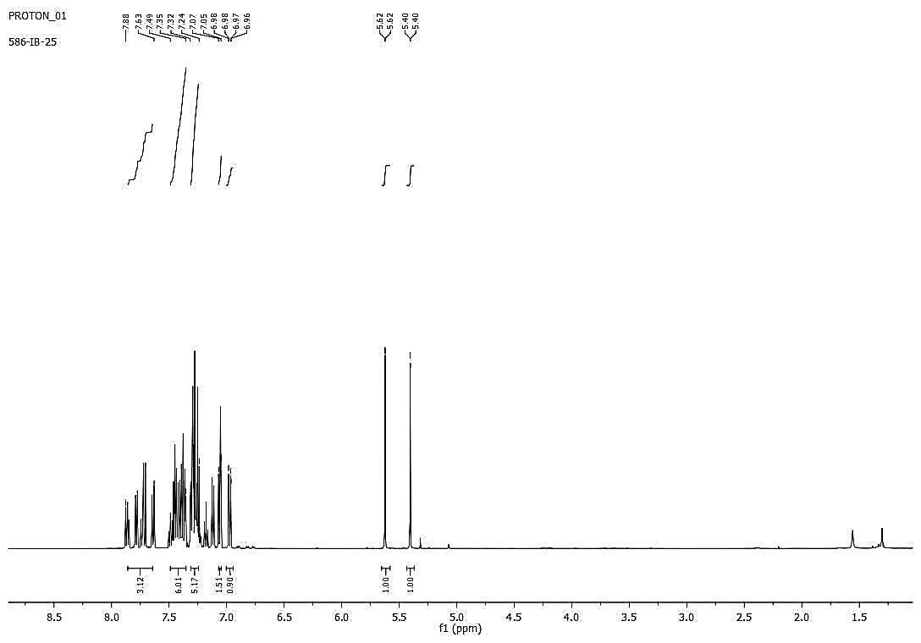
4c
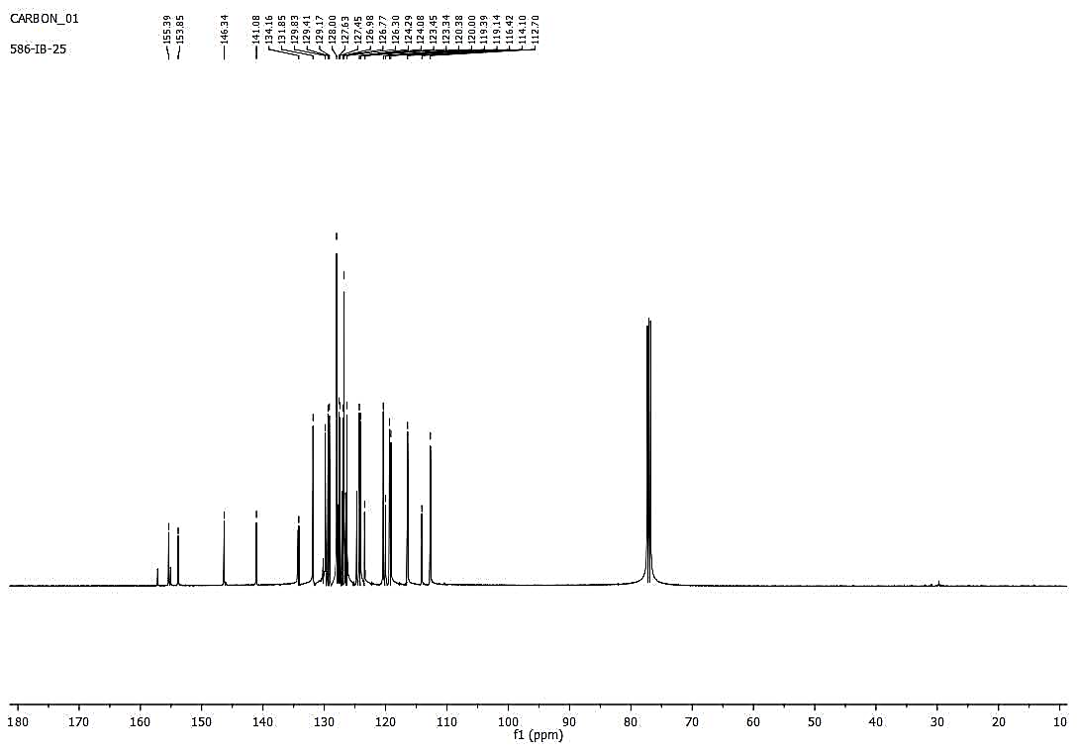
4c
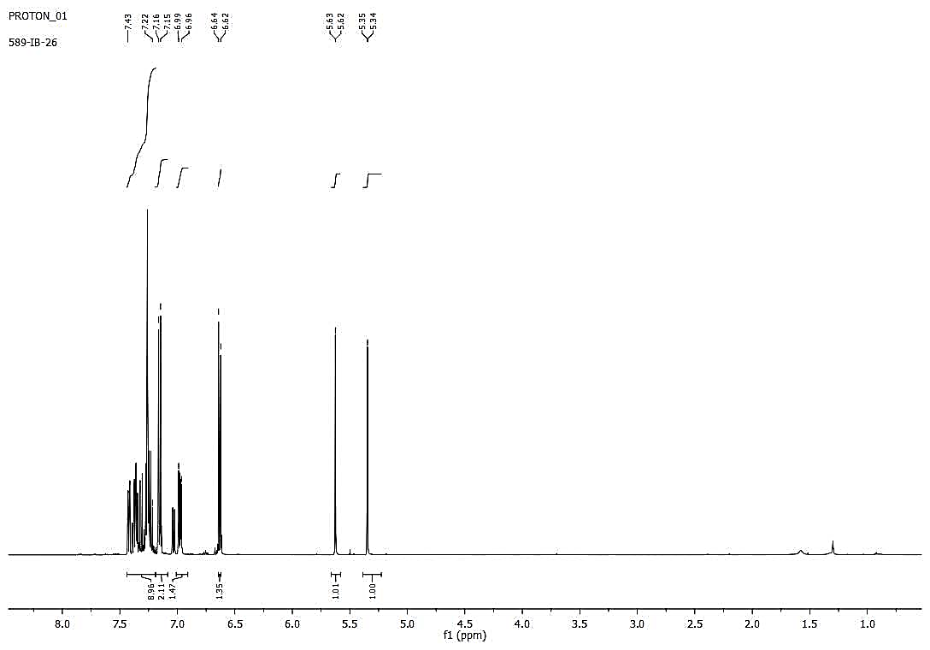
4d
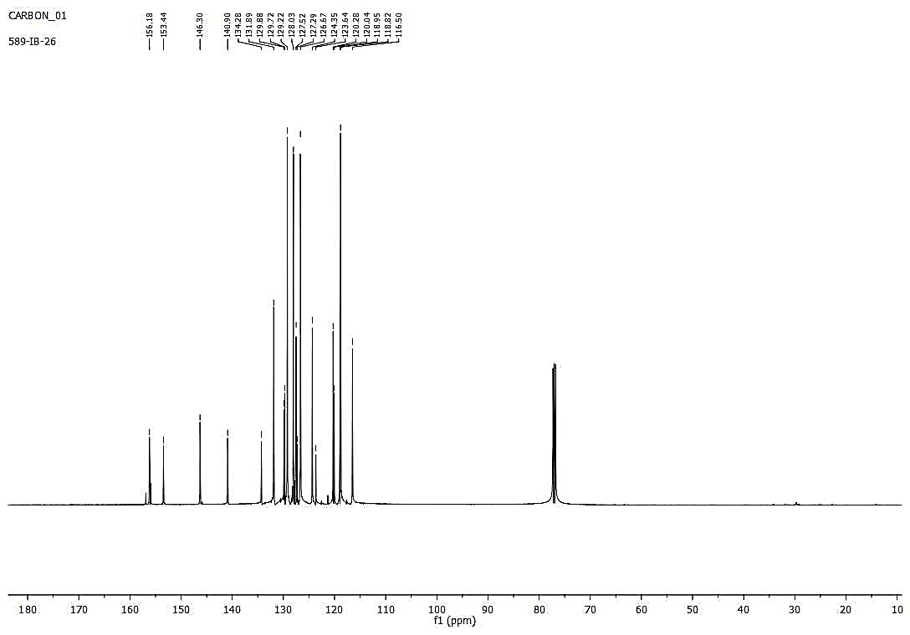
4d
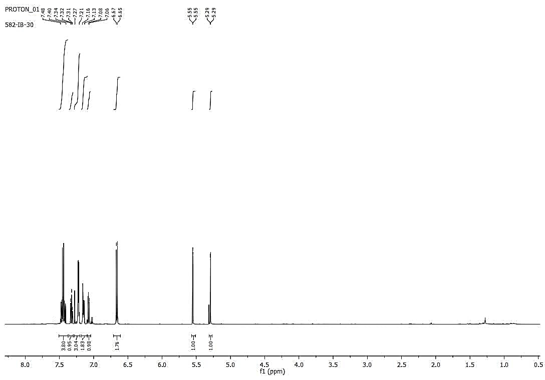
4e
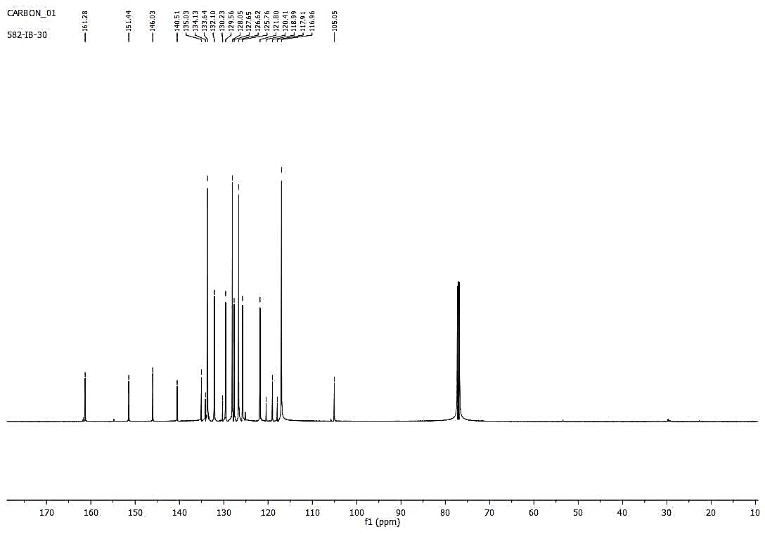
4e
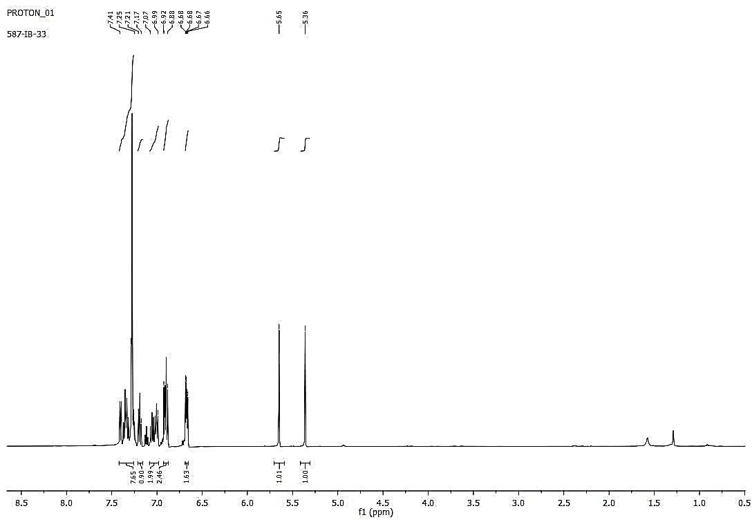
4f
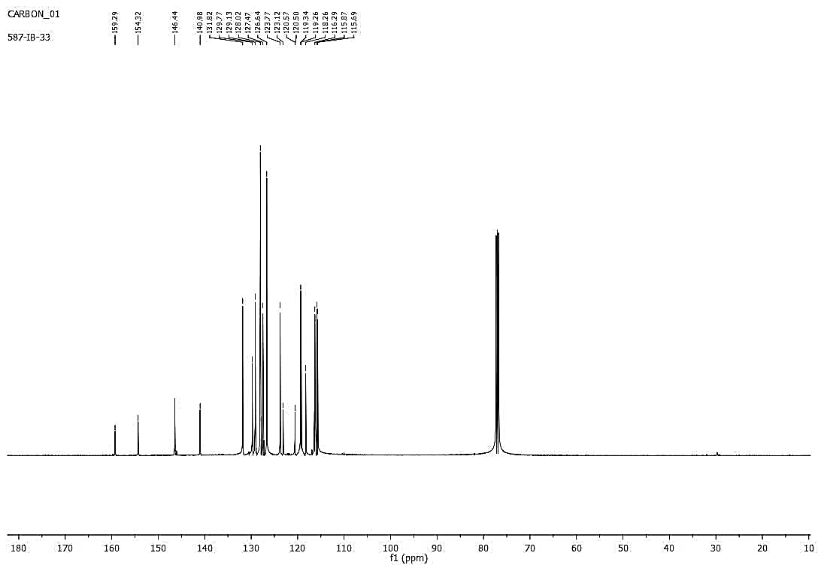
4f
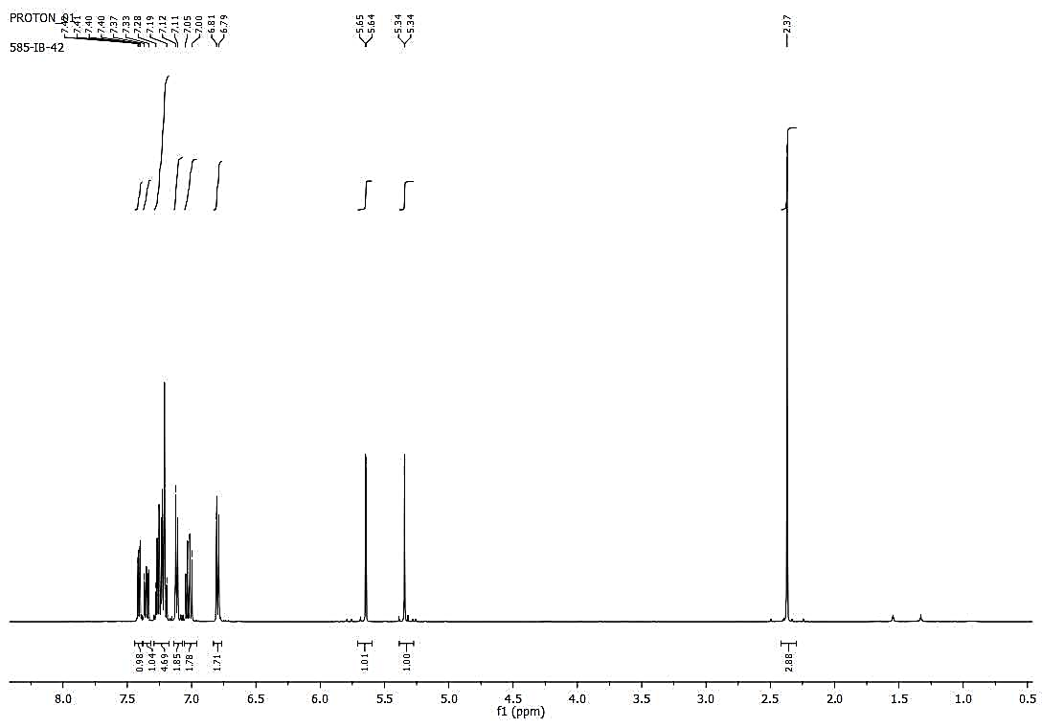
4g
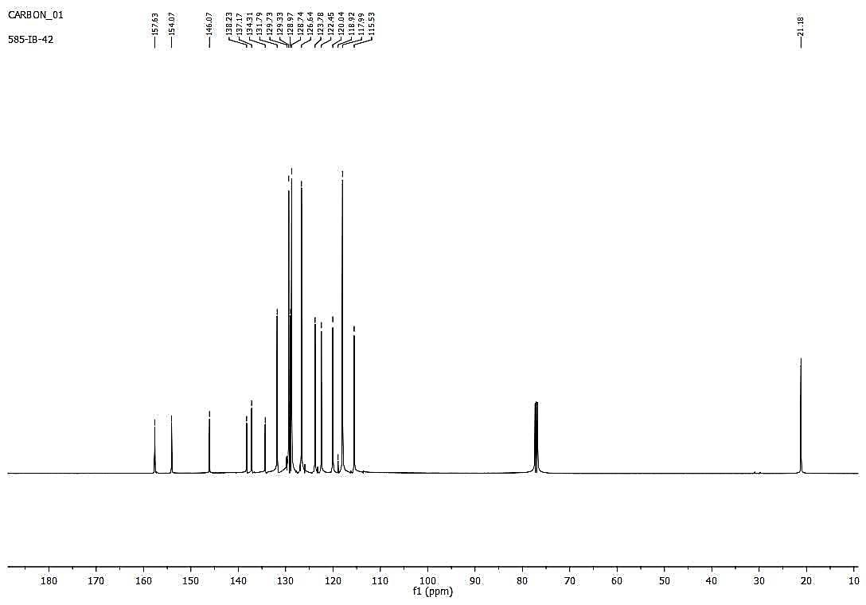
4g
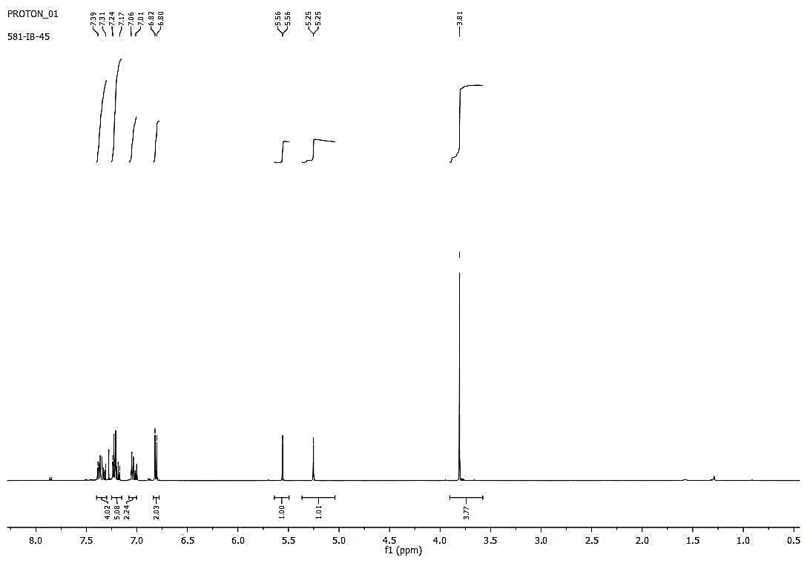
4h
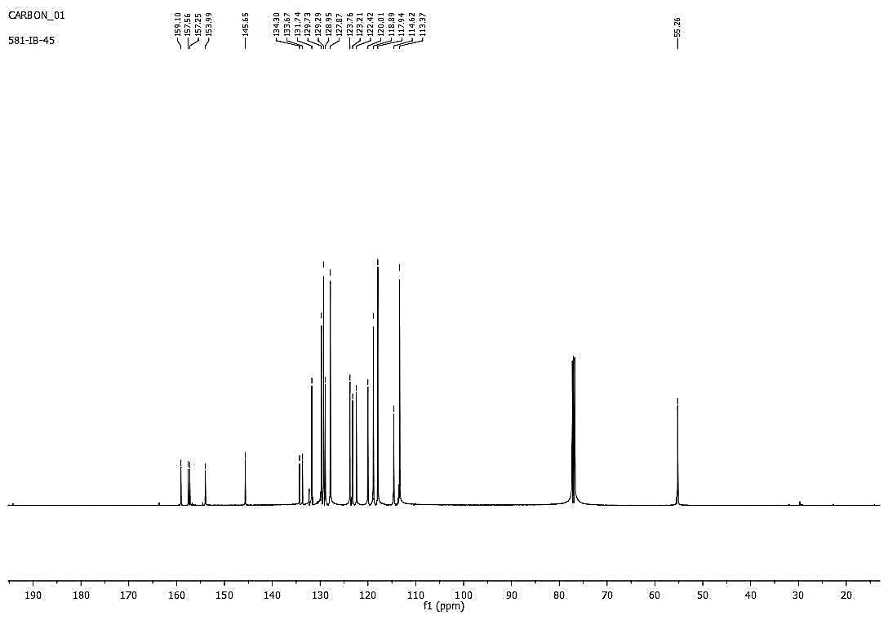
4h
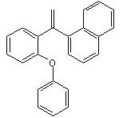
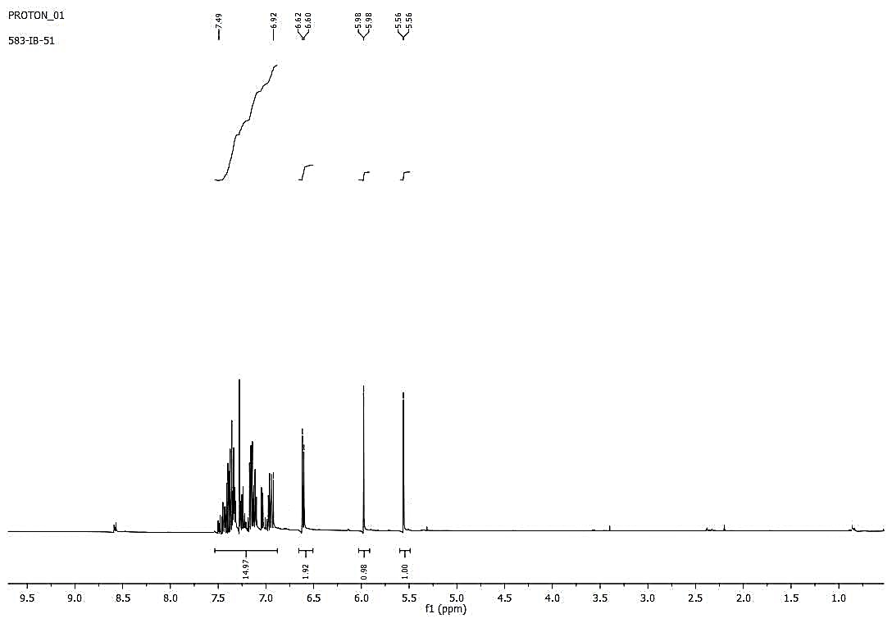
4i
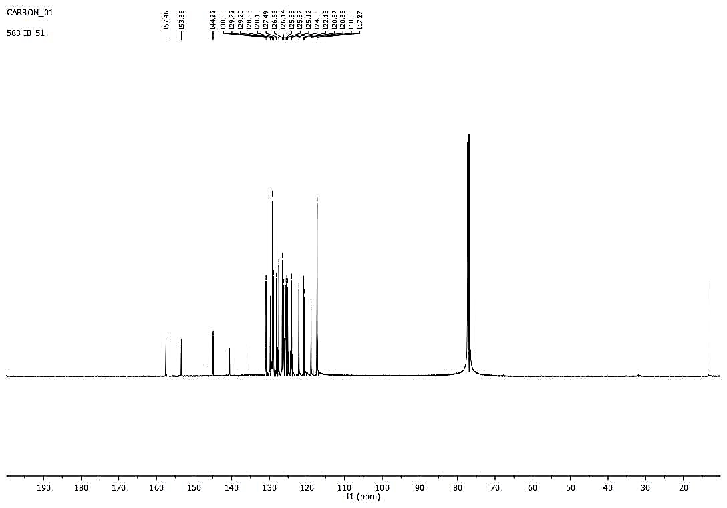
4i
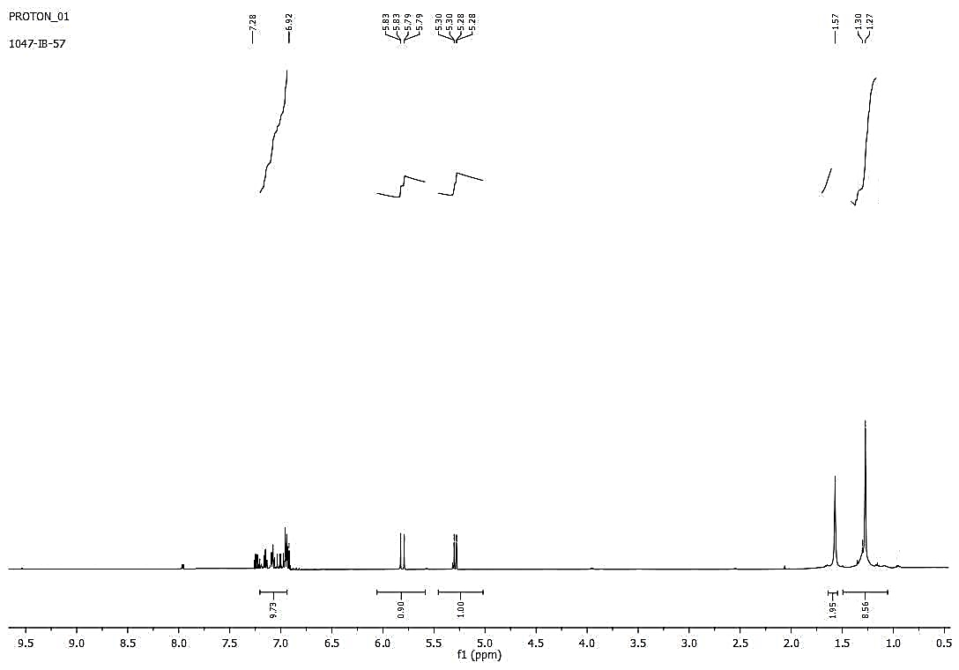
4j
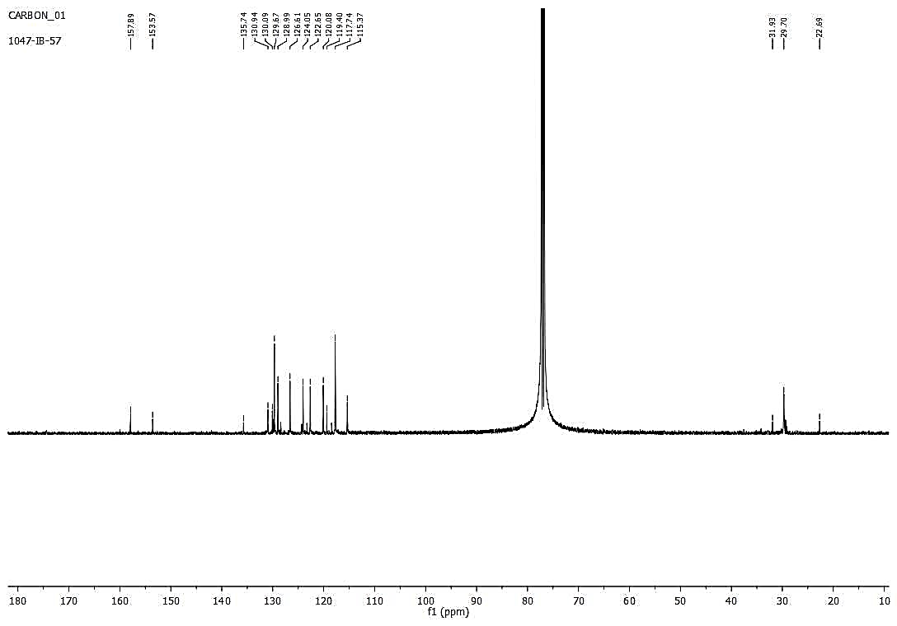
4j
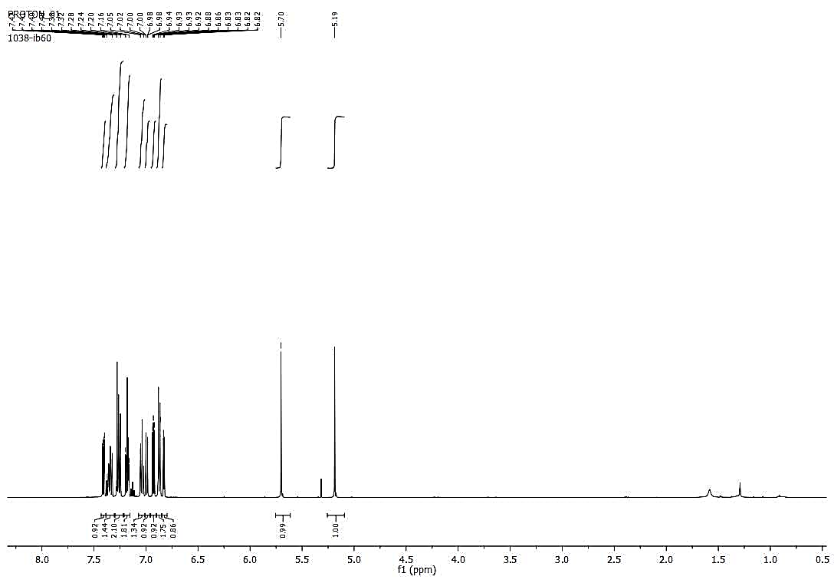
4k
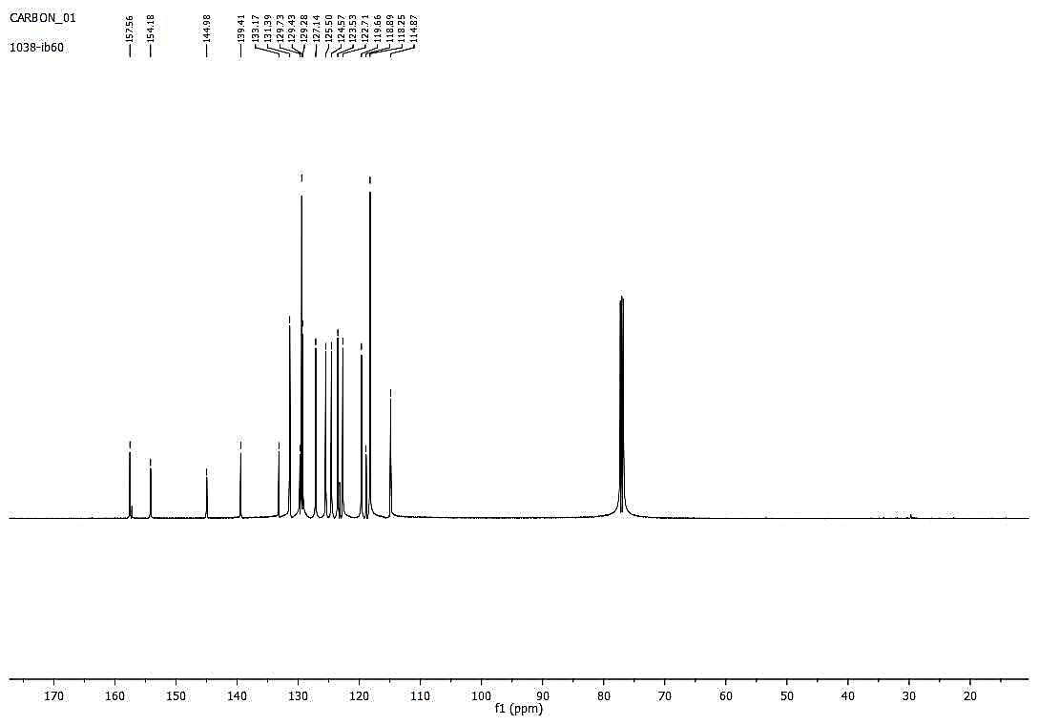
4k
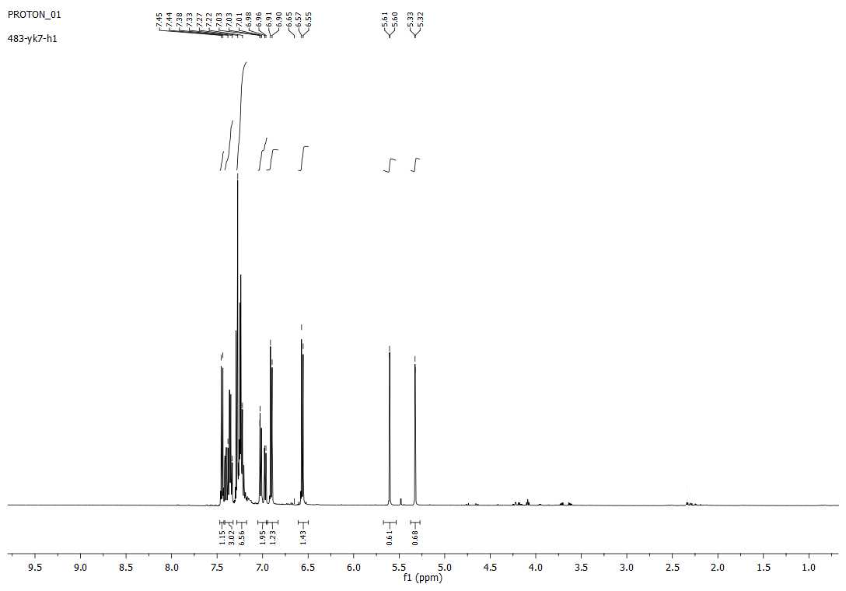
4l
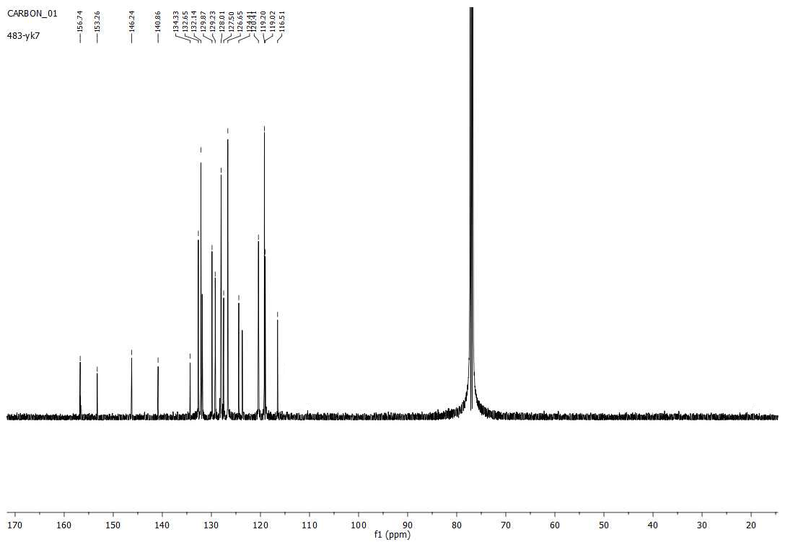
4l
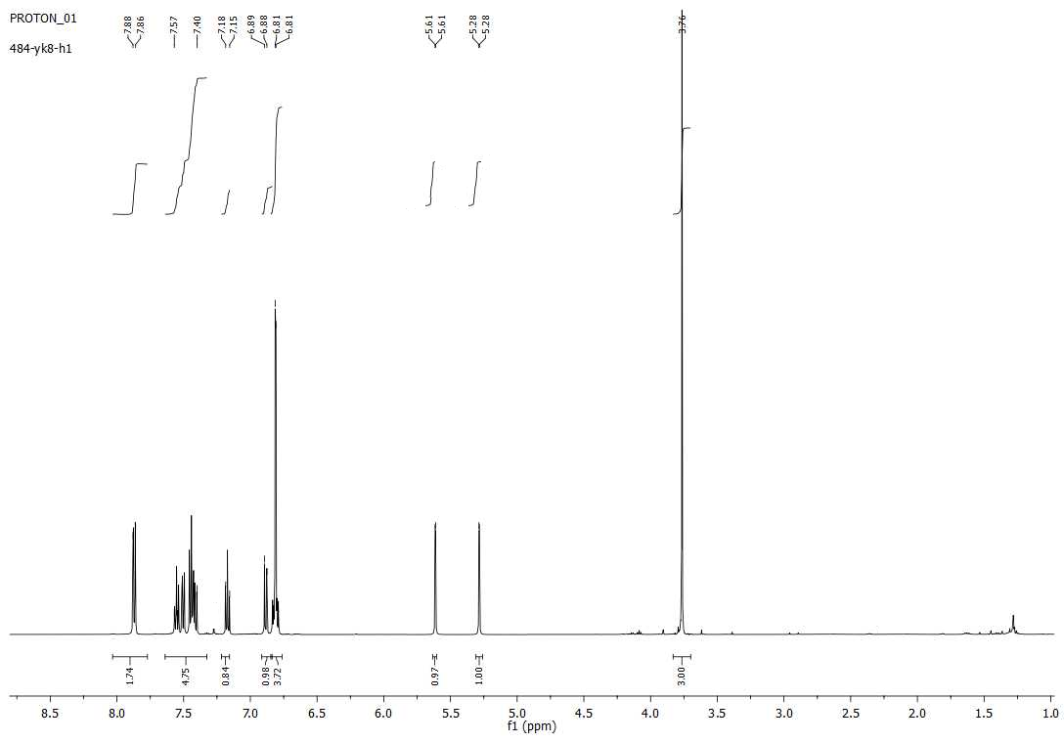
4m
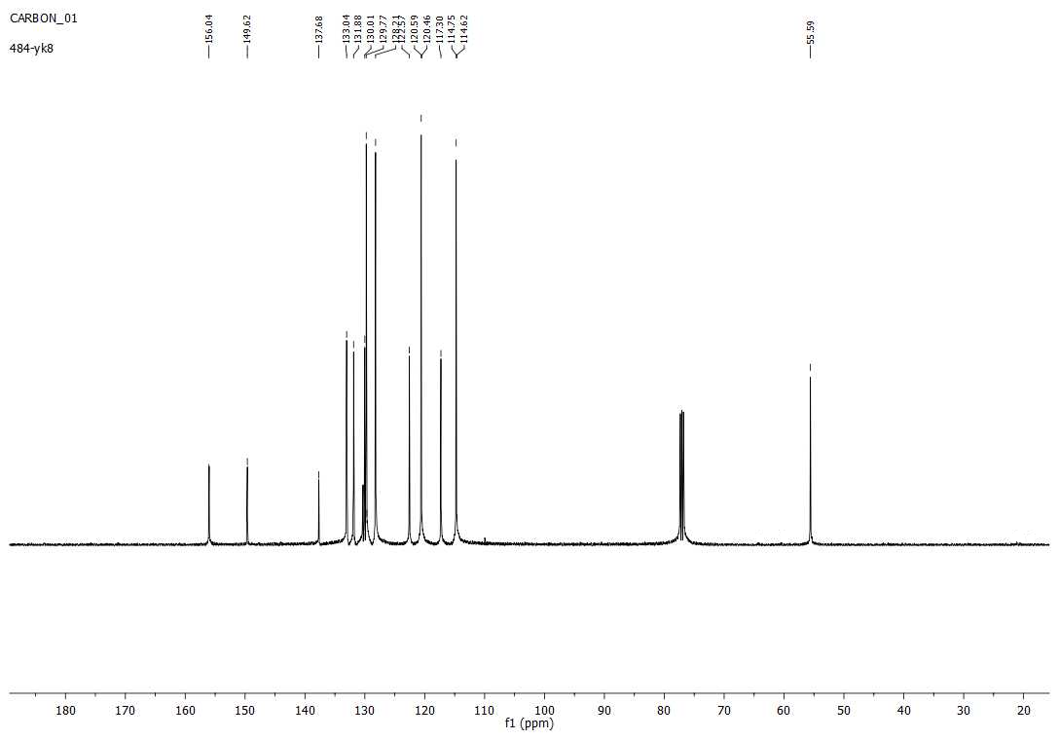
4m
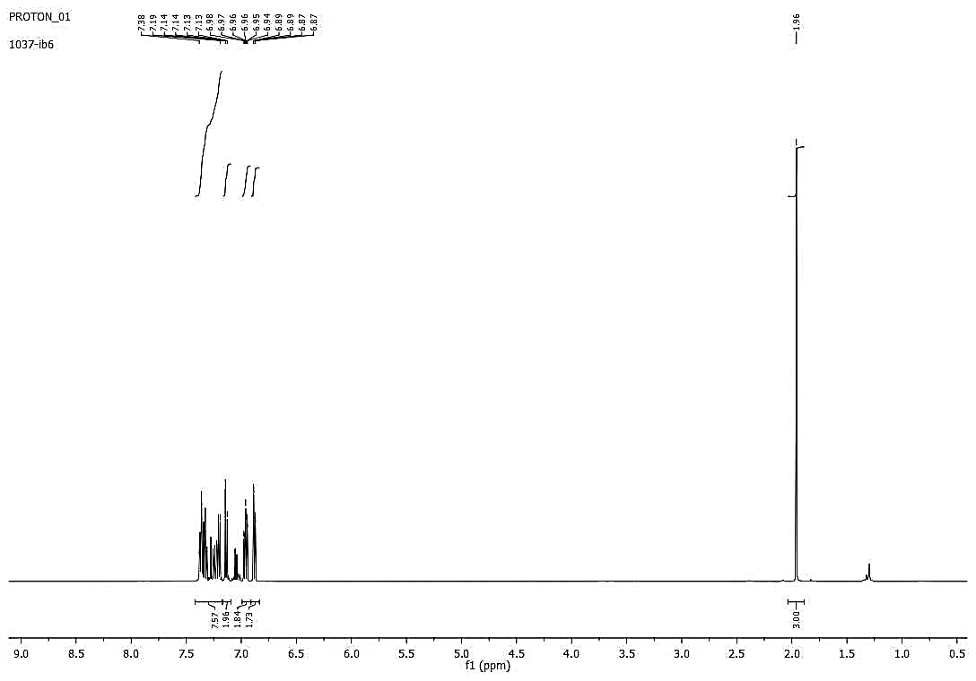
5a
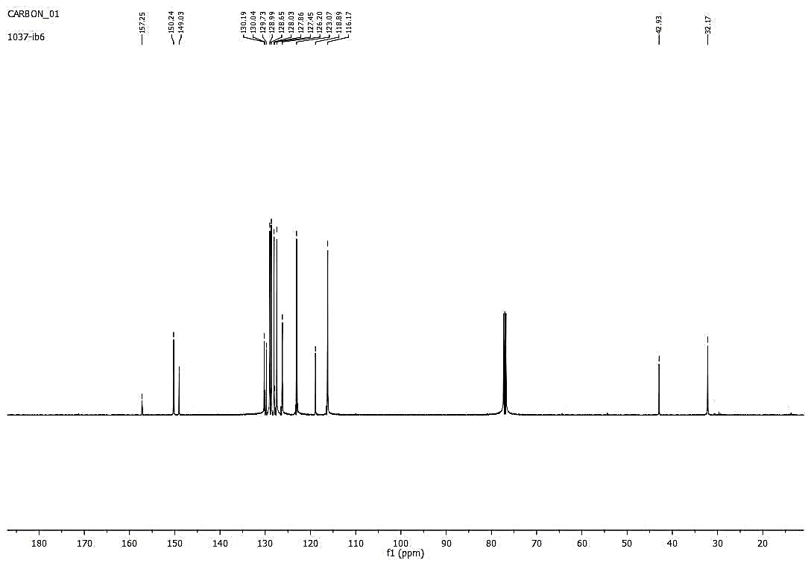
5a
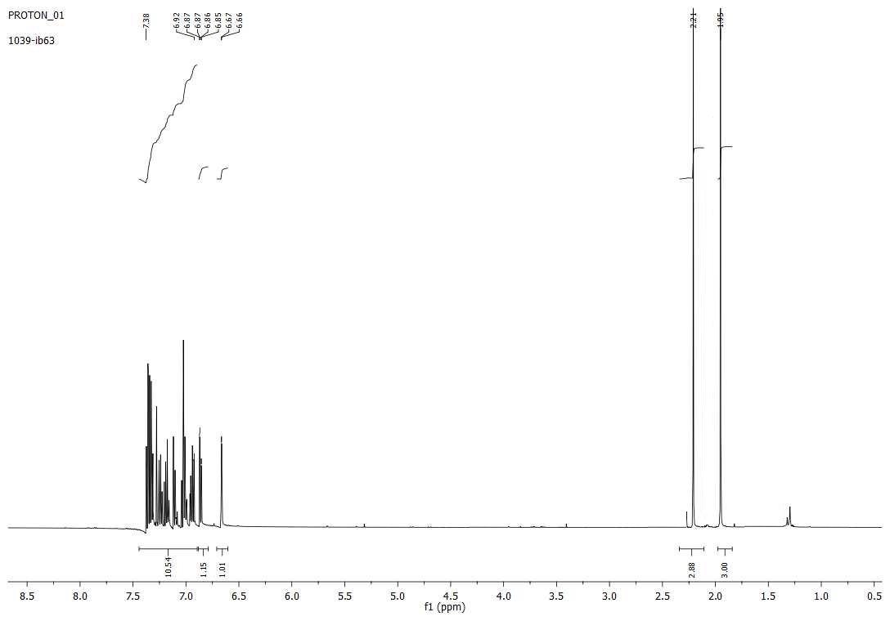
5b
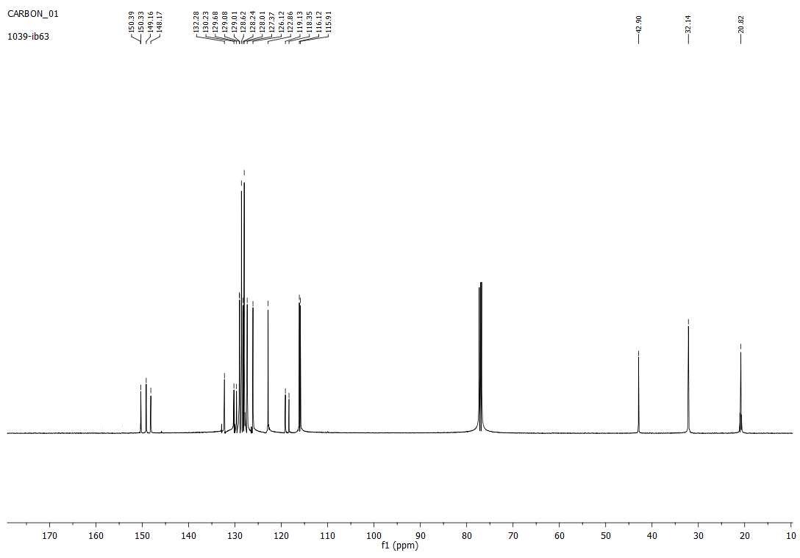
5b
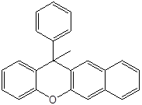
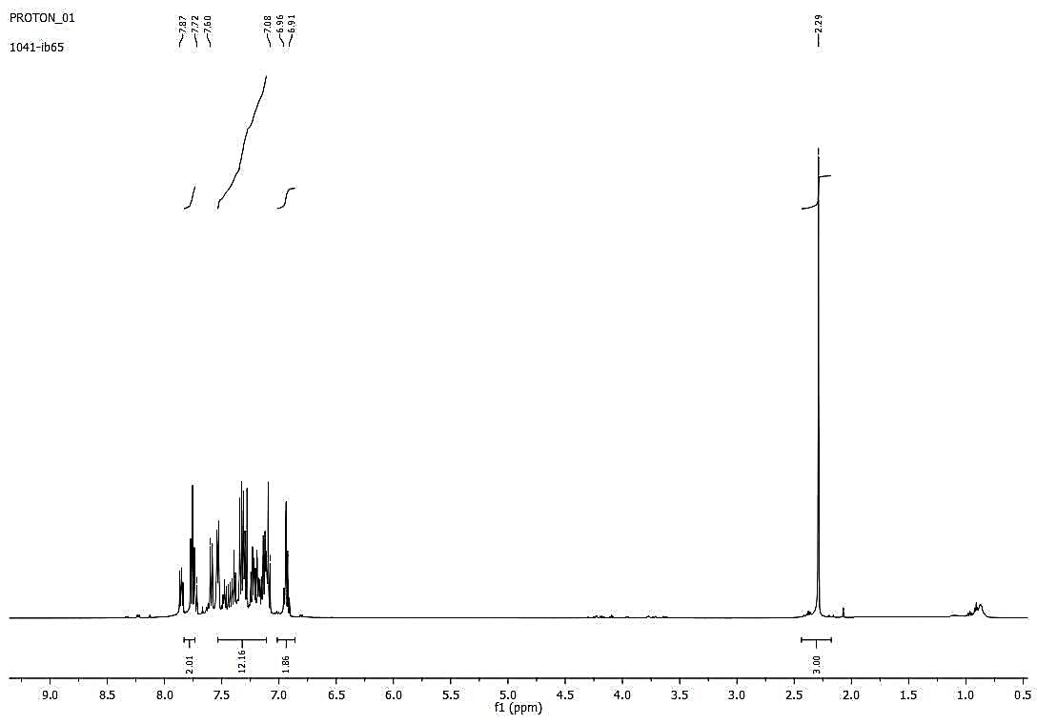
5c
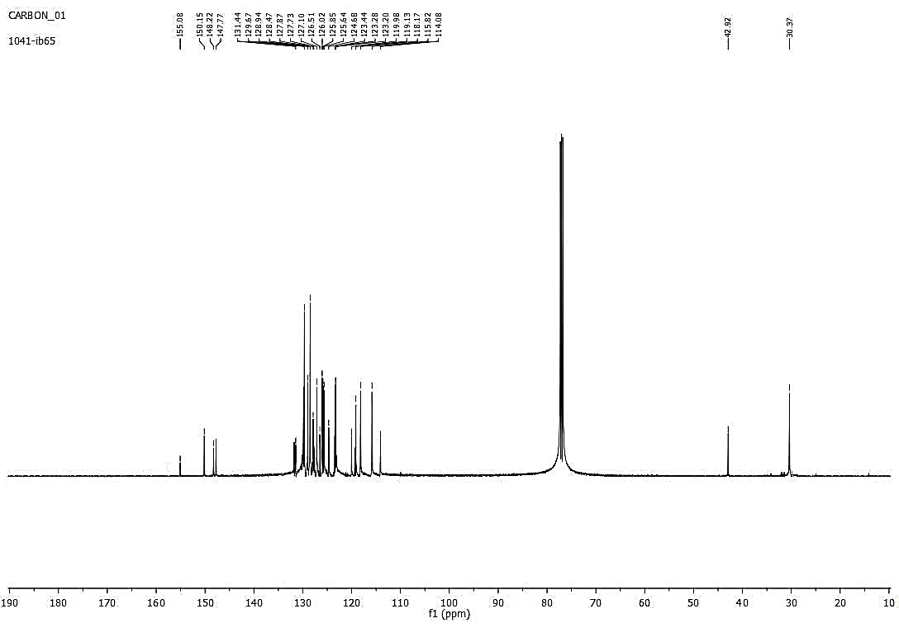
5c
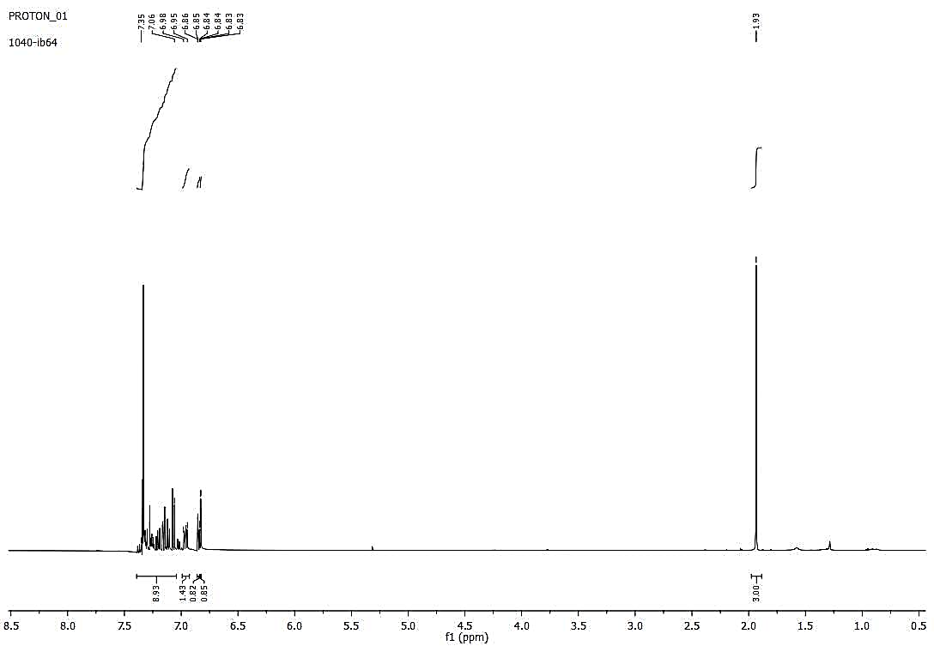
5d
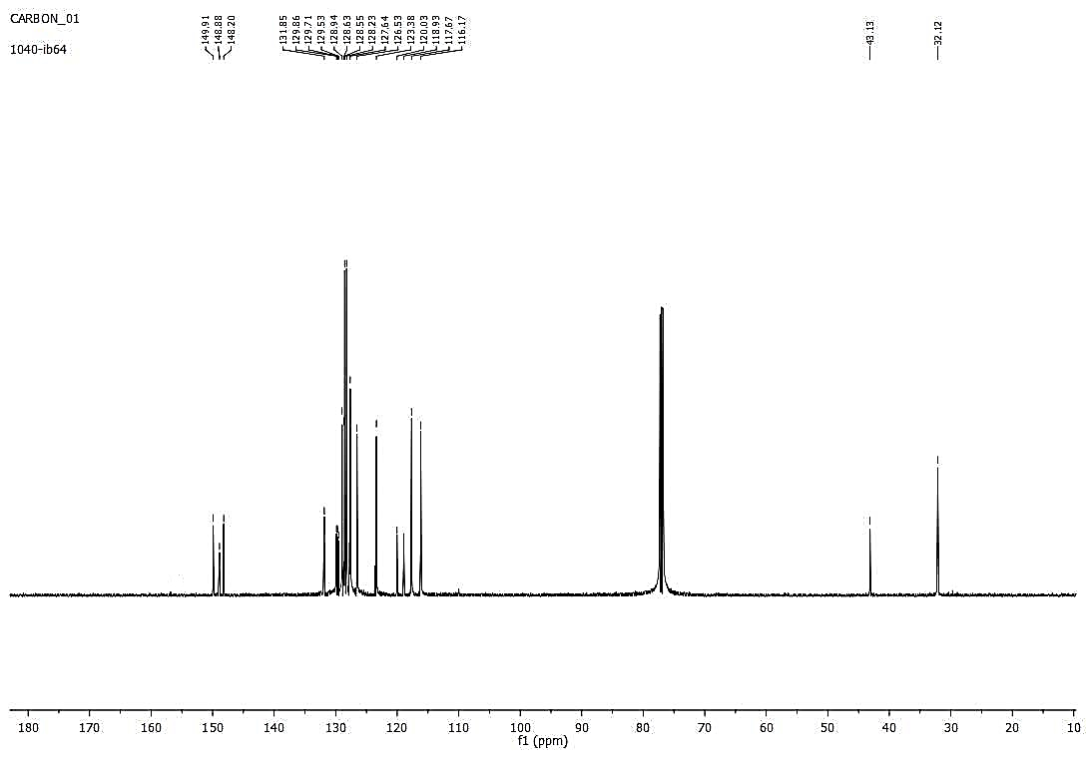
5d
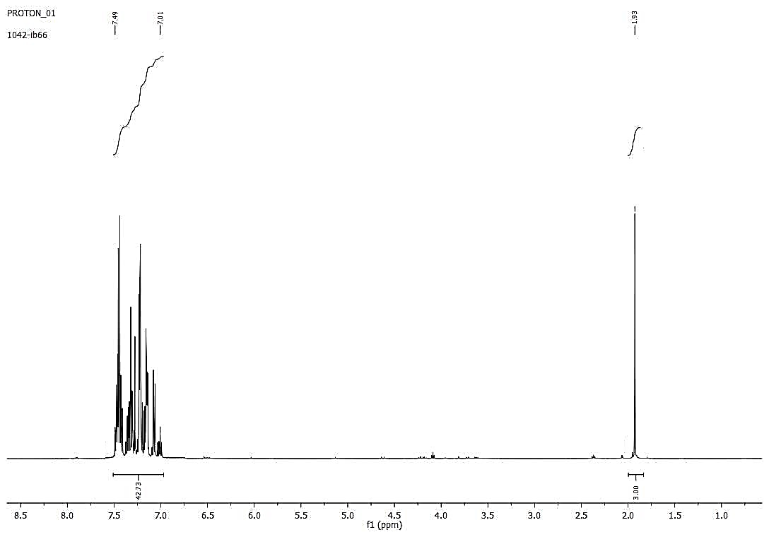
5e
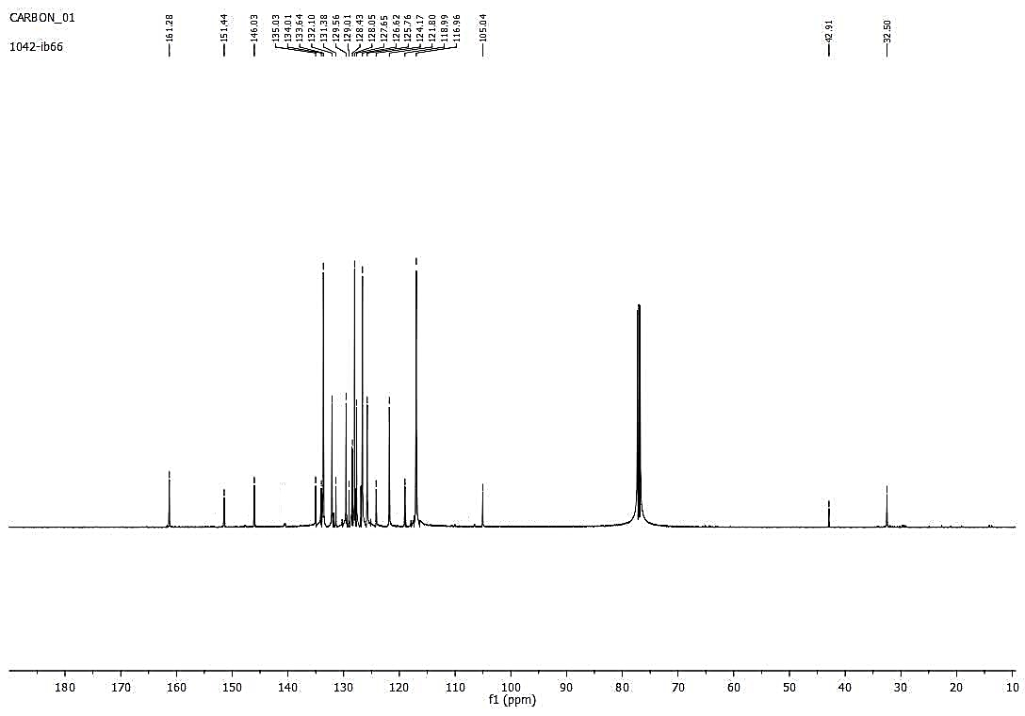
5e
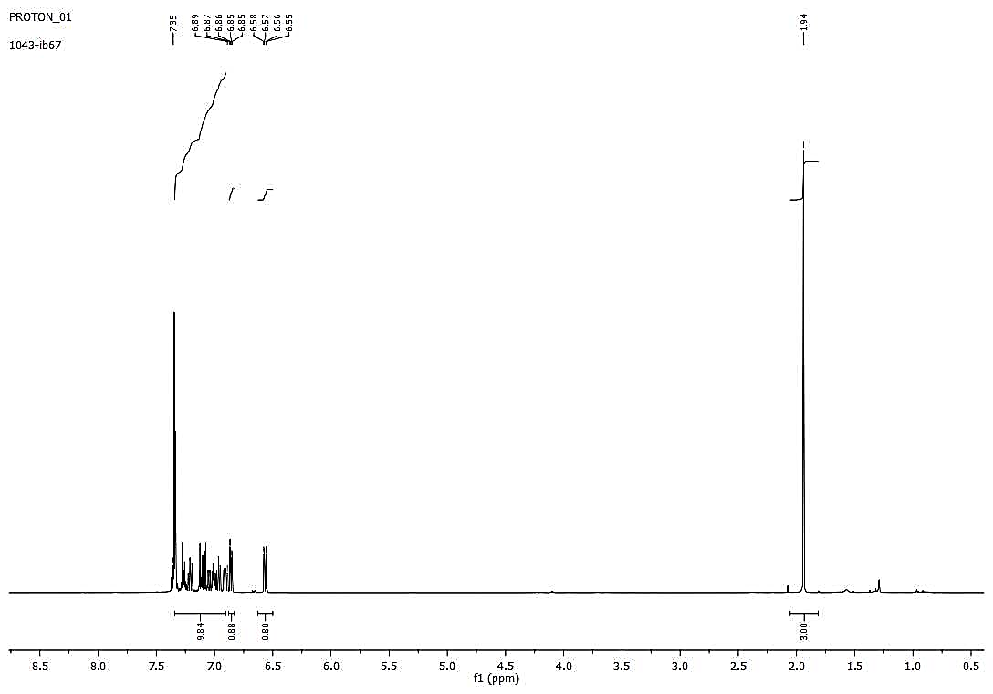
5f
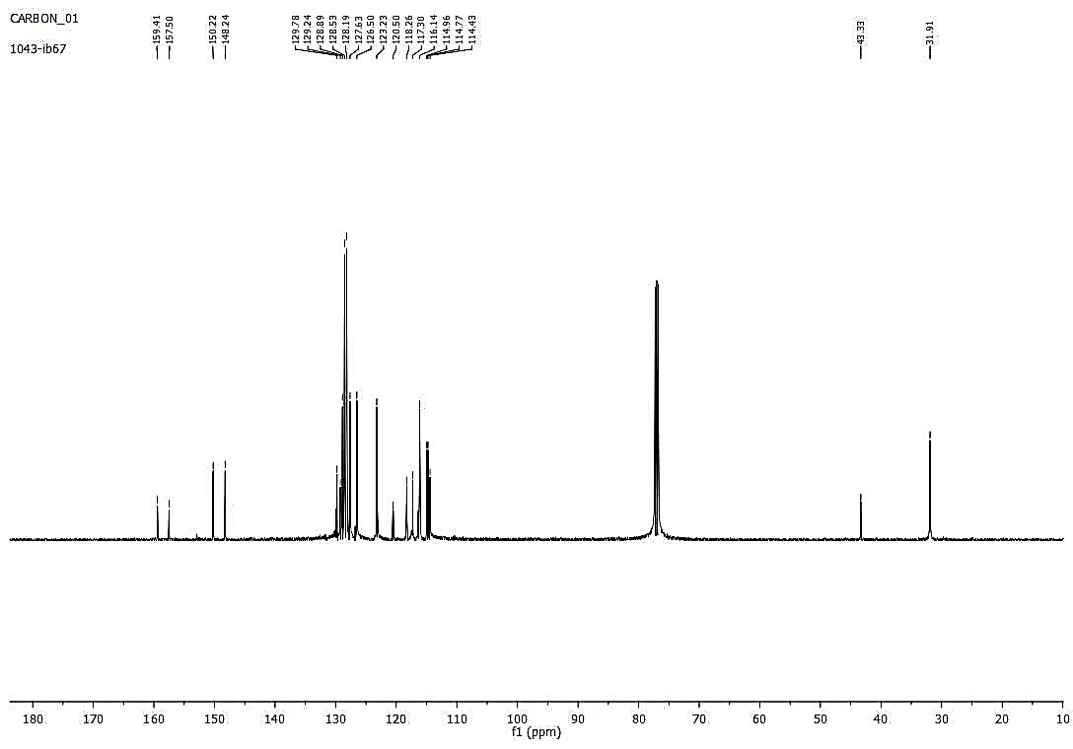
5f
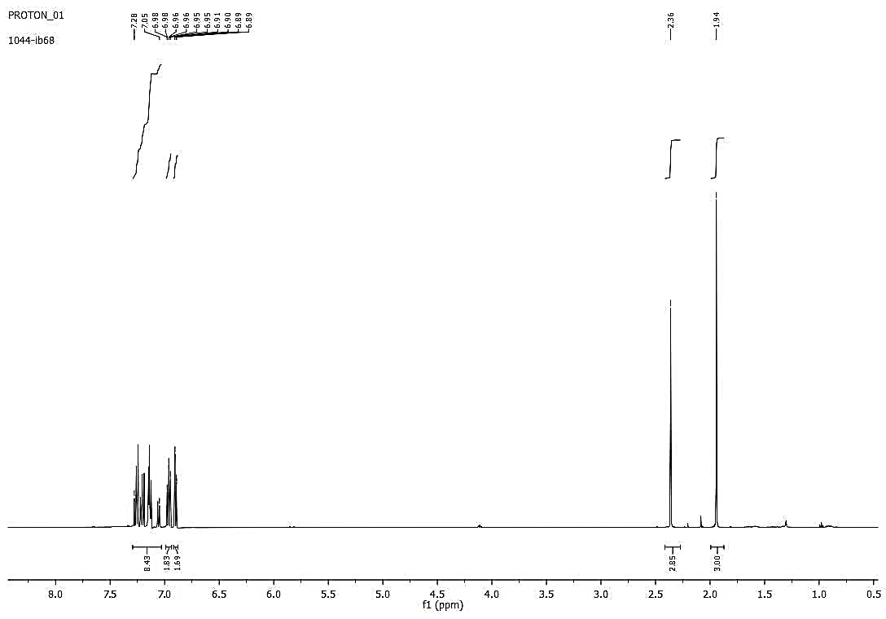
5g
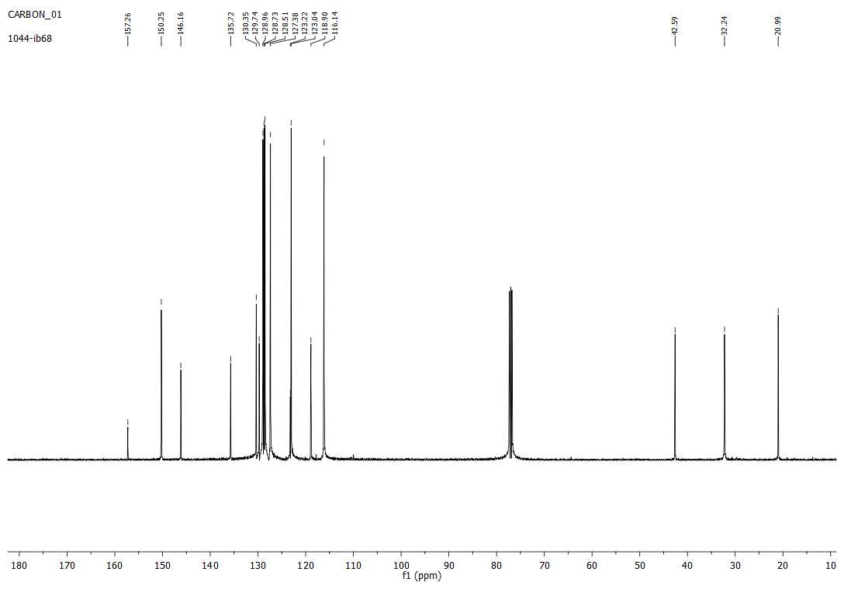
5g
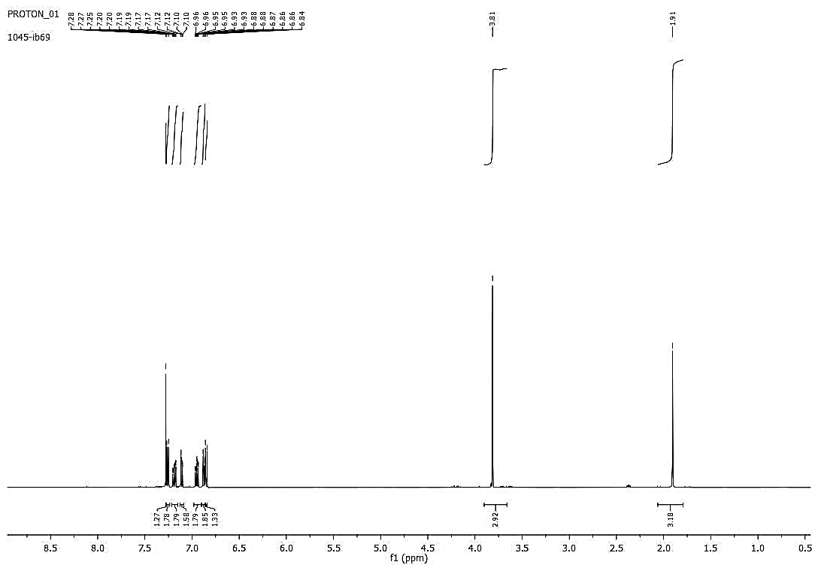
5h
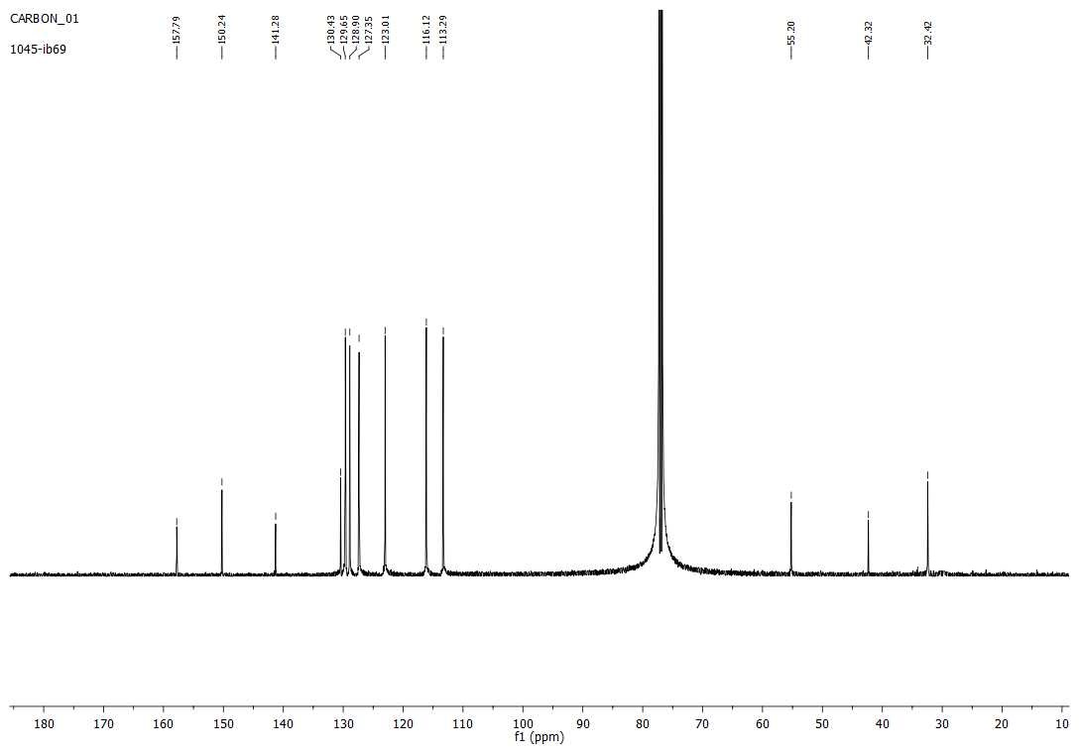
5h
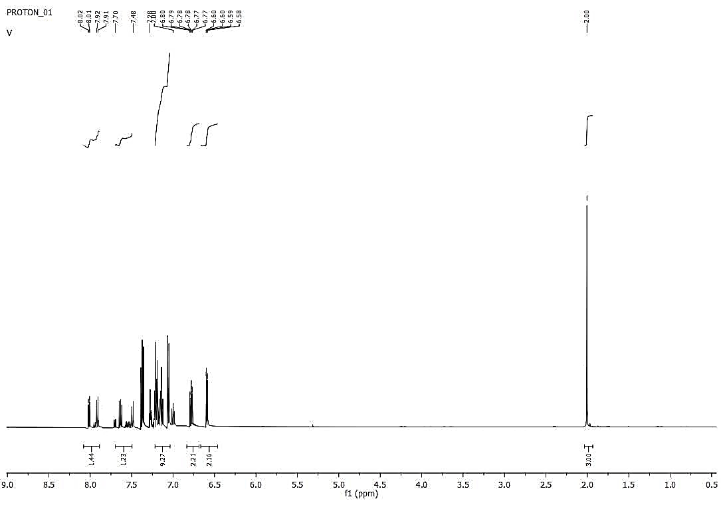
5i
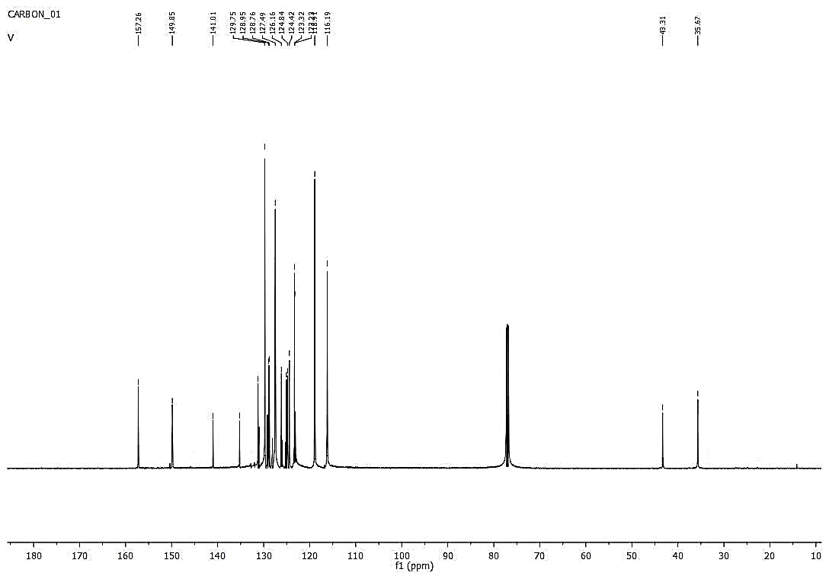
5i
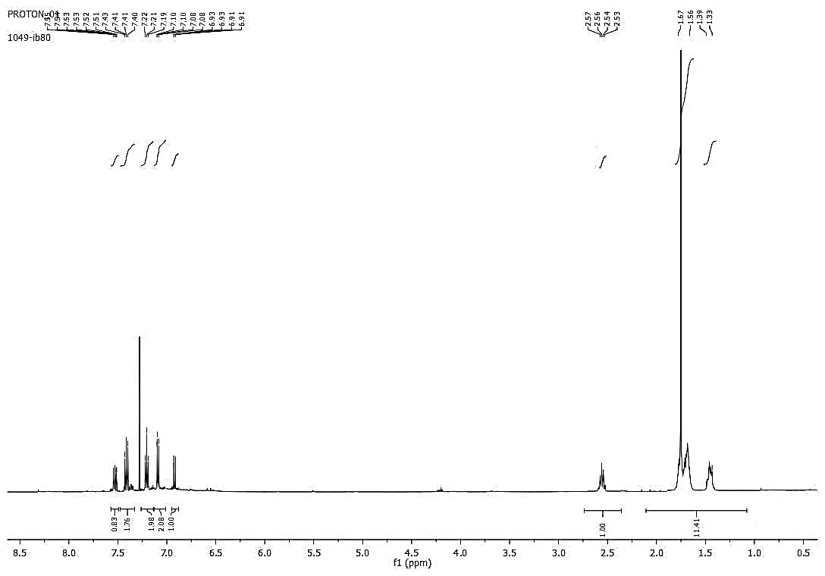
5j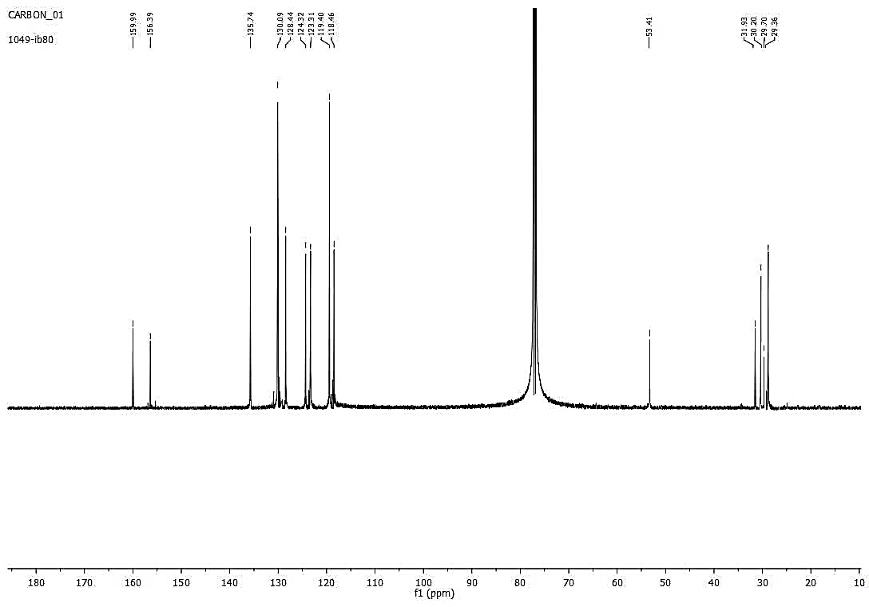
5j
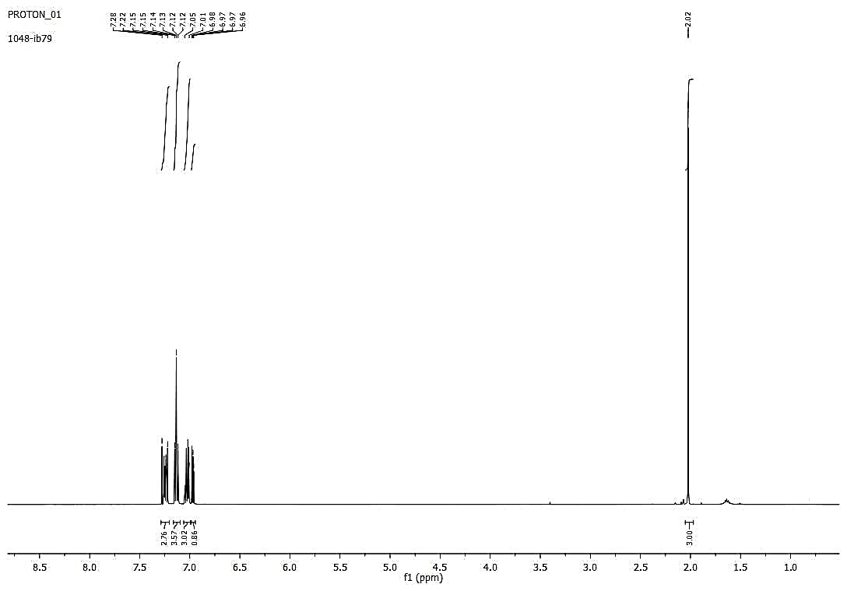
5k
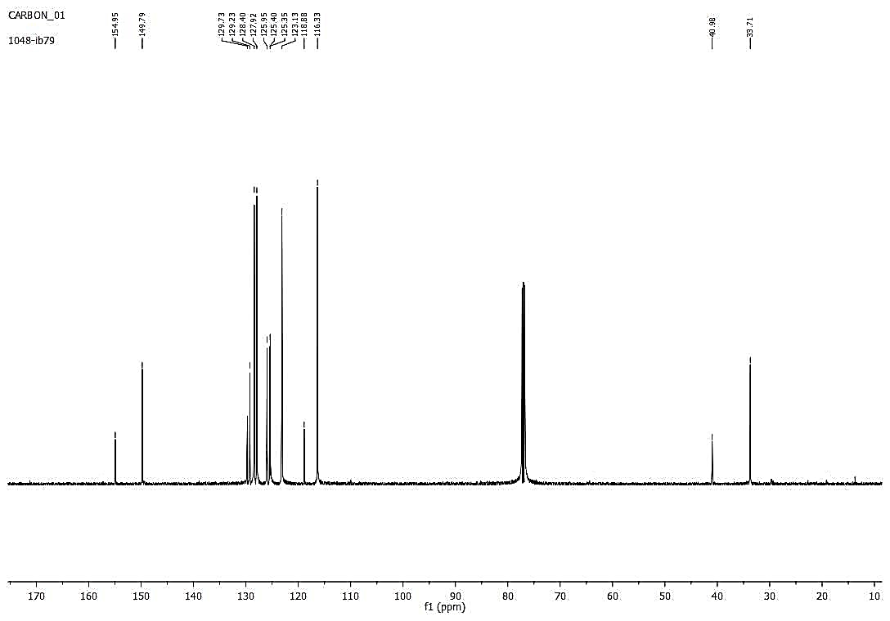
5k
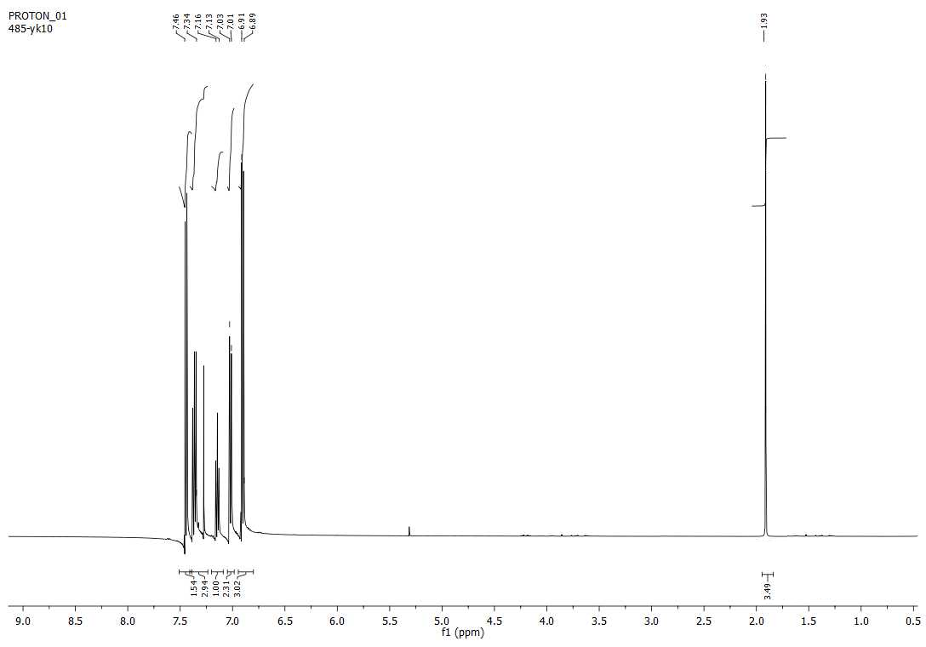
5l
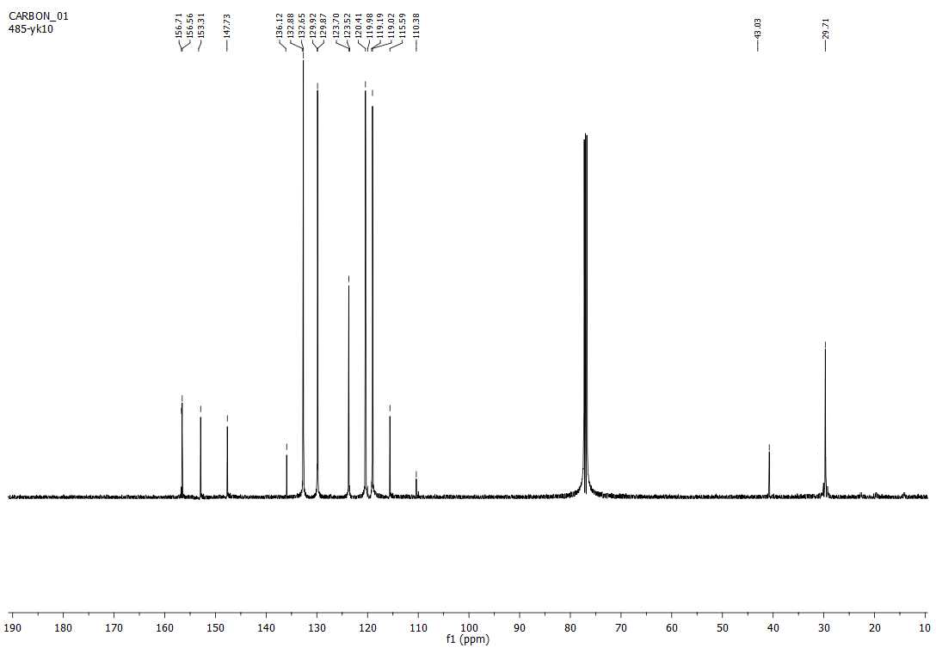
5l

