Supporting Information
Table of Contents
5-Halo substituted porphyrin 4
Bond lengths and angles 4
Table S1: Bond distances, angles, and atom displacement of compounds 1-3. 4
5-Halo-15-phenyl substituted porphyrin 5
Bond lengths and angles 5
Table S2: Bond distances, angles, and atom displacement of compounds 4-8 5
5,15-Dihalo substituted porphyrin 6
Table S3: List of hydrogen···halogen and halogen···halogen interactions seen in compounds 9-15. 6
Bond lengths and angles 7
Table S4: Bond distances, angles, and atom displacement of compounds 9-12. 7
Table S5: Bond distances, angles, and atom displacement of compounds 13-15. 8
5,10-Dihalo substituted porphyrin 9
Table S6: Bond distances, angles, and atom displacement of compounds 16-19. 9
Honourable mentions 10
Table S7: Bond distances, angles, and atom displacement of compounds 20-24. 10
DFT Tables 11
Table S8: Molecular orbital energies (HOMO, LUMO) and singlet state properties (S₁, f₁) together with the porphyrin-phenyl dihedral. 11
Table S9: Molecular orbital energies (HOMO, LUMO). 11
Table S10: Molecular orbital energies (HOMO, LUMO). 11
Series 1 12
Table S11: Bond distances, angles, and atom displacement of compounds 1:1-1:6. 12
Table S12: Bond distances, angles, and atom displacement of compounds 1:7-1:10, 1D, 2D. 13
Table S13: Bond distances, angles, and atom displacement of compounds 1:11-1:15, 3D. 14
Table S14: Comparative tables between crystal structure and calculated structure of compounds 1-3 where D signifies the calculated structure. 15
Series 2 16
Table S15: Bond distances, angles, and atom displacement of compounds 2:1-2:6, 1D, and 1:11. 16
Series 3 17
Table S16: Bond distances, angles, and atom displacement of compounds 3:1-3:3, 2:4. 17
Crystal data and refinement 18
Table S17: Details of XRD data refinement. 18
Table S18: Details of XRD data refinement. 19
Table S19: Details of XRD data refinement. 20
Table S20: Details of XRD data refinement. 21
Complete NSD tables 22
Table S21: NSD out-put of compounds 1-23. 22
Table S22: NSD out-put series 1. 23
Table S23: NSD out-put series 2. 24
Table S24: NSD out-put series 3. 24
NSD tables and plots for crystal structures 25
NSD result generated from 1 (in Å) 25
NSD result generated from 2 (in Å) 26
NSD result generated from 2A (in Å) 27
NSD result generated from 3 (in Å) 28
NSD result generated from 4 (in Å) 29
NSD result generated from 5 (in Å) 30
NSD result generated from 6 (in Å) 31
NSD result generated from 7 (in Å) 32
NSD result generated from 8_1 (in Å) 33
NSD result generated from 8_2 (in Å) 34
NSD result generated from 9 (in Å) 35
NSD result generated from 10 (in Å) 36
NSD result generated from 11 (in Å) 37
NSD result generated from 12 (in Å) 38
NSD result generated from 13 (in Å) 39
NSD result generated from 13A (in Å) 40
NSD result generated from 14 (in Å) 41
NSD result generated from 15 (in Å) 42
NSD result generated from 16 (in Å) 43
NSD result generated from 16A (in Å) 44
NSD result generated from 17 (in Å) 45
NSD result generated from 18 (in Å) 46
NSD result generated from 19 (in Å) 47
NSD result generated from 20 (in Å) 48
NSD result generated from 21 (in Å) 49
NSD result generated from 22 (in Å) 50
NSD result generated from 23 (in Å) 51
NSD result generated from 24 (in Å) 52
NSD tables and plots for DFT structures series 1 53
NSD result generated from 1:1 (in Å) 53
NSD result generated from 1:2 (in Å) 54
NSD result generated from 1:3 (in Å) 55
NSD result generated from 1:4 (in Å) 56
NSD result generated from 1:5 (in Å) 57
NSD result generated from 1:6 (in Å) 58
NSD result generated from 1:7 (in Å) 59
NSD result generated from 1:8 (in Å) 60
NSD result generated from 1:9 (in Å) 61
NSD result generated from 1:10 (in Å) 62
NSD result generated from 1D (in Å) 63
NSD result generated from 2D (in Å) 64
NSD result generated from 1:11 (in Å) 65
NSD result generated from 1:12 (in Å) 66
NSD result generated from 3D (in Å) 67
NSD result generated from 1:13 (in Å) 68
NSD result generated from 1:14 (in Å) 69
NSD result generated from 1:15 (in Å) 70
NSD tables and plots for DFT structures series 2 71
NSD result generated from 2:1 (in Å) 71
NSD result generated from 2:2 (in Å) 72
NSD result generated from 2:3 (in Å) 73
NSD result generated from 2:4 (in Å) 74
NSD result generated from 2:5 (in Å) 75
NSD result generated from 2:6 (in Å) 76
NSD tables and plots for DFT structures series 3 77
NSD result generated from 3:1 (in Å) 77
NSD result generated from 3:2 (in Å) 78
NSD result generated from 3:3 (in Å) 79

5-Halo substituted porphyrin

Bond lengths and angles

Table S1: Bond distances, angles, and atom displacement of compounds 1-3.

Bond Distances,  Bond Angles,  Atom Displacements | 1 | 2 | 2A | 3
CCDC code | MS563 | NESHUO | MS546 | UDERUR
N–C_{a} (Å) | 1.373(4) | 1.384(11) | 1.381(3) | 1.370(5)
C_{a}–C_{b} (Å) | 1.437(9) | 1.430(17) | 1.433(6) | 1.441(14)
C_{a}–C_{m} (Å) | 1.392(5) | 1.377(18) | 1.382(7) | 1.399(8)
C_{b}–C_{b} (Å) | 1.347(2) | 1.326(18) | 1.346(3) | 1.357(9)
∠C_{a}C_{b}C_{b} (°) | 107.6(5) | 107.6(9) | 107.0(3) | 107.3(7)
∠NC_{a}C_{b} (°) | 108.6(9) | 110.0(12) | 110.8(4) | 108.9(19)
∠NC_{a}C_{m} (°) | 125.2(10) | 125.2(13) | 125.7(2) | 125.8(7)
∠C_{a}NC_{a} (°) | 107.6(9) | 104.7(8) | 104.4(15) | 107(2)
∠C_{m}C_{a}C_{b} (°) | 126.2(10) | 124.7(18) | 123.4(4) | 125.3(19)
∠C_{a}C_{m}C_{a} (°) | 127.0(2) | 123(2) | 122.8(8) | 125(2)
Δ24 (Å) | 0.0287 | 0.1769 | 0.0396 | 0.0781
ΔN (Å) | 0.023(15) | 0.015(12) | 0.020(3) | 0.030(2)
ΔC_{a} (Å) | 0.022(13) | 0.200(2) | 0.040(17) | 0.050(3)
ΔC_{b} (Å) | 0.033(18) | 0.140(4) | 0.030(2) | 0.150(5)
ΔC_{m} (Å) | 0.040(2) | 0.360(3) | 0.070(2) | 0.050(3)
∠ pyrrole tilt (°) | 1.8(4) | 11.2(11) | 2.4(8) | 4.0(2)
N···N dist (adj) (Å) | 2.910(4) | 2.748(15) | 2.770(2) | 2.920(7)
N···N dist (opp) (Å) | 4.118(15) | 3.886(12) | 3.917(9) | 4.120(7)

5-Halo-15-phenyl substituted porphyrin

Bond lengths and angles

Table S2: Bond distances, angles, and atom displacement of compounds 4-8

Bond Distances,  Bond Angles,  Atom Displacements | 4 | 5 | 6 | 7 | 8_1 | 8_2
CCDC code | DGIB005a | MS567 | KJF150xp | DGIB007b | TCD662 | TCD662
N–C_{a} (Å) | 1.367(2) | 1.371(4) | 1.371(6) | 1.382(4) | 1.370(4) | 1.373(4)
C_{a}–C_{b} (Å) | 1.444(4) | 1.441(5) | 1.441(7) | 1.435(5) | 1.439(9) | 1.436(12)
C_{a}–C_{m} (Å) | 1.402(7) | 1.400(5) | 1.399(13) | 1.385(6) | 1.402(6) | 1.401(7)
C_{b}–C_{b} (Å) | 1.352(4) | 1.350(5) | 1.3414(8) | 1.335(4) | 1.344(6) | 1.349(8)
∠C_{a}C_{b}C_{b} (°) | 107.3(3) | 107.4(2) | 107.8(5) | 107.2(10) | 107.8(3) | 107.6(6)
∠NC_{a}C_{b} (°) | 108.7(5) | 108.7(5) | 108.1(9) | 110.6(3) | 108.1(9) | 108.4(8)
∠NC_{a}C_{m} (°) | 126.0(8) | 125.8(10) | 126.1(12) | 125.9(11) | 126.3(15) | 126.0(15)
∠C_{a}NC_{a} (°) | 107.9(5) | 107.7(6) | 108.3(10) | 104.3(15) | 108.3(13) | 107.9(11)
∠C_{m}C_{a}C_{b} (°) | 125.2(7) | 125.4(12) | 125.8(8) | 123.4(9) | 125.6(15) | 125.6(14)
∠C_{a}C_{m}C_{a} (°) | 125.9(18) | 126.0(13) | 125.8(14) | 122.2(20) | 125.6(18) | 125.7(17)
Δ24 (Å) | 0.0564 | 0.0688 | 0.0573 | 0.0591 | 0.0553 | 0.0612
ΔN (Å) | 0.070(5) | 0.060(6) | 0.030(3) | 0.020(14) | 0.030(3) | 0.030(3)
ΔC_{a} (Å) | 0.036(18) | 0.060(4) | 0.040(3) | 0.050(3) | 0.040(4) | 0.050(3)
ΔC_{b} (Å) | 0.070(3) | 0.060(5) | 0.080(6) | 0.080(6) | 0.080(5) | 0.080(6)
ΔC_{m} (Å) | 0.050(3) | 0.110(4) | 0.070(3) | 0.070(3) | 0.070(4) | 0.080(2)
∠ pyrrole tilt (°) | 4.2(18) | 4.7(15) | 3.8(13) | 3.2(14) | 3.8(12) | 4.0(10)
N···N dist (adj) (Å) | 2.930(3) | 2.918(11) | 2.926(9) | 2.766(16) | 2.930(2) | 2.920(3)
N···N dist (opp) (Å) | 4.141(7) | 4.130(4) | 4.140(2) | 3.912(4) | 4.140(3) | 4.130(3)

5,15-Dihalo substituted porphyrin

Table S3: List of hydrogen···halogen and halogen···halogen interactions seen in compounds 9-15.
 | D···H–A | Distance (Å) | Angle (°)
9 | Br1···H18–C18 | 3.071(3) | 148.1(1)
 | Br1···H204–C204 | 3.126(3) | 125.4(1)
 | Br1···H205–C205 | 3.200(3) | 149.3(1)
10 | Br1···H10C–C107 | 3.156(5) | 141.7(1)
11 | Br2···Br2–C10 | 3.433(13) | 152.4(11)
 | Br1···H20E–C203 | 3.153(8) | 155.4(2)
 | Br1···H20F–C204 | 3.270(5) | 127.9(2)
12 | Br1···H48–C46 | 3.207(18) | 130.7(8)
13 | Br2···H10I–C105 | 3.079(3) | 125.2(13)
 | Br2···H2–C2 | 3.323(4) | 139.7(9)
 | Br2···H20A–C207 | 3.174(4) | 139.7(9)
 | Br1···H12–C12 | 3.210(4) | 149.5(8)
13A | Br2···H6–C8 | 3.214(4) | 149.6(8)
 | Br1···H10–C18 | 3.328(4) | 139.7(8)
 | Br1···H31–C34 | 3.181(4) | 130.2(11)
 | Br1···H20–C25 | 3.070(4) | 125.3(13)
14 | Br1···H28–C33 | 3.065(5) | 144.1(15)
 | Br1···H10–C18 | 3.453(5) | 150.3(17)
 | Br2···H6–C8 | 3.306(5) | 157.8(17)
 | Br2···H14–C22 | 3.323(6) | 123.6(15)
 | Br2···H27–C33 | 3.129(6) | 132.0(13)
15 | Br1···H23–C35 | 2.979(3) | 158.1(16)
 | Br2···H11–C26 | 2.856(3) | 161.5(15)
 | Br2···H12–C27 | 3.064(4) | 132.3(15)

Bond lengths and angles

Table S4: Bond distances, angles, and atom displacement of compounds 9-12.
Bond Distances,  Bond Angles,  Atom Displacements | 9 | 10 | 11 | 12
CCDC code | MS545 | HE006 | HE015 | NOGWEN
N–C_{a} (Å) | 1.375(2) | 1.371(9) | 1.384(5) | 1.360(4)
C_{a}–C_{b} (Å) | 1.441(9) | 1.439(7) | 1.433(8) | 1.420(3)
C_{a}–C_{m} (Å) | 1.396(3) | 1.399(6) | 1.384(7) | 1.430(3)
C_{b}–C_{b} (Å) | 1.352(7) | 1.352(3) | 1.344(5) | 1.320(3)
∠C_{a}C_{b}C_{b} (°) | 107.5(6) | 107.4(6) | 107.4(5) | 107.1(19)
∠NC_{a}C_{b} (°) | 108.8(10) | 108.9(13) | 109.8(6) | 110.5(14)
∠NC_{a}C_{m} (°) | 125.1(14) | 125.2(9) | 124.3(11) | 124.0(3)
∠C_{a}NC_{a} (°) | 107.5(12) | 107.5(15) | 105.5(3) | 104.0(2)
∠C_{m}C_{a}C_{b} (°) | 126.1(11) | 125.9(9) | 125.5(8) | 125.1(19)
∠C_{a}C_{m}C_{a} (°) | 127.2(16) | 126.9(19) | 122.0(3) | 125.9(20)
Δ24 (Å) | 0.0174 | 0.0459 | 0.3228 | 0.034
ΔN (Å) | 0.029(19) | 0.043(14) | 0.050(4) | 0.022(12)
ΔC_{a} (Å) | 0.012(10) | 0.031(15) | 0.370(8) | 0.026(15)
ΔC_{b} (Å) | 0.016(13) | 0.059(18) | 0.250(19) | 0.040(3)
ΔC_{m} (Å) | 0.019(17) | 0.052(8) | 0.650(4) | 0.041(10)
∠ pyrrole tilt (°) | 1.2(4) | 3.2(4) | 20.8(12) | 2.3(8)
N···N dist (adj) (Å) | 2.918(7) | 2.920(18) | 2.700(3) | 2.890(2)
N···N dist (opp) (Å) | 4.127(13) | 4.13(3) | 3.822(13) | 4.090(2)

Table S5: Bond distances, angles, and atom displacement of compounds 13-15.
Bond Distances,  Bond Angles,  Atom Displacements | 13 | 13A | 14 | 15
CCDC code | MS556 | HUMWES | HUMWAO | LASMOK
N–C_{a} (Å) | 1.372(3) | 1.371(3) | 1.37(5) | 1.377(4)
C_{a}–C_{b} (Å) | 1.440(4) | 1.442(6) | 1.438(6) | 1.445(4)
C_{a}–C_{m} (Å) | 1.398(5) | 1.400(4) | 1.398(7) | 1.398(4)
C_{b}–C_{b} (Å) | 1.351(17) | 1.356(16) | 1.347(5) | 1.351(3)
∠C_{a}C_{b}C_{b} (°) | 107.4(3) | 107.2(3) | 107.48(16) | 107.1(3)
∠NC_{a}C_{b} (°) | 108.8(5) | 109.1(6) | 108.7(6) | 109.8(4)
∠NC_{a}C_{m} (°) | 125.0(9) | 125.1(9) | 125.4(13) | 124.5(12)
∠C_{a}NC_{a} (°) | 107.5(5) | 107.4(7) | 107.7(7) | 106.16(9)
∠C_{m}C_{a}C_{b} (°) | 126.1(9) | 125.8(9) | 125.9(12) | 125.7(8)
∠C_{a}C_{m}C_{a} (°) | 126.0(2) | 126.0(2) | 126.0(2) | 127.3(15)
Δ24 (Å) | 0.155 | 0.154 | 0.0582 | 0.048
ΔN (Å) | 0.050(2) | 0.050(2) | 0.040(3) | 0.070(4)
ΔC_{a} (Å) | 0.120(5) | 0.120(5) | 0.040(3) | 0.028(9)
ΔC_{b} (Å) | 0.280(4) | 0.280(4) | 0.080(6) | 0.070(4)
ΔC_{m} (Å) | 0.090(2) | 0.090(2) | 0.080(3) | 0.020(14)
∠ pyrrole tilt (°) | 6.8(12) | 6.8(12) | 3.7(19) | 3.7(19)
N···N dist (adj) (Å) | 2.910(2) | 2.910(2) | 2.918(8) | 2.895(2)
N···N dist (opp) (Å) | 4.110(2) | 4.110(2) | 4.130(4) | 4.094(4)

5,10-Dihalo substituted porphyrin

Table S6: Bond distances, angles, and atom displacement of compounds 16-19.
Bond Distances,  Bond Angles,  Atom Displacements | 16 | 16A | 17 | 18 | 19
CCDC code | RAKGAN | MS529 | ZOXQUA | ZOXCAS | BASDOR
N–C_{a} (Å) | 1.375(12) | 1.366(6) | 1.377(11) | 1.374(2) | 1.369(2)
C_{a}–C_{b} (Å) | 1.438(13) | 1.438(12) | 1.432(14) | 1.439(5) | 1.442(6)
C_{a}–C_{m} (Å) | 1.406(10) | 1.400(12) | 1.388(18) | 1.402(7) | 1.400(5)
C_{b}–C_{b} (Å) | 1.341(7) | 1.347(11) | 1.341(15) | 1.341(7) | 1.351(7)
∠C_{a}C_{b}C_{b} (°) | 107.8(13) | 107.4(7) | 107.5(10) | 107.4(2) | 107.3(3)
∠NC_{a}C_{b} (°) | 108.4(14) | 108.6(16) | 109.5(5) | 109.4(3) | 108.9(9)
∠NC_{a}C_{m} (°) | 125.1(9) | 125.9(3) | 124.8(16) | 124.4(9) | 125.3(12)
∠C_{a}NC_{a} (°) | 107.6(12) | 107.9(19) | 106.1(4) | 106.4(4) | 107.5(13)
∠C_{m}C_{a}C_{b} (°) | 126.3(15) | 125.4(14) | 125.6(18) | 126.1(12) | 125.7(13)
∠C_{a}C_{m}C_{a} (°) | 126.5(11) | 125.6(10) | 125.0(2) | 127.0(18) | 126.8(18)
Δ24 (Å) | 0.159 | 0.113 | 0.125 | 0.106 | 0.043
ΔN (Å) | 0.050(3) | 0.040(4) | 0.030(18) | 0.011(11) | 0.003(3)
ΔC_{a} (Å) | 0.140(8) | 0.080(5) | 0.140(4) | 0.110(4) | 0.050(7)
ΔC_{b} (Å) | 0.190(9) | 0.200(6) | 0.090(7) | 0.100(8) | 0.034(5)
ΔC_{m} (Å) | 0.242(12) | 0.080(5) | 0.250(3) | 0.200(4) | 0.090(2)
∠ pyrrole tilt (°) | 9.0(14) | 5(3) | 7.6(5) | 6.5(16) | 2.7(3)
N···N dist (adj) (Å) | 2.920(2) | 2.915(16) | 2.841(6) | 2.890(12) | 2.919(2)
N···N dist (opp) (Å) | 4.130(4) | 4.120(4) | 4.017(6) | 4.090(2) | 4.130(4)

Honourable mentions

Table S7: Bond distances, angles, and atom displacement of compounds 20-24.
Bond Distances,  Bond Angles,  Atom Displacements | 20 | 21 | 22 | 23 | 24
CCDC code | YISZAD | QUGMEM | QUGMIQ | MORBEC | HE014
N–C_{a} (Å) | 1.368(10) | 1.381(4) | 1.380(8) | 1.390(20) | 1.369(5)
C_{a}–C_{b} (Å) | 1.452(9) | 1.440(9) | 1.436(7) | 1.440(2) | 1.438(6)
C_{a}–C_{m} (Å) | 1.390(5) | 1.387(5) | 1.388(6) | 1.376(17) | 1.404(4)
C_{b}–C_{b} (Å) | 1.366(6) | 1.333(9) | 1.344(5) | 1.340(2) | 1.350(4)
∠C_{a}C_{b}C_{b} (°) | 106.8(6) | 107.5(4) | 107.3(11) | 107.0(11) | 107.5(4)
∠NC_{a}C_{b} (°) | 109.3(17) | 109.5(3) | 109.7(4) | 111.0(8) | 108.6(8)
∠NC_{a}C_{m} (°) | 124.4(3) | 124.7(15) | 125.0(14) | 124.6(18) | 126.4(4)
∠C_{a}NC_{a} (°) | 107.0(2) | 105.8(3) | 105.8(3) | 104.0(11) | 107.9(8)
∠C_{m}C_{a}C_{b} (°) | 126.3(16) | 125.3(18) | 124.9(18) | 124.3(14) | 125.0(5)
∠C_{a}C_{m}C_{a} (°) | 128.8(14) | 121.5(12) | 121.3(12) | 123.4(19) | 124.9(8)
Δ24 (Å) | 0.023 | 0.327 | 0.303 | 0.166 | 0.047
ΔN (Å) | 0.030(14) | 0.032(19) | 0.021(18) | 0.031(16) | 0.023(20)
ΔC_{a} (Å) | 0.014(16) | 0.380(5) | 0.350(3) | 0.190(4) | 0.040(3)
ΔC_{b} (Å) | 0.029(16) | 0.250(12) | 0.240(6) | 0.130(7) | 0.050(3)
ΔC_{m} (Å) | 0.020(14) | 0.660(3) | 0.620(7) | 0.340(4) | 0.070(6)
∠ pyrrole tilt (°) | 1.8(6) | 20.9(8) | 19.3(11) | 10.2(7) | 2.8(12)
N···N dist (adj) (Å) | 2.926(6) | 2.704(18) | 2.716(15) | 2.737(15) | 2.910(2)
N···N dist (opp) (Å) | 4.140(7) | 3.824(8) | 3.840(20) | 3.869(12) | 4.118(13)

DFT Tables

Table S8: Molecular orbital energies (HOMO, LUMO) and singlet state properties (S₁, f₁) together with the porphyrin-phenyl dihedral.
Series 1 | HOMO (eV) | LUMO (eV) | S₁ (nm) | f₁ | Dihedral (°)
1:1 | -6.68 | -1.08 | 592 | 0.0023 | 69.2
1:2 | -6.75 | -0.90 | 520 | 0.0012 | 82.6
1:3 | -6.68 | -1.18 | 585 | 0.0202 | 69.1
1:4 | -6.85 | -1.00 | 522 | 0.0050 | 81.9
1:5 | -6.64 | -1.32 | 612 | 0.0465 | 68.9
1:6 | -6.82 | -1.14 | 532 | 0.0304 | 81.6
1:7 | -6.76 | -1.24 | 603 | 0.0023 | 72.8
1:8 | -6.91 | -1.08 | 529 | 0.0003 | 81.6
1:9 | -6.83 | -1.40 | 614 | 0.0059 | 78.0
1:10 | -6.96 | -1.24 | 539 | 0.0033 | 81.4
1D | -6.77 | -1.24 | 603 | 0.0018 | 74.1
2D | -6.90 | -1.09 | 530 | 0.0009 | 82.8
1:11 | -6.84 | -1.08 | 614 | 0.0071 | 81.4
1:12 | -6.96 | -1.27 | 541 | 0.0061 | 81.5
3D | -6.77 | -1.24 | 602 | 0.0020 | 75.8
1:13 | -6.89 | -1.09 | 532 | 0.0004 | 80.2
1:14 | -6.83 | -1.18 | 614 | 0.0116 | 87.6
1:15 | -6.94 | -1.28 | 545 | 0.0115 | 81.5
S₁=first singlet state; f₁=oscillator strength

Table S9: Molecular orbital energies (HOMO, LUMO).
Series 2 | HOMO (eV) | LUMO (eV) | S₁ (nm) | f₁ | Dihedral (°)
2:1 | -6.76 | -1.08 | 585 | 0.0006 | 71.4
2:2 | -6.84 | -1.25 | 595 | 0.0007 | 78.3
1D | -6.77 | -1.24 | 603 | 0.0018 | 74.1
1:11 | -6.84 | -1.08 | 614 | 0.0071 | 81.4
2:3 | -6.90 | -1.41 | 607 | 0.0024 | 73.9
2:4 | -6.97 | -1.57 | 620 | 0.0065 | 80.1
2:5 | -6.77 | -1.35 | 601 | 0.0037 | 79.3
2:6 | -6.83 | -1.38 | 612 | 0.0051 | 75.6

Table S10: Molecular orbital energies (HOMO, LUMO).
Series 3 | HOMO (eV) | LUMO (eV) | S₁ (nm) | f₁ | Dihedral (°)
3:1 | -6.82 | -1.37 | 566 | 0.0171 | 74.2
3:2 | -6.69 | -1.17 | 614 | 0.0060 | 75.4
2:6 | -6.83 | -1.38 | 612 | 0.0051 | 75.6
3:3 | -6.83 | -1.37 | 608 | 0.0048 | 75.8

Series 1

Table S11: Bond distances, angles, and atom displacement of compounds 1:1-1:6.
Bond Distances,  Bond Angles,  Atom Displacements | 1:1 | 1:2 | 1:3 | 1:4 | 1:5 | 1:6
CCDC code | Base | Base-Ni | F-Mono | F-Mono-Ni | F-Di | F-Di-Ni
N–C_{a} (Å) | 1.363(4) | 1.374(13) | 1.363(7) | 1.374(4) | 1.363(4) | 1.374(14)
C_{a}–C_{b} (Å) | 1.446(13) | 1.44(2) | 1.445(15) | 1.438(5) | 1.443(13) | 1.436(4)
C_{a}–C_{m} (Å) | 1.398(6) | 1.384(5) | 1.399(11) | 1.384(7) | 1.398(6) | 1.383(5)
C_{b}–C_{b} (Å) | 1.361(8) | 1.355 | 1.361(8) | 1.356(3) | 1.362(8) | 1.3566(2)
∠C_{a}C_{b}C_{b} (°) | 107.0(9) | 106.556(17) | 106.9(9) | 106.5(3) | 106.8(9) | 106.4(5)
∠NC_{a}C_{b} (°) | 109(2) | 111.07(15) | 109(2) | 111.2(4) | 109(2) | 111.4(5)
∠NC_{a}C_{m} (°) | 126.0(8) | 125.72(12) | 125.7(8) | 125.3(7) | 125.3(4) | 125.0(8)
∠C_{a}NC_{a} (°) | 107(3) | 104.7417(11) | 107(3) | 104.5(3) | 107(3) | 104.267(14)
∠C_{m}C_{a}C_{b} (°) | 124(2) | 123.16(7) | 125(2) | 123.4(4) | 125(2) | 123.6(2)
∠C_{a}C_{m}C_{a} (°) | 126(2) | 122.9(10) | 126(3) | 123.4(17) | 126(3) | 123.9(20)
Δ24 (Å) | 0.0185 | 0.1003 | 0.0194 | 0.1084 | 0.02 | 0.1049
ΔN (Å) | 0.033(5) | 0.007(2) | 0.034(6) | 0.008(3) | 0.035(6) | 0.007(3)
ΔC_{a} (Å) | 0.013(4) | 0.116(4) | 0.013(4) | 0.125(4) | 0.014(4) | 0.122(4)
ΔC_{b} (Å) | 0.022(4) | 0.081(6) | 0.023(5) | 0.087(8) | 0.024(5) | 0.084(7)
ΔC_{m} (Å) | 0.009(6) | 0.202(3) | 0.01(6) | 0.217(5) | 0.01(7) | 0.211(4)
∠ pyrrole tilt (°) | 1.46(18) | 6.33(6) | 1.5(2) | 6.84(13) | 1.6(2) | 6.64(8)
N···N dist (adj) (Å) | 2.92(12) | 2.77(2) | 2.92(11) | 2.77(2) | 2.92(11) | 2.77(2)
N···N dist (opp) (Å) | 4.13(8) | 3.92 | 4.13(8) | 3.92 | 4.13(7) | 3.9216(4)

Table S12: Bond distances, angles, and atom displacement of compounds 1:7-1:10, 1D, 2D.
Bond Distances,  Bond Angles,  Atom Displacements | 1:7 | 1:8 | 1:9 | 1:10 | 1D | 2D
CCDC code | Cl-Mono | Cl-Mono-Ni | Cl-Di | Cl-Di-Ni | Br-Mono | Br-Mono-Ni
N–C_{a} (Å) | 1.364(4) | 1.3739(15) | 1.364(4) | 1.3741(3) | 1.364(4) | 1.374(2)
C_{a}–C_{b} (Å) | 1.446(14) | 1.439(2) | 1.445(14) | 1.4384(7) | 1.446(13) | 1.4395(16)
C_{a}–C_{m} (Å) | 1.399(5) | 1.387(4) | 1.401(3) | 1.3887(9) | 1.4(5) | 1.387(4)
C_{b}–C_{b} (Å) | 1.36(8) | 1.3549(3) | 1.359(8) | 1.35509(16) | 1.359(8) | 1.3544(10)
∠C_{a}C_{b}C_{b} (°) | 107.0(9) | 106.58(15) | 107.0(9) | 106.6(2) | 107.0(9) | 106.62(12)
∠NC_{a}C_{b} (°) | 109(2) | 111.01(14) | 109(2) | 110.9(17) | 109(2) | 110.89(12)
∠NC_{a}C_{m} (°) | 125.7(6) | 125.2(7) | 125.5(11) | 124.8(9) | 125.8(7) | 125.2(7)
∠C_{a}NC_{a} (°) | 107(3) | 104.78(6) | 107(3) | 104.897(12) | 107(3) | 104.93(3)
∠C_{m}C_{a}C_{b} (°) | 125(2) | 123.6(6) | 125(2) | 124.1(7) | 125(2) | 123.7(7)
∠C_{a}C_{m}C_{a} (°) | 126.3(17) | 122.9(11) | 126.6(9) | 123.0(12) | 126.3(15) | 122.8(11)
Δ24 (Å) | 0.0175 | 0.1744 | 0.0137 | 0.2249 | 0.0167 | 0.1914
ΔN (Å) | 0.03(6) | 0.01(3) | 0.023(4) | 0.008(6) | 0.028(5) | 0.004(4)
ΔC_{a} (Å) | 0.011(4) | 0.202(5) | 0.009(4) | 0.261(5) | 0.011(4) | 0.223(6)
ΔC_{b} (Å) | 0.021(5) | 0.141(6) | 0.017(4) | 0.181(11) | 0.02(5) | 0.155(13)
ΔC_{m} (Å) | 0.01(6) | 0.3518(18) | 0.007(7) | 0.457(7) | 0.01(6) | 0.389(14)
∠ pyrrole tilt (°) | 1.4(2) | 11.05(2) | 1.09(18) | 14.33(13) | 1.3(2) | 12.2(3)
N···N dist (adj) (Å) | 2.92(5) | 2.763(9) | 2.92(20) | 2.752(2) | 2.92(3) | 2.76(6)
N···N dist (opp) (Å) | 4.13(8) | 3.91(1) | 4.13(7) | 3.89(1) | 4.13(8) | 3.90(1)

Table S13: Bond distances, angles, and atom displacement of compounds 1:11-1:15, 3D.
Bond Distances,  Bond Angles,  Atom Displacements | 1:11 | 1:12 | 3D | 1:13 | 1:14 | 1:15
CCDC code | Br-Di | Br-Di-Ni | I-Mono | I-Mono-Ni | I-Di | I-Di-Ni
N–C_{a} (Å) | 1.365(4) | 1.3737(11) | 1.365(5) | 1.374(2) | 1.366(4) | 1.3742(19)
C_{a}–C_{b} (Å) | 1.446(13) | 1.4388(2) | 1.446(14) | 1.4398(18) | 1.446(13) | 1.4398(13)
C_{a}–C_{m} (Å) | 1.401(3) | 1.39(3) | 1.4(6) | 1.388(4) | 1.402(3) | 1.3914(8)
C_{b}–C_{b} (Å) | 1.358(8) | 1.3552(5) | 1.359(8) | 1.3549(14) | 1.357(8) | 1.3544(7)
∠C_{a}C_{b}C_{b} (°) | 107.0(9) | 106.66(9) | 107.0(9) | 106.66(13) | 107.1(9) | 106.75(5)
∠NC_{a}C_{b} (°) | 109(2) | 110.75(5) | 109(2) | 110.75(20) | 109(2) | 110.51(15)
∠NC_{a}C_{m} (°) | 125.6(14) | 124.8(9) | 125.8(9) | 125.2(7) | 125.7(18) | 124.8(9)
∠C_{a}NC_{a} (°) | 107(3) | 105.0935(18) | 107(3) | 105.12(7) | 107(3) | 105.36(2)
∠C_{m}C_{a}C_{b} (°) | 125(2) | 124.2(9) | 125(2) | 123.8(9) | 125(3) | 124.4(11)
∠C_{a}C_{m}C_{a} (°) | 126.6(5) | 122.8(10) | 126.2(10) | 122.6(8) | 126.4(3) | 122.4(7)
Δ24 (Å) | 0.0102 | 0.2476 | 0.0155 | 0.2226 | 0.0032 | 0.2724
ΔN (Å) | 0.017(3) | 0.008(7) | 0.026(5) | 0.012(8) | 0.0051(10) | 0.009(8)
ΔC_{a} (Å) | 0.006(3) | 0.287(5) | 0.01(4) | 0.258(9) | 0.0019(10) | 0.316(5)
ΔC_{b} (Å) | 0.013(3) | 0.199(13) | 0.019(5) | 0.179(9) | 0.0041(8) | 0.219(16)
ΔC_{m} (Å) | 0.006(5) | 0.504(9) | 0.009(6) | 0.45(11) | 0.002(17) | 0.556(14)
∠ pyrrole tilt (°) | 0.8(12) | 15.8(13) | 1.21(19) | 14.1(3) | 0.25(3) | 17.41(14)
N···N dist (adj) (Å) | 2.92(5) | 2.747(7) | 2.921(8) | 2.753(6) | 2.93(9) | 2.74(12)
N···N dist (opp) (Å) | 4.13(7) | 3.89(1) | 4.13(8) | 3.89(1) | 4.14(7) | 3.875(3)

Table S14: Comparative tables between crystal structure and calculated structure of compounds 1-3 where D signifies the calculated structure.
Bond Distances,  Bond Angles,  Atom Displacements | 1 | 1D | 2 | 2D | 3 | 3D
 | MS563 | Br-Mono | NESHUO | Br-Mono-Ni | UDERUR | I-Mono
N–C_{a} (Å) | 1.373(4) | 1.364(4) | 1.384(11) | 1.374(2) | 1.370(5) | 1.365(5)
C_{a}–C_{b} (Å) | 1.437(9) | 1.446(13) | 1.430(17) | 1.4395(16) | 1.441(14) | 1.446(14)
C_{a}–C_{m} (Å) | 1.392(5) | 1.4(5) | 1.377(18) | 1.387(4) | 1.399(8) | 1.4(6)
C_{b}–C_{b} (Å) | 1.347(2) | 1.359(8) | 1.326(18) | 1.3544(10) | 1.357(9) | 1.359(8)
∠C_{a}C_{b}C_{b} (°) | 107.6(5) | 107.0(9) | 107.6(9) | 106.62(12) | 107.3(7) | 107.0(9)
∠NC_{a}C_{b} (°) | 108.6(9) | 109(2) | 110.0(12) | 110.89(12) | 108.9(19) | 109(2)
∠NC_{a}C_{m} (°) | 125.2(10) | 125.8(7) | 125.2(13) | 125.2(7) | 125.8(7) | 125.8(9)
∠C_{a}NC_{a} (°) | 107.6(9) | 107(3) | 104.7(8) | 104.93(3) | 107(2) | 107(3)
∠C_{m}C_{a}C_{b} (°) | 126.2(10) | 125(2) | 124.7(18) | 123.7(7) | 125.3(19) | 125(2)
∠C_{a}C_{m}C_{a} (°) | 127.0(2) | 126.3(15) | 123(2) | 122.8(11) | 125(2) | 126.2(10)
Δ24 (Å) | 0.0287 | 0.0167 | 0.1769 | 0.1914 | 0.0781 | 0.0155
ΔN (Å) | 0.023(15) | 0.028(5) | 0.015(12) | 0.004(4) | 0.030(2) | 0.026(5)
ΔC_{a} (Å) | 0.022(13) | 0.011(4) | 0.200(2) | 0.223(6) | 0.050(3) | 0.01(4)
ΔC_{b} (Å) | 0.033(18) | 0.02(5) | 0.140(4) | 0.155(13) | 0.150(5) | 0.019(5)
ΔC_{m} (Å) | 0.040(2) | 0.01(6) | 0.360(3) | 0.389(14) | 0.050(3) | 0.009(6)
∠ pyrrole tilt (°) | 1.8(4) | 1.3(2) | 11.2(11) | 12.2(3) | 4.0(2) | 1.21(19)
N···N dist (adj) (Å) | 2.910(4) | 2.92(3) | 2.748(15) | 2.76(6) | 2.920(7) | 2.921(8)
N···N dist (opp) (Å) | 4.118(15) | 4.13(8) | 3.886(12) | 3.90(1) | 4.120(7) | 4.13(8)

Series 2

Table S15: Bond distances, angles, and atom displacement of compounds 2:1-2:6, 1D, and 1:11.
Bond Distances,  Bond Angles,  Atom Displacements | 2:1 | 2:2 | 2:3 | 2:4 | 2:5 | 2:6 | 1D | 1:11
N–C_{a} (Å) | 1.362(4) | 1.364(4) | 1.364(5) | 1.365(4) | 1.364(5) | 1.365(5) | 1.364(4) | 1.365(4)
C_{a}–C_{b} (Å) | 1.447(13) | 1.446(14) | 1.445(13) | 1.445(14) | 1.446(13) | 1.445(13) | 1.446(13) | 1.446(13)
C_{a}–C_{m} (Å) | 1.396(5) | 1.397(6) | 1.399(5) | 1.401(3) | 1.4(6) | 1.401(4) | 1.4(5) | 1.401(3)
C_{b}–C_{b} (Å) | 1.361(8) | 1.36(8) | 1.359(8) | 1.357(8) | 1.359(8) | 1.358(8) | 1.359(8) | 1.358(8)
∠C_{a}C_{b}C_{b} (°) | 106.9(9) | 107.0(9) | 107.0(9) | 107.0(9) | 107.0(9) | 107.0(9) | 107.0(9) | 107.0(9)
∠NC_{a}C_{b} (°) | 109(2) | 109(2) | 109(2) | 109(2) | 109(2) | 109(2) | 109(2) | 109(2)
∠NC_{a}C_{m} (°) | 125.8(6) | 125.6(9) | 125.4(11) | 125.2(10) | 125.8(13) | 125.6(10) | 125.8(7) | 125.6(14)
∠C_{a}NC_{a} (°) | 108(3) | 107(3) | 107(3) | 107(3) | 107(3) | 107(3) | 107(3) | 107(3)
∠C_{m}C_{a}C_{b} (°) | 125(2) | 125(2) | 125(2) | 125(2) | 125(2) | 125(2) | 125(2) | 125(2)
∠C_{a}C_{m}C_{a} (°) | 126.4(15) | 126.7(6) | 126.9(14) | 127.2(8) | 126.3(14) | 126.5(12) | 126.3(15) | 126.6(5)
Δ24 (Å) | 0.0125 | 0.0108 | 0.0148 | 0.012 | 0.0227 | 0.0282 | 0.0167 | 0.0102
ΔN (Å) | 0.016(5) | 0.012(2) | 0.014(3) | 0.01(2) | 0.02(13) | 0.018(13) | 0.028(5) | 0.017(3)
ΔC_{a} (Å) | 0.006(4) | 0.005(4) | 0.008(5) | 0.007(4) | 0.01(8) | 0.016(8) | 0.011(4) | 0.006(3)
ΔC_{b} (Å) | 0.02(12) | 0.019(9) | 0.026(11) | 0.023(8) | 0.044(16) | 0.056(16) | 0.02(5) | 0.013(3)
ΔC_{m} (Å) | 0.006(3) | 0.004(3) | 0.007(3) | 0.004(3) | 0.007(15) | 0.007(3) | 0.01(6) | 0.006(5)
∠ pyrrole tilt (°) | 0.8(6) | 0.6(5) | 0.8(6) | 0.7(4) | 1.4(9) | 1.6(10) | 1.3(2) | 0.8(12)
N···N dist (adj) (Å) | 2.92(6) | 2.92(3) | 2.92(5) | 2.93(3) | 2.92(8) | 2.92(2) | 2.92(3) | 2.92(5)
N···N dist (opp) (Å) | 4.13(9) | 4.13(8) | 4.13(7) | 4.14(7) | 4.13(8) | 4.13(7) | 4.13(8) | 4.13(7)

Series 3

Table S16: Bond distances, angles, and atom displacement of compounds 3:1-3:3, 2:4.
Bond Distances,  Bond Angles,  Atom Displacements | 3:1 | 3:2 | 2:6 | 3:3
CCDC code | F | Cl | Br | I
N–C_{a} (Å) | 1.363(10) | 1.364(4) | 1.365(5) | 1.366(6)
C_{a}–C_{b} (Å) | 1.444(17) | 1.445(13) | 1.445(13) | 1.446(14)
C_{a}–C_{m} (Å) | 1.398(16) | 1.401(3) | 1.401(4) | 1.402(6)
C_{b}–C_{b} (Å) | 1.362(12) | 1.359(8) | 1.358(8) | 1.357(8)
∠C_{a}C_{b}C_{b} (°) | 106.8(10) | 107.0(9) | 107.0(9) | 107.1(9)
∠NC_{a}C_{b} (°) | 109(2) | 109(2) | 109(2) | 108(2)
∠NC_{a}C_{m} (°) | 125.3(12) | 125.5(9) | 125.6(10) | 125.7(10)
∠C_{a}NC_{a} (°) | 107(3) | 107(3) | 107(3) | 107(3)
∠C_{m}C_{a}C_{b} (°) | 125(2) | 125(2) | 125(2) | 125(2)
∠C_{a}C_{m}C_{a} (°) | 126(2) | 126.6(13) | 126.5(12) | 126.4(9)
Δ24 (Å) | 0.0213 | 0.0255 | 0.0282 | 0.0324
ΔN (Å) | 0.022(13) | 0.019(13) | 0.018(13) | 0.016(12)
ΔC_{a} (Å) | 0.01(8) | 0.013(8) | 0.016(8) | 0.019(7)
ΔC_{b} (Å) | 0.04(17) | 0.05(16) | 0.056(16) | 0.066(15)
ΔC_{m} (Å) | 0.006(3) | 0.007(2) | 0.007(3) | 0.007(3)
∠ pyrrole tilt (°) | 1.5(7) | 1.5(10) | 1.6(10) | 1.8(9)
N···N dist (adj) (Å) | 2.916(10) | 2.921(8) | 2.923(2) | 2.926(5)
N···N dist (opp) (Å) | 4.12(8) | 4.13(7) | 4.13(7) | 4.14(7)

Crystal data and refinement

Table S17: Details of XRD data refinement.
Compound | 1 | 2A | 4 | 5
Identification code | MS563 | MS546 | DGIB005A | MS567
CCDC deposition # | 2069451 | 2069452 | 2069454 | 2069455
Empirical formula | C₃₂H₂₁BrN₄ | C₃₄H₂₀N₄Ni | C₄₀H₂₉ClN₄ | C₃₈H₂₅BrN₄
Formula weight | 541.44 | 543.25 | 601.12 | 617.53
Temperature/K | 100(2) | 100(2) | 100(2) | 100(2)
Crystal system | monoclinic | monoclinic | monoclinic | triclinic
Space group | C2/c | C2/c | P2₁/c | P$\overline{1}$
a/Å | 35.1971(15) | 35.0351(14) | 20.4292(7) | 6.3629(3)
b/Å | 6.2785(3) | 6.3588(2) | 10.0496(4) | 12.5190(5)
c/Å | 27.1730(13) | 26.5311(10) | 14.7840(5) | 18.7822(8)
α/° | 90 | 90 | 90 | 101.002(2)
β/° | 125.029(2) | 125.756(3) | 95.238(2) | 92.447(2)
γ/° | 90 | 90 | 90 | 101.742(2)
Volume/Å³ | 4917.1(4) | 4796.5(3) | 3022.56(19) | 1432.72(11)
Z | 8 | 8 | 4 | 2
D_{calc} g/cm³ | 1.463 | 1.505 | 1.321 | 1.431
μ/mm⁻¹ | 2.503 | 1.421 | 1.396 | 2.223
F(000) | 2208.0 | 2240.0 | 1256.0 | 632.0
Crystal size/mm³ | 0.09×0.05×0.03 | 0.50×0.30×0.20 | 0.16×0.12×0.03 | 0.30×0.20×0.10
Radiation | CuK_{α} | CuK_{α} | CuK_{α} | CuK_{α}
Wavelength/Å | λ = 1.54178 | λ = 1.54178 | λ = 1.54178 | λ = 1.54178
2θ/° | 6.694-130.928 | 6.812-130.986 | 4.344-136.752 | 4.810-131.982
Reflections collected | 11234 | 13351 | 23715 | 12765
Independent reflections | 4045 | 4000 | 5526 | 4822
R_{int} | 0.0384 | 0.0399 | 0.0782 | 0.0277
R_{sigma} | 0.0452 | 0.0421 | 0.0766 | 0.0357
Restraints | 30 | 0 | 0 | 0
Parameters | 344 | 352 | 408 | 388
GooF | 1.171 | 1.033 | 1.039 | 1.053
R₁ [I> 2σ (I)] | 0.0509 | 0.0349 | 0.0694 | 0.0308
wR₂ [I> 2σ (I)] | 0.1147 | 0.0896 | 0.1892 | 0.0775
R₁ [all data] | 0.0557 | 0.0405 | 0.0968 | 0.0320
wR₂ [all data] | 0.1167 | 0.0935 | 0.2143 | 0.0785
Largest peak/e Å⁻³ | 0.69 | 0.29 | 0.65 | 0.46
Deepest hole/e Å⁻³ | -0.73 | -0.33 | -0.33 | -0.38

Table S18: Details of XRD data refinement.
Compound | 6 | 7 | 8 | 9
Identification code | KJF150xp | dgib007b | tcd662 | MS545
CCDC deposition # | 2069460 | 2069457 | 2069453 | 2069456
Empirical formula | C₃₈H₄₁BrN₄ | C₃₈H₃₉BrN₄Ni | C₃₈H₄₁IN₄ | C₁₆H₁₀BrN₂
Formula weight | 633.66 | 690.35 | 680.65 | 310.17
Temperature/K | 100(2) | 100(2) | 100(2) | 112(2)
Crystal system | triclinic | triclinic | triclinic | monoclinic
Space group | P$\overline{1}$ | P$\overline{1}$ | P$\overline{1}$ | P2₁/n
a/Å | 4.8845(6) | 4.8416(2) | 4.8665(3) | 11.2118(7)
b/Å | 12.1267(12) | 13.9112(6) | 24.1992(13) | 6.2678(4)
c/Å | 26.324(3) | 23.8431(10) | 27.2069(14) | 17.6195(11)
α/° | 100.441(3) | 106.2510(10) | 74.9098(18) | 90
β/° | 91.101(3) | 92.6350(10) | 89.9892(19) | 100.350(2)
γ/° | 90.923(3) | 91.003(2) | 89.030(2) | 90
Volume/Å³ | 1532.8(3) | 1539.33(11) | 3093.1(3) | 1218.03(13)
Z | 2 | 2 | 4 | 4
D_{calc} g/cm³ | 1.373 | 1.489 | 1.462 | 1.691
μ/mm⁻¹ | 1.375 | 1.963 | 1.070 | 4.463
F(000) | 664.0 | 716.0 | 1400.0 | 620.0
Crystal size/mm³ | 0.45×0.30×0.12 | 0.28×0.08×0.04 | 1.00×0.08×0.04 | 0.30×0.30×0.30
Radiation | MoK_{α} | MoK_{α} | MoK_{α} | CuK_{α}
Wavelength/Å | λ = 0.71073 | λ = 0.71073 | λ = 0.71073 | λ = 1.54178
2θ/° | 3.148-51.252 | 5.304-52.880 | 5.342-50.500 | 8.694-133.954
Reflections collected | 37076 | 25173 | 25863 | 9061
Independent reflections | 5709 | 6288 | 11142 | 2105
R_{int} | 0.0972 | 0.0603 | 0.0637 | 0.0279
R_{sigma} | 0.0765 | 0.0529 | 0.0893 | 0.0207
Restraints | 73 | 1 | 39 | 0
Parameters | 454 | 399 | 746 | 172
GooF | 1.043 | 1.058 | 1.058 | 1.131
R₁ [I> 2σ (I)] | 0.0652 | 0.0460 | 0.0625 | 0.0261
wR₂ [I> 2σ (I)] | 0.1525 | 0.1066 | 0.1225 | 0.0682
R₁ [all data] | 0.0949 | 0.0713 | 0.1005 | 0.0265
wR₂ [all data] | 0.1646 | 0.1215 | 0.1373 | 0.0684
Largest peak/e Å⁻³ | 0.85 | 1.16 | 1.44 | 0.32
Deepest hole/e Å⁻³ | -0.95 | -0.78 | -1.76 | -0.34

Table S19: Details of XRD data refinement.
Compound | 10 | 11 | 13 | 16A
Identification code | HE006 | HE015 | MS556 | MS529
CCDC deposition # | 2069458 | 2069462 | 2069461 | 2069463
Empirical formula | C₃₄H₂₄Br₂N₄ | C₃₀H₃₀Br₂N₄Ni | C₃₅H₃₄Br₂N₄O₃ | C₄₄H₄₂N₄Si₂
Formula weight | 648.39 | 665.11 | 718.48 | 682.99
Temperature/K | 100(2) | 100(2) | 100(2) | 123(2)
Crystal system | orthorhombic | monoclinic | triclinic | triclinic
Space group | Pbcn | C2/c | P$\overline{1}$ | P$\overline{1}$
a/Å | 16.6909(12) | 44.0507(16) | 7.9893(7) | 10.955(3)
b/Å | 6.2095(4) | 10.2192(4) | 11.6397(10) | 12.739(3)
c/Å | 25.1966(17) | 11.8461(4) | 17.1706(15) | 15.334(4)
α/° | 90 | 90 | 90.536(3) | 82.457(5)
β/° | 90 | 91.771(3) | 97.989(3) | 74.585(5)
γ/° | 90 | 90 | 107.786(3) | 66.493(4)
Volume/Å³ | 2611.4(3) | 5330.1(3) | 1503.4(2) | 1891.0(8)
Z | 4 | 8 | 2 | 2
D_{calc} g/cm³ | 1.649 | 1.658 | 1.587 | 1.200
μ/mm⁻¹ | 4.191 | 4.768 | 3.774 | 0.130
F(000) | 1304.0 | 2688.0 | 732.0 | 724.0
Crystal size/mm³ | 0.40×0.35×0.30 | 0.35×0.10×0.05 | 0.50×0.46×0.10 | 0.5 × 0.3 × 0.3
Radiation | CuK_{α} | CuK_{α} | CuK_{α} | MoK_{α}
Wavelength/Å | λ = 1.54178 | λ = 1.54178 | λ = 1.54178 | λ = 0.71073
2θ/° | 7.016-134.196 | 4.014-133.988 | 7.988-131.99 | 3.188-54.998
Reflections collected | 12171 | 18037 | 17701 | 17504
Independent reflections | 2265 | 4611 | 5093 | 8581
R_{int} | 0.0295 | 0.0810 | 0.0269 | 0.0626
R_{sigma} | 0.0262 | 0.0474 | 0.0299 | 0.0940
Restraints | 0 | 18 | 0 | 0
Parameters | 182 | 348 | 401 | 459
GooF | 1.058 | 1.032 | 1.054 | 1.251
R₁ [I> 2σ (I)] | 0.0282 | 0.0443 | 0.0253 | 0.1176
wR₂ [I> 2σ (I)] | 0.0757 | 0.1181 | 0.0655 | 0.2190
R₁ [all data] | 0.0295 | 0.0476 | 0.0255 | 0.1507
wR₂ [all data] | 0.0772 | 0.1209 | 0.0657 | 0.2316
Largest peak/e Å⁻³ | 0.54 | 1.17 | 0.37 | 0.38
Deepest hole/e Å⁻³ | -0.32 | -1.53 | -0.32 | -0.44

Table S20: Details of XRD data refinement.
Compound | 24
Identification code | HE014
CCDC deposition # | 2069459
Empirical formula | C₄₃H₅₈N₄Si
Formula weight | 659.02
Temperature/K | 100(2)
Crystal system | triclinic
Space group | P$\overline{1}$
a/Å | 10.2392(4)
b/Å | 11.2462(5)
c/Å | 17.1716(7)
α/° | 96.815(2)
β/° | 97.845(2)
γ/° | 90.696(2)
Volume/Å³ | 1944.19(14)
Z | 2
D_{calc} g/cm³ | 1.126
μ/mm⁻¹ | 0.778
F(000) | 716.0
Crystal size/mm³ | 0.48 × 0.06 × 0.04
Radiation | CuK_{α}
Wavelength/Å | λ = 1.54178
2θ/° | 10.478-115.286
Reflections collected | 15036
Independent reflections | 5308
R_{int} | 0.0325
R_{sigma} | 0.0403
Restraints | 33
Parameters | 470
GooF | 1.037
R₁ [I> 2σ (I)] | 0.0428
wR₂ [I> 2σ (I)] | 0.1113
R₁ [all data] | 0.0474
wR₂ [all data] | 0.1154
Largest peak/e Å⁻³ | 0.43
Deepest hole/e Å⁻³ | -0.42

Complete NSD tables

Table S21: NSD out-put of compounds 1-23.
CCDC | com | Dip | B2g | B1g | Eu(x) | Eu(y) | A1g | A2g |  | Doop | B2u | B1u | A2u | Eg(x) | Eg(y) | A1u
MS563 | 1 | 0.24 | -0.12 | 0.02 | 0.03 | -0.03 | 0.20 | 0.00 |  | 0.15 | -0.08 | 0.10 | 0.05 | -0.01 | 0.06 | 0.02
NESHUO | 2 | 0.25 | -0.06 | 0.02 | -0.02 | 0.01 | -0.24 | -0.01 |  | 1.01 | 0.10 | 1.00 | -0.06 | 0.03 | 0.06 | 0.00
MS546 | 2A | 0.13 | -0.06 | 0.02 | 0.02 | -0.02 | -0.11 | -0.01 |  | 0.22 | -0.06 | 0.20 | 0.04 | 0.01 | 0.07 | 0.01
UDERUR | 3 | 0.29 | -0.20 | -0.03 | -0.05 | 0.02 | 0.20 | 0.00 |  | 0.47 | 0.42 | 0.13 | -0.06 | -0.15 | 0.09 | -0.02
DGIB005 | 4 | 0.25 | -0.10 | -0.03 | 0.00 | 0.00 | 0.23 | 0.01 |  | 0.31 | 0.05 | 0.02 | -0.05 | 0.11 | 0.28 | -0.01
ms567 | 5 | 0.21 | 0.01 | 0.04 | -0.01 | -0.01 | 0.21 | -0.01 |  | 0.39 | 0.10 | 0.31 | -0.10 | -0.05 | 0.20 | -0.01
KJF150 | 6 | 0.22 | 0.00 | 0.01 | 0.00 | 0.00 | 0.22 | 0.00 |  | 0.36 | -0.22 | -0.08 | -0.02 | -0.27 | -0.06 | -0.01
DGIB007 | 7 | 0.14 | 0.05 | -0.01 | 0.02 | 0.02 | -0.12 | 0.00 |  | 0.36 | 0.26 | 0.08 | -0.01 | 0.24 | 0.00 | 0.01
tcd662_1 | 8_1 | 0.23 | -0.04 | 0.00 | -0.01 | 0.02 | 0.23 | 0.00 |  | 0.34 | -0.16 | 0.10 | 0.05 | -0.07 | -0.27 | 0.00
tcd662_2 | 8_2 | 0.22 | -0.06 | -0.01 | -0.01 | -0.01 | 0.21 | -0.01 |  | 0.37 | 0.20 | -0.05 | -0.02 | -0.06 | -0.30 | 0.00
MS545 | 9 | 0.25 | 0.00 | -0.06 | 0.00 | 0.00 | 0.24 | -0.01 |  | 0.08 | 0.00 | 0.00 | 0.00 | -0.01 | 0.08 | 0.00
HE006 | 10 | 0.24 | -0.06 | -0.02 | 0.00 | 0.00 | 0.23 | -0.01 |  | 0.24 | 0.00 | 0.00 | 0.00 | 0.03 | 0.23 | 0.00
HE015 | 11 | 0.49 | -0.14 | 0.01 | 0.03 | 0.02 | -0.47 | -0.01 |  | 1.90 | 0.55 | 1.81 | -0.19 | 0.07 | -0.05 | 0.00
NOGWEN | 12 | 0.19 | 0.02 | -0.02 | -0.01 | -0.01 | 0.18 | -0.01 |  | 0.17 | 0.08 | -0.02 | -0.02 | -0.15 | -0.01 | 0.00
MS556 | 13 | 0.19 | 0.08 | 0.02 | -0.01 | -0.02 | 0.17 | 0.00 |  | 0.90 | 0.86 | -0.24 | -0.03 | 0.02 | -0.10 | 0.00
HUMWES | 13A | 0.19 | -0.08 | -0.02 | -0.02 | 0.01 | 0.17 | 0.00 |  | 0.89 | 0.85 | -0.24 | 0.03 | 0.10 | 0.02 | 0.00
HUMWAO | 14 | 0.22 | -0.05 | -0.04 | 0.01 | 0.01 | 0.21 | 0.00 |  | 0.36 | 0.22 | 0.01 | -0.06 | 0.26 | 0.11 | -0.02
LASMOK | 15 | 0.21 | -0.02 | -0.01 | 0.00 | 0.01 | 0.21 | 0.00 |  | 0.28 | 0.08 | -0.01 | -0.25 | 0.10 | 0.02 | -0.01
RAKGAN | 16 | 0.21 | 0.07 | -0.01 | 0.00 | 0.00 | 0.20 | -0.01 |  | 0.89 | 0.57 | -0.67 | -0.16 | -0.01 | -0.07 | 0.00
MS529 | 16A | 0.17 | 0.04 | 0.01 | 0.00 | 0.00 | 0.16 | -0.01 |  | 0.67 | 0.60 | -0.21 | -0.10 | -0.14 | 0.11 | 0.01
ZOXQUA | 17 | 0.03 | -0.01 | 0.00 | 0.01 | 0.02 | 0.01 | 0.01 |  | 0.73 | 0.23 | -0.69 | 0.02 | -0.03 | 0.05 | -0.01
ZOXCAS | 18 | 0.18 | 0.01 | 0.04 | -0.01 | 0.04 | 0.17 | -0.01 |  | 0.64 | 0.27 | -0.56 | -0.01 | 0.11 | 0.05 | 0.00
BASDOR | 19 | 0.23 | 0.00 | -0.02 | 0.02 | 0.00 | 0.23 | 0.00 |  | 0.25 | 0.00 | -0.25 | 0.00 | 0.00 | 0.00 | 0.00
YISZAD | 20 | 0.26 | -0.01 | 0.06 | 0.00 | 0.00 | 0.26 | 0.00 |  | 0.12 | 0.00 | 0.00 | 0.00 | 0.08 | 0.09 | 0.00
QUGMEM | 21 | 0.47 | 0.02 | -0.01 | 0.00 | -0.03 | -0.46 | 0.04 |  | 1.89 | 0.34 | -1.85 | -0.09 | 0.09 | 0.00 | -0.01
QUGMIQ | 22 | 0.42 | -0.04 | 0.00 | -0.01 | -0.01 | -0.41 | 0.00 |  | 1.74 | 0.00 | 1.72 | -0.09 | 0.14 | -0.14 | 0.00
MORBEC | 23 | 0.23 | -0.05 | 0.01 | -0.01 | 0.02 | -0.22 | 0.00 |  | 0.96 | 0.23 | 0.93 | -0.02 | 0.07 | -0.01 | -0.02
HE014 | 24 | 0.21 | -0.07 | 0.01 | 0.00 | 0.00 | 0.20 | 0.00 |  | 0.29 | -0.10 | -0.16 | -0.01 | 0.01 | 0.21 | 0.00

Table S22: NSD out-put series 1.
CCDC | COM | Dip | B2g | B1g | Eu(x) | Eu(y) | A1g | A2g |  | Doop | B2u | B1u | A2u | Eg(x) | Eg(y) | A1u
 | 1:1 | 0.38 | -0.32 | -0.05 | 0.00 | 0.00 | 0.21 | 0.00 |  | 0.08 | 0.00 | 0.00 | 0.00 | 0.06 | 0.06 | 0.00
 | 1:2 | 0.14 | -0.06 | 0.00 | 0.00 | 0.00 | -0.12 | 0.00 |  | 0.57 | 0.00 | 0.57 | 0.01 | -0.01 | -0.01 | 0.00
 | 1:3 | 0.37 | -0.31 | -0.04 | 0.00 | 0.00 | 0.21 | -0.01 |  | 0.09 | 0.00 | -0.01 | 0.00 | -0.06 | -0.06 | 0.00
 | 1:4 | 0.14 | -0.07 | 0.00 | 0.00 | 0.00 | -0.13 | 0.00 |  | 0.61 | 0.00 | 0.61 | 0.01 | -0.02 | -0.02 | 0.00
 | 1:5 | 0.37 | 0.31 | 0.03 | 0.00 | 0.00 | 0.21 | -0.01 |  | 0.09 | 0.00 | 0.00 | 0.00 | -0.06 | 0.07 | 0.00
 | 1:6 | 0.15 | -0.08 | 0.00 | 0.00 | 0.00 | -0.12 | 0.00 |  | 0.59 | 0.00 | 0.59 | 0.01 | -0.02 | -0.02 | 0.00
 | 1:7 | 0.26 | -0.13 | -0.04 | -0.02 | 0.02 | 0.22 | 0.00 |  | 0.08 | 0.00 | -0.01 | 0.00 | 0.06 | 0.05 | 0.00
 | 1:8 | 0.19 | 0.04 | 0.00 | 0.02 | 0.02 | -0.18 | 0.00 |  | 0.99 | 0.00 | -0.99 | 0.01 | -0.01 | 0.01 | 0.00
 | 1:9 | 0.23 | -0.03 | 0.02 | 0.00 | 0.00 | 0.23 | 0.00 |  | 0.07 | 0.00 | 0.00 | 0.00 | -0.04 | 0.05 | 0.00
 | 1:10 | 0.24 | -0.01 | 0.00 | 0.00 | 0.00 | -0.24 | 0.00 |  | 1.28 | 0.00 | 1.28 | 0.02 | -0.02 | -0.02 | 0.00
 | 1D | 0.24 | 0.09 | 0.04 | -0.02 | -0.03 | 0.22 | 0.00 |  | 0.08 | 0.00 | 0.01 | 0.00 | -0.05 | 0.06 | 0.00
 | 2D | 0.20 | -0.03 | 0.00 | 0.02 | -0.02 | -0.20 | 0.00 |  | 1.09 | 0.00 | -1.09 | -0.02 | 0.03 | 0.03 | 0.00
 | 1:11 | 0.26 | -0.11 | 0.02 | 0.00 | 0.00 | 0.23 | 0.00 |  | 0.05 | 0.00 | 0.00 | 0.00 | -0.03 | 0.04 | 0.00
 | 1:12 | 0.27 | 0.00 | 0.00 | 0.01 | 0.00 | -0.27 | 0.00 |  | 1.41 | 0.00 | -1.41 | 0.03 | -0.02 | 0.02 | 0.00
 | 3D | 0.23 | -0.02 | -0.04 | 0.03 | -0.03 | 0.23 | 0.00 |  | 0.07 | 0.00 | -0.01 | 0.00 | -0.06 | -0.05 | 0.00
 | 1:13 | 0.24 | -0.02 | 0.00 | -0.02 | 0.02 | -0.24 | 0.00 |  | 1.26 | 0.00 | 1.26 | 0.03 | 0.00 | 0.00 | 0.00
 | 1:14 | 0.33 | -0.22 | 0.02 | 0.00 | 0.00 | 0.24 | 0.00 |  | 0.02 | 0.00 | 0.00 | 0.00 | -0.01 | 0.01 | 0.00
 | 1:15 | 0.31 | -0.02 | 0.00 | 0.01 | 0.01 | -0.31 | 0.00 |  | 1.56 | 0.00 | -1.55 | 0.04 | -0.02 | 0.02 | 0.00

Table S23: NSD out-put series 2.
Series 2 |  | Dip | B2g | B1g | Eu(x) | Eu(y) | A1g | A2g |  | Doop | B2u | B1u | A2u | Eg(x) | Eg(y) | A1u
 | 2:1 | 0.28 | -0.18 | 0.06 | 0.00 | -0.01 | 0.21 | 0.00 |  | 0.07 | -0.06 | -0.01 | 0.00 | -0.03 | -0.03 | 0.00
 | 2:2 | 0.24 | 0.06 | 0.04 | 0.02 | -0.03 | 0.22 | 0.00 |  | 0.06 | -0.05 | 0.00 | 0.00 | -0.02 | -0.02 | 0.00
 | 2:3 | 0.28 | -0.14 | 0.03 | 0.04 | -0.01 | 0.23 | 0.00 |  | 0.08 | -0.07 | -0.01 | 0.00 | -0.03 | -0.03 | 0.00
 | 2:4 | 0.26 | 0.06 | 0.02 | 0.02 | 0.02 | 0.25 | 0.00 |  | 0.07 | -0.07 | 0.00 | 0.00 | -0.02 | -0.02 | 0.00
 | 2:5 | 0.30 | 0.20 | 0.03 | 0.01 | -0.02 | 0.22 | 0.00 |  | 0.14 | -0.12 | 0.00 | 0.01 | 0.00 | -0.06 | 0.00
 | 2:6 | 0.24 | 0.00 | 0.02 | 0.03 | 0.00 | 0.24 | 0.00 |  | 0.17 | -0.16 | 0.00 | 0.01 | 0.00 | -0.06 | 0.00
 | 1D | 0.24 | 0.09 | 0.04 | -0.02 | -0.03 | 0.22 | 0.00 |  | 0.08 | 0.00 | 0.01 | 0.00 | -0.05 | 0.06 | 0.00
 | 1:11 | 0.26 | -0.11 | 0.02 | 0.00 | 0.00 | 0.23 | 0.00 |  | 0.05 | 0.00 | 0.00 | 0.00 | -0.03 | 0.04 | 0.00

Table S24: NSD out-put series 3.
Series 3 |  | Dip | B2g | B1g | Eu(x) | Eu(y) | A1g | A2g |  | Doop | B2u | B1u | A2u | Eg(x) | Eg(y) | A1u
 | 3:1 | 0.21 | 0.00 | 0.03 | -0.01 | 0.00 | 0.21 | 0.00 |  | 0.13 | -0.11 | 0.00 | 0.02 | 0.00 | -0.06 | 0.00
 | 3:2 | 0.23 | 0.00 | 0.02 | 0.02 | 0.00 | 0.23 | 0.00 |  | 0.15 | -0.14 | 0.00 | 0.01 | 0.00 | -0.06 | 0.00
 | 2:6 | 0.24 | 0.00 | 0.02 | 0.03 | 0.00 | 0.24 | 0.00 |  | 0.17 | -0.16 | 0.00 | 0.01 | 0.00 | -0.06 | 0.00
 | 3:3 | 0.25 | 0.00 | 0.02 | 0.05 | 0.00 | 0.25 | 0.00 |  | 0.20 | -0.19 | 0.00 | 0.01 | 0.00 | -0.05 | 0.00

NSD tables and plots for crystal structures

NSD result generated from 1 (in Å)
basis | Δ_{ip} | δ_{ip} | B_{2g} | B_{1g} | E_{u}(x) | E_{u}(y) | A_{1g} | A_{2g}
min. | 0.24 | 0.00 | -0.12 | 0.02 | 0.03 | -0.03 | 0.20 | 0.00
ext. | 0.24 | 0.00 | -0.12 | 0.02 | 0.03 | -0.03 | 0.20 | 0.00
 |  |  | 0.00 | -0.02 | -0.01 | 0.02 | 0.00 | 0.00
total | 0.25 | 0.00 | -0.12 | 0.02 | 0.03 | -0.03 | 0.20 | 0.00
 |  |  | 0.00 | -0.02 | -0.01 | 0.02 | 0.00 | 0.00
 |  |  | -0.02 | -0.03 | 0.00 | 0.00 | 0.06 | 0.00
 |  |  | 0.01 | 0.00 | -0.01 | 0.01 | -0.01 | 0.00
 |  |  | 0.00 | 0.00 | 0.00 | 0.00 | -0.01 | 0.00
 |  |  | -0.01 | -0.01 | 0.00 | 0.00 | 0.02
 |  |  |  |  | 0.00 | 0.00
 |  |  |  |  | -0.01 | 0.00
 |  |  |  |  | -0.01 | 0.00
 |  |  |  |  | 0.00 | 0.00
 |  |  |  |  | 0.00 | 0.00
comp. | 0.25 | 0.00 | 0.13 | 0.04 | 0.03 | 0.03 | 0.21 | 0.00

basis | Δ_{oop} | δ_{oop} | B_{2u} | B_{1u} | A_{2u} | E_{g}(x) | E_{g}(y) | A_{1u}
min. | 0.15 | 0.00 | -0.08 | 0.10 | 0.05 | -0.01 | 0.06 | 0.02
ext. | 0.17 | 0.00 | -0.07 | 0.10 | 0.06 | -0.02 | 0.06 | 0.02
 |  |  | 0.03 | 0.01 | 0.03 | -0.02 | -0.03 | 0.01
total | 0.17 | 0.00 | -0.07 | 0.10 | 0.06 | -0.02 | 0.06 | 0.02
 |  |  | 0.03 | 0.01 | 0.03 | -0.02 | -0.03 | 0.01
 |  |  | 0.00 | 0.01 | -0.01 | 0.00 | 0.00
 |  |  |  |  |  | 0.00 | 0.00
 |  |  |  |  |  | -0.01 | 0.00
comp. | 0.17 | 0.00 | 0.08 | 0.10 | 0.07 | 0.03 | 0.07 | 0.02
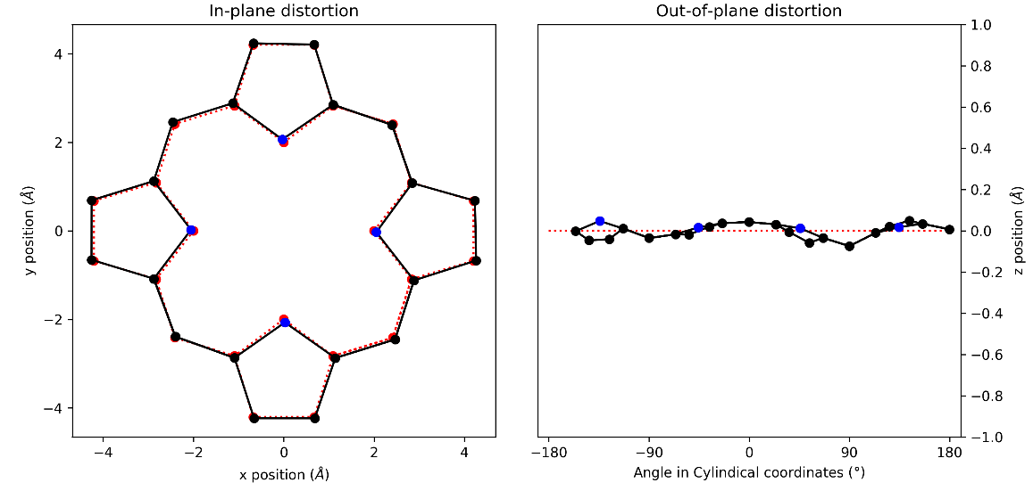
Figure S87: (a) in-plane and (b) out-of-plane skeletal plots of the porphyrin core. Porphyrin is represented in black (C) and blue (N), with the reference structure (CuTPP) in red dotted lines.

NSD result generated from 2 (in Å)
basis | Δ_{ip} | δ_{ip} | B_{2g} | B_{1g} | E_{u}(x) | E_{u}(y) | A_{1g} | A_{2g}
min. | 0.25 | 0.00 | -0.06 | 0.02 | -0.02 | 0.01 | -0.24 | -0.01
ext. | 0.25 | 0.00 | -0.06 | 0.02 | -0.02 | 0.01 | -0.24 | -0.01
 |  |  | 0.03 | 0.01 | 0.02 | -0.01 | 0.02 | 0.00
total | 0.27 | 0.00 | -0.06 | 0.02 | -0.02 | 0.01 | -0.24 | -0.01
 |  |  | 0.03 | 0.01 | 0.02 | -0.01 | 0.02 | 0.00
 |  |  | -0.01 | -0.01 | 0.01 | -0.02 | -0.01 | 0.00
 |  |  | 0.02 | 0.00 | 0.01 | -0.02 | -0.06 | 0.01
 |  |  | 0.00 | 0.02 | -0.01 | 0.01 | -0.03 | 0.02
 |  |  | -0.02 | 0.03 | -0.01 | 0.01 | 0.04
 |  |  |  |  | 0.00 | 0.00
 |  |  |  |  | 0.00 | -0.01
 |  |  |  |  | 0.01 | 0.00
 |  |  |  |  | 0.01 | 0.02
 |  |  |  |  | 0.00 | -0.01
comp. | 0.27 | 0.00 | 0.07 | 0.04 | 0.04 | 0.04 | 0.25 | 0.02

basis | Δ_{oop} | δ_{oop} | B_{2u} | B_{1u} | A_{2u} | E_{g}(x) | E_{g}(y) | A_{1u}
min. | 1.01 | 0.00 | 0.10 | 1.00 | -0.06 | 0.03 | 0.06 | 0.00
ext. | 1.01 | 0.00 | 0.10 | 1.00 | -0.06 | 0.03 | 0.06 | 0.00
 |  |  | -0.03 | 0.00 | 0.03 | -0.05 | -0.05 | -0.01
total | 1.01 | 0.00 | 0.10 | 1.00 | -0.06 | 0.03 | 0.06 | 0.00
 |  |  | -0.03 | 0.00 | 0.03 | -0.05 | -0.05 | -0.01
 |  |  | 0.00 | 0.01 | -0.01 | 0.01 | -0.01
 |  |  |  |  |  | 0.01 | -0.01
 |  |  |  |  |  | 0.00 | 0.00
comp. | 1.01 | 0.00 | 0.10 | 1.00 | 0.06 | 0.06 | 0.08 | 0.01
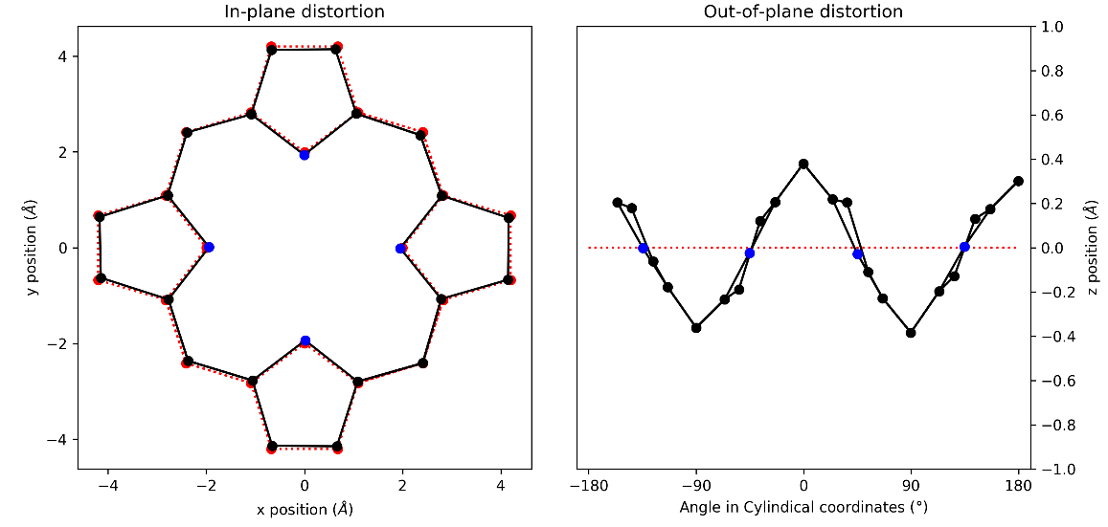
Figure 88: (a) in-plane and (b) out-of-plane skeletal plots of the porphyrin core. Porphyrin is represented in black (C) and blue (N), with the reference structure (CuTPP) in red dotted lines.

NSD result generated from 2A (in Å)
basis | Δ_{ip} | δ_{ip} | B_{2g} | B_{1g} | E_{u}(x) | E_{u}(y) | A_{1g} | A_{2g}
min. | 0.13 | 0.00 | -0.06 | 0.02 | 0.02 | -0.02 | -0.11 | -0.01
ext. | 0.14 | 0.00 | -0.06 | 0.02 | 0.02 | -0.02 | -0.12 | -0.01
 |  |  | -0.03 | 0.00 | 0.00 | 0.01 | -0.04 | 0.00
total | 0.15 | 0.00 | -0.06 | 0.02 | 0.02 | -0.02 | -0.12 | -0.01
 |  |  | -0.03 | 0.00 | 0.00 | 0.01 | -0.04 | 0.00
 |  |  | -0.01 | 0.00 | 0.00 | 0.00 | -0.03 | 0.00
 |  |  | 0.00 | 0.00 | 0.00 | 0.00 | -0.01 | 0.00
 |  |  | 0.01 | 0.00 | 0.00 | 0.01 | -0.01 | 0.00
 |  |  | 0.00 | 0.00 | 0.00 | -0.01 | 0.00
 |  |  |  |  | 0.00 | 0.00
 |  |  |  |  | 0.00 | 0.00
 |  |  |  |  | 0.01 | 0.00
 |  |  |  |  | -0.01 | 0.00
 |  |  |  |  | 0.00 | 0.00
comp. | 0.15 | 0.00 | 0.06 | 0.02 | 0.02 | 0.02 | 0.13 | 0.01

basis | Δ_{oop} | δ_{oop} | B_{2u} | B_{1u} | A_{2u} | E_{g}(x) | E_{g}(y) | A_{1u}
min. | 0.22 | 0.00 | -0.06 | 0.20 | 0.04 | 0.01 | 0.07 | 0.01
ext. | 0.23 | 0.00 | -0.06 | 0.20 | 0.05 | 0.01 | 0.07 | 0.01
 |  |  | 0.01 | 0.00 | 0.03 | -0.01 | -0.03 | 0.00
total | 0.23 | 0.00 | -0.06 | 0.20 | 0.05 | 0.01 | 0.07 | 0.01
 |  |  | 0.01 | 0.00 | 0.03 | -0.01 | -0.03 | 0.00
 |  |  | 0.00 | 0.00 | -0.01 | 0.00 | 0.01
 |  |  |  |  |  | -0.01 | -0.01
 |  |  |  |  |  | 0.00 | 0.00
comp. | 0.23 | 0.00 | 0.06 | 0.20 | 0.06 | 0.01 | 0.08 | 0.01
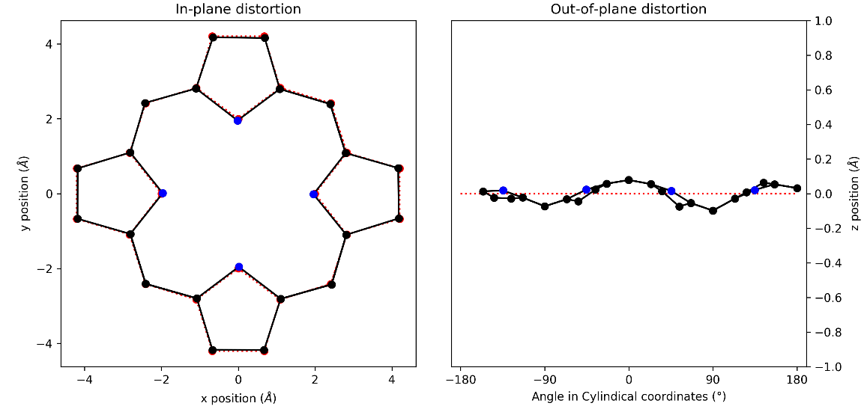
Figure 89: (a) in-plane and (b) out-of-plane skeletal plots of the porphyrin core. Porphyrin is represented in black (C) and blue (N), with the reference structure (CuTPP) in red dotted lines.

NSD result generated from 3 (in Å)
basis | Δ_{ip} | δ_{ip} | B_{2g} | B_{1g} | E_{u}(x) | E_{u}(y) | A_{1g} | A_{2g}
min. | 0.29 | 0.00 | -0.20 | -0.03 | -0.05 | 0.02 | 0.20 | 0.00
ext. | 0.30 | 0.00 | -0.20 | -0.04 | -0.05 | 0.02 | 0.20 | 0.00
 |  |  | -0.04 | -0.07 | 0.02 | -0.04 | -0.02 | 0.01
total | 0.32 | 0.00 | -0.20 | -0.04 | -0.05 | 0.02 | 0.20 | 0.00
 |  |  | -0.04 | -0.07 | 0.02 | -0.04 | -0.02 | 0.01
 |  |  | -0.01 | -0.06 | 0.00 | 0.00 | 0.05 | 0.00
 |  |  | 0.01 | 0.00 | 0.00 | 0.00 | 0.00 | 0.00
 |  |  | 0.00 | 0.01 | 0.00 | 0.01 | 0.01 | 0.00
 |  |  | -0.01 | -0.01 | 0.00 | 0.00 | 0.01
 |  |  |  |  | 0.00 | 0.00
 |  |  |  |  | 0.00 | 0.00
 |  |  |  |  | 0.00 | -0.01
 |  |  |  |  | 0.00 | 0.00
 |  |  |  |  | 0.00 | -0.01
comp. | 0.32 | 0.00 | 0.20 | 0.10 | 0.05 | 0.05 | 0.21 | 0.01

basis | Δ_{oop} | δ_{oop} | B_{2u} | B_{1u} | A_{2u} | E_{g}(x) | E_{g}(y) | A_{1u}
min. | 0.47 | 0.00 | 0.42 | 0.13 | -0.06 | -0.15 | 0.09 | -0.02
ext. | 0.48 | 0.00 | 0.41 | 0.13 | -0.06 | -0.15 | 0.09 | -0.02
 |  |  | -0.11 | -0.01 | 0.00 | -0.01 | 0.00 | -0.01
total | 0.48 | 0.00 | 0.41 | 0.13 | -0.06 | -0.15 | 0.09 | -0.02
 |  |  | -0.11 | -0.01 | 0.00 | -0.01 | 0.00 | -0.01
 |  |  | 0.00 | 0.00 | 0.00 | 0.00 | -0.01
 |  |  |  |  |  | 0.00 | 0.00
 |  |  |  |  |  | -0.01 | 0.00
comp. | 0.48 | 0.00 | 0.43 | 0.13 | 0.06 | 0.15 | 0.09 | 0.02
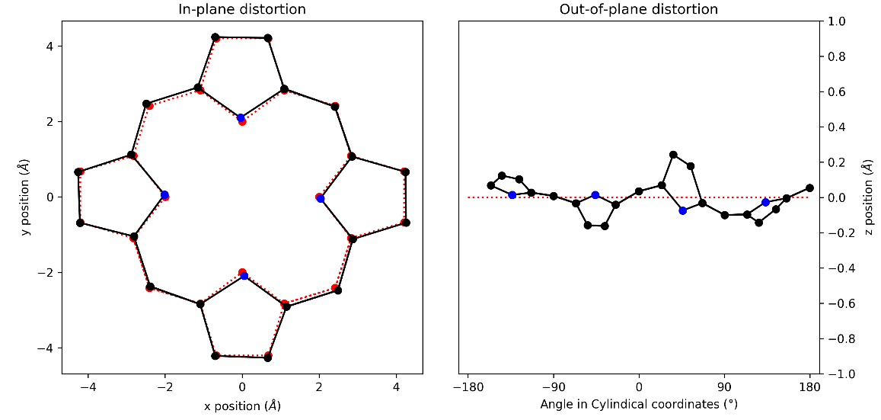
Figure 90: (a) in-plane and (b) out-of-plane skeletal plots of the porphyrin core. Porphyrin is represented in black (C) and blue (N), with the reference structure (CuTPP) in red dotted lines.

NSD result generated from 4 (in Å)
basis | Δ_{ip} | δ_{ip} | B_{2g} | B_{1g} | E_{u}(x) | E_{u}(y) | A_{1g} | A_{2g}
min. | 0.25 | 0.00 | -0.10 | -0.03 | 0.00 | 0.00 | 0.23 | 0.01
ext. | 0.25 | 0.00 | -0.10 | -0.03 | 0.00 | 0.00 | 0.23 | 0.01
 |  |  | -0.02 | 0.01 | 0.01 | -0.02 | -0.02 | 0.00
total | 0.27 | 0.00 | -0.10 | -0.02 | 0.00 | 0.00 | 0.23 | 0.01
 |  |  | -0.02 | 0.01 | 0.01 | -0.01 | -0.02 | 0.00
 |  |  | -0.01 | 0.01 | 0.00 | 0.01 | 0.05 | 0.00
 |  |  | 0.00 | 0.00 | -0.02 | 0.01 | -0.01 | 0.00
 |  |  | 0.00 | 0.00 | 0.00 | -0.01 | 0.02 | 0.00
 |  |  | -0.01 | 0.00 | -0.01 | 0.01 | 0.01
 |  |  |  |  | 0.00 | 0.00
 |  |  |  |  | 0.00 | 0.00
 |  |  |  |  | -0.01 | 0.01
 |  |  |  |  | 0.01 | -0.01
 |  |  |  |  | 0.00 | 0.00
comp. | 0.27 | 0.00 | 0.10 | 0.03 | 0.03 | 0.03 | 0.24 | 0.01

basis | Δ_{oop} | δ_{oop} | B_{2u} | B_{1u} | A_{2u} | E_{g}(x) | E_{g}(y) | A_{1u}
min. | 0.31 | 0.00 | 0.05 | 0.02 | -0.05 | 0.11 | 0.28 | -0.01
ext. | 0.33 | 0.00 | 0.05 | 0.02 | -0.05 | 0.11 | 0.28 | -0.01
 |  |  | -0.03 | 0.00 | 0.00 | 0.00 | 0.10 | 0.01
total | 0.33 | 0.00 | 0.05 | 0.02 | -0.05 | 0.11 | 0.28 | -0.01
 |  |  | -0.03 | 0.00 | 0.00 | 0.00 | 0.10 | 0.01
 |  |  | 0.00 | 0.00 | 0.01 | -0.01 | -0.02
 |  |  |  |  |  | -0.01 | -0.01
 |  |  |  |  |  | 0.00 | 0.01
comp. | 0.33 | 0.00 | 0.05 | 0.02 | 0.05 | 0.11 | 0.30 | 0.01
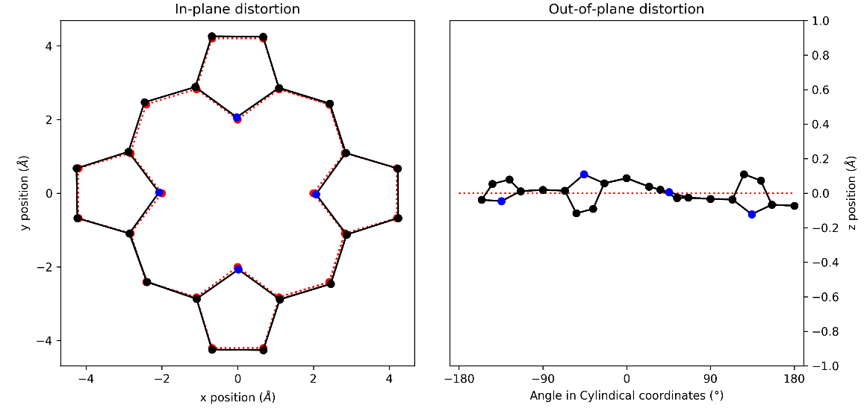
Figure 91: (a) in-plane and (b) out-of-plane skeletal plots of the porphyrin core. Porphyrin is represented in black (C) and blue (N), with the reference structure (CuTPP) in red dotted lines.

NSD result generated from 5 (in Å)
basis | Δ_{ip} | δ_{ip} | B_{2g} | B_{1g} | E_{u}(x) | E_{u}(y) | A_{1g} | A_{2g}
min. | 0.21 | 0.00 | 0.01 | 0.04 | -0.01 | -0.01 | 0.21 | -0.01
ext. | 0.22 | 0.00 | 0.01 | 0.04 | -0.01 | -0.01 | 0.21 | -0.01
 |  |  | 0.01 | 0.03 | 0.01 | 0.01 | -0.02 | 0.00
total | 0.23 | 0.00 | 0.01 | 0.04 | -0.01 | -0.01 | 0.21 | -0.01
 |  |  | 0.01 | 0.03 | 0.01 | 0.01 | -0.02 | 0.00
 |  |  | -0.01 | 0.02 | 0.01 | 0.00 | 0.05 | 0.00
 |  |  | 0.01 | 0.00 | 0.01 | -0.02 | -0.01 | 0.00
 |  |  | 0.00 | -0.01 | 0.00 | 0.00 | 0.01 | 0.00
 |  |  | -0.01 | 0.00 | 0.01 | 0.00 | 0.01
 |  |  |  |  | 0.00 | 0.00
 |  |  |  |  | 0.00 | 0.00
 |  |  |  |  | 0.00 | -0.01
 |  |  |  |  | 0.00 | 0.00
 |  |  |  |  | 0.00 | 0.00
comp. | 0.23 | 0.00 | 0.03 | 0.06 | 0.02 | 0.02 | 0.22 | 0.01

basis | Δ_{oop} | δ_{oop} | B_{2u} | B_{1u} | A_{2u} | E_{g}(x) | E_{g}(y) | A_{1u}
min. | 0.39 | 0.00 | 0.10 | 0.31 | -0.10 | -0.05 | 0.20 | -0.01
ext. | 0.41 | 0.00 | 0.10 | 0.31 | -0.10 | -0.05 | 0.20 | -0.01
 |  |  | 0.03 | 0.00 | -0.04 | 0.01 | 0.09 | -0.01
total | 0.41 | 0.00 | 0.10 | 0.31 | -0.10 | -0.05 | 0.20 | -0.01
 |  |  | 0.03 | 0.00 | -0.04 | 0.01 | 0.09 | -0.01
 |  |  | 0.00 | 0.00 | 0.01 | 0.02 | 0.01
 |  |  |  |  |  | 0.00 | -0.01
 |  |  |  |  |  | -0.01 | 0.01
comp. | 0.41 | 0.00 | 0.11 | 0.31 | 0.11 | 0.05 | 0.22 | 0.01
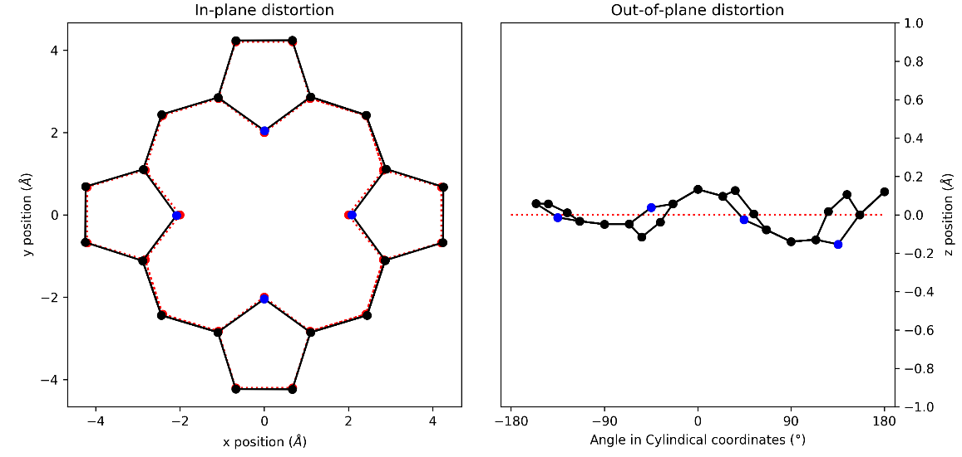
Figure 92: (a) in-plane and (b) out-of-plane skeletal plots of the porphyrin core. Porphyrin is represented in black (C) and blue (N), with the reference structure (CuTPP) in red dotted lines.

NSD result generated from 6 (in Å)
basis | Δ_{ip} | δ_{ip} | B_{2g} | B_{1g} | E_{u}(x) | E_{u}(y) | A_{1g} | A_{2g}
min. | 0.22 | 0.00 | 0.00 | 0.01 | 0.00 | 0.00 | 0.22 | 0.00
ext. | 0.23 | 0.00 | 0.00 | 0.01 | 0.01 | 0.00 | 0.22 | 0.00
 |  |  | -0.01 | 0.01 | 0.03 | 0.02 | -0.03 | 0.00
total | 0.25 | 0.00 | 0.00 | 0.01 | 0.00 | 0.00 | 0.23 | 0.00
 |  |  | -0.01 | 0.01 | 0.03 | 0.02 | -0.03 | 0.00
 |  |  | 0.01 | 0.02 | -0.01 | 0.01 | 0.06 | 0.00
 |  |  | -0.01 | 0.00 | -0.01 | -0.02 | -0.02 | -0.01
 |  |  | -0.01 | 0.00 | 0.00 | 0.00 | 0.01 | 0.00
 |  |  | 0.00 | 0.01 | 0.00 | -0.02 | 0.03
 |  |  |  |  | 0.00 | 0.00
 |  |  |  |  | 0.00 | -0.01
 |  |  |  |  | -0.01 | 0.01
 |  |  |  |  | 0.00 | 0.00
 |  |  |  |  | 0.01 | -0.01
comp. | 0.25 | 0.00 | 0.03 | 0.03 | 0.03 | 0.04 | 0.24 | 0.01

basis | Δ_{oop} | δ_{oop} | B_{2u} | B_{1u} | A_{2u} | E_{g}(x) | E_{g}(y) | A_{1u}
min. | 0.36 | 0.00 | -0.22 | -0.08 | -0.02 | -0.27 | -0.06 | -0.01
ext. | 0.36 | 0.00 | -0.22 | -0.08 | -0.02 | -0.27 | -0.06 | -0.01
 |  |  | 0.01 | 0.01 | 0.00 | 0.03 | 0.01 | 0.00
total | 0.36 | 0.00 | -0.22 | -0.08 | -0.02 | -0.27 | -0.06 | -0.01
 |  |  | 0.02 | 0.01 | 0.00 | 0.03 | 0.01 | 0.00
 |  |  | 0.00 | 0.00 | 0.00 | 0.01 | 0.01
 |  |  |  |  |  | 0.00 | 0.00
 |  |  |  |  |  | -0.01 | 0.01
comp. | 0.36 | 0.00 | 0.22 | 0.08 | 0.02 | 0.27 | 0.06 | 0.01
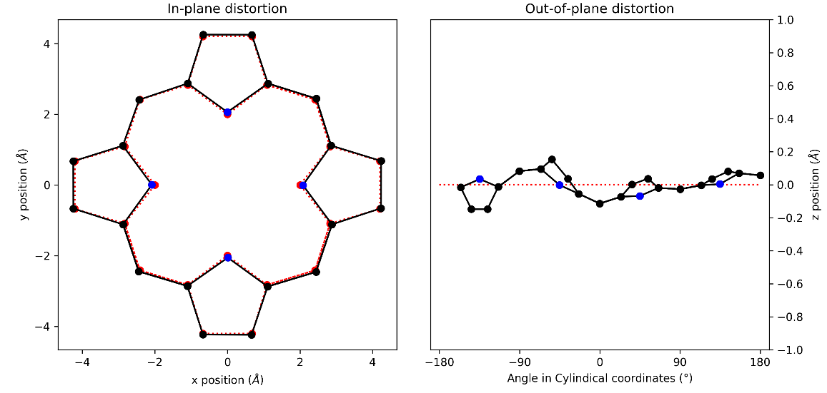
Figure 93: (a) in-plane and (b) out-of-plane skeletal plots of the porphyrin core. Porphyrin is represented in black (C) and blue (N), with the reference structure (CuTPP) in red dotted lines.

NSD result generated from 7 (in Å)
basis | Δ_{ip} | δ_{ip} | B_{2g} | B_{1g} | E_{u}(x) | E_{u}(y) | A_{1g} | A_{2g}
min. | 0.14 | 0.00 | 0.05 | -0.01 | 0.02 | 0.02 | -0.12 | 0.00
ext. | 0.15 | 0.00 | 0.05 | -0.01 | 0.02 | 0.02 | -0.12 | 0.00
 |  |  | 0.00 | 0.00 | 0.03 | 0.01 | -0.05 | 0.00
total | 0.16 | 0.00 | 0.05 | -0.01 | 0.02 | 0.02 | -0.13 | 0.00
 |  |  | 0.00 | 0.00 | 0.03 | 0.01 | -0.05 | 0.00
 |  |  | 0.01 | 0.00 | -0.01 | -0.01 | -0.04 | 0.00
 |  |  | -0.01 | 0.00 | -0.02 | -0.02 | -0.02 | 0.00
 |  |  | 0.00 | 0.00 | 0.00 | 0.00 | -0.01 | 0.00
 |  |  | 0.00 | 0.00 | -0.01 | -0.01 | 0.01
 |  |  |  |  | 0.00 | 0.00
 |  |  |  |  | 0.00 | 0.00
 |  |  |  |  | -0.01 | 0.00
 |  |  |  |  | 0.01 | 0.01
 |  |  |  |  | 0.01 | 0.00
comp. | 0.16 | 0.00 | 0.05 | 0.01 | 0.04 | 0.03 | 0.14 | 0.01

basis | Δ_{oop} | δ_{oop} | B_{2u} | B_{1u} | A_{2u} | E_{g}(x) | E_{g}(y) | A_{1u}
min. | 0.36 | 0.00 | 0.26 | 0.08 | -0.01 | 0.24 | 0.00 | 0.01
ext. | 0.37 | 0.00 | 0.26 | 0.08 | 0.00 | 0.23 | 0.00 | 0.01
 |  |  | 0.00 | 0.00 | 0.03 | -0.09 | -0.02 | 0.00
total | 0.37 | 0.00 | 0.26 | 0.08 | 0.00 | 0.23 | 0.00 | 0.01
 |  |  | 0.00 | 0.00 | 0.03 | -0.09 | -0.02 | 0.00
 |  |  | 0.00 | 0.00 | 0.00 | -0.01 | 0.00
 |  |  |  |  |  | 0.00 | 0.00
 |  |  |  |  |  | 0.01 | 0.00
comp. | 0.37 | 0.00 | 0.26 | 0.08 | 0.03 | 0.25 | 0.02 | 0.01
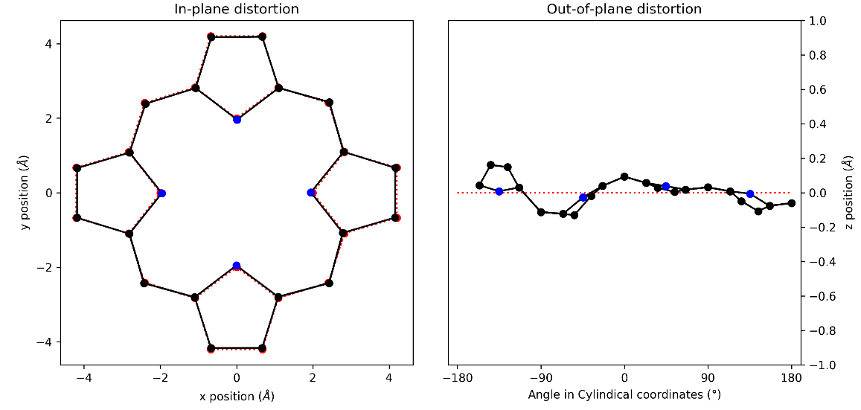
Figure 94: (a) in-plane and (b) out-of-plane skeletal plots of the porphyrin core. Porphyrin is represented in black (C) and blue (N), with the reference structure (CuTPP) in red dotted lines.

NSD result generated from 8_1 (in Å)
basis | Δ_{ip} | δ_{ip} | B_{2g} | B_{1g} | E_{u}(x) | E_{u}(y) | A_{1g} | A_{2g}
min. | 0.23 | 0.00 | -0.04 | 0.00 | -0.01 | 0.02 | 0.23 | 0.00
ext. | 0.24 | 0.00 | -0.04 | 0.00 | -0.01 | 0.02 | 0.23 | 0.00
 |  |  | -0.03 | -0.03 | 0.02 | 0.01 | -0.04 | -0.01
total | 0.26 | 0.00 | -0.04 | 0.00 | -0.01 | 0.02 | 0.23 | 0.00
 |  |  | -0.03 | -0.03 | 0.02 | 0.01 | -0.04 | -0.01
 |  |  | 0.02 | -0.02 | 0.00 | 0.00 | 0.06 | 0.00
 |  |  | -0.02 | 0.00 | -0.02 | -0.01 | -0.02 | 0.00
 |  |  | -0.01 | 0.00 | 0.00 | 0.00 | 0.01 | 0.00
 |  |  | 0.01 | 0.00 | -0.01 | -0.01 | 0.02
 |  |  |  |  | -0.01 | 0.01
 |  |  |  |  | 0.00 | 0.00
 |  |  |  |  | -0.01 | -0.01
 |  |  |  |  | 0.01 | 0.00
 |  |  |  |  | 0.00 | 0.00
comp. | 0.26 | 0.00 | 0.06 | 0.04 | 0.03 | 0.03 | 0.24 | 0.01

basis | Δ_{oop} | δ_{oop} | B_{2u} | B_{1u} | A_{2u} | E_{g}(x) | E_{g}(y) | A_{1u}
min. | 0.34 | 0.00 | -0.16 | 0.10 | 0.05 | -0.07 | -0.27 | 0.00
ext. | 0.34 | 0.00 | -0.16 | 0.10 | 0.05 | -0.07 | -0.27 | 0.00
 |  |  | 0.01 | -0.01 | 0.00 | 0.01 | 0.03 | 0.00
total | 0.34 | 0.00 | -0.16 | 0.10 | 0.05 | -0.07 | -0.27 | 0.00
 |  |  | 0.01 | -0.01 | 0.00 | 0.01 | 0.03 | 0.00
 |  |  | 0.01 | 0.00 | 0.00 | 0.01 | 0.02
 |  |  |  |  |  | 0.00 | 0.00
 |  |  |  |  |  | 0.01 | 0.00
comp. | 0.34 | 0.00 | 0.16 | 0.10 | 0.05 | 0.07 | 0.28 | 0.00
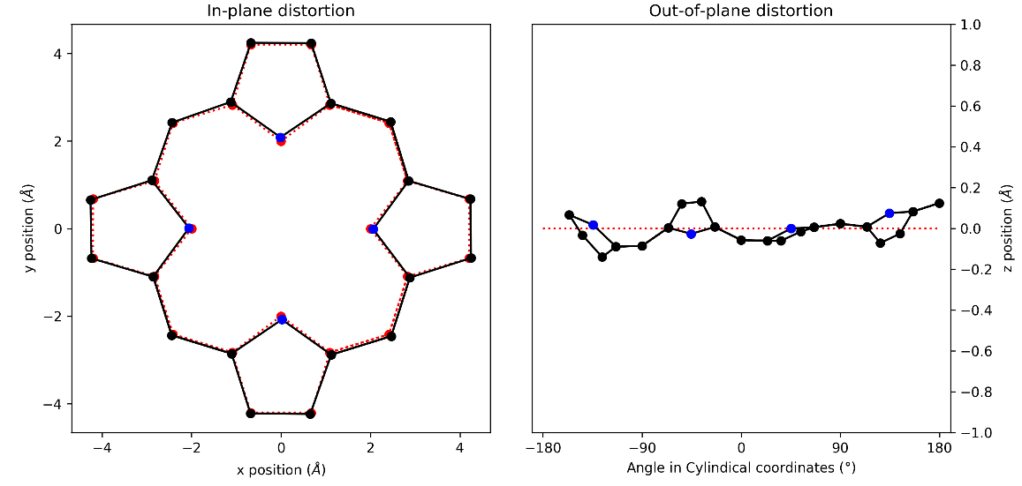
Figure 95: (a) in-plane and (b) out-of-plane skeletal plots of the porphyrin core. Porphyrin is represented in black (C) and blue (N), with the reference structure (CuTPP) in red dotted lines.

NSD result generated from 8_2 (in Å)
basis | Δ_{ip} | δ_{ip} | B_{2g} | B_{1g} | E_{u}(x) | E_{u}(y) | A_{1g} | A_{2g}
min. | 0.22 | 0.00 | -0.06 | -0.01 | -0.01 | -0.01 | 0.21 | -0.01
ext. | 0.23 | 0.00 | -0.06 | -0.01 | -0.01 | -0.01 | 0.21 | -0.01
 |  |  | -0.03 | -0.02 | -0.03 | -0.02 | -0.04 | 0.00
total | 0.25 | 0.00 | -0.06 | -0.01 | -0.01 | -0.01 | 0.22 | -0.01
 |  |  | -0.03 | -0.02 | -0.03 | -0.02 | -0.04 | 0.00
 |  |  | 0.01 | -0.02 | 0.00 | 0.01 | 0.06 | 0.00
 |  |  | -0.02 | 0.00 | 0.02 | 0.01 | -0.01 | -0.01
 |  |  | 0.00 | 0.01 | 0.00 | 0.00 | 0.00 | 0.01
 |  |  | 0.01 | 0.00 | 0.00 | 0.00 | 0.01
 |  |  |  |  | 0.00 | 0.00
 |  |  |  |  | 0.00 | 0.00
 |  |  |  |  | 0.01 | 0.01
 |  |  |  |  | 0.00 | 0.00
 |  |  |  |  | 0.00 | 0.01
comp. | 0.25 | 0.00 | 0.07 | 0.03 | 0.04 | 0.03 | 0.23 | 0.02

basis | Δ_{oop} | δ_{oop} | B_{2u} | B_{1u} | A_{2u} | E_{g}(x) | E_{g}(y) | A_{1u}
min. | 0.37 | 0.00 | 0.20 | -0.05 | -0.02 | -0.06 | -0.30 | 0.00
ext. | 0.37 | 0.00 | 0.20 | -0.05 | -0.02 | -0.06 | -0.30 | 0.00
 |  |  | -0.01 | 0.00 | 0.00 | 0.03 | 0.04 | 0.01
total | 0.37 | 0.00 | 0.20 | -0.05 | -0.02 | -0.06 | -0.30 | 0.00
 |  |  | -0.01 | 0.00 | 0.00 | 0.03 | 0.04 | 0.01
 |  |  | 0.00 | -0.01 | 0.00 | -0.01 | 0.02
 |  |  |  |  |  | 0.00 | 0.00
 |  |  |  |  |  | 0.00 | -0.01
comp. | 0.37 | 0.00 | 0.20 | 0.05 | 0.02 | 0.06 | 0.30 | 0.01
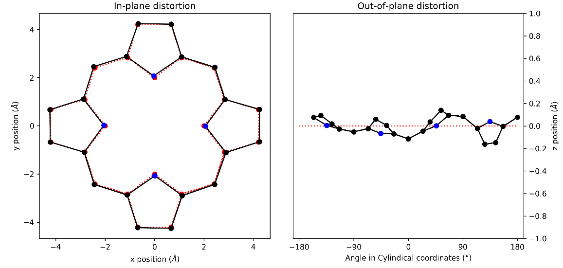
Figure 96: (a) in-plane and (b) out-of-plane skeletal plots of the porphyrin core. Porphyrin is represented in black (C) and blue (N), with the reference structure (CuTPP) in red dotted lines.

NSD result generated from 9 (in Å)
basis | Δ_{ip} | δ_{ip} | B_{2g} | B_{1g} | E_{u}(x) | E_{u}(y) | A_{1g} | A_{2g}
min. | 0.25 | 0.00 | 0.00 | -0.06 | 0.00 | 0.00 | 0.24 | -0.01
ext. | 0.25 | 0.00 | 0.00 | -0.06 | 0.00 | 0.00 | 0.24 | -0.01
 |  |  | -0.02 | 0.03 | 0.00 | 0.00 | 0.00 | 0.00
total | 0.26 | 0.00 | 0.00 | -0.06 | 0.00 | 0.00 | 0.24 | -0.01
 |  |  | -0.02 | 0.03 | 0.00 | 0.00 | 0.00 | 0.00
 |  |  | 0.03 | 0.03 | 0.00 | 0.00 | 0.05 | 0.00
 |  |  | -0.02 | 0.00 | 0.00 | 0.00 | 0.00 | 0.00
 |  |  | 0.00 | -0.01 | 0.00 | 0.00 | -0.01 | 0.00
 |  |  | 0.01 | 0.00 | 0.00 | 0.00 | 0.01
 |  |  |  |  | 0.00 | 0.00
 |  |  |  |  | 0.00 | 0.00
 |  |  |  |  | 0.00 | 0.00
 |  |  |  |  | 0.00 | 0.00
 |  |  |  |  | 0.00 | 0.00
comp. | 0.26 | 0.00 | 0.04 | 0.08 | 0.00 | 0.00 | 0.25 | 0.01

basis | Δ_{oop} | δ_{oop} | B_{2u} | B_{1u} | A_{2u} | E_{g}(x) | E_{g}(y) | A_{1u}
min. | 0.08 | 0.00 | 0.00 | 0.00 | 0.00 | -0.01 | 0.08 | 0.00
ext. | 0.11 | 0.00 | 0.00 | 0.00 | 0.00 | -0.01 | 0.08 | 0.00
 |  |  | 0.00 | 0.00 | 0.00 | 0.06 | 0.02 | 0.00
total | 0.11 | 0.00 | 0.00 | 0.00 | 0.00 | -0.01 | 0.08 | 0.00
 |  |  | 0.00 | 0.00 | 0.00 | 0.06 | 0.02 | 0.00
 |  |  | 0.00 | 0.00 | 0.00 | 0.01 | -0.01
 |  |  |  |  |  | 0.00 | 0.00
 |  |  |  |  |  | 0.01 | 0.00
comp. | 0.11 | 0.00 | 0.00 | 0.00 | 0.00 | 0.07 | 0.08 | 0.00
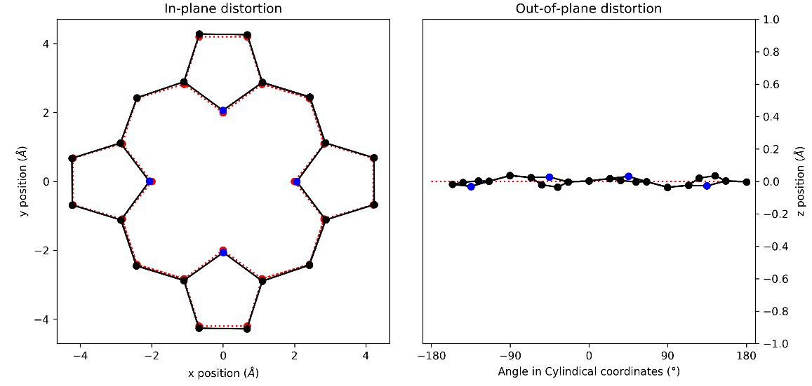
Figure 97: (a) in-plane and (b) out-of-plane skeletal plots of the porphyrin core. Porphyrin is represented in black (C) and blue (N), with the reference structure (CuTPP) in red dotted lines.

NSD result generated from 10 (in Å)
basis | Δ_{ip} | δ_{ip} | B_{2g} | B_{1g} | E_{u}(x) | E_{u}(y) | A_{1g} | A_{2g}
min. | 0.24 | 0.00 | -0.06 | -0.02 | 0.00 | 0.00 | 0.23 | -0.01
ext. | 0.24 | 0.00 | -0.06 | -0.02 | 0.00 | 0.00 | 0.23 | -0.01
 |  |  | -0.01 | 0.04 | 0.00 | 0.00 | 0.00 | -0.01
total | 0.26 | 0.00 | -0.06 | -0.02 | 0.00 | 0.00 | 0.23 | -0.01
 |  |  | -0.01 | 0.04 | 0.00 | 0.00 | 0.00 | -0.01
 |  |  | -0.03 | 0.04 | 0.00 | 0.00 | 0.05 | 0.00
 |  |  | 0.01 | 0.00 | 0.00 | 0.00 | -0.01 | 0.00
 |  |  | 0.00 | -0.01 | 0.00 | 0.00 | 0.00 | 0.00
 |  |  | -0.01 | 0.01 | 0.00 | 0.00 | 0.01
 |  |  |  |  | 0.00 | 0.00
 |  |  |  |  | 0.00 | 0.00
 |  |  |  |  | 0.00 | 0.00
 |  |  |  |  | 0.00 | 0.00
 |  |  |  |  | 0.00 | 0.00
comp. | 0.26 | 0.00 | 0.07 | 0.06 | 0.00 | 0.00 | 0.24 | 0.01

basis | Δ_{oop} | δ_{oop} | B_{2u} | B_{1u} | A_{2u} | E_{g}(x) | E_{g}(y) | A_{1u}
min. | 0.24 | 0.00 | 0.00 | 0.00 | 0.00 | 0.03 | 0.23 | 0.00
ext. | 0.24 | 0.00 | 0.00 | 0.00 | 0.00 | 0.03 | 0.23 | 0.00
 |  |  | 0.00 | 0.00 | 0.00 | 0.04 | 0.00 | 0.00
total | 0.24 | 0.00 | 0.00 | 0.00 | 0.00 | 0.03 | 0.23 | 0.00
 |  |  | 0.00 | 0.00 | 0.00 | 0.04 | 0.00 | 0.00
 |  |  | 0.00 | 0.00 | 0.00 | 0.02 | 0.01
 |  |  |  |  |  | 0.00 | -0.02
 |  |  |  |  |  | -0.01 | 0.01
comp. | 0.24 | 0.00 | 0.00 | 0.00 | 0.00 | 0.06 | 0.24 | 0.00
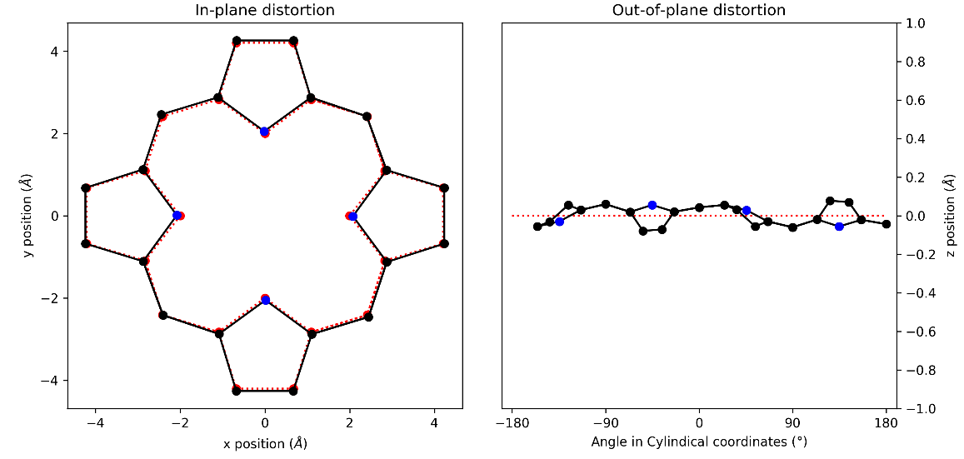
Figure 98: (a) in-plane and (b) out-of-plane skeletal plots of the porphyrin core. Porphyrin is represented in black (C) and blue (N), with the reference structure (CuTPP) in red dotted lines.

NSD result generated from 11 (in Å)
basis | Δ_{ip} | δ_{ip} | B_{2g} | B_{1g} | E_{u}(x) | E_{u}(y) | A_{1g} | A_{2g}
min. | 0.49 | 0.01 | -0.14 | 0.01 | 0.03 | 0.02 | -0.47 | -0.01
ext. | 0.53 | 0.01 | -0.14 | 0.01 | 0.03 | 0.02 | -0.47 | -0.01
 |  |  | 0.05 | 0.01 | -0.01 | -0.01 | 0.16 | 0.07
total | 0.54 | 0.00 | -0.14 | 0.01 | 0.03 | 0.02 | -0.47 | -0.01
 |  |  | 0.05 | 0.01 | -0.01 | -0.01 | 0.16 | 0.07
 |  |  | -0.01 | -0.01 | 0.00 | 0.01 | 0.02 | -0.01
 |  |  | 0.04 | 0.01 | 0.02 | 0.01 | -0.11 | 0.00
 |  |  | 0.00 | 0.00 | 0.00 | 0.00 | -0.03 | 0.02
 |  |  | 0.00 | 0.01 | 0.00 | 0.00 | 0.07
 |  |  |  |  | 0.01 | 0.00
 |  |  |  |  | 0.00 | 0.00
 |  |  |  |  | -0.02 | 0.00
 |  |  |  |  | 0.00 | -0.01
 |  |  |  |  | 0.00 | 0.00
comp. | 0.54 | 0.00 | 0.15 | 0.02 | 0.04 | 0.03 | 0.51 | 0.08

basis | Δ_{oop} | δ_{oop} | B_{2u} | B_{1u} | A_{2u} | E_{g}(x) | E_{g}(y) | A_{1u}
min. | 1.90 | 0.00 | 0.55 | 1.81 | -0.19 | 0.07 | -0.05 | 0.00
ext. | 1.90 | 0.00 | 0.55 | 1.81 | -0.19 | 0.07 | -0.05 | 0.00
 |  |  | 0.00 | 0.02 | 0.06 | -0.03 | 0.00 | 0.00
total | 1.90 | 0.00 | 0.54 | 1.81 | -0.19 | 0.07 | -0.05 | 0.00
 |  |  | 0.00 | 0.02 | 0.06 | -0.03 | 0.00 | 0.00
 |  |  | -0.01 | 0.02 | -0.01 | 0.00 | 0.01
 |  |  |  |  |  | 0.00 | 0.00
 |  |  |  |  |  | 0.00 | 0.00
comp. | 1.90 | 0.00 | 0.55 | 1.81 | 0.20 | 0.07 | 0.05 | 0.00
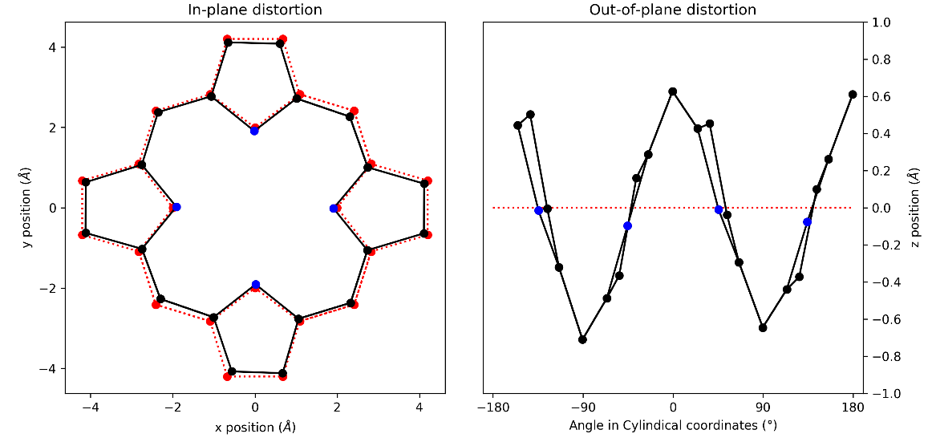
Figure 99: (a) in-plane and (b) out-of-plane skeletal plots of the porphyrin core. Porphyrin is represented in black (C) and blue (N), with the reference structure (CuTPP) in red dotted lines.

NSD result generated from 12 (in Å)
basis | Δ_{ip} | δ_{ip} | B_{2g} | B_{1g} | E_{u}(x) | E_{u}(y) | A_{1g} | A_{2g}
min. | 0.19 | 0.01 | 0.02 | -0.02 | -0.01 | -0.01 | 0.18 | -0.01
ext. | 0.21 | 0.01 | 0.02 | -0.02 | -0.01 | -0.01 | 0.18 | -0.01
 |  |  | -0.07 | -0.05 | -0.01 | 0.00 | 0.01 | 0.01
total | 0.26 | 0.00 | 0.02 | -0.02 | -0.01 | -0.01 | 0.18 | -0.01
 |  |  | -0.07 | -0.05 | -0.01 | 0.00 | 0.01 | 0.01
 |  |  | 0.05 | 0.03 | 0.01 | -0.01 | 0.03 | 0.00
 |  |  | 0.02 | 0.02 | -0.01 | -0.01 | -0.09 | 0.00
 |  |  | 0.00 | 0.05 | 0.01 | -0.01 | 0.01 | -0.01
 |  |  | -0.02 | 0.02 | -0.01 | -0.01 | -0.02
 |  |  |  |  | 0.02 | -0.01
 |  |  |  |  | 0.02 | -0.02
 |  |  |  |  | -0.05 | -0.03
 |  |  |  |  | 0.02 | -0.01
 |  |  |  |  | 0.02 | -0.01
comp. | 0.26 | 0.00 | 0.09 | 0.08 | 0.07 | 0.05 | 0.21 | 0.01

basis | Δ_{oop} | δ_{oop} | B_{2u} | B_{1u} | A_{2u} | E_{g}(x) | E_{g}(y) | A_{1u}
min. | 0.17 | 0.00 | 0.08 | -0.02 | -0.02 | -0.15 | -0.01 | 0.00
ext. | 0.19 | 0.00 | 0.08 | -0.02 | -0.02 | -0.15 | -0.01 | 0.00
 |  |  | -0.04 | 0.02 | 0.01 | 0.05 | -0.03 | 0.02
total | 0.20 | 0.00 | 0.08 | -0.02 | -0.02 | -0.15 | -0.01 | 0.00
 |  |  | -0.04 | 0.02 | 0.01 | 0.05 | -0.03 | 0.02
 |  |  | -0.01 | 0.04 | 0.00 | -0.03 | 0.00
 |  |  |  |  |  | 0.02 | 0.01
 |  |  |  |  |  | -0.03 | 0.00
comp. | 0.20 | 0.00 | 0.09 | 0.04 | 0.03 | 0.17 | 0.04 | 0.02
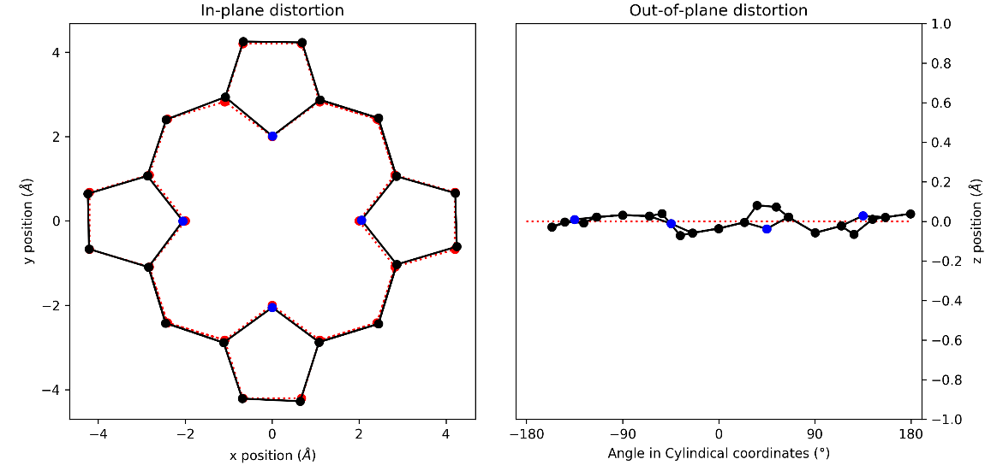
Figure 100: (a) in-plane and (b) out-of-plane skeletal plots of the porphyrin core. Porphyrin is represented in black (C) and blue (N), with the reference structure (CuTPP) in red dotted lines.

NSD result generated from 13 (in Å)
basis | Δ_{ip} | δ_{ip} | B_{2g} | B_{1g} | E_{u}(x) | E_{u}(y) | A_{1g} | A_{2g}
min. | 0.19 | 0.00 | 0.08 | 0.02 | -0.01 | -0.02 | 0.17 | 0.00
ext. | 0.20 | 0.00 | 0.08 | 0.02 | -0.01 | -0.02 | 0.17 | 0.00
 |  |  | -0.01 | 0.02 | -0.02 | 0.01 | -0.01 | -0.02
total | 0.21 | 0.00 | 0.08 | 0.02 | -0.01 | -0.02 | 0.18 | 0.00
 |  |  | -0.01 | 0.02 | -0.02 | 0.01 | -0.01 | -0.02
 |  |  | 0.03 | 0.01 | 0.00 | 0.00 | 0.06 | 0.00
 |  |  | -0.02 | 0.00 | 0.01 | -0.01 | -0.01 | 0.00
 |  |  | 0.00 | 0.00 | 0.01 | 0.00 | 0.00 | 0.00
 |  |  | 0.01 | 0.00 | 0.00 | 0.00 | 0.01
 |  |  |  |  | 0.00 | 0.00
 |  |  |  |  | 0.00 | 0.00
 |  |  |  |  | 0.00 | 0.00
 |  |  |  |  | 0.00 | 0.00
 |  |  |  |  | 0.00 | 0.00
comp. | 0.21 | 0.00 | 0.09 | 0.03 | 0.02 | 0.02 | 0.19 | 0.02

basis | Δ_{oop} | δ_{oop} | B_{2u} | B_{1u} | A_{2u} | E_{g}(x) | E_{g}(y) | A_{1u}
min. | 0.90 | 0.00 | 0.86 | -0.24 | -0.03 | 0.02 | -0.10 | 0.00
ext. | 0.90 | 0.00 | 0.86 | -0.24 | -0.03 | 0.02 | -0.10 | 0.00
 |  |  | -0.03 | 0.00 | -0.01 | 0.00 | 0.01 | 0.00
total | 0.90 | 0.00 | 0.86 | -0.24 | -0.03 | 0.02 | -0.10 | 0.00
 |  |  | -0.03 | 0.00 | -0.01 | 0.00 | 0.01 | 0.00
 |  |  | -0.01 | 0.00 | 0.00 | 0.01 | -0.01
 |  |  |  |  |  | 0.00 | 0.00
 |  |  |  |  |  | 0.00 | 0.00
comp. | 0.90 | 0.00 | 0.86 | 0.24 | 0.03 | 0.02 | 0.10 | 0.00
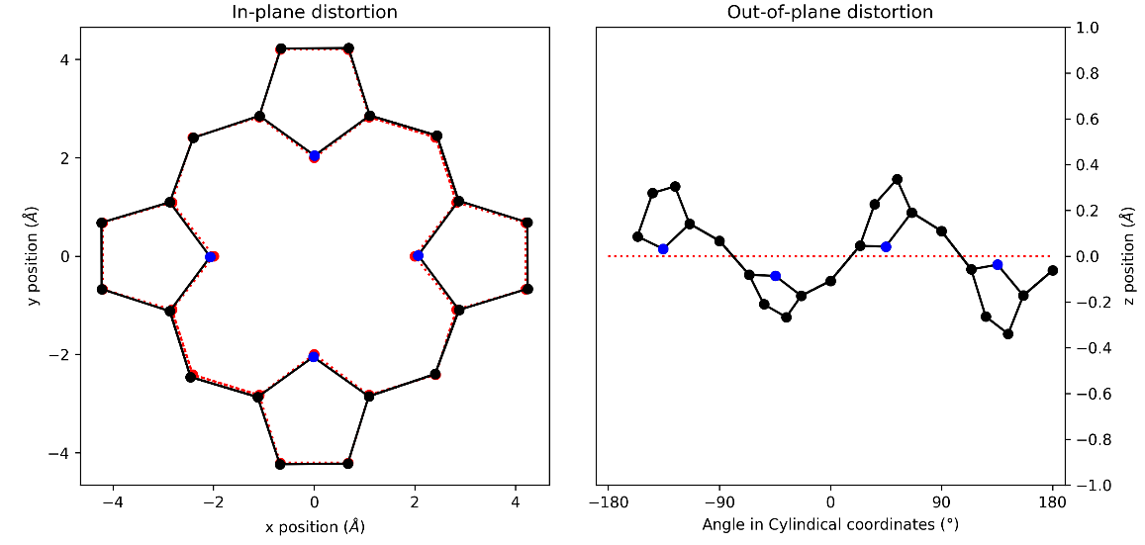
Figure 101: (a) in-plane and (b) out-of-plane skeletal plots of the porphyrin core. Porphyrin is represented in black (C) and blue (N), with the reference structure (CuTPP) in red dotted lines.

NSD result generated from 13A (in Å)
basis | Δ_{ip} | δ_{ip} | B_{2g} | B_{1g} | E_{u}(x) | E_{u}(y) | A_{1g} | A_{2g}
min. | 0.19 | 0.00 | -0.08 | -0.02 | -0.02 | 0.01 | 0.17 | 0.00
ext. | 0.20 | 0.00 | -0.08 | -0.02 | -0.02 | 0.01 | 0.17 | 0.00
 |  |  | 0.01 | -0.02 | 0.01 | 0.02 | -0.01 | -0.02
total | 0.21 | 0.00 | -0.08 | -0.02 | -0.02 | 0.01 | 0.18 | 0.00
 |  |  | 0.01 | -0.02 | 0.01 | 0.02 | -0.01 | -0.02
 |  |  | -0.03 | -0.02 | 0.00 | 0.00 | 0.06 | 0.00
 |  |  | 0.02 | 0.00 | 0.00 | -0.01 | 0.00 | 0.00
 |  |  | 0.00 | 0.00 | 0.00 | -0.01 | 0.00 | 0.00
 |  |  | -0.01 | 0.00 | 0.00 | 0.00 | 0.01
 |  |  |  |  | 0.00 | 0.00
 |  |  |  |  | 0.00 | 0.00
 |  |  |  |  | 0.00 | 0.00
 |  |  |  |  | 0.00 | 0.00
 |  |  |  |  | 0.00 | 0.00
comp. | 0.21 | 0.00 | 0.09 | 0.03 | 0.02 | 0.02 | 0.19 | 0.02

basis | Δ_{oop} | δ_{oop} | B_{2u} | B_{1u} | A_{2u} | E_{g}(x) | E_{g}(y) | A_{1u}
min. | 0.89 | 0.00 | 0.85 | -0.24 | 0.03 | 0.10 | 0.02 | 0.00
ext. | 0.89 | 0.00 | 0.85 | -0.24 | 0.03 | 0.10 | 0.02 | 0.00
 |  |  | -0.03 | 0.00 | 0.01 | -0.01 | 0.00 | 0.00
total | 0.89 | 0.00 | 0.85 | -0.24 | 0.03 | 0.10 | 0.02 | 0.00
 |  |  | -0.03 | 0.00 | 0.01 | -0.01 | 0.00 | 0.00
 |  |  | -0.01 | 0.00 | 0.00 | 0.01 | 0.01
 |  |  |  |  |  | 0.00 | 0.00
 |  |  |  |  |  | 0.00 | 0.00
comp. | 0.89 | 0.00 | 0.85 | 0.24 | 0.03 | 0.10 | 0.02 | 0.00
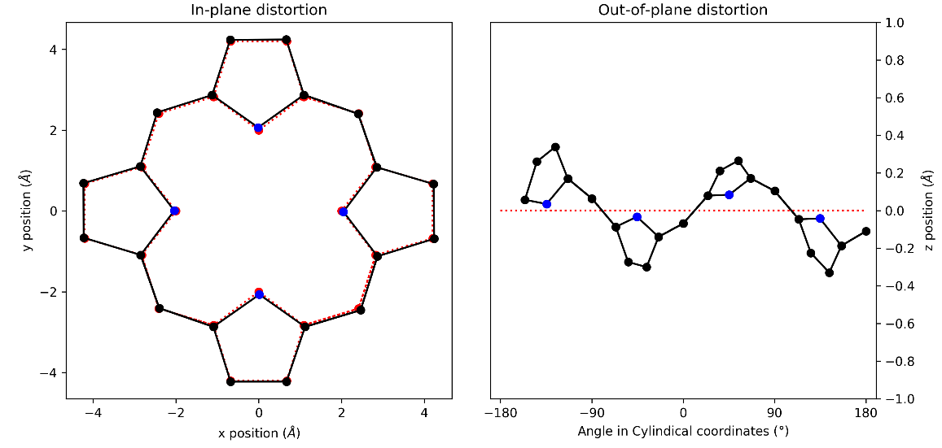
Figure 102: (a) in-plane and (b) out-of-plane skeletal plots of the porphyrin core. Porphyrin is represented in black (C) and blue (N), with the reference structure (CuTPP) in red dotted lines.

NSD result generated from 14 (in Å)
basis | Δ_{ip} | δ_{ip} | B_{2g} | B_{1g} | E_{u}(x) | E_{u}(y) | A_{1g} | A_{2g}
min. | 0.22 | 0.00 | -0.05 | -0.04 | 0.01 | 0.01 | 0.21 | 0.00
ext. | 0.22 | 0.00 | -0.05 | -0.04 | 0.01 | 0.01 | 0.21 | 0.00
 |  |  | 0.01 | -0.02 | -0.01 | 0.00 | -0.01 | 0.00
total | 0.23 | 0.00 | -0.05 | -0.04 | 0.01 | 0.01 | 0.21 | 0.00
 |  |  | 0.01 | -0.02 | -0.01 | 0.00 | -0.01 | 0.00
 |  |  | -0.03 | -0.02 | 0.00 | 0.00 | 0.06 | 0.00
 |  |  | 0.02 | -0.01 | 0.00 | 0.00 | -0.01 | 0.00
 |  |  | 0.01 | 0.00 | 0.00 | -0.01 | 0.00 | -0.01
 |  |  | -0.01 | 0.00 | 0.00 | 0.00 | 0.02
 |  |  |  |  | 0.00 | 0.00
 |  |  |  |  | 0.00 | 0.01
 |  |  |  |  | 0.00 | 0.00
 |  |  |  |  | 0.00 | 0.00
 |  |  |  |  | 0.00 | 0.00
comp. | 0.23 | 0.00 | 0.06 | 0.05 | 0.01 | 0.02 | 0.22 | 0.01

basis | Δ_{oop} | δ_{oop} | B_{2u} | B_{1u} | A_{2u} | E_{g}(x) | E_{g}(y) | A_{1u}
min. | 0.36 | 0.00 | 0.22 | 0.01 | -0.06 | 0.26 | 0.11 | -0.02
ext. | 0.37 | 0.00 | 0.22 | 0.01 | -0.06 | 0.25 | 0.11 | -0.02
 |  |  | -0.04 | 0.00 | -0.05 | -0.05 | 0.03 | 0.00
total | 0.37 | 0.00 | 0.22 | 0.01 | -0.06 | 0.25 | 0.11 | -0.02
 |  |  | -0.04 | 0.00 | -0.05 | -0.05 | 0.03 | 0.00
 |  |  | 0.00 | -0.01 | 0.00 | -0.03 | -0.01
 |  |  |  |  |  | 0.00 | 0.00
 |  |  |  |  |  | 0.01 | 0.00
comp. | 0.37 | 0.00 | 0.22 | 0.01 | 0.08 | 0.26 | 0.11 | 0.02
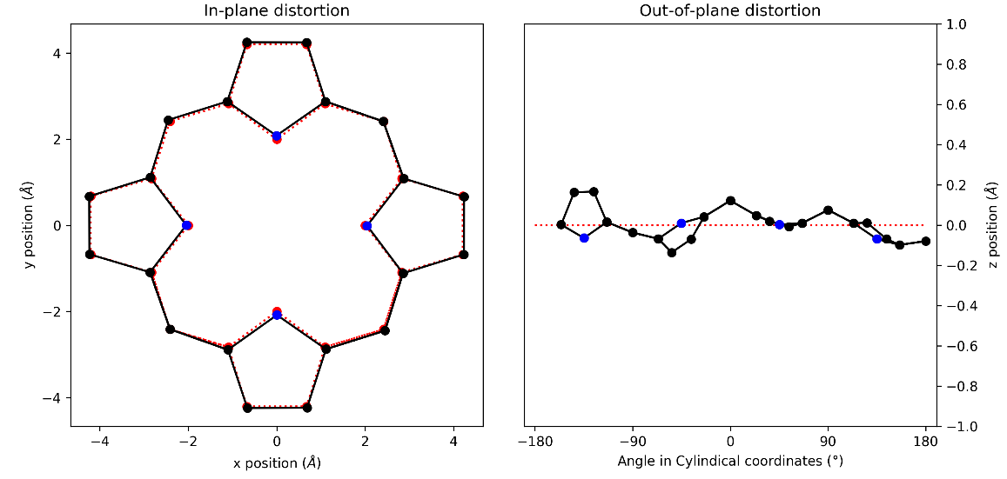
Figure 103: (a) in-plane and (b) out-of-plane skeletal plots of the porphyrin core. Porphyrin is represented in black (C) and blue (N), with the reference structure (CuTPP) in red dotted lines.

NSD result generated from 15 (in Å)
basis | Δ_{ip} | δ_{ip} | B_{2g} | B_{1g} | E_{u}(x) | E_{u}(y) | A_{1g} | A_{2g}
min. | 0.21 | 0.00 | -0.02 | -0.01 | 0.00 | 0.01 | 0.21 | 0.00
ext. | 0.21 | 0.00 | -0.02 | -0.01 | 0.00 | 0.01 | 0.21 | 0.00
 |  |  | 0.02 | 0.00 | 0.00 | 0.01 | 0.02 | 0.00
total | 0.22 | 0.00 | -0.02 | -0.01 | 0.00 | 0.01 | 0.21 | 0.00
 |  |  | 0.02 | 0.00 | 0.00 | 0.01 | 0.02 | 0.00
 |  |  | -0.03 | 0.00 | 0.00 | 0.00 | 0.02 | 0.00
 |  |  | 0.02 | 0.00 | 0.00 | 0.00 | -0.01 | 0.00
 |  |  | 0.01 | 0.00 | 0.00 | -0.01 | -0.01 | -0.01
 |  |  | 0.00 | -0.01 | 0.00 | 0.00 | 0.01
 |  |  |  |  | 0.00 | 0.00
 |  |  |  |  | 0.00 | 0.00
 |  |  |  |  | 0.00 | 0.00
 |  |  |  |  | 0.00 | 0.00
 |  |  |  |  | 0.00 | 0.00
comp. | 0.22 | 0.00 | 0.04 | 0.01 | 0.01 | 0.01 | 0.21 | 0.01

basis | Δ_{oop} | δ_{oop} | B_{2u} | B_{1u} | A_{2u} | E_{g}(x) | E_{g}(y) | A_{1u}
min. | 0.28 | 0.00 | 0.08 | -0.01 | -0.25 | 0.10 | 0.02 | -0.01
ext. | 0.29 | 0.00 | 0.08 | -0.01 | -0.25 | 0.11 | 0.02 | -0.01
 |  |  | 0.00 | 0.00 | 0.03 | 0.07 | 0.00 | 0.00
total | 0.29 | 0.00 | 0.08 | -0.01 | -0.25 | 0.11 | 0.02 | -0.01
 |  |  | 0.00 | 0.00 | 0.03 | 0.07 | 0.00 | 0.00
 |  |  | 0.00 | 0.00 | -0.01 | 0.00 | -0.01
 |  |  |  |  |  | 0.00 | -0.01
 |  |  |  |  |  | 0.00 | 0.00
comp. | 0.29 | 0.00 | 0.08 | 0.01 | 0.25 | 0.13 | 0.02 | 0.01
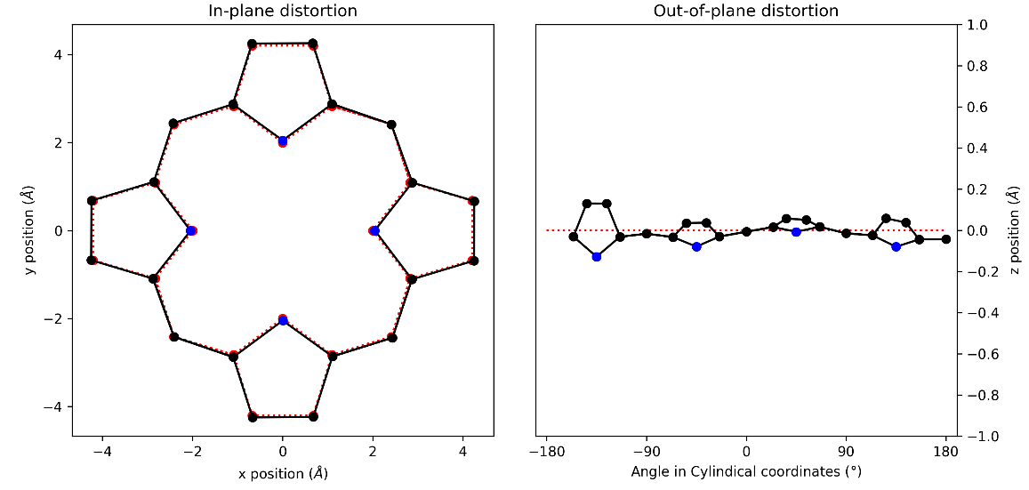
Figure 104 (a) in-plane and (b) out-of-plane skeletal plots of the porphyrin core. Porphyrin is represented in black (C) and blue (N), with the reference structure (CuTPP) in red dotted lines.

NSD result generated from 16 (in Å)
basis | Δ_{ip} | δ_{ip} | B_{2g} | B_{1g} | E_{u}(x) | E_{u}(y) | A_{1g} | A_{2g}
min. | 0.21 | 0.00 | 0.07 | -0.01 | 0.00 | 0.00 | 0.20 | -0.01
ext. | 0.22 | 0.00 | 0.07 | -0.01 | 0.00 | 0.00 | 0.20 | -0.01
 |  |  | 0.00 | -0.04 | -0.01 | 0.02 | 0.00 | -0.03
total | 0.25 | 0.00 | 0.07 | -0.01 | 0.00 | 0.00 | 0.20 | -0.02
 |  |  | 0.00 | -0.04 | -0.01 | 0.02 | 0.00 | -0.03
 |  |  | -0.01 | -0.04 | 0.00 | 0.00 | 0.07 | -0.01
 |  |  | -0.01 | 0.02 | 0.00 | -0.03 | -0.04 | 0.00
 |  |  | 0.01 | 0.00 | 0.02 | 0.02 | 0.00 | -0.02
 |  |  | 0.01 | -0.01 | -0.01 | 0.02 | 0.02
 |  |  |  |  | 0.00 | -0.01
 |  |  |  |  | 0.01 | 0.00
 |  |  |  |  | 0.00 | 0.00
 |  |  |  |  | 0.00 | 0.00
 |  |  |  |  | 0.00 | 0.00
comp. | 0.25 | 0.00 | 0.07 | 0.07 | 0.03 | 0.04 | 0.22 | 0.04

basis | Δ_{oop} | δ_{oop} | B_{2u} | B_{1u} | A_{2u} | E_{g}(x) | E_{g}(y) | A_{1u}
min. | 0.89 | 0.00 | 0.57 | -0.67 | -0.16 | -0.01 | -0.07 | 0.00
ext. | 0.90 | 0.00 | 0.57 | -0.67 | -0.16 | -0.01 | -0.07 | 0.00
 |  |  | -0.07 | -0.02 | -0.01 | 0.00 | -0.05 | 0.00
total | 0.90 | 0.00 | 0.57 | -0.67 | -0.16 | -0.01 | -0.07 | 0.00
 |  |  | -0.07 | -0.02 | -0.01 | 0.00 | -0.05 | 0.00
 |  |  | -0.02 | 0.01 | 0.00 | 0.01 | 0.00
 |  |  |  |  |  | 0.00 | 0.00
 |  |  |  |  |  | -0.02 | 0.00
comp. | 0.90 | 0.00 | 0.57 | 0.67 | 0.16 | 0.02 | 0.08 | 0.00
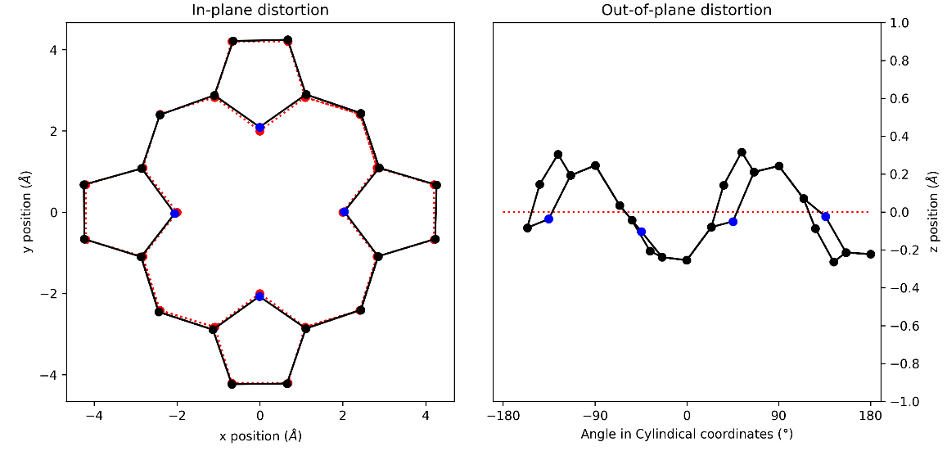
Figure 105: (a) in-plane and (b) out-of-plane skeletal plots of the porphyrin core. Porphyrin is represented in black (C) and blue (N), with the reference structure (CuTPP) in red dotted lines.

NSD result generated from 16A (in Å)
basis | Δ_{ip} | δ_{ip} | B_{2g} | B_{1g} | E_{u}(x) | E_{u}(y) | A_{1g} | A_{2g}
min. | 0.17 | 0.00 | 0.04 | 0.01 | 0.00 | 0.00 | 0.16 | -0.01
ext. | 0.19 | 0.00 | 0.04 | 0.00 | 0.00 | 0.00 | 0.16 | -0.01
 |  |  | 0.00 | -0.06 | 0.00 | -0.04 | -0.03 | -0.01
total | 0.21 | 0.00 | 0.04 | 0.00 | 0.00 | 0.00 | 0.17 | -0.01
 |  |  | 0.00 | -0.06 | 0.00 | -0.04 | -0.03 | -0.01
 |  |  | 0.01 | -0.05 | 0.00 | 0.00 | 0.07 | -0.01
 |  |  | 0.00 | 0.00 | -0.01 | 0.01 | -0.01 | 0.00
 |  |  | 0.01 | 0.01 | 0.00 | 0.01 | 0.01 | 0.01
 |  |  | 0.01 | -0.01 | 0.00 | 0.00 | 0.01
 |  |  |  |  | 0.01 | 0.00
 |  |  |  |  | 0.00 | -0.01
 |  |  |  |  | 0.00 | 0.00
 |  |  |  |  | 0.00 | 0.00
 |  |  |  |  | 0.00 | -0.01
comp. | 0.21 | 0.00 | 0.04 | 0.08 | 0.02 | 0.04 | 0.19 | 0.02

basis | Δ_{oop} | δ_{oop} | B_{2u} | B_{1u} | A_{2u} | E_{g}(x) | E_{g}(y) | A_{1u}
min. | 0.67 | 0.00 | 0.60 | -0.21 | -0.10 | -0.14 | 0.11 | 0.01
ext. | 0.68 | 0.00 | 0.60 | -0.21 | -0.10 | -0.14 | 0.11 | 0.01
 |  |  | -0.07 | -0.01 | -0.02 | 0.04 | 0.07 | 0.01
total | 0.68 | 0.00 | 0.60 | -0.21 | -0.10 | -0.14 | 0.11 | 0.01
 |  |  | -0.07 | -0.01 | -0.02 | 0.04 | 0.07 | 0.01
 |  |  | -0.01 | 0.00 | 0.00 | 0.02 | 0.01
 |  |  |  |  |  | 0.01 | -0.01
 |  |  |  |  |  | -0.02 | 0.00
comp. | 0.68 | 0.00 | 0.61 | 0.21 | 0.10 | 0.15 | 0.13 | 0.02
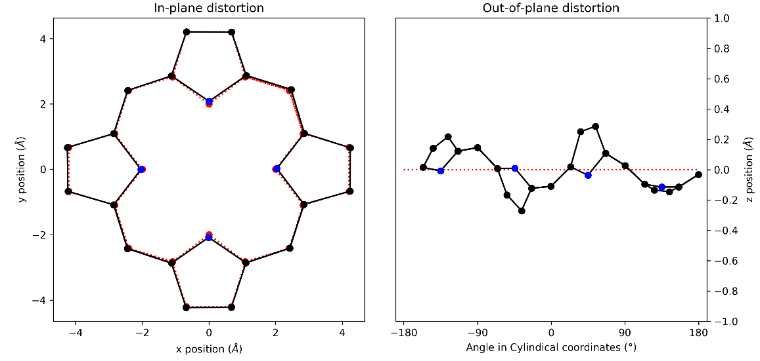
Figure 106: (a) in-plane and (b) out-of-plane skeletal plots of the porphyrin core. Porphyrin is represented in black (C) and blue (N), with the reference structure (CuTPP) in red dotted lines.

NSD result generated from 17 (in Å)
basis | Δ_{ip} | δ_{ip} | B_{2g} | B_{1g} | E_{u}(x) | E_{u}(y) | A_{1g} | A_{2g}
min. | 0.03 | 0.00 | -0.01 | 0.00 | 0.01 | 0.02 | 0.01 | 0.01
ext. | 0.05 | 0.00 | -0.01 | 0.00 | 0.01 | 0.02 | 0.01 | 0.01
 |  |  | -0.02 | 0.00 | 0.01 | 0.00 | 0.02 | -0.01
total | 0.09 | 0.00 | -0.01 | 0.00 | 0.01 | 0.02 | 0.01 | 0.01
 |  |  | -0.02 | 0.00 | 0.01 | 0.00 | 0.02 | -0.01
 |  |  | -0.01 | 0.01 | -0.01 | 0.00 | 0.03 | 0.00
 |  |  | 0.00 | 0.01 | -0.02 | 0.01 | -0.03 | 0.00
 |  |  | -0.01 | 0.00 | 0.01 | 0.00 | -0.02 | -0.01
 |  |  | -0.01 | -0.02 | -0.02 | -0.01 | 0.02
 |  |  |  |  | -0.02 | -0.01
 |  |  |  |  | 0.00 | 0.00
 |  |  |  |  | -0.03 | 0.01
 |  |  |  |  | 0.03 | 0.00
 |  |  |  |  | 0.00 | -0.01
comp. | 0.09 | 0.00 | 0.03 | 0.02 | 0.06 | 0.03 | 0.06 | 0.02

basis | Δ_{oop} | δ_{oop} | B_{2u} | B_{1u} | A_{2u} | E_{g}(x) | E_{g}(y) | A_{1u}
min. | 0.73 | 0.00 | 0.23 | -0.69 | 0.02 | -0.03 | 0.05 | -0.01
ext. | 0.74 | 0.00 | 0.23 | -0.69 | 0.02 | -0.03 | 0.05 | -0.01
 |  |  | 0.04 | -0.02 | 0.06 | 0.01 | 0.00 | 0.01
total | 0.74 | 0.00 | 0.23 | -0.69 | 0.02 | -0.03 | 0.05 | -0.01
 |  |  | 0.04 | -0.02 | 0.06 | 0.01 | 0.00 | 0.01
 |  |  | -0.01 | -0.01 | -0.01 | 0.00 | -0.01
 |  |  |  |  |  | 0.02 | 0.01
 |  |  |  |  |  | 0.00 | 0.00
comp. | 0.74 | 0.00 | 0.23 | 0.69 | 0.06 | 0.04 | 0.05 | 0.01
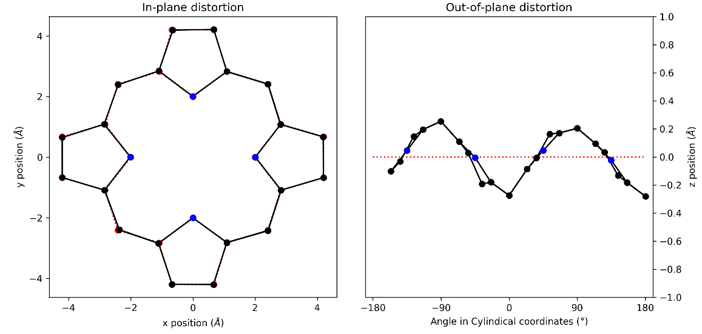
Figure 107: (a) in-plane and (b) out-of-plane skeletal plots of the porphyrin core. Porphyrin is represented in black (C) and blue (N), with the reference structure (CuTPP) in red dotted lines.

NSD result generated from 18 (in Å)
basis | Δ_{ip} | δ_{ip} | B_{2g} | B_{1g} | E_{u}(x) | E_{u}(y) | A_{1g} | A_{2g}
min. | 0.18 | 0.00 | 0.01 | 0.04 | -0.01 | 0.04 | 0.17 | -0.01
ext. | 0.18 | 0.00 | 0.01 | 0.04 | -0.01 | 0.04 | 0.17 | -0.01
 |  |  | 0.01 | 0.01 | -0.01 | 0.02 | 0.03 | -0.02
total | 0.19 | 0.00 | 0.01 | 0.04 | -0.01 | 0.04 | 0.17 | -0.01
 |  |  | 0.01 | 0.01 | -0.01 | 0.02 | 0.03 | -0.02
 |  |  | 0.00 | 0.00 | -0.01 | -0.01 | 0.03 | 0.00
 |  |  | -0.01 | 0.00 | -0.01 | -0.02 | -0.04 | 0.00
 |  |  | 0.01 | 0.01 | 0.01 | 0.01 | -0.01 | 0.00
 |  |  | 0.00 | 0.00 | 0.00 | -0.01 | 0.01
 |  |  |  |  | -0.01 | 0.00
 |  |  |  |  | -0.01 | -0.01
 |  |  |  |  | 0.00 | -0.01
 |  |  |  |  | 0.00 | 0.01
 |  |  |  |  | 0.00 | 0.00
comp. | 0.19 | 0.00 | 0.02 | 0.04 | 0.02 | 0.05 | 0.18 | 0.02

basis | Δ_{oop} | δ_{oop} | B_{2u} | B_{1u} | A_{2u} | E_{g}(x) | E_{g}(y) | A_{1u}
min. | 0.64 | 0.00 | 0.27 | -0.56 | -0.01 | 0.11 | 0.05 | 0.00
ext. | 0.64 | 0.00 | 0.27 | -0.56 | -0.02 | 0.11 | 0.05 | 0.00
 |  |  | -0.03 | -0.01 | -0.04 | -0.06 | -0.05 | 0.01
total | 0.64 | 0.00 | 0.27 | -0.56 | -0.02 | 0.11 | 0.05 | 0.00
 |  |  | -0.03 | -0.01 | -0.04 | -0.06 | -0.05 | 0.01
 |  |  | 0.00 | -0.01 | 0.01 | 0.00 | 0.01
 |  |  |  |  |  | 0.00 | 0.00
 |  |  |  |  |  | 0.00 | 0.01
comp. | 0.64 | 0.00 | 0.27 | 0.56 | 0.04 | 0.12 | 0.07 | 0.01
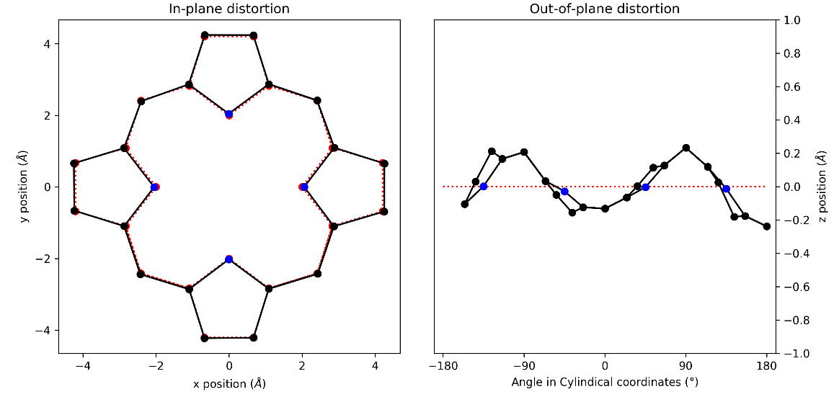
Figure 108: (a) in-plane and (b) out-of-plane skeletal plots of the porphyrin core. Porphyrin is represented in black (C) and blue (N), with the reference structure (CuTPP) in red dotted lines.

NSD result generated from 19 (in Å)
basis | Δ_{ip} | δ_{ip} | B_{2g} | B_{1g} | E_{u}(x) | E_{u}(y) | A_{1g} | A_{2g}
min. | 0.23 | 0.00 | 0.00 | -0.02 | 0.02 | 0.00 | 0.23 | 0.00
ext. | 0.23 | 0.00 | 0.00 | -0.02 | 0.02 | 0.00 | 0.23 | 0.00
 |  |  | 0.00 | -0.04 | 0.00 | 0.00 | 0.01 | 0.00
total | 0.25 | 0.00 | 0.00 | -0.02 | 0.02 | 0.00 | 0.23 | 0.00
 |  |  | 0.00 | -0.04 | 0.00 | 0.00 | 0.01 | 0.00
 |  |  | 0.00 | -0.03 | -0.02 | 0.00 | 0.05 | 0.00
 |  |  | 0.00 | 0.00 | -0.03 | 0.00 | -0.01 | 0.00
 |  |  | 0.00 | 0.01 | 0.01 | 0.00 | 0.01 | 0.00
 |  |  | 0.00 | -0.01 | 0.00 | 0.00 | 0.01
 |  |  |  |  | 0.00 | 0.00
 |  |  |  |  | 0.00 | 0.00
 |  |  |  |  | -0.01 | 0.00
 |  |  |  |  | 0.01 | 0.00
 |  |  |  |  | 0.00 | 0.00
comp. | 0.25 | 0.00 | 0.00 | 0.05 | 0.04 | 0.00 | 0.24 | 0.00

basis | Δ_{oop} | δ_{oop} | B_{2u} | B_{1u} | A_{2u} | E_{g}(x) | E_{g}(y) | A_{1u}
min. | 0.25 | 0.00 | 0.00 | -0.25 | 0.00 | 0.00 | 0.00 | 0.00
ext. | 0.25 | 0.00 | 0.00 | -0.25 | 0.00 | 0.00 | 0.00 | 0.00
 |  |  | 0.00 | 0.00 | 0.00 | -0.02 | 0.00 | 0.00
total | 0.25 | 0.00 | 0.00 | -0.25 | 0.00 | 0.00 | 0.00 | 0.00
 |  |  | 0.00 | 0.00 | 0.00 | -0.02 | 0.00 | 0.00
 |  |  | 0.00 | -0.01 | 0.00 | 0.01 | 0.00
 |  |  |  |  |  | 0.01 | 0.00
 |  |  |  |  |  | 0.00 | 0.00
comp. | 0.25 | 0.00 | 0.00 | 0.25 | 0.00 | 0.02 | 0.00 | 0.01
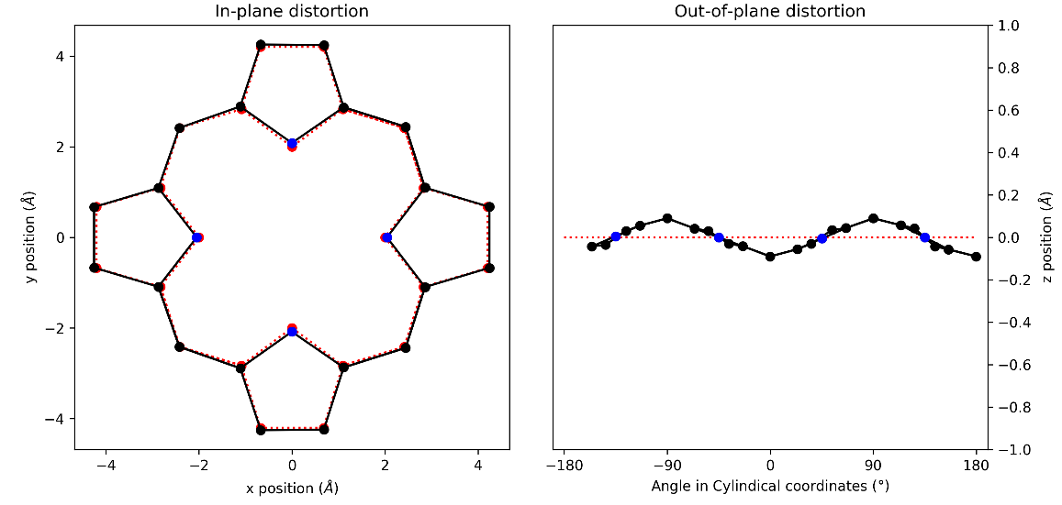
Figure 109: (a) in-plane and (b) out-of-plane skeletal plots of the porphyrin core. Porphyrin is represented in black (C) and blue (N), with the reference structure (CuTPP) in red dotted lines.

NSD result generated from 20 (in Å)
basis | Δ_{ip} | δ_{ip} | B_{2g} | B_{1g} | E_{u}(x) | E_{u}(y) | A_{1g} | A_{2g}
min. | 0.26 | 0.00 | -0.01 | 0.06 | 0.00 | 0.00 | 0.26 | 0.00
ext. | 0.28 | 0.00 | -0.01 | 0.06 | 0.00 | 0.00 | 0.26 | 0.00
 |  |  | -0.01 | 0.06 | 0.00 | 0.00 | 0.06 | 0.00
total | 0.29 | 0.00 | -0.01 | 0.07 | 0.00 | 0.00 | 0.26 | 0.00
 |  |  | -0.01 | 0.06 | 0.00 | 0.00 | 0.06 | 0.00
 |  |  | 0.01 | 0.05 | 0.00 | 0.00 | 0.04 | 0.00
 |  |  | 0.00 | 0.00 | 0.00 | 0.00 | 0.02 | 0.00
 |  |  | 0.00 | -0.01 | 0.00 | 0.00 | 0.00 | 0.00
 |  |  | 0.00 | 0.01 | 0.00 | 0.00 | 0.01
 |  |  |  |  | 0.00 | 0.00
 |  |  |  |  | 0.00 | 0.00
 |  |  |  |  | 0.00 | 0.00
 |  |  |  |  | 0.00 | 0.00
 |  |  |  |  | 0.00 | 0.00
comp. | 0.29 | 0.00 | 0.02 | 0.10 | 0.00 | 0.00 | 0.27 | 0.00

basis | Δ_{oop} | δ_{oop} | B_{2u} | B_{1u} | A_{2u} | E_{g}(x) | E_{g}(y) | A_{1u}
min. | 0.12 | 0.00 | 0.00 | 0.00 | 0.00 | 0.08 | 0.09 | 0.00
ext. | 0.14 | 0.00 | 0.00 | 0.00 | 0.00 | 0.09 | 0.09 | 0.00
 |  |  | 0.00 | 0.00 | 0.00 | 0.05 | -0.02 | 0.00
total | 0.14 | 0.00 | 0.00 | 0.00 | 0.00 | 0.09 | 0.09 | 0.00
 |  |  | 0.00 | 0.00 | 0.00 | 0.05 | -0.02 | 0.00
 |  |  | 0.00 | 0.00 | 0.00 | -0.01 | 0.01
 |  |  |  |  |  | 0.00 | 0.00
 |  |  |  |  |  | 0.00 | 0.00
comp. | 0.14 | 0.00 | 0.00 | 0.00 | 0.00 | 0.10 | 0.09 | 0.00
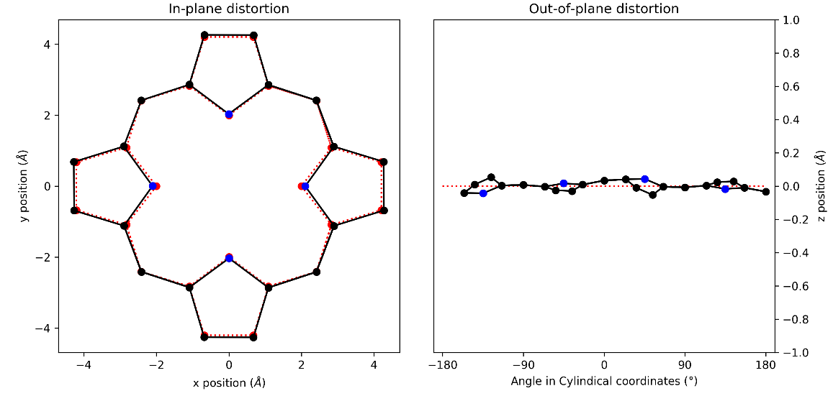
Figure 110: (a) in-plane and (b) out-of-plane skeletal plots of the porphyrin core. Porphyrin is represented in black (C) and blue (N), with the reference structure (CuTPP) in red dotted lines.

NSD result generated from 21 (in Å)
basis | Δ_{ip} | δ_{ip} | B_{2g} | B_{1g} | E_{u}(x) | E_{u}(y) | A_{1g} | A_{2g}
min. | 0.47 | 0.01 | 0.02 | -0.01 | 0.00 | -0.03 | -0.46 | 0.04
ext. | 0.50 | 0.01 | 0.02 | -0.01 | 0.00 | -0.03 | -0.46 | 0.04
 |  |  | 0.01 | -0.01 | -0.02 | -0.01 | 0.17 | -0.06
total | 0.52 | 0.00 | 0.02 | -0.01 | 0.00 | -0.03 | -0.46 | 0.03
 |  |  | 0.01 | -0.01 | -0.02 | -0.01 | 0.17 | -0.06
 |  |  | -0.02 | 0.00 | -0.03 | 0.00 | 0.01 | 0.00
 |  |  | 0.00 | 0.00 | -0.04 | 0.02 | -0.13 | -0.01
 |  |  | 0.00 | 0.00 | 0.01 | -0.01 | -0.01 | -0.02
 |  |  | 0.00 | 0.00 | 0.00 | 0.00 | 0.08
 |  |  |  |  | 0.00 | -0.01
 |  |  |  |  | 0.00 | 0.00
 |  |  |  |  | 0.00 | 0.01
 |  |  |  |  | 0.01 | 0.00
 |  |  |  |  | 0.00 | 0.00
comp. | 0.52 | 0.00 | 0.03 | 0.02 | 0.05 | 0.04 | 0.51 | 0.07

basis | Δ_{oop} | δ_{oop} | B_{2u} | B_{1u} | A_{2u} | E_{g}(x) | E_{g}(y) | A_{1u}
min. | 1.89 | 0.00 | 0.34 | -1.85 | -0.09 | 0.09 | 0.00 | -0.01
ext. | 1.89 | 0.00 | 0.34 | -1.85 | -0.09 | 0.09 | 0.00 | -0.01
 |  |  | 0.00 | -0.02 | 0.01 | -0.02 | -0.02 | 0.00
total | 1.89 | 0.00 | 0.34 | -1.85 | -0.09 | 0.09 | 0.00 | -0.01
 |  |  | 0.00 | -0.02 | 0.01 | -0.02 | -0.02 | 0.00
 |  |  | 0.00 | -0.02 | 0.00 | -0.02 | -0.02
 |  |  |  |  |  | 0.00 | 0.00
 |  |  |  |  |  | 0.00 | 0.01
comp. | 1.89 | 0.00 | 0.34 | 1.85 | 0.09 | 0.10 | 0.03 | 0.01
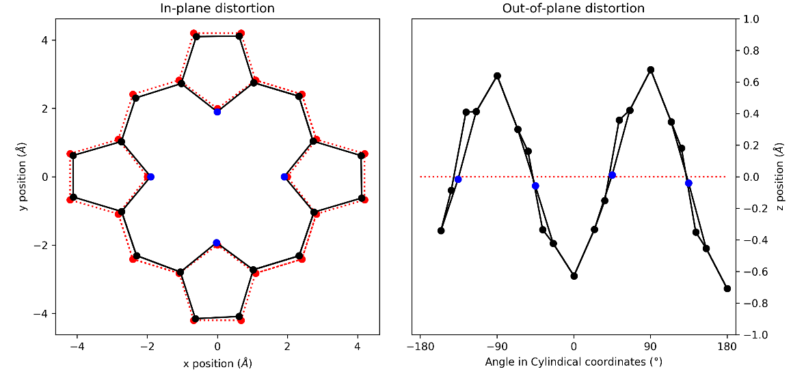
Figure 111: (a) in-plane and (b) out-of-plane skeletal plots of the porphyrin core. Porphyrin is represented in black (C) and blue (N), with the reference structure (CuTPP) in red dotted lines.

NSD result generated from 22 (in Å)
basis | Δ_{ip} | δ_{ip} | B_{2g} | B_{1g} | E_{u}(x) | E_{u}(y) | A_{1g} | A_{2g}
min. | 0.42 | 0.01 | -0.04 | 0.00 | -0.01 | -0.01 | -0.41 | 0.00
ext. | 0.44 | 0.00 | -0.04 | 0.00 | -0.01 | -0.01 | -0.41 | 0.00
 |  |  | 0.01 | 0.00 | -0.02 | -0.02 | 0.13 | 0.00
total | 0.46 | 0.00 | -0.04 | 0.00 | -0.01 | -0.01 | -0.41 | 0.00
 |  |  | 0.01 | 0.00 | -0.02 | -0.02 | 0.13 | 0.00
 |  |  | 0.03 | 0.00 | 0.01 | 0.01 | 0.01 | 0.00
 |  |  | -0.01 | 0.00 | 0.03 | 0.03 | -0.10 | 0.00
 |  |  | 0.00 | 0.00 | -0.02 | -0.02 | -0.01 | 0.00
 |  |  | 0.02 | 0.00 | 0.01 | 0.01 | 0.06
 |  |  |  |  | 0.00 | 0.00
 |  |  |  |  | 0.01 | 0.01
 |  |  |  |  | 0.00 | 0.00
 |  |  |  |  | 0.00 | 0.00
 |  |  |  |  | 0.00 | 0.00
comp. | 0.46 | 0.00 | 0.06 | 0.00 | 0.05 | 0.05 | 0.45 | 0.00

basis | Δ_{oop} | δ_{oop} | B_{2u} | B_{1u} | A_{2u} | E_{g}(x) | E_{g}(y) | A_{1u}
min. | 1.74 | 0.00 | 0.00 | 1.72 | -0.09 | 0.14 | -0.14 | 0.00
ext. | 1.74 | 0.00 | 0.00 | 1.72 | -0.09 | 0.14 | -0.14 | 0.00
 |  |  | 0.00 | 0.02 | 0.05 | -0.01 | 0.01 | 0.00
total | 1.74 | 0.00 | 0.00 | 1.72 | -0.09 | 0.14 | -0.14 | 0.00
 |  |  | 0.00 | 0.02 | 0.05 | -0.01 | 0.01 | 0.00
 |  |  | 0.00 | 0.03 | 0.00 | -0.05 | 0.05
 |  |  |  |  |  | -0.01 | 0.01
 |  |  |  |  |  | 0.00 | 0.00
comp. | 1.74 | 0.00 | 0.00 | 1.72 | 0.10 | 0.15 | 0.15 | 0.00
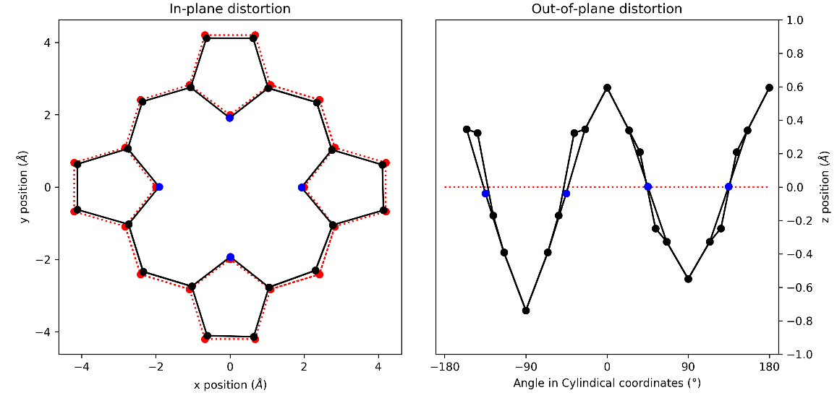
Figure 112: (a) in-plane and (b) out-of-plane skeletal plots of the porphyrin core. Porphyrin is represented in black (C) and blue (N), with the reference structure (CuTPP) in red dotted lines.

NSD result generated from 23 (in Å)
basis | Δ_{ip} | δ_{ip} | B_{2g} | B_{1g} | E_{u}(x) | E_{u}(y) | A_{1g} | A_{2g}
min. | 0.23 | 0.00 | -0.05 | 0.01 | -0.01 | 0.02 | -0.22 | 0.00
ext. | 0.23 | 0.00 | -0.05 | 0.01 | -0.01 | 0.02 | -0.22 | 0.00
 |  |  | 0.03 | 0.01 | -0.02 | 0.00 | 0.04 | -0.01
total | 0.26 | 0.00 | -0.05 | 0.01 | -0.01 | 0.02 | -0.22 | 0.00
 |  |  | 0.03 | 0.01 | -0.02 | 0.00 | 0.04 | -0.01
 |  |  | -0.02 | -0.01 | 0.01 | 0.00 | -0.04 | 0.00
 |  |  | 0.00 | 0.02 | 0.00 | -0.02 | -0.03 | -0.03
 |  |  | 0.01 | 0.01 | -0.01 | -0.02 | -0.03 | 0.01
 |  |  | 0.00 | 0.01 | 0.01 | 0.01 | 0.02
 |  |  |  |  | 0.04 | 0.00
 |  |  |  |  | 0.01 | -0.03
 |  |  |  |  | 0.01 | -0.01
 |  |  |  |  | 0.00 | 0.01
 |  |  |  |  | -0.02 | 0.00
comp. | 0.26 | 0.00 | 0.06 | 0.03 | 0.05 | 0.05 | 0.24 | 0.03

basis | Δ_{oop} | δ_{oop} | B_{2u} | B_{1u} | A_{2u} | E_{g}(x) | E_{g}(y) | A_{1u}
min. | 0.96 | 0.00 | 0.23 | 0.93 | -0.02 | 0.07 | -0.01 | -0.02
ext. | 0.97 | 0.00 | 0.23 | 0.93 | -0.02 | 0.07 | -0.01 | -0.02
 |  |  | 0.04 | 0.02 | 0.01 | -0.04 | 0.05 | 0.02
total | 0.97 | 0.00 | 0.23 | 0.93 | -0.02 | 0.07 | -0.01 | -0.02
 |  |  | 0.04 | 0.02 | 0.01 | -0.04 | 0.05 | 0.02
 |  |  | 0.00 | 0.02 | 0.01 | -0.03 | 0.02
 |  |  |  |  |  | 0.01 | -0.01
 |  |  |  |  |  | 0.03 | 0.00
comp. | 0.97 | 0.00 | 0.24 | 0.93 | 0.02 | 0.09 | 0.05 | 0.03
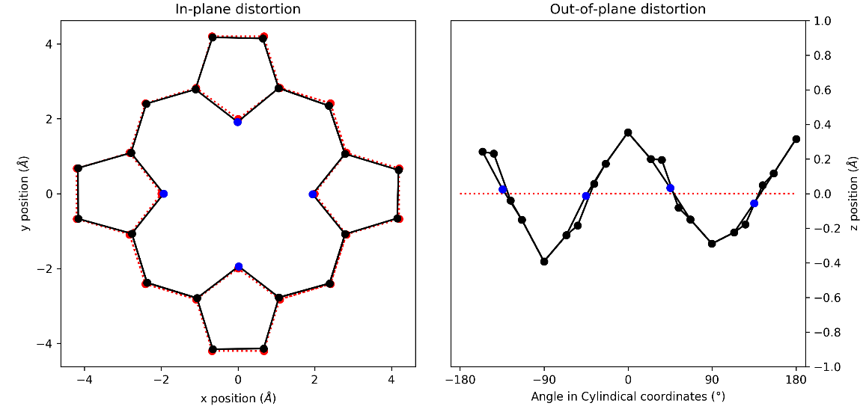
Figure 113: (a) in-plane and (b) out-of-plane skeletal plots of the porphyrin core. Porphyrin is represented in black (C) and blue (N), with the reference structure (CuTPP) in red dotted lines.

NSD result generated from 24 (in Å)
basis | Δ_{ip} | δ_{ip} | B_{2g} | B_{1g} | E_{u}(x) | E_{u}(y) | A_{1g} | A_{2g}
min. | 0.21 | 0.00 | -0.07 | 0.01 | 0.00 | 0.00 | 0.20 | 0.00
ext. | 0.22 | 0.00 | -0.07 | 0.01 | 0.00 | 0.00 | 0.20 | 0.00
 |  |  | -0.01 | -0.02 | -0.02 | 0.01 | -0.04 | 0.00
total | 0.23 | 0.00 | -0.07 | 0.01 | 0.00 | 0.00 | 0.20 | 0.00
 |  |  | -0.01 | -0.02 | -0.02 | 0.01 | -0.04 | 0.00
 |  |  | -0.01 | -0.02 | 0.00 | 0.00 | 0.05 | 0.00
 |  |  | 0.00 | 0.00 | 0.00 | 0.00 | -0.01 | 0.00
 |  |  | 0.00 | 0.00 | 0.00 | 0.00 | 0.02 | 0.00
 |  |  | 0.00 | 0.00 | 0.00 | 0.00 | 0.01
 |  |  |  |  | 0.00 | 0.00
 |  |  |  |  | 0.00 | 0.00
 |  |  |  |  | 0.00 | 0.00
 |  |  |  |  | 0.00 | 0.00
 |  |  |  |  | 0.00 | 0.01
comp. | 0.23 | 0.00 | 0.07 | 0.03 | 0.02 | 0.02 | 0.21 | 0.00

basis | Δ_{oop} | δ_{oop} | B_{2u} | B_{1u} | A_{2u} | E_{g}(x) | E_{g}(y) | A_{1u}
min. | 0.29 | 0.00 | -0.10 | -0.16 | -0.01 | 0.01 | 0.21 | 0.00
ext. | 0.30 | 0.00 | -0.10 | -0.16 | -0.01 | 0.01 | 0.21 | 0.00
 |  |  | -0.04 | -0.01 | 0.01 | 0.04 | -0.07 | 0.00
total | 0.30 | 0.00 | -0.10 | -0.16 | -0.01 | 0.01 | 0.21 | 0.00
 |  |  | -0.04 | -0.01 | 0.01 | 0.04 | -0.07 | 0.00
 |  |  | 0.00 | -0.01 | 0.00 | 0.01 | -0.02
 |  |  |  |  |  | 0.00 | -0.01
 |  |  |  |  |  | 0.01 | 0.01
comp. | 0.30 | 0.00 | 0.11 | 0.16 | 0.01 | 0.04 | 0.22 | 0.00
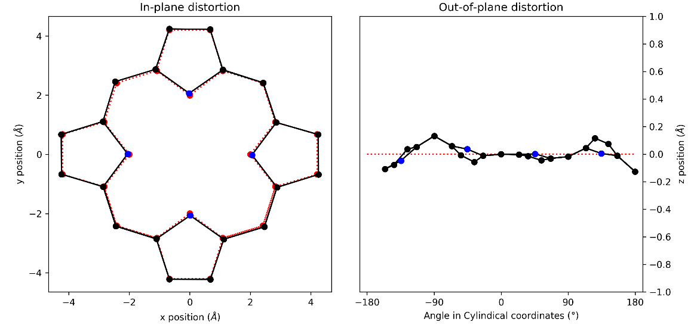
Figure 114: (a) in-plane and (b) out-of-plane skeletal plots of the porphyrin core. Porphyrin is represented in black (C) and blue (N), with the reference structure (CuTPP) in red dotted lines.

NSD tables and plots for DFT structures series 1

NSD result generated from 1:1 (in Å)
basis | Δ_{ip} | δ_{ip} | B_{2g} | B_{1g} | E_{u}(x) | E_{u}(y) | A_{1g} | A_{2g}
min. | 0.38 | 0.00 | -0.32 | -0.05 | 0.00 | 0.00 | 0.21 | 0.00
ext. | 0.40 | 0.00 | -0.32 | -0.05 | 0.00 | 0.00 | 0.21 | 0.00
 |  |  | -0.05 | -0.09 | 0.00 | 0.00 | 0.00 | 0.00
total | 0.41 | 0.00 | -0.32 | -0.05 | 0.00 | 0.00 | 0.21 | 0.00
 |  |  | -0.05 | -0.09 | 0.00 | 0.00 | 0.00 | 0.00
 |  |  | 0.00 | -0.06 | 0.00 | 0.00 | 0.05 | 0.00
 |  |  | 0.00 | 0.00 | 0.00 | 0.00 | 0.01 | 0.00
 |  |  | 0.00 | 0.01 | 0.00 | 0.00 | 0.02 | 0.00
 |  |  | -0.01 | -0.01 | 0.00 | 0.00 | 0.01
 |  |  |  |  | 0.00 | 0.00
 |  |  |  |  | 0.00 | 0.00
 |  |  |  |  | 0.00 | 0.00
 |  |  |  |  | 0.00 | 0.00
 |  |  |  |  | 0.00 | 0.00
comp. | 0.41 | 0.00 | 0.32 | 0.12 | 0.00 | 0.00 | 0.22 | 0.00

basis | Δ_{oop} | δ_{oop} | B_{2u} | B_{1u} | A_{2u} | E_{g}(x) | E_{g}(y) | A_{1u}
min. | 0.08 | 0.00 | 0.00 | 0.00 | 0.00 | 0.06 | 0.06 | 0.00
ext. | 0.10 | 0.00 | 0.00 | 0.00 | 0.00 | 0.06 | 0.06 | 0.00
 |  |  | 0.00 | 0.00 | 0.00 | 0.05 | 0.03 | 0.00
total | 0.10 | 0.00 | 0.00 | 0.00 | 0.00 | 0.06 | 0.06 | 0.00
 |  |  | 0.00 | 0.00 | 0.00 | 0.05 | 0.03 | 0.00
 |  |  | 0.00 | 0.00 | 0.00 | 0.00 | 0.00
 |  |  |  |  |  | 0.00 | 0.00
 |  |  |  |  |  | 0.00 | 0.00
comp. | 0.10 | 0.00 | 0.00 | 0.00 | 0.00 | 0.08 | 0.07 | 0.00
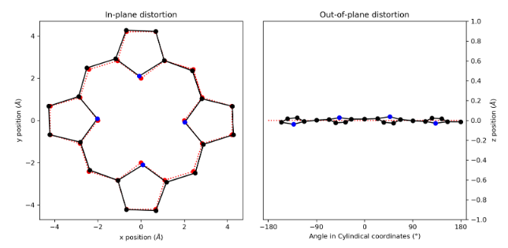
Figure 115: (a) in-plane and (b) out-of-plane skeletal plots of the porphyrin core.
Porphyrin is represented in black (C) and blue (N), with the reference structure (CuTPP) in red dotted lines.

NSD result generated from 1:2 (in Å)
basis | Δ_{ip} | δ_{ip} | B_{2g} | B_{1g} | E_{u}(x) | E_{u}(y) | A_{1g} | A_{2g}
min. | 0.14 | 0.00 | -0.06 | 0.00 | 0.00 | 0.00 | -0.12 | 0.00
ext. | 0.14 | 0.00 | -0.07 | 0.00 | 0.00 | 0.00 | -0.12 | 0.00
 |  |  | -0.02 | 0.00 | 0.00 | 0.00 | 0.00 | 0.00
total | 0.15 | 0.00 | -0.06 | 0.00 | 0.00 | 0.00 | -0.12 | 0.00
 |  |  | -0.02 | 0.00 | 0.00 | 0.00 | 0.00 | 0.00
 |  |  | -0.01 | 0.00 | 0.00 | 0.00 | -0.03 | 0.00
 |  |  | 0.01 | 0.00 | 0.00 | 0.00 | -0.01 | 0.00
 |  |  | 0.00 | 0.00 | 0.00 | 0.00 | 0.00 | 0.00
 |  |  | 0.00 | 0.00 | 0.00 | 0.00 | 0.00
 |  |  |  |  | 0.00 | 0.00
 |  |  |  |  | 0.00 | 0.00
 |  |  |  |  | 0.00 | 0.00
 |  |  |  |  | 0.00 | 0.00
 |  |  |  |  | 0.00 | 0.00
comp. | 0.15 | 0.00 | 0.07 | 0.00 | 0.00 | 0.00 | 0.13 | 0.00

basis | Δ_{oop} | δ_{oop} | B_{2u} | B_{1u} | A_{2u} | E_{g}(x) | E_{g}(y) | A_{1u}
min. | 0.57 | 0.00 | 0.00 | 0.57 | 0.01 | -0.01 | -0.01 | 0.00
ext. | 0.57 | 0.00 | 0.00 | 0.57 | 0.01 | -0.01 | -0.01 | 0.00
 |  |  | 0.00 | 0.00 | 0.00 | -0.01 | -0.01 | 0.00
total | 0.57 | 0.00 | 0.00 | 0.57 | 0.01 | -0.01 | -0.01 | 0.00
 |  |  | 0.00 | 0.00 | 0.00 | -0.01 | -0.01 | 0.00
 |  |  | 0.00 | 0.01 | 0.00 | 0.00 | 0.00
 |  |  |  |  |  | 0.00 | 0.00
 |  |  |  |  |  | 0.00 | 0.00
comp. | 0.57 | 0.00 | 0.00 | 0.57 | 0.01 | 0.02 | 0.02 | 0.00
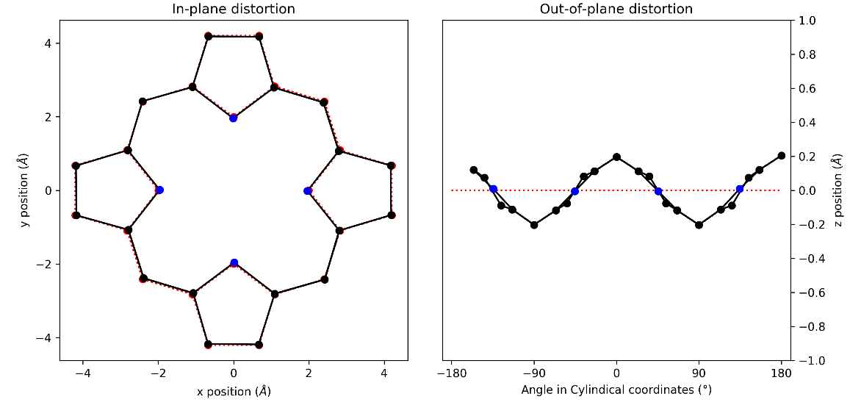
Figure 116: (a) in-plane and (b) out-of-plane skeletal plots of the porphyrin core.
Porphyrin is represented in black (C) and blue (N), with the reference structure (CuTPP) in red dotted lines.

NSD result generated from 1:3 (in Å)
basis | Δ_{ip} | δ_{ip} | B_{2g} | B_{1g} | E_{u}(x) | E_{u}(y) | A_{1g} | A_{2g}
min. | 0.37 | 0.00 | -0.31 | -0.04 | 0.00 | 0.00 | 0.21 | -0.01
ext. | 0.39 | 0.00 | -0.31 | -0.04 | 0.00 | 0.00 | 0.21 | -0.01
 |  |  | -0.05 | -0.09 | 0.01 | 0.01 | 0.01 | 0.00
total | 0.40 | 0.00 | -0.31 | -0.04 | 0.00 | 0.00 | 0.21 | -0.01
 |  |  | -0.05 | -0.09 | 0.01 | 0.01 | 0.01 | 0.00
 |  |  | -0.01 | -0.06 | 0.00 | 0.00 | 0.05 | 0.00
 |  |  | 0.00 | 0.00 | -0.01 | 0.02 | 0.01 | 0.00
 |  |  | 0.00 | 0.01 | 0.00 | -0.01 | 0.02 | 0.00
 |  |  | -0.01 | -0.01 | 0.00 | 0.00 | 0.01
 |  |  |  |  | 0.00 | 0.00
 |  |  |  |  | 0.00 | 0.00
 |  |  |  |  | 0.00 | 0.01
 |  |  |  |  | 0.00 | 0.00
 |  |  |  |  | -0.01 | 0.02
comp. | 0.40 | 0.00 | 0.31 | 0.11 | 0.02 | 0.03 | 0.22 | 0.01

basis | Δ_{oop} | δ_{oop} | B_{2u} | B_{1u} | A_{2u} | E_{g}(x) | E_{g}(y) | A_{1u}
min. | 0.09 | 0.00 | 0.00 | -0.01 | 0.00 | -0.06 | -0.06 | 0.00
ext. | 0.11 | 0.00 | 0.00 | -0.01 | 0.00 | -0.07 | -0.06 | 0.00
 |  |  | 0.00 | 0.00 | 0.00 | -0.05 | -0.03 | 0.00
total | 0.11 | 0.00 | 0.00 | -0.01 | 0.00 | -0.07 | -0.06 | 0.00
 |  |  | 0.00 | 0.00 | 0.00 | -0.05 | -0.03 | 0.00
 |  |  | 0.00 | 0.00 | 0.00 | 0.00 | 0.00
 |  |  |  |  |  | 0.00 | 0.00
 |  |  |  |  |  | 0.00 | 0.00
comp. | 0.11 | 0.00 | 0.00 | 0.01 | 0.00 | 0.08 | 0.07 | 0.00
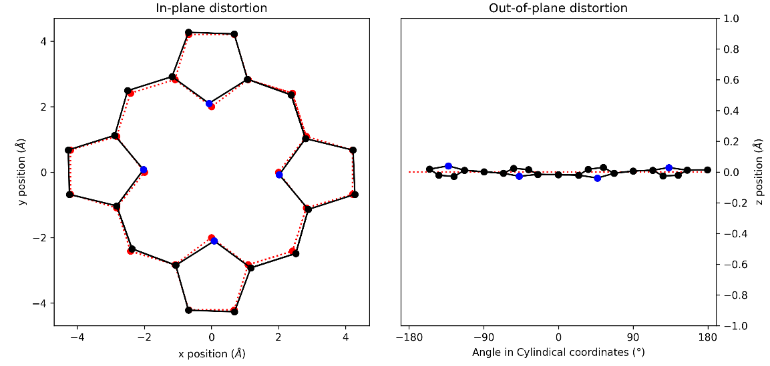
Figure 117: (a) in-plane and (b) out-of-plane skeletal plots of the porphyrin core.
Porphyrin is represented in black (C) and blue (N), with the reference structure (CuTPP) in red dotted lines.

NSD result generated from 1:4 (in Å)
basis | Δ_{ip} | δ_{ip} | B_{2g} | B_{1g} | E_{u}(x) | E_{u}(y) | A_{1g} | A_{2g}
min. | 0.14 | 0.00 | -0.07 | 0.00 | 0.00 | 0.00 | -0.13 | 0.00
ext. | 0.15 | 0.00 | -0.07 | 0.00 | 0.00 | 0.00 | -0.13 | 0.00
 |  |  | -0.02 | 0.00 | 0.00 | 0.00 | 0.01 | 0.00
total | 0.15 | 0.00 | -0.07 | 0.00 | 0.00 | 0.00 | -0.13 | 0.00
 |  |  | -0.02 | 0.00 | 0.00 | 0.00 | 0.01 | 0.00
 |  |  | -0.02 | 0.00 | 0.00 | 0.00 | -0.03 | 0.00
 |  |  | 0.01 | 0.00 | 0.01 | -0.01 | -0.01 | 0.00
 |  |  | 0.00 | 0.00 | 0.00 | 0.00 | 0.00 | 0.00
 |  |  | -0.01 | 0.00 | 0.00 | 0.00 | 0.00
 |  |  |  |  | 0.00 | 0.00
 |  |  |  |  | 0.00 | 0.00
 |  |  |  |  | 0.01 | 0.00
 |  |  |  |  | 0.00 | 0.00
 |  |  |  |  | 0.01 | -0.01
comp. | 0.15 | 0.00 | 0.08 | 0.00 | 0.02 | 0.02 | 0.13 | 0.00

basis | Δ_{oop} | δ_{oop} | B_{2u} | B_{1u} | A_{2u} | E_{g}(x) | E_{g}(y) | A_{1u}
min. | 0.61 | 0.00 | 0.00 | 0.61 | 0.01 | -0.02 | -0.02 | 0.00
ext. | 0.61 | 0.00 | 0.00 | 0.61 | 0.01 | -0.02 | -0.02 | 0.00
 |  |  | 0.00 | 0.00 | 0.00 | -0.01 | -0.01 | 0.00
total | 0.61 | 0.00 | 0.00 | 0.61 | 0.01 | -0.02 | -0.02 | 0.00
 |  |  | 0.00 | 0.00 | 0.00 | -0.01 | -0.01 | 0.00
 |  |  | 0.00 | 0.01 | 0.00 | 0.00 | 0.00
 |  |  |  |  |  | 0.00 | 0.00
 |  |  |  |  |  | 0.00 | 0.00
comp. | 0.61 | 0.00 | 0.00 | 0.61 | 0.01 | 0.02 | 0.02 | 0.00
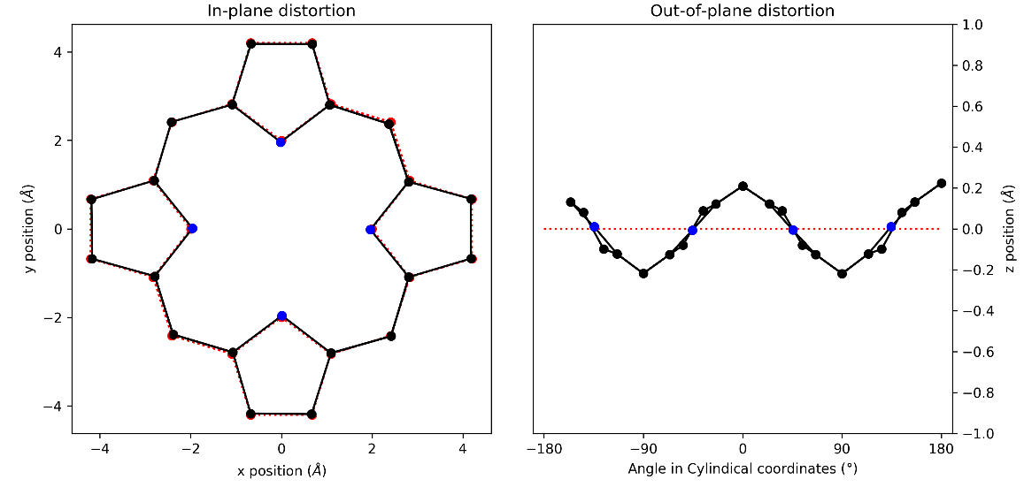
Figure 118: (a) in-plane and (b) out-of-plane skeletal plots of the porphyrin core.
Porphyrin is represented in black (C) and blue (N), with the reference structure (CuTPP) in red dotted lines.

NSD result generated from 1:5 (in Å)
basis | Δ_{ip} | δ_{ip} | B_{2g} | B_{1g} | E_{u}(x) | E_{u}(y) | A_{1g} | A_{2g}
min. | 0.37 | 0.00 | 0.31 | 0.03 | 0.00 | 0.00 | 0.21 | -0.01
ext. | 0.39 | 0.00 | 0.31 | 0.03 | 0.00 | 0.00 | 0.21 | -0.01
 |  |  | 0.05 | 0.08 | 0.00 | 0.00 | 0.02 | 0.01
total | 0.40 | 0.00 | 0.31 | 0.03 | 0.00 | 0.00 | 0.21 | -0.01
 |  |  | 0.05 | 0.09 | 0.00 | 0.00 | 0.02 | 0.01
 |  |  | 0.03 | 0.06 | 0.00 | 0.00 | 0.05 | 0.00
 |  |  | -0.01 | 0.00 | 0.00 | 0.00 | 0.00 | 0.00
 |  |  | 0.00 | -0.01 | 0.00 | 0.00 | 0.02 | 0.00
 |  |  | 0.01 | 0.01 | 0.00 | 0.00 | 0.00
 |  |  |  |  | 0.00 | 0.00
 |  |  |  |  | 0.00 | 0.00
 |  |  |  |  | 0.00 | 0.00
 |  |  |  |  | 0.00 | 0.00
 |  |  |  |  | 0.00 | 0.00
comp. | 0.40 | 0.00 | 0.32 | 0.11 | 0.00 | 0.00 | 0.22 | 0.01

basis | Δ_{oop} | δ_{oop} | B_{2u} | B_{1u} | A_{2u} | E_{g}(x) | E_{g}(y) | A_{1u}
min. | 0.09 | 0.00 | 0.00 | 0.00 | 0.00 | -0.06 | 0.07 | 0.00
ext. | 0.11 | 0.00 | 0.00 | 0.00 | 0.00 | -0.06 | 0.07 | 0.00
 |  |  | 0.00 | 0.00 | 0.00 | -0.03 | 0.05 | 0.00
total | 0.11 | 0.00 | 0.00 | 0.00 | 0.00 | -0.06 | 0.07 | 0.00
 |  |  | 0.00 | 0.00 | 0.00 | -0.03 | 0.05 | 0.00
 |  |  | 0.00 | 0.00 | 0.00 | 0.00 | 0.00
 |  |  |  |  |  | 0.00 | 0.00
 |  |  |  |  |  | 0.00 | 0.00
comp. | 0.11 | 0.00 | 0.00 | 0.00 | 0.00 | 0.07 | 0.09 | 0.00
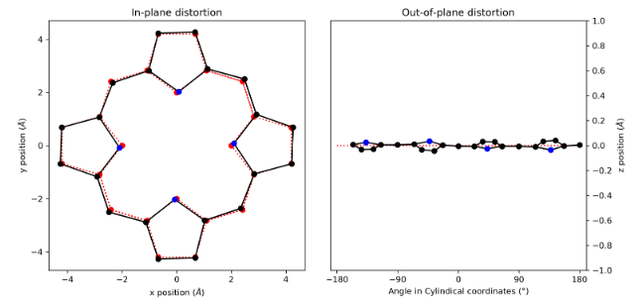
Figure 119: (a) in-plane and (b) out-of-plane skeletal plots of the porphyrin core.
Porphyrin is represented in black (C) and blue (N), with the reference structure (CuTPP) in red dotted lines.

NSD result generated from 1:6 (in Å)
basis | Δ_{ip} | δ_{ip} | B_{2g} | B_{1g} | E_{u}(x) | E_{u}(y) | A_{1g} | A_{2g}
min. | 0.15 | 0.00 | -0.08 | 0.00 | 0.00 | 0.00 | -0.12 | 0.00
ext. | 0.15 | 0.00 | -0.08 | 0.00 | 0.00 | 0.00 | -0.12 | 0.00
 |  |  | -0.02 | 0.00 | 0.00 | 0.00 | 0.02 | 0.00
total | 0.16 | 0.00 | -0.08 | 0.00 | 0.00 | 0.00 | -0.13 | 0.00
 |  |  | -0.02 | 0.00 | 0.00 | 0.00 | 0.02 | 0.00
 |  |  | -0.03 | 0.00 | 0.00 | 0.00 | -0.03 | 0.00
 |  |  | 0.02 | 0.00 | 0.00 | 0.00 | -0.01 | 0.00
 |  |  | 0.01 | 0.00 | 0.00 | 0.00 | -0.01 | 0.00
 |  |  | -0.01 | 0.00 | 0.00 | 0.00 | 0.00
 |  |  |  |  | 0.00 | 0.00
 |  |  |  |  | 0.00 | 0.00
 |  |  |  |  | 0.00 | 0.00
 |  |  |  |  | 0.00 | 0.00
 |  |  |  |  | 0.00 | 0.00
comp. | 0.16 | 0.00 | 0.09 | 0.00 | 0.00 | 0.00 | 0.13 | 0.00

basis | Δ_{oop} | δ_{oop} | B_{2u} | B_{1u} | A_{2u} | E_{g}(x) | E_{g}(y) | A_{1u}
min. | 0.59 | 0.00 | 0.00 | 0.59 | 0.01 | -0.02 | -0.02 | 0.00
ext. | 0.59 | 0.00 | 0.00 | 0.59 | 0.01 | -0.02 | -0.02 | 0.00
 |  |  | 0.00 | 0.00 | 0.00 | -0.01 | -0.01 | 0.00
total | 0.59 | 0.00 | 0.00 | 0.59 | 0.01 | -0.02 | -0.02 | 0.00
 |  |  | 0.00 | 0.00 | 0.00 | -0.01 | -0.01 | 0.00
 |  |  | 0.00 | 0.01 | 0.00 | 0.00 | 0.00
 |  |  |  |  |  | 0.00 | 0.00
 |  |  |  |  |  | 0.00 | 0.00
comp. | 0.59 | 0.00 | 0.00 | 0.59 | 0.01 | 0.02 | 0.02 | 0.00
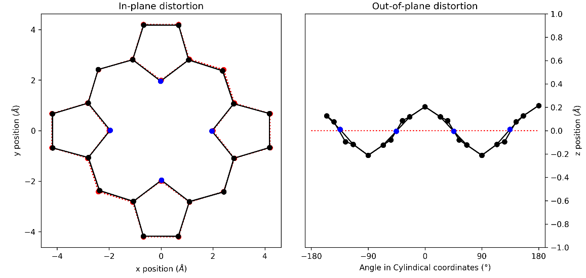
Figure 120: (a) in-plane and (b) out-of-plane skeletal plots of the porphyrin core.
Porphyrin is represented in black (C) and blue (N), with the reference structure (CuTPP) in red dotted lines.

NSD result generated from 1:7 (in Å)
basis | Δ_{ip} | δ_{ip} | B_{2g} | B_{1g} | E_{u}(x) | E_{u}(y) | A_{1g} | A_{2g}
min. | 0.26 | 0.00 | -0.13 | -0.04 | -0.02 | 0.02 | 0.22 | 0.00
ext. | 0.28 | 0.00 | -0.13 | -0.04 | -0.02 | 0.02 | 0.22 | 0.00
 |  |  | -0.01 | -0.09 | 0.01 | -0.02 | 0.00 | 0.00
total | 0.29 | 0.00 | -0.13 | -0.04 | -0.02 | 0.02 | 0.22 | 0.00
 |  |  | -0.01 | -0.09 | 0.01 | -0.02 | 0.00 | 0.00
 |  |  | -0.01 | -0.06 | 0.00 | 0.00 | 0.04 | 0.00
 |  |  | 0.01 | 0.00 | 0.01 | -0.01 | 0.00 | 0.00
 |  |  | 0.00 | 0.01 | 0.00 | 0.00 | 0.02 | 0.00
 |  |  | -0.01 | -0.01 | 0.00 | 0.00 | 0.01
 |  |  |  |  | 0.00 | 0.00
 |  |  |  |  | 0.00 | 0.00
 |  |  |  |  | 0.00 | 0.00
 |  |  |  |  | 0.00 | 0.00
 |  |  |  |  | 0.00 | 0.00
comp. | 0.29 | 0.00 | 0.14 | 0.12 | 0.02 | 0.03 | 0.23 | 0.00

basis | Δ_{oop} | δ_{oop} | B_{2u} | B_{1u} | A_{2u} | E_{g}(x) | E_{g}(y) | A_{1u}
min. | 0.08 | 0.00 | 0.00 | -0.01 | 0.00 | 0.06 | 0.05 | 0.00
ext. | 0.10 | 0.00 | 0.00 | -0.01 | 0.00 | 0.06 | 0.06 | 0.00
 |  |  | 0.00 | 0.00 | 0.00 | 0.04 | 0.02 | 0.00
total | 0.10 | 0.00 | 0.00 | -0.01 | 0.00 | 0.06 | 0.06 | 0.00
 |  |  | 0.00 | 0.00 | 0.00 | 0.04 | 0.02 | 0.00
 |  |  | 0.00 | 0.00 | 0.00 | 0.00 | 0.00
 |  |  |  |  |  | 0.00 | 0.00
 |  |  |  |  |  | 0.00 | 0.00
comp. | 0.10 | 0.00 | 0.00 | 0.01 | 0.00 | 0.08 | 0.06 | 0.00
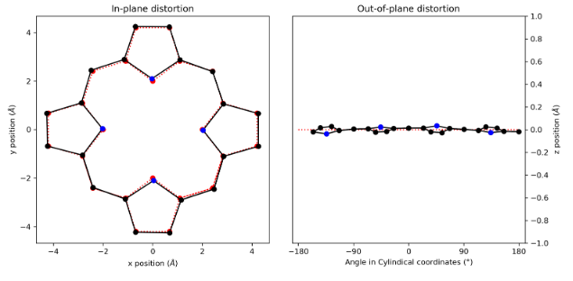
Figure 121: (a) in-plane and (b) out-of-plane skeletal plots of the porphyrin core.
Porphyrin is represented in black (C) and blue (N), with the reference structure (CuTPP) in red dotted lines.

NSD result generated from 1:8 (in Å)
basis | Δ_{ip} | δ_{ip} | B_{2g} | B_{1g} | E_{u}(x) | E_{u}(y) | A_{1g} | A_{2g}
min. | 0.19 | 0.00 | 0.04 | 0.00 | 0.02 | 0.02 | -0.18 | 0.00
ext. | 0.19 | 0.00 | 0.04 | 0.00 | 0.02 | 0.02 | -0.18 | 0.00
 |  |  | 0.00 | 0.00 | -0.01 | -0.01 | 0.04 | 0.00
total | 0.20 | 0.00 | 0.04 | 0.00 | 0.02 | 0.02 | -0.18 | 0.00
 |  |  | 0.00 | 0.00 | -0.01 | -0.01 | 0.04 | 0.00
 |  |  | 0.01 | 0.00 | -0.01 | 0.00 | -0.02 | 0.00
 |  |  | -0.01 | 0.00 | -0.01 | -0.01 | -0.03 | 0.00
 |  |  | 0.00 | 0.00 | 0.00 | 0.00 | 0.00 | 0.00
 |  |  | 0.00 | 0.00 | 0.00 | 0.00 | 0.01
 |  |  |  |  | 0.00 | 0.00
 |  |  |  |  | 0.00 | 0.00
 |  |  |  |  | 0.00 | 0.00
 |  |  |  |  | 0.00 | 0.00
 |  |  |  |  | 0.00 | 0.00
comp. | 0.20 | 0.00 | 0.04 | 0.00 | 0.03 | 0.03 | 0.19 | 0.00

basis | Δ_{oop} | δ_{oop} | B_{2u} | B_{1u} | A_{2u} | E_{g}(x) | E_{g}(y) | A_{1u}
min. | 0.99 | 0.00 | 0.00 | -0.99 | 0.01 | -0.01 | 0.01 | 0.00
ext. | 0.99 | 0.00 | 0.00 | -0.99 | 0.01 | -0.01 | 0.01 | 0.00
 |  |  | 0.00 | 0.00 | 0.00 | -0.02 | 0.02 | 0.00
total | 0.99 | 0.00 | 0.00 | -0.99 | 0.01 | -0.01 | 0.01 | 0.00
 |  |  | 0.00 | 0.00 | 0.00 | -0.02 | 0.02 | 0.00
 |  |  | 0.00 | -0.02 | 0.00 | 0.00 | 0.00
 |  |  |  |  |  | 0.00 | 0.00
 |  |  |  |  |  | 0.00 | 0.00
comp. | 0.99 | 0.00 | 0.00 | 0.99 | 0.01 | 0.02 | 0.02 | 0.00
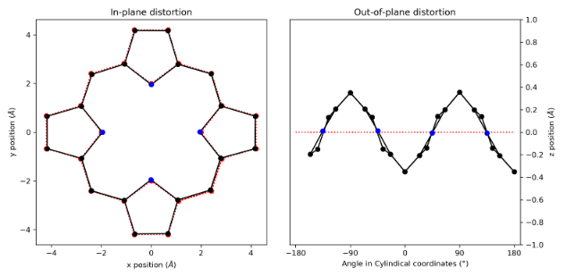
Figure 122: (a) in-plane and (b) out-of-plane skeletal plots of the porphyrin core.
Porphyrin is represented in black (C) and blue (N), with the reference structure (CuTPP) in red dotted lines.

NSD result generated from 1:9 (in Å)
basis | Δ_{ip} | δ_{ip} | B_{2g} | B_{1g} | E_{u}(x) | E_{u}(y) | A_{1g} | A_{2g}
min. | 0.23 | 0.00 | -0.03 | 0.02 | 0.00 | 0.00 | 0.23 | 0.00
ext. | 0.25 | 0.00 | -0.03 | 0.02 | 0.00 | 0.00 | 0.23 | 0.00
 |  |  | -0.02 | 0.09 | 0.00 | 0.00 | 0.01 | 0.00
total | 0.26 | 0.00 | -0.04 | 0.03 | 0.00 | 0.00 | 0.23 | 0.00
 |  |  | -0.02 | 0.09 | 0.00 | 0.00 | 0.01 | 0.00
 |  |  | 0.02 | 0.06 | 0.00 | 0.00 | 0.04 | 0.00
 |  |  | -0.01 | 0.00 | 0.00 | 0.00 | 0.00 | 0.00
 |  |  | 0.00 | -0.01 | 0.00 | 0.00 | 0.02 | 0.00
 |  |  | 0.00 | 0.01 | 0.00 | 0.00 | 0.01
 |  |  |  |  | 0.00 | 0.00
 |  |  |  |  | 0.00 | 0.00
 |  |  |  |  | 0.00 | 0.00
 |  |  |  |  | 0.00 | 0.00
 |  |  |  |  | 0.00 | 0.00
comp. | 0.26 | 0.00 | 0.05 | 0.11 | 0.00 | 0.00 | 0.24 | 0.00

basis | Δ_{oop} | δ_{oop} | B_{2u} | B_{1u} | A_{2u} | E_{g}(x) | E_{g}(y) | A_{1u}
min. | 0.07 | 0.00 | 0.00 | 0.00 | 0.00 | -0.04 | 0.05 | 0.00
ext. | 0.08 | 0.00 | 0.00 | 0.00 | 0.00 | -0.04 | 0.05 | 0.00
 |  |  | 0.00 | 0.00 | 0.00 | -0.02 | 0.03 | 0.00
total | 0.08 | 0.00 | 0.00 | 0.00 | 0.00 | -0.04 | 0.05 | 0.00
 |  |  | 0.00 | 0.00 | 0.00 | -0.02 | 0.03 | 0.00
 |  |  | 0.00 | 0.00 | 0.00 | 0.00 | 0.00
 |  |  |  |  |  | 0.00 | 0.00
 |  |  |  |  |  | 0.00 | 0.00
comp. | 0.08 | 0.00 | 0.00 | 0.00 | 0.00 | 0.05 | 0.06 | 0.00
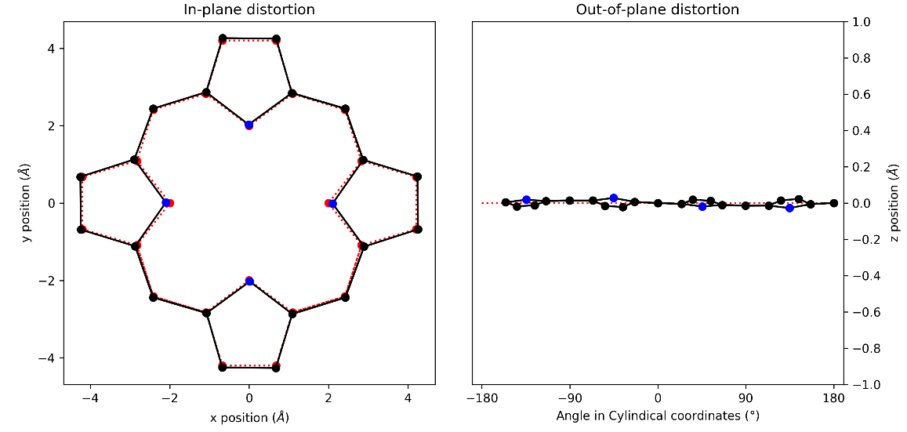
Figure 123: (a) in-plane and (b) out-of-plane skeletal plots of the porphyrin core.
Porphyrin is represented in black (C) and blue (N), with the reference structure (CuTPP) in red dotted lines.

NSD result generated from 1:10 (in Å)
basis | Δ_{ip} | δ_{ip} | B_{2g} | B_{1g} | E_{u}(x) | E_{u}(y) | A_{1g} | A_{2g}
min. | 0.24 | 0.00 | -0.01 | 0.00 | 0.00 | 0.00 | -0.24 | 0.00
ext. | 0.26 | 0.00 | -0.01 | 0.00 | 0.00 | 0.00 | -0.24 | 0.00
 |  |  | 0.01 | 0.00 | 0.00 | 0.00 | 0.09 | 0.00
total | 0.27 | 0.00 | -0.01 | 0.00 | 0.00 | 0.00 | -0.24 | 0.00
 |  |  | 0.01 | 0.00 | 0.00 | 0.00 | 0.09 | 0.00
 |  |  | -0.02 | 0.00 | 0.00 | 0.00 | -0.02 | 0.00
 |  |  | 0.01 | 0.00 | 0.00 | 0.00 | -0.05 | 0.00
 |  |  | 0.00 | 0.00 | 0.00 | 0.00 | 0.00 | 0.00
 |  |  | 0.00 | 0.00 | 0.00 | 0.00 | 0.02
 |  |  |  |  | 0.00 | 0.00
 |  |  |  |  | 0.00 | 0.00
 |  |  |  |  | 0.00 | 0.00
 |  |  |  |  | 0.00 | 0.00
 |  |  |  |  | 0.00 | 0.00
comp. | 0.27 | 0.00 | 0.03 | 0.00 | 0.01 | 0.01 | 0.26 | 0.00

basis | Δ_{oop} | δ_{oop} | B_{2u} | B_{1u} | A_{2u} | E_{g}(x) | E_{g}(y) | A_{1u}
min. | 1.28 | 0.00 | 0.00 | 1.28 | 0.02 | -0.02 | -0.02 | 0.00
ext. | 1.28 | 0.00 | 0.00 | 1.28 | 0.02 | -0.02 | -0.02 | 0.00
 |  |  | 0.00 | 0.00 | -0.01 | -0.01 | -0.01 | 0.00
total | 1.28 | 0.00 | 0.00 | 1.28 | 0.02 | -0.02 | -0.02 | 0.00
 |  |  | 0.00 | 0.00 | -0.01 | -0.01 | -0.01 | 0.00
 |  |  | 0.00 | 0.02 | 0.00 | 0.00 | 0.00
 |  |  |  |  |  | 0.00 | 0.00
 |  |  |  |  |  | 0.00 | 0.00
comp. | 1.28 | 0.00 | 0.00 | 1.28 | 0.03 | 0.02 | 0.02 | 0.00
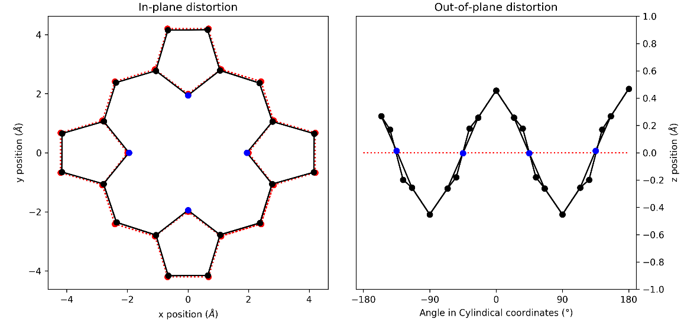
Figure 124: (a) in-plane and (b) out-of-plane skeletal plots of the porphyrin core.
Porphyrin is represented in black (C) and blue (N), with the reference structure (CuTPP) in red dotted lines.

NSD result generated from 1D (in Å)
basis | Δ_{ip} | δ_{ip} | B_{2g} | B_{1g} | E_{u}(x) | E_{u}(y) | A_{1g} | A_{2g}
min. | 0.24 | 0.00 | 0.09 | 0.04 | -0.02 | -0.03 | 0.22 | 0.00
ext. | 0.26 | 0.00 | 0.09 | 0.04 | -0.02 | -0.03 | 0.22 | 0.00
 |  |  | 0.00 | 0.09 | 0.03 | 0.01 | 0.00 | 0.00
total | 0.28 | 0.00 | 0.09 | 0.04 | -0.02 | -0.03 | 0.23 | 0.00
 |  |  | 0.00 | 0.09 | 0.03 | 0.01 | 0.00 | 0.00
 |  |  | 0.01 | 0.06 | 0.01 | 0.00 | 0.04 | 0.00
 |  |  | -0.01 | 0.00 | 0.01 | 0.01 | 0.00 | 0.00
 |  |  | 0.00 | -0.01 | 0.00 | 0.00 | 0.02 | 0.00
 |  |  | 0.01 | 0.01 | 0.00 | 0.00 | 0.01
 |  |  |  |  | 0.00 | 0.00
 |  |  |  |  | 0.00 | 0.00
 |  |  |  |  | 0.00 | 0.00
 |  |  |  |  | 0.00 | 0.00
 |  |  |  |  | 0.00 | 0.00
comp. | 0.28 | 0.00 | 0.09 | 0.11 | 0.04 | 0.03 | 0.23 | 0.00

basis | Δ_{oop} | δ_{oop} | B_{2u} | B_{1u} | A_{2u} | E_{g}(x) | E_{g}(y) | A_{1u}
min. | 0.08 | 0.00 | 0.00 | 0.01 | 0.00 | -0.05 | 0.06 | 0.00
ext. | 0.09 | 0.00 | 0.00 | 0.01 | 0.00 | -0.05 | 0.06 | 0.00
 |  |  | 0.00 | 0.00 | 0.00 | -0.02 | 0.04 | 0.00
total | 0.09 | 0.00 | 0.00 | 0.01 | 0.00 | -0.05 | 0.06 | 0.00
 |  |  | 0.00 | 0.00 | 0.00 | -0.02 | 0.04 | 0.00
 |  |  | 0.00 | 0.00 | 0.00 | 0.00 | 0.00
 |  |  |  |  |  | 0.00 | 0.00
 |  |  |  |  |  | 0.00 | 0.00
comp. | 0.09 | 0.00 | 0.00 | 0.01 | 0.00 | 0.06 | 0.07 | 0.00
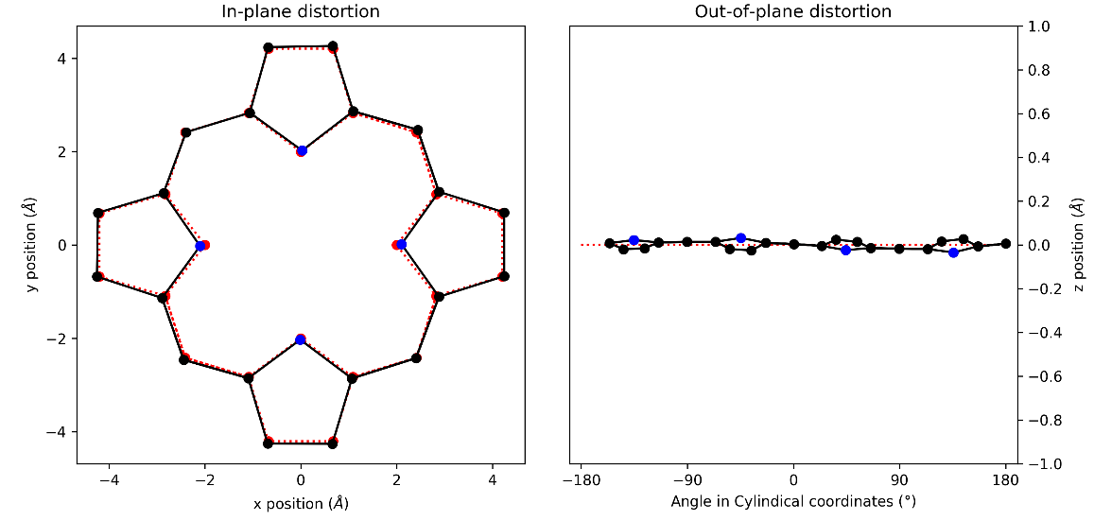
Figure 125: (a) in-plane and (b) out-of-plane skeletal plots of the porphyrin core.
Porphyrin is represented in black (C) and blue (N), with the reference structure (CuTPP) in red dotted lines.

NSD result generated from 2D (in Å)
basis | Δ_{ip} | δ_{ip} | B_{2g} | B_{1g} | E_{u}(x) | E_{u}(y) | A_{1g} | A_{2g}
min. | 0.20 | 0.00 | -0.03 | 0.00 | 0.02 | -0.02 | -0.20 | 0.00
ext. | 0.21 | 0.00 | -0.03 | 0.00 | 0.02 | -0.02 | -0.20 | 0.00
 |  |  | 0.00 | 0.00 | -0.01 | 0.01 | 0.06 | 0.00
total | 0.22 | 0.00 | -0.03 | 0.00 | 0.02 | -0.02 | -0.20 | 0.00
 |  |  | 0.00 | 0.00 | -0.01 | 0.01 | 0.06 | 0.00
 |  |  | -0.02 | 0.00 | 0.00 | 0.00 | -0.02 | 0.00
 |  |  | 0.01 | 0.00 | -0.01 | 0.01 | -0.04 | 0.00
 |  |  | 0.00 | 0.00 | 0.00 | 0.00 | 0.00 | 0.00
 |  |  | -0.01 | 0.00 | 0.00 | 0.00 | 0.02
 |  |  |  |  | 0.00 | 0.00
 |  |  |  |  | 0.00 | 0.00
 |  |  |  |  | 0.00 | 0.00
 |  |  |  |  | 0.00 | 0.00
 |  |  |  |  | 0.00 | 0.00
comp. | 0.22 | 0.00 | 0.03 | 0.00 | 0.02 | 0.02 | 0.21 | 0.00

basis | Δ_{oop} | δ_{oop} | B_{2u} | B_{1u} | A_{2u} | E_{g}(x) | E_{g}(y) | A_{1u}
min. | 1.09 | 0.00 | 0.00 | -1.09 | -0.02 | 0.03 | 0.03 | 0.00
ext. | 1.09 | 0.00 | 0.00 | -1.09 | -0.02 | 0.03 | 0.03 | 0.00
 |  |  | 0.00 | 0.00 | 0.01 | 0.00 | 0.00 | 0.00
total | 1.09 | 0.00 | 0.00 | -1.09 | -0.02 | 0.03 | 0.03 | 0.00
 |  |  | 0.00 | 0.00 | 0.01 | 0.00 | 0.00 | 0.00
 |  |  | 0.00 | -0.02 | 0.00 | 0.00 | 0.00
 |  |  |  |  |  | 0.00 | 0.00
 |  |  |  |  |  | 0.00 | 0.00
comp. | 1.09 | 0.00 | 0.00 | 1.09 | 0.02 | 0.03 | 0.03 | 0.00
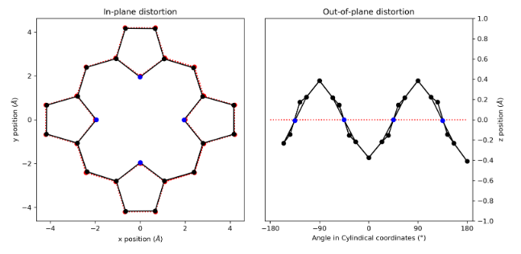
Figure 126: (a) in-plane and (b) out-of-plane skeletal plots of the porphyrin core.
Porphyrin is represented in black (C) and blue (N), with the reference structure (CuTPP) in red dotted lines.

NSD result generated from 1:11 (in Å)
basis | Δ_{ip} | δ_{ip} | B_{2g} | B_{1g} | E_{u}(x) | E_{u}(y) | A_{1g} | A_{2g}
min. | 0.26 | 0.00 | -0.11 | 0.02 | 0.00 | 0.00 | 0.23 | 0.00
ext. | 0.28 | 0.00 | -0.11 | 0.02 | 0.00 | 0.00 | 0.23 | 0.00
 |  |  | -0.04 | 0.08 | 0.00 | 0.00 | 0.01 | 0.00
total | 0.29 | 0.00 | -0.11 | 0.03 | 0.00 | 0.00 | 0.24 | 0.00
 |  |  | -0.04 | 0.09 | 0.00 | 0.00 | 0.01 | 0.00
 |  |  | 0.02 | 0.06 | 0.00 | 0.00 | 0.04 | 0.00
 |  |  | -0.02 | 0.00 | 0.00 | 0.00 | 0.00 | 0.00
 |  |  | -0.01 | -0.01 | 0.00 | 0.00 | 0.02 | 0.00
 |  |  | 0.00 | 0.01 | 0.00 | 0.00 | 0.01
 |  |  |  |  | 0.00 | 0.00
 |  |  |  |  | 0.00 | 0.00
 |  |  |  |  | 0.00 | 0.00
 |  |  |  |  | 0.00 | 0.00
 |  |  |  |  | 0.00 | 0.00
comp. | 0.29 | 0.00 | 0.13 | 0.11 | 0.00 | 0.00 | 0.24 | 0.00

basis | Δ_{oop} | δ_{oop} | B_{2u} | B_{1u} | A_{2u} | E_{g}(x) | E_{g}(y) | A_{1u}
min. | 0.05 | 0.00 | 0.00 | 0.00 | 0.00 | -0.03 | 0.04 | 0.00
ext. | 0.06 | 0.00 | 0.00 | 0.00 | 0.00 | -0.03 | 0.04 | 0.00
 |  |  | 0.00 | 0.00 | 0.00 | -0.01 | 0.02 | 0.00
total | 0.06 | 0.00 | 0.00 | 0.00 | 0.00 | -0.03 | 0.04 | 0.00
 |  |  | 0.00 | 0.00 | 0.00 | -0.01 | 0.02 | 0.00
 |  |  | 0.00 | 0.00 | 0.00 | 0.00 | 0.00
 |  |  |  |  |  | 0.00 | 0.00
 |  |  |  |  |  | 0.00 | 0.00
comp. | 0.06 | 0.00 | 0.00 | 0.00 | 0.00 | 0.04 | 0.04 | 0.00
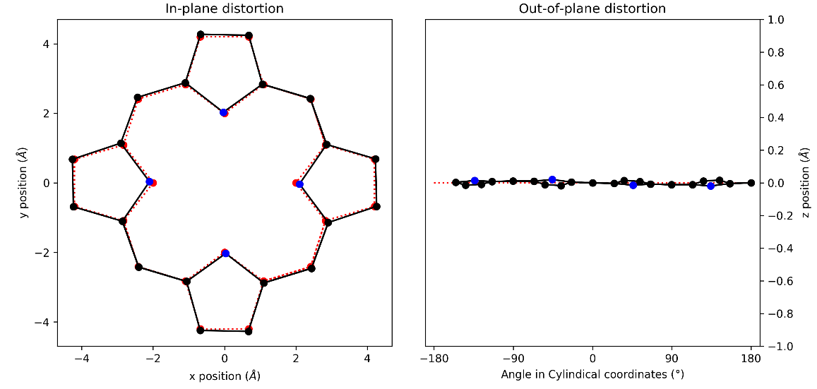
Figure 127: (a) in-plane and (b) out-of-plane skeletal plots of the porphyrin core.
Porphyrin is represented in black (C) and blue (N), with the reference structure (CuTPP) in red dotted lines.

NSD result generated from 1:12 (in Å)
basis | Δ_{ip} | δ_{ip} | B_{2g} | B_{1g} | E_{u}(x) | E_{u}(y) | A_{1g} | A_{2g}
min. | 0.27 | 0.00 | 0.00 | 0.00 | 0.01 | 0.00 | -0.27 | 0.00
ext. | 0.29 | 0.00 | 0.00 | 0.00 | 0.01 | 0.00 | -0.27 | 0.00
 |  |  | -0.02 | 0.00 | -0.01 | -0.01 | 0.11 | 0.00
total | 0.30 | 0.00 | 0.00 | 0.00 | 0.01 | 0.00 | -0.27 | 0.00
 |  |  | -0.02 | 0.00 | -0.01 | -0.01 | 0.11 | 0.00
 |  |  | 0.02 | 0.00 | 0.00 | 0.00 | -0.01 | 0.00
 |  |  | -0.01 | 0.00 | 0.00 | 0.00 | -0.07 | 0.00
 |  |  | 0.00 | 0.00 | 0.00 | 0.00 | 0.00 | 0.00
 |  |  | 0.01 | 0.00 | 0.00 | 0.00 | 0.03
 |  |  |  |  | 0.00 | 0.00
 |  |  |  |  | 0.00 | 0.00
 |  |  |  |  | 0.00 | 0.00
 |  |  |  |  | 0.00 | 0.00
 |  |  |  |  | 0.00 | 0.00
comp. | 0.30 | 0.00 | 0.04 | 0.00 | 0.01 | 0.01 | 0.30 | 0.00

basis | Δ_{oop} | δ_{oop} | B_{2u} | B_{1u} | A_{2u} | E_{g}(x) | E_{g}(y) | A_{1u}
min. | 1.41 | 0.00 | 0.00 | -1.41 | 0.03 | -0.02 | 0.02 | 0.00
ext. | 1.41 | 0.00 | 0.00 | -1.41 | 0.03 | -0.02 | 0.02 | 0.00
 |  |  | 0.00 | 0.00 | -0.02 | -0.01 | 0.01 | 0.00
total | 1.41 | 0.00 | 0.00 | -1.41 | 0.03 | -0.02 | 0.02 | 0.00
 |  |  | 0.00 | 0.00 | -0.02 | -0.01 | 0.01 | 0.00
 |  |  | 0.00 | -0.02 | 0.00 | 0.00 | 0.00
 |  |  |  |  |  | 0.00 | 0.00
 |  |  |  |  |  | 0.00 | 0.00
comp. | 1.41 | 0.00 | 0.00 | 1.41 | 0.03 | 0.02 | 0.02 | 0.00
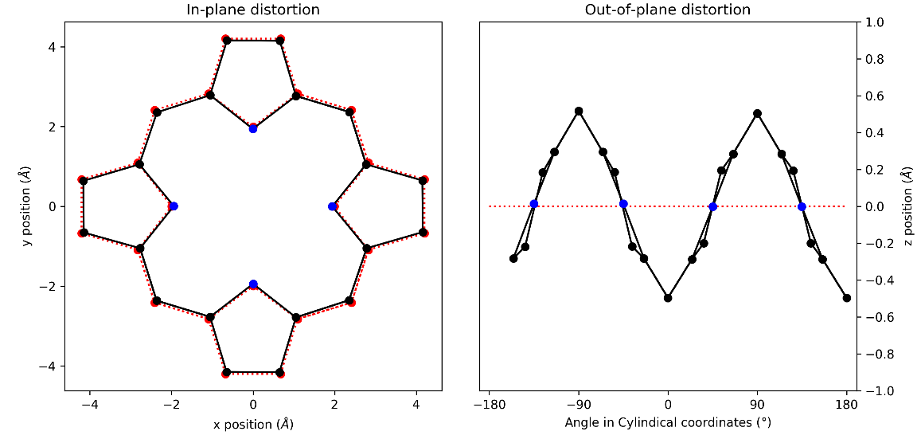
Figure 128: (a) in-plane and (b) out-of-plane skeletal plots of the porphyrin core.
Porphyrin is represented in black (C) and blue (N), with the reference structure (CuTPP) in red dotted lines.

NSD result generated from 3D (in Å)
basis | Δ_{ip} | δ_{ip} | B_{2g} | B_{1g} | E_{u}(x) | E_{u}(y) | A_{1g} | A_{2g}
min. | 0.23 | 0.00 | -0.02 | -0.04 | 0.03 | -0.03 | 0.23 | 0.00
ext. | 0.25 | 0.00 | -0.02 | -0.04 | 0.03 | -0.03 | 0.23 | 0.00
 |  |  | 0.01 | -0.09 | -0.02 | 0.03 | 0.00 | 0.00
total | 0.27 | 0.00 | -0.02 | -0.04 | 0.03 | -0.03 | 0.23 | 0.00
 |  |  | 0.01 | -0.09 | -0.02 | 0.03 | 0.00 | 0.00
 |  |  | -0.01 | -0.06 | 0.00 | 0.01 | 0.04 | 0.00
 |  |  | 0.01 | 0.00 | 0.00 | 0.00 | 0.00 | 0.00
 |  |  | 0.00 | 0.01 | 0.00 | 0.00 | 0.02 | 0.00
 |  |  | -0.01 | -0.01 | 0.00 | 0.00 | 0.01
 |  |  |  |  | 0.00 | 0.00
 |  |  |  |  | 0.00 | 0.00
 |  |  |  |  | 0.00 | 0.00
 |  |  |  |  | 0.00 | 0.00
 |  |  |  |  | 0.00 | 0.00
comp. | 0.27 | 0.00 | 0.03 | 0.12 | 0.04 | 0.04 | 0.23 | 0.00

basis | Δ_{oop} | δ_{oop} | B_{2u} | B_{1u} | A_{2u} | E_{g}(x) | E_{g}(y) | A_{1u}
min. | 0.07 | 0.00 | 0.00 | -0.01 | 0.00 | -0.06 | -0.05 | 0.00
ext. | 0.09 | 0.00 | 0.00 | -0.01 | 0.00 | -0.06 | -0.05 | 0.00
 |  |  | 0.00 | 0.00 | 0.00 | -0.04 | -0.02 | 0.00
total | 0.09 | 0.00 | 0.00 | -0.01 | 0.00 | -0.06 | -0.05 | 0.00
 |  |  | 0.00 | 0.00 | 0.00 | -0.04 | -0.02 | 0.00
 |  |  | 0.00 | 0.00 | 0.00 | 0.00 | 0.00
 |  |  |  |  |  | 0.00 | 0.00
 |  |  |  |  |  | 0.00 | 0.00
comp. | 0.09 | 0.00 | 0.00 | 0.01 | 0.00 | 0.07 | 0.05 | 0.00
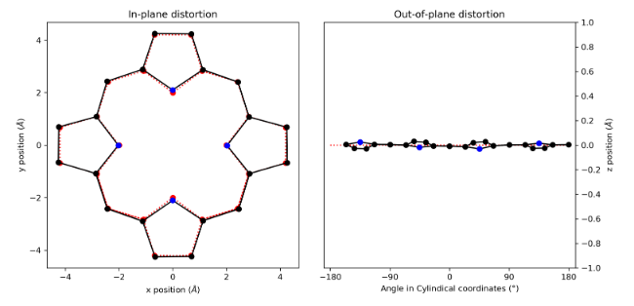
Figure 129: (a) in-plane and (b) out-of-plane skeletal plots of the porphyrin core.
Porphyrin is represented in black (C) and blue (N), with the reference structure (CuTPP) in red dotted lines.

NSD result generated from 1:13 (in Å)
basis | Δ_{ip} | δ_{ip} | B_{2g} | B_{1g} | E_{u}(x) | E_{u}(y) | A_{1g} | A_{2g}
min. | 0.24 | 0.00 | -0.02 | 0.00 | -0.02 | 0.02 | -0.24 | 0.00
ext. | 0.26 | 0.00 | -0.02 | 0.00 | -0.02 | 0.02 | -0.24 | 0.00
 |  |  | 0.01 | 0.00 | 0.02 | -0.02 | 0.08 | 0.00
total | 0.26 | 0.00 | -0.02 | 0.00 | -0.02 | 0.02 | -0.24 | 0.00
 |  |  | 0.01 | 0.00 | 0.02 | -0.02 | 0.08 | 0.00
 |  |  | -0.01 | 0.00 | 0.01 | -0.01 | -0.02 | 0.00
 |  |  | 0.01 | 0.00 | 0.01 | -0.01 | -0.05 | 0.00
 |  |  | 0.00 | 0.00 | 0.00 | 0.00 | 0.00 | 0.00
 |  |  | -0.01 | 0.00 | 0.00 | 0.00 | 0.02
 |  |  |  |  | 0.00 | 0.00
 |  |  |  |  | 0.00 | 0.00
 |  |  |  |  | 0.00 | 0.00
 |  |  |  |  | 0.00 | 0.00
 |  |  |  |  | 0.00 | 0.00
comp. | 0.26 | 0.00 | 0.02 | 0.00 | 0.04 | 0.03 | 0.26 | 0.00

basis | Δ_{oop} | δ_{oop} | B_{2u} | B_{1u} | A_{2u} | E_{g}(x) | E_{g}(y) | A_{1u}
min. | 1.26 | 0.00 | 0.00 | 1.26 | 0.03 | 0.00 | 0.00 | 0.00
ext. | 1.27 | 0.00 | 0.00 | 1.26 | 0.03 | 0.00 | 0.00 | 0.00
 |  |  | 0.00 | 0.00 | -0.01 | -0.03 | -0.03 | 0.00
total | 1.27 | 0.00 | 0.00 | 1.26 | 0.03 | 0.00 | 0.00 | 0.00
 |  |  | 0.00 | 0.00 | -0.01 | -0.03 | -0.03 | 0.00
 |  |  | 0.00 | 0.02 | 0.00 | 0.00 | -0.01
 |  |  |  |  |  | 0.00 | 0.00
 |  |  |  |  |  | 0.00 | 0.00
comp. | 1.27 | 0.00 | 0.00 | 1.26 | 0.03 | 0.03 | 0.03 | 0.00
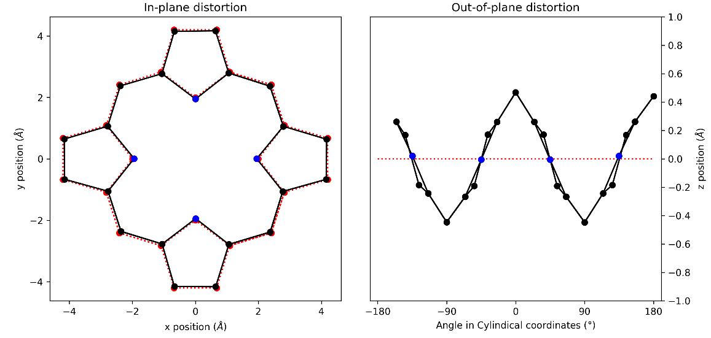
Figure 130: (a) in-plane and (b) out-of-plane skeletal plots of the porphyrin core.
Porphyrin is represented in black (C) and blue (N), with the reference structure (CuTPP) in red dotted lines.

NSD result generated from 1:14 (in Å)
basis | Δ_{ip} | δ_{ip} | B_{2g} | B_{1g} | E_{u}(x) | E_{u}(y) | A_{1g} | A_{2g}
min. | 0.33 | 0.00 | -0.22 | 0.02 | 0.00 | 0.00 | 0.24 | 0.00
ext. | 0.35 | 0.00 | -0.22 | 0.02 | 0.00 | 0.00 | 0.24 | 0.00
 |  |  | -0.07 | 0.08 | 0.00 | 0.00 | 0.00 | 0.00
total | 0.36 | 0.00 | -0.22 | 0.02 | 0.00 | 0.00 | 0.25 | 0.00
 |  |  | -0.07 | 0.09 | 0.00 | 0.00 | 0.00 | 0.00
 |  |  | 0.02 | 0.06 | 0.00 | 0.00 | 0.04 | 0.00
 |  |  | -0.02 | 0.00 | 0.00 | 0.00 | 0.00 | 0.00
 |  |  | -0.01 | -0.01 | 0.00 | 0.00 | 0.02 | 0.00
 |  |  | 0.00 | 0.01 | 0.00 | 0.00 | 0.01
 |  |  |  |  | 0.00 | 0.00
 |  |  |  |  | 0.00 | 0.00
 |  |  |  |  | 0.00 | 0.00
 |  |  |  |  | 0.00 | 0.00
 |  |  |  |  | 0.00 | 0.00
comp. | 0.36 | 0.00 | 0.24 | 0.11 | 0.00 | 0.00 | 0.25 | 0.01

basis | Δ_{oop} | δ_{oop} | B_{2u} | B_{1u} | A_{2u} | E_{g}(x) | E_{g}(y) | A_{1u}
min. | 0.02 | 0.00 | 0.00 | 0.00 | 0.00 | -0.01 | 0.01 | 0.00
ext. | 0.02 | 0.00 | 0.00 | 0.00 | 0.00 | -0.01 | 0.01 | 0.00
 |  |  | 0.00 | 0.00 | 0.00 | 0.00 | 0.01 | 0.00
total | 0.02 | 0.00 | 0.00 | 0.00 | 0.00 | -0.01 | 0.01 | 0.00
 |  |  | 0.00 | 0.00 | 0.00 | 0.00 | 0.01 | 0.00
 |  |  | 0.00 | 0.00 | 0.00 | 0.00 | 0.00
 |  |  |  |  |  | 0.00 | 0.00
 |  |  |  |  |  | 0.00 | 0.00
comp. | 0.02 | 0.00 | 0.00 | 0.00 | 0.00 | 0.01 | 0.01 | 0.00
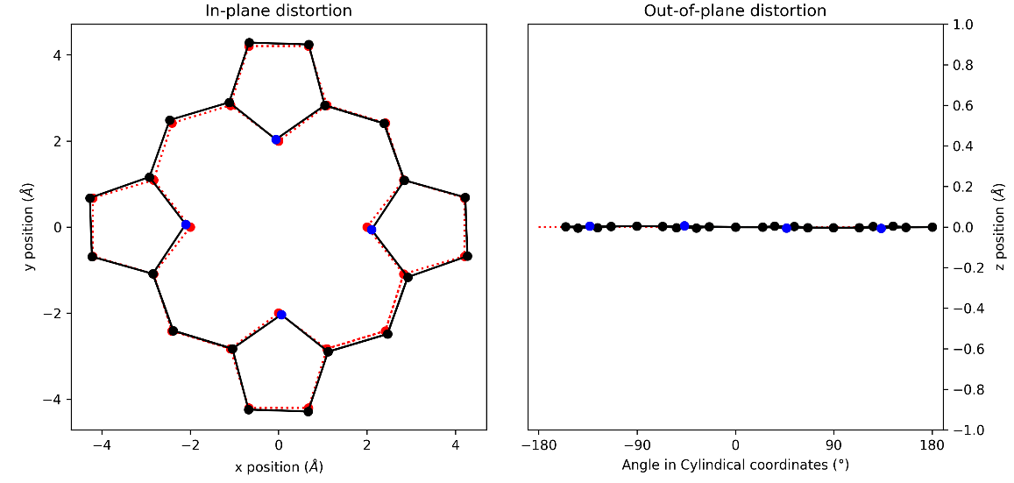
Figure 131: (a) in-plane and (b) out-of-plane skeletal plots of the porphyrin core.
Porphyrin is represented in black (C) and blue (N), with the reference structure (CuTPP) in red dotted lines.

NSD result generated from 1:15 (in Å)
basis | Δ_{ip} | δ_{ip} | B_{2g} | B_{1g} | E_{u}(x) | E_{u}(y) | A_{1g} | A_{2g}
min. | 0.31 | 0.01 | -0.02 | 0.00 | 0.01 | 0.01 | -0.31 | 0.00
ext. | 0.34 | 0.00 | -0.02 | 0.00 | 0.01 | 0.01 | -0.31 | 0.00
 |  |  | -0.03 | 0.00 | -0.01 | -0.01 | 0.13 | 0.00
total | 0.35 | 0.00 | -0.02 | 0.00 | 0.01 | 0.01 | -0.31 | 0.00
 |  |  | -0.03 | 0.00 | -0.01 | -0.01 | 0.13 | 0.00
 |  |  | 0.02 | 0.00 | 0.00 | 0.00 | -0.01 | 0.00
 |  |  | -0.01 | 0.00 | 0.00 | 0.00 | -0.08 | 0.00
 |  |  | 0.00 | 0.00 | 0.00 | 0.00 | 0.00 | 0.00
 |  |  | 0.01 | 0.00 | 0.00 | 0.00 | 0.04
 |  |  |  |  | 0.00 | 0.00
 |  |  |  |  | 0.00 | 0.00
 |  |  |  |  | 0.00 | 0.00
 |  |  |  |  | 0.00 | 0.00
 |  |  |  |  | 0.00 | 0.00
comp. | 0.35 | 0.00 | 0.05 | 0.00 | 0.01 | 0.01 | 0.35 | 0.00

basis | Δ_{oop} | δ_{oop} | B_{2u} | B_{1u} | A_{2u} | E_{g}(x) | E_{g}(y) | A_{1u}
min. | 1.56 | 0.00 | 0.00 | -1.55 | 0.04 | -0.02 | 0.02 | 0.00
ext. | 1.56 | 0.00 | 0.00 | -1.55 | 0.04 | -0.02 | 0.02 | 0.00
 |  |  | 0.00 | 0.00 | -0.03 | -0.01 | 0.01 | 0.00
total | 1.56 | 0.00 | 0.00 | -1.55 | 0.04 | -0.02 | 0.02 | 0.00
 |  |  | 0.00 | 0.00 | -0.03 | -0.01 | 0.01 | 0.00
 |  |  | 0.00 | -0.03 | 0.00 | 0.00 | 0.00
 |  |  |  |  |  | 0.00 | 0.00
 |  |  |  |  |  | 0.00 | 0.00
comp. | 1.56 | 0.00 | 0.00 | 1.56 | 0.05 | 0.02 | 0.02 | 0.00
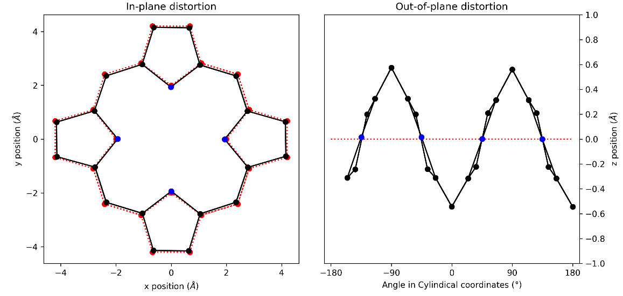
Figure 132: (a) in-plane and (b) out-of-plane skeletal plots of the porphyrin core.
Porphyrin is represented in black (C) and blue (N), with the reference structure (CuTPP) in red dotted lines.

NSD tables and plots for DFT structures series 2

NSD result generated from 2:1 (in Å)
basis | Δ_{ip} | δ_{ip} | B_{2g} | B_{1g} | E_{u}(x) | E_{u}(y) | A_{1g} | A_{2g}
min. | 0.28 | 0.00 | -0.18 | 0.06 | 0.00 | -0.01 | 0.21 | 0.00
ext. | 0.30 | 0.00 | -0.18 | 0.06 | 0.00 | -0.01 | 0.21 | 0.00
 |  |  | -0.03 | 0.09 | 0.02 | 0.01 | 0.01 | 0.00
total | 0.31 | 0.00 | -0.18 | 0.06 | 0.00 | -0.01 | 0.21 | 0.00
 |  |  | -0.03 | 0.09 | 0.02 | 0.01 | 0.01 | 0.00
 |  |  | 0.00 | 0.06 | 0.00 | 0.00 | 0.05 | 0.00
 |  |  | 0.00 | 0.00 | 0.00 | 0.00 | 0.01 | 0.00
 |  |  | 0.00 | -0.01 | 0.00 | 0.00 | 0.02 | 0.00
 |  |  | 0.00 | 0.01 | 0.00 | 0.00 | 0.01
 |  |  |  |  | 0.00 | 0.00
 |  |  |  |  | 0.00 | 0.00
 |  |  |  |  | 0.00 | 0.00
 |  |  |  |  | 0.00 | 0.00
 |  |  |  |  | 0.00 | 0.00
comp. | 0.31 | 0.00 | 0.18 | 0.13 | 0.02 | 0.02 | 0.22 | 0.00

basis | Δ_{oop} | δ_{oop} | B_{2u} | B_{1u} | A_{2u} | E_{g}(x) | E_{g}(y) | A_{1u}
min. | 0.07 | 0.00 | -0.06 | -0.01 | 0.00 | -0.03 | -0.03 | 0.00
ext. | 0.08 | 0.00 | -0.05 | -0.01 | 0.00 | -0.03 | -0.03 | 0.00
 |  |  | 0.02 | 0.00 | 0.00 | -0.01 | -0.02 | 0.00
total | 0.08 | 0.00 | -0.05 | -0.01 | 0.00 | -0.03 | -0.03 | 0.00
 |  |  | 0.02 | 0.00 | 0.00 | -0.01 | -0.02 | 0.00
 |  |  | 0.00 | 0.00 | 0.00 | 0.00 | 0.00
 |  |  |  |  |  | 0.00 | 0.00
 |  |  |  |  |  | 0.00 | 0.00
comp. | 0.08 | 0.00 | 0.06 | 0.01 | 0.00 | 0.03 | 0.04 | 0.00
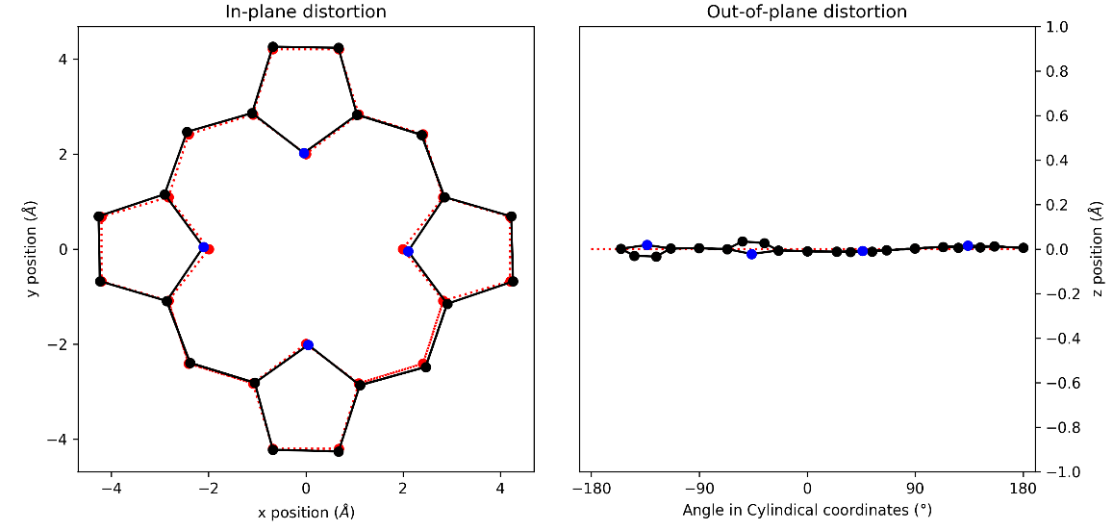
Figure 133: (a) in-plane and (b) out-of-plane skeletal plots of the porphyrin core. Porphyrin is represented in black (C) and blue (N), with the reference structure (CuTPP) in red dotted lines.

NSD result generated from 2:2 (in Å)
basis | Δ_{ip} | δ_{ip} | B_{2g} | B_{1g} | E_{u}(x) | E_{u}(y) | A_{1g} | A_{2g}
min. | 0.24 | 0.00 | 0.06 | 0.04 | 0.02 | -0.03 | 0.22 | 0.00
ext. | 0.25 | 0.00 | 0.07 | 0.04 | 0.02 | -0.03 | 0.22 | 0.00
 |  |  | 0.02 | 0.09 | 0.00 | 0.03 | 0.01 | 0.00
total | 0.27 | 0.00 | 0.07 | 0.05 | 0.01 | -0.03 | 0.22 | 0.00
 |  |  | 0.02 | 0.09 | 0.00 | 0.03 | 0.01 | 0.00
 |  |  | -0.01 | 0.06 | -0.01 | 0.00 | 0.05 | 0.00
 |  |  | 0.01 | 0.00 | -0.01 | 0.00 | 0.01 | 0.00
 |  |  | 0.00 | -0.01 | 0.00 | 0.00 | 0.02 | 0.00
 |  |  | 0.00 | 0.01 | 0.00 | 0.00 | 0.01
 |  |  |  |  | 0.00 | 0.00
 |  |  |  |  | 0.00 | 0.00
 |  |  |  |  | 0.00 | 0.00
 |  |  |  |  | 0.00 | 0.00
 |  |  |  |  | 0.00 | 0.00
comp. | 0.27 | 0.00 | 0.07 | 0.12 | 0.02 | 0.04 | 0.23 | 0.00

basis | Δ_{oop} | δ_{oop} | B_{2u} | B_{1u} | A_{2u} | E_{g}(x) | E_{g}(y) | A_{1u}
min. | 0.06 | 0.00 | -0.05 | 0.00 | 0.00 | -0.02 | -0.02 | 0.00
ext. | 0.07 | 0.00 | -0.05 | 0.00 | 0.00 | -0.03 | -0.02 | 0.00
 |  |  | 0.02 | 0.00 | 0.00 | -0.01 | -0.02 | 0.00
total | 0.07 | 0.00 | -0.05 | 0.00 | 0.00 | -0.03 | -0.02 | 0.00
 |  |  | 0.02 | 0.00 | 0.00 | -0.01 | -0.02 | 0.00
 |  |  | 0.00 | 0.00 | 0.00 | 0.00 | 0.00
 |  |  |  |  |  | 0.00 | 0.00
 |  |  |  |  |  | 0.00 | 0.00
comp. | 0.07 | 0.00 | 0.06 | 0.00 | 0.00 | 0.03 | 0.03 | 0.00
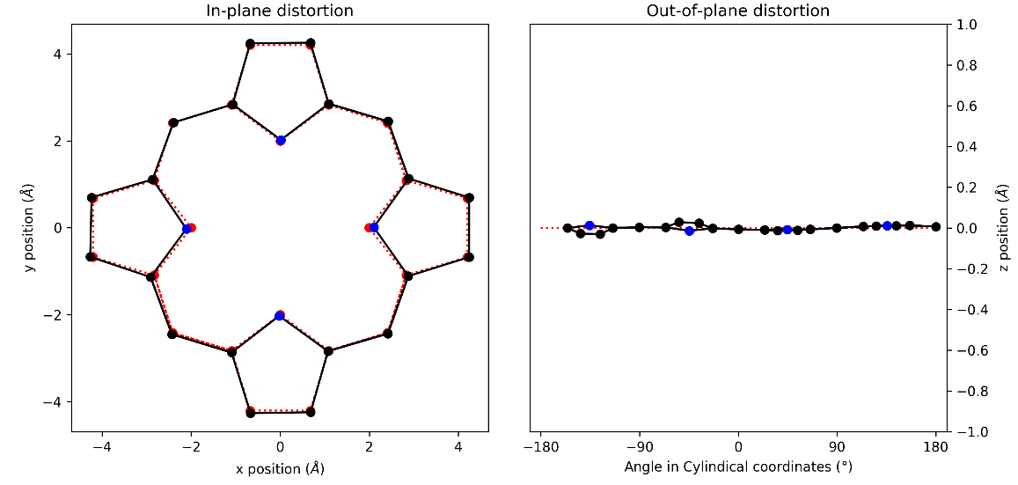
Figure 134: (a) in-plane and (b) out-of-plane skeletal plots of the porphyrin core. Porphyrin is represented in black (C) and blue (N), with the reference structure (CuTPP) in red dotted lines.

NSD result generated from 2:3 (in Å)
basis | Δ_{ip} | δ_{ip} | B_{2g} | B_{1g} | E_{u}(x) | E_{u}(y) | A_{1g} | A_{2g}
min. | 0.28 | 0.00 | -0.14 | 0.03 | 0.04 | -0.01 | 0.23 | 0.00
ext. | 0.29 | 0.00 | -0.14 | 0.03 | 0.04 | -0.01 | 0.23 | 0.00
 |  |  | -0.02 | 0.09 | -0.03 | 0.02 | 0.02 | 0.00
total | 0.31 | 0.00 | -0.14 | 0.04 | 0.04 | -0.01 | 0.24 | 0.00
 |  |  | -0.02 | 0.09 | -0.03 | 0.02 | 0.02 | 0.00
 |  |  | 0.00 | 0.06 | -0.01 | 0.00 | 0.05 | 0.00
 |  |  | 0.00 | 0.00 | -0.02 | 0.00 | 0.00 | 0.00
 |  |  | 0.00 | -0.01 | 0.00 | 0.00 | 0.02 | 0.00
 |  |  | 0.00 | 0.01 | 0.00 | 0.00 | 0.01
 |  |  |  |  | 0.00 | 0.00
 |  |  |  |  | 0.00 | 0.00
 |  |  |  |  | 0.00 | 0.00
 |  |  |  |  | 0.00 | 0.00
 |  |  |  |  | 0.00 | 0.00
comp. | 0.31 | 0.00 | 0.14 | 0.11 | 0.05 | 0.02 | 0.24 | 0.00

basis | Δ_{oop} | δ_{oop} | B_{2u} | B_{1u} | A_{2u} | E_{g}(x) | E_{g}(y) | A_{1u}
min. | 0.08 | 0.00 | -0.07 | -0.01 | 0.00 | -0.03 | -0.03 | 0.00
ext. | 0.09 | 0.00 | -0.07 | -0.01 | 0.00 | -0.03 | -0.03 | 0.00
 |  |  | 0.02 | 0.00 | 0.00 | -0.01 | -0.02 | 0.00
total | 0.09 | 0.00 | -0.07 | -0.01 | 0.00 | -0.03 | -0.03 | 0.00
 |  |  | 0.02 | 0.00 | 0.00 | -0.01 | -0.02 | 0.00
 |  |  | 0.00 | 0.00 | 0.00 | 0.00 | 0.00
 |  |  |  |  |  | 0.00 | 0.00
 |  |  |  |  |  | 0.00 | 0.00
comp. | 0.09 | 0.00 | 0.08 | 0.01 | 0.00 | 0.03 | 0.03 | 0.00
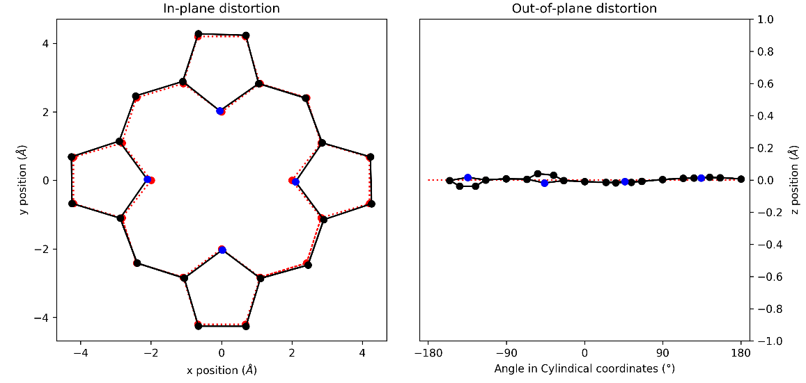
Figure 135: (a) in-plane and (b) out-of-plane skeletal plots of the porphyrin core. Porphyrin is represented in black (C) and blue (N), with the reference structure (CuTPP) in red dotted lines.

NSD result generated from 2:4 (in Å)
basis | Δ_{ip} | δ_{ip} | B_{2g} | B_{1g} | E_{u}(x) | E_{u}(y) | A_{1g} | A_{2g}
min. | 0.26 | 0.00 | 0.06 | 0.02 | 0.02 | 0.02 | 0.25 | 0.00
ext. | 0.27 | 0.00 | 0.06 | 0.02 | 0.02 | 0.02 | 0.25 | 0.00
 |  |  | 0.02 | 0.09 | 0.00 | 0.00 | 0.02 | 0.00
total | 0.29 | 0.00 | 0.06 | 0.02 | 0.02 | 0.02 | 0.25 | 0.00
 |  |  | 0.02 | 0.09 | -0.01 | 0.00 | 0.02 | 0.00
 |  |  | -0.01 | 0.06 | -0.01 | 0.00 | 0.05 | 0.00
 |  |  | 0.01 | 0.00 | -0.01 | -0.01 | 0.00 | 0.00
 |  |  | 0.00 | -0.01 | 0.00 | 0.00 | 0.01 | 0.00
 |  |  | 0.00 | 0.01 | 0.00 | 0.00 | 0.01
 |  |  |  |  | 0.00 | 0.00
 |  |  |  |  | 0.00 | 0.00
 |  |  |  |  | 0.00 | 0.00
 |  |  |  |  | 0.00 | 0.00
 |  |  |  |  | 0.00 | 0.00
comp. | 0.29 | 0.00 | 0.07 | 0.11 | 0.02 | 0.02 | 0.26 | 0.00

basis | Δ_{oop} | δ_{oop} | B_{2u} | B_{1u} | A_{2u} | E_{g}(x) | E_{g}(y) | A_{1u}
min. | 0.07 | 0.00 | -0.07 | 0.00 | 0.00 | -0.02 | -0.02 | 0.00
ext. | 0.07 | 0.00 | -0.06 | 0.00 | 0.00 | -0.02 | -0.02 | 0.00
 |  |  | 0.01 | 0.00 | 0.00 | -0.01 | -0.01 | 0.00
total | 0.07 | 0.00 | -0.06 | 0.00 | 0.00 | -0.02 | -0.02 | 0.00
 |  |  | 0.01 | 0.00 | 0.00 | -0.01 | -0.01 | 0.00
 |  |  | 0.00 | 0.00 | 0.00 | 0.00 | 0.00
 |  |  |  |  |  | 0.00 | 0.00
 |  |  |  |  |  | 0.00 | 0.00
comp. | 0.07 | 0.00 | 0.07 | 0.00 | 0.00 | 0.02 | 0.03 | 0.00
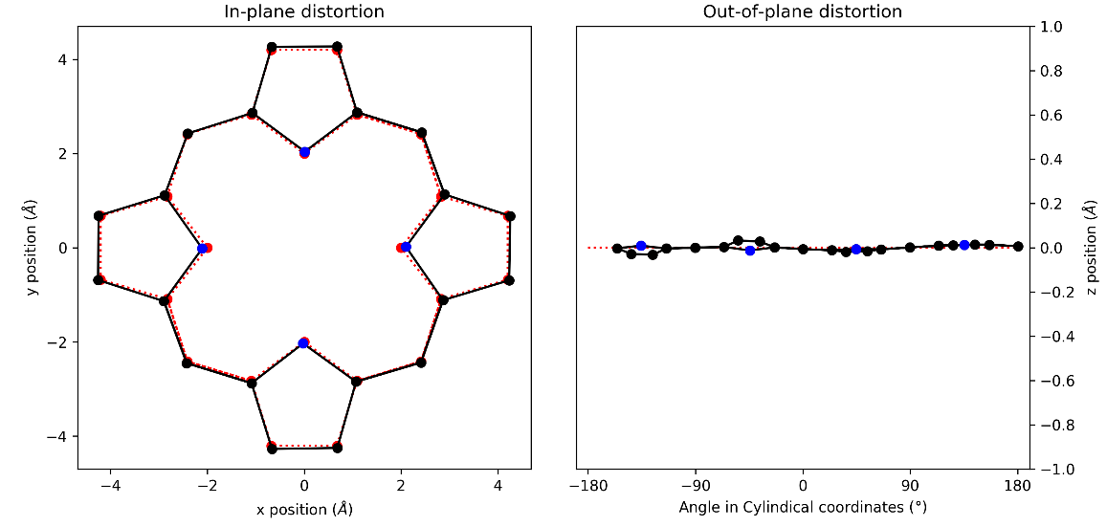
Figure 136: (a) in-plane and (b) out-of-plane skeletal plots of the porphyrin core. Porphyrin is represented in black (C) and blue (N), with the reference structure (CuTPP) in red dotted lines.

NSD result generated from 2:5 (in Å)
basis | Δ_{ip} | δ_{ip} | B_{2g} | B_{1g} | E_{u}(x) | E_{u}(y) | A_{1g} | A_{2g}
min. | 0.30 | 0.00 | 0.20 | 0.03 | 0.01 | -0.02 | 0.22 | 0.00
ext. | 0.32 | 0.00 | 0.20 | 0.03 | 0.01 | -0.02 | 0.22 | 0.00
 |  |  | 0.04 | 0.09 | 0.02 | 0.01 | 0.00 | 0.00
total | 0.33 | 0.00 | 0.21 | 0.04 | 0.01 | -0.02 | 0.22 | 0.00
 |  |  | 0.04 | 0.09 | 0.02 | 0.01 | 0.00 | 0.00
 |  |  | -0.01 | 0.06 | -0.01 | 0.00 | 0.04 | 0.00
 |  |  | 0.01 | 0.00 | -0.01 | 0.01 | 0.00 | 0.00
 |  |  | 0.00 | -0.01 | 0.00 | 0.00 | 0.02 | 0.00
 |  |  | 0.00 | 0.01 | -0.01 | 0.00 | 0.01
 |  |  |  |  | 0.00 | 0.00
 |  |  |  |  | 0.00 | 0.00
 |  |  |  |  | 0.00 | 0.00
 |  |  |  |  | 0.00 | 0.00
 |  |  |  |  | 0.00 | 0.00
comp. | 0.33 | 0.00 | 0.21 | 0.11 | 0.03 | 0.03 | 0.23 | 0.00

basis | Δ_{oop} | δ_{oop} | B_{2u} | B_{1u} | A_{2u} | E_{g}(x) | E_{g}(y) | A_{1u}
min. | 0.14 | 0.00 | -0.12 | 0.00 | 0.01 | 0.00 | -0.06 | 0.00
ext. | 0.15 | 0.00 | -0.12 | 0.00 | 0.01 | 0.00 | -0.06 | 0.00
 |  |  | 0.04 | 0.00 | 0.00 | 0.00 | -0.04 | 0.00
total | 0.15 | 0.00 | -0.12 | 0.00 | 0.01 | 0.00 | -0.06 | 0.00
 |  |  | 0.04 | 0.00 | 0.00 | 0.00 | -0.04 | 0.00
 |  |  | 0.00 | 0.00 | 0.00 | 0.00 | 0.00
 |  |  |  |  |  | 0.00 | 0.00
 |  |  |  |  |  | 0.00 | 0.00
comp. | 0.15 | 0.00 | 0.13 | 0.00 | 0.01 | 0.01 | 0.07 | 0.00
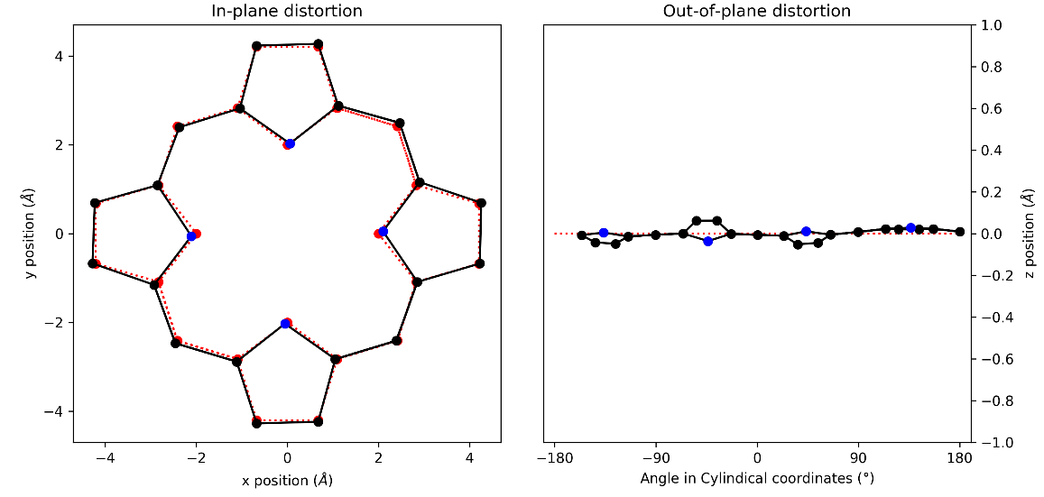
Figure 137: (a) in-plane and (b) out-of-plane skeletal plots of the porphyrin core. Porphyrin is represented in black (C) and blue (N), with the reference structure (CuTPP) in red dotted lines.

NSD result generated from 2:6 (in Å)
basis | Δ_{ip} | δ_{ip} | B_{2g} | B_{1g} | E_{u}(x) | E_{u}(y) | A_{1g} | A_{2g}
min. | 0.24 | 0.00 | 0.00 | 0.02 | 0.03 | 0.00 | 0.24 | 0.00
ext. | 0.25 | 0.00 | 0.00 | 0.02 | 0.03 | 0.00 | 0.24 | 0.00
 |  |  | 0.00 | 0.08 | -0.01 | 0.00 | 0.01 | 0.00
total | 0.27 | 0.00 | 0.00 | 0.02 | 0.03 | 0.00 | 0.24 | 0.00
 |  |  | 0.00 | 0.09 | -0.01 | 0.00 | 0.01 | 0.00
 |  |  | 0.00 | 0.06 | -0.01 | 0.00 | 0.04 | 0.00
 |  |  | 0.00 | 0.00 | -0.02 | 0.00 | 0.00 | 0.00
 |  |  | 0.00 | -0.01 | 0.00 | 0.00 | 0.02 | 0.00
 |  |  | 0.00 | 0.01 | -0.01 | 0.00 | 0.01
 |  |  |  |  | 0.00 | 0.00
 |  |  |  |  | -0.01 | 0.00
 |  |  |  |  | -0.01 | 0.00
 |  |  |  |  | 0.00 | 0.00
 |  |  |  |  | 0.01 | 0.00
comp. | 0.27 | 0.00 | 0.00 | 0.11 | 0.04 | 0.00 | 0.24 | 0.00

basis | Δ_{oop} | δ_{oop} | B_{2u} | B_{1u} | A_{2u} | E_{g}(x) | E_{g}(y) | A_{1u}
min. | 0.17 | 0.00 | -0.16 | 0.00 | 0.01 | 0.00 | -0.06 | 0.00
ext. | 0.18 | 0.00 | -0.16 | 0.00 | 0.01 | 0.00 | -0.06 | 0.00
 |  |  | 0.04 | 0.00 | -0.01 | 0.00 | -0.03 | 0.00
total | 0.18 | 0.00 | -0.16 | 0.00 | 0.01 | 0.00 | -0.06 | 0.00
 |  |  | 0.04 | 0.00 | -0.01 | 0.00 | -0.03 | 0.00
 |  |  | 0.00 | 0.00 | 0.00 | 0.00 | 0.00
 |  |  |  |  |  | 0.00 | 0.00
 |  |  |  |  |  | 0.00 | 0.00
comp. | 0.18 | 0.00 | 0.17 | 0.00 | 0.01 | 0.00 | 0.07 | 0.00
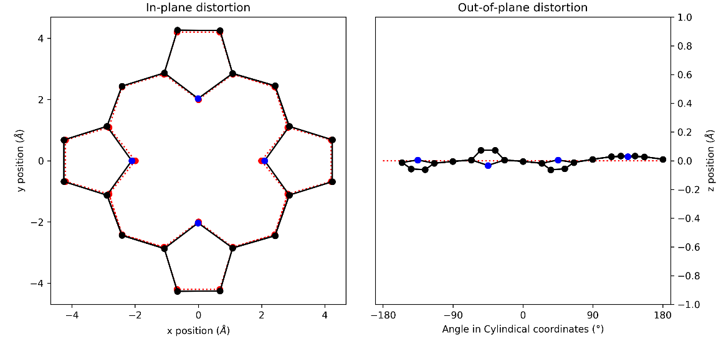
Figure 138: (a) in-plane and (b) out-of-plane skeletal plots of the porphyrin core. Porphyrin is represented in black (C) and blue (N), with the reference structure (CuTPP) in red dotted lines.

NSD tables and plots for DFT structures series 3

NSD result generated from 3:1 (in Å)
basis | Δ_{ip} | δ_{ip} | B_{2g} | B_{1g} | E_{u}(x) | E_{u}(y) | A_{1g} | A_{2g}
min. | 0.21 | 0.00 | 0.00 | 0.03 | -0.01 | 0.00 | 0.21 | 0.00
ext. | 0.23 | 0.00 | 0.00 | 0.04 | -0.01 | 0.00 | 0.21 | 0.00
 |  |  | 0.00 | 0.09 | 0.03 | 0.00 | 0.02 | 0.00
total | 0.26 | 0.00 | 0.00 | 0.04 | -0.01 | 0.00 | 0.21 | 0.00
 |  |  | 0.00 | 0.09 | 0.03 | 0.00 | 0.02 | 0.00
 |  |  | 0.00 | 0.06 | 0.00 | 0.00 | 0.04 | 0.00
 |  |  | 0.00 | 0.00 | -0.04 | 0.00 | 0.01 | 0.00
 |  |  | 0.00 | -0.01 | 0.02 | 0.00 | 0.02 | 0.00
 |  |  | 0.00 | 0.01 | -0.01 | 0.00 | 0.00
 |  |  |  |  | 0.00 | 0.00
 |  |  |  |  | 0.00 | 0.00
 |  |  |  |  | -0.02 | 0.00
 |  |  |  |  | 0.01 | 0.00
 |  |  |  |  | -0.03 | 0.00
comp. | 0.26 | 0.00 | 0.00 | 0.11 | 0.06 | 0.00 | 0.22 | 0.00

basis | Δ_{oop} | δ_{oop} | B_{2u} | B_{1u} | A_{2u} | E_{g}(x) | E_{g}(y) | A_{1u}
min. | 0.13 | 0.00 | -0.11 | 0.00 | 0.02 | 0.00 | -0.06 | 0.00
ext. | 0.14 | 0.00 | -0.11 | 0.00 | 0.02 | 0.00 | -0.06 | 0.00
 |  |  | 0.04 | 0.00 | -0.01 | 0.00 | -0.04 | 0.00
total | 0.14 | 0.00 | -0.11 | 0.00 | 0.02 | 0.00 | -0.06 | 0.00
 |  |  | 0.04 | 0.00 | -0.01 | 0.00 | -0.04 | 0.00
 |  |  | 0.00 | 0.00 | 0.00 | 0.00 | 0.00
 |  |  |  |  |  | 0.00 | 0.00
 |  |  |  |  |  | 0.00 | 0.00
comp. | 0.14 | 0.00 | 0.11 | 0.00 | 0.02 | 0.00 | 0.07 | 0.00
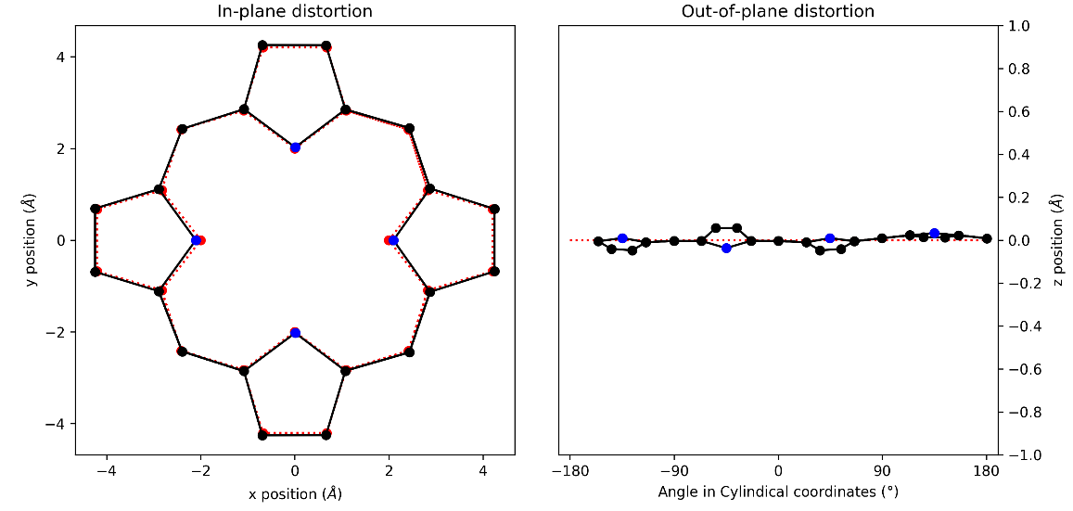
Figure 139: (a) in-plane and (b) out-of-plane skeletal plots of the porphyrin core. Porphyrin is represented in black (C) and blue (N), with the reference structure (CuTPP) in red dotted lines.

NSD result generated from 3:2 (in Å)
basis | Δ_{ip} | δ_{ip} | B_{2g} | B_{1g} | E_{u}(x) | E_{u}(y) | A_{1g} | A_{2g}
min. | 0.23 | 0.00 | 0.00 | 0.02 | 0.02 | 0.00 | 0.23 | 0.00
ext. | 0.25 | 0.00 | 0.00 | 0.02 | 0.02 | 0.00 | 0.23 | 0.00
 |  |  | 0.00 | 0.09 | 0.00 | 0.00 | 0.01 | 0.00
total | 0.26 | 0.00 | 0.00 | 0.03 | 0.02 | 0.00 | 0.23 | 0.00
 |  |  | 0.00 | 0.09 | 0.00 | 0.00 | 0.01 | 0.00
 |  |  | 0.00 | 0.06 | -0.01 | 0.00 | 0.04 | 0.00
 |  |  | 0.00 | 0.00 | -0.02 | 0.00 | 0.00 | 0.00
 |  |  | 0.00 | -0.01 | 0.01 | 0.00 | 0.02 | 0.00
 |  |  | 0.00 | 0.01 | -0.01 | 0.00 | 0.01
 |  |  |  |  | 0.00 | 0.00
 |  |  |  |  | 0.00 | 0.00
 |  |  |  |  | -0.01 | 0.00
 |  |  |  |  | 0.00 | 0.00
 |  |  |  |  | 0.00 | 0.00
comp. | 0.26 | 0.00 | 0.00 | 0.11 | 0.03 | 0.00 | 0.24 | 0.00

basis | Δ_{oop} | δ_{oop} | B_{2u} | B_{1u} | A_{2u} | E_{g}(x) | E_{g}(y) | A_{1u}
min. | 0.15 | 0.00 | -0.14 | 0.00 | 0.01 | 0.00 | -0.06 | 0.00
ext. | 0.16 | 0.00 | -0.14 | 0.00 | 0.01 | 0.00 | -0.06 | 0.00
 |  |  | 0.04 | 0.00 | -0.01 | 0.00 | -0.04 | 0.00
total | 0.16 | 0.00 | -0.14 | 0.00 | 0.01 | 0.00 | -0.06 | 0.00
 |  |  | 0.04 | 0.00 | -0.01 | 0.00 | -0.04 | 0.00
 |  |  | 0.00 | 0.00 | 0.00 | 0.00 | 0.00
 |  |  |  |  |  | 0.00 | 0.00
 |  |  |  |  |  | 0.00 | 0.00
comp. | 0.16 | 0.00 | 0.15 | 0.00 | 0.01 | 0.00 | 0.07 | 0.00
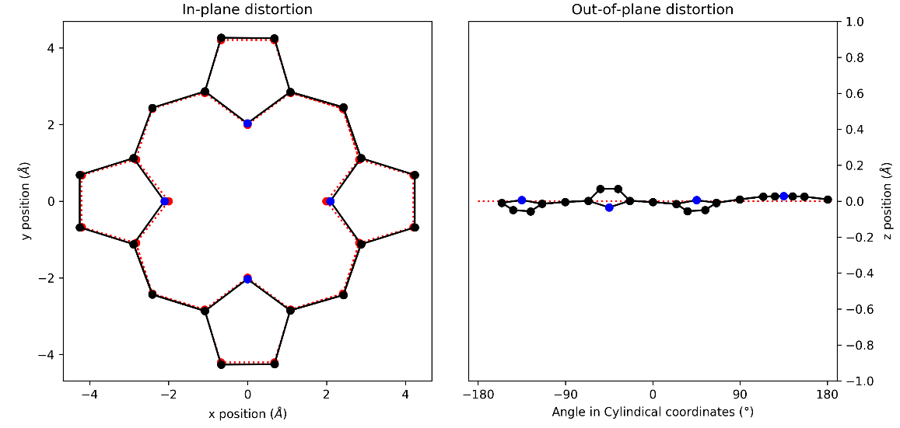
Figure 140: (a) in-plane and (b) out-of-plane skeletal plots of the porphyrin core. Porphyrin is represented in black (C) and blue (N), with the reference structure (CuTPP) in red dotted lines.

NSD result generated from 3:3 (in Å)
basis | Δ_{ip} | δ_{ip} | B_{2g} | B_{1g} | E_{u}(x) | E_{u}(y) | A_{1g} | A_{2g}
min. | 0.25 | 0.00 | 0.00 | 0.02 | 0.05 | 0.00 | 0.25 | 0.00
ext. | 0.27 | 0.00 | 0.00 | 0.02 | 0.05 | 0.00 | 0.25 | 0.00
 |  |  | 0.00 | 0.09 | -0.02 | 0.00 | 0.00 | 0.00
total | 0.28 | 0.00 | 0.00 | 0.02 | 0.05 | 0.00 | 0.25 | 0.00
 |  |  | 0.00 | 0.09 | -0.02 | 0.00 | 0.00 | 0.00
 |  |  | 0.00 | 0.06 | -0.02 | 0.00 | 0.04 | 0.00
 |  |  | 0.00 | 0.00 | -0.01 | 0.00 | 0.00 | 0.00
 |  |  | 0.00 | -0.01 | 0.00 | 0.00 | 0.02 | 0.00
 |  |  | 0.00 | 0.01 | 0.00 | 0.00 | 0.01
 |  |  |  |  | 0.00 | 0.00
 |  |  |  |  | -0.01 | 0.00
 |  |  |  |  | 0.00 | 0.00
 |  |  |  |  | 0.00 | 0.00
 |  |  |  |  | 0.01 | 0.00
comp. | 0.28 | 0.00 | 0.00 | 0.11 | 0.06 | 0.00 | 0.25 | 0.00

basis | Δ_{oop} | δ_{oop} | B_{2u} | B_{1u} | A_{2u} | E_{g}(x) | E_{g}(y) | A_{1u}
min. | 0.20 | 0.00 | -0.19 | 0.00 | 0.01 | 0.00 | -0.05 | 0.00
ext. | 0.20 | 0.00 | -0.19 | 0.00 | 0.01 | 0.00 | -0.05 | 0.00
 |  |  | 0.04 | 0.00 | -0.01 | 0.00 | -0.03 | 0.00
total | 0.20 | 0.00 | -0.19 | 0.00 | 0.01 | 0.00 | -0.05 | 0.00
 |  |  | 0.04 | 0.00 | -0.01 | 0.00 | -0.03 | 0.00
 |  |  | 0.00 | 0.00 | 0.00 | 0.00 | 0.00
 |  |  |  |  |  | 0.00 | 0.00
 |  |  |  |  |  | 0.00 | 0.00
comp. | 0.20 | 0.00 | 0.19 | 0.00 | 0.01 | 0.00 | 0.06 | 0.00
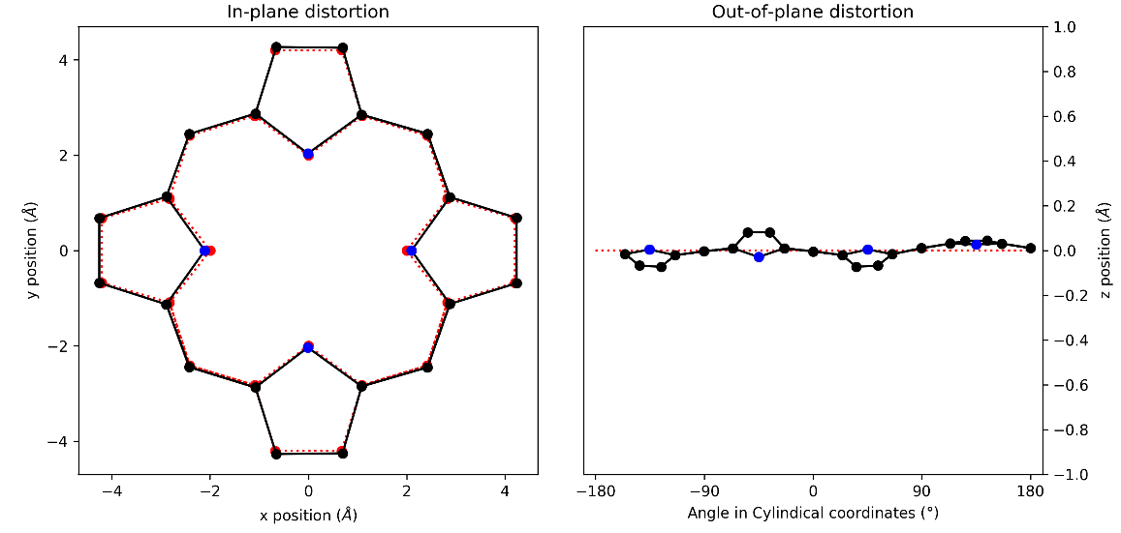
Figure 141: (a) in-plane and (b) out-of-plane skeletal plots of the porphyrin core. Porphyrin is represented in black (C) and blue (N), with the reference structure (CuTPP) in red dotted lines.

