Supporting information
for

Synthesis and transformation of sphingosine analogue pinane-based
2-amino-1,3-diols
Ákos Bajtel^{1‡}, Mounir Raji ^{2‡}, Matti Haukka^{3‡}, Ferenc Fülöp^{2,4‡} and Zsolt Szakonyi*^{,2,5}

Address: ¹Department of Pharmacognosy, University of Szeged, Eötvös u. 6, Szeged, 6720, Hungary, ²Institute of Pharmaceutical Chemistry, University of Szeged, H-6720 Szeged, Eötvös u. 6, Hungary,³Department of Chemistry, University of Jyväskylä, POB 35, 40351 Jyväskylä, Finland, ⁴Stereochemistry Research Group of the Hungarian Academy of Sciences, H-6720 Szeged, Eötvös u. 6, Hungary, ⁵Interdisciplinary Centre of Natural Products, University of Szeged, Szeged, Hungary

Contents

¹H, ¹³C NMR, COSY, NOESY, HSQC and HMBC spectra of new compounds S3-S30
Time-dependent tautomerisation of 19A to 19B in CDCl₃ solution S31
X-ray data of compounds 7 and 15 S32

¹H, ¹³C NMR, COSY, HSQC and HMBC of 6 (CDCl₃)
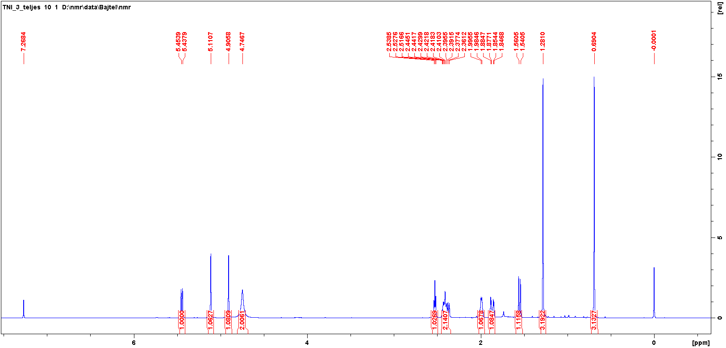
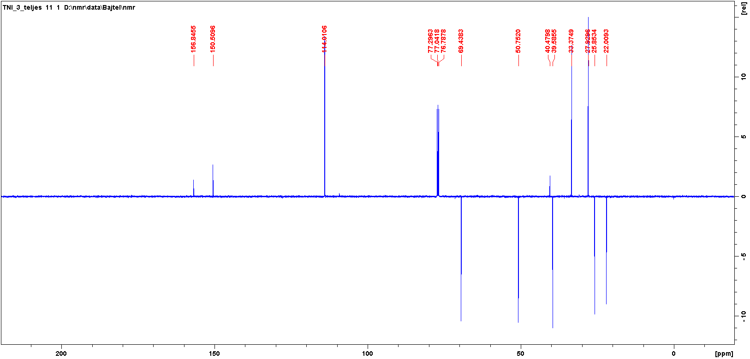

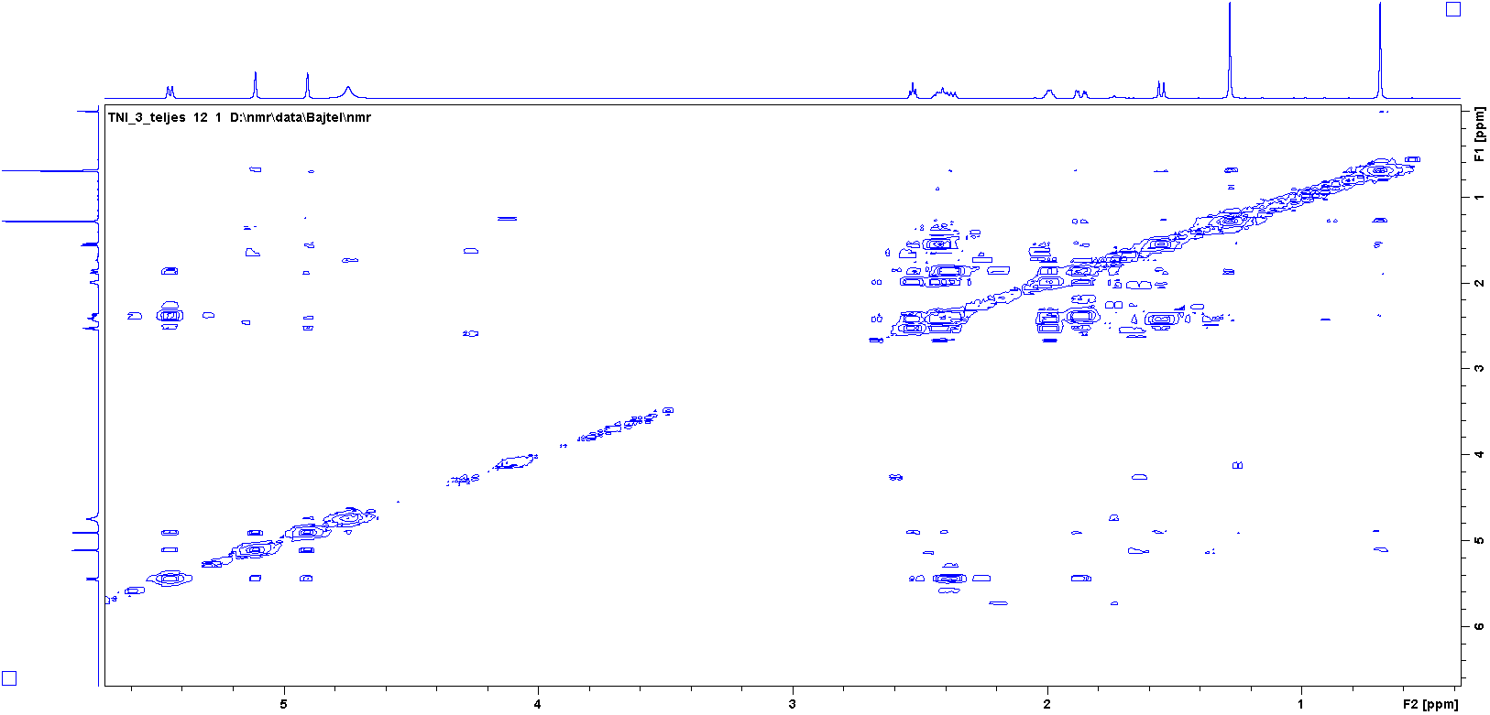
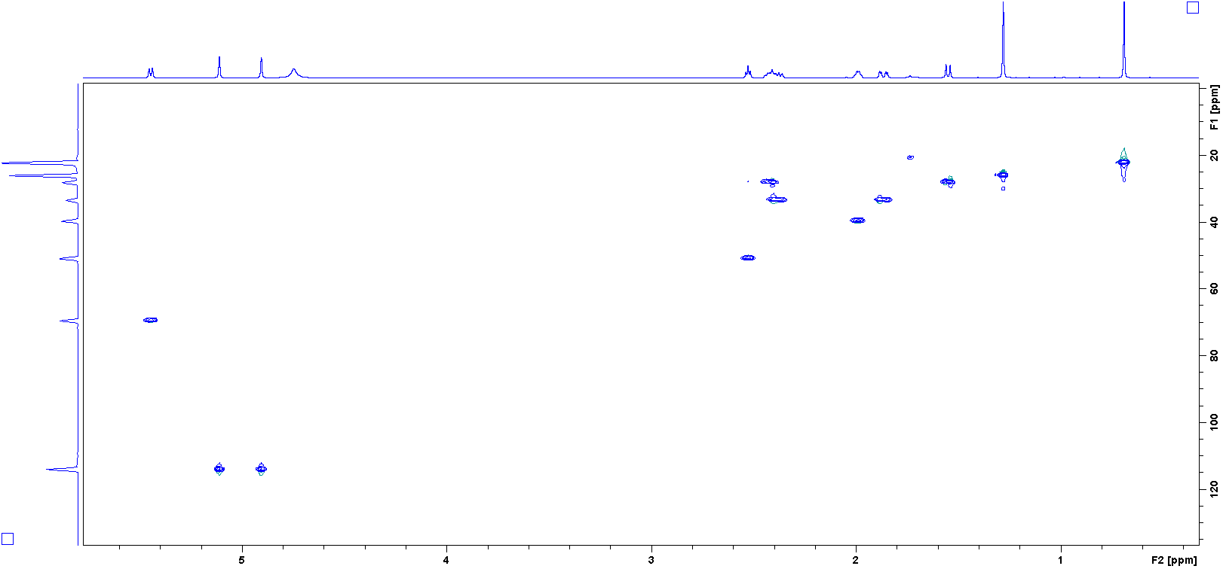
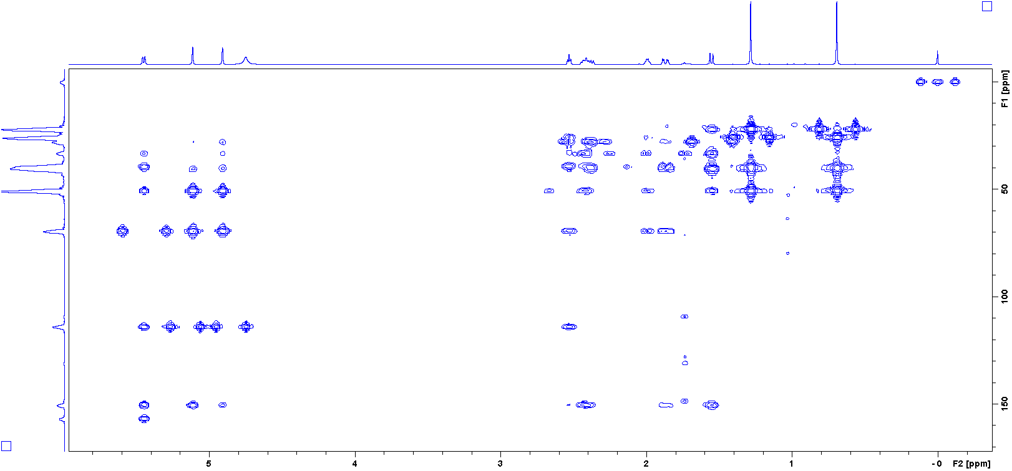

¹H, ¹³C NMR, COSY, NOESY, HSQC and HMBC of 7 (DMSO-d₆)
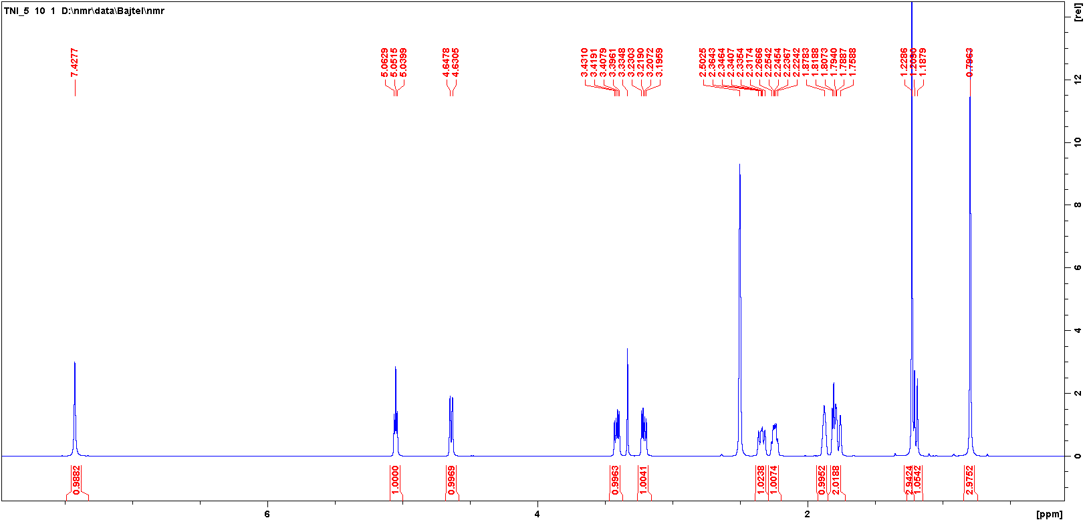
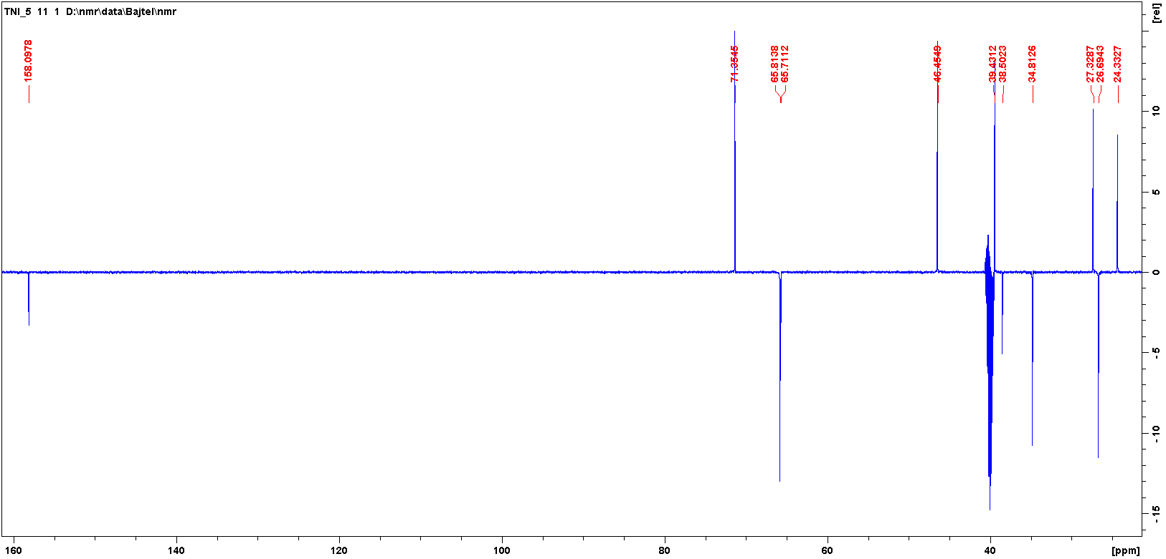
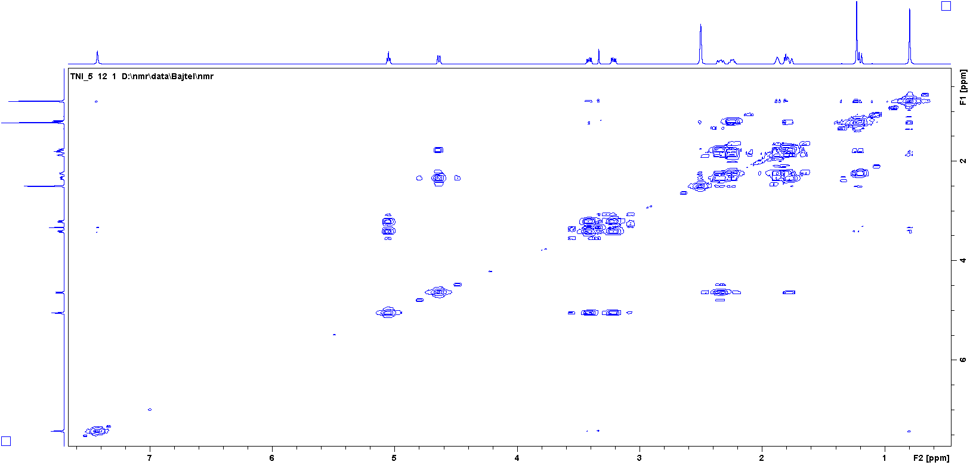

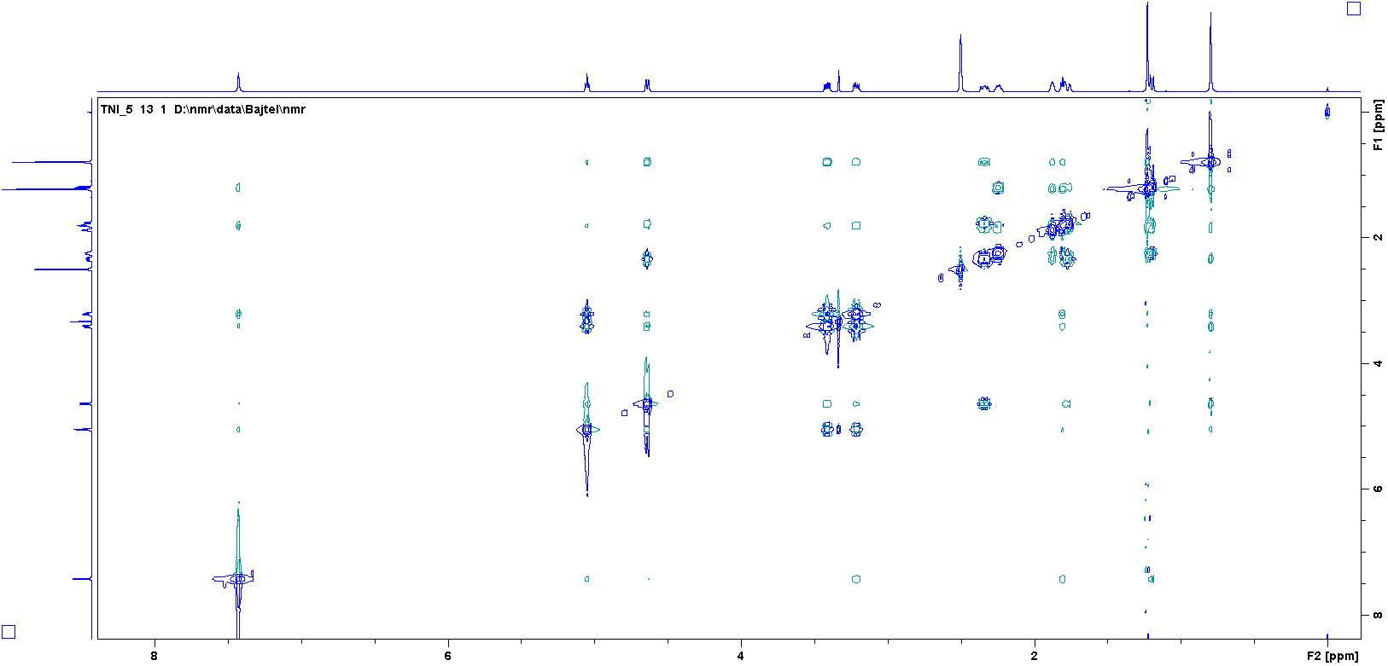
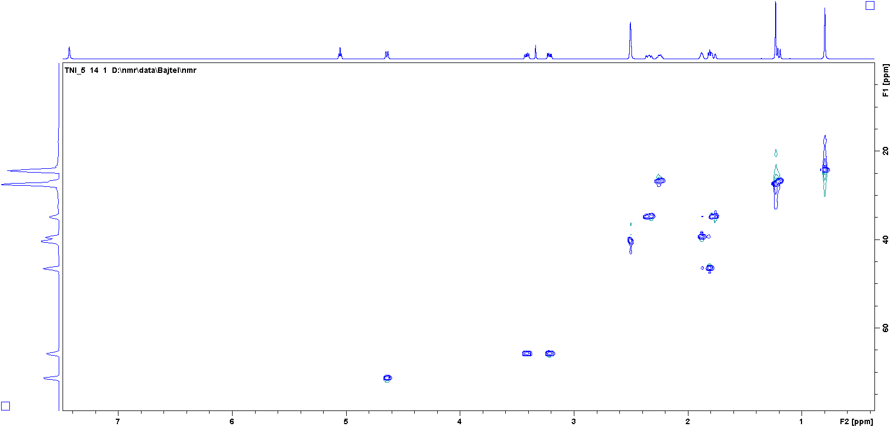
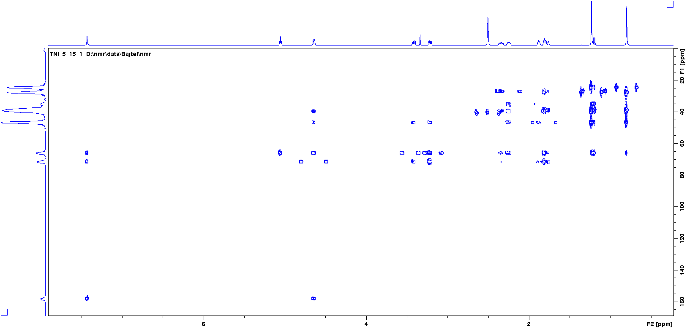
¹H, ¹³C NMR, COSY, NOESY, HSQC and HMBC of 10 (DMSO-d₆)
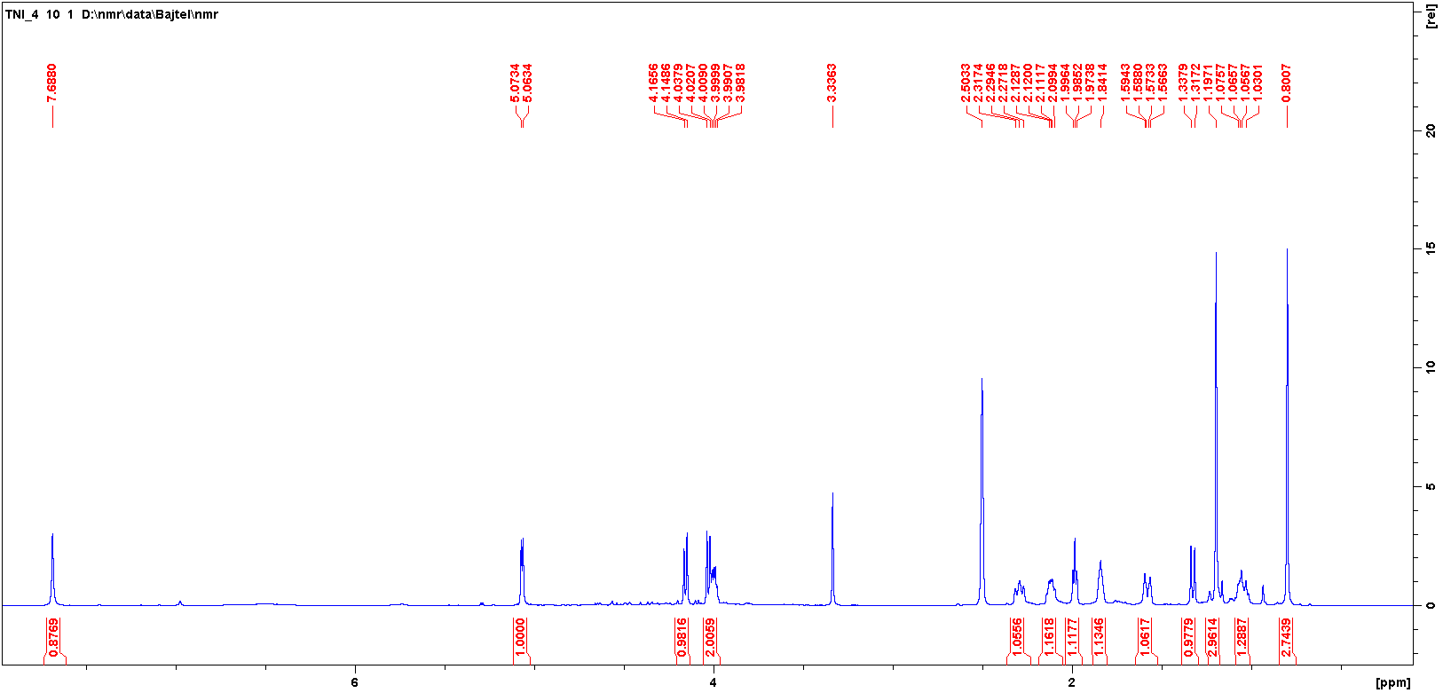

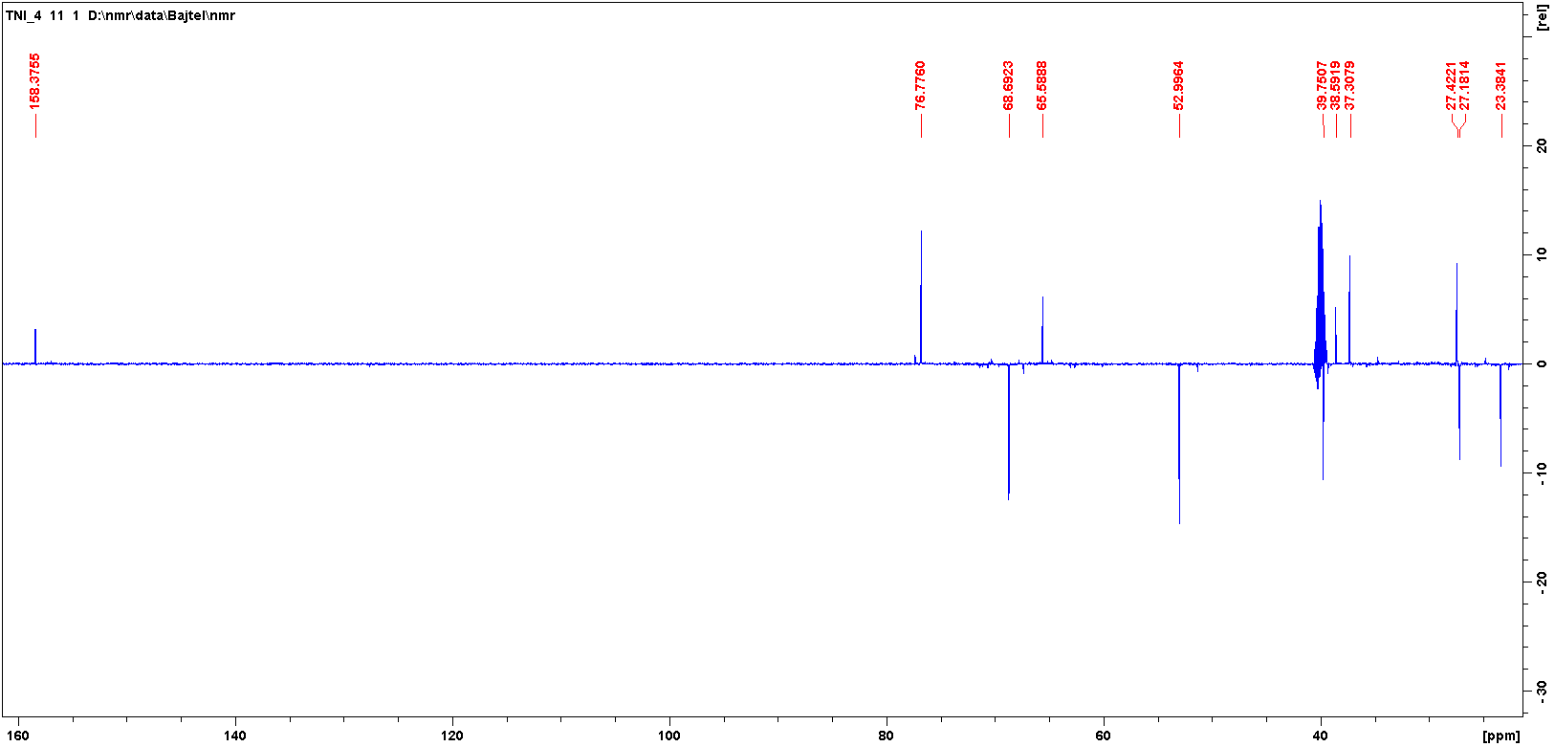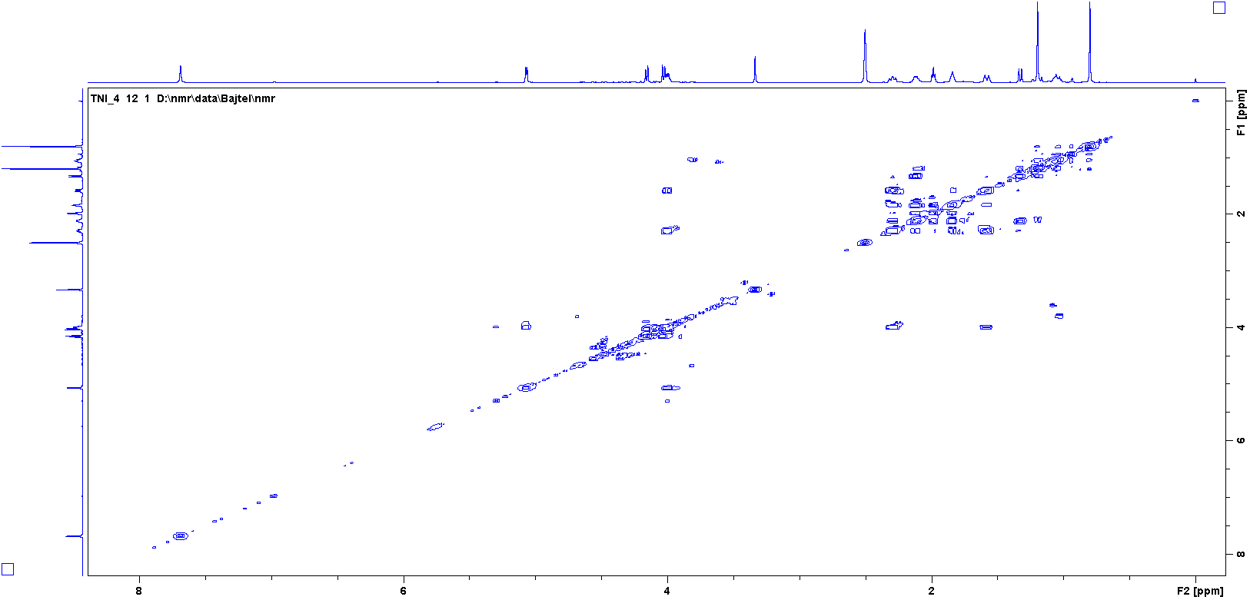
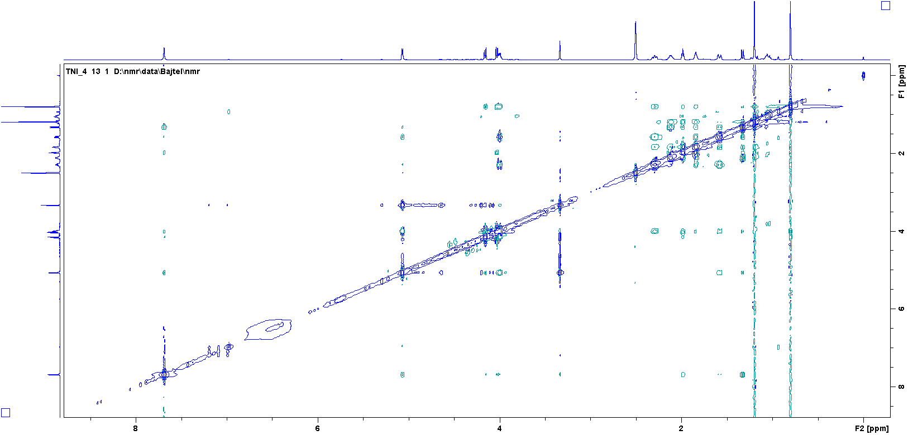
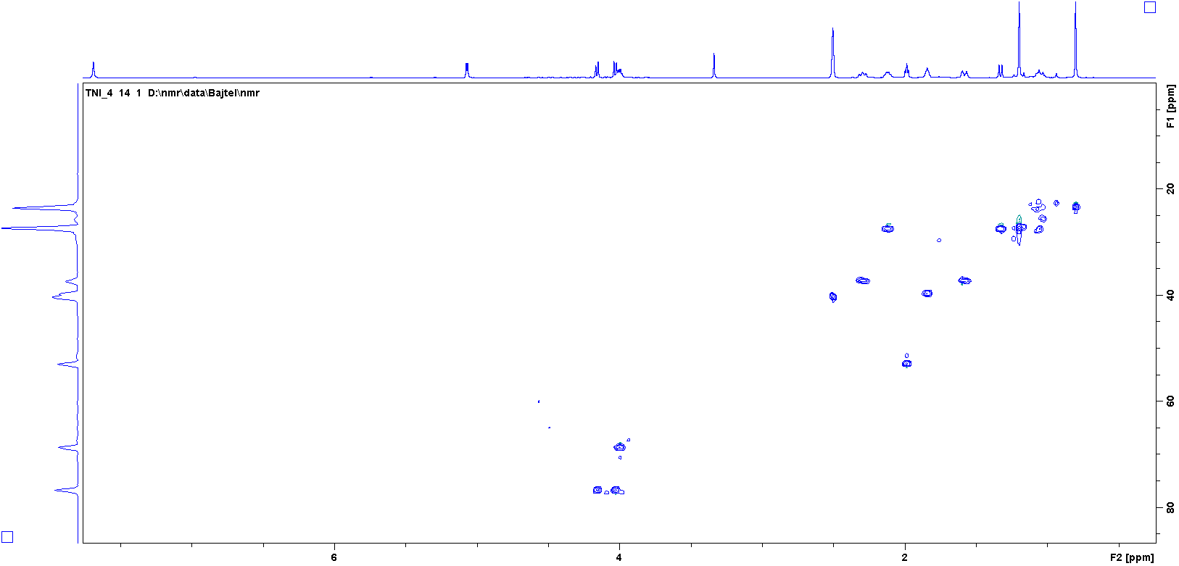
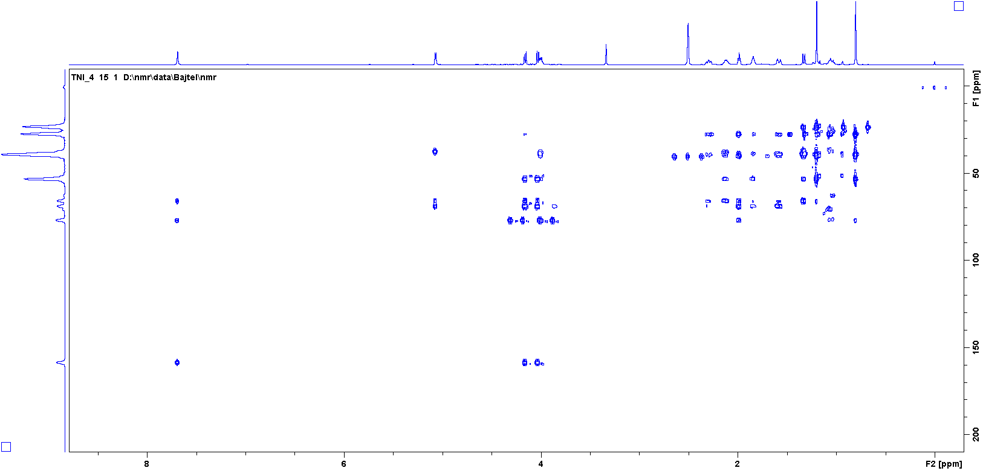

¹H, ¹³C NMR, COSY, NOESY, HSQC and HMBC of 11 (DMSO-d₆)
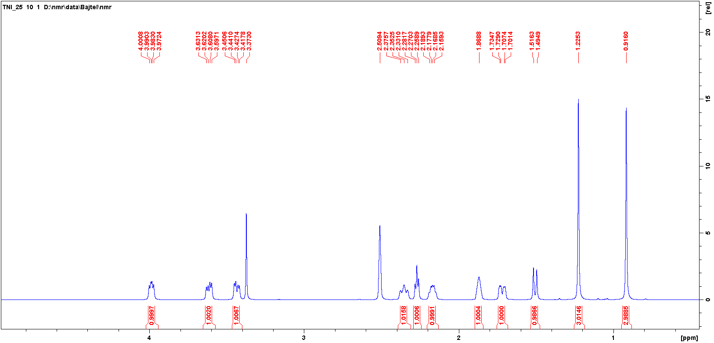
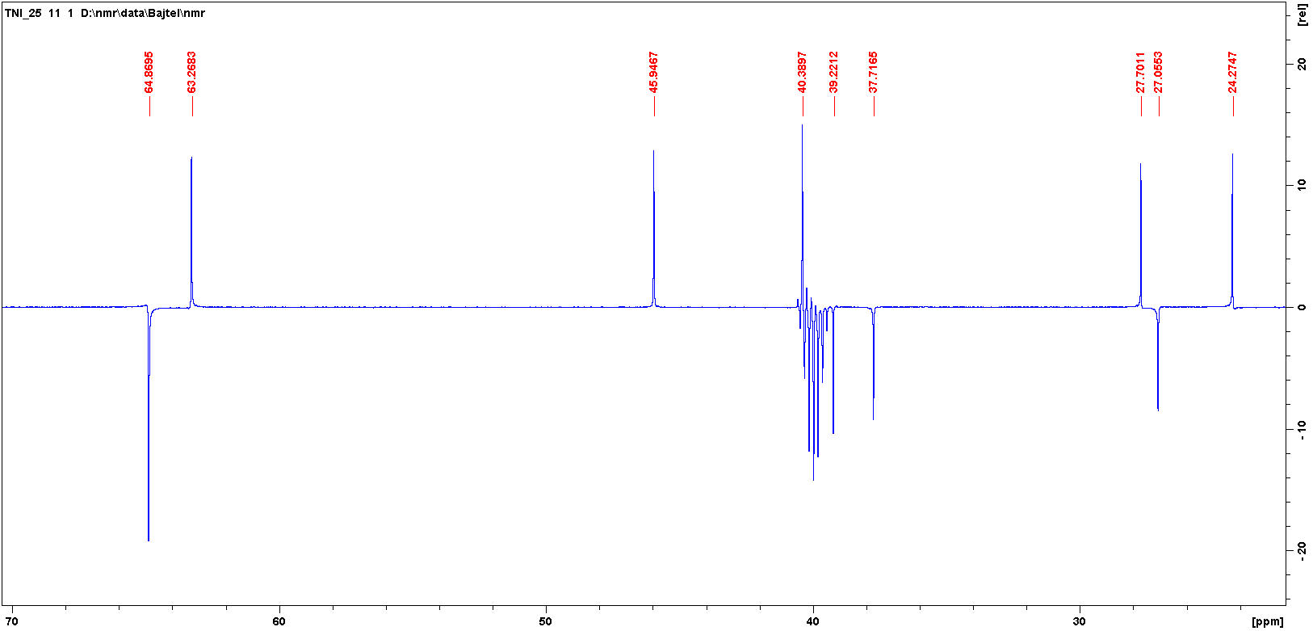
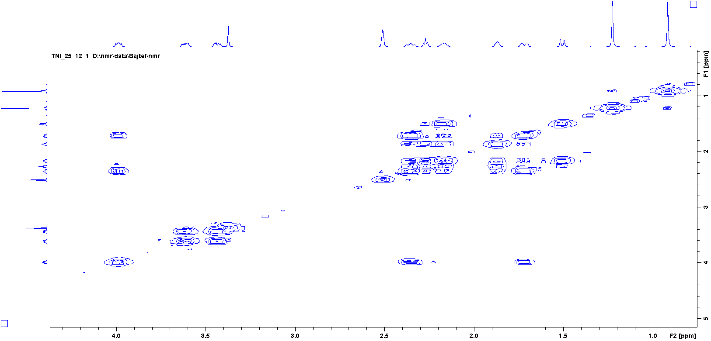
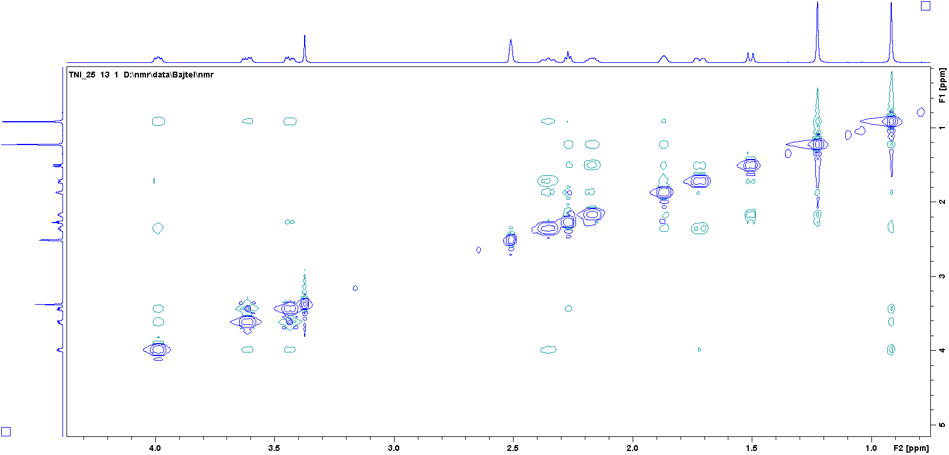
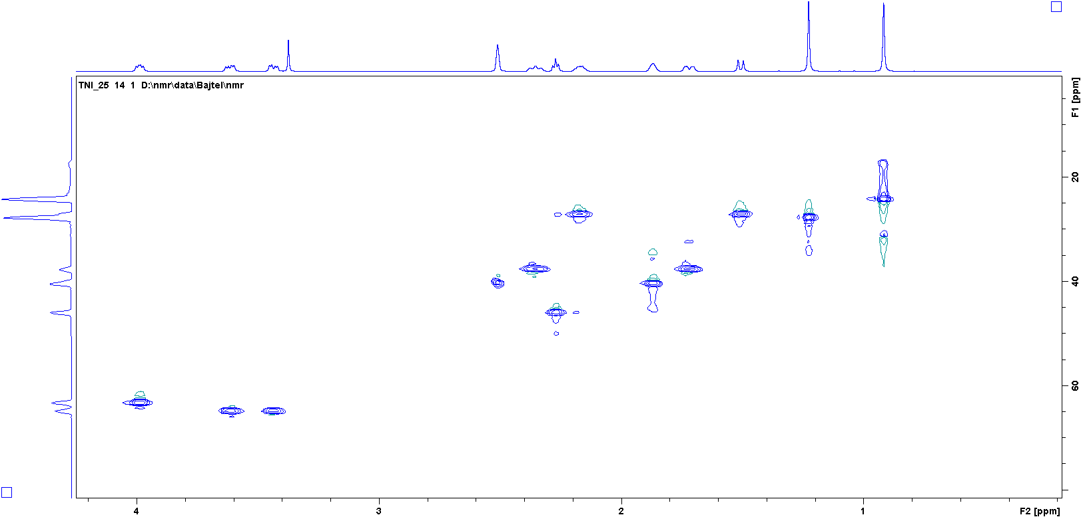
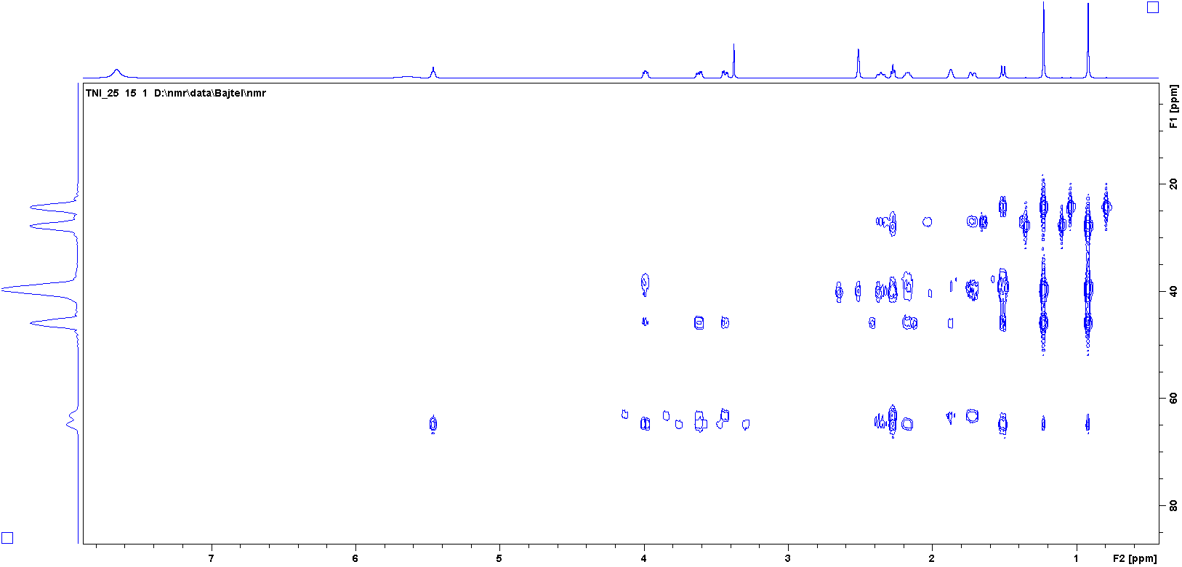

¹H, ¹³C NMR, COSY, HSQC and HMBC of 12 (DMSO-d₆)
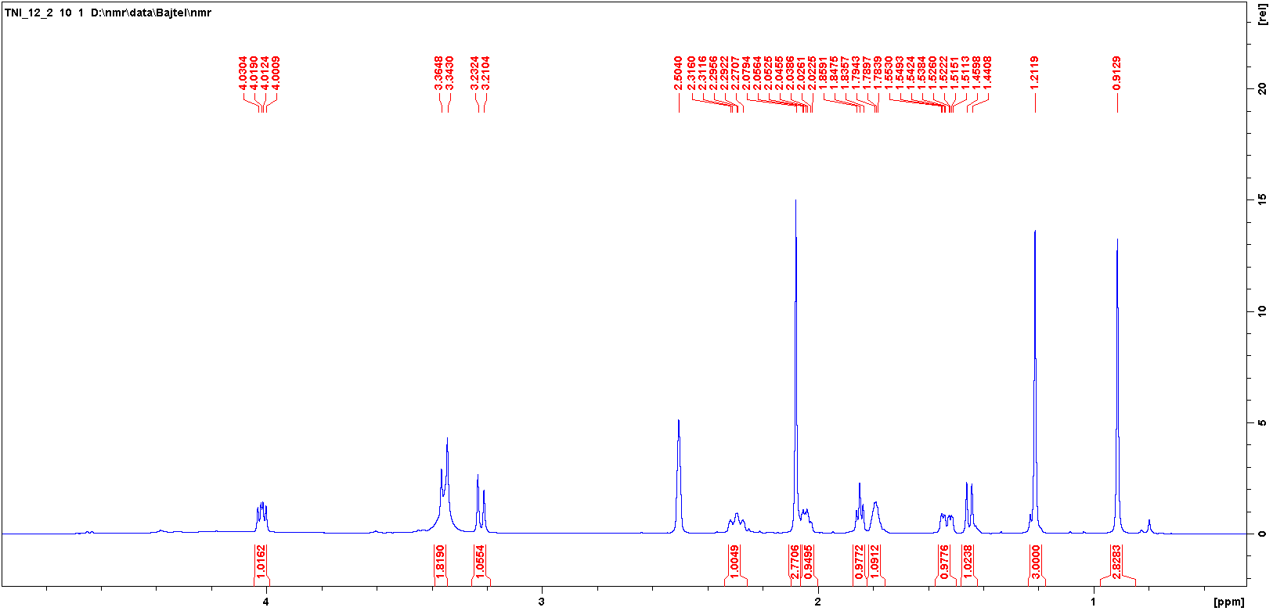
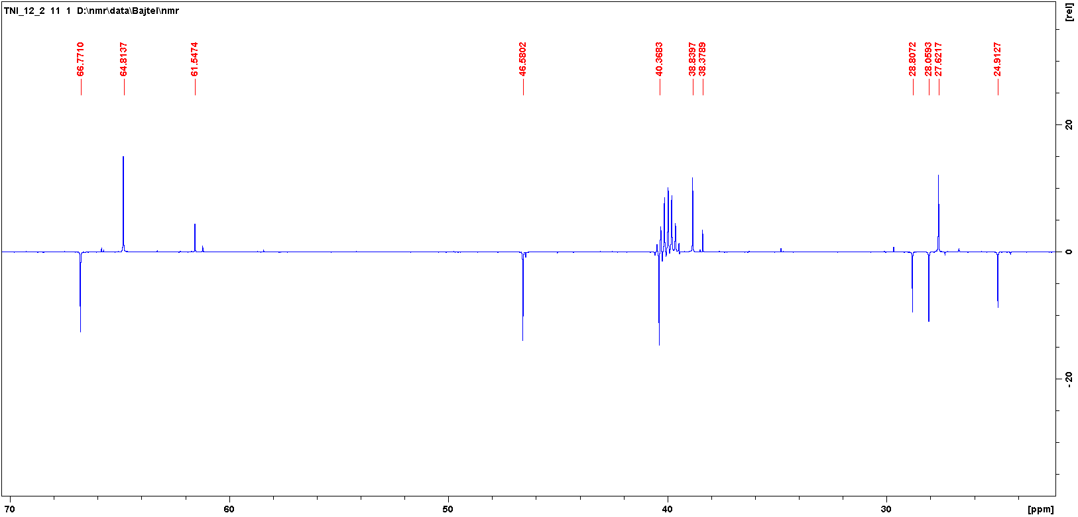
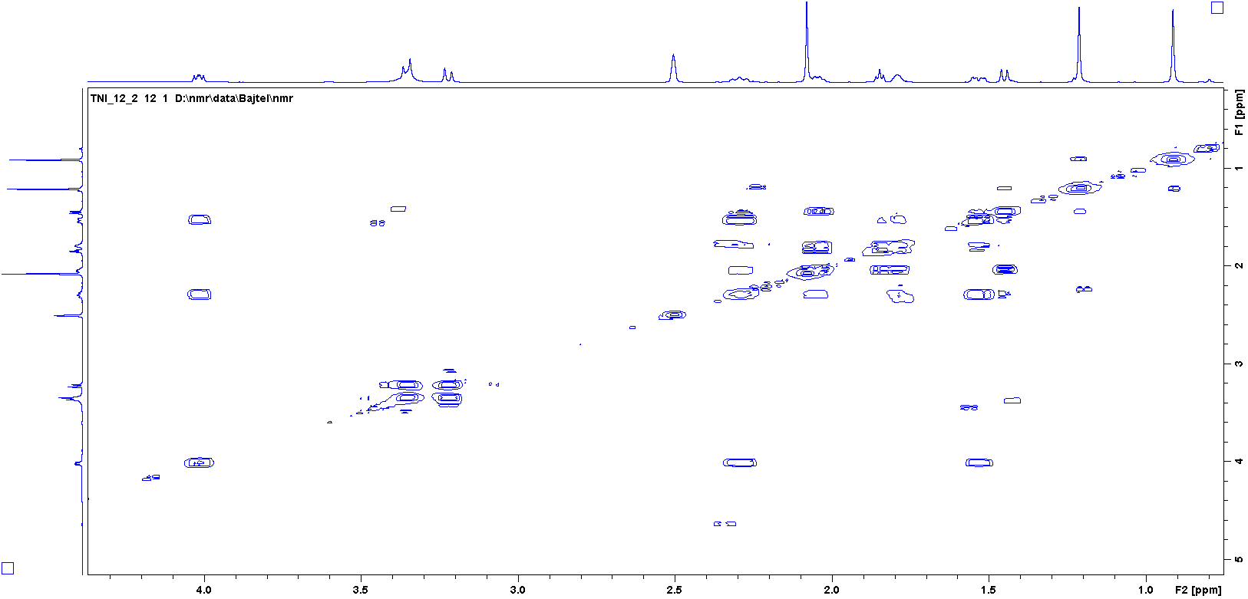
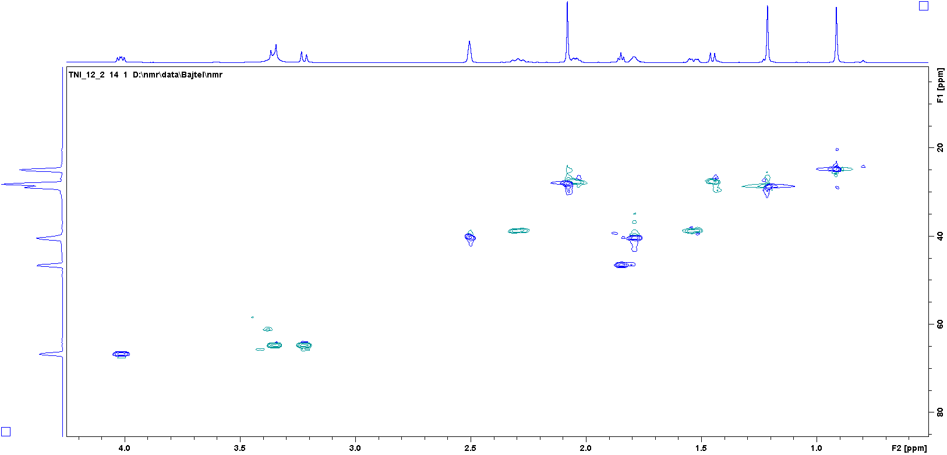
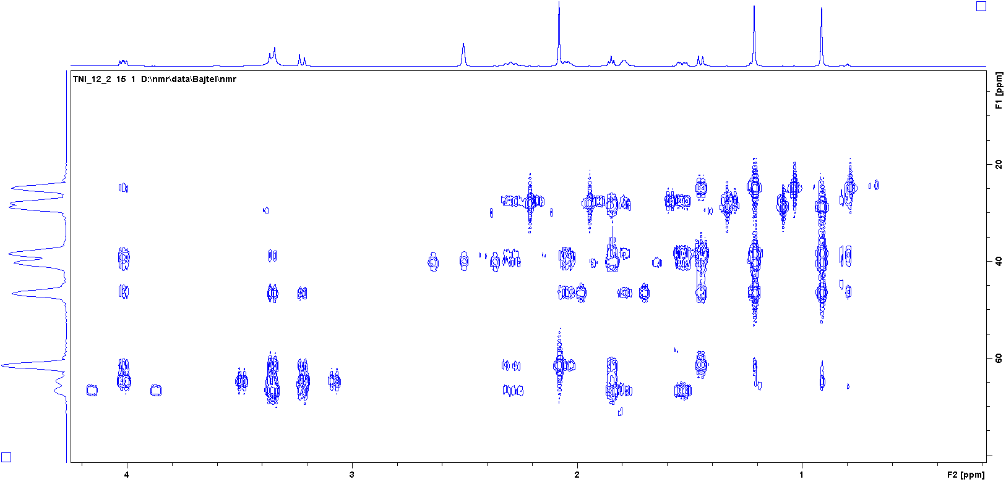

¹H, ¹³C NMR, COSY, HSQC and HMBC of 14 (DMSO-d₆)
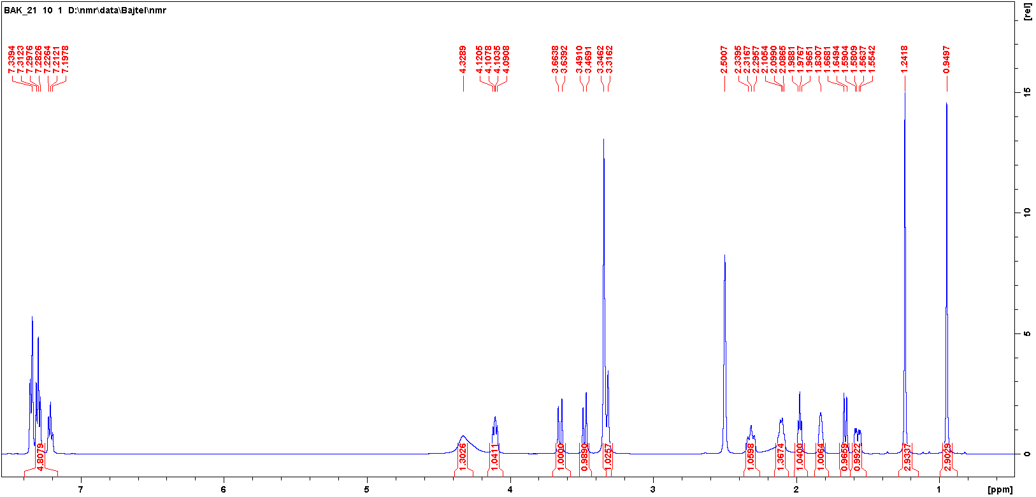
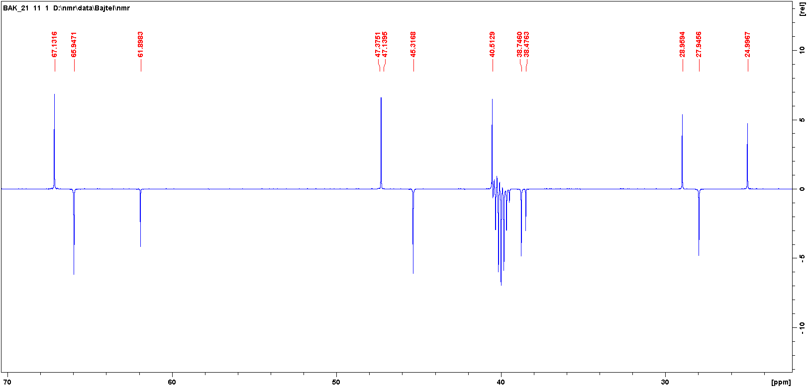
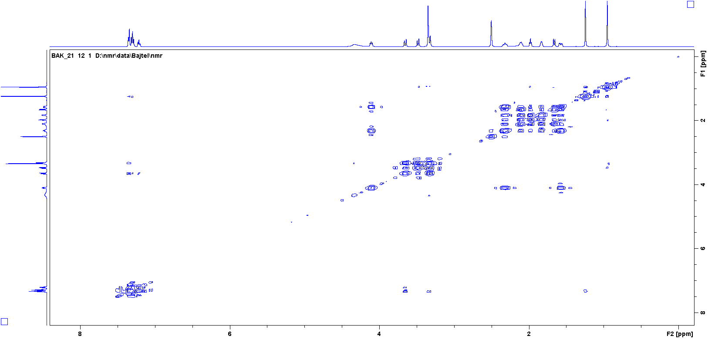
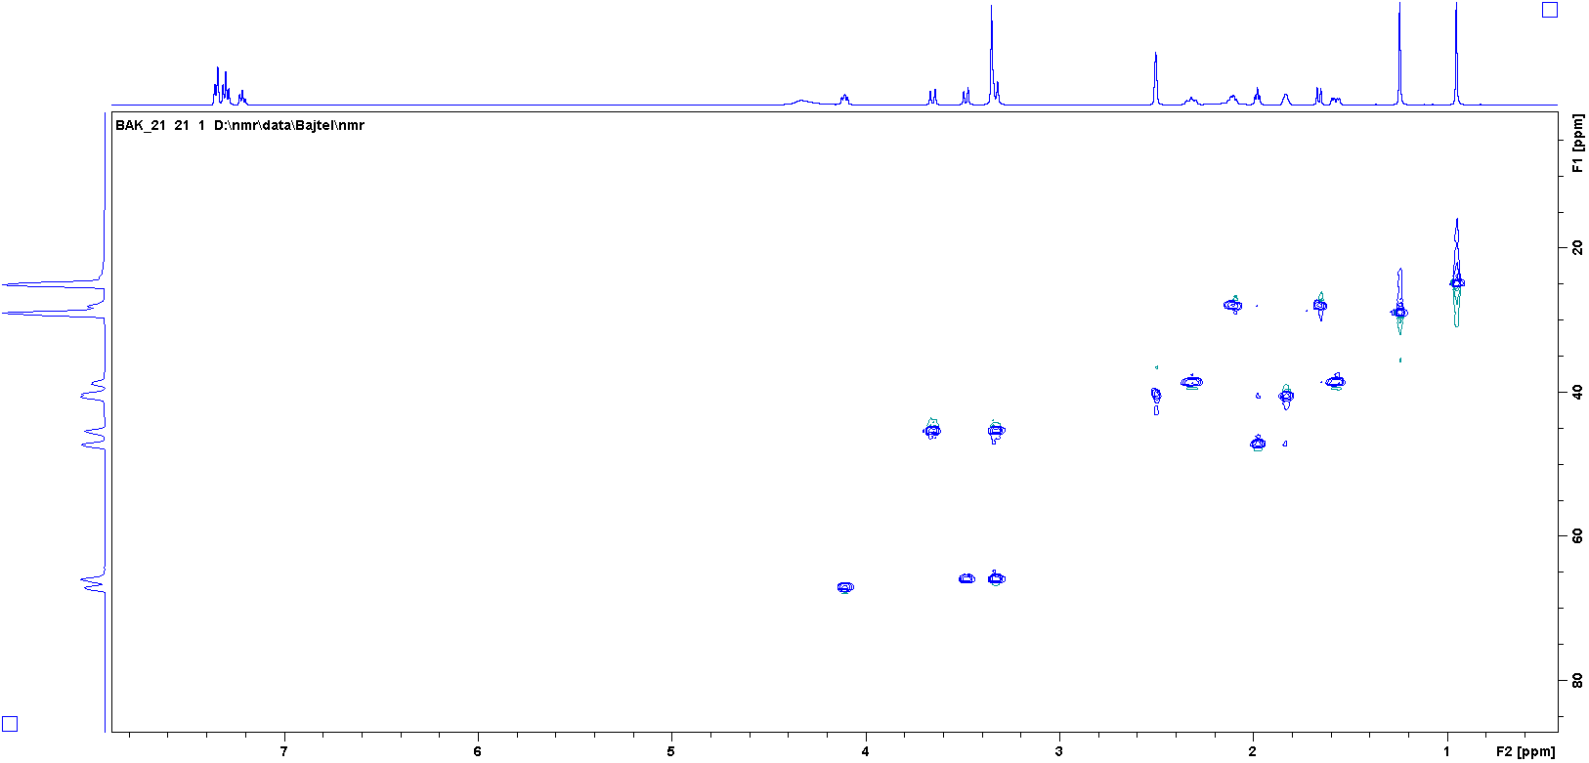
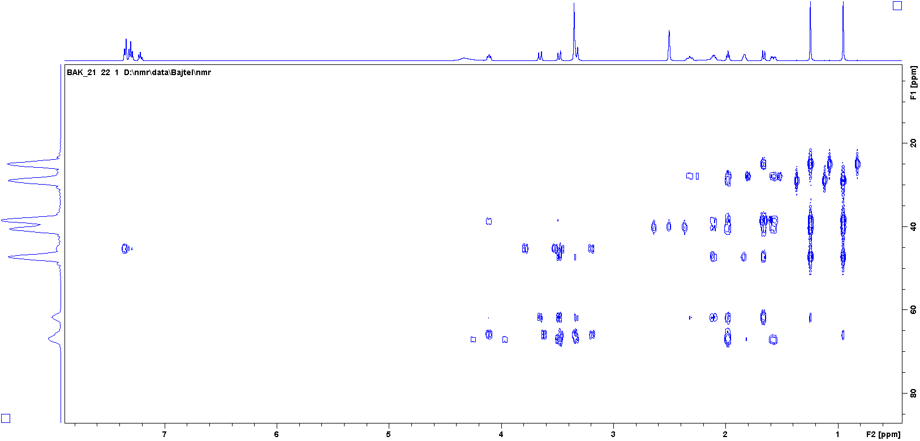

¹H, ¹³C NMR and HMBC of 15 (CDCl₃)
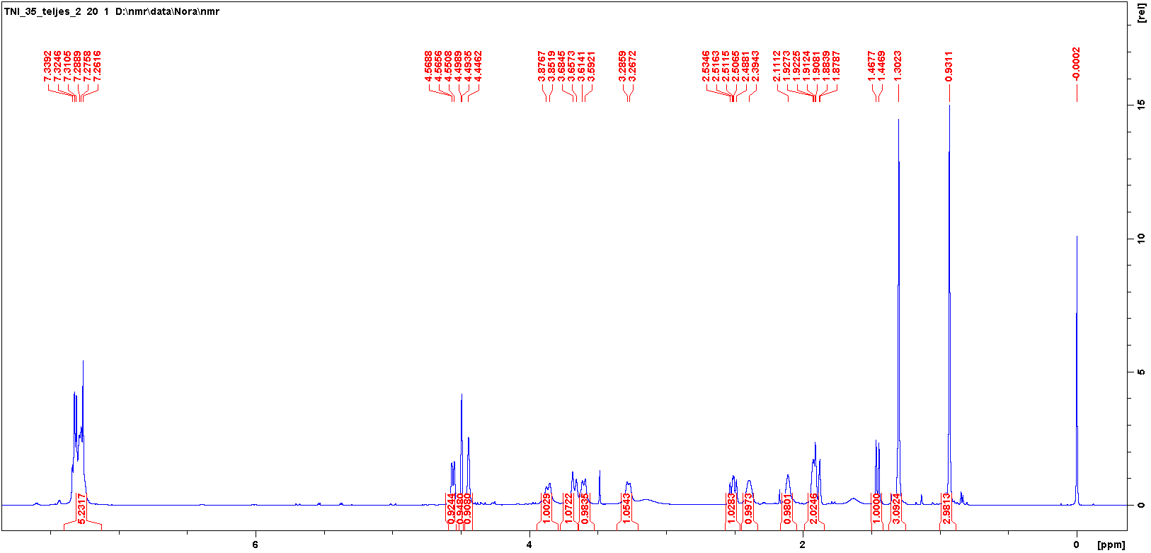

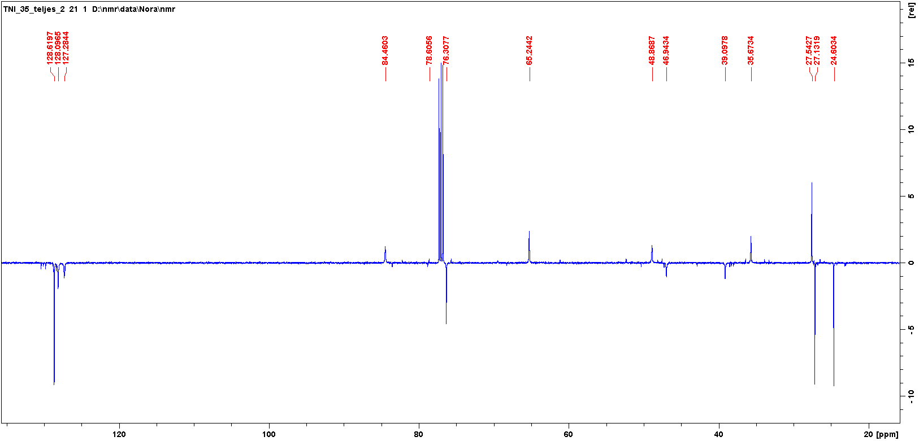

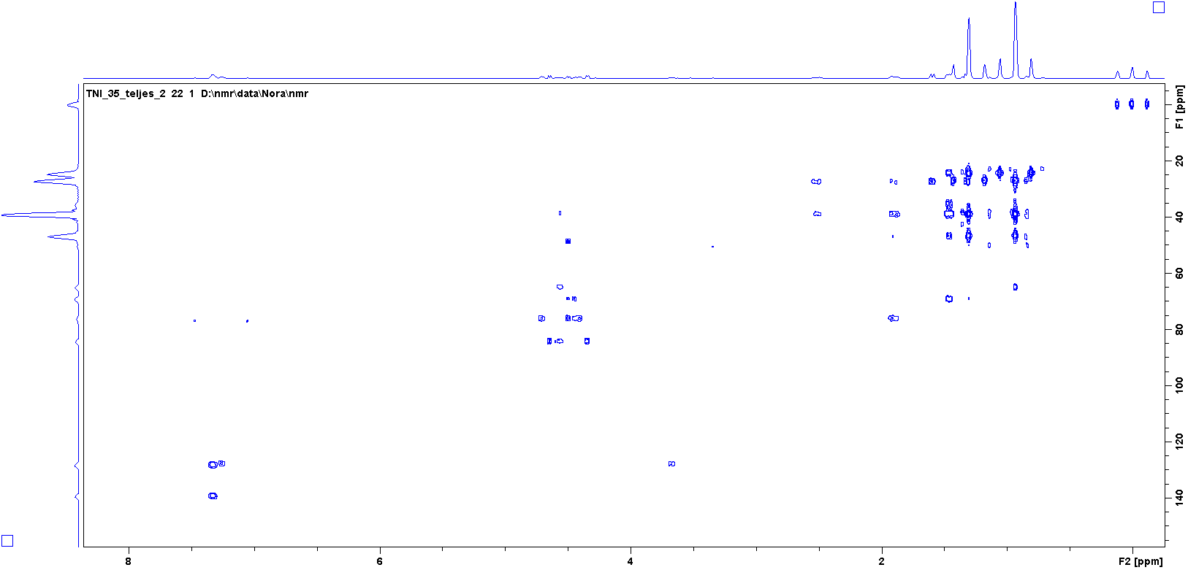

¹H, ¹³C NMR, COSY, HSQC and HMBC of 16 (CDCl₃)
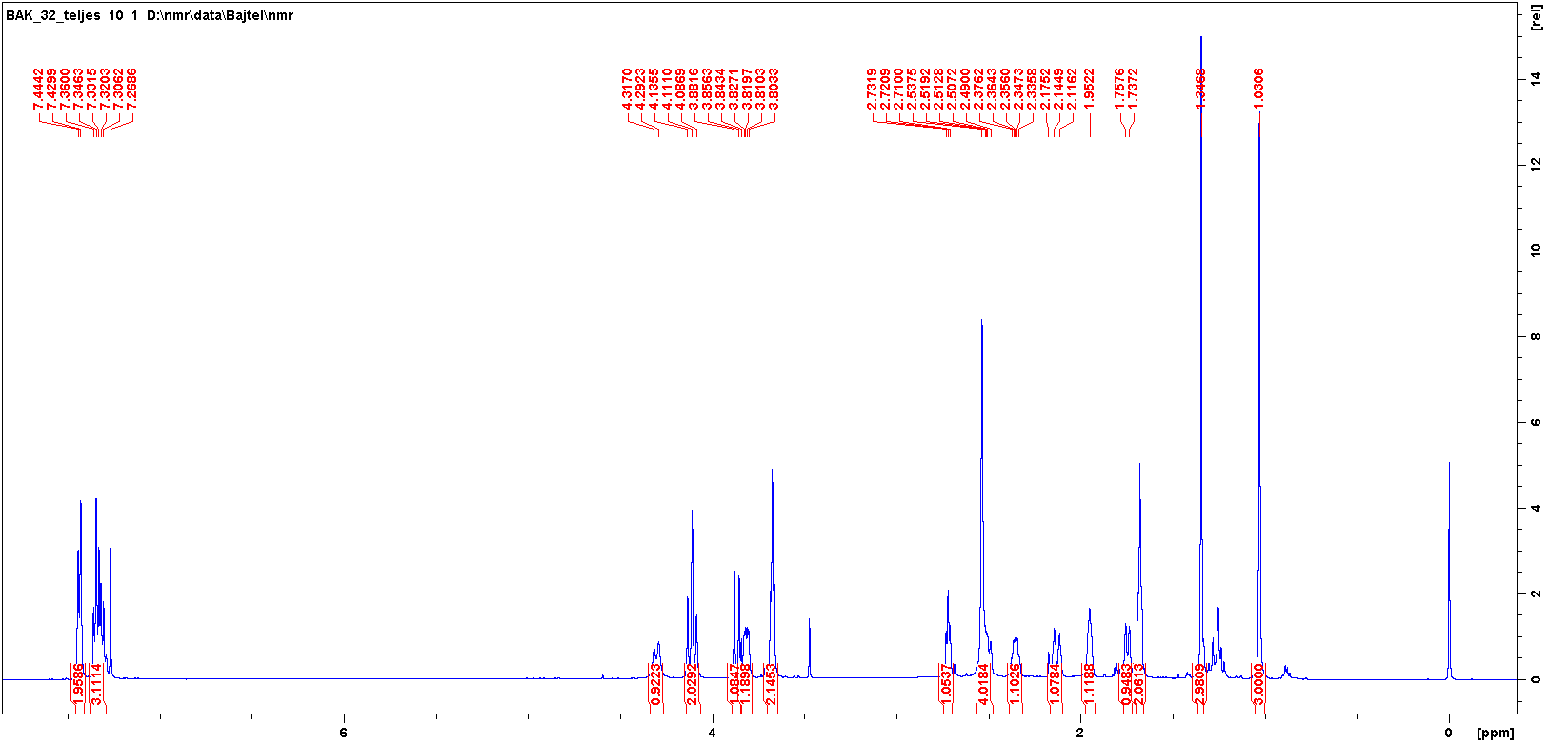
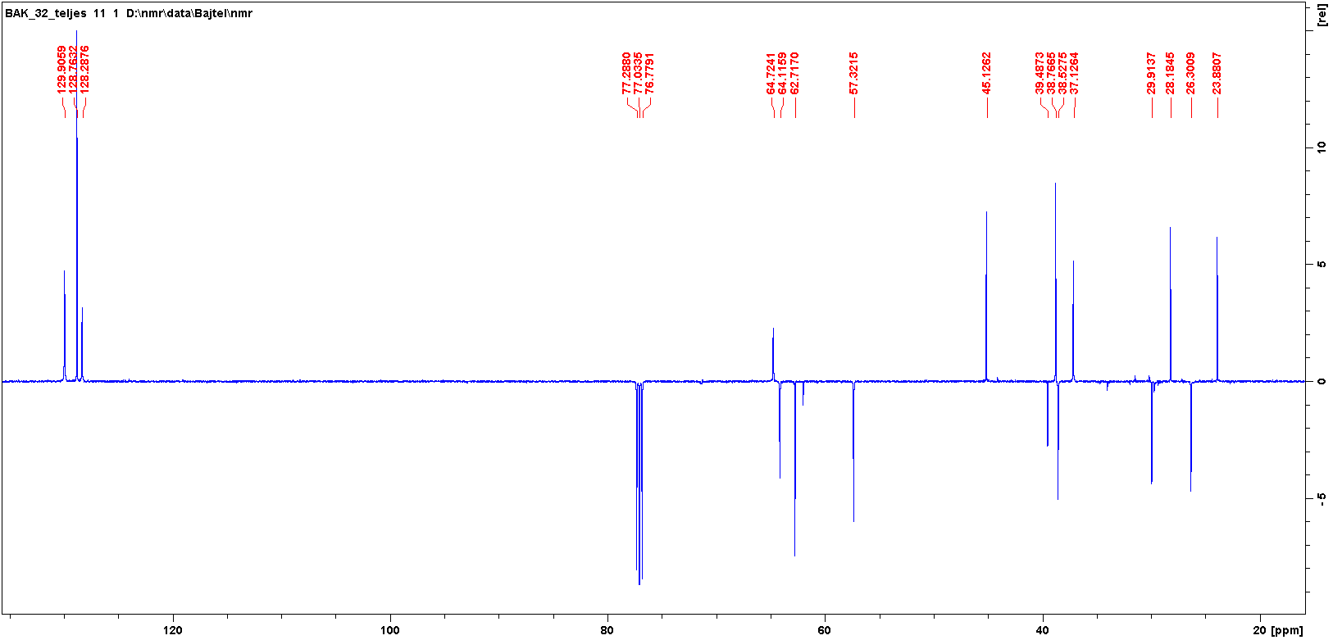
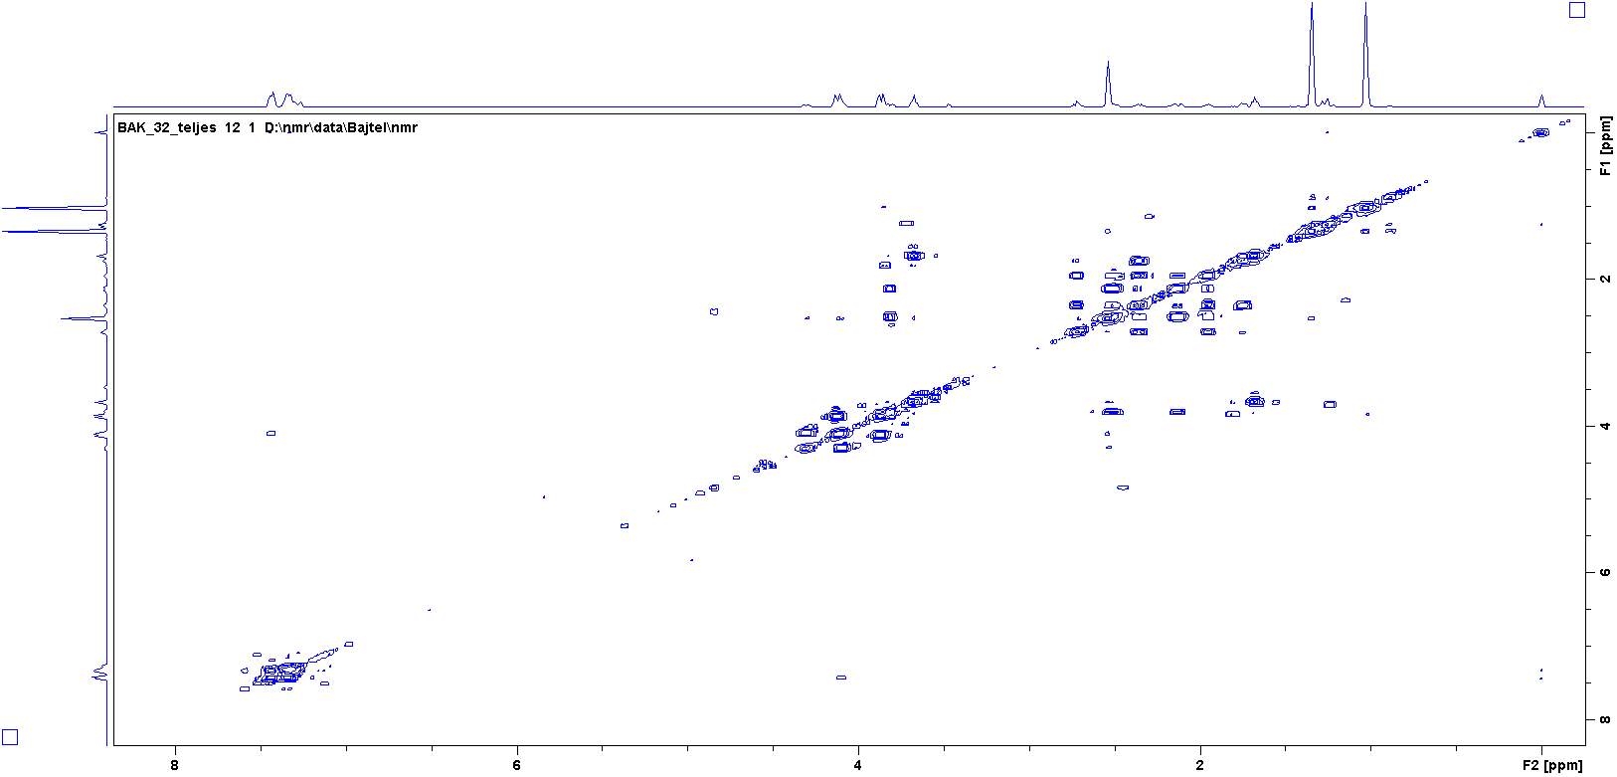
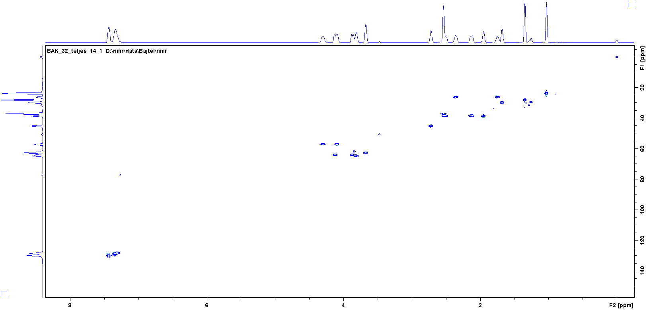
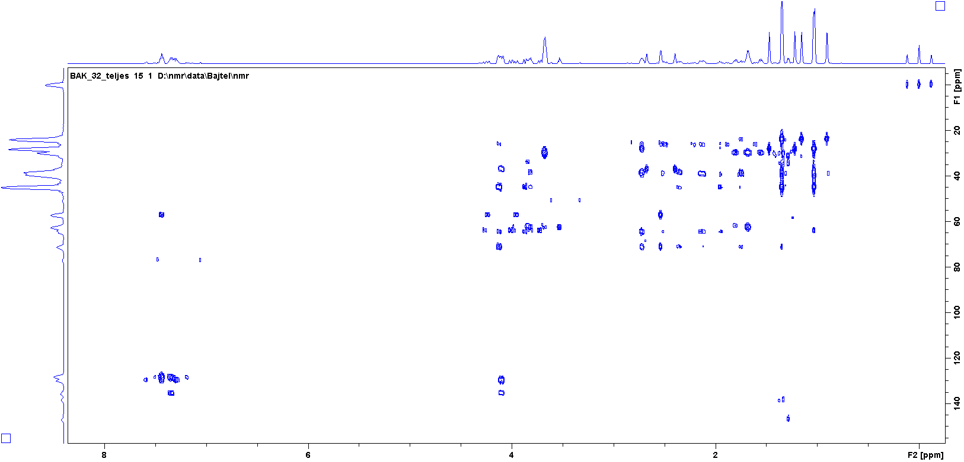

¹H, ¹³C NMR, COSY, NOESY, HSQC and HMBC of 17 (DMSO-d₆)
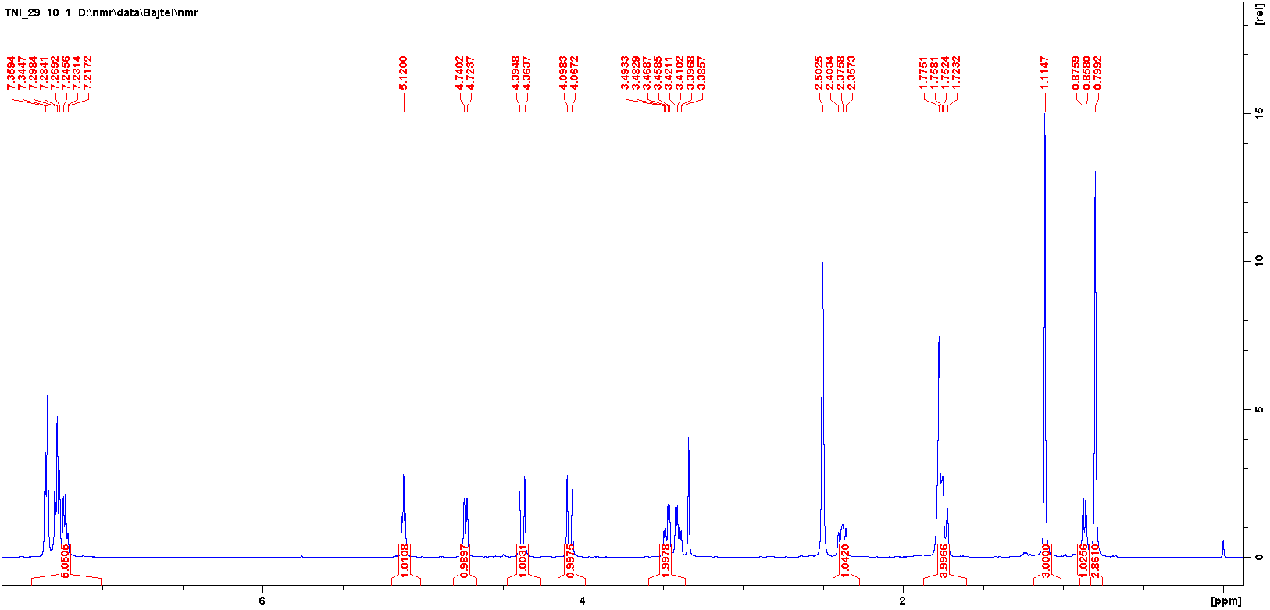
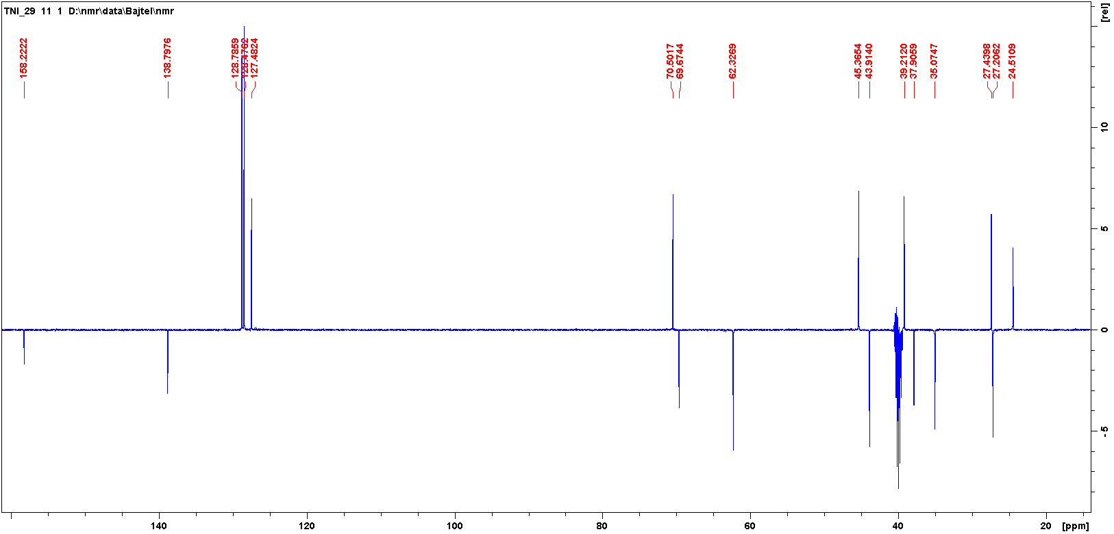

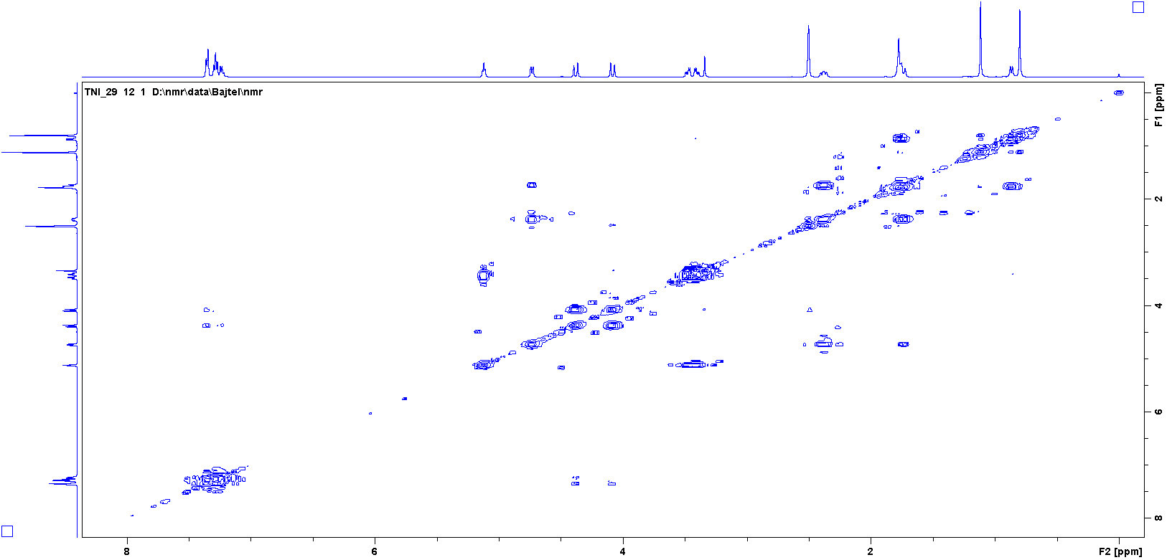

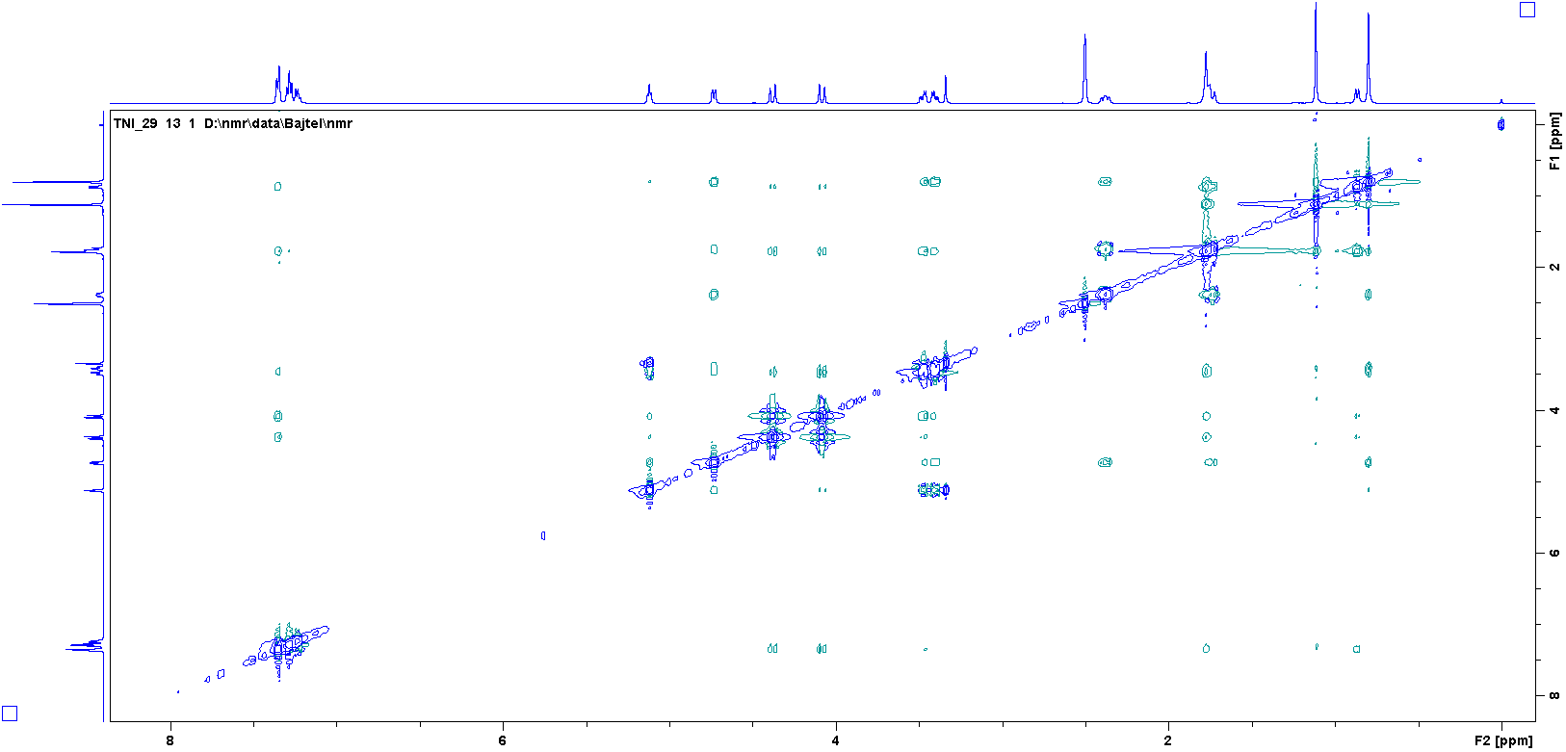

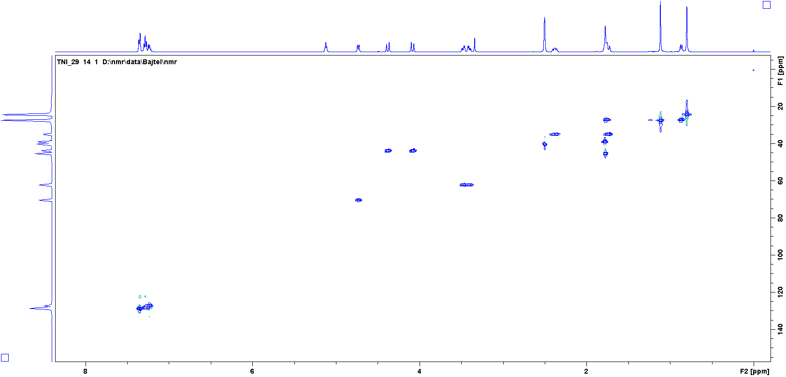

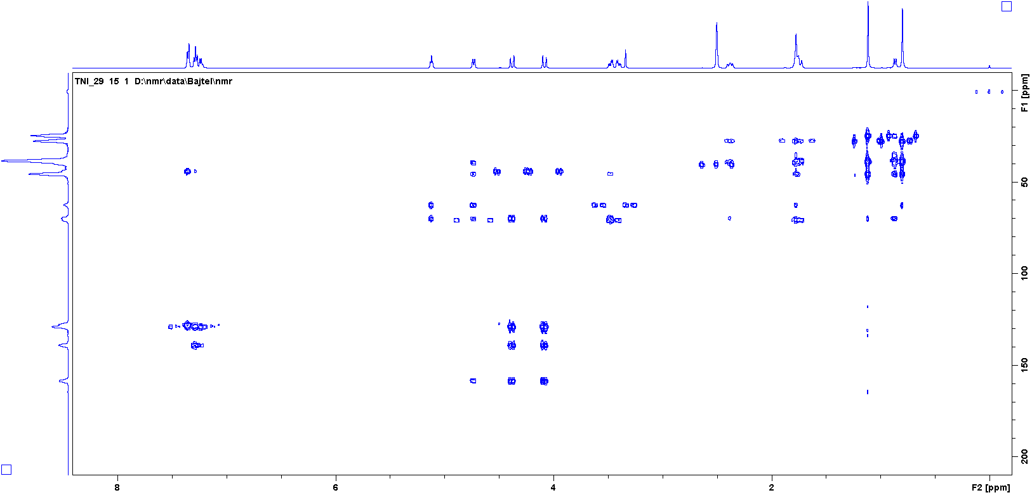

¹H, ¹³C NMR, COSY, HSQC and HMBC of 18 (CDCl₃)
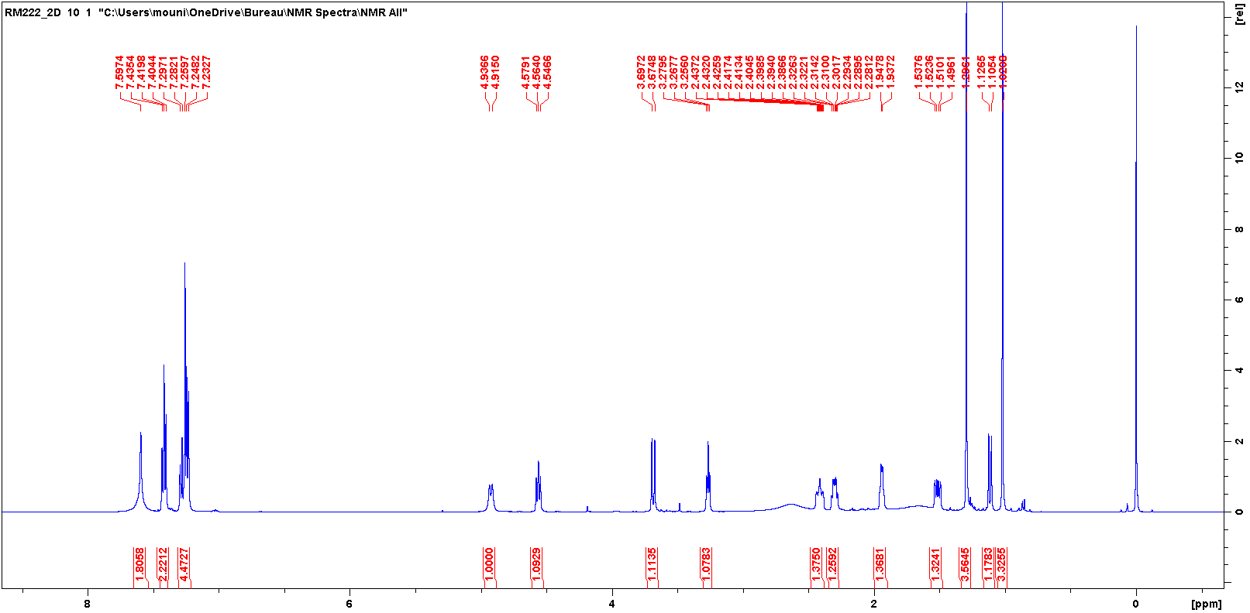
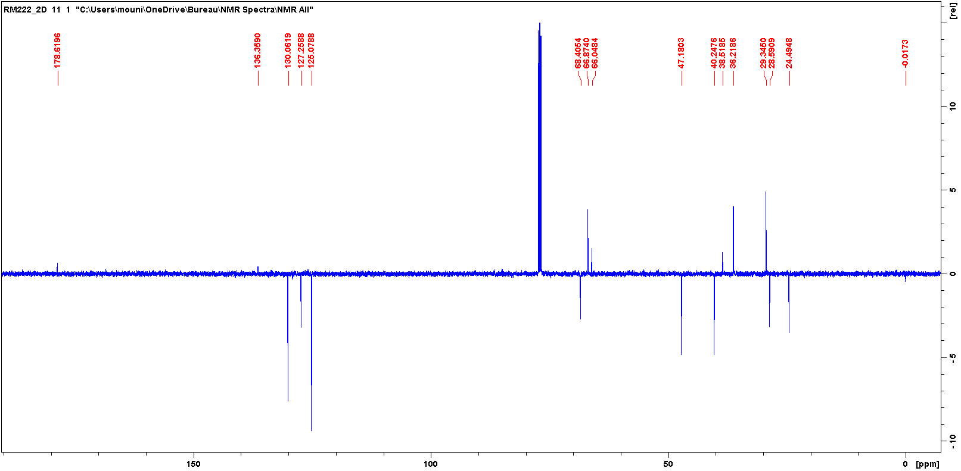
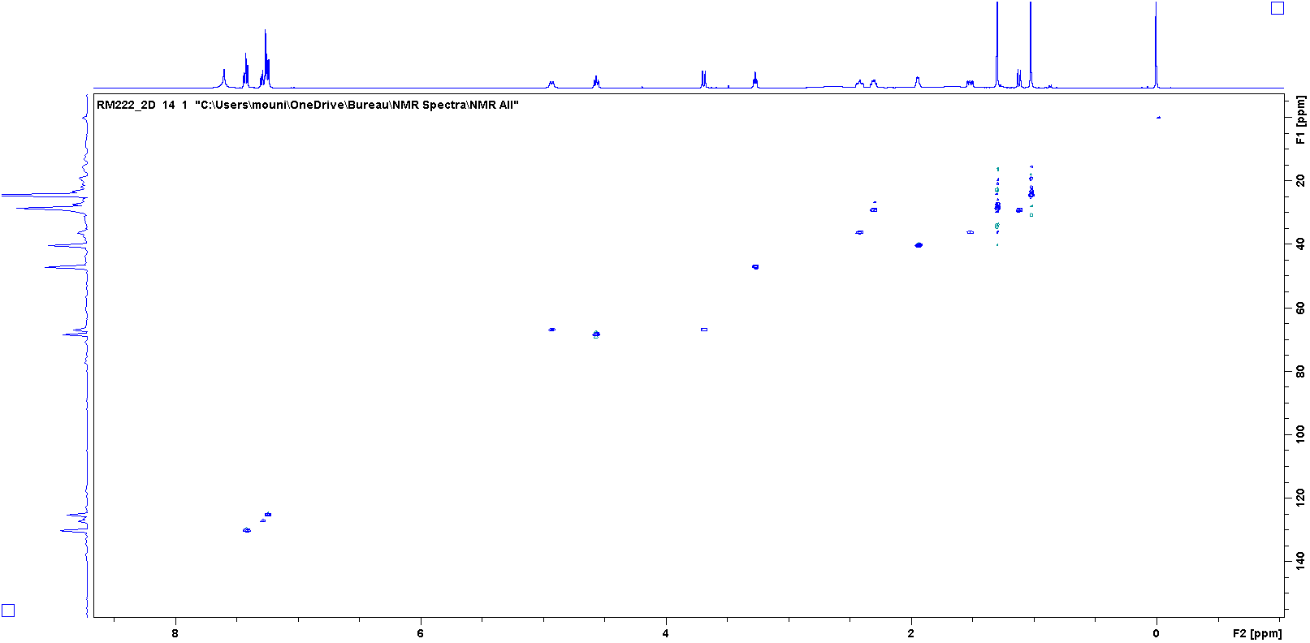
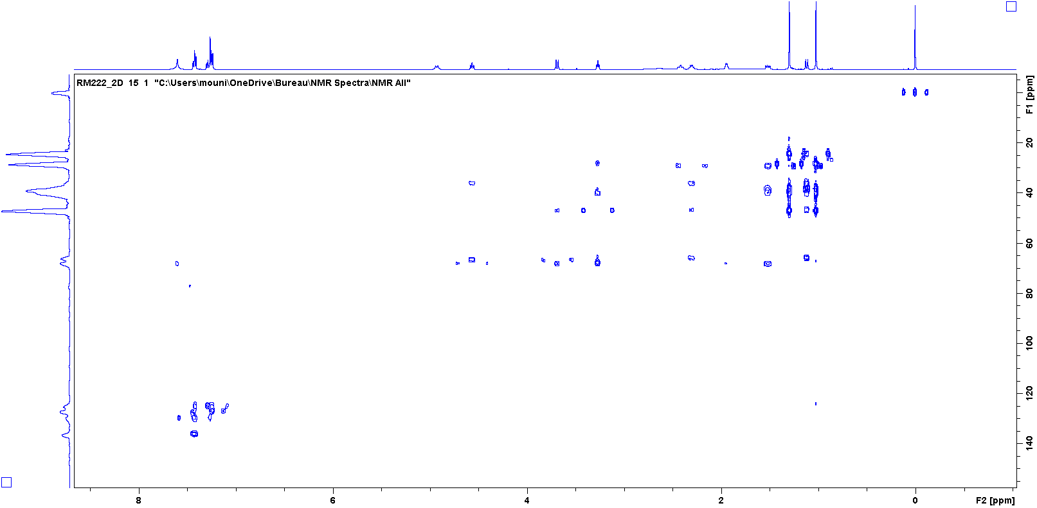
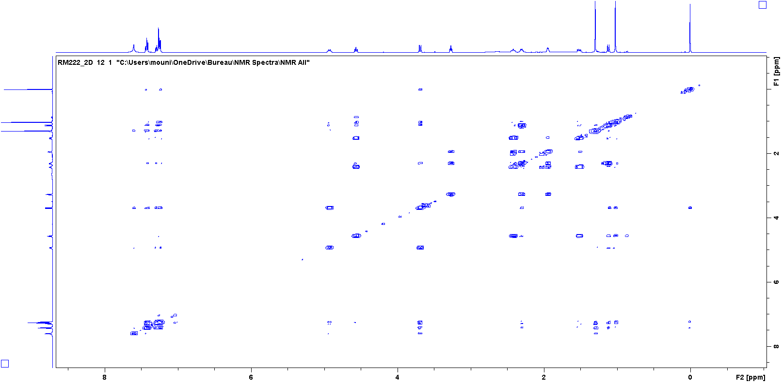

¹H, ¹³C NMR, COSY, NOESY, HSQC and HMBC of 19A (CDCl₃)
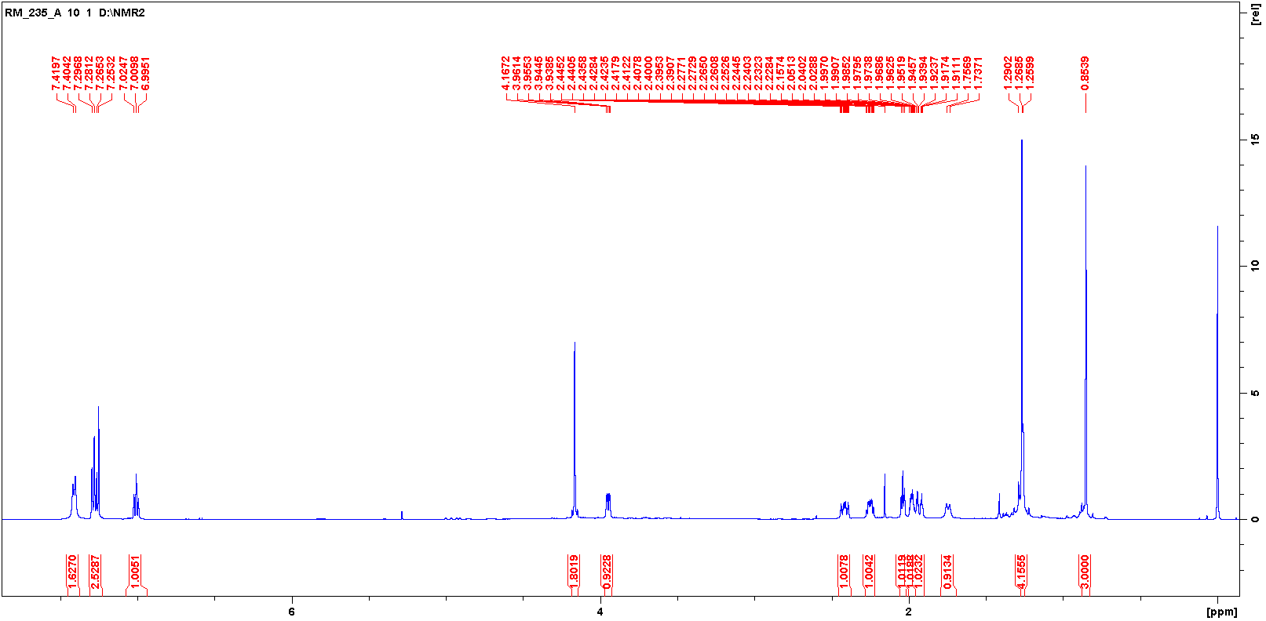
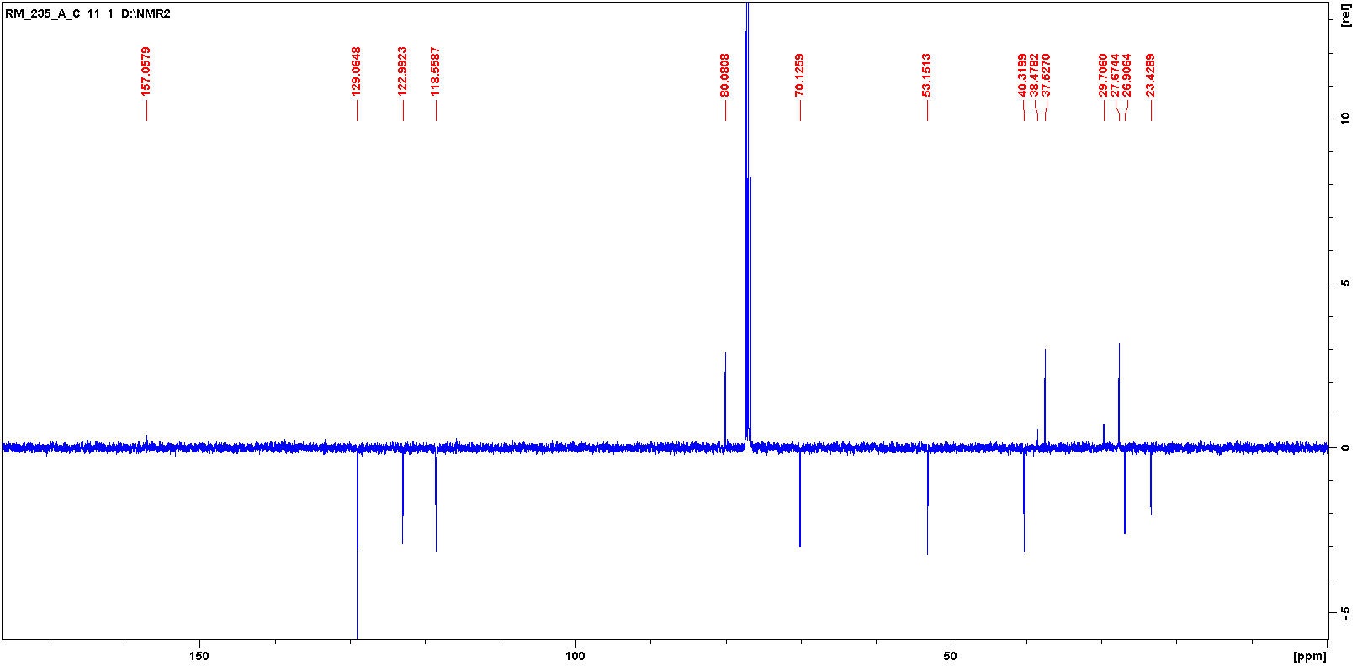
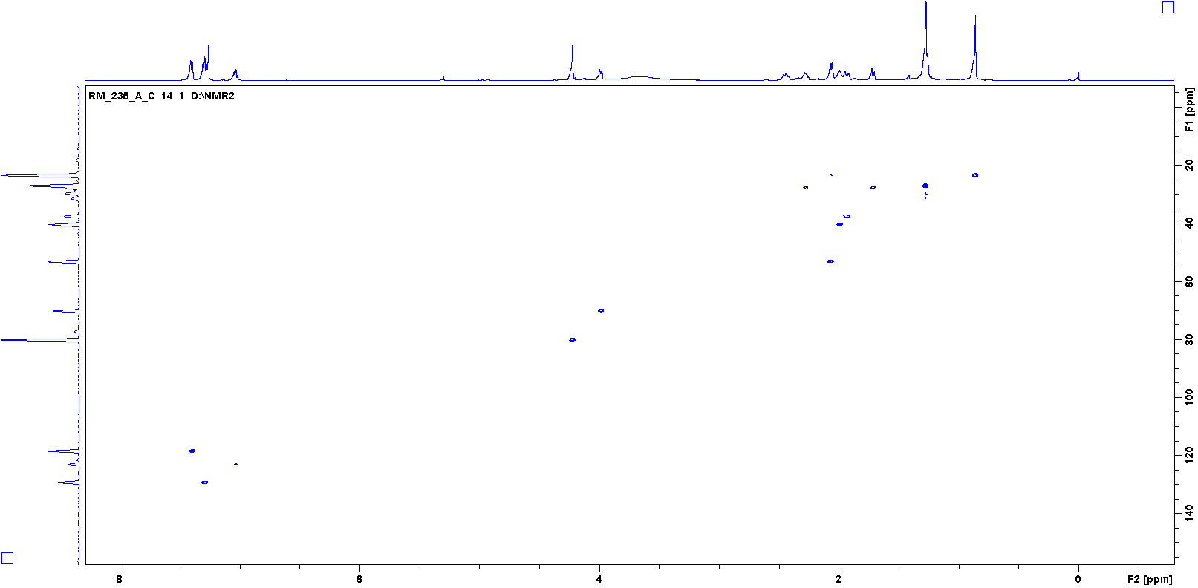
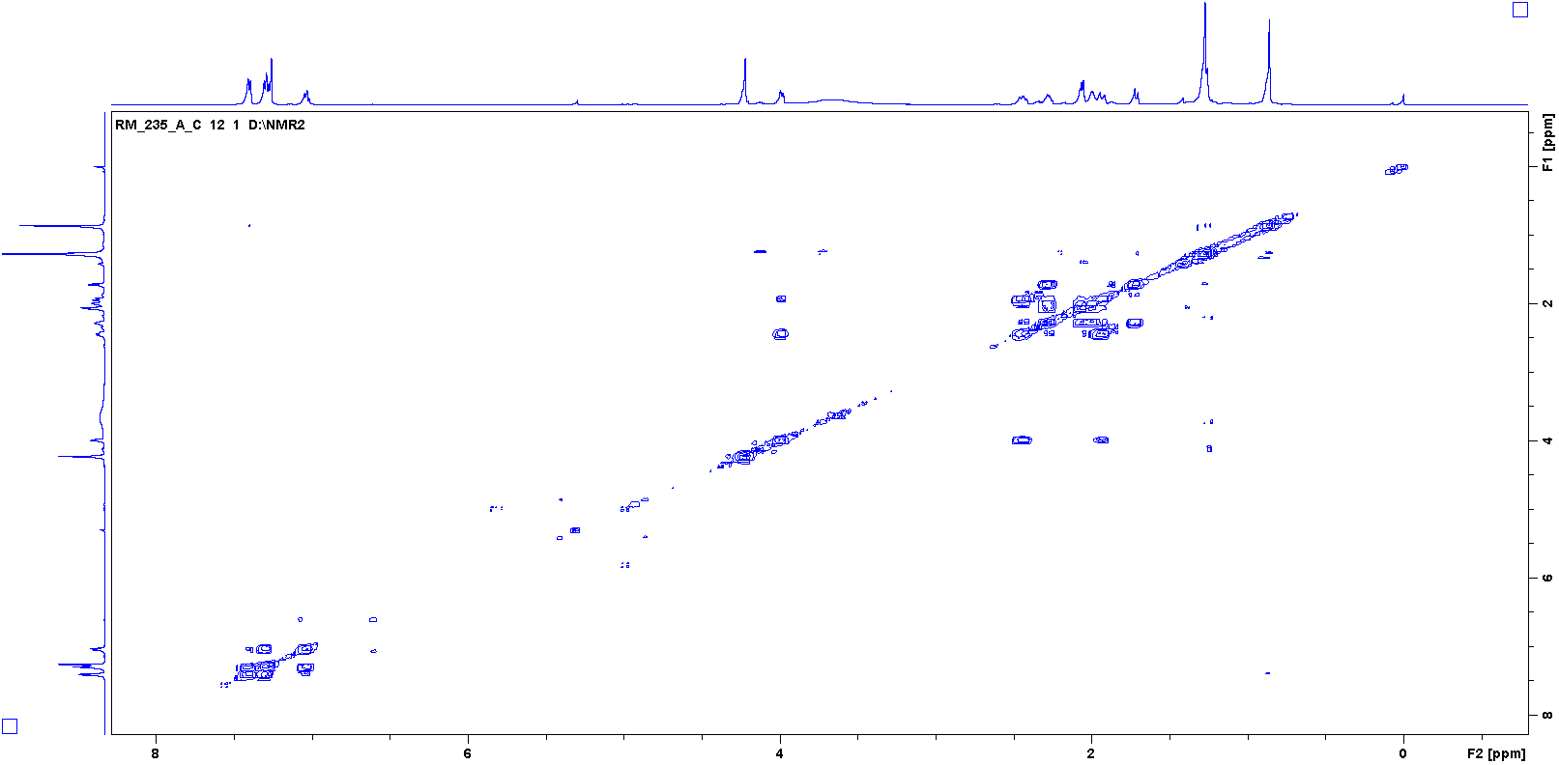
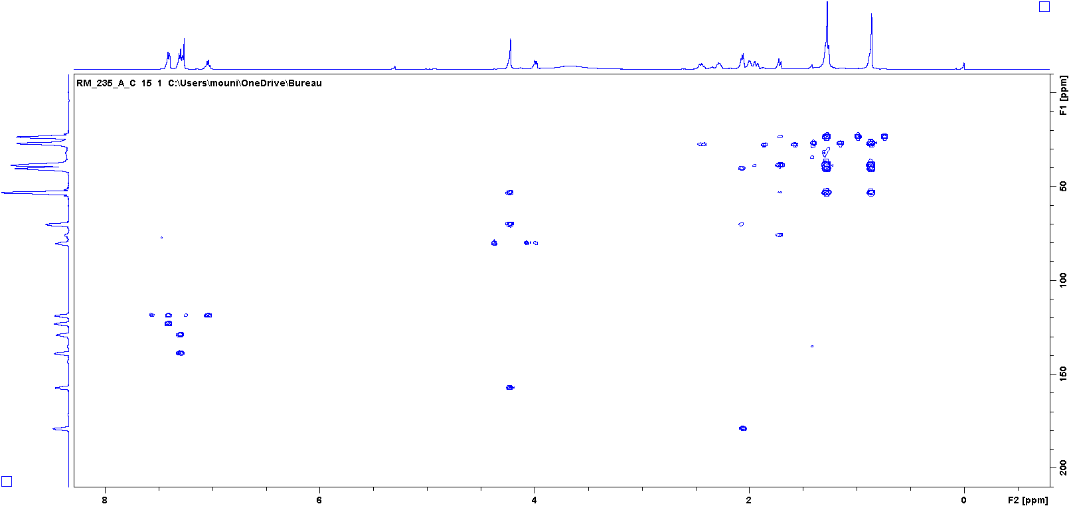
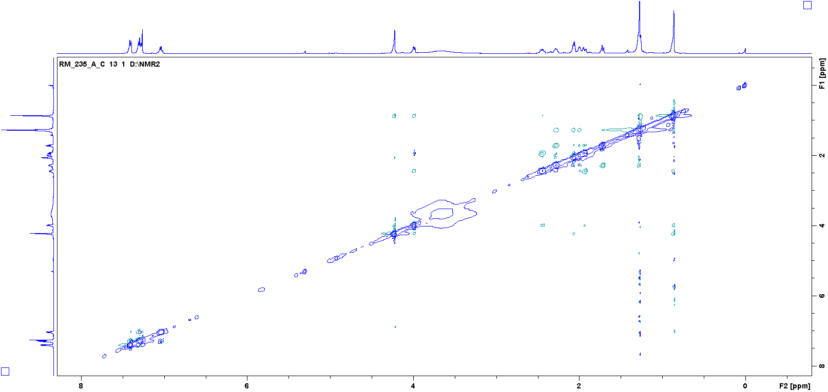

¹H, ¹³C NMR, COSY,NOESY, HSQC and HMBC of 13A-E (CDCl₃)

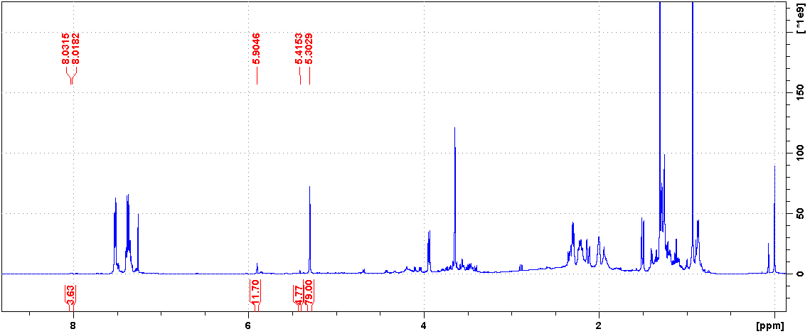
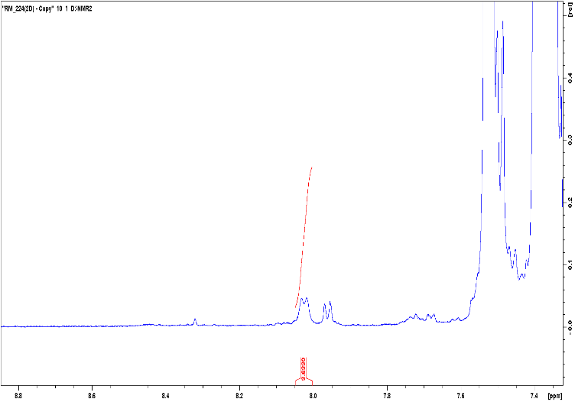
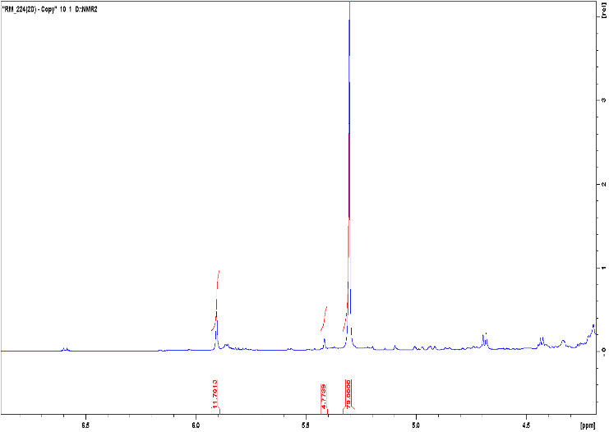

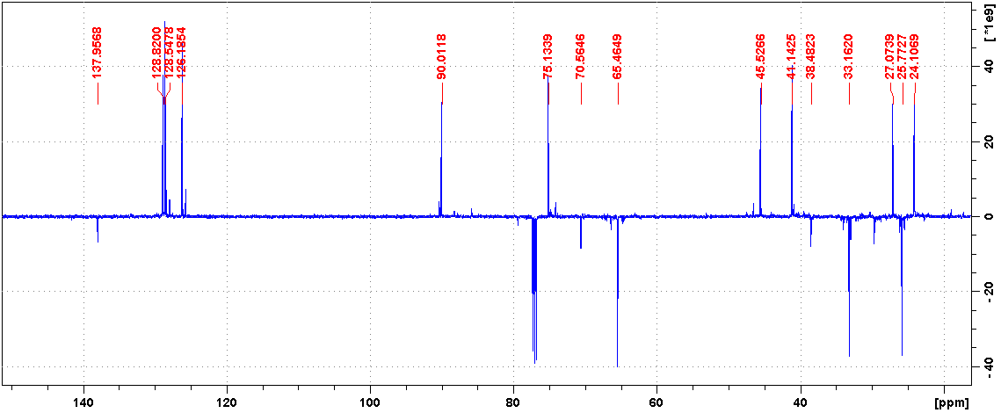
13A-E
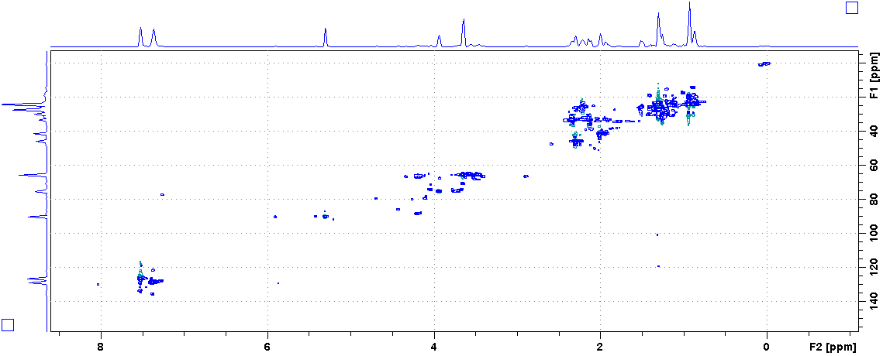
13A-E
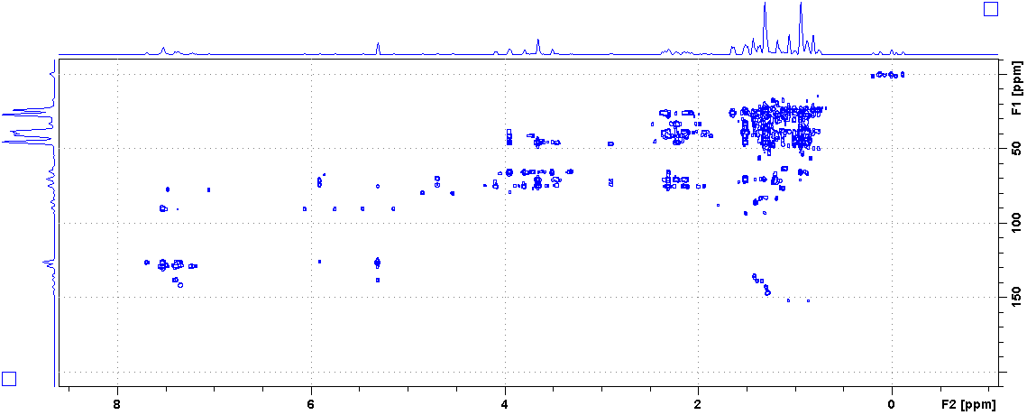
13A-E
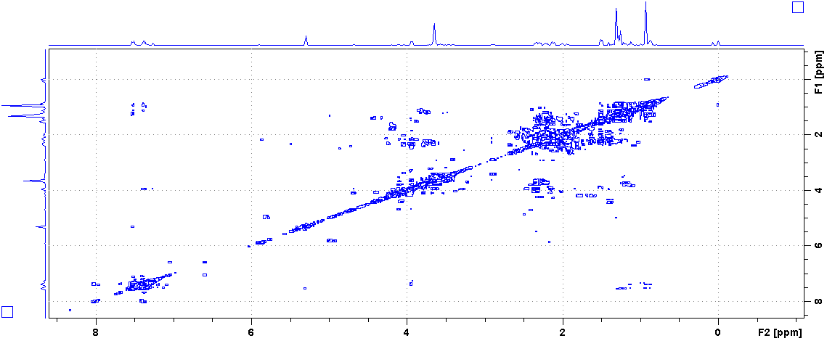
13A-E
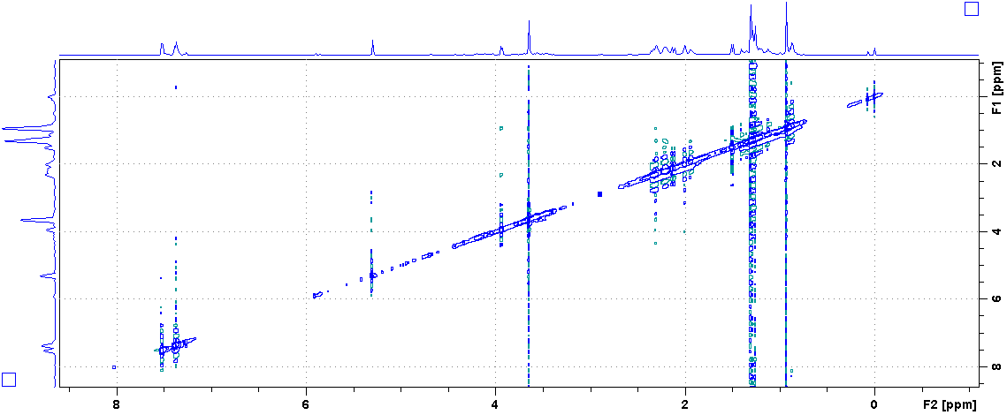
13A-E
¹H, ¹³C NMR, HSQC, HMBC, COSY and NOESY of 19B (CDCl₃)
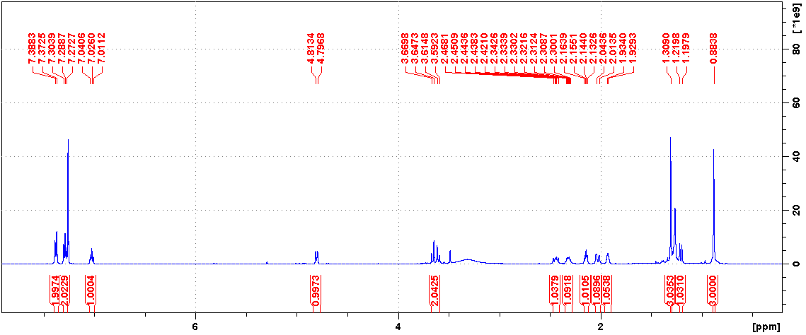
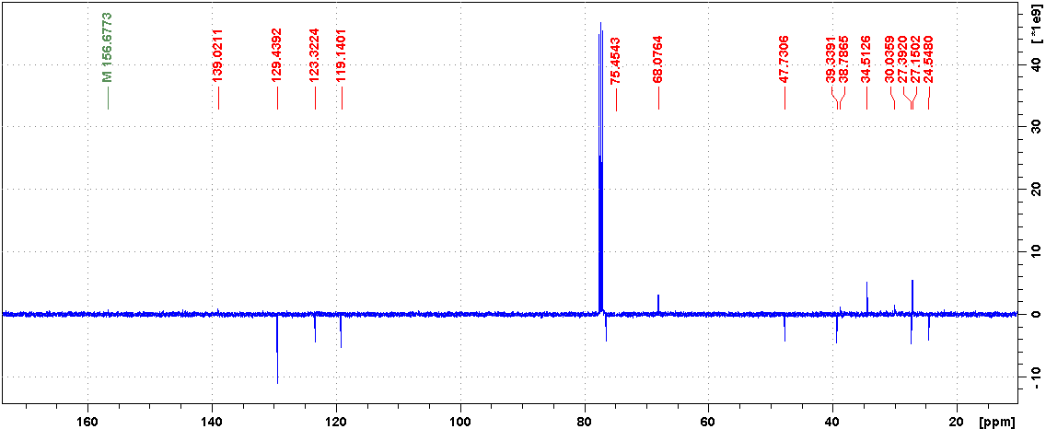
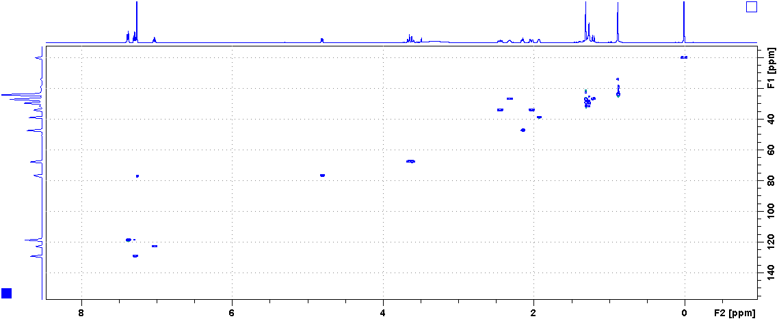
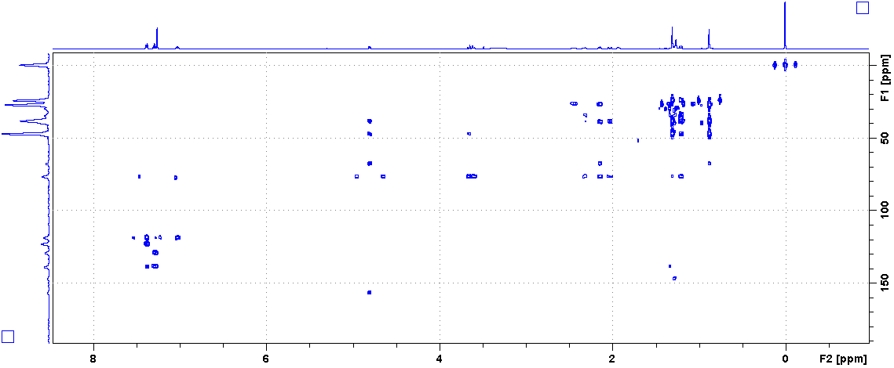
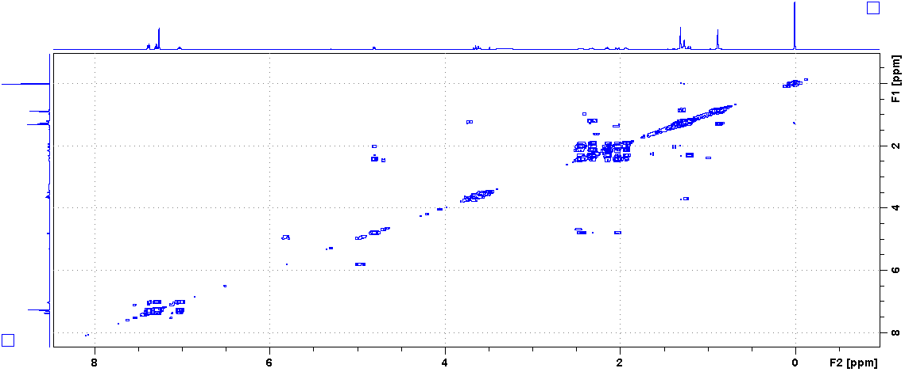
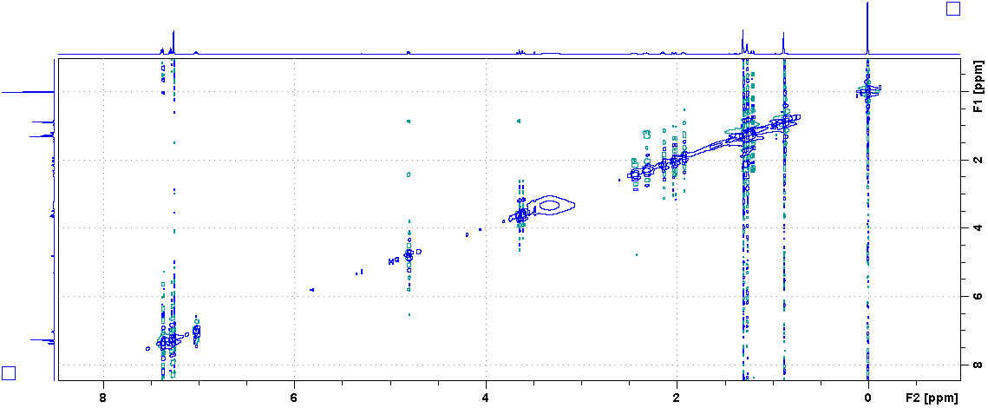

Time-dependent tautomerisation of 19A to 19B in CDCl₃ solution
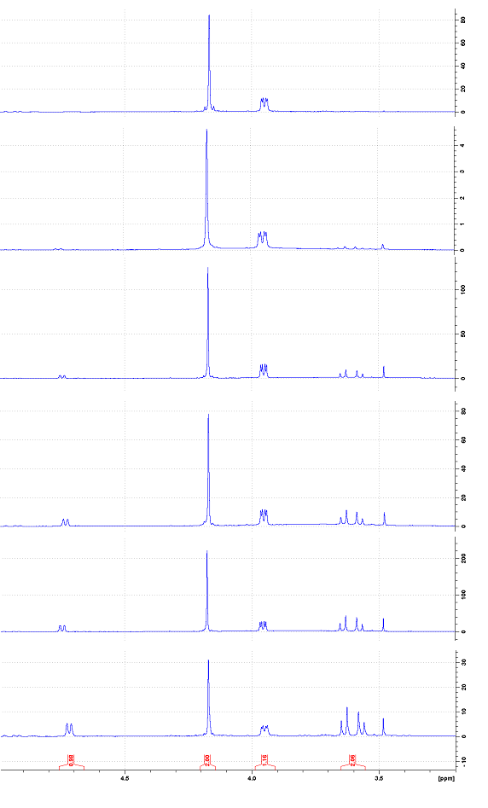
10 days
5 days
17 days
24 days
30 days

X-Ray structure determinations
The crystals of 7 and 15 were immersed in cryo-oil, mounted in a loop, and measured at a temperature of 120 K. The X-ray diffraction data were collected on a Rigaku Oxford Diffraction Supernova diffractometer using Cu Kα radiation. The CrysAlisPro software package was used for cell refinements and data reductions. A multi-scan (7) or an analytical absorption correction (15) was applied to the intensities before structure solutions by using CrysAlisPro software. The structures were solved by intrinsic phasing (SHELXT) method. Structural refinements were carried out using SHELXL software with SHELXLE graphical user interface. The NH and OH hydrogen atoms were located from the difference Fourier map and refined isotropically. All other hydrogen atoms were positioned geometrically and constrained to ride on their parent atoms, with C-H = 0.95-1.00 Å and U_{iso} = 1.2-1.5 U_{eq}(parent atom). The crystallographic details are summarized in Table S1. The deposition number CCDC 2063842 (7) and CCDC 2063843 (15) contain supplementary crystallographic data for this paper. These data can be obtained free of charge from The Cambridge Crystallographic Data Centre via http://www.ccdc.cam.ac.uk/conts/retrieving.html (or from the Cambridge Crystallographic Data Centre, 12 Union Road, Cambridge CB2 1EZ, UK; Fax: (internat.) + 44-1223-336-033; E-mail: deposit@ccdc.cam.ac.uk)

Table S1. Crystal Data.
 | 7 | 15
empirical formula | C₁₁H₁₇NO₃ | C₁₈H₂₅NO₂
fw | 211.25 | 287.39
temp (K) | 120(2) | 120(2)
λ(Å) | 1.54184 | 1.54184 Å
cryst syst | Monoclinic | Monoclinic
space group | P2₁ | P2₁
a (Å) | 7.93530(6) | a = 8.41050(10)
b (Å) | 10.89885(6) | b = 7.23460(10)
c (Å) | 12.63719(8) | c = 13.4036(2)
β (deg) | 97.9249(7) | β= 102.960(2)°
V (Å³) | 1082.498(12) | 794.79(2)
Z | 4 | 2
ρ_{calc} (Mg/m³) | 1.296 | 1.201
μ(Mo Kα) (mm⁻¹) | 0.770 | 0.608
No. reflns. | 24009 | 16590
Unique reflns. | 4528 | 3329
GOOF (F²) | 1.042 | 1.038
R_{int} | 0.0194 | 0.0310
R1ª (I ≥ 2σ) | 0.0249 | 0.0305
wR2^{b} (I ≥ 2σ) | 0.0664 | 0.0766
ª R1 = Σ||F_{o}| – |F_{c}||/Σ|F_{o}|. ^{b} wR2 = [Σ[w(F_{o}² – F_{c}²)²]/ Σ[w(F_{o}²)²]]^{1/2}.

