Supporting Information
Substituted Nitrogen-Bridged Diazocines
Pascal Lentes, Jeremy Rudtke and Rainer Herges*
Otto Diels-Institute of Organic Chemistry, Christian Albrechts University Kiel, Otto Hahn Platz 4, 24118 Kiel, Germany. E-mail: rherges@.uni-kiel.de

Table of Contents

I. Analytical equipment·····························································································1-2
II. Syntheses·········································································································2-30
III. UV-Vis switching experiments··············································································31-41
IV. ¹H-NMR switching experiments············································································42-49

I. Analytical equipment
NMR spectroscopy
NMR spectra were measured in deuterated solvents (Deutero). The spectra were referenced to the following solvent residual signals:
solvent | degree of deuteration | ¹H signal  (ppm) | ¹³C signal  (ppm)
acetone-d₆ | 99.8 % | 2.05 (quintet) | 29.84 (septet)
chloroform-d₁ | 99.8 % | 7.26 (singlet) | 77.16 (triplet)
CD₃CN | 99.5 % | 1.94 (quintet) | /
water-d₂ | 99.9 % | 4.79 (singlet) | /
Spectra were recorded with a Bruker AC 200 (¹H NMR: 200 MHz), a Bruker DRX 500 (¹H NMR: 500 MHz, ¹³C NMR: 125 MHz), and a Bruker AV 600 (¹H NMR: 600 MHz, ¹³C NMR: 150 MHz). The multiplicities of the signals were abbreviated with s (singlet), d (doublet), t (triplet), q (quartet), quint (quintet), m (multiplet) and br. (broad) in addition for broad signals.

Melting point
Melting points were measured with a Melting Point B-540 (Büchi) in melting point tubes without further correction.

Mass spectrometry
Mass spectra (EI) and high-resolution mass spectra (HR-EI) were measured with an AccuTOF GCv 4G (Joel) with an ionization energy of 70 eV. HR-ESI mass spectra were measured with a Q Exactive Plus (Thermo Scientific).

IR spectroscopy
Infrared spectra were measured with a Perkin-Elmer 1600 Series FT-IR spectrometer with an A531-G Golden-Gate-Diamond-ATR-unit. Signals were abbreviated with w (weak), m (medium), s (strong) for its intensity.

Chromatography
Silica gel (Merck, particle size 0.040-0.063 mm) was used for column chromatography purifications. R_{f} values were determined by thin layer chromatography on Polygeram® SilG/UV254 (Macherey Nagel, 0.2 mm particle size).

UV-vis spectroscopy
UV-vis spectra were measured with a Lambda 650 spectrometer (Perkin-Elmer) and quartz cuvettes of 10 mm optical path length were used.
Chemicals
All commercially available chemicals and solvents were used without purification.
Light sources
For exposure experiments with 400 nm, a custom-built LED light source was used. Irradiation wavelength of the 400 nm LED light source was measured via a mobile UV-vis spectrometer (USB4000-UV-vis, Ocean Optics, Largo, FL, USA).
Figure SI.1: Emission spectrum of 400 nm LED light source. The full width at half maximum (FWHM) amounts to 12 nm (396-401 nm, maximum at 401 nm).

II. Syntheses

II.1 Synthesis of (9H-fluorene-9-yl)methyl (2-aminobenzyl)(2-aminophenyl)carbamate
(9H-Fluorene-9-yl)methyl (2-aminophenyl)(2-nitrobenzyl)carbamate (6.80 g, 14.6 mmol) was dissolved in 500 mL of ethanol and 250 mL of a 1m NH₄Cl solution in water was added. It was heated to 75 °C and zink-powder (7.64 g, 117 mmol, 8 eq) was added. The reaction mixture was stirred at 75 °C for 1 h and then hot filtrated. The solvent was evaporated and to the residue was added 500 mL of DCM and 500 mL of deionized water. The organic layer was separated and was extracted twice with DCM. The combined organic layers were dried over MgSO₄ and the solvent was evaporated. The crude product, a white powder (6.36 g, 14.6 mmol, quant.) was used without further purification.

melting point: 75.7 °C
¹H NMR (600 MHz, acetone-d₆, 298 K): δ = 7.79 (d, ³J = 6.9 Hz, 1 H, Ar-H), 7.54-6.31 (m, 14 H, Ar-H), 5.04-3.95 (m, 5 H, aliph. H) ppm.
¹³C NMR (150 MHz, acetone-d₆, 298 K): δ = 131.28, 130.86, 130.47, 130.27, 129.76, 129.32, 128.77, 128.47, 128.44, 127.88, 127.85, 127.81, 126.60, 126.45, 126.25, 124.11, 123.92, 123.75, 121.30, 121.15, 120.69, 120.63, 119.96, 119.78, 117.64, 117.24, 116.65, 115.90, 68.71, 68.34, 67.87, 50.66, 49.63, 49.38, 47.96, 47.84 ppm.
IR (ATR): ṽ = 3353 (w), 3038 (w), 1618 (s), 1621 (m), 1501 (m), 1450 (m), 1409 (s), 1356 (w), 1310 (s), 1276 (s), 1215 (w), 1128 (m), 1069 (w), 1007 (w), 979 (m), 939 (w), 860 (w), 739 (s), 631 (m), 621 (w), 602 (w), 552 (w), 525 (m) cm⁻¹.
MS (ESI HR, CHCl₃/MeOH): m/z (C₂₈H₂₅N₃O₂+H⁺) = calc.: 436.20195, found: 436.20159 ± 0.84 ppm.
Figure SII.1: ¹H NMR spectrum of the given aniline compound.
Figure SII.2: ¹³C NMR spectrum of the given aniline compound.

II.2 Synthesis of (9H-fluorene-9-yl)methyl (Z)-dibenzo[c,g][1,2,5]triazocine-11(12H)-carboxylate (8c)
(9H-Fluorene-9-yl)methyl (2-aminobenzyl)(2-aminophenyl)carbamate (3.70 g, 8.50 mmol) was dissolved in 250 mL of acetic acid and mCPBA (3.81 g, 17.0 mmol, ≥ 77%) in 250 mL of acetic acid was added dropwise over a period of 2 h. The reaction mixture was stirred at rt. over night and after that, the solvent was evaporated. To the residue was added 100 mL of DCM and 250 mL of half-concentrated NaHCO₃ solution in deionized water and the organic layer was separated. It was extracted twice with DCM and the combined organic layers were dried over MgSO₄. The solvent was evaporated and flash column chromatography on silica (0.040-0.063 mm, ethyl acetate/cyclohexane = 1:3, R_{f} = 0.38) gave a yellow solid (8c, 2.28 g, 5.28 mmol, 62%).

¹H NMR (200 MHz, acetone-d₆, 300 K): δ = 7.83 (d, ³J = 7.2 Hz, 2 H, Ar-H), 7.73-6.73 (m 14 H, Ar-H), 5.12-3.94 (m, 5 H, aliph. H) ppm.

Figure SII.3: ¹H NMR spectrum of compound 8c.

II.3 Synthesis of Chloral
Under a nitrogen atmosphere, 5 mL of concentrated H₂SO₄ was added to chloral hydrate (10.0 g, 60.5 mmol) and chloral (6.31 g, 42.8 mmol, 71%) was directly distilled out of the reaction mixture with a vigreux condenser.
boiling point: 98 °C
¹H NMR (200 MHz, CDCl₃, 300 K): δ = 9.06 (s, 1 H, CHO) ppm.
Figure SII.4: ¹H NMR spectrum of chloral.

II.4 Synthesis of (Z)-dibenzo[c,g][1,2,5]triazocine-11(12H)-carbaldehyde (11c)
Under a nitrogen atmosphere, (Z)-11,12-dihydrodibenzo[c,g][1,2,5]triazocine¹ 9c (100 mg, 478 µmol) was dissolved in MeCN (10 mL anhydrous), and DIPEA (832 µL, 4.78 mmol) and chloral (466 µL, 4.78 mmol) were added. The reaction mixture was stirred at rt. for 21 h. The solvent was removed and separation of the products by flash column chromatography on silica (0.040-0.063 mm, ethyl acetate/cyclohexane = 1:2, R_{f} = 0.33) gave a pale yellow solid (11c, 86 mg, 362 µmol, 76%).

melting point: 206.5 °C
¹H NMR (500 MHz, acetone-d₆, 298 K): δ = 8.38 (s, 1 H, CHO), 7.38 (td, ³J = 7.7 Hz, ⁴J = 1.3 Hz, 1 H, H-2), 7.34-7.28 (m, 2 H, H-1, H-3), 7.24-7.17 (m, 2 H, H-8, H-9), 7.15 (dd, ³J = 7.9 Hz, ⁴J = 1.2 Hz, 1 H, H-4), 7.01 (dd, ³J = 7.9 Hz, ⁴J = 1.1 Hz, 1 H, H-7/10), 6.91 (dd, ³J = 7.8 Hz, ⁴J = 1.5 Hz, 1 H, H-7/10), 4.52 (m_{c}, 2 H, CH₂) ppm.
¹³C NMR (125 MHz, acetone-d₆, 298 K): δ = 162.27 (C=O), 157.61 (C-12a), 152.96 (C-4a), 131.38 (C-1), 130.31 (C-2), 129.10 (C-8/9), 128.98 (C-8/9), 128.73 (C-3), 128.06 (C-4), 123.15 (C-6a/10a), 120.46 (C-7/10), 119.30 (C-7/10), 49.47 (CH₂) ppm.
IR (ATR): ṽ = 2251 (w), 1662 (s), 1587 (w), 1514 (w), 1476 (m), 1439 (w), 1367 (w), 1309 (s), 1273 (m), 1242 (m), 1152 (w), 1040 (w), 1015 (w), 944 (w), 916 (w), 857 (w), 804 (w), 774 (s), 755 (s), 727 (s), 687 (m), 661 (w),631 (w), 596 (w), 550 (s), 538 (m) cm⁻¹.
MS (ESI HR, CHCl₃/MeOH): m/z (C₁₄H₁₁⁷⁹BrN₃O+H⁺) = calc.: 238.09749, found: 238.09758 ± 0.39 ppm.
Figure SII.5: ¹H NMR spectrum of compound 11c.
Figure SII.6: ¹³C NMR spectrum of compound 11c.

II.5 Synthesis of tert-butyl (2-((4-bromo-2-nitrobenzyl)amino)phenyl)carbamate (4a)
Under a nitrogen atmosphere, a solution of tert-butyl (2-aminophenyl)carbamate¹ (2, 2.62 g, 12.6 mmol) in 50 mL of abs. THF was prepared, and then triethylamine (4.30 mL, 13.5 mmol) and 4-bromo-1-(bromomethyl)-2-nitrobenzene (3a, 3.72 g, 12.6 mmol) was added. The reaction mixture was refluxed for 20 h and after that, the solvent was evaporated. 50 mL of water and 50 mL of DCM were added to the residue. The organic layer was separated and it was extracted twice with 50 mL of DCM. The combined organic layers were dried over MgSO₄ and the solvent was evaporated. Recrystallization from cyclohexane/ethyl acetate (1:1) gave a yellow solid (4a, 3.03 g, 8.85 mmol, 71%).

melting point: 151.1 °C
¹H NMR (500 MHz, acetone-d₆, 298 K): δ = 8.24 (d, ⁴J = 2.0 Hz, 1 H, Ar^{II}-H-6), 7.83 (dd, ³J = 8.4 Hz, ⁴J = 2.0 Hz, 1 H, Ar^{II}-H-4), 7.73 (d, ³J = 8.4 Hz, 1 H, Ar^{II}-H-3), 7.63 (s, 1 H, NH ), 7.25 (d, ³J = 7.6 Hz, 1 H, Ar^{I}-H-2), 6.93 (td, ³J = 7.6 Hz, ⁴J = 1.5 Hz, 1 H, Ar^{I}-H-4), 6.64 (td, ³J = 7.6 Hz, ⁴J = 1.3 Hz, 1 H, Ar^{I}-H-3), 6.50 (dd, ³J = 7.6 Hz, ⁴J = 1.1 Hz, 1 H, Ar^{I}-H-5), 5.59-5.42 (m, 1 H, NH ), 4.76 (d, ³J = 6.2 Hz, 2 H, CH₂), 1.47 (s, 9H, CH₃) ppm.
¹³C NMR (125 MHz, acetone-d₆, 298 K): δ = 155.13 (C=O), 150.02 (Ar^{II}-C-1), 142.84 (Ar^{I}-C-6), 137.22 (Ar^{II}-C-4), 136.28 (Ar^{II}-C-2), 132.44 (Ar^{II}-C-3), 128.32 (Ar^{II}-C-6), 127.11 (Ar^{I}-C-4), 126.87 (Ar^{I}-C-2), 125.50 (Ar^{I}-C-1), 120.93 (Ar^{II}-C-5), 118.02 (Ar^{I}-C-3), 112.35 (Ar^{I}-C-5), 79.90 (C-(CH₃)₃), 45.09 (-CH₂), 28.58 (-CH₃) ppm.
IR (ATR): ṽ = 3400 (m), 3270 (w), 2976 (w), 1686 (m), 1604 (m), 1528 (s), 1462 (m), 1348 (w), 1151(s) 830 (m), 753 (m) cm⁻¹.
MS (EI, 70 eV): m/z (%) = 421.06 (3) [M]⁺, 365.00 (13) [C₁₄H₁₂BrN₃O₄]⁺, 321.01 (9) [C₁₃H₁₂BrN₃O₂]⁺, 286.99 (18) [C₁₃H₁₀BrN₃]⁺, 197.95 (14) [C₇H₇BrN₂]⁺, 119.06 (32) [C₇H₇N₂]⁺, 107.06 (32) [C₆H₇N₂]⁺.
MS (HR) (EI, 70 eV): m/z (C₁₈H₂₀⁷⁹BrN₃O₄) = calc.: 421.06372, found: 421.06392 ± 0.49 ppm.

Figure SII.7: ¹H NMR spectrum of compound 4a.
Figure SII.8: ¹³C NMR spectrum of compound 4a.

II.6 Synthesis of (9H-fluorene-9-yl)methyl (4-bromo-2-nitrobenzyl)(2-((tert-butoxycarbonyl)-amino)phenyl)carbamate (5a)
Under a nitrogen atmosphere, a solution of tert-butyl (2-((4-bromo-2-nitrobenzyl)amino)phenyl)carbamate (4a, 1.70 g, 4.94 mmol) in anhydrous DMF (20 mL) was prepared, and then DIPEA (861 µL, 4.94 mmol) and 9-Fluorenylmethoxycarbonyl chloride (2.40 g, 9.89 mmol) dissolved in anhydrous DMF (20 mL) were added. The reaction mixture was stirred at rt. for 48 h and after that, the solvent was evaporated. 50 mL of water and 50 mL of DCM were added to the residue. The organic layer was separated and it was extracted twice with DCM. The combined organic layers were dried over MgSO₄ and the solvent was evaporated. Flash column chromatography on silica (0.040-0.063 mm, ethyl acetate/cyclohexane = 1:3, R_{f} = 0.44) gave a colorless solid (5a, 1.78 g, 2.76 mmol, 56%).

melting point: 164.3 °C
¹H NMR (500 MHz, acetone-d₆, 298 K): δ = 8.14 (d, ⁴J = 2.1 Hz, 1 H), 8.03-7.66 (m, 5 H), 7.55-7.00 (m, 10 H), 5.27-4.88 (m, 2 H, aliph. H), 4.61-3.96 (m, 3 H, aliph. H), 1.46 (s, 9H, CH₃) ppm.
¹³C NMR (125 MHz, acetone-d₆, 298 K): δ = 155.54 (C=O), 142.10, 137.03, 129.18, 128.49, 128.20, 127.86, 126.07, 124.43, 120.74, 80.46, 68.43, 47.83, 28.48 (CH₃) ppm.
IR (ATR): ṽ = 3380 (w), 2977 (w), 1719 (s), 1595 (w), 1535 (s), 1518 (s), 1477 (w), 1450 (m), 1390 (m), 1342 (m), 1292 (m), 1278 (m), 1218 (m), 1187 (m), 1153 (s), 1042 (w), 1025 (w), 976 (w), 942 (w), 933 (w), 885 (w), 843 (w), 801 (w), 756 (s), 739(s), 670 (w), 645 (w), 618 (m), 535 (m) cm⁻¹.
MS (ESI HR, CHCl₃/MeOH): m/z (C₃₃H₃₀⁷⁹BrN₃O₆+H⁺) = calc.: 644.13907, found: 644.13932 ± 0.38 ppm.

Figure SII.9: ¹H NMR spectrum of compound 5a.
Figure SII.10: ¹³C NMR spectrum of compound 5a.

II.7 Synthesis of (9H-fluorene-9-yl)methyl (2-aminophenyl)(4-bromo-2-nitrobenzyl)carbamate (6a)
(9H-Fluorene-9-yl)methyl (4-bromo-2-nitrobenzyl)(2-((tert-butoxycarbonyl)-amino)phenyl)carbamate 5a (1.20 g, 1.86 mmol) was dissolved in 25 mL of DCM and 15 mL of TFA was added. The reaction mixture was stirred at rt. for 16 h and then neutralized with saturated aqueous NaHCO₃. The organic layer was separated and it was extracted twice with DCM. The combined organic layers were dried over MgSO₄ and the solvent was evaporated. A pale yellow solid (6a, 1.01 g, 1.86 mmol, quant.) was obtained.

melting point: 79.6 °C
¹H NMR (500 MHz, acetone-d₆, 298 K): δ = 8.12 (d, ⁴J = 1.8 Hz, 1 H), 7.98-7.58 (m, 4 H), 7.58-6.50 (m, 10 H), 5.58-3.89 (m, 5 H) ppm.
¹³C NMR (125 MHz, acetone-d₆, 298 K): δ = 144.90, 142.13, 136.87, 133.24, 130.35, 129.02, 128.45, 128.05, 127.85, 127.81, 126.17, 124.44, 121.50 120.73, 120.68, 68.41, 49.68, 47.99, 47.90 ppm.
IR (ATR): ṽ = 3363 (w), 2251 (w), 1965 (s), 1621 (w), 1528 (s), 1503 (m), 1450 (w), 1404 (w), 1340 (m), 1299 (s), 1136 (m), 1101 (w), 1022 (w), 988 (w), 877 (m), 797 (w), 757 (s), 739 (s), 621 (w), 534 (w) cm⁻¹.
MS (ESI HR, CHCl₃/MeOH): m/z (C₂₈H₂₂⁷⁹BrN₃O₄+H⁺) = calc.: 544.08665, found: 544.08639 ± 0.48 ppm.

Figure SII.11: ¹H NMR spectrum of compound 6a.

Figure SII.12: ¹³C NMR spectrum of compound 6a.

II.8 Synthesis of (9H-fluorene-9-yl)methyl (Z)-3-bromodibenzo[c,g][1,2,5]triazocine-11(12H)-carboxylate (8a)
(9H-Fluorene-9-yl)methyl (2-aminophenyl)(4-bromo-2-nitrobenzyl)carbamate (6a, 858 mg, 1.58 mmol) was suspended in 100 mL of ethanol and 50 mL of a 1m NH₄Cl solution in water was added. The reaction mixture was heated to 75 °C and zink-powder (824 mg, 12.6 mmol, 8 eq.) was added. The reaction mixture was stirred at 75 °C for 1 h and then hot filtrated. The solvent was evaporated and DCM (50 mL) and deionized water (50 mL) were added to the residue. The organic layer was separated and it was extracted twice with DCM. The combined organic layers were dried over MgSO₄ and the solvent was evaporated. The crude product was dissolved in 50 mL of acetic acid and mCPBA (708 mg, 3.15 mmol, ≥ 77%) dissolved in 50 mL of acetic acid was added dropwise over a period of 2 h. The reaction mixture was stirred at rt. overnight and after that, the solvent was evaporated. 50 mL of DCM (50 mL) and half-concentrated NaHCO₃ (50 mL, dissolved in deionized water) were added to the residue and the organic layer was separated. It was extracted twice with DCM and the combined organic layers were dried over MgSO₄. The solvent was evaporated and flash column chromatography on silica (0.040-0.063 mm, ethyl acetate/cyclohexane = 1:3, R_{f} = 0.51) gave a yellow solid (8a, 451 mg, 883 µmol, 56%).

melting point: 91.4 °C
¹H NMR (500 MHz, acetone-d₆, 298 K): δ = 8.18-6.66 (m, 15 H, Ar-H), 5.13-3.87 (m, 5 H, aliph. H) ppm.
¹³C NMR (125 MHz, acetone-d₆, 298 K): δ = 154.75, 142.11, 132.72, 131.30, 130.53, 129.56, 129.13, 128.56, 127.92, 126.14, 124.23, 122.63, 120.85, 119.66, 68.52, 52.74, 47.99, 47.78 ppm.
IR (ATR): ṽ = 2924 (w), 1702 (s), 1591 (w), 1476 (w), 1449 (m), 1390 (s), 1321 (s), 1295 (s), 1242 (w), 1128 (w), 1078 (w), 1041 (m), 102 (w), 866 (w), 818 (w), 757 (s), 737 (s), 694 (w), 670 (w), 650 (w), 621 (w), 604 (w), 549 (m), 513 (w) cm⁻¹.
MS (ESI HR, CHCl₃/MeOH): m/z (C₂₈H₂₀⁷⁹BrN₃O₂+H⁺) = calc.: 510.08117, found: 510.08153 ± 0.7 ppm.

Figure SII.13: ¹H NMR spectrum of compound 8a.
Figure SII.14: ¹³C NMR spectrum of compound 8a.

II.9 Synthesis of (Z)-3-bromo-11,12-dihydrodibenzo[c,g][1,2,5]triazocine (9a)
(9H-Fluorene-9-yl)methyl (Z)-3-bromodibenzo[c,g][1,2,5]triazocine-11(12H)-carboxylate (8a, 382 mg, 748 µmol) was dissolved in 10 mL of DCM and 25 mL of NEt₃ was added. The reaction mixture was stirred at rt. for 22 h. The solvent was removed and flash column chromatography on silica (0.040-0.063 mm, ethyl acetate/cyclohexane = 1:2, R_{f} = 0.54) gave a red solid (9a, 201 mg, 698 µmol, 93%).

melting point: 160.3 °C
¹H NMR (500 MHz, acetone-d₆, 298 K): δ = 7.44 (dd, ³J = 8.1 Hz, ⁴J = 2.0 Hz, 1 H, H-2), 7.35 (d, ⁴J = 2.0 Hz, 1 H, H-4), 7.31 (d, ³J = 8.1 Hz, 1 H, H-1), 6.88 (td, ³J = 7.7 Hz, ⁴J = 1.6 Hz, 1 H, H-9), 6.75 (dd, ³J = 8.0 Hz, ⁴J = 1.6 Hz, 1 H, H-7), 6.65 (td, ³J = 7.5 Hz, ⁴J = 1.2 Hz, 1 H, H-8), 6.56 (dd, ³J = 8.2 Hz, ⁴J = 1.0 Hz, 1 H, H-10), 5.42 (m_{c}, 1 H, NH), 3.98 (m_{c}, 2 H, CH₂) ppm.
¹³C NMR (125 MHz, acetone-d₆, 298 K): δ = 160.24 (C-4a), 144.64 (C-6a), 137.04 (C-10a), 132.43 (C-1), 131.85 (C-2), 129.06 (C-9), 124.00 (C-3), 123.56 (C-7), 122.67 (C-4), 121.76 (C-12a), 119.93 (C-10), 118.31 (C-8), 47.15 (CH₂) ppm.
IR (ATR): ṽ = 3322 (m), 2959 (w), 1601 (m), 1587 (m), 1568 (w), 1513 (m), 1480 (s), 1456 (m), 1422 (w), 1389 (m), 1363 (w), 1251 (m), 1191 (w), 1161 (m), 1119 (m), 1093 (m), 1072 (m), 956 (w), 898 (m), 831 (s), 812 (s); 768 (m), 741 (s), 720 (s), 703 (w), 651 (w), 604 (m), 560 (w), 513 (m) cm⁻¹.
MS (ESI HR, CHCl₃/MeOH): m/z (C₁₃H₁₀⁷⁹BrN₃+H⁺) = calc.: 288.01309, found: 288.01278 ± 1.07 ppm.

Figure SII.15: ¹H NMR spectrum of compound 9a.
Figure SII.16: ¹³C NMR spectrum of compound 9a.

II.10 Synthesis of (Z)-1-(3-bromodibenzo[c,g][1,2,5]triazocin-11(12H)-yl)ethan-1-one (10a)
Under a nitrogen atmosphere, a solution of (Z)-3-bromo-11,12-dihydrodibenzo[c,g][1,2,5]triazocine (9a, 52 mg, 180 µmol) in anhydrous DMF (5 mL) was prepared, and then TEA (503 µL, 20 eq) and HOAc (103 µL, 1.80 mmol) were added. The reaction mixture was cooled to 0 °C and T3P (1.08 mL, 1.80 mmol, 50% in ethyl acetate) was added dropwise. The ice bath was removed and it was stirred for 22 h. 50 mL DCM and 50 mL deionized water were added and the organic layer was separated. It was extracted twice with DCM and the combined organic layers were dried over MgSO₄. The solvent was removed and flash column chromatography on silica (0.040-0.063 mm, ethyl acetate/cyclohexane = 1:1, R_{f} = 0.31) gave a pale yellow solid (10a, 51 mg, 154 µmol, 86%).

melting point: 164.9 °C
¹H NMR (500 MHz, acetone-d₆, 298 K): δ = 7.41 (td, ³J = 7.5 Hz, ⁴J = 1.8 Hz, 1 H, H-8/9), 7.34-7.36 (m, 3 H, H-2, Ar-H, Ar-H), 7.19 (d, ³J = 7.2 Hz, 1 H, H-1), 7.12 (d, ⁴J = 2.0 Hz, 1 H, H-4), 7.06 (dd, ³J = 7.8 Hz, ⁴J = 1.4 Hz, 1 H, H-7/10), 5.02 (d, ²J = 14.5 Hz, 1 H, CH₂a), 4.32 (d, ²J = 14.5 Hz, 1 H, CH₂b), 1.80 (s, 3 H, CH₃) ppm.
¹³C NMR (125 MHz, acetone-d₆, 298 K): δ = 169.39 (C=O), 157.21 (C-4a), 154.16 (C-6a/10a), 132.77 (C-1), 131.29 (Ar-C), 130.29 (Ar-C), 130.26 (C-8/9), 129.57 (Ar-C), 129.45 (C-6a/10a), 124.74 (C-12a), 122.69 (C-4), 122.34 (C-3), 120.02 (C-7/10), 51.53 (CH₂), 20.04 (CH₃) ppm.
IR (ATR): ṽ = 3048 (w), 2924 (w), 1658 (s), 1590 (m), 1516 (w), 1475 (m), 1380 (s), 1338 (s), 1294 (m), 1242 (w), 1161 (w), 1115 (w), 1085 (w), 1070 (w), 1006 (w), 963 (w), 943 (w), 925 (w), 888 (w), 872 (w), 848 (m), 815 (s), 789 (w), 763 (s), 739 (m), 689 (w), 659 (m), 626 (w), 596 (m), 576 (m), 584 (s), 518 (m) cm⁻¹.
MS (ESI HR, CHCl₃/MeOH): m/z (C₁₅H₁₂⁷⁹BrN₃+H⁺) = calc.: 330.02365, found: 330.02334 ± 0.95 ppm.

Figure SII.17: ¹H NMR spectrum of compound 10a.
Figure SII.18: ¹³C NMR spectrum of compound 10a.

II.11 Synthesis of (Z)-3-bromodibenzo[c,g][1,2,5]triazocine-11(12H)-carbaldehyde (11a)
Under a nitrogen atmosphere, a solution of (Z)-3-bromo-11,12-dihydrodibenzo[c,g][1,2,5]triazocine (9a, 100 mg, 348 µmol) in anhydrous MeCN (6 mL) was prepared, and then DIPEA (604 µL, 3.48 mmol) and chloral (338 µL, 3.48 mmol) were added. The reaction mixture was stirred at rt. for 20 h. The solvent was removed and flash column chromatography on silica (0.040-0.063 mm, ethyl acetate/cyclohexane = 1:2, R_{f} = 0.35) gave a pale yellow solid (11a, 92 mg, 291 µmol, 84%).
melting point: 201.8 °C
¹H NMR (500 MHz, acetone-d₆, 298 K): δ = 8.36 (s, 1 H, CHO), 7.39 (dd, ³J = 8.2 Hz, ⁴J = 2.0 Hz, 1 H, H-2), 7.36 (td, ³J = 7.7 Hz, ⁴J = 1.3 Hz, 1 H, H-8/9), 7.31 (d, ³J = 8.1 Hz, 1 H, H-1), 7.28-7.23 (m, H, H-2, H-4, H-8/9), 7.18 (dd, ³J = 7.9 Hz, ⁴J = 1.2 Hz, 1 H, H-7/10), 6.97 (dd, ³J = 7.8 Hz, ⁴J = 1.4 Hz, 1 H, H-7/10), 4.52 (m_{c}, 2 H, CH₂) ppm.
¹³C NMR (125 MHz, acetone-d₆, 298 K): δ = 162.30 (CHO), 158.37 (C-4a), 152.77 (C-6a/10a), 133.31 (C-1), 131.69 (C-2), 129.45 (C-8/9), 129.25 (C-8/9), 128.29 (C-7/10), 123.19 (C-3), 122.88 (C-12a), 122.21 (C-4), 120.51 (C-7/10), 48.98 (CH₂) ppm.
IR (ATR): ṽ = 3353 (w), 3038 (w), 1682 (s), 1621 (m), 1501 (s), 1450 (m), 1409 (s), 1356 (m), 1310 (s), 1276 (s), 1215 (m), 1128 (m), 1096 (w), 1007 (w), 979 (m), 939 (w), 860 (w), 739 (s), 631 (w), 621 (w), 552 (w), 525 (m) cm⁻¹.
MS (ESI HR, CHCl₃/MeOH): m/z (C₁₄H₁₀⁷⁹BrN₃O+H⁺) = calc.: 316.00800, found: 316.00781 ± 0.59 ppm.

Figure SII.19: ¹H NMR spectrum of compound 11a.
Figure SII.20: ¹³C NMR spectrum of compound 11a.

II.12 Synthesis of 1-(bromomethyl)-4-iodo-2-nitrobenzene (3b)
Under a nitrogen atmosphere, a solution of 4-iodo-1-methyl-2-nitrobenzene (5.00 g, 19.0 mmol) in anhydrous MeCN (21 mL) was prepared, and then NBS (4.00 g, 22.6 mmol) and AIBN (97.2 mg, 600 µmol) were added. The reaction mixture was refluxed for 24 h. The solvent was removed and flash column chromatography on silica (0.040-0.063 mm, ethyl acetate/cyclohexane = 1:12, R_{f} = 0.43) gave a brown solid (3b, 1.07 g, 3.12 mmol, 16%).
melting point: 103.9 °C
¹H NMR (500 MHz, CDCl₃, 298 K): δ = 8.35 (d, ⁴J = 1.8 Hz, 1 H, H-3), 7.93 (dd, ³J = 8.2 Hz, ⁴J = 1.8 Hz, 1 H, H-5), 7.30 (d, ³J = 8.2 Hz, H-6), 7.46 (s, 2 H, CH₂) ppm.
¹³C NMR (125 MHz, CDCl₃, 298 K): δ = 148.06 (C-2), 142.77 (C-5), 134.29 (C-3), 133.91 (C-6), 132.58 (C-1), 93.60 (C-4), 28.18 (CH₂) ppm.
IR (ATR): ṽ = 3081 (w), 1702 (w), 1592 (w), 1555 (w), 1518 (s), 1476 (w), 1433 (m), 1342 (m), 1275 (w), 1223 (m), 1204 (w), 1164 (w), 1124 (w), 1077 (w), 971 (w), 897 (w), 889 (w), 870 (m), 837 (m), 804 (m), 762 (w), 705 (w), 681 (w), 627 (w), 611 (m), 567 (w) cm⁻¹.
MS (EI, 70 eV): m/z(%) = 341 (11) [M]⁺, 262 (100) [M-Br]⁺, 242 (5) [M-BrO]⁺.
MS (EI, HR, 70 eV): m/z (C₇H₅⁷⁹BrINO₂+H⁺) = calc.: 330.85483, found: 340.85328 ± 4.65 ppm.

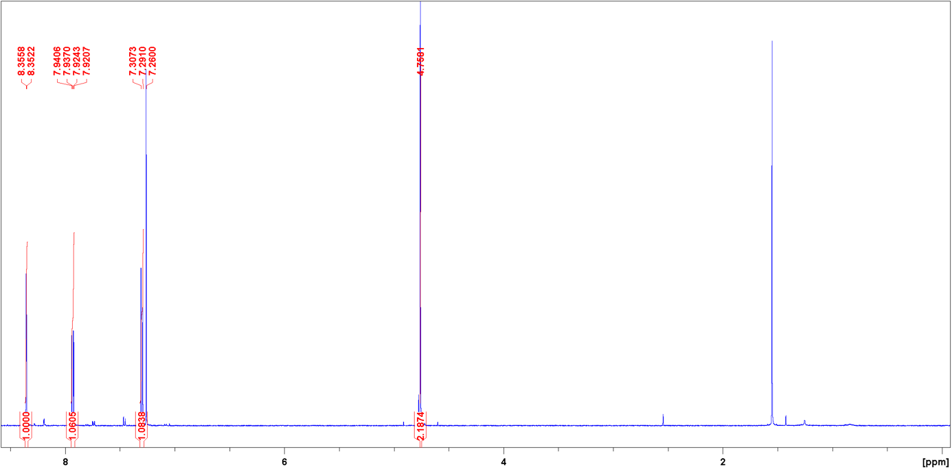
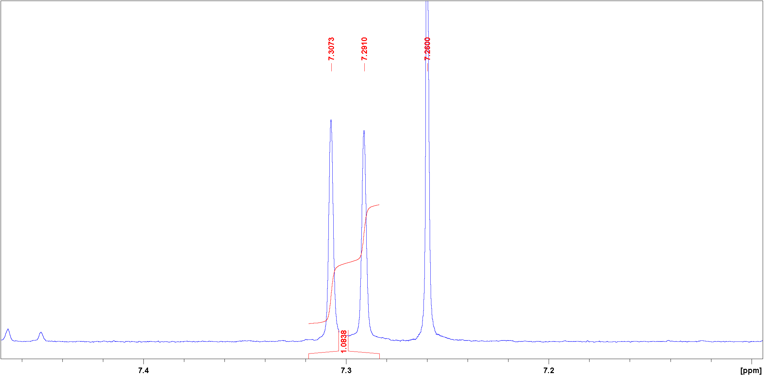
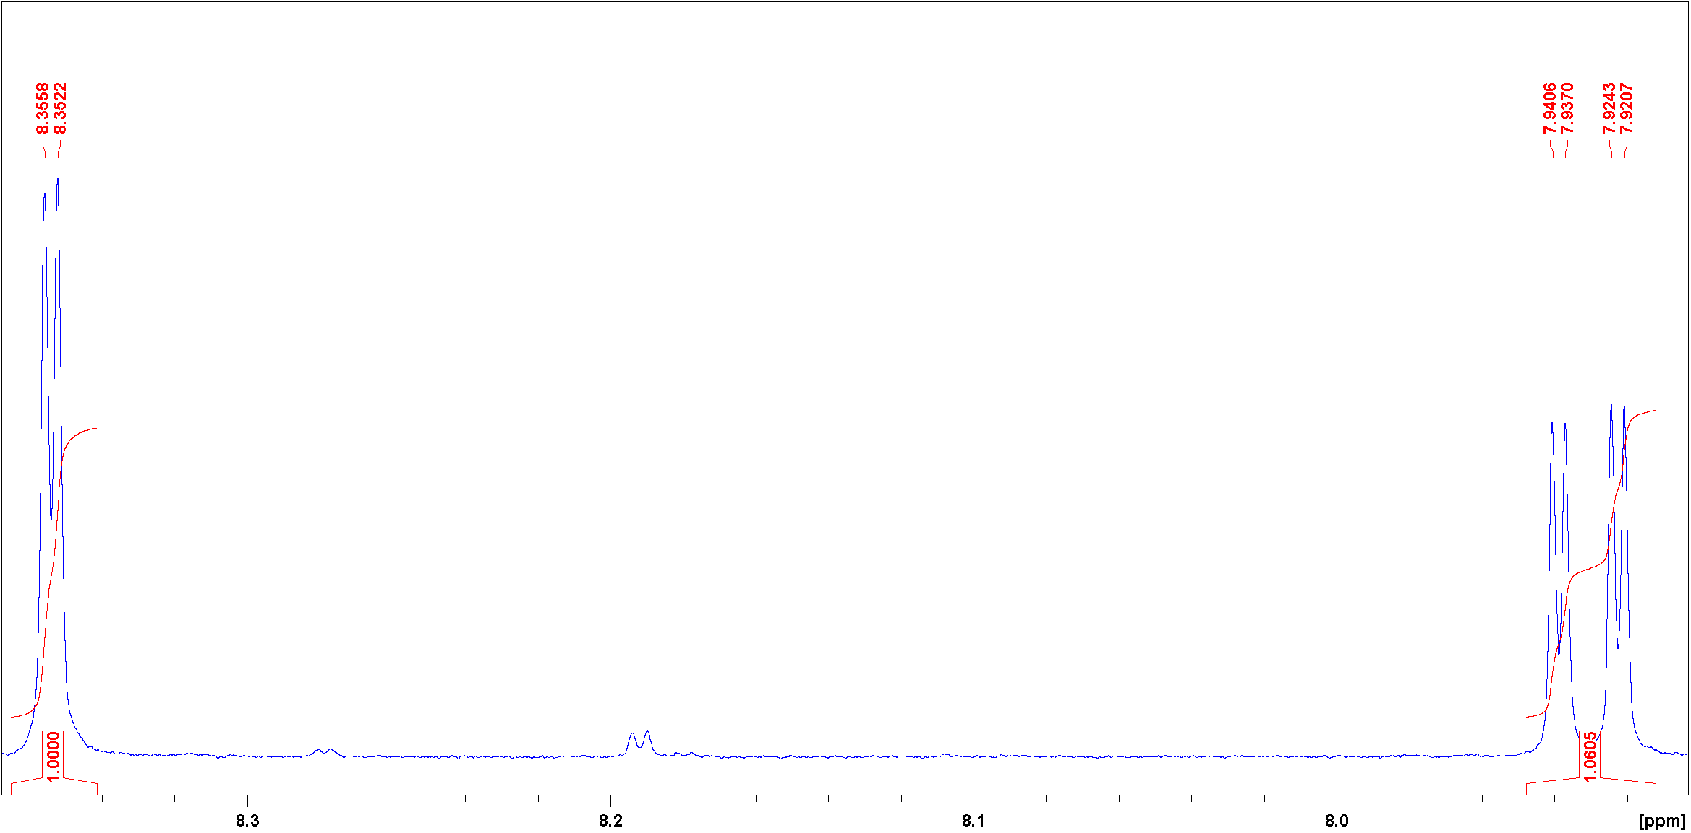

Figure SII.21: ¹H NMR spectrum of compound 3b.
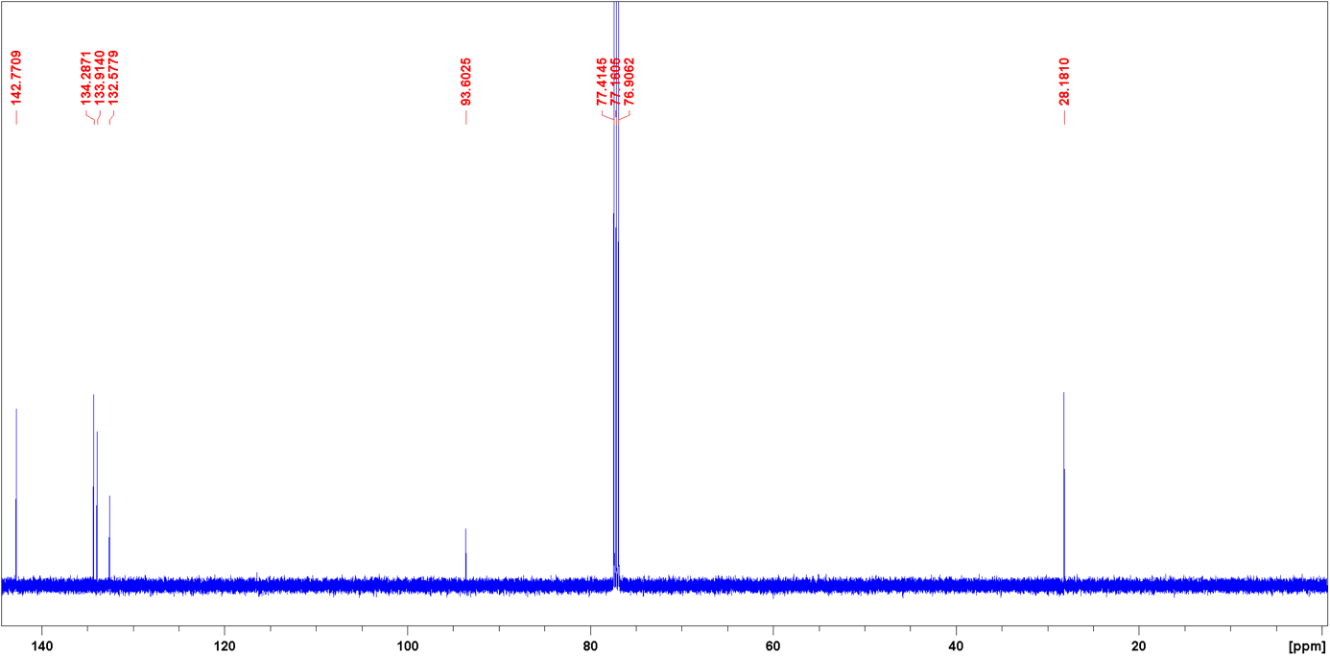

Figure SII.22: ¹³C NMR spectrum of compound 3b.

II.13 Synthesis of tert-butyl (2-((4-iodo-2-nitrobenzyl)amino)phenyl)carbamate (4b)
Under a nitrogen atmosphere, a solution of tert-butyl (2-aminophenyl)carbamate¹ (2, 651 mg, 3.12 mmol) in anhydrous THF (12 mL) was prepared, and then TEA (477 µL, 3.42 mmol) and 1-(bromomethyl)-4-iodo-2-nitrobenzene (3b, 1.07 g, 3.12 µmol) were added. The reaction mixture was refluxed for 20 h and after that, the solvent was removed. Deionized water and DCM were added, the organic layer was separated and it was extracted twice with DCM. The combined organic layers were dried over MgSO₄ and the solvent was evaporated. Recrystallization from ethyl acetate/cyclohexane = 1:1 gave a yellow solid (4b, 1.41 g, 3.00 mmol, 96%).
melting point: 143.5 °C
¹H NMR (500 MHz, CDCl₃, 298 K): δ = 8.38 (d, ⁴J = 1.8 Hz, 1 H, Ar^{II}-H-3), 7.85 (dd, ³J = 8.2 Hz, ⁴J = 1.8 Hz, 1 H, Ar^{II}-H-5), 7.40 (d, ³J = 8.2 Hz, 1H, Ar^{II}-H-6), 7.25 (d, ³J = 7.7 Hz, 1 H, Ar^{I}-H-6), 7.01 (td, ³J = 7.7 Hz, ⁴J = 1.5 Hz, 1 H, Ar^{I}-H-4), 6.80 (t, ³J = 7.7 Hz, 1 H, Ar^{I}-H-5), 6.52 (d, ³J = 7.7 Hz, 1 H, Ar^{I}-H-3), 6.28 (br. s, 1 H, NH), 4.69 (s, 2 H, -CH₂), 1.51 (s, 9 H, tBu-H) ppm.
¹³C NMR (125 MHz, CDCl₃, 298 K): δ = 154.39 (C=O),148.69 (Ar^{II}-C-2), 140.69 (Ar^{I}-C-2), 142.74 (Ar^{II}-C-5), 134.55 (Ar^{II}-C-1), 133.81 (Ar^{II}-C-3), 131.85 (Ar^{II}-C-6), 127.09 (Ar^{I}-C-4), 126.03 (Ar^{I}-C-6), 124.84 (Ar^{I}-C-1), 119.72 (Ar^{I}-C-5), 113.62 (Ar^{I}-C-3), 91.87 (Ar^{II}-C-4), 81.08 (-C-(CH₃)₃, 45.84 (-CH₂), 28.46 (-CH₃) ppm.
IR (ATR): ṽ = 3414 (w), 3314 (w), 2924 (w), 2847 (w), 1679 (m), 1606 (m), 1531 (m), 1503 (m), 1460 (m), 1392 (w), 1363 (w), 1343 (m), 1329 (m), 1305 (w), 1285 (w), 1271 (m), 1247 (m), 1159 (s), 1133 (w), 1085 (w), 1055 (w), 1029 (w), 990 (w), 937 (w), 906 (w), 890 (w), 869 (w), 837 (w), 821 (w), 783 (w), 774 (w), 754 (w), 741 (w), 717 (w), 692 (w), 647 (w), 599 (w), 523 (w) cm⁻¹.

MS (ESI HR, CHCl₃/MeOH): m/z (C₁₈H₂₀IN₃O₄+H⁺) = calc.: 470.05713, found: 470.05680 ± 0.69 ppm.

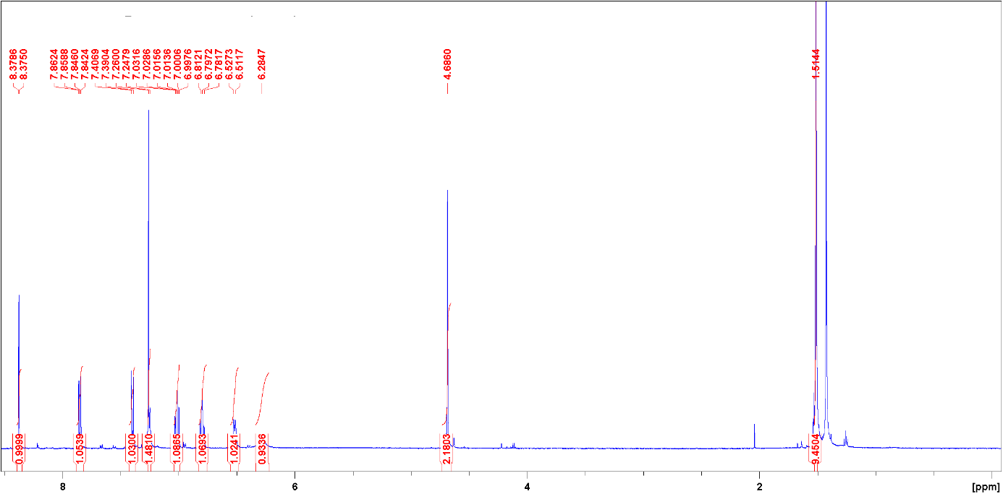
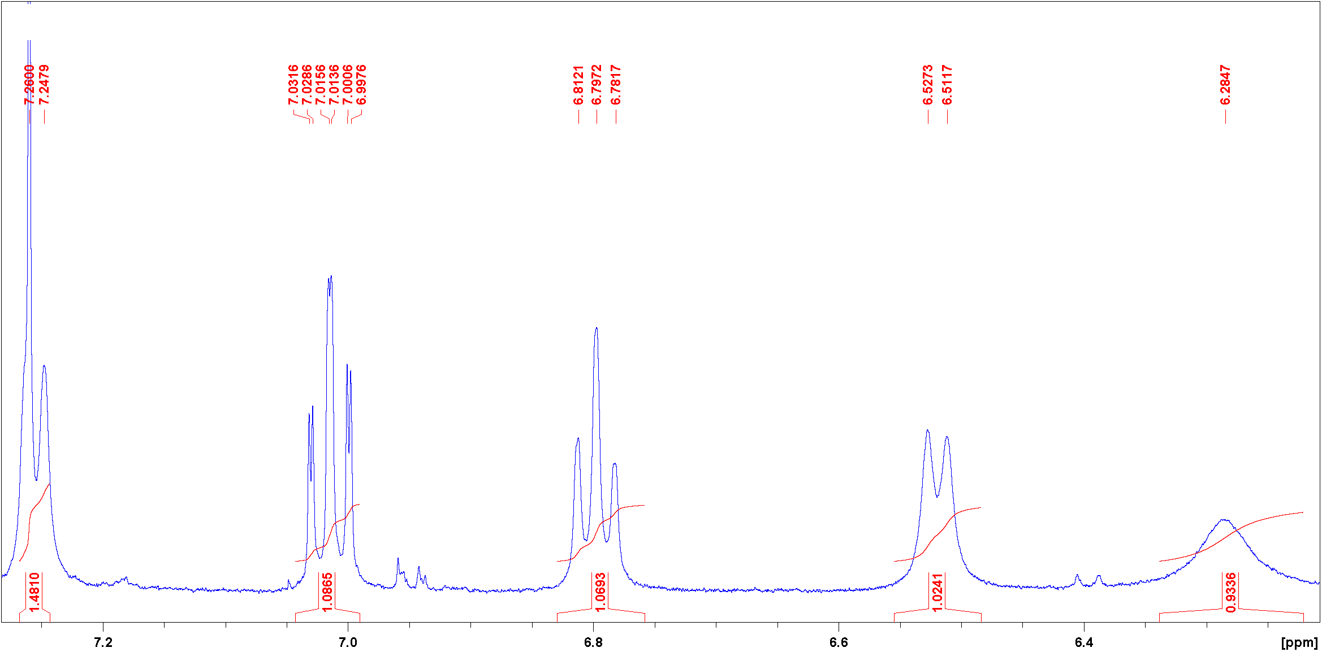
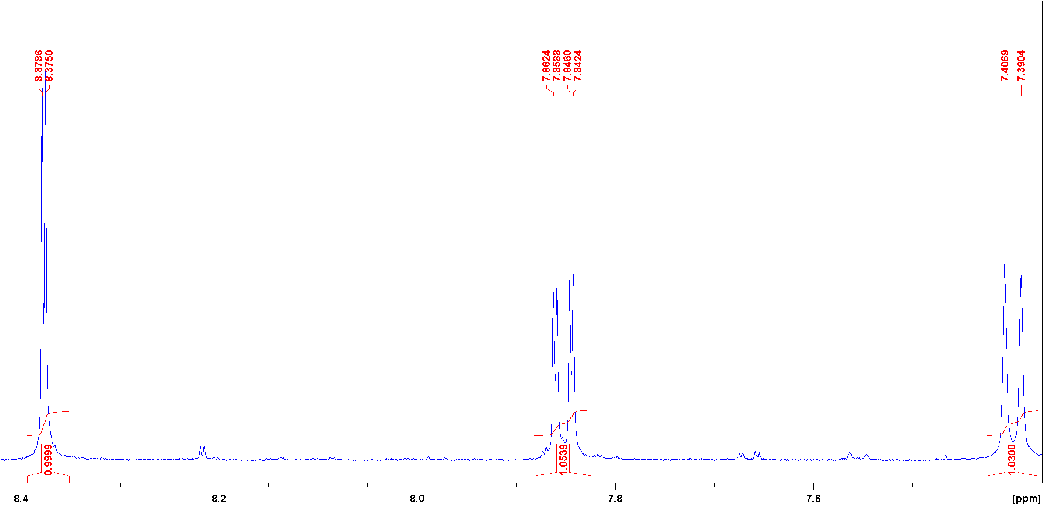
Figure SII.23: ¹H NMR spectrum of compound 4b.
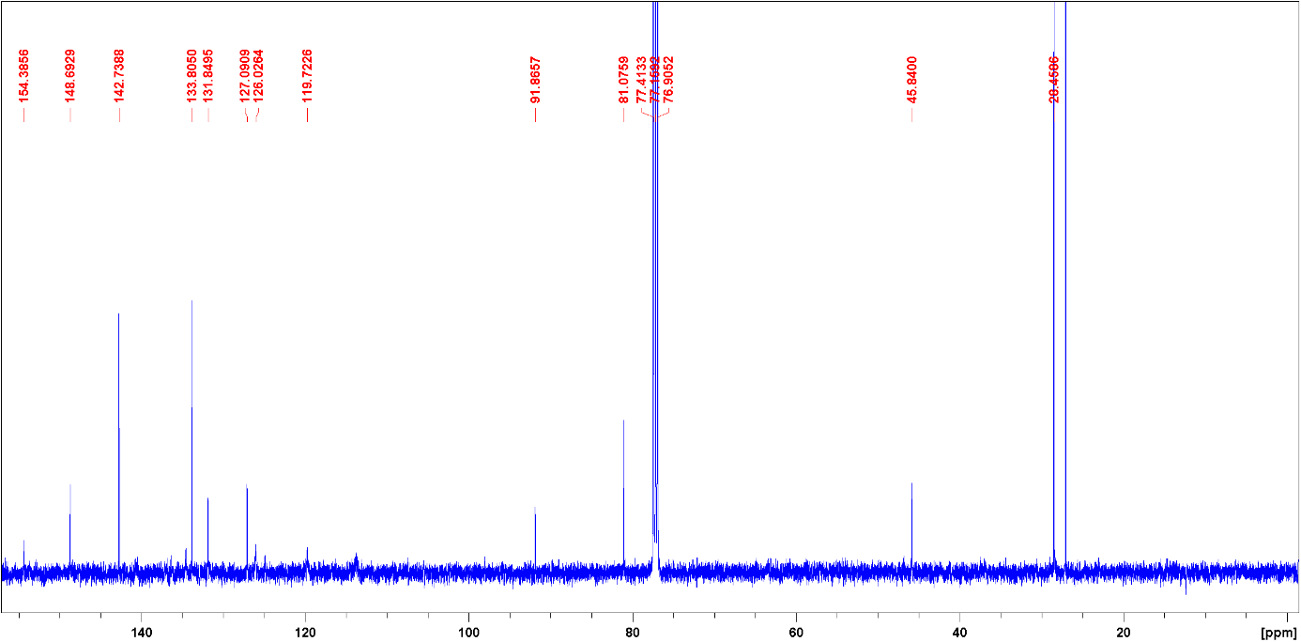
Figure SII.24: ¹³C NMR spectrum of compound 4b.

II.14 Synthesis of (9H-fluorene-9-yl)methyl (2-((tert-butoxycarbonyl)amino)phenyl)(4-iodo-2-nitrobenzyl)carbamate (5b)
Under a nitrogen atmosphere, a solution of tert-butyl (2-((4-iodo-2-nitrobenzyl)amino)phenyl)carbamate (4b, 1.41 g, 3.00 mmol) in anhydrous DMF (12 mL) was prepared, and then DIPEA (510 µL, 3.00 mmol) and Fmoc-chloride (1.55 g, 6.00 µmol) were added. The reaction mixture was stirred for 91 h at rt. and after that, the solvent was evaporated. Deionized water and DCM were added, the organic layer was separated and it was extracted twice with DCM. The combined organic layers were dried over MgSO₄ and the solvent was evaporated. Flash column chromatography on silica (0.040-0.063 mm, ethyl acetate/cyclohexane = 1:4, R_{f} = 0.45) gave a white solid (5b, 682 mg, 986 µmol, 33%).
melting point: 131.6 °C
¹H NMR (500 MHz, acetone-d₆, 298 K): δ = 8.29 (d, ⁴J = 1.7 Hz, 1 H, Ar-H), 8.14-7.55 (m, 5 H), 7.84-7.54-6.87 (m, 10 H), 5.12 (br. S, 1 H, -CH₂), 5.28-4.76 (m, 2 H), 4.73-3.96 (m, 3 H), 1.46 (s, 9 H, tBu-H) ppm.
¹³C NMR (125 MHz, acetone-d₆, 298 K): δ = 153.53, 143.00, 142.08, 133.86, 129.96, 129.22, 128.48, 127.86, 126.06, 124.43, 122.55, 120.73, 92.68, 80.46, 68.42, 47.83, 28.60 ppm.
IR (ATR): ṽ = 2976 (w), 1706 (m), 1594 (w), 1524 (m), 1477 (s), 1449 1449, 1392 (w), 1366 (m), 1345 (m), 1295 (m), 1274 (m), 1239 (m), 1153 (s), 1046 (w), 1024 (m), 984 (w), 870 (w), 835 (w), 758 (m), 739 (s), 620 (w), 588 (w), 553 (w) cm⁻¹.
MS (ESI HR, CHCl₃/MeOH): m/z (C₃₃H₃₀IN₃O₆+H⁺) = calc.: 692.12521, found: 692.12442 ± 1.14 ppm.

Figure SII.25: ¹H NMR spectrum of compound 5b.
Figure SII.26: ¹³C NMR spectrum of compound 5b.

II.15 Synthesis of (9H-fluorene-9-yl)methyl (2-aminophenyl)(4-iodo-2-nitrobenzyl)carbamate (6b)
A solution of (9H-Fluorene-9-yl)methyl (2-((tert-butoxycarbonyl)amino)phenyl)(4-iodo-2-nitrobenzyl)carbamate 5b (2.15 g, 3.11 mmol) in DCM (20 mL) was prepared, and then TFA (12 mL) was added. The reaction mixture was stirred for 20 h at rt. and after that, it was neutralized with saturated aqueous NaHCO₃ solution. The organic layer was separated and it was extracted twice with DCM. The combined organic layers were dried over MgSO₄ and the solvent was evaporated. A yellow solid (6b, 1.76 g, 2.97 mmol, 96%) was obtained.
melting point: 85.7 °C
¹H NMR (500 MHz, CDCl₃, 298 K): δ = 8.24 (d, ⁴J = 1.8 Hz, 1 H,), 7.87 (br. s, 1 H, 1 H), 7.71-7.62 (m, 2 H), 7.39-7.29 (m, 3 H), 7.24-7.07 (m, 5 H), 6.82-6.72 (m, 2 H), 6.70-6.65 (m, 1 H), 5.23 (br. s, 1 H, CH₂), 4.93 (br. s, 1 H, CH₂), 4.50-4.32 (m, 2 H, Fmoc-CH₂), 4.07 (br. s, 1 H, Fmoc-CH), 3.60 (br. s, 2 H, NH₂).
¹³C NMR (125 MHz, CDCl₃, 298 K): δ = 156.20, 143.52, 142.32, 141.41, 133.50, 132.44, 128.81, 128.6, 127.78, 127.08, 125.27, 120.02, 118.99, 116.6, 68.05, 47.21 ppm.
IR (ATR): ṽ = 3360 (w), 3065 (w), 1696 (m), 1620 (w), 1525 (m), 1501 (w), 1450 (w), 1403 (w), 1340 (w), 1297 (m), 1271 (w), 1157 (w), 1137 (w), 1044 (w), 987 (w), 739 (s), 692 (w), 620 (w), 535 (w) cm⁻¹.
MS (ESI HR, CHCl₃/MeOH): m/z (C₂₈H₂₂IN₃O₄+H⁺) = calc.: 592.07278, found: 592.07234 ± 0.73 ppm.

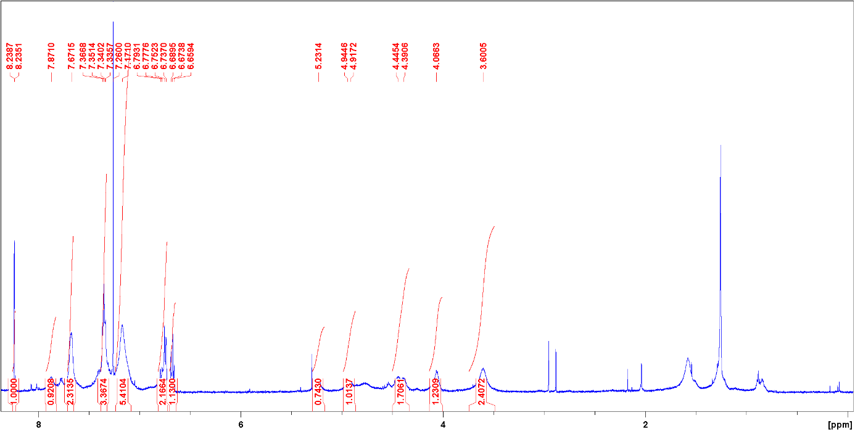
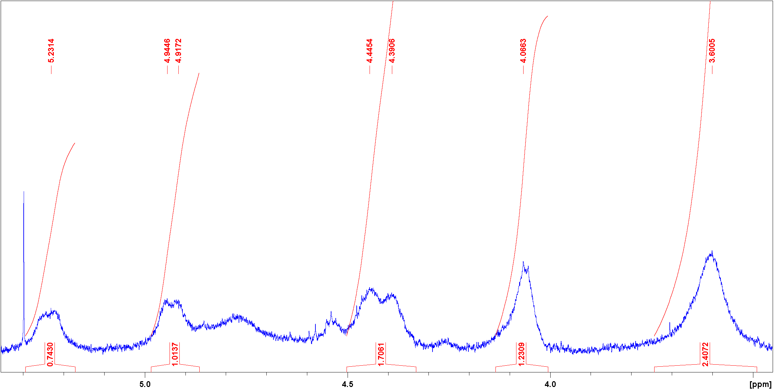
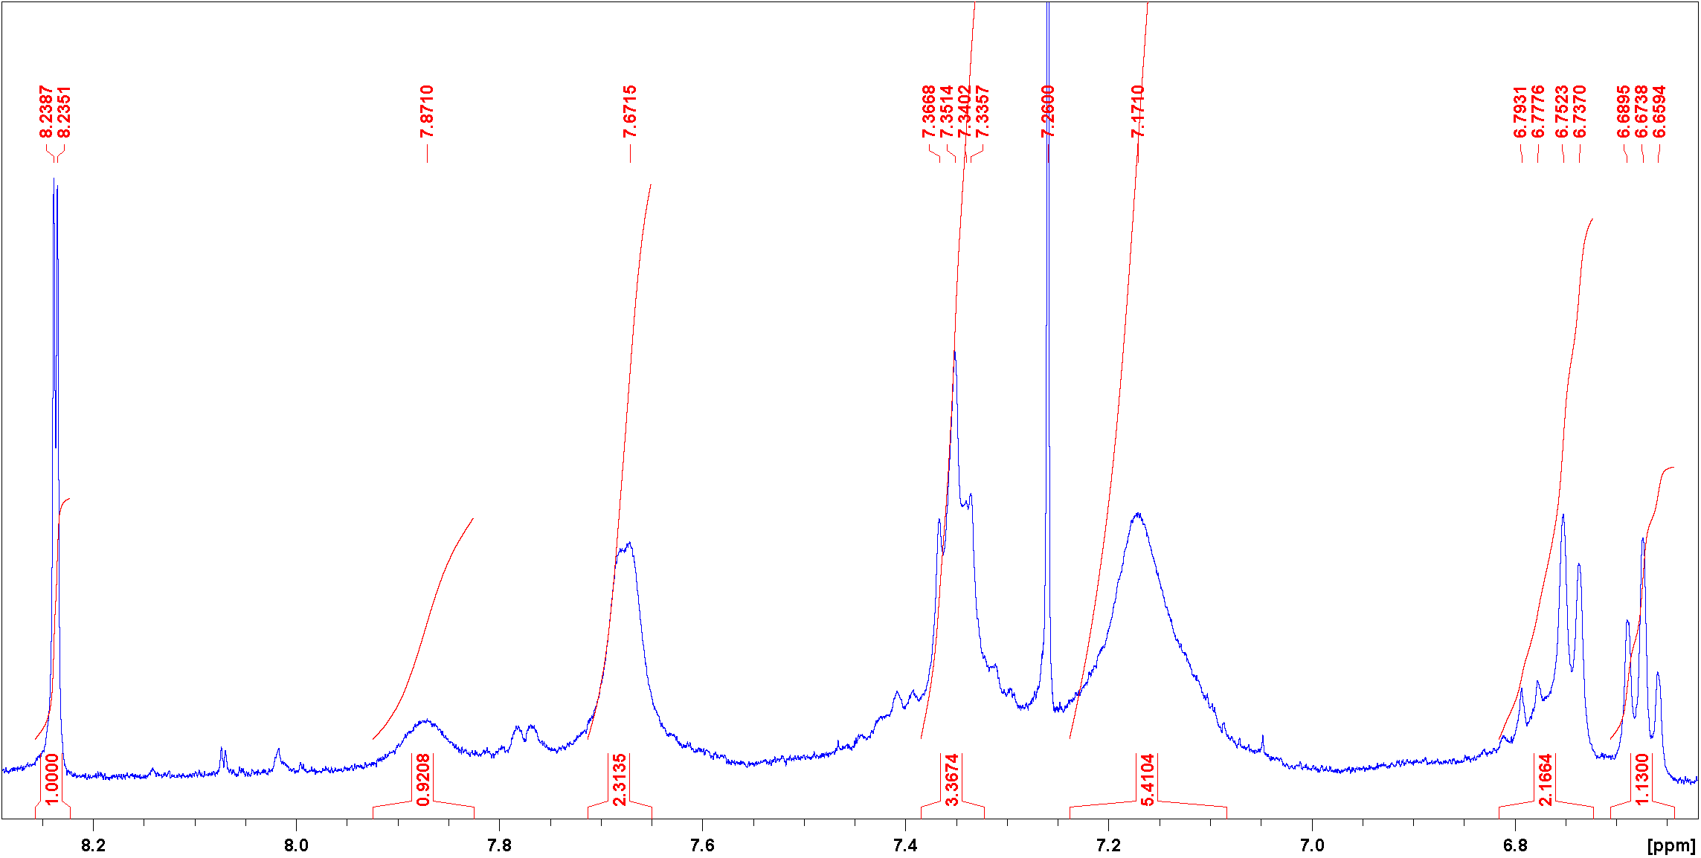
Figure SII.27: ¹H NMR spectrum of compound 6b.
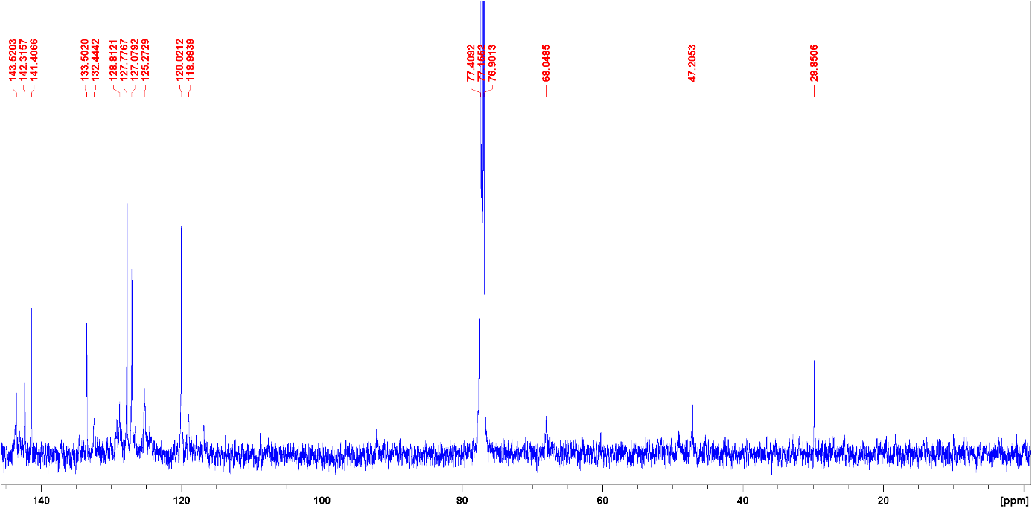
Figure SII.28: ¹³C NMR spectrum of compound 6b.

II.16 Synthesis of (9H-fluorene-9-yl)methyl (Z)-3-iododibenzo[c,g][1,2,5]triazocine-11(12H)-carboxylate (8b)
(9H-Fluorene-9-yl)methyl (2-aminophenyl)(4-iodo-2-nitrobenzyl)carbamate (6b, 1.55 g, 2.62 mmol) was suspended in 250 mL of ethanol and SnCl₂ $∙$ 2 H₂O (2.96 g, 14.9 mmol) was added. The reaction mixture was heated to 75 °C and zink-powder (824 mg, 12.6 mmol, 8 eq) was added. It was stirred at rt. over night and afterwards neutralized with saturated aqueous NaHCO₃ solution. The solvent was evaporated and to the residue was added DCM and deionized water. The organic layer was separated and it was extracted twice with DCM. The combined organic layers were dried over MgSO₄ and the solvent was evaporated. The crude product was dissolved in 150 mL of acetic acid and mCPBA (1.17 g, 3.15 mmol, ≥ 77%) in 150 mL of acetic acid was added dropwise over a period of 2 h. The reaction mixture was stirred at rt. over night and after that, the solvent was evaporated. To the residue was added DCM and half-concentrated aqueous NaHCO₃ solution in deionized water and the organic layer was separated. It was extracted twice with DCM and the combined organic layers were dried over MgSO₄. The solvent was evaporated and flash column chromatography on silica (0.040-0.063 mm, ethyl acetate/cyclohexane = 1:4, R_{f} = 0.41) gave a yellow solid (8b, 833 mg, 1.49 mmol, 56%).

melting point: 87.6 °C
¹H NMR (600 MHz, acetone-d₆, 298 K): δ = 8.15-6.65 (m, 15 H, Ar-H), 5.05-3.99 (m, 5 H, aliph. H) ppm.
¹³C NMR (150 MHz, acetone-d₆, 298 K): δ = 154.71, 153.87, 144.72, 142.08, 137.37, 132.64, 130.47, 129.54, 129.13, 128.53, 128.36, 127.89, 126.12, 124.68, 120.78, 119.69, 68.50, 52.85, 47.74 ppm. ppm.
IR (ATR): ṽ = 2925 (w), 2850 (w),2036 (w), 1703 (s), 1586 (w), 1477 (w), 1449 (m), 1390 (m), 1320 (s), 1295 (s), 1230 (m), 1129 (m), 1105 (m), 1041 (m), 1022 (m), 863 (w), 816 (w), 756 (s), 738 (s), 693 (w), 621 (m), 603 (w), 549 (m), 512 (w) cm⁻¹.
MS (ESI HR, CHCl₃/MeOH): m/z (C₂₈H₂₀IN₃O₂+H⁺) = calc.: 558.06730, found: 558.06694 ± 0.63 ppm.

Figure SII.29: ¹H NMR spectrum of compound 8b.
Figure SII.30: ¹³C NMR spectrum of compound 8b.

II.17 Synthesis of (Z)-3-iodo-11,12-dihydrodibenzo[c,g][1,2,5]triazocine (9b)
(9H-Fluorene-9-yl)methyl (Z)-3-iododibenzo[c,g][1,2,5]triazocine-11(12H)-carboxylate (8b, 813 mg, 1.46 mmol) was dissolved in 20 mL of DCM and 50 mL of NEt₃ was added. The reaction mixture was stirred at rt. for 20 h. The solvent was removed and flash column chromatography on silica (0.040-0.063 mm, ethyl acetate/cyclohexane = 1:3, R_{f} = 0.43) gave a red solid (9b, 410 mg, 1.22 mmol, 84%).
melting point: 165.2 °C
¹H NMR (500 MHz, acetone-d₆, 298 K): δ = 7.63 (dd, ³J = 8.0 Hz, ⁴J = 1.7 Hz, 1 H, H-2), 7.52 (d, ⁴J = 1.7 Hz, 1 H, H-4), 7.16 (d, ³J = 8.0 Hz, 1 H, H-1), 6.87 (td, ³J = 7.6 Hz, ⁴J = 1.6 Hz, 1 H, H-9), 6.75 (dd, ³J = 8.0 Hz, ⁴J = 1.5 Hz, 1 H, H-7), 6.65 (td, ³J = 7.5 Hz, ⁴J = 1.2 Hz, 1 H, H-8), 6.56 (dd, ³J = 8.2 Hz, ⁴J = 1.1 Hz, 1 H, H-10), 5.43 (m_{c}, 1 H, NH), 3.96 (m_{c}, 2 H, CH₂) ppm.
¹³C NMR (125 MHz, acetone-d₆, 298 K): δ = 160.26 (C-4a), 144.64 (C-6a), 137.88 (C-2), 137.08 (C-10a), 132.44 (C-1), 129.06 (C-9), 128.50 (C-4), 124.49 (C-12a), 123.61 (C-7), 119.93 (C-10), 118.30 (C-8), 93.11 (C-3), 47.15 (CH₂) ppm.
IR (ATR): ṽ = 3323 (m), 2959 (w), 1601 (m), 1581 (m), 1561 (w), 1518 (m), 1479 (s), 1453 (m), 1383 (m), 1364 (w), 1322 (m), 1251 (w), 1161 (w), 1139 (w), 1117 (w), 1094 (m), 1068 (w), 949 (w), 896 (m), 831 (s), 806 (s), 764 (m), 742 (s), 720 (s), 701 (w), 645 (w), 600 (s), 559 (w), 511 (m) cm⁻¹.
MS (ESI HR, CHCl₃/MeOH): m/z (C₁₃H₁₀IN₃+H⁺) = calc.: 335.99922, found: 335.99888 ± 1.02 ppm.

Figure SII.31: ¹H NMR spectrum of compound 9b.
Figure SII.32: ¹³C NMR spectrum of compound 9b.

II.18 Synthesis of (Z)-3-iododibenzo[c,g][1,2,5]triazocine-11(12H)-carbaldehyde (11b)
Under a nitrogen atmosphere, a solution of (Z)-3-iodo-11,12-dihydrodibenzo[c,g][1,2,5]triazocine (9b, 50.0 mg, 149 µmol) in anhydrous MeCN (5 mL) was prepared, and then DIPEA (260 µL, 1.49 mmol) and chloral (146 µL, 1.49 mmol) were added. The reaction mixture was stirred at rt. for 22 h. The solvent was removed and flash column chromatography on silica (0.040-0.063 mm, ethyl acetate/cyclohexane = 1:2, R_{f} = 0.20) gave a pale yellow solid (11b, 28 mg, 77.1 µmol, 52%).
melting point: 208.9 °C
¹H NMR (500 MHz, acetone-d₆, 298 K): δ = 8.35 (s, 1 H, CHO), 7.58 (dd, ³J = 8.0 Hz, ⁴J = 1.7 Hz, 1 H, H-2), 7.41 (d, ⁴J = 1.7 Hz, 1 H, H-4), 7.36 (td, ³J = 7.7 Hz, ⁴J = 1.3 Hz, 1 H, H-9), 7.26 (td, ³J = 7.5 Hz, ⁴J = 1.5 Hz, 1 H, H-8), 7.18 (dd, ³J = 7.9 Hz, ⁴J = 1.3 Hz, 1 H, H-7), 7.15 (d, ³J = 8.0 Hz, 1 H, H-1), 6.96 (dd, ³J = 7.8 Hz, ⁴J = 1.4 Hz, 1 H, H-10), 4.50 (m_{c}, 2 H, CH₂) ppm.
¹³C NMR (125 MHz, acetone-d₆, 298 K): δ = 162.37 (C=O), 158.26 (C-4a), 152.78 (C-6a), 137.80 (C-2), 133.25 (C-1), 129.44 (C-8), 129.28 (C-9), 128.28 (C-7), 128.19 (C-12a), 127.93 (C-4), 123.30 (C-10a), 120.54 (C-10), 94.57 (C-3), 49.12 (CH₂) ppm.
IR (ATR): ṽ = 3070 (w), 3045 (w), 2880 (w), 1935 (w), 1668 (s), 1538 (m), 1513 (w), 1475 (m), 1387 (w), 1358 (m), 1313 (s), 1277 (m), 1242 (m), 1209 (w), 1117 (m), 1038 (m), 1012 (w), 956 (m), 028 (w), 892 (w), 828 (s), 810 (s), 759 (s), 741 (m), 692 (m), 666 (m), 647 (w), 605 (w), 562 (s), 516 (m) cm⁻¹.
MS (ESI HR, CHCl₃/MeOH): m/z (C₁₄H₁₀IN₃O+H⁺) = calc.: 363.99413, found: 363.99426 ± 0.36 ppm.

Figure SII.33: ¹H NMR spectrum of compound 11b.
Figure SII.34: ¹³C NMR spectrum of compound 11b.

II.19 Synthesis of (Z)-1-(3-iododibenzo[c,g][1,2,5]triazocine-11(12H)-yl)ethan-1-one (10b)
Under a nitrogen atmosphere, a solution of (Z)-3-iodo-11,12-dihydrodibenzo[c,g][1,2,5]triazocine (9b, 100 mg, 298 µmol) in anhydrous DMF (5 mL) was prepared, and then TEA (832 µL, 20 eq) and HOAcl (171 µL, 2.98 mmol) were added. The reaction mixture was cooled to 0 °C and T3P (1.78 mL, 2.98 mmol, 50% in ethyl acetate) was added dropwise. The ice bath was removed and it was stirred for 21 h. 50 mL DCM and 50 mL deionized water were added and the organic layer was separated. It was extracted twice with DCM and the combined organic layers were dried over MgSO₄. The solvent was removed and flash column chromatography on silica (0.040-0.063 mm, ethyl acetate/cyclohexane = 1:2, R_{f} = 0.13) gave a pale yellow solid (10b, 68 mg, 180 µmol, 60%).

melting point: 170.0 °C
¹H NMR (500 MHz, acetone-d₆, 298 K): δ = 7.51 (dd, ³J = 8.1 Hz, ⁴J = 1.8 Hz, 1 H, H-2), 7.51 (td, ³J = 7.4 Hz, ⁴J = 1.8 Hz, 1 H, H-8/9), 7.34-7.26 (m, 3 H, H-4, Ar-H, Ar-H), 7.06 (dd, ³J = 8.0 Hz, ⁴J = 1.3 Hz, 1 H, H-7/10), 7.03 (d, ³J = 8.1 Hz, 1 H, H-1), 5.03 (d, ²J = 14.5 Hz, 1 H, CH₂a), 4.30 (d, ²J = 14.9 Hz, 1 H, CH₂b), 1.79 (s, 3 H, CH₃) ppm.
¹³C NMR (125 MHz, acetone-d₆, 298 K): δ = 169.50 (C=O), 157.09 (C-4a), 154.15 (C-6a/10a), 137.40 (C-2), 132.73 (C-1), 130.32 (C-7/10), 130.19 (Ar-C), 129.58 (Ar-C), 129.44 (C-6a/10a), 128.43 (C-4), 125.19 (C-12a), 120.05 (C-7/10), 93.56 (C-6a/10a), 51.65 (CH₂), ppm.
IR (ATR): ṽ = 3058 (w), 3012 (w), 2928 (w), 2251 (w), 1652 (s), 1583 (w), 1556 (w), 1513 (w), 1473 (m), 1434 (w), 1378 (s), 1336 (s), 1297 (m), 1250 (w), 1111 (m), 1084 (m), 1031 (m), 1009 (w), 971 (m), 917 (w), 842 (m), 824 (s), 768 (s), 691 (m), 653 (m), 598 (s), 582 (s), 534 (w), 515 (m) cm⁻¹.
MS (ESI HR, CHCl₃/MeOH): m/z (C₁₅H₁₂IN₃O+H⁺) = calc.: 378.00978, found: 378.00937 ± 1.08 ppm.

Figure SII.35: ¹H NMR spectrum of compound 10b.
Figure SII.36: ¹³C NMR spectrum of compound 10b.

III. UV-vis switching experiments

All samples were irradiated to the photostationary state (PSS) with 400 nm in the given solvent or solvent mixture. The extrapolated UV-vis spectra of the E compounds were calculated from the UV-vis spectra of the PSS and the percentage of the E compounds which were measured by ¹H NMR (for details see SIV) by the following equation (1):
$$A_{E, extrapol.}=\left\{A_{PSS}-\left(A_{Z}∙\left[1- \frac{100\%}{\%PSS}\right]\right)\right\}/\left(\frac{100\%}{\%PSS}\right)$$ | (1)

Figure SIII.1: UV-vis spectra of Br-NAc-diazocine 10a in MeCN at 25 °C before (black) and after irradiation with 400 nm (dashed red). The extrapolated E spectrum is given in blue (left) and molar extinction coefficient (ε) determination of the maxiumum absorption (λ_{max}) of the nπ*-transitions of the E (green) and Z (blue) isomers (right).

Figure SIII.2: UV-vis spectra of the half-life determination of Br-NAc-diazocine 10a in MeCN at different temperatures (left) with corresponding first order kinetic plots (right) and Arrhenius plot (bottom).

Figure SIII.3: UV-vis spectra of Br-NAc-diazocine 10a in water at 25 °C before (black) and after irradiation with 400 nm (dashed red). The extrapolated E spectrum is given in blue (left) and molar extinction coefficient (ε) determination of the maxiumum absorption (λ_{max}) of the nπ*-transitions of the E (green) and Z (blue) isomers (right).

Figure SIII.4: UV-vis spectra of the half-life determination of Br-NAc-diazocine 10a in water at different temperatures (left) with corresponding first order kinetic plots (right) and Arrhenius plot (bottom).

Figure SIII.5: UV-vis spectra of I-NAc-diazocine 10b in MeCN at 25 °C before (black) and after irradiation with 400 nm (dashed red). The extrapolated E spectrum is given in blue (left) and molar extinction coefficient (ε) determination of the maxiumum absorption (λ_{max}) of the nπ*-transitions of the E (green) and Z (blue) isomers (right).

Figure SIII.6: UV-vis spectra of the half-life determination of I-NAc-diazocine 10b in MeCN at different temperatures (left) with corresponding first order kinetic plots (right) and Arrhenius plot (bottom).
Figure SIII.7: UV-vis spectra of Br-NCHO-diazocine 11a in MeCN at 25 °C before (black) and after irradiation with 400 nm (dashed red). The extrapolated E spectrum is given in blue (left) and molar extinction coefficient (ε) determination of the maxiumum absorption (λ_{max}) of the nπ*-transitions of the E (green) and Z (blue) isomers (right).

Figure SIII.8: UV-vis spectra of the half-life determination of Br-NCHO-diazocine 11a in MeCN at different temperatures (left) with corresponding first order kinetic plots (right) and Arrhenius plot (bottom).

Figure SIII.9: UV-vis spectra of I-NCHO-diazocine 11b in MeCN at 25 °C before (black) and after irradiation with 400 nm (dashed red). The extrapolated E spectrum is given in blue (left) and molar extinction coefficient (ε) determination of the maxiumum absorption (λ_{max}) of the nπ*-transitions of the E (green) and Z (blue) isomers (right).

Figure SIII.10: UV-vis spectra of the half-life determination of I-NCHO-diazocine 11b in MeCN at different temperatures (left) with corresponding first order kinetic plots (right) and Arrhenius plot (bottom).

Figure SIII.11: UV-vis spectra of NCHO-diazocine 11c in MeCN at 25 °C before (black) and after irradiation with 400 nm (dashed red). The extrapolated E spectrum is given in blue (left) and molar extinction coefficient (ε) determination of the maxiumum absorption (λ_{max}) of the nπ*-transitions of the E (green) and Z (blue) isomers (right).

Figure SIII.12: UV-vis spectra of the half-life determination of NCHO-diazocine 11c in MeCN at different temperatures (left) with corresponding first order kinetic plots (right) and Arrhenius plot (bottom).

Figure SIII.13: UV-vis spectra of NCHO-diazocine 11c in water at 25 °C before (black) and after irradiation with 400 nm (dashed red). The extrapolated E spectrum is given in blue (left) and molar extinction coefficient (ε) determination of the maxiumum absorption (λ_{max}) of the nπ*-transitions of the E (green) and Z (blue) isomers (right).

Figure SIII.14: UV-vis spectra of the half-life determination of NCHO-diazocine 11c in water at different temperatures (left) with corresponding first order kinetic plots (right) and Arrhenius plot (bottom).
IV. ¹H NMR switching experiments

Photostationary states (PSS) of compounds 10 and 11 were measured via ¹H NMR by integration of the different species after irradiation with 400 nm. The value of the integrals and the extrapolated values is given in Table SIV.1. ¹H NMR und UV-Vis spectra (SIII) were measured at 250 µM concentrations, except of Br-NCHO diazocine 11a (150 µM due to solubility limit). The following equation was used for extrapolation of the photostationary states:
$${PSS}_{extrapol.}=PSS∙ e^{kt}$$ | (2)
k is the rate constant at 25 °C (see SIII) and t the measuring time (180 s): 60 s preparation (transfer into the spectrometer and shimming) and ~120 s measuring time for 32 scans. All spectra were measured at a Bruker AV 600 spectrometer.

Table SIV.1: Measured and extrapolated photostationary states of compounds 10 and 11 in MeCN and water.
 | CD₃CN |  | D₂O
 | measured  PSS / % | extrapolated  PSS / % | measured  PSS / % | extrapolated  PSS / %
Br-NAc 10a | 76 | 81 | 68 | 70
I-NAc 10b | 76 | 82 | - | -
NCHO 11c | 83 | 85 | 68 | 69
Br-NCHO 11a | 79 | 82 | - | -
I-NCHO 11b | 77 | 80 | - | -

Figure SIV.1: ¹H NMR spectrum (aromatic region) of Br-NAc diazocine 10a in CD₃CN at 298K.

Figure SIV.2: ¹H NMR spectrum (aromatic region) of Br-NAc diazocine 10a in CD₃CN at 298K after irradiation with 400 nm.

Figure SIV.3: ¹H NMR spectrum (aromatic region) of I-NAc diazocine 10b in CD₃CN at 298K.

Figure SIV.4: ¹H NMR spectrum (aromatic region) of I-NAc diazocine 10b in CD₃CN at 298K after irradiation with 400 nm.

Figure SIV.5: ¹H NMR spectrum (aromatic region) of Br-NCHO diazocine 11a in CD₃CN at 298K.

Figure SIV.6: ¹H NMR spectrum (aromatic region) of Br-NCHO diazocine 11a in CD₃CN at 298K after irradiation with 400 nm.

Figure SIV.7: ¹H NMR spectrum (aromatic region) of I-NCHO diazocine 11b in CD₃CN at 298K.
Figure SIV.8: ¹H NMR spectrum (aromatic region) of I-NCHO diazocine 11b in CD₃CN at 298K after irradiation with 400 nm.

Figure SIV.9: ¹H NMR spectrum (aromatic region) of NCHO diazocine 11c in CD₃CN at 298K.

Figure SIV.10: ¹H NMR spectrum (aromatic region) of NCHO diazocine 11c in CD₃CN at 298K after irradiation with 400 nm.

Figure SIV.11: ¹H NMR spectrum (aromatic region) of Br-NAc diazocine 10a in D₂O at 298K.

Figure SIV.12: ¹H NMR spectrum (aromatic region) of Br-NAc diazocine 10a in D₂O at 298K after irradiation with 400 nm.

Figure SIV.13: ¹H NMR spectrum (aromatic region) of NCHO diazocine 11c in D₂O at 298K.

Figure SIV.14: ¹H NMR spectrum (aromatic region) of NCHO diazocine 11c in D₂O at 298K after irradiation with 400 nm.

Lentes, P.; Stadler, E.; Röhricht, F.; Brahms, A.; Gröbner, J.; Sönnichsen, F. D.; Gescheidt, G.; Herges, R. J. Am. Chem. Soc. 2019, 141, 34, 13592–13600.
Liebig, J. Justus Liebigs Ann. Chem. 1832, 1, 182–230.
Schehr, M.; Hugenbusch, D.; Moje, T.; Näther, C.; Herges, R. Beilstein J. Org. Chem. 2018, 14, 2799–2904.

