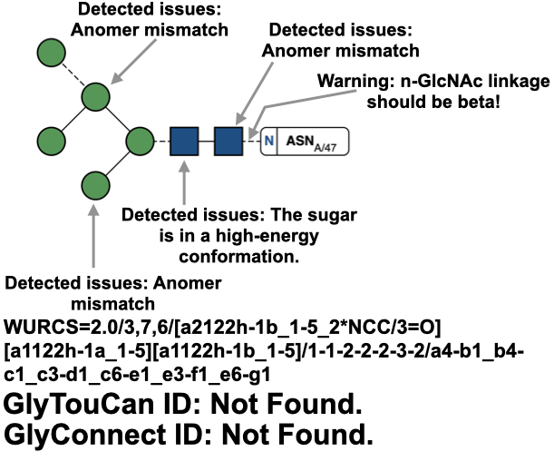
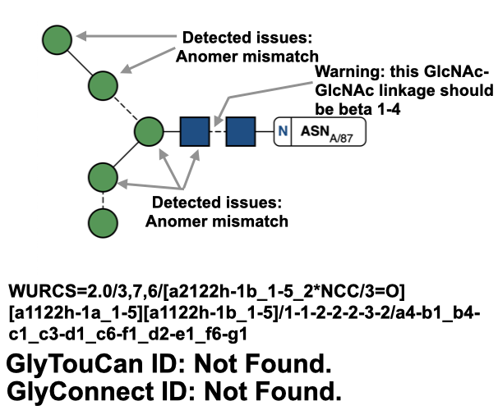
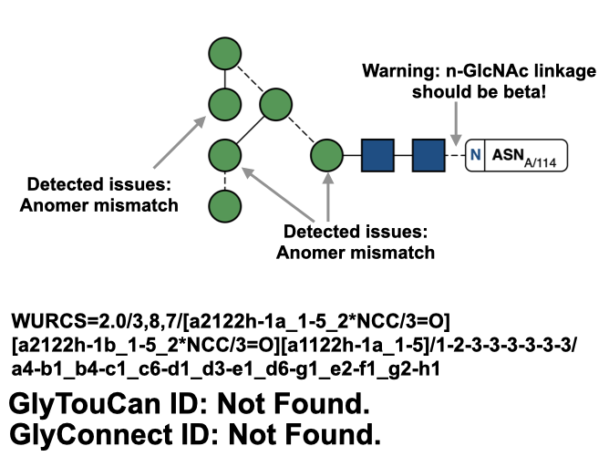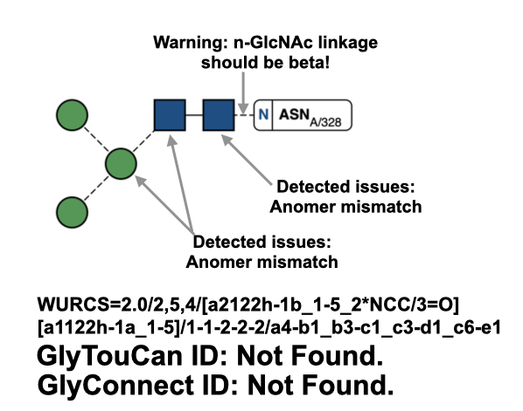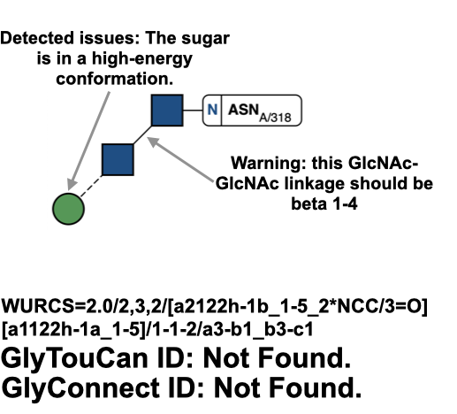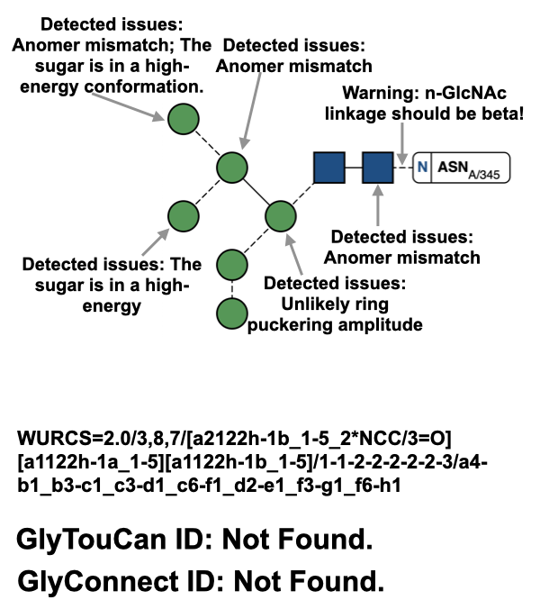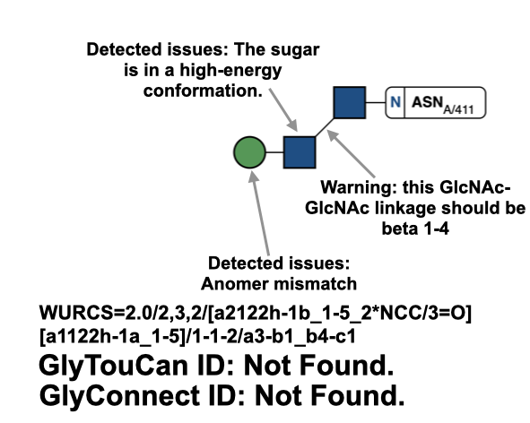
Supplementary Figure 1: Remainder of N-linked glycans detected by Privateer in Epstein Barr Virus Major Envelope Glycoprotein (PDB entry: 2H6O; Kim et al., 2006). Depicts detected glycan chains that failed to return GlyTouCan and GlyConnect IDs, with their WURCS sequences generated and modelling errors detected by Privateer.

