Supporting Information

The Cucurbit[8]uril effect on the properties of Oroxin A
Zhishu Zeng, Jun Xie, Guangyan Luo, Zhu Tao, and Qianjun Zhang*
Key Laboratory of Macrocyclic and Supramolecular Chemistry of Guizhou Province, Guizhou University, Guiyang 550025, China.
Email: Qianjun Zhang* - qianjunzhang@126.com
* Corresponding author
Table of Contents
Material S2
Apparatus S2
Methods S2
¹H NMR and MS S2
UV-vis measurements S3
Synthesis of inclusion complex S3
IR spectroscopy S3
Phase solubility method S4
ABTS radical scavenging activity S4
In vitro release studies S5
References S5

Material
Q[8] (purity ≥97%) was prepared in the Key Laboratory of Macrocyclic and Supramolecular Chemistry of Guizhou Province, China. 2,2'-azino-bis(3-ethylbenzothiazoline-6-sulfonic acid)(ABTS), OA, K₂S₂O₈ and other reagents (purity ≥97%) were purchased from Sigma-Aldrich.
Apparatus
UV-2700 double beam UV-visible spectrophotometer; RE-52A rotary evaporator; VERTEX70 (Bruker, Germany) Fourier infrared spectrometer; FA2204N electronic balance; JNM-ECZ400s MHz nuclear magnetic resonance (NMR) spectrometer; SB-5200D ultrasonic instrument; SHY-2A Thermostatic oscillator; Agilent 6545 Q-TOF LC/MS.
Methods
¹H NMR and MS
A JEOL JNM-ECZ400s spectrometer was used for recorded the ¹H NMR spectra at 20℃. ¹H NMR titration experiments of OA with Q[8] were performed in D₂O containing 10% DMSO by volume.
A ESI-TOF Mass Spectrometry of the OA-Q[8] inclusion complex were recorded on an Agilent 6545 Q-TOF at room temperature. And an aqueous solution of OA@Q[8] was prepared at a concentration of 1.00 × 10⁻⁴ mol∙L⁻¹, then the solution was filtered and tested by MS.
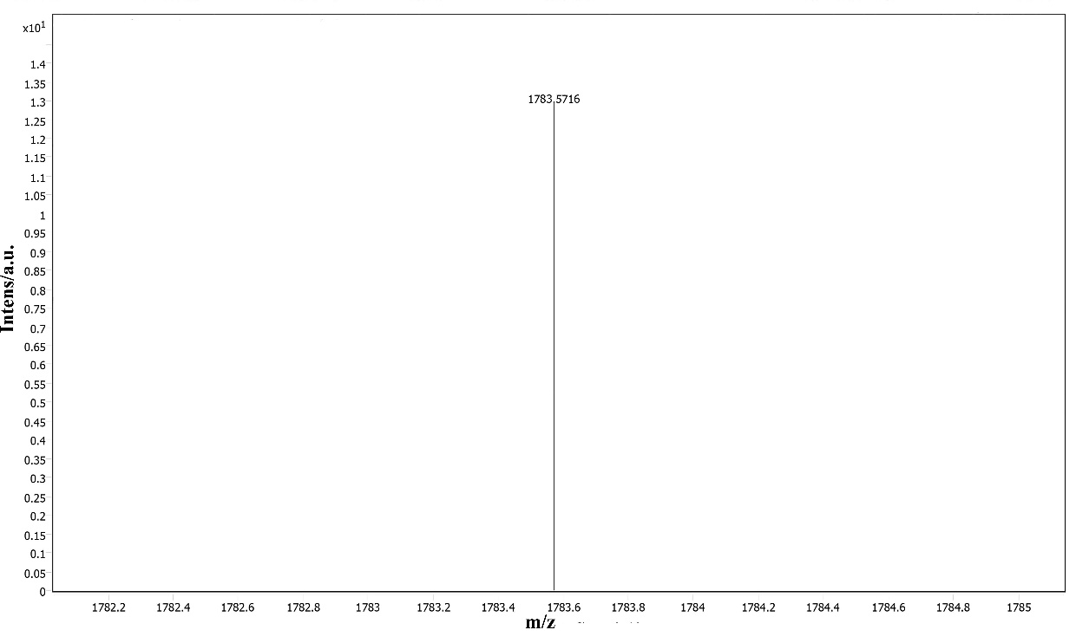
Figure S1 ESI-TOF mass spectrometry of the OA@Q[8] inclusion complex
UV-vis measurements
UV-visible spectra were recorded from samples in 1 cm quartz cells on UV-2700 double beam UV-visible spectrophotometer. The host and guests were dissolved in distilled water. UV-visible spectra were obtained at a OA concentration of 2×10⁻⁵ mol·L⁻¹ and different Q[8] concentrations for the OA@Q[8] system.
Synthesis of inclusion complex
The requisite amount of Q[8] and OA were weighed according to the ratio n(OA):n(Q[8]) = 1:1, dissolved in deionized water and the solutions mixed and stirred for 1 h. The solvents were then evaporated to leave the OA@Q[8] inclusion complex (1:1).
IR spectroscopy
OA, Q[8], a physical mixture of OA and Q[8] (NQ[8]:NOA = 1:1) and OA@Q[8] were weighed and mixed with dry KBr, respectively. The mixtures were pressed into a standard mold to prepare the required discs, and the infrared spectra measured over the wavenumber range of 4000–400 cm^{–1}.
Phase solubility method
Calibration curve for OA and OA@Q[8] standard solution: A series of different concentrations (from 5.0 × 10⁻⁶ mol·L⁻¹ to 2.5 × 10⁻⁵ mol·L⁻¹) of OA and OA@Q[8] solutions were measured at λ = 275nm and the standard calibration curve was obtained. The regression equation of OA is A₁=30560c+0.0148, R²=0.9997; and the regression equation of OA@Q[8] is A₂=25900c+0.0089, R²=0.9999.
Determination of phase solubility of OA: 5.0 mg of OA placed into 10 mL volumetric flasks and different volumes (0, 2, 4, 6, 8 and 10 mL) of a 1 × 10⁻⁴ M Q[8] solution added. Water was used to make up the remaining volume and the flasks were then subjected to ultrasonication for 60 min until a solid-liquid equilibrium was achieved. Measured the absorbance at λ=275 nm after filtration through a 0.5 μm membrane filter. The content of OA was calculated according to the working curve.
ABTS radical scavenging activity
The antioxidant capacity was estimated based on radical scavenging activity according to the method described by Cristina D. A et al [1]. ABTS^{+•} stock solution was prepared by mixing 7.0 mmol·L⁻¹ of 2,2-diazo-bis-(3-ethylbenzothiazol-6-sulfonic acid) diammonium salt (ABTS) aqueous solution with 2.45 mmol·L⁻¹ of potassium persulfate solution by equal volume, and placing it in a dark room for 12-16 h at room temperature. Dilute the stock solution with 5 mmol·L⁻¹ phosphate-buffered saline (pH 7.4) to an absorbance of 0.70±0.02 at λ=730 nm. After addition 100μL different of concentrations of sample (OA and OA@Q[8]) to 10 mL of diluted ABTS^{+•} solution, reading an absorbance at 20 min. Evaluate the effect of Q[8] on the antioxidant activity of OA. The percentage inhibition displayed by the test compounds was calculated using the following equation:
I(%) = [(A_{control} – A_{sample} )/A control] × 100%
Where A_{control} is the absorbance of the control reaction solution (containing all the reagents except the test compound) and A_{sample} is the absorbance of the reaction solution in the presence of the test compound. The half-inhibition concentration (IC₅₀) was calculated using the clearance rate curve.
In vitro release studies
The dialysis bag method [2] was used to investigate the in vitro release behavior of OA@Q[8] inclusion complex. 3.0 mg of OA and 6.8 mg of the OA@Q[8] inclusion compound (with the same mass of OA) were accurately weighed and place them in a dialysis bag (molecular weight cut-off: 500). Seal the dialysis bag and place it in 100 mL artificial gastric juice (pH = 1.2 hydrochloric acid solution) or artificial intestinal fluid (pH = 6.8 phosphate buffer solution) and shaken in a water bath at 37°C. At appropriate time intervals, aliquots (3 mL) of the sample solution were removed (while replenishing the same volume of fresh release medium 3 mL) and the absorbance of the samples was measured at 275 nm. The cumulative release of OA was calculated from the absorbance of OA.

References
- Delgado-Andrade C.; Rufián-Henares J.; Morales F. J. J. Agr. Food. Chem., 2005, 53(20): 7832-7836.
- Fontana M. C.; Coradini K.; Pohlmann A. R.; Guterres S. S.; Beck R. C. R. J. Nanosci. Nanotechno., 2010, 10(5): 3091-3099.

