Supporting Information
Synthesis of phosphinoylchroman-4-ones via metal-free phosphinoylation/cyclization cascade mediated by K₂S₂O₈

Qiang Liu,^{a, b} Weibang Lu,ª Guanqun Xie,ª* Xiaoxia Wangª
ª Dongguan University of Technology, Dongguan, 523808, China
^{b} Department of Applied Chemistry, School of Science, Xi’an Jiaotong University, Xi’an, 710049, China

E-mail：2018008@dgut.edu.cn

Contents
1. | General Information | S2
2. | General Procedures for the Preparation of Substrates | S2
3. | General Procedures for the Preparation of Products. | S3
4. | Characterization of Products | S4-10
5. | References | S11
6. | ¹H NMR, ¹³C NMR, ¹⁹F NMR and ³¹P Spectra for Products | S12-51
7. | X-ray crystallography data for 3aa and 3ba | S52-60

1. General Information

¹H NMR (600 MHz) and ¹³C NMR (150 MHz) spectra were obtained in CDCl₃ or DMSO-d₆. HRMS (ESI) spectra were recorded on a 1200-6520 Q-TOF/Agilent mass spectrometer using electrospray ionization. The starting materials were purchased from Aldrich, Energy Chemical Chemicals used without further purification. Flash column chromatography was performed using 200-300 mesh silica gel.

2. General Procedure for the Preparation of Substrates
General Procedure for Preparation of Substrates 1 ^{[1]}
A solution of salicylaldehyde (5.0 g, 40.9 mmol) in dry DMF (30.0 mL) was treated with K₂CO₃ (6.2 g, 45.0 mmol) and allyl bromide (3.89 mL, 45.0 mmol). The mixture was stirred overnight at room temperature. Then it was poured into saturated aqueous NH₄Cl and extracted 4 times with EtOAc. The organic phases were evaporated and then subjected to column chromatography (PE/EtOAc = 50/1-10/1) to afford the starting materials 1 (6.0 g).
General Procedure for the Preparation of Substrates 2 ^{[2]}
Diethyl phosphonate (0.456 g, 3.0 mmol) and anhydrous THF (20 ml) was added slowly to the Grignard reagent (purchased from Aldrich) (10.0 mmol, 1M in THF) at 0 ºC under N₂ atmosphere, then stirred at room temperature for 1.5 hours. After quenching with saturated aqueous NH₄Cl and extracted 4 times with EtOAc, the mixture was purified by silica gel column chromatography (Dichloromethane/Methanol = 80/1-40/1) to afford the title compound as a colorless oil in 96% yield.
Procedure for the Preparation of Substrates 1j ^{[3]}
To a solution of the 2-formylphenylboronic acid and corresponding allyl halide (1.5 equiv.) in THF (0.2 M) in a round-bottom flask were added PdCl₂(PPh₃)₂ (2.5 mol %). The reaction mixture was heated to 50 °C, then aq Na₂CO₃ (1 M, 2 equiv.) solution was added drop wise over a period of 1 h and the heating continued in reflux for 3-4 h. The reaction mixture was quenched with H₂O and extracted with DCM (three times). The combined organic layer was washed with brine, dried over MgSO₄, and concentrated in vacuum. The residue was purified by column chromatography on silica gel (EtOAc/PE = 1:50) to afford the desired yellow product 1j.

3. General Procedures for the Preparation of Products.

A reaction tube protected by the nitrogen equipped with a magnetic stir bar was charged with 2-(allyloxy)benzaldehyde 1 (0.30 mmol), and diphenylphosphine oxide (DPPO) 2 (1.5 equiv.), K₂S₂O₈ (3.0 equiv.), and DMSO/H₂O (4:1, 5.0 mL), respectively. The mixtures were allowed to react at 80 °C for 18h. When the reaction was completed, the mixture was charged in 30 mL water and extracted with CH₂Cl₂ (15 mL x 3 times). The CH₂Cl₂ layers were combined and dried over Na₂SO₄, which was further was purified by column chromatography on silica gel (eluent, petroleum ether/ethyl acetate = 1:1 or CH₂Cl₂/ MeOH = 20:1) to afford the desired product 3

Gram-scale reaction:
A reaction tube protected by the nitrogen equipped with a magnetic stir bar was charged with 1b (1.0 g), 2a (1.5 equiv.), K₂S₂O₈ (3.0 equiv.), and DMSO/H₂O (4:1, 50.0 mL), respectively. The mixtures were allowed to react at 80 °C for 12h. When the reaction was completed, the mixture was charged in 400 mL water and then extracted with CH₂Cl₂ (50 mL x 3 times). The CH₂Cl₂ layers were combined and dried over Na₂SO₄, and the solvent was removed to afford the crude product, which was further purified by column chromatography on silica gel (eluent, petroleum ether/ethyl acetate = 1:1) to obtain the desired product 3ba.

4. Characterization of Products
3-((diphenylphosphoryl)methyl)chroman-4-one (3aa).⁴
White solid, 63 mg, 58 % yield; R_{f} = 0.28 (Petroleum ether/EtOAc = 1:1 v/v); ¹H NMR (600 MHz, DMSO-d6) δ 7.98 – 7.77 (m, 4H), 7.74 (dd, J = 7.8, 1.4 Hz, 1H), 7.56 (m, 7H), 7.17 – 6.87 (m, 2H), 4.65 (dd, J = 11.3, 5.2 Hz, 1H), 4.36 (t, J = 11.5 Hz, 1H), 3.13 (ddd, J = 15.6, 9.3, 2.4 Hz, 1H), 3.07 – 2.93 (m, 1H), 2.38 (ddd, J = 15.6, 12.1, 10.5 Hz, 1H). ¹³C NMR (150 MHz, DMSO-D6) δ 192.17 (d, J = 12.2 Hz), 161.6, 136.7, 134.5 (d, J = 98.0 Hz), 133.1 (d, J = 97.9 Hz), 132.3, 131.0 (d, J = 9.3 Hz), 130.7 (d, J = 9.5 Hz), 129.3, 129.3, 129.2, 127.3, 121.9, 120.3, 118.2, 70.3, 40.8 (d, J = 2.5 Hz), 24.6 (d, J = 72.3 Hz). ³¹P NMR (243 MHz, DMSO-d6) δ 29.5. HRMS (ESI-TOF) m/z calcd for C₂₂H₂₀O₃P, 363.1145, [M + H]+, found 363.1146.

3-((diphenylphosphoryl)methyl)-6-methylchroman-4-one (3ba).
White solid. 70 mg, 62 % yield; R_{f} = 0.35 (PE:EtOAc, 1:1); ¹H NMR (600 MHz, DMSO-d6) δ 7.96 – 7.72 (m, 4H), 7.62 – 7.47 (m, 7H), 7.36 (dd, J = 8.5, 2.3 Hz, 1H), 6.90 (d, J = 8.4 Hz, 1H), 4.61 (dd, J = 11.3, 5.1 Hz, 1H), 4.30 (t, J = 11.4 Hz, 1H), 3.11 (ddd, J = 15.6, 9.3, 2.5 Hz, 1H), 3.00 – 2.87 (m, 1H), 2.37 (ddd, J = 15.6, 12.1, 10.4 Hz, 1H), 2.24 (s, 3H). ¹³C NMR (150 MHz, DMSO-d6) δ 192.2 (d, J = 12.1 Hz), 159.6, 137.6, 134.5 (d, J = 98.0 Hz), 133.1 (d, J = 97.6 Hz), 132.3 (d, J = 2.4 Hz), 131.0 (d, J = 9.2 Hz), 130.9, 130.7 (d, J = 9.4 Hz), 129.37, 129.29, 129.22, 126.7, 119.9, 118.0, 70.3, 40.8 (d, J = 2.6 Hz), 24.6 (d, J = 72.2 Hz), 20.3. ³¹P NMR (243 MHz, DMSO-d6) δ 29.5. HRMS (ESI-TOF) m/z calcd for C₂₃H₂₂O₃P, 377.1301, [M + H]+, found 377.1302.

3-((diphenylphosphoryl)methyl)-8-methylchroman-4-one (3ca).
White solid, 62 mg, 55% yield; R_{f} = 0.37 (Petroleum ether/EtOAc = 1:1 v/v); ¹H NMR (600 MHz, DMSO-D6) δ 7.85 (m, 4H), 7.56 (m, 7H), 7.42 (m, 1H), 6.95 (m, 1H), 4.68 (m, 1H), 4.35 (m, 1H), 3.11 (m, 1H), 2.98 (m, 1H), 2.39 (m, 1H), 2.14 (s, 3H). ¹³C NMR (150 MHz, DMSO-D6) δ 192.4 (d, J = 11.9 Hz), 159.8, 137.2, 134.5 (d, J = 96.3 Hz), 133.2 (d, J = 98.2 Hz), 132.3, 131.0 (d, J = 9.1 Hz), 130.7 (d, J = 9.4 Hz), 129.3 (d, J = 10.8 Hz), 129.2 (d, J = 10.5 Hz), 127.1, 124.9, 121.3, 119.9, 70.3, 40.6, 24.6 (d, J = 72.5 Hz), 15.6. ³¹P NMR (243 MHz, DMSO-D6) δ 29.5. HRMS (ESI-TOF) m/z calcd for C₂₃H₂₂O₃P, 377.1301, [M + H]+, found 377.1302.

8-(tert-butyl)-3-((diphenylphosphoryl)methyl)chroman-4-one (3da).
White solid, 60 mg, 48 % yield; R_{f} = 0.42 (Petroleum ether/EtOAc = 1:1 v/v); ¹H NMR (600 MHz, CDCl₃) δ 7.93 – 7.81 (m, 2H), 7.82 – 7.63 (m, 3H), 7.65 – 7.36 (m, 7H), 6.93 (t, J = 7.7 Hz, 1H), 5.07 (dd, J = 11.3, 5.4 Hz, 1H), 4.24 (t, J = 11.7 Hz, 1H), 3.34 (ddd, J = 15.8, 7.5, 1.7 Hz, 1H), 3.24 – 2.97 (m, 1H), 2.18 – 1.94 (m, 1H), 1.35 (s, 9H). ¹³C NMR (150 MHz, CDCl₃) δ 193.0 (d, J = 12.5 Hz), 161.0, 139.1, 133.6 (d, J = 100.2 Hz), 133.1, 132.1, 132.0 (d, J = 2.6 Hz), 131.2 (d, J = 98.9 Hz), 131.0 (d, J = 9.2 Hz), 130.4 (d, J = 9.5 Hz), 129.0 (d, J = 11.7 Hz), 128.8 (d, J = 11.8 Hz), 125.5, 121.0, 120.8, 70.2, 40.6 (d, J = 2.4 Hz), 34.9, 29.5, 25.0 (d, J = 73.6 Hz). ³¹P NMR (243 MHz, CDCl₃) δ 32.3. HRMS (ESI-TOF) m/z calcd for C₂₆H₂₈O₃P, 419.1771, [M + H]+, found 419.1772.

6,8-di-tert-butyl-3-((diphenylphosphoryl)methyl)chroman-4-one (3ea).
Oil, 80 mg, 56 % yield; ¹H NMR (600 MHz, DMSO-D6) δ 7.85 (d, J = 4.7 Hz, 4H), 7.56 (m, 8H), 4.70 (dd, J = 10.9, 4.6 Hz, 1H), 4.33 (t, J = 11.1 Hz, 1H), 3.19 – 3.04 (m, 1H), 2.99 (d, J = 8.5 Hz, 1H), 2.45 – 2.32 (m, 1H), 1.31 (s, 9H), 1.23 (s, 9H). ¹³C NMR (150 MHz, DMSO-D6) δ 192.9, 158.8, 143.2, 138.3, 134.6 (d, J = 97.4 Hz), 133.3 (d, J = 96.7 Hz), 132.3, 131.0 (d, J = 9.3 Hz), 130.7 (d, J = 9.6 Hz), 130.5, 129.3, 129.2, 129.2, 121.1, 120.4, 70.0, 40.7, 35.1, 34.5, 31.4, 29.9, 24.8 (d, J = 71.1 Hz). ³¹P NMR (243 MHz, DMSO-D6) δ 29.5. HRMS (ESI-TOF) m/z calcd for C₃₀H₃₆O₃P, 475.2397, [M + H]+, found 475.2398.

6-chloro-3-((diphenylphosphoryl)methyl)chroman-4-one (3fa).⁴
White solid, 62 mg, 52 % yield; ¹H NMR (600 MHz, DMSO-D6) δ 7.95 – 7.73 (m, 4H), 7.73 – 7.42 (m, 8H), 7.05 (d, J = 8.9 Hz, 1H), 4.70 (dd, J = 11.4, 5.2 Hz, 1H), 4.40 (t, J = 11.5 Hz, 1H), 3.24 – 3.09 (m, 1H), 3.07 (m, 1H), 2.45 – 2.29 (m, 1H). ¹³C NMR (150 MHz, DMSO -d6) δ 191.3 (d, J = 12.3 Hz), 160.2, 136.1, 134.4 (d, J = 98.3 Hz), 133.0 (d, J = 97.7 Hz), 132.3, 131.1 (d, J = 9.3 Hz), 130.7 (d, J = 9.5 Hz), 129.36, 129.29, 129.21, 126.1, 126.0, 121.3, 120.6, 70.5, 40.5 (d, J = 2.4 Hz), 24.6 (d, J = 72.2 Hz). ³¹P NMR (243 MHz, DMSO-d6) δ 29.4. HRMS (ESI-TOF) m/z calcd for C₂₂H₁₉O₃PCl, 397.0755, [M + H]+, found 397.0754.

7-bromo-3-((diphenylphosphoryl)methyl)chroman-4-one (3ga).
White solid, 66 mg, 50 % yield; ¹H NMR (600 MHz, DMSO-D6) δ 7.92 – 7.81 (m, 4H), 7.65 (d, J = 8.4 Hz, 1H), 7.61 – 7.46 (m, 6H), 7.31 (d, J = 1.8 Hz, 1H), 7.25 (dd, J = 8.4, 1.8 Hz, 1H), 4.67 (dd, J = 11.4, 5.2 Hz, 1H), 4.40 (t, J = 11.4 Hz, 1H), 3.11 (ddd, J = 15.5, 9.3, 2.7 Hz, 1H), 3.08 – 2.98 (m, 1H), 2.38 (ddd, J = 15.6, 12.2, 10.2 Hz, 1H). ¹³C NMR (151 MHz, DMSO-D6) δ 191.5 (d, J = 12.1 Hz), 161.9, 134.5 (d, J = 98.3 Hz), 133.1 (d, J = 97.7 Hz), 132.3 (d, J = 2.3 Hz), 131.4 (d, J = 10.3 Hz), 131.0 (d, J = 9.3 Hz), 130.7 (d, J = 9.5 Hz), 129.8, 129.5 (d, J = 12.7 Hz), 129.3 (s), 129.3 (d, J = 1.2 Hz), 129.2, 129.0, 125.2, 121.0, 119.6, 70.7, 40.6, 24.6 (d, J = 72.0 Hz). ³¹P NMR (243 MHz, DMSO-D6) δ 29.3. HRMS (ESI-TOF) m/z calcd for C₂₂H₁₉O₃PBr, 441.0250, [M + H]+, found 441.0245.

3-((diphenylphosphoryl)methyl)-5-fluorochroman-4-one (3ha).
White solid, 61 mg, 54 % yield; ¹H NMR (600 MHz, DMSO-D6) δ 7.84 (dt, J = 11.6, 6.9 Hz, 4H), 7.70 – 7.31 (m, 7H), 6.83 (t, J = 9.8 Hz, 2H), 4.67 (dd, J = 11.2, 5.0 Hz, 1H), 4.40 (t, J = 11.3 Hz, 1H), 3.11 (dd, J = 13.2, 9.4 Hz, 1H), 3.00 (m, 1H), 2.35 (m, 1H). ¹³C NMR (150 MHz, DMSO-D6) δ 189.7 (d, J = 12.5 Hz), 162.3 (d, J = 2.7 Hz), 161.3 (d, J = 262.9 Hz), 136.9 (d, J = 11.8 Hz), 134.5 (d, J = 98.4 Hz), 133.0 (d, J = 97.7 Hz), 132.3, 131.0 (d, J = 9.3 Hz), 130.7 (d, J = 9.5 Hz), 129.3 (d, J = 11.0 Hz), 129.2 (d, J = 11.1 Hz), 114.2, 110.4 (d, J = 8.9 Hz), 109.0 (d, J = 20.7 Hz), 70.1, 41.3, 24.5 (d, J = 72.1 Hz). ¹⁹F NMR (565 MHz, DMSO-D6) δ -111.5. ³¹P NMR (243 MHz, DMSO-D6) δ 29.5. HRMS (ESI-TOF) m/z calcd for C₂₂H₁₉O₃PF, 381.1050, [M + H]+, found 381.1052.

2-((diphenylphosphoryl)methyl)-2,3-dihydro-1H-benzo[f]chromen-1-one (3ia).
Oil, 56 mg, 45 % yield; ¹H NMR (600 MHz, DMSO-D6) δ 9.29 (d, J = 8.6 Hz, 1H), 8.12 (d, J = 9.1 Hz, 1H), 8.00 – 7.80 (m, 5H), 7.71 – 7.62 (m, 1H), 7.62 – 7.51 (m, 6H), 7.47 (dd, J = 11.0, 3.9 Hz, 1H), 7.18 (d, J = 9.0 Hz, 1H), 4.77 (dd, J = 11.3, 5.1 Hz, 1H), 4.52 (t, J = 11.2 Hz, 1H), 3.19 (ddd, J = 15.5, 9.3, 2.7 Hz, 1H), 3.13 – 3.01 (m, 1H), 2.46 (ddd, J = 15.5, 12.2, 10.5 Hz, 1H). ¹³C NMR (150 MHz, DMSO-D6) δ 193.2 (d, J = 12.1 Hz), 163.6, 138.1, 134.6 (d, J = 98.0 Hz), 133.2 (d, J = 97.4 Hz), 132.33, 132.32, 131.4, 131.1 (d, J = 9.3 Hz), 130.7 (d, J = 9.4 Hz), 129.9, 129.37, 129.30, 129.3 (d, J = 2.5 Hz), 129.2 (d, J = 2.3 Hz), 125.3, 125.2, 119.2, 111.4, 70.2, 41.2, 25.0 (d, J = 71.9 Hz). ³¹P NMR (243 MHz, DMSO-D6) δ 29.6. HRMS (ESI-TOF) m/z calcd for C₂₆H₂₂O₃P, 413.1301, [M + H]+, found 413.1300.

2-((diphenylphosphoryl)methyl)-2,3-dihydro-1H-inden-1-one (3ja).⁴
Oil, 44 mg, 42 % yield; ¹H NMR (600 MHz, DMSO-D6) δ 7.91 – 7.82 (m, 4H), 7.65 (t, J = 8.5 Hz, 2H), 7.61 – 7.52 (m, 6H), 7.49 (d, J = 7.5 Hz, 1H), 7.41 (t, J = 7.4 Hz, 1H), 3.11 (dd, J = 17.2, 7.9 Hz, 1H), 3.03 – 2.92 (m, 1H), 2.84 (ddd, J = 16.4, 13.6, 6.2 Hz, 2H), 2.63 (dt, J = 15.0, 10.9 Hz, 1H). ¹³C NMR (150 MHz, DMSO-D6) δ 206.9 (d, J = 14.4 Hz), 154.0, 135.6, 135.5, 134.51 (d, J = 96.7 Hz), 134.00 (d, J = 96.7 Hz), 132.2, 131.0 (d, J = 9.5 Hz), 130.9 (d, J = 9.3 Hz), 129.3 (d, J = 11.4 Hz), 129.1 (d, J = 11.4 Hz), 127.9, 127.2, 123.7, 41.6 (d, J = 3.9 Hz), 33.7, 30.6 (d, J = 72.8 Hz). ³¹P NMR (243 MHz, DMSO-D6) δ 29.2. HRMS (ESI-TOF) m/z calcd for C₂₂H₂₀O₂P, 347.1195, [M + H]+, found 347.1202.

3-((di-o-tolylphosphoryl)methyl)chroman-4-one (3ab).
White solid, 63 mg, 54% yield; ¹NMR (600 MHz, DMSO-D6) δ 7.84 (dd, J = 12.0, 7.6 Hz, 1H), 7.76 (m, 2H), 7.57 (m, 1H), 7.50 (dd, J = 13.8, 7.4 Hz, 2H), 7.39 (q, J = 7.6 Hz, 2H), 7.32 – 7.23 (m, 2H), 7.13 – 7.05 (m, 1H), 7.03 (d, J = 8.3 Hz, 1H), 4.66 (dd, J = 11.3, 5.3 Hz, 1H), 4.39 (t, J = 11.5 Hz, 1H), 3.16 (ddd, J = 15.6, 8.9, 1.9 Hz, 1H), 3.09 – 2.87 (m, 1H), 2.42 (m, 1H), 2.24 (s, 3H), 2.23 (s, 3H). ¹³C NMR (150 MHz, DMSO-D6) δ 192.3 (d, J = 12.0 Hz), 161.7, 141.2 (d, J = 2.8 Hz), 141.1 (d, J = 3.5 Hz), 136.7, 132.5 (d, J = 4.4 Hz), 132.5 (d, J = 3.2 Hz), 132.4 (d, J = 96.1 Hz), 132.3 (d, J = 10.2 Hz), 132.2 (d, J = 10.1 Hz), 131.8, 131.7, 131.0 (d, J = 94.3 Hz), 127.3, 126.4 (d, J = 2.5 Hz), 126.4 (d, J = 2.7 Hz), 121.9, 120.3, 118.3, 70.4, 40.8, 23.7 (d, J = 72.7 Hz), 21.0 (d, J = 4.0 Hz), 20.9(d, J = 4.3 Hz). ³¹P NMR (243 MHz, DMSO-D6) δ 32.1. HRMS (ESI-TOF) m/z calcd for C₂₄H₂₄O₃P, 391.1458, [M + H]+, found 391.1460.

3-((di-p-tolylphosphoryl)methyl)chroman-4-one (3ac).
White solid, 66 mg, 56 % yield; ¹H NMR (600 MHz, DMSO-d6) δ 7.86 – 7.62 (m, 5H), 7.55 (t, J = 7.4 Hz, 1H), 7.34 (d, J = 7.4 Hz, 4H), 7.06 (t, J = 7.4 Hz, 1H), 7.01 (d, J = 8.3 Hz, 1H), 4.65 (dd, J = 11.3, 5.1 Hz, 1H), 4.35 (t, J = 11.5 Hz, 1H), 3.12 – 3.03 (m, 1H), 2.97 (d, J = 11.3 Hz, 1H), 2.41 – 2.05 (m, 7H). ¹³C NMR (150 MHz, DMSO-D6) δ 192.2 (d, J = 12.3 Hz), 161.6, 142.3, 136.7, 131.4 (d, J = 101.7 Hz), 131.0 (d, J = 9.6 Hz), 130.7 (d, J = 9.7 Hz), 130.0 (d, J = 97.4 Hz), 129.9 (d, J = 11.8 Hz), 129.8 (d, J = 11.8 Hz), 127.3, 121.9, 120.3, 118.2, 70.3, 40.8, 24.7 (d, J = 72.7 Hz), 21.5. ³¹P NMR (243 MHz, DMSO-D6) δ 29.7. HRMS (ESI-TOF) m/z calcd for C₂₄H₂₄O₃P, 391.1458, [M + H]+, found 391.1459.

3-((bis(4-(tert-butyl)phenyl)phosphoryl)methyl)chroman-4-one (3ad).
Oil, 85 mg, 60 % yield; ¹H NMR (600 MHz, DMSO-D6) δ 8.02 – 7.36 (m, 10H), 7.06 (t, J = 7.4 Hz, 1H), 7.00 (d, J = 8.3 Hz, 1H), 4.71 (dd, J = 11.3, 5.2 Hz, 1H), 4.38 (t, J = 11.5 Hz, 1H), 3.13 (m, 1H), 2.99 (d, J = 8.6 Hz, 1H), 2.43 – 2.10 (m, 1H), 1.26 (s, 9H), 1.25 (s, 9H). ¹³C NMR (150 MHz, DMSO-D6) δ 192.2 (d, J = 12.3 Hz), 161.6, 155.0, 136.7, 131.6 (d, J = 100.2 Hz), 130.9 (d, J = 9.5 Hz), 130.5 (d, J = 9.9 Hz), 130.1 (d, J = 99.4 Hz), 127.3, 126.2 (d, J = 11.6 Hz), 126.0 (d, J = 11.7 Hz), 121.9, 120.3 118.2, 70.3, 40.8, 35.1, 31.2, 31.2, 24.6 (d, J = 72.9 Hz). ³¹P NMR (243 MHz, DMSO-D6) δ 29.3. HRMS (ESI-TOF) m/z calcd for C₃₀H₃₆O₃P, 475.2397, [M + H]+, found 475.2398.

3-((bis(2,4-dimethylphenyl)phosphoryl)methyl)chroman-4-one (3ae).
Oil, 65 mg, 52 % yield; ¹H NMR (600 MHz, DMSO-D6) δ 7.74 (dd, J = 7.9, 1.7 Hz, 1H), 7.55 (ddd, J = 8.6, 7.2, 1.7 Hz, 1H), 7.43 (d, J = 11.6 Hz, 4H), 7.18 (d, J = 4.3 Hz, 2H), 7.10 – 7.03 (m, 1H), 7.00 (d, J = 8.3 Hz, 1H), 4.65 (dd, J = 11.4, 5.1 Hz, 1H), 4.34 (t, J = 11.4 Hz, 1H), 3.06 (ddd, J = 15.5, 9.3, 2.5 Hz, 1H), 3.02 – 2.93 (m, 1H), 2.33 – 2.28 (m, 13H). ¹³C NMR (150 MHz, DMSO-D6) δ 192.3 (d, J = 12.2 Hz), 161.6, 138.5 (d, J = 6.8 Hz), 138.4 (d, J = 6.9 Hz), 136.6, 134.6 (d, J = 97.4 Hz), 133.6 (d, J = 2.5 Hz), 133.6 (d, J = 2.6 Hz), 133.2 (d, J = 96.6 Hz), 128.4 (d, J = 9.1 Hz), 128.1 (d, J = 9.4 Hz), 127.3, 121.9, 120.3, 118.2, 70.3, 40.8, 24.6 (d, J = 72.3 Hz), 21.3, 21.2. ³¹P NMR (243 MHz, DMSO-D6) δ 29.4. HRMS (ESI-TOF) m/z calcd for C₂₆H₂₈O₃P, 419.1771, [M + H]+, found 419.1772.

3-((bis(3,5-dimethylphenyl)phosphoryl)methyl)chroman-4-one (3af).
Oil, 68 mg, 54% yield; ¹H NMR (600 MHz, DMSO -d₆) δ 7.75 (dd, J = 7.8, 1.2 Hz, 1H), 7.72 (dd, J = 12.2, 7.9 Hz, 1H), 7.61 (dd, J = 12.5, 7.9 Hz, 1H), 7.57 – 7.48 (m, 1H), 7.16 (t, J = 7.2 Hz, 2H), 7.12 – 6.92 (m, 4H), 4.69 (dd, J = 11.2, 5.3 Hz, 1H), 4.36 (t, J = 11.6 Hz, 1H), 3.13 (dd, J = 14.5, 8.6 Hz, 1H), 2.98 (q, J = 14.6 Hz, 1H), 2.41 – 2.31 (m, 1H), 2.29 (s, 3H), 2.27 (s, 3H), 2.21 (s, 3H), 2.19 (s, 3H). ¹³C NMR (150 MHz, DMSO-d₆) δ 191.8 (d, J = 12.0 Hz), 161.1, 140.6 (d, J = 8.6 Hz), 140.5 (d, J = 8.3 Hz), 136.1, 132.4 (d, J = 10.8 Hz), 132.3 (d, J = 10.6 Hz), 132.1 (d, J = 10.1 Hz), 131.3 (d, J = 11.2 Hz), 128.9 (d, J = 97.8 Hz), 127.4 (d, J = 97.0 Hz), 126.8, 126.48 (d, J = 11.4 Hz), 126.40 (d, J = 11.7 Hz), 121.3, 119.8, 117.7, 69.9, 40.4, 23.3 (d, J = 72.3 Hz), 20.78 (d, J = 2.9 Hz), 20.76 (d, J = 2.9 Hz), 20.4 (d, J = 3.8 Hz), 20.3 (d, J = 4.2 Hz). ³¹P NMR (243 MHz, DMSO-d6) δ 31.9. HRMS (ESI-TOF) m/z calcd for C₂₆H₂₈O₃P, 419.1771, [M + H]+, found 419.1772.

3-((bis(4-fluorophenyl)phosphoryl)methyl)chroman-4-one (3ag).
Oil, 69 mg, 58% yield; ¹H NMR (600 MHz, DMSO-D6) δ 7.79 – 7.69 (m, 5H), 7.61 (qd, J = 8.6, 3.5 Hz, 2H), 7.55 (ddd, J = 8.7, 7.3, 1.7 Hz, 1H), 7.44 (td, J = 8.5, 4.2 Hz, 2H), 7.18 – 7.03 (m, 1H), 7.00 (d, J = 8.3 Hz, 1H), 4.68 (dd, J = 11.4, 5.1 Hz, 1H), 4.38 (t, J = 11.3 Hz, 1H), 3.24 (ddd, J = 15.7, 9.3, 3.0 Hz, 1H), 3.15 – 2.98 (m, 1H), 2.64 – 2.33 (m, 1H). ¹³C NMR (150 MHz, DMSO-D6) δ 192.0 (d, J = 11.9 Hz), 162.56 (dd, J = 247.7, 6.7 Hz), 162.45 (dd, J = 247.8, 6.8 Hz), 161.5, 136.97 (dd, J = 96.9, 5.5 Hz), 136.6, 135.68 (dd, J = 96.9, 5.5 Hz), 131.85 (dd, J = 13.3, 6.3 Hz), 131.81 (dd, J = 13.3, 7.1 Hz), 127.34(dd, J = 8.8, 2.8 Hz), 127.3, 127.03 (dd, J = 8.8, 2.8 Hz), 121.9, 120.3, 119.6 (d, J = 21.0 Hz), 118.2, 117.75 (dd, J = 22.3, 10.6 Hz), 117.4 (dd, J = 22.3, 10.7 Hz), 70.3, 40.6 (d, J = 2.5 Hz), 24.5 (d, J = 73.1 Hz). ¹⁹F NMR (565 MHz, DMSO-D6) δ -111.16 (d, J = 5.7 Hz), -111.18 (d, J = 5.7 Hz). ³¹P NMR (243 MHz, DMSO-D6) δ 28.3 (t, J = 5.5 Hz). HRMS (ESI-TOF) m/z calcd for C₂₂H₁₈O₃PF₂, 399.0956, [M + H]+, found 399.0958.

3-((di(naphthalen-2-yl)phosphoryl)methyl)chroman-4-one (3ah).
White solid, 69 mg, 50 % yield; ¹H NMR (600 MHz, DMSO-D6) δ 8.60 (dd, J = 12.9, 8.9 Hz, 2H), 8.10 (d, J = 7.9 Hz, 2H), 8.06 (dd, J = 8.4, 2.1 Hz, 2H), 7.98 (t, J = 7.0 Hz, 2H), 7.90 (dd, J = 19.2, 9.4 Hz, 2H), 7.73 (dd, J = 7.9, 1.5 Hz, 1H), 7.67 – 7.57 (m, 4H), 7.56 – 7.49 (m, 1H), 7.04 (t, J = 7.5 Hz, 1H), 6.99 (d, J = 8.3 Hz, 1H), 4.73 (dd, J = 11.3, 5.1 Hz, 1H), 4.43 (t, J = 11.4 Hz, 1H), 3.35 (ddd, J = 15.5, 9.1, 2.4 Hz, 1H), 3.22 – 3.01 (m, 1H), 2.58 (m, 1H). ¹³C NMR (150 MHz, DMSO-D6) δ 192.2 (d, J = 12.0 Hz), 161.6, 136.6, 134.6 (d, J = 1.8 Hz), 134.6 (d, J = 2.2 Hz), 132.9 (d, J = 8.5 Hz), 132.6 (d, J = 4.0 Hz), 132.5 (d, J = 3.8 Hz), 132.3 (d, J = 9.0 Hz), 131.8 (d, J = 98.1 Hz), 130.5 (d, J = 97.3 Hz), 129.5, 129.3, 129.0 (d, J = 11.5 Hz), 128.9 (d, J = 11.3 Hz), 128.7, 128.2, 127.7, 127.5 (d, J = 3.9 Hz), 127.3, 126.1 (d, J = 10.7 Hz), 126.0 (d, J = 10.5 Hz), 121.9, 120.3, 118.2, 70.4), 40.8, 24.6 (d, J = 73.0 Hz). ³¹P NMR (243 MHz, DMSO-D6) δ 29.9. HRMS (ESI-TOF) m/z calcd for C₃₀H₂₄O₃P, 463.1458, [M + H]+, found 463.1458.

ethyl ((4-oxochroman-3-yl)methyl)(phenyl)phosphinate (3ai).
Oil, 44 mg, 44 % yield; ¹H NMR (600 MHz, DMSO-D6) δ 7.86 – 7.46 (m, 7H), 7.18 – 6.88 (m, 2H), 4.68 (m, 1H), 4.35 (m, 1H), 4.09 – 3.70 (m, 2H), 3.29 – 2.83 (m, 1H), 2.75 – 2.54 (m, 1H), 2.13 – 1.81 (m, 1H), 1.22 (td, J = 7.0, 2.1 Hz, 3H). ¹³C NMR (150 MHz, DMSO-D6) δ 192.0 (dd, J = 13.1, 11.7 Hz), 161.6 (d, J = 3.5 Hz), 136.6 (d, J = 3.5 Hz), 133.0 (d, J = 2.6 Hz), 131.8 (d, J = 9.9 Hz), 131.6 (d, J = 10.1 Hz), 130.8 (d, J = 122.6 Hz), 129.3 (dd, J = 12.1, 0.8 Hz), 127.3 (d, J = 6.5 Hz), 121.9 (d, J = 2.1 Hz), 120.3 (d, J = 8.6 Hz), 118.2 (d, J = 1.4 Hz), 70.2 (d, J = 9.2 Hz), 60.8 (d, J = 6.2 Hz), 40.7 (d, J = 3.3 Hz), 24.6 (dd, J = 101.9, 65.7 Hz), 16.7 (dd, J = 6.0, 1.6 Hz). ³¹P NMR (243 MHz, DMSO-D6) δ 42.3 or 41.5. HRMS (ESI-TOF) m/z calcd for C₁₈H₂₀O₄P, 331.1094, [M + H]+, found 331.1092.

diethyl ((4-oxochroman-3-yl)methyl)phosphonate (3aj).^{4,5}
Oil, 25 mg, 28% yield; ¹H NMR (600 MHz, DMSO-D6) δ 7.78 (dd, J = 7.8, 1.7 Hz, 1H), 7.59 (ddd, J = 8.9, 7.2, 1.7 Hz, 1H), 7.08 (ddd, J = 16.6, 11.4, 4.6 Hz, 2H), 4.72 (dd, J = 11.3, 5.3 Hz, 1H), 4.36 (t, J = 11.7 Hz, 1H), 4.16 – 3.85 (m, 4H), 3.24 – 3.01 (m, 1H), 2.40 (ddd, J = 18.9, 15.8, 3.2 Hz, 2H), 1.83 (td, J = 16.3, 9.8 Hz, 1H), 1.25 (t, J = 7.1 Hz, 6H). ¹³C NMR (150 MHz, DMSO) δ 192.1 (d, J = 14.6 Hz), 161.6, 136.6, 127.3, 121.9, 120.3, 118.2, 70.2, 61.9 (d, J = 6.3 Hz), 61.7 (d, J = 6.3 Hz), 40.82, 20.7 (d, J = 143.7 Hz), 16.6 (d, J = 5.8 Hz). ³¹P NMR (243 MHz, DMSO-D6) δ 29.4. HRMS (ESI-TOF) m/z calcd for C₁₄H₂₀O₅P, 299.1043, [M + H]+, found 299.1048.
2-(3-(diphenylphosphoryl)propoxy)benzaldehyde, 4. Colorless oil.
¹H NMR (600 MHz, DMSO-D6) δ 10.40 (s, 1H), 7.89 – 7.79 (m, 4H), 7.69 (dd, J = 7.6, 1.6 Hz, 1H), 7.63 – 7.58 (m, 1H), 7.57 – 7.42 (m, 6H), 7.12 (d, J = 8.4 Hz, 1H), 7.05 (t, J = 7.4 Hz, 1H), 4.18 (t, J = 6.1 Hz, 2H), 2.85 – 2.55 (m, 2H), 1.96 (dd, J = 15.5, 9.9 Hz, 2H). ¹³C NMR (150 MHz, DMSO-D6-d6) δ 189.9, 161.1, 136.7, 134.2 (d, J = 96.4 Hz), 132.0 (d, J = 2.1 Hz), 130.8 (d, J = 9.3 Hz), 129.1 (d, J = 11.2 Hz), 128.2, 124.7, 121.0, 113.7, 68.4 (d, J = 14.2 Hz), 25.3 (d, J = 72.3 Hz), 21.8 (d, J = 3.1 Hz). ³¹P NMR (243 MHz, DMSO-d6) δ 30.3. HRMS (ESI-TOF) m/z calcd for C₂₂H₂₂O₃P, 365.1301, [M + H]+, found 365.1302.

5. References
[1] a) N. J. Parmar, B. D. Parmar, T. R. Sutariya, R. Kant, V. K. Gupta, Tetrahedron Letters, 2014, 55, 6060-6064; b) K. Hirano, A. T. Biju, I. Piel and F. Glorius, J. Am. Chem. Soc. 2009, 131, 14190-14191; c) G. Bashiardes, I. Safir, A. S. Mohamed, F. Barbot, J. Laduranty, Org. Lett. 2003, 5, 4915-4918.
[2] D. Zhang, M. Lian, J. Liu, S. Tang, G. Liu, C. Ma, Q. Meng, H. Peng, D. Zhu, Org. Lett. 2019, 21, 2597-2601.
[3] S. K. Thummanapelli, S. Hosseyni, Y. Su, N. G. Akhmedov, X. Shi, Chem. Commun. 2016, 52, 7687-7690.
[4] S. C. Cullen and T. Rovis, Org. Lett., 2008, 10, 3141-3144.
[5] J. Zhao, P. Li, X. Li, C. Xia and F. Li. Chem. Commun., 2016, 52, 3661-3664.

6. ¹H NMR, ¹³C NMR, ³¹P NMR and ¹⁹F NMR Spectra for Products

Compound 3aa ¹H NMR, ¹³C NMR and ³¹P NMR
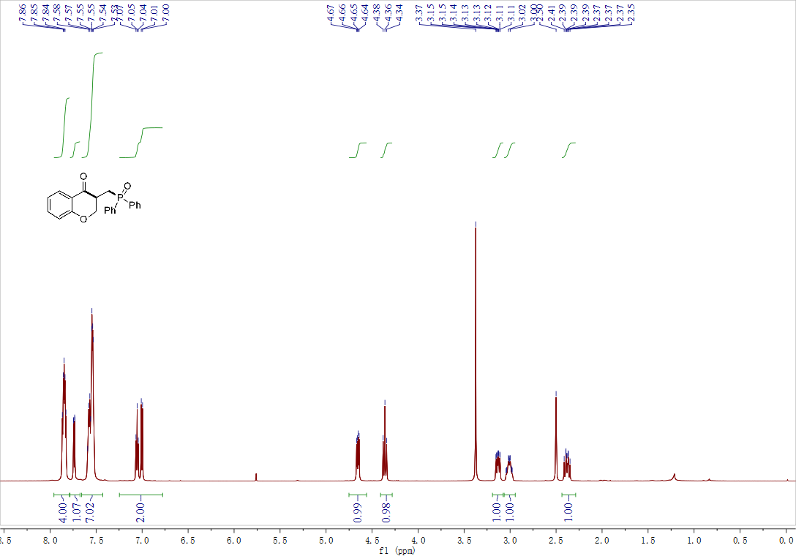

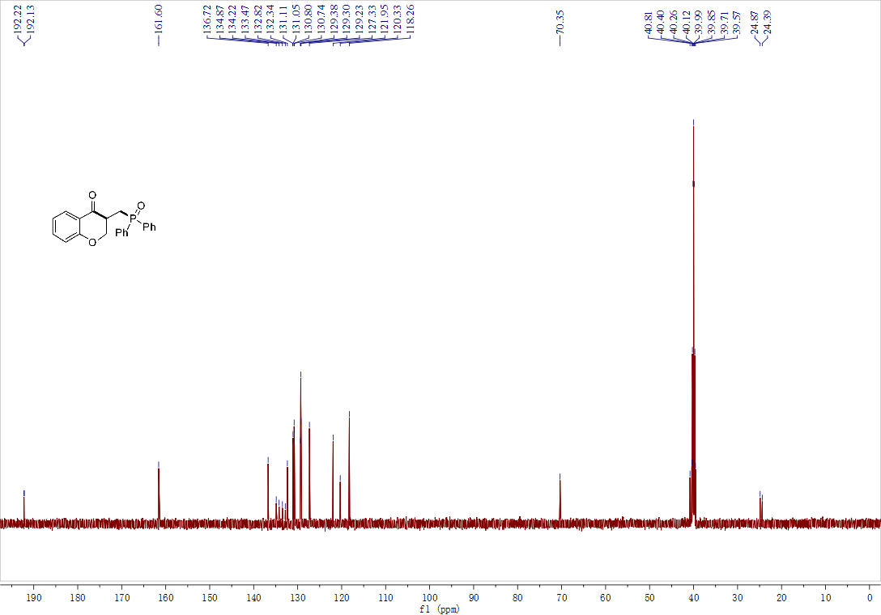
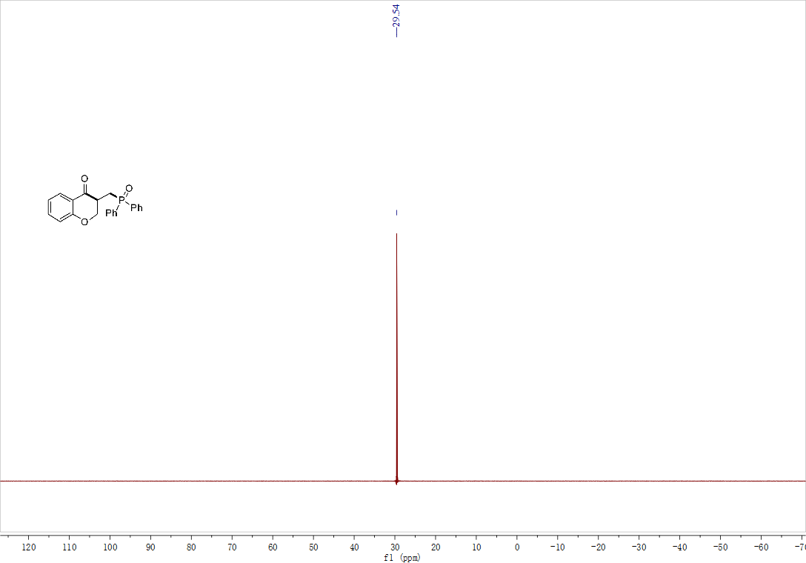

Compound 3ba ¹H NMR, ¹³C NMR and ³¹P NMR

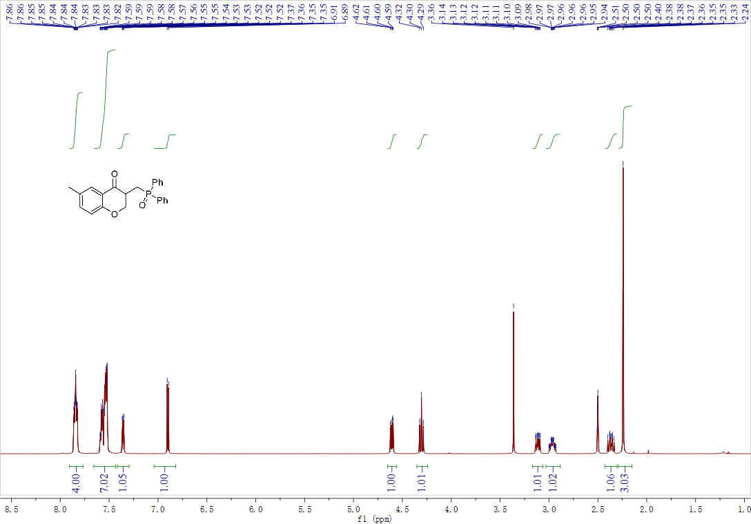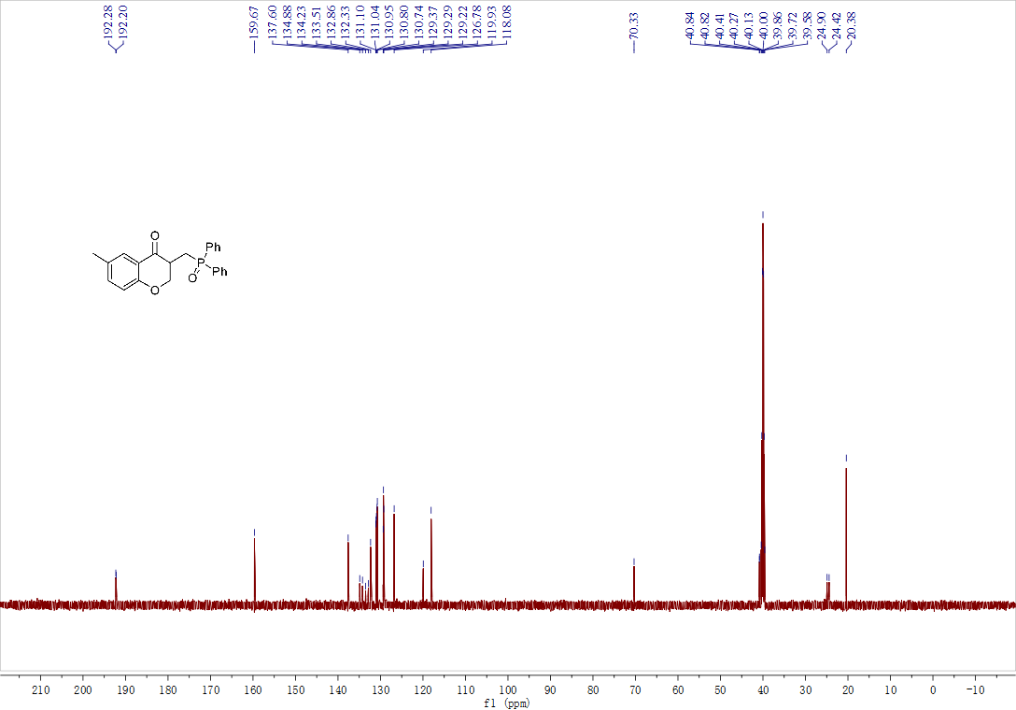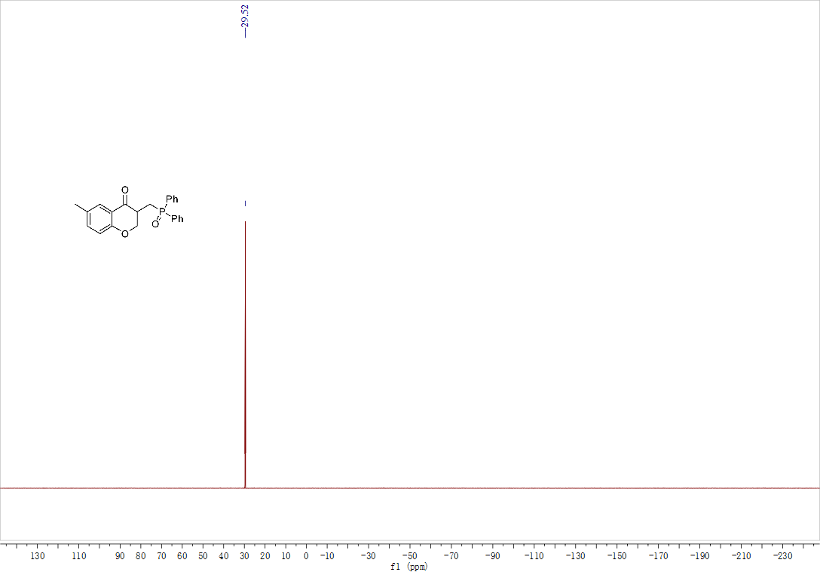

Compound 3ca ¹H NMR, ¹³C NMR and ³¹P NMR
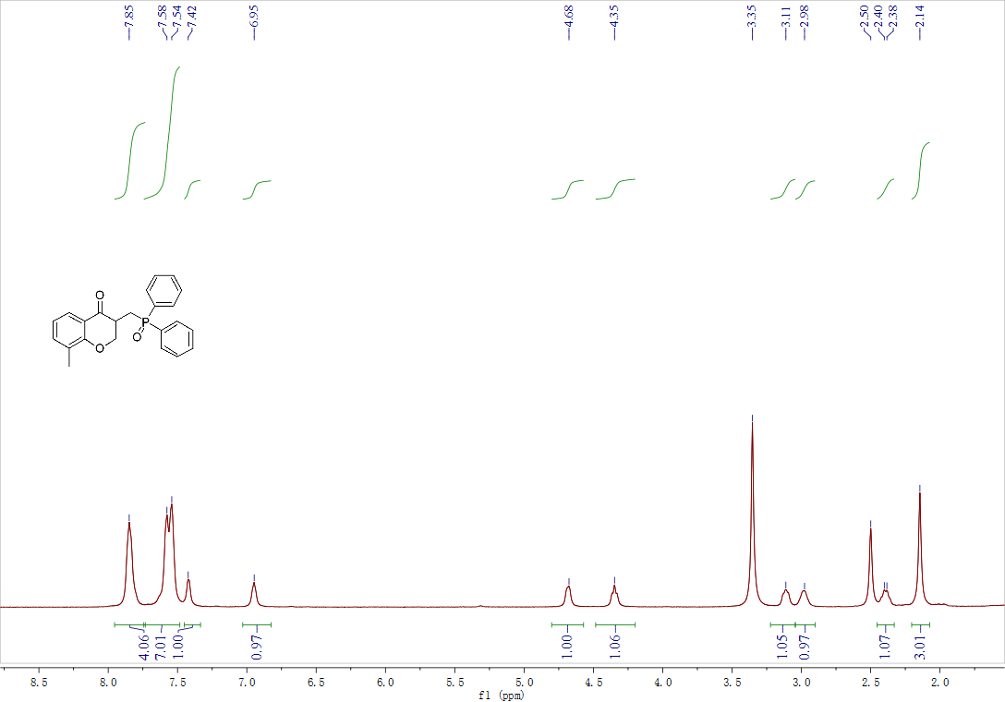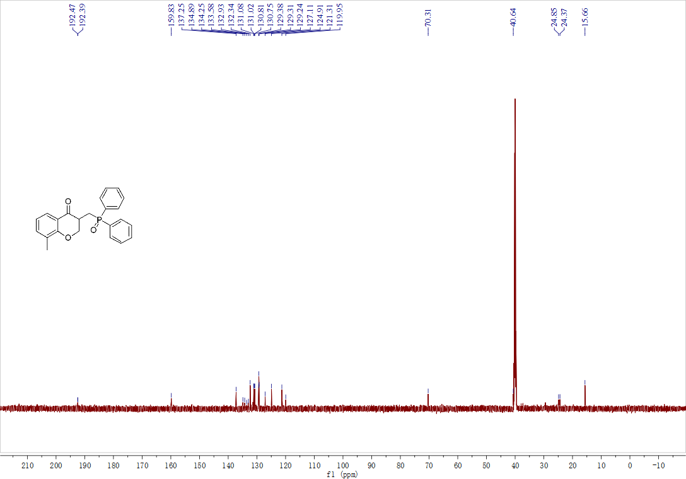

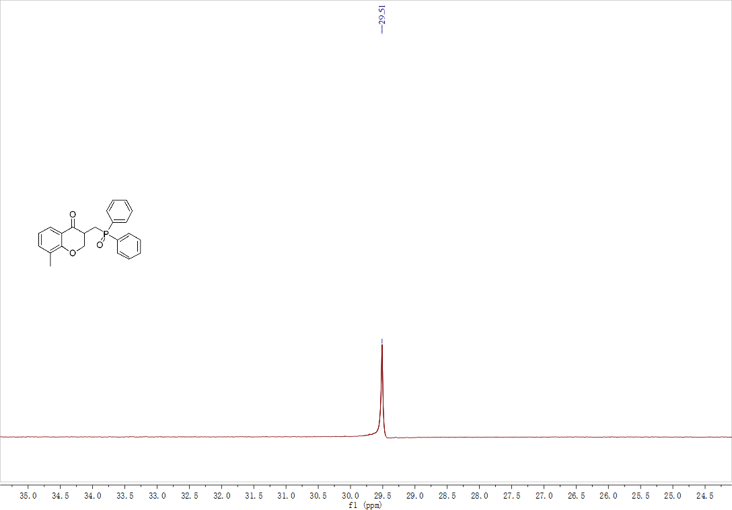

Compound 3da ¹H NMR, ¹³C NMR and ³¹P NMR

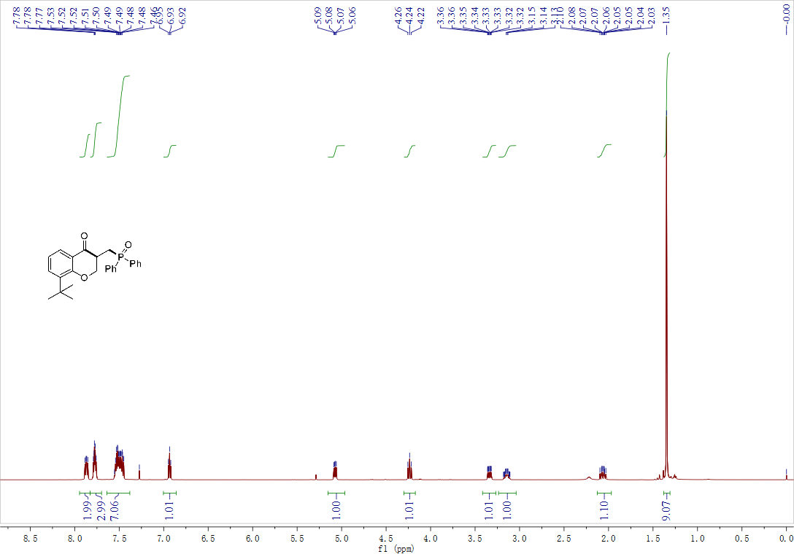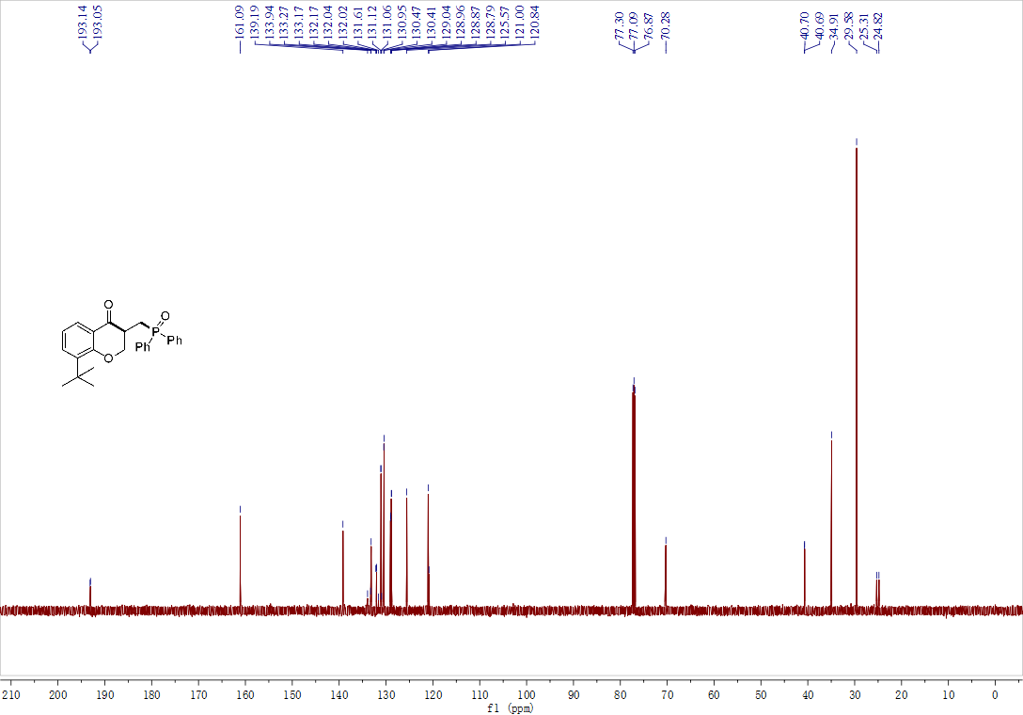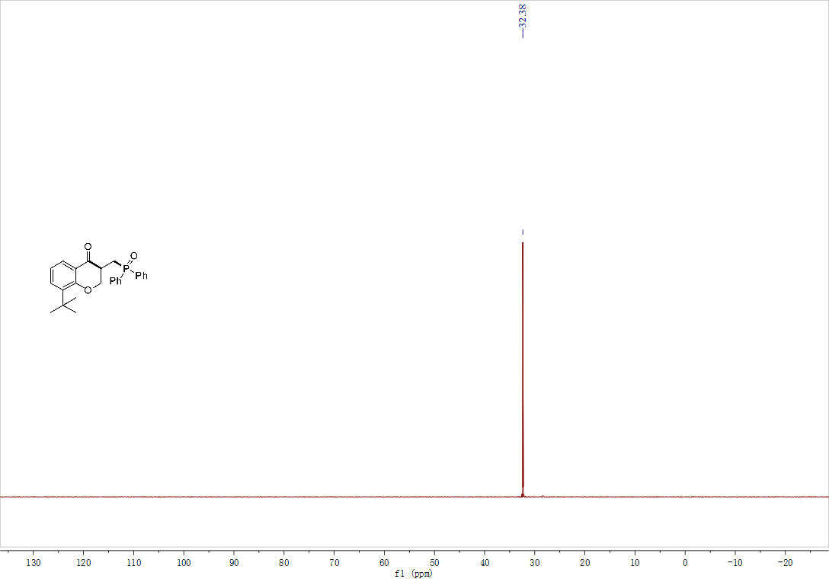

Compound 3ea ¹H NMR, ¹³C NMR and ³¹P NMR

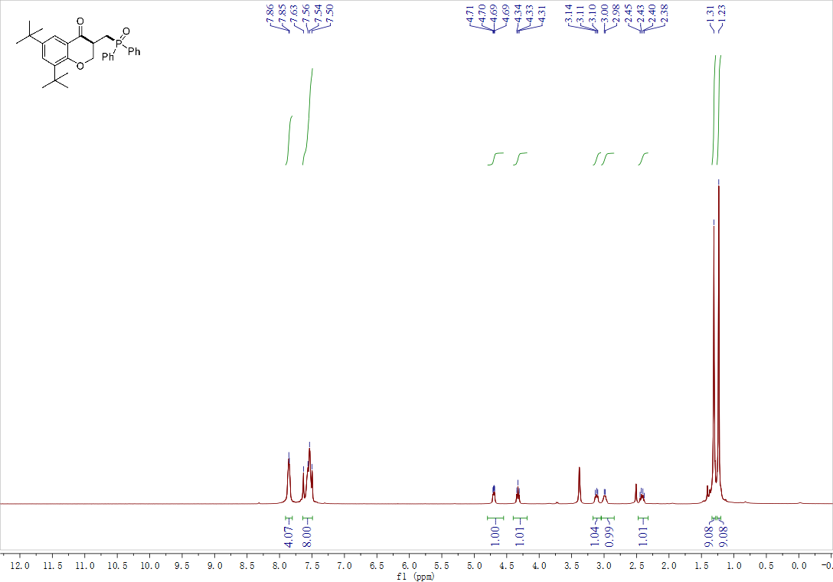
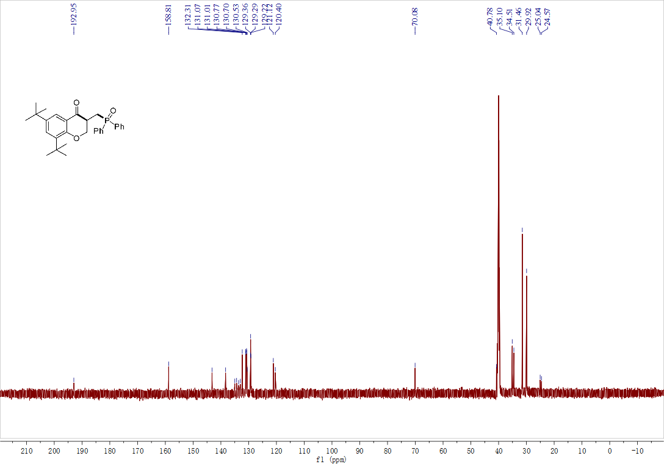
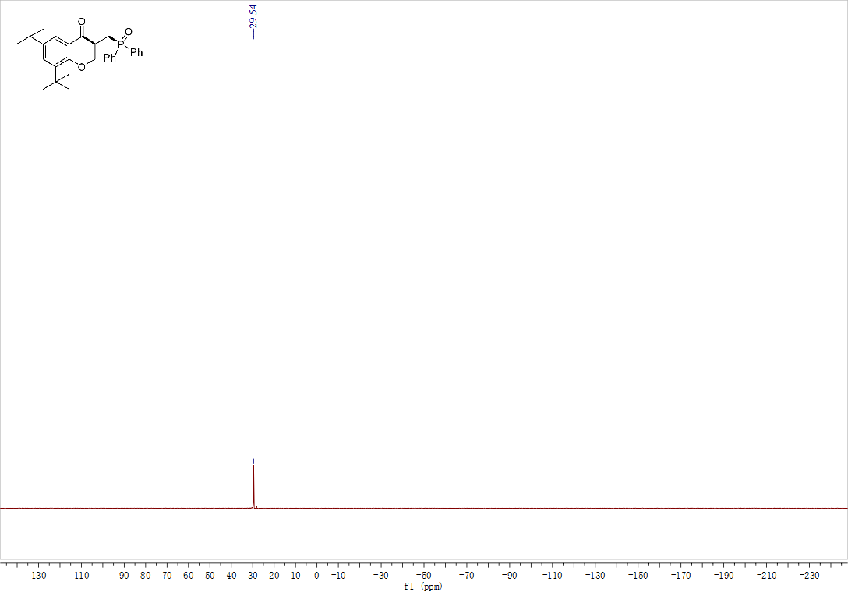

Compound 3fa ¹H NMR, ¹³C NMR and ³¹P NMR

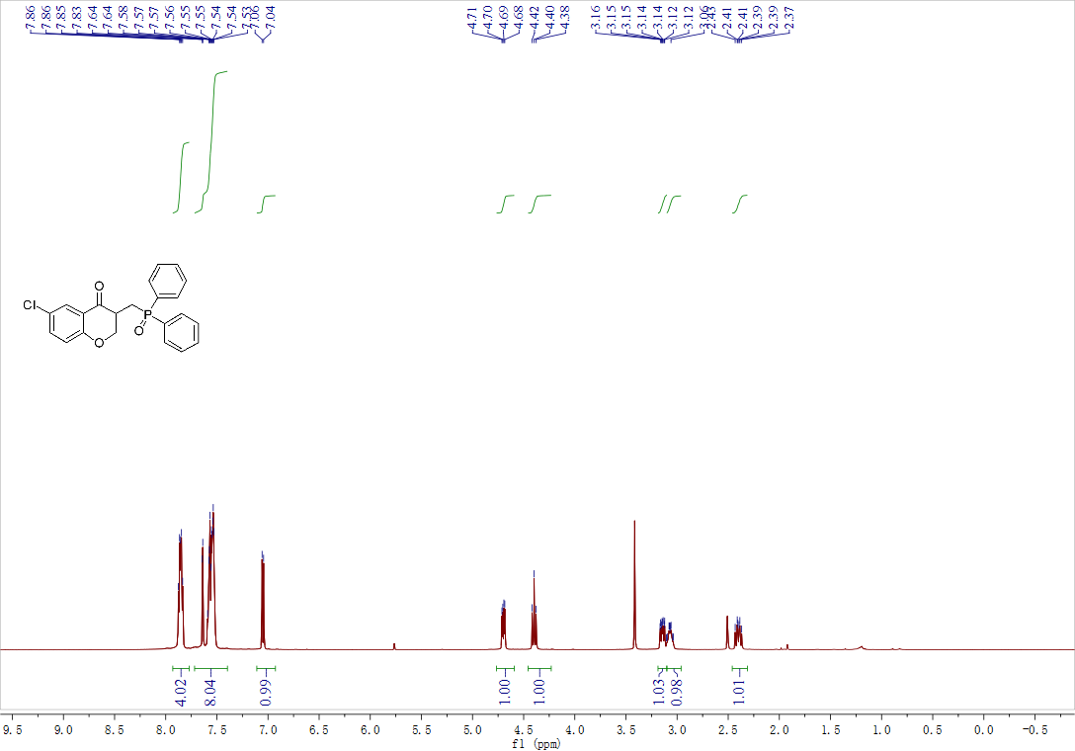

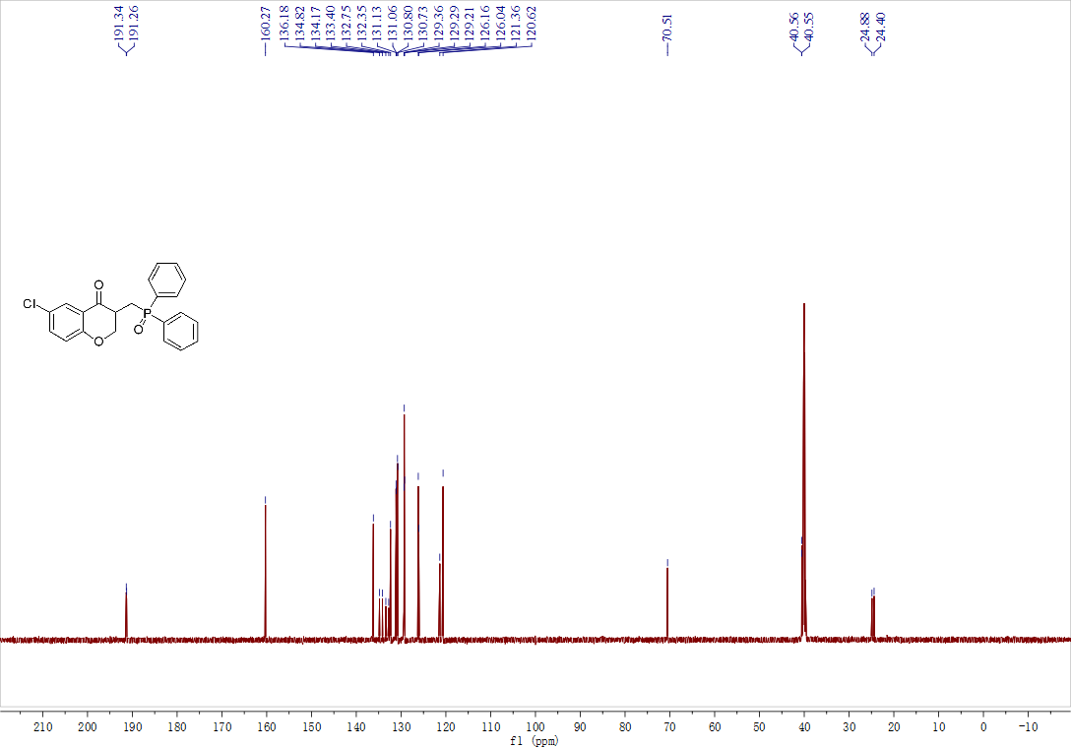
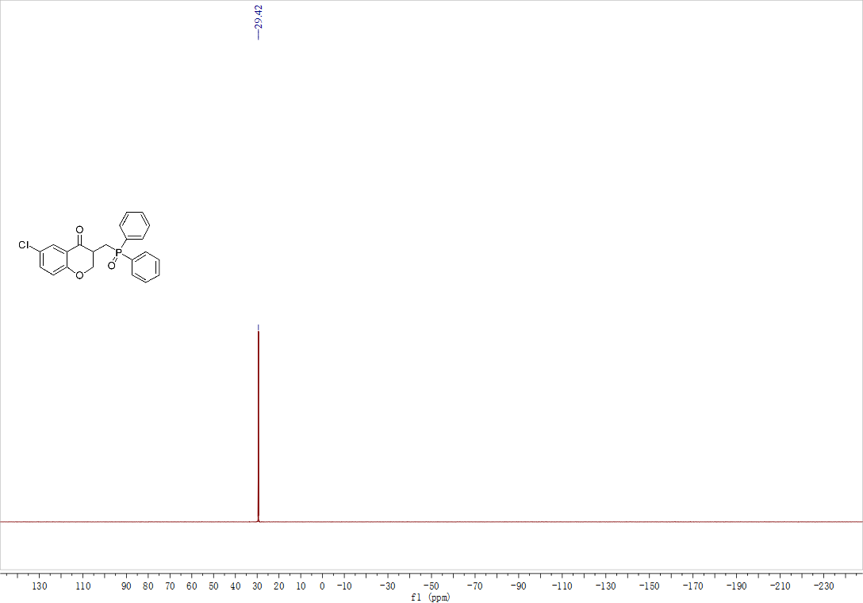

Compound 3ga ¹H NMR, ¹³C NMR and ³¹P NMR

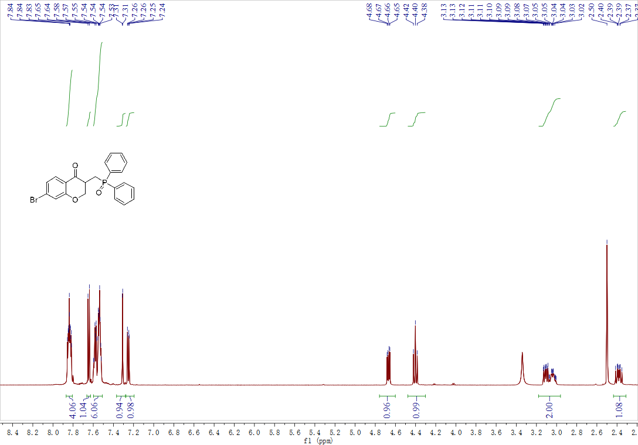

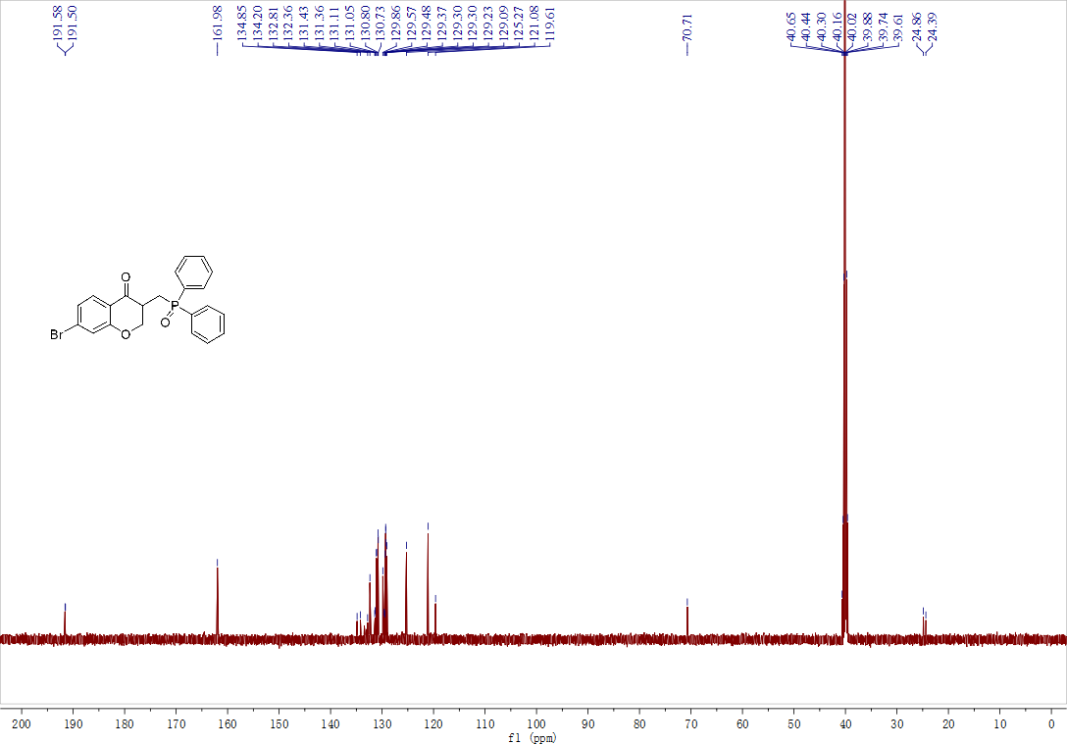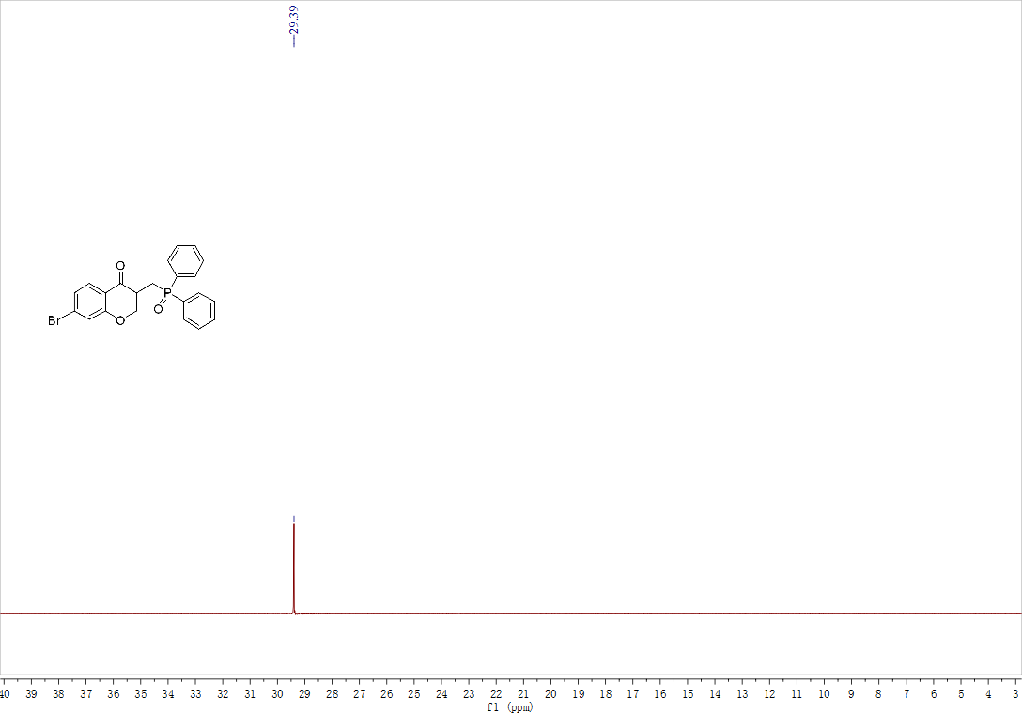

Compound 3ha ¹H NMR, ¹³C NMR, ¹⁹F NMR and ³¹P NMR

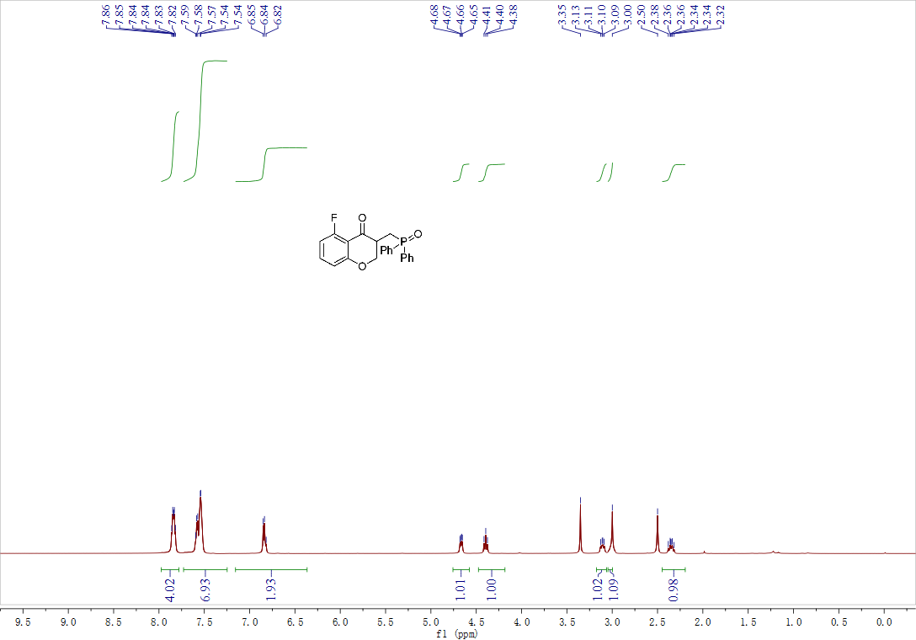
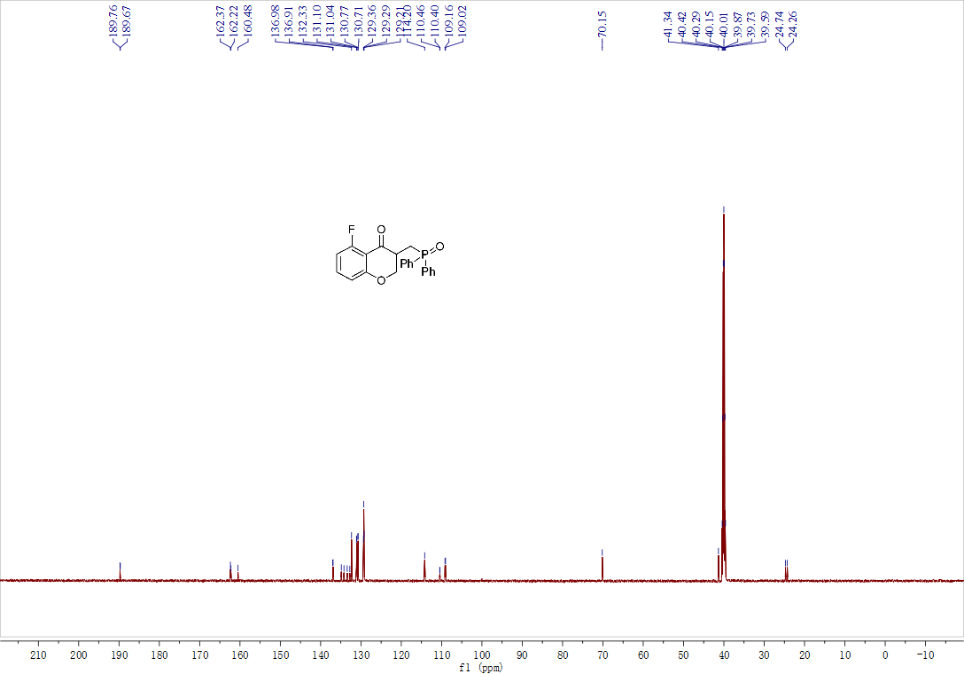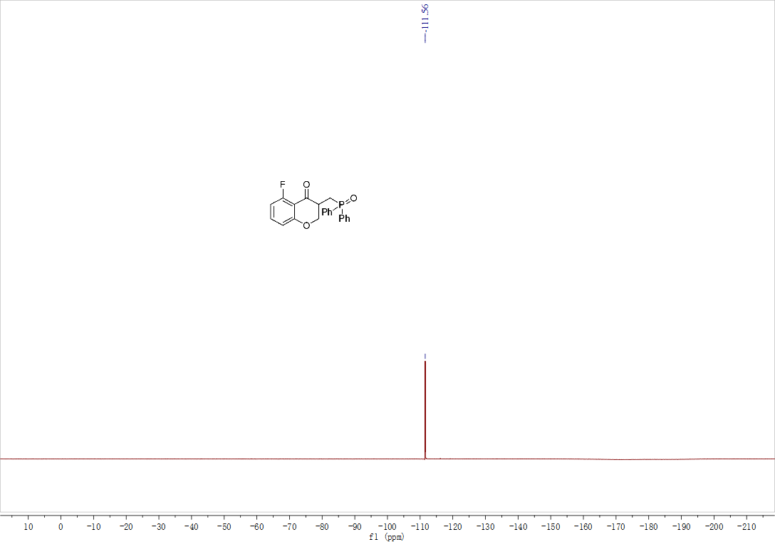
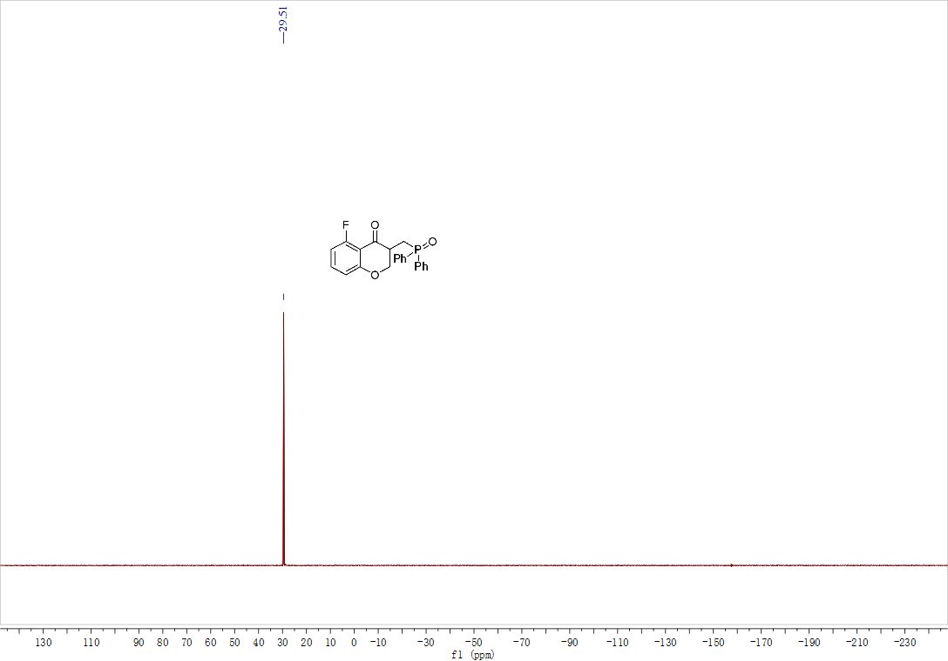

Compound 3ia ¹H NMR, ¹³C NMR and ³¹P NMR

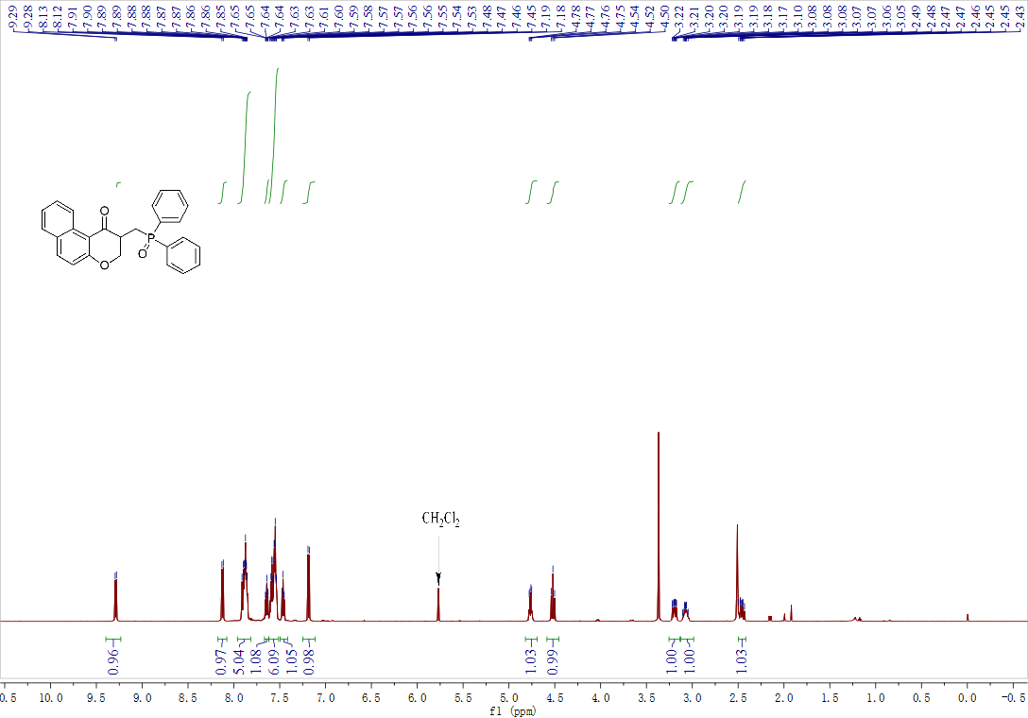
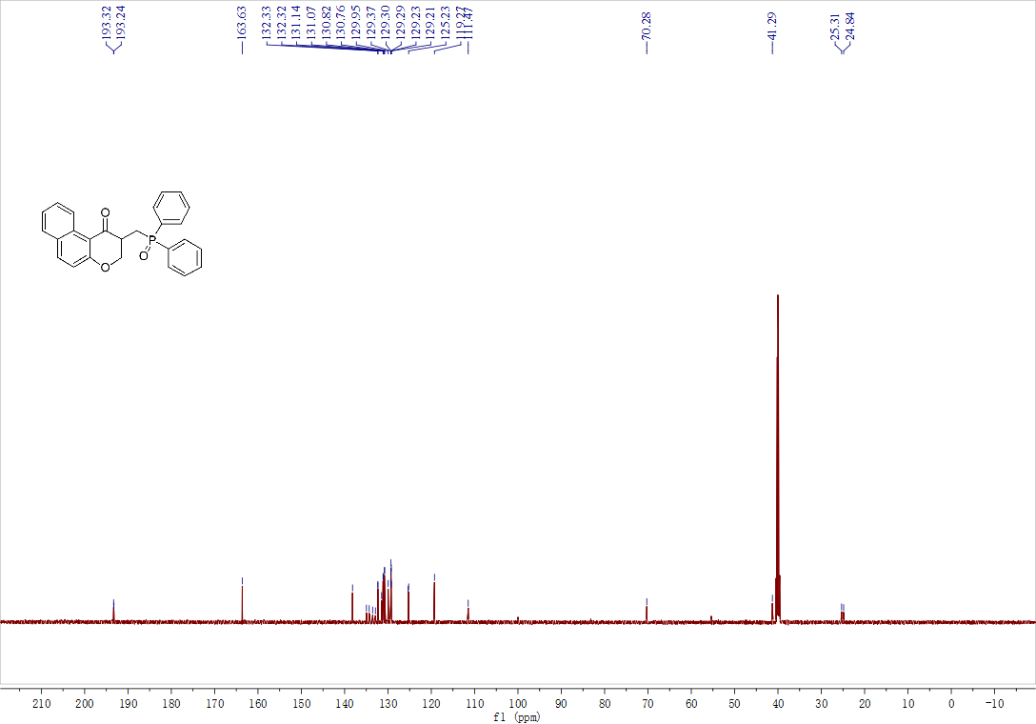

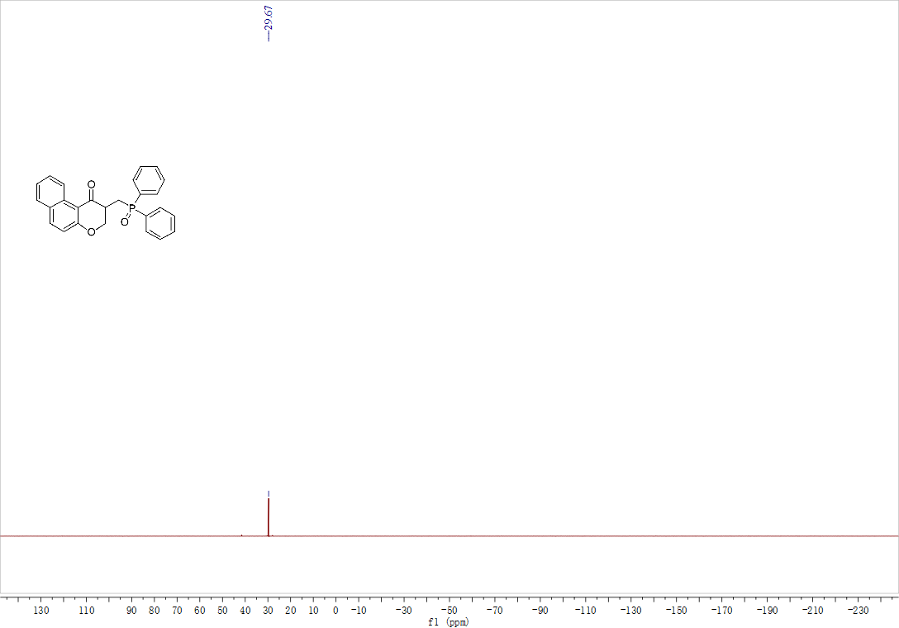

Compound 3ja ¹H NMR, ¹³C NMR and ³¹P NMR

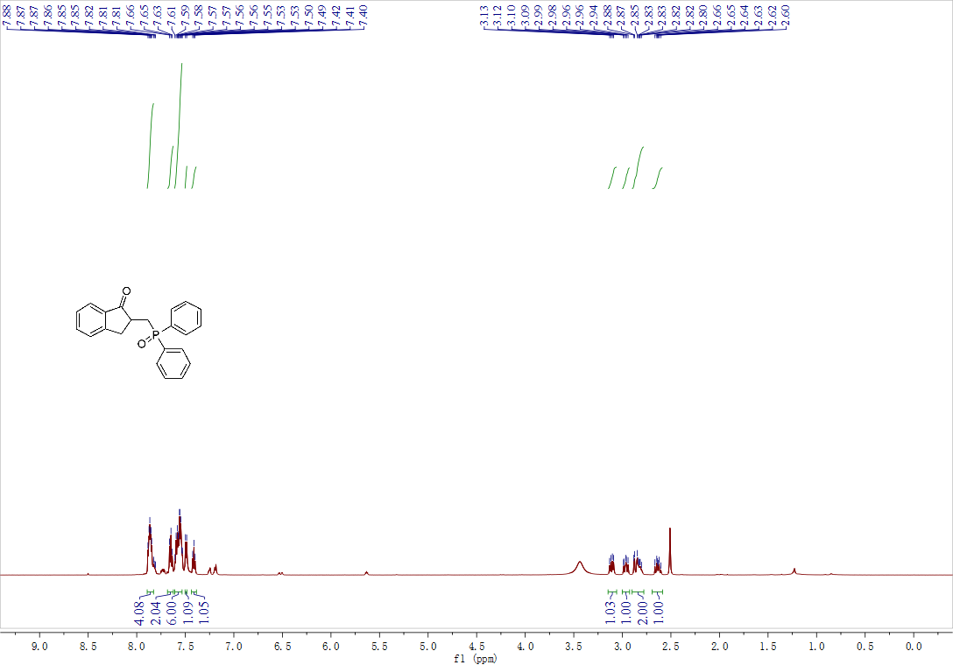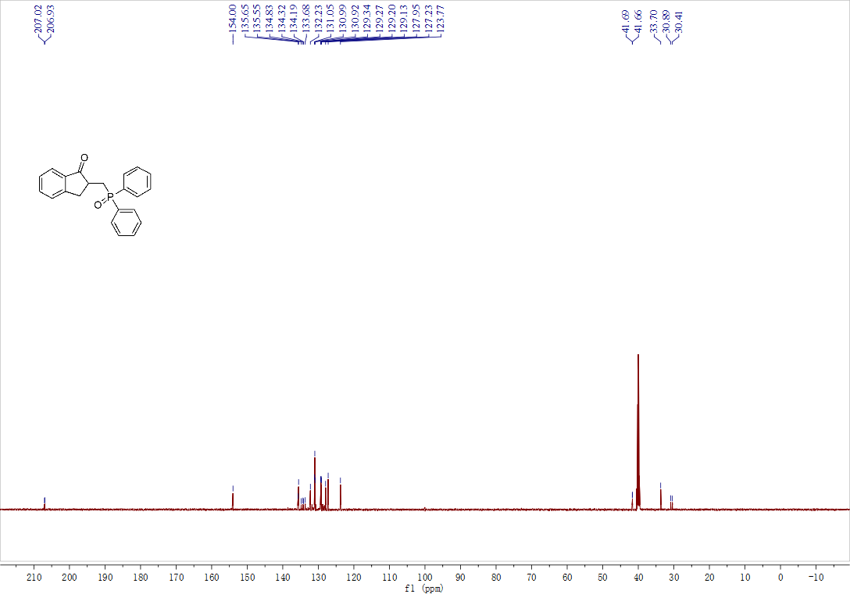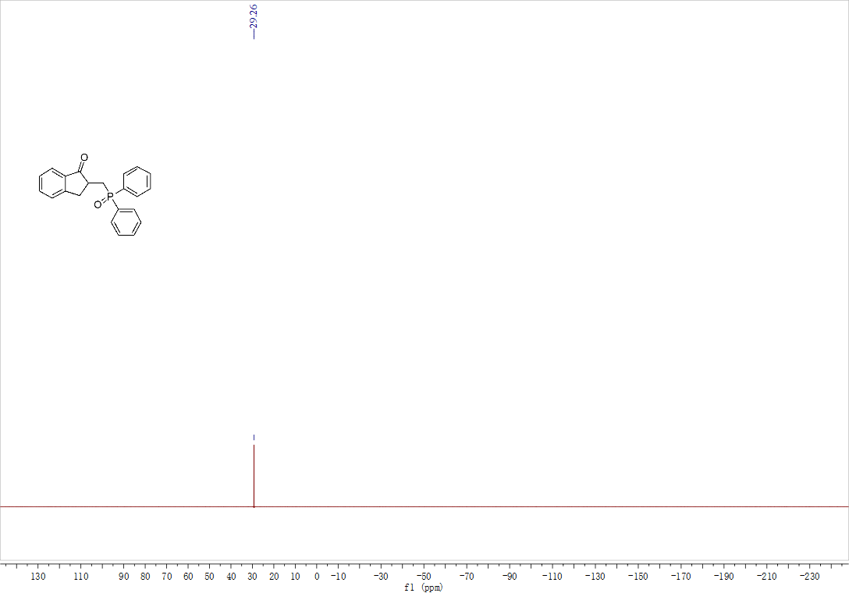

Compound 3ab ¹H NMR, ¹³C NMR and ³¹P NMR

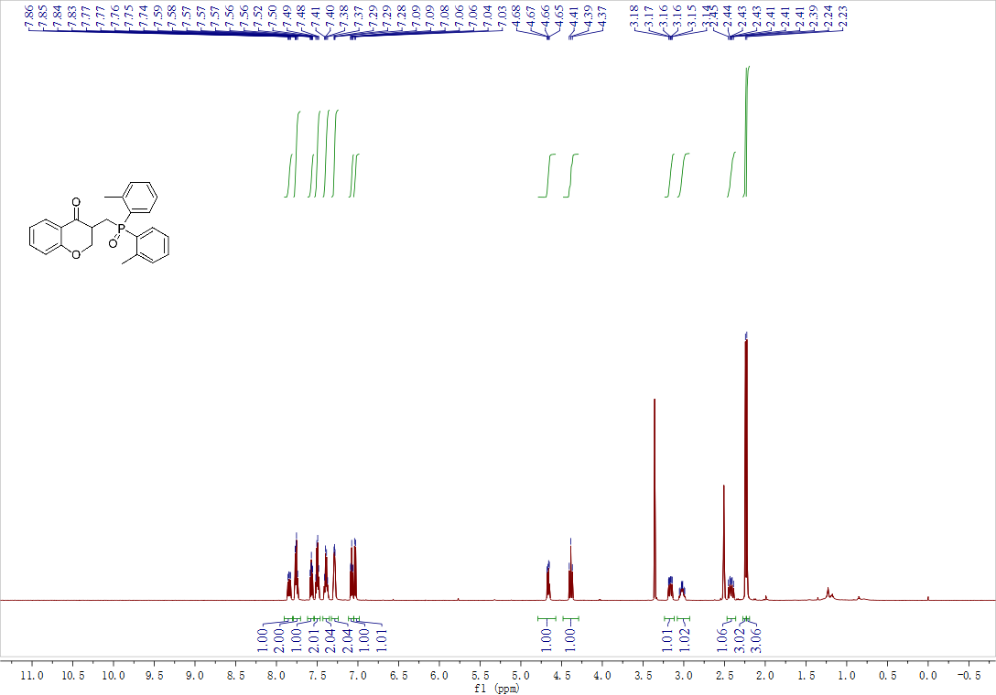
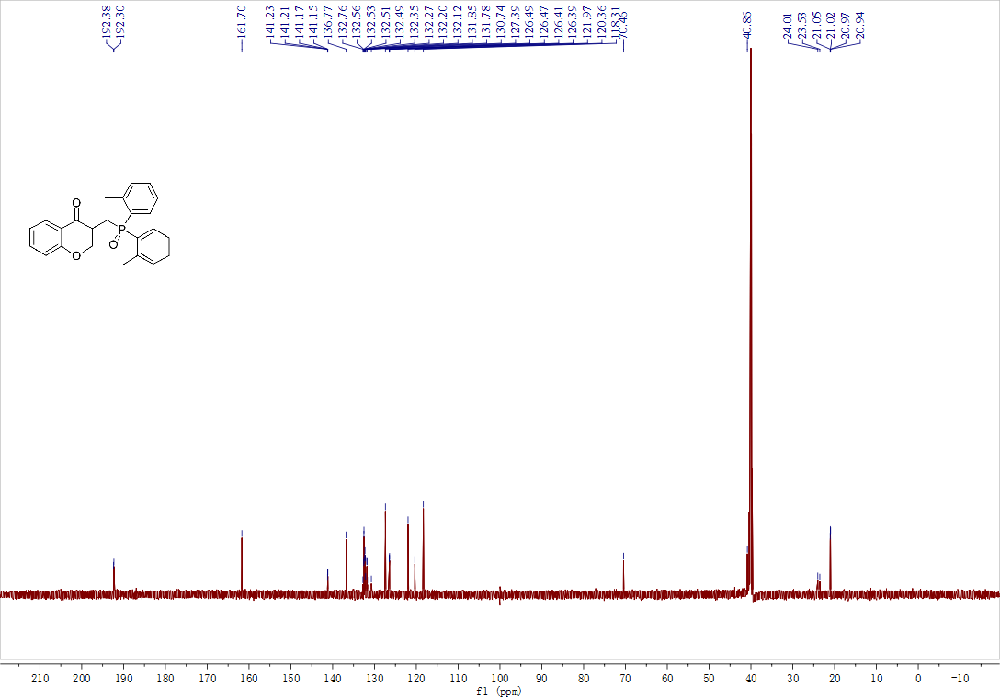
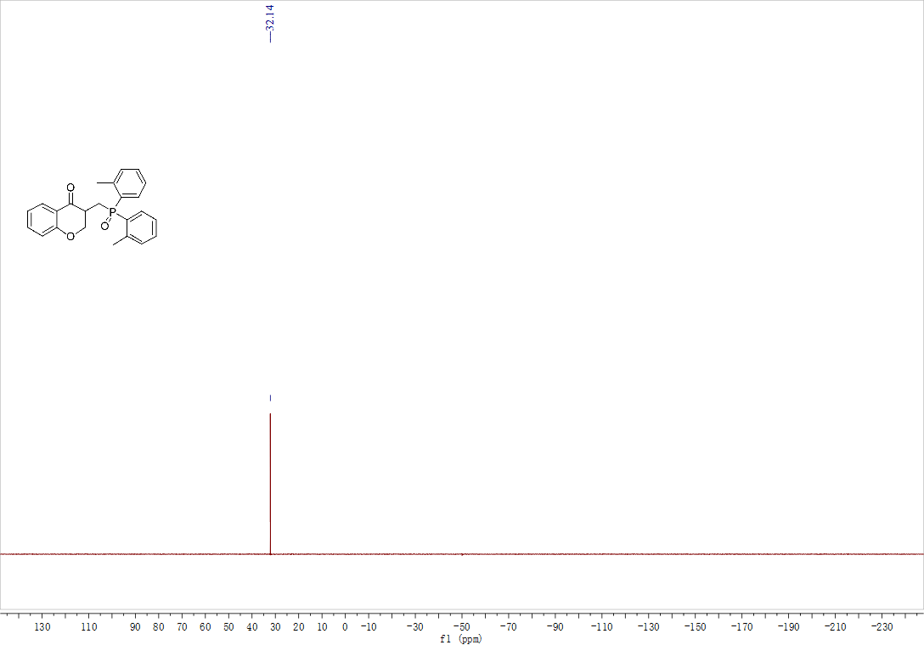

Compound 3ac ¹H NMR, ¹³C NMR and ³¹P NMR

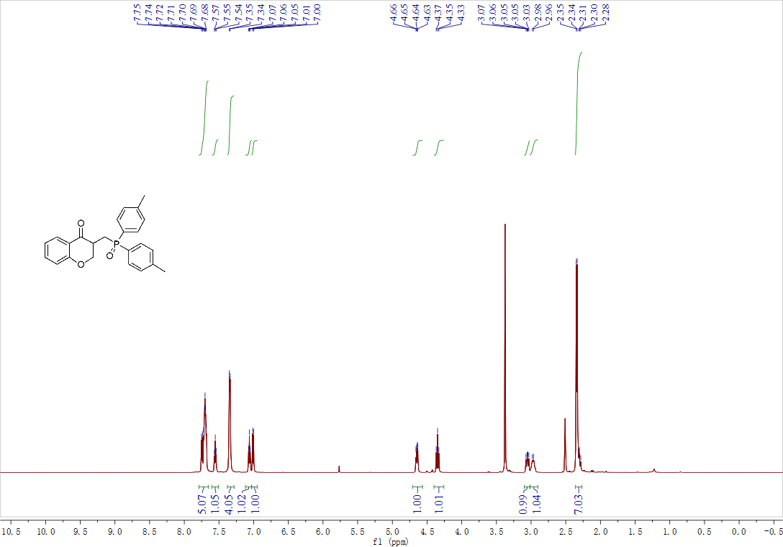
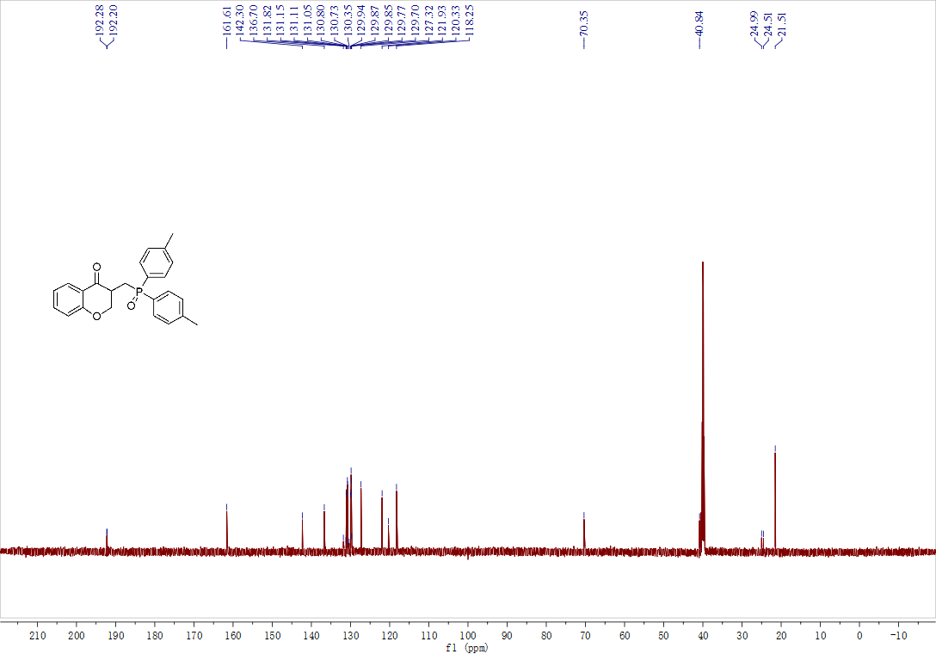
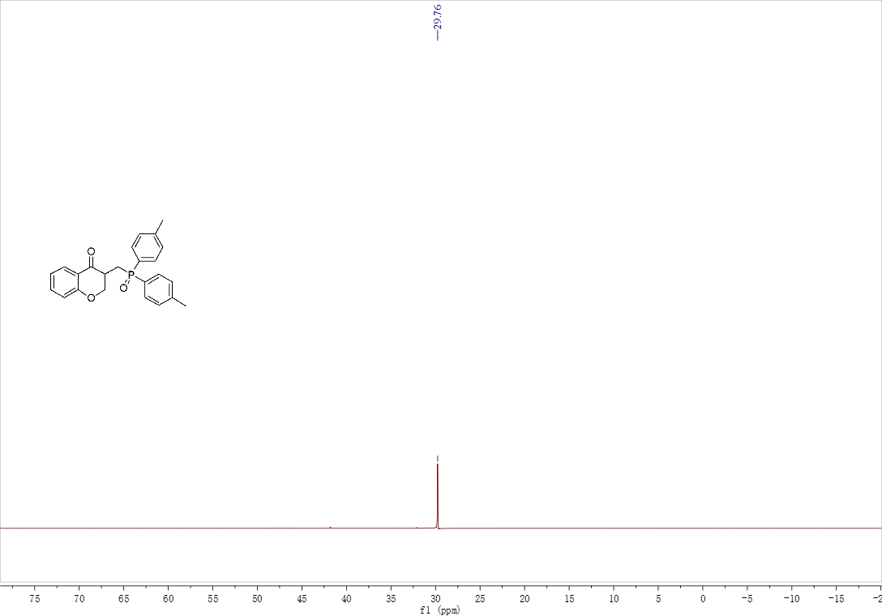

Compound 3ad ¹H NMR, ¹³C NMR and ³¹P NMR

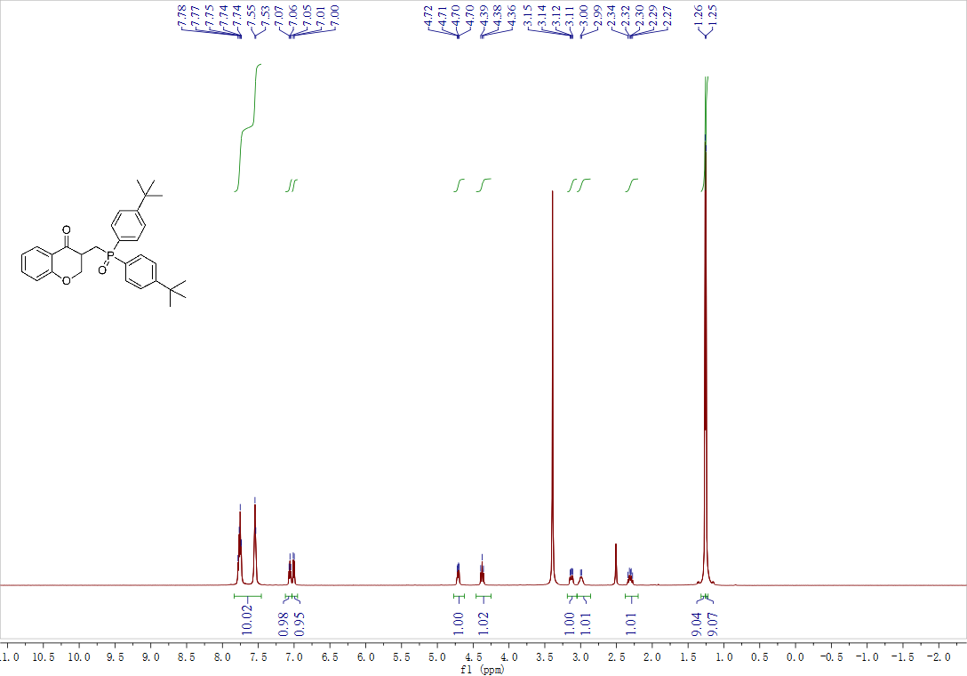
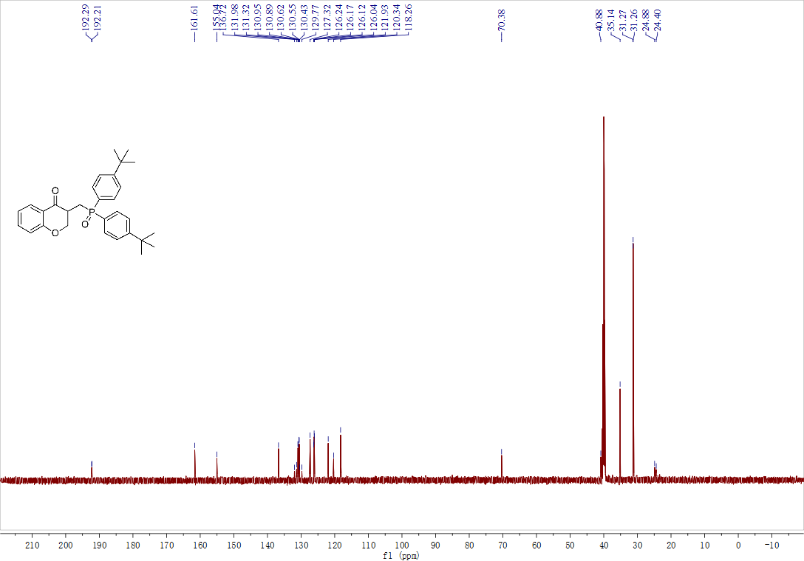
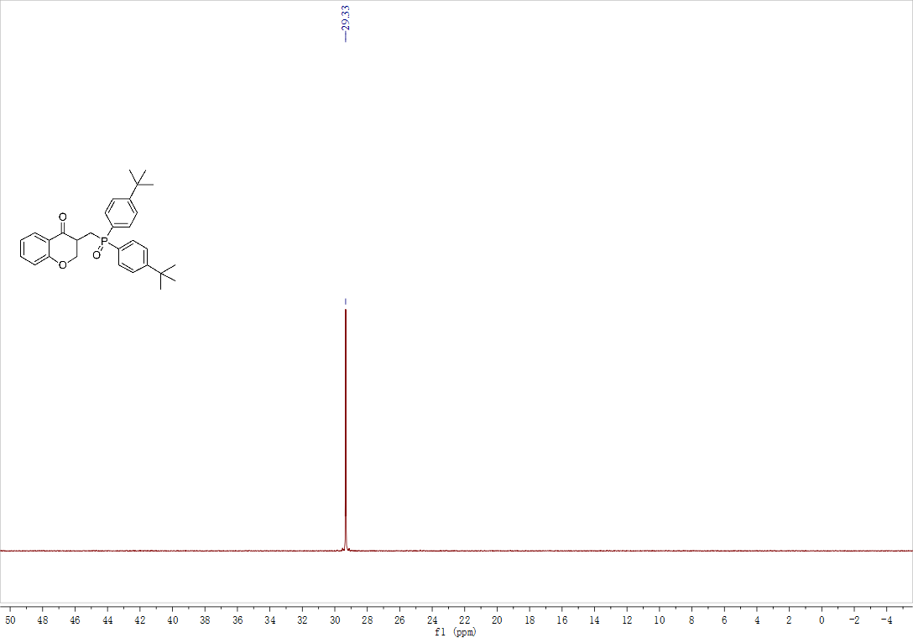

Compound 3ae ¹H NMR, ¹³C NMR and ³¹P NMR

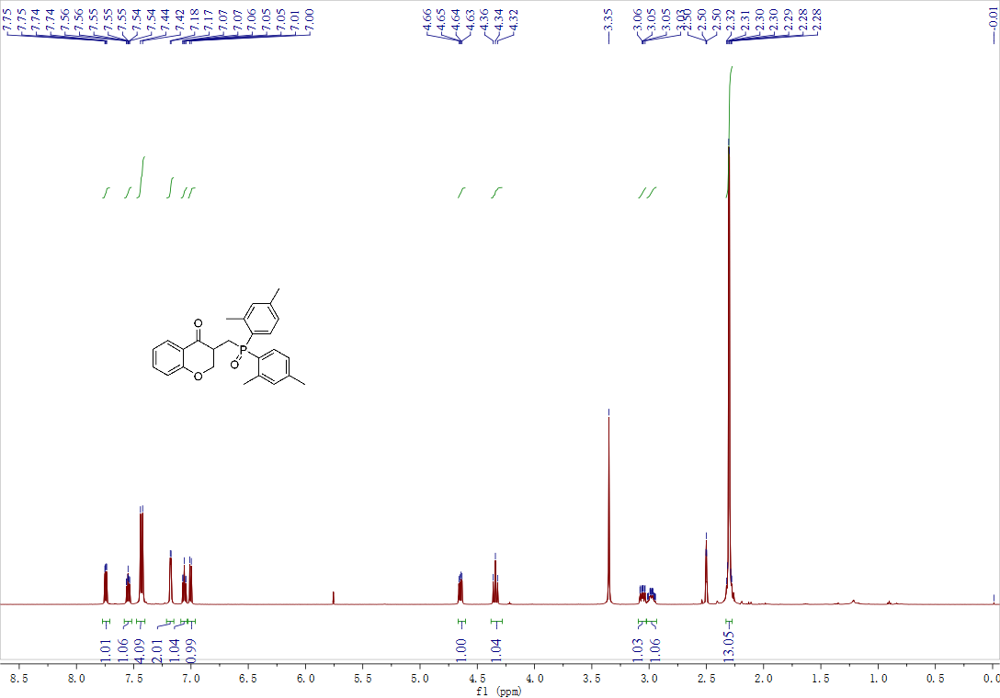

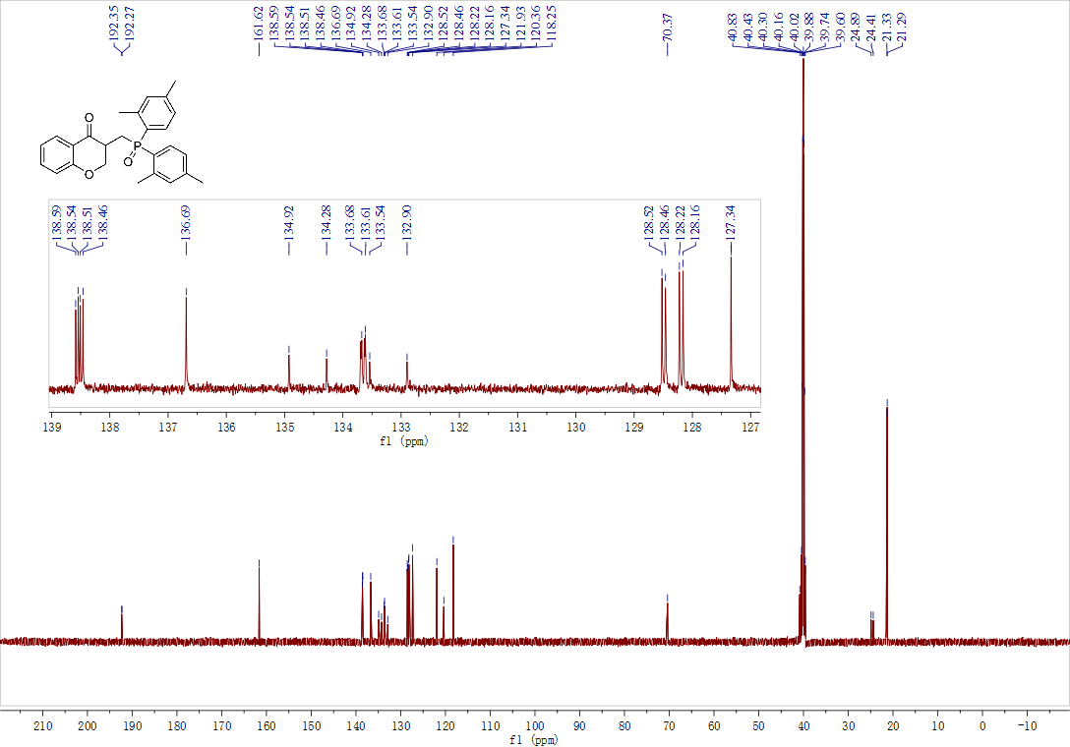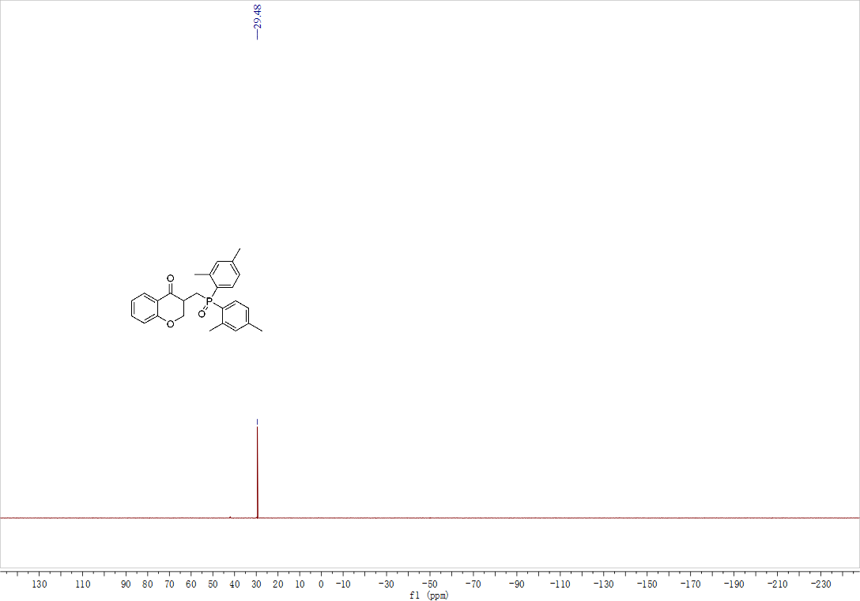

Compound 3af ¹H NMR, ¹³C NMR and ³¹P NMR

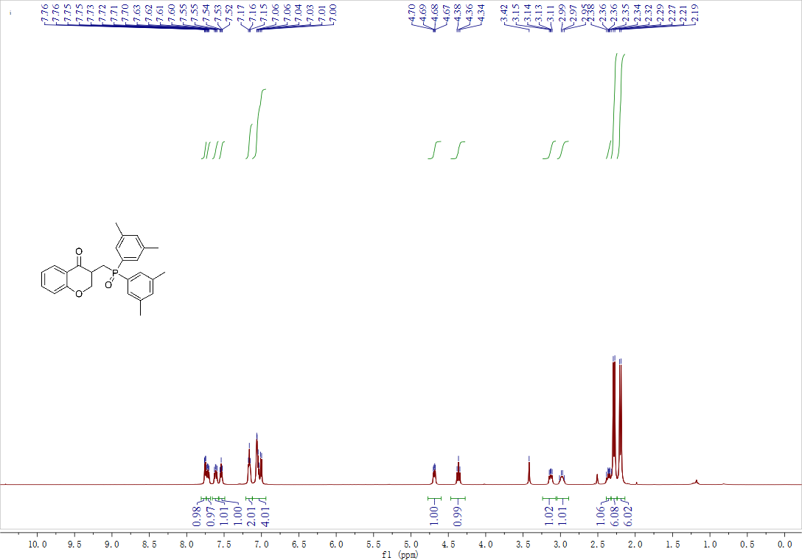
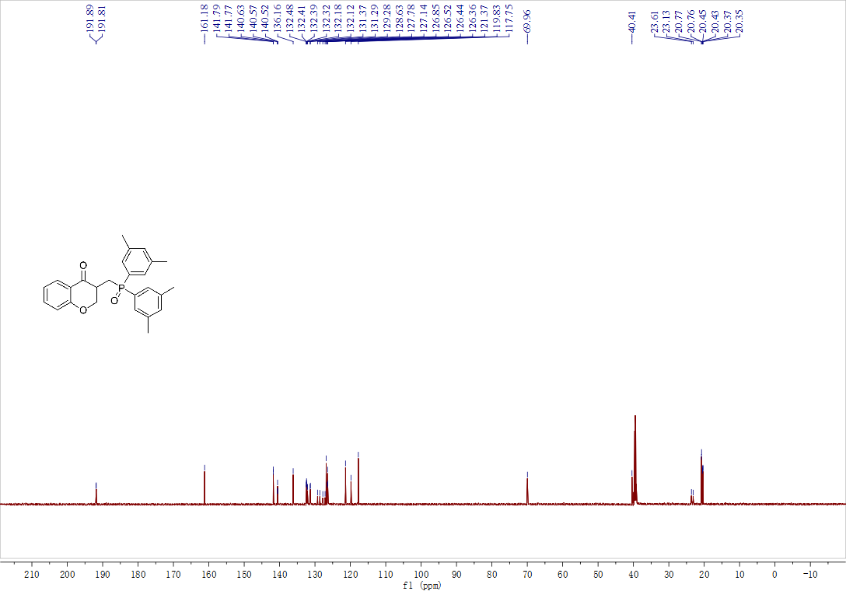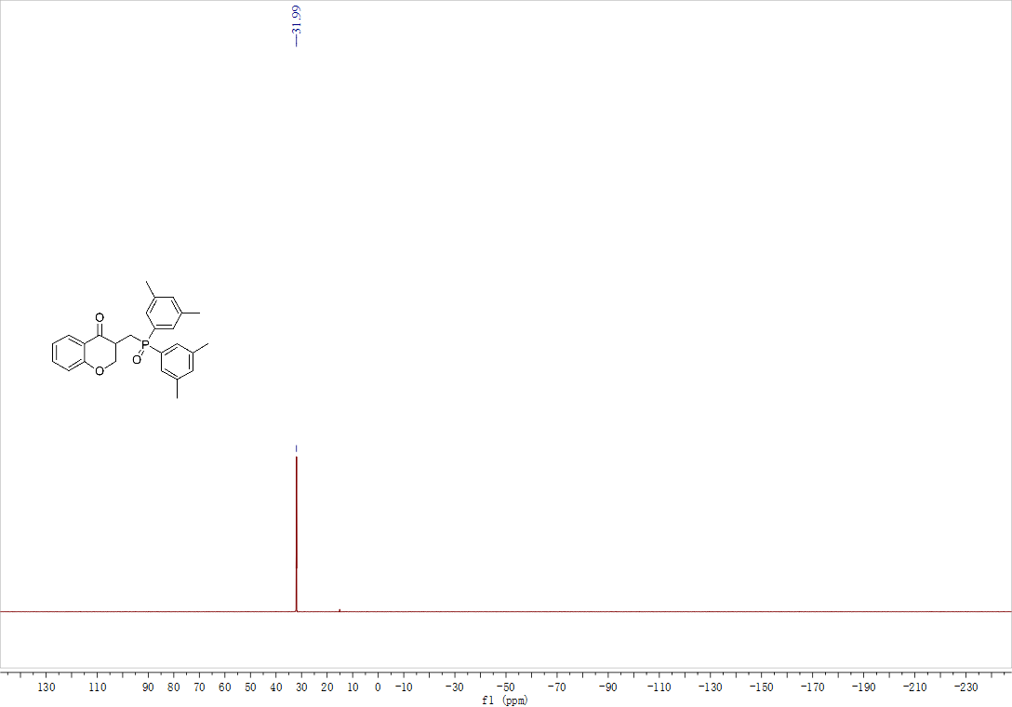

Compound 3ag ¹H NMR, ¹³C NMR, ¹⁹F NMR and ³¹P NMR

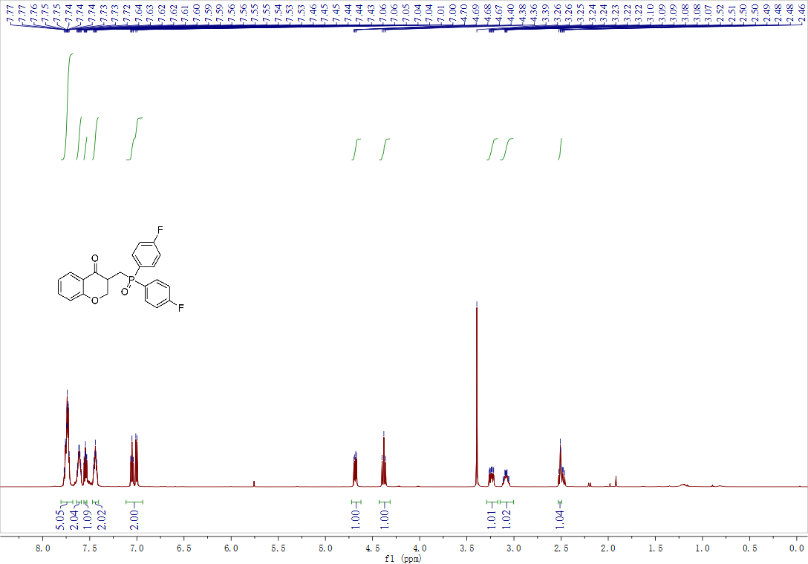
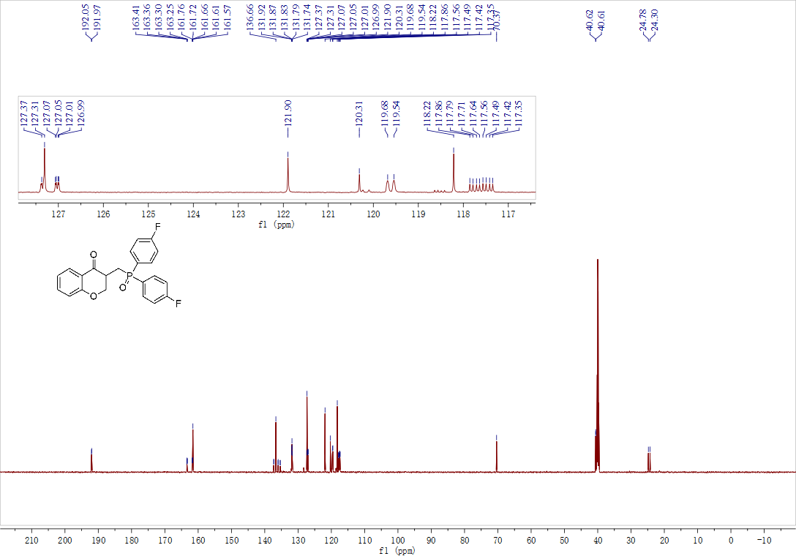
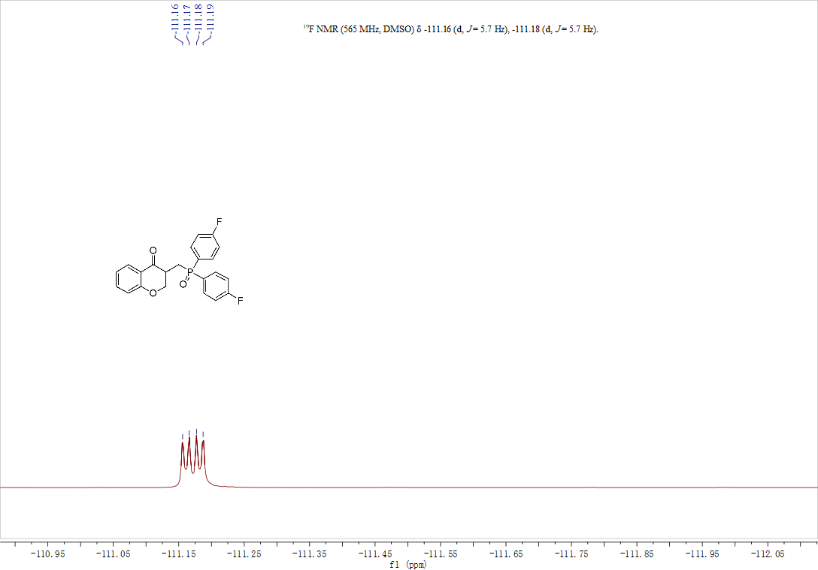

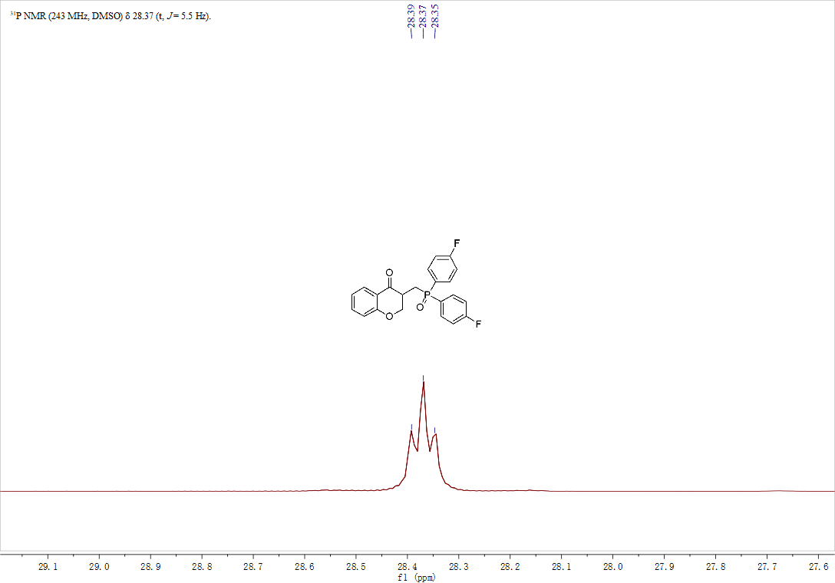

Compound 3ah ¹H NMR, ¹³C NMR and ³¹P NMR

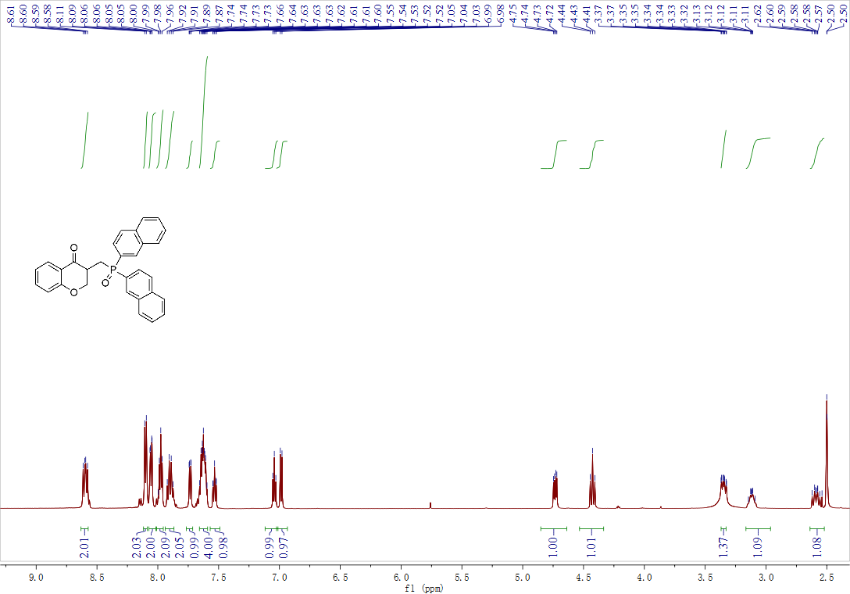

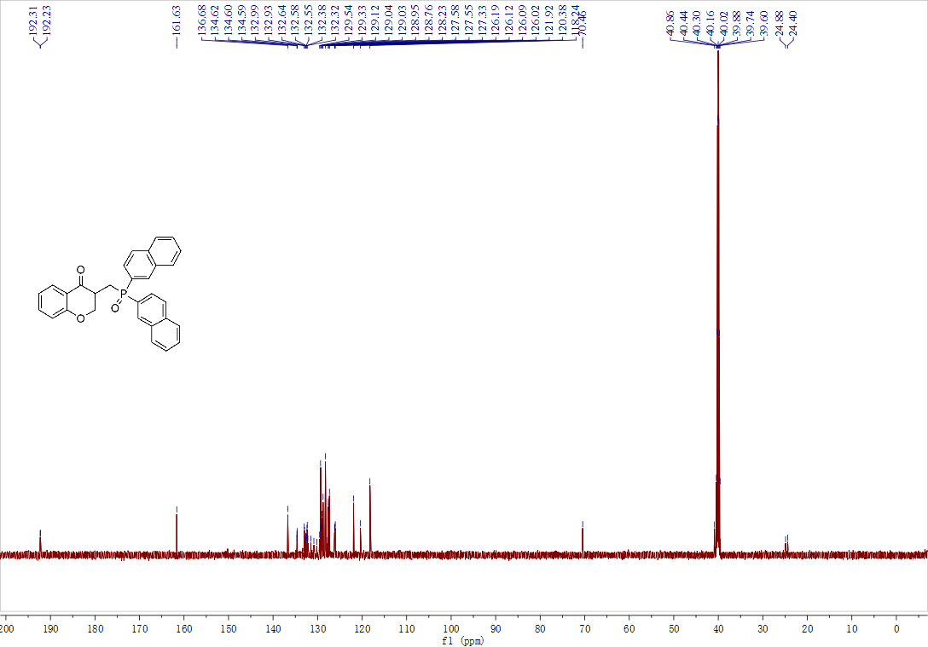

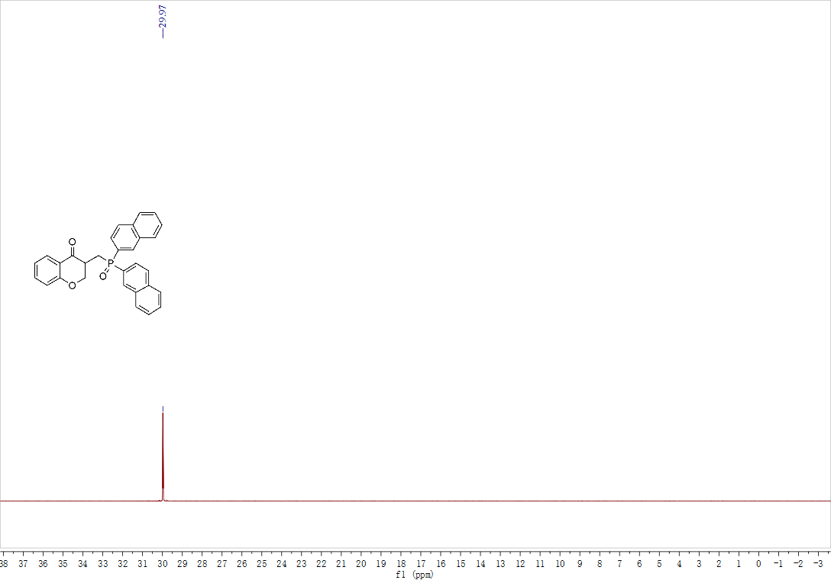

Compound 3ai ¹H NMR, ¹³C NMR and ³¹P NMR

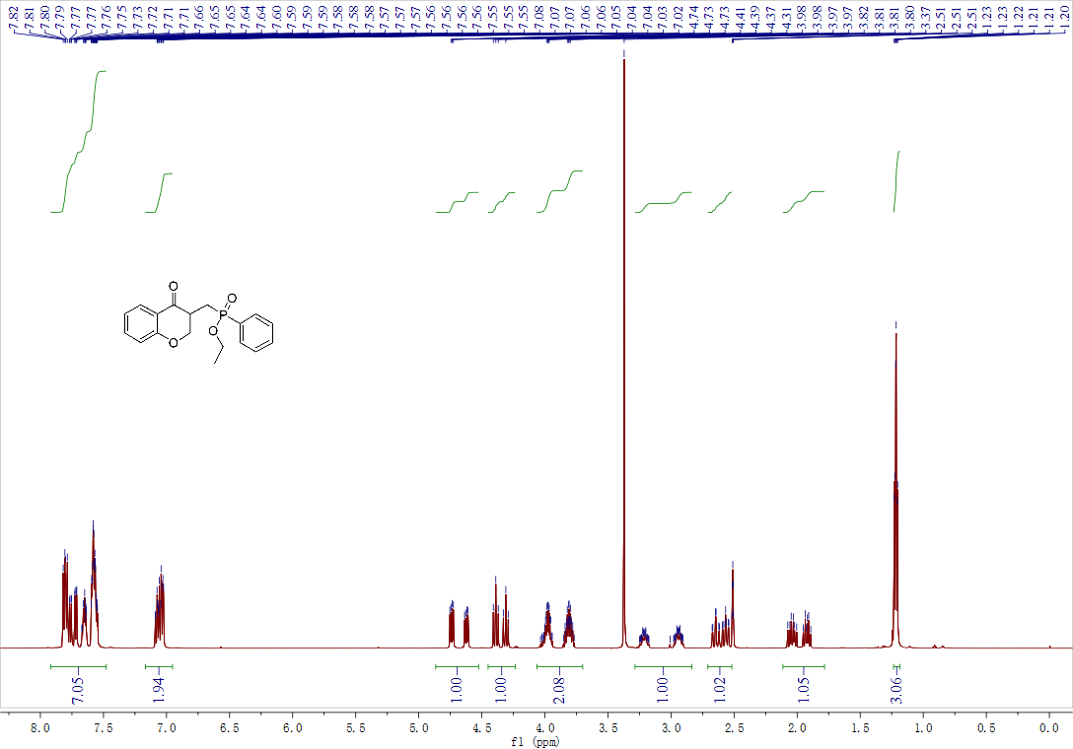

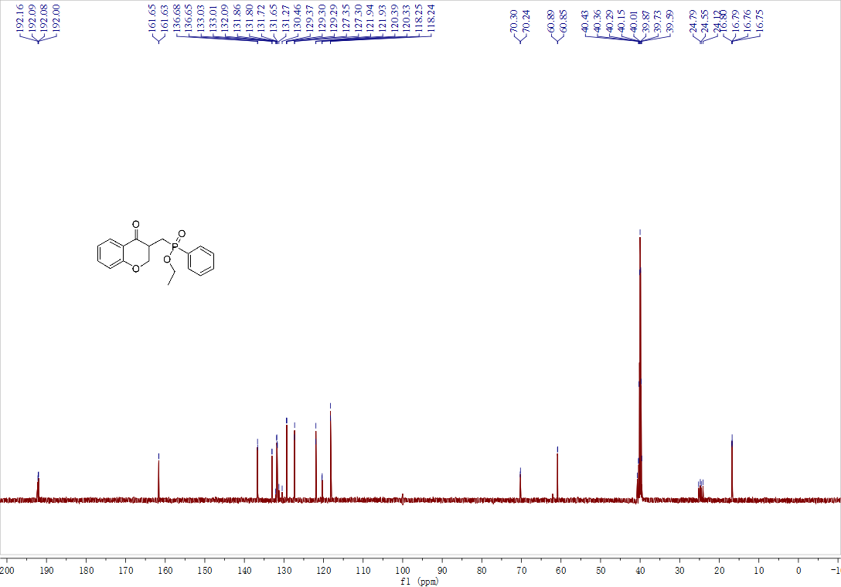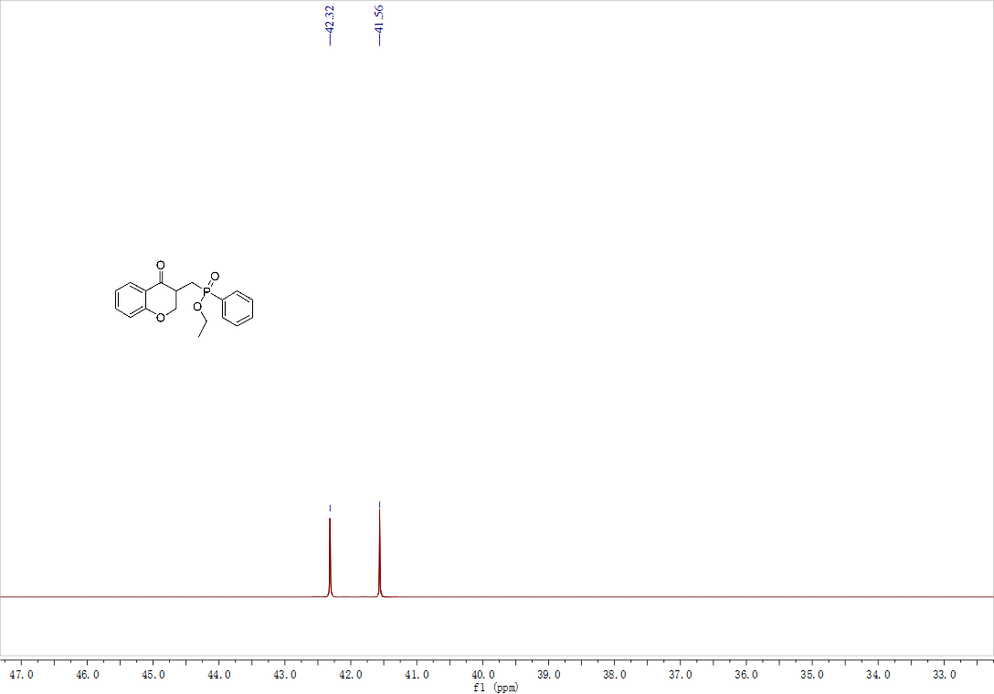

Compound 3aj ¹H NMR, ¹³C NMR and ³¹P NMR

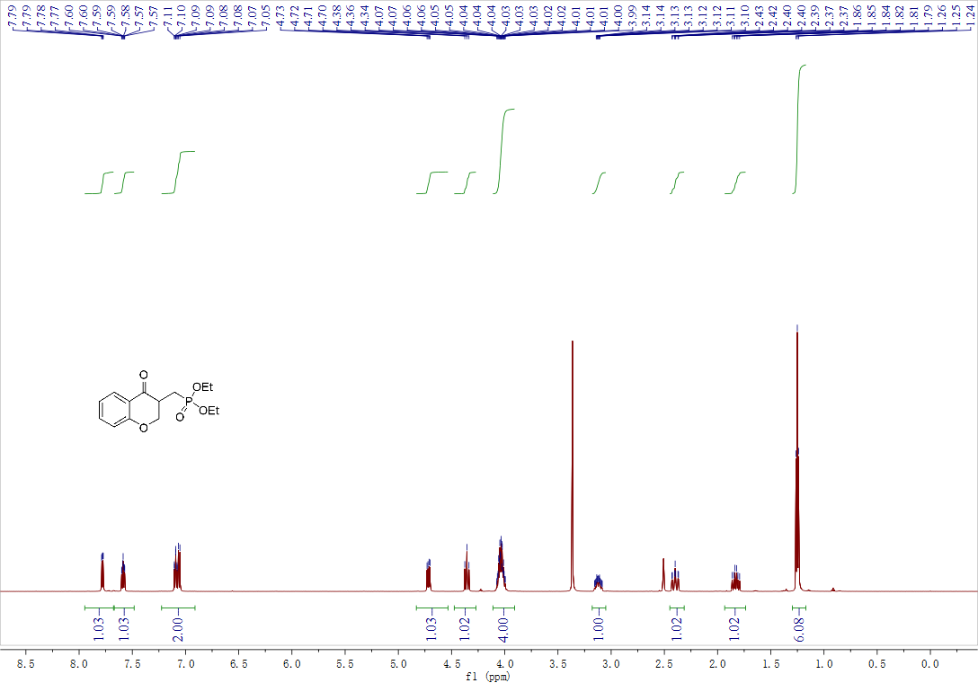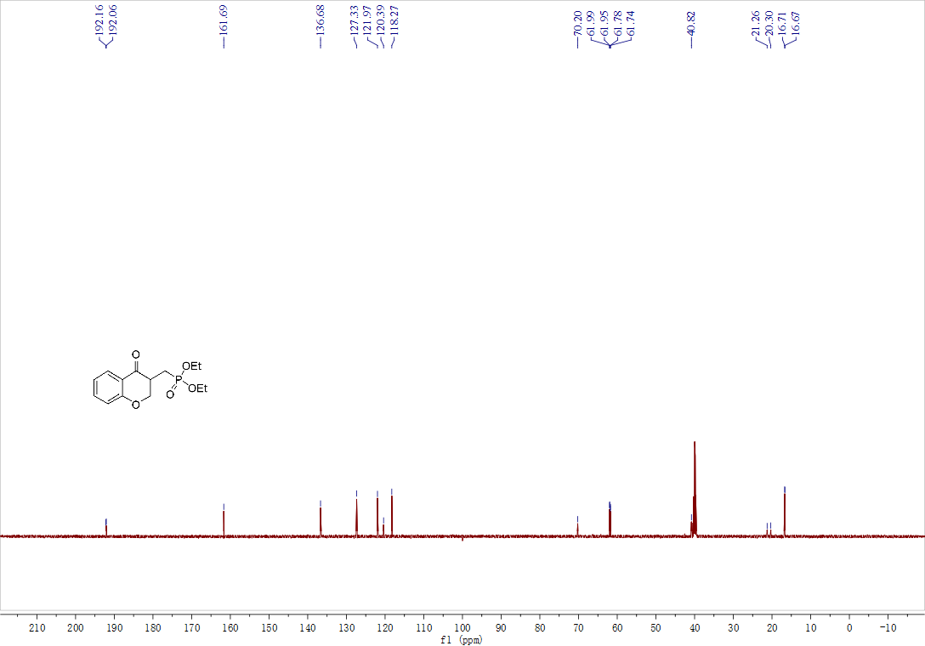

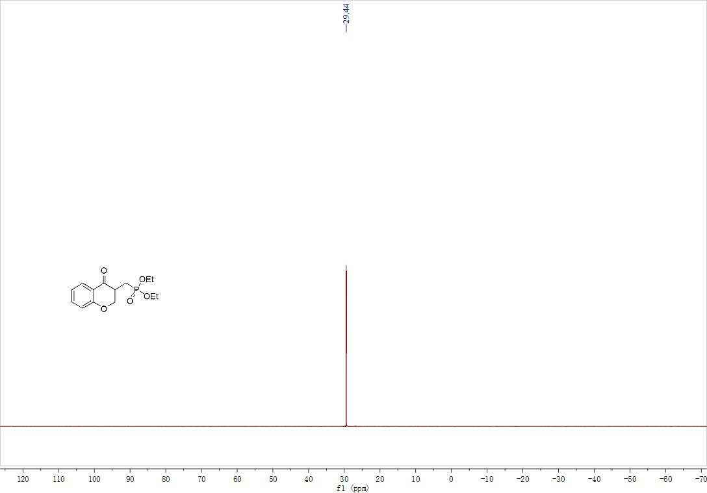

Compound 4 ¹H NMR, ¹³C NMR, ¹³C dept135 NMR and ³¹P NMR

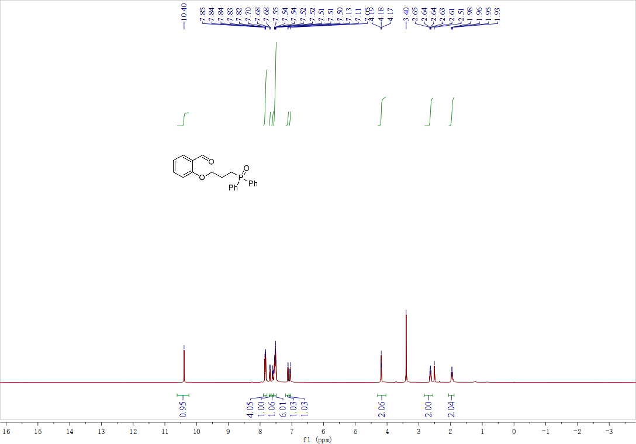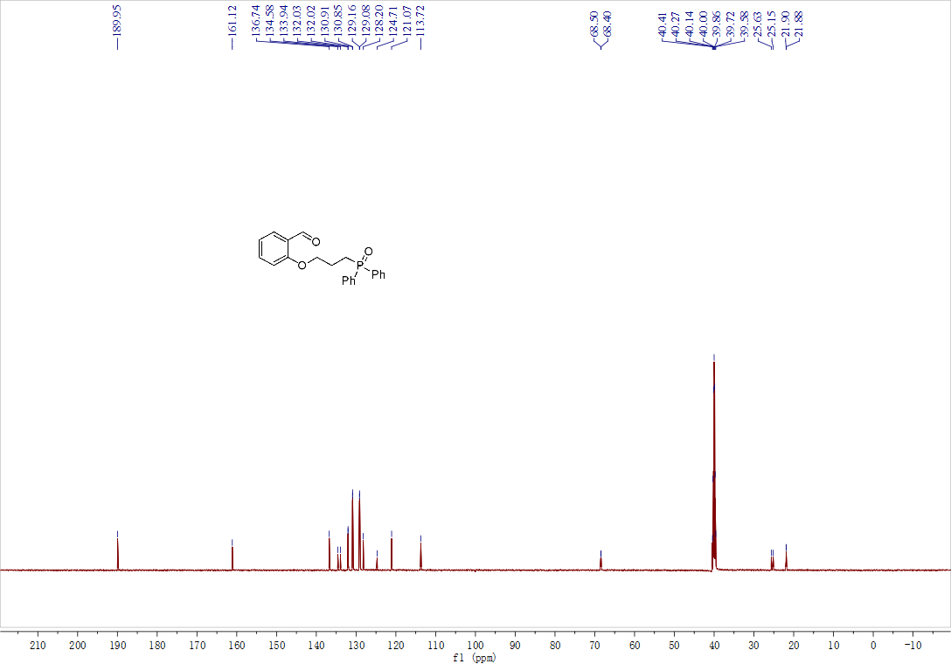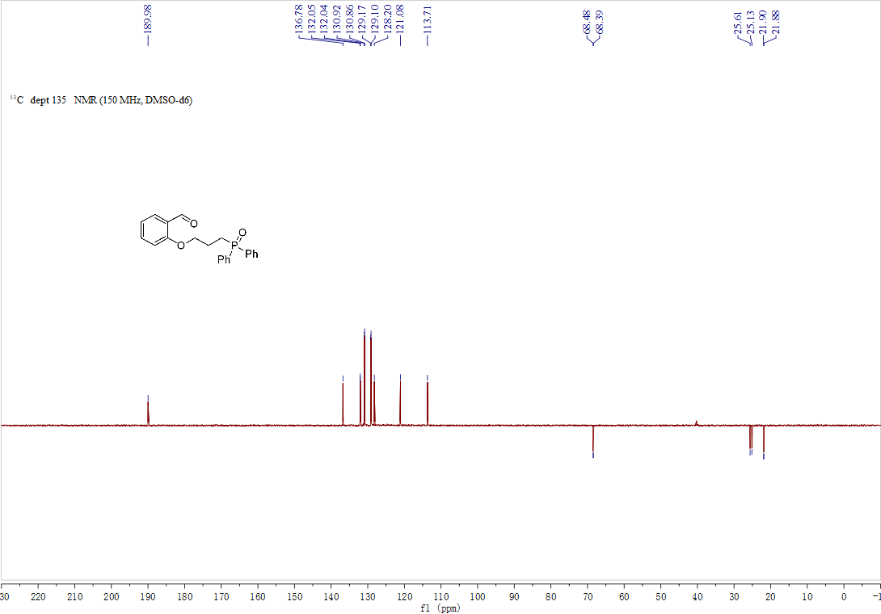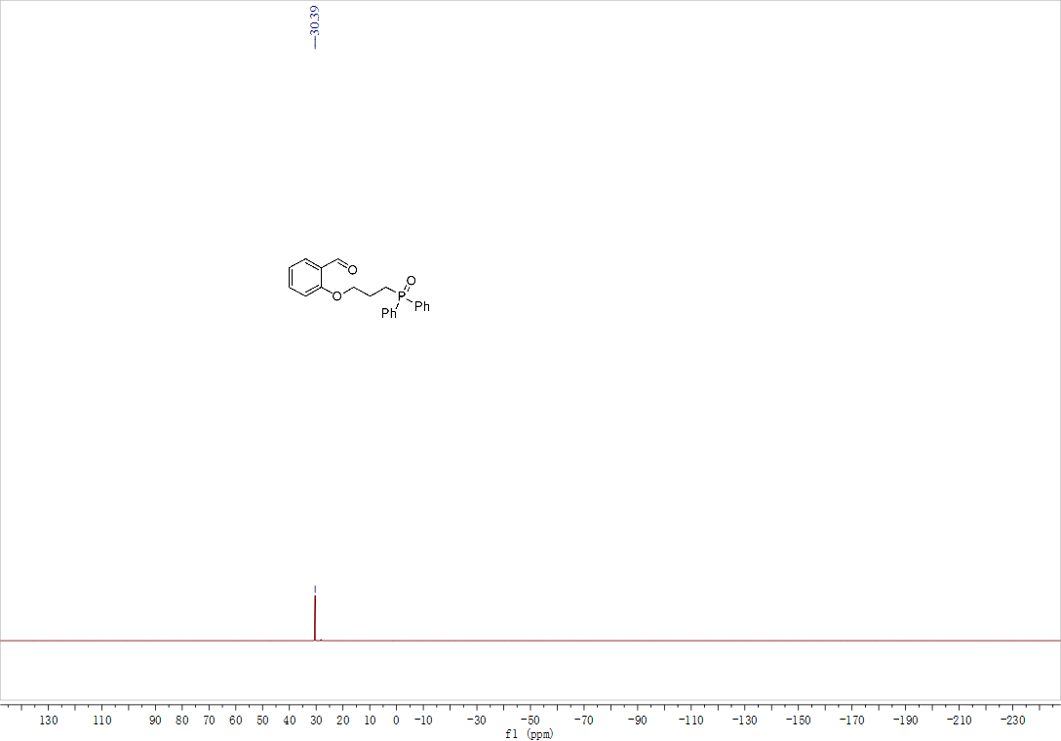

7 X-ray crystallography data for 3aa and 3ba
Compound 3aa:
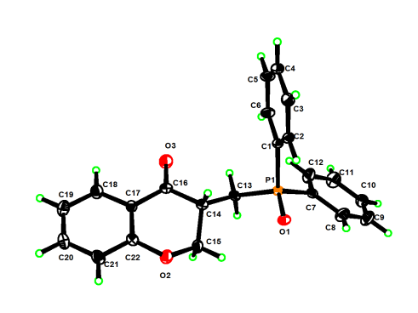
Table 1 Crystal data and structure refinement for 3aa.
Identification code | 3aa
Empirical formula | C₂₂H₁₉O₃P
Formula weight | 362.34
Temperature/K | 170.0
Crystal system | orthorhombic
Space group | P2₁2₁2₁
a/Å | 8.4345(8)
b/Å | 13.1057(12)
c/Å | 16.7585(17)
α/° | 90
β/° | 90
γ/° | 90
Volume/Å³ | 1852.5(3)
Z | 4
ρ_{calc}g/cm³ | 1.299
μ/mm⁻¹ | 0.167
F(000) | 760.0
Crystal size/mm³ | 0.16 × 0.12 × 0.08
Radiation | MoKα (λ = 0.71073)
2Θ range for data collection/° | 3.946 to 53.484
Index ranges | -8 ≤ h ≤ 10, -16 ≤ k ≤ 16, -18 ≤ l ≤ 20
Reflections collected | 13092
Independent reflections | 3805 [R_{int} = 0.0776, R_{sigma} = 0.0911]
Data/restraints/parameters | 3805/0/236
Goodness-of-fit on F² | 1.191
Final R indexes [I>=2σ (I)] | R₁ = 0.0700, wR₂ = 0.1100
Final R indexes [all data] | R₁ = 0.1115, wR₂ = 0.1240
Largest diff. peak/hole / e Å⁻³ | 0.45/-0.37
Flack parameter | 0.5(2)

Table 2 Fractional Atomic Coordinates (×10⁴) and Equivalent Isotropic Displacement Parameters (Å²×10³) for 3aa. U_{eq} is defined as 1/3 of of the trace of the orthogonalised U_{IJ} tensor.
Atom | x | y | z | U(eq)
P1 | 8431.5(16) | 4870.9(10) | 5549.6(9) | 22.4(3)
O1 | 9480(4) | 4154(3) | 5113(2) | 26.4(9)
O2 | 10597(5) | 6176(3) | 3183(2) | 38.3(11)
O3 | 6971(5) | 7652(3) | 4322(3) | 45.3(12)
C14 | 8759(6) | 6239(4) | 4313(3) | 23.3(13)
C17 | 8598(7) | 7504(4) | 3183(3) | 24.9(13)
C1 | 6369(6) | 4556(3) | 5397(3) | 21.2(12)
C2 | 6044(6) | 3653(4) | 5003(3) | 25.1(13)
C7 | 8839(6) | 4871(4) | 6602(3) | 24.1(12)
C16 | 8024(6) | 7195(4) | 3973(4) | 27.4(14)
C6 | 5126(6) | 5168(4) | 5646(3) | 30.3(13)
C22 | 9844(7) | 6973(4) | 2816(3) | 28.6(14)
C13 | 8642(6) | 6172(4) | 5225(3) | 25.0(13)
C4 | 3250(7) | 3984(4) | 5095(4) | 31.6(14)
C3 | 4486(7) | 3373(4) | 4847(4) | 30.6(14)
C15 | 10461(7) | 6162(4) | 4037(3) | 34.2(15)
C18 | 7904(7) | 8310(4) | 2770(4) | 37.3(16)
C8 | 9832(8) | 4128(5) | 6900(4) | 42.5(17)
C12 | 8239(8) | 5585(5) | 7125(4) | 42.6(17)
C21 | 10345(8) | 7227(5) | 2051(3) | 37.0(16)
C20 | 9634(8) | 8028(5) | 1665(4) | 38.9(16)
C5 | 3574(6) | 4879(4) | 5494(4) | 34.0(13)
C10 | 9654(7) | 4830(5) | 8211(4) | 40.4(16)
C19 | 8419(9) | 8575(4) | 2022(4) | 41.9(17)
C11 | 8646(9) | 5570(5) | 7927(4) | 47.6(18)
C9 | 10234(8) | 4107(5) | 7702(4) | 47.4(18)

Table 3 Anisotropic Displacement Parameters (Å²×10³) for 3aa. The Anisotropic displacement factor exponent takes the form: -2π²[h²a*²U₁₁+2hka*b*U₁₂+…].
Atom | U₁₁ | U₂₂ | U₃₃ | U₂₃ | U₁₃ | U₁₂
P1 | 16.7(6) | 22.3(7) | 28.3(8) | -0.6(6) | 0.1(7) | -0.2(6)
O1 | 22(2) | 27(2) | 30(2) | -3.8(17) | 3.3(18) | 4.7(16)
O2 | 44(3) | 40(3) | 32(3) | 5(2) | 10(2) | 19(2)
O3 | 46(3) | 47(3) | 42(3) | 6(2) | 15(2) | 22(2)
C14 | 24(3) | 21(3) | 25(3) | -6(2) | 3(3) | 1(2)
C17 | 27(3) | 21(3) | 26(3) | 1(2) | -1(3) | -3(2)
C1 | 16(3) | 22(3) | 25(3) | 1(2) | -1(2) | -2(2)
C2 | 21(3) | 22(3) | 32(4) | 2(2) | 0(3) | 2(2)
C7 | 20(3) | 24(3) | 29(3) | 0(2) | 2(2) | -5(2)
C16 | 21(3) | 29(3) | 32(4) | -4(3) | 1(3) | 0(2)
C6 | 21(3) | 27(3) | 43(4) | -6(3) | 3(3) | 3(2)
C22 | 30(3) | 28(3) | 28(3) | 1(3) | 3(3) | -3(3)
C13 | 21(3) | 26(3) | 29(3) | 1(2) | 1(3) | -6(2)
C4 | 21(3) | 35(3) | 39(4) | 6(3) | -5(3) | -6(3)
C3 | 31(3) | 21(3) | 39(4) | -2(3) | -3(3) | -6(2)
C15 | 39(4) | 36(3) | 28(4) | 7(3) | 7(3) | 10(3)
C18 | 45(4) | 33(3) | 35(4) | 3(3) | 6(3) | 11(3)
C8 | 41(4) | 43(4) | 44(5) | -2(3) | 0(3) | 15(3)
C12 | 50(4) | 45(4) | 33(4) | 3(3) | -5(4) | 13(3)
C21 | 44(4) | 39(4) | 29(4) | -2(3) | 12(3) | 3(3)
C20 | 52(4) | 38(4) | 27(4) | 7(3) | 1(3) | -5(3)
C5 | 19(3) | 39(3) | 44(4) | -2(3) | 8(3) | 6(3)
C10 | 36(3) | 59(4) | 26(4) | 8(3) | -8(3) | -4(4)
C19 | 53(4) | 34(3) | 39(4) | 8(3) | -5(4) | 8(4)
C11 | 62(5) | 55(4) | 26(4) | -10(3) | -2(4) | 8(4)
C9 | 48(4) | 60(4) | 34(4) | 6(3) | -6(4) | 20(4)

Table 4 Bond Lengths for 3aa.
Atom | Atom | Length/Å |  | Atom | Atom | Length/Å
P1 | O1 | 1.483(4) |  | C2 | C3 | 1.390(7)
P1 | C1 | 1.806(5) |  | C7 | C8 | 1.379(8)
P1 | C7 | 1.797(5) |  | C7 | C12 | 1.378(8)
P1 | C13 | 1.799(5) |  | C6 | C5 | 1.386(7)
O2 | C22 | 1.370(6) |  | C22 | C21 | 1.389(8)
O2 | C15 | 1.436(7) |  | C4 | C3 | 1.379(8)
O3 | C16 | 1.221(6) |  | C4 | C5 | 1.377(7)
C14 | C16 | 1.509(7) |  | C18 | C19 | 1.371(8)
C14 | C13 | 1.534(7) |  | C8 | C9 | 1.387(9)
C14 | C15 | 1.512(7) |  | C12 | C11 | 1.388(8)
C17 | C16 | 1.466(8) |  | C21 | C20 | 1.371(8)
C17 | C22 | 1.402(8) |  | C20 | C19 | 1.386(9)
C17 | C18 | 1.392(7) |  | C10 | C11 | 1.374(8)
C1 | C2 | 1.382(7) |  | C10 | C9 | 1.366(9)
C1 | C6 | 1.384(7)

Table 5 Bond Angles for 3aa.
Atom | Atom | Atom | Angle/˚ |  | Atom | Atom | Atom | Angle/˚
O1 | P1 | C1 | 111.1(2) |  | O3 | C16 | C17 | 122.5(5)
O1 | P1 | C7 | 111.7(2) |  | C17 | C16 | C14 | 115.8(5)
O1 | P1 | C13 | 113.1(2) |  | C1 | C6 | C5 | 120.2(5)
C7 | P1 | C1 | 108.8(2) |  | O2 | C22 | C17 | 122.0(5)
C7 | P1 | C13 | 106.1(2) |  | O2 | C22 | C21 | 117.1(5)
C13 | P1 | C1 | 105.6(2) |  | C21 | C22 | C17 | 120.9(5)
C22 | O2 | C15 | 114.8(4) |  | C14 | C13 | P1 | 111.2(3)
C16 | C14 | C13 | 113.4(4) |  | C5 | C4 | C3 | 119.4(5)
C16 | C14 | C15 | 109.3(4) |  | C4 | C3 | C2 | 120.3(5)
C15 | C14 | C13 | 111.2(4) |  | O2 | C15 | C14 | 112.4(5)
C22 | C17 | C16 | 120.4(5) |  | C19 | C18 | C17 | 120.9(6)
C18 | C17 | C16 | 121.4(5) |  | C7 | C8 | C9 | 120.9(6)
C18 | C17 | C22 | 118.2(5) |  | C7 | C12 | C11 | 121.0(6)
C2 | C1 | P1 | 117.0(4) |  | C20 | C21 | C22 | 119.0(6)
C2 | C1 | C6 | 119.3(5) |  | C21 | C20 | C19 | 121.0(6)
C6 | C1 | P1 | 123.7(4) |  | C4 | C5 | C6 | 120.6(5)
C1 | C2 | C3 | 120.3(5) |  | C9 | C10 | C11 | 119.7(6)
C8 | C7 | P1 | 118.1(4) |  | C18 | C19 | C20 | 119.9(6)
C12 | C7 | P1 | 123.6(4) |  | C10 | C11 | C12 | 119.9(6)
C12 | C7 | C8 | 118.2(5) |  | C10 | C9 | C8 | 120.3(6)
O3 | C16 | C14 | 121.6(5)

Table 6 Hydrogen Atom Coordinates (Å×10⁴) and Isotropic Displacement Parameters (Å²×10³) for 3aa.
Atom | x | y | z | U(eq)
H14 | 8171.58 | 5642.61 | 4086.63 | 28
H2 | 6889.8 | 3223.11 | 4838.69 | 30
H6 | 5337.46 | 5786.58 | 5920.83 | 36
H13A | 7718.26 | 6574.26 | 5409.68 | 30
H13B | 9607.39 | 6470.95 | 5466.49 | 30
H4 | 2184.71 | 3790.26 | 4991.48 | 38
H3 | 4271.57 | 2756.4 | 4569.09 | 37
H15A | 11073.16 | 6738.4 | 4261.64 | 41
H15B | 10928.17 | 5521.03 | 4243.6 | 41
H18 | 7063.22 | 8682.45 | 3009.42 | 45
H8 | 10247.66 | 3622.92 | 6551.27 | 51
H12 | 7536.05 | 6095.55 | 6932.95 | 51
H21 | 11169.05 | 6851.58 | 1799.98 | 44
H20 | 9979.08 | 8210.55 | 1144.64 | 47
H5 | 2726.43 | 5302.82 | 5666.33 | 41
H10 | 9945.13 | 4822.29 | 8758.98 | 48
H19 | 7944.11 | 9131.34 | 1748.54 | 50
H11 | 8228.89 | 6070.1 | 8279.78 | 57
H9 | 10916.15 | 3587.84 | 7898.83 | 57

Compound 3ba :
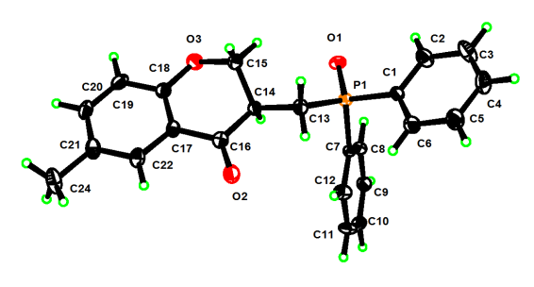

Table 1 Crystal data and structure refinement for 3ba.
Identification code | 3ba
Empirical formula | C₂₃H₂₁O₃P
Formula weight | 376.37
Temperature/K | 170.0
Crystal system | monoclinic
Space group | P2₁/c
a/Å | 14.3475(13)
b/Å | 8.5440(7)
c/Å | 17.3370(13)
α/° | 90
β/° | 113.471(3)
γ/° | 90
Volume/Å³ | 1949.4(3)
Z | 4
ρ_{calc}g/cm³ | 1.282
μ/mm⁻¹ | 0.161
F(000) | 792.0
Crystal size/mm³ | 0.15 × 0.12 × 0.08
Radiation | MoKα (λ = 0.71073)
2Θ range for data collection/° | 4.816 to 52.774
Index ranges | -17 ≤ h ≤ 17, -10 ≤ k ≤ 9, -21 ≤ l ≤ 18
Reflections collected | 13708
Independent reflections | 3934 [R_{int} = 0.1109, R_{sigma} = 0.1304]
Data/restraints/parameters | 3934/0/245
Goodness-of-fit on F² | 1.087
Final R indexes [I>=2σ (I)] | R₁ = 0.0839, wR₂ = 0.1179
Final R indexes [all data] | R₁ = 0.1692, wR₂ = 0.1462
Largest diff. peak/hole / e Å⁻³ | 0.50/-0.45

Table 2 Fractional Atomic Coordinates (×10⁴) and Equivalent Isotropic Displacement Parameters (Å²×10³) for 3ba. U_{eq} is defined as 1/3 of of the trace of the orthogonalised U_{IJ} tensor.
Atom | x | y | z | U(eq)
P1 | 7972.3(8) | 4173.5(13) | 3471.8(7) | 26.3(3)
O1 | 8574.2(19) | 3192(3) | 4213.2(16) | 32.3(7)
O2 | 4793(2) | 5311(4) | 2869.9(18) | 43.4(8)
O3 | 5921(2) | 2110(4) | 4786.8(18) | 43.5(8)
C7 | 8087(3) | 6233(5) | 3730(2) | 23.5(9)
C8 | 8931(3) | 6708(5) | 4429(2) | 30.4(10)
C14 | 6211(3) | 3763(5) | 3747(2) | 26.4(10)
C13 | 6629(3) | 3754(5) | 3050(2) | 30.4(10)
C18 | 4975(3) | 2735(5) | 4577(3) | 33.1(11)
C17 | 4557(3) | 3826(5) | 3928(2) | 28.6(10)
C1 | 8372(3) | 3950(5) | 2614(2) | 27.0(10)
C16 | 5136(3) | 4379(5) | 3448(3) | 32.4(11)
C10 | 8403(3) | 9376(5) | 4179(3) | 34.1(11)
C22 | 3584(3) | 4402(6) | 3764(2) | 35.9(11)
C9 | 9081(3) | 8264(5) | 4650(3) | 32.6(11)
C11 | 7554(3) | 8921(5) | 3489(3) | 37.6(12)
C6 | 7896(3) | 4692(6) | 1850(3) | 43.0(12)
C21 | 3027(3) | 3927(6) | 4212(3) | 38.9(12)
C15 | 6277(3) | 2144(5) | 4123(3) | 38.8(12)
C12 | 7390(3) | 7358(5) | 3263(3) | 35.9(11)
C19 | 4430(4) | 2262(5) | 5042(3) | 41.5(12)
C2 | 9219(3) | 3034(6) | 2746(3) | 43.9(13)
C20 | 3475(3) | 2850(5) | 4856(3) | 40.5(12)
C5 | 8246(4) | 4510(6) | 1219(3) | 52.0(14)
C4 | 9088(4) | 3608(6) | 1354(3) | 54.7(15)
C3 | 9575(4) | 2866(7) | 2111(3) | 60.2(16)
C24 | 1963(3) | 4554(7) | 3997(3) | 61.6(17)

Table 3 Anisotropic Displacement Parameters (Å²×10³) for 3ba. The Anisotropic displacement factor exponent takes the form: -2π²[h²a*²U₁₁+2hka*b*U₁₂+…].
Atom | U₁₁ | U₂₂ | U₃₃ | U₂₃ | U₁₃ | U₁₂
P1 | 27.6(6) | 23.2(6) | 28.3(6) | 0.0(5) | 11.4(5) | 0.3(5)
O1 | 33.4(16) | 26.7(18) | 32.0(16) | 5.6(13) | 7.9(13) | 2.6(13)
O2 | 35.1(17) | 57(2) | 39.4(18) | 17.8(17) | 16.7(15) | 9.9(16)
O3 | 51(2) | 45(2) | 43.3(19) | 15.6(16) | 27.5(16) | 14.8(16)
C7 | 28(2) | 19(2) | 26(2) | 1.1(17) | 14.4(19) | 2.4(18)
C8 | 27(2) | 28(3) | 36(3) | 6(2) | 13(2) | 6(2)
C14 | 27(2) | 24(2) | 30(2) | -3.3(19) | 14.1(18) | -2.5(18)
C13 | 31(2) | 31(3) | 30(2) | -7.6(19) | 13.3(19) | -5(2)
C18 | 37(3) | 28(3) | 37(3) | -4(2) | 18(2) | -3(2)
C17 | 29(2) | 34(3) | 26(2) | -4(2) | 13.7(18) | -5(2)
C1 | 25(2) | 27(3) | 31(2) | -2(2) | 13.1(18) | 1.9(19)
C16 | 33(2) | 35(3) | 29(2) | -6(2) | 11(2) | -5(2)
C10 | 43(3) | 21(3) | 42(3) | -1(2) | 21(2) | -2(2)
C22 | 34(2) | 49(3) | 25(2) | -3(2) | 12.4(19) | -7(2)
C9 | 30(2) | 29(3) | 38(3) | -5(2) | 12(2) | -4(2)
C11 | 47(3) | 24(3) | 38(3) | 3(2) | 13(2) | 14(2)
C6 | 50(3) | 44(3) | 43(3) | 7(2) | 27(2) | 10(2)
C21 | 33(2) | 54(3) | 32(2) | -10(2) | 16(2) | -10(2)
C15 | 47(3) | 36(3) | 44(3) | 7(2) | 29(2) | 4(2)
C12 | 39(3) | 35(3) | 26(2) | -1(2) | 5(2) | 4(2)
C19 | 61(3) | 29(3) | 44(3) | 3(2) | 31(3) | -4(2)
C2 | 39(3) | 56(4) | 36(3) | 1(2) | 14(2) | 12(2)
C20 | 49(3) | 40(3) | 45(3) | -11(2) | 32(2) | -16(2)
C5 | 59(3) | 66(4) | 38(3) | 8(3) | 28(3) | 12(3)
C4 | 57(3) | 74(4) | 47(3) | 1(3) | 35(3) | 3(3)
C3 | 49(3) | 81(4) | 57(4) | -6(3) | 28(3) | 22(3)
C24 | 32(3) | 104(5) | 53(3) | 2(3) | 21(2) | 1(3)

Table 4 Bond Lengths for 3ba.
Atom | Atom | Length/Å |  | Atom | Atom | Length/Å
P1 | O1 | 1.489(3) |  | C17 | C16 | 1.469(6)
P1 | C7 | 1.807(4) |  | C17 | C22 | 1.397(5)
P1 | C13 | 1.804(4) |  | C1 | C6 | 1.379(6)
P1 | C1 | 1.805(4) |  | C1 | C2 | 1.385(5)
O2 | C16 | 1.220(5) |  | C10 | C9 | 1.373(5)
O3 | C18 | 1.366(5) |  | C10 | C11 | 1.380(5)
O3 | C15 | 1.433(5) |  | C22 | C21 | 1.378(6)
C7 | C8 | 1.389(5) |  | C11 | C12 | 1.385(6)
C7 | C12 | 1.391(5) |  | C6 | C5 | 1.383(6)
C8 | C9 | 1.377(6) |  | C21 | C20 | 1.391(6)
C14 | C13 | 1.549(5) |  | C21 | C24 | 1.517(6)
C14 | C16 | 1.512(5) |  | C19 | C20 | 1.371(6)
C14 | C15 | 1.516(5) |  | C2 | C3 | 1.393(6)
C18 | C17 | 1.398(6) |  | C5 | C4 | 1.373(6)
C18 | C19 | 1.390(6) |  | C4 | C3 | 1.372(6)

Table 5 Bond Angles for 3ba.
Atom | Atom | Atom | Angle/˚ |  | Atom | Atom | Atom | Angle/˚
O1 | P1 | C7 | 111.74(17) |  | C6 | C1 | C2 | 119.0(4)
O1 | P1 | C13 | 113.38(18) |  | C2 | C1 | P1 | 118.0(3)
O1 | P1 | C1 | 112.73(18) |  | O2 | C16 | C14 | 122.0(4)
C13 | P1 | C7 | 105.75(18) |  | O2 | C16 | C17 | 122.8(4)
C13 | P1 | C1 | 106.48(18) |  | C17 | C16 | C14 | 115.1(4)
C1 | P1 | C7 | 106.21(19) |  | C9 | C10 | C11 | 119.5(4)
C18 | O3 | C15 | 114.3(3) |  | C21 | C22 | C17 | 122.5(4)
C8 | C7 | P1 | 117.5(3) |  | C10 | C9 | C8 | 120.5(4)
C8 | C7 | C12 | 118.7(4) |  | C10 | C11 | C12 | 120.6(4)
C12 | C7 | P1 | 123.7(3) |  | C1 | C6 | C5 | 120.8(4)
C9 | C8 | C7 | 120.7(4) |  | C22 | C21 | C20 | 117.4(4)
C16 | C14 | C13 | 113.2(3) |  | C22 | C21 | C24 | 120.7(4)
C16 | C14 | C15 | 110.2(3) |  | C20 | C21 | C24 | 121.9(4)
C15 | C14 | C13 | 110.7(3) |  | O3 | C15 | C14 | 112.5(3)
C14 | C13 | P1 | 111.5(3) |  | C11 | C12 | C7 | 120.0(4)
O3 | C18 | C17 | 122.6(4) |  | C20 | C19 | C18 | 119.8(4)
O3 | C18 | C19 | 117.4(4) |  | C1 | C2 | C3 | 120.0(4)
C19 | C18 | C17 | 120.0(4) |  | C19 | C20 | C21 | 122.1(4)
C18 | C17 | C16 | 120.7(4) |  | C4 | C5 | C6 | 120.0(5)
C22 | C17 | C18 | 118.2(4) |  | C3 | C4 | C5 | 120.0(5)
C22 | C17 | C16 | 121.1(4) |  | C4 | C3 | C2 | 120.1(5)
C6 | C1 | P1 | 123.0(3)

Table 6 Hydrogen Atom Coordinates (Å×10⁴) and Isotropic Displacement Parameters (Å²×10³) for 3ba.
Atom | x | y | z | U(eq)
H8 | 9408.81 | 5950.41 | 4758.08 | 36
H14 | 6654.19 | 4472.78 | 4204.32 | 32
H13A | 6262.68 | 4545.69 | 2618.42 | 36
H13B | 6505.76 | 2715.28 | 2773.73 | 36
H10 | 8518.3 | 10451.36 | 4325.77 | 41
H22 | 3296.45 | 5148.44 | 3327.25 | 43
H9 | 9658.32 | 8569.72 | 5132.97 | 39
H11 | 7077.24 | 9685.88 | 3167.27 | 45
H6 | 7321.24 | 5335.06 | 1756.8 | 52
H15A | 5868.74 | 1406.8 | 3675.61 | 47
H15B | 6992.41 | 1786.02 | 4345.06 | 47
H12 | 6801.23 | 7054.86 | 2789.12 | 43
H19 | 4717.2 | 1532.5 | 5488.36 | 50
H2 | 9556.66 | 2519.05 | 3270.03 | 53
H20 | 3108.47 | 2511.84 | 5176.52 | 49
H5 | 7902.76 | 5009.56 | 691.09 | 62
H4 | 9334.51 | 3496.51 | 922.71 | 66
H3 | 10155.56 | 2237.92 | 2202.94 | 72
H24A | 1977.3 | 5316.29 | 4424.34 | 92
H24B | 1509.41 | 3687.56 | 3984.39 | 92
H24C | 1715.64 | 5062.44 | 3445.36 | 92

