Supporting Information for

A Novel Sustainable Method to Prepare Glutaric Acid from Glucose

Lei Hao¹, Chaojie Li¹, Lianbo Zhao¹, Xixian Xie ^{2, ∗} , Kui Lu ^{1, 2 ∗}
¹ China International Science and Technology Cooperation Base of Food Nutrition/Safety and Medicinal Chemistry, Tianjin International Cooperation Research Centre of Food Nutrition/Safety and Medicinal Chemistry, Tianjin China, 300457. Email: lukui@tust.edu.cn;
² National and Local United Engineering Lab of Metabolic Control Fermentation Technology, Tianjin University of Science and Technology, Tianjin 300457, P. R. China Tianjin Engineering Lab of Efficient and Green Amino Acid Manufacture, Tianjin University of Science and Technology, Tianjin 300457, P. R. China College of Biotechnology, Tianjin University of Science & Technology, Tianjin China, 300457. Email: xixianxie@tust.edu.cn

1) General and Materials
General：
All solvents were distilled prior to use. Unless otherwise noted, chemicals were used as received without further purification. The solvents for reaction were distilled over Na (for toluene, 1,4-dioxane and THF) or CaH₂ (for DCE and MeCN) under a nitrogen atmosphere. All reactions were carried out in oven-dried glassware under an inert atmosphere (nitrogen or argon). For chromatography, 200−300 mesh silica gel was employed. ¹H and ¹³C were recorded at 400 MHz, 100 MHz and 376 MHz respectively. Chemical shifts are reported in ppm using tetramethylsilane as internal standard. HRMS was performed on an FTMS mass instrument. Melting points are reported as uncorrected.

2) NMR spectra

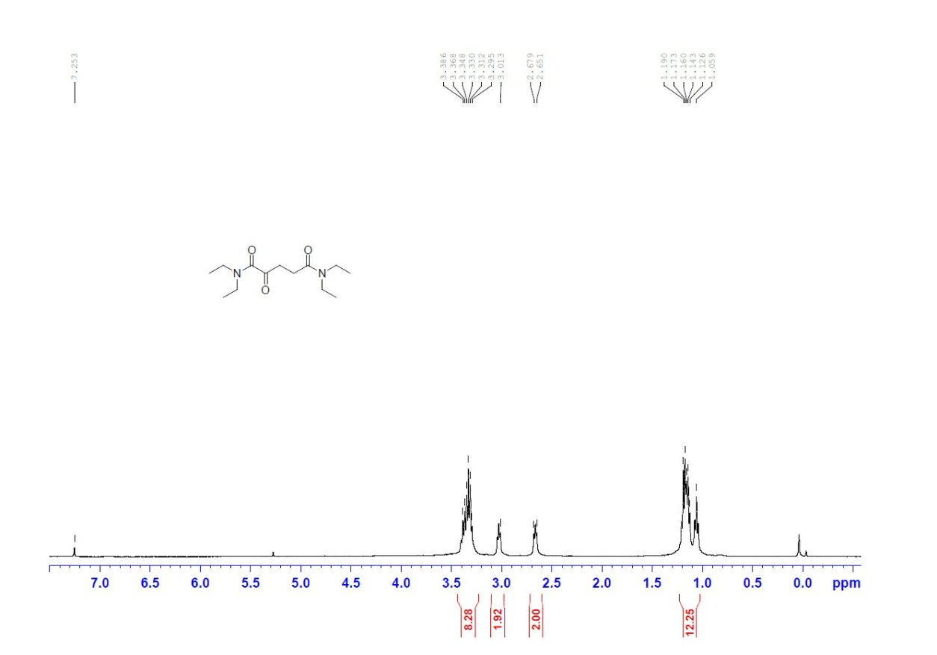
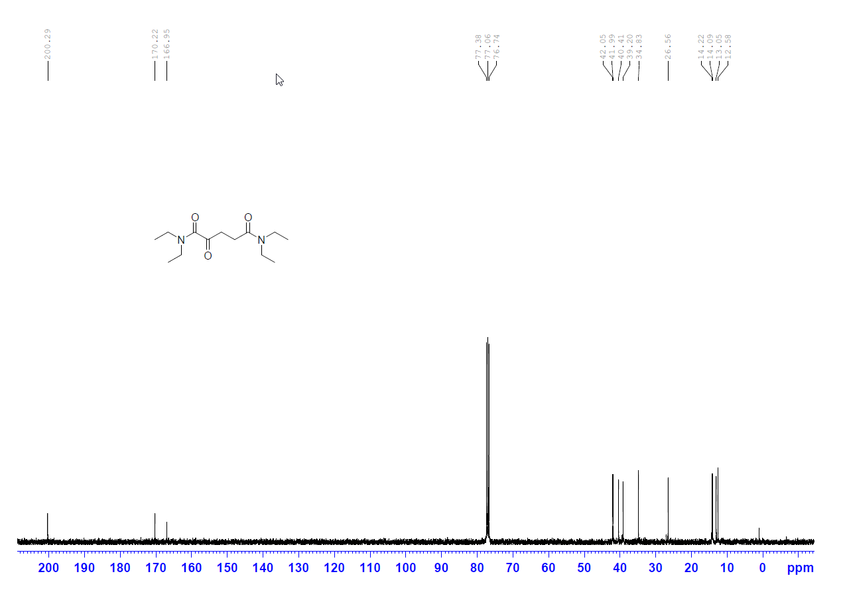

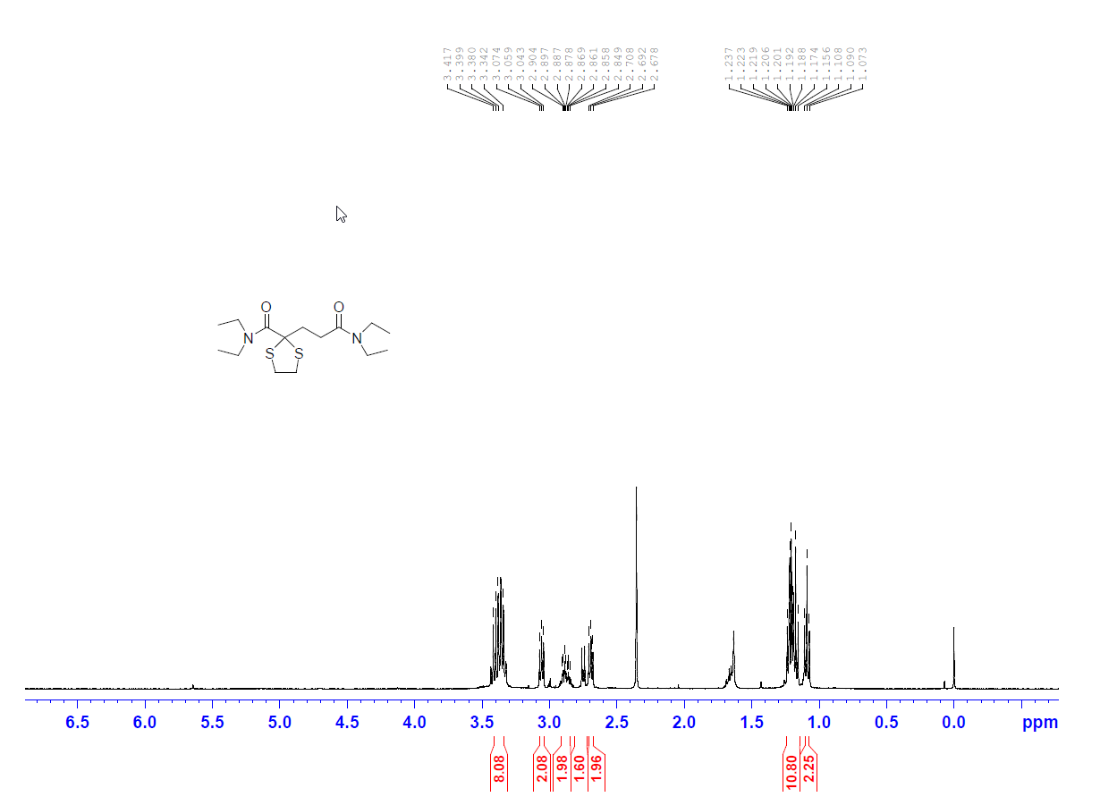
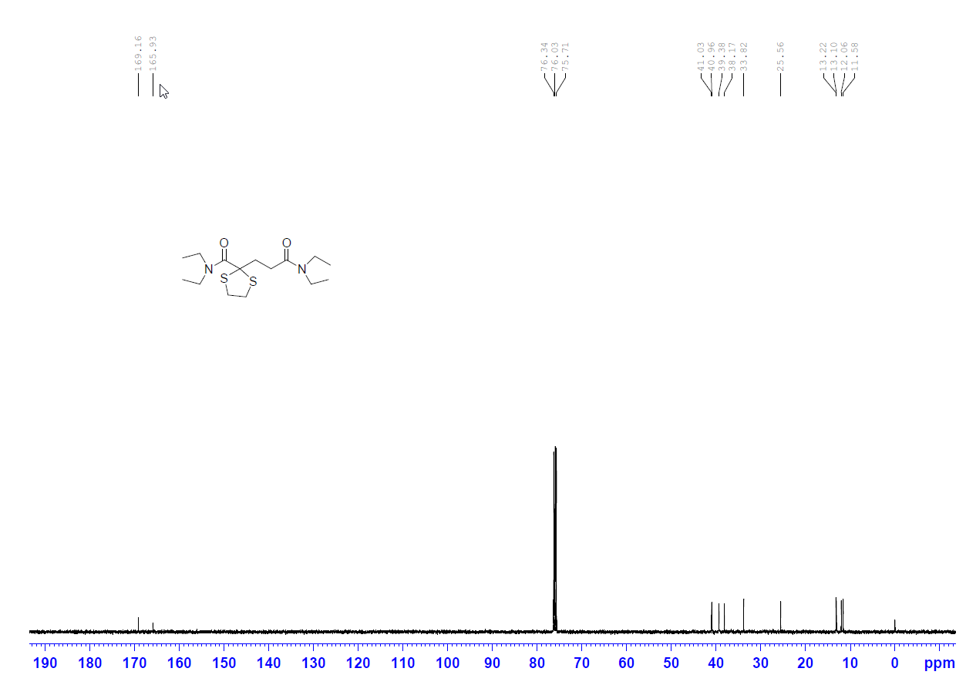

∗ Xixian Xie. Tel.: +86 22 60601251; e-mail: xixianxie@tust.edu.cn
∗ Kui Lu. Tel.: +86 22 60912562; e-mail: lukui@mail.tjnu.edu.cn

