Supporting Information
For

A study on the synthesis of β-amino acids: the first synthesis of a bicyclic hemiaminal (3,3-dimethyl-1-(2,4,5-trifluorophenyl) tetrahydro-3H,5H-oxazolo[3,4-c] [1,3] oxazin-5-one)

Özlem Gündoğdu, Ertan Şahin and Yunus Kara

Experimental procedure, copies of ¹H and ¹³C NMR spectra, X-Ray diffraction

Table of contents
Experimental procedure and spectroscopic data ……..……………………… . .3
Copies of 400 MHz ¹H NMR and 100 MHz ¹³C NMR spectrum of 3,3-dimethyl-1-(2,4,5-trifluorophenyl) tetrahydro-3H,5H-oxazolo[3,4-c] [1,3] oxazin-5-one (11) in CDCl₃ ……………………………………………………………...…..……………... 4
X-ray diffraction analysis of 11 ………………………………………..……………. 5

Experimental Procedure

Benzyl (S)-(4-((tert- butyldimethylsilyl) oxy)-1-oxo-1-(2,4,5-trifluorophenyl) butan-2-yl) carbamate (6)
Benzyl (S)-(4-((tert- butyldimethylsilyl) oxy)-1-oxo-1-(2,4,5-trifluorophenyl) butan-2-yl) carbamate (6) was synthesized according to the literature procedure [7].
The reduction reaction of benzyl (S)-(4-((tert- butyldimethylsilyl) oxy)-1-oxo-1-(2,4,5-trifluorophenyl) butan-2-yl) carbamate (6) with sodium borohydride.
To a magnetically stirred solution of benzyl (S)-(4-((tert-butyldimethylsilyl)oxy)-1-oxo-1-(2,4,5-trifluorophenyl)butan-2-yl)carbamate 6 (1 g , 2.07 mmol) in MeOH (20 mL) was added NaBH₄ (86.14 mg, 2.27 mmol) at 0 °C and the reaction mixture was stirred for an additional 16 h at this temperature. Then the reaction was stirred for 16 at room temperature. During this time, the reaction was monitored by TLC. The solvent was evaporated. EtOAc (5 mL) was added and the mixture was washed with saturated NH₄Cl (10 mL). The solid was filtered off and extracted with EtOAc (3 × 15 mL). The combined organic phase was washed with saturated NH₄Cl (20 mL) and dried (Na₂SO₄). The product mixture was purified by silica gel column chromatography (EtOAc/hexane 50:50) to give benzylic alcohol 7. Benzyl (S)-(4-(tert-butyldimethylsilyl) oxy)-1-oxo-1-(2,4,5-trifluorophenyl) butan-2-yl) carbamate (6) was obtained in 93% yield. Yellow viscous, R_{f} = 0.5 (30% AcOEt/hexane). ¹H NMR (400 MHz, CDCl₃) δ 7.64–7.12 (m, 6H), 6.82 (m, J =9.5, 6.2 Hz, 1H), 5.55 (dt, J =43.1, 6.1 Hz, 1H), 5.15 (m, 2H), 4.80-4.60 (m, 1H), 4.08 (m, J =13.3, 7.2, 5.5 Hz, 1H), 3.72 (dt, J =30.5, 5.6 Hz, 2H), 2.06–1.46 (m, 2H), 0.89 (dt, J =17.5, 4.5 Hz, 9H), 0.28– -0.11 (m, 6H). ¹³C NMR (100 MHz, CDCl₃) δ 157.06, 156.82, 155.71, 153.29, 150.78, 150.66, 150.52, 148.41, 148.29, 148.15, 145.97, 145.88, 145.84, 136.46, 128.73, 128.59, 128.41, 128.37, 128.24, 128.07, 125.48, 125.30, 116.74, 116.68, 116.54, 116.48, 116.17, 116.11, 115.96, 115.90, 105.60, 105.56, 105.40, 105.35, 105.28, 105.12, 105.07, 69.70, 68.73, 68.29, 67.16, 67.00, 60.12, 59.65, 54.62, 54.01, 53.58, 36.25, 35.08, 31.56, 29.95, 26.03, 18.38. IR (neat) (cm⁻¹); 3405, 2954, 2930, 2885, 2858, 1699, 1631 Anal. calc. for C₂₄H₃₂F₃NO₄Si : C: 59.61, H: 6.67, N: 2.90. Found: C: 59.23, H: 6.697, N: 2.82.

Pd-C catalyzed hydrogenation of benzyl (S)-(4-((tert- butyldimethylsilyl) oxy)-1-oxo-1-(2,4,5-trifluorophenyl) butan-2-yl) carbamate (6)
To a suspension of Pd/C (20%) in EtOH (10 mL) was added benzyl (S)-(4-(tert-butyldimethylsilyl)oxy)-1-oxo-1-(2,4,5-trifluorophenyl)butan-2-yl)carbamate (6) (260 mg, 0.53 mmol). The reaction flask was purged with hydrogen gas three times before being allowed to stir under a hydrogen balloon for 16 h at room temperature. Upon completion, the reaction mixture was filtered and concentrated in vacuo. The crude product was purified via a silica gel column to give 8 (96%) as a white solid (AcOEt/hexanes). ¹H NMR (400 MHz, CDCl₃) δ 7.33 (m, J =18.9, 9.2, 3.4 Hz, 1H), 6.92–6.77 (m, 1H), 4.87 (d, J =4.3 Hz, 1H), 3.80-3.60 (m, J =7.1 Hz, 3H), 3.23 (dt, J =8.3, 3.9 Hz, 1H), 2.8-3.1 (brs, 2H), 1.79–1.40 (m, 2H), 0.97–0.74 (m, 9H), 0.11–0.03 (m, 6H). ¹³C NMR (100 MHz, CDCl₃) δ 155.84, 147.98, 128.39, 127.07, 126.21, 116.57, 116.50, 116.36, 116.30, 116.10, 105.59, 105.42, 105.38, 105.35, 105.30, 105.13, 105.09, 70.18, 69.45, 61.64, 61.17, 60.76, 58.42, 54.83, 54.41, 53.63, 36.48, 33.72, 33.68, 29.19, 26.16, 26.09, 26.04, 26.02, 25.87, 18.56, 18.37, 18.35, -3.39, -5.04, -5.30. IR (neat) (cm⁻¹): 3356, 2954, 2930, 2885, 2858, 1630 Anal. calc. for C₁₆H₂₆F₃NO₂Si Calc. : C: 54.99, H: 7.50, N: 4.01. Found: C: 55.04, H: 7.429, N: 3.622.
Synthesis of (4S)-4-(2-((tert-butyldimethylsilyl) oxy) ethyl)-5-(2,4,5-trifluorophenyl) oxazolidin-2-one (10)
ROUTE A: To a magnetically stirred solution of (2R)-2-amino-4-((tert-butyldimethylsilyl)oxy)-1-(2,4,5-trifluorophenyl)butan-1-ol (8) (156 mg, 0.44 mmol) in DCM (20 mL) were added NEt₃ (0.12 mL, 0.89 mmol) and ClCO₂Cl₃ (0.05 mL, 0.44 mmol) in N₂ atm at 0 °C. The mixture was stirred at the same temperature for 2 h. The reaction was monitored by TLC. The solvent was evaporated. EtOAc (5 mL) was added and the mixture was washed with saturated NH₄Cl (10 mL) and extracted with EtOAc (3 × 15 mL). The combined organic phase was washed with saturated NH₄Cl (20 mL) and dried (Na₂SO₄). The product mixture was purified by silica gel column chromatography (EtOAc/hexane 50:50) to give benzylic alcohol 10. (4S)-4-(2-((tert-butyldimethylsilyl) oxy) ethyl)-5-(2,4,5-trifluorophenyl) oxazolidin-2-one (10) was obtained in 55% yield. Yellow viscous, R_{f} = 0.6 (30% AcOEt/hexane).
ROUTE B: Onto a suspension of 24% NaOMe (2.15 mmol) in THF was added dropwise solution of benzyl (S)-(4-((tert-butyldimethylsilyl)oxy)-1-oxo-1-(2,4,5-trifluorophenyl)butan-2-yl)carbamate (7) (520 mg, 1.07 mmol) in THF at rt under nitrogen gas atm. The reaction mixture was stirred at 25 °C for 4 h. The solvent was evaporated. EtOAc (5 mL) was added and the mixture was washed with water (10 mL) and extracted with EtOAc (3 × 15 mL). The combined organic phase was dried over Na₂SO₄, filtered, and the solvent was removed in an evaporator. The product mixture was purified by silica gel column chromatography (EtOAc/hexane 30:70). (4S)-4-(2-((tert-butyldimethylsilyl) oxy) ethyl)-5-(2,4,5-trifluorophenyl) oxazolidin-2-one (10) was obtained in 60% yield. Yellow viscous, R_{f} = 0.6 (30% AcOEt/hexane). ¹H NMR (400 MHz, CDCl₃) δ 7.40–7.31 (m, 1H), 6.96 (m, J =9.7, 6.3, 1.6 Hz, 1H), 5.90–5.80 (m, 2H), 4.25 (t, J =9.5 Hz, 1H), 3.82–3.54 (m, 2H), 1.38–1.08 (m, 2H), 0.88 (d, J =1.5 Hz, 9H), 0.17–-0.03 (m, 6H). ¹³C NMR (100 MHz, CDCl₃) δ 157.97, 148.57, 146.27, 119.81, 116.00, 115.95, 115.79, 115.74, 106.10, 105.89, 105.83, 105.62, 94.57, 74.70, 74.67, 61.51, 55.83, 33.46, 26.09, 18.36, -5.27, -5.36. IR (neat) (cm⁻¹): 3267, 2954, 2930, 2885, 2858, 1766, 1632 Anal. calc. for C₁₇H₂₄F₃NO₃Si Calc.: C: 54.38, H: 6.44, N: 3.73. Found: C: 54.09, H: 6.464, N: 3.572
3,3-Dimethyl-1-(2,4,5-trifluorophenyl) tetrahydro-3H,5H-oxazolo[3,4-c] [1,3] oxazin-5-one (11).
Compound 11 was synthesized in acetone according to procedure Route A. ¹H NMR (400 MHz, CDCl₃) δ δ 7.39 – 7.27 (m, 1H), 7.04 – 6.93 (m, 1H), 5.59 (d, J = 7.8 Hz, 1H), 4.32 – 4.17 (m, 3H), 1.94 (s, 3H), 1.78 – 1.69 (m, 1H), 1.59 (s, 3H), 1.36– 1.26 (m, 1H) ¹³C NMR (100 MHz, CDCl₃) δ 149.39, 115.96, 115.79, 115.73, 105.72, 105.51, 105.25, 95.79, 72.50, 66.55, 56.02, 26.81, 24.71, 24.47 IR (neat) (cm⁻¹): 2954, 2930, 2885, 2858, 1766, 1632 m.p: 140-144

400 MHz ¹H NMR spectrum of 3,3-dimethyl-1-(2,4,5-trifluorophenyl) tetrahydro-3H,5H-oxazolo[3,4-c] [1,3] oxazin-5-one (11) in CDCl₃

100 MHz ¹³C NMR spectrum of 3,3-dimethyl-1-(2,4,5-trifluorophenyl) tetrahydro-3H,5H-oxazolo[3,4-c] [1,3] oxazin-5-one (11) in CDCl₃

X-ray diffraction analysis:
For the crystal structure determination, single-crystal of compound 10 was used for data collection on a four-circle Rigaku R-AXIS RAPID-S diffractometer (equipped with a two-dimensional area IP detector). Graphite-monochromated Mo-K_{α} radiation (λ = 0.71073 Å) and oscillation scans technique with Δw = 5º for one image were used for data collection. The lattice parameters were determined by the least-squares methods on the basis of all reflections with F² > 2σ(F²). Integration of the intensities, correction for Lorentz and polarization effects and cell refinement was performed using CrystalClear (Rigaku/MSC Inc.,2005) software. The structures were solved by direct methods using SHELXS-97, which allowed location of most of the heaviest atoms, with the remaining non-hydrogen atoms being located from difference Fourier maps calculated from successive full-matrix least squares refinement cycles on F² using SHELXL-97. All non-hydrogen atoms were refined using anisotropic displacement parameters. Hydrogens attached to carbons were located at their geometric positions using appropriate HFIX instructions in SHELXL. The final difference Fourier maps showed no peaks of chemical significance. Crystal data for 10: C₁₀H₁₃N₂O₃SCl, crystal system, space group: monoclinic, C2/c; (no:15); unit cell dimensions: a=25.777(4), b=12.9001(19), c= 19.295(3)Å, α= 90, β = 126.950(4), γ = 90º; volume: 5127.6(15) Å³; Z = 8; calculated density: 1.434g/cm³; absorption coefficient: 0.459 mm⁻¹ ; F(000)= 2304; θ-range for data collection 2.6–25.2º ; refinement method: full matrix least-square on F²; data/parameters: 3194/309; goodness-of-fit on F²: 1.108; final R-indices [I > 2σ(I)]: R₁ = 0.050, wR₂ = 0.123; largest diff. peak and hole: 0.230 and -0.380 e Å⁻³.

Crystallographic data for the structure (10) reported in this paper have been deposited with the Cambridge Crystallographic Data Center as supplementary publication No. CCDC-1852080 Copies of these data can be obtained free of charge on application to CCDC, 12 Union Road, Cambridge CB2 1EZ, UK; FAX: (+44) 1223 336033, or online via www.ccdc. cam.ac.uk/data_request/cif, or by emailing data_request@ccdc.cam.ac.uk.
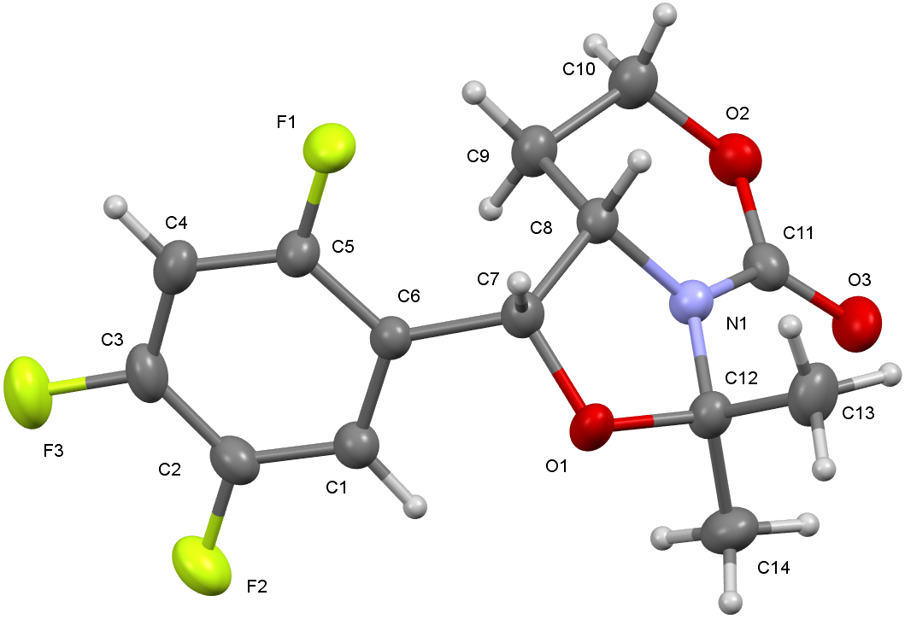
Figure 2a

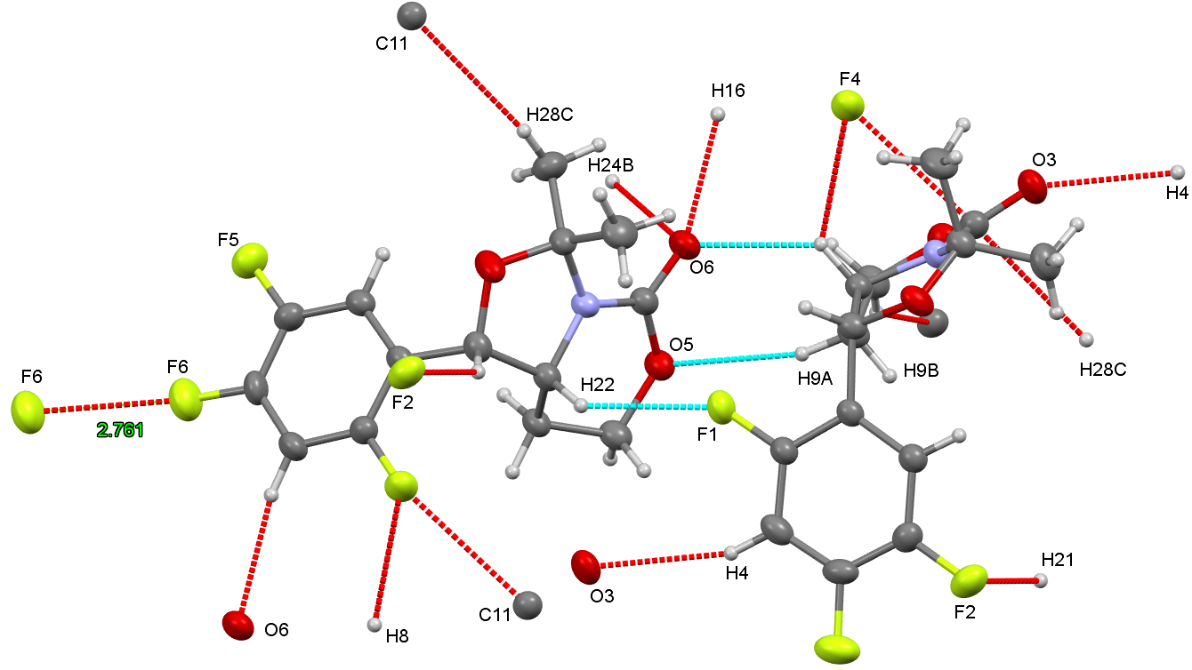
Figure 2b

