Suppotring Information for

A polar mineral tourmaline enables synthesis of 0D/2D CuO photocatalyst with enhanced photocatalytic activity

Changqiang Yu¹, Min Wen¹, Zhen Tong¹, Shuhua Li¹, Yanhong Yin^{*,1,2,3}, Xianbin Liu¹, Yesheng Li¹, Tongxiang Liang¹, Ziping Wu¹ and Dionysios D. Dionysiou^{*,2}

¹ School of Materials Science and Engineering, Jiangxi University of Science and Technology, Ganzhou 341000, China
² Environmental Engineering and Science Program, Department of Chemical and Environmental Engineering, University of Cincinnati, Cincinnati, OH 45221, United States
³ Chongyi Zhangyuan Tungsten Co., Ltd., Ganzhou 341000, China

*Corresponding authors. E-mail: yinyanhong@jxust.edu.cn (Y. H. Yin), dionysios.d.dionysiou@uc.edu (D. D. Dionysiou).

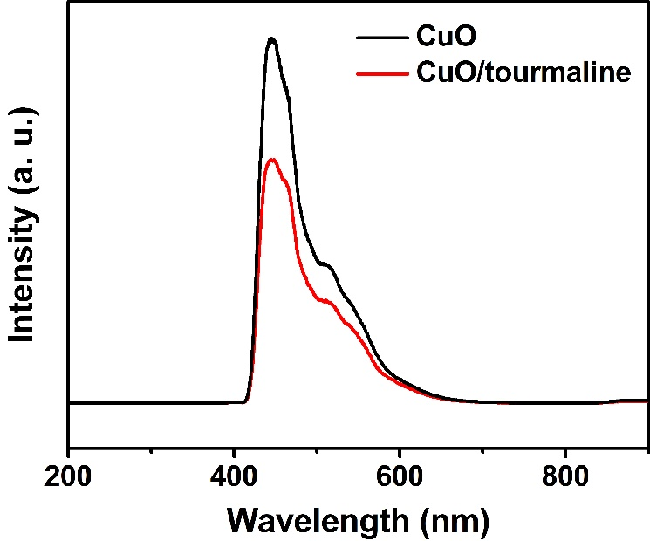
Figure S1: PL spectra of the CuO and CuO/tourmaline composite.

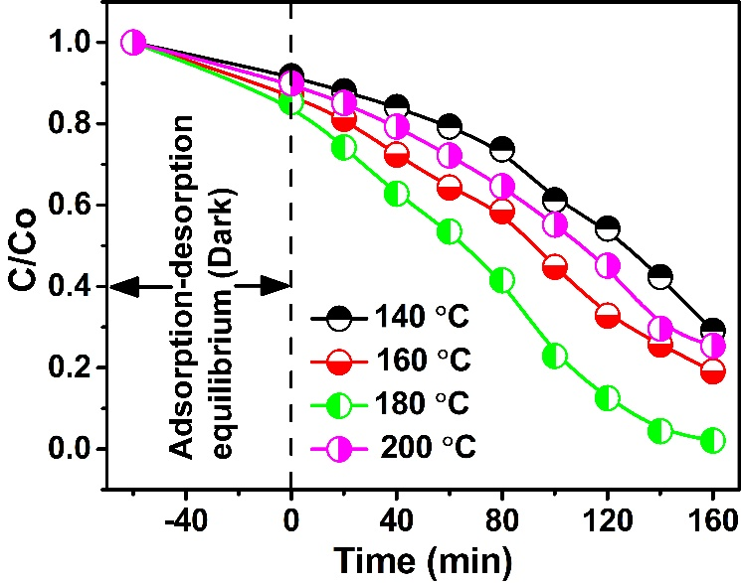
Figure S2: Photocatalytic degradation curves of MB by the CuO/tourmaline composite with different synthesis temperatures.

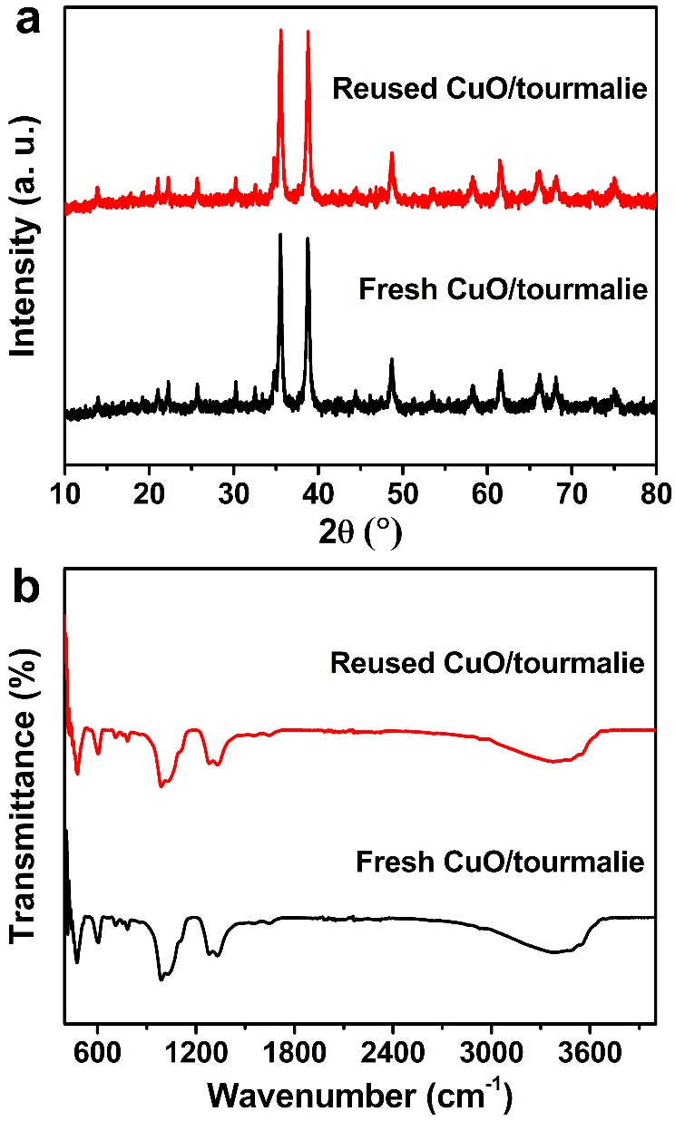
Figure S3: (a) XRD patterns and (b) FTIR spectra of the fresh and reused CuO/tourmaline composite.

