**Supporting information**



(b)

(a)

Figure S1 (a) XRD patterns and (b) XPS of as prepared g-C3N4.

Thermal decomposition of physically mixed melamine with urea in a tube furnace at 600 oC for 4 hours in argon atmosphere yielded orange precipitates of graphitic carbon nitrides (g-C3N4). XRD patterns (Figure S1a) and XPS (Figure S2b) match with reported literature (Ref. 18), which confirms the formation of g-C3N4.

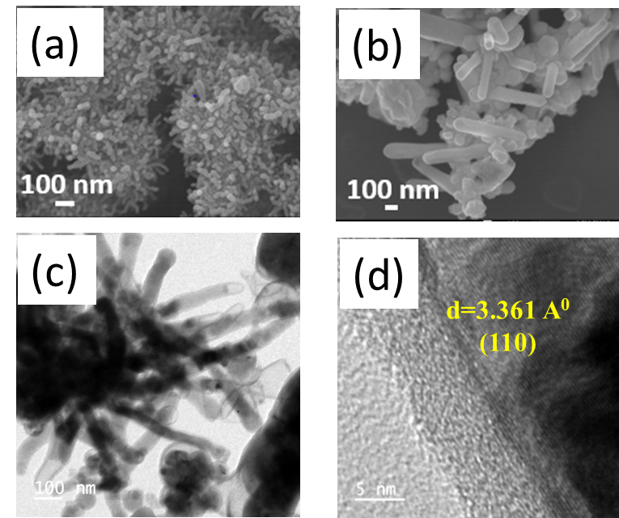

Figure S2 SEM (a and b), TEM (c) and HRTEM (d) images of ZnF2 nanorods synthesized by microwave irradiation of Zn with sulphur and g-C3N4 in Teflon beaker.

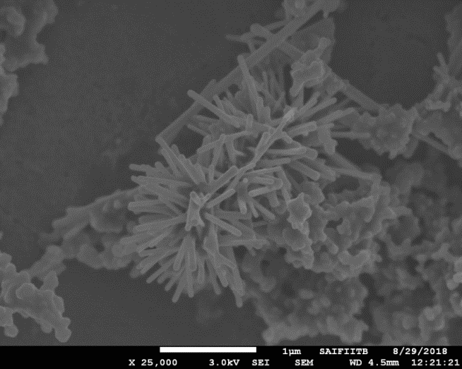

(b)

(a)

NiF2

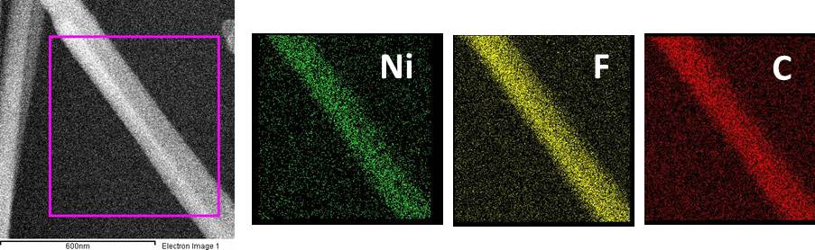 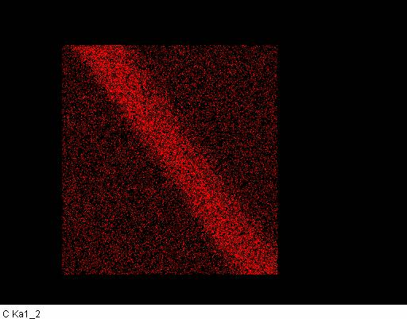

(c)

**Ni**

**F**

**C**

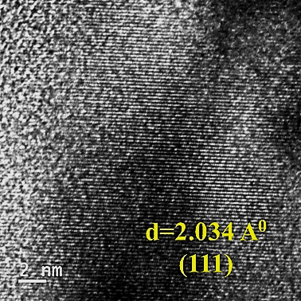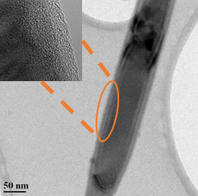

(d)

(e)

Figure S3 SEM images (a and b) and (c) EDS elemental mapping of Ni, F, C on one of the NiF2 nanorods synthesized by microwave irradiation of Ni with sulphur and g-C3N4 in Teflon beaker. TEM (d) and HRTEM (e) images of NiF2 nanorod. Inset in (d) shows the magnified image at the edge of the nanorod.

Microwave irradiation of Ni with sulfur and g-C3N4 in Teflon beaker yield formation of NiF2 nanorods. Formation of NiF2 nanorods along with Ni nanoparticles covered with fluorinated amorphous carbon can be seen in SEM images (Figure S3 a and b). Figure S3c SEM and EDS mapping of Ni, F and C on top of one of the NiF2 nanorods confirms the presence of Ni, F and C. TEM image in Figure S3d and inset within confirming the amorphous coating on the NiF2 nanorod. HRTEM image in Figure S3e confirms the single-crystalline nature of the nanorods with <111> growth direction.