Supporting Information

Synthesis and physicochemical evaluation of fluorinated lipopeptide precursors of ligands for microbubble targeting

Masayori Hagimori, Estefanía E. Mendoza-Ortega and Marie Pierre Krafft

Table of Contents
1. Figure S1. Mass Spectrometry data of (SG)₅-KSS-K(C₂H₄-C₆F₁₃)₂ (1) S3
2. Figure S2. RP-HPLC chromatogram of (SG)₅-KSS-K(C₂H₄-C₆F₁₃)₂ (1) S3
3. Figure S3. Mass Spectrometry data of (SG)₅-KSS-K(C₂H₄-C₇F₁₅)₂ (2) S4
4. Figure S4. RP-HPLC chromatogram of (SG)₅-KSS-K(C₂H₄-C₇F₁₅)₂ (2) S4
5. Figure S5. Mass Spectrometry data of (SG)₅-KSS-K(C₂H₄-C₈F₁₇)₂ (3) S5
6. Figure S6. RP-HPLC chromatogram of (SG)₅-KSS-K(C₂H₄-C₈F₁₇)₂ (3) S5
7. Figure S7. Mass Spectrometry data of (SG)₅-KSS-K(C₁₀H₂₁)₂ (4) S6
8. Figure S8. RP-HPLC chromatogram of (SG)₅-KSS-K(C₁₀H₂₁)₂ (4) S6

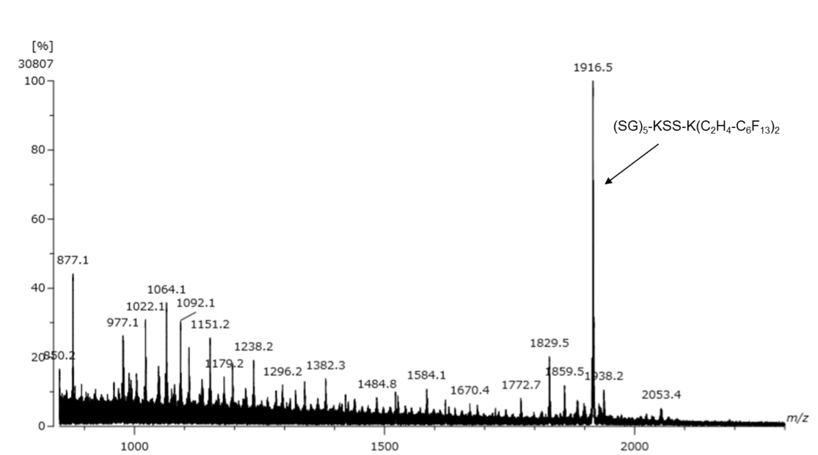
Figure S1: Mass Spectrometry data of (SG)₅-KSS-K(C₂H₄-C₆F₁₃)₂ (1). Exact mass of the (SG)₅-KSS-K(C₂H₄-C₆F₁₃)₂ [M+H]⁺ was calculated 1916.5511 and found 1916.5509.

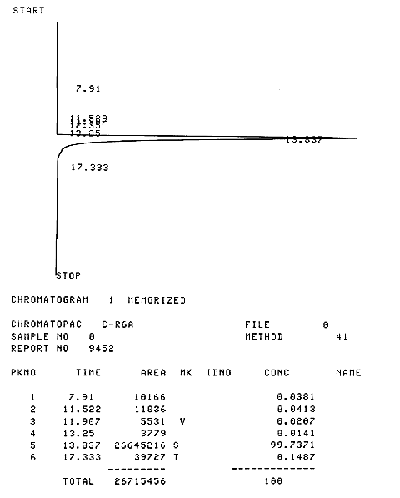
Figure S2: RP-HPLC chromatogram of (SG)₅-KSS-K(C₂H₄-C₆F₁₃)₂ (1). HPLC conditions: the column was a COSMOSIL 5C18-AR-II 4.6 mm × 250 mm, flow rate was 0.5 mL/min, UV excitation at 220 nm, mobile phase systems were CH₃CN : H₂O = 80:20.
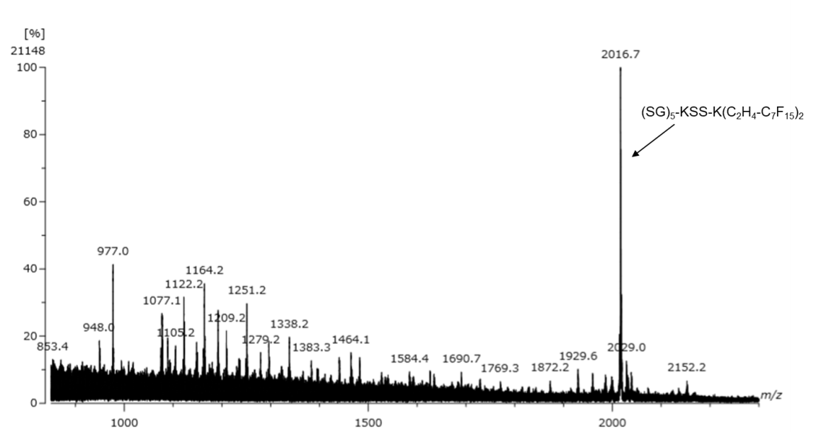
Figure S3: Mass Spectrometry data of (SG)₅-KSS-K(C₂H₄-C₇F₁₅)₂ (2). Exact mass of the (SG)₅-KSS-K(C₂H₄-C₇F₁₅)₂ [M+H]⁺ was calculated 2016.5447 and found 2016.5448.

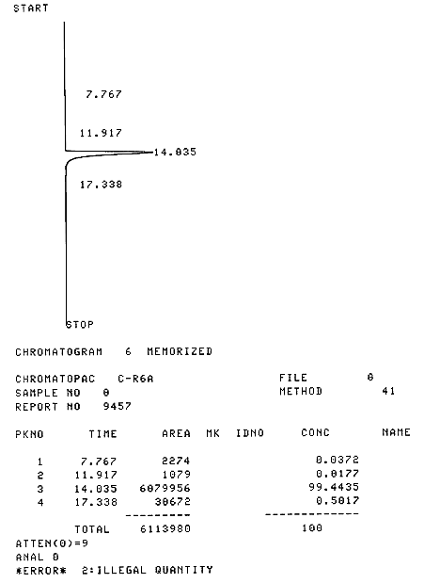
Figure S4: RP-HPLC chromatogram of (SG)₅-KSS-K(C₂H₄-C₇F₁₅)₂ (2). HPLC conditions: the column was a COSMOSIL 5C18-AR-II 4.6 mm × 250 mm, flow rate was 0.5 mL/min, UV excitation at 220 nm, mobile phase systems were CH₃CN : H₂O = 80:20.
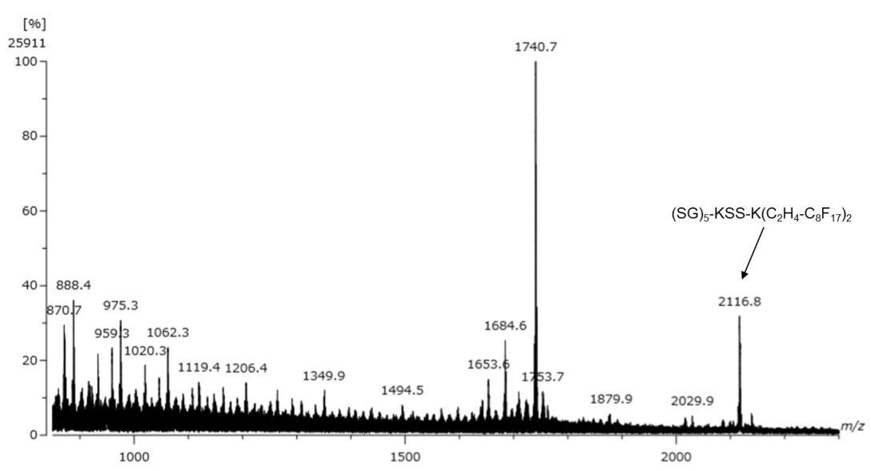
Figure S5: Mass Spectrometry data of (SG)₅-KSS-K(C₂H₄-C₈F₁₇)₂ (3). Exact mass of the (SG)₅-KSS-K(C₂H₄-C₈F₁₇)₂ [M+H]⁺ was calculated 2116.5383 and found 2116.5381.

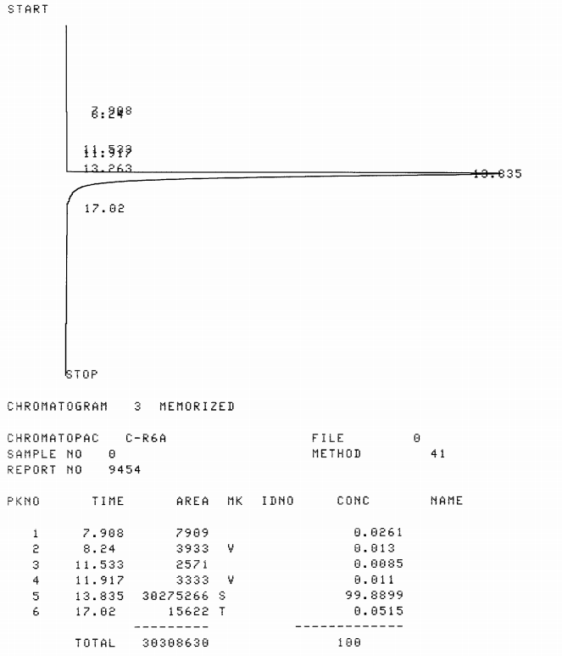
Figure S6: RP-HPLC chromatogram of (SG)₅-KSS-K(C₂H₄-C₈F₁₇)₂ (3). HPLC conditions: the column was a COSMOSIL 5C18-AR-II 4.6 mm × 250 mm, flow rate was 0.5 mL/min, UV excitation at 220 nm, mobile phase systems were CH₃CN : H₂O = 80:20.
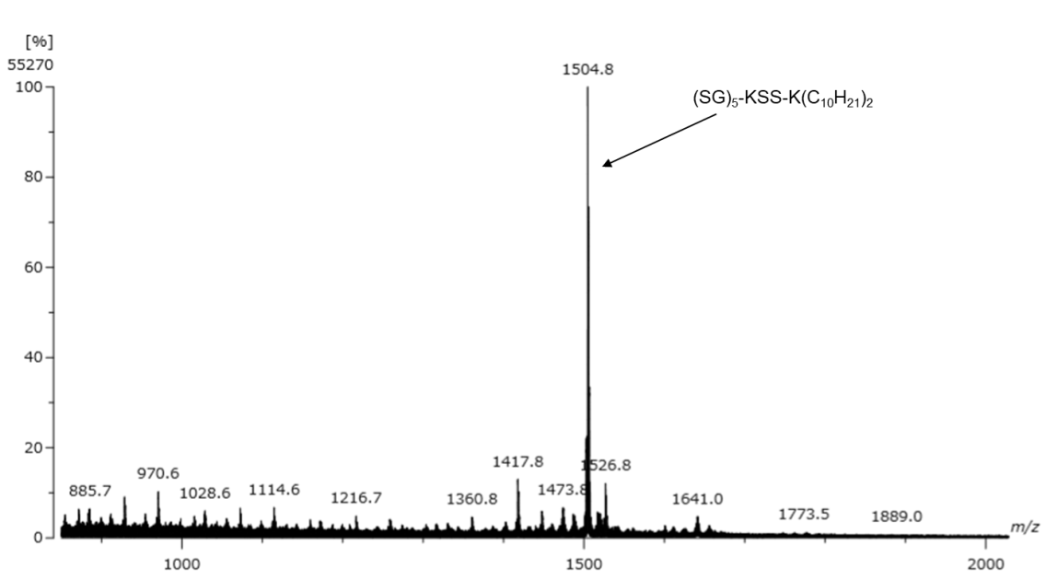
Figure S7: Mass Spectrometry data of (SG)₅-KSS-K(C₁₀H₂₁)₂ (4). Exact mass of the (SG)₅-KSS-K(C₁₀H₂₁)₂ [M+H]⁺ was calculated 1504.8586 and found 1504.8585.

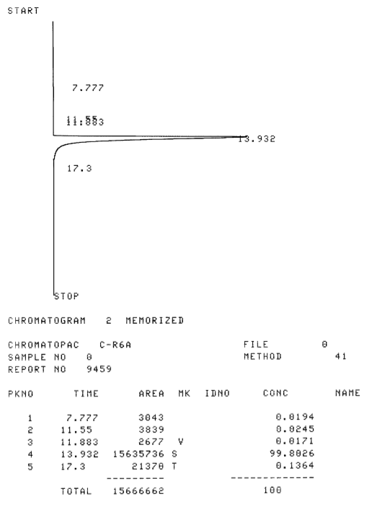
Figure S8: RP-HPLC chromatogram of (SG)₅-KSS-K(C₁₀H₂₁)₂ (4). HPLC conditions: the column was a COSMOSIL 5C18-AR-II 4.6 mm × 250 mm, flow rate was 0.5 mL/min, UV excitation at 220 nm, mobile phase systems were CH₃CN : H₂O = 80:20.

