Supplementary materials

Experimental procedures
General procedure for synthesis of 8. A solution of salt 7 (17 mmol) in chloroform (150 ml) was shaken with a solution of sodium hydroxide (3.41 g, 85 mmol) in water (40 ml), and an intense yellow color immediately appeared. The organic layer was separated, dried with anhydrous sodium sulfate, and concentrated to give tetrazole-5-aminides 8 as light-yellow crystals. Compound 8a was crystallized from hexane to give crystals suitable for single crystal X-ray analysis.
1,3-Di-tert-butyltetrazolium-5-aminide (8a). Yield 3.05 g (91 %). Mp 69–70 °C. UV-Vis, λ_{max} (nm): water – 262; MeOH – 205, 256; CHCl₃ – 246, 317; THF – 216, 338; hexane – 224, 344. ¹H NMR (500.0 MHz, DMSO-d₆), δ: 4.31 (br, s, 1H, NH), 1.59 (s, 9H, t-Bu), 1.54 (s, 9H, t-Bu) ppm; ¹³C NMR (125.7 MHz, DMSO-d₆), δ: 162.1 (CN₄), 65.2 (CMe₃), 58.9 (CMe₃), 28.1 (3Me), 26.5 (3Me) ppm. IR (neat), ṽ: 3327 (w), 3193 (w), 2984 (s), 2941 (s), 2913 (m), 2878 (m), 1610 (s), 1474 (s), 1455 (s), 1420 (m), 1402 (m), 1385 (s), 1369 (s), 1311 (s), 1292 (m), 1175 (s), 1083 (m), 1036 (s), 993 (s), 939 (m), 844 (m), 819 (w), 787 (w), 728 (m), 685 (s), 650 (s), 610 (s), 567 (w), 489 (w), 461 (w), 442 (w), 420 (w) cm^{–1}. Raman, ṽ (rel. int.): 2984 (11), 2928 (21), 2791 (3), 2719 (4), 1620 (14), 1590 (19), 1444 (30), 1403 (54), 1366 (15), 1307 (28), 1288 (5), 1230 (17), 1176 (66), 1149 (16), 1079 (27), 1033 (22), 989 (62), 936 (32), 841 (47), 815 (100), 783 (67), 681 (3), 606 (47), 565 (44), 457 (5), 413 (4), 337 (4), 316 (5), 267 (6) cm^{–1}.
1-Methyl-3-tert-butyltetrazolium-5-aminide (8b). Yield 2.31 g (88 %). Mp 48–51 °C. ¹H NMR (500.0 MHz, DMSO-d₆), δ: 3.53 (s, 3H, Me), 1.57 (s, 9H, t-Bu) ppm; ¹³C NMR (125.7 MHz, DMSO-d₆), δ: 163.1 (CN₄), 66.0 (CMe₃), 31.8 (Me), 28.2 (3Me) ppm. IR (neat), ṽ: 3310 (w), 3028 (w), 2991 (m), 2943 (m), 2881 (w), 1824 (w), 1620 (s), 1513 (w), 1462 (s), 1445 (m), 1414 (m), 1373 (s), 1317 (m), 1296 (w), 1223 (s), 1187 (s), 1131 (w), 1100 (w), 1067 (w), 1042 (m), 1006 (w), 988 (m), 943 (w), 934 (w), 843 (s), 736 (s), 675 (s), 589 (m), 570 (m), 513 (w), 460 (w), 438 (w) cm^{–1}.
3-Methyl-1-tert-butyltetrazolium-5-aminide (8c). Yield 2.53 g (96 %). Mp 44–46 °C. ¹H NMR (500.0 MHz, DMSO-d₆), δ: 4.32 (br, s, 1H, NH), 3.95 (s, 3H, Me), 1.59 (s, 9H, t-Bu) ppm; ¹³C NMR (125.7 MHz, DMSO-d₆), δ: 162.3 (CN₄), 59.2 (CMe₃), 41.7 (Me), 26.7 (3Me) ppm. IR (neat), ṽ: 3372 (m), 3283 (m), 2979 (w), 2920 (m), 2851 (w), 1741 (w), 1654 (m), 1585 (s), 1484 (w), 1456 (m), 1396 (m), 1356 (s), 1228 (s), 1210 (s), 1163 (s), 1112 (m), 1078 (s), 1039 (m), 1012 (m), 933 (w), 851 (m), 807 (m), 791 (m), 737 (m), 658 (s) cm^{–1}.
Bistetrazolium salt 9. To solution of compound 8a (1.0 g, 5.1 mmol) in acetone (5 ml) 1,2-dibromoethane (0.22 ml, 2.5 mmol) was added. System refluxed 3 h. Precipitate was filtered, dried and washed with cold acetone to give salt 9. Yield 0.36 g (24 %). Mp 187–190 °C. ¹H NMR (500.0 MHz, DMSO-d6), δ: 8.01 (s, 1H, NH), 3.65 (s, 4H, 2CH2), 1.70 (s, 9H, t-Bu), 1.67 (s, 9H, t-Bu) ppm; ¹³C NMR (125.7 MHz, DMSO-d6), δ: 155.5 (CN₄), 83.8 (CMe₃), 69.1 (CMe₃), 64.1 (2CH₂), 27.6 (3Me), 26.5 (3Me) ppm. IR (neat), ṽ: 3146 (m), 3100 (m), 2986 (m), 2943 (m), 1622 (s), 1542 (w), 1492 (m), 1437 (w), 1409 (w), 1376 (m), 1352 (m), 1312 (w), 1278 (w), 1242 (m), 1234 (m), 1218 (m), 1187 (s), 1167 (m), 1095 (w), 1073 (w), 1046 (w), 1027 (w), 943 (w), 905 (m), 869 (w), 835 (w), 818 (w), 789 (w), 732 (w), 669 (w), 646 (w), 587 (w), 559 (w), 544 (w), 493 (w), 457 (w), 444 (w), 424 (w) cm^{–1}.
Bistetrazolium-5-aminide 10. Compound 9 (0.14 g, 0.33 mmol) was dissolved in chloroform (5 ml), and then a solution of sodium hydroxide (0.132 g, 3.3 mmol) was added. The organic layer was separated, dried with anhydrous sodium sulfate, and concentrated to give 10 as yellow crystals. The obtained compound was recrystallized from toluene to give crystals suitable for single crystal X-ray analysis. Yield 0.10 g (94 %). Mp 192–194 °C. UV-Vis, λ_{max} (nm): MeOH – 206, 263; CHCl₃ – 244, 348; THF – 232, 362; hexane – 223, 367. ¹H NMR (500.0 MHz, CD₃CN), δ: 3.29 (s, 4H, 2CH₂), 1.62 (s, 9H, t-Bu), 1.61 (s, 9H, t-Bu) ppm; ¹³C NMR (125.7 MHz, CD₃CN), δ: 158.7 (CN₄), 66.9 (CMe₃), 60.9 (CMe₃), 50.0 (2CH₂), 28.3 (3Me), 27.0 (3Me) ppm. IR (neat), ṽ: 2991 (m), 2979 (m), 2965 (m), 2938 (m), 2915 (m), 2874 (m), 2821 (m), 1625 (s), 1479 (m), 1462 (s), 1437 (w), 1397 (m), 1367 (s), 1352 (m), 1290 (s), 1272 (s), 1253 (s), 1211 (w), 1190 (s), 1173 (s), 1116 (s), 1057 (m), 1035 (m), 990 (m), 937 (m), 855 (m), 800 (w), 719 (m), 670 (w), 648 (m), 598 (s), 564 (w), 491 (m), 430 (w) cm^{–1}. Raman, ṽ (rel. int.): 2979 (17), 2926 (24), 2859 (11), 2815 (17), 2715 (5), 1642 (43), 1449 (59), 1403 (73), 1392 (74), 1368 (28), 1345 (10), 1290 (17), 1274 (26), 1263 (26), 1233 (40), 1170 (51), 1109 (56), 1088 (1088), 1030 (38), 986 (74), 929 (38), 866 (21), 815 (100), 802 (36), 714 (4), 649 (66), 609 (6), 562 (44), 470 (11), 450 (10), 371 (3), 340 (9), 267 (5) cm^{–1}.
(1,3-Di-tert-butyl-1H-tetrazol-3-ium-5-yl)(1-phenyl-1H-tetrazol-5-yl)amide (11a). Compound 8a (0.43 g, 2.2 mmol) and 5-(methylsulfonyl)-1-phenyl-1H-tetrazole (0.45 g, 2.0 mmol) were dissolved in acetonitrile (10 ml). Sodium hydroxide (0.088 g, 2.2 mmol) was added, and the mixture refluxed for 5 h. Precipitate was filtered and discarded. Filtrate was evaporated to dryness, recrystallized from ethyl alcohol to give 11 as white crystals. After recrystallization from acetonitrile crystals suitable for X-ray analysis were obtained. Yield 0.32 g (46 %). Mp 206–208 °C. ¹H NMR (500.0 MHz, DMSO-d₆), δ: 7.85–7.45 (m, 5H, Ph), 1.69 (s, 9H, t-Bu), 1.70 (s, 9H, t-Bu) ppm; ¹³C NMR (125.7 MHz, DMSO-d₆), δ: 157.9 (CN₄), 156.4 (CN₄), 135.7 (C⁴, Ph), 129.6 (C^{3,5}, Ph), 128.4 (C¹, Ph), 123.5 (C^{2,6}, Ph), 67.8 (CMe₃), 62.6 (CMe₃), 28.3 (3Me), 27.1 (3Me) ppm. IR (neat), ṽ: 3363 (w), 3061 (w), 2985 (w), 2667 (w), 2924 (m), 2852 (w), 1603 (m), 1568 (s), 1520 (s), 1499 (s), 1475 (m), 1455 (s), 1412 (m), 1403 (m), 1374 (m), 1363 (m), 1344 (m), 1295 (w), 1276 (w), 1264 (w), 1235 (m), 1213 (m), 1178 (s), 1159 (m), 1124 (m), 1093 (s), 1070 (m), 1044 (w), 1035 (w), 1018 (w), 1002 (m), 984 (w), 969 (w), 962 (w), 938 (w), 912 (m), 868 (m), 839 (w), 827 (w), 816 (w), 758 (s), 745 (m), 739 (m), 694 (m), 686 (s) cm^{–1}.
N-(2-(tert-butyl)-2H-tetrazol-5-yl)-1-phenyl-1H-tetrazol-5-amine (12a). Compound 11 (0.045 g, 0.13 mmol) refluxed in 2 ml of 10 % HCl for 3 h. After cooling to room temperature precipitate was filtered and recrystallized from ethyl alcohol to give 12 as a white solid. Yield 0,017 g (56 %). Mp 133–135 °C. ¹H NMR (500.0 MHz, DMSO-d₆), δ: 11.06 (br, s, 1H, NH), 7.74–7.53 (m, 5H, Ph), 1.52 (s, 9H, t-Bu) ppm; ¹³C NMR (125.7 MHz, DMSO-d₆), δ: 161.1 (CN₄), 151.9 (CN₄), 133.8 (C⁴, Ph), 130.4 (C¹, Ph), 130.2 (C^{2,6}, Ph), 124.8 (C^{3,5}, Ph), 64.4 (CMe₃), 28.9 (3Me) ppm. IR (neat), ṽ: 2986 (w), 2909 (w), 2828 (w), 2770 (w), 1655 (w), 1615 (s), 1593 (m), 1549 (m), 1524 (s), 1497 (s), 1455 (m), 1402 (w), 1370 (m), 1344 (m), 1314 (m), 1287 (w), 1259 (w), 1237 (w), 1201 (m), 1188 (m), 1172 (w), 1157 (w), 1129 (m), 1093 (m), 1072 (m), 1046 (m), 1012 (s), 988 (w), 939 (w), 918 (w), 861 (m), 831 (m), 814 (w), 760 (s), 748 (s), 722 (s), 685 (s), 595 (m), 554 (m), 503 (w), 476 (w), 449 (w) cm^{–1}.
(1-methyl-3-tert-butyl-1H-tetrazol-3-ium-5-yl)(1-phenyl-1H-tetrazol-5-yl)amide (11b). Compound 8b (0.16 g, 1.0 mmol) and 5-(methylsulfonyl)-1-phenyl-1H-tetrazole (0.22 g, 1.0 mmol) were dissolved in acetonitrile (5 ml). Sodium hydroxide (0.044 g, 1.1 mmol) was added and mixture refluxed for 5 h. Precipitate was filtered and discarded. Filtrate was evaporated to dryness, recrystallized from ethyl alcohol to give 13 as white crystals. Yield 0.15 g (50 %). Mp 213–215 °C. ¹H NMR (500.0 MHz, DMSO-d₆), δ: 7.99–7.43 (m, 5H, Ph), 3.84 (s, 3H, Me), 1.70 (s, 9H, t-Bu) ppm; ¹³C NMR (125.7 MHz, DMSO-d₆), δ: 158.7 (CN₄), 156.3 (CN₄), 135.8 (C⁴, Ph), 130.0 (C^{3,5}, Ph), 128.1 (C¹, Ph), 122.6 (C^{2,6}, Ph), 68.1 (CMe₃), 33.2 (Me), 28.3 (3Me) ppm. IR (neat), ṽ: 3074 (w), 2987 (w), 1652 (w), 1606 (s), 1587 (s), 1525 (s), 1497 (s), 1457 (s), 1414 (w), 1404 (w), 1393 (s), 1375 (s), 1359 (w), 1327 (m), 1292 (m), 1264 (m), 1228 (m), 1182 (s), 1164 (m), 1134 (s), 1099 (s), 1073 (s), 1037 (m), 1017 (m), 987 (s), 925 (m), 900 (s), 824 (w), 764 (s), 743 (w), 729 (m), 696 (m), 666 (s), 616 (w), 576 (m), 546 (m), 542 (m), 518 (w), 491 (m), 468 (m) cm^{–1}.
1-Methyl-N-(1-phenyl-1H-tetrazol-5-yl)-1H-tetrazol-5-amine (12b). Compound 13 (0.1038 g, 0.35 mmol) refluxed in 2.5 ml of 10 % HCl for 6 h. After cooling to room temperature precipitate was filtered and recrystallized from ethyl alcohol to give 12 as a white solid. Yield 0,037 g (44 %). Mp 187–190 °C. ¹H NMR (500.0 MHz, DMSO-d₆), δ: 7.89–7.50 (m, 5H, Ph), 3.82 (s, 3H, Me) ppm; ¹³C NMR (125.7 MHz, DMSO-d₆), δ: 153.2 (CN₄), 151.1 (CN₄), 134.4 (C¹, Ph), 130.0 (C⁴, Ph), 129.4 (C^{2,6}, Ph), 123.3 (C^{3,5}, Ph), 32.9 (Me) ppm. IR (neat), ṽ: 3016 (m), 1671 (w), 1623 (s), 1608 (s), 1590 (s), 1537 (s), 1498 (s), 1491 (s), 1450 (s), 1420 (w), 1401 (s), 1328 (w), 1301 (w), 1282 (w), 1268 (w), 1256 (w), 1219 (m), 1175 (w), 1160 (w), 1141 (m), 1115 (s), 1198 (m), 1069 (m), 1023 (s), 1005 (m), 980 (m), 911 (w), 827 (m), 810 (m), 754 (s), 713 (s), 682 (s), 663 (s), 616 (w), 548 (w), 508 (m), 498 (m), 473 (w), 452 (s) cm^{–1}.

Results of calculations of UV-Vis spectra of 8a
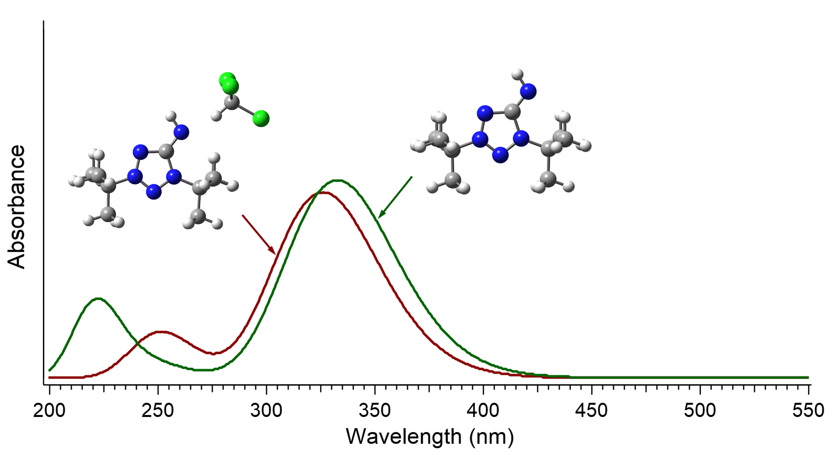
Fig. S1. The TD-tHCTHhyb/6-311+G(2d,p) calculated absorption spectra of 8a in chloroform for two different models: continuum SMD (green curve); combined continuum SMD and super-molecule model, taking into account the formation of a hydrogen bond between 8a and chloroform (red curve).
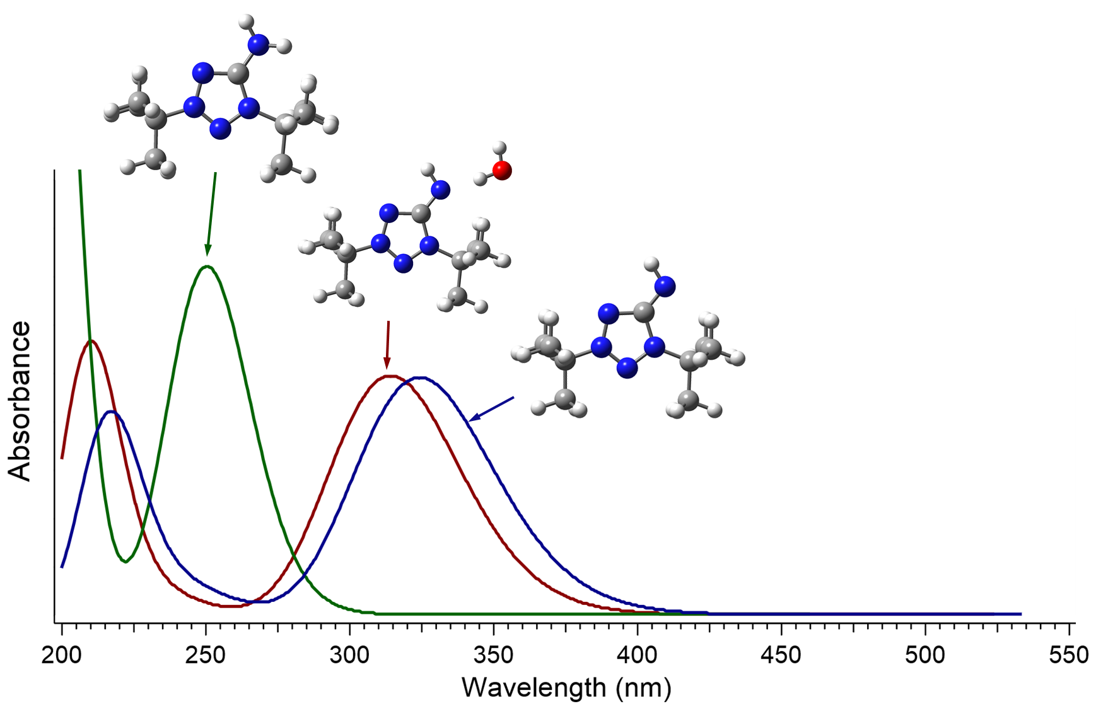
Fig. S2. The TD-tHCTHhyb/6-311+G(2d,p) calculated absorption spectra of 8a in water for three different models: continuum SMD (blue curve); combined continuum SMD and super-molecule model, taking into account the formation of a hydrogen bond between 8a and chloroform (red curve); continuum SMD model, taking into account the protonation of 8a in water solution (green curve).
TGA/DSC details for compounds 8a and 10
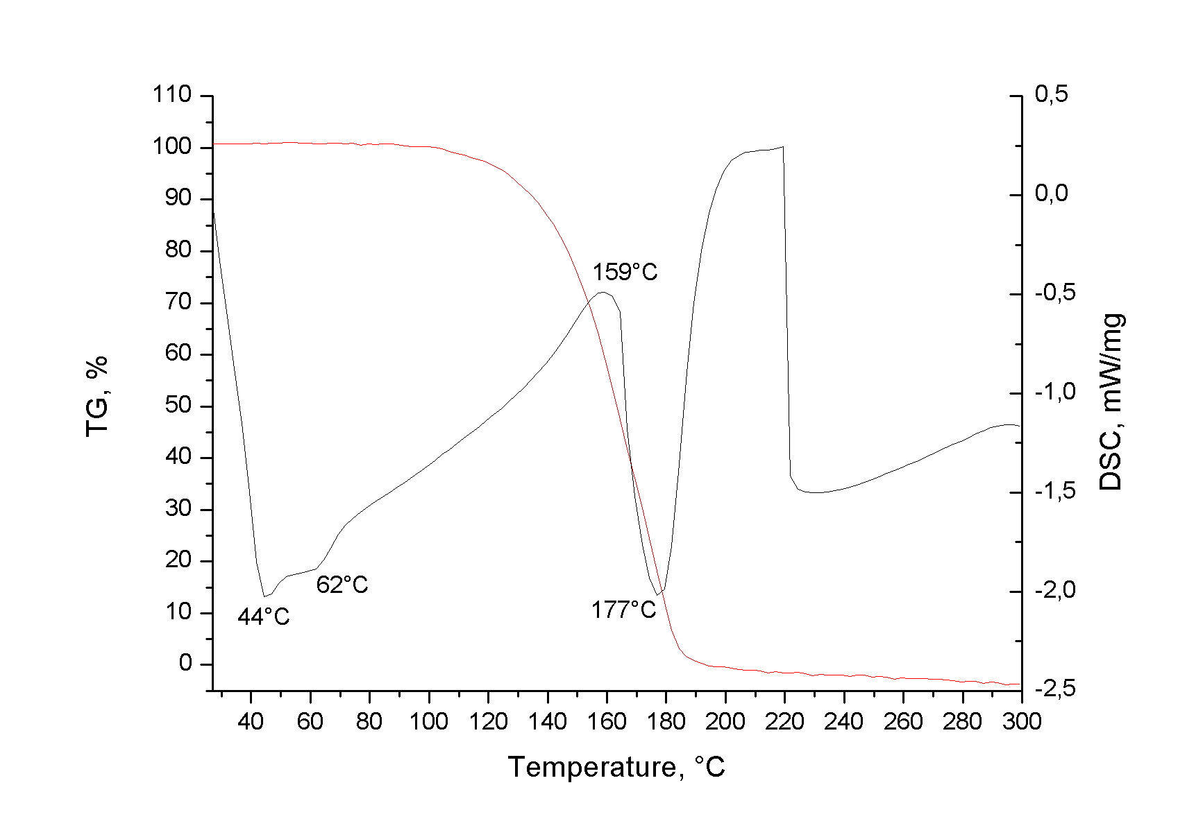
Fig. S3. TG and DSC curves of compound 8a
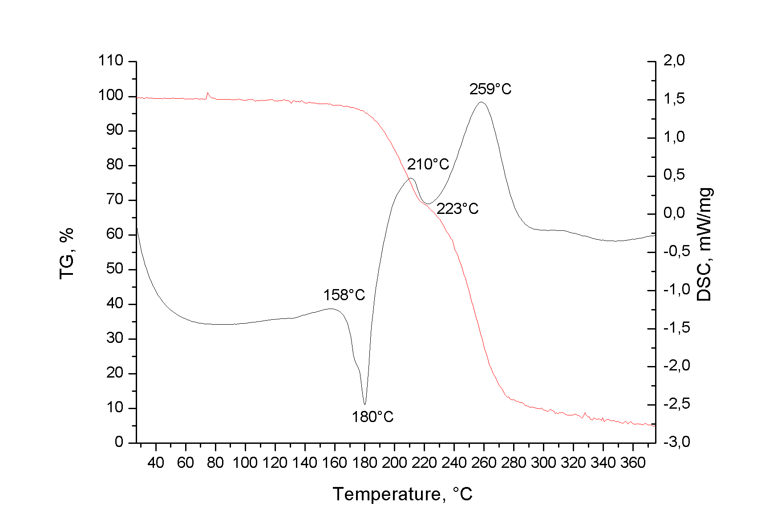
Fig. S4. TG and DSC curves of bistetrazolium-5-aminide 10

