Supporting Information
for
In silico approach: Anthocyanin derivatives as potential inhibitors of the COVID-19 main protease
Muhammad Ikhlas Abdjan¹, Khusna Arif Rakhman², Sri Handayani³, Chairil Anjasmara Robo Putra⁴, Imam Siswanto¹*
¹Department of Chemistry, Faculty of Science and Technology, Universitas Airlangga, kampus C Mulyorejo, Surabaya 60115, Indonesia
²Department of Chemistry Education, Universitas Khairun, Ternate, Indonesia
³Department of Chemical Education, Faculty of Mathematics and Natural Sciences, State University of Yogyakarta, Yogyakarta, Indonesia
⁴Post Graduate School, Universitas Airlangga, Jl. Dharmawangsa 30, Surabaya 60286, Indonesia

Email: imamsiswanto@fst.unair.ac.id
* Corresponding author

Additional data

Solvent Accessibility Surface Area
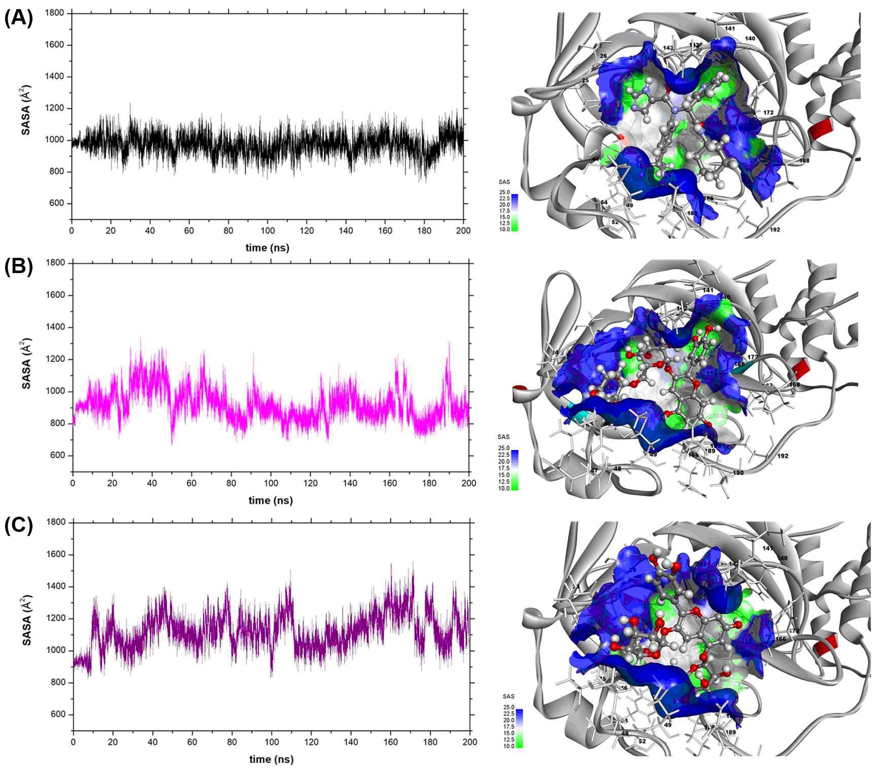
Figure S1: Solvent accessibility surface area of COVID-19 main protease active site plot along the simulation time (200 ns) of each complex: (A) X77, (B) C5, and (C) C6.

Bioavailability and Drug-Likeness Screening
Table S1: Prediction of ADMET properties used admetSAR service website.
Parameters | Code C5 | Code C6
Blood-brain barrier | BBB- | BBB-
Human intestinal absorption | HIA+ | HIA+
P-glycoprotein substrate | Substrate | Substrate
P-glycoprotein inhibitor | Non-inhibitor | Non-inhibitor
Renal organic cation transporter | Non-inhibitor | Non-inhibitor
Aqueous solubility (LogS) | -2.63 | -2.10
Subcellular localization | Mitochondria | Mitochondria
CYP450 2C9 subtrate | Non-substrate | Non-substrate
CYP450 2C9 inhibitor | Non-inhibitor | Non-inhibitor
CYP450 2D6 subtrate | Non-substrate | Non-substrate
CYP450 2D6 inhibitor | Non-inhibitor | Non-inhibitor
CYP450 3A4 subtrate | Non-substrate | Non-substrate
CYP450 3A4 inhibitor | Non-inhibitor | Non-inhibitor
CYP450 1A2 inhibitor | Non-inhibitor | Non-inhibitor
CYP450 2C19 inhibitor | Non-inhibitor | Non-inhibitor
Human ether-a-go-go-related-gene-inhibition | Weak inhibitor | Weak inhibitor
AMES toxicity | Non-AMES toxic | Non-AMES toxic
carcinoges | Non-Carcinogens | Non-Carcinogens
biodegradation | Not-ready-biodegradable | Not-ready-Biodegradable
Acute oral toxicity | III | IV
Carcinogenicity (three-class) | Non-required | Non-required
Rat acute toxicity (LD50, mol/kg) | 2.27 | 2.16

