Supporting Information
Preparation of anthracene-based tetra-perimidine hexafluorophosphate and selective recognition for chromium(III) ion

Qing-Xiang Liu,^{a,*} Shao-Cong Yu,ª Zhi-Xiang Zhao,ª Feng Yangª and Yue Dingª

ª Tianjin Key Laboratory of Structure and Performance for Functional Molecules, MOE Key Laboratory of Inorganic-Organic Hybrid Functional Material Chemistry, College of Chemistry, Tianjin Normal University, Tianjin 300387, P. R. China .
* Corresponding author, E-mail: tjnulqx@163.com

Table of Contents

1. CCDC numbers for compound 3.
2. Crystal data and structure refinements for 3 (Table S1).
3. The crystal packings of compound 3 (Figure S1a-Figure S1b).
4. The Figures of fluorescence and UV/vis spectroscopies for compound 3 (Figure S2-Figure S9).
5. The Figure of MS spectra for 3·Cr³⁺. (Figure S10).
6. Infrared spectra of 3 and 3·Cr³⁺ (Figure S11).
7. The ¹H NMR and ¹³C NMR spectra of of intermediate and compound 3 (Figure S12-Figure S20).

1. CCDC number for compound 3.
CCDC 1918752 contains the supplementary crystallographic data for compound The data can be obtained free of charge via http//www.ccdc.cam.ac.uk/conts/retrieving. html, or from the Cambridge Crystallographic Data Centre, 12 Union Road, Cambridge, CB2 1EZ, UK; fax: (+44) 223-336-033; or e-mail: deposit@ccdc.cam. ac. uk.

2. Crystal data and structure refinements for 3
Table S1: Crystal data and structure refinements for 3
Chemical formula | C₈₄H₉₀F₂₄N₁₄P₄ | F(000) | 968
Formula weight | 1875.57 | Cryst size, mm | 0.25 × 0.15 × 0.14
Cryst syst | Triclinic | θ_{min}, θ_{max}, deg | 3.74, 67.06
Space group | Pī | T /K | 172.9(1)
a/Å | 11.850(5) | No. of data collected | 14087
b/Å | 12.401(6) | No. of unique data | 7439
c/Å | 14.951(5) | No. of refined params | 579
α/deg | 92.4(1) | Goodness-of-fit on F^{2 a} | 1.048
β/deg | 94.3(1) | Final R indices^{b} [I > 2σ(I)]
γ/deg | 107.3(4) | R₁ | 0.0754
V/Å³ | 2086.65(1) | wR₂ | 0.1986
Z | 1 | R indices (all data)
D_{calcd}, Mg/m³ | 1.493 | R₁ | 0.1117
Abs coeff, mm⁻¹ | 1.797 | wR₂ | 0.2238
ª GOF = [Σω(F_{o}² - F_{c}²)² /(n - p)]^{1/2}, where n is the number of reflection and p is the number of parameters refined. ^{b} R₁ = Σ(||F_{o}| - |F_{c}||)/Σ|F_{o}|; wR₂ =[Σ[w(F_{o}² - F_{c}²)² ]/ Σw(F_{o}²)²]^{1/2}.

3. The crystal packings of compound 3

Figure S1(a): 1D supermolecular chain of 3.

Figure S1(b): 2D supermolecular layer of 3.

4. The Figures of fluorescence and UV/vis spectroscopies for compound 3
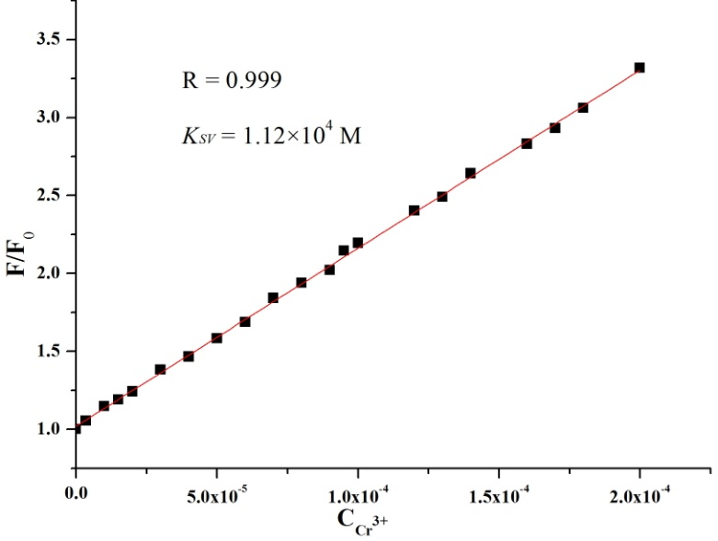
Figure S2: Stern-Volmer plot of 3 (5.0 × 10⁻⁶ mol/L)in the presence of Cr³⁺ in CH₃CN/DMSO (v:v = 9:1) at 25 ˚C.
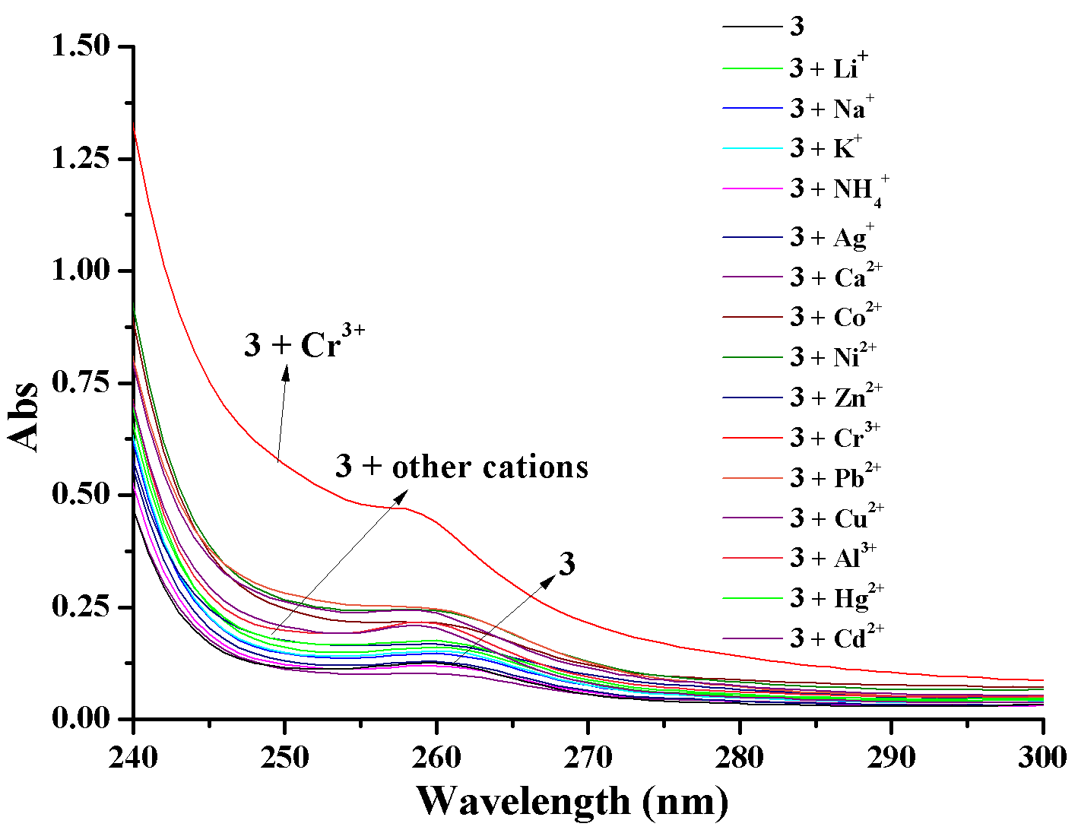
Figure S3: UV/vis absorption change of 3 (5.0 × 10⁻⁶ mol/L) upon the addition of the nitrate salts of Li⁺, Na⁺, K⁺, NH₄⁺, Ca²⁺, Al³⁺, Zn²⁺, Cd²⁺, Ag⁺, Pb²⁺, Co²⁺, Hg²⁺, Al³⁺, Ni²⁺ and Cr³⁺ (5 × 10⁻⁵ mol/L) in acetonitrile at 25 ˚C.
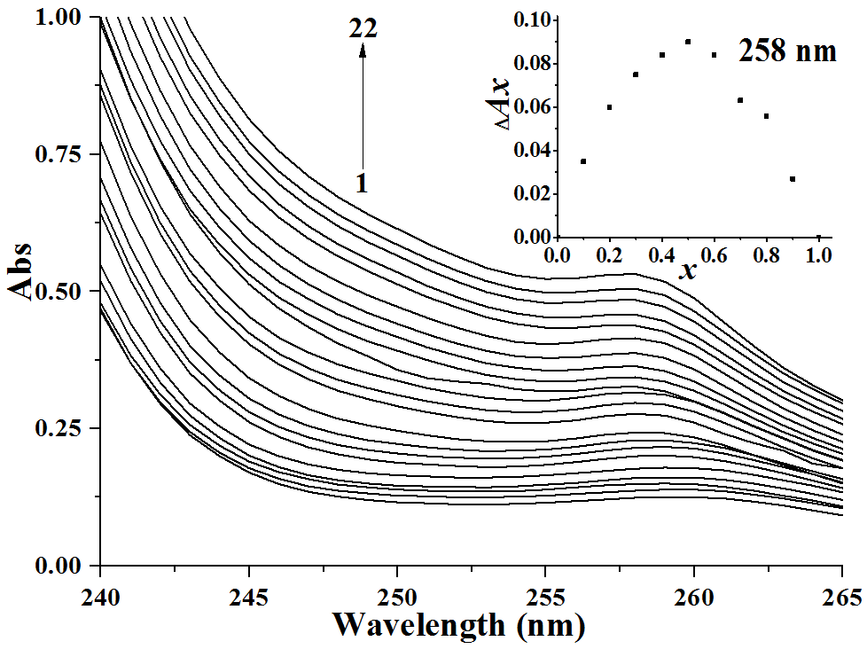
Figure S4: The UV-Vis absorption spectra of 3 (5.0 × 10⁻⁶ mol/L) in CH₃CN/DMSO (v:v = 9:1) at 25 ˚C. C_{Cr}³⁺ for curves 1-22 are 0, 0.02, 0.06, 0.1, 0.2, 0.4, 0.6, 0.8, 1.2, 1.4, 1.6, 1.8, 2.0, 2.2, 2.4, 2.6, 2.8, 3.0, 3.2, 3.4, 3.5 and 3.6 × 10⁻⁵. Inset: the Job’s plot for 3·Cr³⁺ complex in CH₃CN/DMSO (v:v = 9:1) at 258 nm.

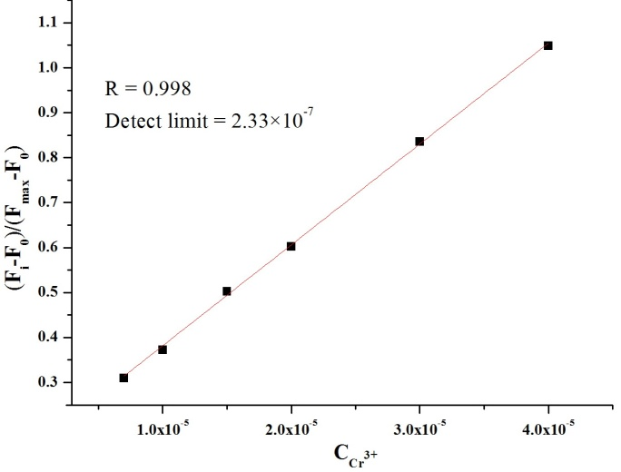
Figure S5: Emission (at 423 nm) of 3 at different concentrations of Cr³⁺ (0.7, 1.0, 1.5, 2.0, 3.0, 4.0 × 10⁻⁵ mol/L) added, normalized between the minimum emission (0.0 M Cr³⁺) and the emission 4.0 × 10⁻⁵ mol/L Cr³⁺. The detection limit was determined to be 2.33 × 10⁻⁷ mol/L.
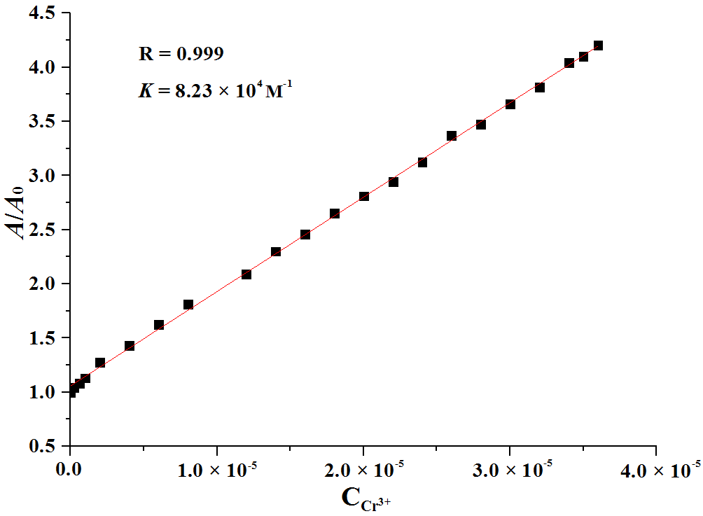
Figure S6: Benesi-Hildebrand plot of host 3 (5.0 × 10⁻⁶ mol/L) in the presence of Cr³⁺ in CH₃CN/DMSO (v:v = 9:1) at 25 ˚C.
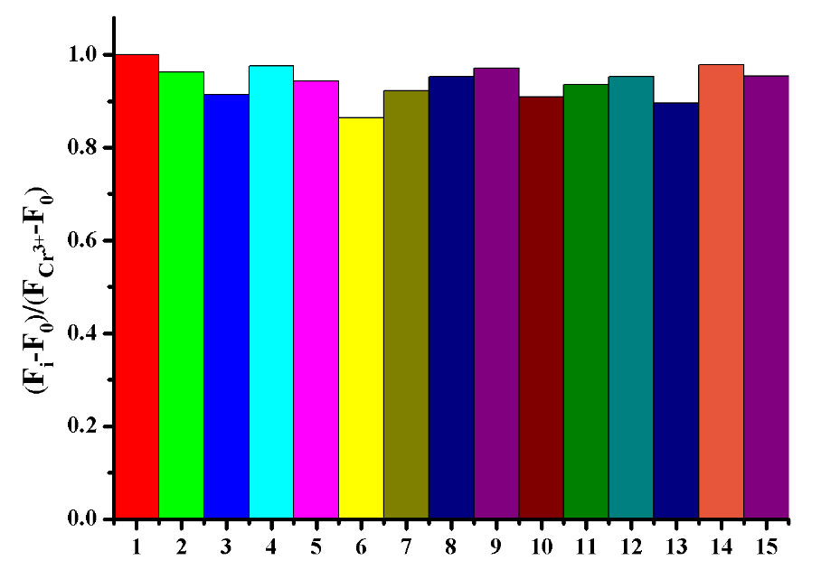
Figure S7: Change ratio ((F_{i} - F₀)/(F_{Cr}³⁺ - F₀)) of fluorescence intensity of 3 (5.0 × 10⁻⁶ mol/L) at 423 nm upon the addition of 30 equiv. Cr³⁺ in the presence of 30 equiv. background cations. 1: Cr³⁺; 2: Cr³⁺ + Li⁺; 3: Cr³⁺ + Na⁺; 4: Cr³⁺ + K⁺; 5: Cr³⁺ + NH₄⁺; 6: Cr³⁺ + Ag⁺; 7: Cr³⁺ + Ca²⁺; 8: Cr³⁺ + Co²⁺; 9: Cr³⁺ + Ni²⁺; 10: Cr³⁺ + Zn²⁺; 11: Cr³⁺ + Cu²⁺; 12: Cr³⁺ + Cd²⁺; 13: Cr³⁺ + Pb²⁺; 14: Cr³⁺ + Hg²⁺; 15: Cr³⁺ + Al³⁺ in CH₃CN/DMSO (v:v = 9:1) at 25 ˚C.
Figure S8: Fluorescence intensity of 3 (5.0 × 10⁻⁶ mol/L) in various mixtures of different Cr³⁺ salts (1: CrCl₃, 2: CrBr₃, 3: Cr₂(SO₄)₃, 4: Cr(NO₃)₃, 5: Cr(OAc)₃; 3.0 × 10⁻⁶ mol/L) in CH₃CN/DMSO (v:v = 9:1) at 25 ˚C.
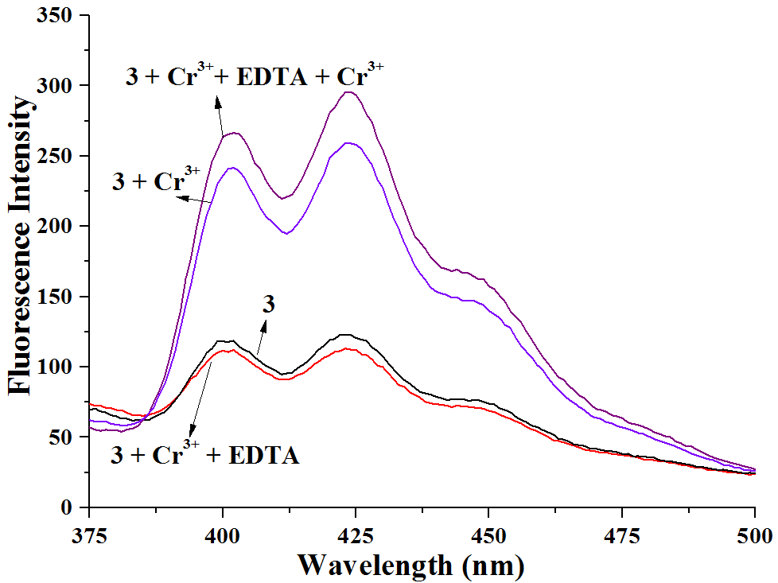
Figure S9: Fluorescence reversibility of 3 upon the detection of Cr³⁺. Fluorescent changes of 3 after the addition of Cr³⁺, EDTA, Cr³⁺ in that order in CH₃CN/DMSO (v:v = 9:1) at 25 ˚C.

5. The Figure of HRMS spectra for 3·Cr³⁺
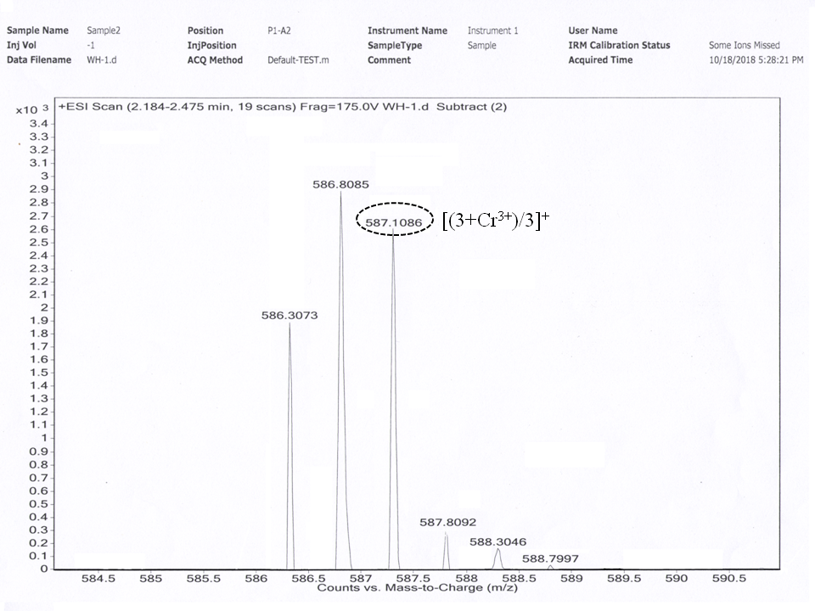

Figure S10: HRMS spectra for 3·Cr³⁺

6. Infrared spectra of 3 and 3·Cr³⁺
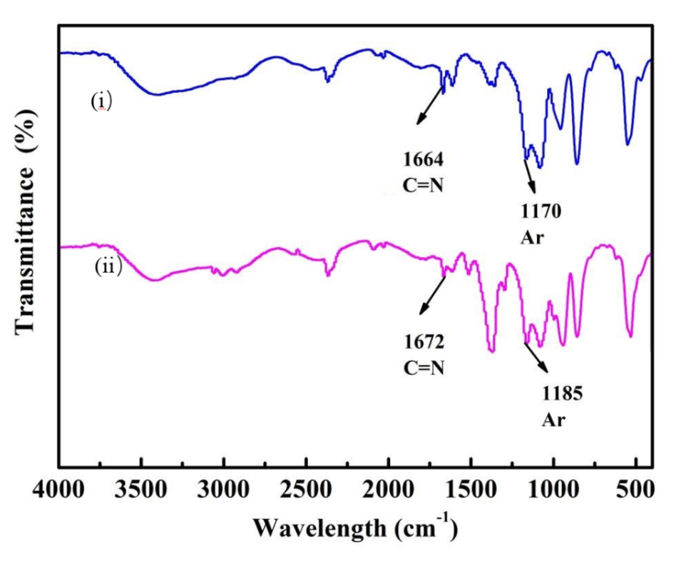
Figure S11: Infrared spectroscopy of 3 (top) and 3.Cr³⁺ (bottom).

7. The ¹H NMR and ¹³C NMR spectra of intermediate and compound 3
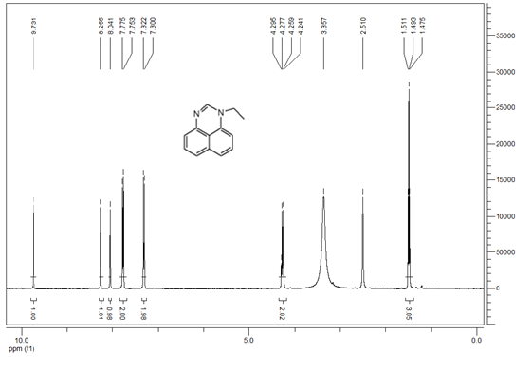
Figure S12: The ¹H NMR (400 MHz, DMSO-d₆) spectra of 1-ethylperimidine.

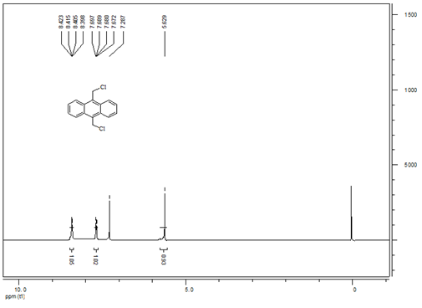
Figure S13: The ¹H NMR (400 MHz, CDCl₃) spectra of 9,10-bis(chloromethyl)anthracene.

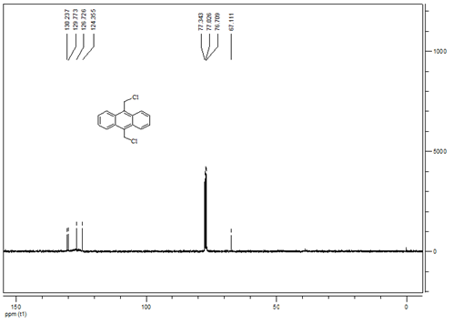
Figure S14: The ¹³C NMR (100 MHz, CDCl₃) spectra of 9,10-bis(chloromethyl)anthracene.

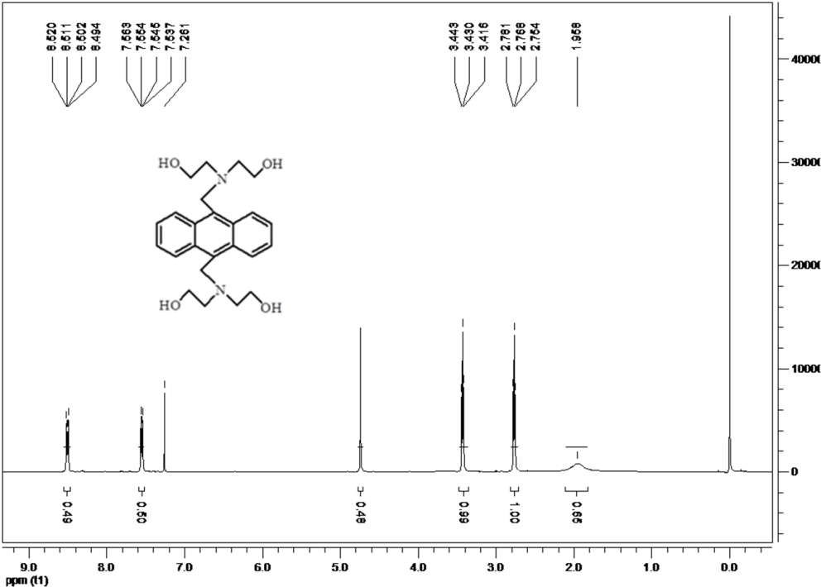
Figure S15: The ¹H NMR (600 MHz, CDCl₃) spectra of 9,10-bis[bi(2-hydoxylethyl)aminemethyl]anthracene.

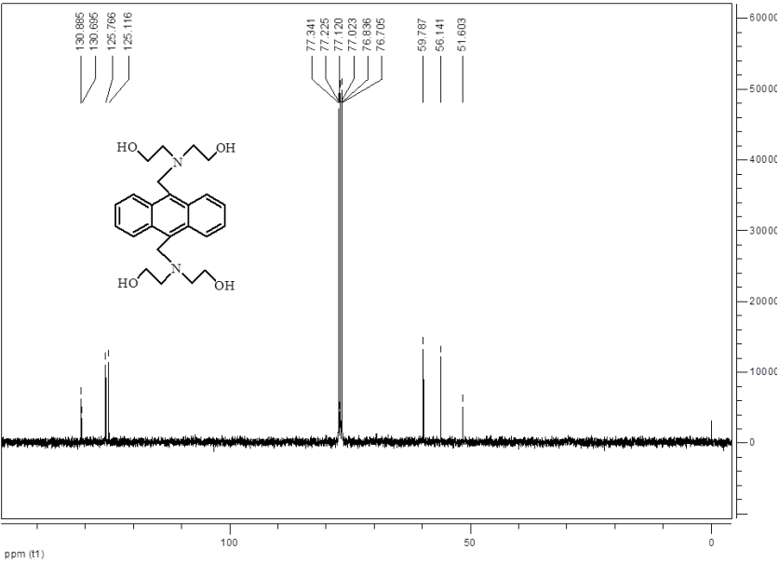
Figure S16: The ¹³C NMR (150 MHz, CDCl₃) spectra of 9,10-bis[bi(2-hydoxylethyl)aminemethyl]anthracene

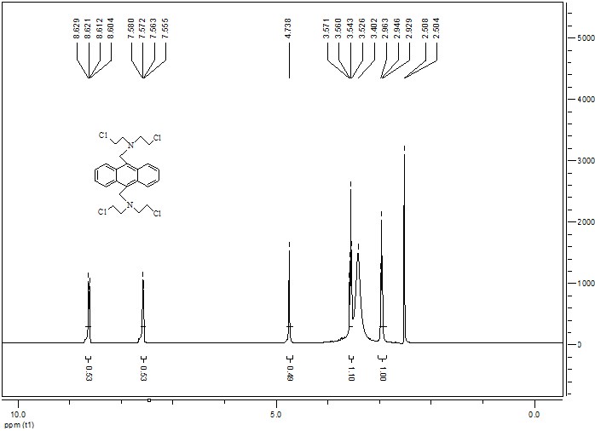
Figure S17: The ¹H NMR (600 MHz, DMSO-d₆) spectra of 9,10-bis[bi(2-chloroethyl)aminemethyl]anthracene.

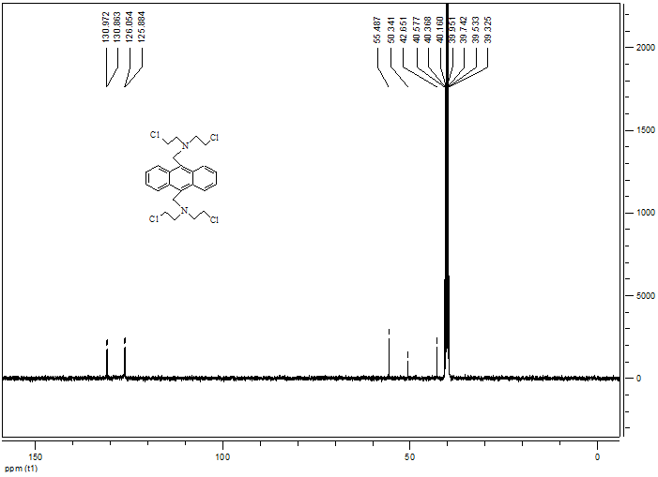
Figure S18: The ¹³C NMR (150 MHz, DMSO-d₆) spectra of 9,10-bis[bi(2-chloroethyl)aminemethyl]anthracene.

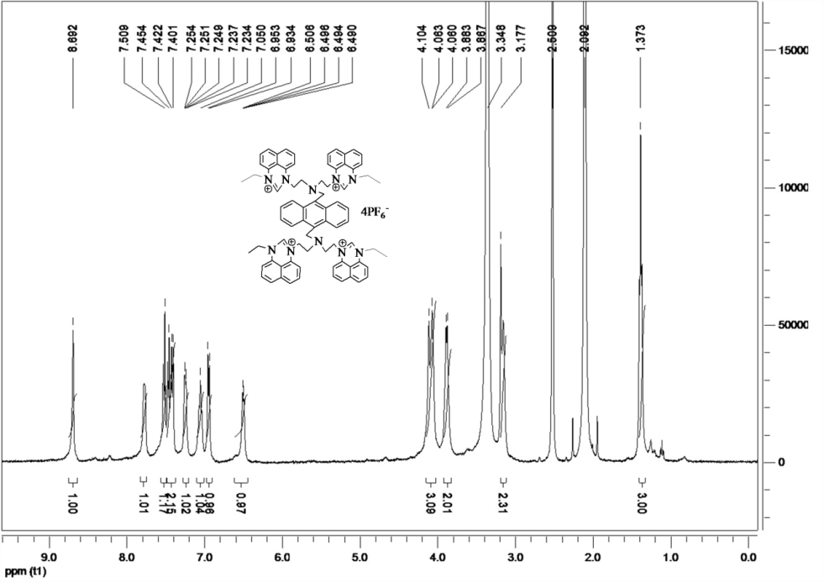
Figure S19: The ¹H NMR (600 MHz, DMSO-d₆) spectrum of 3.

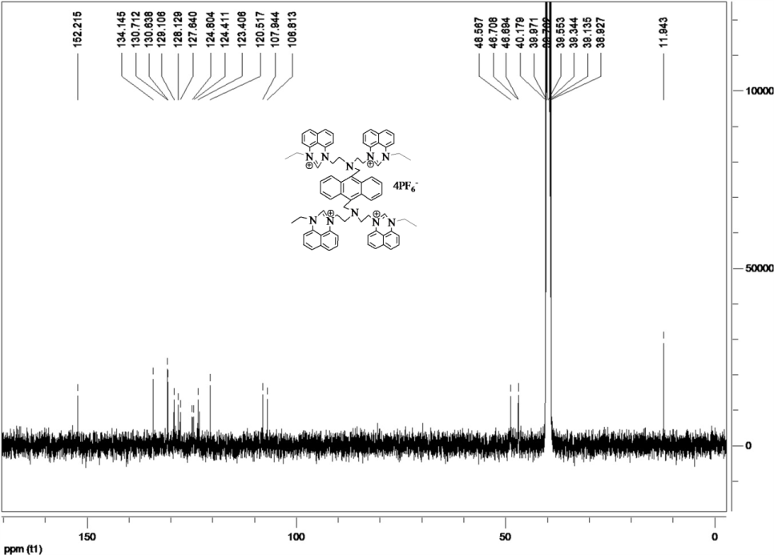
Figure S20: The ¹³C NMR (150 MHz, DMSO-d₆) spectrum of 3.

