Supplementary file

Design and facile synthesis of defect rich C-MoS₂/rGO nanosheets for enhanced lithium-sulfur battery performance
Chengxiang Tianª, Juwei Wuª, Zheng Maª, Bo Liª, Pengcheng Li, Xiaotao Zu^{b}, Xia Xiangª
ª School of Physics, University of Electronic Science and Technology of China, Chengdu 610054, China
Corresponding authors: xiaxiang@uestc.edu.cn (Xia Xiang)
Tel: 86-28-8320-2130

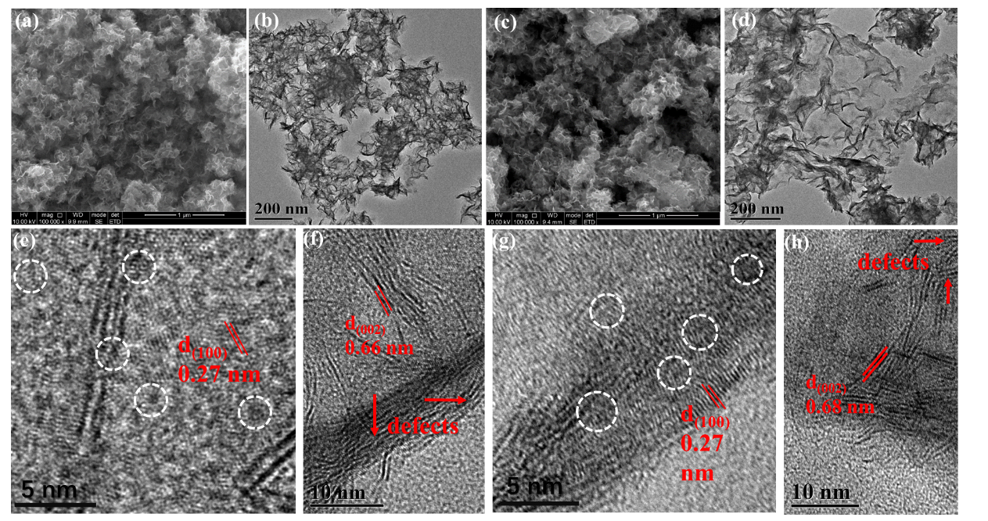
Fig. S1 Morphological images of the C-MoS₂/rGO-4 (a) SEM image, (b) TEM image, and (e-f) HRTEM images; Morphological images of the C-MoS₂/rGO-8 (c) SEM image, (d) TEM image, (g-h) HRTEM images.
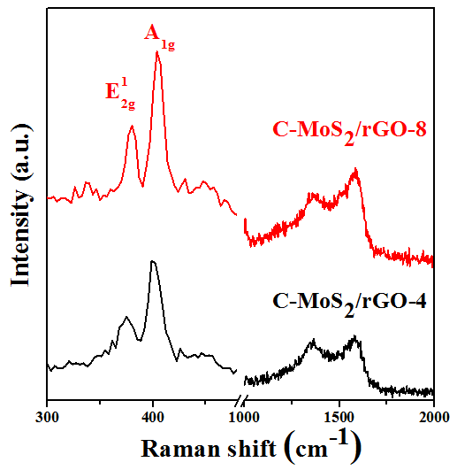
Fig. S2 Raman spectra of C-MoS₂/rGO-4 and C-MoS₂/rGO-8 composites.
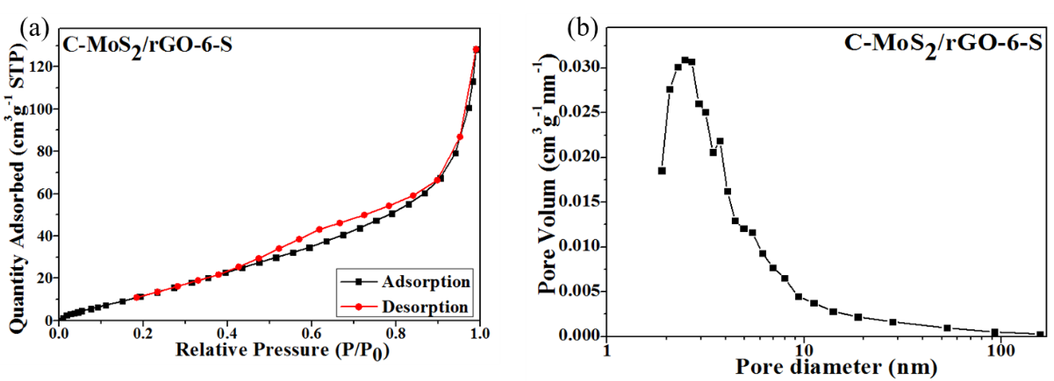
Fig. S3 (a) N₂ adsorption/desorption isotherms and (b) corresponding pore size distributions of C-MoS₂/rGO-6-S composite.
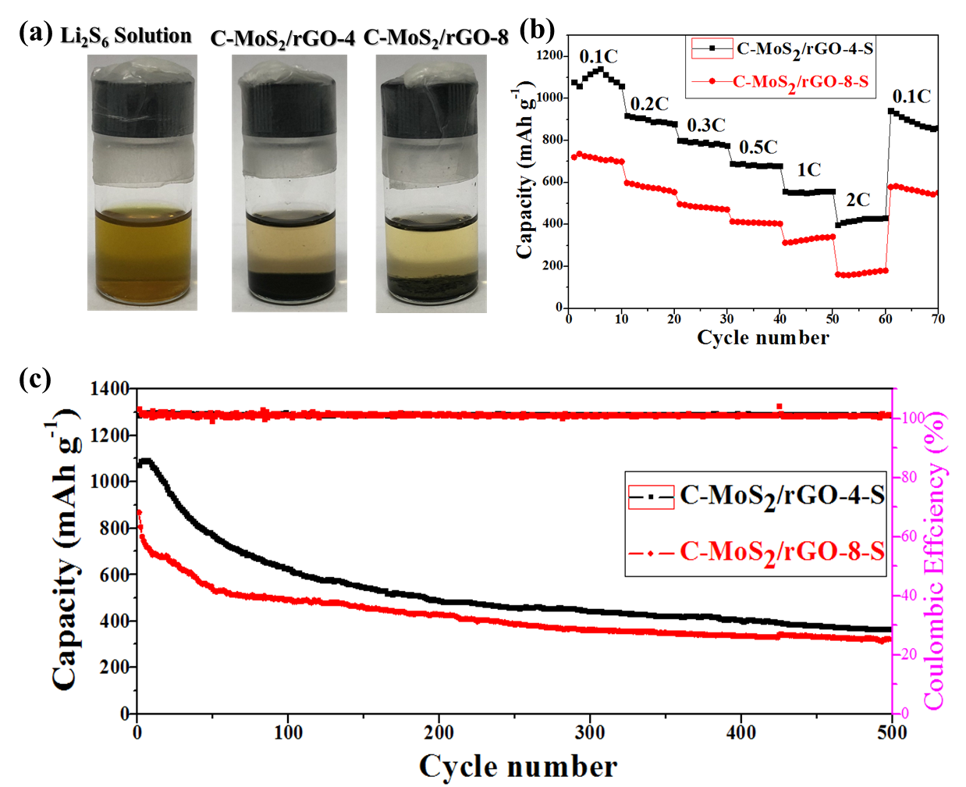
Fig. S4 (a) Photos of the Li₂S₆ solution after 12 h adsorption experiments with same amount of C-MoS₂/rGO-4 and C-MoS₂/rGO-8 composites. (b) and (c) Rate performances at different current densities and long-term cycling performance of at 0.2C of C-MoS₂/rGO-4 and C-MoS₂/rGO-8 composites.

