Synthesis of multi-substituted indene derivatives from aryl, vinyl, and alkyl/aryl carbinols

Supplementary Information
Experimental procedures, characterization data and copies of
¹H and ¹³C NMR spectra of all compounds

Content Pages
General experimental procedure and characterization data for all compounds S2–S16
Copies of ¹H and ¹³C NMR spectra of two new aryl vinyl ketones S17-S18
Copies of ¹H spectra for all tertiary carbinols S18–S29
Copies of ¹H and ¹³C NMR spectra for all indene compounds S30–S55

1. General Information:
All reagents and solvents were analytically pure and were used as purchased. Columnchromatography was carried out using silica gel (100-200 or 230–400 mesh). Thin-layer chromatography(TLC) was performed onpre-coated silica gel-60 F254 (0.5 mm) glass plates and visualized byexposure to UV light (254 nm) or staining the plates in methanolic anisaldehyde-sulphuric acid-acetic acid solutions and charring on a hot plate.IR spectra wererecorded as neat over the range 600–4000 cm⁻¹. Mass spectra were recorded on Micro Mass VG-7070H mass spectrometer for ESI and are given in mass units (m/z).The ¹H and¹³C NMR spectra ofpurified products were recorded in CDCl₃solvent on 500 MHz, 400 MHz, 300 MHz and 125 MHz, 100 MHz and 75 MHz spectrometer, respectively at ambient temperature. Data were reported as chemical shifts in ppm withrespect to the residual solvent signal CDCl₃ (¹H NMR: δ = 7.24 ppm; ¹³C NMR: δ = 77.16 ppm). The abbreviations used for Peakmultiplicities are reported as follows: s = singlet, d = doublet, t = triplet, q = quartet, dd =doublet of doublet, dq = doublet of quartets, brs = broad singlet and m = multiplet.
2. General procedure for the synthesis of aryl vinylketone intermediates (1):
All the aryl vinyl ketones (1a-1n) were prepared according to the following literature method.
First Step: In a flame-dried flask purged with argon, substituted aryl bromide (1.1 equiv) was dissolved in THF (35 mL) and cooled to -78 °C. n-Butyllithium solution (1.1 equiv, 1.6 M in hexanes) was added dropwise, and the reaction was stirred at -78 °C for 45 minutes. The desired α, ß-unsaturated aldehyde (1.0 equiv) in THF (9 mL) was then added dropwise, and the reaction was stirred for an hour before it was allowed to warm slowly to 0 °C over an additional 2-3 hours. The reaction was quenched at 0 °C with a volume of saturated ammonium chloride solution equal to the volume of aryl bromide solution and diluted with an equivalent amount of water. The aqueous layer was extracted two times with EtOAc, and the combined layers were washed one time each with water and brine. The organic layer was then dried over Na₂SO₄, filtered and concentrated in vacuo to afford the crude product. Purification by using silica gel column chromatography with 10-20% EtOAc/hexanes solution furnished the desired product.
Second Step: To that aryl vinyl alcohol (1.0 equiv) in dry CH₂Cl₂ (25 mL) was added BaMnO₄ (2.0 equiv). The reaction mixture was stirred at rt. The reaction was monitored by TLC and after completion of the starting material; the reaction mixture was filtered through Celite. The solvent was evaporated under reduced pressure, and the residue was purified by using silica gel column chromatography to afford the required aryl vinyl ketone intermediate.
Allaryl vinyl ketones are already known in literature except 1d and 1j.
1-(4-methoxyphenyl)-2-methylenebutan-1-one (1d^{new}):
¹H NMR (400 MHz, CDCl₃): δ 7.77 (d, J = 8.9 Hz, 2H), 6.88 (d, J = 8.9 Hz, 2H), 5.66 (s,1H), 5.43 (s, 1H), 3.80 (s, 3H), 2.43 (q, J = 8.9, 15.6 Hz, 2H), 1.06 (t, J = 8.9 Hz, 3H); ¹³C NMR (100 MHz, CDCl₃): δ 197.0, 162.9, 149.6, 131.7, 130.0, 121.6, 113.2, 55.2, 25.5, 12.1.
1-(4-methoxyphenyl)-2-methylbut-2-en-1-one (1j^{new})(E:Z= 1: 0.2) :
¹H NMR (400 MHz, CDCl₃): δ 7.91 (d, J = 8.8 Hz, 2H), 6.95 (d, J = 8.8 Hz, 2H), 5.73 (q, J = 7.0, 14.0 Hz, 1H), 3.87 (s, 3H), 1.95 (s, 3H), 1.51 (d, J = 7.0, 3H); ¹³C NMR (100 MHz, CDCl₃): δ 199.3, 163.7, 138.9, 136.5, 131.5, 129.3, 125.4, 113.8, 113.2, 55.4, 55.3, 21.1, 15.3.
3. General procedure for the synthesis of aryl vinyl carbinol (2a-2i):
To a solution of dry diisopropylamine (DIPA) (1.1 equiv) in anhydrous THF was added n-BuLi (1.6 M, 1.1 equiv) at –78 °C under argon. After 10 min at this temperature, the mixture was allowed to warm to rt for 20 min and was cooled again to –78 °C. To the above generated LDA solution, ethyl acetate (2.0 equiv) was added using THF dropwise at –78 °C and stirred the reaction mixture for 45 minutes at the same temperature. Then aryl vinyl ketone (1 equiv) was cannulated to the reaction mixture in dry THF (2 mL), reaction was monitored by TLC, after completion quenched with saturated aq NH₄Cl. The reaction mixture was extracted thrice with EtOAc, washed with brine, dried over Na₂SO₄, filtered and concentrated in vacuo. The crude product was purified by flash column chromatography using EtOAc/hexane as eluent.
Ethyl 3-hydroxy-4-methyl-3-(3,4,5-trimethoxyphenyl)pent-4-enoate (2a): Yield: 80%; Colorless oil; R_{f} = 0.5 (25% EtOAc/hexanes);¹H NMR (400 MHz, CDCl₃): δ 6.68 (s, 2H), 5.06 (s, 1H), 4.96 (s, 1H), 4.91 (s, 1H), 4.21- 4.10 (q,Ј = 7.1 Hz, 2H), 3.85 (s, 6H), 3.83 (s, 3H), 3.03 (d, Ј = 16.0 Hz, 1H), 2.90 (d, Ј = 16.0 Hz, 1H ), 1.66 (s, 3H), 1.22 (t, Ј = 7.1 Hz, 3H).
Ethyl 3-(3,5-dimethoxyphenyl)-3-hydroxy-4-phenylpent-4-enoate (2b): Yield: 65%; Colorless oil; R_{f} = 0.6 (20% EtOAc/hexanes);¹H NMR (400 MHz, CDCl₃):δ 7.22-7.16 (m, 3H), 7.05- 7.02 (m, 2H), 6.68 (d,Ј = 2.2 Hz, 2H), 6.38 (t, Ј = 2.2 Hz, 1H), 5.46 (s, 1H), 5.26 (s, 1H), 4.92 (s, 1H), 4.18- 4.10 (m, 2H), 3.77 (s, 6H), 3.05 (d, Ј = 16.2 Hz, 1H), 2.94 (d, Ј = 16.2 Hz, 1H), 1.21 (t, Ј = 7.0 Hz, 3H).
Ethyl 3-hydroxy-3-(4-methoxyphenyl)-4-methylpent-4-enoate (2c): Yield: 70%; Colorless oil; R_{f} = 0.5 (15% EtOAc/hexanes); ¹H NMR (400 MHz, CDCl₃): δ 7.36 (d, Ј = 8.9 Hz, 2H), 6.85 (d, Ј = 8.9 Hz, 2H), 5.07 (s, 1H), 4.94 (t, Ј = 1.2 Hz, 1H), 4.80 (s, 1H), 4.08- 4.18 (d, Ј = 7.0 Hz, 2H), 3.79 (s, 3H), 3.03 (d, Ј = 16.0 Hz, 1H), 2.92 (d, Ј = 16.0 Hz, 1H), 1.63 (s, 3H), 1.21 (t, Ј = 7.0 Hz, 3H).
Ethyl 3-hydroxy-3-(4-methoxyphenyl)-4-methylenehexanoate (2d): Yield: 65%; Colorless oil; R_{f} = 0.5 (15% EtOAc/hexanes); ¹H NMR (400 MHz, CDCl₃): δ 7.34 (d, Ј = 8.8 Hz, 2H), 6.84 (d, Ј = 8.8 Hz, 2H), 5.16 (s, 1H), 4.96 (t, Ј = 1.6 Hz, 1H), 4.81 (s, 1H), 4.18- 4.08 (d, Ј = 7.2 Hz, 2H), 3.79 (s, 3H), 3.04 (d, Ј = 16.0 Hz, 1H), 2.90 (d, Ј = 16.0 Hz, 1H), 2.09- 2.00 (m, 1H), 1.89- 1.77 (m, 1H), 1.21 (t, Ј = 7.2 Hz, 3H), 0.93 (t, Ј = 7.3 Hz, 3H).
Ethyl3-(3,5-dimethoxyphenyl)-3-hydroxy-4-methylhex-4-enoate (2e) (E : Z= 4.2: 10): Yield: 66%; Colorless oil; R_{f} = 0.5 (20% EtOAc/hexanes); ¹H NMR (400 MHz, CDCl₃): δ 6.63 (d, Ј = 2.3 Hz, 2H), 6.58 (d, Ј = 2.2 Hz, 1H), 6.35 (t, Ј = 2.3 Hz, 1H), 5.60 (q, Ј = 6.7 Hz, 0.4H), 5.46 (q, Ј =7.2 Hz, 1H), 4.80 (s, 0.2H), 4.73 (s, 0.6H), 4.10-4.20 (m, 2H), 3.78 (s, 6H), 2.87-3.06 (m,2H), 1.74 (s, 2H), 1.67 (dd, Ј= 7.2, 1.4 Hz, 3H), 1.18-1.28 (m, 3.H).
Ethyl 3-(3,5-dimethoxyphenyl)-3-hydroxy-4-methylpent-4-enoate (2f): Yield: 95%; Colorless oil; R_{f} = 0.5 (20% EtOAc/hexanes); ¹H NMR (400 MHz, CDCl₃): δ 6.62 (d, Ј = 2.3 Hz, 2H), 6.35 (t, Ј= 2.3 Hz, 1H), 5.06 (s, 1H), 4.94 (s, 1H), 4.88 (s, 1H), 4.14 (q, Ј = 7.0 Hz, 2H), 3.78 (s, 6H), 3.02 (d, Ј = 16.1 Hz, 1H), 2.90 (d, Ј = 16.1 Hz, 1H), 1.64 (s, 3H), 1.22 (t, Ј = 7.0 Hz, 3H).
Ethyl(E)-3-(3,5-dimethoxyphenyl)-3-hydroxy-4-methyl-5-phenylpent-4-enoate(2g): Yield: 50%; Colorless oil; R_{f} = 0.5 (20% EtOAc/hexanes); ¹H NMR (400 MHz, CDCl₃): δ 7.33 (t, Ј = 7.4 Hz, 2H), 7.27- 7.19 (m, 3H), 6.70 (s, 1H), 6.67 (d, Ј = 2.2 Hz, 2H), 6.37 (t, Ј = 2.2 Hz, 1H), 4.99 (s, 1H), 4.17 (q, Ј= 7.0 Hz, 2H), 3.79 (s, 6H), 3.14 (d, Ј = 15.8 Hz, 1H), 3.02 (d, Ј = 15.8 Hz, 1H), 1.73 (d, Ј = 1.2 Hz, 3H), 1.2 (t, Ј = 7.0 Hz, 3H).
Ethyl (E)-3-hydroxy-4-methyl-3-(naphthalen-2-yl)hex-4-enoate (2h): Yield: 85%; Colorless oil; R_{f} = 0.5 (20% EtOAc/hexanes); dr ratio: 1:2; ¹H NMR (500 MHz, CDCl₃): δ 7.93 (s, 0.5 H), 7.88 (s, 1H), 7.84- 7.76 (m, 5H), 7.60 (dd, Ј = 8.6 Hz, 1H), 7.48- 7.43 (m, 3.5H), 5.67-5.73 (m, 0.5H), 5.48-5.54 (m, 1H), 4.93 (s, 0.5H), 4.86 (s, 1H), 4.19- 4.11 (m, 3H), 3.19 (d, Ј = 16.17 Hz, 1.1H), 3.13 (d, Ј = 14.5 Hz, 0.5H), 3.10 (d, Ј = 16.8 Hz, 2H), 3.02 (d, Ј = 16.2 Hz, 1H), 1.82 (s, 3H), 1.68 (dd, Ј = 6.7 Hz, 1H), 1.65 (dd, Ј = 7.32 Hz, 2H), 1.22 (t, Ј = 7.1Hz, 3H), 1.18 (t, Ј = 7.1 Hz, 1H).
Ethyl 3-hydroxy-4-methylene-3-(3,4,5-trimethoxyphenyl)hexanoate (2i): Yield: 75%; Colorless oil; R_{f} = 0.5 (25% EtOAc/hexanes); ¹H NMR (400 MHz, CDCl₃): δ 6.66 (s, 2H), 5.15 (s, 1H), 4.99 (t, Ј = 1.5 Hz, 1H), 4.93 (s, 1H), 4.15 (q, Ј = 7.0 Hz, 2H), 3.84 (s, 6H), 3.82 (s, 3H), 3.04 (d, Ј = 16.1 Hz, 1H), 2.87 (d, Ј = 16.1 Hz, 1H), 2.10 (dq, Ј = 9.1, 7.5 Hz, 1H), 1.84 (dq, Ј = 9.1, 7.4 Hz, 1H), 1.22 (t, Ј = 7.0 Hz, 3H), 0.96 (t, Ј = 7.5, 7.4 Hz, 3H).
4. General procedure for the synthesis of aryl vinyl carbinol (2j-2p): To an oven dried round bottom flask equipped with stirring bar, under nitrogen atmosphere is added a suspension of NaH (60% suspension, 2 equiv) in dry THF (3 mL/mmol) at 0°C. Then ethyl acetoacetate (1.5 equiv) was added dropwise and stirred for 10 minutes after which n-BuLi (1.6 M, 2 equiv) was added dropwise at the same temperature and stirred the reaction mixture for further 15 minutes at this temperature. After that arylvinyl ketone (1 equiv) was cannulated to the reaction mixture in dry THF (1-2 mL), the reaction was monitored by TLC, quenched with aq NH₄Cl solution, extracted thrice with EtOAc, washed with a saturated brine solution, dried over Na₂SO₄, filtered and concentrated in vacuo. The crude product was purified by flash column chromatographyusing EtOAc/hexane as eluent.
Ethyl5-hydroxy-5-(4-methoxyphenyl)-6-methyl-3-oxooct-6-enoate (2j) (E : Z = 0.46: 1): Yield: 81%; Pale yellow oil; R_{f} = 0.5 (20% EtOAc/hexanes); ¹H NMR (500 MHz, CDCl₃): δ 7.27-7.35 (m, 2H), 6.82-6.87 (m, 2H), 5.55 (m, 0.6H), 5.45 (m, 0.3H) 4.25 (q, J = 7.1 Hz, 2H), 3.80 (s, 3H), 3.45 (s, 2H), 3.15-3.28 (dd, J = 17.2, 17.2 Hz, 2H), 1.75 (m, 1H), 1.65 (m, 3H), 1.45 (m, 2H), 1.25 (t, J = 7.1 Hz, 3H); LCMS (m/z): 319 (M-H).
Ethyl (E)-5-hydroxy-6-methyl-3-oxo-5-phenyloct-6-enoate (2k) (E : Z = 10: 1.73): Yield: 56%; Pale yellow oil; R_{f} = 0.5 (20% EtOAc/hexanes); ¹H NMR (500 MHz, CDCl₃): δ 7.43 (d, J =7.1 Hz, 2H), 7.30 (t, J = 7.3 Hz, 2H), 7.20 (d, J = 7.3, 1H), 5.49 (q, J = 7.3 Hz, 1H) 4.16-4.21 (q, J = 7.1 Hz, 2H), 3.44 (s, 2H), 3.36(d,J =17.4 Hz,1H), 3.20 (d,J =17.5 Hz, 1H), 1.80 (s, 3H), 1.65 (d, J = 7.3 Hz, 3H), 1.22 (t, J = 7.1 Hz, 3H); LCMS (m/z): 289 (M-H).
Ethyl 5-hydroxy-5-(4-methoxyphenyl)-6-methylene-3-oxooctanoate (2l): Yield: 80%; Pale yellow oil; R_{f} = 0.5 (20% EtOAc/hexanes); ¹H NMR (500 MHz,CDCl₃) : δ 7.32 (d, J = 8.9 Hz, 2H), 6.80 (d, J = 8.8 Hz, 2H), 5.10 (s, 1H), 5.0 (s, 1H), 4.40 (s,1H) 4.20 (q, J = 7.3 Hz, 2H),3.80 (s, 3H), 3.40 (s, 2H), 3.15-3.35 (dd, J = 17.4, 17.5 Hz, 2H), 1.80-2.10 (qq, J = 7.3, 7.4 Hz, 2H), 1.25 (t, J = 7.3 Hz, 3H), 0.95 (t, J = 7.3, 7.4 Hz, 3H); LCMS (m/z): 303 (M-OH), 319 (M-H).
Ethyl 5-hydroxy-6-methyl-3-oxo-5-(3,4,5-trimethoxyphenyl)hept-6-enoate (2m): Yield: 78%; Pale yellow oil; R_{f} = 0.5 (20% EtOAc/hexanes); ¹H NMR (500 MHz, CDCl₃) : δ 6.63 (s, 2H), 4.98 (s, 1H), 4.95 (s, 1H),4.43 (s, 1H), 4.12-4.16 (q, J = 7.3 Hz, 2H), 3.83 (s, 6H), 3.80 (s, 3H),3.39 (s, 2H),3.18-3.32(dd, J = 17.5, 17.5 Hz, 2H),1.62 (s, 3H),1.25 (t, J = 7.1 Hz, 3H); LCMS (m/z): 349 (M-OH), 365 (M-H).
Ethyl (E)-5-(3,5-dimethoxyphenyl)-5-hydroxy-6-methyl-3-oxo-7-phenylhept-6-enoate (2n): Yield: 85%; Pale yellow oil; R_{f} = 0.5 (20% EtOAc/hexanes); ¹H NMR (500 MHz, CDCl₃) :δ 7.32 (d, J = 7.2 Hz, 2H), 7.15-7.25 (m, 3H), 6.63 (d, J = 2.3 Hz, 2H), 6.35 (m, 1H), 4.50 (s, 1H), 4.20 (q, J = 7.1 Hz, 2H), 3.79 (s, 6H), 3.48 (s, 2H), 3.30-3.40 (m, 2H), 1.70 (s, 3H), 1.25 (t, J = 7.1 Hz, 3H); LCMS (m/z): 411 (M-H).
Ethyl (E)-5-(3,5-dimethoxyphenyl)-5-hydroxy-6-methyl-3-oxooct-6-enoate (2o): Yield: 75%; Pale yellow oil; R_{f} = 0.5 (20% EtOAc/hexanes); ¹H NMR (500 MHz, CDCl₃): δ 6.55 (d, J = 2.2 Hz, 2H), 6.35 (d, J = 2.2 Hz, 1H), 5.52 (q, J = 6.7 Hz, 1H), 4.35 (s, 1H), 4.12-4.21(q, J = 7.2 Hz, 2H),3.80 (s, 6H), 3.40 (s, 2H), 3.15-3.28 (dd, J = 17.2, 17.2 Hz, 2H), 1.63 (d, J = 6.7 Hz, 3H), 1.50 (s, 3H), 1.25 (t, J= 7.2 Hz, 3H); LCMS (m/z): 349 (M-H), 333 (M-OH).
Ethyl (E)-5-hydroxy-6-methyl-5-(naphthalene-2-yl)-3-oxooct-6-enoate (2p): Yield: 75%; Pale yellow oil; R_{f} = 0.5 (20% EtOAc/hexanes); ¹H NMR (500 MHz, CDCl₃): δ 7.79-7.86 (m, 4H), 7.53-7.57 (dd, J =1.9, 1.9 Hz, 1H), 7.45-7.48 (m, 2H), 5.51 (q, J = 7.3 Hz, 1H), 4.32 (s, 1H), 4.15-4.21 (q, J = 7.2 Hz, 2H), 3.46 (s, 2H), 3.43-3.48 (d, J = 17.5 Hz, 1H), 3.29-3.34 (d, J = 17.5 Hz, 1H), 1.82 (s, 3H), 1.60 (d, J = 7.3 Hz, 3H), 1.25 (t, J = 7.2 Hz, 3H); LCMS (m/z): 339 (M-H).
5. General procedure for the synthesis of aryl vinyl carbinol (2q-2z):
In a flame-dried flask purged with argon, aryl bromide (1.1 equiv) was dissolved in THF (0.1 M) and cooled to -78 °C. n-BuLi (1.1 equiv, 1.6 M in hexanes) was added dropwise, and the reaction was stirred at -78 °C for 45 minutes. The desired aryl vinyl ketone (1.0 equiv) in THF was then cannulated to that reaction mixture and was stirred for 5 h before it was allowed to warm slowly to 0 °C over an additional 2-3 h. The reaction was quenched at 0 °C with a volume of saturated NH₄Cl solution equal to the volume of aryl bromide solution and diluted with an equivalent amount of water. The aqueous layer was extracted twice with EtOAc, the combined organic layers were washed one time each with water and brine, dried over Na₂SO₄, filtered and concentrated under reduced pressure. The crude product was purified by flash chromatography with 10-40% EtOAc/hexane as eluent to furnish the desired product.
(E)-1-(3,5-Dimethoxyphenyl)-1-(4-methoxyphenyl)-2-methylbut-2-en-1-ol(2q): Yield: 81%; Colorless oil; R_{f} = 0.5 (20% EtOAc/hexanes); ¹H NMR(400 MHz,CDCl₃): δ 7.17 (d, J = 8.8Hz, 2H), 6.74 (d, J = 8.8 Hz, 2H), 6.47 (d, J = 2.2 Hz, 2H), 6.30 (t, J = 2.2 Hz, 1H), 5.51 (q, J =7.4 Hz,1H), 3.70 (s, 3H), 3.66 (s, 6H), 2.44 (brs, 1H), 1.63 (pentet, J= 3.0, 1.5 Hz, 3H), 1.14 (dq, J = 7.4, 1.5 Hz, 3H); IR (Neat): ν_{max} 3515, 2998, 2954, 2934, 2835, 1591, 1508, 1455, 1422, 1347, 1287, 1245, 1203, 1152, 1101, 1062, 1034, 992, 995, 833, 796, 762, 696; LCMS (m/z): 311 (M-OH).
(E)-1-(3,5-Dimethoxyphenyl)-1-(4-methoxyphenyl)-2-methylpent-2-en-1-ol (2r): Yield: 83%; Colorless oil; R_{f}= 0.5 (20% EtOAc/hexanes); ¹H NMR (500 MHz, CDCl₃): δ 7.22 (d, J = 8.8 Hz, 2H), 6.83 (d, J = 8.8 Hz, 2H), 6.52 (d, J = 2.2 Hz, 2H), 6.38 (t, J = 2.2 Hz, 1H), 5.16 (t, J = 7.6 Hz, 1H), 3.80 (s, 3H), 3.75 (s, 6H), 2.48 (brs, 1H), 2.11-2.03 (pentet, J = 15.2, 7.6 Hz, 2H), 1.66 (s, 3H), 0.95 (t, J = 7.6 Hz, 3H); IR (Neat): ν_{max} 3492, 2955, 2924, 2855, 1594, 1483, 1453, 1424, 1345, 1286, 1203, 1153, 1065, 1014, 923, 840, 758, 699, 651; LCMS (m/z): 325 (M+H).
(E)-1-(3,5-Dimethoxyphenyl)-1-(4-methoxyphenyl)-2-methyl-3-phenylprop-2-en-1-ol (2s): Yield: 84%; Colorlessoil; R_{f} = 0.5 (40% EtOAc/hexanes); ¹HNMR (400 MHz, CDCl₃): δ 7.36-7.29 (m, 4H), 7.28-7.19 (m, 3H), 6.89 (d, J = 8.9 Hz, 2H), 6.61 (d, J = 2.3 Hz, 2H), 6.42 (t, J = 2.3 Hz, 1H), 6.33 (brs, 1H), 3.81 (s, 3H), 3.77 (s, 6H), 2.61 (brs, 1H), 1.91 (d, J = 1.2 Hz, 3H); IR(Neat): ν_{max} 3495, 2955, 2934, 2835, 1604, 1508, 1456, 1424, 1342, 1296, 1249, 1203, 1153, 1062, 1034, 919, 834, 802, 755, 699; LCMS (m/z): 373 (M-OH).
1-(3,5-Dimethoxyphenyl)-1-(4-methoxyphenyl)-2,3-dimethylbut-2-en-1-ol (2t):
As both starting material and product appeared in the same R_{f,} spectral data was not clean and so based on mass we proceeded to next step.
Yield: crude 87%; Colorless oil; R_{f} = 0.5 (40% EtOAc/hexane); LCMS (m/z): 325 (M-OH).
(E)-1-(3,5-Dimethoxyphenyl)-1-(4-methoxyphenyl)-4-methyl-2-phenylpent-2-en-1-ol (2u): Yield: 88%; Colorless oil; R_{f}= 0.5 (30% EtOAc/hexanes); ¹H NMR (400 MHz,CDCl₃): δ 7.27 (d, J = 8.8 Hz, 2H), 7.24-7.18 (m, 3H), 6.98 (d, J = 7.3Hz, 2H), 6.81 (d, J = 8.8 Hz, 2H), 6.65 (d, J = 2.1 Hz, 2H), 6.39 (t, J = 2.1 Hz, 1H), 5.03 (d, J = 10 Hz, 1H), 3.77 (s, 3H), 3.72 (s, 6H), 2.21 (brs, 1H), 2.07 (m, 1H), 0.83 (d, J = 6.7 Hz, 6H); IR (Neat): ν_{max} 2957, 2835, 1603, 1507, 1457, 1437, 1300, 1248, 1204, 1154, 1053, 1033, 938, 834, 769, 706, 572; LCMS (m/z): 401 (M-OH).
(E)-4-(1-(3,5-Dimethoxyphenyl)-1-hydroxy-2-methylbut-2-en-1-yl)phenol (2v): Yield: 71%; Colorless oil; R_{f} = 0.5 (20% EtOAc/hexanes); ¹H NMR (400 MHz, CDCl₃) : δ 7.20 (d, J = 8.8 Hz, 2H), 6.75 (d, J = 8.8 Hz, 2H), 6.55 (d, J = 2.3 Hz, 2H), 6.39 (t, J = 2.3 Hz, 1H), 5.60 (dq, J = 7.3, 1.3 Hz, 1H), 3.76 (s, 6H), 2.43 (brs, 1H), 1.70 (pentet, J = 2.9, 1.4 Hz, 3H), 1.23 (dq, J = 7.3, 1.4 Hz, 3H); IR (Neat): ν_{max} 3376, 2962, 2929, 2838, 1603, 1511, 1458, 1349, 1300, 1205, 1156, 1106, 1064, 990, 931, 838; LCMS (m/z): 297 (M-OH).
(E)-1-(3,5-Dimethoxyphenyl)-1-(2-fluorophenyl)-2-methylbut-2-en-1-ol (2w): Yield: 78%; Colorless oil; R_{f} = 0.5 (20% EtOAc/hexanes); ¹H NMR (400 MHz, CDCl₃): δ 7.23 (m, 1H), 7.06-6.97 (m, 2H), 6.90 (d, J = 8.0, 1.7 Hz, 1H), 6.55 (d, J = 2.3 Hz, 2H), 6.40 (t, J = 2.3 Hz, 1H), 5.15 (q, J = 6.7 Hz, 1H), 3.75 (s, 6H), 1.73 (s, 3H), 1.65 (d, J = 6.7 Hz, 3H); IR (Neat): ν_{max} 2953, 2936, 2836, 1594, 1483, 1454, 1424, 1344, 1287, 1203, 1153, 1066, 1014, 937, 840, 758, 699; LCMS(m/z): 299 (M-OH).
(E)-1-(3,5-Dimethoxyphenyl)-2-methyl-1-(thiophen-2-yl)but-2-en-1-ol (2x): Yield: 83%; Colorlessoil; R_{f}= 0.5 (10%EtOAc/Hexanes); ¹H NMR (500 MHz,CDCl₃): δ 7.23 (dd, J = 5.0, 1.0 Hz, 0.4H), 6.91 (dd, J = 5.0, 3.5 Hz, 0.5H), 6.85 (d, J = 3.8 Hz, 0.7H), 6.77 (dd, J = 3.5, 1.0 Hz, 0.3H), 6.73 (d, J = 2.2 Hz, 0.2 H), 6.60 (d, J = 2.2 Hz, 0.7H), 6.57 (d, J = 2.1 Hz, 1.4H), 6.52 (d, J = 3.8 Hz, 0.7H), 6.39 (m, 1H), 5.42 (qq, J = 7.3, 1.3 Hz, 1H), 3.76 (s, 6H), 1.65 (s, 3H), 1.64 (d, J = 7.3 Hz, 3H); IR (Neat): ν_{max} 3500, 3001, 2939, 2836, 1640, 1592, 1455, 1424, 1350, 1299, 1204, 1155, 1063, 1033, 839, 800, 742; LCMS(m/z): 287 (M-OH).
(E)-1-(3,5-Dimethoxyphenyl)-2-methyl-1-(pyridin-2-yl)but-2-en-1-ol (2y): Yield: 78%; Colorless oil; R_{f} = 0.5 (20% EtOAc/hexanes); ¹H NMR (400 MHz, CDCl₃): δ 8.26 (dd, J = 7.5, 1.6 Hz, 1H), 7.60 (dd, J = 7.5, 1.6 Hz, 1H), 7.24-7.19 (m, 2H), 6.62 (d, J = 2.2 Hz, 2H), 6.36 (t, J = 2.2 Hz, 1H), 5.98 (brs, 1H), 4.97 (qq, J = 7.3, 1.3 Hz, 1H), 3.76 (s, 6H), 1.69 (s, 3H), 1.62 (dq, J = 7.3, 1.3 Hz, 3H); IR (Neat): ν_{max} 3392, 2919, 1590, 1455, 1423, 1342, 1287, 1202, 1151, 1063, 1029, 996, 923, 837, 758, 701, 683; LCMS (m/z): 300(M+H).
(E)-1-(3,5-Dimethoxyphenyl)-1-(2,5-dimethylphenyl)-2-methylbut-2-en-1-ol (2z)
As both starting material and product appeared in the same R_{f,} spectral data was not clean and so based on mass we proceeded to next step.
Yield: crude 78%; Colorlessoil; R_{f} = 0.5 (20% EtOAc/hexane); LCMS (m/z): 309 (M+H).
6. General procedure for the synthesis of highly substituted indenes (3a-3z):
Aryl vinyl alcohol, 2a-2z (1.0 equiv) was dissolved in CH₂Cl₂ (0.1 M) and the reaction mixture was cooled to - 78 °C. To the reaction mixture BF₃.Et₂O (1 equiv) was added and the reaction was monitored by TLC. After completion, the reaction mixture was quenched by using saturated NaHCO₃ and brine and was extracted with dichloromethane(1 x 3). The organic layer was then dried over Na₂SO₄, filtered and concentrated in vacuo to afford the crude product. Purification using column chromatography with 10-20% EtOAc/hexane solution provided the desiredindenes 3a-3z.
Ethyl 2-(5,6,7-trimethoxy-2-methyl-1H-inden-3-yl)acetate (3a): Yield: 90%; Colorless oil; R_{f} = 0.5 (20% EtOAc/hexanes);¹H NMR (400 MHz, CDCl₃): δ 6.66 (s, 1H), 4.14 (q, J = 7.0, 2H), 3.97 (s, 3H), 3.89 (s, 3H), 3.84 (s, 3H), 3.47 (s, 2H), 3.34 (s, 2H), 2.11 (s, 3H), 1.25 (t, J = 7.0 Hz, 3H);¹³C NMR (100 MHz, CDCl₃): δ 170.6, 152.7, 152.7, 148.6, 141.6, 138.4, 129.1, 124.3, 98.2, 60.8, 60.4, 59.7, 55.9, 40.1, 31.3, 13.9, 13.8; IR (Neat): ν_{max} 2929, 2852, 1732, 1604, 1580, 1467, 1415, 1367, 1299, 1253, 1175, 1147, 1112, 1074, 1036, 960; LCMS (m/z): 307 (M+H).
Ethyl 2-(5,7-dimethoxy-2-phenyl-1H-inden-3-yl)acetate (3b): Yield: 85%; Colorless oil; R_{f} = 0.6 (20% EtOAc/hexanes); ¹H NMR (400 MHz, CDCl₃): δ 7.55 (dd, Ј = 7.3, 1.9 Hz, 2H), 7.42 (dt, Ј = 7.3, 1.2 Hz, 2H), 7.32 (t, Ј = 7.3 Hz, 1H), 6.67 (d, Ј = 1.9 Hz, 1H), 6.40 (d, Ј = 1.9 Hz, 1H), 4.21 (q, Ј = 7.0 Hz, 2H), 3.89 (s, 3H), 3.87 (s, 3H), 3.71 (s, 2H), 3.68 (s, 2H), 1.28 (t, Ј = 7.0 Hz, 3H); ¹³C NMR (100 MHz, CDCl₃): δ 170.9, 160.4, 155.1, 147.6, 145.2, 136.2, 130.7, 128.1, 127.9, 127.0, 121.2, 96.8, 95.7, 60.6, 55.32, 55.0, 38.0, 32.6, 13.9; IR (Neat): ν_{max} 2926, 2838, 1731, 1602, 1587, 1482, 1359, 1318, 1254, 1207, 1192, 1146, 1045, 933, 825, 761, 700; LCMS (m/z): 339 (M+H).
Ethyl 2-(6-methoxy-2-methyl-1H-inden-3-yl)acetate (3c): Yield: 45%; Colorless oil; R_{f} = 0.4 (10% EtOAc/hexanes); ¹H NMR(400 MHz, CDCl₃): δ 7.17 (d, Ј = 8.3 Hz, 1H), 6.98 (d, Ј = 2.4 Hz, 1H), 6.81 (dd, Ј = 8.3, 2.4 Hz, 1H), 4.13 (q, Ј = 7.0 Hz, 2H), 3.81 (s, 3H), 3.49 (s, 2H), 3.29 (s, 2H), 2.08 (s, 3H), 1.24 (t, Ј = 7.0 Hz, 3H); ¹³C NMR (100 MHz, CDCl₃): δ 171.1, 157.3, 143.7, 139.5, 139.1, 129.2, 118.5, 111.3, 110.2, 60.7, 55.5, 42.6, 31.7, 14.1, 14.0; IR (Neat): ν_{max} 2923, 2852, 1733, 1598, 1479, 1369, 1261, 1166, 1125, 1094, 1034, 772; LCMS (m/z): 247 (M+H).
Ethyl 2-(2-ethyl-6-methoxy-1H-inden-3-yl)acetate (3d): Yield: 55%; Colorless oil; R_{f} = 0.4 (10% EtOAc/hexanes); ¹H NMR (500 MHz, CDCl₃): δ 7.20 (d, J = 8.2 Hz, 1H), 7.0 (d, J = 2.4 Hz, 1H), 6.82 (dd, J = 8.3, 2.4 Hz, 1H), 4.12 (q, J = 7.1 Hz, 2H), 3.82 (s, 3H), 3.50 (s, 2H), 3.33 (s, 2H), 2.50 (q, J = 7.6, Hz, 2H), 1.23 (t, J = 7.1 Hz, 3H), 1.16 (t, J = 7.6 Hz, 3H); ¹³C NMR (100 MHz, CDCl₃): δ 171.4, 157.6, 145.8, 144.1, 139.4, 128.7, 119.12, 111.7, 110.6, 61.0, 55.9, 40.1, 31.9, 22.0, 14.5, 14.4; IR (Neat): ν_{max} 2965, 2932, 1733, 1599, 1481, 1464, 1368, 1287, 1256, 1156, 1124, 1094, 1033, 838, 815, 772; LCMS (m/z): 261 (M+H).
Ethyl 2-(5,7-dimethoxy-1,2-dimethyl-1H-inden-3-yl)acetate (3e): Yield: 95%; Colorless oil; R_{f} = 0.5 (20% EtOAc/hexanes); ¹H NMR (400 MHz, CDCl₃): δ 6.50 (d, J = 1.9 Hz, 1H), 6.29 (d, J = 1.9 Hz, 1H), 4.12 (q, J = 7.0 Hz, 2H), 3.83 (s, 3H), 3.83 (s, 3H), 3.46 (s, 2H), 3.29 (q, J = 7.4 Hz, 1H), 2.01 (s, 3H), 1.30 (d, J = 7.4 Hz, 3H), 1.23 (t, J = 7.0 Hz, 3H); ¹³C NMR (100 MHz, CDCl₃): δ 171.0, 160.5, 155.6, 148.9, 146.7, 127.9, 126.5, 96.3, 95.0, 60.6, 55.5, 55.2, 45.5, 31.7, 14.3, 14.2, 12.2; IR (Neat): ν_{max} 2960, 2933, 2839, 1734, 1591, 1484, 1462, 1452, 1428, 1355, 1291, 1259, 1201, 1150, 1085, 1033, 933, 825; LCMS (m/z): 291 (M+H).
Ethyl 2-(5,7-dimethoxy-2-methyl-1H-inden-3-yl)acetate (3f): Yield: 88%; Colorless oil; R_{f} = 0.5 (20% EtOAc/hexanes); ¹H NMR (500 MHz, CDCl₃): δ 6.53 (d, Ј = 1.8 Hz, 1H), 6.31 (d, Ј = 1.8 Hz, 1H), 4.13 (q, Ј = 7.1 Hz, 2H), 3.84 (s, 3H), 3.84 (s, 3H), 3.48 (s, 2H), 3.24 (s, 2H), 2.12 (s, 3H), 1.24 (t, Ј = 7.1 Hz, 3H); ¹³C NMR (100 MHz, CDCl₃): δ 170.6, 160.2, 154.8, 147.7, 142.9, 129.2, 120.6, 96.2, 94.7, 60.4, 55.2, 54.9, 39.2, 31.4, 13.9, 13.8; IR (Neat): ν_{max} 2931, 2839, 1732, 1591, 1484, 1462, 1358, 1294, 1260, 1202, 1150, 1078, 1033, 932, 822; LCMS (m/z): 277 (M + H).
Ethyl 2-(5,7-dimethoxy-2-methyl-1-phenyl-1H-inden-3-yl)acetate (3g): Yield: 97%; Colorless oil; R_{f} = 0.5 (20% EtOAc/hexanes); ¹H NMR (400 MHz, CDCl₃): δ 7.25-7.13 (m, Ј = 6.7 Hz, 3H), 7.02 (d, Ј = 6.7 Hz, 2H) 6.54 (d, Ј = 1.9 Hz, 1H), 6.23 (d, Ј = 1.9 Hz, 1H), 4.34 (s, 1H), 4.16 (q, Ј = 7.0 Hz, 2H), 3.84 (s, 3H), 3.58 (s, 3H), 3.54 (d, Ј = 15.2 Hz, 1H), 3.49 (d, Ј = 15.2 Hz, 1H), 1.83 (s, 3H), 1.25 (t, Ј = 7.0 Hz, 3H); ¹³C NMR (100 MHz, CDCl₃): δ 170.6, 160.6, 155.2, 147.6, 147.1, 139.2, 129.2, 127.8, 127.7, 126.0, 125.8, 96.2, 95.4, 60.4, 56.5, 55.2, 55.1, 31.4, 13.9, 12.3; IR (Neat): ν_{max} 2925, 2852, 1733, 1592, 1592, 1452, 1357, 1279, 1204, 1155, 1677, 1030, 935, 825, 772, 700; LCMS (m/z): 353 (M+H).
Ethyl 2-(1,2-dimethyl-1H-cyclopenta[b]naphthalen-3-yl)acetate (3h): Yield: 95%; Colorless oil; R_{f} = 0.5 (20% EtOAc/hexanes);¹H NMR (400 MHz, CDCl₃): δ 7.97 (d, Ј = 8.4 Hz, 1H), 7.88 (d, Ј = 8.1 Hz, 1H), 7.78 (d, Ј = 8.3 Hz, 1H), 7.52 (d, Ј = 8.4 Hz, 1H), 7.48 (t, Ј = 8.1 Hz, 1H), 7.37 (t, Ј = 8.1 Hz, 1H), 4.14 (q, Ј = 7.0 Hz, 2H), 3.66 (q, Ј = 7.4 Hz, 1H), 3.61 (s, 2H), 2.14 (s, 3H), 1.46 (d, Ј = 7.4 Hz, 3H), 1.23 (t, Ј = 7.0 Hz, 3H); ¹³C NMR (100 MHz, CDCl₃): δ 171.4, 148.0, 143.5, 142.0, 131.8, 129.4, 129.4, 128.8, 127.5, 126.1, 124.1, 123.5, 118.7, 61.0, 47.1, 32.1, 17.5, 14.4, 12.6; IR (Neat): ν_{max} 2975, 2928, 2872, 1732, 1619, 1586, 1516, 1459, 1444, 1368, 1298, 1255, 1160, 1034, 819, 748; LCMS (m/z): 281 (M+H).
Ethyl 2-(2-ethyl-5,6,7-trimethoxy-1H-inden-3-yl)acetate (3i): Yield: 88%; Colorless oil; R_{f} = 0.4 (20% EtOAc/hexanes); ¹H NMR (400 MHz, CDCl₃): δ 6.68 (s, 1H) 4.13 (q, Ј = 7.0 Hz, 2H), 3.98 (s, 3H), 3.89 (s, 3H), 3.85 (s, 3H), 3.48 (s, 2H), 3.36 (s, 2H), 2.51 (q, Ј = 7.5 Hz, 2H), 1.25 (t, Ј = 7.0 Hz, 3H), 1.16 (t, Ј = 7.5 Hz, 3H); ¹³C NMR (100 MHz, CDCl₃): δ 170.6, 152.8, 148.8, 147.7, 141.6, 138.5, 128.3, 124.5, 98.42, 60.8, 60.4, 59.8, 56.0, 37.2, 31.3, 21.5, 13.8; IR (Neat): ν_{max} 2966, 2935, 1732, 1606, 1580, 1467, 1415, 1367, 1299, 1252, 1173, 1143, 1112, 1037, 965, 772; LCMS (m/z): 321 (M+H).
Ethyl4-(6-methoxy-1,2-dimethyl-1H-inden-3-yl)-3-oxobutanoate (3j): Yield: 90%; Pale yellow oil; R_{f} = 0.2 (20% EtOAc/hexanes); ¹H NMR(500 MHz, CDCl₃): δ 7.09 (d, J = 8.2 Hz, 1H), 6.97 (s, 1H), 6.75 (d, J = 8.2 Hz, 1H), 4.10-4.19 (q, J = 7.6 Hz, 2H), 3.80 (s, 3H), 3.65 (s, 2H), 3.40 (s, 2H), 3.20-3.30 (q, J = 7.4, 7.3 Hz, 1H), 2.0 (s, 3H),1.30 (d, J = 7.6 Hz, 3H), 1.26 (t, J = 7.1 Hz, 3H); ¹³C NMR (100 MHz, CDCl₃): δ 200.2, 166.8, 157.4, 149.4, 145.3, 136.8, 126.9, 118.2, 116.0, 109.4, 60.9, 55.2, 47.3, 46.8, 40.4, 15.6, 13.7, 11.9; IR (Neat): ν_{max} 2965, 2931, 1736, 1715, 1608, 1560, 1480, 1366, 1315, 1287, 1251, 1237, 1193, 1177, 1141, 1129, 1091, 1028, 921, 865, 848, 814, 753, 730, 646; LCMS (m/z): 303 (M+H).
Ethyl 4-(1, 2-dimethyl-1H-inden-3-yl)-3-oxobutanoate (3k): Yield: 86%; Pale yellow oil; R_{f} = 0.2 (20% EtOAc/hexanes); ¹H NMR (500 MHz, CDCl₃): δ 7.39 (d, J = 8.0 Hz, 1H), 7.25 (d, J = 6.7 Hz, 1H), 7.18 (dd, J = 8.8, 1.6 Hz, 2H), 4.21-4.28 (q, J = 7.2 Hz, 2H), 3.70 (s, 2H), 3.40 (s, 2H), 3.21-3.33 (q, J = 7.6 Hz, 1H), 2.09 (s, 3H), 1.25 (d, J = 7.6 Hz, 3H), 1.20 (t, J = 7.2 Hz, 3H); ¹³C NMR (125 MHz, CDCl₃): δ 200.0, 166.8, 147.7, 147.6, 143.7, 127.4, 126.2, 124.1, 122.1, 117.8, 61.0, 47.4, 46.9, 40.3, 15.3, 13.7, 12.0; IR (Neat): ν_{max} 2962, 2927, 2870, 2854, 1738, 1716, 1625, 1467, 1446, 1407, 1315, 1224, 1153, 1095, 1032, 767, 752, 702, 626; LCMS (m/z): 273 (M+H).
Ethyl 4-(2-ethyl-6-methoxy-1H-inden-3-yl)-3-oxobutanoate (3l): Yield: 76%; Pale yellow oil; R_{f} = 0.2 (20% EtOAc/hexanes); ¹H NMR (500 MHz, CDCl₃): δ 7.10 (d, J = 8.2 Hz, 1H), 7.0 (s, 1H), 6.80 (d, J = 8.2 Hz, 1H), 4.20-4.25 (q, J = 7.1 Hz, 2H),3.80 (s, 3H), 3.70 (s, 2H), 3.42 (s, 2H), 3.30 (s, 2H), 2.50 (q, J = 7.5 Hz, 2H), 1.25 (t, J = 7.1 Hz, 3H), 1.15 (t, J = 7.5 Hz, 3H); ¹³C NMR (125 MHz, CDCl₃): δ 200.2, 166.8, 157.3, 146.2, 143.5, 138.3, 127.5, 118.3,111.2, 110.2, 61.0, 55.3, 47.4, 40.3, 39.6, 21.4, 13.7; IR (Neat): ν_{max} 2963, 2930, 1740, 1716, 1601, 1584, 1511, 1480, 1462, 1367, 1254, 1220, 1177, 1125,1091, 1031, 837, 772; LCMS (m/z): 319 (M-H).
Ethyl 3-oxo-4-(5, 6, 7-trimethoxy-2-methyl-1H-inden-3-yl)butanoate (3m): Yield: 82%; Pale yellow oil; R_{f} = 0.2 (20%EtOAc/hexanes); ¹H NMR (500 MHz, CDCl₃): δ 6.53 (s, 1H), 4.11-4.14 (q, J = 7.2 Hz, 2H), 4.0 (s, 3H), 3.84 (s, 3H), 3.81 (s, 3H), 3.63 (s, 2H), 3.42 (s, 2H), 3.35 (s, 2H), 2.10 (s, 3H),1.20 (t, J = 7.2 Hz, 3H); ¹³C NMR (125 MHz, CDCl₃): δ 200.3, 171.1, 167.1, 153.3, 149.1, 142.8, 141.6, 128.9, 124.6, 98.4, 61.1, 60.3, 56.3, 47.8, 40.5, 29.6, 21.03, 14.2, 14.1; IR (Neat): ν_{max} 2926, 2853, 1737, 1582, 1467, 1414, 1367, 1311, 1248, 1196, 1113, 1035, 834; LCMS (m/z): 349 (M+H).
Ethyl 4-(5, 7-dimethoxy-2-methyl-1-phenyl-1H-inden-3-yl)-3-oxobutanoate (3n): Yield: 86%; Pale yellow oil; R_{f} = 0.2 (20% EtOAc/hexanes); ¹H NMR (500 MHz, CDCl₃): δ 7.16-7.25 (m, 3H), 7.0 (d, J = 6.8 Hz, 2H), 6.47 (s, 1H), 6.23 (s, 1H), 4.35 (s, 1H), 4.11-4.15 (q, J = 7.1 Hz, 2H), 3.82 (s, 3H), 3.70 (dd, J = 15.9, 16.0 Hz, 2H), 3.60 (s, 3H), 3.48 (s, 2H), 1.80 (s, 3H), 1.25 (t, J = 7.1 Hz, 3H); ¹³C NMR (125 MHz, CDCl₃): δ 200.2, 167.1, 161.2, 155.7, 148.9, 147.1, 139.3, 128.8, 128.3, 127.9, 126.3, 126.2, 96.5, 96.0, 61.4, 57.0, 55.6, 55.4, 47.7, 40.8, 29.7, 14.0, 12.7; IR (Neat): ν_{max} 2959, 2924, 2852, 1741, 1716, 1592, 1483, 1463, 1452, 1357, 1315, 1204, 1156, 1133, 1073, 1029, 935, 825, 772, 700, 639, 583; LCMS (m/z): 395 (M+H).
Ethyl 4-(5,7-dimethoxy-1,2-dimethyl -1H-inden-3-yl)-3oxobutanoate (3o): Yield: 89%; Pale yellow oil; R_{f} = 0.2 (20% EtOAc/hexanes); ¹H NMR (500 MHz, CDCl₃): δ 6.40 (s, 1H), 6.30 (s, 1H), 4.11-4.14 (q, J = 7.1 Hz, 2H), 3.82 (s, 3H), 3.80 (s, 3H), 3.63 (s, 2H), 3.40 (s, 2H), 3.27-3.33 (q, J = 7.3 Hz, 1H), 2.0 (s, 3H), 1.30 (d, J =7.3 Hz, 3H), 1.20 (t, J = 7.1 Hz, 3H); ¹³C NMR (125 MHz, CDCl₃): δ 200.6, 167.2, 160.7, 155.8, 149.9, 146.3, 127.4, 126.6, 96.2, 95.3, 61.3, 55.6, 55.2, 47.6, 45.7, 40.8, 14.4, 14.0, 12.3; IR (Neat): ν_{max} 2961, 2933, 2870, 2840, 1742, 1716, 1590, 1484, 1464, 1354, 1301, 1246, 1200, 1160,1139, 1081, 1030, 933, 825; LCMS (m/z): 333 (M+H).
Ethyl 4-(1, 2-dimethyl-1H-cyclopenta[b]naphthalene-3-yl)- 3-oxobutanoate (3p): Yield: 82%; Pale yellow oil; R_{f} = 0.2 (20% EtOAc/hexanes); ¹H NMR (500 MHz, CDCl₃): δ 7.98 (d, J = 8.3 Hz, 1H),7.89 (d, J = 8.2 Hz, 1H), 7.77 (d, J = 8.3 Hz, 1H), 7.50 (t, J = 8.3 Hz,1H), 7.40 (m, 2H), 4.21-4.28 (q, J = 7.2 Hz, 2H), 3.80 (s, 2H), 3.69 (q, J = 7.4Hz, 1H), 3.47 (s, 2H), 2.11 (s, 3H), 1.45 (d, J = 7.4 Hz, 3H), 1.20 (t, J = 7.2 Hz, 3H); ¹³C NMR (125 MHz, CDCl₃): δ 200.1, 166.8, 148.4, 143.0, 140.9, 131.3, 128.8, 127.3, 125.7, 125.2, 123.7, 122.9, 117.7, 113.5, 60.0, 46.6, 47.4, 40.4, 16.9, 13.7, 12.1; IR (Neat): ν_{max} 2976, 2929, 1715, 1658, 1619, 1572, 1367, 1315, 1247, 1156, 1098, 1030, 817, 749; LCMS (m/z): 323(M+H).
5,7-dimethoxy-3-(4-methoxyphenyl)-1,2-dimethyl-1H-indene (3q): Yield: 91%; Colorless oil; R_{f} = 0.5 (20% EtOAc/hexanes); ¹H NMR (500 MHz, CDCl₃): δ 7.33 (d, J = 8.6 Hz, 2H), 7.01 (d, J = 8.6 Hz, 2H), 6.43 (d, J = 1.8 Hz, 1H), 6.34 (d, J = 1.8 Hz, 1H), 3.89 (s, 3H), 3.88 (s, 3H), 3.78 (s, 3H), 3.42 (q, J = 7.4 Hz, 1H), 2.03 (s, 3H), 1.41 (d, J = 7.4 Hz, 3H); ¹³C NMR (125 MHz, CDCl₃): δ 160.4, 158.4,155.8, 147.5, 147.0, 136.3, 130.3, 127.9, 126.8, 113.7, 97.1, 95.1, 55.5, 55.2, 45.7, 14.5, 12.8; IR (Neat): ν_{max} 2954, 2924, 2853, 1700, 1603, 1509, 1457, 1349, 1302, 1247, 1142, 1108, 1038, 980, 934, 835, 773; LCMS (m/z): 311 (M+H).
1-Ethyl-5,7-dimethoxy-3-(4-methoxyphenyl)-2-methyl-1H-indene (3r): Yield: 91%; Colorless oil; R_{f}= 0.5 (20% EtOAc/hexanes); ¹H NMR (400 MHz, CDCl₃): δ 7.31 (d, J = 8.8 Hz, 2H), 7.0 (d, J = 8.8 Hz, 2H), 6.39 (d, J = 1.9 Hz, 1H), 6.32 (d, J = 1.9 Hz, 1H), 3.87 (s, 3H), 3.86 (s, 3H), 3.77 (s, 3H), 3.53 (t, J = 4.2 Hz, 1H), 2.40 (m, 1H), 1.99 (s, 3H), 1.94 (m, 1H), 0.46 (t, J = 7.3 Hz, 3H); ¹³C NMR (100 MHz, CDCl₃): δ 160.3, 158.4, 155.8, 148.5, 144.6, 138.0, 130.3, 128.0, 124.2, 113.7, 96.9, 94.9, 55.4, 55.2, 51.0, 20.5, 13.0, 7.4; IR(Neat): ν_{max} 2959, 2931, 2835, 1603, 1509, 1460, 1353, 1304, 1287, 1243, 1209, 1173, 1139, 1100, 1034, 987, 934, 833, 762, 742; LCMS (m/z): 325 (M+H).
5,7-dimethoxy-3-(4-methoxyphenyl)-2-methyl-1-phenyl-1H-indene (3s): Yield: 88%; Colorless oil; R_{f} = 0.5 (20% EtOAc/hexanes); ¹H NMR (500 MHz, CDCl₃): δ 7.27 (d, J = 8.2 Hz, 2H), 7.13 (d, J = 8.2 Hz, 2H), 7.08 (t, J = 7.3 Hz, 1H), 6.99 (d, J = 7.3 Hz, 2H), 6.91 (d, J = 8.2 Hz, 2H), 6.37 (d, J = 1.6 Hz, 1H), 6.17 (d, J = 1.6 Hz, 1H), 4.33 (s, 1H), 3.76 (s, 3H), 3.67 (s, 3H), 3.50 (s, 3H), 1.73 (s, 3H);¹³C NMR (125 MHz, CDCl₃): δ 160.9, 158.6, 155.7, 148.2, 145.9, 139.8, 137.6, 130.2, 128.1, 128.0, 127.5, 126.5, 123.1, 113.8, 97.5, 95.7, 57.0, 55.5, 55.4, 55.2, 13.3; IR (Neat): ν_{max} 2955, 2935, 2835, 1602, 1510, 1457, 1350, 1294, 1246, 1207, 1156, 1136, 1100, 1036, 988, 935, 835, 765, 700; LCMS (m/z): 373 (M+H).
5,7-dimethoxy-3-(4-methoxyphenyl)-1,1,2-trimethyl-1H-indene (3t): Yield: 88%; Colorless oil; R_{f} = 0.5 (20% EtOAc/hexanes); ¹H NMR (500 MHz, CDCl₃): δ 7.33 (d, J = 8.6 Hz, 2H), 7.01 (d, J = 8.6 Hz, 2H), 6.40 (d, J = 1.9 Hz, 1H), 6.33 (d, J = 1.9 Hz, 1H), 3.88 (s, 3H), 3.87 (s, 3H), 3.78 (s, 3H), 1.91 (s, 3H), 1.38 (s, 6H); ¹³CNMR (125 MHz, CDCl₃): δ 160.2, 158.4, 155.8, 151.5, 146.0, 134.3, 131.1, 130.3, 127.9, 113.7, 97.0, 95.1, 55.4, 55.2, 55.1, 49.9, 21.6, 10.1; IR (Neat): ν_{max} 2955, 2929, 2835, 1603, 1510, 1458, 1348, 1283, 1245, 1211, 1175, 1151, 1100, 1038, 989, 932, 840, 765, 674; LCMS (m/z): 325 (M+H).
1-Isopropyl-5,7-dimethoxy-3-(4-methoxyphenyl)-2-phenyl-1H-indene(3u): Yield: 95%; Colorlessoil; R_{f} = 0.5 (20% EtOAc/hexanes); ¹HNMR (500 MHz, CDCl₃): δ 7.25-7.12 (m, 7H), 6.87 (d, J = 8.8 Hz, 2H), 6.43 (d, J = 2.0 Hz, 1H), 6.40 (d, J = 2.0 Hz, 1H), 4.15 (d, J = 2.4 Hz, 1H), 3.89 (s, 3H), 3.83 (s, 3H), 3.78 (s, 3H), 2.47 (m, 1H), 0.88 (d, J = 6.9 Hz, 3H), 0.56 (d, J = 6.9 Hz, 3H); ¹³C NMR (125 MHz, CDCl₃): δ 160.5, 158.5, 156.0, 148.5, 147.3, 139.1, 137.4, 130.7, 129.7, 127.8, 126.5, 125.1, 113.8, 97.7, 95.9, 55.8, 55.5, 55.1, 29.2, 19.4, 19.3; IR (Neat): ν_{max} 2954, 2930, 2835, 1599, 1510, 1461, 1357, 1287, 1245, 1208, 1173, 1144, 1103, 1036, 982, 936, 833, 778, 748; LCMS (m/z): 401 (M+H).
4-(5,7-Dimethoxy-1,2-dimethyl-1H-inden-3-yl)phenol (3v): Yield: 79%; Colorless oil; R_{f} = 0.5 (20% EtOAc/hexanes); ¹H NMR (400 MHz, CDCl₃): δ 7.18 (d, J = 8.6 Hz, 2H), 6.84 (d, J = 8.6 Hz, 2H), 6.32 (d, J = 2.0 Hz, 1H), 6.25 (d, J = 2.0 Hz, 1H), 5.13 (brs, 1H), 3.80 (s, 3H), 3.69 (s, 3H), 3.31 (q, J = 7.3 Hz, 1H), 1.92 (s, 3H), 1.31 (d, J = 7.3 Hz, 3H); ¹³C NMR (100 MHz, CDCl₃): δ 160.4, 155.8, 154.0, 147.4, 147.6, 136.2, 130, 127.8, 126, 115.2, 97.1, 95.0, 55.5, 55.2, 45.7, 14.5, 12.8; IR (Neat): ν_{max} 2954, 2934, 2835, 1603, 1510, 1461, 1349, 1301, 1286, 1246, 1212, 1140, 1100, 1037, 990, 933, 835, 801, 760; LCMS (m/z): 297 (M-H).
3-(2-Fluorophenyl)-5,7-dimethoxy-1,2-dimethyl-1H-indene (3w): Yield: 80%; Colorless oil; R_{f}= 0.5 (20% EtOAc/hexanes); ¹H NMR (300 MHz, CDCl₃):δ 7.33 (m, 2H, due to F-coupling), 7.22-7.03 (m, 2H, due to F-coupling), 6.33 (d, J = 1.6 Hz, 1H), 6.26 (d, J = 1.6 Hz, 1H), 3.86 (s, 3H), 3.75 (s, 3H), 3.44 (q, J = 7.4 Hz, 1H), 1.95 (s, 3H), 1.41 (d, J = 7.4 Hz, 3H); ¹³C NMR (75 MHz, CDCl₃): δ 161.4, 160.5, 158.9, 155.8, 150.1, 146.7, 131.5, 128.9, 126.7, 123.8, 123.0, 116.0, 97.0, 95.1, 55.5, 55.2, 46.0, 45.8, 14.5, 13.0; IR (Neat): ν_{max} 2960, 2932, 2837, 1605, 1590, 1484, 1450, 1350, 1302, 1244, 1202, 1141, 1112, 1046, 993, 941, 824, 756; LCMS (m/z): 299 (M+H).
2-(5,7-Dimethoxy-1,2-dimethyl-1H-inden-3-yl)thiophene-1H-indene (3x): Yield: 85%; Colorlessoil; R_{f} = 0.5 (20% EtOAc/hexanes); ¹H NMR (500 MHz, CDCl₃): δ 7.23 (s, 1H), 7.0 (d, J = 2.2 Hz, 1H), 6.80 (d, J = 2.2 Hz, 1H), 6.60 (s, 1H), 6.35 (s, 1H), 3.86 (s, 3H), 3.81 (s, 3H), 3.49 (q, J = 7.3 Hz, 1H), 2.12 (s, 3H), 1.37 (d, J = 7.3 Hz, 3H); ¹³C NMR (125 MHz, CDCl₃): δ 160.6, 155.8, 150.5, 145.9, 138.3, 129.9, 126.8, 129.2, 126.4, 111.1, 96.9, 95.5, 55.6, 55.2, 46.0, 14.3, 13.3; IR (Neat): ν_{max} 3745, 2993, 1603, 1512, 1481, 1349, 1309, 1199, 1149, 1098, 974, 827, 798, 750, 668; LCMS (m/z): 299 (M+H).
2-(5,7-Dimethoxy-1,2-dimethyl-1H-inden-3-yl)pyridine (3y): Yield: 62%; Colorless oil; R_{f} = 0.5 (20% EtOAc/hexanes); ¹H NMR (400 MHz, CDCl₃): δ 8.75 (d, J = 5.1 Hz, 1H), 7.76 (td, J = 7.7, 1.7 Hz, 1H), 7.42 (d, J = 7.7 Hz, 1H), 7.22 (m, 1H), 6.62 (d, J = 1.9 Hz, 1H), 6.33 (d, J = 1.9 Hz, 1H) 3.86 (s, 3H), 3.78 (s, 3H), 3.45 (q, J = 7.3 Hz, 1H), 2.13 (s, 3H), 1.41 (d, J = 7.3 Hz, 3H); ¹³C NMR (100 MHz, CDCl₃): δ 160.4, 155.7, 154.9, 150.5, 149.6, 145.9, 136.9, 135.9, 126.8, 124.2, 121.5, 97.6, 95.2, 55.5, 55.2, 46.2, 14.3, 13.1; IR (Neat): ν_{max} 2932, 2836, 1581, 1465, 1431, 1352, 1301, 1214, 1196, 1139, 1106, 1046, 1002, 933, 827, 751, 686, 618; LCMS (m/z): 282 (M+H).
3-(2,5-Dimethylphenyl)-5,7-dimethoxy-1,2-dimethyl-1H-indene (3z): Yield: 79%; Colorlessoil; R_{f} = 0.5 (20% EtOAc/hexanes); ¹HNMR (400 MHz, CDCl₃): δ 7.18 (d, J = 7.7 Hz, 1H), 7.08 (d, J = 7.7 Hz, 1H), 6.97 (m, 1H), 6.30 (d, J = 1.9 Hz, 1H), 6.07 (d, J = 1.9 Hz, 1H), 3.87 (s, 3H), 3.71 (s, 3H), 3.42 (q, J = 7.3 Hz, 1H), 2.34 (s, 3H), 2.09 (s, 3H), 1.83 (s, 3H), 1.39 (d, J = 7.3 Hz, 3H); ¹³C NMR (100 MHz, CDCl₃): δ 160.6, 155.7,148.0, 147.6, 137.3, 136.9, 135.4, 135.0, 128.7, 127.5, 126.8, 125.2, 97.4, 95.0, 55.6, 55.2, 45.6, 20.5, 16.3, 14.8, 12.8; IR (Neat): ν_{max} 2957, 2935, 2905, 2835, 1591, 1481, 1452, 1347, 1300, 1197, 1140, 1118, 1045, 933, 826, 782, 734, 635; LCMS (m/z): 309 (M+H).

1-(4-methoxyphenyl)-2-methylenebutan-1-one (1d)
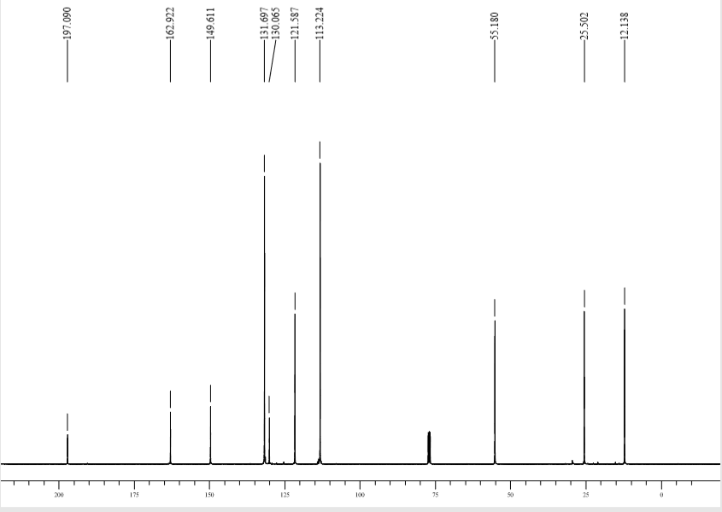

1-(4-methoxyphenyl)-2-methylbut-2-en-1-one (1j)
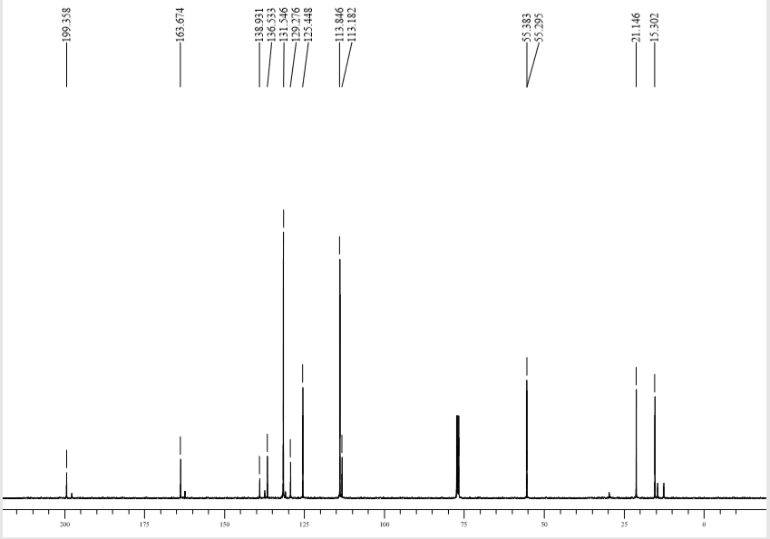

Ethyl 3-hydroxy-4-methyl-3-(3,4,5-trimethoxyphenyl)pent-4-enoate (2a)

Ethyl 3-(3,5-dimethoxyphenyl)-3-hydroxy-4-phenylpent-4-enoate (2b)
Ethyl 3-hydroxy-3-(4-methoxyphenyl)-4-methylpent-4-enoate (2c)

Ethyl 3-hydroxy-3-(4-methoxyphenyl)-4-methylenehexanoate (2d)

Ethyl (E)-3-(3,5-dimethoxyphenyl)-3-hydroxy-4-methylhex-4-enoate (2e)
Ethyl 3-(3,5-dimethoxyphenyl)-3-hydroxy-4-methylpent-4-enoate (2f)
Ethyl(E)-3-(3,5-dimethoxyphenyl)-3-hydroxy-4-methyl-5-phenylpent-4-enoate(2g)
Ethyl (E)-3-hydroxy-4-methyl-3-(naphthalen-2-yl)hex-4-enoate (2h)
Ethyl 3-hydroxy-4-methylene-3-(3,4,5-trimethoxyphenyl)hexanoate (2i)
Ethyl (E)-5-hydroxy-5-(4-methoxyphenyl)-6-methyl-3-oxooct-6-enoate (2j)

Ethyl (E)-5-hydroxy-6-methyl-3-oxo-5-phenyloct-6-enoate (2k)

Ethyl 5-hydroxy-5-(4-methoxyphenyl)-6-methylene-3-oxooctanoate (2l)

Ethyl 5-hydroxy-6-methyl-3-oxo-5-(3,4,5-trimethoxyphenyl)hept-6-enoate (2m)

Ethyl (E)-5-(3,5-dimethoxyphenyl)-5-hydroxy-6-methyl-3-oxo-7-phenylhept-6-enoate (2n):

Ethyl (E)-5-(3,5-dimethoxyphenyl)-5-hydroxy-6-methyl-3-oxooct-6-enoate (2o)

Ethyl (E)-5-hydroxy-6-methyl-5-(naphthalene-2-yl)-3-oxooct-6-enoate (2p)
(E)-1-(3,5-dimethoxyphenyl)-1-(4-methoxyphenyl)-2-methylbut-2-en-1-ol (2q)

(E)-1-(3,5-dimethoxyphenyl)-1-(4-methoxyphenyl)-2-methylpent-2-en-1-ol (2r)

(E)-1-(3,5-dimethoxyphenyl)-1-(4-methoxyphenyl)-2-methyl-3-phenylprop-2-en-1-ol (2s)
(E)-1-(3,5-dimethoxyphenyl)-1-(4-methoxyphenyl)-4-methyl-2-phenylpent-2-en-1-ol (2u)

(E)-4-(1-(3,5-dimethoxyphenyl)-1-hydroxy-2-methylbut-2-en-1-yl)phenol (2v)

(E)-1-(3,5-dimethoxyphenyl)-1-(2-fluorophenyl)-2-methylbut-2-en-1-ol(2w)
(E)-1-(3,5-dimethoxyphenyl)-2-methyl-1-(thiophen-2-yl)but-2-en-1-ol (2x)
(E)-1-(3,5-dimethoxyphenyl)-2-methyl-1-(pyridin-2-yl)but-2-en-1-ol(2y)
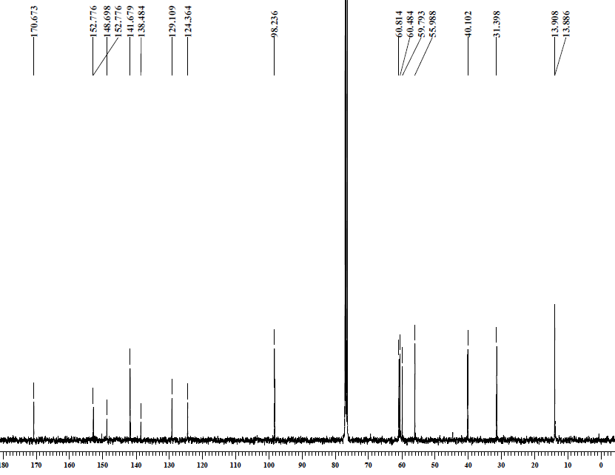
Ethyl 2-(5,6,7-trimethoxy-2-methyl-1H-inden-3-yl)acetate (3a)
Ethyl 2-(5,7-dimethoxy-2-phenyl-1H-inden-3-yl)acetate (3b)
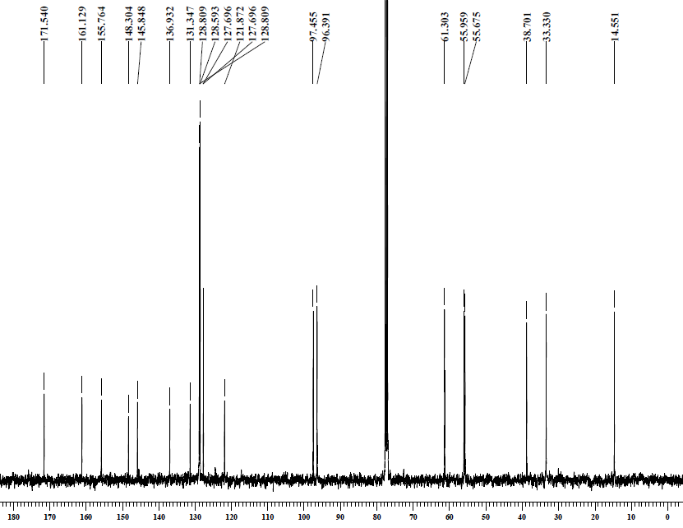
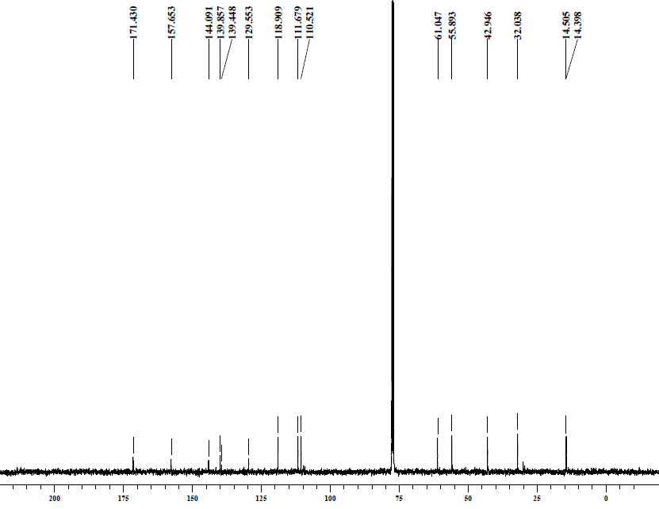
Ethyl 2-(6-methoxy-2-methyl-1H-inden-3-yl)acetate (3c)
Ethyl 2-(2-ethyl-6-methoxy-1H-inden-3-yl)acetate (3d)
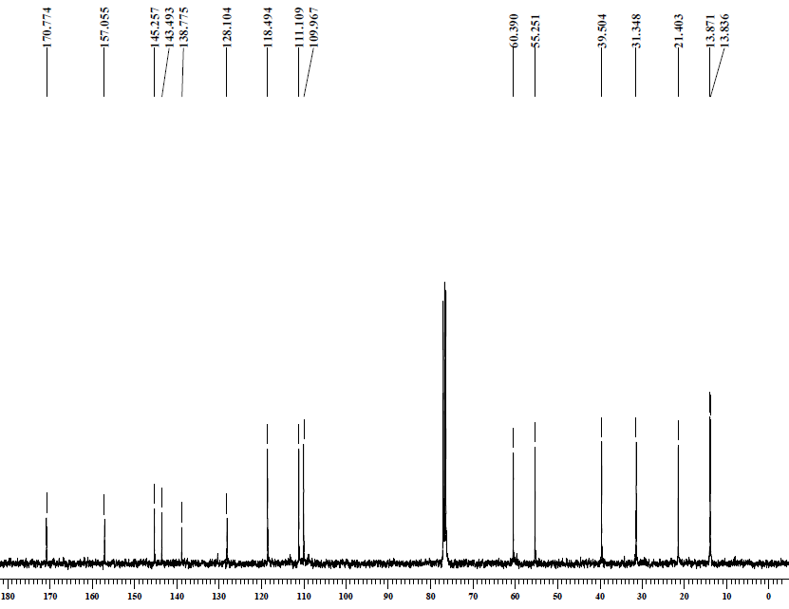
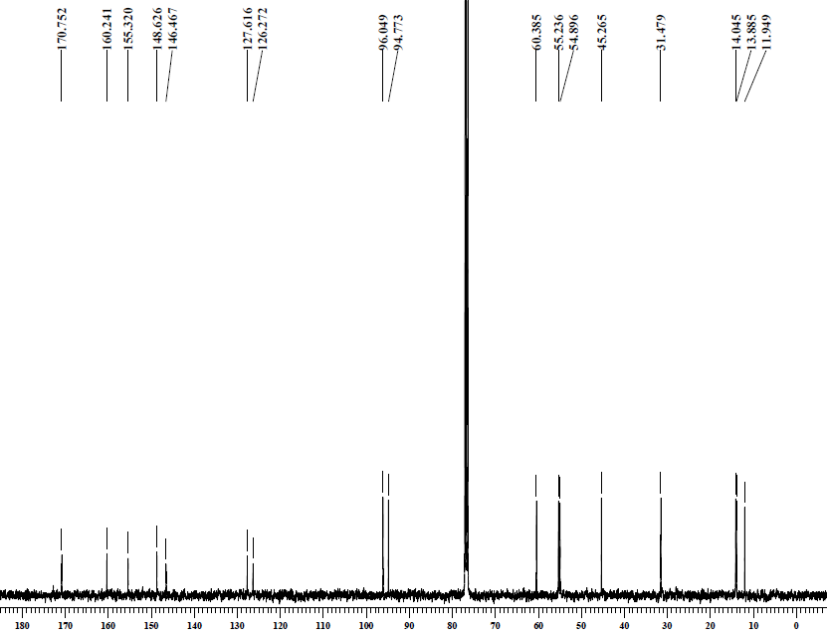
Ethyl 2-(5,7-dimethoxy-1,2-dimethyl-1H-inden-3-yl)acetate (3e)
Ethyl 2-(5,7-dimethoxy-2-methyl-1H-inden-3-yl)acetate (3f)
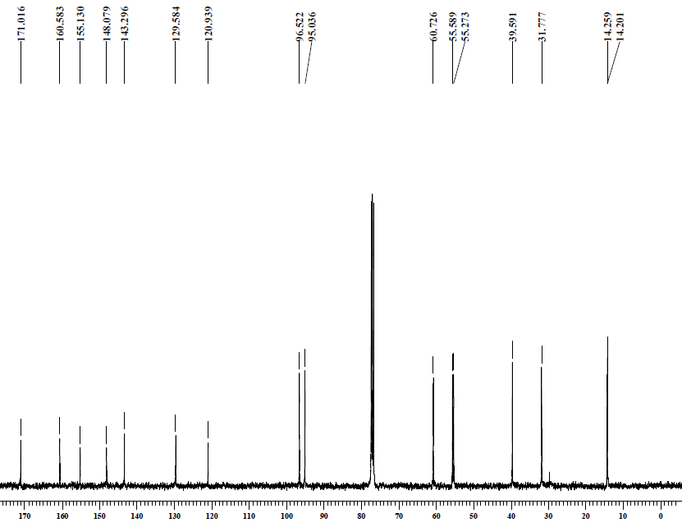
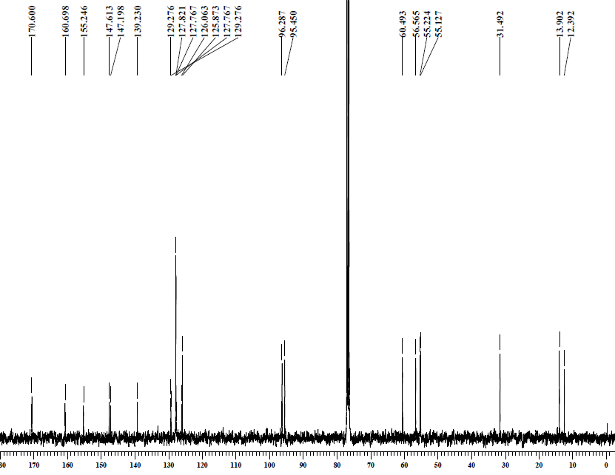
Ethyl 2-(5,7-dimethoxy-2-methyl-1-phenyl-1H-inden-3-yl)acetate (3g)

Ethyl 2-(1,2-dimethyl-1H-cyclopenta[b]naphthalen-3-yl)acetate (3h)
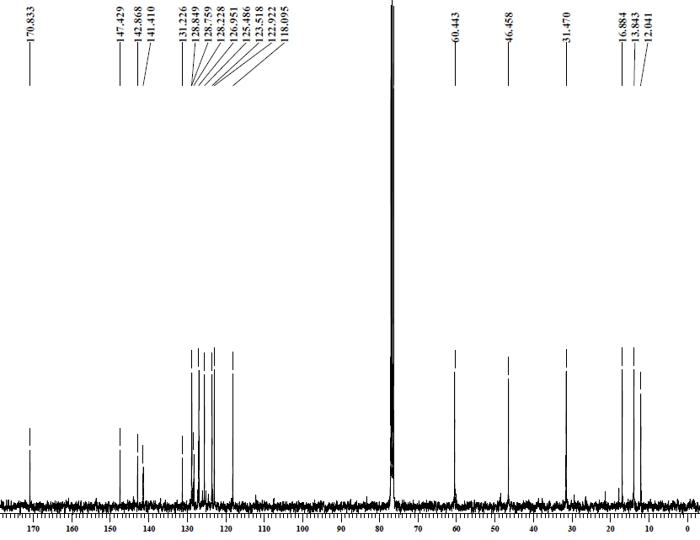
Ethyl 2-(2-ethyl-5,6,7-trimethoxy-1H-inden-3-yl)acetate (3i)
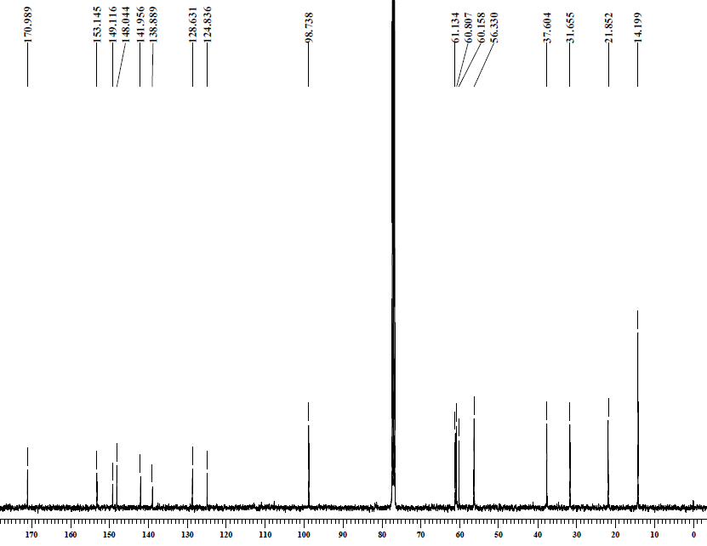
Ethyl 4-(6-methoxy-1,2-dimethyl-1H-inden-3-yl)-3-oxobutanoate (3j)
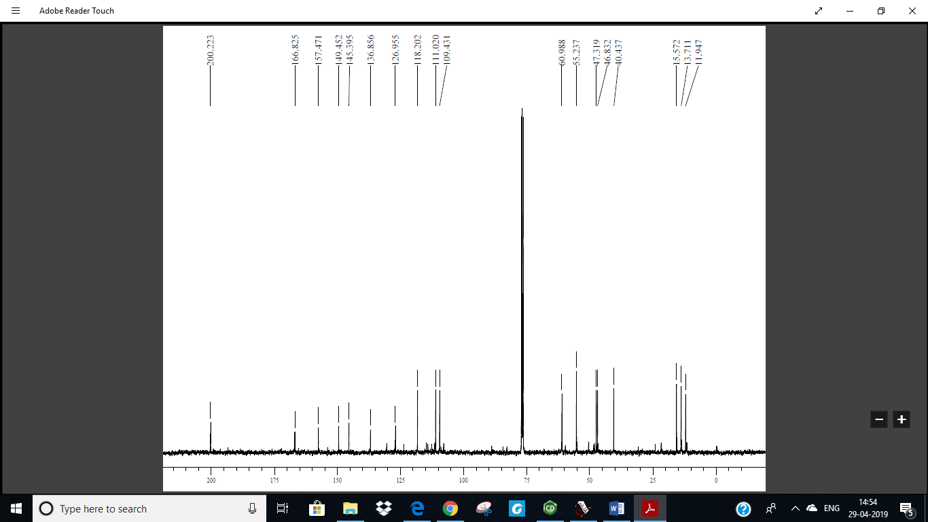

Ethyl 4-(1, 2-dimethyl-1H-inden-3-yl)-3-oxobutanoate (3k)
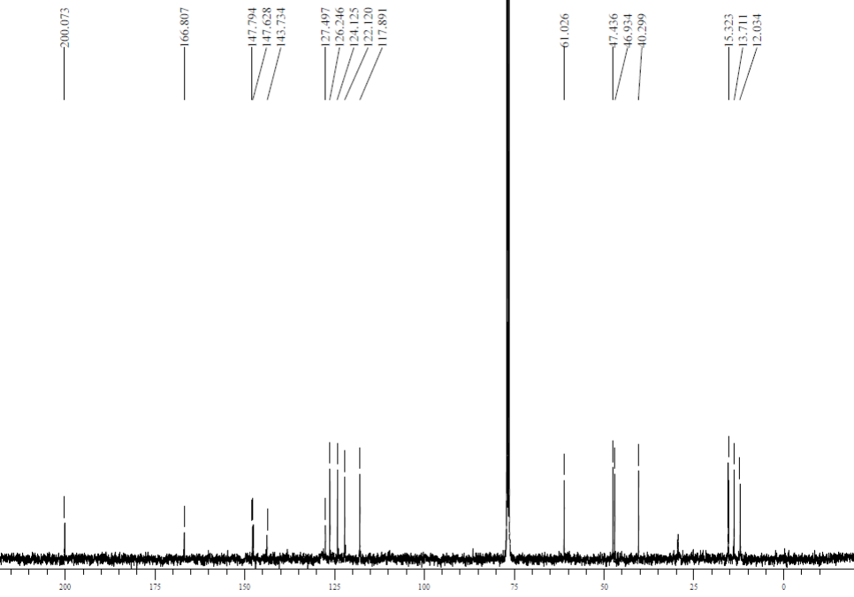
Ethyl 4-(2-ethyl-6-methoxy-1H-inden-3-yl)-3-oxobutanoate (3l)
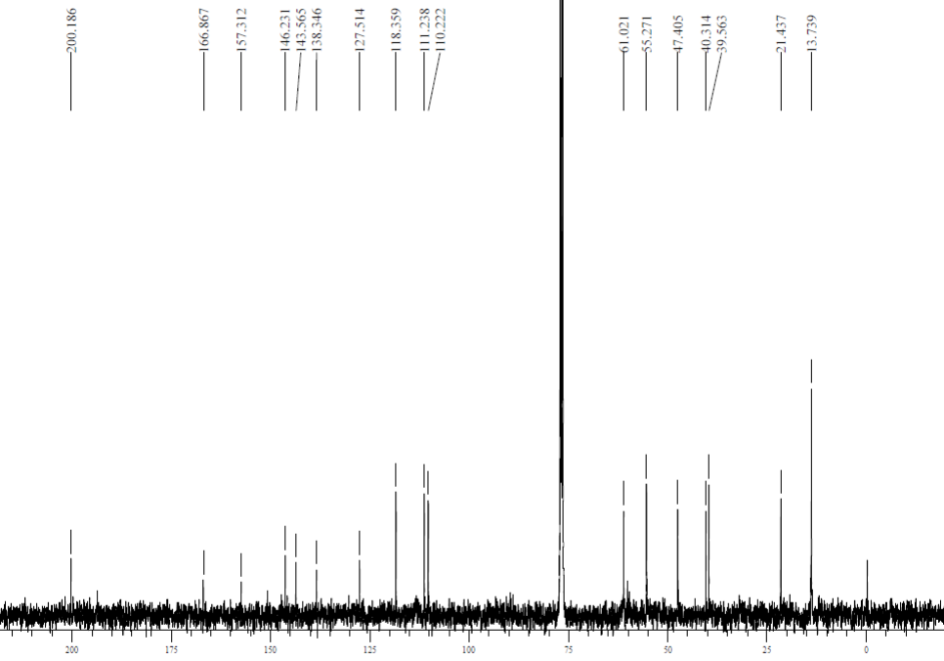

Ethyl 3-oxo-4-(5, 6, 7-trimethoxy-2-methyl-1H-inden-3-yl)butanoate (3m)
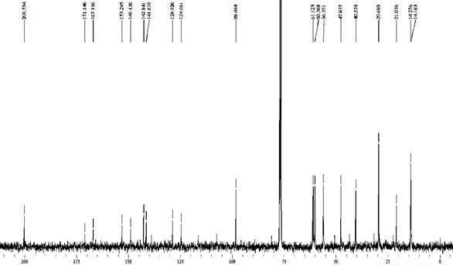

Ethyl 4-(5, 7-dimethoxy-2-methyl-1-phenyl-1H-inden-3-yl)-3-oxobutanoate (3n)
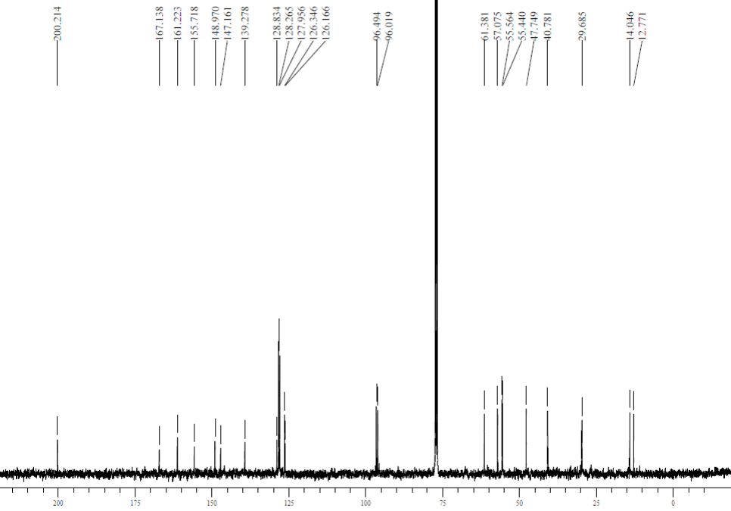

Ethyl 4-(5,7-dimethoxy-1,2-dimethyl -1H-inden-3-yl)-3oxobutanoate (3o)
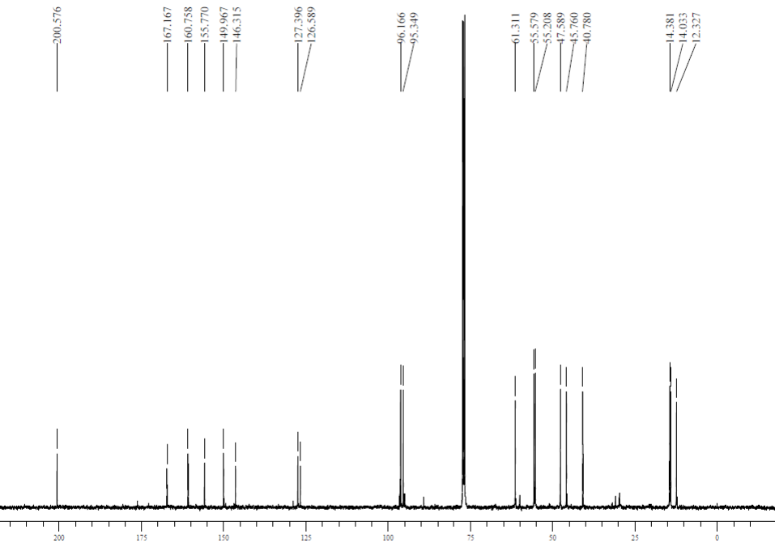

Ethyl 4-(1, 2-dimethyl-1H-cyclopenta[b]naphthalene-3-yl)- 3-oxobutanoate (3p)
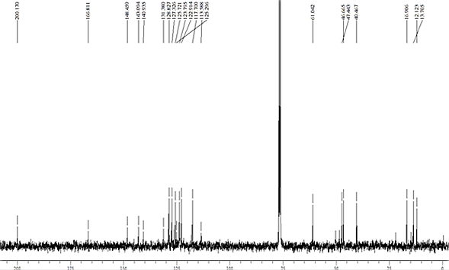

5,7-dimethoxy-3-(4-methoxyphenyl)-1,2-dimethyl-1H-indene(3q)
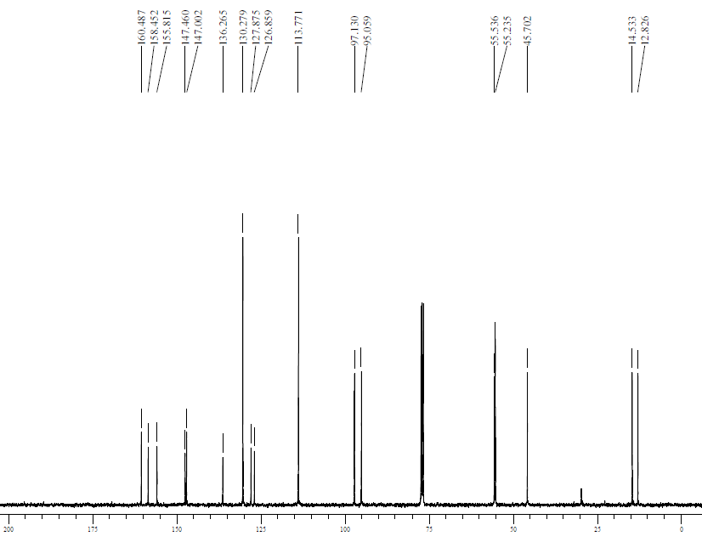

1-Ethyl-5,7-dimethoxy-3-(4-methoxyphenyl)-2-methyl-1H-indene(3r)

5,7-dimethoxy-3-(4-methoxyphenyl)-2-methyl-1-phenyl-1H-indene(3s)

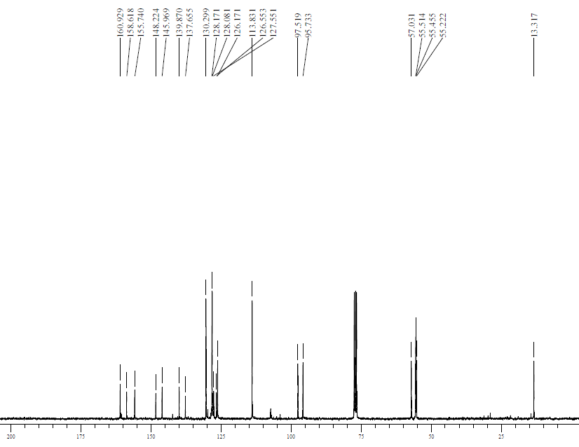

5,7-dimethoxy-3-(4-methoxyphenyl)-1,1,2-trimethyl-1H-indene(3t)
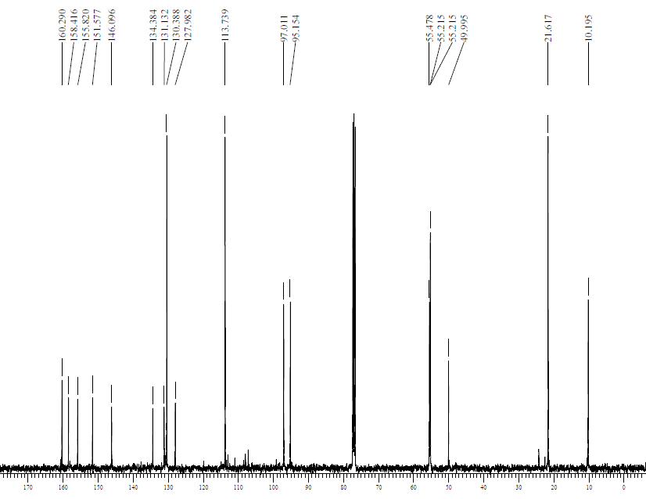

1-isopropyl-5,7-dimethoxy-3-(4-methoxyphenyl)-2-phenyl-1H-indene(3u)
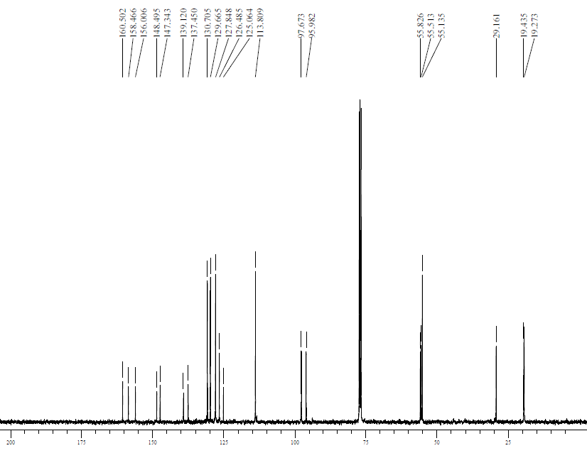

4-(5,7-dimethoxy-1,2-dimethyl-1H-inden-3-yl)phenol(3v)
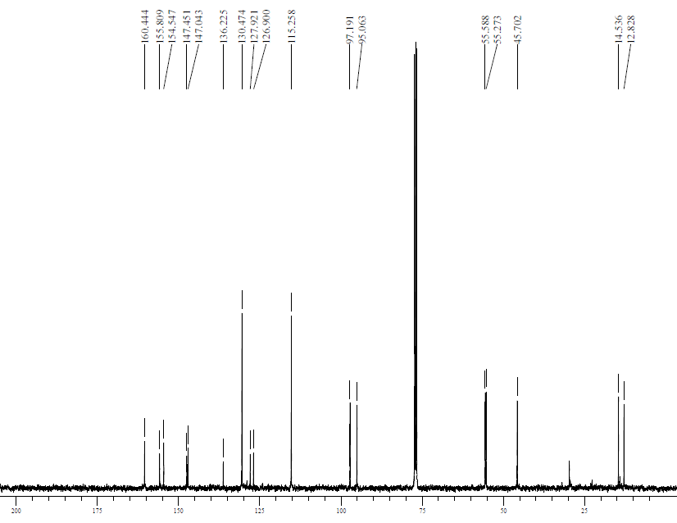

3-(2-fluorophenyl)-5,7-dimethoxy-1,2-dimethyl-1H-indene(3w)

2-(5,7-dimethoxy-1,2-dimethyl-1H-inden-3-yl)thiophene-1H-indene(3x)

2-(5,7-dimethoxy-1,2-dimethyl-1H-inden-3-yl)pyridine(3y)

3-(2,5-dimethylphenyl)-5,7-dimethoxy-1,2-dimethyl-1H-indene (3z)

