Supporting information

Archangelolide: Sesquiterpene lactone with immunobiological potential from Laserpitium archangelica

Silvie Rimpelová^{1,}*, Michal Jurášek², Lucie Peterková¹, Jiří Bejček¹, Vojtěch Spiwok¹, Miloš Majdl², Michal Jirásko³, Miloš Buděšínský⁴, Juraj Harmatha⁴, Eva Kmoníčková^{3,5}, Pavel Drašar^{2,}*, Tomáš Ruml^{1,}*

¹Department of Biochemistry and Microbiology, University of Chemistry and Technology, Prague, Technická 5, 166 28, Prague 6, Czech Republic
²Department of Chemistry of Natural Compounds, University of Chemistry and Technology, Prague, Technická 5, 166 28, Prague 6, Czech Republic
³Charles University in Prague, Faculty of Medicine in Pilsen, 301 66 Pilsen, Czech Republic
⁴Institute of Organic Chemistry and Biochemistry, Academy of Sciences of the Czech Republic, Flemingovo náměstí 2, 166 10 Prague 6, Czech Republic
⁵Institute of Experimental Medicine, Academy of Sciences of the Czech Republic, v.v.i., 14220 Prague 4, Czech Republic

*Corresponding authors: silvie.rimpelova@vscht.cz
pavel.drasar@vscht.cz
tomas.ruml@vscht.cz

- Analytical data
  - General techniques and apparatus
HRMS data were measured by Micro Q-TOF with ESI ionization. FTIR spectra were measured by Nicolet iS10 models by ATR technique using KBr crystal. Specific rotations were measured by Autopol VI polarimeter. For thin layer chromatograms (TLC), we used plates coated with a silica gel bound to starch for detection in UV light (TLC Silica gel 60 F254, Merck).
The NMR spectra were measured by Bruker AVANCE-600 instrument (¹H at 600.13 MHz and ¹³C at 150.9 MHz) with a cryo-probe in CDCl₃ at 25 °C. Structural assignments of proton and carbon signals were achieved by combining one-dimensional ¹H and ¹³C-spectra with two-dimensional homonuclear 2D-H,H-COSY, 2D-H,H-ROESY and heteronuclear 2D-H,C-HSQC and 2D-H,C-HMBC spectra. Carbon-13 and proton NMR data of compounds 1, 3, 4 and 5 are summarized in Table S1. For visualization, diluted sulfuric acid in MeOH was used and the plates were successively heated.
For column chromatography, silica gel (30-60 μm, SiliTech, MP Biomedicals) was used.
The click reactions were carried out in microwave reactor Biotage Initiator Classic.

Table S1. Carbon-13 and proton NMR data of compounds 1, 3, 4 and 5 in CDCl₃. Data for a substituent in the position 11 in compounds 4 and 5 are shown in Fig. S1.
Position | 1 |  | 3 |  | 4 |  | 5
 | ¹³C | ¹H | ¹³C | ¹H | ¹³C | ¹H | ¹³C | ¹H
1 | 52.70 | 3.32 dd | 52.94 | 3.29 dd | 52.65 | 3.32 dd | 52.69 | 3.33 dd
2 | 79.05 | 5.82 m | 78.63 | 5.81 m | 79.04 | 5.83 m | 79.03 | 5.83 m
3 | 127.17 | 5.66 m | 126.96 | 5.65 m | 127.16 | 5.66 m | 127.23 | 5.66 m
4 | 148.94 | -- | 148.77 | -- | 148.86 | -- | 148.86 | --
5 | 50.13 | 3.05 m | 49.30 | 3.07 dd | 50.10 | 3.05 dd | 50.12 | 3.05 dd
6 | 76.82 | 4.81 dd | 77.30 | 4.66 dd | 76.85 | 4.82 dd | 77.06 | 4.84 dd
7 | 48.15 | 3.61 dd | 53.25 | 3.06 dd | 48.22 | 3.60 dd | 48.25 | 3.61 dd
8 | 65.43 | 5.61 td | 64.74 | 5.69 td | 65.50 | 5.60 td | 65.49 | 5.60 td
9 | 44.22 | 2.59 dd 2.06 dd | 43.59 | 2.58 dd 2.14 dd | 44.19 | 2.60 dd  2.07 dd | 44.19 | 2.58 dd 2.07 dd
10 | 80.87 | -- | 81.10 | -- | 80.83 | -- | 80.87 | --
11 | 78.16 | -- | 73.22 | -- | 78.24 | -- | 78.50 | --
12 | 173.60 | -- | 178.51 | -- | 173.56 | -- | 173.73 | --
13 | 20.43 | 1.58 s | 22.40 | 1.57 s | 20.34 | 1.57 s | 20.40 | 1.57 s
14 | 26.28 | 1.43 s | 26.44 | 1.44 s | 26.19 | 1.44 s | 26.27 | 1.43 s
15 | 17.72 | 1.94 br q | 17.43 | 1.92 br q | 17.67 | 1.94 br q | 17.70 | 1.94 br q
2-OAng | 167.46 | -- | 167.41 | -- | 167.41 | -- | 167.45 | --
 | 127.79 | -- | 127.62 | -- | 127.74 | -- | 127.78 | --
 | 137.86 | 6.04 qq | 137.94 | 6.05 qq | 137.80 | 6.04 qq | 137.85 | 6.04 qq
 | 15.73 | 1.95 dq | 15.63 | 1.95 dq | 15.68 | 1.95 dq | 15.72 | 1.95 dq
 | 20.54 | 1.86 p | 20.41 | 1.86 p | 20.49 | 1.86 p | 20.52 | 1.86 p
8-OMeBu | 174.85 | -- | 175.18 | -- | 174.83 | -- | 174.82 | --
 | 41.35 | 2.31 m | 41.05 | 2.35 m | 41.28 | 2.33 m | 41.30 | 2.29 m
 | 26.42 | 1.72 m 1.46 m | 26.23 | 1.72 m 1.45 m | 26.34 | 1.72 m 1.46 m | 26.40 | 1.68 m 1.44 m
 | 11.68 | 0.93 t | 11.48 | 0.91 t | 11.66 | 0.93 t | 11.69 | 0.91 t
 | 16.36 | 1.15 d | 16.23 | 1.14 d | 16.37 | 1.15 d | 16.40 | 1.12 d
10-OAc | 170.07 | -- | 170.09 | -- | 170.04 | -- | 170.09 | --
 | 22.35 | 2.02 s | 22.25 | 2.05 s | 22.30 | 2.02 s | 22.33 | 2.02 s
11-OAc | 169.77 | -- | -- | -- | -- | -- | -- | --
 | 20.97 | 2.08 s | -- | -- | -- | -- | -- | --
11-OH | -- | -- | -- | 3.01 br s | -- | -- | -- | --

Fig. S1. Assignments of the ¹H and ¹³C signals for the azidopentanoate and “dansylated” residues

  - Infrared, optical rotations
Archangelolide (1): α_{D}²⁰= -117 (measured with c=1, CHCl₃) IR: 3455 (vw), 2969 (m), 2931 (m), 2877 (w), 1794 (γ-lactone, vs), 1736 (vs), 1694 (w), 1456 (m), 1381 (m), 1370 (m), 1238 (vs), 1152 (γ-lactone, vs), 1099 (s), 1042 (m), 1018 (s), 980 (m).

11-Deacetyl archangelolide (3): α_{D}²⁰= -135.2 (measured with c=0.25, DCM). IR: 3462 (br. m), 2971 (m), 2934 (m), 2877 (w), 2254 (vw), 1785 (γ-lactone, s), 1732 (vs), 1649 (w), 1457 (m), 1379 (m), 1304 (w), 1234 (vs), 1155 (γ-lactone, vs), 1107 (m), 1084 (m), 1042 (m), 1014 (m), 981 (m).

11-Azidovaleroyl archangelolide (4): α_{D}²⁰= -201.2 (measured with c=0.25, DCM). IR: 2968 (m), 2934 (m), 2876 (w-m), 2097 (ν N₃, s), 1792 (γ-lactone, s), 1734 (vs), 1649 (w), 1456 (m), 1381 (m), 1351 (m), 1236 (s), 1152 (γ-lactone, s), 1099 (m), 1042 (m), 1014 (m).

11-(5-(4-((5-(Dimethylamino)naphthalene-1-sulfonamido)methyl)-1H-1,2,3-triazol-1-yl)pentanoyl archangelolide (5): α_{D}²⁰= -72.8 (measured with c=0.25, DCM). IR: 3287 (w), 2958 (s), 2924 (vs), 2853 (s), 1789 (γ-lactone, s), 1733 (vs), 1456 (m), 1382 (m), 1321 (m), 1258 (s), 1236 (s), 1145 (γ-lactone, vs), 1099 (s), 1043 (s), 1018 (s).

  - HRMS analyses of the compounds
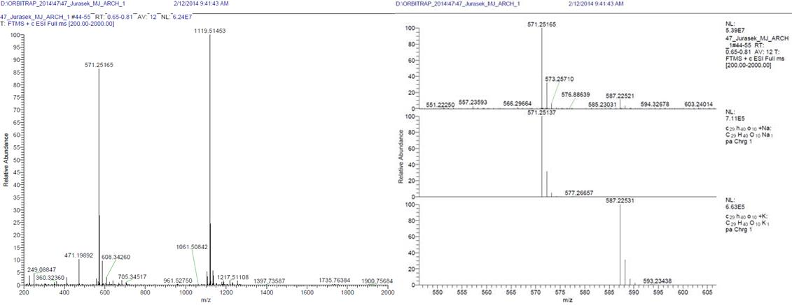
Fig. S2. HRMS of archangelolide, compound 1. HRMS-ESI: monoisotopic mass 548.26215 Da, found (m/z) 571.25165 corresponds to [M+Na]⁺, 587.22521 to [M+K]⁺ and 1119.51453 to [2M+Na]⁺ ion in the proposed structure.

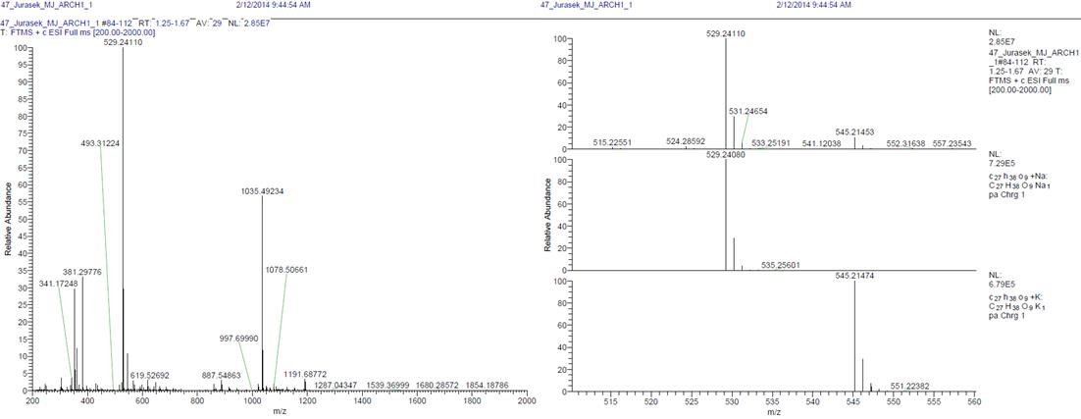
Fig. S3. HRMS of compound 3. HRMS-ESI: monoisotopic mass 506.25158 Da, found (m/z) 529.24110 corresponds to [M+Na]⁺, 545.21453 to [M+K]⁺ and 1035.49234 to [2M+Na]⁺ ion in the proposed structure.

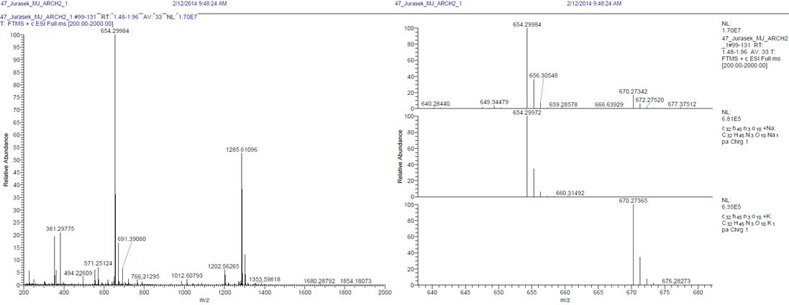
Fig. S4. HRMS of compound 4. HRMS-ESI: monoisotopic mass 631.31049 Da, found (m/z) 654.29984 corresponds to [M+Na]⁺, 670.27342 to [M+K]⁺ and 1285.61096 to [2M+Na]⁺ ion in the proposed structure.

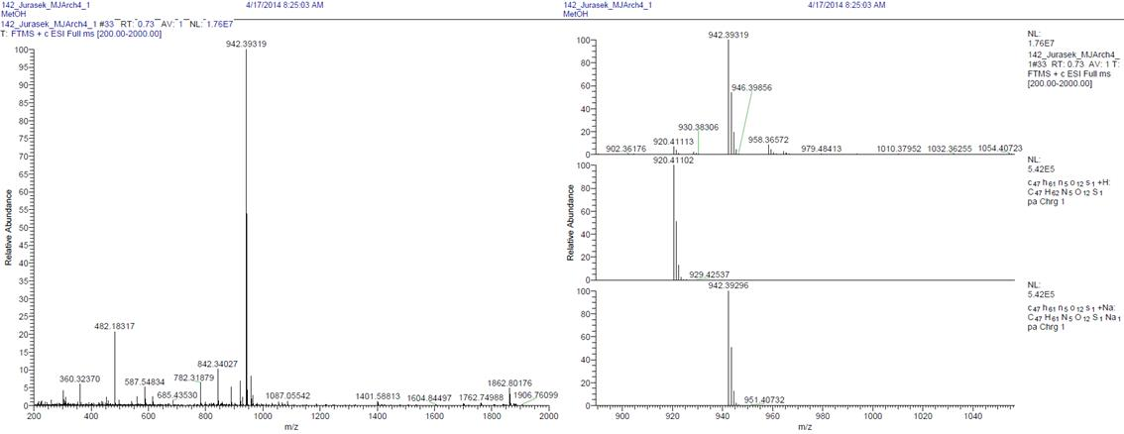
Fig. S5. HRMS of compound 5. HRMS-ESI: monoisotopic mass 919.40374 Da, found (m/z) 920.39319 corresponds to [M+H]⁺, 942.39319 to [M+Na]⁺ ion in the proposed structure.

  - HPLC Analyses of the tested compounds
HPLC analyses were performed using C18 column (0.5 × 280 mm) with UV detection. We used gradient elution with a flow rate of 0.8 mLmin⁻¹ with the following systems: system A – 100 % water and system B 100 % MeOH. The method was optimized for 15 min. with the following gradient.
 | Time [min] | B [%]
1 | 0 | 40
2 | 5 | 100
3 | 15 | 100

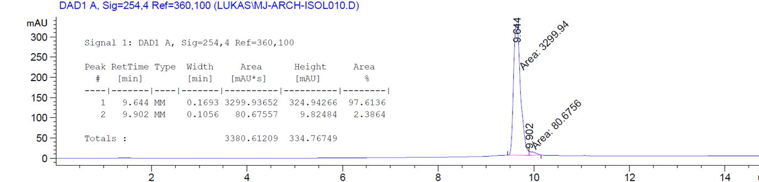
Fig. S6. HPLC of compound 1

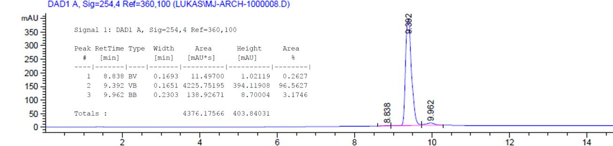
Fig. S7. HPLC of compound 3

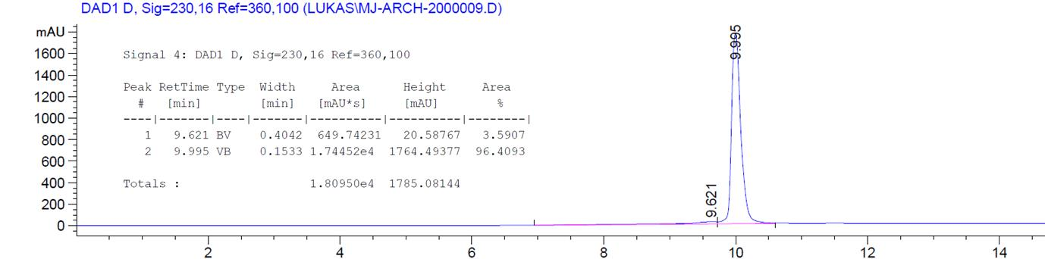
Fig. S8. HPLC of compound 4
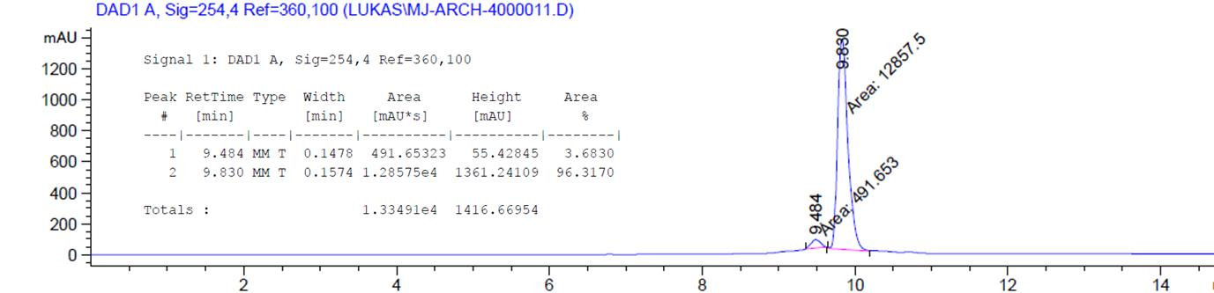
Fig. S9. HPLC of compound 5

  - Fluorescence properties of compound 5
The fluorescence spectra were recorded using Cary Eclipse fluorescence spectrometer. The sample was concentrated in MeOH to 10⁻⁴ M solution, which was further diluted with MeOH or 0.01 M phosphate buffer saline (PBS) to 10⁻⁵ M concentration. The PBS sample contained 10 % of MeOH. The excitation wavelength of 340 nm was used.

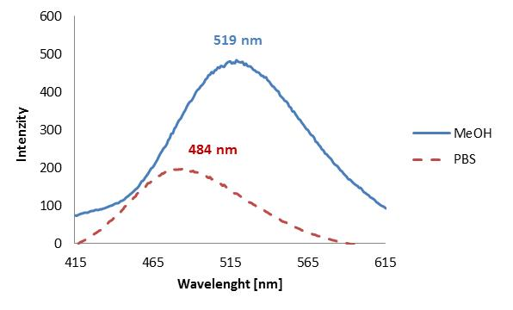
Fig. S10. Fluorescence properties of fluorescent archangelolide conjugate (compound 5). Methanol (blue line) and PBS (red dashed line).

  - Intracellular localization
Fig. S5. Intracellular localization of archangelolide-dansyl (5) in primary cells of lung fibroblast (MRC-5). Fluorescence microscopy of living cells treated with 1 µM concentration of compound 5 for 2 h.

Fig. S6. Co-localization of archangelolide-dansyl (5) with a marker of endoplasmic reticulum (top row) and with a mitochondrial marker (bottom row) in primary cells of lung fibroblast (MRC-5). Fluorescence microscopy of living cells treated with 1 µM concentration of compound 5 for 2 h and ER-Tracker Red (30 min.) or a mitochondria-specific dye from [1] (10 min.).

  - Cytotoxicity
Table S2. Viability of cells treated with archangelolide (compound 1) for 24, 48 and 72 h measured by WST-1 assay. The IC₅₀ value represents the inhibitory concentration of a compound necessary to kill 50 % of cells.
Comp. |  | IC₅₀ [µM]
Comp. | Time | MRC-5 | LNCaP | PC-3 | U-2 OS | MCF-7
1 | 24 h | n.r. | n.r. | n.r. | n.r. | n.r.
1 | 48 h | n.r. | n.r. | n.r. | n.r. | n.r.
1 | 72 h | n.r. | 48.6 | n.r. | n.r. | n.r.

Table S3. Viability of cells treated with archangelolide and its derivatives for 24 h measured by WST-1 assay. The IC₅₀ value represents the inhibitory concentration of a compound necessary to kill 50 % of cells.
Comp. | IC₅₀ [µM]; 24 h
Comp. | HT-29 | C2C12 | MiaPaCa-2 | HEK 293T | A549
1 | n.r. | n.r. | n.r. | n.r. | n.r.
3 | n.r. | n.r. | n.r. | n.r. | n.r.
4 | n.r. | n.r. | n.r. | n.r. | n.r.
5 | n.r. | n.r. | n.r. | n.r. | n.r.
Dns | n.r. | n.r. | n.r. | n.r. | n.r.

Table S4. Viability of cells treated with archangelolide and its derivatives for 48 h measured by WST-1 assay. The IC₅₀ value represents the inhibitory concentration of a compound necessary to kill 50 % of cells.
Comp. | IC₅₀ [µM]; 48 h
Comp. | HT-29 | C2C12 | MiaPaCa-2 | HEK 293T | A549
1 | n.r. | n.r. | n.r. | n.r. | n.r.
3 | n.r. | n.r. | n.r. | n.r. | n.r.
4 | n.r. | n.r. | n.r. | n.r. | n.r.
5 | n.r. | n.r. | n.r. | n.r. | n.r.
Dns | n.r. | n.r. | n.r. | n.r. | n.r.

Table S5. Viability of cells treated with archangelolide and its derivatives for 72 h measured by WST-1 assay. The IC₅₀ value represents the inhibitory concentration of a compound necessary to kill 50 % of cells.
Comp. | IC₅₀ [µM]; 72 h
Comp. | HT-29 | C2C12 | MiaPaCa-2 | HEK 293T | A549
1 | n.r. | n.r. | n.r. | 42.3 | n.r.
3 | n.r. | n.r. | n.r. | n.r. | n.r.
4 | n.r. | n.r. | n.r. | 37.5 | n.r.
5 | n.r. | n.r. | n.r. | n.r. | n.r.
Dns | n.r. | n.r. | n.r. | n.r. | n.r.

Fig. S7. Viability of primary fibroblasts (MRC-5) and cells derived from prostate carcinomas (LNCaP, PC-3) treated with archangelolide for 72 h measured by WST-1 assay.

Fig. S8. Viability of cells from human osteosarcoma (U-2 OS), breast carcinoma (MCF-7) and pancreas adenocarcinoma (Mia PaCa-2) treated with archangelolide for 72 h measured by WST-1 assay.
Fig. S9. Viability of human embryonic fibroblasts from kidney (HEK 293T) treated with archangelolide for 72 h measured by WST-1 assay.

Table S6. Hydrogen bonding and hydrophobicity of SLs
 | thapsigargin | trilobolide | archangelolide
formula | C₃₄H₅₀O₁₂ | C₂₇H₃₈O₁₀ | C₂₉H₄₀O₁₀
logP^{a,b} | 6.98 | 4.26 | 4.9
number of hydrogen bond donor atoms^{b} | 2 | 2 | 0
number of hydrogen bond acceptor atoms^{b} | 12 | 10 | 10
ª octanol-water partition coefficient
^{b} predicted with: Advanced Chemistry Development, Toronto, ACD/Percepta 14.2.0 (Build 2977)

REFERENCES
[1] Rimpelová, S.; Bříza, T.; Králová, J.; Záruba, K.; Kejík, Z.; Císařová, I.; Martásek, P.; Ruml, T.; Král, V. Bioconjug. Chem. 2013, 24, 1445-1454.

