**Soybean-derived blue photoluminescent carbon dots**

Shanshan Wang a,b, Wei Sun c, Dong-sheng Yang a * and Fuqian Yang b*

a Department of Chemistry

University of Kentucky, Lexington, KY 40506, United States

b Materials Program, Department of Chemical and Materials Engineering

University of Kentucky, Lexington, KY 40506, United States

c College of Chemistry, Chemical Engineering and Environmental Engineering,

Liaoning Shihua University, Fushun, Liaoning, 113001, China

**Figure S1.** EDX spectrum of HTC-CDs.

**Figure S2.** XPS survey spectra of LA-CDs-x%.

**Figure S3.** Deconvoluted high resolution spectra of N1s: (a) LA-CDs-5%, (b) LA-CDs-10% NH4OH, (c) LA-CDs-15%, (d) LA-CDs-20%, and (e) LA-CDs-30%; (f) FT-IR spectra of LA-CDs-x%.

**Figure S4.** PL spectra of LA-CDs-x%: (a) x=5, (b) x=10, (c) x=15, (d) x=20, and (e) x=30; (f) UV-Visible absorption spectra of LA-CDs-x%.

**Figure S5.** PL spectra of laser ablated Teflon in deionized water.

**Figure S6.** PL spectra of annealed soybean at different temperatures with the flow of argon gas for 2 h

**Table S1.** Element fractions in the soybean-derived carbon nanoparticles calculated from the XPS spectra

**Table S2.** Element fractions in LA-CDs-x% calculated from the XPS spectra

**Table S3.** Area ratios of bond structures in LA-CDs-x% calculated from the XPS spectra



**Figure S1.** EDX spectrum of HTC-CDs.



**Figure S2.** XPS survey spectra of LA-CDs-x%.







**Figure S3.** Deconvoluted high resolution spectra of N1s: (a) LA-CDs-5%, (b) LA-CDs-10% NH4OH, (c) LA-CDs-15%, (d) LA-CDs-20%, and (e) LA-CDs-30%; (f) FT-IR spectra of LA-CDs-x%.

 





**Figure S4.** PL spectra of LA-CDs-x%: (a) x=5, (b) x=10, (c) x=15, (d) x=20, and (e) x=30; (f) UV-Visible absorption spectra of LA-CDs-x%.



**Figure S5.** PL spectra of laser-ablated Teflon in deionized water.

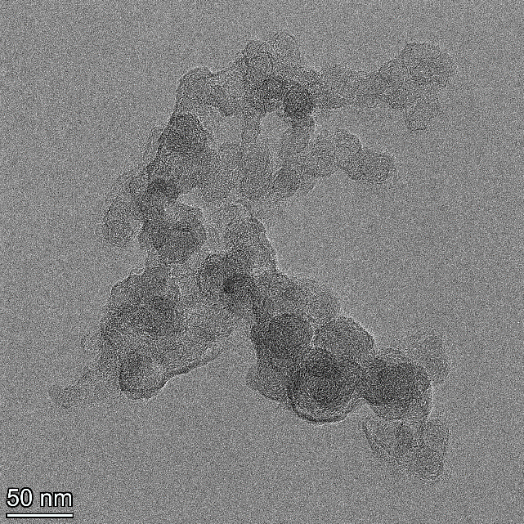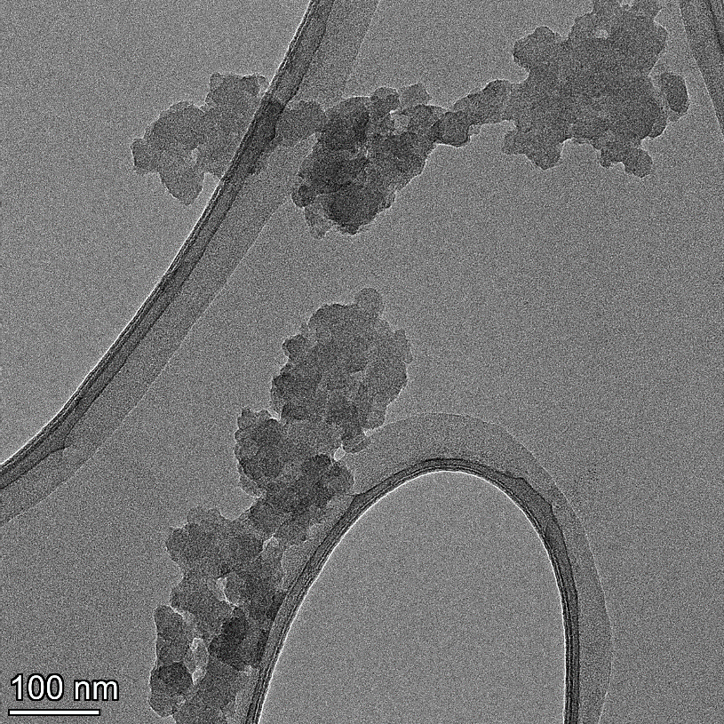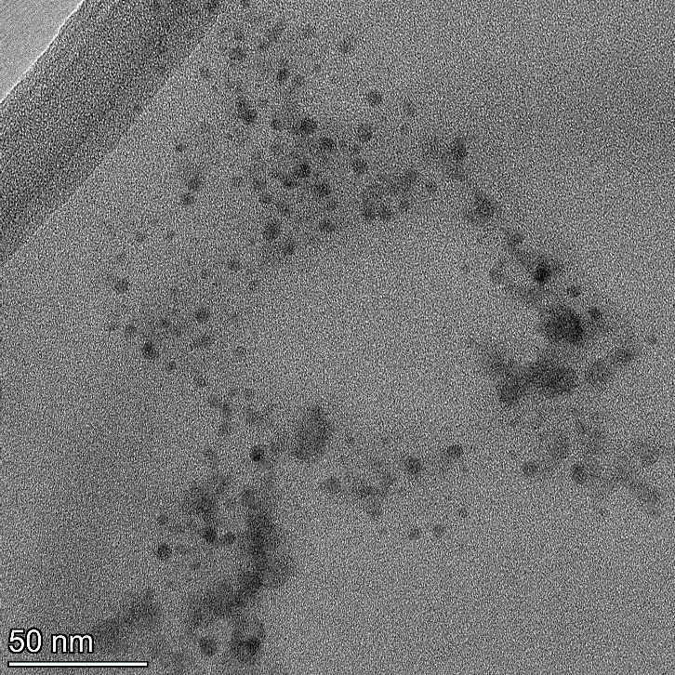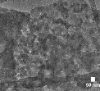

**Figure S6.** PL spectra of annealed soybean at different temperatures with the flow of argon gas for 2 h

**Table S1.** Element fractions in the soybean-derived carbon nanoparticles calculated from the XPS spectra

|  |  |  |  |
| --- | --- | --- | --- |
|  | C1s | N1s | O1s |
| HTC-CDs | 73.6 | 10.3 | 16.1 |
| Annealed-CDs | 60.0 | 0 | 40.0 |
| LA-CDs-10% | 51.1 | 4.4 | 44.5 |

**Table S2.** Element fractions in LA-CDs-x% calculated from the XPS spectra

|  |  |  |  |  |  |  |  |  |  |  |
| --- | --- | --- | --- | --- | --- | --- | --- | --- | --- | --- |
| Element | LA-CDs-5% | | LA-CDs-10% | | LA-CDs-15% | | LA-CDs-20% | | LA-CDs-30% | |
| Position (eV) | at.% | Position (eV) | at.% | Position (eV) | at.% | Position (eV) | at.% | Position (eV) | at.% |
| C | 285.4 | 42.6 | 286.4 | 51.1 | 287.2 | 54.7 | 285.2 | 38.9 | 287.9 | 60.1 |
| N | 400.1 | 3.8 | 400.8 | 4.4 | 401.4 | 7.8 | 400.3 | 4.7 | 402.1 | 5.2 |
| O | 532.7 | 53.6 | 533.1 | 44.5 | 533.4 | 37.5 | 532.4 | 56.4 | 534.6 | 34.7 |

**Table S3.** Area ratios of bond structures in LA-CDs-x% calculated from the XPS spectra

|  |  |  |  |  |
| --- | --- | --- | --- | --- |
| Name/Area Ratio% | Graphitic | Pyrrolic | Amine | Pyridinic |
| LA-CDs-5% | 8.3 | 49.4 | 30.9 | 8.4 |
| LA-CDs-10% | 19.0 | 44.0 | 25.1 | 11.9 |
| LA-CDs-15% | 12.3 | 19.8 | 44.1 | 23.8 |
| LA-CDs-20% | 10.1 | 55.9 | 19.5 | 14.5 |
| LA-CDs-30% | 11.4 | 39.4 | 31.9 | 17.3 |

Absolute Quantum yield (QY) measurement with integrating sphere: The QY was measured and calculated on Fluoromax-4 using integrating sphere according to the following equation as below:



*La*=Total number of incident photons, *Lb*=Total photos not absorbed by sample.

*Pa*= “Dark signal” in the emission wavelength area, *Pb*=Total number of photons emitted in emission wavelength area.