**Supporting information for**

**Microwave-assisted Synthesis of 2-Substituted 4,5,6,7-Tetrahydro-1,3-thiazepines from 4-aminobutanol**

María C. Mollo,a Natalia B. Kilimciler,a Juan A. Bisceglia,a and Liliana R. Orellia*

Universidad de Buenos Aires. CONICET. Departamento de Química Orgánica. Facultad de Farmacia y Bioquímica. Junín 956, (1113) Buenos Aires, Argentina.

|  |  |
| --- | --- |
| 1. General Information | S2 |
| 1. Representative Procedures for Synthesis | S2 |
| 1. Characterization data for compounds **1-4** | S4 |
| 1. Copies of 1H and 13C NMR Spectra of compounds **1-4** | S17 |
| 1. References | S71 |

**1. General Information**

Chromatography was carried out using Merck Kieselgel 60 (230 – 400 mesh). Thin layer chromatography was performed on Silica gel and was visualized by U.V. Melting points were determined with a Büchi capillary apparatus and are uncorrected. 1H and 13C NMR spectra were recorded on a Bruker Bio Spin Avance III 600 MHz spectrometer or a Bruker Avance II 500 MHz spectrometer, using deuteriochloroform as the solvent. In 1H NMR spectra, chemical shifts (ppm) referenced to CHCl3 (7.27 ppm in CDCl3). In 13C NMR spectra, chemical shifts (ppm) were referenced to the deuterated solvent (77.0 ppm in CDCl3). D2O was employed to confirm exchangeable protons (ex). Splitting multiplicities are reported as singlet (s), broad signal (bs), doublet (d), double doublet (dd), triplet (t), quartet (q), heptet (h) and multiplet (m). HRMS (ESI) were performed with a Bruker MicroTOF-Q II spectrometer. Reagents, solvents and starting materials were purchased from standard sources and purified according to literature procedures.

**2. Representative Procedures for Synthesis**

1. **General procedure for the synthesis of *N, O*-diaroyl-1,4-aminobutanols (1)**

A solution of the acyl chloride or anhydride (5 mmol) in anhydrous dichloromethane (5 mL) was added dropwise to a mixture of 1,4-aminobutanol (2.5 mmol), DMAP (0.10 mmol) and 0.7 mL of triethylamine. The reaction mixture was stirred at room temperature until the disappearance of the acid chloride by TLC was observed. For compounds **1l,m** the reaction was carried out at reflux for 48 h. After the reaction was completed, dichloromethane was evaporated *in vacuo*. The crude product was purified by column chromatography (Silicagel, hexane: ethyl acetate 3: 2🡪1:1).

1. **General procedure for the synthesis of *N*-thioaroyl-*O*-aroyl-1,4-aminobutanols (2)**

To a solution of amidoester **1** (2 mmol) in toluene (20 mL) was added LR (0.75 mmol). The mixture was heated at reflux for 30 min. After the reaction is complete, the toluene is evaporated *in vacuo*. The resulting residue is purified by column chromatography (Silicagel, dichloromethane).

1. **General procedure for the synthesis of N-(4-hydroxybutyl) benzothioamides (3)**

Thioamidoester **2** (1.5 mmol) was placed in a round bottomed flask and a solution of K2CO3 in water: methanol 1: 1 was added. The mixture was stirred at 70 °C for 30 minutes. After completion of the reaction, as indicated by TLC, the solvent is evaporated in vacuo. For compounds **3l,m** the reaction was carried out using 10% NaOH:methanol at reflux for 4h. The mixture obtained is diluted with water (15 mL) and extracted with dichloromethane (3 x 30 mL). The combined organic phases were washed with water, dried over anhydrous Na 2 SO 4, filtered and concentrated *in vacuo*. The crude product was purified by column chromatography (Silicagel, hexane: ethyl acetate 1: 1🡪2: 3)

1. **General procedure for the synthesis of 4,5,6,7-Tetrahydro-1,3-thiazepines (4)**

A mixture of the corresponding compound **3** (1 mmol) and neat PPSE (6 g) was reacted in the microwave reactor (Monowave 300, Anton Paar) at the indicated temperature and time. After reaching room temperature, the resulting oil was treated with ethyl acetate (25 mL) and 10% aqueous NaOH (10 mL). The aqueous phase was extracted with ethyl acetate (2 x 25 mL). The organic phases were pooled, washed with water (5 mL), filtered, dried over Na2SO4 and filtered. The solvent was removed *in vacuo*. The crude products were purified by column chromatography (Silicagel, hexane: ethyl acetate 3:2).

**3. Characterization data for compounds 1-6**

Compounds **1a,**1 **1b,**2 **1i,**3 **3a,**4 **3j,**5 **4a,**6 **4f** 7 were described in the literature.

**4-Benzamidobutyl benzoate(1a)** 1



Prepared according to the general procedure, 706.25 mg, 95%. White solid, mp (hexane/CHCl3): 42-44°C.

**1H NMR** (600 MHz, CDCl3) δ 1.71-1.74 (m, 2H), 1.79-1.84 (m, 2H), 3.47-3.50 (m, 2H), 4.31 (t, *J*=6.5 Hz, 2H), 6.86 (bs ex, 1H), 7.35-7.45 (m, 5H), 7.53 (t, *J*=7.5 Hz, 1H), 7.77 (d, *J*=7.2 Hz, 2H), 8.00 (d, *J*=7.2 Hz, 2H).

**13C NMR** (151 MHz, CDCl3) δ 26.1, 26.15, 39.5, 64.4, 126.8, 128.2, 128.3, 129.4, 130.0, 131.2, 132.8, 134.5, 166.5, 167.6.

**HRMS (ESI)**: m/z Calcd. for C18H20NO3+ [M+H]+: 298.1438; found: [M+H]+: 224.1443.

**4-(4-Chlorobenzamido)butyl 4-chlorobenzoate (1b)**2



Prepared according to the general procedure, 824.0 mg, 90%. White solid, mp (ethyl acetate): 147-148°C.

**1H NMR** (500 MHz, CDCl3) δ 1.74-1.80 (m, 2H), 1.84-1.89 (m, 2H), 3.51-3.55 (m, 2H), 4.36 (t, *J*= 6.4 Hz, 2H), 6.26 (bs ex, 1H), 7.39-7.42 (m, 4H), 7.70 (ddd, *J*=8.7, 2.3, 2.0 Hz, 2H), 7.96 (ddd, *J*=8.7, 2.3, 2.0 Hz, 2H).

**13C NMR** (125 MHz, CDCl3) δ 26.27, 26.30, 39.7, 64.7, 128.3, 128.6, 128.7, 128.8, 130.9, 132.9, 137.7, 139.4, 165.8, 166.5.

**HRMS (ESI)**: m/z Calcd. for C18H18Cl2NO3+ [M+H]+: 366.0658; found: [M+H]+: 366.0662.

**4-(4-Methylbenzamido)butyl 4-methylbenzoate(1c)**



Prepared according to the general procedure, 756.0 mg, 93 %. White solid, mp (hexane/ CHCl3): 103-105°C.

**1H NMR** (500 MHz, CDCl3) δ 1.75-1.81 (m, 2H), 1.84-1.90 (m, 2H), 2.39 (s, 3H), 2.41 (s, 3H), 3.51-3.55 (m, 2H), 4.35 (t, *J*=6.4 Hz, 2H), 6.28 (bs ex, 1H), 7.21-7.24 (m, 4H), 7.67 (d, *J*=8.0 Hz , 2H), 7.91 (d, *J*= 8.0 Hz, 2H).

**13C NMR** (125 MHz, CDCl3) δ 21.4, 21.6, 26.3, 26.4, 39.6, 64.3, 126.8, 127.5, 129.1, 129.2, 129.5, 131.7, 141.7, 143.6, 166.7, 167.5

**HRMS (ESI):** m/z calcd. for C20H24NO3+ [M+H]+: 326.1751; found: [M+H]+: 326.1756.

**4-(4-Methoxybenzamido)butyl 4-methoxybenzoate(1d)**



Prepared according to the general procedure, 849.0 mg, 95%. White solid, mp (isopropanol): 132-134°C.

**1H NMR**(500 MHz, CDCl3) δ 1.74-1.80 (m, 2H), 1.83-1.88 (m, 2H), 3.51-3.54 (m, 2H), 3.84 (s, 3H) ,3.86 (s, 3H), 4.32-4.35 (m, 2H), 6.29 (bs ex, 1H), 6.90-6.92 (m, 4H), 7.74 (ddd, *J*=8.9, 2.8, 2.1 Hz, 2H), 8.00 (ddd, *J*=8.9, 2.8, 2.1 Hz, 2H).

**13C NMR** (125 MHz, CDCl3) δ 26.38, 26.43, 39.6, 55.36, 55.40, 64.2, 113.6, 113.7, 122.6, 126.8, 128.6, 131.5, 162.1, 163.3, 166.4, 167.1.

**HRMS (ESI):** m/z calcd. for C20H24NO5+ [M+H]+: 358.1649; found: [M+H]+: 358.1655.

**4-(4-Nitrobenzamido)butyl 4-nitrobenzoate(1e)**



Prepared according to the general procedure, 871,5 mg, 90 %. Yellow solid, mp (isopropanol): 130-131°C.

**1H NMR** (500 MHz, CDCl3) δ 1.80-1.86 (m, 2H), 1.90-1.96 (m, 2H), 3.58-3.62 (m, 2H), 4.46 (t, *J*=6.4 Hz, 2H), 6.33 (bs ex, 1H), 7.94 (d, *J*=8.7 Hz 2H), 8.22 (d, *J*= 8.9 Hz, 2H), 8.29-8.31 (m, 4H).

**13C NMR** (125 MHz, CDCl3) 26.1, 26.1, 39.9, 65.2, 123.5, 123.8, 128.1, 130.7, 135.5, 140.1, 149.5, 150.5, 164.7, 165.6.

**HRMS (ESI)**: m/z Calcd. for C18H18N3O7+ [M+H]+: 388.1139; found: [M+H]+: 388.1134.

**4-(2,4-Dichlorobenzamido)butyl 2,4-dichlorobenzoate (1f)**



Prepared according to the general procedure, 1022,6 mg, 94 %. White solid, mp (ethyl acetate): 100-102°C.

**1H NMR** (500 MHz, CDCl3) δ 1.77-1.82 (m, 2H), 1.86-1.91 (m, 2H), 3.51-3.55 (m, 2H), 4.38 (t, *J*=6.5 Hz, 2H), 6.36 (bs ex, 1H), 7.27-7.31 (m, 2H), 7.41 (d, *J*=2.0 Hz, 1H), 7.47 (d, *J*=2.0 Hz, 1H), 7.61 (d, *J*= 8.0 Hz, 1H), 7.79 (d, *J*=8.0 Hz, 1H) .

**13C NMR** (125 MHz, CDCl3) δ 26.1, 26.2, 39.7, 65.2, 127.0, 127.5, 128.4, 130.0, 131.0, 131.2, 131.3, 132.5, 133.4, 134.8, 136.7, 138.3, 164.8, 165.5.

**HRMS (ESI):** m/z calcd. for C18H16Cl4NO3+ [M+H]+: 433.9879; found: [M+H]+: 433.9885 .

**4-(2-Fluorobenzamido)butyl 2-fluorobenzoate (1g)**



Prepared according to the general procedure, 800 mg, 96%. White solid, mp (ethyl acetate): 60-62°C

**1H NMR** (500 MHz, CDCl3) δ ), 1.79-1.84 (m, 2H), 1.85-1.92 (m, 2H), 3.56-3.60 (m, 2H), 4.39-4.41 (m, 2H), 6.82 (bs ex, 1H), 7.10-7.16 (m, 2H), 7.20-7.23 (m, 1H), 7.25-7.28 (m, 1H), 7.45-7.49 (m, 1H), 7.50-7.55 (m,1H), 7.94 (td, *J=*7.5, 1.8 Hz, 1H), 8.10 (td, *J=*8.0, 1.8 Hz, 1H).

**13C NMR** (125 MHz, CDCl3) δ 26.1, 26.3, 39.6, 64.9, 115.9 (d, *J*= 25.4 Hz), 117.0 (d, *J*= 22.7 Hz), 118.7 (d, *J*= 9.1 Hz), 121.0 (d, *J*= 10.9 Hz),123.9 (d, *J*= 3.6 Hz), 124.8 (d, *J*= 2.7 Hz), 132.0 (d, *J*= 3.6 Hz), 132.1 (d, *J*= 2.7 Hz),133.2 (d, *J*= 9.1 Hz), 134.4 (d, *J*= 9.1 Hz), 160.5 (d, *J*= 247.1 Hz), 162.2 (d, *J*= 259.8 Hz), 163.3 (d, *J*= 2.7 Hz),164.5 (d, *J*= 3.6 Hz).

**HRMS (ESI)**: m/z Calcd. for C18H18F2NO3+ [M+H]+: 334.1249; found: [M+H]+: 334.1253.

**4-(2-Methylbenzamido)butyl 2-methylbenzoate(1h)**



Prepared according to the general procedure, 732.2 mg, 90 %. White solid, mp (hexane/ CHCl3): 100-102°C.

**1H NMR** (600 MHz, CDCl3) δ 1.76-1.81 (m, 2H), 1.86-1.90 (m, 2H), 2.44 (s, 3H), 2.60 (s, 3H), 3.50-3.54 (m, 2H), 4.35 (t, *J*=6.4 Hz, 2H), 5.89 (bs ex, 1H), 7.18-7.25 (m, 4H), 7.31 (t, *J*=7.5 Hz, 1H), 7.34 (d, *J*=7.5 Hz, 1H), 7.40 (d, *J*= 7.5 Hz, 1H), 7.90 (d, *J*=8.0 Hz, 1H) .

**13C NMR** (151 MHz, CDCl3) δ 19.7, 21.7, 26.3, 26.5, 39.4, 64.2, 125.7, 126.5, 129.6, 129.8, 130.5, 131.0, 131.7, 132.0, 135.9, 136.5, 140.1, 167.6, 170.2.

**HRMS (ESI):** m/z calcd. for C20H24NO3+ [M+H]+: 326.1751 ; found: [M+H]+: 326.1745.

**4-Cinnamamidobutyl cinnamate (1i)**3



Prepared according to the general procedure, 830.0 mg, 95%. White solid, mp (hexane/ethyl acetate): 103-106°C.

**1H NMR** (600 MHz, CDCl3) δ 1.69-1.74 (m, 2H), 1.78-1.83 (m, 2H) , 3.45-3.49 (m, 2H), 4.25 (t, *J*=6.5 Hz, 2H), 5.90 (bs ex, 1H), 6.42 (d, *J*=15.6 Hz, 1H), 6.44 (d, *J*=16 Hz, 1H), 7.34-7.36 (m, 3H), 7.37-7.40 (m, 3H), 7.48-7.50 (m, 2H), 7.50-7.54 (m, 2H), 7.64 (d, *J*=15.6 Hz, 1H), 7.70 (d, *J*=16 Hz, 1H).

**13C NMR** (151 MHz, CDCl3) δ 26.3, 26.3, 39.3, 64.1, 118.0, 120.6, 127.7, 128.1, 128.8, 128.9, 129.6, 130.3, 134.3, 134.8, 141.0, 144.9, 165.9, 167.0.

HRMS (ESI): m/z calcd. for C22H24NO3+ [M+H]+: 350.1751; found: [M+H]+: 350.1755.

**4-(2-Phenylacetamido)butyl 2-phenylacetate(1j)**



Prepared according to the general procedure, 700.0 mg, 86%. White solid, mp (hexane/ethyl acetate): 47-49°C.

**1H NMR** (600 MHz, CDCl3)    m  1.55-1.60 (m, 2H), 3.21 (c, *J* = 7.0 Hz, 2H), 3.58 (s, 2H), 3.61 (s, 2H), 4.07 (t, *J* = 6.5 Hz, 2H), 5.40 (bs ex, 1H), 7.26-7.28 (m, 5H), 7.31-7.34 (m, 3H), 7.37–7.39 (m, 2H).

**13C NMR** (151 MHz, CDCl3) δ 25.9, 26.0, 39.1, 41.4, 43.8, 64.3, 127.1, 127.4, 128.5, 129.0, 129.2, 129.4, 134.0, 134.9, 170.9, 171.5.

**HRMS (ESI):** m/z calcd. for C20H24NO3+ [M+H]+: 326.1751; found: [M+H]+: 326.1744.

**4-Hexanamidobutyl hexanoate (1k)**



Prepared according to the general procedure, 499.5 mg, 70%. Colorless oil.

**1H NMR** (600 MHz, CDCl3)    m  1.25-1.33 (m, 8H), 1.52-1.66 (m, 8H), 2.14 (t, *J* = 7.7 Hz, 2H), 2.25 (t, *J* = 7.6 Hz, 2H), 3.24-3.27 (m, 2H), 4.05 (t, *J* = 6.5 Hz, 2H), 5.78 (bs ex, 1H).

**13C NMR** (151 MHz, CDCl3) δ 13.80, 13.83, 22.2, 22.3, 24.6, 25.4, 26.1, 26.2, 31.2, 31.4, 34.2, 36.7, 38.9, 63.7, 173.3, 173.9.

**HRMS (ESI):** m/z calcd. for C16H32NO3+ [M+H]+: 286.2377; found: [M+H]+: 286.2380.

**4-Isobutyramidobutyl isobutyrate (1l)**



Prepared according to the general procedure, 533 mg, 93%. Yellow oil.

**1H NMR** (600 MHz, CDCl3)  1.14-1.16 (m, 12H) 1.54-1.59 (m, 2H) 1.63-1.68 (m, 2H) 2.33 (h, *J* = 6.5 Hz, 1H), 2.53 (h, *J* = 6.5 Hz,1H), 3.26-3.29 (m, 2H), 4.07 (t, *J* = 6.5 Hz, 2H), 5.62 (bs ex, 1H).

**13C NMR** (151 MHz, CDCl3) δ 18.9, 19.6, 26.1, 26.2, 34.0, 35.6, 38.9, 63.8, 177.0, 177.2.

**HRMS (ESI):** m/z calcd. for C12H24NO3+ [M+H]+: 230.1751; found: [M+H]+: 230.1744.

**4-Pivalamidobutyl pivalate (1m)**



Prepared according to the general procedure, 533 mg, 77%. Yellow solid, mp (ethyl acetate): 38-40°C.

**1H NMR** (600 MHz, CDCl3)  1.19 (s, 18 H) 1.54-1.59 (m, 2H) 1.63-1.68 (m, 2H) 3.26-3.29 (m, 2H), 4.07 (t, *J* = 6.5 Hz, 2H), 5.70 (bs ex, 1H).

**13C NMR** (151 MHz, CDCl3) δ 26.1, 26.3, 27.2, 27.6, 38.6, 38.7, 39.1, 63.9, 178.4, 178.6.

**HRMS (ESI):** m/z calcd. for C14H28NO3+ [M+H]+: 258.2064; found: [M+H]+: 258.2081.

**4-Phenylthioamidobutyl benzoate (2a)**



Prepared according to the general procedure, 595.4 mg, 95%. Yellow oil.

**1H NMR** (600 MHz, CDCl3) δ 1.90-1.97 (m, 4H), 3.92-3.95 (m, 2H), 4.40 (t, *J*=5.9 Hz, 2H), 7.36-7.39 (m, 2H), 7.43-7.46 (m, 3H), 7.57 (t, *J*=7.4 Hz, 1H), 7.73-7.74 (m, 3H), 8.05 (d, *J*=7.3 Hz, 2H).

**13C NMR** (151 MHz, CDCl3) δ 24.8, 26.4, 46.3, 64.3, 126.6, 128.4, 128.5, 129.5, 130.1, 131.0, 133.0, 141.9, 166.6, 199.5.

**HRMS (ESI)**: m/z Calcd. for C18H20NO2S+ [M+H]+: 314.1209; found: [M+H]+: 314.1215.

**4-(4-Chlorophenylthioamido)butyl 4-chlorobenzoate (2b)**



Prepared according to the general procedure, 711,0 mg, 93%. White solid, mp (ethyl acetate): 141-143°C.

**1H NMR** (500 MHz, CDCl3) δ 1.90-1.95 (m, 4H), 3.91-3.95 (m, 2H), 4.40 (t, *J*= 6.0 Hz, 2H), 7.36 (ddd, *J*=8.6, 2.6, 2.0 Hz, 2H), 7.42 (ddd, *J*=8.6, 2.3, 2.0 Hz, 2H), 7.66 (bs ex, 1H), 7.69 (ddd, *J*=8.6, 2.6, 2.0 Hz, 2H), 7.98 (ddd, *J*=8.6, 2.3, 2.0 Hz, 2H).

**13C NMR** (125 MHz, CDCl3) δ 24.8, 26.4, 46.4, 64.5, 127.9, 128.5, 128.7, 128.8, 131.0, 137.3, 139.6, 140.1, 165.8, 198.0.

**HRMS (ESI)**: m/z Calcd. for C18H18Cl2NO2S+ [M+H]+: 382.0430; found: [M+H]+: 382.0425.

**4-(4-Methylphenylthioamido)butyl 4-methylbenzoate (2c)**



Prepared according to the general procedure, 648.8 mg, 95%. Yellow solid (Hexane/ CHCl3), mp 108-110°C.

**1H NMR** (500 MHz, CDCl3) δ 1.88-1.97 (m, 4H), 2.37 (s, 3H), 2.42 (s, 3H), 3.91-3.95 (m, 2H), 4.38 (t, *J*= 6.0 Hz, 2H), 7.17-7.18 (m, 2H), 7.23-7.25 (m, 2H), 7.66 (d, *J*= 8.2 Hz, 2H) , 7.70 (bs ex, 1H), 7.93 (d, *J*= 8.2, 2H).

**13C NMR** (125 MHz, CDCl3) δ 21.3, 21.7, 24.9, 26.5, 46.3, 64.2, 126.6, 127.4, 129.11, 129.12, 129.6, 139.1, 141.6, 143.7, 166.7, 199.2.

**HRMS (ESI)**: m/z Calcd. for C20H24NO2S+ [M+H]+: 342.1522; found: [M+H]+: 342.1530.

**4-(4-Methoxyphenylthioamido)butyl 4-methoxybenzoate (2d)**



Prepared according to the general procedure, 694.7 mg, 93%. Yellow solid (ethyl acetate), mp 119-121°C.

**1H NMR** (500 MHz, CDCl3) δ 1.87-1.96 (m, 4H), 3.84 (s, 3H), 3.86 (s, 3H), 3.91-3.95 (m, 2H), 4.36 (t, *J*= 6.1 Hz, 2H), 6.87 (d, *J*= 8.9 Hz, 2H), 6.92 (d, *J*=8.9 Hz, 2H), 7.67 (bs ex, 1H), 7.76 (d, *J*= 8.9 Hz, 2H), 7.99 (d, *J*= 8.9, 2H).

**13C NMR** (125 MHz, CDCl3) δ 24.9, 26.5, 46.3, 55.42, 55.45, 64.0, 113.6, 113.6, 122.5, 128.4, 131.6, 134.1, 162.1, 163.4, 166.4, 198.2.

**HRMS (ESI)**: m/z Calcd. for C20H24NO4S+ [M+H]+: 374.1421; found: [M+H]+: 374.1425.

**4-(4-nitrophenylthioamido)butyl 4-nitrobenzoate (2e)**



Prepared according to the general procedure, 807,0 mg, 100 %. Yellow solid, mp (isopropanol): 133-135°C

**1H NMR** (600 MHz, CDCl3) δ 1.97-2.01 (m, 4H), 3.95-3.97 (m, 2H), 4.47 (t, *J*=6.0 Hz, 2H), 7.83 (bs ex, 1H), 7.86 (d, *J*=8.6 Hz 2H), 8.21-8.23 (m, 4H), 8.29 (d, *J*= 8.7 Hz, 2H).

**13C NMR** (151 MHz, CDCl3) 24.6, 26.2, 46.4, 65.1, 123.6, 123.7, 127.6, 130.7, 135.4, 146.9, 148.9, 150.6, 164.7, 197.0.

**HRMS (ESI)**: m/z Calcd. for C18H18N3O6S+ [M+H]+: 404.0911; found: [M+H]+: 404.0905.

**4-(2,4-dichlorophenylthioamido)butyl 2,4-dichlorobenzoate (2f)**



Prepared according to the general procedure, 785.0 mg, 87 %. Yellow solid, mp (ethyl acetate): 134-136°C

**1H NMR** (600 MHz, CDCl3) δ 1.90-1.98 (m, 4H), 3.89-3.92 (m, 2H), 4.41 (t, *J*=5.7 Hz, 2H), 7.26 (dd, *J*=8.4, 2.0 Hz, 1H), 7.31 (dd, *J*=8.4, 2.0 Hz, 1H), 7.37 (d, *J*=2.0 Hz, 1H), 7.47 (d, *J*=2.0 Hz, 1H), 7.51 (d, *J*=8.4 Hz, 1H), 7.58 (bs ex, 1H), 7.80 (d, *J*=8.4 Hz, 1H).

**13C NMR** (151 MHz, CDCl3) δ 24.6, 26.2, 45.9, 65.1, 127.1, 127.4, 128.3, 129.1, 129.6, 131.0, 131.1, 132.5, 134.7, 135.7, 138.4, 140.3, 164.9, 196.1

**HRMS (ESI)**: m/z Calcd. for C18H16Cl4NO2S+ [M+H]+: 449.9650; found: [M+H]+: 449.9656.

**4-(2-Fluorophenylthioamido)butyl 2-fluorobenzoate (2g)**



Prepared according to the general procedure, 629.0 mg, 90%. Yellow oil.

**1H NMR** (500 MHz, CDCl3) δ 1.91-1.98 (m, 4H), 3.94-3.97 (m, 2H), 4.41 (d, *J*= 6 Hz, 2H), 7.03-7.08 (m, 1H), 7.18-7.23 (m, 1H), 7.37-7.40 (m, 1H), 7.50-7.5m (m, 1H), 7.94 (td, *J=*7.5, 1.8 Hz, 1H), 7.96 (bs ex, 1H), 8.10 (td, *J=*8.0, 1.9 Hz, 1H).

**13C NMR** (125 MHz, CDCl3) δ 24.7, 26.1, 46.4, 64.7, 115.8 (d, *J*= 23.6 Hz), 116.9 (d, *J*= 22.5 Hz), 118.7 (d, *J*= 10.0 Hz) , 124.0 (d, *J*= 3.6 Hz),124.5 (d, *J*= 3.6 Hz), 128.1 (d, *J*= 10.7 Hz), 132.1, 132.2 (d, *J*= 9.0 Hz),133.3 (d, *J*= 1.6 Hz), 134.5 (d, *J*= 9.0 Hz), 157.6 (d, *J*= 248.4 Hz), 161.9 (d, *J*= 259.6 Hz), 164.5 (d, *J*= 3.6 Hz), 193.6 (d, *J*= 1.7 Hz).

**HRMS (ESI)**: m/z Calcd. for C18H18F2NO2S+ [M+H]+: 350.1021; found: [M+H]+: 350.1014.

**4-(2-Methylphenylthioamido)butyl 2-methylbenzoate (2h)**



Prepared according to the general procedure, 628.0 mg, 92%. White solid (Hexane/ CHCl3), mp 91-93°C.

**1H NMR** (500 MHz, CDCl3) δ 1.90-1.93 (m, 4H), 2.37 (s, 3H), 2.59 (s, 3H), 3.88-3.92 (m, 2H), 4.35-4.37 (m, 2H), 7.17-7.20 (m, 2H), 7.23-7.27 (m, 4H), 7.41 (td, *J*= 7.4, 1,2 Hz, 2H) , 7.46 (bs ex, 1H), 7.90 (d, *J*= 7.4, 2H).

**13C NMR** (125 MHz, CDCl3) δ 19.3, 21.7, 24.9, 26.4, 45.4, 64.0, 125.7, 125.9, 126.5, 128.9, 129.5, 130.5, 130.7, 131.7, 132.0, 132.8, 140.1, 143.9, 167.5, 201.9.

**HRMS (ESI)**: m/z Calcd. for C20H24NO2S+ [M+H]+: 342.1522; found: [M+H]+: 342.1525.

**4-((E)-3-Phenylprop-2-enethioamido)butyl cinnamate (2i)**



Prepared according to the general procedure, 694.4 mg, 95%. White solid, mp (hexane/ethyl acetate): 122-125°C.

This compound was obtained as inseparable mixture of E/Z diasteroisomers.8 Only the major isomer is reported.

**1H NMR** (600 MHz, CDCl3) δ 1.81-1.90 (m, 4H), 3.89-3.92 (m, 2H), 4.29 (t, *J*=6.0 Hz, 2H), 6.47 (d, *J*=16.0, 1H), 6.86 (d, *J*=15.3 Hz, 1H), 7.35-7.37 (m, 3H), 7.39-7.41 (m, 3H), 7.52-7.57 (m, 4H), 7.57 (bs ex, 1H), 7.71 (d, *J*=16 Hz, 1H), 7.82 (d, *J*=15.3 Hz, 1H).

**13C NMR** (151 MHz, CDCl3) δ 24.8, 26.5, 45.6, 63.9, 117.8, 127.6, 128.0, 128.1, 128.85, 128.89, 129.8, 130.4, 134.3, 134.9, 141.6, 145.1, 167.1, 194.9.

**HRMS (ESI)**: m/z Calcd. for C22H24NO2S+ [M+H]+: 366.1522; found: [M+H]+: 366.1518.

**4-(2-Phenylethanethioamido)butyl 2-phenylacetate (2j)**



Prepared according to the general procedure, 546.0 mg, 80%. Yellow oil.

**1H NMR** (600 MHz, CDCl3)    m  3.60-3.62 (m, 4H)*, 4.06 (t, *J* = 6.0 Hz, 2H), 4.13 (s, 2H), 6.99 (bs ex, 1H), 7.25-7.27 (m, 5H), 7.30-7.40 (m, 5H).

**13C NMR** (151 MHz, CDCl3) δ 24.3, 25.9, 41.4, 45.5, 53.2, 64.1, 127.1, 127.9, 128.6, 129.2, 129.3, 129.5, 134.0, 134.8, 171.5, 202.1.

**HRMS (ESI)**: m/z Calcd. for C20H24NO2S+ [M+H]+: 342.1522; found: [M+H]+: 342.1527.

*overlapping signals

**4-Hexanethioamidobutyl hexanoate (2k)**



Prepared according to the general procedure, 603.0 mg, 100%. Yellow oil.

**1H NMR** (600 MHz, CDCl3)    m  1.27-1.38 (m, 8H), 1.60-1.65 (m, 2H), 1.70-1.79 (m, 6H), 2.30 (t, *J* = 7.6 Hz, 2H), 2.64 (t, *J* = 7.7 Hz, 2H), 3.69-3.73 (m, 2H), 4.11 (t, *J* = 6.0 Hz, 2H), 7.37 (bs ex, 1H).

**13C NMR** (151 MHz, CDCl3) δ 13.87, 13.90, 22.3, 22.4, 24.5, 24.6, 26.2, 29.1, 31.1, 31.3, 34.3, 45.5, 47.3, 63.5, 174.0, 205.9.

**HRMS (ESI)**: m/z Calcd. for C16H32NO2S+ [M+H]+: 302.2148; found: [M+H]+: 302.2154.

**4-(2-methylpropanethioamido)butyl isobutyrate (2l)**



Prepared according to the general procedure, 417.0 mg, 85%. Yellow oil.

**1H NMR** (600 MHz, CDCl3)  1.15 (d, *J* = 7.0 Hz, 6H) 1.25 (d, *J* = 6.6 Hz, 6H) 1.70-1.75 (m, 4H) 2.54 (h, *J* = 7.0 Hz, 1H), 2.80 (h, *J* = 6.6 Hz,1H), 3.70-3.73 (m, 2H), 4.09-4.11 (m, 2H), 7.40 (bs ex, 1H).

**13C NMR** (151 MHz, CDCl3) δ 18.9, 22.6, 24.5, 26.2, 34.0, 44.5, 45.2, 63.6, 177.2, 211.7.

**HRMS (ESI):** m/z calcd. for C12H24NO2S+ [M+H]+: 246.1522; found: [M+H]+: 246.1526.

**4-(2,2-Dimethylpropanethioamido)butyl pivalate (2m)**



Prepared according to the general procedure, 475 mg, 87%. White solid, mp (Hexane/ CHCl3): 35-47°C.

**1H NMR** (600 MHz, CDCl3)  1.20 (s, 9 H) 1.35 (s, 9 H), 1.69-1.73 (m, 4H) 3.71-3.74 (m, 2H), 4.10 (t, *J* = 6.2 Hz, 2H), 5.70 (bs ex, 1H).

**13C NMR** (151 MHz, CDCl3) δ 24.5, 26.2, 27.2, 30.1, 38.7, 44.5, 45.8, 63.6, 178.6, 213.46.

**HRMS (ESI):** m/z calcd. for C14H28NO2S+ [M+H]+: 274.1835; found: [M+H]+: 274.1841.

**N-(4-Hydroxybutyl)benzothioamide (3a)**4



Prepared according to the general procedure, 298.0 mg, 95%. White solid (Hexane/ CHCl3), mp 61-62°C.

**1H NMR** (600 MHz, CDCl3) δ 1.70-1.74 (m, 2H), 1.82 (bs ex, 1H), 1.86-1.91 (m, 2H), 3.74 (t, *J*= 6.0 Hz, 2H), 3.83-3.87 (m, 2H), 7.36-7.38 (m, 2H), 7.43-7.46 (m, 1H), 7.75 (d, *J*= 7.3 Hz, 2H) , 8.32 (bs ex, 1H).

**4-Chloro-N-(4-hydroxybutyl)benzothioamide (3b)**



Prepared according to the general procedure, 318.0 mg, 87%. White solid (Hexane/ CHCl3), mp 89-90°C.

**1H NMR** (500 MHz, CDCl3) δ 1.69-1.74 (m, 2H), 1.86-1.91 (m, 2H), 1.97 (bs ex, 1H), 3.73 (t, *J*= 6.0 Hz, 2H), 3.79-3.83 (m, 2H), 7.33 (ddd, *J*=8.6, 2.6, 2.0 Hz, 2H), 7.70 (ddd, *J*=8.6, 2.6, 2.0 Hz, 2H), 8.50 (bs ex, 1H).

**13C NMR** (125 MHz, CDCl3) δ 24.7, 29.6, 46.9, 62.2, 128.1, 128.5, 137.1, 139.9, 197.2

**HRMS (ESI)**: m/z Calcd. for C11H15ClNOS+[M+H]+: 244.0557; found: [M+H]+: 244.0561.

**N-(4-Hydroxybutyl)-4-methylbenzothioamide (3c)**



Prepared according to the general procedure, 274.0 mg, 82%. Yellow oil.

**1H NMR** (500 MHz, CDCl3) δ 1.71-1.76 (m, 2H), 1.90-1.93 (m, 2H), 2.38 (s, 3H), 3.76 (t, *J*= 6.0 Hz, 2H), 3.85-3.88 (m, 2H), 7.18 (d, *J*=8.1 Hz, 2H), 7.68 (d, *J*=8.1 Hz, 2H), 8.20 (bs ex, 1H).

**13C NMR** (125 MHz, CDCl3) δ 21.3, 24.7, 29.7, 46.6, 62.3, 126.7, 129.1, 139.0, 141.5, 198.7.

**HRMS (ESI)**: m/z Calcd. for C12H18NOS+ [M+H]+: 224.1104; found: [M+H]+: 224.1111.

**N-(4-Hydroxybutyl)-4-methoxybenzothioamide (3d)**



Prepared according to the general procedure, 312.0 mg, 87%. Yellow oil.

**1H NMR** (500 MHz, CDCl3) δ 1.70-1.75 (m, 2H), 1.85 (bs ex, 1H), 1.86-1.92 (m, 2H), 3.75 (m, *J*= 6.0 Hz, 2H), 3.84-3.87 (m, 5H), 6.87 (ddd, *J*=8.8, 3.1, 2.0 Hz, 2H), 7.78 (ddd, *J*=8.8, 3.1, 2.0 Hz, 2H), 8.19 (bs ex, 1H).

**13C NMR** (125 MHz, CDCl3) δ 24.7, 29.7, 46.6, 55.4, 62.3, 113.5, 128.5, 134.1, 162.0, 197.7.

**HRMS (ESI)**: m/z Calcd. for C12H18NO2S+ [M+H]+: 240.1053; found: [M+H]+: 240.1059.

*Overlapping signals

**N-(4-Hydroxybutyl)-4-nitrobenzothioamide (3e)**



Prepared according to the general procedure, 347.3 mg, 91%. Yellow oil.

**1H NMR** (500 MHz, CDCl3) δ 1.70 (bs ex, 1H) 1.76-1.81 (m, 2H), 1.93-1.98 (m, 2H), 3.80 (t, *J*= 5.8 Hz, 2H), 3.84-3.87 (m, 2H), 7.91 (ddd, *J*=8.6, 2.5, 1.9 Hz, 2H), 8.22 (ddd, *J*=8.6, 2.5, 1.9 Hz, 2H), 8.76 (bs ex, 1H).

**13C NMR** (125 MHz, CDCl3) δ 24.7, 29.5, 47.2, 62.4, 123.6, 127.8, 146.9, 148.8, 196.0.

**HRMS (ESI)**: m/z Calcd. for C11H15N2O3S+ [M+H]+: 255.0798; found: [M+H]+: 255.0793.

**2,4-Dichloro-N-(4-hydroxybutyl)benzothioamide (3f)**



Prepared according to the general procedure, 408.9 mg, 98%. Yellow oil.

**1H NMR** (600 MHz, CDCl3) δ 1.69-1.74 (m, 3H)*, 1.86-1.90 (m, 2H), 3.72 (t, *J*= 6.0 Hz, 2H), 3.82-3.85 (m, 2H), 7.26 (dd, *J=*8.3, 2 Hz; 1H), 7.38 (d, *J=*8.3 Hz, 1H), 7.49 (d, *J=*2.0 Hz, 1H), 8.11 (bs ex, 1H).

**13C NMR** (151 MHz, CDCl3) δ 24.5, 29.7, 46.3, 62.2, 127.3, 129.2, 129.6, 130.9, 135.5, 140.5, 195.6.

**HRMS (ESI)**: m/z Calcd. for C11H14Cl2NOS+ [M+H]+: 278.0168; found: [M+H]+: 278.0164.

*overlapping signals

**2-Fluoro-N-(4-hydroxybutyl)benzothioamide (3g)**



Prepared according to the general procedure, 307 mg, 90%. Pale yellow oil.

**1H NMR** (500 MHz, CDCl3) δ 1.69-1.74 (m, 3H)*, 1.86-1.92 (m, 2H), 3.74 (t, *J=*6.1 Hz, 2H), 3.88-3.91 (m, 2H), 7.05-7.09 (m, 1H), 7.18-7.22 (m, 1H), 7.37-7.42 (m, 1H), 8.08 (td, *J=*8.0, 1.8 Hz, 1H), 8.33 (bs ex, 1H).

**13C NMR** (125 MHz, CDCl3) δ 24.5, 29.6, 46.7, 62.2, 115.8 (d, J=23.5 Hz), 124.5 (d, *J=*3.3 Hz), 128.4 (d, *J=*10.9 Hz), 132.2 (d, *J=*9 Hz), 133.2 (d, *J=*1.6 Hz), 156.6 (d, *J=*248.6 Hz), 193.3.

**HRMS (ESI)**: m/z Calcd. for C11H15FNOS+ [M+H]+: 228.0853; found: [M+H]+: 228.0856.

*overlapping signals

**N-(4-Hydroxybutyl)-2-methylbenzothioamide (3h)**



Prepared according to the general procedure, 278 mg, 83%. Yellow oil.

**1H NMR** (500 MHz, CDCl3) δ 1.68-1.74 (m, 2H), 1.84-1.90 (m, 2H), 2.38 (s, 3H), 3.73 (t, *J*= 6.0 Hz, 2H), 3.83-3.87 (m, 2H), 7.18 (d, *J=*7.5, 2H), 7.23-7.27 (m, 3H), 7.76 (bs ex, 1H).

**13C NMR** (125 MHz, CDCl3) δ 19.4, 24.6, 29.7, 45.8, 62.20, 126.0, 126.5, 128.9, 130.7, 132.9, 144.0, 201.5.

**HRMS (ESI)**: m/z Calcd. for C12H18NOS+ [M+H]+: 224,1104; found: [M+H]+: 224,1099.

**(E)-N-(4-Hydroxybutyl)-3-phenylprop-2-enethioamide (3i)**



Prepared according to the general procedure, 282 mg, 80%. Yellow solid (Hexane/ CHCl3), mp 80-83°C

This compound was obtained as inseparable mixture of E/Z diasteroisomers.8 Only the major isomer is reported.

**1H NMR** (600 MHz, CDCl3) δ 1.68-1.72 (m, 2H), 1.83-1.88 (m, 3H)*, 3.74 (t, *J=*6 Hz, 2H), 3.81-3.84 (m, 2H), 6.84 (d, *J=*16 Hz, 1H), 7.34-7.37 (m, 4H), 7.52-7.53 (m, 2H), 7.80 (d, *J=*16 Hz, 1H), 8.09 (bs ex, 1H).

**13C NMR** (151 MHz, CDCl3) δ 24.8, 29.7, 45.8, 62.2, 127.7, 128.0, 128.8, 129.7, 134.9, 141.3, 194.3.

**HRMS (ESI)**: m/z Calcd. for C13H18NOS+ [M+H]+: 236.1104; found: [M+H]+: 236.1110.

*overlapping signals

**N-(4-Hydroxybutyl)-2-phenylethanethioamide (3j)**5



Prepared according to the general procedure, 268 mg, 80%. Yellow oil.

**1H NMR** (600 MHz, CDCl3) δ 1.47 (bs ex, 1H), 1.51-1.55 (m, 2H), 1.65-1.69 (m, 2H), 3.58 (t, *J*= 6.0 Hz, 2H), 3.64-3.67 (m, 2H), 4.13 (s, 2H), 7.26 (d, *J=*7.1 Hz, 2H), 7.32-7.34 (m, 1H), 7.37-7.39 (m, 2H), 7.56 (bs ex, 1H).

**N-(4-Hydroxybutyl)hexanamide (3k)**



Prepared according to the general procedure, 284.0 mg, 93%. Yellow oil.

**1H NMR** (600 MHz, CDCl3) δ 0.88 (t, *J=*7.1 Hz, 2H), 1.26-1.34 (m, 4H), 1.63-1.67 (m, 2H), 1.73-1.80 (m, 4H), 2.27 (bs ex, 1H) 2.62 (t, *J=*7.7 Hz, 2H), 2.78-2.79 (m, 2H), 3.65-3.69 (m, 2H), 3.70 (t, *J=*6.0 Hz, 2H), 8.00 (bs ex, 1H).

**13C NMR** (151 MHz, CDCl3) δ 13.9, 22.3, 24.5, 29.0, 29.5, 31.0, 45.8, 47.1, 62.1, 205.4.

**HRMS (ESI)**: m/z Calcd. for C10H22NOS+ [M+H]+: 204.1417; found: [M+H]+: 204.1421.

**N-(4-Hydroxybutyl)-2-methylpropanethioamide (3l)**



Prepared according to the general procedure, 187mg, 71%. White solid (hexane/CHCl3 crystallized): 44-46°C.

**1H NMR** (600 MHz, CDCl3) δ 1.22 (d, *J=*6.7 Hz, 6H), 1.62-1.66 (m, 2H), 1.75-1.80 (m, 2H), 2.46 (bs ex, 1H), 2.81 (h, *J=*6.7 Hz, 1H), 3.65-3.70 (m, 4H), 8.04 (bs ex, 1H).

**13C NMR** (151 MHz, CDCl3) δ 22.4, 24.4, 29.5, 44.3, 45.5, 62.0, 211.1.

**HRMS (ESI)**: m/z Calcd. for C8H18NOS+ [M+H]+: 176.1104; found: [M+H]+: 176.1106.

**N-(4-Hydroxybutyl)-2,2-dimethylpropanethioamide (3m)**



Prepared according to the general procedure, 252 mg, 89%. Yellow oil.

**1H NMR** (600 MHz, CDCl3) δ 1.34 (s, 9H), 1.63-1.67 (m, 2H), 1.77-1.82 (m, 2H), 2.09 (bs ex, 1H), 3.68-3.72 (m, 4H), 7.88 (bs ex, 1H).

**13C NMR** (151 MHz, CDCl3) δ 24.3, 29.5, 30.0, 44.4, 46.2, 62.0, 213.1.

**HRMS (ESI)**: m/z Calcd. for C9H20NOS+ [M+H]+: 190.1260; found: [M+H]+: 190.1251.

**2-Phenyl-4,5,6,7-tetrahydro-1,3-thiazepine (4a)** 6



Prepared according to the general procedure, 139.0 mg, 73%. Colorless oil.

**1H NMR** (600 MHz, CDCl3) δ 1.89-1.92 (m, 2H), 2.07-2.11 (m, 2H), 2.91-2.93 (m, 2H), 4.07-4.09 (m, 2H), 7.37-7.39 (m, 2H), 7.43 (t, *J* = 7.3 Hz, 1H), 7.95 (d, *J* = 7.8 Hz, 2H).

**13C NMR** (151 MHz, CDCl3) δ 25.6, 28.0, 30.9, 53.8, 128.1, 128.5, 130.5, 139.8, 163.8.

**HRMS (ESI):** m/z calcd. for C11H14NS+ [M+H]+: 192.0841; found: 192.0845.

**2-(4-Chlorophenyl)-4,5,6,7-tetrahydro-1,3-thiazepine (4b)**



Prepared according to the general procedure, 185 mg, 82%. Yellow oil.

**1H NMR** (500 MHz, CDCl3) δ 1.87-1.92 (m, 2H), 2.06-2.11 (m, 2H), 2.91-2.93 (m,2H), 4.05-4.07 (m, 2H), 7.35 (ddd, *J*=8.6, 2.5, 1.8 Hz, 2H), 7.91 (ddd, *J*=8.6, 2.5, 1.8 Hz, 2H).

**13C NMR** (125 MHz, CDCl3) δ 25.5, 28.0, 31.0, 53.8, 128.3, 129.8, 136.8, 138.0, 163.1.

**HRMS (ESI):** m/z calcd. for C11H13ClNS+ [M+H]+: 226.0452; found: 226.0448.

**2-(4-Methylphenyl)-4,5,6,7-tetrahydro-1,3-thiazepine (4c)**



Prepared according to the general procedure, 147.8 mg, 72%. Yellow oil.

**1H NMR** (300 MHz, CDCl3) δ 1.85-1.93 (m, 2H), 2.04-2.11 (m, 2H), 2.38 (s, 3H), 2.88-2.92 (m, 2H), 4.03-4.07 (m, 2H), 7.18 (d, *J*=8.1 Hz, 2H), 7.85 (ddd, *J*=8.1 Hz, 2H).

**13C NMR** (75 MHz, CDCl3) δ 21.3, 25.7, 28.0, 30.9, 53.7, 128.5, 128.8, 137.1, 140.8, 163.7.

**HRMS (ESI):** m/z calcd. for C12H16NS+ [M+H]+: 206.0998; found: 206.0992.

**2-(4-Methoxyphenyl)-4,5,6,7-tetrahydro-1,3-thiazepine (4d)**

Prepared according to the general procedure, 177.1 mg, 80%. Colorless oil.



**1H NMR** (500 MHz, CDCl3) δ 1.85-1.89 (m, 2H), 2.03-2.08 (m, 2H), 2.87-2.89 (m, 2H), 3.83 (s, 3H), 4.01-4.03 (m, 2H), 6.88 (ddd, *J*=8.9, 2.9, 2.0 Hz, 2H), 7.91 (ddd, *J*=8.9, 2.9, 2.0 Hz, 2H).

**13C NMR** (125 MHz, CDCl3) δ 25.8, 28.0, 30.9, 53.6, 55.3, 113.3, 130.1, 132.4, 161.6, 163.2.

**HRMS (ESI):** m/z calcd. for C12H16NOS+ [M+H]+: 222.0947; found: 222.0952.

**2-(4-Nitrophenyl)-4,5,6,7-tetrahydro-1,3-thiazepine (4e)**

Prepared according to the general procedure, 153.6 mg, 65%. Yellow solid, mp (hexane/CHCl3 crystallized): 89-91°C.



**1H NMR** (500 MHz, CDCl3) δ 1.90-1.96 (m, 2H), 2.09-2.14 (m, 2H), 2.95-2.97 (m, 2H), 4.11-4.14 (m, 2H), 8.12 (ddd, *J*=9.0, 2.3, 2.0 Hz, 2H), 8.22 (ddd, *J*=9.0, 2.3, 2.0 Hz, 2H).

**13C NMR** (125 MHz, CDCl3) δ 25.3, 28.1, 31.0, 54.1, 123.3, 129.3, 145.1, 149.0, 162.2.

**HRMS (ESI):** m/z calcd. for C11H13N2O2S+ [M+H]+: 237.0692; found: 237.0700.

**2-(2,4-Dichlorophenyl)-4,5,6,7-tetrahydro-1,3-thiazepine (4f)**7



Prepared according to the general procedure, 182.0 mg, 70%. Pale yellow oil.

**1H NMR** (500 MHz, CDCl3) δ 1.90-1.94 (m, 2H), 2.16-2.20 (m, 2H), 2.94-2.96 (t, 2H), 4.04-4.06 (m, 2H), 7.23 (dd, *J=*8.3, 1.5 Hz; 1H), 7.26 (d, *J=*8.3 Hz, 1H), 7.39 (d, *J=*1.5 Hz, 1H).

**13C NMR** (125 MHz,CDCl3) δ 25.6, 28.3, 31.8, 53.5, 127.0, 129.7, 130.4, 132.8, 135.2, 138.6, 161.5.

**HRMS (ESI):** m/z calcd. for C11H12Cl2NS+ [M+H]+: 260.0062; found: 260.0058.

**2-(2-Fluorophenyl)-4,5,6,7-tetrahydro-1,3-thiazepine (4g)**

Prepared according to the general procedure, 134.0 mg, 64%. Pale yellow oil.



**1H NMR** (500 MHz, CDCl3) δ 1.91-1.95 (m, 2H), 2.14-2.18 (m, 2H) , 2.95-2.97 (m, 2H), 4.09-4.11 (m, 2H), 7.07-7.10 (m, 1H), 7.13-7.15 (m, 1H), 7.33-7.37 (m, 1H), 7.52 (td, *J=*7.5, 1.7 Hz, 1H).

**13C NMR** (125 MHz, CDCl3) δ 25.5, 28.1, 31.4, 53.4, 116.1 (d, J=22.0 Hz), 123.8 (d, *J=*3.7 Hz), 129.0 (d, *J=*10.5 Hz), 130.3 (d, *J=*2.4 Hz), 131.1 (d, *J=*8.5 Hz), 159.8 (d, *J=*251.6 Hz), 160.4.

**HRMS (ESI):** m/z calcd. for C11H13FNS+ [M+H]+: 210.0747; found: 210.0750.

**2-(4-Methylphenyl)-4,5,6,7-tetrahydro-1,3-thiazepine (4h)**

Prepared according to the general procedure, 133.5 mg, 65%. Colorless oil.



**1H NMR** (500 MHz, CDCl3) δ 1.96-2.01 (m, 2H), 2.18-2.22 (m, 2H), 2.44 (s, 3H), 2.99-3.01 (m, 2H), 4.06-4.08 (m, 2H), 7.17-7.20 (m, 2H), 7.23-7.26 (m, 1H), 7.17-7.20 (m, 2H), 7.35-7.37 (m, 1H).

**13C NMR** (125 MHz, CDCl3) δ 19.8, 26.2, 28.0, 31.4, 52.7, 125.5, 128.9, 129.0, 130.6, 135.5, 140.5, 164.6.

**HRMS (ESI):** m/z calcd. for C12H16NS+ [M+H]+: 206.0998; found: 206,1000.

**(E)-2-Styryl-4,5,6,7-tetrahydro-1,3-thiazepine (4i)**

Prepared according to the general procedure, 141.2 mg, 65%. Colorless oil.



**1H NMR** (600 MHz, CDCl3) δ 1.79-1.83 (m, 2H), 2.02-2.06 (m, 2H), 2.79-2.81 (m, 2H), 4.01-4.03 (m, 2H), 6.88 (d, *J=*16 Hz, 1H), 7.30-7.32 (m, 1H), 7.35-7.37 (m, 2H), 7.50 (d, *J=*7.5 Hz, 2H), 7.54 (d, *J=*16 Hz, 1H).

**13C NMR** (151 MHz, CDCl3) δ 25.6, 28.5, 30.7, 53.7, 127.5, 128.7, 129.0, 130.5, 135.8, 138.8, 163.5.

**HRMS (ESI):** m/z calcd. for C13H16NS+ [M+H]+: 218.0998; found: 218.0991.

**2-Benzyl-4,5,6,7-tetrahydro-1,3-thiazepine (4j)**



Prepared according to the general procedure, 154 mg, 75%. Colorless oil.

**1H NMR** (600 MHz, CDCl3) δ 1.79-1.83 (m, 2H), 1.91-1.95 (m, 2H), 2.68-2.70 (m, 2H), 3.72 (s, 2H), 3.85-3.87 (m, 2H), 7.24-7.33 (5H, m).

**13C NMR** (151 MHz, CDCl3) δ 25.8, 28.0, 30.5, 49.7, 52.4, 126.7, 128.4, 129.1, 136.7, 164.8. **HRMS (ESI):** m/z calcd. for C12H16NS+ [M+H]+: 206.0998; found: 206.1003.

**2-Pentyl-4,5,6,7-tetrahydro-1,3-thiazepine (4k)**

Prepared according to the general procedure, 148.3 mg, 80%. Colorless oil.



**1H NMR** (600 MHz, CDCl3) δ 0.88-0.90 (m, 3H), 1.28-1.35 (m, 4H), 1.60-1.67 (m, 2H), 1.78-1.83 (m, 2H), 1.98-2.02 (m, 2H), 2.38 (t, *J=*7.7 Hz, 2H), 2.78-2.79 (m, 2H), 3.79-3.81 (m, 2H).

**13C NMR** (151 MHz, CDCl3) δ 14.0, 22.4, 26.0, 27.3, 28.0, 30.3, 31.3, 43.4, 52.2, 166.5.

**HRMS (ESI):** m/z calcd. for C10H20NS+ [M+H]+: 186.1311; found: 186.1307.

**2-Isopropyl-4,5,6,7-tetrahydro-1,3-thiazepine (4l)**



Prepared according to the general procedure, 149.4 mg, 95%. Colorless oil.

**1H NMR** (600 MHz, CDCl3) δ 1.16 (d, *J=*6.9 Hz, 6H), 1.76-1.80 (m, 2H), 1.95-1.99 (m, 2H), 2.60 (h, *J=*6.9 Hz, 1H), 2.74-2.76 (m, 2H), 3.81-3.83 (m, 2H).

**13C NMR** (151 MHz, CDCl3) δ 20.5, 25.7, 28.0, 30.2, 41.5, 52.3, 171.6.

**HRMS (ESI):** m/z calcd. for C8H16NS+ [M+H]+: 158.0998; found: 158.1051.

**2-(*Tert*-butyl)-4,5,6,7-tetrahydro-1,3-thiazepine (4m)**



Prepared according to the general procedure, 68.5 mg, 40%. Colorless oil.

**1H NMR** (600 MHz, CDCl3) δ 1.20 (s, 9H), 1.71-1.75 (m, 2H), 1.91-1.95 (m, 2H), 2.67-2.69 (m, 2H), 3.83-3.85 (m, 2H).

**13C NMR** (151 MHz, CDCl3) δ 25.3, 28.0, 28.2, 30.3, 43.1, 52.8, 173.9.

**HRMS (ESI):** m/z calcd. for C9H18NS+ [M+H]+: 172.1154; found: 172.1147.

**4. Copies of 1H and 13C NMR spectra of compounds 1-4**

1H NMR (600 MHz, CDCl3) spectrum of compound **1a**

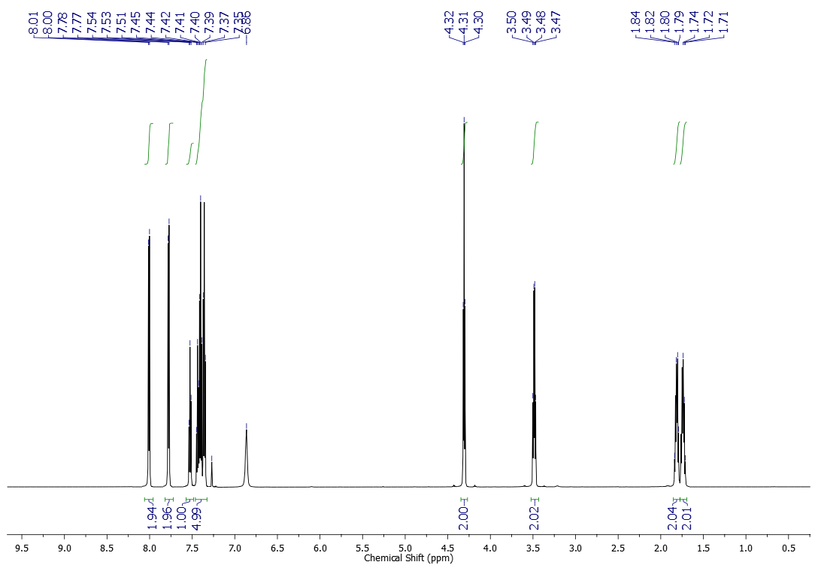



13C NMR (151 MHz, CDCl3) spectrum of compound **1a**

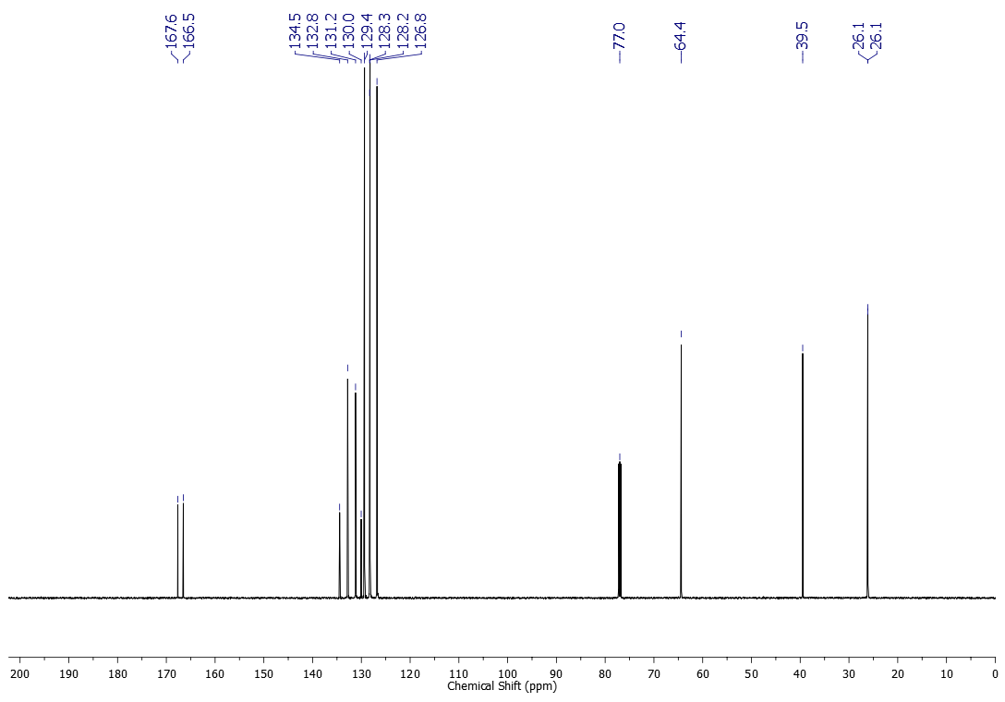



1H NMR (500 MHz, CDCl3) spectrum of compound **1b**

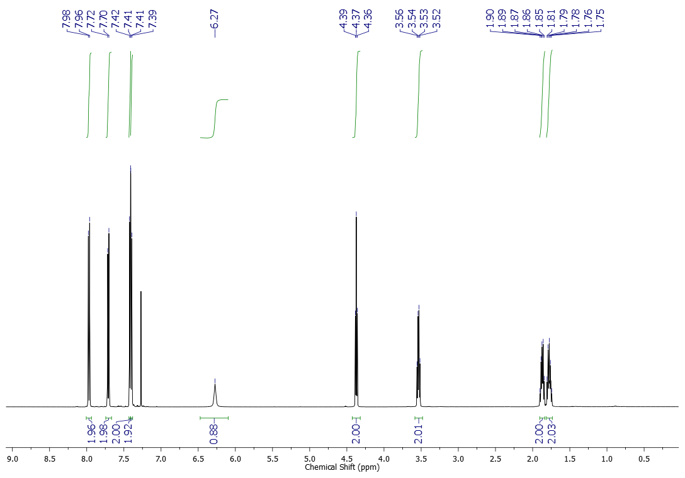



13C NMR (125 MHz, CDCl3) spectrum of compound **1b**

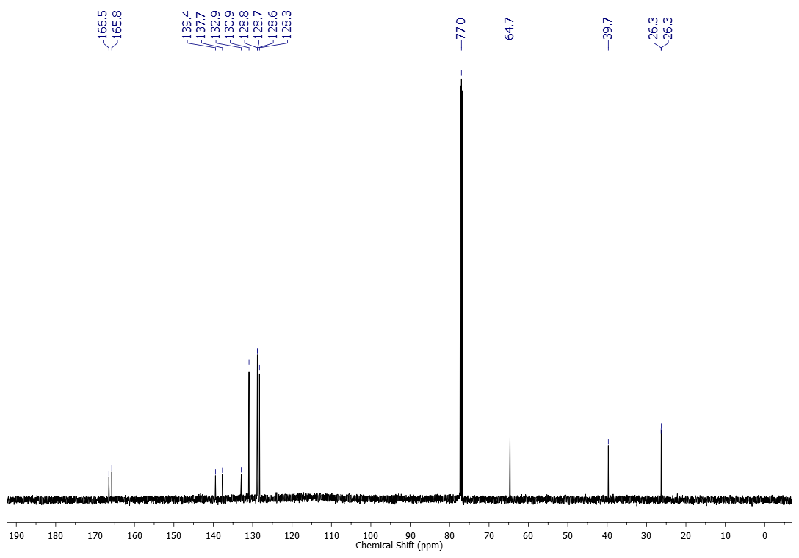



1H NMR (500 MHz, CDCl3) spectrum of compound **1c**

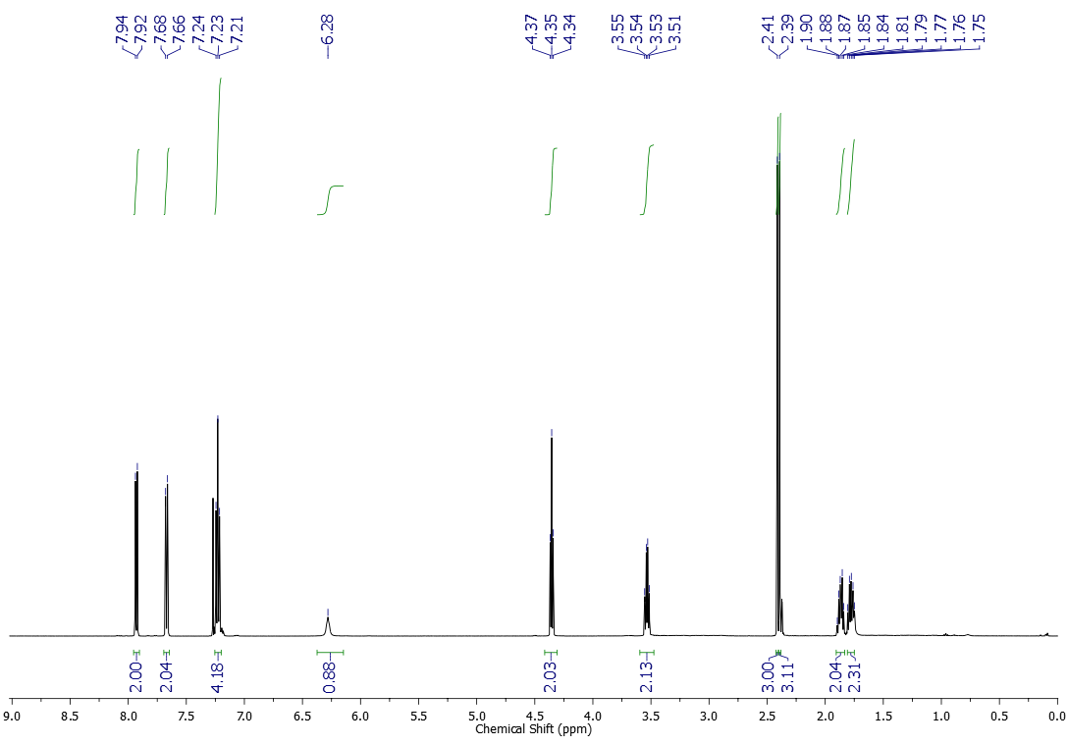



13C NMR (125 MHz, CDCl3) spectrum of compound **1c**

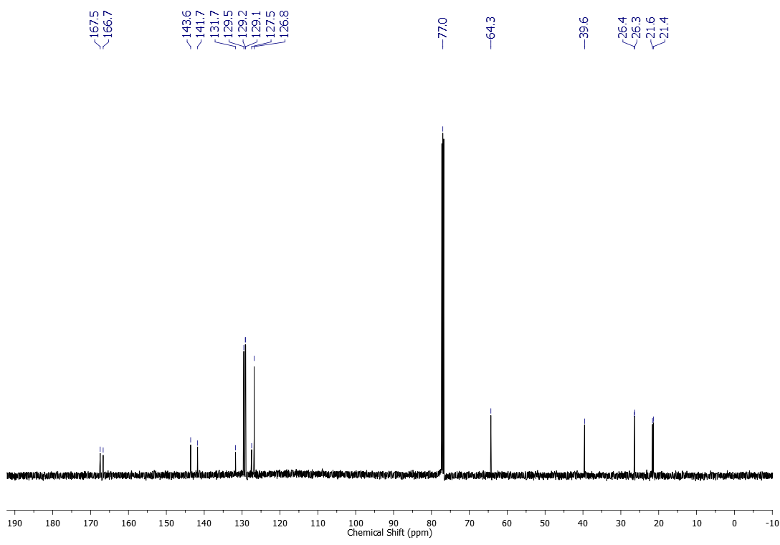



1H NMR (500 MHz, CDCl3) spectrum of compound **1d**

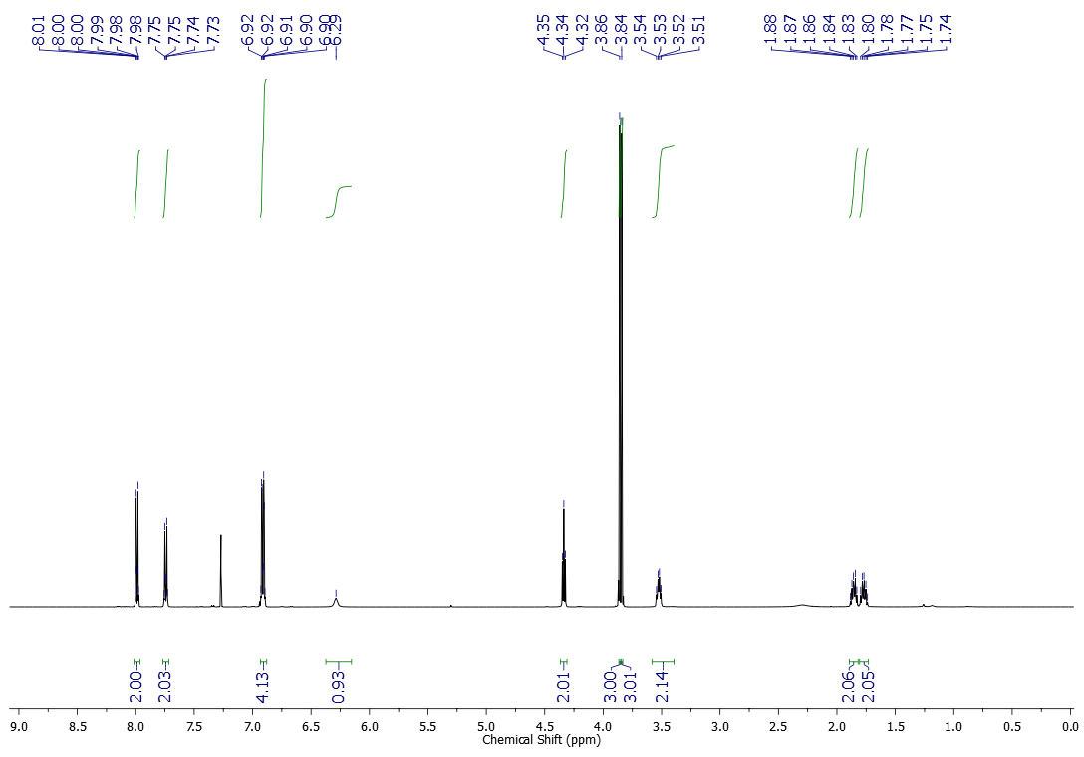



13C NMR (125 MHz, CDCl3) spectrum of compound **1d**

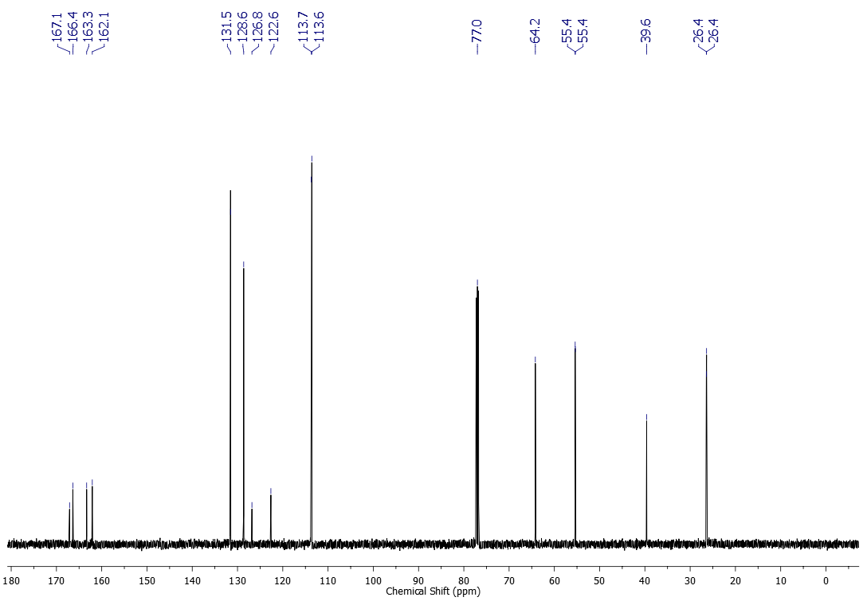



1H NMR (500 MHz, CDCl3) spectrum of compound **1e**

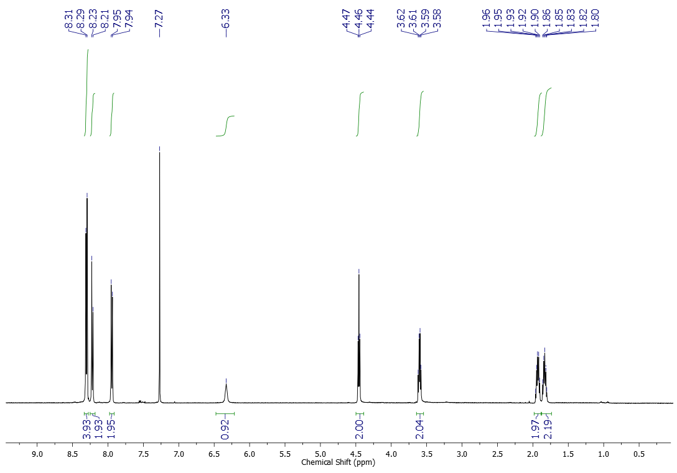



13C NMR (125 MHz, CDCl3) spectrum of compound **1e**

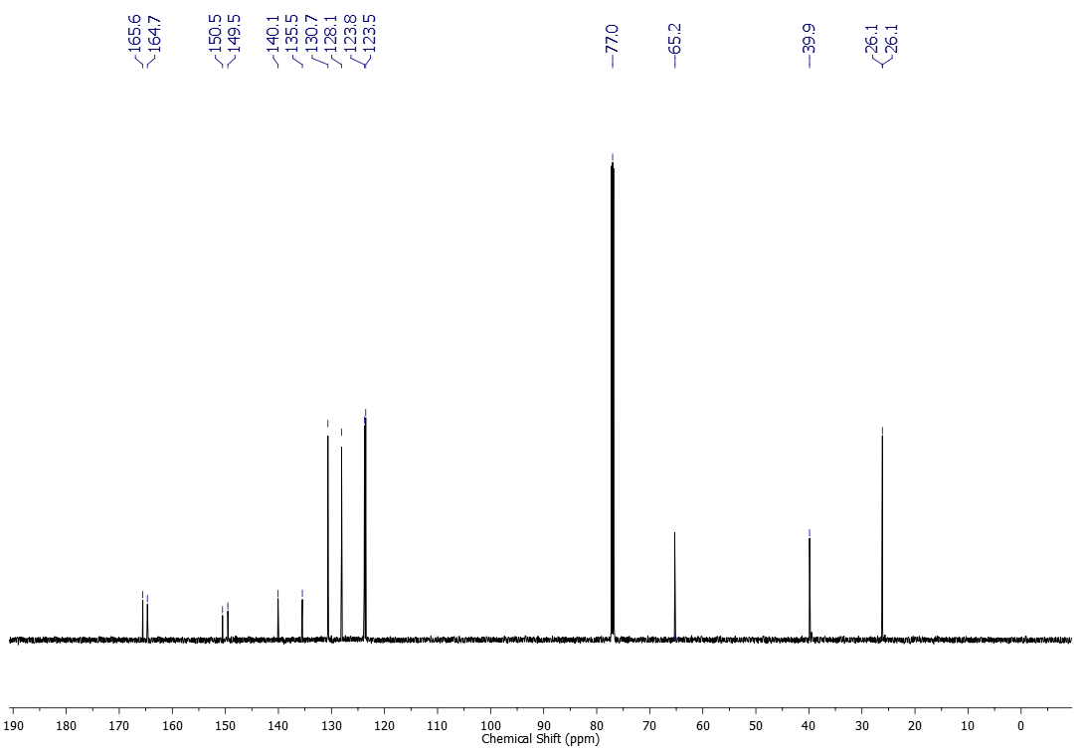



1H NMR (500 MHz, CDCl3) spectrum of compound **1f**

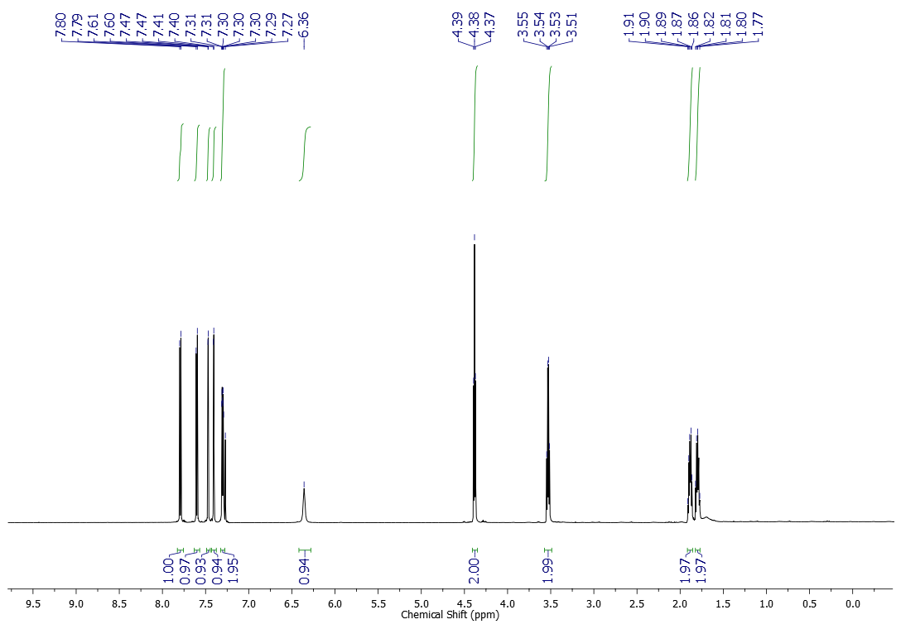



13C NMR (125 MHz, CDCl3) spectrum of compound **1f**

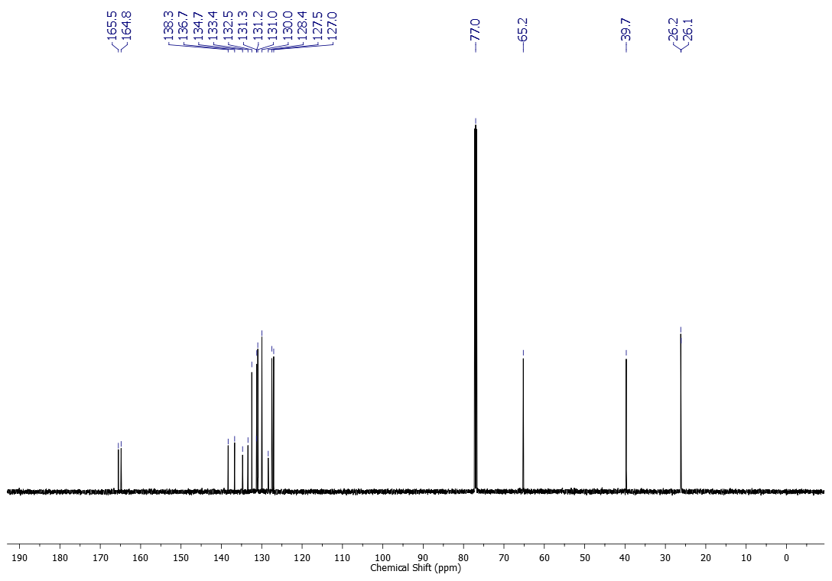



1H NMR (500 MHz, CDCl3) spectrum of compound **1g**

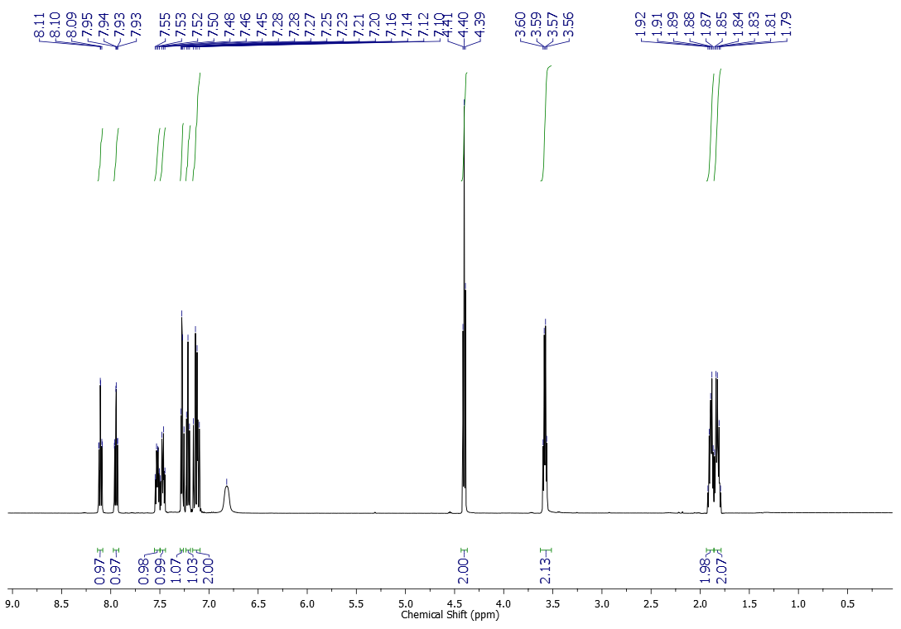



13C NMR (125 MHz, CDCl3) spectrum of compound **1g**

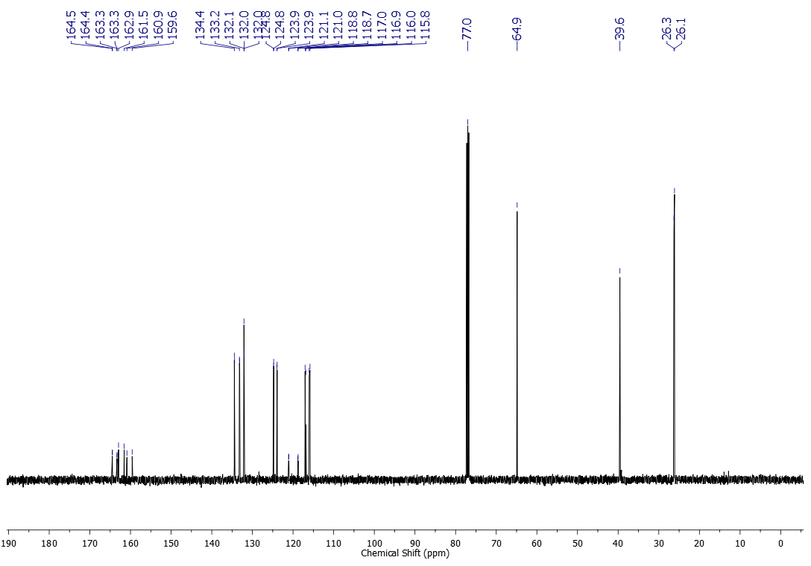



1H NMR (600 MHz, CDCl3) spectrum of compound **1h**

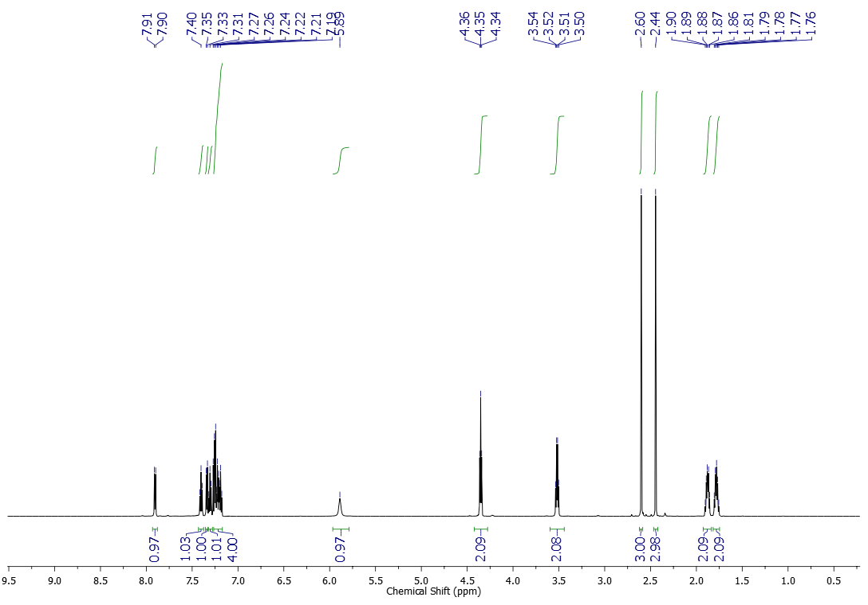



13C NMR (151 MHz, CDCl3) spectrum of compound **1h**

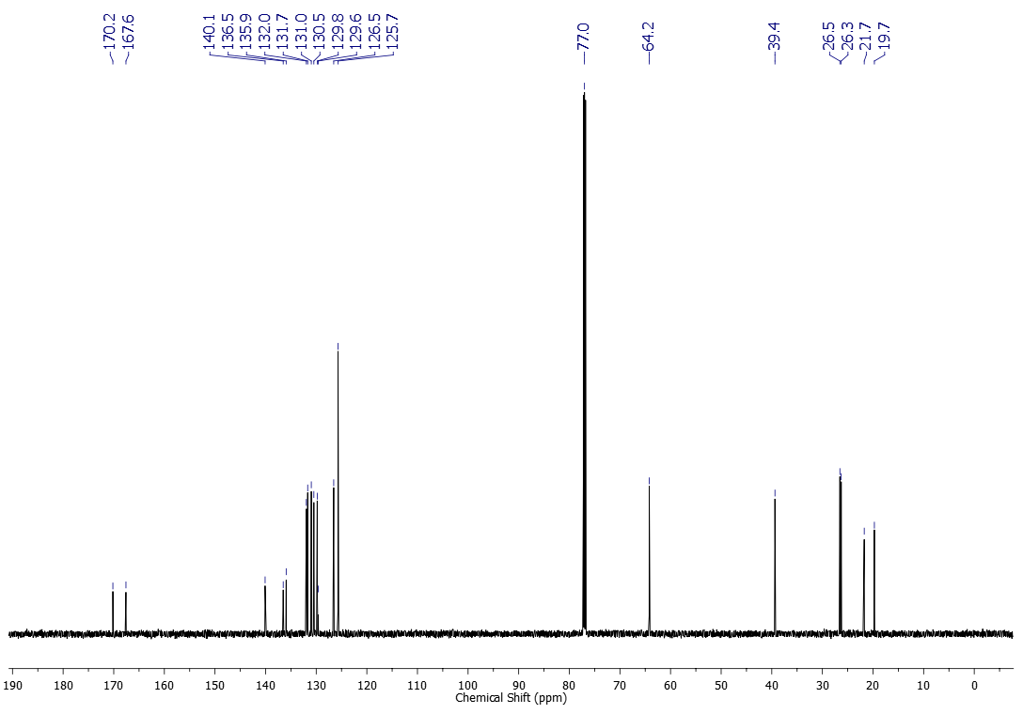



1H NMR (600 MHz, CDCl3) spectrum of compound **1i**

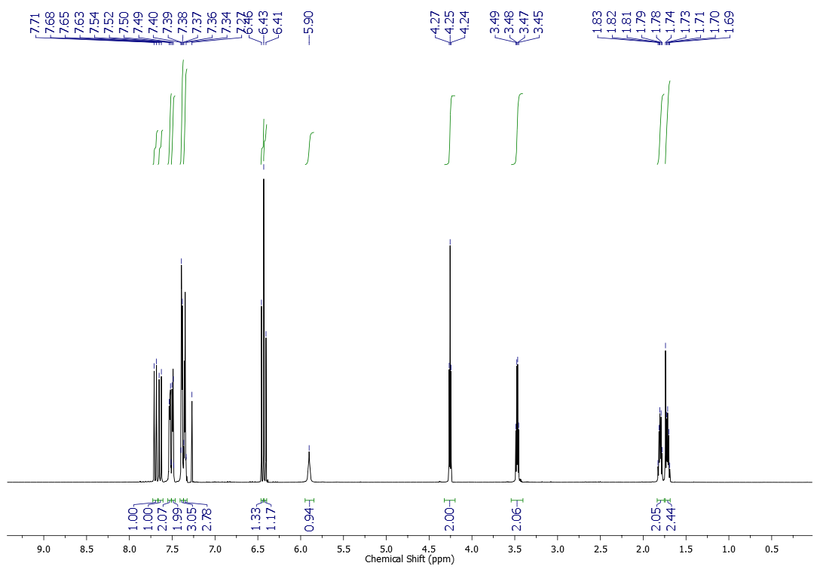



13C NMR (151 MHz, CDCl3) spectrum of compound **1i**

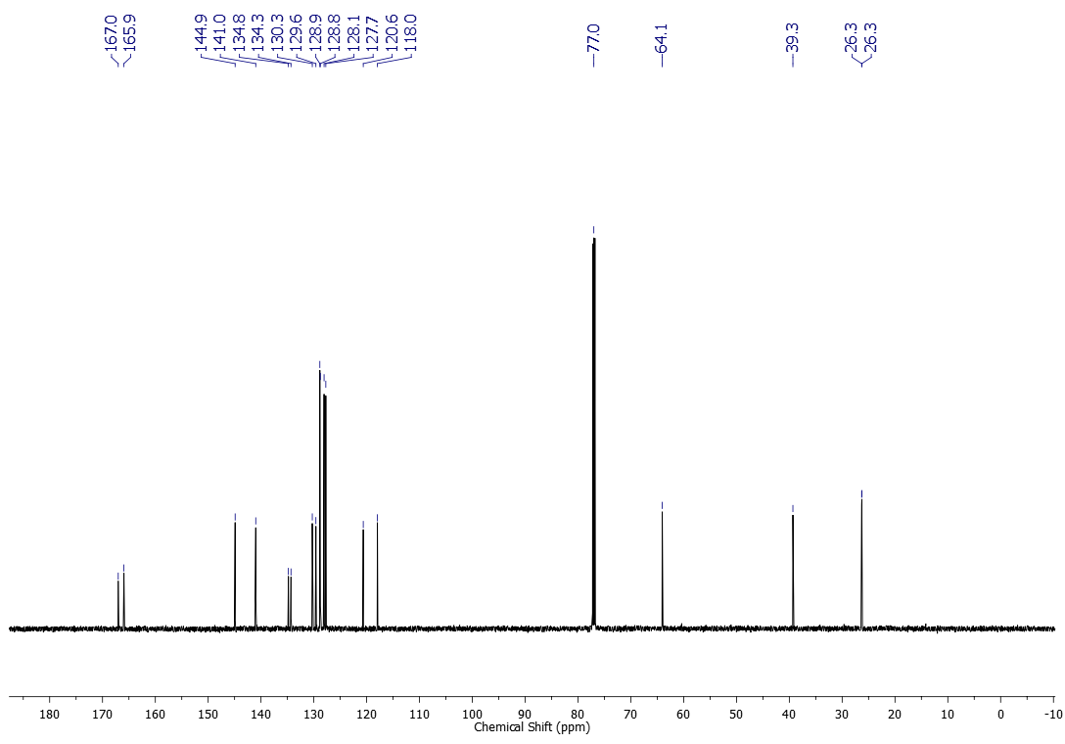



1H NMR (600 MHz, CDCl3) spectrum of compound **1j**

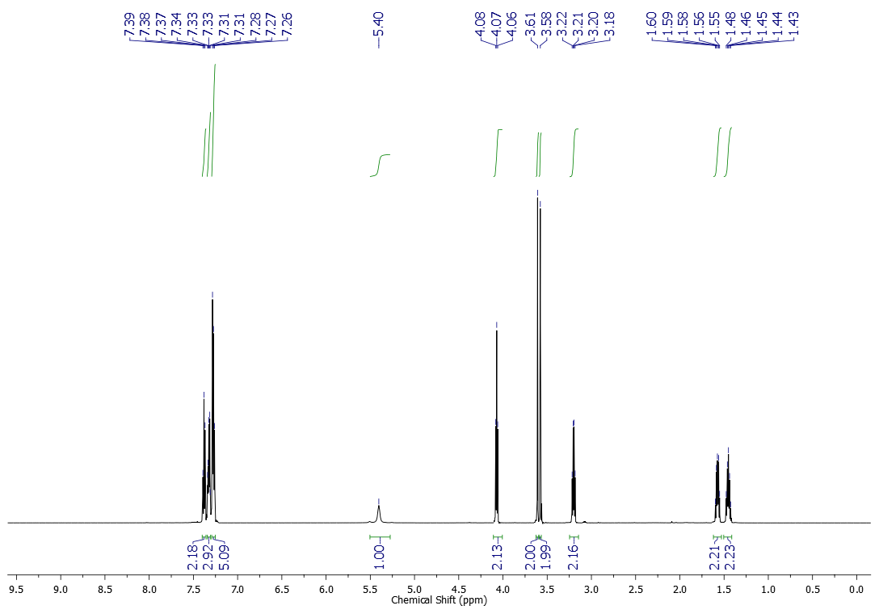



13C NMR (151 MHz, CDCl3) spectrum of compound **1j**

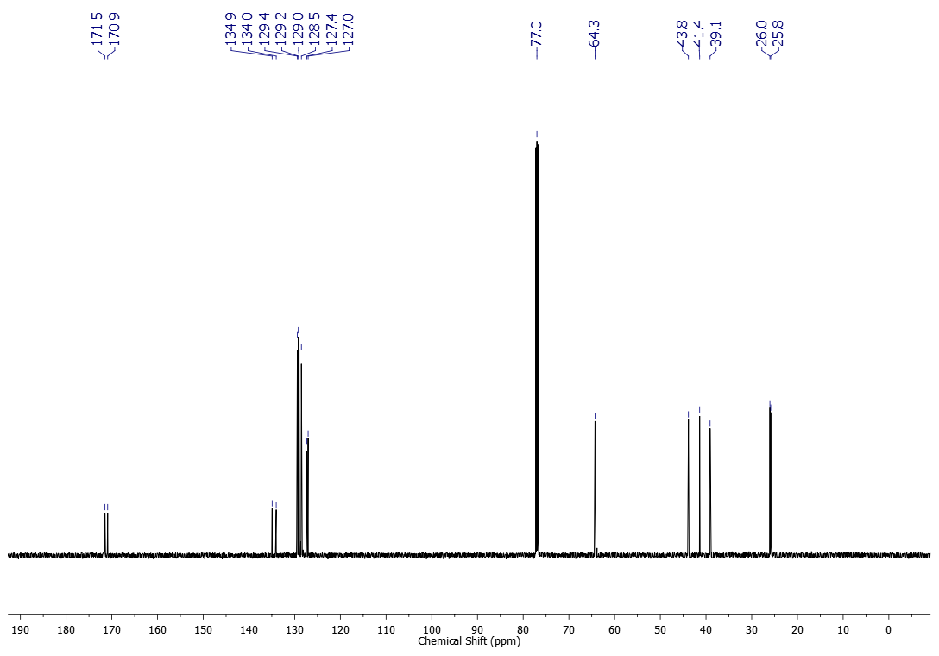



1H NMR (600 MHz, CDCl3) spectrum of compound **1k**

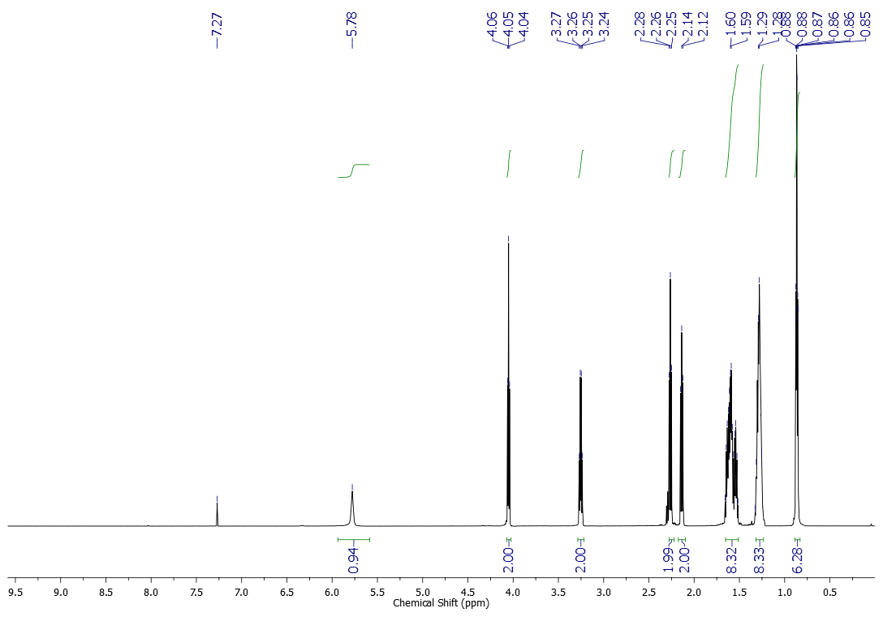



13C NMR (151 MHz, CDCl3) spectrum of compound **1k**

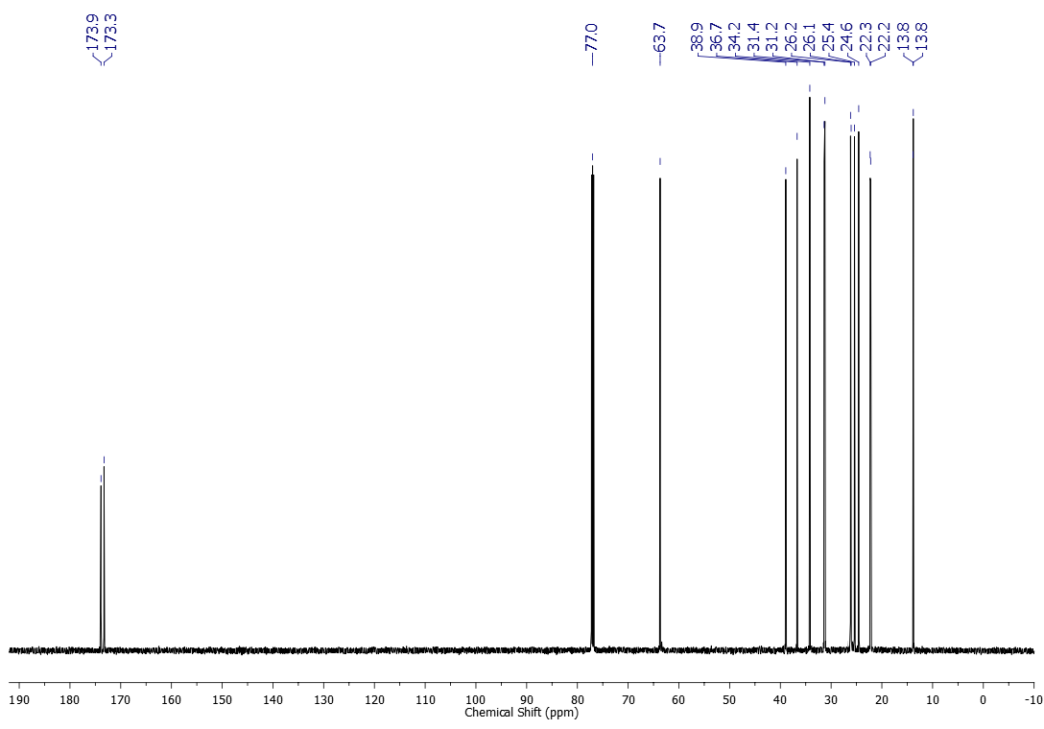



1H NMR (600 MHz, CDCl3) spectrum of compound **1l**

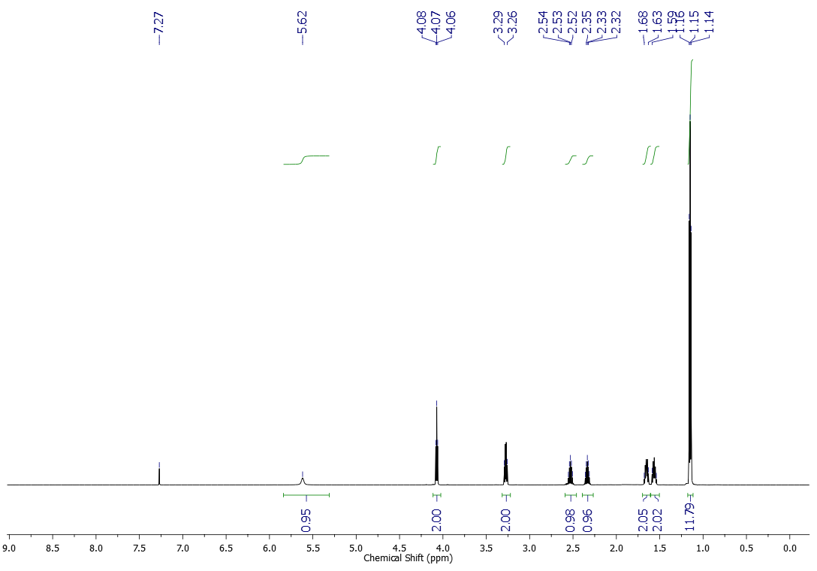



13C NMR (151 MHz, CDCl3) spectrum of compound **1l**

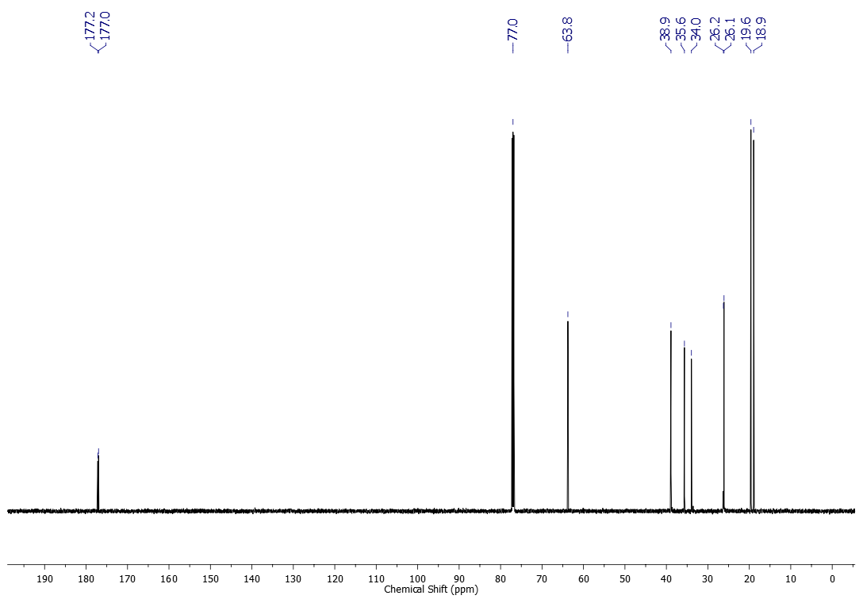



1H NMR (600 MHz, CDCl3) spectrum of compound **1m**

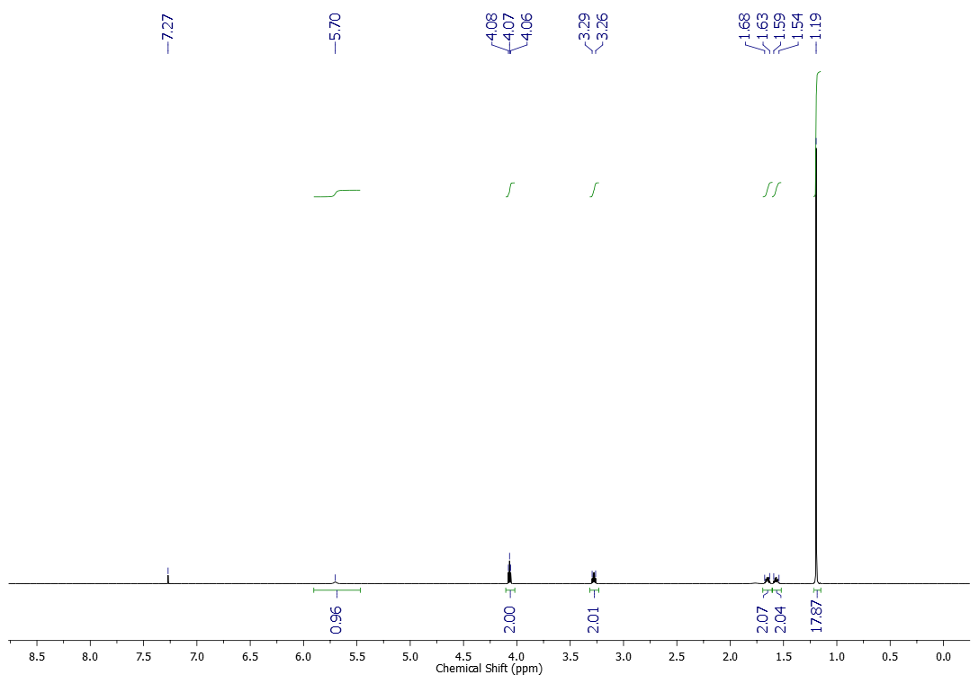



13C NMR (151 MHz, CDCl3) spectrum of compound **1m**

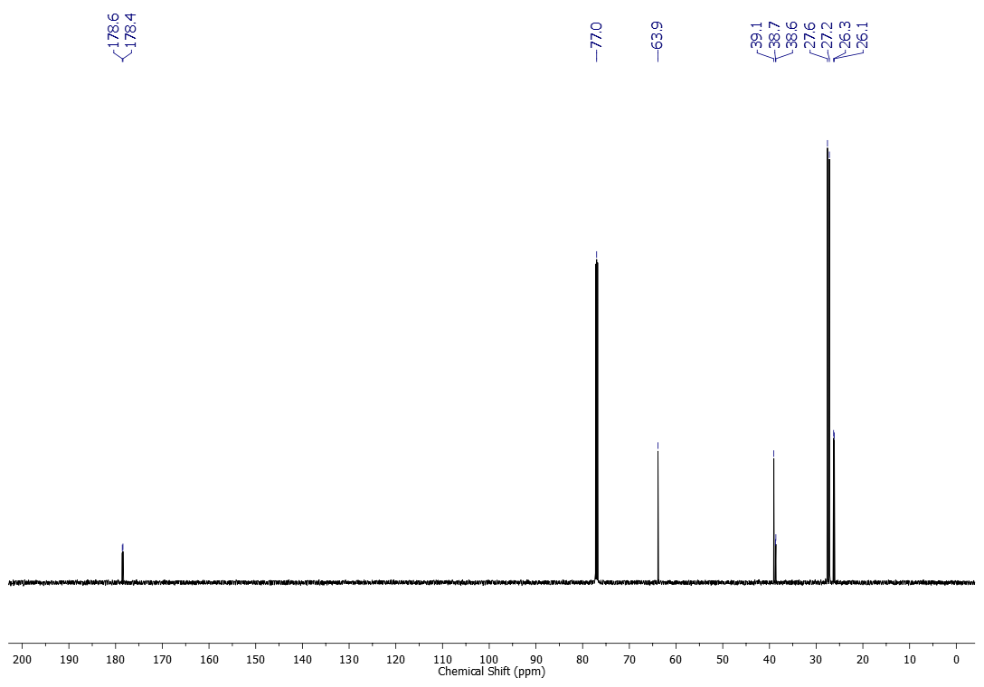



1H NMR (600 MHz, CDCl3) spectrum of compound **2a**

**C508 HRMN Fenil**



13C NMR (151 MHz, CDCl3) spectrum of compound **2a**

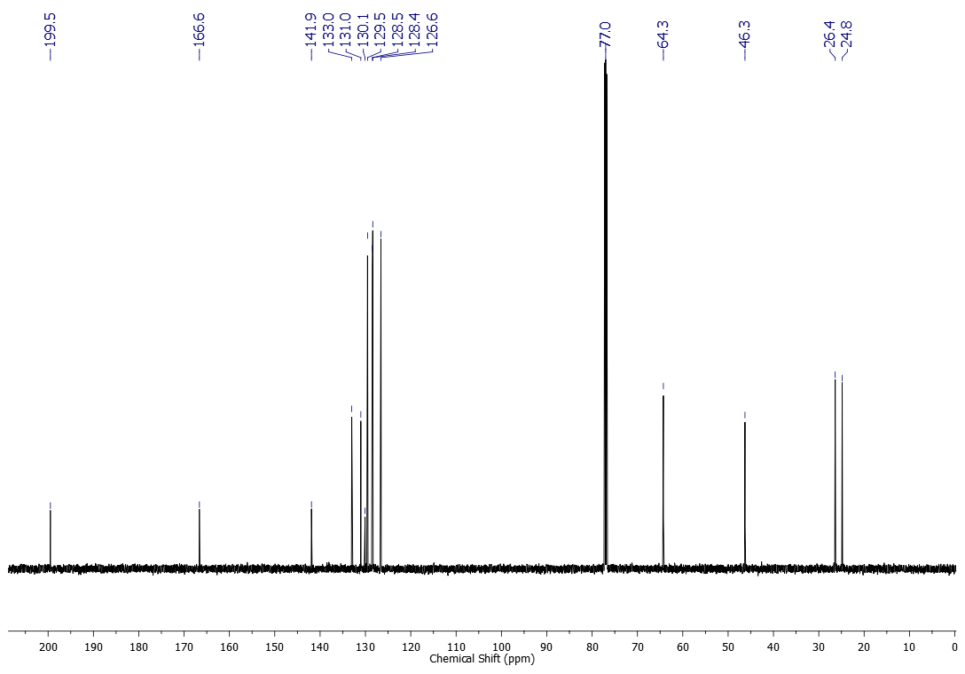



1H NMR (500 MHz, CDCl3) spectrum of compound **2b**

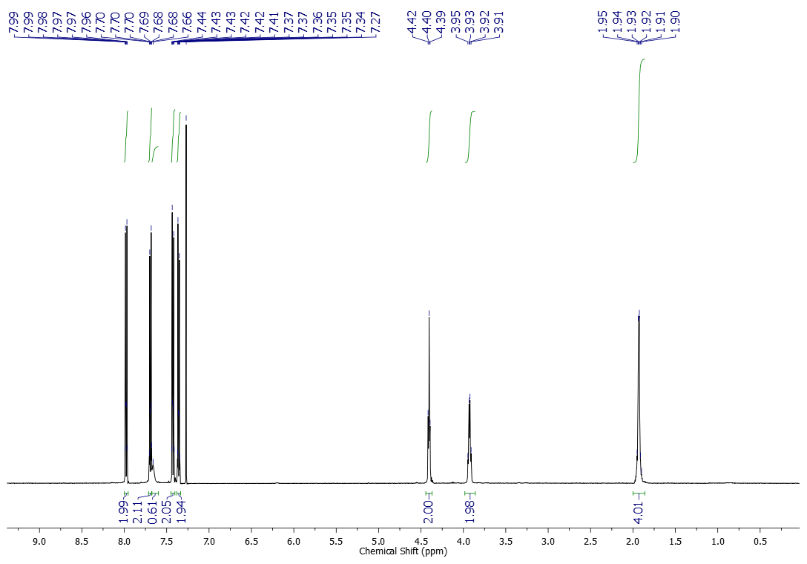



13C NMR (125 MHz, CDCl3) spectrum of compound **2b**

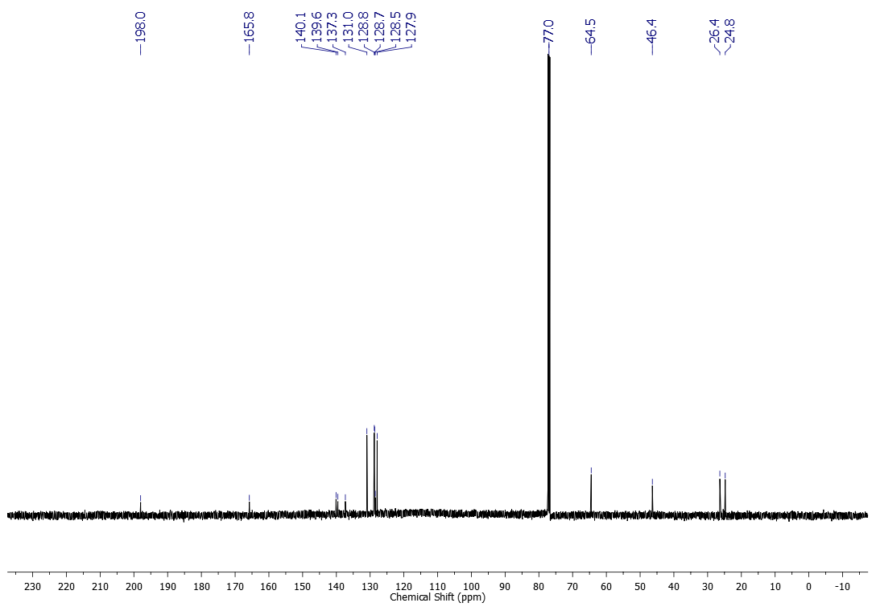



1H NMR (500 MHz, CDCl3) spectrum of compound **2c**

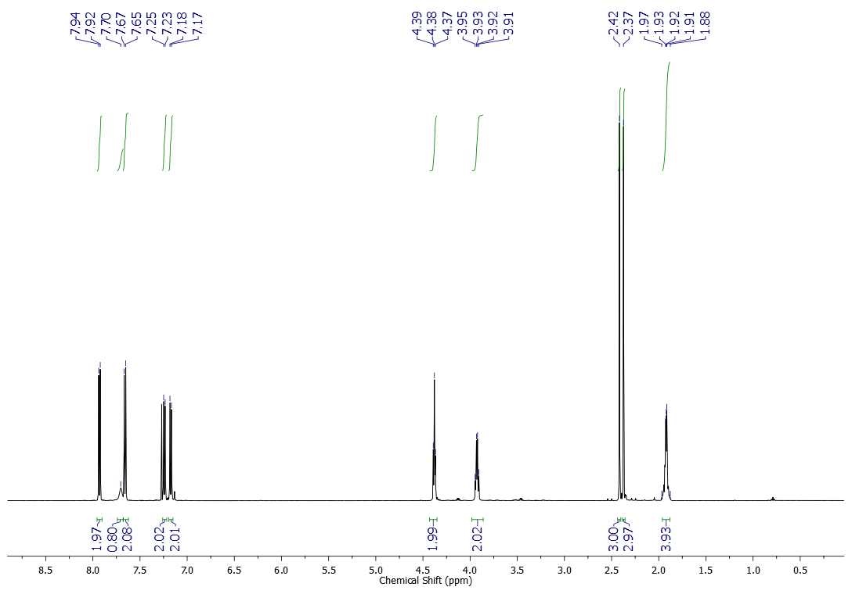



13C NMR (125 MHz, CDCl3) spectrum of compound **2c**

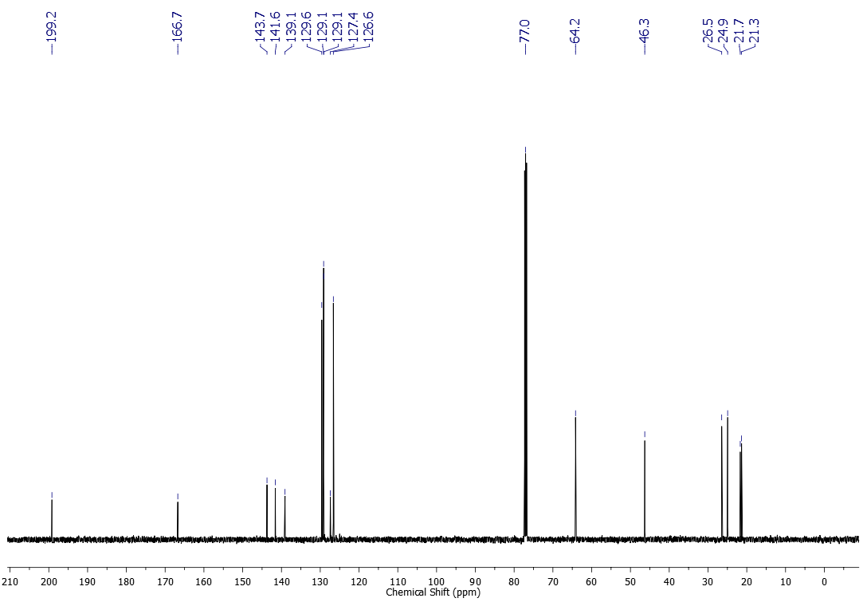



1H NMR (500 MHz, CDCl3) spectrum of compound **2d**

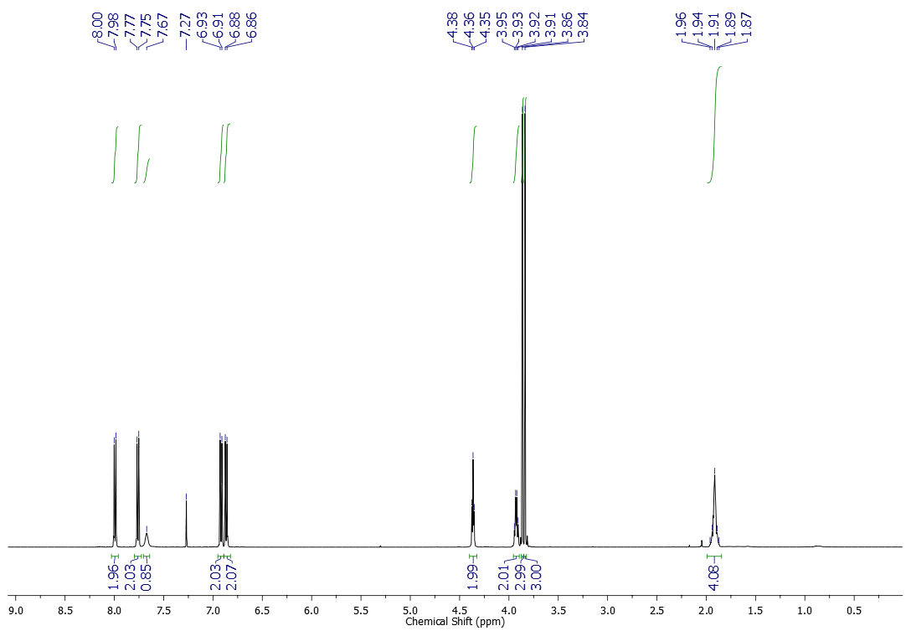



13C NMR (125 MHz, CDCl3) spectrum of compound **2d**

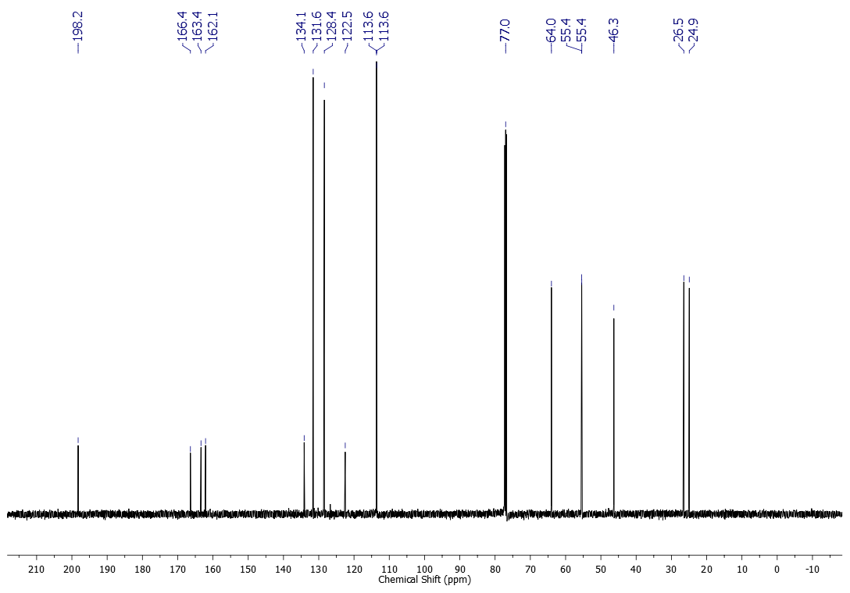



1H NMR (600 MHz, CDCl3) spectrum of compound **2e**

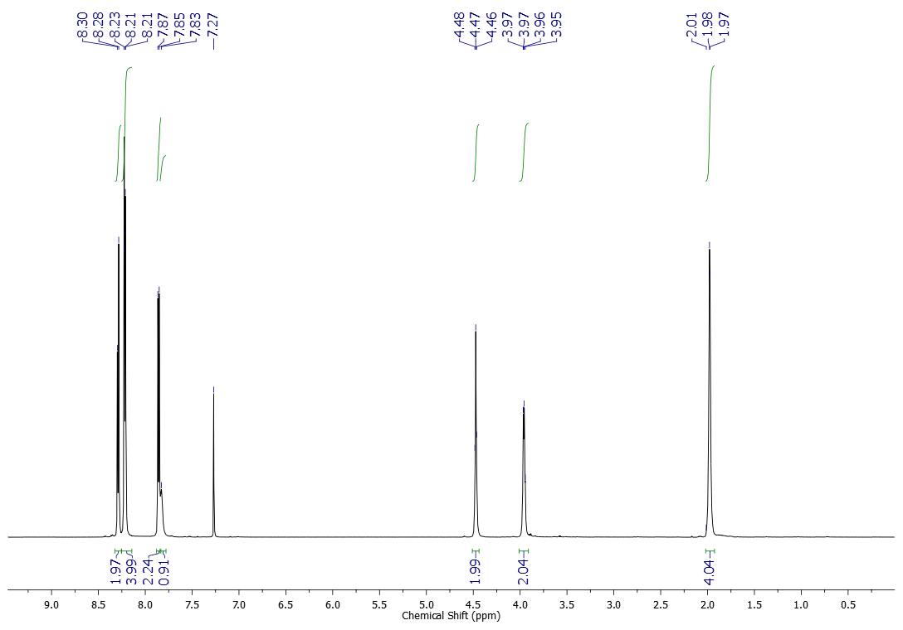



13C NMR (151 MHz, CDCl3) spectrum of compound **2e**

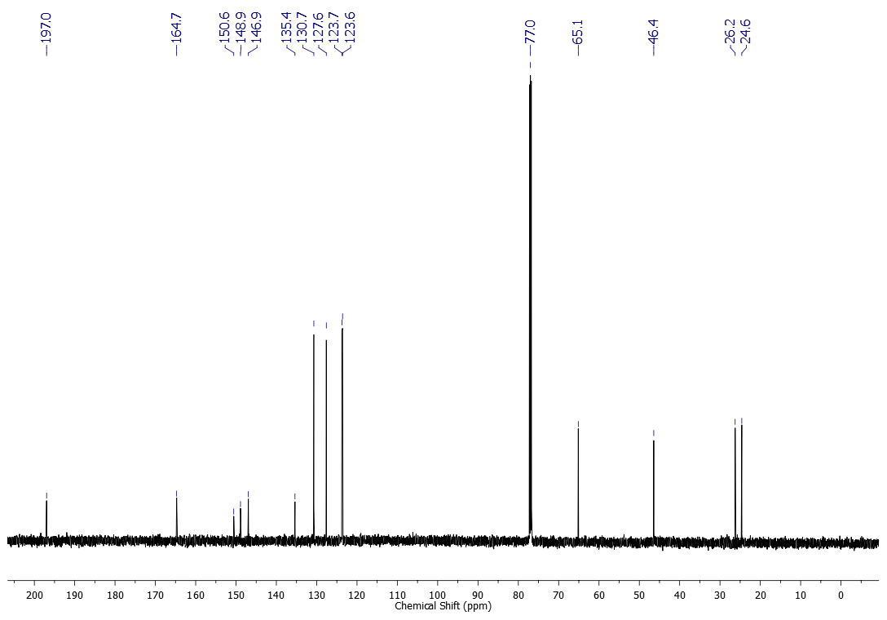



1H NMR (600 MHz, CDCl3) spectrum of compound **2f**

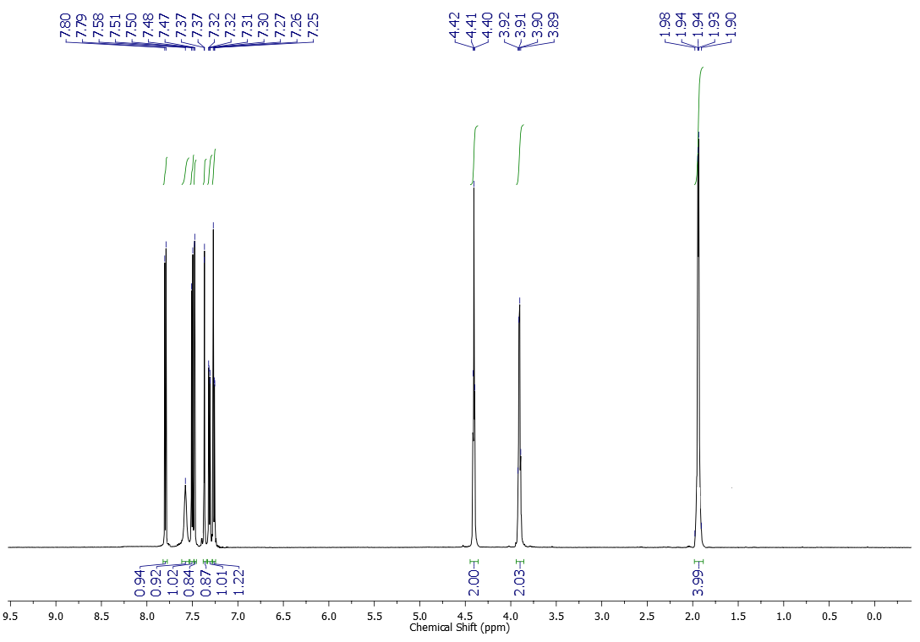



13C NMR (151 MHz, CDCl3) spectrum of compound **2f**

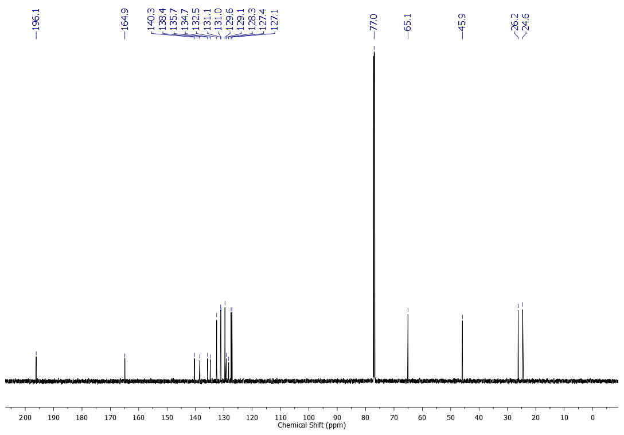



1H NMR (500 MHz, CDCl3) spectrum of compound **2g**

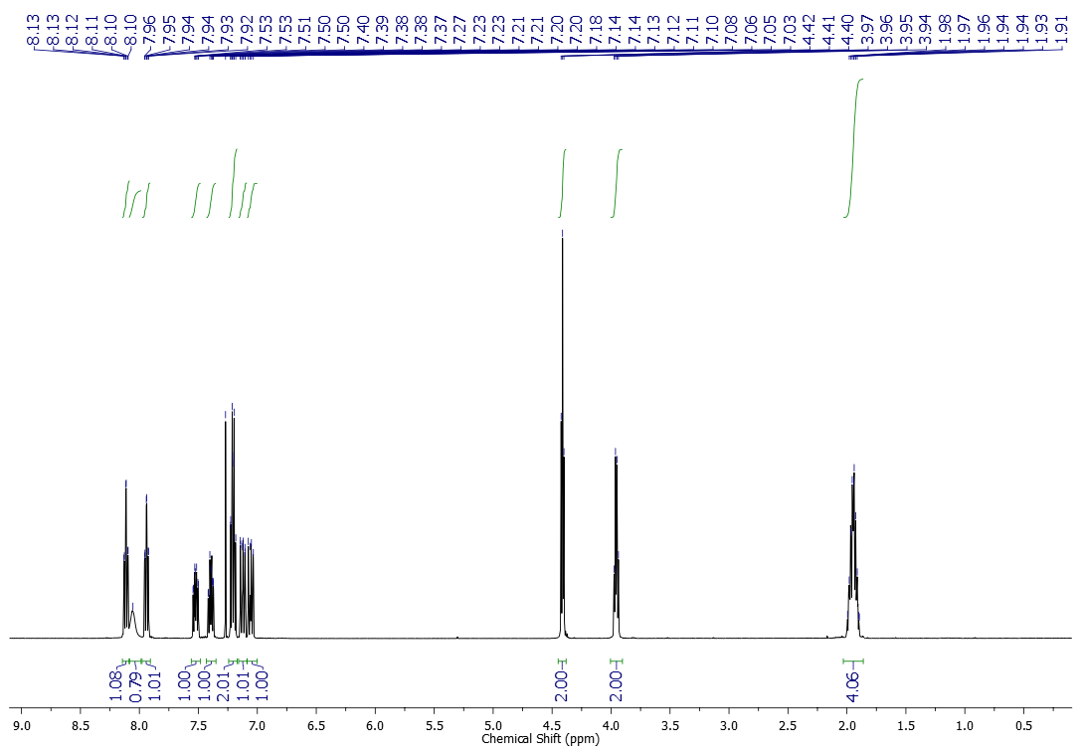



13C NMR (125 MHz, CDCl3) spectrum of compound **2g**

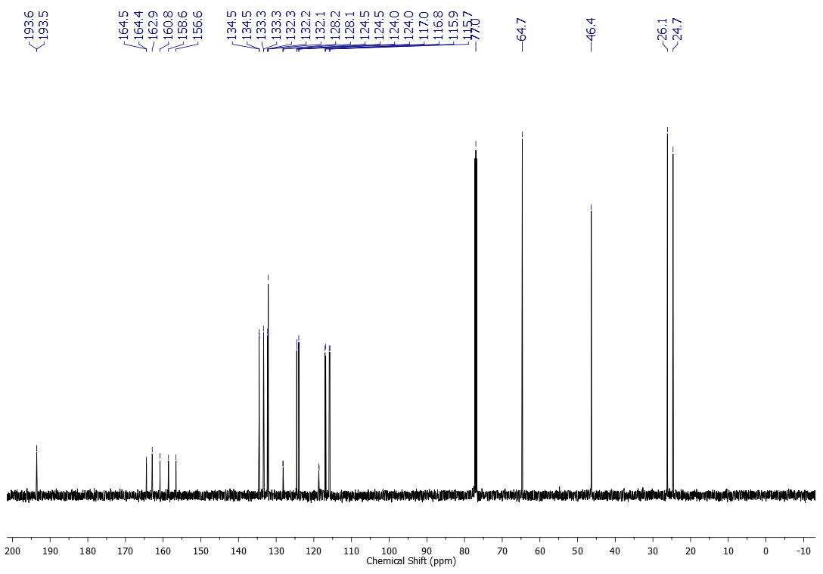



1H NMR (500 MHz, CDCl3) spectrum of compound **2h**

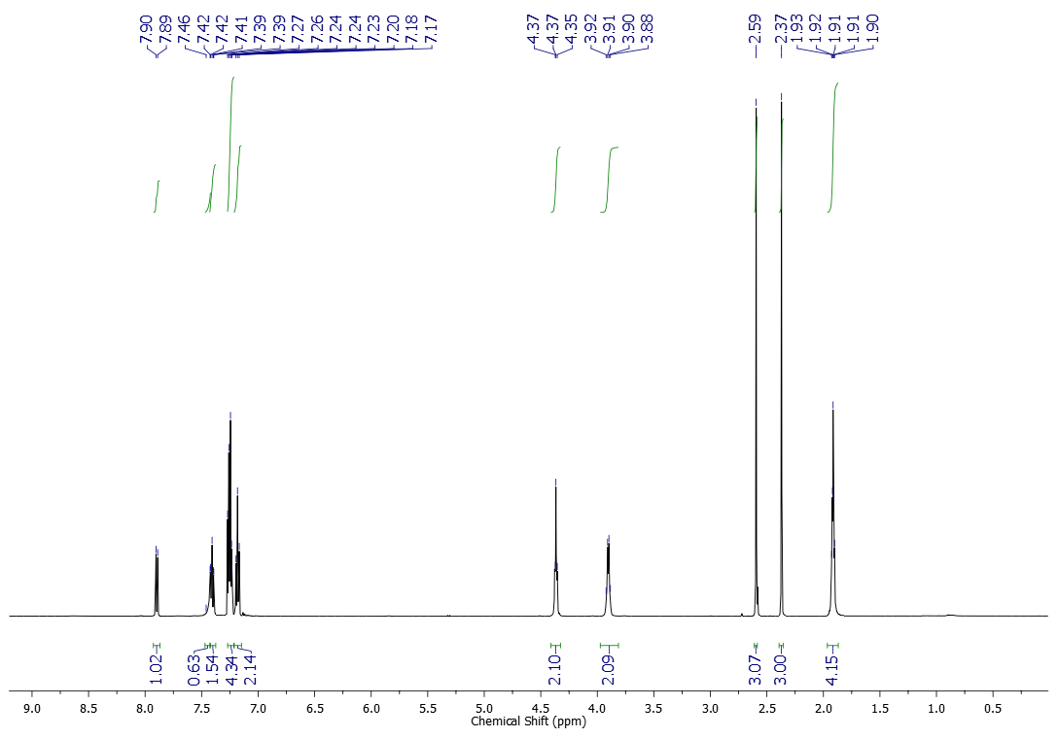



13C NMR (125 MHz, CDCl3) spectrum of compound **2h**

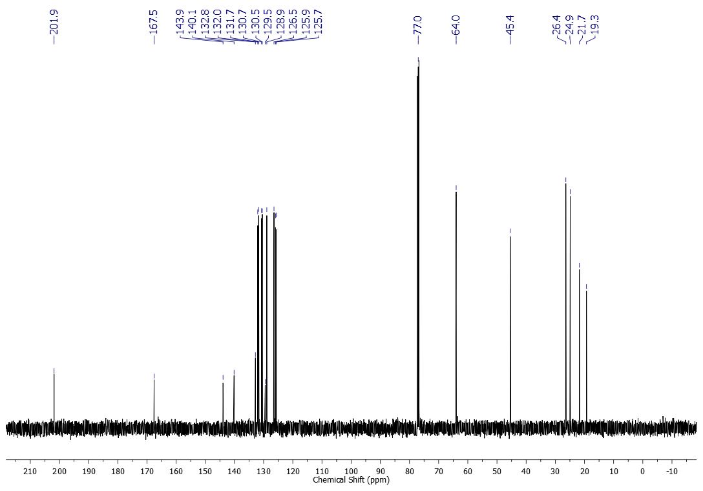



1H NMR (600 MHz, CDCl3) spectrum of compound **2i**

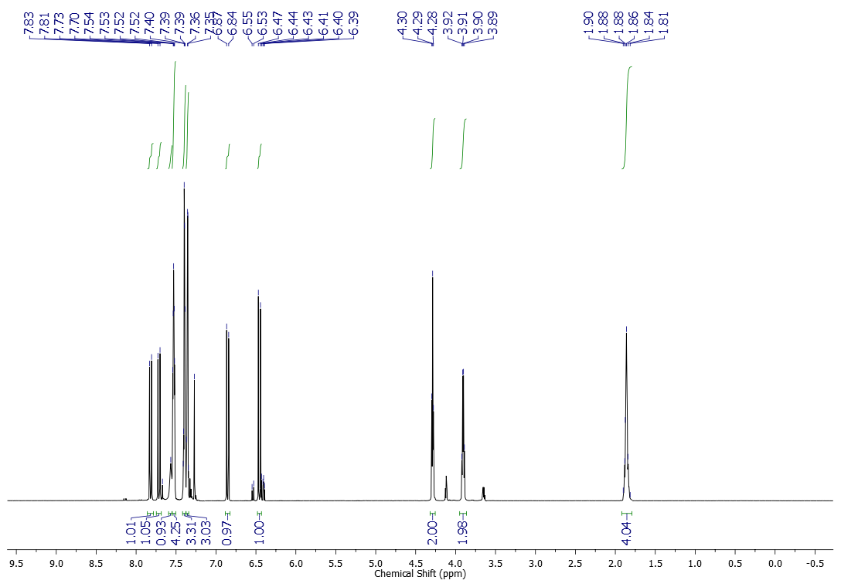



13C NMR (151 MHz, CDCl3) spectrum of compound **2i**

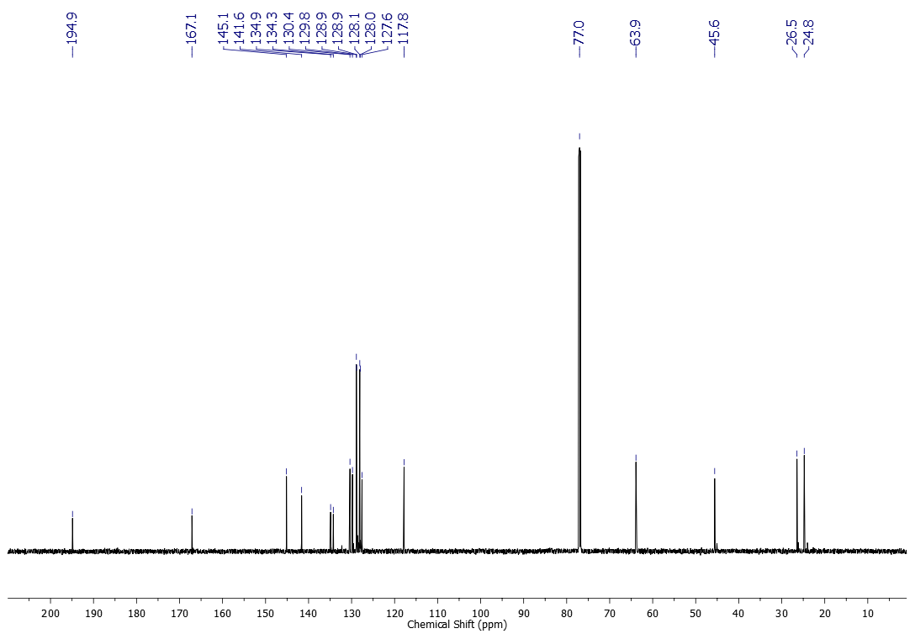



1H NMR (600 MHz, CDCl3) spectrum of compound **2j**

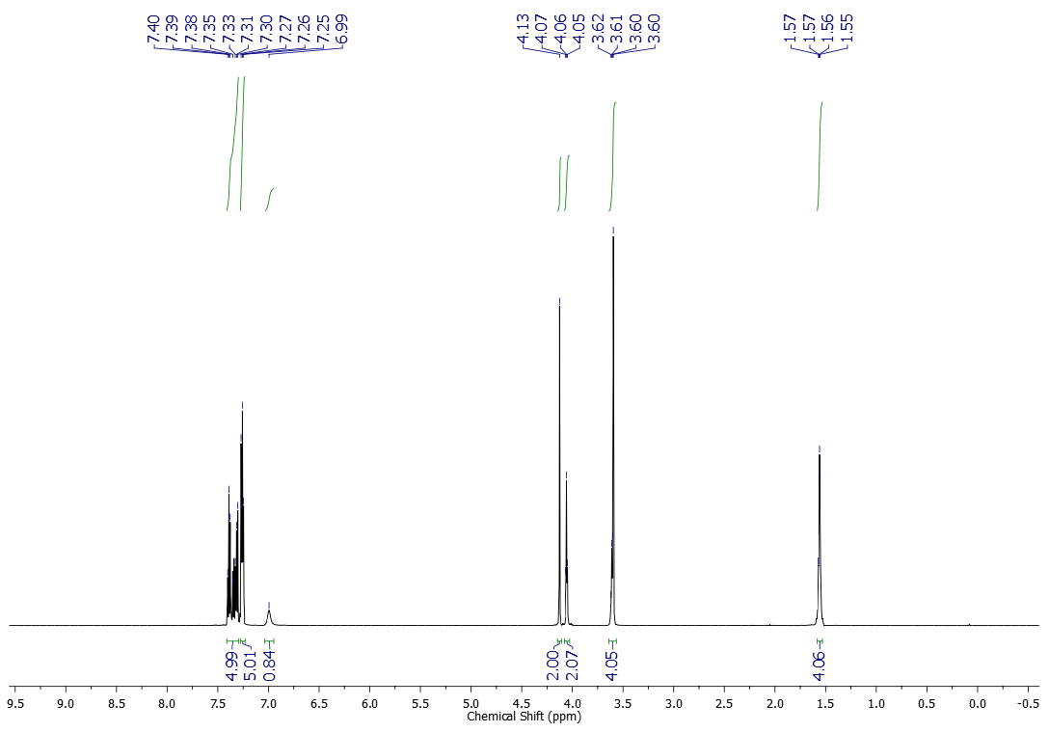



13C NMR (151 MHz, CDCl3) spectrum of compound **2j**

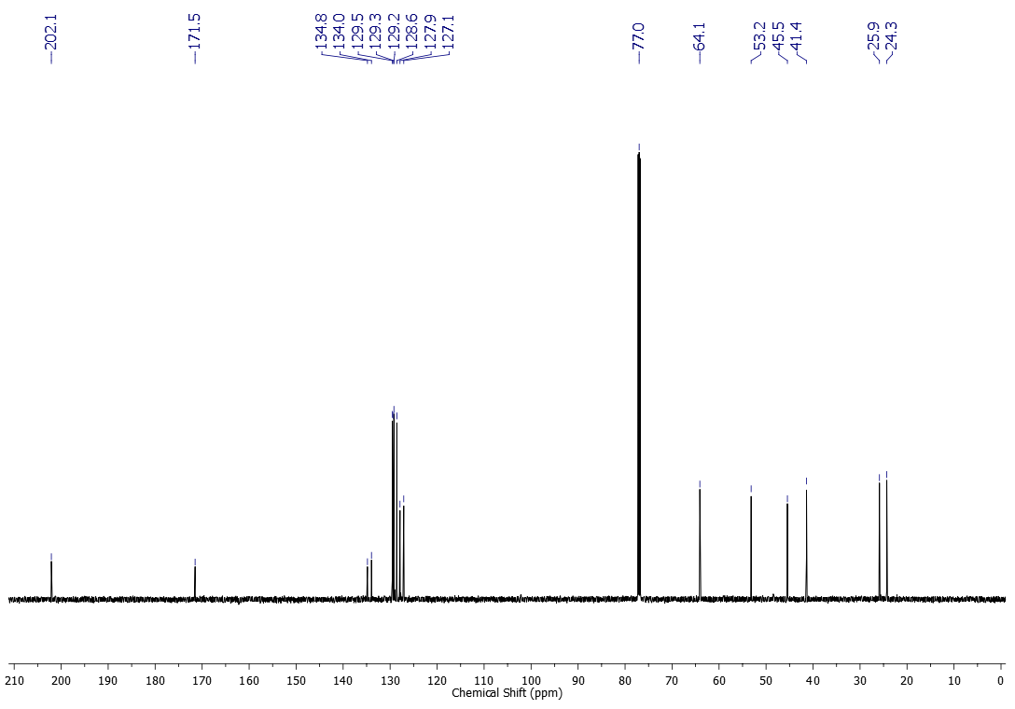



1H NMR (600 MHz, CDCl3) spectrum of compound **2k**

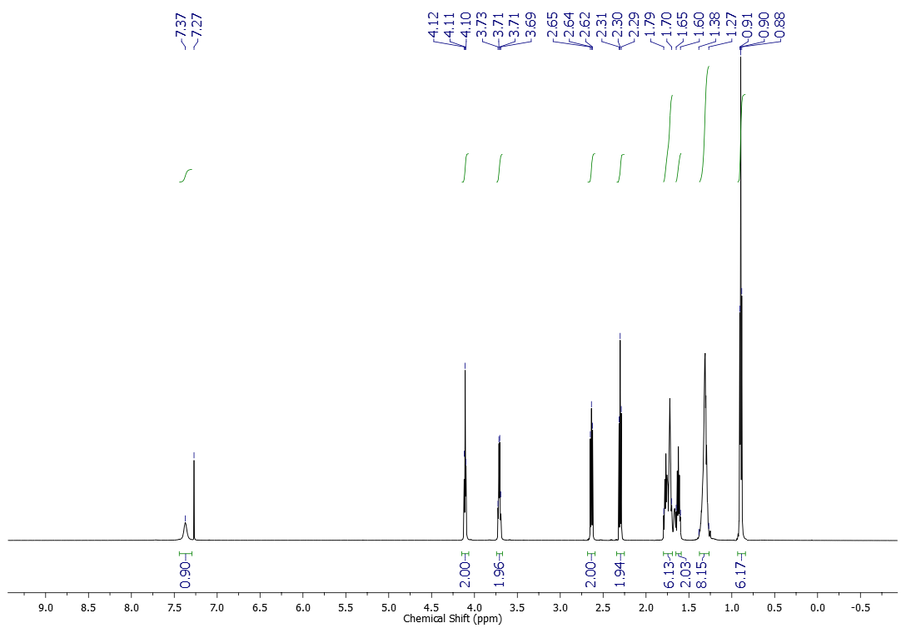



13C NMR (151 MHz, CDCl3) spectrum of compound **2k**

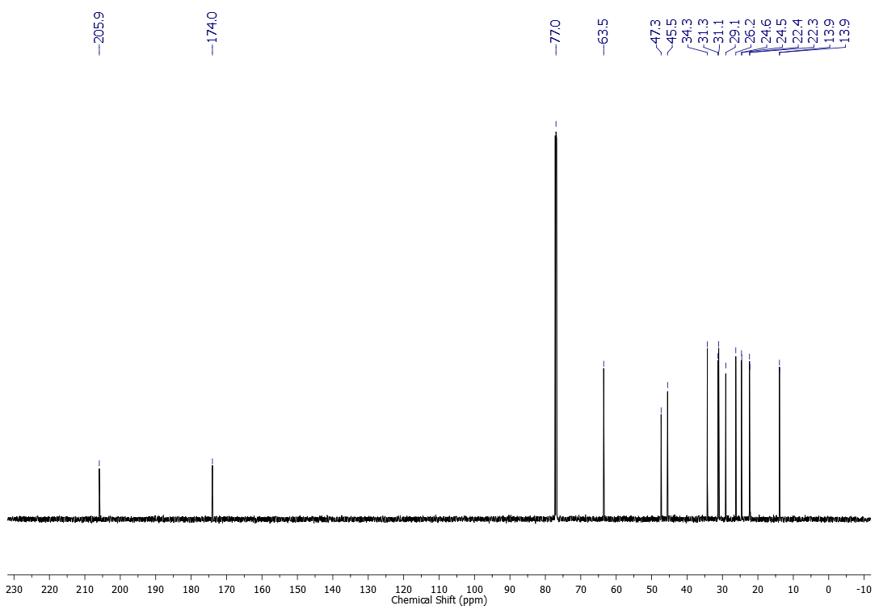



1H NMR (600 MHz, CDCl3) spectrum of compound **2l**

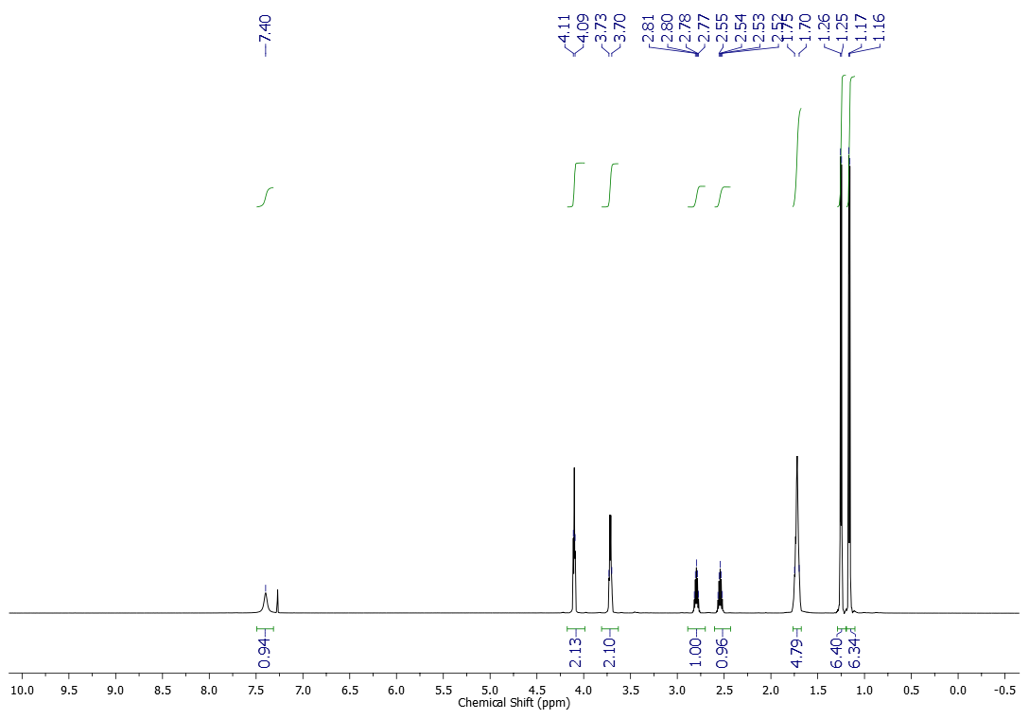



13C NMR (151 MHz, CDCl3) spectrum of compound **2l**

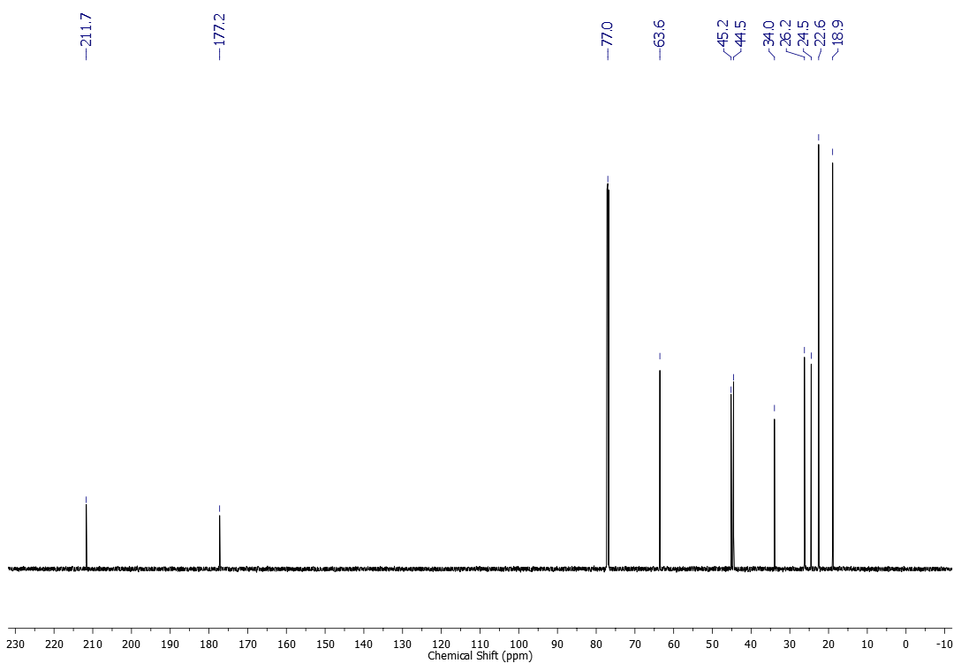



1H NMR (600 MHz, CDCl3) spectrum of compound **2m**

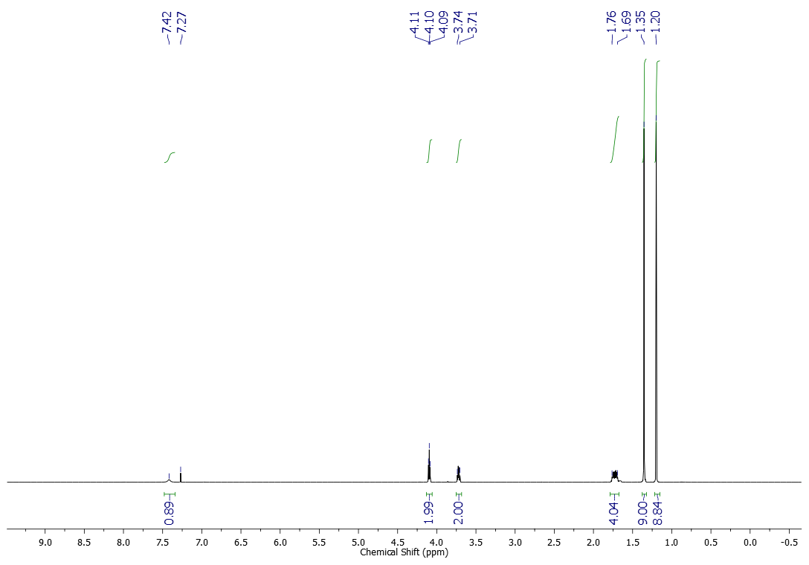



13C NMR (151 MHz, CDCl3) spectrum of compound **2m**

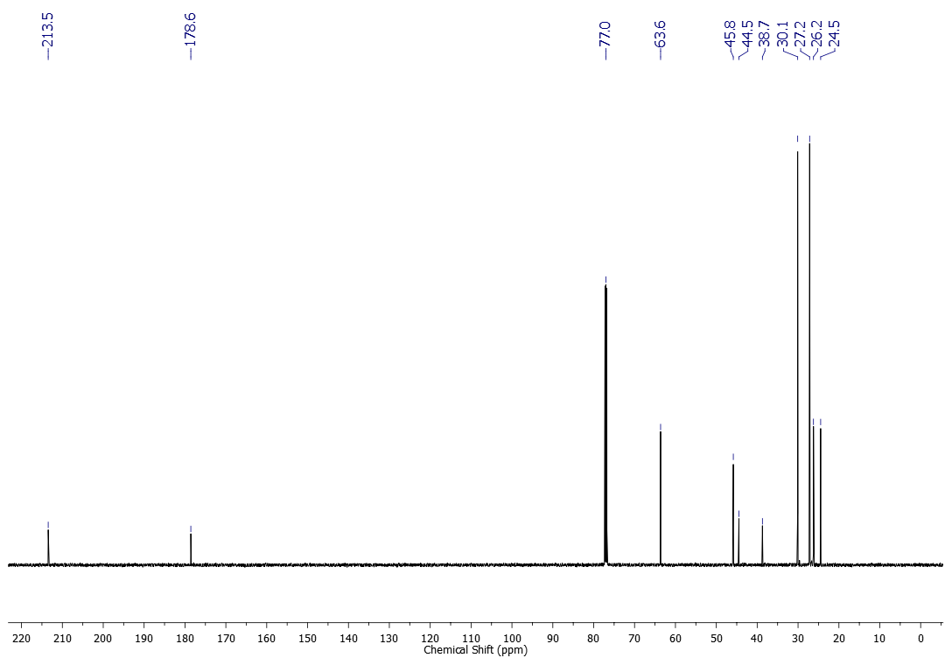



1H NMR (600 MHz, CDCl3) spectrum of compound **3a**

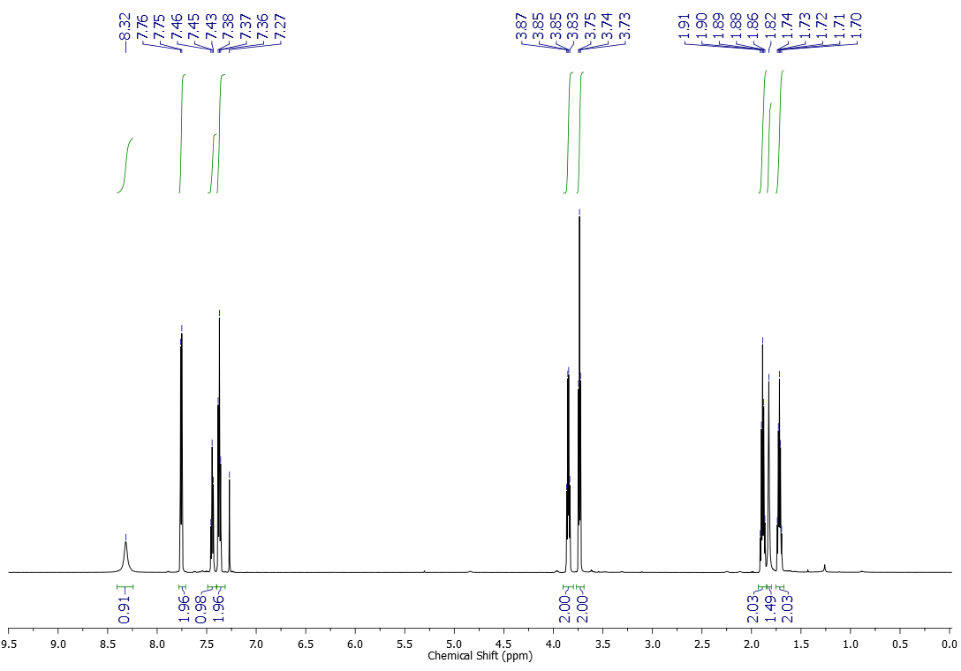



1H NMR (500 MHz, CDCl3) spectrum of compound **3b**

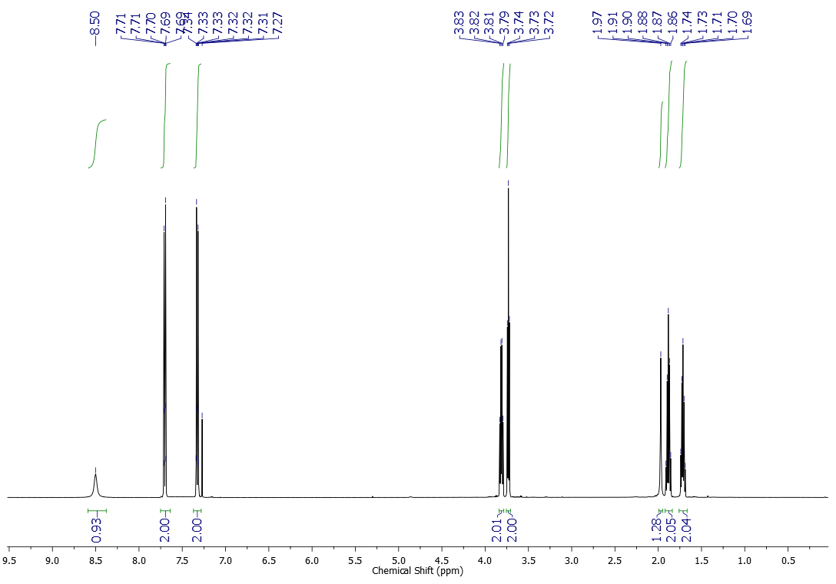



13C NMR (125 MHz, CDCl3) spectrum of compound **3b**

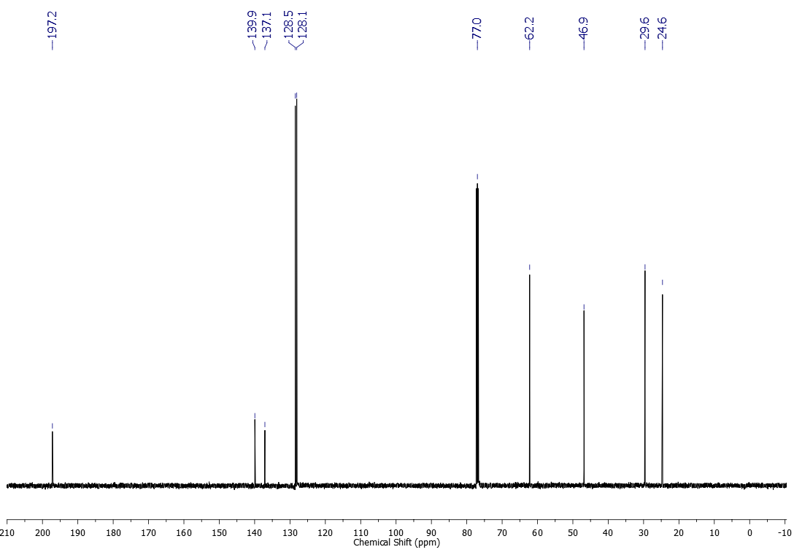



1H NMR (500 MHz, CDCl3) spectrum of compound **3c**

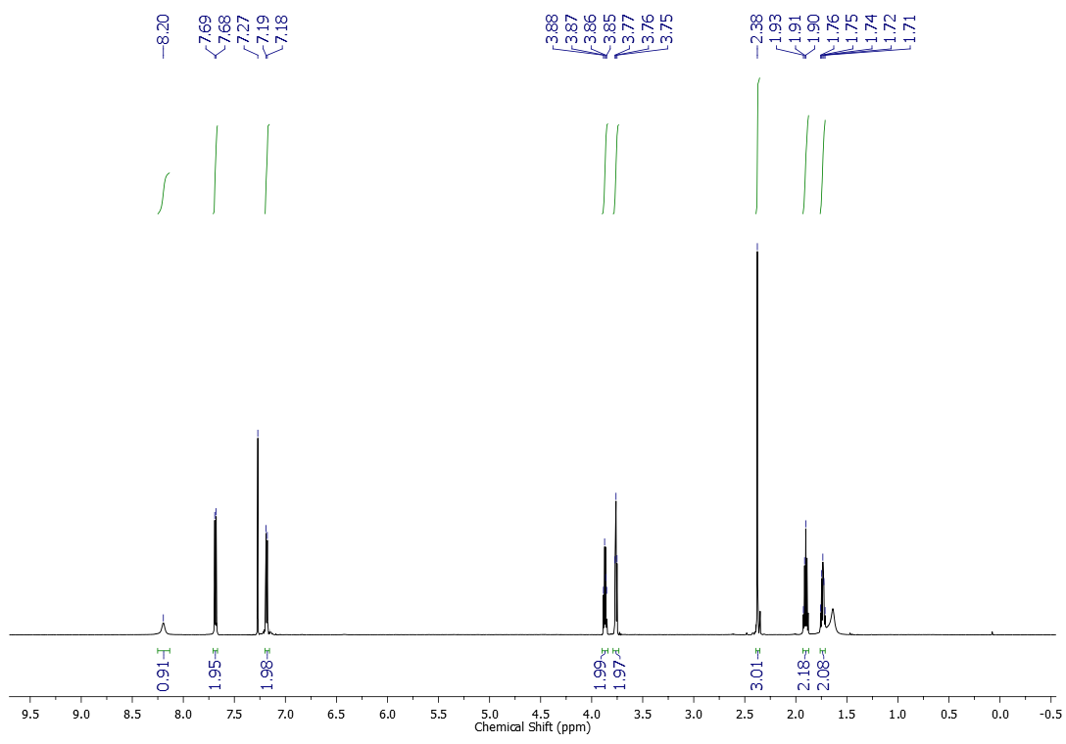



13C NMR (125 MHz, CDCl3) spectrum of compound **3c**

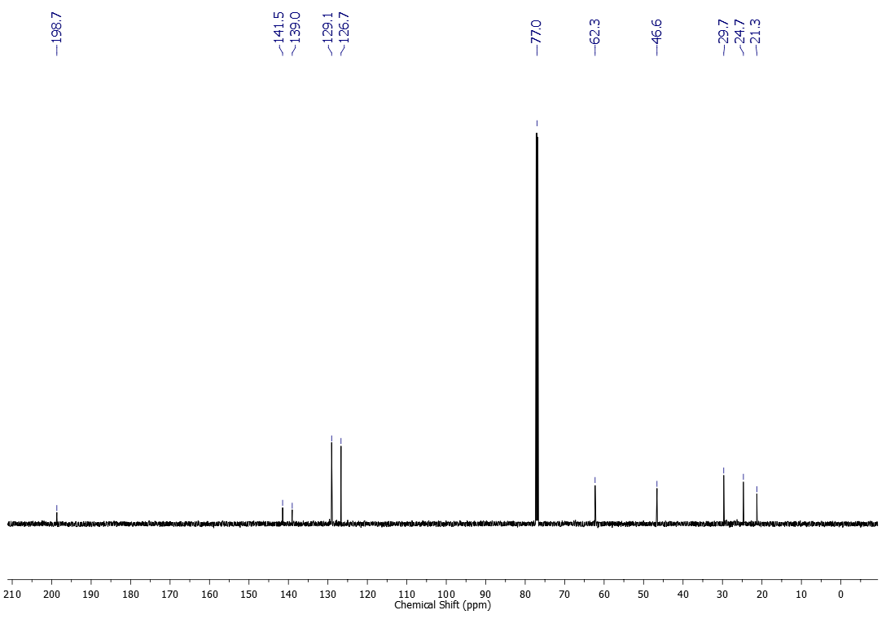



1H NMR (500 MHz, CDCl3) spectrum of compound **3d**

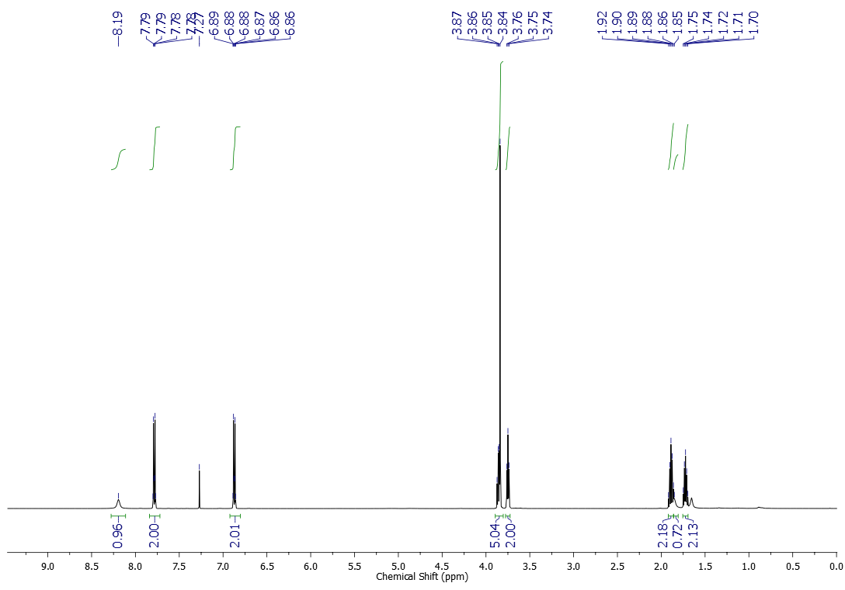



13C NMR (125 MHz, CDCl3) spectrum of compound **3d**

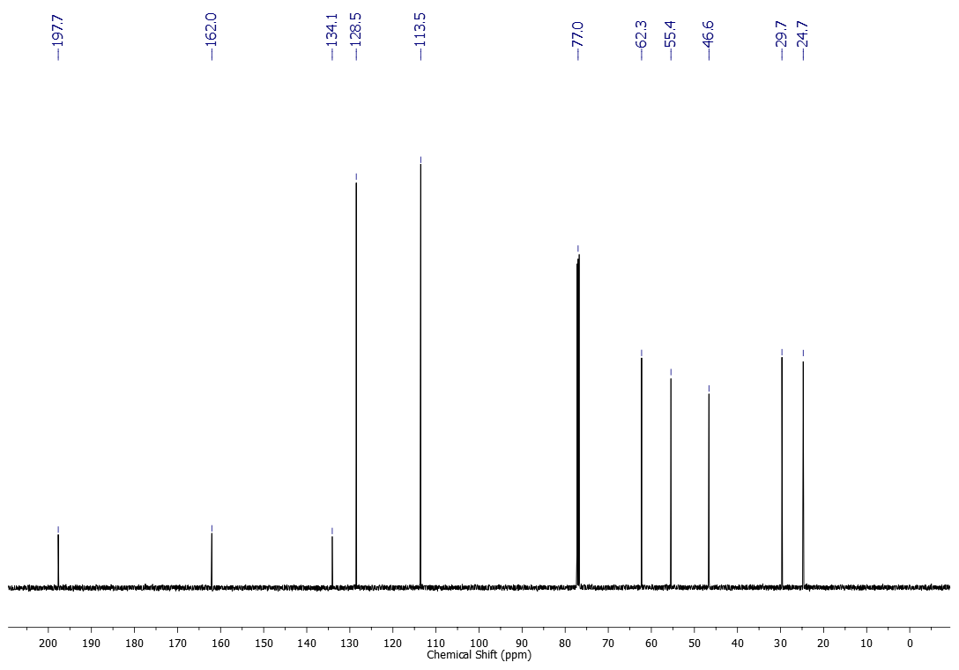



1H NMR (500 MHz, CDCl3) spectrum of compound **3e**

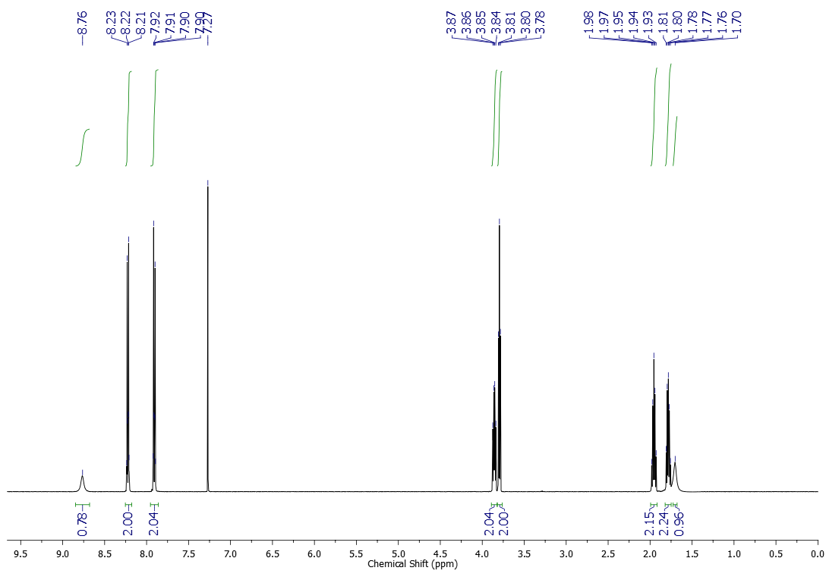



13C NMR (125 MHz, CDCl3) spectrum of compound **3e**

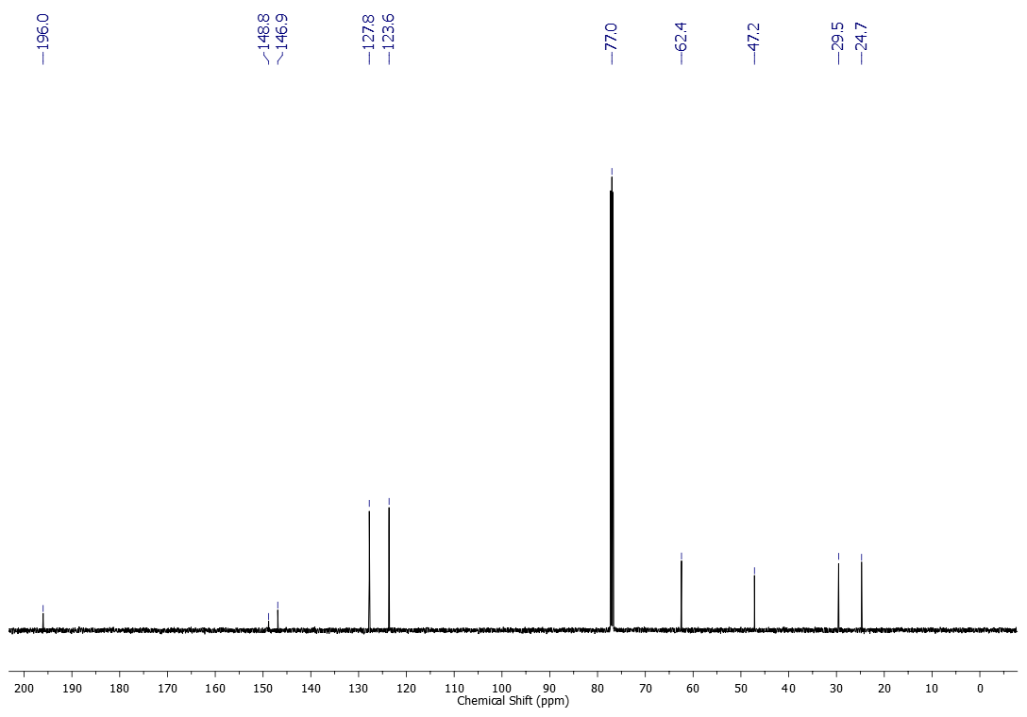



1H NMR (600 MHz, CDCl3) spectrum of compound **3f**

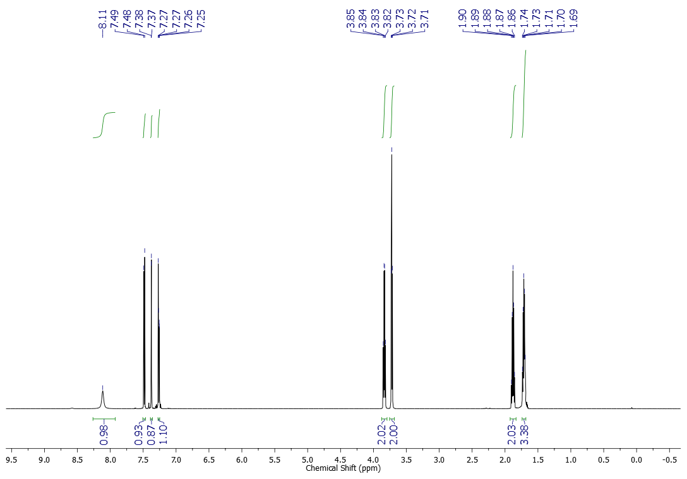



13C NMR (151 MHz, CDCl3) spectrum of compound **3f**

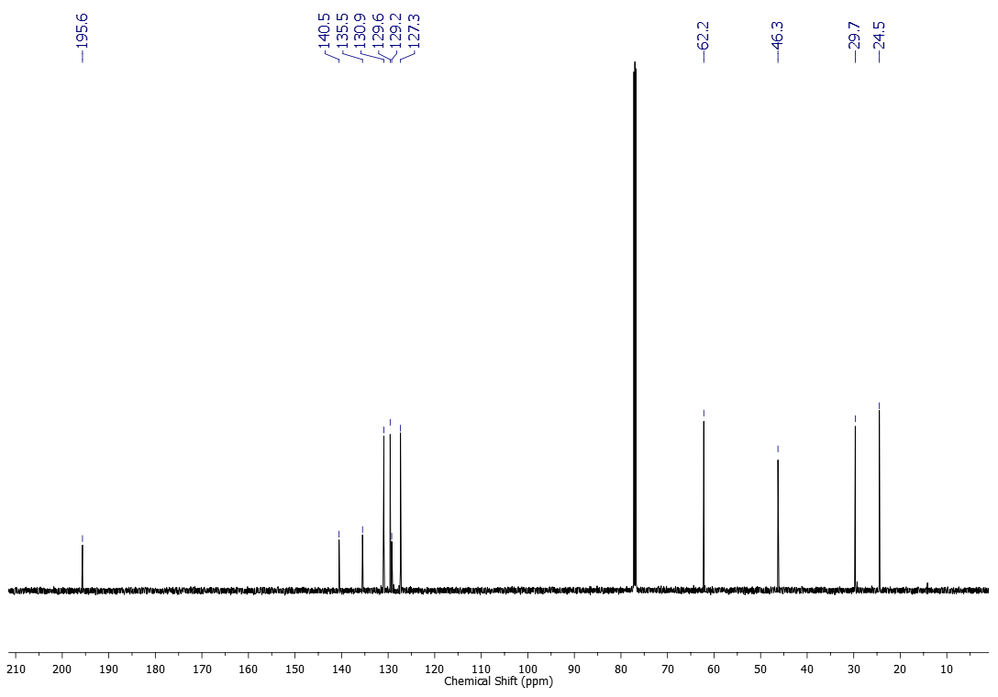



1H NMR (500 MHz, CDCl3) spectrum of compound **3g**

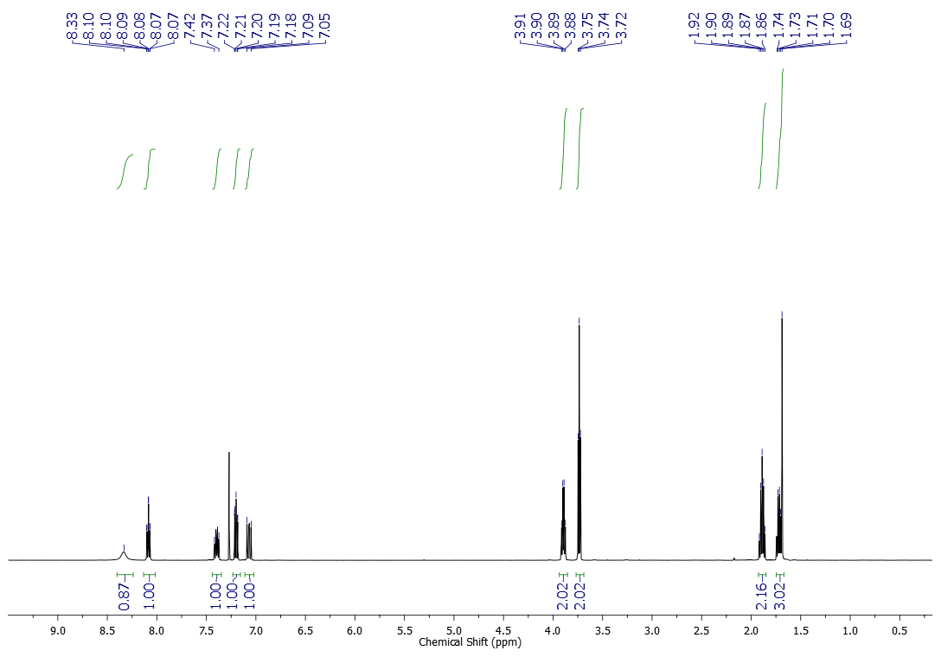



13C NMR (125 MHz, CDCl3) spectrum of compound **3g**

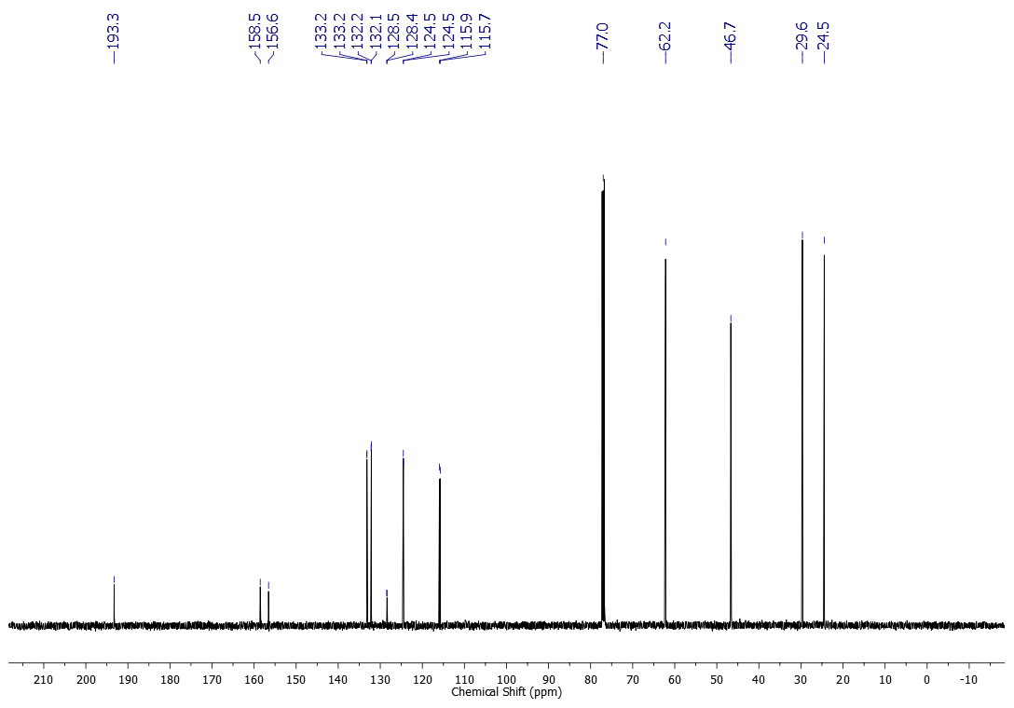



1H NMR (500 MHz, CDCl3) spectrum of compound **3h**

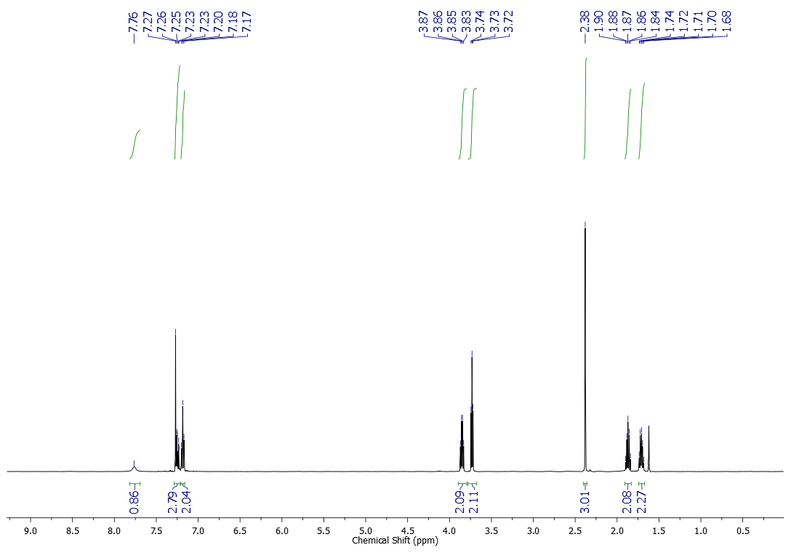



13C NMR (125 MHz, CDCl3) spectrum of compound **3h**

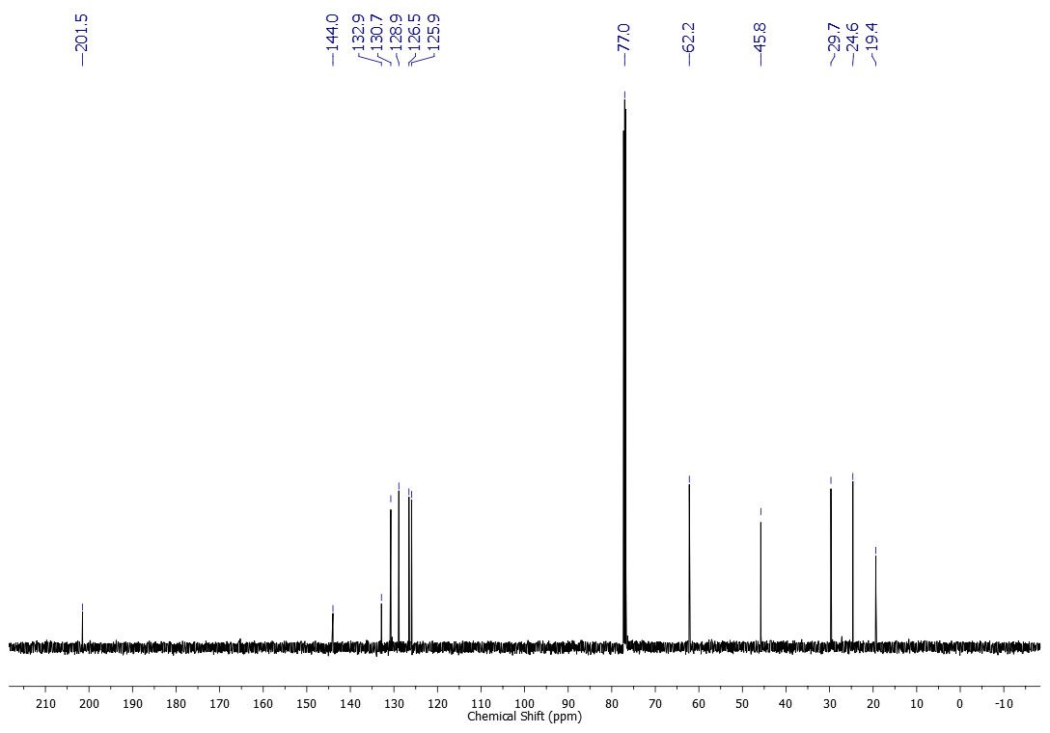



1H NMR (600 MHz, CDCl3) spectrum of compound **3i**

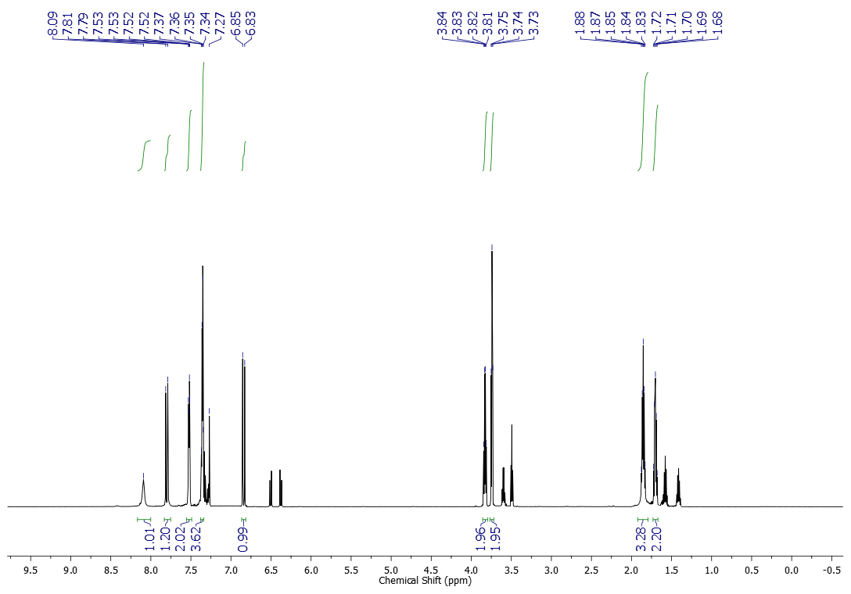



13C NMR (151 MHz, CDCl3) spectrum of compound **3i**

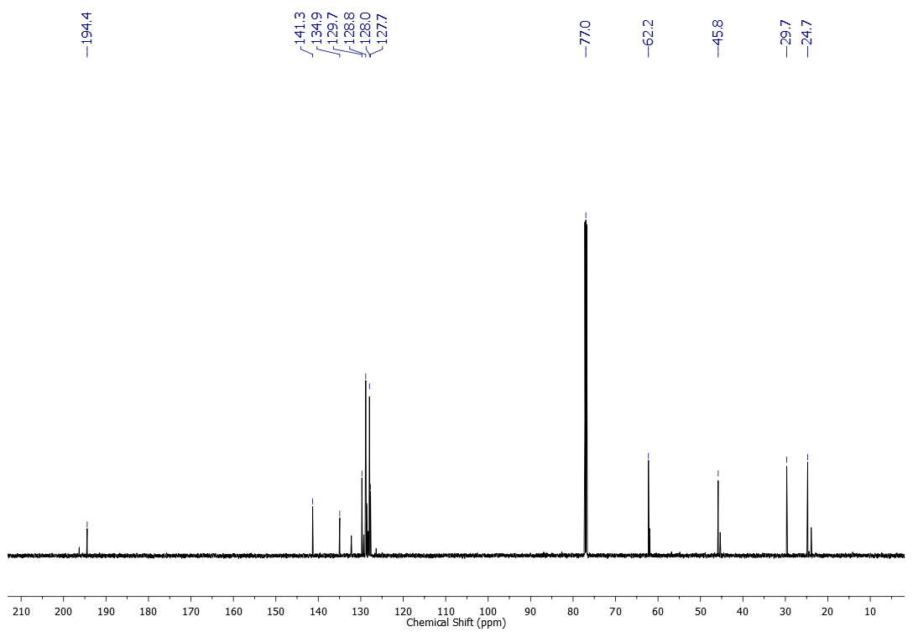



1H NMR (600 MHz, CDCl3) spectrum of compound **3j**

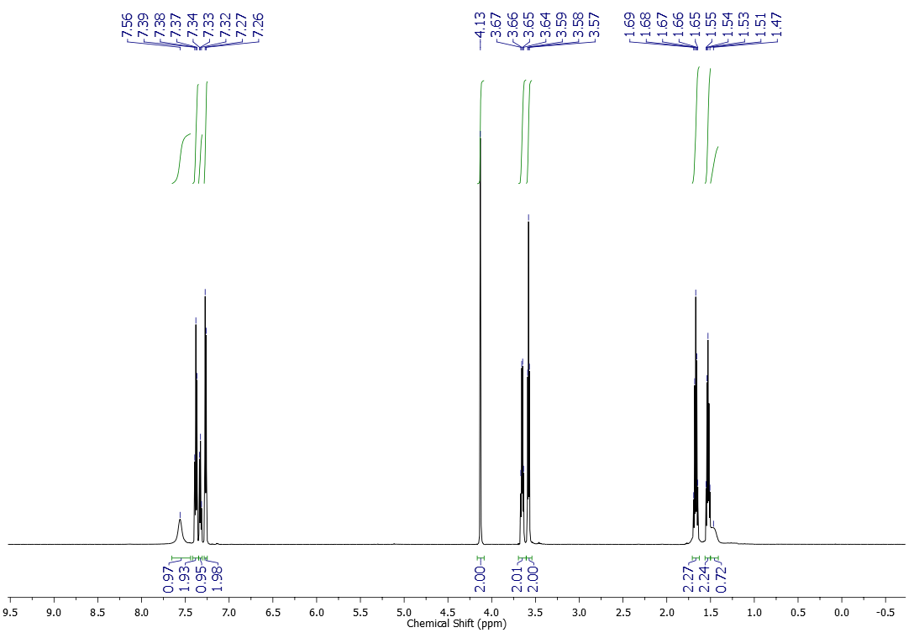



1H NMR (600 MHz, CDCl3) spectrum of compound **3k**

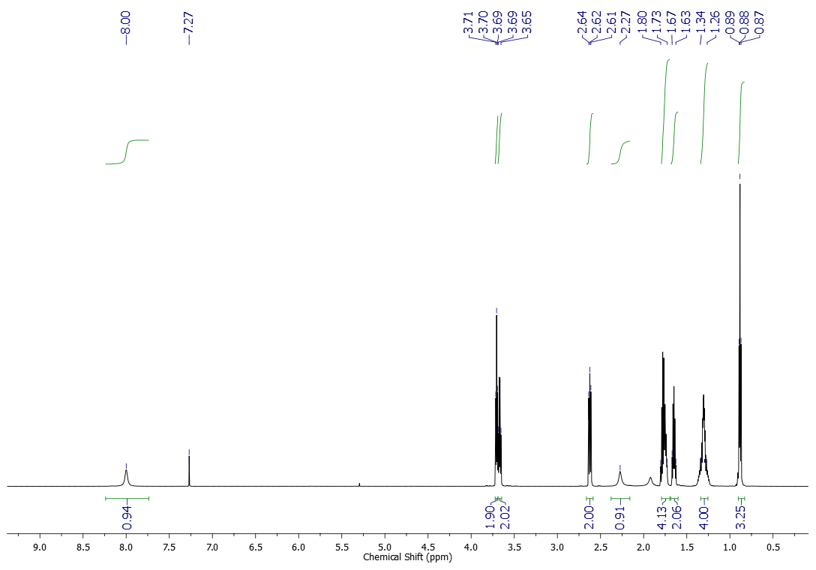



13C NMR (151 MHz, CDCl3) spectrum of compound **3k**

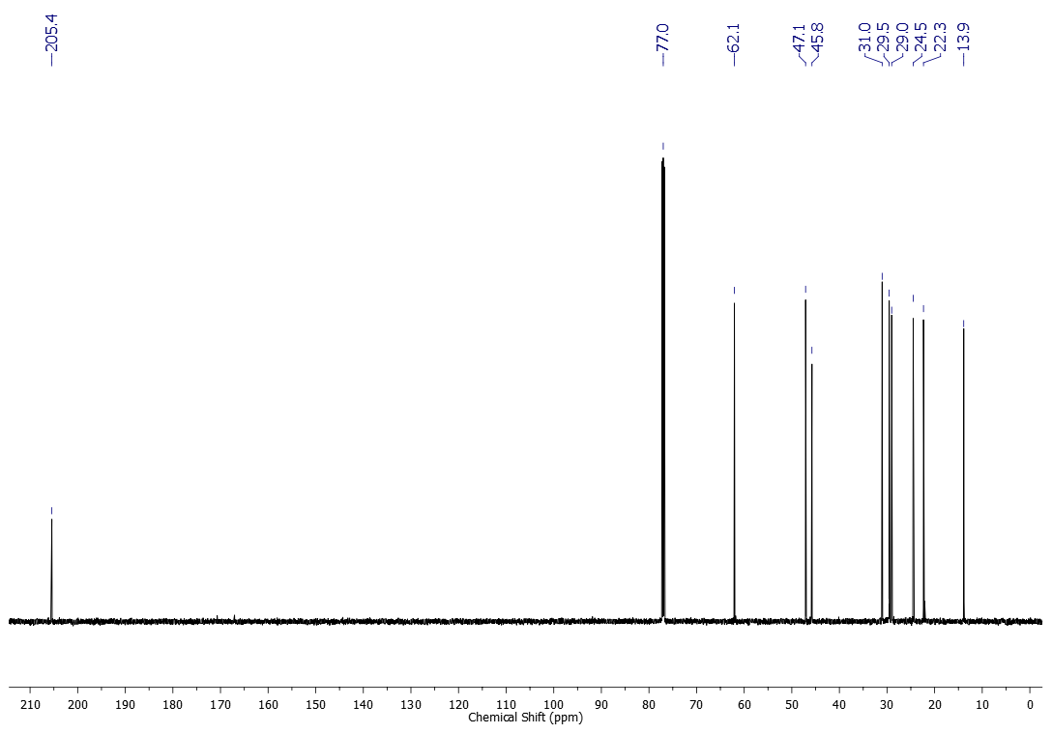



1H NMR (600 MHz, CDCl3) spectrum of compound **3l**

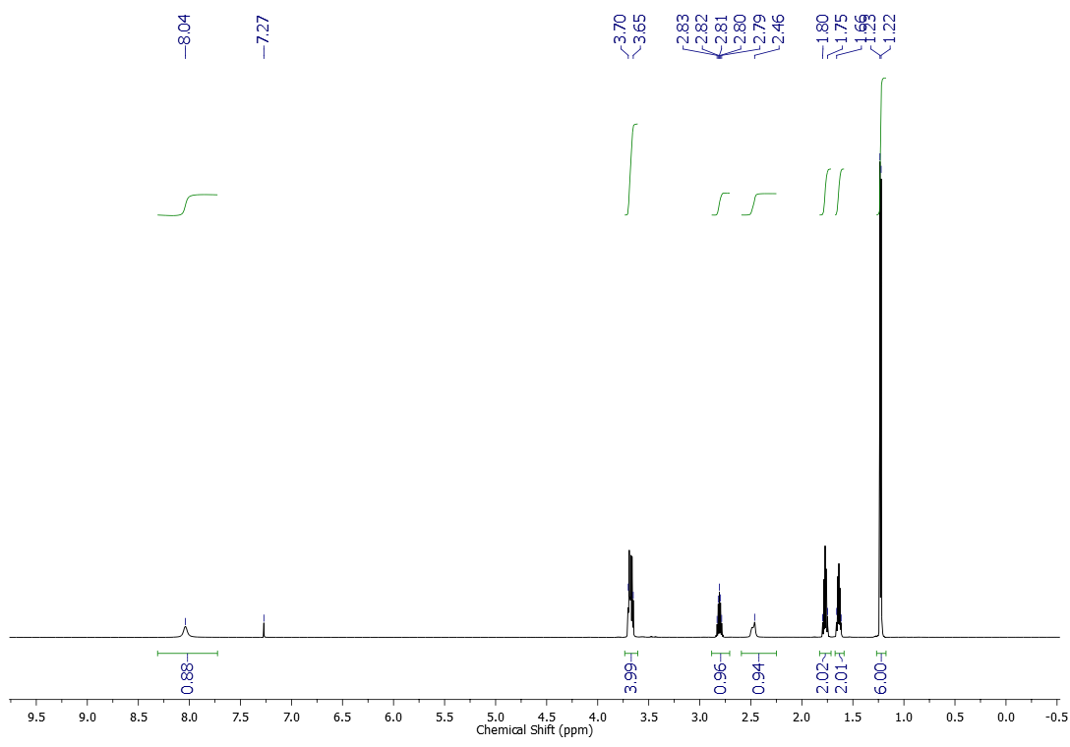



13C NMR (151 MHz, CDCl3) spectrum of compound **3l**

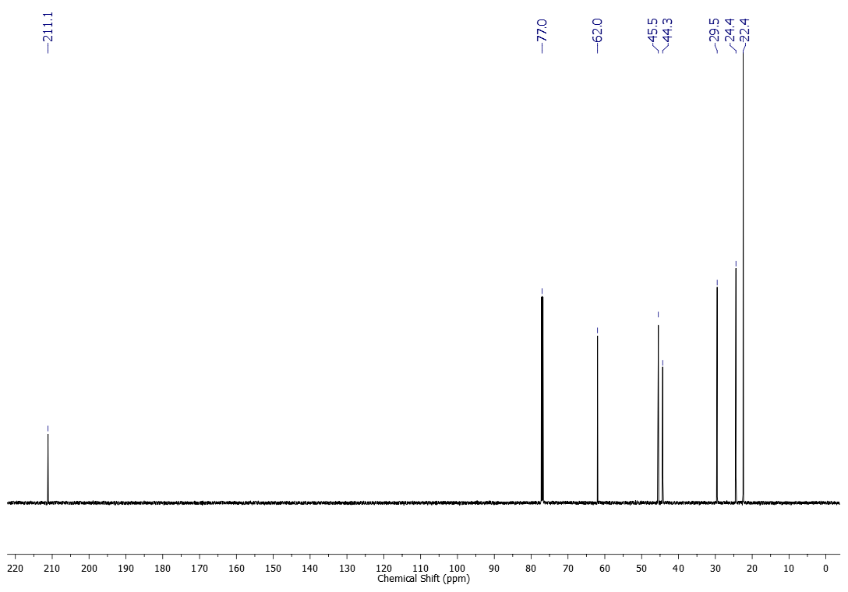



1H NMR (600 MHz, CDCl3) spectrum of compound **3m**

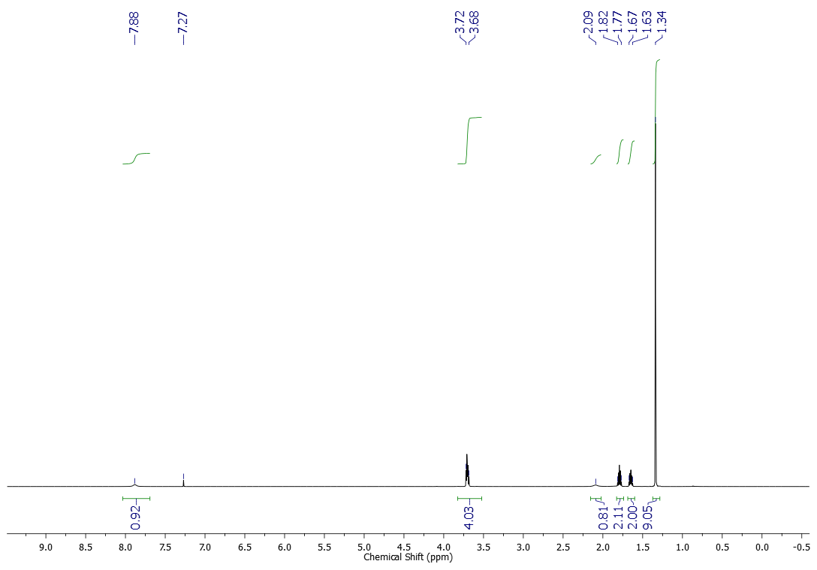



13C NMR (151 MHz, CDCl3) spectrum of compound **3m**

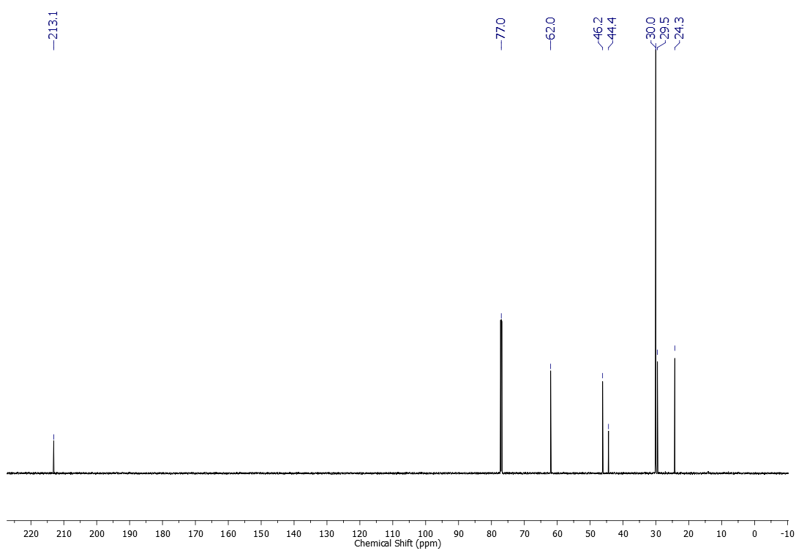



1H NMR (600 MHz, CDCl3) spectrum of compound **4a**

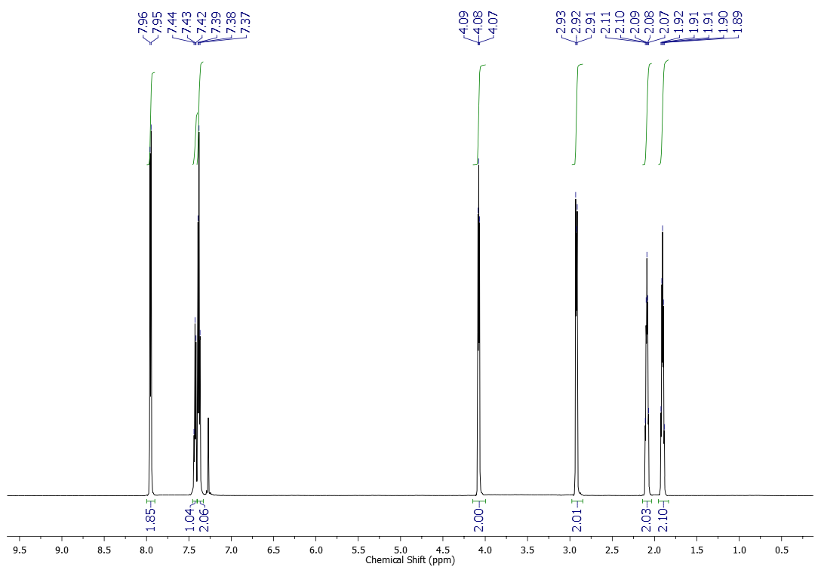



13C NMR (151 MHz, CDCl3) spectrum of compound **4a**

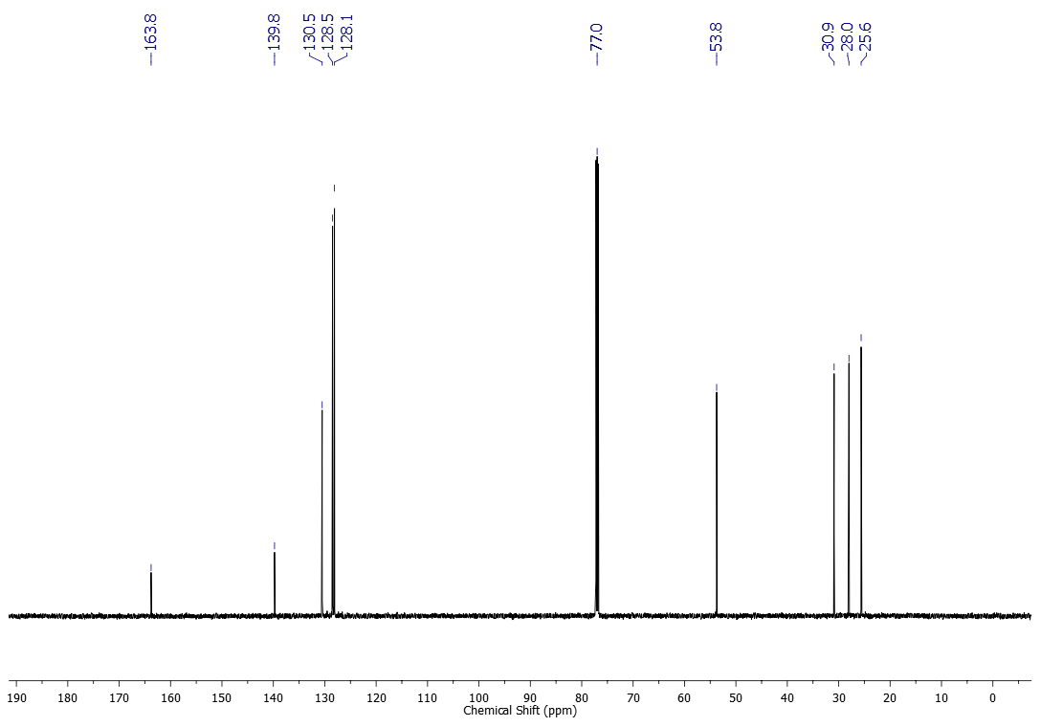



NOESY spectrum of compound **4a**

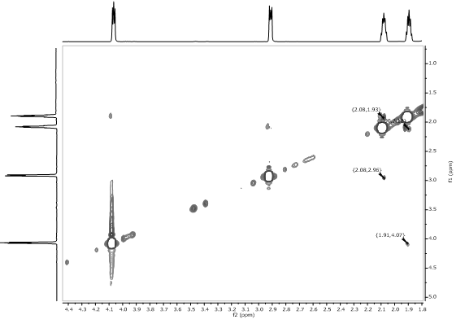



HSQC spectrum of compound **4a**

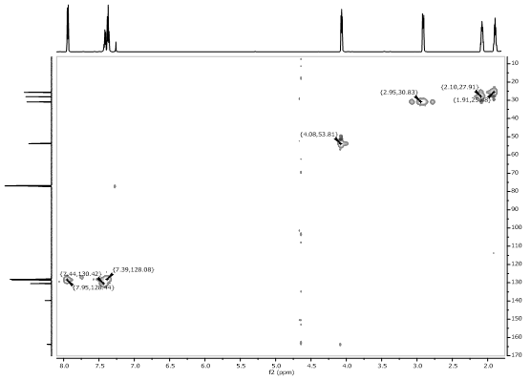



HMBC spectrum of compound **4a**

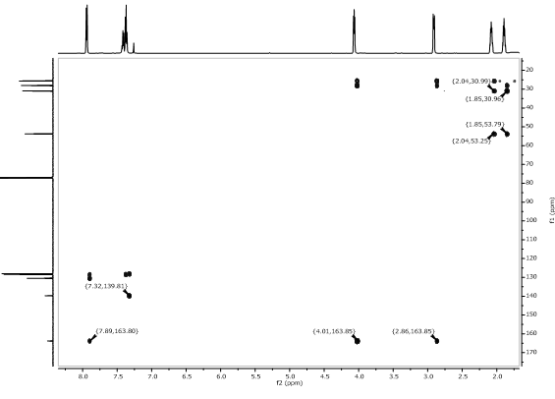



1H NMR (500 MHz, CDCl3) spectrum of compound **4b**

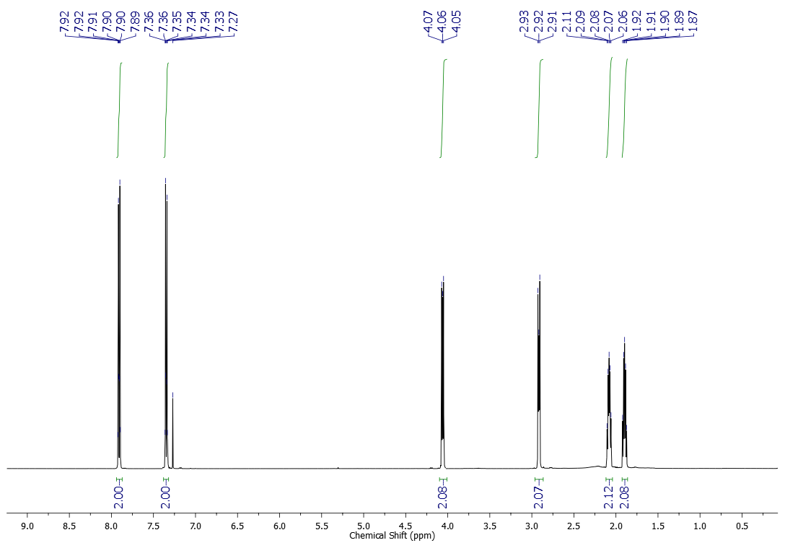



13C NMR (125 MHz, CDCl3) spectrum of compound **4b**

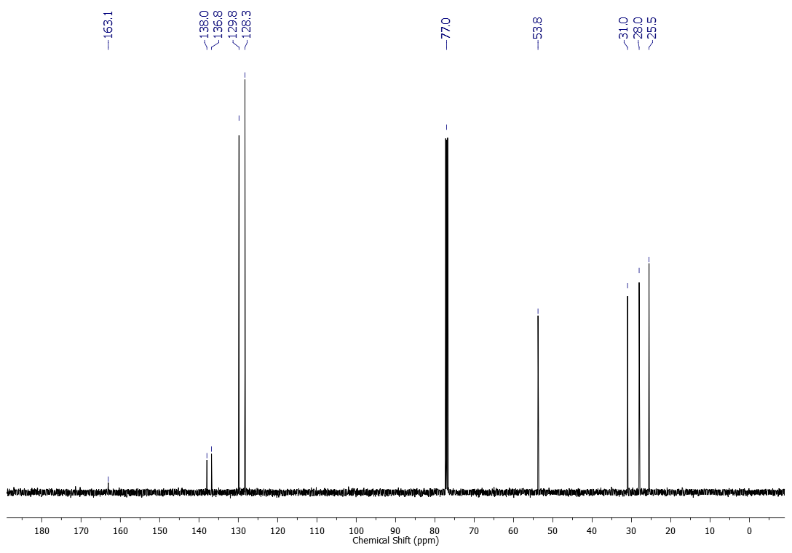



1H NMR (300 MHz, CDCl3) spectrum of compound **4c**

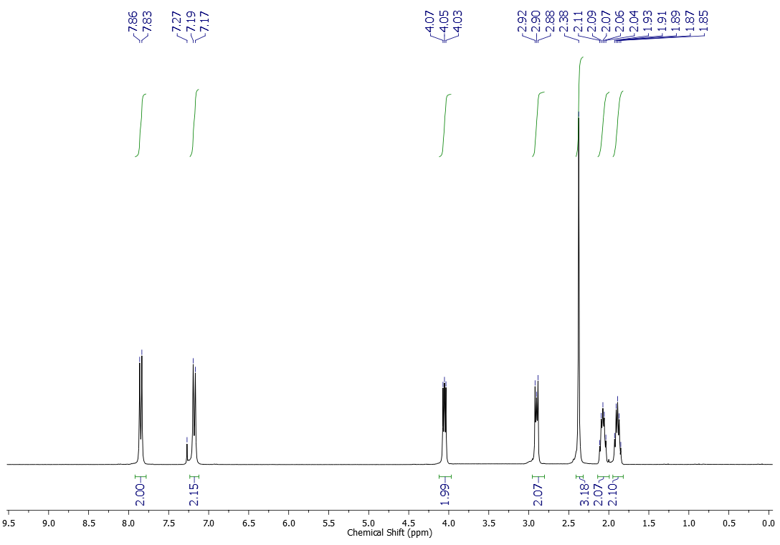



13C NMR (75 MHz, CDCl3) spectrum of compound **4c**

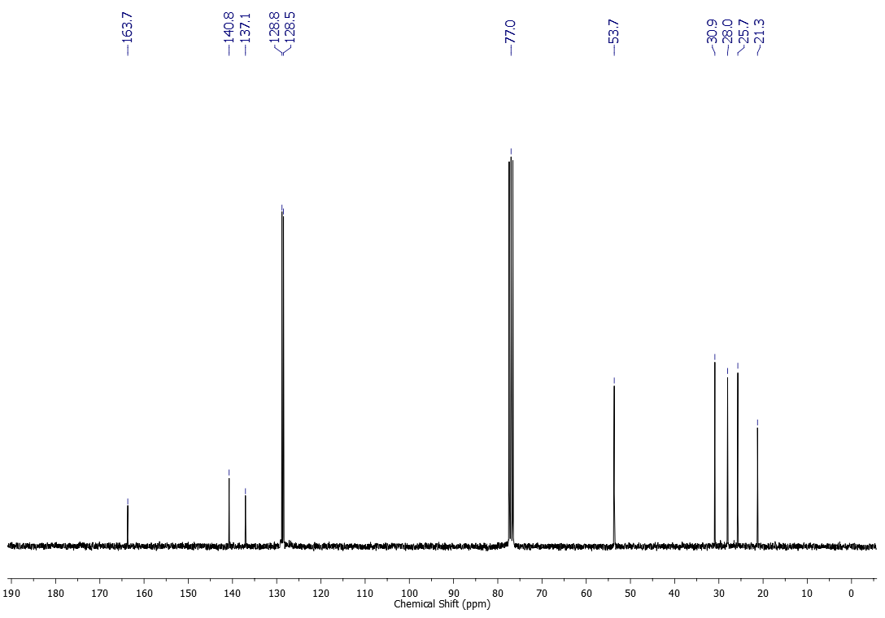



1H NMR (500 MHz, CDCl3) spectrum of compound **4d**

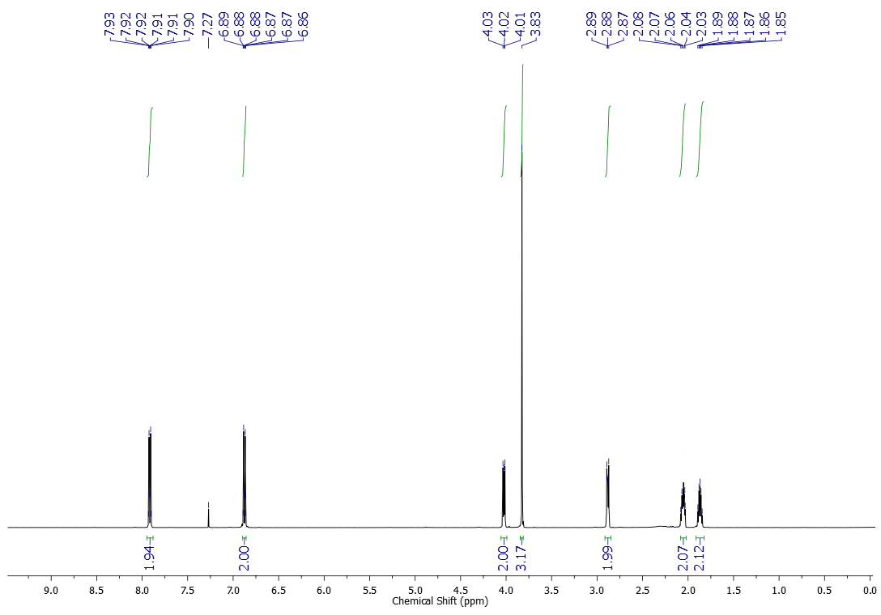



13C NMR (125 MHz, CDCl3) spectrum of compound **4d**

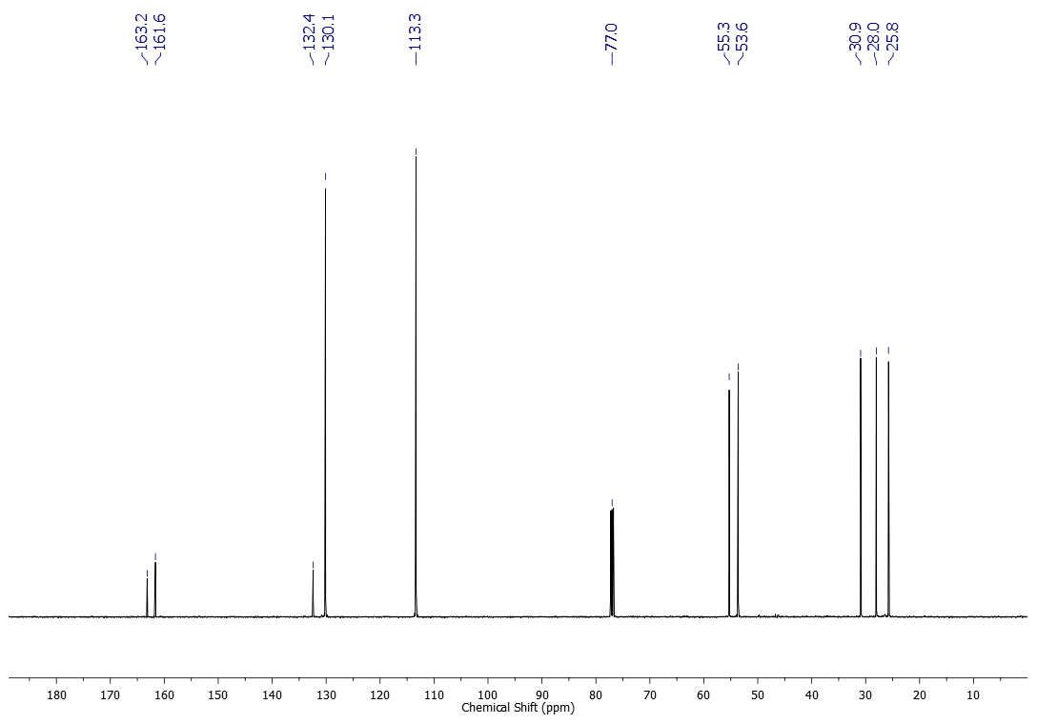



1H NMR (500 MHz, CDCl3) spectrum of compound **4e**

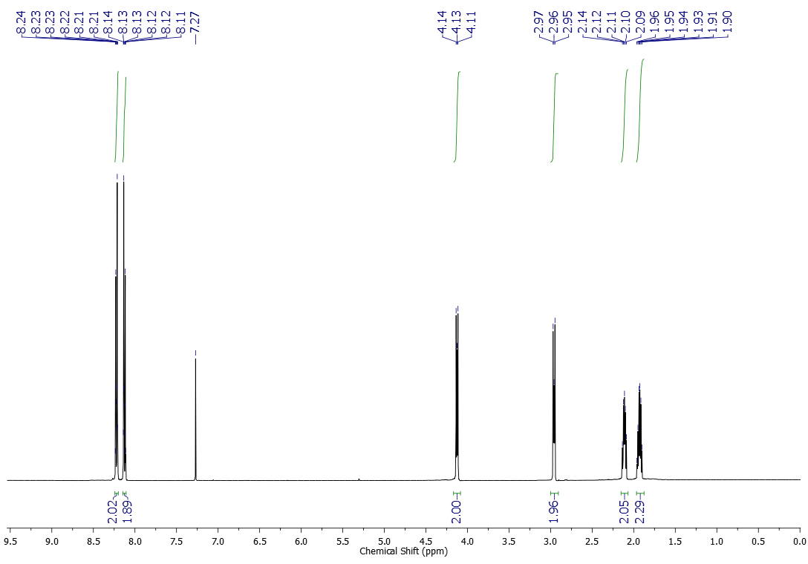



13C NMR (125 MHz, CDCl3) spectrum of compound **4e**

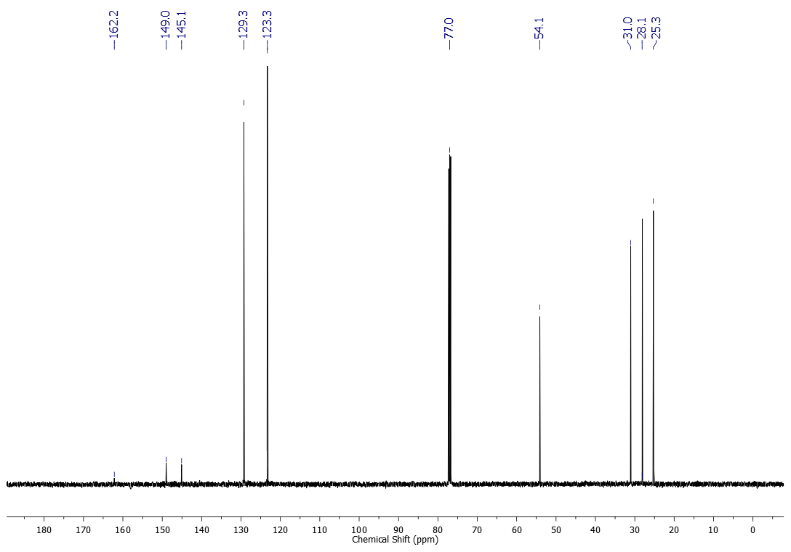



1H NMR (500 MHz, CDCl3) spectrum of compound **4f**

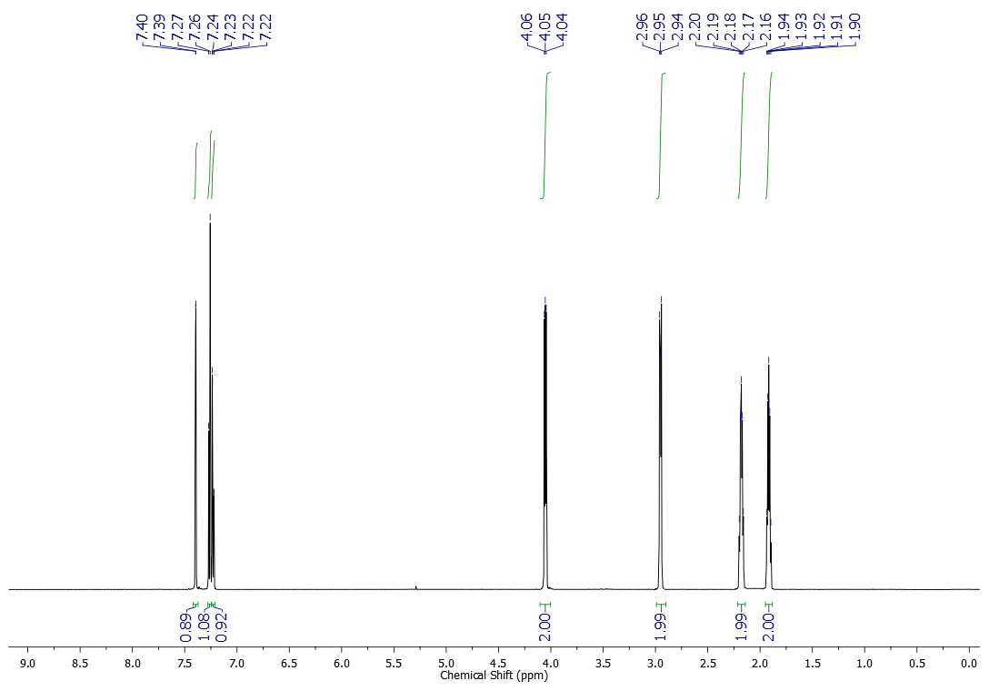



13C NMR (125 MHz, CDCl3) spectrum of compound **4f**

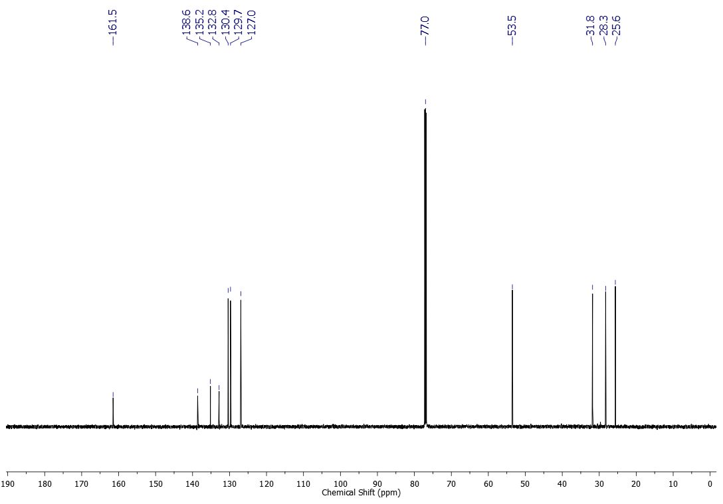



1H NMR (500 MHz, CDCl3) spectrum of compound **4g**

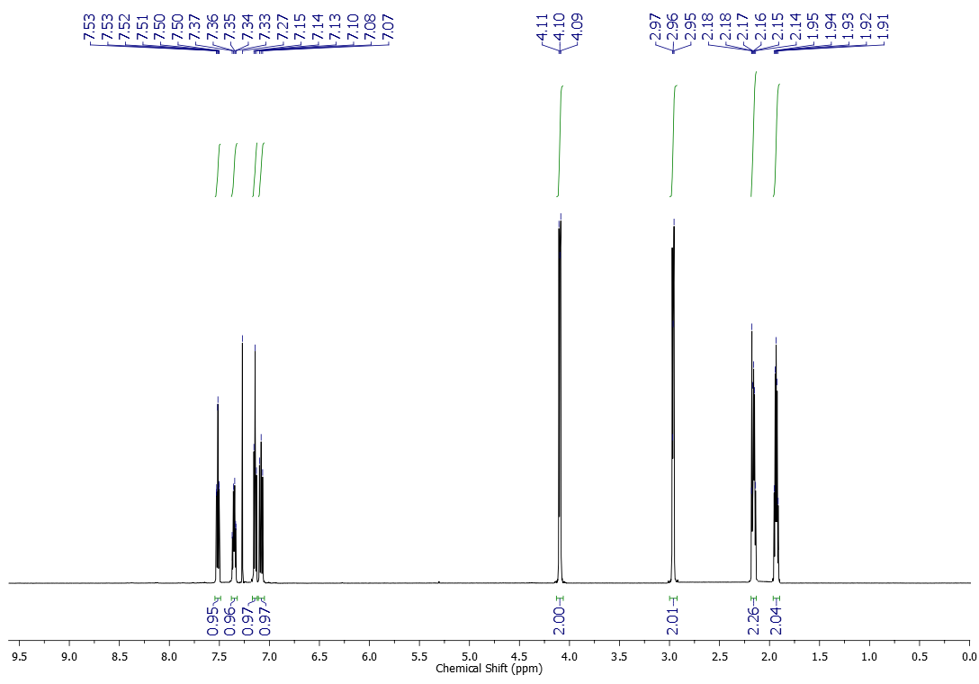



13C NMR (125 MHz, CDCl3) spectrum of compound **4g**

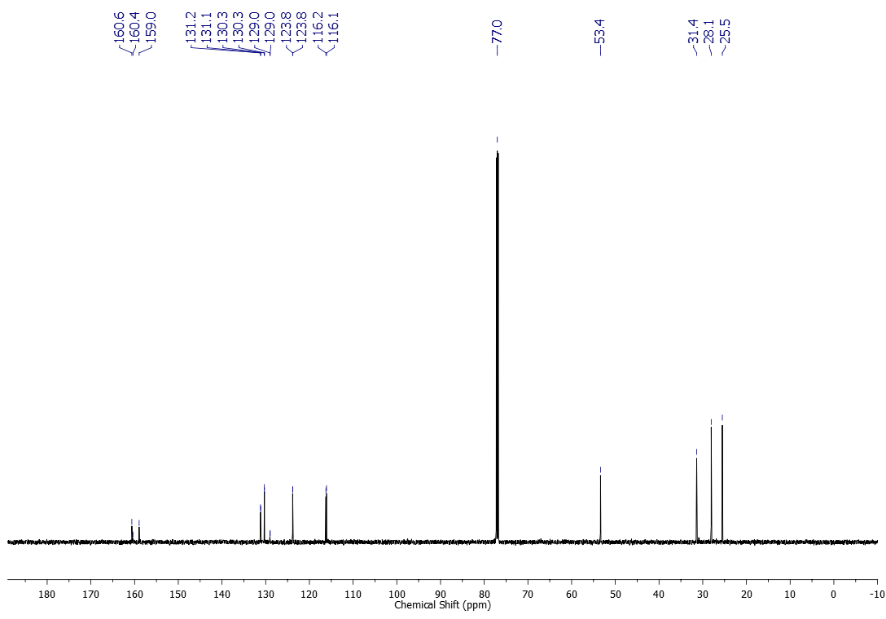



1H NMR (500 MHz, CDCl3) spectrum of compound **4h**

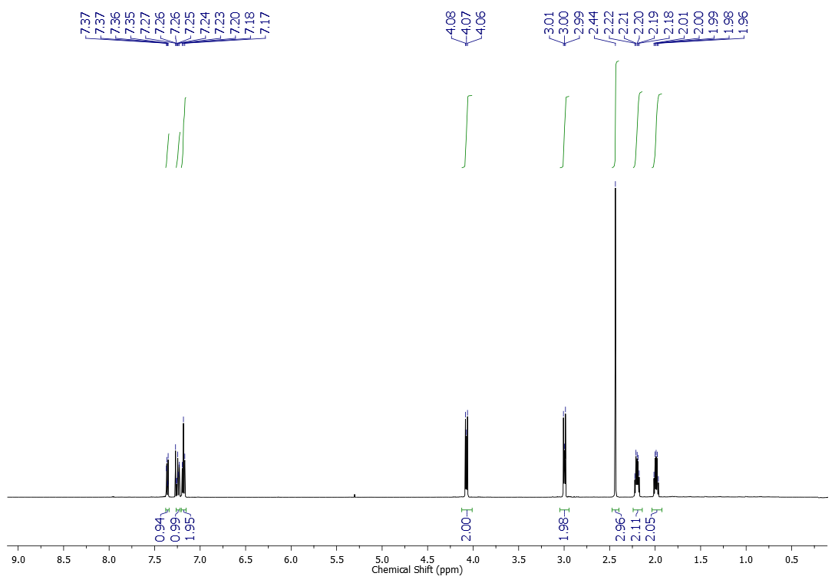



13C NMR (125 MHz, CDCl3) spectrum of compound **4h**

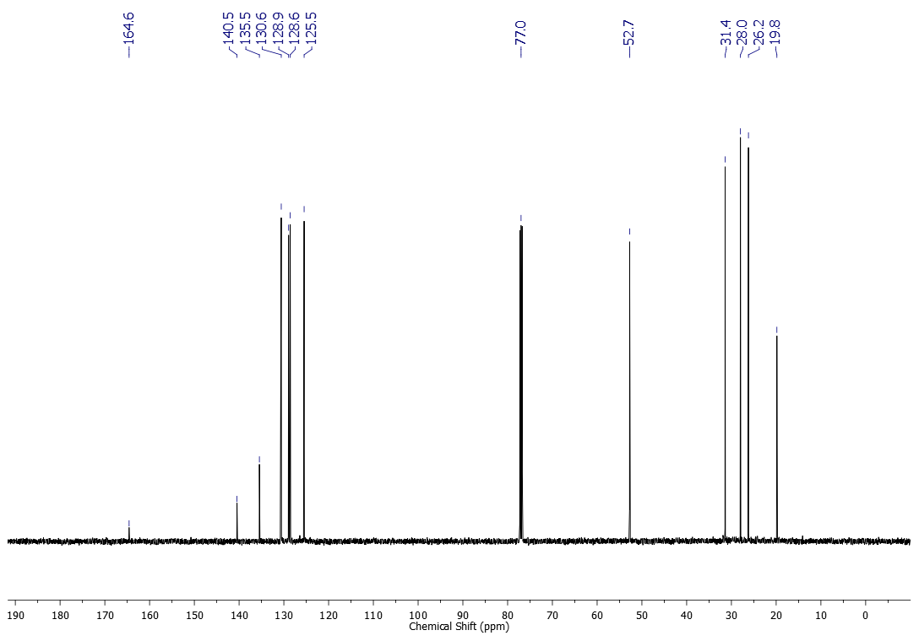



1H NMR (600 MHz, CDCl3) spectrum of compound **4i**

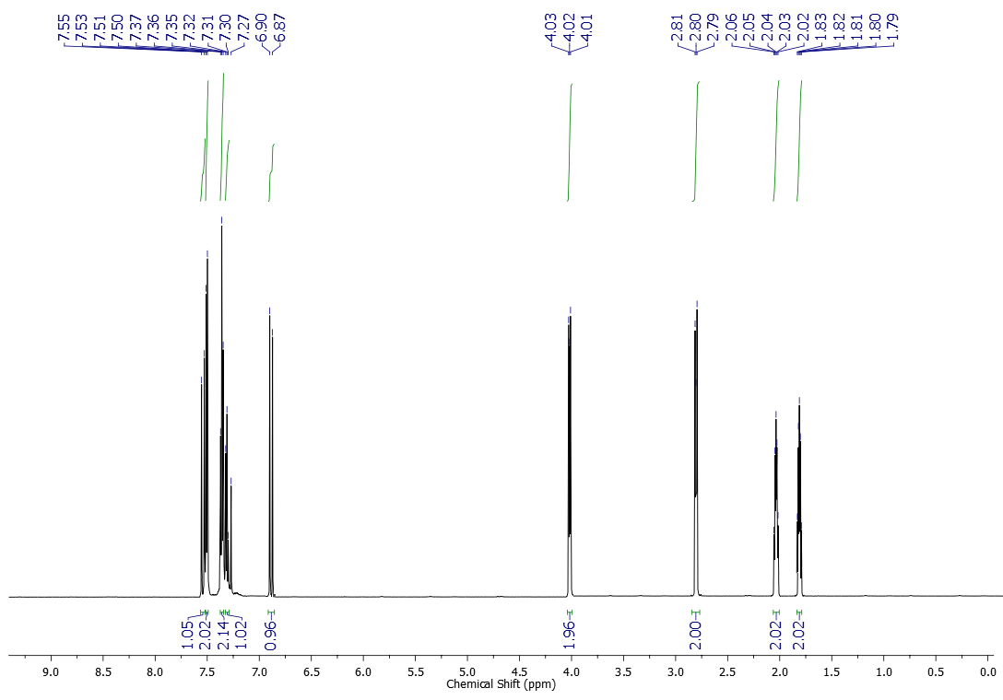



13C NMR (151 MHz, CDCl3) spectrum of compound **4i**

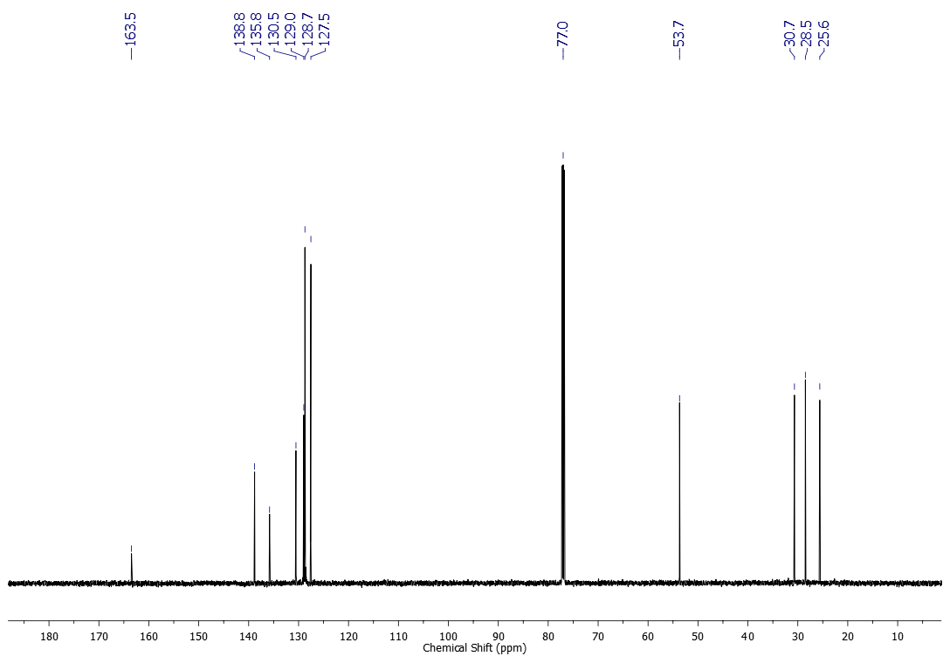



1H NMR (600 MHz, CDCl3) spectrum of compound **4j**

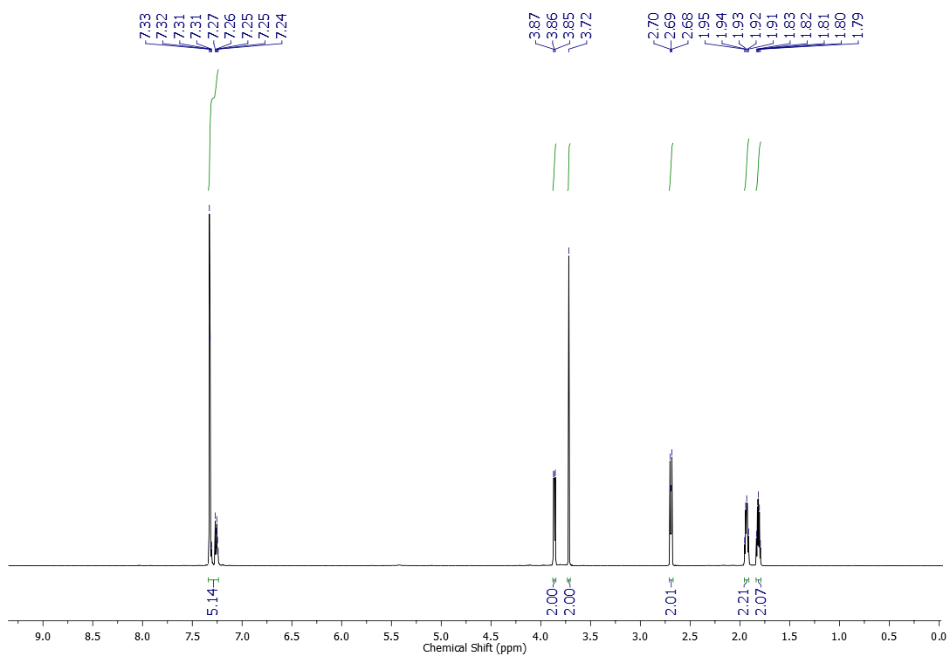



13C NMR (151 MHz, CDCl3) spectrum of compound **4j**

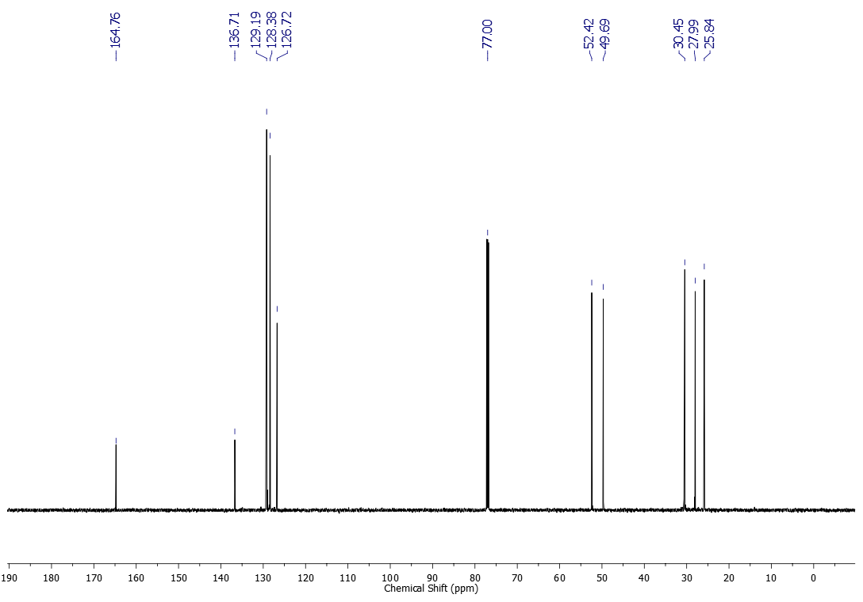



1H NMR (600 MHz, CDCl3) spectrum of compound **4k**

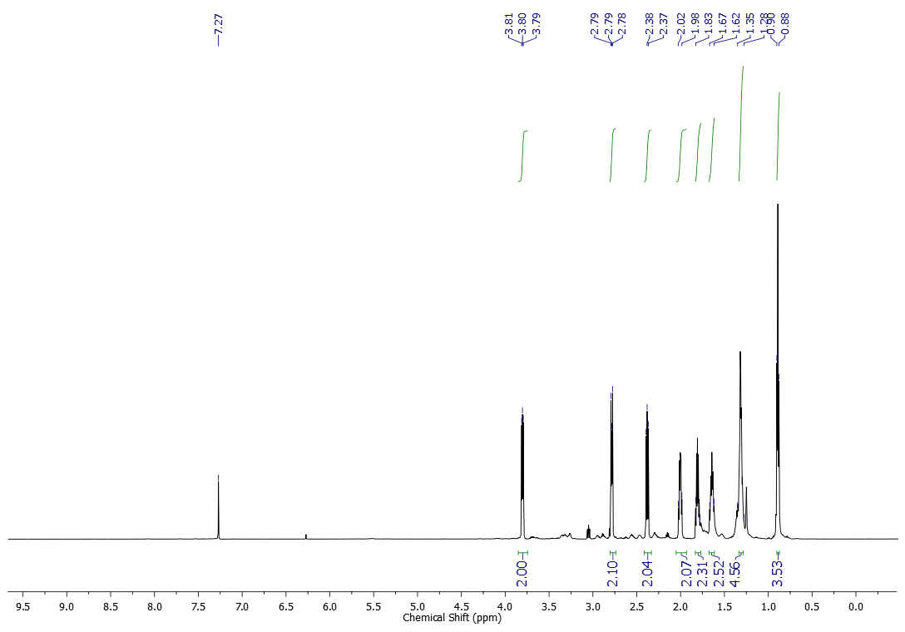



13C NMR (151 MHz, CDCl3) spectrum of compound **4k**

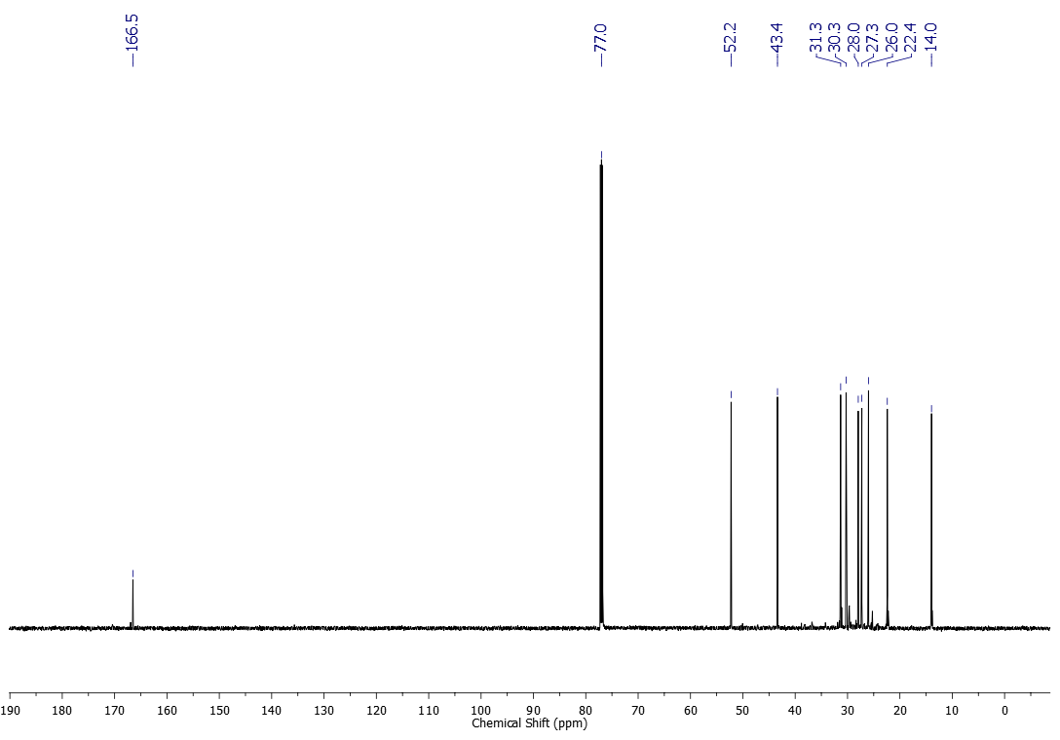



Compound **4k** underwent partial decomposition after purification.

1H NMR (600 MHz, CDCl3) spectrum of compound **4l**

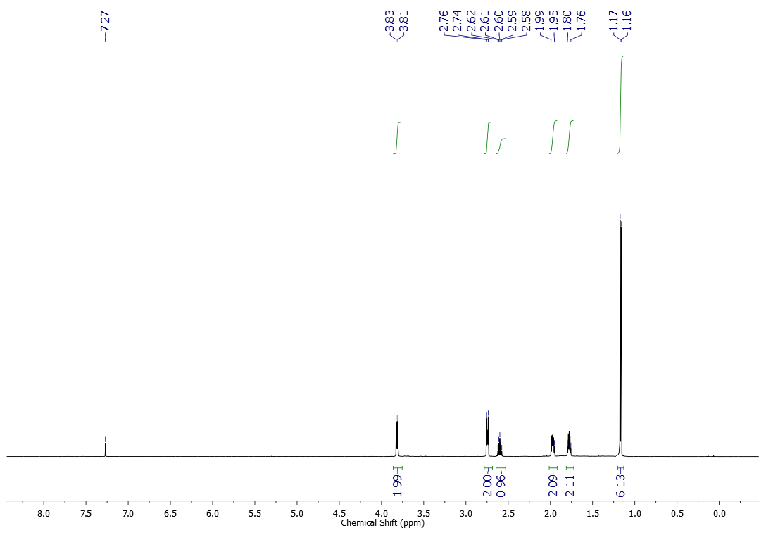



13C NMR (151 MHz, CDCl3) spectrum of compound **4l**

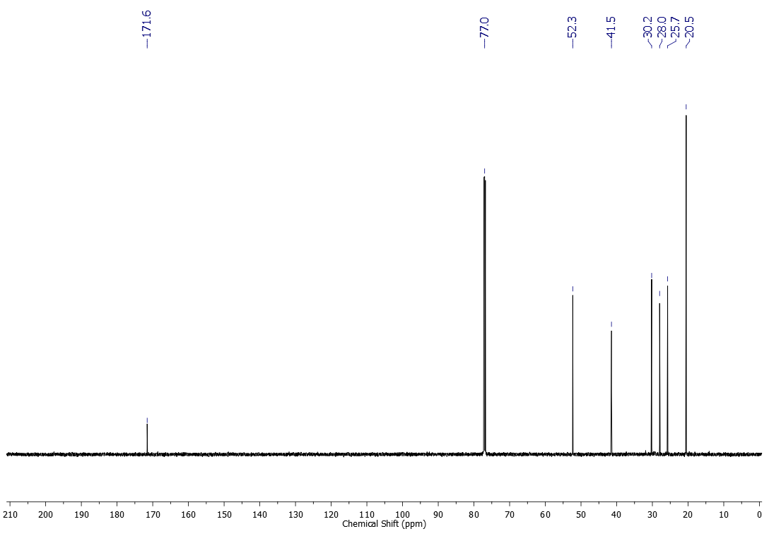



1H NMR (600 MHz, CDCl3) spectrum of compound **4m**

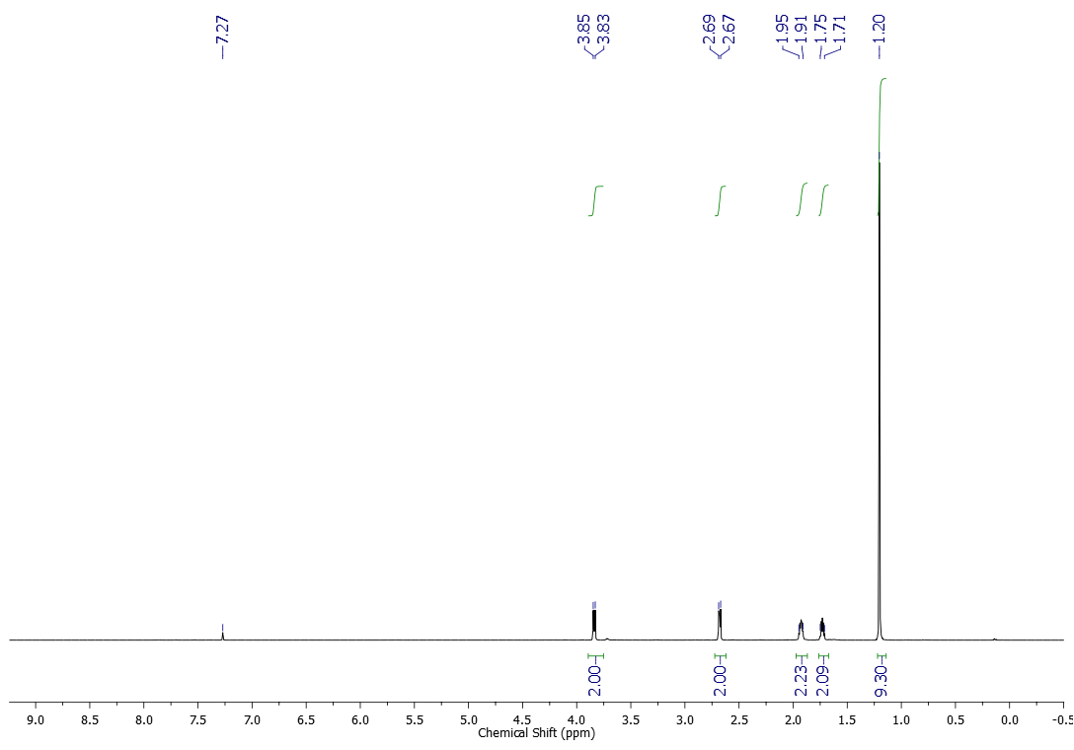



13C NMR (151 MHz, CDCl3) spectrum of compound **4m**

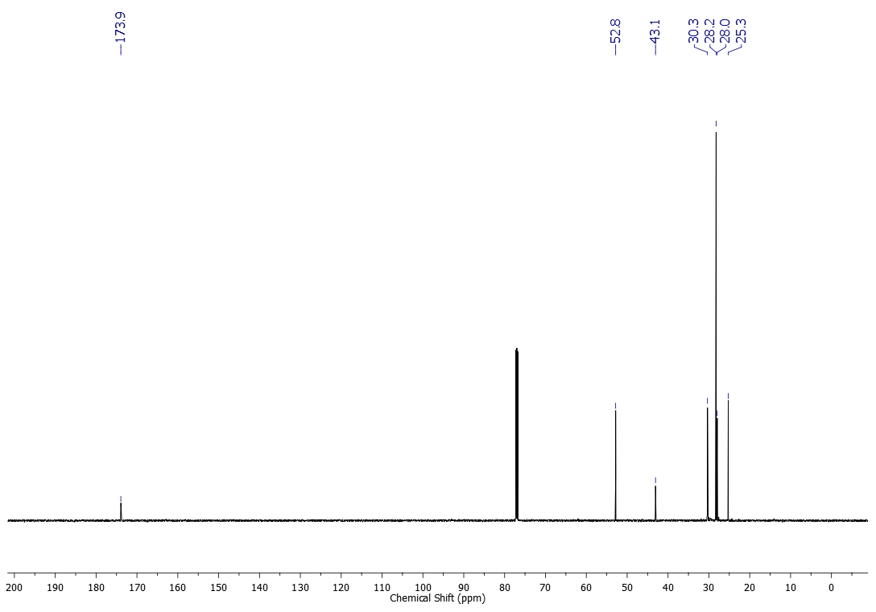



**5. References**

1. Wang, J.; Changxiu, L.; Mingzhi, G.; Jiyu, L.; Xianzhong, L.; Jing, M.; Renqi, P. Chinese Patent CN101104589, **2008**.
2. Inada, H.; Kuwayama, Y.; Noro, M.; Fukagawa, N. Chinese Patent CN103709449, **2004**.
3. Greger, H.; Hofer, M.; Teichmann, K.; Schinnerl, J.; Pannell, C. M.; Vajrodaya, S.; Hofer, O. *Phytochemistry*, **2008,** *69*, 928.
4. Nguyen, T. B.; Al-Mourabit., A. *Org. Lett*. **2012**, *14*, 4274.
5. Nguyen, T. B.; Tran, M. Q.; Ermolenko, L; Al-Mourabit., A. *Org. Lett*. **2014**, *16*, 310.

Wipf, P.; Hayes, G. B. *Tetrahedron* **1998**, *54*, 6987.

1. Yates, J.; Rosinger, H. P.; Hackmann, J. T. GB Patent 1013441A, **1963**.
2. Stewart, W. E.; Siddall, T. H. *Chem. Rev.* **1970**, *70*, 517.