Supporting information

Green Cyclocondensation of β-Ethylthio-β-indolyl-α, β-unsaturated Ketones with Semicarbazide Hydrochloride as Hydrazine Equivalent in Water: Aqueous Synthesis of 3-Pyrazolyl Indoles
Yanhui Zhao¹, Haifeng Yu¹*, Peiqiu Liao², Wenju Wang¹*
¹College of Chemistry, Baicheng Normal University, Baicheng, Jilin 137000, China.
² Jilin Province Key Laboratory of Organic Functional Molecular Design & Synthesis, Department of Chemistry, Northeast Normal University, Changchun, Jilin 130024, China.

General Considerations
A ¹H and ¹³C{1H} NMR spectra were recorded on a Bruker DRX-600 spectrometer and the chemical shift values refer to δ TMS=0.00 ppm; The HRMS analysis was achieved on Bruck micro Tof using ESI method. All the melting points were uncorrected. Analytical TLC plates, Sigma-Aldrich silica gel 60F200 were viewed by UV light (254 nm). Chromatographic purifications were performed on SDZF silica gel 160.
Typical procedure for the preparation of 3-pyrazolyl indoles 3
The mixture of 1 (0.25 mmol), 2 (56.2 mg, 0.50 mmol) and PEG-400 (0.25 mL, 0.75 mmol) in water (1 mL) in 20 mL reaction tube was stirred at reflux until 1 was completely consumed by TLC monitoring. After the mixture was allowed to cool down to ambient temperature, some white solid deposited from the reaction system. The white solid was collected by filtration and washed with water (3 × 25 mL) to give 3 in good yield.
1-methyl-3-(3-phenyl-1H-pyrazol-5-yl)-1H-indole 3a: white solid; m.p. 220-222 ºC.¹H NMR (DMSO-d₆, 600 MHz): δ = 13.1 (br, 1 H), 8.10 (s, 1 H), 7.91 (s, 2 H), 7.77 (s, 1 H), 7.50 (d, J=7.7 Hz, 1 H), 7.45 (t, 2 H), 7.33( t, 1 H), 7.25 (t, 1 H), 7.18 (t, 1 H), 7.06 (s, 1 H), 3.85 (s, 3 H). ¹³C NMR (DMSO-d₆, 150 MHz) δ =136.9 (2 C), 128.7 (2 C), 127.5, 127.3 (3 C), 125.1 (5 C), 121.8, 119.8, 110.1, 98.8, 32.7. HRMS Cacldfor C₁₈H₁₆N₃⁺: ([M+H]⁺) 274.1339; Found: 274.1349.
1-methyl-3-(3-(o-tolyl)-1H-pyrazol-5-yl)-1H-indole 3b white solid; m.p. 163-165ºC. ¹H NMR (CDCl₃, 600 MHz): 8.02 (d, J = 7.9 Hz, 1 H), 7.52 (d, J = 7.5 Hz, 1 H), 7.33 (d, J=8.3 Hz, 1 H), 7.32 (s, 2 H), 7.28 (d, J = 7.7 Hz, 1 H), 7.26 ( d, J = 7.4 Hz, 2 H), 7.22-7.20 (m, 1 H), 7.18 (t, 1 H), 3.69 (s, 3 H), 2.49 (s, 3 H). ¹³C NMR (CDCl₃, 150 MHz) δ =137.2, 136.2, 131.0 (2 C), 129.2, 128.2, 126.9 (2 C), 126.1, 126.0 (2 C), 122.3, 120.4, 120.3 (2 C), 109.6, 103.1, 32.9, 21.1. HRMS Cacld for C₁₉H₁₈N₃⁺: ([M+H]⁺) 288.1495; Found: 288.1488.
1-methyl-3-(3-(m-tolyl)-1H-pyrazol-5-yl)-1H-indole 3c white solid; m.p. 190-192ºC. ¹H NMR (Acetone-d₆, 600 MHz): 12.2 (s, 1 H), 8.13 (d, J = 7.9 Hz, 1 H), 7.77 (s, 1 H), 7.72 (d, J = 7.7 Hz, 1 H), 7.68 (s, 1 H), 7.45 (d, J = 8.2 Hz, 1 H), 7.31( t, 1 H), 7.25(t, 1 H), 7.18-7.14 (m, 2 H), 7.01 (s, 1 H), 3.89 (s, 3 H), 2.39 (s, 3 H). ¹³C NMR (Acetone-d₆, 150 MHz) δ =138.9, 138.3, 129.4 (2 C), 129.0, 127.8(2 C), 126.9(2 C), 123.4 (2 C), 122.8 (2 C), 120.7 (2 C), 110.6, 99.9, 33.1, 21.5. HRMS Cacld for C₁₉H₁₈N₃⁺: ([M+H]⁺) 288.1495; Found: 288.1490.
1-methyl-3-(3-(p-tolyl)-1H-pyrazol-5-yl)-1H-indole 3d white solid; m.p. 214-216ºC. ¹H NMR (CDCl₃, 600 MHz): 7.98 (d, J = 7.7 Hz, 1 H), 7.65 (d, J = 7.6 Hz, 2 H), 7.33-7.29 (m, 3 H), 7.22 (t, 1 H), 7.16 (d, J = 7.8 Hz, 2 H), 6.78 (s, 1 H), 3.62 (s, 3 H), 2.37 (s, 3 H). ¹³C NMR (CDCl₃, 150 MHz) δ =137.7, 137.2, 129.5(3 C), 127.0 (2 C), 125.9, 125.7(4 C), 122.3, 120.3, 120.2 109.6, 99.8, 32.8, 21.4. HRMS Cacld for C₁₉H₁₈N₃⁺: ([M+H]⁺) 288.1495; Found: 288.1498.
3-(3-(4-methoxyphenyl)-1H-pyrazol-5-yl)-1-methyl-1H-indole 3e white solid; m.p. 186-188ºC. ¹H NMR (CDCl₃, 600 MHz): 7.96 (d, J = 7.2 Hz, 1 H), 7.66 (d, J = 7.6 Hz, 2 H), 7.30 (s, 3 H), 7.29 (s, 1 H), 7.25(s,1 H), 7.22-7.20 (m, 1 H), 6.83 (d, J = 8.6 Hz, 2 H), 6.72 (s, 1 H), 3.79 (s, 3 H), 3.54 (s, 3 H). ¹³C NMR (CDCl₃, 150 MHz) δ =159.4, 137.1, 127.0 (6 C), 125.9, 122.2, 120.2, 120.1, 114.1(3 C), 109.6, 99.4, 55.4, 32.8. HRMS Cacld for C₁₉H₁₈N₃O⁺: ([M+H]⁺) 304.1444; Found: 304.1448.
3-(3-(4-chlorophenyl)-1H-pyrazol-5-yl)-1-methyl-1H-indole 3f white solid; m.p. 247-249ºC. ¹H NMR (DMSO-d₆, 600 MHz): 13.1 (s, 1 H), 8.02-7.85 (m, 3 H), 7.80 (s, 1 H), 7.51 (s, 1 H),7.49 (s, 2 H), 7.19(t, 3 H), 3.85 (s, 3 H). ¹³C NMR (DMSO-d₆, 150 MHz) δ =150.3, 139.1, 137.3, 133.4, 132.1, 129.0, 127.8 (2 C), 127.3(2 C),125.2, 122.4, 120.5, 120.2, 110.7, 104.8, 99.2, 33.2. HRMS Cacld for C₁₈H₁₅ClN₃⁺: ([M+H]⁺) 308.0949; Found: 308.0955.
3-(3-(4-bromophenyl)-1H-pyrazol-5-yl)-1-methyl-1H-indole 3g white solid; m.p. 167-169ºC.¹H NMR (DMSO-d₆, 600 MHz): 13.1 (s, 1 H), 8.0 (d, J = 7.3Hz, 1 H), 7.90 (d, J = 7.4Hz, 2 H), 7.77 (s, 1 H), 7.61 (d, J = 7.4Hz, 2 H), 7.52(d, J = 7.6 Hz,1 H), 7.25 (t, 1 H), 7.19 (t, 1 H), 7.12 (s, 1 H), 3.86 (s, 3 H). ¹³C NMR (DMSO-d₆, 150 MHz) δ =149.9, 138.7, 136.8, 133.3, 131.9, 131.5 (2 C), 127.2 (2 C), 124.7, 122.0, 120.2, 120.0, 119.7, 110.2, 104.3, 98.8, 32.8. HRMS Cacld for C₁₈H₁₅BrN₃⁺: ([M+H]⁺) 352.0444; Found: 352.0440.
1-methyl-3-(3-(thiophen-2-yl)-1H-pyrazol-5-yl)-1H-indole 3h white solid; m.p. 248-250ºC. ¹H NMR (DMSO-d₆, 600 MHz): 13.0 (s, 1 H), 7.96 (d, J = 7.6Hz, 1 H), 7.77 (s, 1 H), 7.52 (d, J = 8.0Hz, 1 H), 7.51 (d, J = 3.4 Hz,1 H), 7.44 (s, 1 H), 7.27 (t, 1 H), 7.20 (t, 1 H), 7.11 (s, 1 H), 6.97 (s, 1 H), 3.86 (s, 3 H). ¹³C NMR (DMSO-d₆, 150 MHz) δ =146.7, 138.5, 137.4, 136.8, 127.6, 127.4, 124.7, 124.4, 123.6, 122.0, 120.0, 119.6, 110.3, 104.1, 98.4, 32.8. HRMS Cacld for C₁₆H₁₄N₃S⁺: ([M+H]⁺) 280.0903; Found: 280.0910.
1-methyl-3-(3-(naphthalen-1-yl)-1H-pyrazol-5-yl)-1H-indole 3i white solid; m.p. 164-166ºC. ¹H NMR (CDCl₃, 600 MHz): 12.5 (s, 1 H), 8.43 (s, 1 H), 7.98 (s, 1 H), 7.81 (d, J = 7.7Hz, 1 H), 7.72 (d, J = 8.0Hz, 1 H), 7.58 (s, 1 H), 7.44-7.41 (m, 2 H), 7.25-7.23 (m, 3 H), 7.14 (t, 2 H), 6.84 (s, 1 H), 3.38 (s, 3 H). ¹³C NMR (CDCl₃, 150 MHz) δ =137.0, 133.7, 131.3, 128.4, 128.2 (2 C), 127.0 (2 C), 126.9 (2 C), 126.3, 125.8 (3 C), 125.2 (2 C), 122.0, 120.1 (2 C), 109.4, 103.7, 32.4. HRMS Cacld for C₂₂H₁₈N₃⁺: ([M+H]⁺) 324.1495; Found: 324.1490.
1,5-dimethyl-3-(3-phenyl-1H-pyrazol-5-yl)-1H-indole 3j white solid; m.p. 227- 229ºC. ¹H NMR (Acetone-d₆, 600 MHz): 12.25 (br, 1 Η),7.94 (d, J = 7.7 Hz, 3 H), 7.63 (s, 1 H), 7.43 (t, 2 H), 7.33 (d, J = 8.3 Hz, 1 H), 7.31 (d, J = 7.4 Hz, 1 H), 7.08 (d, J = 8.3 Hz, 1 H), 7.02 (s, 1 H), 3.84 (s, 3 H), 2.47 (s, 3 H). ¹³C NMR (Acetone-d₆, 150 MHz) δ =136.8, 129.7, 129.5 (3 C), 128.3, 127.8(2 C), 126.9, 126.2 (4 C), 124.4, 110.3, 99.7, 99.7, 33.1, 21.6. HRMS Cacld for C₁₉H₁₈N₃⁺: ([M+H]⁺) 288.1495; Found: 288.1500.
5-methoxy-1-methyl-3-(3-phenyl-1H-pyrazol-5-yl)-1H-indole 3k white solid; m.p. 225-227ºC. ¹H NMR (Acetone-d₆, 600 MHz): 12.25 (br, 1 Η),7.93 (d, J = 7.5 Hz, 2 H),7.64 (s, 1 H), 7.44 (t, 2 H), 7.35 (d, J = 8.9 Hz, 1 H), 7.32 (t, 1 H), 6.99 (s, 1 H), 6.90 (dd, J₁= 8.8 Hz, J₂ = 2.3 Hz, 1 H), 7.25-7.23 (m, 3 H), 7.14 (t, 2 H), 6.84 (s, 1 H), 3.38 (s, 3 H). ¹³C NMR (Acetone-d₆, 150 MHz) δ =155.8, 133.6, 129.6 (3 C), 128.4 (4 C), 127.1, 126.3 (4 C), 113.1, 111.4, 99.7, 56.0, 33.3. HRMS Cacld for C₁₉H₁₈N₃O⁺: ([M+H]⁺) 304.1444; Found: 304.1441.
5-bromo-1-methyl-3-(3-phenyl-1H-pyrazol-5-yl)-1H-indole 3l white solid; m.p. 245-247ºC.¹H NMR (Acetone-d₆, 600 MHz): 8.36 (s, 1 Η), 7.91 (d, J = 7.6 Hz, 2 H), 7.74 (s, 1 H), 7.47-7.43 (m, 3 H), 7.36-7.34 (m, 2 H), 7.04 (s, 1 H), 3.91 (s, 3 H). ¹³C NMR (Acetone-d₆, 150 MHz) δ =137.1, 129.7 (3 C), 129.4(2 C), 128.6, 128.3, 126.3 (4 C), 125.4, 124.1, 113.8, 112.6, 100.1,33.4. HRMS Cacld for C₁₈H₁₅BrN₃⁺: ([M+H]⁺) 352.0444; Found: 352.0447.
1-ethyl-3-(3-phenyl-1H-pyrazol-5-yl)-1H-indole 3m white solid; m.p. 176-177ºC. ¹H NMR (Acetone-d₆, 400 MHz): 8.13 (d, J = 7.8 Hz, 1 H), 7.95 (d, J = 8.4 Hz, 2 H), 7.75 (s, 1 H), 7.48-8.41 (m, 3 H), 7.31 (t, 1 H), 7.23 (t, 1 H ), (t, 1 H), 7.04 (s, 1 H), 4.28-4.23 (m, 2 H), 1.44 (t, 3 H). ¹³C NMR (Acetone-d₆, 100 MHz) δ =137.3, 129.5 (4 C), 128.3, 126.8, 126.2 (4 C), 126.1, 122.7, 121.4, 120.7, 110.6, 99.9, 41.6, 15.7. HRMS Cacld for C₁₉H₁₈N₃⁺: ([M+H]⁺) 288.1495; Found: 288.1502.
1-benzyl-3-(3-phenyl-1H-pyrazol-5-yl)-1H-indole 3n white solid; m.p. 193-195ºC. ¹H NMR (CDCl₃, 600 MHz): 11.7 (s, 1 Η), 7.97 (d, J = 7.3 Hz, 1 H), 7.74 (d, J = 7.2 Hz, 2 H), 7.36 (s, 1 H), 7.32 (t, 2 H), 7.28 (d, J = 7.3 Hz, 1 H), 7.26 (t, 1 H), 7.23 (d, J = 7.2 Hz, 1 H ), 7.20-7.17 (m, 4 H), 7.03 (t, 2 H), 6.79 (s, 1 H), 5.05 (s, 2 H). ¹³C NMR (CDCl₃, 150 MHz) δ =136.8, 136.7, 128.8 (4 C), 128.7, 127.8, 128.6, 127.7, 126.8 (4 C), 126.3, 126.0, 125.6 (2 C), 122.4, 120.5, 120.2, 110.2, 100.0, 50.0. HRMS Cacld for C₂₄H₂₀N₃⁺: ([M+H]⁺) 350.1652; Found: 350.1660.
1-methyl-3-(3-methyl-1H-pyrazol-5-yl)-1H-indole 3o white solid; m.p. 174-176ºC. ¹H NMR (DMSO-d₆, 400 MHz): 8.01 (d, J = 7.8 Hz, 1 H), 7.63 (s, 1 Η), 7.44 (d, J = 8.1 Hz, 1 H), 7.19 (t, 1 H), 7.10 (t, 1 H), 6.30 (s, 1 H), 3.80 (s, 3 H), 2.26 (s, 3 H). ¹³C NMR (DMSO-d₆, 100 MHz) δ =138.0 (2 C), 128.2 (2 C), 126.4, 122.7 (2 C), 121.8, 120.6 (2 C), 111.0, 102.0, 33.7. HRMS Cacld for C₁₃H₁₄N₃⁺: ([M+H]⁺) 212.1182; Found: 212.1179.
2-methyl-3-(3-phenyl-1H-pyrazol-5-yl)-1H-indole 3p white solid; m.p. 184-186ºC.
¹ H NMR (CDCl₃, 600 MHz): 8.05 (s, 1 Η), 7.80 (d, J = 7.6 Hz, 2 H), 7.75 (d, J = 7.7 Hz, 1 H), 7.33 (t, 2 H), 7.28 (t, 1 H), 7.24 (t, 1 H), 7.16 (t, 1 H), 7.13 (t, 1 H), 6.71 (s, 1 H), 2.41 (s, 3 H). ¹³C NMR (CDCl₃, 150 MHz) δ =135.1, 133.4, 128.7 (4 C), 127.7, 127.1, 125.7(4 C), 121.8, 120.5, 118.6, 110.5, 101.5, 12.7. HRMS Cacld for C₁₈H₁₆N₃⁺: ([M+H]⁺) 274.1339; Found: 274.1330.

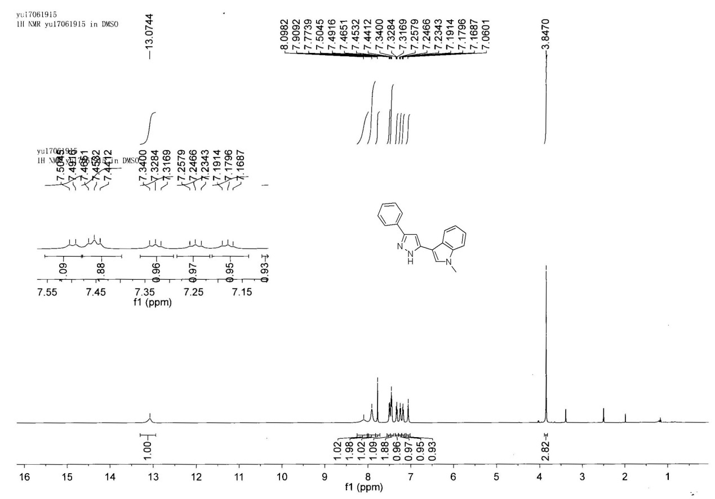
¹H NMR of 3a

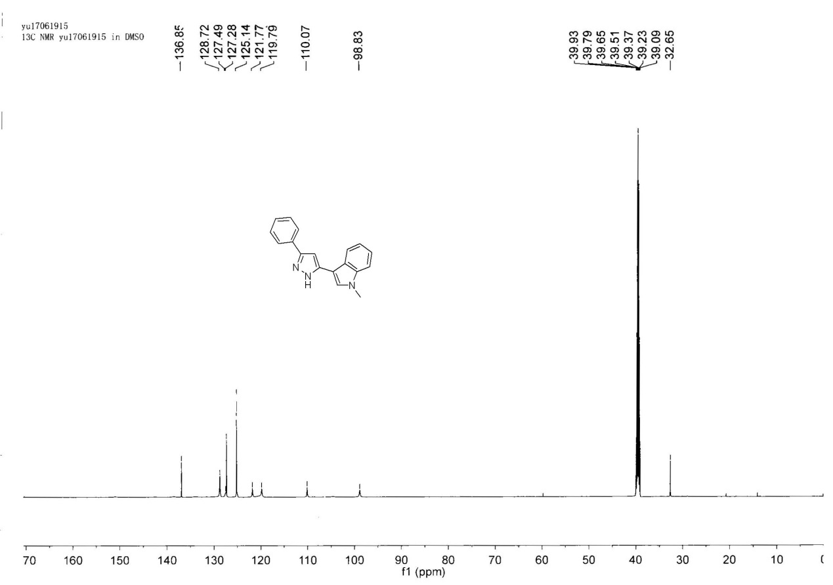
¹³C NMR of 3a

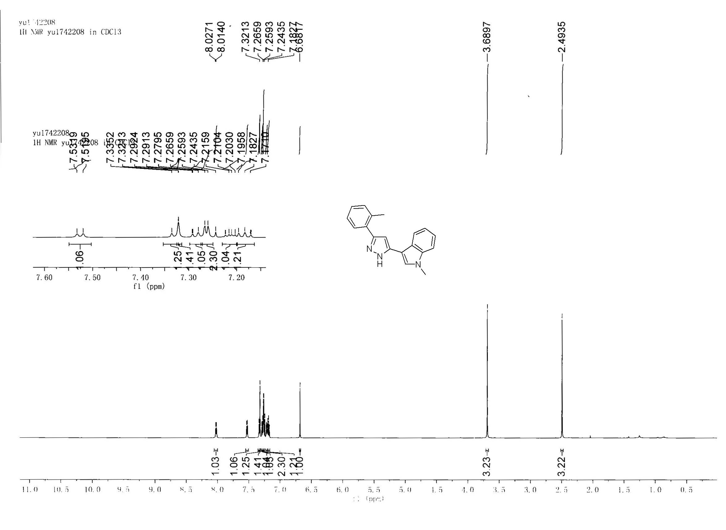
¹H NMR of 3b

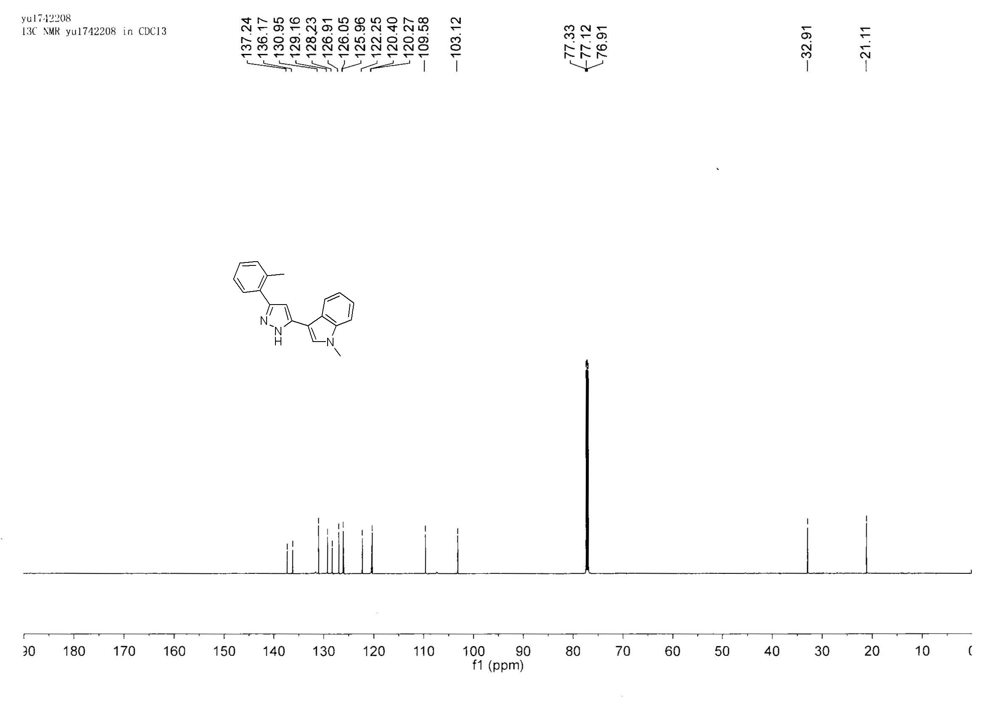
¹³C NMR of 3b

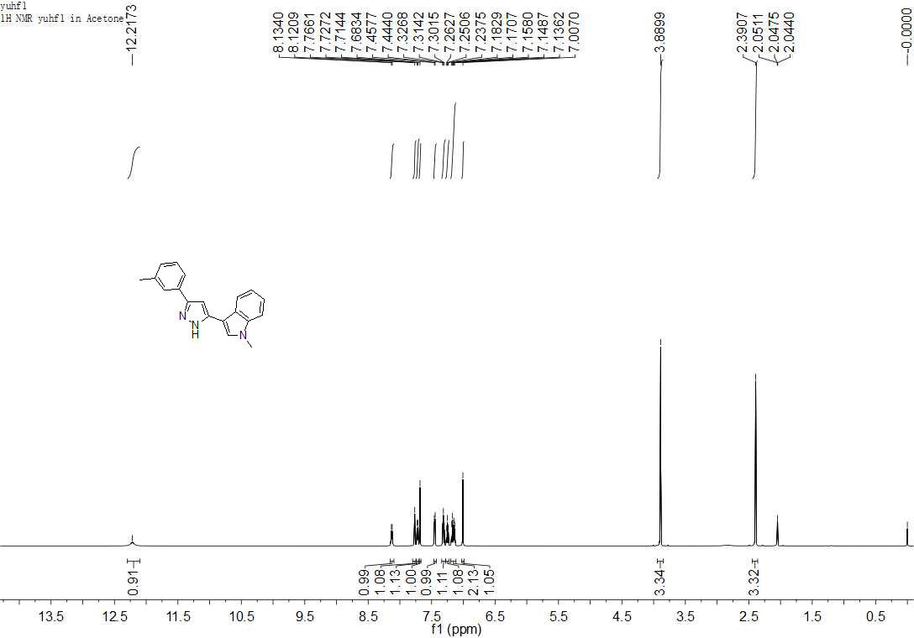
¹H NMR of 3c

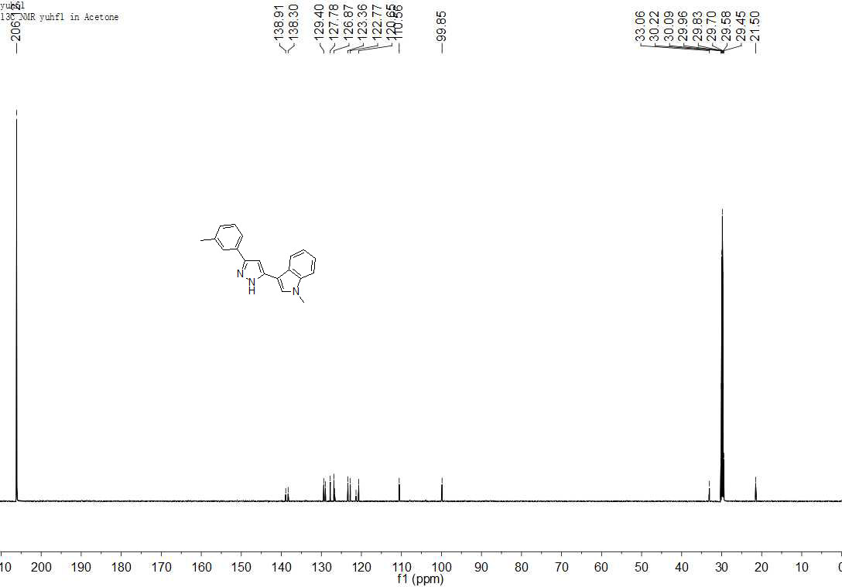
¹³C NMR of 3c

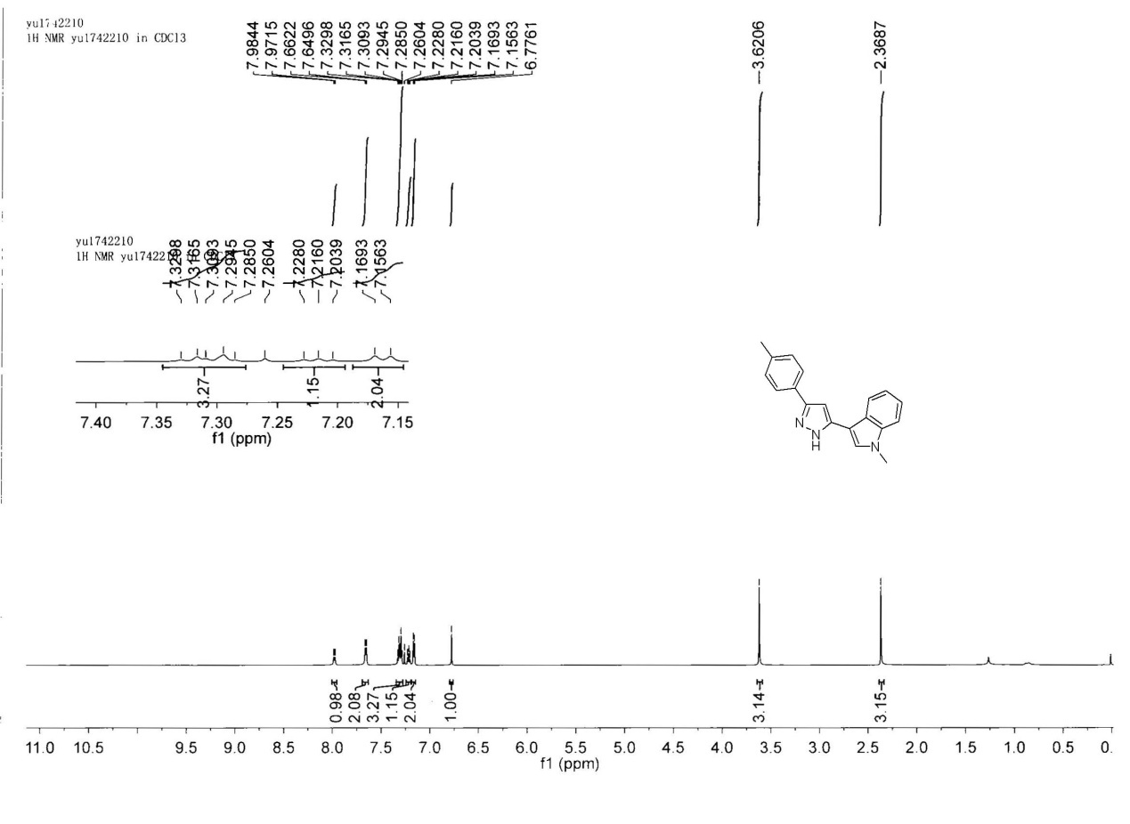
¹H NMR of 3d

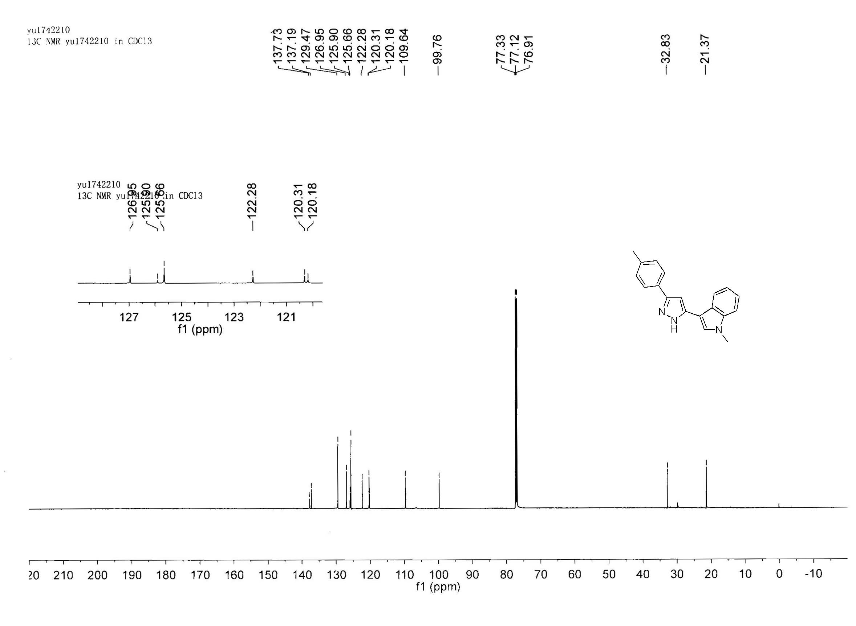
¹³C NMR of 3d

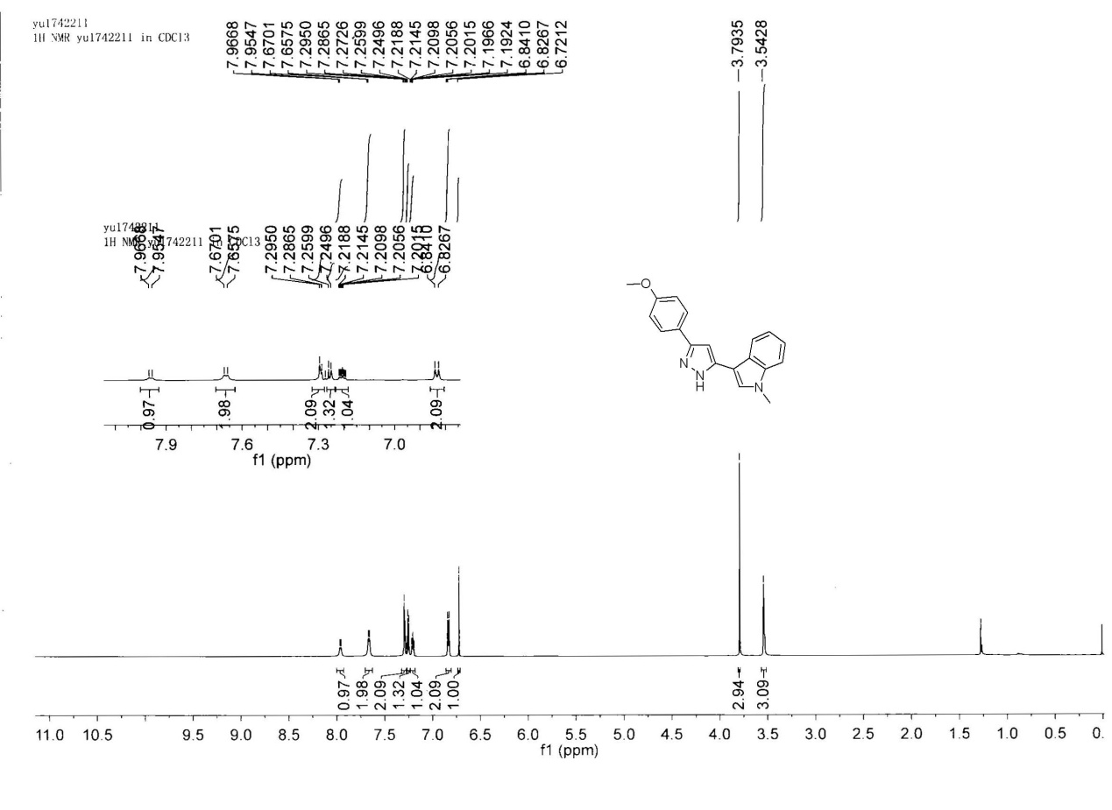
¹H NMR of 3e

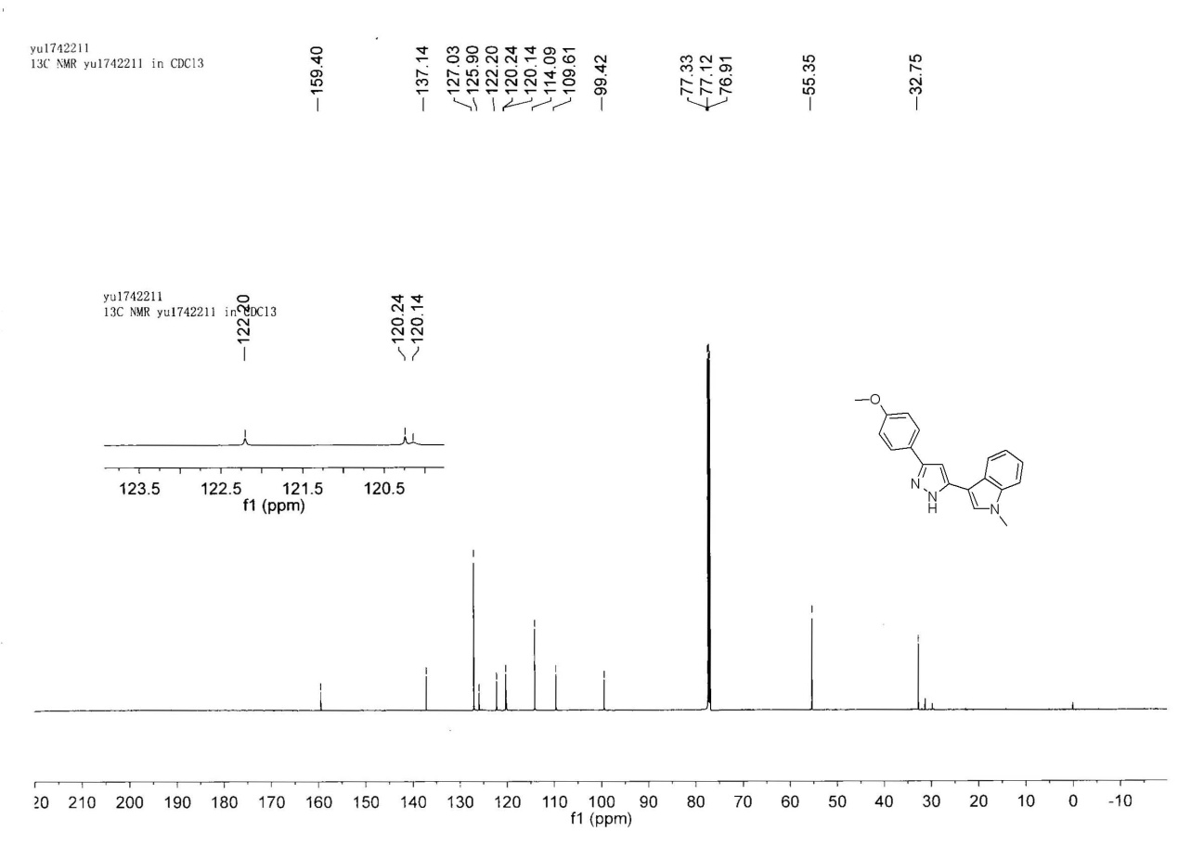
¹³C NMR of 3e

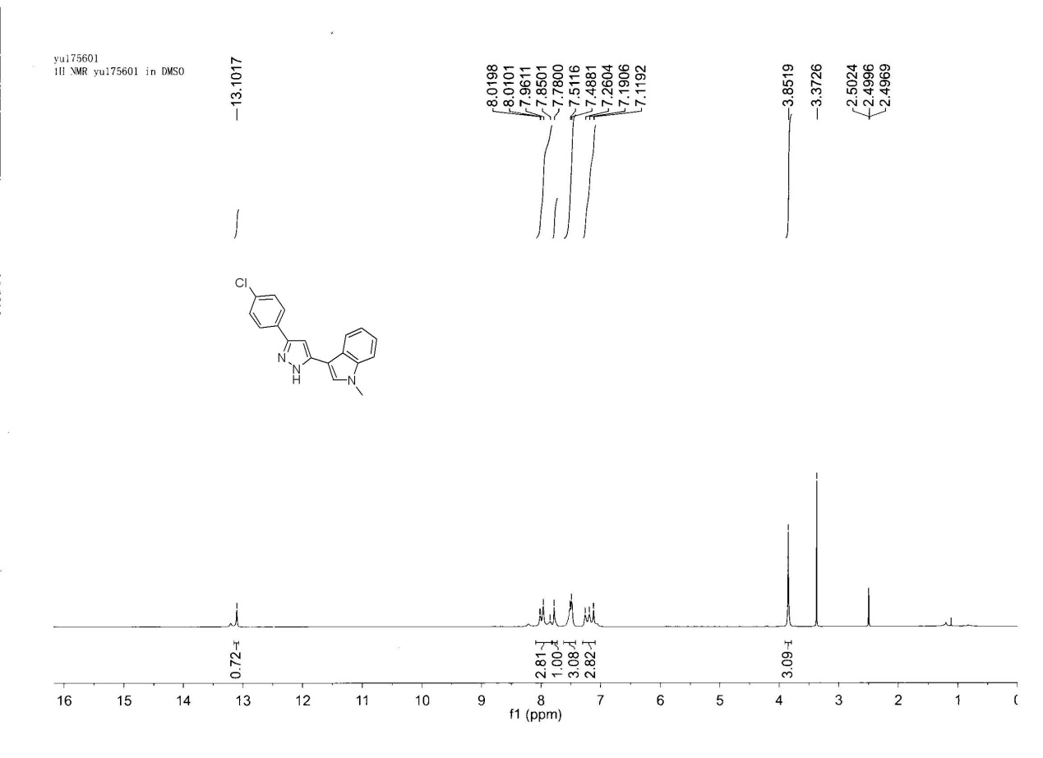
¹H NMR of 3f

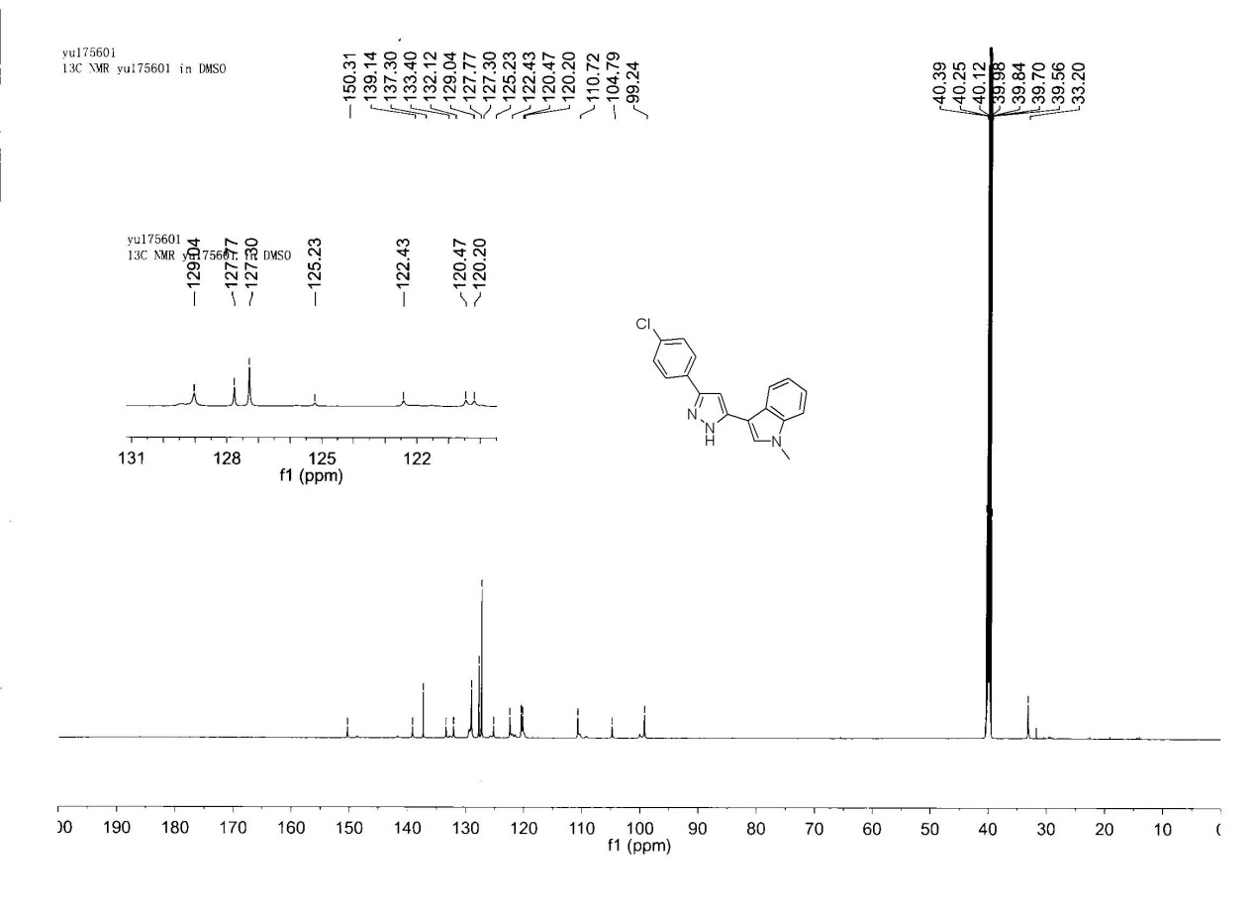
¹³C NMR of 3f

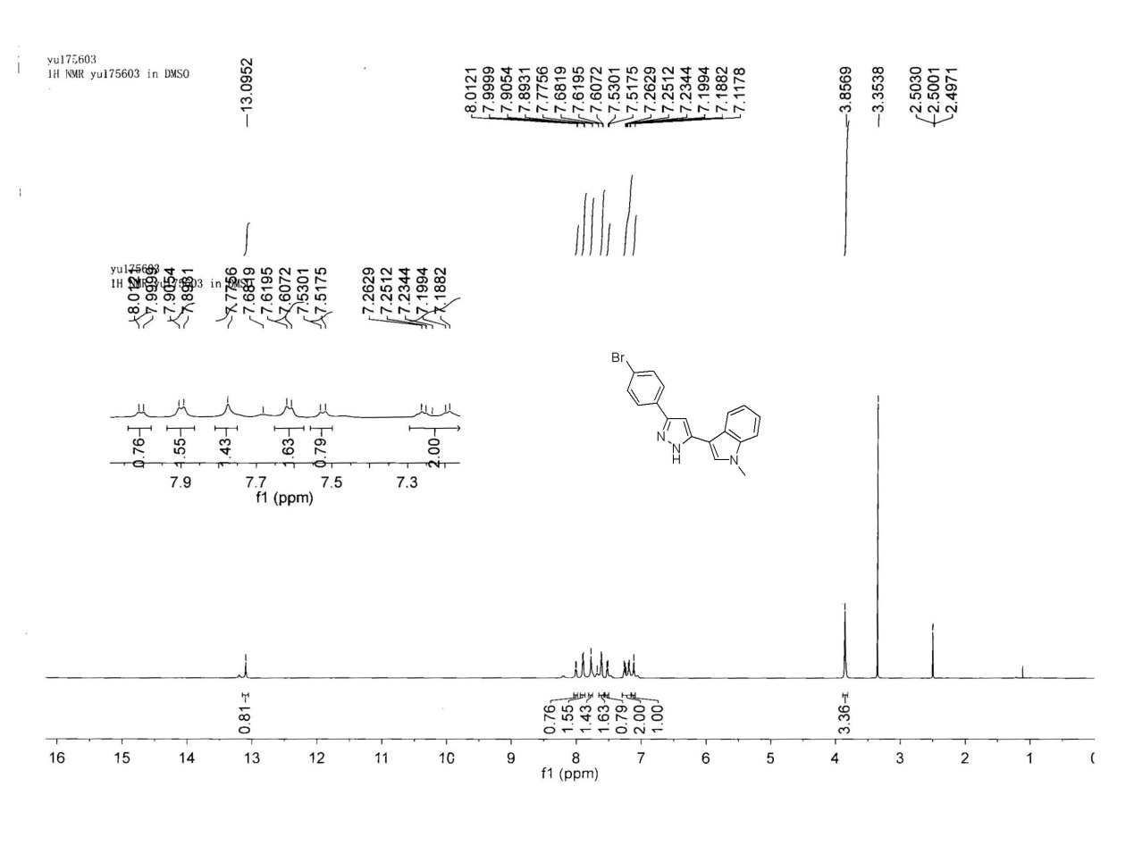
¹H NMR of 3g

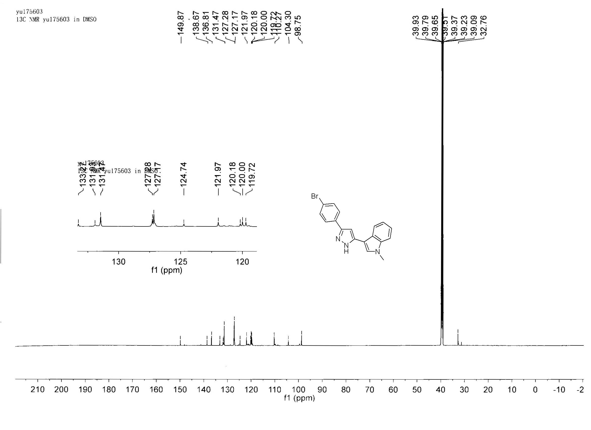
¹³C NMR of 3g
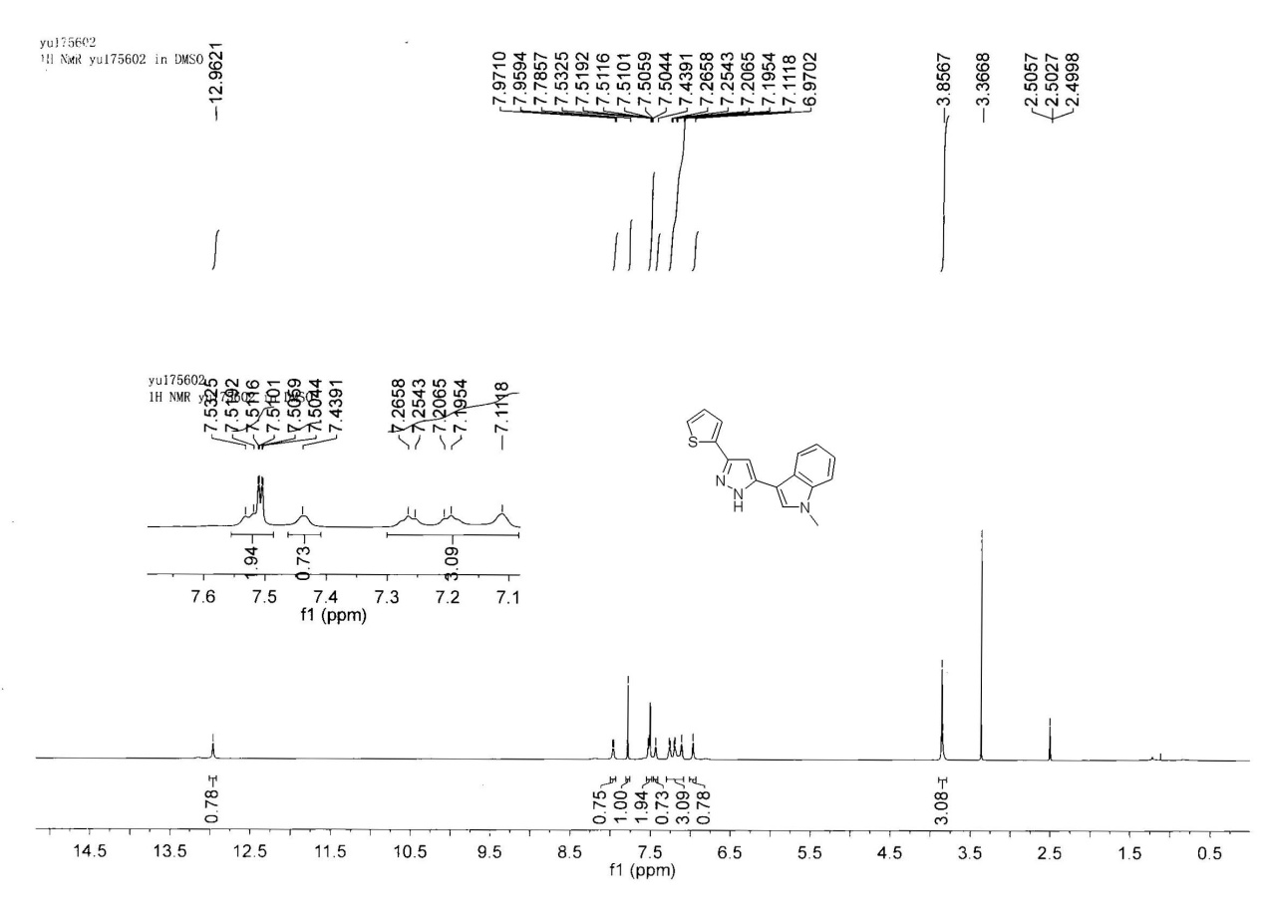
¹H NMR of 3h

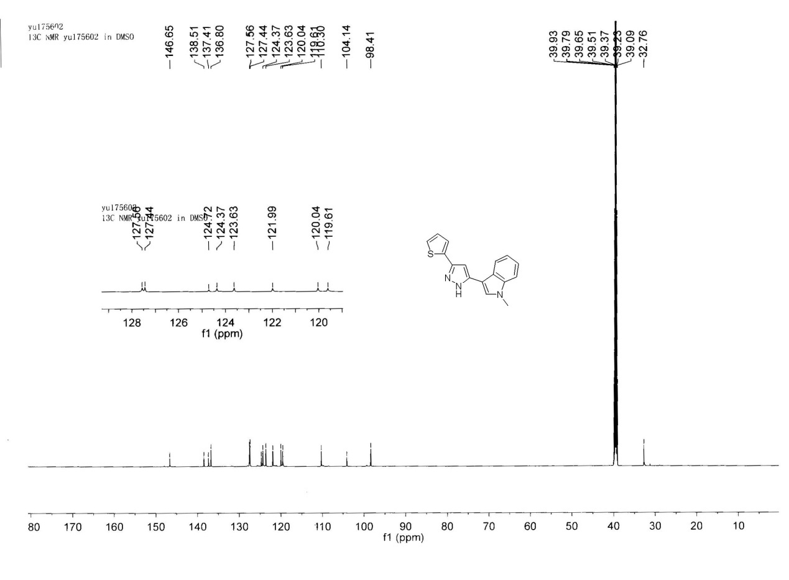
¹³C NMR of 3h

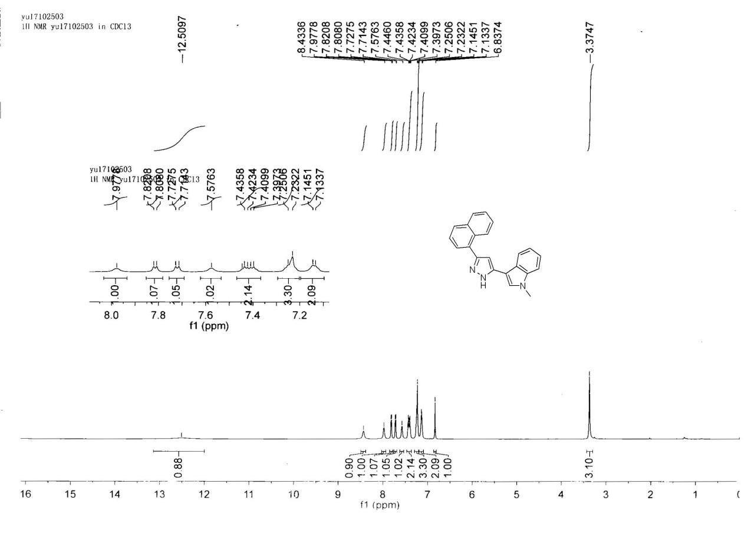
¹H NMR of 3i

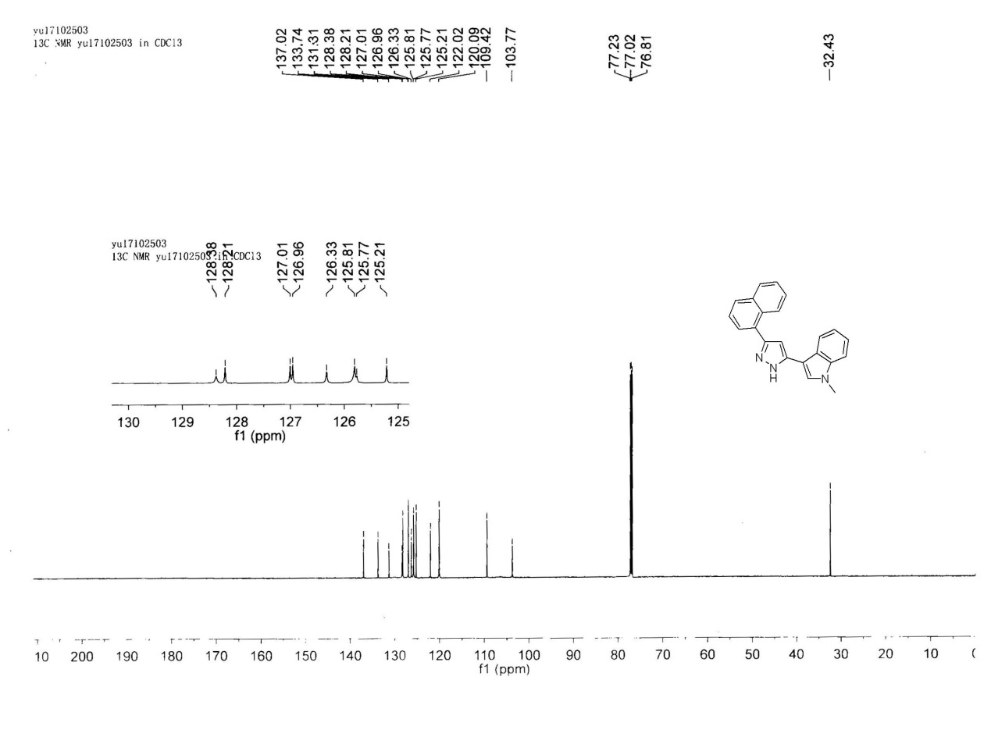
¹³C NMR of 3i

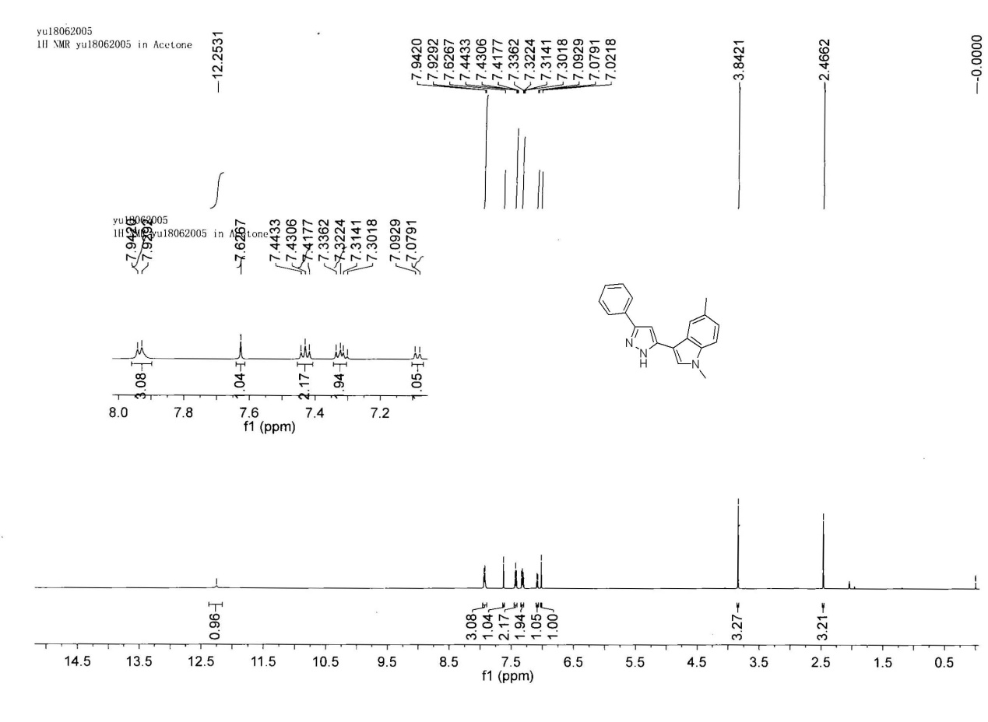
¹H NMR of 3j

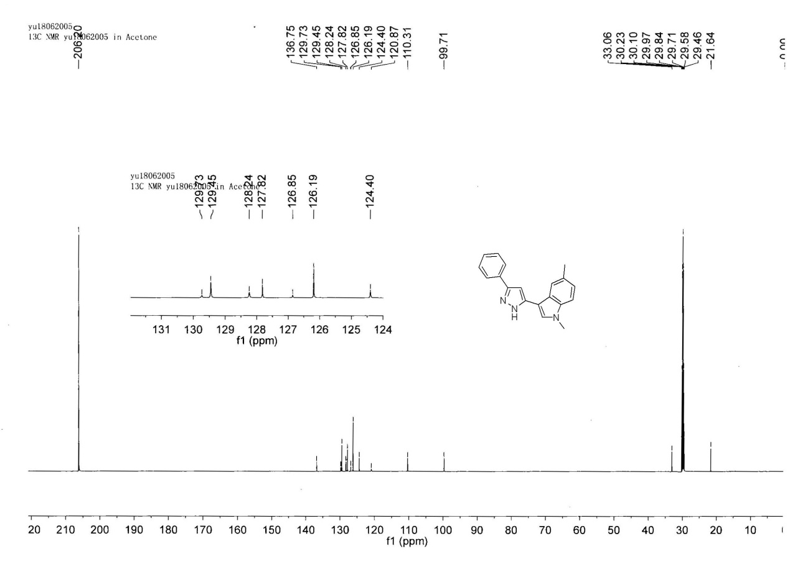
¹³C NMR of 3j

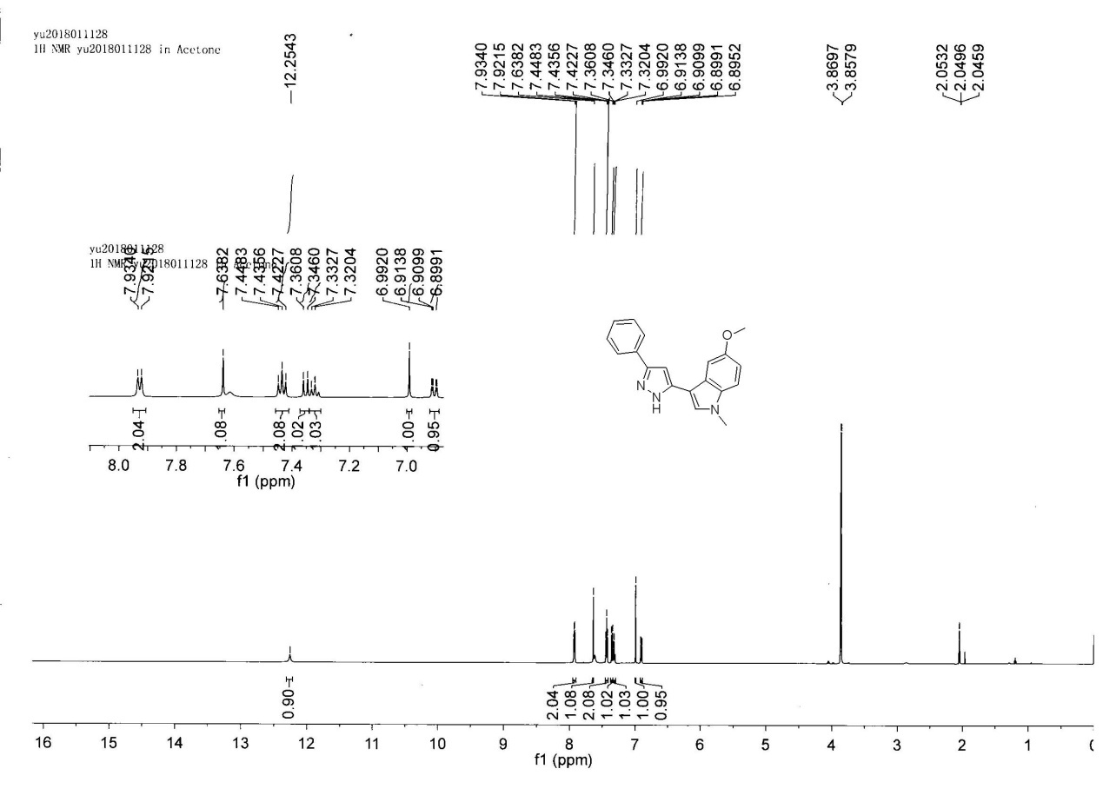
¹H NMR of 3k

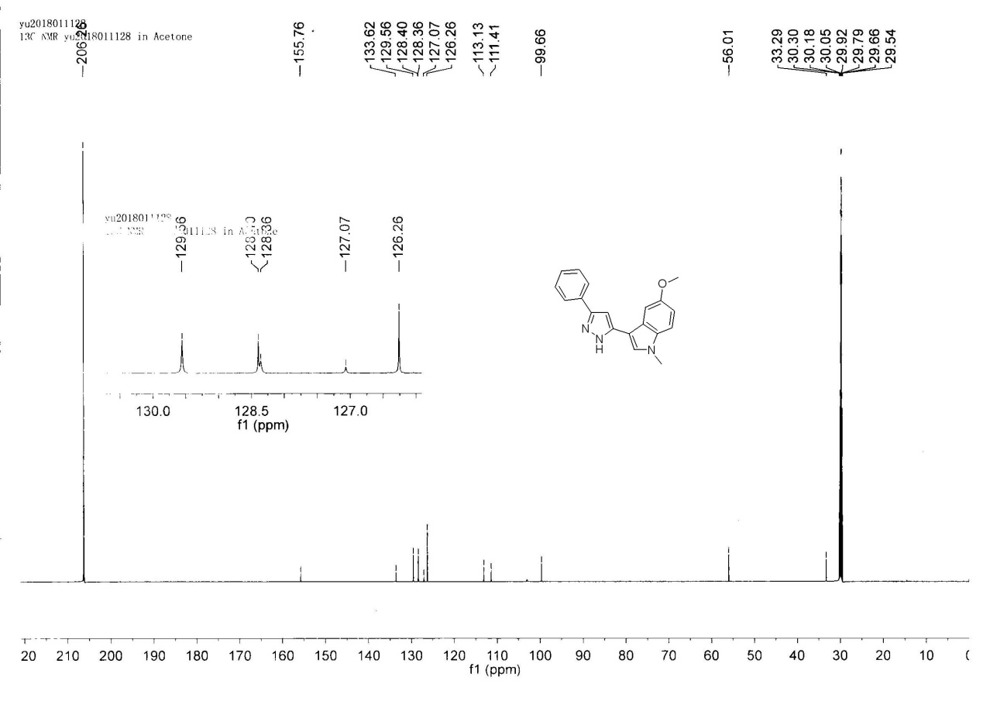
¹³C NMR of 3k

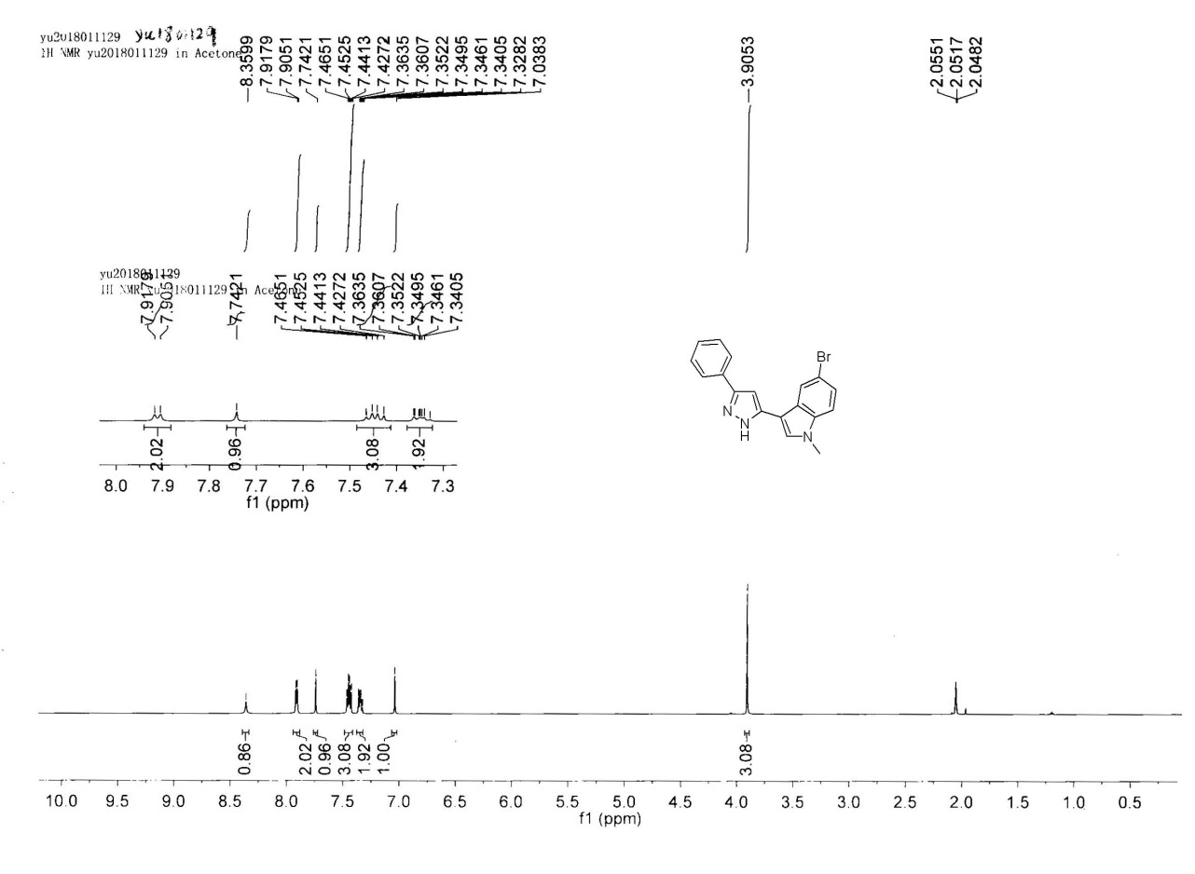
¹H NMR of 3l

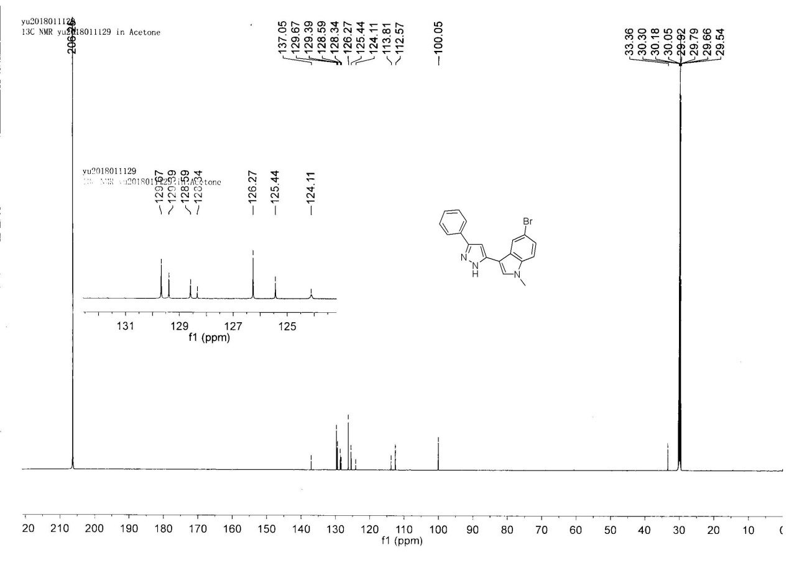
¹³C NMR of 3l

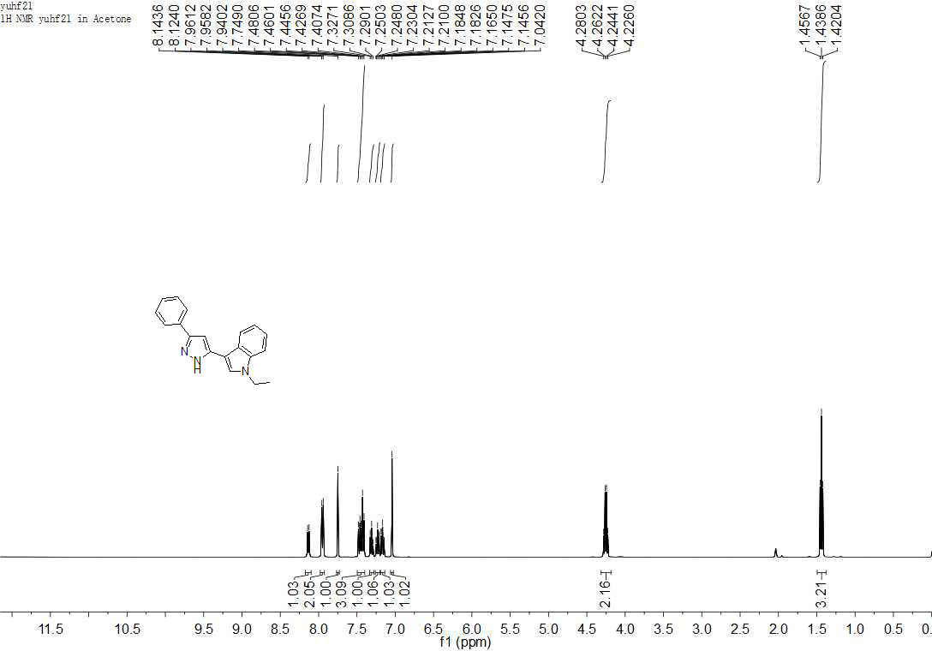
¹H NMR of 3m

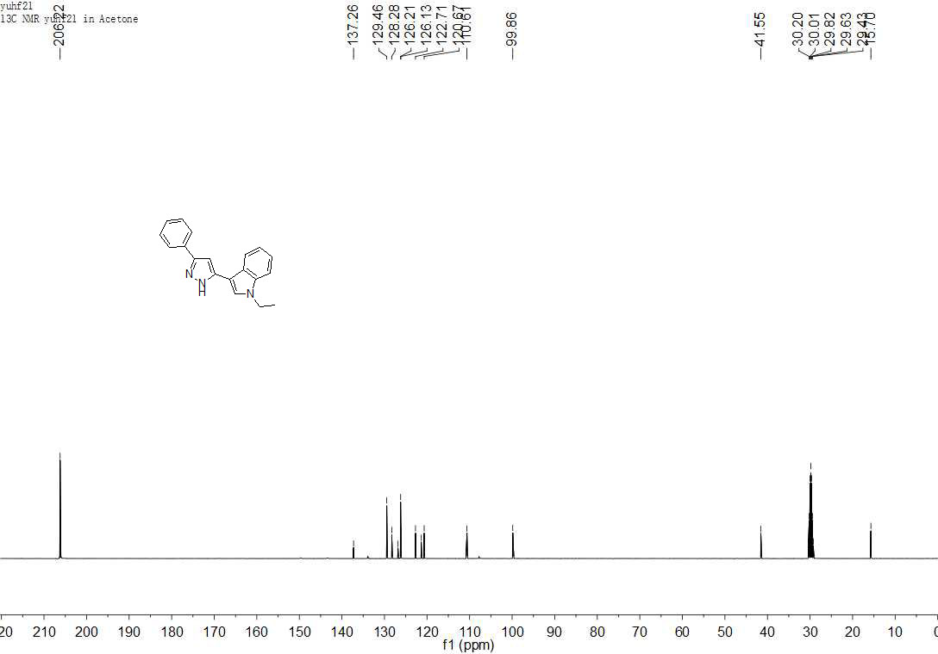
¹³C NMR of 3m

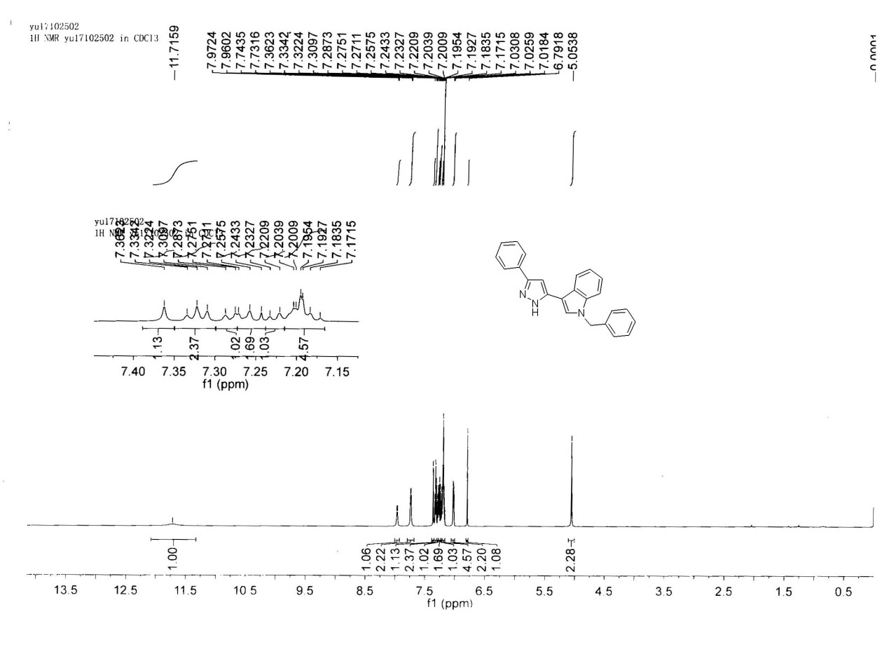
¹H NMR of 3n

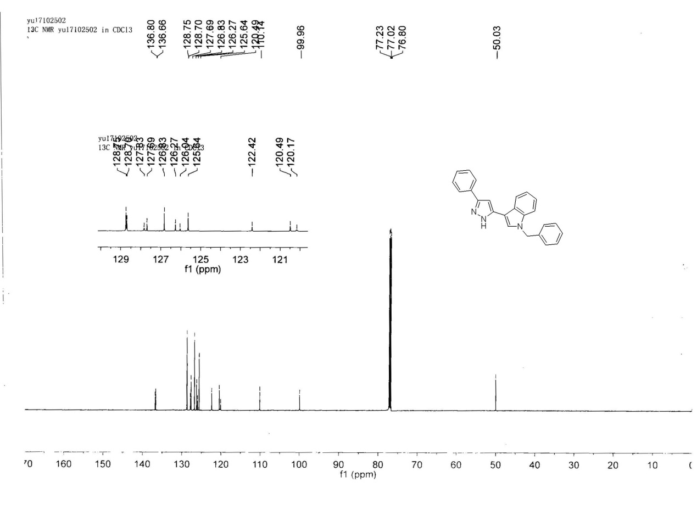
¹³C NMR of 3n

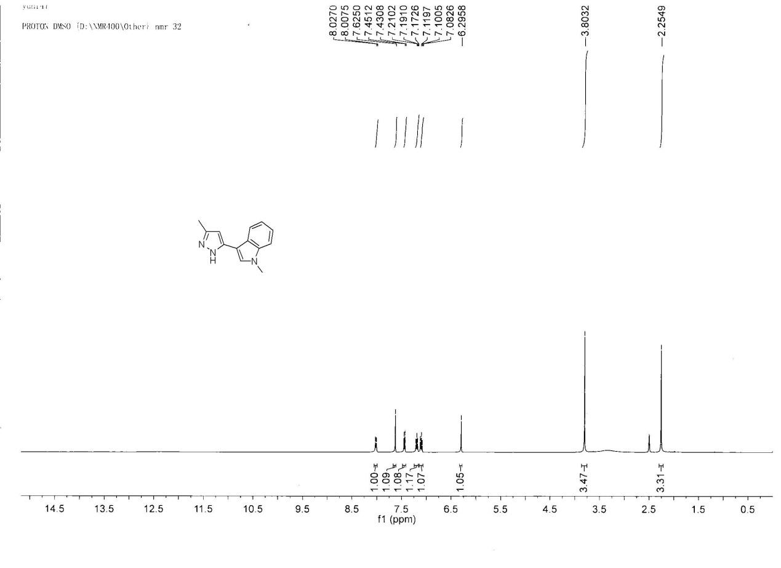
¹H NMR of 3o

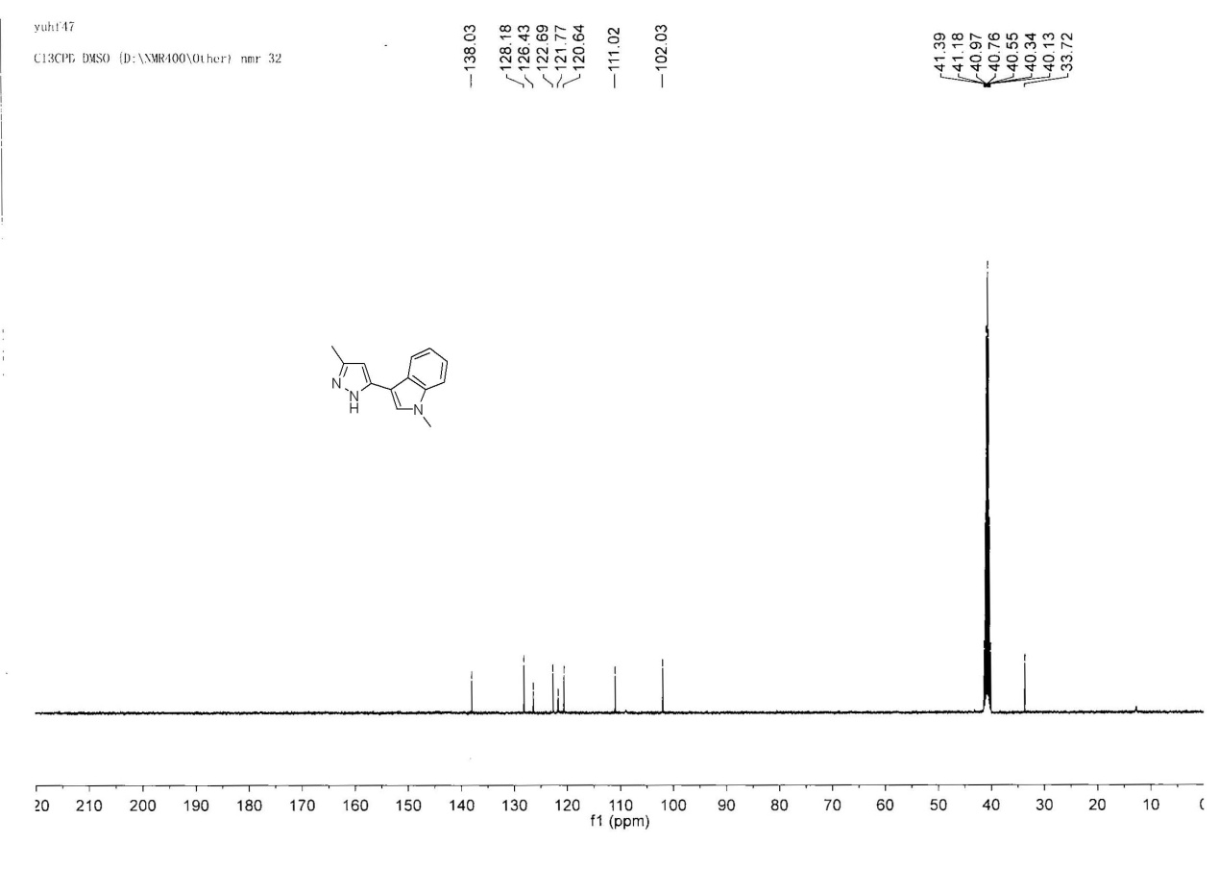
¹³C NMR of 3o
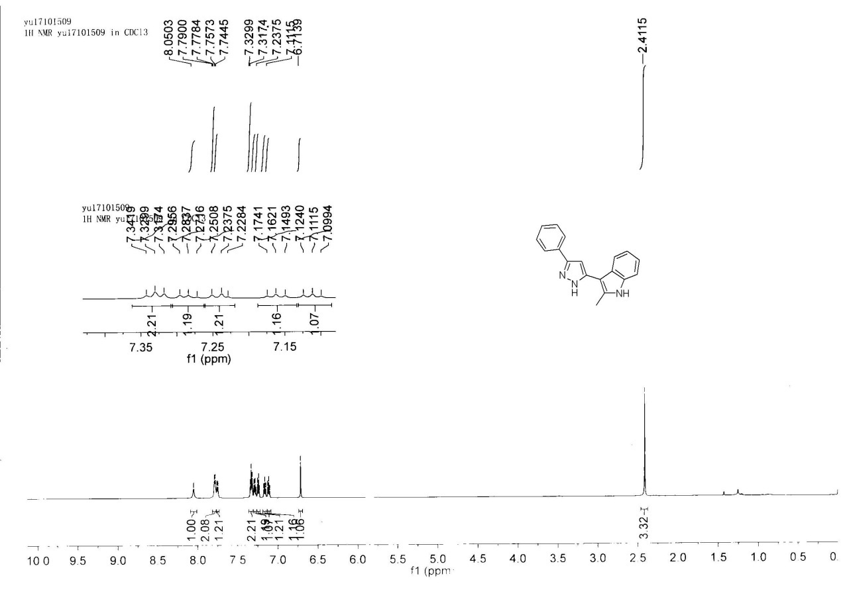
¹H NMR of 3p
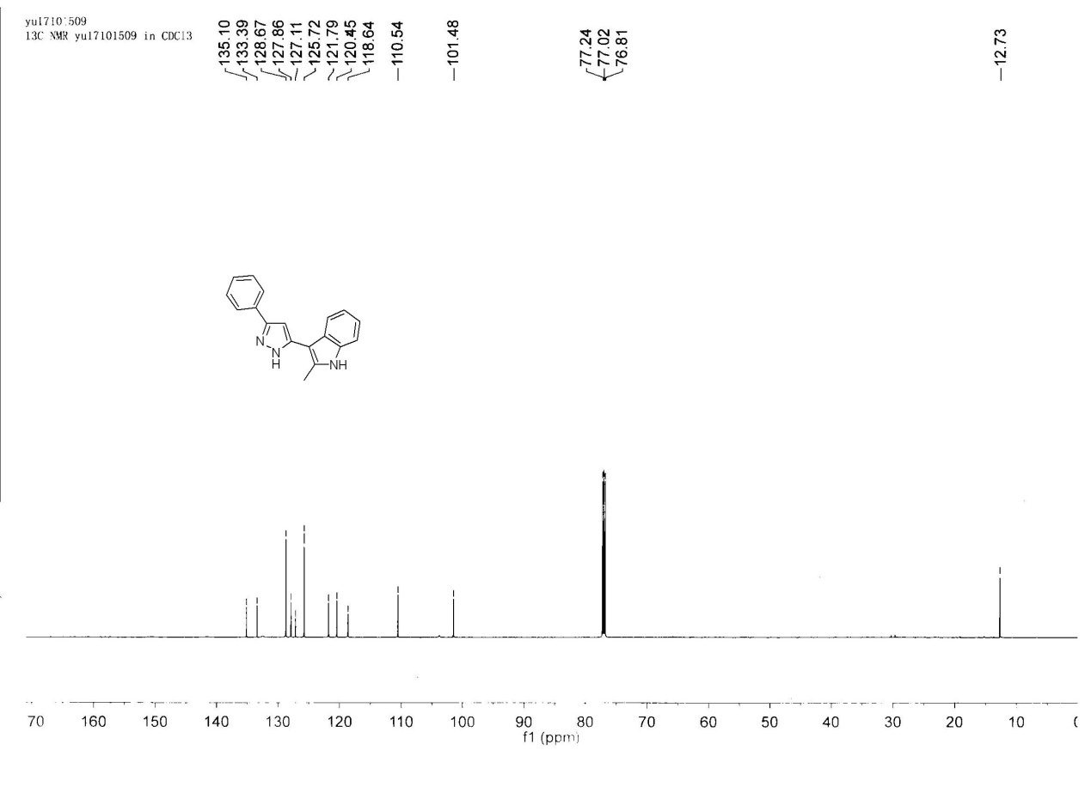
¹³C NMR of 3p

