A high yield gold nanoparticle-based DNA isolation method for human papillomaviruses genotypes from cervical cancer tissue samples
Noorossadat Seyyedi^{1,2}, Fatemeh Farjadian³, Ali Farhadi¹, Gholamreza Rafiei Dehbidi¹, Reza Ranjbaran¹, Farahnaz Zare¹, Mohammad Ali Okhovat¹, Negin Nikouyan¹, Abbas Behzad-Behbahani^{1*}
¹Diagnostic Laboratory Sciences and Technology Research Center, School of Paramedical Sciences, Shiraz University of Medical Sciences, Shiraz, Iran
²Department of Medical Biotechnology, School of Paramedical Sciences, Shiraz University of Medical Sciences, Shiraz, Iran
³Pharmaceutical Sciences Research Center, Shiraz University of Medical Sciences, Shiraz, Iran

*Corresponding Author
Abbas Behzad-Behbahani
Present address: Diagnosis Laboratory Sciences and Technology Research Center, School of Paramedical Sciences, Shiraz University of Medical Sciences, Shiraz, Iran.
Tel: +98 71 32270301
Fax: +98 71 32270301
Email address: behzadba@sums.ac.ir
Alternative Email address: behzadba@gmail.com

- Experimental procedures
  - Materials
pHPV-16 (ATCC® 45113D) and HPV-18 (ATCC® 45152D) purified plasmid DNAs were purchased from American Type Culture Collection (ATCC) (USA). Plasmid vector pBME containing a synthetic partial DNA sequence of the L1 ORF of HPV genotypes 45, 52, and 58 was purchased from Biomatik (Canada). Chloroauric acid, trisodium citrate, and sodium borohydride were purchased from Sigma (Germany). TA cloning vector pTZ57R and all restriction digestion enzymes were purchased from Thermo Fisher Scientific Inc. (Lithuania). Primers and the probes were purchased from Metabion AG (Germany). SYBR Premix ExTaq II (Tli RNaseH Plus) was purchased from Takara (Japan). GF-1 plasmid DNA extraction Kit and GF-1 Gel DNA Recovery Kit were purchased from Vivantis (Malaysia). The QIAamp DNA FFPE Tissue Kit was purchased from Qiagen (Germany). Ampliquality HPV-TYPE kit was purchased from AB Analitica (Italy). All other chemicals were purchased from Merck (Germany).
  - Instruments
A UV/Visible Spectrophotometer (WPA Lightwave II /Biochrom, US/UK) was used to determine the ultraviolet-visible/UV-vis absorption and to determine the range of amplicon concentration. Hydrodynamic diameter (HD) of the particles was confirmed by dynamic light scattering (DLS) instrument (NANO-flex, Microtrac, USA) and zeta potential was determined by Nano-ZS Zetasizer. Transmission electron microscopy/TEM image was captured by Zeiss - EM10C - 80 KV (Zeiss, Germany) and particle size analyses were conducted using ImageJ software version 1.47v, an image analysis software developed by the NIH (http://imagejnihgov/ij/). The amplification of extracted DNA was performed on a Rotor-Gene Q 5plex Platform real-time PCR system (QIAGEN, Germany) and data analysis were performed by Rotor-Gene Q Series Software (QIAGEN, Germany/ version 2.0.2).
  - Methods
    - Plasmids and bacterial strains
HPV-16 and HPV-18 purified plasmid DNAs were received in Escherichia coli strain DH5α. A synthetic partial DNA sequence of the L1 ORF of HPV genotypes 45, 52, and 58 containing designed restriction endonuclease recognition sites (Bam HI, Hind III, Nde I) were also received in plasmid vector pBME in Escherichia coli strain DH5α. Due to the existence of partial nucleotide sequence homology among HPV-18, 31, and 33, we used HPV-18 purified DNA plasmid as a source of HPV-31 and 33 DNA in our experiment.
Plasmids extraction and agarose gel purification of DNA after electrophoresis were performed according to the procedure described by the manufacturers. The purified plasmids were used as the controls during the study to develop efficient hybridization methods. Using defined restriction enzymes, type-specific sequences were isolated, purified and cloned in TA cloning vector pTZ57R for further study.
    - Primers and Probes Design
GP5+/GP6+ consensus primers were used to amplify a conserved region of HPV L1 gene [1]. Using Gene Runner software, oligonucleotide probes were designed to specifically hybridize to their target sequence of each genotype (Table S1). The DNA probes were prepared with a thiol linker group (HS–(CH2)6–), to conjugate to the gold nanoparticles surface.
In-silico specificity of the probes was confirmed by BLAST search of probe sequences (https://www.ncbi.nlm.nih.gov/tools/primer-blast/).

Table S1, Specific probes designed for the specific purification of HPV DNA
Probe names | Probe sequence 5′- 3′
HPV-16 probe | TTTGTTACTGTTGTTGATACTACACGCTTTTTTTTTTTT-thiol-C6
HPV-18,31,33 probe | TTATTTGTTACTGTGGTAGATACTTTTTTTTTTTT-thiol-C6
HPV-45 probe | TTTGTTACTGTAGTGGACACTACCCTTTTTTTTTTTT-thiol-C6
HPV-52 probe | TTTGTCACAGTTGTGGATACCACTCTTTTTTTTTTTT-thiol-C6
HPV-58 probe | TTATTTGTTACCGTGGTTGATACCTTTTTTTTTTTT-thiol-C6
Bold and underline sequences are complementary to the sequence of the HPV, poly T at the 3′ terminus acts as a spacer for increasing the distance between probes and surface of AuNPs

    - Synthesis of AuNPs
AuNPs were synthesized as previously described [2]. Briefly, chloroauric acid (0.5 mL of 0.01 M) was dissolved in 18 mL ultra-purified water, sodium citrate (0.5 mL) in the concentration of 0.01 M was then added and the mixture was incubated for 5 minutes at room temperature. To have particles less than 10 nm, sodium borohydride (0.5 mL of 0.1 M) was rapidly injected to the reaction mixture. Particles were then stored at 4°C in a dark place.
    - Conjugation of oligonucleotide probes to AuNPs
Thiol-modified oligonucleotide probes conjugation was performed through the reported procedure [3]. Initially, a series of experiments in hybridization was performed to optimize the concentration of thiol-modified DNA probes and AuNP solution (Figure S1). Indeed, different concentrations of the thiol-modified probe (5, 10, 20, and 40 μM) were separately added to the solution (1.06 µg/ml, 980 μl) of AuNPs and incubated in a water bath for 24 h at 37°C. Besides, all the thiol-modified probe concentrations were also added to a concentration of 2.13 µg/ml AuNP solution. For strong attachment of probes to the surface of AuNPs, salt buffer solution (0.05–1.0 M NaCl in 10 mM Na2HPO4, pH 7.4) at six different time points in the next 48 h interval was added to the mixture. The mixture was centrifuged for 30 min at 19,530 × g to remove unbounded probes from the functionalized AuNP solution. Following the removal of supernatant, the red oily precipitate was washed twice with phosphate buffer saline (PBS, pH 7), followed by centrifugation and redispersion in 0.05 M NaCl solution. Moreover, 20 and 40 µL volume of optimum concentration from the functionalized AuNPs solution was tested to achieve the final assay volume.
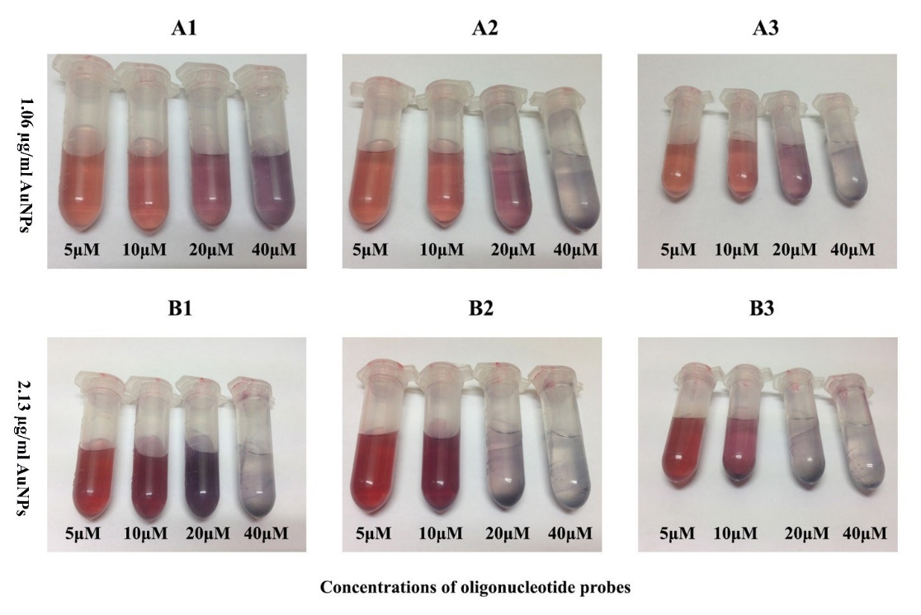
Figure S1, Optimization of AuNPs and thiol-modified oligonucleotide probes concentrations by gradually adding sodium chloride. 0.1 M (A1, B1, 12 hr.), 0.2 M (A2, B2, 24 hr.), and 0.4 M (A3, B3, 48 hr.) of sodium chloride.

    - Optimization of hybridization temperature and time
Using AuNP to achieve maximum efficiency, different hybridization conditions were optimized for the purification of HPV DNA from FFPE tissue samples. To establish the optimal hybridization time, the functionalized AuNPs solution was allowed to react with the PCR products for times ranging from 30, 45, and 60 min at a pre-determined temperature, which was approximately 5°C below the melting temperature.
    - Preparation of template DNA for hybridization
To determine the method ability to purify the lowest concentration of HPV DNA, a ten-fold dilution series range 10¹⁰ to 10⁰ copies of plasmids containing high-risk HPV DNA were PCR amplified by GP5+/GP6+ consensus primers.
The reaction mixture (final volume 25 µL) consisted of 12.5 µL of SYBR Green Premix, 2 µL of the template DNA, and 0.4 μM of each primer. The amplification was performed on the real-time machine at 95°C for 30 s, followed by 50 cycles of 95°C for 5 s, 60°C for 20 s, and 72°C for 20 s. Melting curve analysis of the amplified products was conducted at the end of each PCR to confirm that one PCR product was amplified.
    - Purification method for high-risk HPV DNA
To evaluate our newly developed purification method for the yield and purity of DNA, a volume of 20 μl of the probe-AuNP conjugate was mixed with 2 μl of a dilution series (ten-fold step) of PCR products and 8 μl of 2X saline-sodium citrate (SSC) buffer. The hybridization reaction was performed at 94°C for 12 min followed by 30 min incubation of HPV-16 at 57°C, HPV-18, 31, and 33 at 45°C, HPV-45 and 52 at 56°C and HPV-58 at 54°C.
In order to remove excessive unbounded DNA, the tubes were centrifuged at 16000 ×g for 10 min. Following supernatant removal, the red oily precipitate was then washed once with PBS containing 0.01% Tween 20 and twice with PBS (pH 7.2-7.6 at 25°C), and centrifuged at 16000 × g for 10 min and the pellet was dispersed into 20 µL double distilled water.
DNA bound to the probe-AuNP conjugate was eluted by heat treatment. Eppendorf tubes were heated at 95°C for 2.5 min and then centrifuged at 16000 ×g for 10 min. The supernatant was transferred to a fresh tube and used directly in the PCR assay.
    - SYBR Green-based quantitative real-time PCR
The DNA purification method accuracy was investigated by quantitative real-time PCR using GP5+/GP6+ consensus primers and Takara SYBR Green Master Mix as described above, except that a unit of Taq DNA polymerase and bovine serum albumin (700 ng/µL) was added to enhance PCR amplification yield. For quantification of HPV DNA and to generate standard curves, in separate experiments, real-time PCR assay was performed on ten-fold dilution series of each plasmids DNA containing high-risk HPV genotypes 16, 18, 31, 33, 45, 52, and 58 (ranging from 10¹⁰ copies to 1 copy per reaction).

    - Sensitivity evaluation of DNA extraction methods
To determine the sensitivity of the DNA extraction methods, HPV-16 DNA containing plasmid was initially amplified by PCR assay using GP5+/GP6+ consensus primers and the amplicons concentration was determined. Following, 8×10² to 8 × 10⁴ copies/µL of the amplicons were added to 200 µL of HPV DNA negative tissue lysate and the tubes were subjected to DNA purification by AuNPs method and Qiagen FFPE DNA extraction kit. Real-time PCR assay was then performed to evaluate the sensitivity of each extraction methods. The experiments were repeated thrice.

    - DNA purification from FFPE cervical tissue samples
To evaluate the efficiency of present DNA purification method on FFPE tissue samples, a total of 9 FFPE cervical cancer tissue specimens were obtained from the archive of pathology, Namazi Hospital, Shiraz, Iran. The duration of formalin storage for the clinical specimens used in this study was more than 6 months. Eight 10-μm thick sections were cut and placed in a 1.5 mL microcentrifuge tube and were subjected to purification. Briefly, 180 µL of lysis buffer containing 10 mM NaCl, 1 mM EDTA, 20 mM Tris-HCl, and 10% sodium dodecyl sulfate (SDS) in pH 8.0, was added directly to the paraffin sections and incubated for 20 min at 120°C. Melted paraffin wax was then mixed to obtain a homogenous suspension in lysis buffer. Tubes were briefly centrifuged to bring any condensation down from the walls and lid. Proteinase K at a concentration of 10mg/mL was added to the tubes and incubated at 65°C for 16 hours in the heat block. Tissue lysate was then adopted as the target DNA to perform the proposed purification strategy as shown in Scheme S1.
DNA extracts were tested using quantitative real-time PCR assay, and its concentration was calculated from the standard curve. The HPV genotypes were then confirmed by The Ampliquality HPV-TYPE genotyping test which is based on reverse hybridization method.
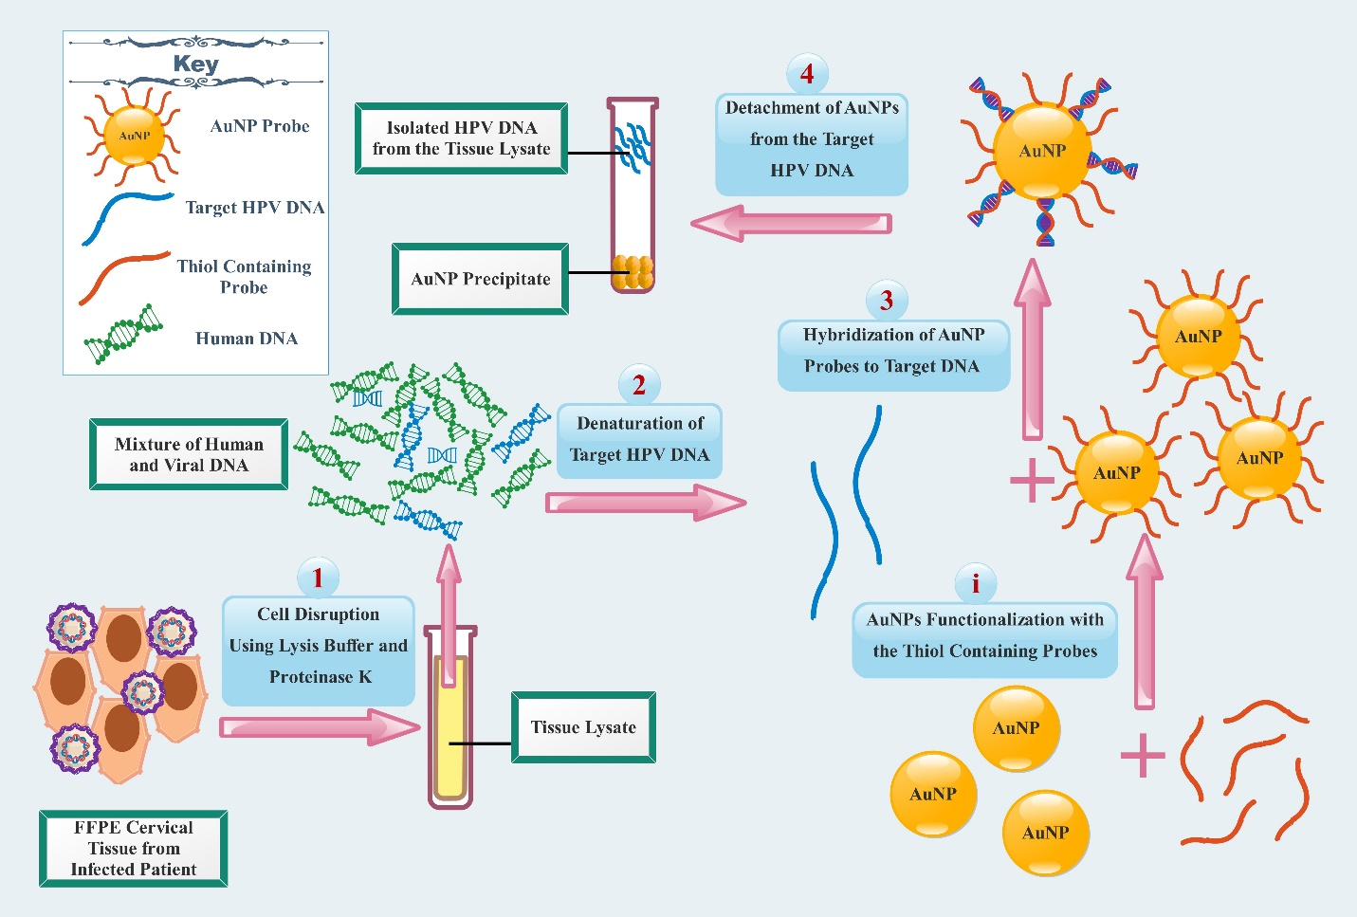
Scheme S1, Schematic diagram shows DNA purification based on AuNPs by liquid phase hybridization approach. Step 1: Cell disruption using lysis buffer and proteinase K; Step 2: denaturation of target DNA; Step 3: hybridization of AuNP probes to target DNA; Step 4: detachment of AuNPs from the target HPV DNA.
    - Specificity determination of assay
To perform the specificity of AuNPs purification method, 9 HPV negative FFPE samples from benign ovarian tumor, and FFPE cervical specimens previously tested positive for the low-risk HPV genotypes 6, 53, 87, and 90 were subjected to the purification and genotyping method as described above.

References

1. de Roda Husman, A.-M.; Walboomers, J. M. M.; van den Brule, A. J. C.; Meijer, C. J. L. M.; Snijders, P. J. F. J. Gen. Virol. 1995, 76 (4), 1057–1062. https://doi.org/10.1099/0022-1317-76-4-1057.
2. Etame, A. B.; Smith, C. A.; Chan, W. C. W.; Rutka, J. T. Nanomedicine Nanotechnology, Biol. Med. 2011, 7 (6), 992–1000. https://doi.org/10.1016/j.nano.2011.04.004.
3. Quintela, I. A.; De Los Reyes, B. G.; Lin, C. S.; Wu, V. C. H. Nanoscale 2015, 7 (6), 2417–2426. https://doi.org/10.1039/c4nr05869k.

